A Seamless Auxetic Substrate with a Negative Poisson’s Ratio of -1
Yung Lee^{a,b†}, Bongkyun Jang^{c†}, Hyunggwi Song^{a,d}, Sumin Kim^{a,e}, Yong Won Kwon^{a,e}, Hyun Seok Kang^{a,b}, Min Seong Kim^{d}, Inkyu Park^{d}, Taek-Soo Kim^{a,d}, Junho Jang^{a,b}, Jae-Hyun Kim^{c}, Jang-Ung Park^{a,e,f}, and Byeong-Soo Bae^{a,b}*

ª Wearable Platform Materials Technology Center (WMC), KAIST, Daejeon, 34141, Republic of Korea

^{b} Department of Materials Science and Engineering, KAIST, Daejeon, 34141, Republic of Korea

^{c} Department of Nano Mechanics Korea Institute of Machinery & Materials (KIMM) 156, Gajeongbuk-ro, Yuseong-gu, Daejeon 34103, Republic of Korea

^{d} Department of Mechanical Engineering, KAIST, Daejeon, 34141, Republic of Korea

^{e} Department of Materials Science and Engineering, Yonsei University, Seoul, 03722, Republic of Korea

^{f} Department of Neurosurgery, Yonsei University College of Medicine, Seoul, 03722, Republic of Korea

† These authors contributed equally to this work

*Corresponding authors: bsbae@kaist.ac.kr (B.-S. Bae)
Supplementary information

Supplementary Note 1: Design rationale of auxetic structures
Auxetics can be categorized into two classes: scaffold types, and face types.¹⁻⁴ Despite scaffold type auxetics can exhibit higher stretchability by deploying the scaffolds into spaces, they often create expansive open spaces. This characteristic makes them less suitable as substrates; their sparse scaffolds do not furnish a sufficient area requisite for device fabrication. On the other hand, face-type auxetics provide a sufficient rigid area for devices, nearly 100% surface coverage. Among these, we chose the 'rotating square unit' type auxetic structure due to its well-established and straightforward physical behavior.^{5,6} This particular structure also exhibits orthotropic behavior. To clarify, anisotropic auxetics can manifest a negative Poisson’s ratio exceeding -1 in one specific direction, while nearing 0 in alternative directions.³ In contrast, the rotating square type consistently exhibits a negative Poisson’s ratio limit of -1, across all directions.
The rotating square type auxetic structure is composed of two main elements: a square-shaped island and hinges. These hinges connect to all four sides of the square but are biased towards the vertices without adjoining. When the film is stretched in a particular direction, the hinges parallel to the loading direction align, causing the square-shaped island to rotate. Consequently, the perforations expand in both the loading and its orthogonal directions, generating auxetic expansion. In the case of seamless auxetic film, the auxetic domain operates similarly. However, the stretching of the stretchable domain generates a counteracting force due to the inherent properties of the elastic material. This opposing force in the transversal direction can inhibit the optimal auxetic behavior observed in unfilled structures. Thus, to attain the ideal negative Poisson’s ratio, it's imperative to pair a soft elastic material with a negligible modulus of elasticity alongside a sufficiently rigid material.

Supplementary Note 2: Wrinkling behavior of S-AUX films
Fig.S5 demonstrates that S-AUX film with thin woven GFRP (four plies of glass-fabric) is prone to out-of-plane buckling of the hinges rather than in-plane bending. This results in wrinkling and reduced auxeticity, particularly in high-strain regions (Figure 2c). The wrinkling behavior is associated with the thickness of the hinges in the auxetic domain, which support the rotation of square islands while resisting bending (Supplementary Note 1). In two-dimensional condition, the square islands only rotate in-plane, but in three-dimensional situations, the hinges are subjected to undesired out-of-plane bending. Maximizing the bending stiffness of the hinge in the out-of-plane direction is crucial to mitigate this effect. The bending stiffness (K) is defined as the multiplication of the elastic modulus (E) and the bending moment of inertia (I). For a rectangular parallelepiped-shaped beam, the moment of inertia is proportional to (height)³, where height toward the out-of-plane direction represents the thickness in this case. Therefore, increasing the thickness of the rigid area containing the hinges is essential to achieve the ideal auxetic behavior.

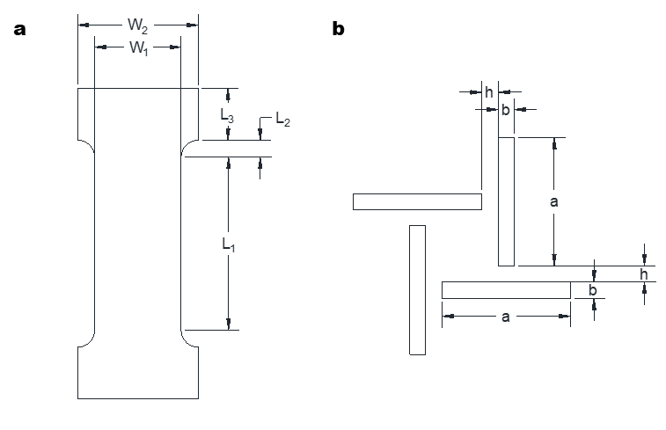
Supplementary Figure 1︱Design parameters of Poisson’s ratio measurement specimens. a, dimension parameters of dog bone specimens. b, dimension parameters of an auxetic pattern

Table S1. The dimension parameters of auxetic structures and dog bone specimens.
Specimen number | L₁ | L₂ | L₃ | W₁ | W₂ | a | b | h | t
1 | 50 | 5 | 15 | 25 | 35 | 4 | 0.5 | 0.5 | 0.3
2 | 18 | 6.6 | 12 | 8 | 15.1 | 1.45 | 0.18 | 0.18 | 0.1

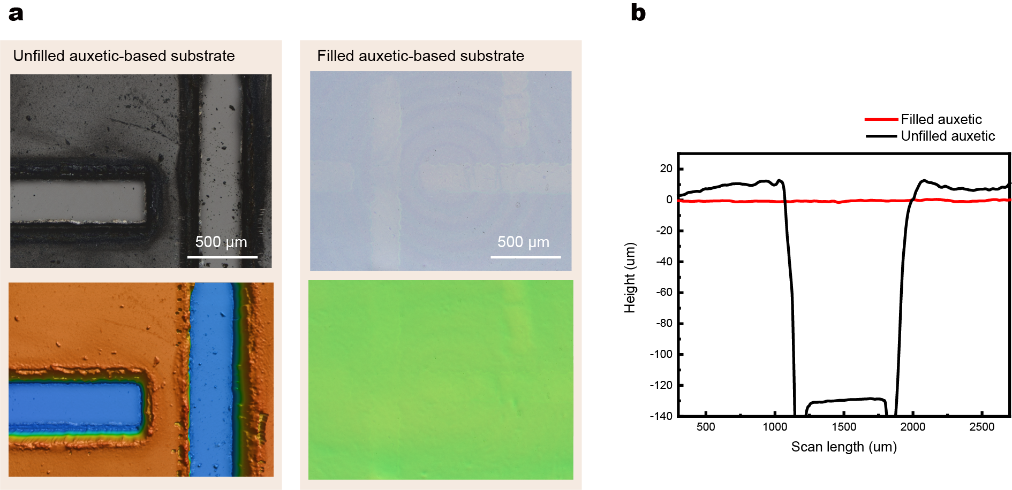
Supplementary Figure 2︱Surface morphology of S-AUX film before and after filling perforations obtained using a 3D confocal microscope. a, an optical microscope image (top) and a height profile image (bottom) of an unfilled (left) and a filled (right) S-AUX film. b, cross-sectional height profile curves of filled and unfilled S-AUX films.

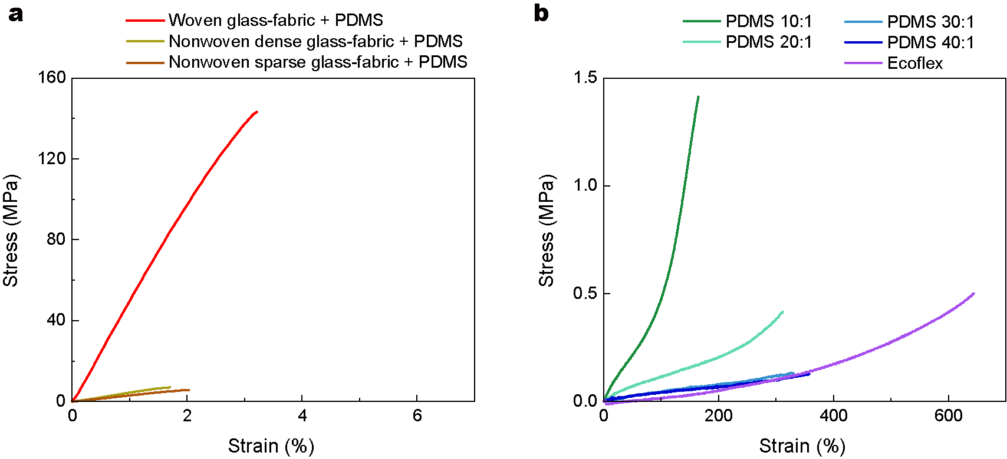
Supplementary Figure 3︱Tensile test results of materials. a, stress-strain curves of glass-fabric reinforced PDMS (GFRP) films with respect to type of the glass-fabrics. b, stress-strain curves of elastomers with a various mixing ratio and the elastomer types.

Table S2 | Summary of the mechanical properties of glass-fabric reinforced PDMS films and pristine elastomer films
Entry | Material | Modulus (MPa) | Elongation at break (%)
1 | Woven glass-fabric + PDMS (Woven GFRP) | 6200 | 3.2
2 | Nonwoven dense glass-fabric + PDMS | 475 | 1.7
3 | Nonwoven sparse glass-fabric + PDMS | 320 | 2.0
4 | PDMS 10:1 | 0.82 | 159
5 | PDMS 20:1 | 0.085 | 286
6 | PDMS 30:1 | 0.041 | 329
7 | PDMS 40:1 | 0.029 | 320
8 | Ecoflex | 0.027 | 645

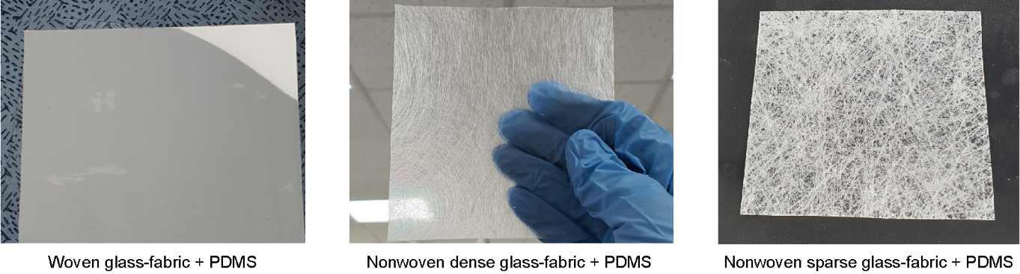
Supplementary Figure 4︱Glass-fabric reinforced PDMS films. a, Glass-fabric reinforced PDMS film with woven glass-fabric (left), nonwoven dense glass-fabric (center), and nonwoven sparse glass-fabric (right)
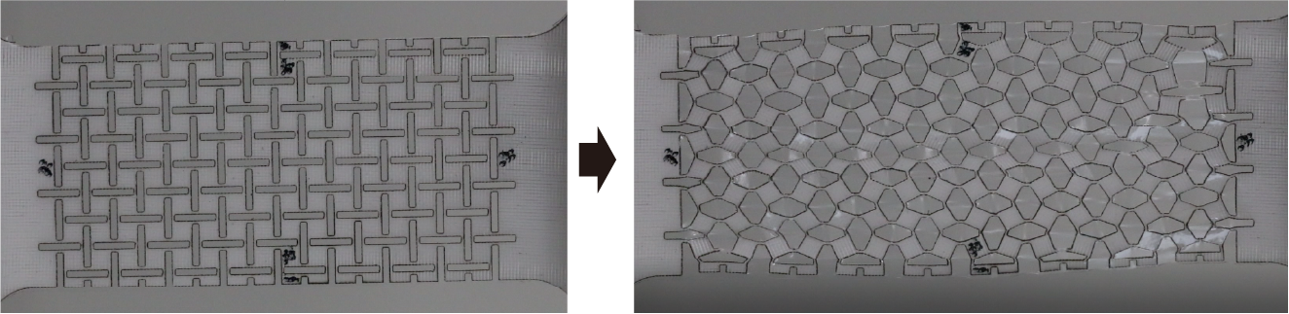
Supplementary Figure 5︱ Wrinkling behavior of thin S-AUX film at high strain region. Thin S-AUX film (4 ply) subjected to a uniaxial tension in horizontal direction: initial state (left), stretched state (right)

Table S3 | Summary of Poisson’s ratio of the S-AUX films according to the component materials
Entry | Rigid auxetic material | Soft elastic material | E_{rigid}/E_{soft} | PR_{min} | Auxetic elongation (%)
1 | Bare PDMS | Bare PDMS | 1 | 0.45 | N/A
2 | Nonwoven sparse GFRPDMS | PDMS 10:1 | 3.9 ⨯ 10² | 0.15 | N/A
3 | Nonwoven dense GFRPDMS | PDMS 10:1 | 5.8 ⨯ 10² | -0.12 | 5.6
4 | Woven GFRPDMS | PDMS 10:1 | 7.6 ⨯ 10³ | -0.47 | 9.9
5 | Woven GFRPDMS | PDMS 20:1 | 7.3 ⨯ 10⁴ | -0.80 | 16.6
6 | Woven GFRPDMS | PDMS 30:1 | 1.5 ⨯ 10⁵ | -0.88 | 14.9
7 | Woven GFRPDMS | PDMS 40:1 | 2.1 ⨯ 10⁵ | -0.90 | 11.3
8 | Woven GFRPDMS | Ecoflex | 2.3 ⨯ 10⁵ | -0.99 | 23.6
9 | Woven GFRPDMS | Unfilled | ∞ | -0.99 | 23.3

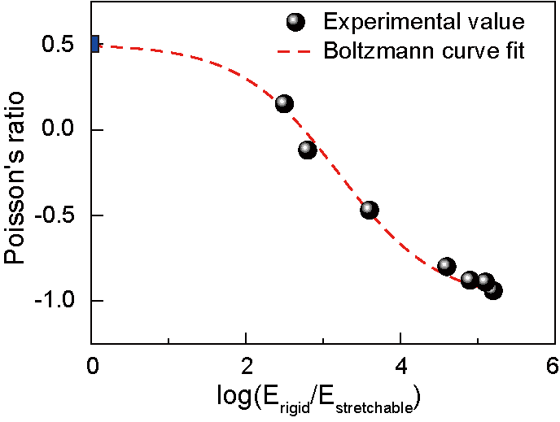
Supplementary Figure 6︱ Relative change in Poisson’s ratio plotted against the logarithm of the modulus difference.⁷⁻⁹ Minimum Poisson’s ratio of the S-AUX film with various modulus difference is graphically represented. x-axis uses the logarithmic scale of the ratio of the modulus of the rigid domain (E_{rigid}) to the modulus of the soft domain (E_{soft}).

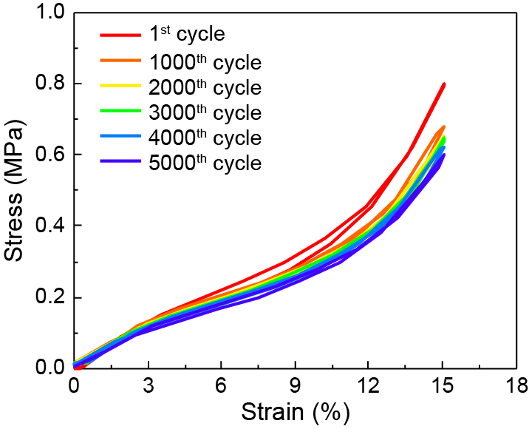
Supplementary Figure 7︱ Reliability of S-AUX film under cyclic stretching. Stress-strain curves of an S-AUX film under 20% uniaxial stretching for every 1,000 cycles until 5,000 times.

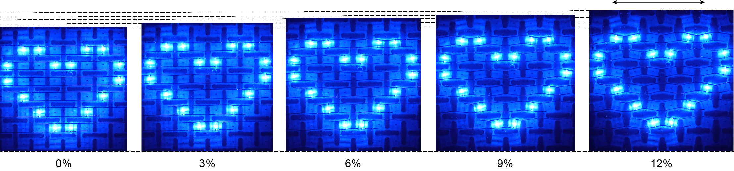 Supplementary Figure 8︱ Uniform expansion behavior of a S-AUX film-based stretchable display. Uniform expansion of a heart-shaped image during stretching from 0 to 12% (arrows indicate stretching directions).

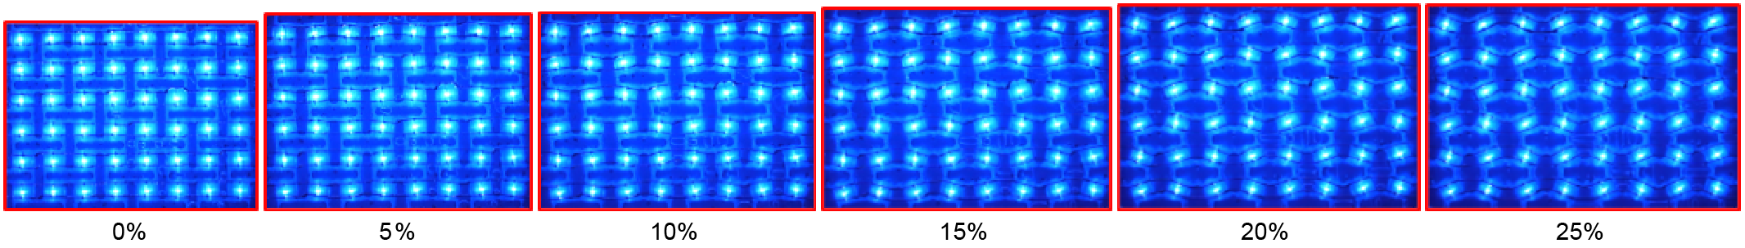
Supplementary Figure 9︱ Stretching of an S-AUX film-based micro-LED display during driving. Stretched configurations of an S-AUX film-based display under uniaxial tension in longitudinal direction from 0 to 25%.

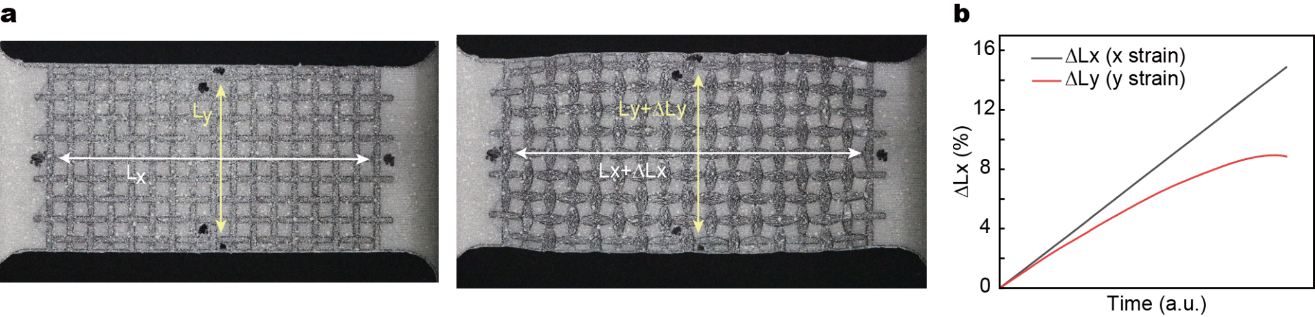
Supplementary Figure 10︱Poisson’s ratio measurement of the S-AUX films. a, speckle-patterned S-AUX film and the fiducial point marks for DIC analysis. b, DIC-measured x-axis and y-axis strain under uniaxial stretching.

Table S4. Comparison of specifications of the auxetic substrates.
Ref.  Year | Seamless  surface | Modulus  Ratio | Materials |  | Poisson’s  ratio | Application | Stretchability | Cyclic stretching  test  (count/strain)
Ref.  Year | Seamless  surface | Modulus  Ratio | Rigid area | Stretchable  area
2018¹⁰ | N | N/A | Hydrogel | N/A | -0.32 | Sensor | 30% | 500 / 30%
2019¹¹ | Y | 4.2×10² | TPU | Ecoflex 00-10 | -0.4 | Strain sensor | 50% | 5,000 / 30%
2019¹² | N | N/A | PET | N/A | N/A | Touch sensor | 13.7% | N/A
2021¹³ | N | N/A | PI | N/A | N/A | Wearable electronics | 30% | N/A
2021¹⁴ | N | N/A | PI | N/A | N/A | Optoelectronics | 30% | 15 / 30%
2021¹⁵ | Y | 30 | Silicone (E650) | Ecoflex 00-50 | -0.14 | Strain sensor | 40% | 100 / 40%
2022⁵ | N | N/A | PI | N/A | -1 | Display | 24.5% | N/A / 10.5%
2022¹⁶ | N | N/A | PI +  silicone (hinge) | N/A | N/A | Electronics | 25.9% | N/A
2022¹⁷ | Y | N/A | Glass fiber reinforced Ecoflex | Ecoflex 00-30 | -0.74 | Sensor | 10% | 1,000 / 15%
This work | Y | 2.6×10⁵ | Glass-fabric reinforced PDMS | Ecoflex/PDMS | -1 | Display | 25% | 5,000 / 20%

1 Kolken, H. M. A. & Zadpoor, A. A. Auxetic mechanical metamaterials. Rsc Adv 7, 5111-5129 (2017). https://doi.org/10.1039/c6ra27333e
2 Wu, W. W. et al. Mechanical design and multifunctional applications of chiral mechanical metamaterials: A review. Mater Design 180 (2019). https://doi.org/10.1016/j.matdes.2019.107950
3 Mizzi, L., Azzopardi, K. M., Attard, D., Grima, J. N. & Gatt, R. Auxetic metamaterials exhibiting giant negative Poisson's ratios. Phys Status Solidi-R 9, 425-430 (2015). https://doi.org/10.1002/pssr.201510178
4 Veerabagu, U., Palza, H. & Quero, F. Review: Auxetic Polymer-Based Mechanical Metamaterials for Biomedical Applications. Acs Biomater Sci Eng (2022). https://doi.org/10.1021/acsbiomaterials.2c00109
5 Jang, B. et al. Auxetic Meta-Display: Stretchable Display without Image Distortion. Adv Funct Mater 32, 2113299 (2022). https://doi.org/10.1002/adfm.202113299
6 Grima, J. N. & Evans, K. E. Auxetic behavior from rotating squares. J Mater Sci Lett 19, 1563-1565 (2000). https://doi.org/Doi 10.1023/A:1006781224002
7 Kochmann, D. M. & Venturini, G. N. Homogenized mechanical properties of auxetic composite materials in finite-strain elasticity. Smart Mater Struct 22 (2013). https://doi.org/10.1088/0964-1726/22/8/084004
8 Peng, X. L., Soyarslan, C. & Bargmann, S. Phase contrast mediated switch of auxetic mechanism in composites of infilled re-entrant honeycomb microstructures. Extreme Mech Lett 35 (2020). https://doi.org/10.1016/j.eml.2020.100641
9 Pozniak, A. A., Wojciechowski, K. W., Grima, J. N. & Mizzi, L. Planar auxeticity from elliptic inclusions. Compos Part B-Eng 94, 379-388 (2016). https://doi.org/10.1016/j.compositesb.2016.03.003
10 Kim, H. W. et al. Hygroscopic Auxetic On-Skin Sensors for Easy-to-Handle Repeated Daily Use. Acs Appl Mater Inter 10, 40141-40148 (2018). https://doi.org/10.1021/acsami.8b13857
11 Lee, Y. J. et al. Auxetic elastomers: Mechanically programmable meta-elastomers with an unusual Poisson's ratio overcome the gauge limit of a capacitive type strain sensor. Extreme Mech Lett 31 (2019). https://doi.org/10.1016/j.eml.2019.100516
12 Lee, Y. et al. Graphene-based stretchable/wearable self-powered touch sensor. Nano Energy 62, 259-267 (2019). https://doi.org/10.1016/j.nanoen.2019.05.039
13 Yeon, H. et al. Long-term reliable physical health monitoring by sweat pore-inspired perforated electronic skins. Sci Adv 7 (2021). https://doi.org/10.1126/sciadv.abg8459
14 Rao, Z. Y. et al. Curvy, shape-adaptive imagers based on printed optoelectronic pixels with a kirigami design. Nat Electron 4, 513-521 (2021). https://doi.org/10.1038/s41928-021-00600-1
15 Wang, Z. W. et al. High-Performance Auxetic Bilayer Conductive Mesh-Based Multi-Material Integrated Stretchable Strain Sensors. Acs Appl Mater Inter 13, 23038-23048 (2021). https://doi.org/10.1021/acsami.1c06295
16 Jiang, S. et al. A Snakeskin-Inspired, Soft-Hinge Kirigami Metamaterial for Self-Adaptive Conformal Electronic Armor. Adv Mater 34 (2022). https://doi.org/10.1002/adma.202204091
17 Kim, M. S. et al. Skin-like Omnidirectional Stretchable Platform with Negative Poisson's Ratio for Wearable Strain-Pressure Simultaneous Sensor. Adv Funct Mater 33 (2023). https://doi.org/10.1002/adfm.202208792

