Supplementary Information

Structure-Functional Activity of Pyrone Derivatives for Inhibition of Barnacle Settlement and Biofilm Formation

Mo Aqib Raza Khan,^{a,#} Bo-Wei Wang,^{b,c,d,#} Hsiu-Chin Lin,^{a,b} Yu-Liang Yang,^{c,d} Chih-Chuang Liaw^{a,b,e,f*}

ªDepartment of Marine Biotechnology and Resources, National Sun Yat-sen University, Kaohsiung 80424, Taiwan
^{b}Doctoral Degree Program in Marine Biotechnology, National Sun Yat-sen University, Kaohsiung 80424, Taiwan
^{c}Agricultural Biotechnology Research Center, Academia Sinica, Taipei 115, Taiwan
^{d}Biotechnology Center in Southern Taiwan, Academia Sinica, Tainan 711, Taiwan
^{e}Graduate Institute of Natural Products, Kaohsiung Medical University, Kaohsiung 807, Taiwan
^{f}Graduate Institute of Pharmacognosy, Taipei Medical University, Taipei 110, Taiwan
#These authors contributed equally on the work.

*Corresponding author. Phone: +886-7-5252000-5058. Fax: +886-7-525-5020.
E-mail: ccliaw@mail.nsysu.edu.tw (Prof. Chih-Chuang Liaw)

List of table and figures
Table S1. Settlement inhibition results of the pyrone-derivatives against Barnacle A. amphitrite 5
Table S2. Antibacterial activities of pyrones against Gram-positive S. cohnii, S. saprophyticus, and Gram-negative L. hongkongensis, P. angustum and A. macleodii 6
Table S3. Antibiofilm formation activities of pyrones against Gram-positive S. cohnii, S. saprophyticus, and Gram-negative L. hongkongensis, P. angustum and A. macleodii 7
Table S4. Settlement inhibition data results of active compounds 8
Table S5. Antibacterial activity results of active pyrone-derivatives against marine bacteria 10
Table S6. Antibiofilm formation activity of active pyrone-derivatives against marine bacteria 10

Figure 1. ¹H NMR spectrum of 6-propyl-2H-pyran-2-one (1) 18
Figure 2. ¹³C NMR spectrum of 6-propyl-2H-pyran-2-one (1) 18
Figure 3. HSQC spectrum of 6-propyl-2H-pyran-2-one (1) 19
Figure 4. MS spectrum of 6-propyl-2H-pyran-2-one (1) 19
Figure 5. ¹H NMR spectrum of 6-isobutyl-2H-pyran-2-one (2) 20
Figure 6. ¹³C NMR spectrum of 6-isobutyl-2H-pyran-2-one (2) 20
Figure 7. HSQC spectrum of 6-isobutyl-2H-pyran-2-one (2) 21
Figure 8. MS spectrum of 6-isobutyl-2H-pyran-2-one (2) 21
Figure 9. ¹H NMR spectrum of 6-(pentan-2-yl)-2H-pyran-2-one (3) 22
Figure 10. ¹³C NMR spectrum of 6-(pentan-2-yl)-2H-pyran-2-one (3) 22
Figure 11. HSQC spectrum of 6-(pentan-2-yl)-2H-pyran-2-one (3) 23
Figure 12. MS spectrum of 6-(pentan-2-yl)-2H-pyran-2-one (3) 23
Figure 13. ¹H NMR spectrum of 6-isopentyl-2H-pyran-2-one (4) 24
Figure 14. ¹³C NMR spectrum of 6-isopentyl-2H-pyran-2-one (4) 24
Figure 15. HSQC spectrum of 6-isopentyl-2H-pyran-2-one (4) 25
Figure 16. MS spectrum of 6-isopentyl-2H-pyran-2-one (4) 25
Figure 17. ¹H NMR spectrum of 6-octyl-2H-pyran-2-one (5) 26
Figure 18. ¹³C NMR spectrum of 6-octyl-2H-pyran-2-one (5) 26
Figure 19. HSQC spectrum of 6-octyl-2H-pyran-2-one (5) 27
Figure 20. MS spectrum of 6-octyl-2H-pyran-2-one (5) 27
Figure 21. ¹H NMR spectrum of 6-nonyl-2H-pyran-2-one (6) 28
Figure 22. ¹³C NMR spectrum of 6-nonyl-2H-pyran-2-one (6) 28
Figure 23. HSQC spectrum of 6-nonyl-2H-pyran-2-one (6) 29
Figure 24. MS spectrum of 6-nonyl-2H-pyran-2-one (6) 29
Figure 25. ¹H NMR spectrum of 6-(oct-7-yn-1-yl)-2H-pyran-2-one (7) 30
Figure 26. ¹³C NMR spectrum of 6-(oct-7-yn-1-yl)-2H-pyran-2-one (7) 30
Figure 27. HSQC spectrum of 6-(oct-7-yn-1-yl)-2H-pyran-2-one (7) 31
Figure 28. HMBC spectrum of 6-(oct-7-yn-1-yl)-2H-pyran-2-one (7) 31
Figure 29. MS spectrum of 6-(oct-7-yn-1-yl)-2H-pyran-2-one (7) 32
Figure 30. ¹H NMR spectrum of 6-(chloromethyl)-2H-pyran-2-one (8) 32
Figure 31. ¹³C NMR spectrum of 6-(chloromethyl)-2H-pyran-2-one (8) 33
Figure 32. HSQC spectrum of 6-(chloromethyl)-2H-pyran-2-one (8) 33
Figure 33. HSQC spectrum of 6-(chloromethyl)-2H-pyran-2-one (8) 34
Figure 34. MS spectrum of 6-(chloromethyl)-2H-pyran-2-one (8) 34
Figure 35. ¹H NMR spectrum of 6-(4-chlorobutyl)-2H-pyran-2-one (9) 35
Figure 36. ¹³C NMR spectrum of 6-(4-chlorobutyl)-2H-pyran-2-one (9) 35
Figure 37. MS spectrum of 6-(4-chlorobutyl)-2H-pyran-2-one (9) 36
Figure 38. ¹H NMR spectrum of 6-pentyl-4-phenyl-2H-pyran-2-one (10) 36
Figure 39. ¹³C NMR spectrum of 6-pentyl-4-phenyl-2H-pyran-2-one (10) 37
Figure 40. HSQC spectrum of 6-heptyl-2H-pyran-2-one (10) 37
Figure 41. MS spectrum of 6-heptyl-2H-pyran-2-one (10) 38
Figure 42. ¹H NMR spectrum of 4-(4-bromophenyl)-6-pentyl-2H-pyran-2-one (11) 38
Figure 43. ¹³C NMR spectrum of 4-(4-bromophenyl)-6-pentyl-2H-pyran-2-one (11) 39
Figure 44. MS spectrum of 4-(4-bromophenyl)-6-pentyl-2H-pyran-2-one (11) 39
Figure 45. ¹H NMR spectrum of 4-(naphthalen-2-yl)-6-pentyl-2H-pyran-2-one (12) 40
Figure 46. ¹³C NMR spectrum of 4-(naphthalen-2-yl)-6-pentyl-2H-pyran-2-one (12) 40
Figure 47. HSQC spectrum of 4-(naphthalen-2-yl)-6-pentyl-2H-pyran-2-one (12) 41
Figure 48. MS spectrum of 4-(naphthalen-2-yl)-6-pentyl-2H-pyran-2-one (12) 41
Figure 49. ¹H NMR spectrum of 4-(furan-2-yl)-6-pentyl-2H-pyran-2-one (13) 42
Figure 50. ¹³C NMR spectrum of 4-(furan-2-yl)-6-pentyl-2H-pyran-2-one (13) 42
Figure 51. HSQC spectrum of 4-(furan-2-yl)-6-pentyl-2H-pyran-2-one (13) 43
Figure 52. MS spectrum of 4-(furan-2-yl)-6-pentyl-2H-pyran-2-one (13) 43
Figure 53. ¹H NMR spectrum of 4-(4-bromophenyl)-6-heptyl-2H-pyran-2-one (14) 44
Figure 54. ¹³C NMR spectrum of 4-(4-bromophenyl)-6-heptyl-2H-pyran-2-one (14) 44
Figure 55. HSQC spectrum of 4-(4-bromophenyl)-6-heptyl-2H-pyran-2-one (14) 45
Figure 56. HMBC spectrum of 4-(4-bromophenyl)-6-heptyl-2H-pyran-2-one (14) 45
Figure 57. MS spectrum of 4-(4-bromophenyl)-6-heptyl-2H-pyran-2-one (14) 46
Figure 58. ¹H NMR spectrum of 6-heptyl-4-(prop-1-en-2-yl)-2H-pyran-2-one (15) 46
Figure 59. ¹³C NMR spectrum of 6-heptyl-4-(prop-1-en-2-yl)-2H-pyran-2-one (15) 47
Figure 60. HSQC spectrum of 6-heptyl-4-(prop-1-en-2-yl)-2H-pyran-2-one (15) 47
Figure 61. HMBC spectrum of 6-heptyl-4-(prop-1-en-2-yl)-2H-pyran-2-one (15) 48
Figure 62. MS spectrum of 6-heptyl-4-(prop-1-en-2-yl)-2H-pyran-2-one (15) 48
Figure 63. ¹H NMR spectrum of 6-(2-bromoethyl)-4-(4-bromophenyl)-2H-pyran-2-one (16) 49
Figure 64. ¹³C NMR spectrum of 6-(2-bromoethyl)-4-(4-bromophenyl)-2H-pyran-2-one (16) 49
Figure 65. HSQC spectrum of 6-(2-bromoethyl)-4-(4-bromophenyl)-2H-pyran-2-one (16) 50
Figure 66. MS spectrum of 6-(2-bromoethyl)-4-(4-bromophenyl)-2H-pyran-2-one (16) 50
Figure 67. ¹H NMR spectrum of 6-(2-bromoethyl)-4-methyl-2H-pyran-2-one (17) 51
Figure 68. ¹³C NMR spectrum of 6-(2-bromoethyl)-4-methyl-2H-pyran-2-one (17) 51
Figure 69. HSQC spectrum of 6-(2-bromoethyl)-4-methyl-2H-pyran-2-one (17) 52
Figure 70. HMBC spectrum of 6-(2-bromoethyl)-4-methyl-2H-pyran-2-one (17) 52
Figure 71. HMBC NMR spectrum of 6-(2-bromoethyl)-4-methyl-2H-pyran-2-one (17) 53
Figure 72. ¹H NMR spectrum of 6-(4-chlorobutyl)-2H-pyran-2-one (18) 53
Figure 73. ¹³C NMR spectrum of 6-(4-chlorobutyl)-2H-pyran-2-one (18) 54
Figure 74. HSQC spectrum of 6-(4-chlorobutyl)-2H-pyran-2-one (18) 54
Figure 75. MS spectrum of 6-(4-chlorobutyl)-2H-pyran-2-one (18) 55
Figure 76. ¹H NMR spectrum of 6-(cyclohexylmethyl)-4-phenyl-2H-pyran-2-one (19) 55
Figure 77. ¹³C NMR spectrum of 6-(cyclohexylmethyl)-4-phenyl-2H-pyran-2-one (19) 56
Figure 78. HSQC spectrum of 6-(cyclohexylmethyl)-4-phenyl-2H-pyran-2-one (19) 56
Figure 79. MS spectrum of 6-(cyclohexylmethyl)-4-phenyl-2H-pyran-2-one (19) 57
Figure 80. ¹H NMR spectrum of 4-methyl-6-phenyl-2H-pyran-2-one (20) 57
Figure 81. ¹³C NMR spectrum of 4-methyl-6-phenyl-2H-pyran-2-one (20) 58
Figure 82. HSQC spectrum of 4-methyl-6-phenyl-2H-pyran-2-one (20) 58
Figure 83. MS spectrum of 4-methyl-6-phenyl-2H-pyran-2-one (20) 59
Figure 84. ¹H NMR spectrum of 6-(cyclopentylmethyl)-4-(naphthalen-2-yl)-2H-pyran-2-one (21) 59
Figure 85. ¹³C NMR spectrum of 6-(cyclopentylmethyl)-4-(naphthalen-2-yl)-2H-pyran-2-one (21) 60
Figure 86. HSQC spectrum of 6-(cyclopentylmethyl)-4-(naphthalen-2-yl)-2H-pyran-2-one (21) 60
Figure 87. MS spectrum of 6-(cyclopentylmethyl)-4-(naphthalen-2-yl)-2H-pyran-2-one (21) 61
Figure 88. ¹H NMR spectrum of 6-benzyl-4-(prop-1-en-2-yl)-2H-pyran-2-one (22) 61
Figure 89. ¹³C NMR spectrum of 6-benzyl-4-(prop-1-en-2-yl)-2H-pyran-2-one (22) 62
Figure 90. HSQC NMR spectrum of 6-benzyl-4-(prop-1-en-2-yl)-2H-pyran-2-one (22) 62
Figure 91. MS spectrum of 6-benzyl-4-(prop-1-en-2-yl)-2H-pyran-2-one (22) 63
Figure 92. ¹H NMR spectrum of 6-(cyclopentylmethyl)-4-(furan-2-yl)-2H-pyran-2-one (23) 63
Figure 93. ¹³C NMR spectrum of 6-(cyclopentylmethyl)-4-(furan-2-yl)-2H-pyran-2-one (23) 64
Figure 94. HSQC spectrum of 6-(cyclopentylmethyl)-4-(furan-2-yl)-2H-pyran-2-one (23) 64
Figure 95. MS spectrum of 6-(cyclopentylmethyl)-4-(furan-2-yl)-2H-pyran-2-one (23) 65
Figure 96. ¹H NMR spectrum of 6-(cyclohexylmethyl)-4-(furan-2-yl)-2H-pyran-2-one (24) 65
Figure 97. ¹³C NMR spectrum of 6-(cyclohexylmethyl)-4-(furan-2-yl)-2H-pyran-2-one (24) 66
Figure 98. HSQC spectrum of 6-(cyclohexylmethyl)-4-(furan-2-yl)-2H-pyran-2-one (24) 66
Figure 99. MS spectrum of 6-(cyclohexylmethyl)-4-(furan-2-yl)-2H-pyran-2-one (24) 67
Figure 100. ¹H NMR spectrum of 6-benzyl-4-(furan-2-yl)-2H-pyran-2-one (25) 67
Figure 101. ¹³C NMR spectrum of 6-benzyl-4-(furan-2-yl)-2H-pyran-2-one (25) 68
Figure 102. HSQC spectrum of 6-benzyl-4-(furan-2-yl)-2H-pyran-2-one (25) 68
Figure 103. HMBC spectrum of 6-benzyl-4-(furan-2-yl)-2H-pyran-2-one (25) 69
Figure 104. MS spectrum of 6-benzyl-4-(furan-2-yl)-2H-pyran-2-one (25) 69

Table S1. Settlement inhibition results of the pyrone-derivatives against Barnacle A. amphitrite
Compounds | EC₅₀ (µg/mL) | Compound | EC₅₀ (µg/mL)
1 | 5.90 | 14 | 6.74
2 | 6.54 | 15 | 5.31
3 | 8.01 | 16 | 4.84
4 | 5.91 | 17 | 5.44
5 | 6.88 | 18 | 9.25
6 | 7.60 | 19 | 6.94
7 | 5.15 | 20 | 4.29
8 | 5.31 | 21 | 8.29
9 | 7.64 | 22 | 6.00
10 | 4.30 | 23 | 3.94
11 | 3.59 | 24 | 4.86
12 | 4.36 | 25 | 3.36
13 | 3.29
Note: Inhibitory effects of Pyrone-derivatives on cyprid settlement in A. amphitrite after a 48-h period.

Table S2. Antibacterial activities of pyrones against Gram-positive S. cohnii, S. saprophyticus, and Gram-negative L. hongkongensis, P. angustum and A. macleodii
Compounds | Antibacterial activity
Compounds | S. cohnii | S. saprophyticus |  | L. hongkongensis | P. angustum | A. macleodii
1 | ++ |  | - | ++ | - | -
2 | - |  | - | ++ | - | -
3 | + |  | - | ++ | - | -
4 | - |  | - | ++ | - | -
5 | + |  | - | + | - | -
6 | + |  | - | + | - | -
7 | +++ |  | ++ | ++ | +++ | -
8 | ++ |  | +++ | +++ | +++ | ++
9 | +++ |  | ++ | +++ | +++ | +
10 | + |  | - | +++ | - | -
11 | ++ |  | - | +++ | - | -
12 | ++ |  | - | +++ | - | -
13 | ++ |  | - | +++ | +++ | -
14 | ++ |  | - | ++ | - | -
15 | + |  | - | ++ | - | -
16 | + |  | - | +++ | - | -
17 | - |  | - | +++ | - | -
18 | - |  | - | + | - | -
19 | +++ |  | - | +++ | - | -
20 | +++ |  | - | +++ | - | -
21 | ++ |  | - | ++ | - | -
22 | ++ |  | - | +++ | - | -
23 | ++ |  | ++ | +++ | +++ | -
24 | ++ |  | ++ | +++ | +++ | -
25 | ++ |  | - | +++ | +++ | -
Note: + indicates 10%-20%, ++ indicates 20%-40%, and +++ indicates 50%-80% of bacterial growth inhibition at 25 µg/mL. - indicates no activity Copper pyrithione was used as the positive control and can inhibit bacterial growth at 0.4 µg/mL

Table S3. Antibiofilm formation activities of pyrones against Gram-positive S. cohnii, S. saprophyticus, and Gram-negative L. hongkongensis, P. angustum and A. macleodii
Compounds | Antibiofilm formation activity
Compounds | S. cohnii | L. hongkongensis | S. saprophyticus | P. angustum | A. macleodii
1 | - | - | - | - | -
2 | - | - | - | - | -
3 | - | - | - | - | -
4 | - | - | - | - | -
5 | - | - | - | - | -
6 | - | - | - | - | -
7 | + | +++ | - | - | -
8 | ++ | +++ | - | - | -
9 | +++ | +++ | - | - | -
10 | + | +++ | - | - | -
11 | +++ | +++ | - | - | -
12 | +++ | +++ | - | - | -
13 | +++ | +++ | - | - | -
14 | - | + | - | - | -
15 | + | + | - | - | -
16 | ++ | +++ | - | - | -
17 | - | +++ | - | - | -
18 | - | - | - | - | -
19 | ++ | ++ | - | - | -
20 | +++ | +++ | - | - | -
21 | ++ | + | - | - | -
22 | +++ | +++ | - | - | -
23 | +++ | +++ | - | - | -
24 | +++ | +++ | - | - | -
25 | +++ | +++ | - | - | -
Note: + indicates 10%-20%, ++ indicates 20%-40%, and +++ indicates 50%-80% of biofilm growth inhibition at 6.125 µg/mL. - indicates no activity

Table S4. Settlement inhibition data results of active compounds
Sea Water | Conc. (ppm) | Number (48hr) | Swim | Still | Searching | * | Settlement | Death | Attachment (%) | Death  (%)
Control | 0 | 14 |  |  |  |  | 14 |  | 100 | 0
Control | 0 | 14 |  |  |  |  | 14 |  | 100 | 0
Control | 0 | 14 |  |  |  |  | 14 |  | 100 | 0
Compound | Conc. (ppm) | Number (48hr) | Swim | Still | Searching | * | Settlement | Death | Attachment  (%) | Death  (%)
10 | 3 | 11 |  |  | 2 |  | 7 | 2 | 63.63636364 | 18
10 | 3 | 14 |  |  | 3 | 1 | 8 | 1 | 57.14285714 | 7
10 | 3 | 12 |  |  | 2 |  | 9 | 1 | 75 | 8
10 | 5 | 11 |  | 4 | 4 |  | 2 | 1 | 18.18181818 | 9.09090909
10 | 5 | 13 | 3 | 2 | 4 |  | 2 | 2 | 15.38461538 | 15.3846154
10 | 5 | 13 | 4 | 3 | 2 |  | 3 | 1 | 23.07692308 | 7.69230769
10 | 10 | 12 | 2 | 4 | 3 |  | 1 | 2 | 8.333333333 | 17
10 | 10 | 13 | 4 | 5 | 2 |  | 1 | 1 | 7.692307692 | 8
10 | 10 | 11 | 2 | 4 | 1 |  | 2 | 2 | 18.18181818 | 18
10 | 20 | 13 |  | 2 |  | 1 |  | 10 | 0 | 77
10 | 20 | 15 |  |  |  | 1 | 1 | 11 | 6.666666667 | 73
10 | 20 | 13 |  | 1 |  |  | 1 | 11 | 7.692307692 | 85
Compound | Conc. (ppm) | Number (48hr) | Swim | Still | Searching | * | Settlement | Death | Attachment  (%) | Death  (%)
11 | 3 | 11 |  | 2 | 2 |  | 7 |  | 63.63636364 | 0
11 | 3 | 13 | 1 | 1 | 3 |  | 8 |  | 61.53846154 | 0
11 | 3 | 14 |  | 2 | 2 |  | 9 | 1 | 64.28571429 | 7
11 | 5 | 11 | 8 | 2 |  |  | 1 | 0 | 9.090909091 | 0
11 | 5 | 13 | 3 | 6 | 1 |  | 2 | 1 | 15.38461538 | 8
11 | 5 | 13 | 6 | 3 |  |  | 3 | 2 | 23.07692308 | 15
11 | 10 | 12 | 4 | 4 |  |  | 0 | 2 | 0 | 17
11 | 10 | 15 | 5 | 3 |  |  | 2 | 2 | 13.33333333 | 13
11 | 10 | 16 | 4 | 5 |  |  | 1 | 3 | 6.25 | 19
11 | 20 | 15 |  | 1 |  |  |  | 14 | 0 | 93.3333333
11 | 20 | 14 |  | 2 |  |  |  | 12 | 0 | 80
11 | 20 | 14 |  | 1 |  |  |  | 13 | 0 | 86.6666667
Compound | Conc. (ppm) | Number (48hr) | Swim | Still | Searching | * | Settlement | Death | Attachment  (%) | Death  (%)
12 | 3 | 13 |  | 1 | 2 |  | 9 | 0 | 69.23076923 | 0
12 | 3 | 13 |  | 1 | 1 |  | 10 | 1 | 76.92307692 | 8
12 | 3 | 15 | 1 |  | 3 |  | 10 | 1 | 66.66666667 | 7
12 | 5 | 14 | 3 | 6 | 1 |  | 2 | 2 | 14.28571429 | 14
12 | 5 | 12 | 4 | 6 |  |  | 2 |  | 16.66666667 | 0
12 | 5 | 12 | 5 | 5 |  |  | 1 |  | 8.333333333 | 0
12 | 10 | 12 | 3 | 5 |  |  | 2 | 2 | 16.66666667 | 17
12 | 10 | 14 | 3 | 5 |  |  | 3 | 2 | 21.42857143 | 14
12 | 10 | 13 | 4 | 5 |  |  | 3 | 2 | 23.07692308 | 15
12 | 20 | 17 |  |  |  |  |  | 17 | 0 | 100
12 | 20 | 14 |  |  |  |  |  | 14 | 0 | 100
12 | 20 | 13 |  |  |  |  |  | 13 | 0 | 100
Compound | Conc. (ppm) | Number (48hr) | Swim | Still | Searching | * | Settlement | Death | Attachment  (%) | Death  (%)
13 | 3 | 14 | 1 |  | 4 |  | 7 | 2 | 50 | 14
13 | 3 | 13 | 2 |  | 2 |  | 7 | 2 | 53.84615385 | 15
13 | 3 | 12 | 2 |  | 2 |  | 6 | 2 | 50 | 17
13 | 5 | 11 | 4 | 4 | 3 |  |  |  | 0 | 0
13 | 5 | 13 | 3 | 4 | 3 |  | 2 | 1 | 15.38461538 | 8
13 | 5 | 10 | 2 | 4 | 0 |  | 1 | 1 | 10 | 10
13 | 10 | 14 | 3 | 5 | 2 |  | 1 | 3 | 7.142857143 | 21
13 | 10 | 16 | 4 | 6 | 3 |  | 1 | 2 | 6.25 | 13
13 | 10 | 14 | 3 | 5 | 3 |  | 1 | 2 | 7.142857143 | 14
13 | 20 | 17 |  | 4 | 2 | 1 | 1 | 6 | 5.882352941 | 35
13 | 20 | 16 |  | 7 | 3 |  | 0 | 5 | 0 | 31
13 | 20 | 14 |  | 4 | 4 |  | 1 | 5 | 7.142857143 | 36
Compound | Conc. (ppm) | Number (48hr) | Swim | Still | Searching | * | Settlement | Death | Attachment  (%) | Death  (%)
16 | 3 | 10 |  | 1 |  |  | 8 | 1 | 80 | 10
16 | 3 | 14 |  |  | 1 |  | 9 | 2 | 64.28571429 | 14
16 | 3 | 13 |  |  | 2 |  | 8 | 2 | 61.53846154 | 15
16 | 5 | 18 | 3 | 6 | 5 | 1 | 3 | 1 | 16.66666667 | 5.55555556
16 | 5 | 12 | 2 | 4 | 3 | 0 | 3 | 0 | 25 | 0
16 | 5 | 15 |  | 5 | 5 | 2 | 3 | 0 | 20 | 0
16 | 10 | 12 | 2 | 3 | 2 |  | 2 | 3 | 16.66666667 | 25
16 | 10 | 13 | 4 | 2 | 2 |  | 1 | 4 | 7.692307692 | 30.7692308
16 | 10 | 11 | 1 | 3 | 2 |  | 2 | 3 | 18.18181818 | 27.2727273
16 | 20 | 12 |  | 1 | 1 |  | 0 | 9 | 0 | 75
16 | 20 | 14 |  | 2 | 1 |  | 0 | 11 | 0 | 78.5714286
16 | 20 | 12 |  | 3 | 1 |  | 0 | 8 | 0 | 66.6666667
Compound | Conc. (ppm) | Number (48hr) | Swim | Still | Searching | * | Settlement | Death | Attachment  (%) | Death  (%)
20 | 3 | 15 |  |  | 1 |  | 12 | 2 | 80 | 13
20 | 3 | 14 |  | 2 | 2 |  | 9 | 1 | 64.28571429 | 7
20 | 3 | 15 |  | 2 | 2 |  | 9 | 2 | 60 | 13
20 | 5 | 13 | 2 | 0 | 2 |  | 5 | 3 | 38.46153846 | 23
20 | 5 | 11 | 0 | 2 | 2 |  | 3 | 4 | 27.27272727 | 36
20 | 5 | 14 | 2 | 3 | 2 |  | 4 | 3 | 28.57142857 | 21
20 | 10 | 14 |  |  | 2 |  | 3 | 9 | 21.42857143 | 64
20 | 10 | 14 |  | 1 | 2 |  | 2 | 9 | 14.28571429 | 64
20 | 10 | 13 |  | 2 |  |  | 3 | 8 | 23.07692308 | 62
20 | 20 | 13 |  |  | 2 |  |  | 11 | 0 | 84.6153846
20 | 20 | 12 |  |  | 1 |  |  | 10 | 0 | 83.3333333
20 | 20 | 11 |  |  |  |  |  | 9 | 0 | 81.8181818
Compound | Conc. (ppm) | Number (48hr) | Swim | Still | Searching | * | Settlement | Death | Attachment  (%) | Death  (%)
23 | 3 | 17 | 3 | 0 | 3 |  | 11 | 0 | 64.70588235 | 0
23 | 3 | 16 | 3 | 0 | 3 |  | 10 | 0 | 62.5 | 0
23 | 3 | 17 | 2 |  | 4 |  | 10 | 1 | 58.82352941 | 5.88235294
23 | 5 | 10 | 0 | 2 | 3 |  | 1 | 4 | 10 | 40
23 | 5 | 11 | 1 | 1 | 4 |  | 2 | 3 | 18.18181818 | 27.2727273
23 | 5 | 14 | 2 | 2 | 5 |  | 2 | 3 | 14.28571429 | 21.4285714
23 | 10 | 14 | 0 | 4 | 1 |  | 3 | 6 | 21.42857143 | 42.8571429
23 | 10 | 13 | 0 | 4 | 2 |  | 2 | 5 | 15.38461538 | 38.4615385
23 | 10 | 11 | 0 | 3 | 1 |  | 1 | 6 | 9.090909091 | 54.5454545
23 | 20 | 12 |  | 0 |  |  |  | 12 | 0 | 100
23 | 20 | 11 |  | 1 |  |  |  | 10 | 0 | 90.9090909
23 | 20 | 14 |  | 2 |  |  |  | 12 | 0 | 85.7142857
Compound | Conc. (ppm) | Number (48hr) | Swim | Still | Searching | * | Settlement | Death | Attachment  (%) | Death  (%)
24 | 3 | 14 |  |  | 2 |  | 11 | 1 | 78.57142857 | 7.14285714
24 | 3 | 13 |  |  | 2 |  | 11 | 0 | 84.61538462 | 0
24 | 3 | 17 |  |  | 2 |  | 15 | 1 | 88.23529412 | 5.88235294
24 | 5 | 14 |  | 3 | 2 |  | 3 | 6 | 21.42857143 | 42.8571429
24 | 5 | 14 |  | 3 | 3 |  | 4 | 4 | 28.57142857 | 28.5714286
24 | 5 | 12 |  | 2 | 2 |  | 4 | 4 | 33.33333333 | 33.3333333
24 | 10 | 16 | 1 | 3 | 3 |  | 3 | 6 | 18.75 | 37.5
24 | 10 | 14 |  | 3 | 2 |  | 2 | 7 | 14.28571429 | 50
24 | 10 | 12 |  | 1 | 3 |  | 2 | 6 | 16.66666667 | 50
24 | 20 | 10 |  |  |  | 2 |  | 8 | 0 | 80
24 | 20 | 11 |  |  |  | 1 |  | 10 | 0 | 90.9090909
24 | 20 | 11 |  |  |  | 1 |  | 10 | 0 | 90.9090909
Compound | Conc. (ppm) | Number (48hr) | Swim | Still | Searching | * | Settlement | Death | Attachment  (%) | Death  (%)
25 | 3 | 15 | 3 | 2 | 3 |  | 7 | 1 | 46.66666667 | 6.66666667
25 | 3 | 12 | 3 | 1 | 2 |  | 6 |  | 50 | 0
25 | 3 | 13 | 2 |  | 3 |  | 7 | 1 | 53.84615385 | 7.69230769
25 | 5 | 12 | 0 | 2 | 6 | 2 | 0 | 2 | 0 | 16.6666667
25 | 5 | 10 | 0 | 1 | 4 | 2 | 2 | 1 | 20 | 10
25 | 5 | 11 | 2 | 2 | 3 | 2 | 1 | 1 | 9.090909091 | 9.09090909
25 | 10 | 13 | 2 | 2 | 3 |  | 2 | 4 | 15.38461538 | 30.7692308
25 | 10 | 11 | 1 | 4 | 1 |  | 1 | 4 | 9.090909091 | 36.3636364
25 | 10 | 12 | 1 | 1 | 2 |  | 2 | 5 | 16.66666667 | 41.6666667
25 | 20 | 13 |  | 2 | 1 |  | 0 | 10 | 0 | 76.9230769
25 | 20 | 13 |  | 2 | 1 |  | 0 | 12 | 0 | 92.3076923
25 | 20 | 13 |  | 3 | 1 |  | 0 | 12 | 0 | 92.3076923

Table S5. Antibacterial activity results of active pyrone-derivatives against marine bacteria
Antibacterial activity results against S. cohnii
S. cohnii | Untreated | 7 | 9 | 19 | 20
Average value at  25 µg/mL | 100 | 50 | 42 | 50 | 43
Average value at  12.5 µg/mL | 100 | 60 | 63 | 67 | 64
Average value at  6.125 µg/mL | 100 | 100 | 100 | 97 | 95
Antibacterial activity results against L. hongkongensis
L. hongkongensis | Untreated | 7 | 8 | 9 | 10 | 11 | 12 | 13 | 16 | 17 | 19 | 20 | 22 | 23 | 24 | 25
Average value at  25 µg/mL | 100 | 37 | 40 | 49 | 26 | 44 | 50 | 38 | 38 | 33 | 37 | 33 | 32 | 41 | 33 | 39
Average value at  12.5 µg/mL | 100 | 90 | 48 | 56 | 58 | 56 | 58 | 45 | 69 | 80 | 75 | 61 | 55 | 60 | 47 | 42
Average value at  6.125 µg/mL | 100 | 100 | 91 | 100 | 100 | 100 | 87 | 85 | 90 | 97 | 100 | 87 | 89 | 100 | 91 | 89
Antibacterial activity results against P. angustum
P. angustum | Untreated | 7 | 8 | 9 | 13 | 23 | 24 | 25
Average value at  25 µg/mL | 100 | 37 | 39 | 49 | 27 | 45 | 41 | 37
Average value at  12.5 µg/mL | 100 | 87 | 47 | 61 | 66 | 62 | 50 | 42
Average value at  6.125 µg/mL | 100 | 100 | 100 | 100 | 100 | 100 | 87 | 85

Table S6. Antibiofilm formation activity of active pyrone-derivatives against marine bacteria
Antibiofilm formation activity results against S. cohnii
S. cohnii | Untreated | 9 | 11 | 12 | 13 | 20 | 22 | 23 | 24
Average value at  6.125 µg/mL | 100 | 25 | 21 | 23 | 16 | 17 | 17 | 17 | 13
Antibiofilm formation activity results against L. hongkongensis
L. hongkongensis | Untreated | 7 | 8 | 9 | 11 | 12 | 13 | 16 | 17 | 20 | 22 | 23 | 24 | 25
Average value at  6.125 µg/mL | 100 | 27 | 34 | 41 | 33 | 23 | 28 | 23 | 23 | 28 | 22 | 19 | 14 | 27

Syntheses of pyrone derivatives
6-propyl-2H-pyran-2-one (1)
Propiolic acid (50.7 mg, 0.72 mmole, 1.0 equivalent), 1-Pentyne (147.9mg, 2.17 mmole, 3.0 equivalent), and [(Ph₃P)AuCl] (17.9 mg, 0.03 mmole, 0.05 equivalent) were dissolved in 1.0 mL anhydrous CH₂Cl₂. AgOTF (9.3 mg, 0.03 mmole, 0.05 equivalent) was added to the solution as a mixture. The reaction mixture was stirred at 400 rpm under air at room temperature for 12 hours. The residue was purified by flash chromatography on a silica gel column (Hexane/Ethyl acetate = 7/1) to give 28.7 mg calculated product 1 in 28.7% yield.

6-isobutyl-2H-pyran-2-one (2)
Propiolic acid (46.0 mg, 0.66 mmole, 1.0 equivalent), 4-Methyl-1-pentyne (161.9 mg, 1.97 mmole, 3.0 equivalent), and [(Ph₃P)AuCl] (16.3 mg, 0.03 mmole, 0.05 equivalent) were dissolved in 1.0 mL anhydrous CH₂Cl₂. AgOTF (8.4 mg, 0.03 mmole, 0.05 equivalent) was added to the solution as a mixture. The reaction mixture was stirred at 400 rpm under air at room temperature for 12 hours. The residue was purified by flash chromatography on a silica gel column (Hexane/Ethyl acetate = 7/1) to give 50.1 mg calculated product 3 in 50.1% yield.

6-(pentan-2-yl)-2H-pyran-2-one (3)
Propiolic acid (42.1 mg, 0.60 mmole, 1.0 equivalent), 3-Methyl-1-hexyne (173.6 mg, 1.81 mmole, 3.0 equivalent), and [(Ph₃P)AuCl] (14.9 mg, 0.03 mmole, 0.05 equivalent) were dissolved in 1.0 mL anhydrous CH₂Cl₂. AgOTF (7.7 mg, 0.03 mmole, 0.05 equivalent) was added to the solution as a mixture. The reaction mixture was stirred at 400 rpm under air at room temperature for 12 hours. The residue was purified by flash chromatography on a silica gel column (Hexane/Ethyl acetate = 9/1) to give 35.4 mg calculated product 5 in 35.4% yield.

6-isopentyl-2H-pyran-2-one (4)
Propiolic acid (42.1 mg, 0.60 mmole, 1.0 equivalent), 5-Methyl-1-hexyne (173.6 mg, 1.81 mmole, 3.0 equivalent), and [(Ph₃P)AuCl] (14.9 mg, 0.03 mmole, 0.05 equivalent) were dissolved in 1.0 mL anhydrous CH₂Cl₂. AgOTF (7.7 mg, 0.03 mmole, 0.05 equivalent) was added to the solution as a mixture. The reaction mixture was stirred at 400 rpm under air at room temperature for 12 hours. The residue was purified by flash chromatography on a silica gel column (Hexane/Ethyl acetate = 9/1) to give 53.1 mg calculated product 4 in 53.1% yield.

6-octyl-2H-pyran-2-one (5)
Propiolic acid (33.6 mg, 0.48 mmole, 1.0 equivalent), 1-Decyne (199.1 mg, 1.81 mmole, 3.0 equivalent), and [(Ph₃P)AuCl] (11.9 mg, 0.02 mmole, 0.05 equivalent) were dissolved in 1.0 mL anhydrous CH₂Cl₂. AgOTF (6.2 mg, 0.02 mmole, 0.05 equivalent) was added to the solution as a mixture. The reaction mixture was stirred at 400 rpm under air at room temperature for 12 hours. The residue was purified by flash chromatography on a silica gel column (Hexane/Ethyl acetate = 9/1) to give 76.5 mg calculated product 5 in 76.5% yield.

6-nonyl-2H-pyran-2-one (6)
Propiolic acid (31.5 mg, 0.45 mmole, 1.0 equivalent), 1-Undecyne (205.5 mg, 1.35 mmole, 3.0 equivalent), and [(Ph₃P)AuCl] (11.1 mg, 0.02 mmole, 0.05 equivalent) were dissolved in 1.0 mL anhydrous CH₂Cl₂. AgOTF (5.8 mg, 0.02 mmole, 0.05 equivalent) was added to the solution as a mixture. The reaction mixture was stirred at 400 rpm under air at room temperature for 12 hours. The residue was purified by flash chromatography on a silica gel column (Hexane/Ethyl acetate = 9/1) to give 60.8 mg calculated product 11 in 60.8% yield.

6-(oct-7-yn-1-yl)-2H-pyran-2-one (7)
Propiolic acid (34.3 mg, 0.49 mmole, 1.0 equivalent), 1,9-Decadiyne (197.1 mg, 1.47 mmole, 3.0 equivalent), and [(Ph₃P)AuCl] (12.1 mg, 0.02 mmole, 0.05 equivalent) were dissolved in 1.0 mL anhydrous CH₂Cl₂. AgOTF (6.3 mg, 0.02 mmole, 0.05 equivalent) was added to the solution as a mixture. The reaction mixture was stirred at 400 rpm under air at room temperature for 12 hours. The residue was purified by flash chromatography on a silica gel column (Hexane/Ethyl acetate = 2/1) to give 29.1 mg calculated product 10 in 29.1% yield.

6-(chloromethyl)-2H-pyran-2-one (8)
Propiolic acid (48.6 mg, 0.69 mmole, 1.0 equivalent), Propargyl chloride (154.2 mg, 2.08 mmole, 3.0 equivalent), and [(Ph₃P)AuCl] (17.2 mg, 0.03 mmole, 0.05 equivalent) were dissolved in 1.0 mL anhydrous CH₂Cl₂. AgOTF (8.9 mg, 0.03 mmole, 0.05 equivalent) was added to the solution as a mixture. The reaction mixture was stirred at 400 rpm under air at room temperature for 12 hours. The residue was purified by flash chromatography on a silica gel column (Hexane/Ethyl acetate = 5/1) to give 14.5 mg calculated product 1 in 14.5% yield.

6-(4-chlorobutyl)-2H-pyran-2-one (9)
Propiolic acid (37.6 mg, 0.54 mmole, 1.0 equivalent), 6-Chloro-1-hexyne (187.1 mg, 1.61 mmole, 3.0 equivalent), and [(Ph₃P)AuCl] (13.3 mg, 0.03 mmole, 0.05 equivalent) were dissolved in 1.0 mL anhydrous CH₂Cl₂. AgOTF (6.9 mg, 0.03 mmole, 0.05 equivalent) was added to the solution as a mixture. The reaction mixture was stirred at 400 rpm under air at room temperature for 12 hours. The residue was purified by flash chromatography on a silica gel column (Hexane/Ethyl acetate = 9/1) to give 54.4 mg calculated product 8 in 54.4% yield.

6-pentyl-4-phenyl-2H-pyran-2-one (10)
Phenylpropiolic acid (30.2 mg, 0.21 mmole, 1.0 equivalent), 1-Heptyne (119.1 mg, 1.24 mmole, 6.0 equivalent), and [(Ph₃P)AuCl] (33.7 mg, 0.07 mmole, 0.33 equivalent) were dissolved in 1.0 mL anhydrous CH₂Cl₂. AgOTF (17.5 mg, 0.07 mmole, 0.33 equivalent) was added to the solution as a mixture. The reaction mixture stirred in 400 rpm under air at room temperature for 12 hours. The residue was purified by flash chromatography on silica gel column (Toluene/Ethyl acetate = 14/1) to give 27.5 mg calculated product 10 in 55% yield.

4-(4-bromophenyl)-6-pentyl-2H -pyran-2-one (11)
1-Heptyne (90.1 mg, 0.94 mmole, 6.0 equivalent) and [(Ph₃P)AuCl] (25.5 mg, 0.05 mmole, 0.33 equivalent) were dissolved in 0.9 mL anhydrous CH₂Cl₂. 3-(4-bromophenyl)-2-propynoic acid (35.0 mg, 0.16 mmole, 1.0 equivalent) dissolved in 0.1 mL tetrahydrofuran and added into the solution. Then AgOTF (13.2 mg, 0.05 mmole, 0.33 equivalent) was added as a mixture. The reaction mixture stirred in 400 rpm under air at room temperature for 12 hours. The residue was purified by flash chromatography on silica gel column (Toluene/Ethyl acetate = 14/1) to give 14.1 mg calculated product 11 in 28.2% yield.
6-pentyl-4-(prop-1-en-2-yl)-2H-pyran-2-one (12)
1- Heptyne (98.7 mg, 1.03 mmole, 6.0 equivalent) and [(Ph₃P)AuCl] (27.9 mg, 0.05 mmole, 0.33 equivalent) were dissolved in 0.9 mL anhydrous CH₂Cl₂. 3-(2-naphthyl)prop-2-ynoic acid (33.6 mg, 0.17 mmole, 1.0 equivalent) dissolved in 0.1 mL tetrahydrofuran and added into the solution. Then AgOTF (14.5 mg, 0.06 mmole, 0.33 equivalent) was added as a mixture. The reaction mixture stirred in 400 rpm under air at room temperature for 12 hours. The residue was purified by flash chromatography on silica gel column (Toluene/Ethyl acetate = 14/1) to give 37.2 mg calculated product 12 in 74.4% yield.
4-(furan-2-yl)-6-pentyl-2H -pyran-2-one (13)
3-(Furan-2-yl)prop-2-ynoic acid (29.3 mg, 0.22 mmole, 1.0 equivalent), 1-Heptyne (124.2 mg, 1.29 mmole, 6.0 equivalent), and [(Ph₃P)AuCl] (35.2 mg, 0.07 mmole, 0.33 equivalent) were dissolved in 1.0 mL anhydrous CH₂Cl₂. AgOTF (18.3 mg, 0.07 mmole, 0.33 equivalent) was added to the solution as a mixture. The reaction mixture stirred in 400 rpm under air at room temperature for 12 hours. The residue was purified by flash chromatography on silica gel column (Toluene/Ethyl acetate = 14/1) to give 27.9 mg calculated product 13 in 55.8% yield.
4-(4-bromophenyl)-6-heptyl-2H -pyran-2-one (14)
1-Nonyne (107.0 mg, 0.86 mmole, 6.0 equivalent), and [(Ph₃P)AuCl] (23.5 mg, 0.05 mmole, 0.33 equivalent) were dissolved in 0.9 mL anhydrous CH₂Cl₂. 3-(4-bromophenyl)-2-propynoic acid (32.2 mg, 0.14 mmole, 1.0 equivalent) dissolved in 0.1 mL tetrahydrofuran and added into the solution. Then AgOTF (12.2 mg, 0.05 mmole, 0.33 equivalent) was added as a mixture. The reaction mixture stirred in 400 rpm under air at room temperature for 12 hours. The residue was purified by flash chromatography on silica gel column (Toluene/Ethyl acetate = 14/1) to give 19.1 mg calculated product 14 in 38.2% yield.
6-heptyl-4-(prop-1-en-2-yl)- 2H -pyran-2-one (15)
1-Nonyne (116.3 mg, 0.94 mmole, 6.0 equivalent) and [(Ph₃P)AuCl] (25.5 mg, 0.05 mmole, 0.33 equivalent) were dissolved in 0.9 mL anhydrous CH₂Cl₂. 3-(2-naphthyl)prop-2-ynoic acid (30.6 mg, 0.16 mmole, 1.0 equivalent) dissolved in 0.1 mL tetrahydrofuran and added into the solution. Then AgOTF (13.2 mg, 0.05 mmole, 0.33 equivalent)was added as a mixture. The reaction mixture stirred in 400 rpm under air at room temperature for 12 hours. The residue was purified by flash chromatography on silica gel column (Toluene/Ethyl acetate = 14/1) to give 28.0 mg calculated product 15 in 56% yield.
6-(2-bromoethyl)-4-(4-bromophenyl)- 2H -pyran-2-one (16)
4-Bromo-1-butyne (142.4 mg, 1.08 mmole, 6.0 equivalent) and [(Ph₃P)AuCl] (29.4 mg, 0.06 mmole, 0.33 equivalent) were dissolved in 0.9 mL anhydrous CH₂Cl₂. 3-(4-bromophenyl)-2-propynoic acid (26.3 mg, 0.18 mmole, 1.0 equivalent) dissolved in 0.1 mL tetrahydrofuran and added into the solution. Then AgOTF (15.3 mg, 0.06 mmole, 0.33 equivalent) was added as a mixture. The reaction mixture stirred in 400 rpm under air at room temperature for 12 hours. The residue was purified by flash chromatography on silica gel column (Toluene/Ethyl acetate = 9/1) to give 29.0 mg calculated product 16 in 58% yield.
6-(2-bromoethyl)-4-methyl-2H -pyran-2-one (17)
2-Butynoic acid (19.5 mg, 0.23 mmole, 1.0 equivalent), 4-Bromo-1-butyne (183.3mg, 1.39 mmole, 6.0 equivalent), and [(Ph₃P)AuCl] (37.8 mg, 0.08 mmole, 0.33 equivalent) were dissolved in 1.0 mL anhydrous CH₂Cl₂. AgOTF (19.6 mg, 0.08 mmole, 0.33 equivalent) was added to the solution as a mixture. The reaction mixture stirred in 400 rpm under air at room temperature for 12 hours. The residue was purified by flash chromatography on silica gel column (Toluene/Ethyl acetate = 9/1) to give 39.3 mg calculated product A1 in 78.6% yield.
6-(cyclohexylmethyl)-4-methyl-2H -pyran-2-one (18)
2-Butynoic acid (20.4 mg, 0.24 mmole, 1.0 equivalent), 3-Cyclohexyl-1-propyne (177.7mg, 1.46 mmole, 6.0 equivalent), and [(Ph₃P)AuCl] (39.6 mg, 0.08 mmole, 0.33 equivalent) were dissolved in 1.0 mL anhydrous CH₂Cl₂. AgOTF (20.6 mg, 0.08 mmole, 0.33 equivalent) was added to the solution as a mixture. The reaction mixture stirred in 400 rpm under air at room temperature for 12 hours. The residue was purified by flash chromatography on silica gel column (Toluene/Ethyl acetate = 9/1) to give 15.0 mg calculated product 18 in 30% yield.
6-(cyclohexylmethyl)-4-phenyl-2H -pyran-2-one (19)
Phenylpropiolic acid (27.2 mg, 0.19 mmole, 1.0 equivalent), 3-Cyclohexyl-1-propyne (136.6 mg, 1.12 mmole, 6.0 equivalent), and [(Ph₃P)AuCl] (30.4 mg, 0.06 mmole, 0.33 equivalent) were dissolved in 1.0 mL anhydrous CH₂Cl₂. AgOTF (15.8 mg, 0.06 mmole, 0.33 equivalent) was added to the solution as a mixture. The reaction mixture stirred in 400 rpm under air at room temperature for 12 hours. The residue was purified by flash chromatography on silica gel column (Toluene/Ethyl acetate = 9/1) to give 18.1 mg calculated product 19 in 36.2% yield.
4-methyl-6-phenyl-2H -pyran-2-one (20)
2-Butynoic acid (22.6 mg, 0.27 mmole, 1.0 equivalent), 3-Phenyl-1-propyne (164.5 mg, 1.61 mmole, 6.0 equivalent), and [(Ph₃P)AuCl] (43.9 mg, 0.09 mmole, 0.33 equivalent) were dissolved in 1.0 mL anhydrous CH₂Cl₂. AgOTF (22.8 mg, 0.09 mmole, 0.33 equivalent) was added to the solution as a mixture. The reaction mixture stirred in 400 rpm under air at room temperature for 12 hours. The residue was purified by flash chromatography on silica gel column (Toluene/Ethyl acetate = 9/1) to give 17.5 mg calculated product 20 in 35% yield.
6-(cyclopentylmethyl)-4-(naphthalen-2-yl)- 2H-pyran-2-one (21)
3-Cyclopentyl-1-propyne (106.6 mg, 0.9 mmole, 6.0 equivalent) and [(Ph₃P)AuCl] (26.8 mg, 0.05 mmole, 0.33 equivalent) were dissolved in 0.9 mL anhydrous CH₂Cl₂. 3-(2-naphthyl)prop-2-ynoic acid (32.2 mg, 0.16 mmole, 1.0 equivalent) dissolved in 0.1 mL tetrahydrofuran and added into the solution. Then AgOTF (13.9 mg, 0.05 mmole, 0.33 equivalent) was added as a mixture. The reaction mixture stirred in 400 rpm under air at room temperature for 12 hours. The residue was purified by flash chromatography on silica gel column (Toluene/Ethyl acetate = 9/1) to give 5.4 mg calculated product 21 in 10.8% yield.
6-benzyl-4-(prop-1-en-2-yl)- 2H -pyran-2-one (22)
Phenylacetylene (111.6 mg, 0.96 mmole, 6.0 equivalent) and [(Ph₃P)AuCl] (26.2 mg, 0.05 mmole, 0.33 equivalent) were dissolved in 0.9 mL anhydrous CH₂Cl₂. 3-(2-naphthyl)prop-2-ynoic acid (31.4 mg, 0.16 mmole, 1.0 equivalent) dissolved in 0.1 mL tetrahydrofuran and added into the solution. Then AgOTF (13.5 mg, 0.05 mmole, 0.33 equivalent) was added as a mixture. The reaction mixture stirred in 400 rpm under air at room temperature for 12 hours. The residue was purified by flash chromatography on silica gel column (Toluene/Ethyl acetate = 9/1) to give 24.0 mg calculated product 22 in 48% yield.
6-(cyclopentylmethyl)-4-(furan-2-yl)- 2H-pyran-2-one (23)
3-(Furan-2-yl)prop-2-ynoic acid (27.9 mg, 0.20 mmole, 1.0 equivalent), 3-Cyclopentyl-1-propyne (132.8 mg, 1.23 mmole, 6.0 equivalent), and [(Ph₃P)AuCl] (33.4 mg, 0.07 mmole, 0.33 equivalent) were dissolved in 1.0 mL anhydrous CH₂Cl₂. AgOTF (17.4 mg, 0.07 mmole, 0.33 equivalent) was added to the solution as a mixture. The reaction mixture stirred in 400 rpm under air at room temperature for 12 hours. The residue was purified by flash chromatography on silica gel column (Toluene/Ethyl acetate = 9/1) to give 12.2 mg calculated product 23 in 24.4% yield.
6-(cyclohexylmethyl)-4-(furan-2-yl)- 2H-pyran-2-one (24)
3-(Furan-2-yl)prop-2-ynoic acid (26.3 mg, 0.19 mmole, 1.0 equivalent), 3-Cyclohexyl-1-propyne (141.9 mg, 1.16 mmole, 6.0 equivalent), and [(Ph₃P)AuCl] (31.6 mg, 0.06 mmole, 0.33 equivalent) were dissolved in 1.0 mL anhydrous CH₂Cl₂. AgOTF (16.4mg, 0.06 mmole, 0.33 equivalent) was added to the solution as a mixture. The reaction mixture stirred in 400 rpm under air at room temperature for 12 hours. The residue was purified by flash chromatography on silica gel column (Toluene/Ethyl acetate = 9/1) to give 12.2 mg calculated product 24 in 24.4% yield.
6-benzyl-4-(furan-2-yl)- 2H-pyran-2-one (25)
3-(Furan-2-yl)prop-2-ynoic acid (27.0 mg, 0.20 mmole, 1.0 equivalent), Phenylacetylene (138.1 mg, 1.19 mmole, 6.0 equivalent), and [(Ph₃P)AuCl] (32.4 mg, 0.07 mmole, 0.33 equivalent) were dissolved in 1.0 mL anhydrous CH₂Cl₂. AgOTF (16.8 mg, 0.07 mmole, 0.33 equivalent) was added to the solution as a mixture. The reaction mixture stirred in 400 rpm under air at room temperature for 12 hours. The residue was purified by flash chromatography on silica gel column (Toluene/Ethyl acetate = 9/1) to give 19.1 mg calculated product 25 in 38.2% yield.

Spectral data of pyrone-derivatives
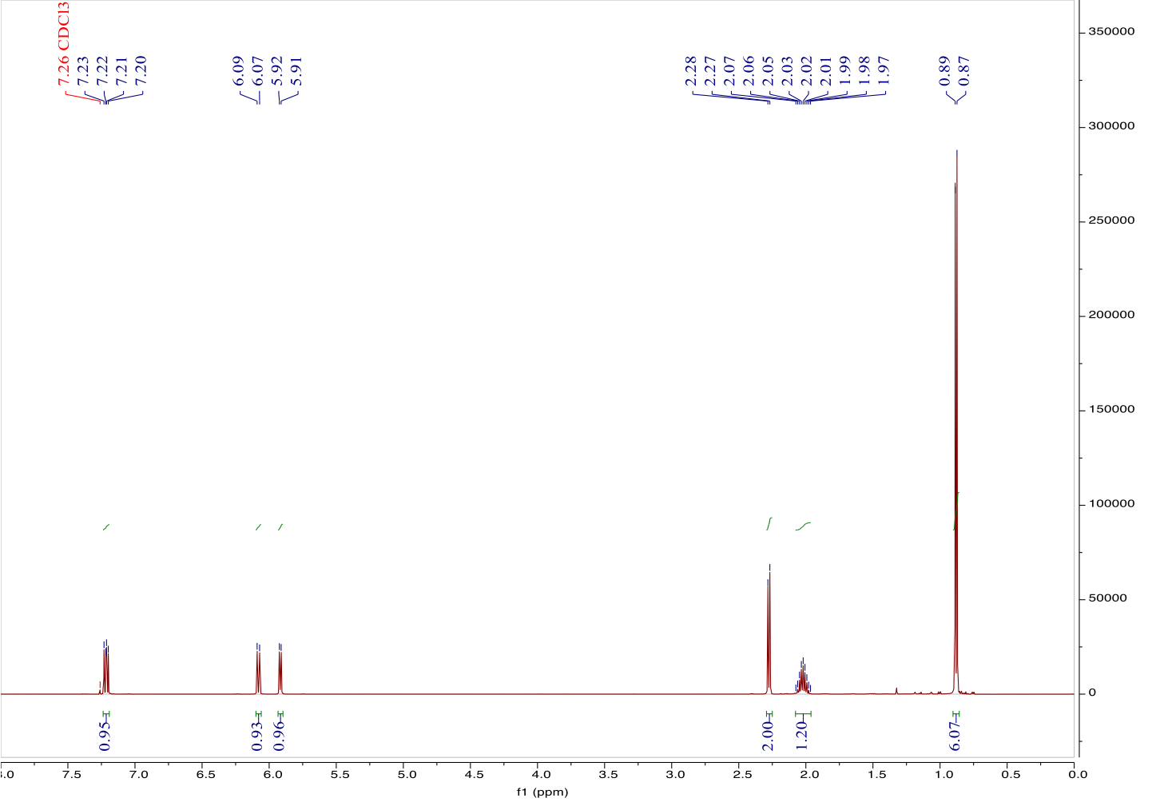
Figure 1. ¹H NMR spectrum of 6-propyl-2H-pyran-2-one (1)

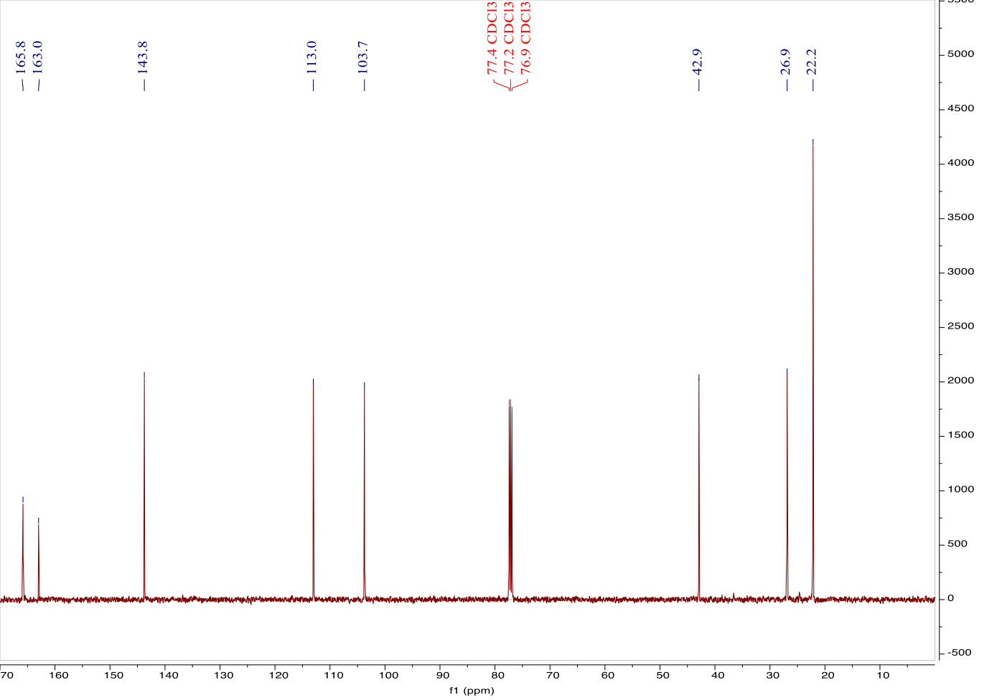
Figure 2. ¹³C NMR spectrum of 6-propyl-2H-pyran-2-one (1)
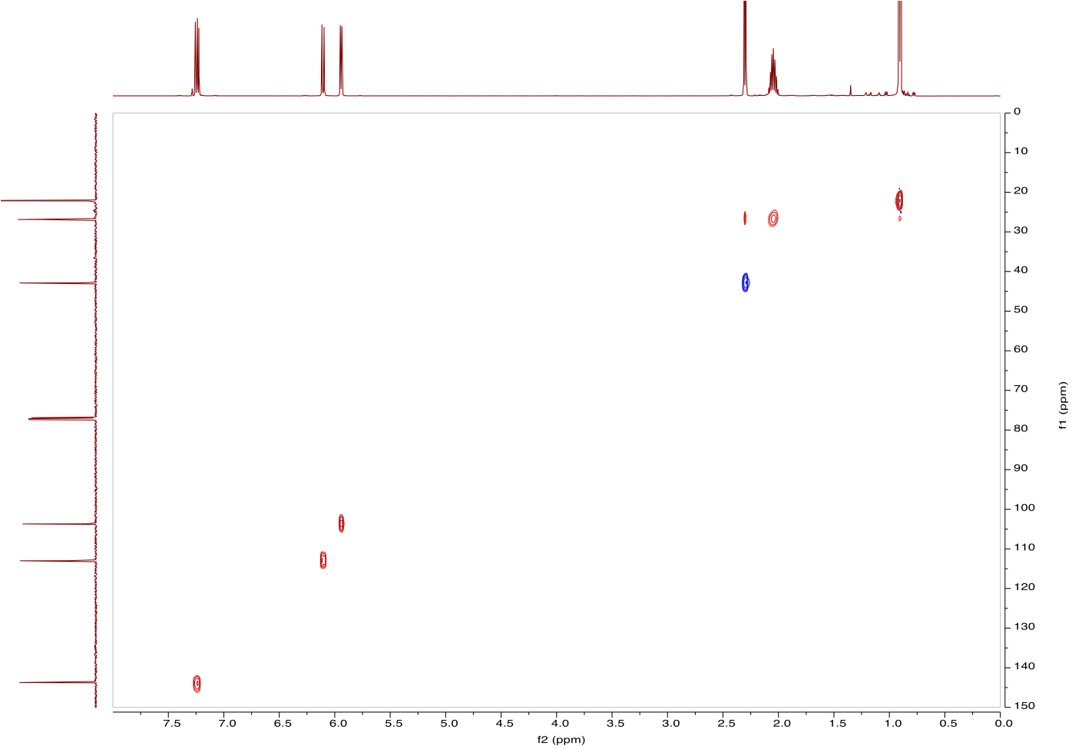
Figure 3. HSQC spectrum of 6-propyl-2H-pyran-2-one (1)
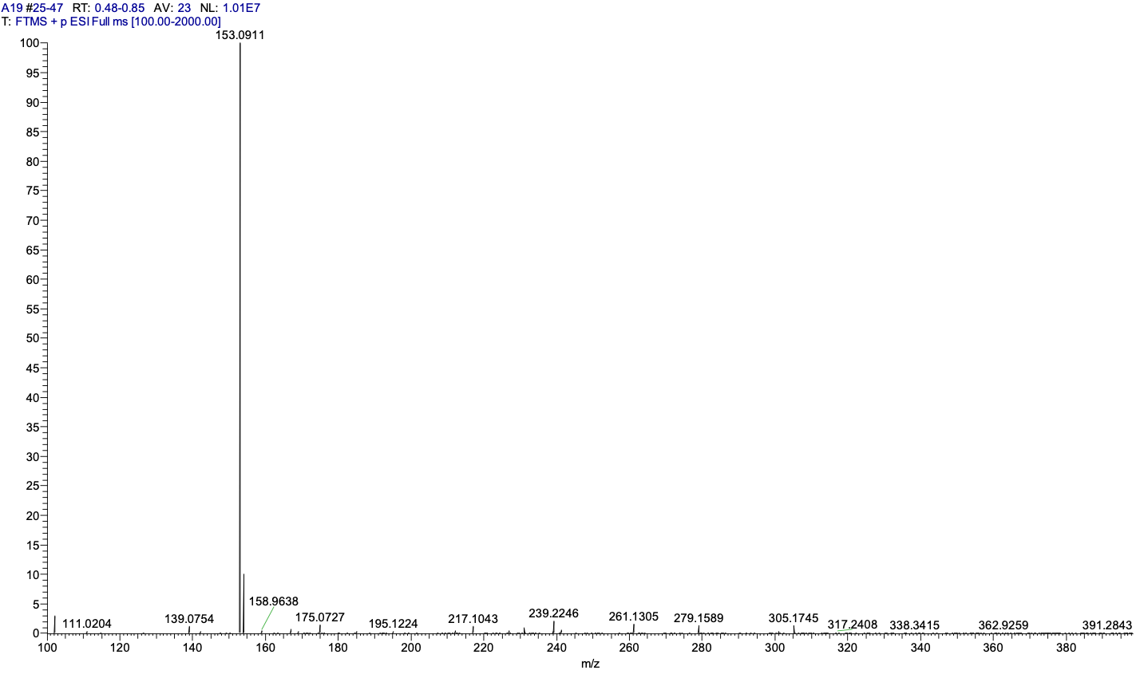
Figure 4. MS spectrum of 6-propyl-2H-pyran-2-one (1)

Figure 5. ¹H NMR spectrum of 6-isobutyl-2H-pyran-2-one (2)
Figure 6. ¹³C NMR spectrum of 6-isobutyl-2H-pyran-2-one (2)

Figure 7. HSQC spectrum of 6-isobutyl-2H-pyran-2-one (2)
Figure 8. MS spectrum of 6-isobutyl-2H-pyran-2-one (2)

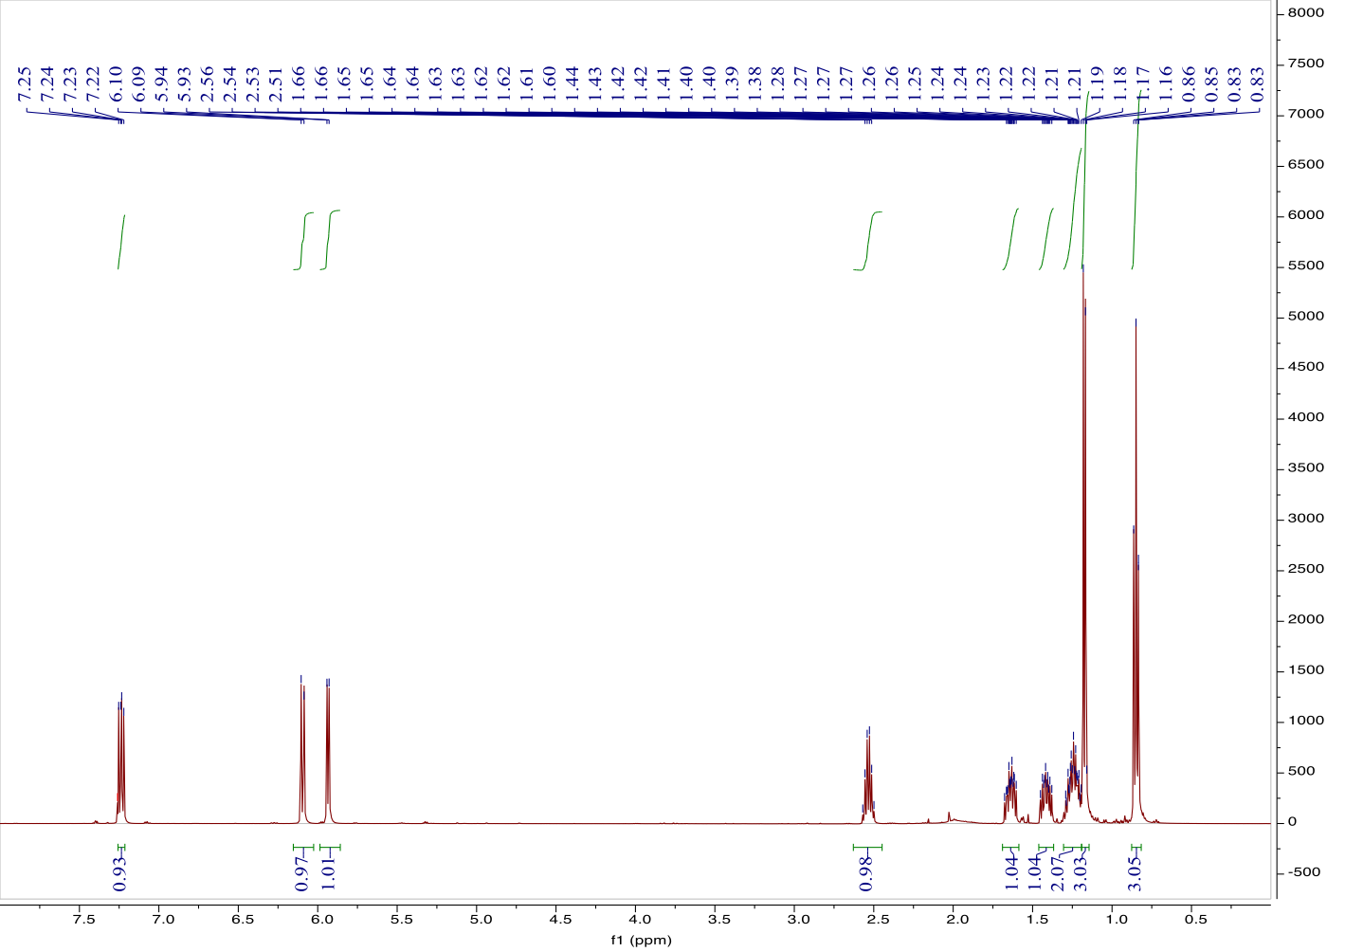
Figure 9. ¹H NMR spectrum of 6-(pentan-2-yl)-2H-pyran-2-one (3)

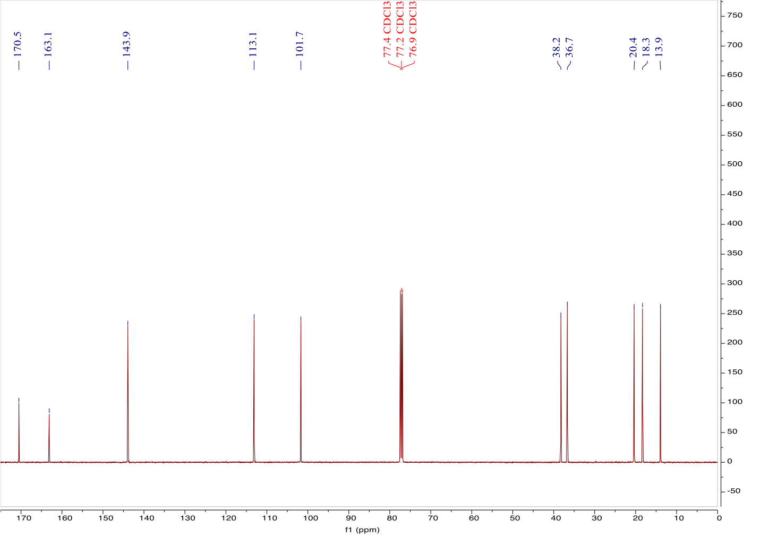
Figure 10. ¹³C NMR spectrum of 6-(pentan-2-yl)-2H-pyran-2-one (3)

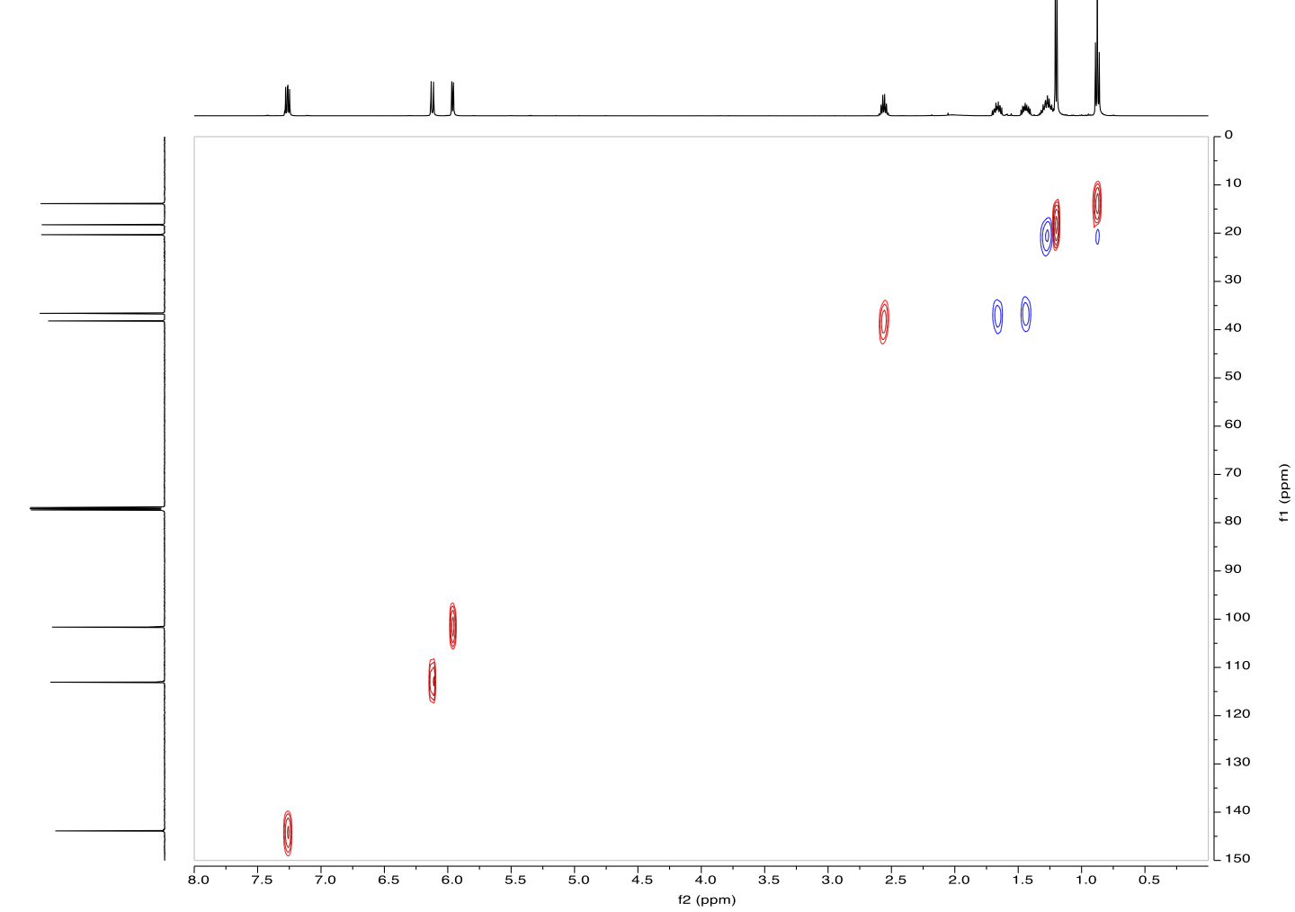
Figure 11. HSQC spectrum of 6-(pentan-2-yl)-2H-pyran-2-one (3)

Figure 12. MS spectrum of 6-(pentan-2-yl)-2H-pyran-2-one (3)
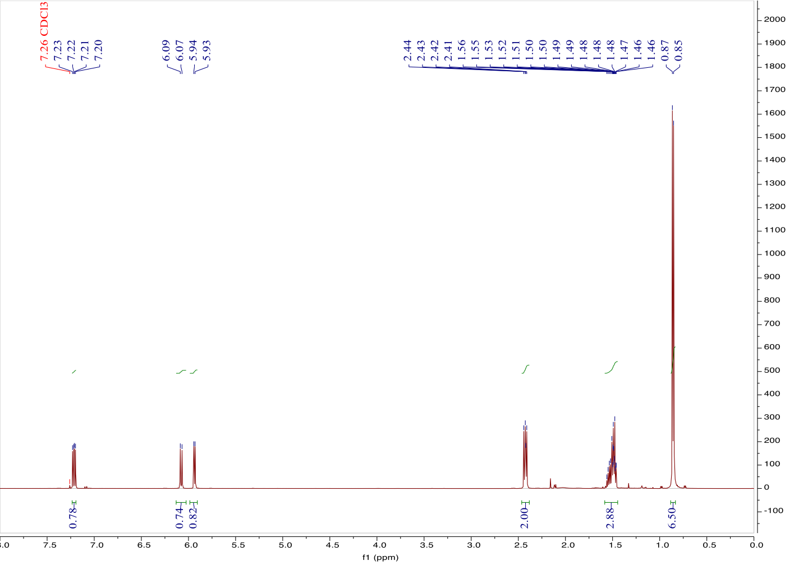
Figure 13. ¹H NMR spectrum of 6-isopentyl-2H-pyran-2-one (4)
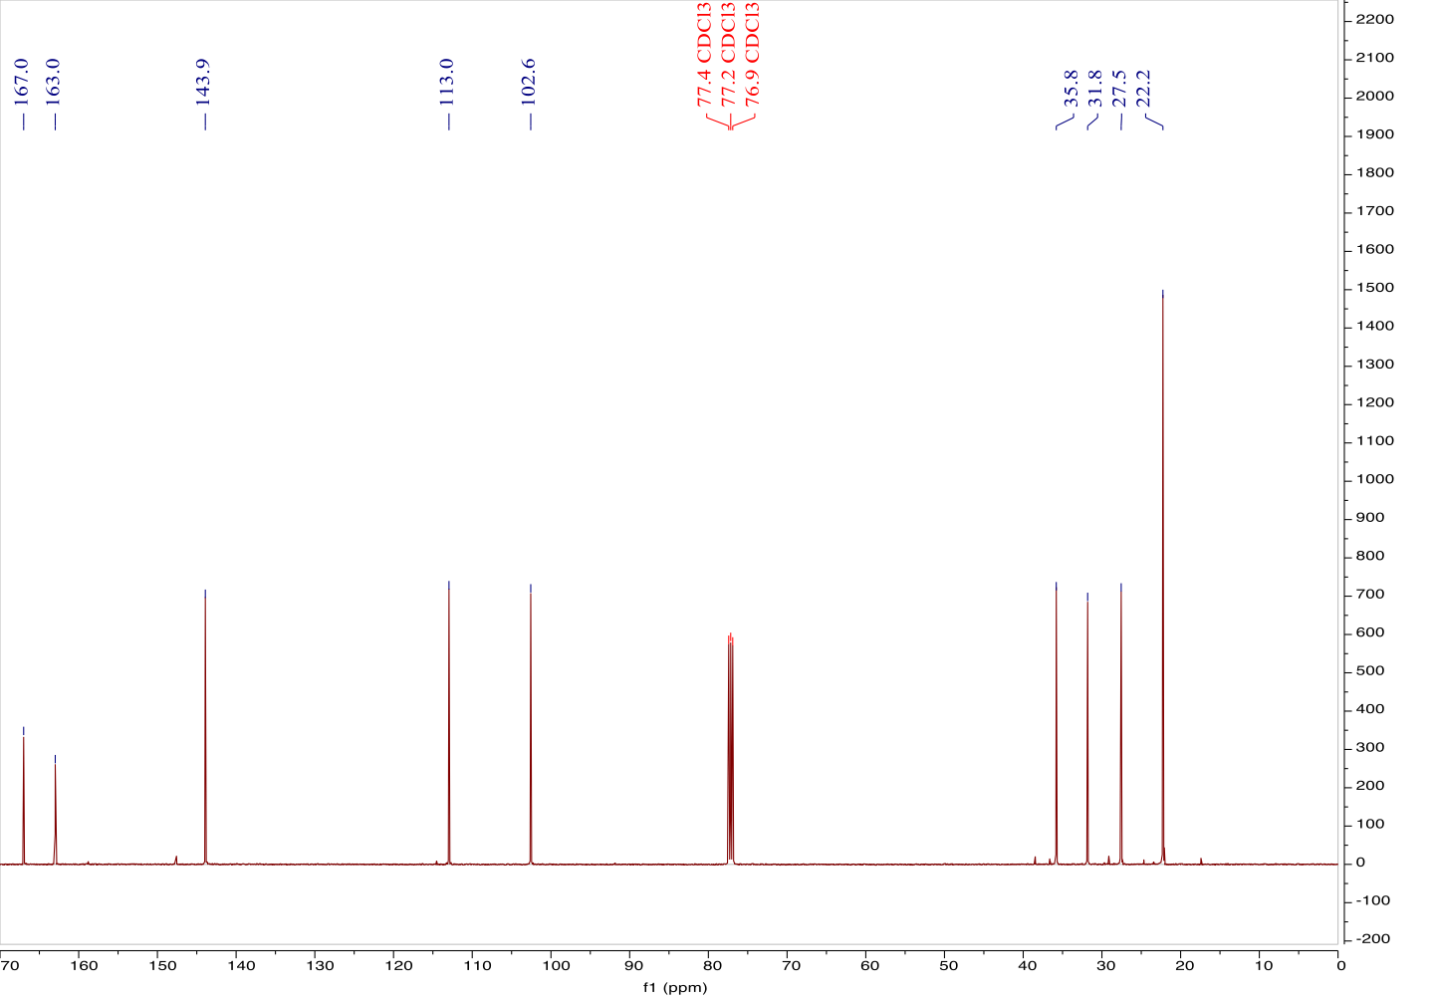
Figure 14. ¹³C NMR spectrum of 6-isopentyl-2H-pyran-2-one (4)
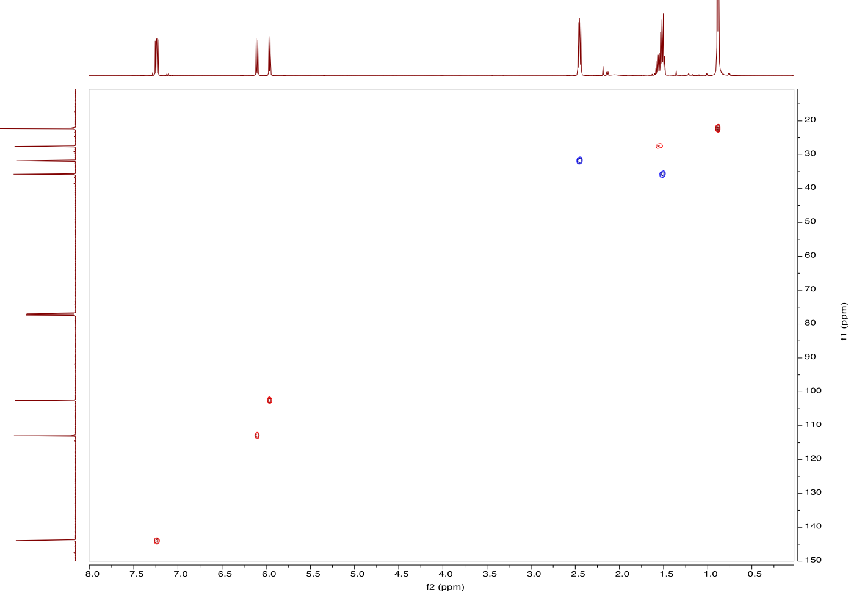
Figure 15. HSQC spectrum of 6-isopentyl-2H-pyran-2-one (4)
Figure 16. MS spectrum of 6-isopentyl-2H-pyran-2-one (4)
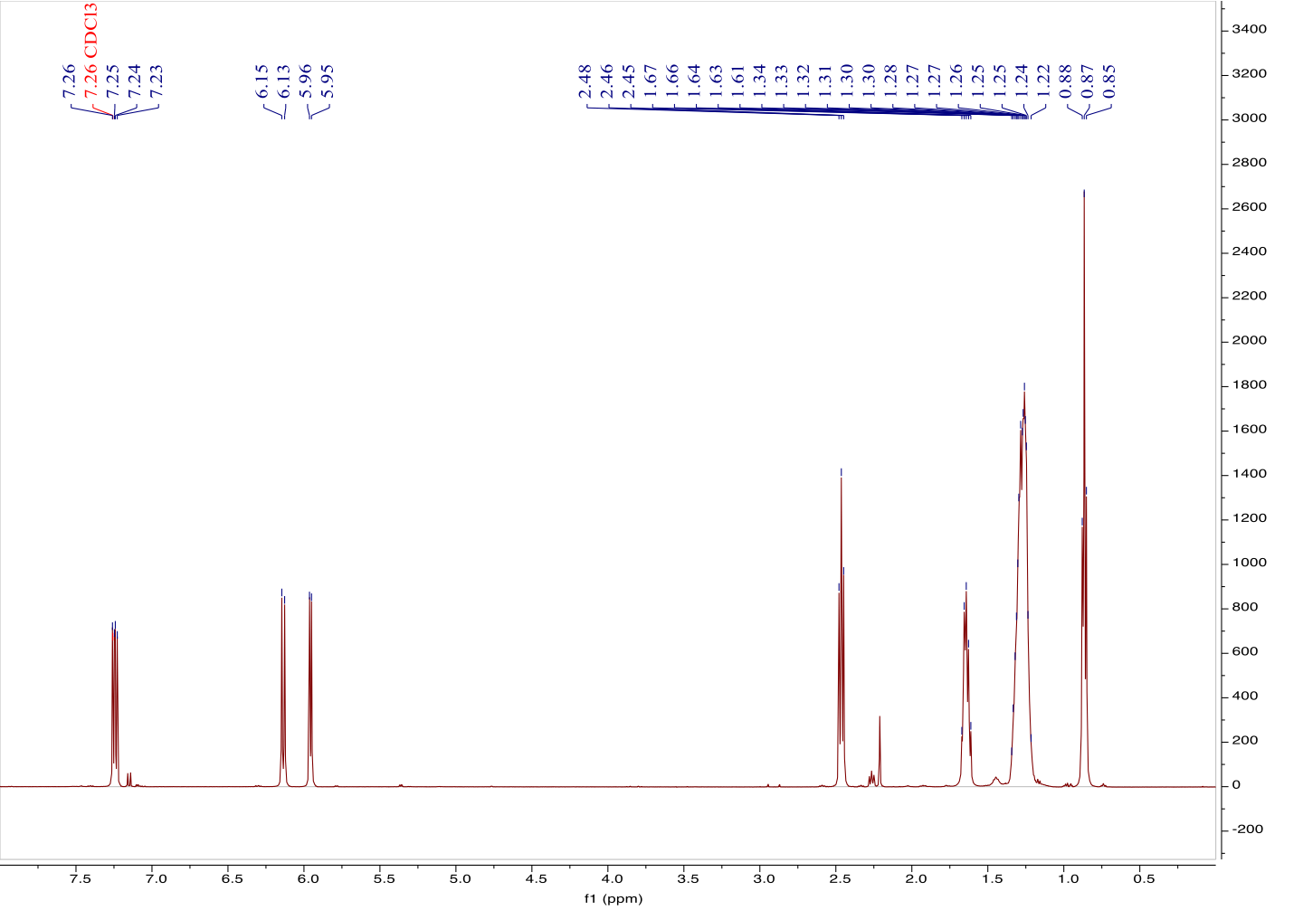
Figure 17. ¹H NMR spectrum of 6-octyl-2H-pyran-2-one (5)
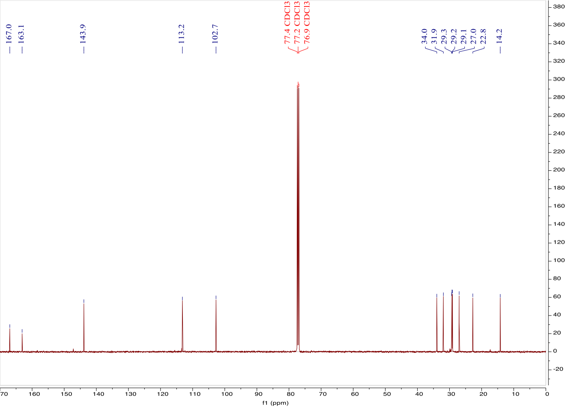
Figure 18. ¹³C NMR spectrum of 6-octyl-2H-pyran-2-one (5)

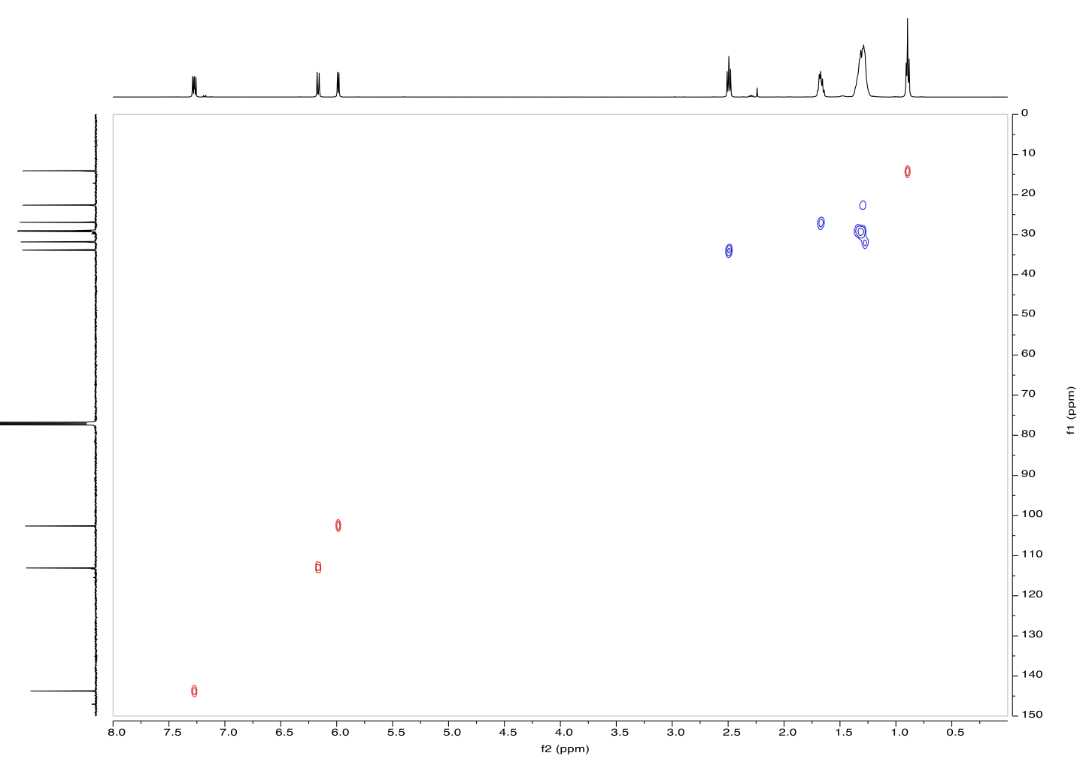
Figure 19. HSQC spectrum of 6-octyl-2H-pyran-2-one (5)
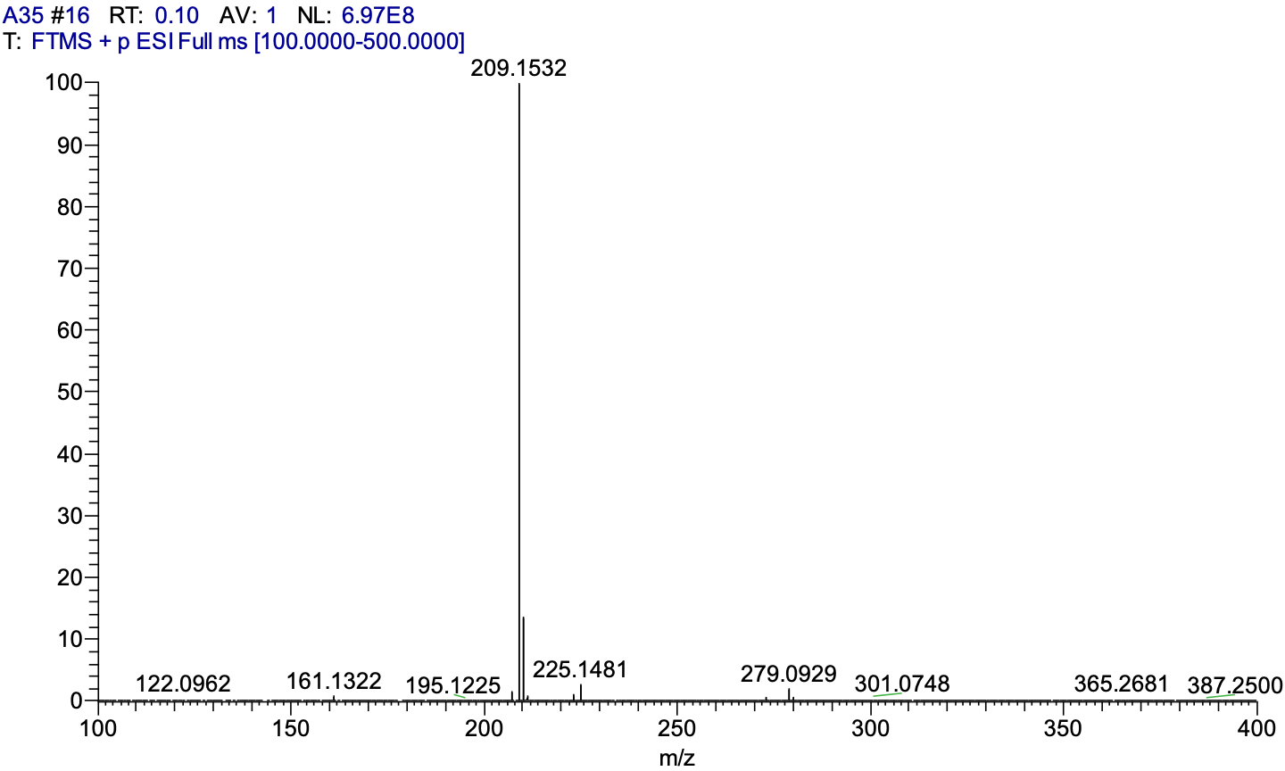
Figure 20. MS spectrum of 6-octyl-2H-pyran-2-one (5)

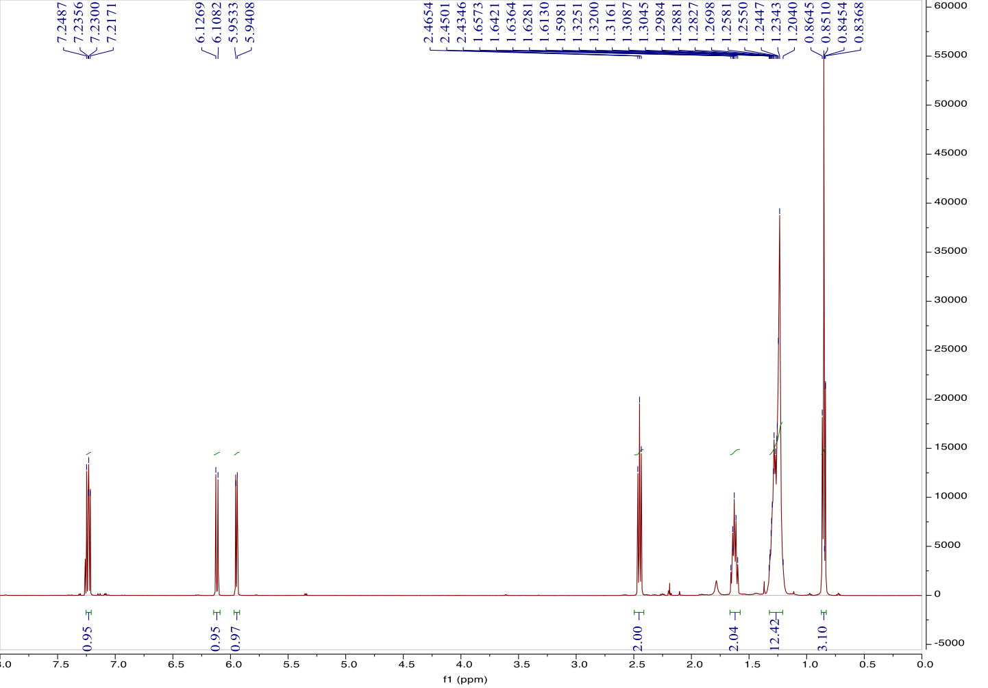
Figure 21. ¹H NMR spectrum of 6-nonyl-2H-pyran-2-one (6)
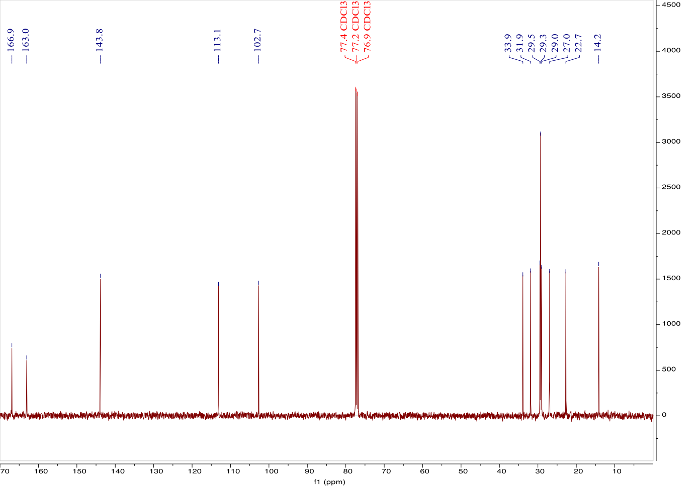
Figure 22. ¹³C NMR spectrum of 6-nonyl-2H-pyran-2-one (6)
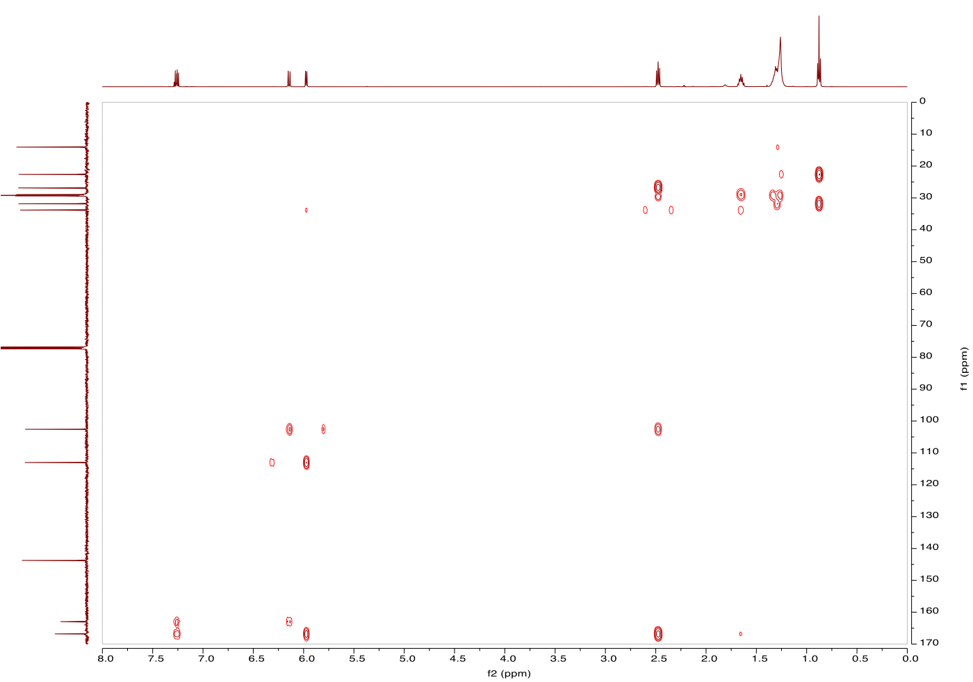
Figure 23. HSQC spectrum of 6-nonyl-2H-pyran-2-one (6)
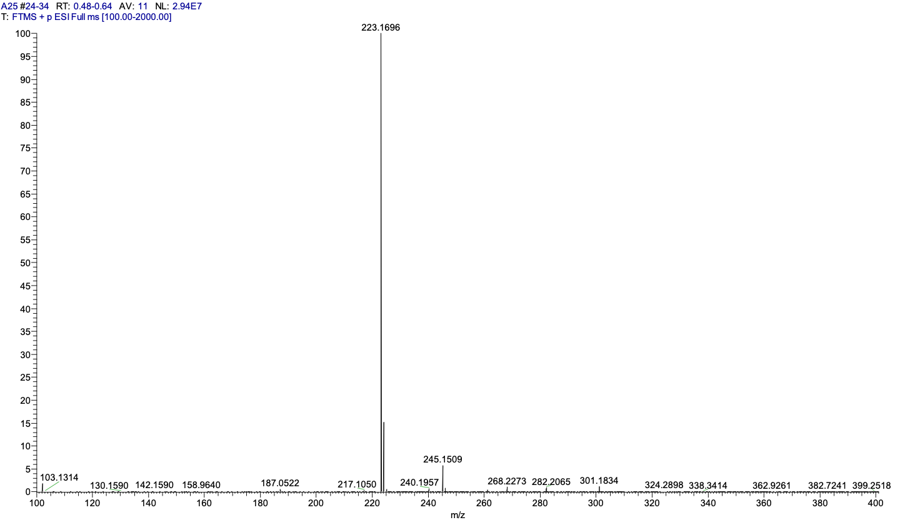
Figure 24. MS spectrum of 6-nonyl-2H-pyran-2-one (6)
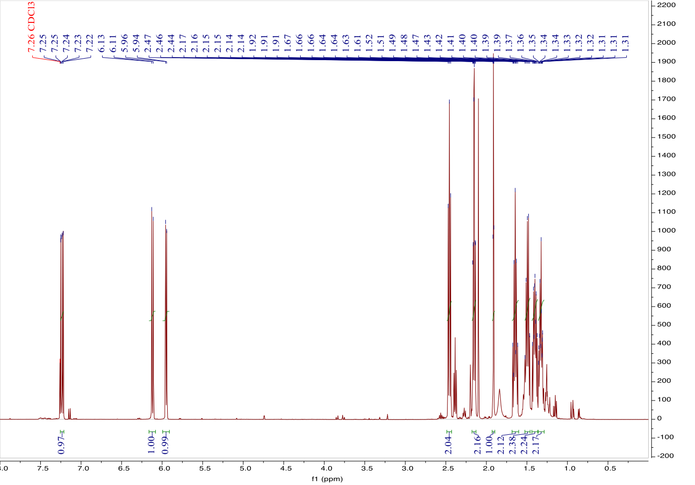
Figure 25. ¹H NMR spectrum of 6-(oct-7-yn-1-yl)-2H-pyran-2-one (7)
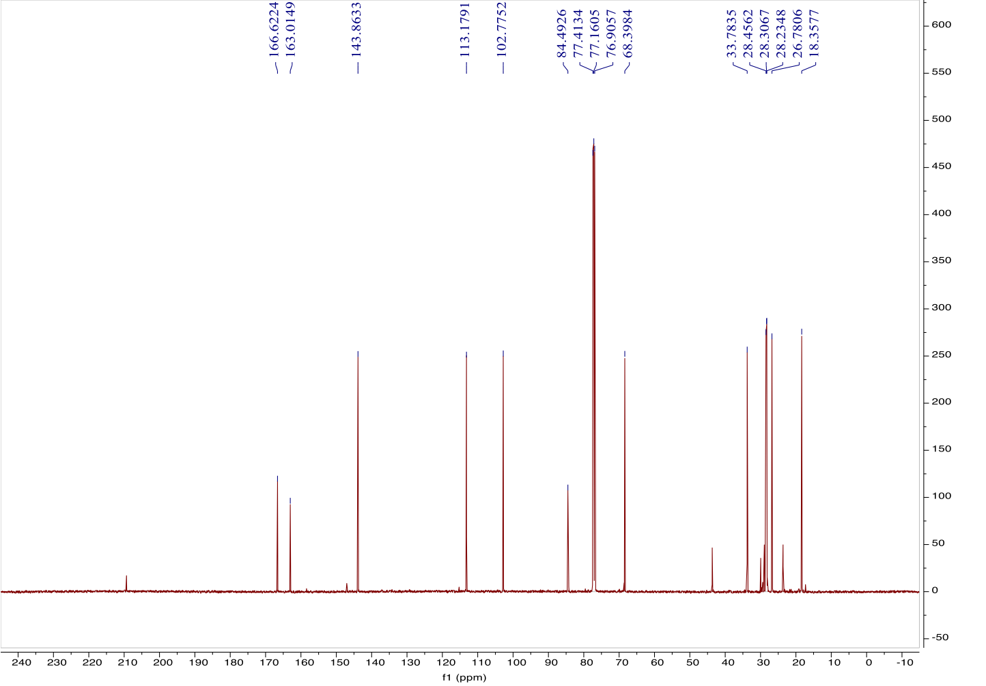
Figure 26. ¹³C NMR spectrum of 6-(oct-7-yn-1-yl)-2H-pyran-2-one (7)
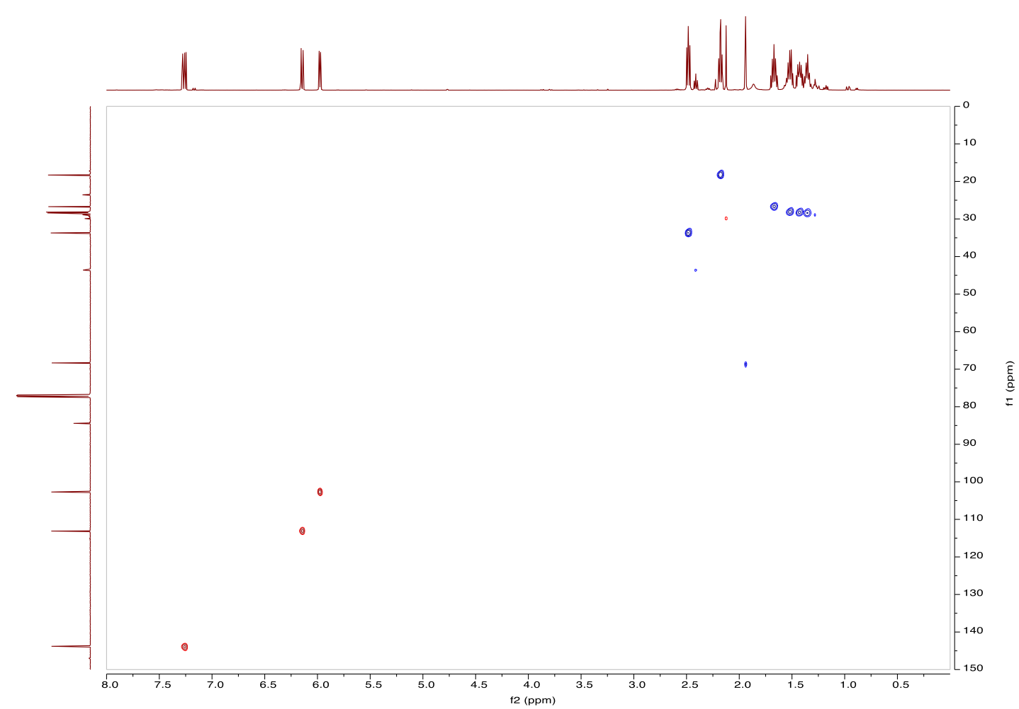
Figure 27. HSQC spectrum of 6-(oct-7-yn-1-yl)-2H-pyran-2-one (7)
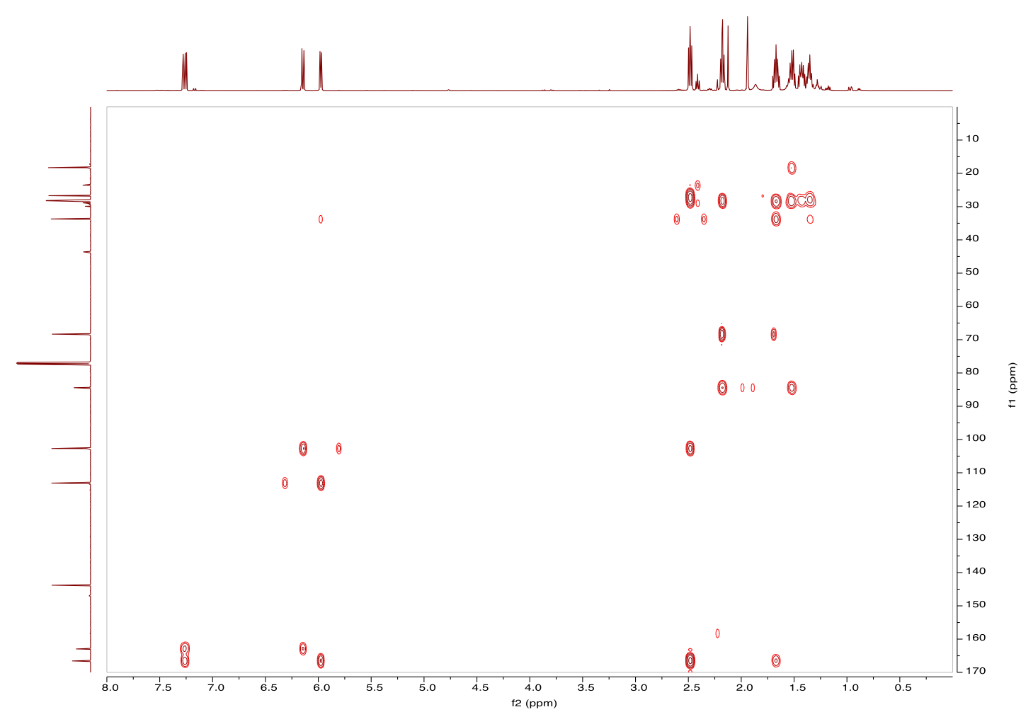
Figure 28. HMBC spectrum of 6-(oct-7-yn-1-yl)-2H-pyran-2-one (7)
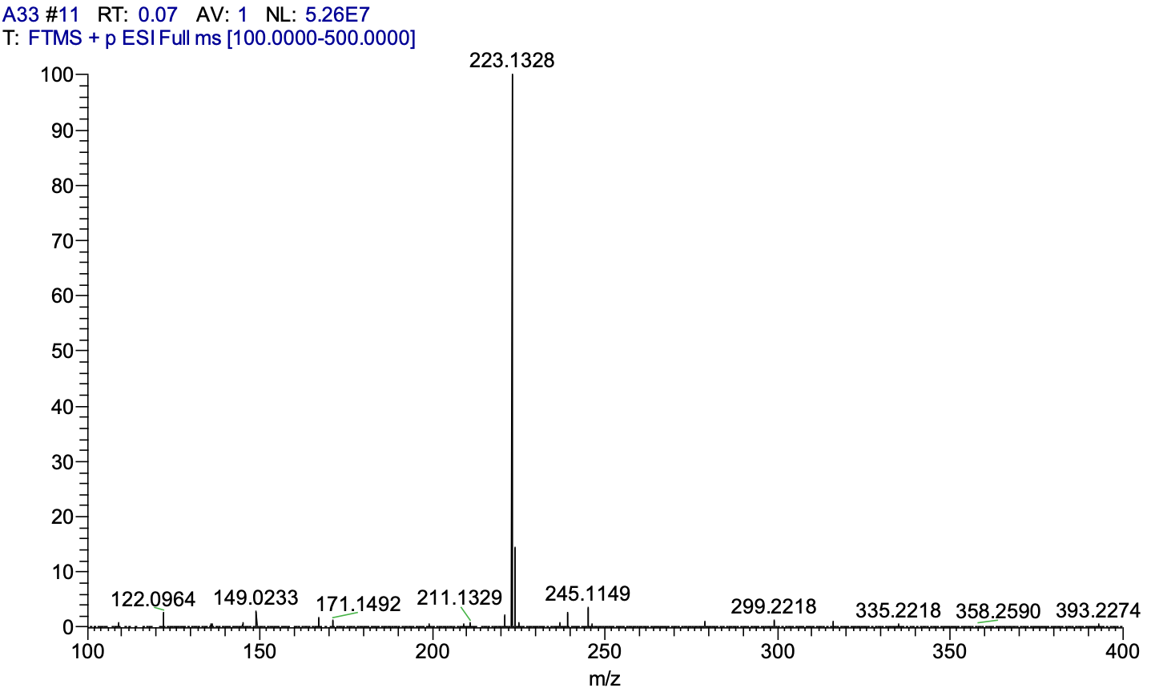
Figure 29. MS spectrum of 6-(oct-7-yn-1-yl)-2H-pyran-2-one (7)
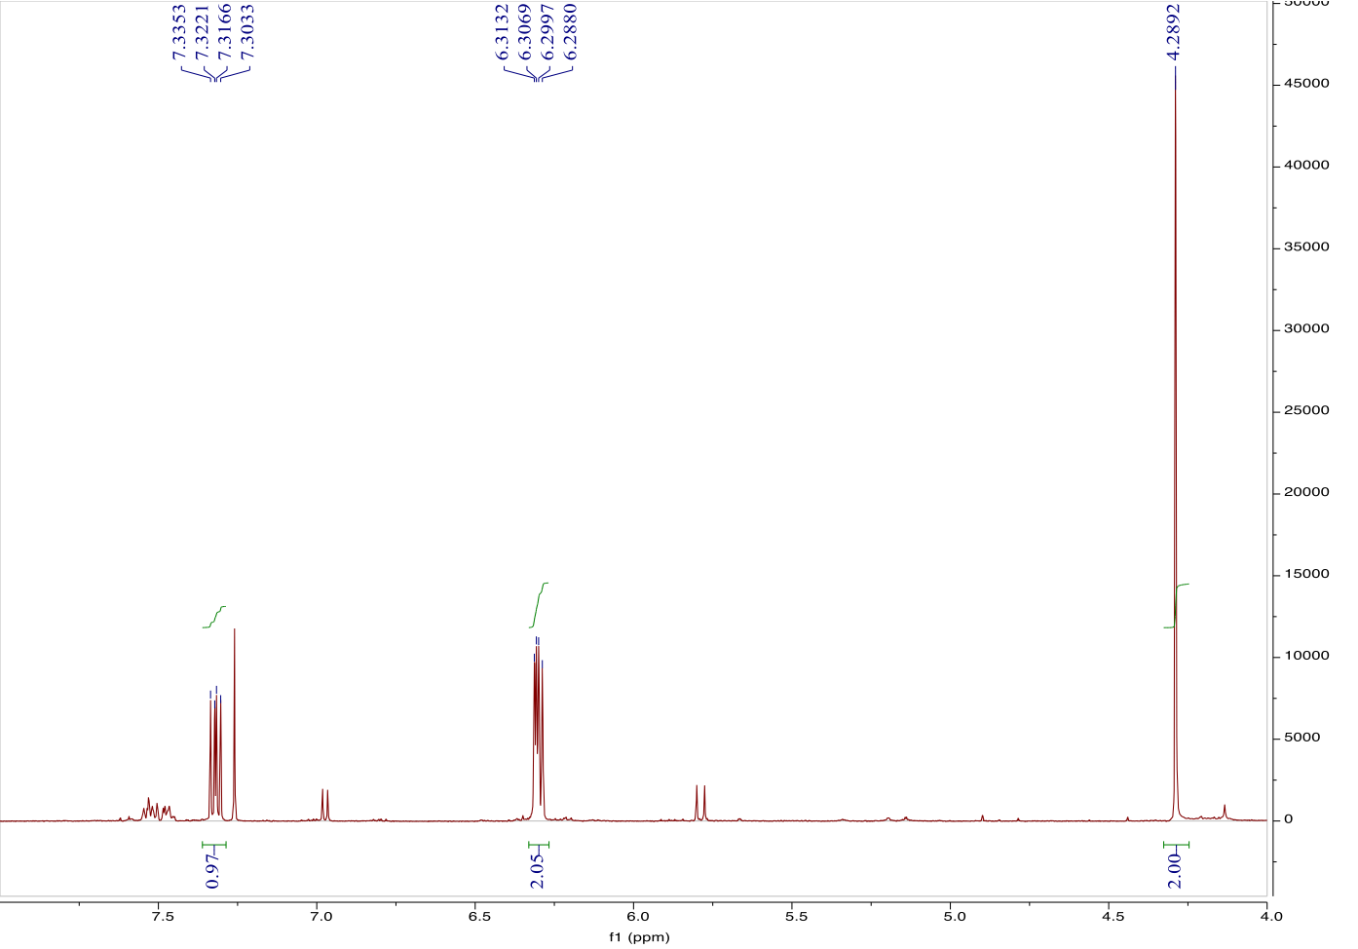
Figure 30. ¹H NMR spectrum of 6-(chloromethyl)-2H-pyran-2-one (8)
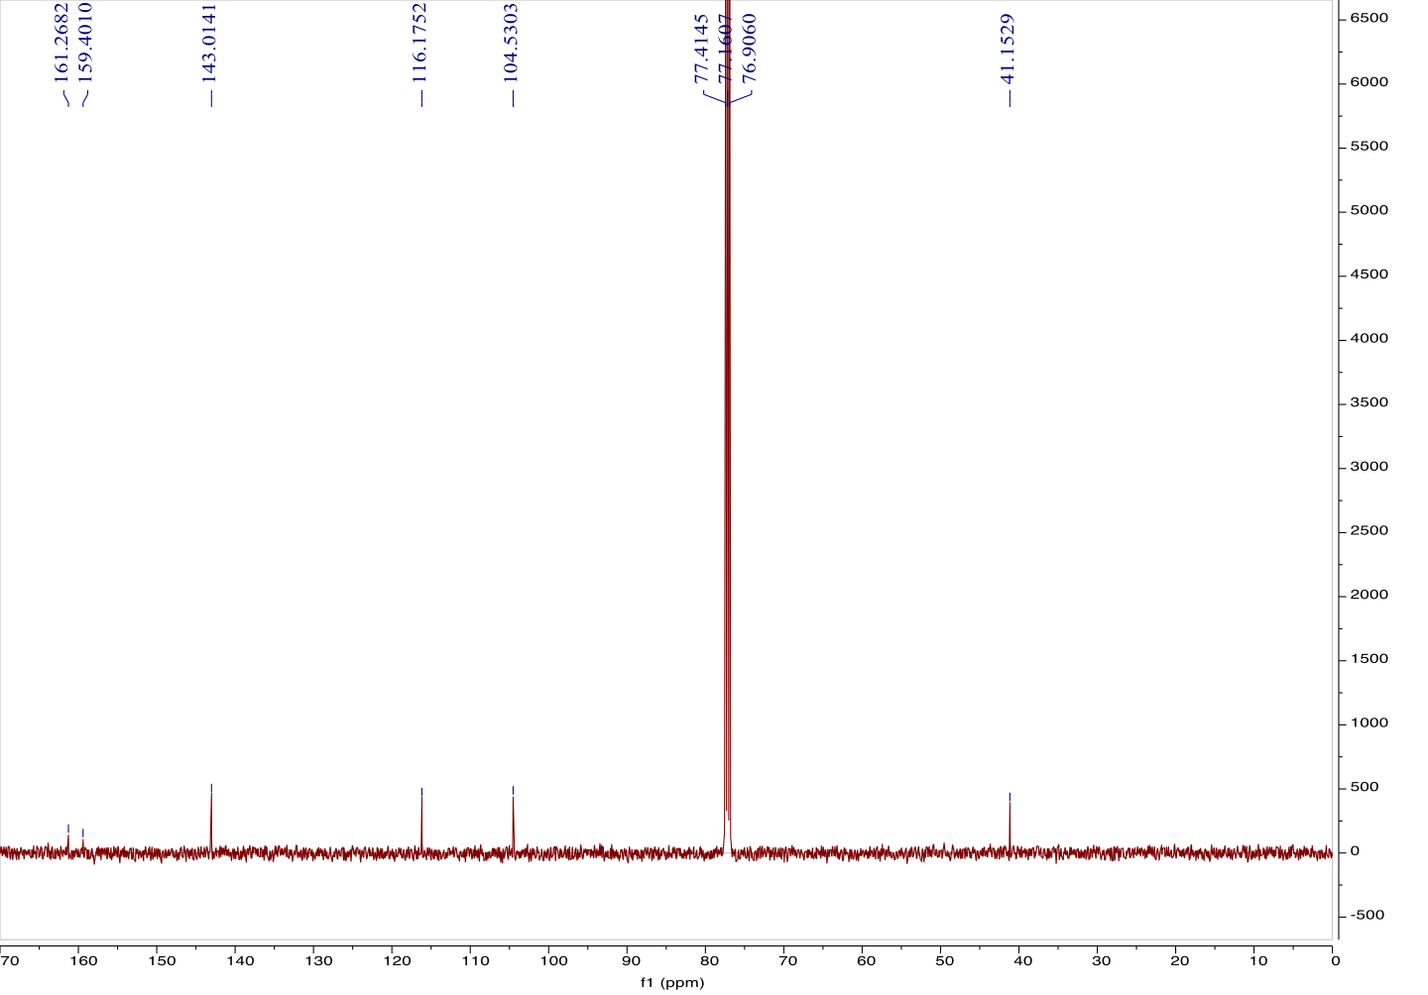
Figure 31. ¹³C NMR spectrum of 6-(chloromethyl)-2H-pyran-2-one (8)
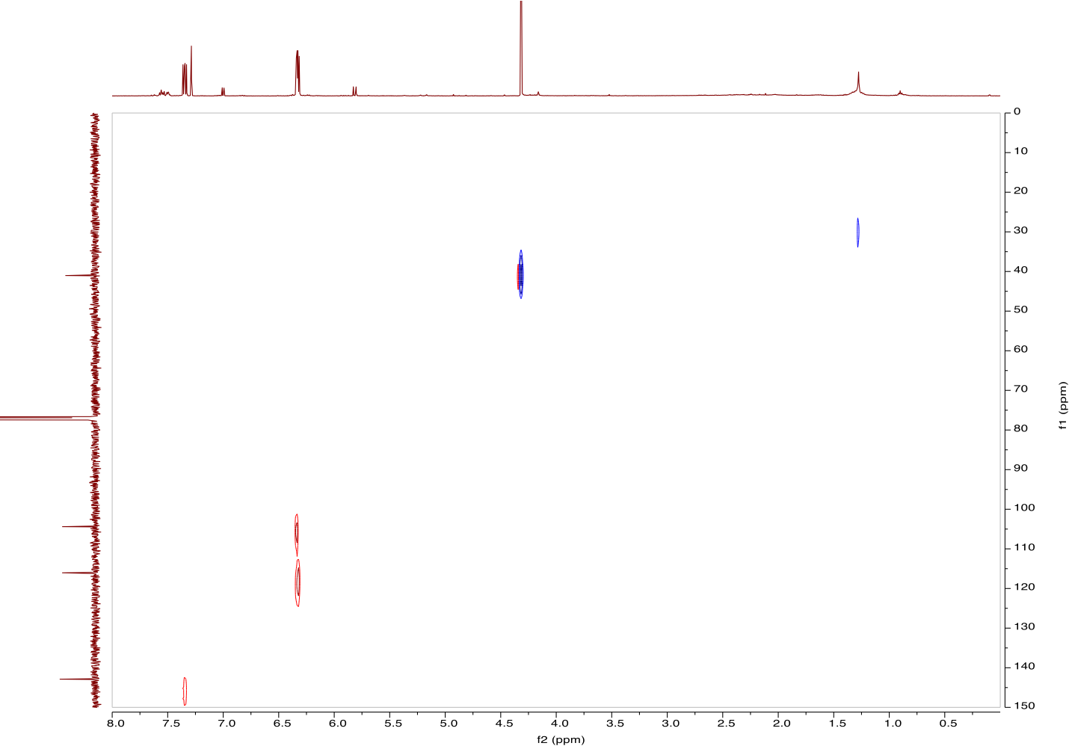
Figure 32. HSQC spectrum of 6-(chloromethyl)-2H-pyran-2-one (8)
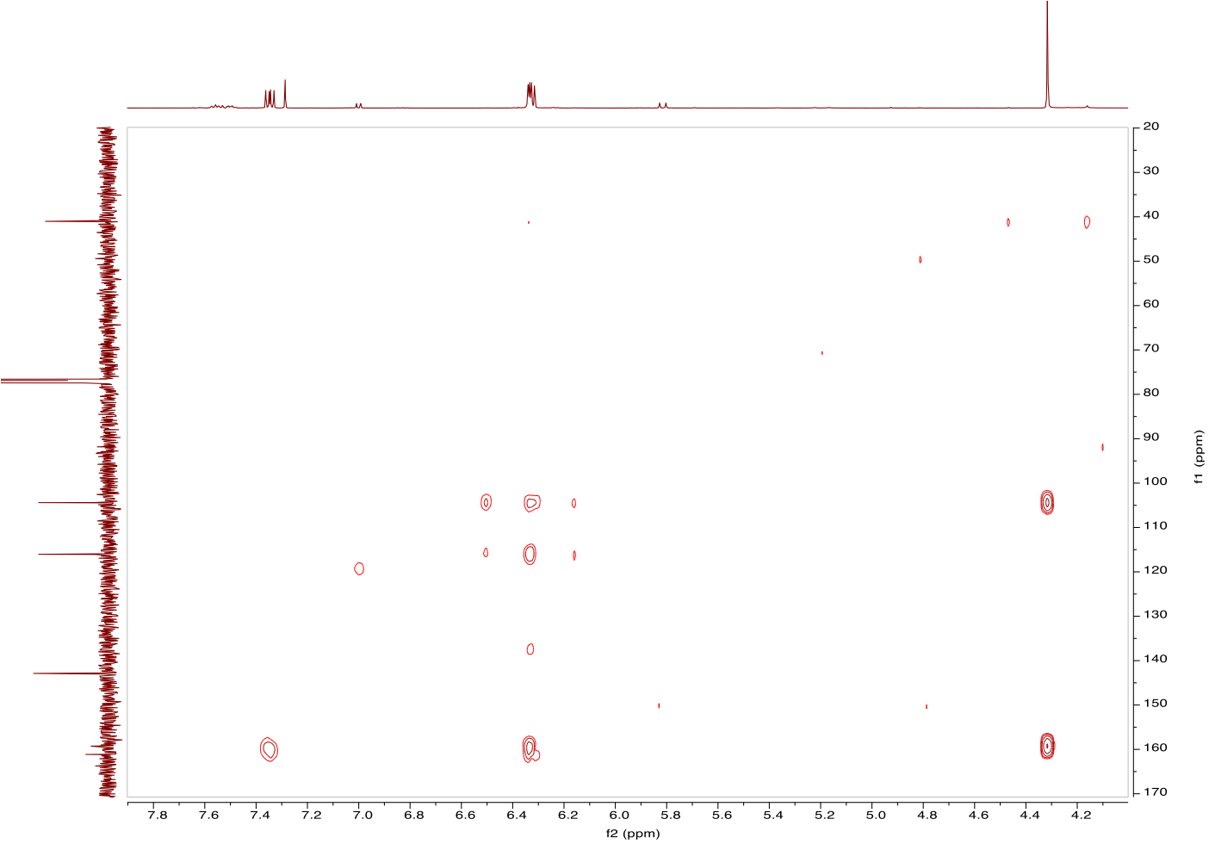
Figure 33. HSQC spectrum of 6-(chloromethyl)-2H-pyran-2-one (8)
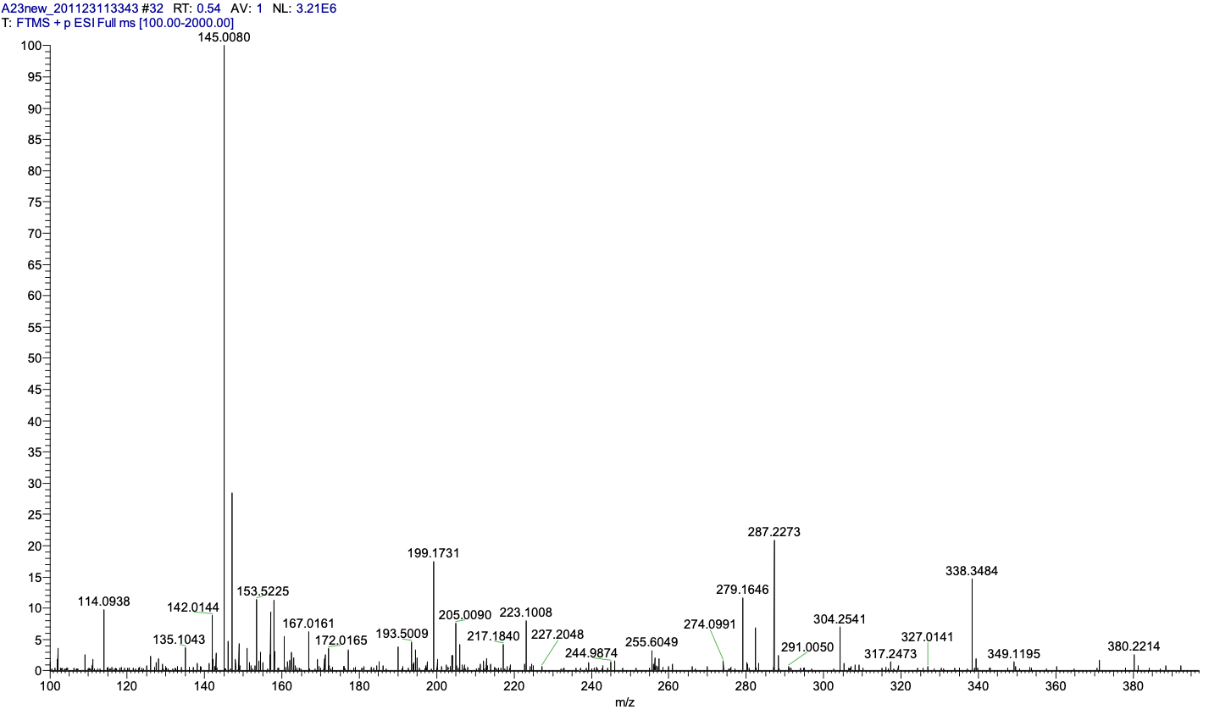
Figure 34. MS spectrum of 6-(chloromethyl)-2H-pyran-2-one (8)
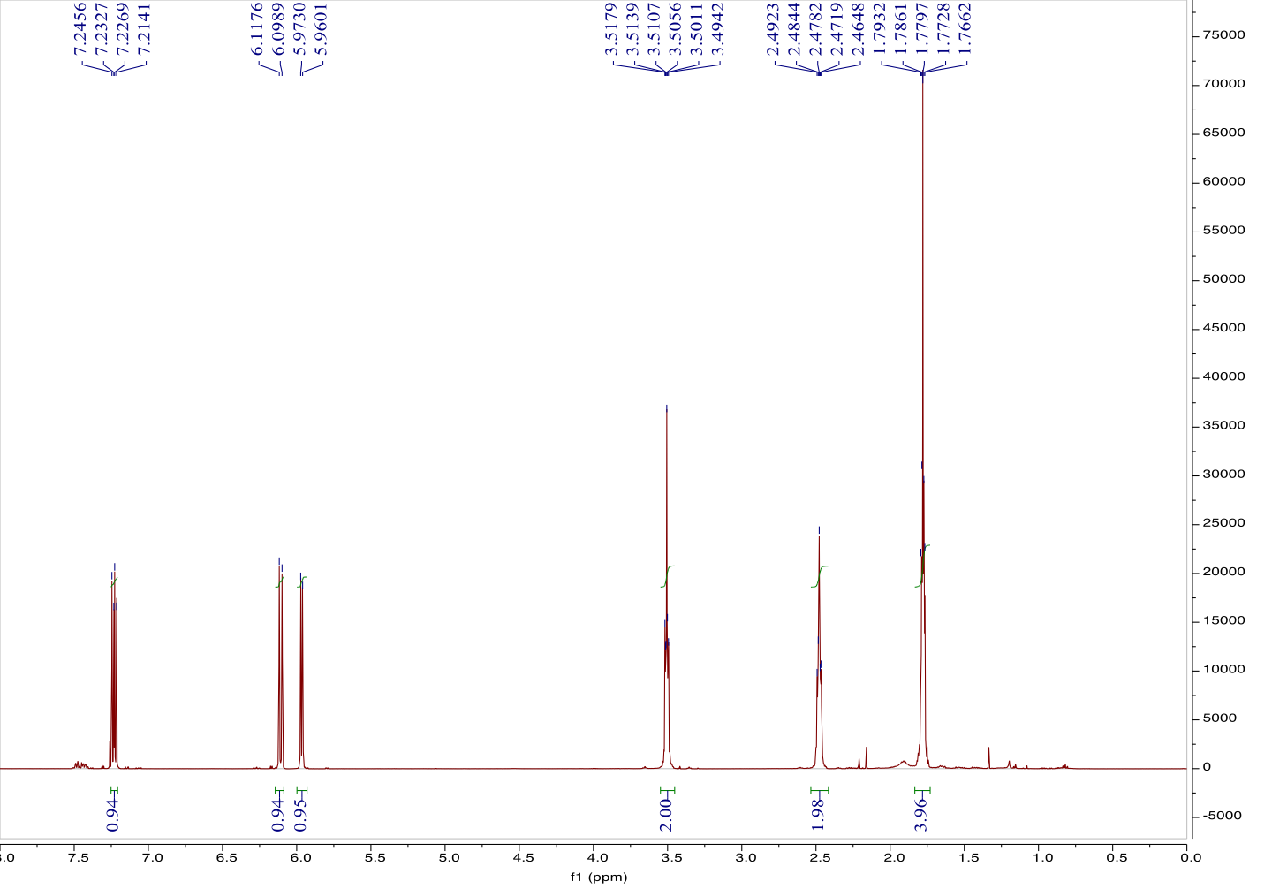
Figure 35. ¹H NMR spectrum of 6-(4-chlorobutyl)-2H-pyran-2-one (9)
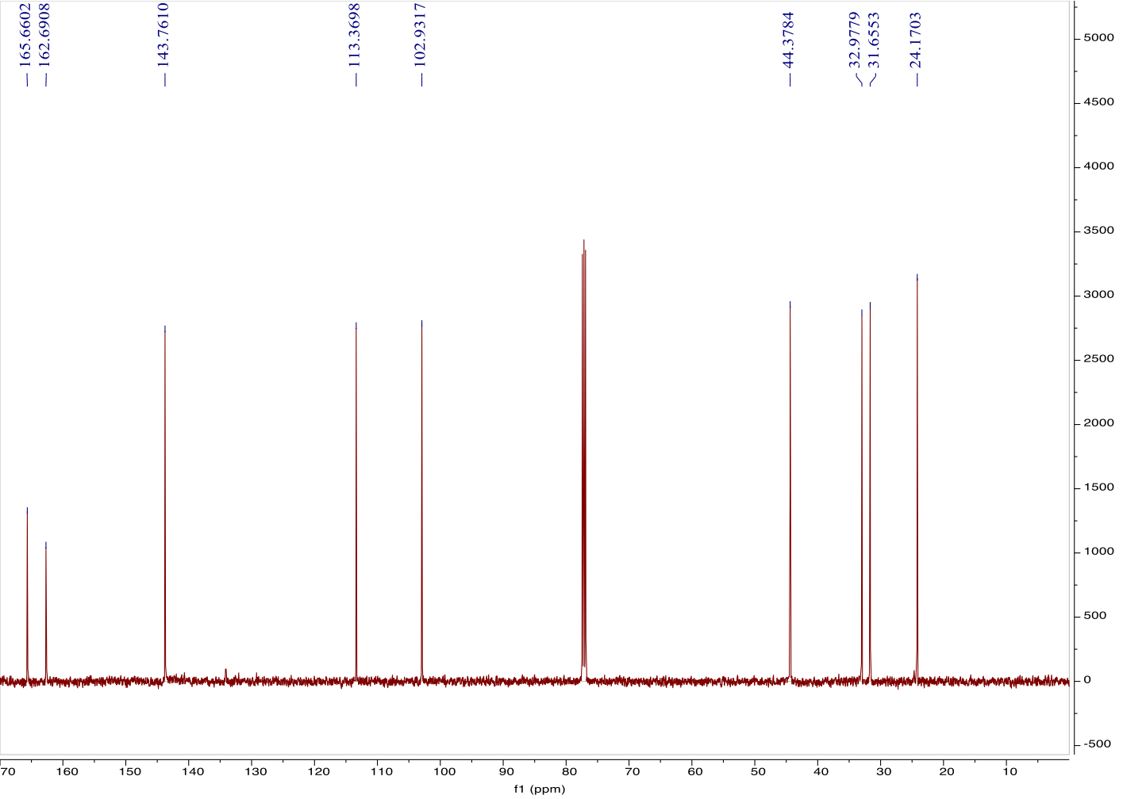
Figure 36. ¹³C NMR spectrum of 6-(4-chlorobutyl)-2H-pyran-2-one (9)

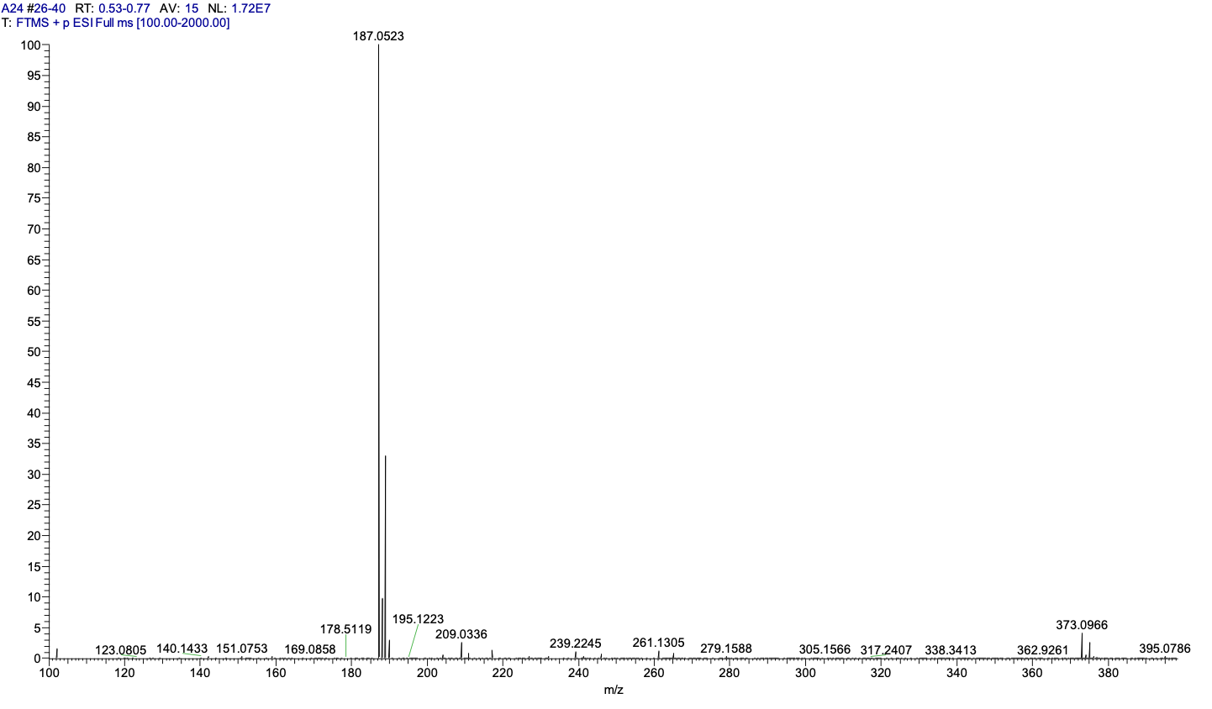
Figure 37. MS spectrum of 6-(4-chlorobutyl)-2H-pyran-2-one (9)
Figure 38. ¹H NMR spectrum of 6-pentyl-4-phenyl-2H-pyran-2-one (10)
Figure 39. ¹³C NMR spectrum of 6-pentyl-4-phenyl-2H-pyran-2-one (10)
Figure 40. HSQC spectrum of 6-heptyl-2H-pyran-2-one (10)
Figure 41. MS spectrum of 6-heptyl-2H-pyran-2-one (10)
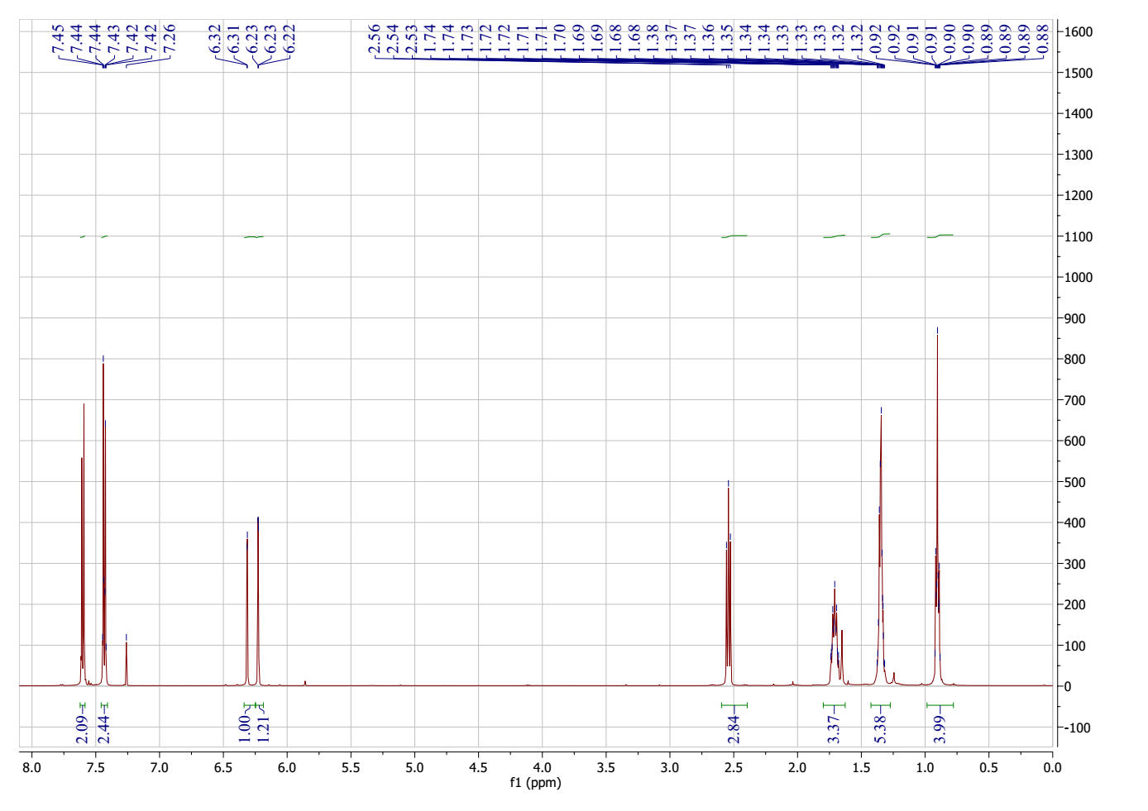
Figure 42. ¹H NMR spectrum of 4-(4-bromophenyl)-6-pentyl-2H-pyran-2-one (11)
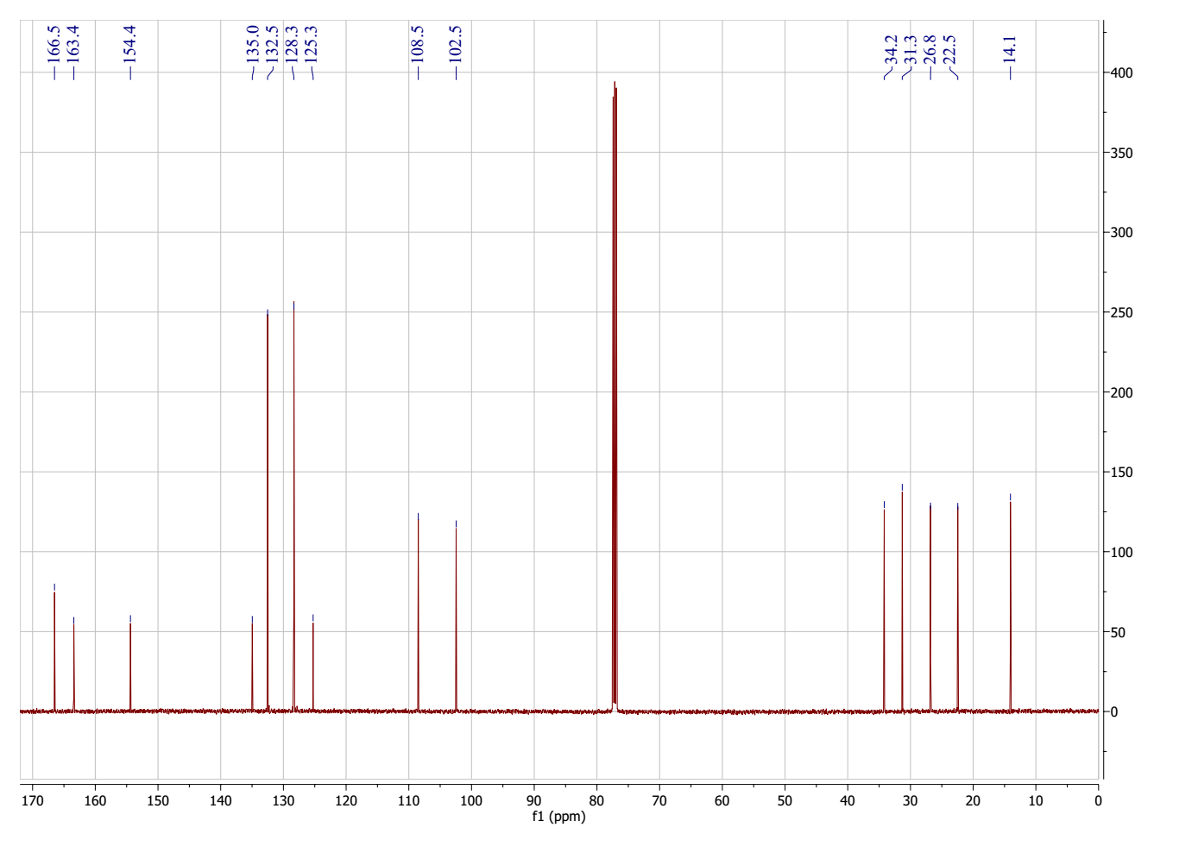
Figure 43. ¹³C NMR spectrum of 4-(4-bromophenyl)-6-pentyl-2H-pyran-2-one (11)
Figure 44. MS spectrum of 4-(4-bromophenyl)-6-pentyl-2H-pyran-2-one (11)
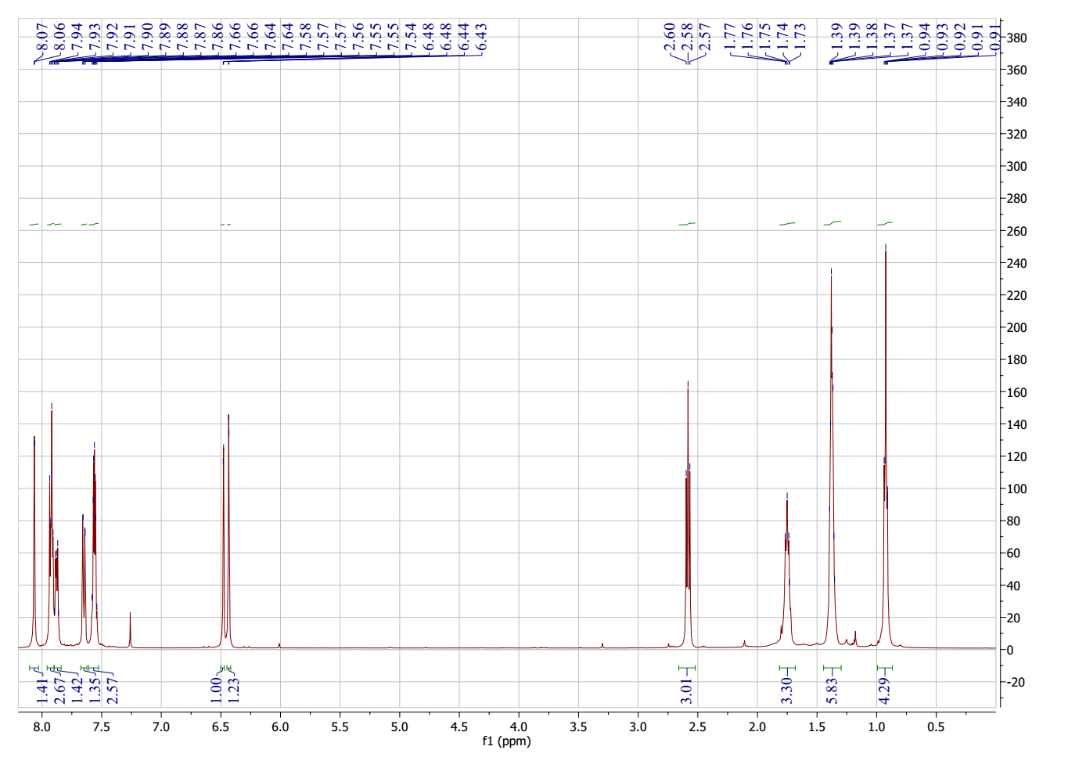
Figure 45. ¹H NMR spectrum of 4-(naphthalen-2-yl)-6-pentyl-2H-pyran-2-one (12)
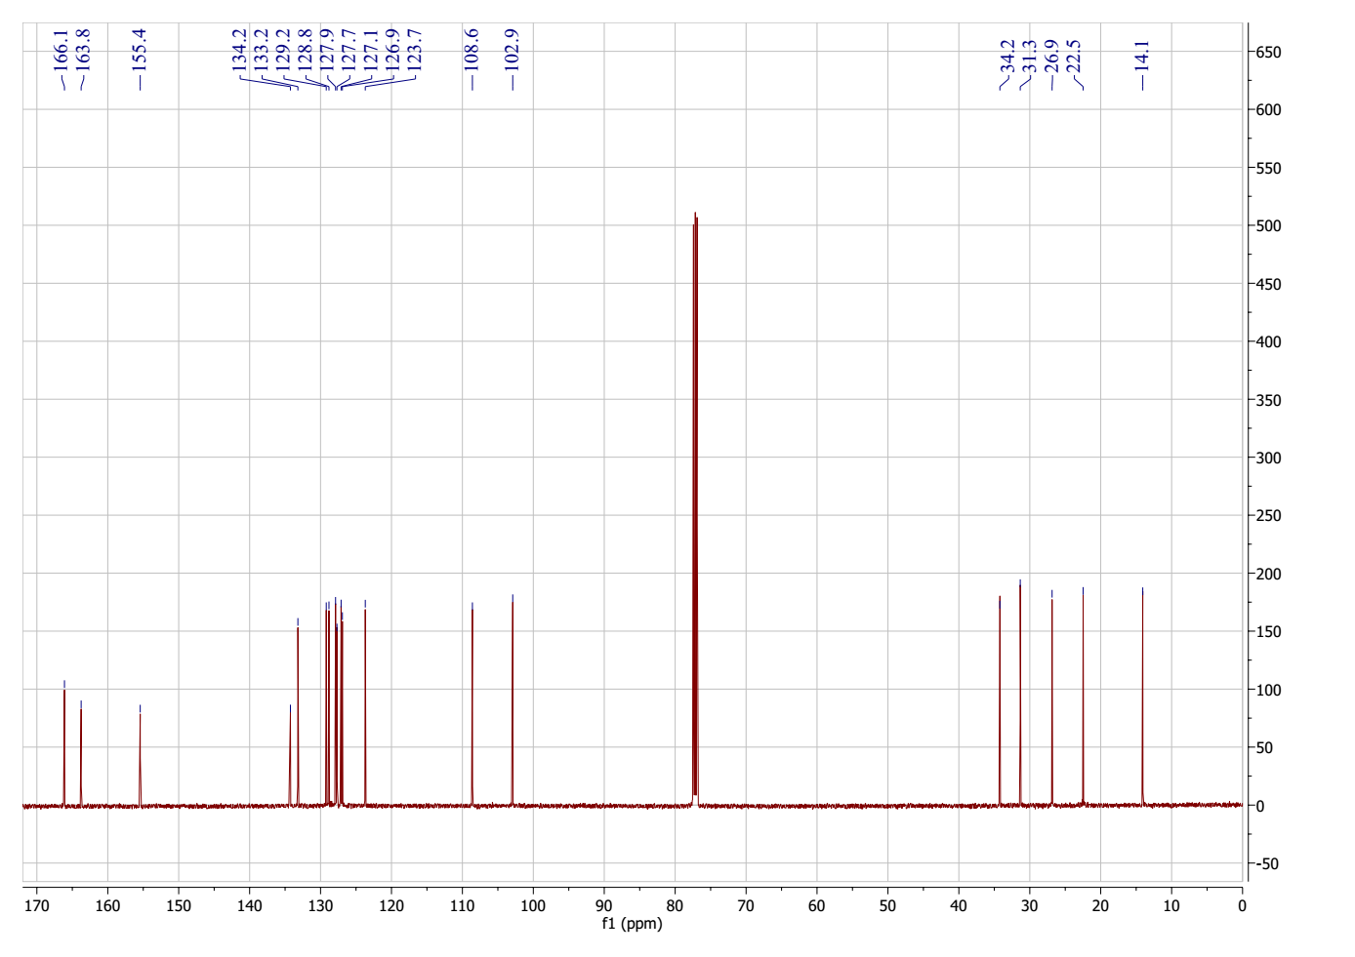
Figure 46. ¹³C NMR spectrum of 4-(naphthalen-2-yl)-6-pentyl-2H-pyran-2-one (12)
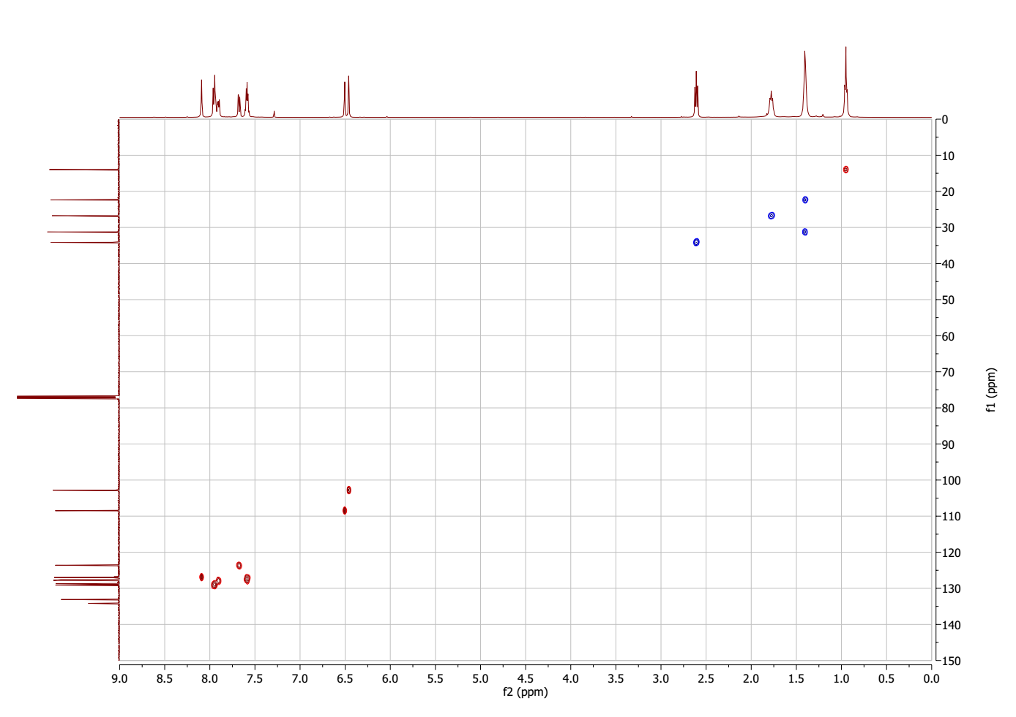
Figure 47. HSQC spectrum of 4-(naphthalen-2-yl)-6-pentyl-2H-pyran-2-one (12)
Figure 48. MS spectrum of 4-(naphthalen-2-yl)-6-pentyl-2H-pyran-2-one (12)

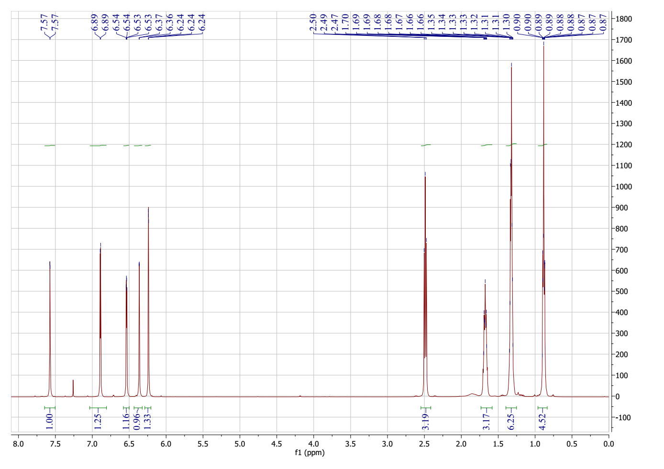
Figure 49. ¹H NMR spectrum of 4-(furan-2-yl)-6-pentyl-2H-pyran-2-one (13)
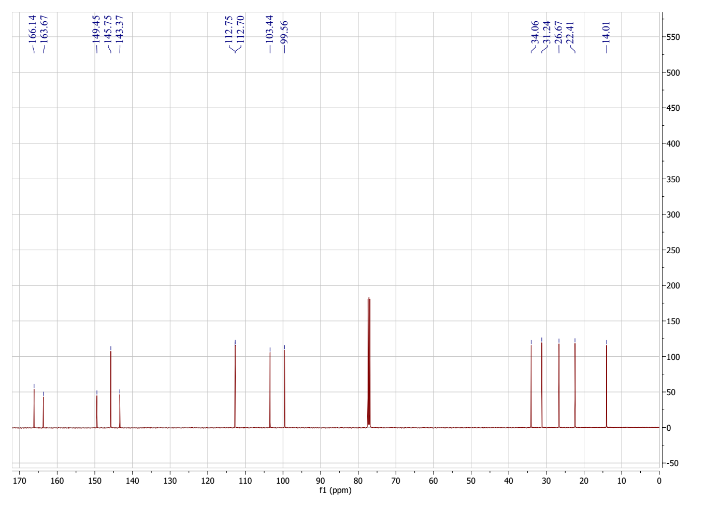
Figure 50. ¹³C NMR spectrum of 4-(furan-2-yl)-6-pentyl-2H-pyran-2-one (13)
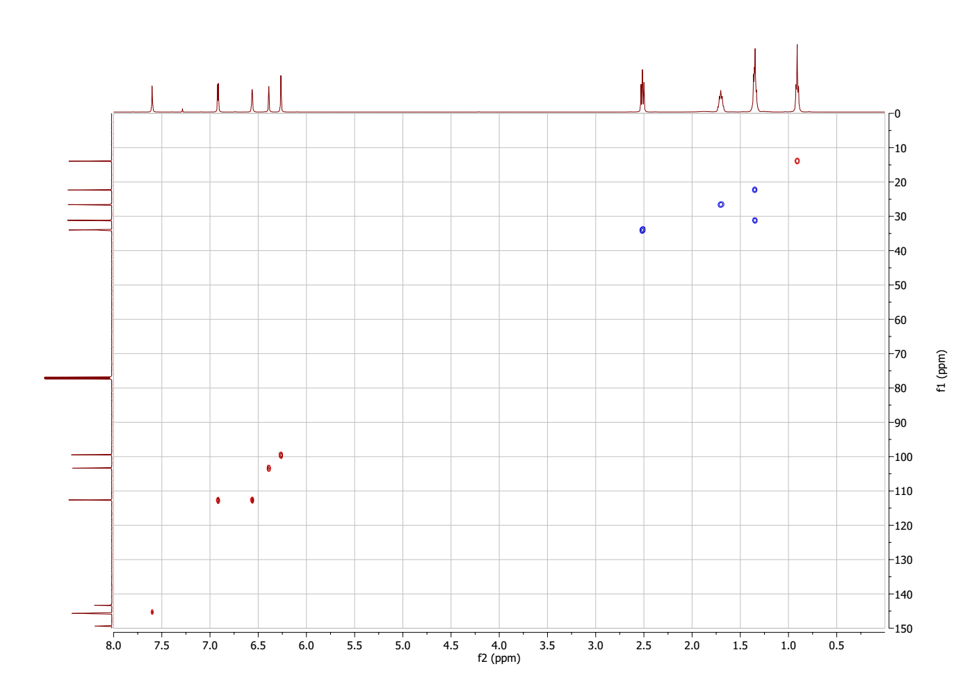
Figure 51. HSQC spectrum of 4-(furan-2-yl)-6-pentyl-2H-pyran-2-one (13)
Figure 52. MS spectrum of 4-(furan-2-yl)-6-pentyl-2H-pyran-2-one (13)
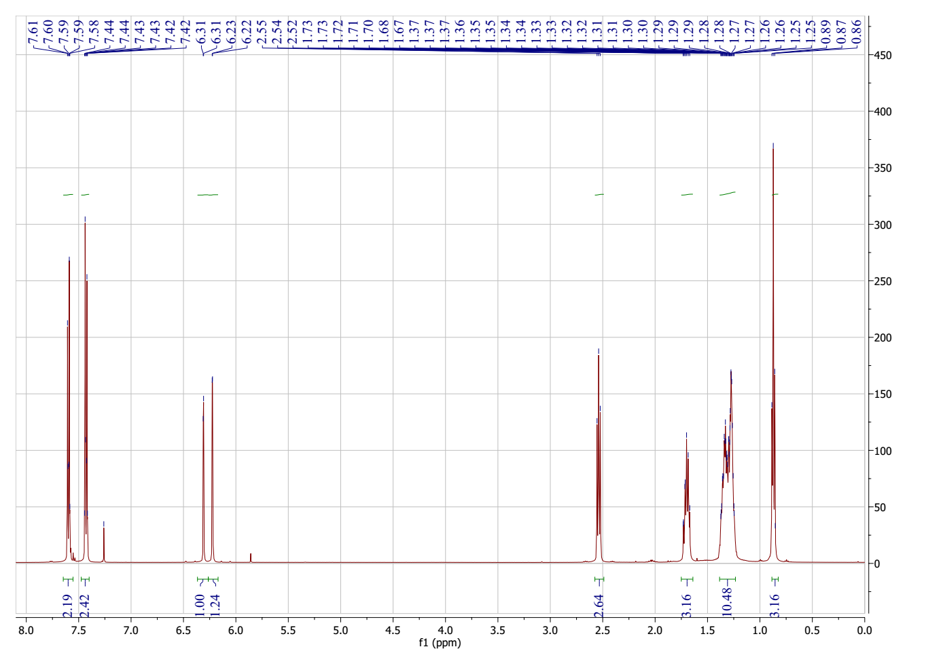
Figure 53. ¹H NMR spectrum of 4-(4-bromophenyl)-6-heptyl-2H-pyran-2-one (14)
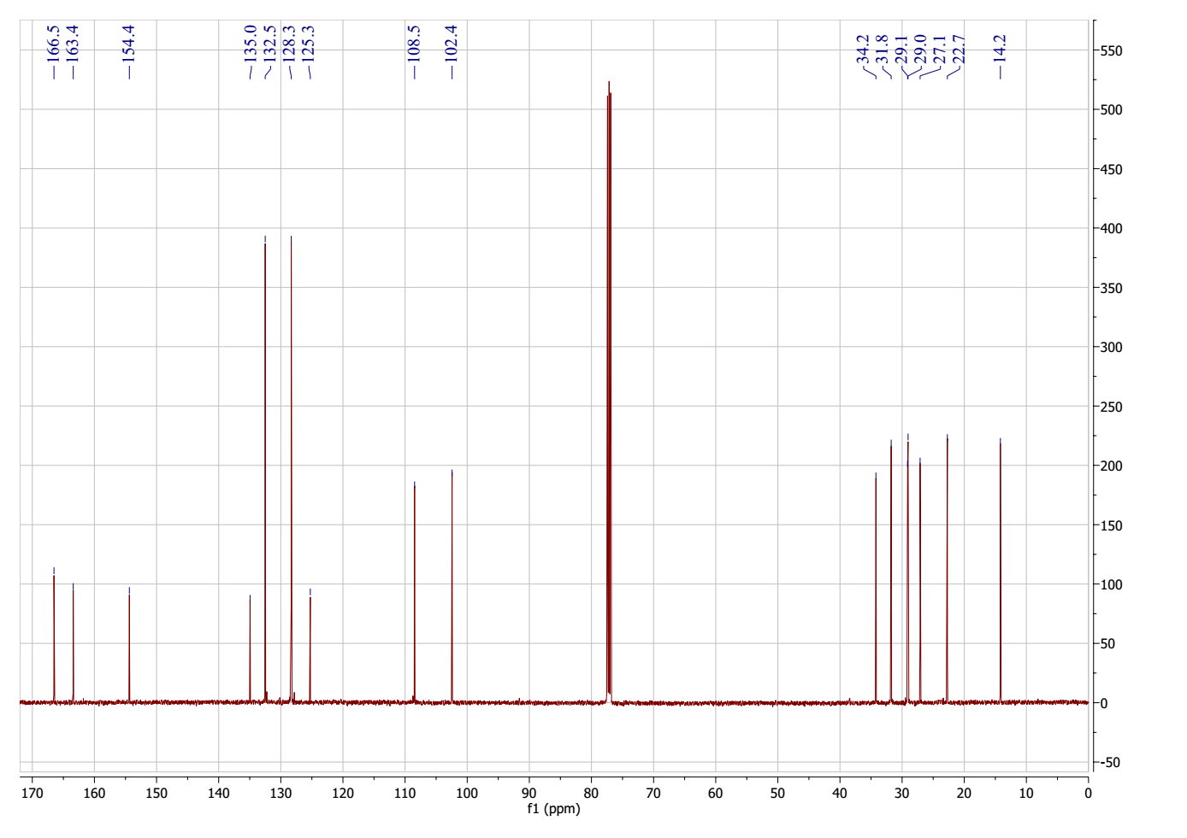
Figure 54. ¹³C NMR spectrum of 4-(4-bromophenyl)-6-heptyl-2H-pyran-2-one (14)
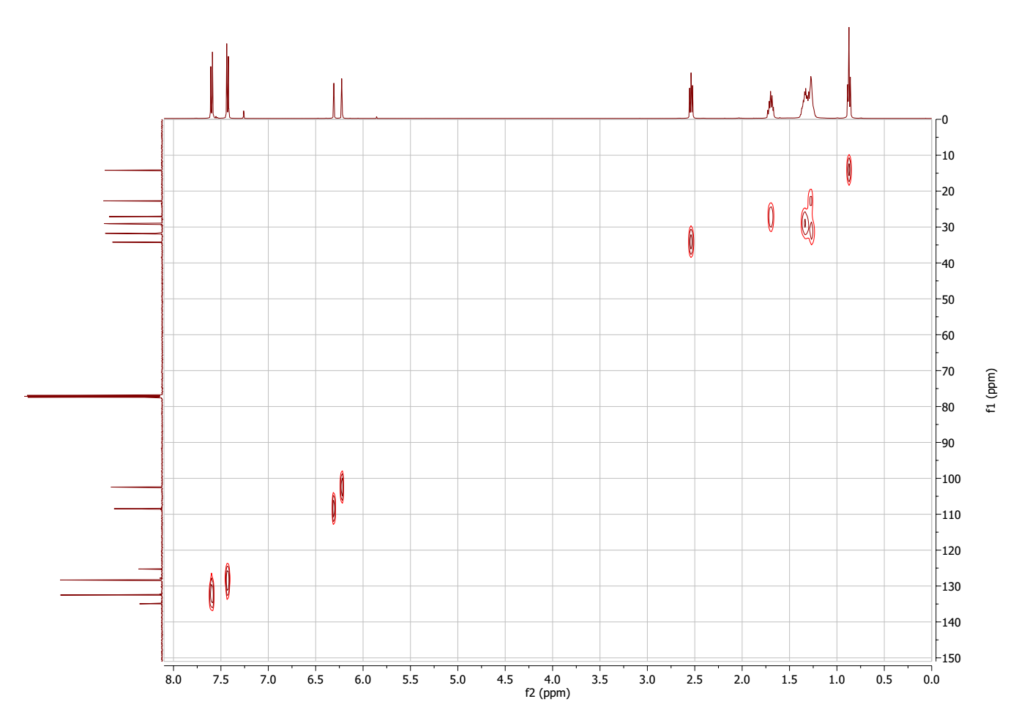
Figure 55. HSQC spectrum of 4-(4-bromophenyl)-6-heptyl-2H-pyran-2-one (14)
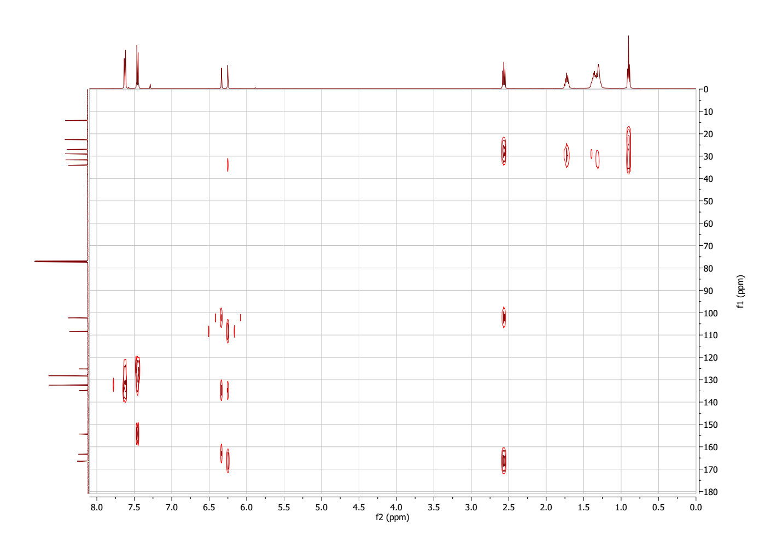
Figure 56. HMBC spectrum of 4-(4-bromophenyl)-6-heptyl-2H-pyran-2-one (14)
Figure 57. MS spectrum of 4-(4-bromophenyl)-6-heptyl-2H-pyran-2-one (14)

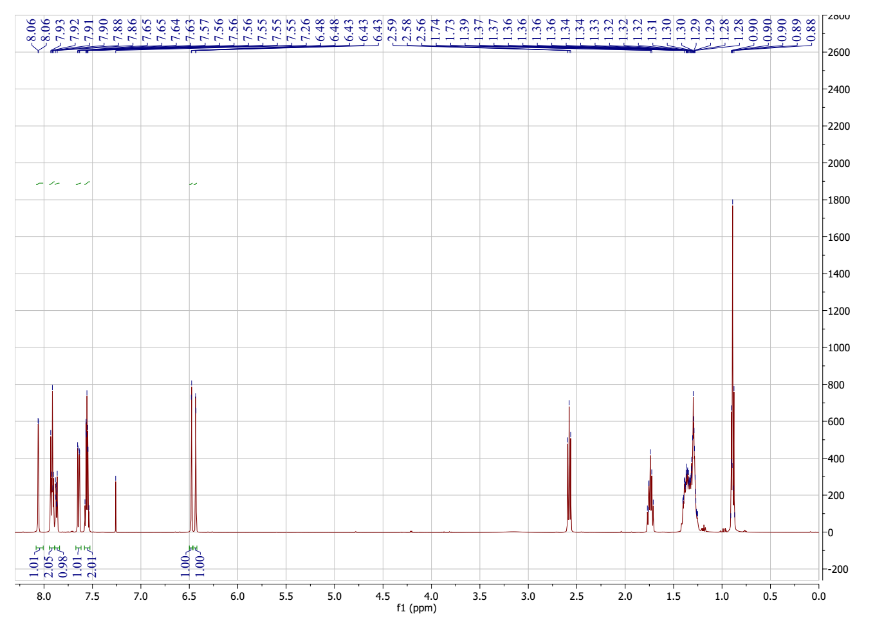
Figure 58. ¹H NMR spectrum of 6-heptyl-4-(prop-1-en-2-yl)-2H-pyran-2-one (15)
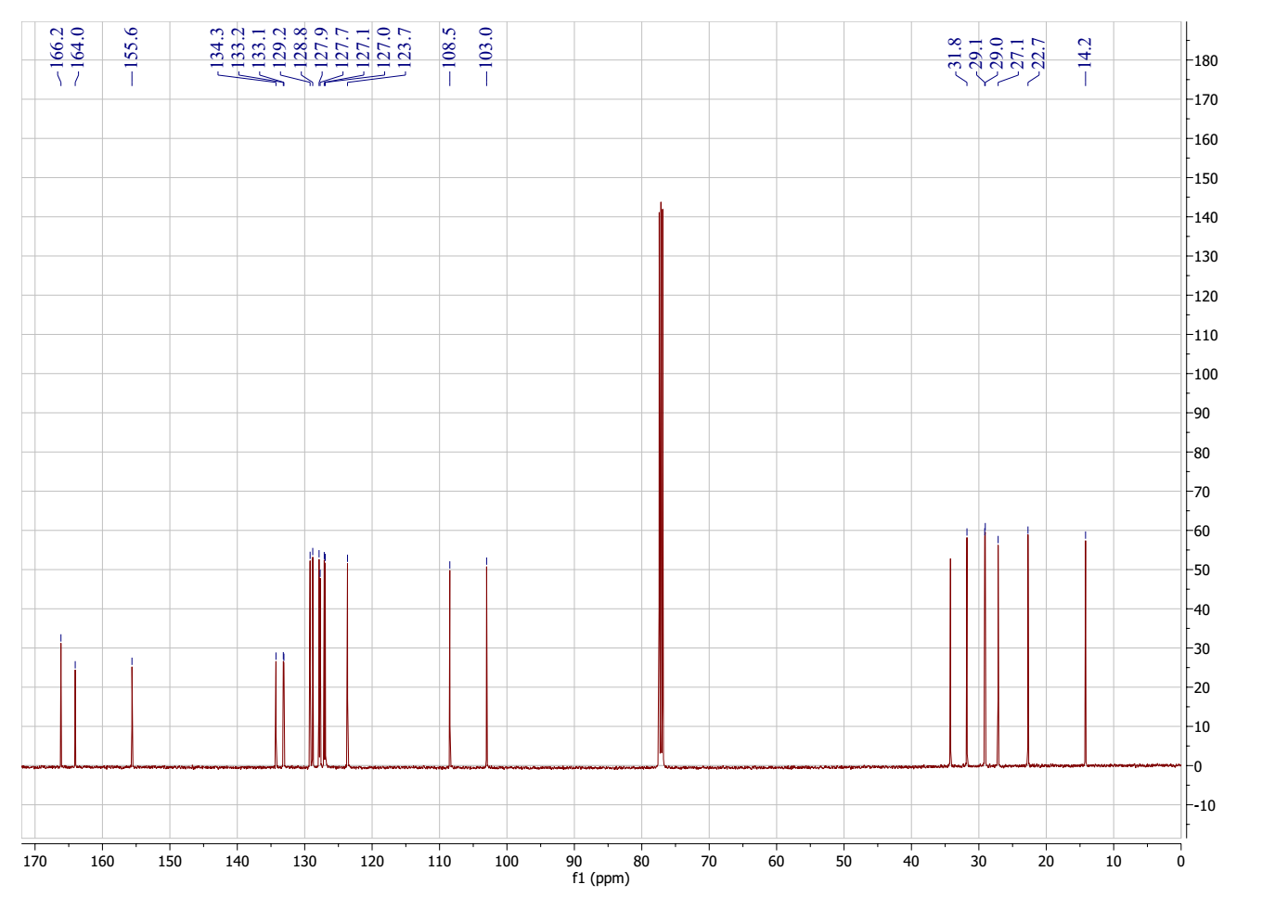
Figure 59. ¹³C NMR spectrum of 6-heptyl-4-(prop-1-en-2-yl)-2H-pyran-2-one (15)
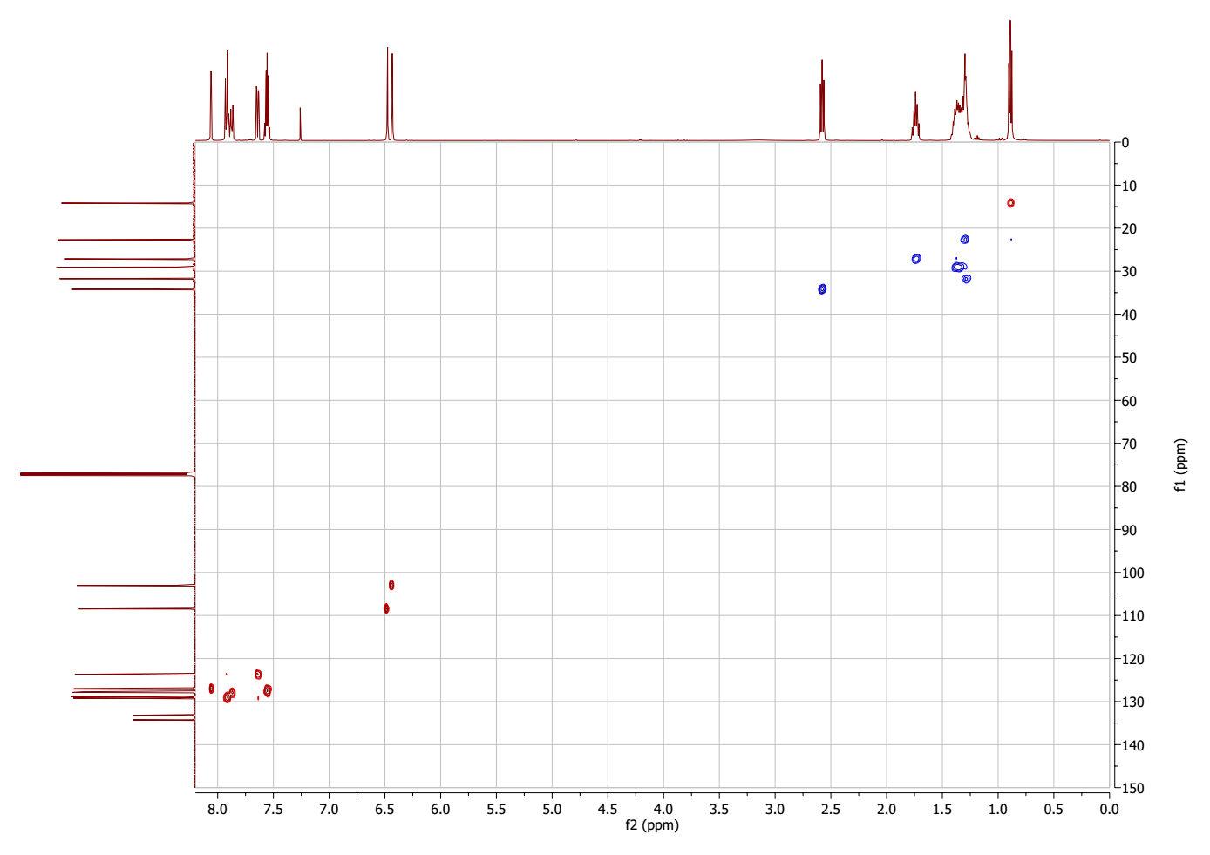
Figure 60. HSQC spectrum of 6-heptyl-4-(prop-1-en-2-yl)-2H-pyran-2-one (15)
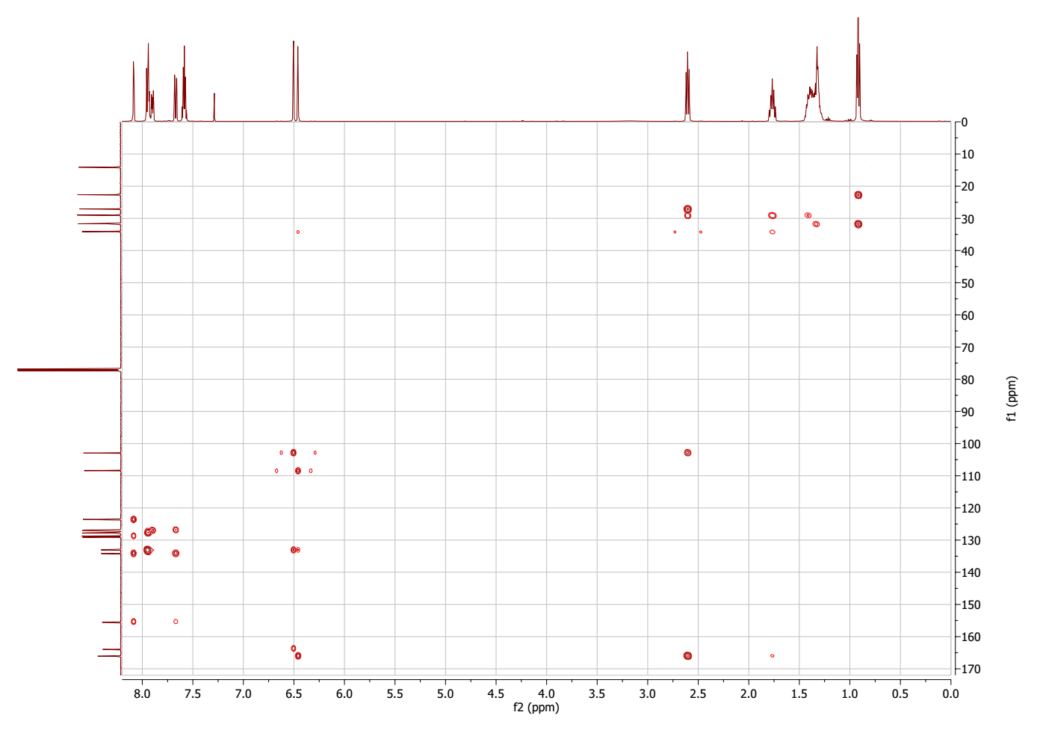
Figure 61. HMBC spectrum of 6-heptyl-4-(prop-1-en-2-yl)-2H-pyran-2-one (15)
Figure 62. MS spectrum of 6-heptyl-4-(prop-1-en-2-yl)-2H-pyran-2-one (15)
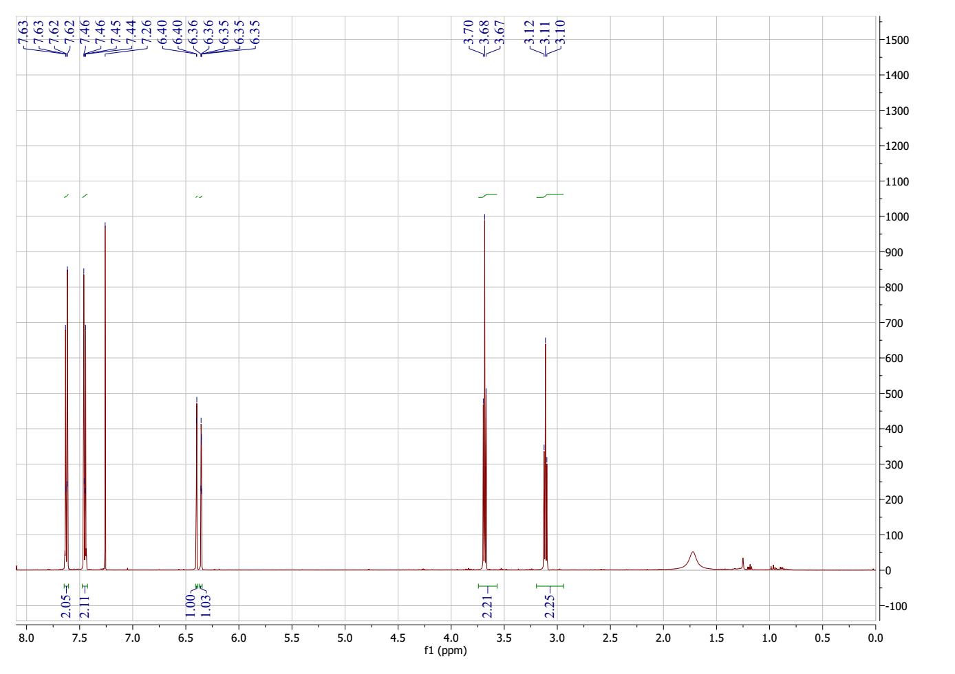
Figure 63. ¹H NMR spectrum of 6-(2-bromoethyl)-4-(4-bromophenyl)-2H-pyran-2-one (16)
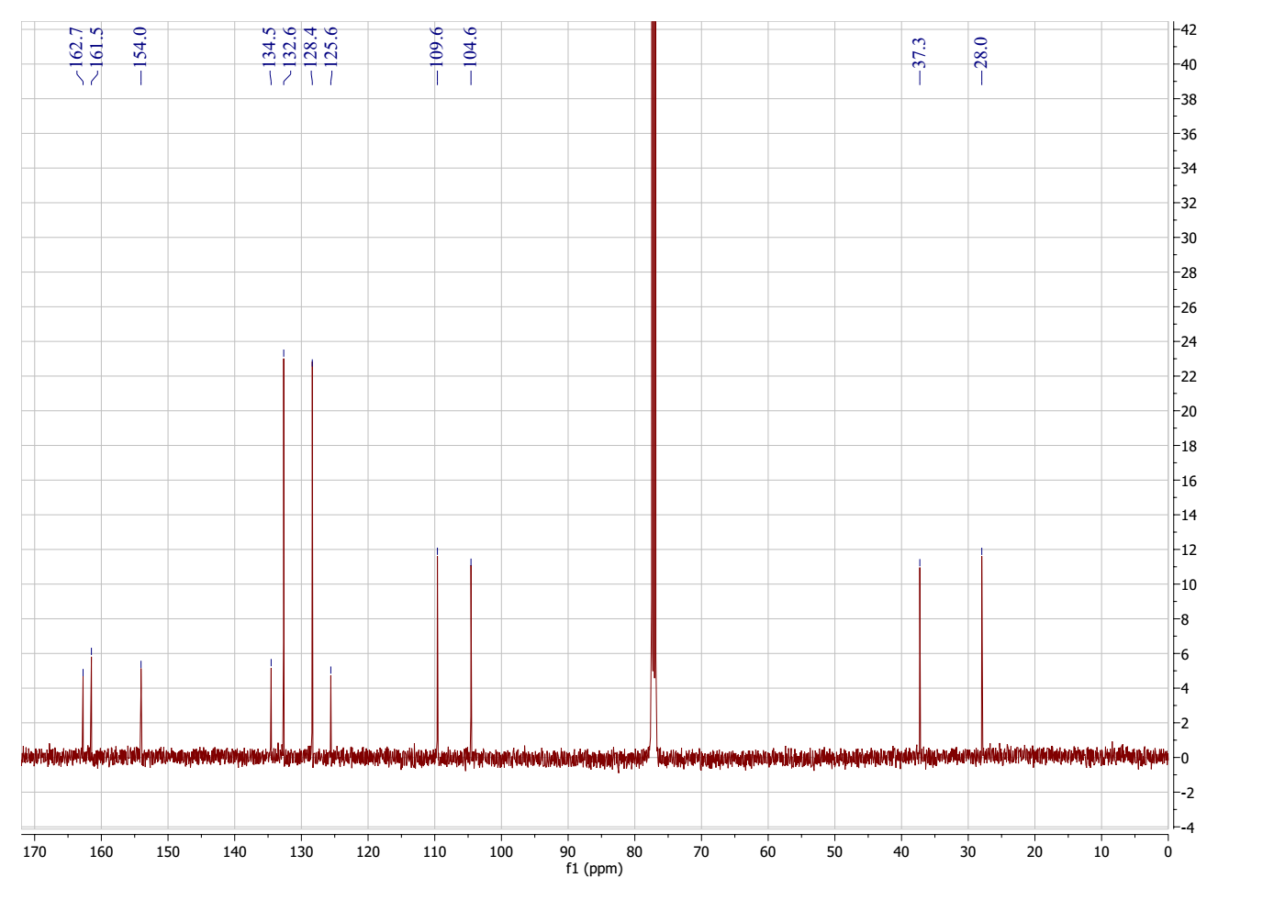
Figure 64. ¹³C NMR spectrum of 6-(2-bromoethyl)-4-(4-bromophenyl)-2H-pyran-2-one (16)
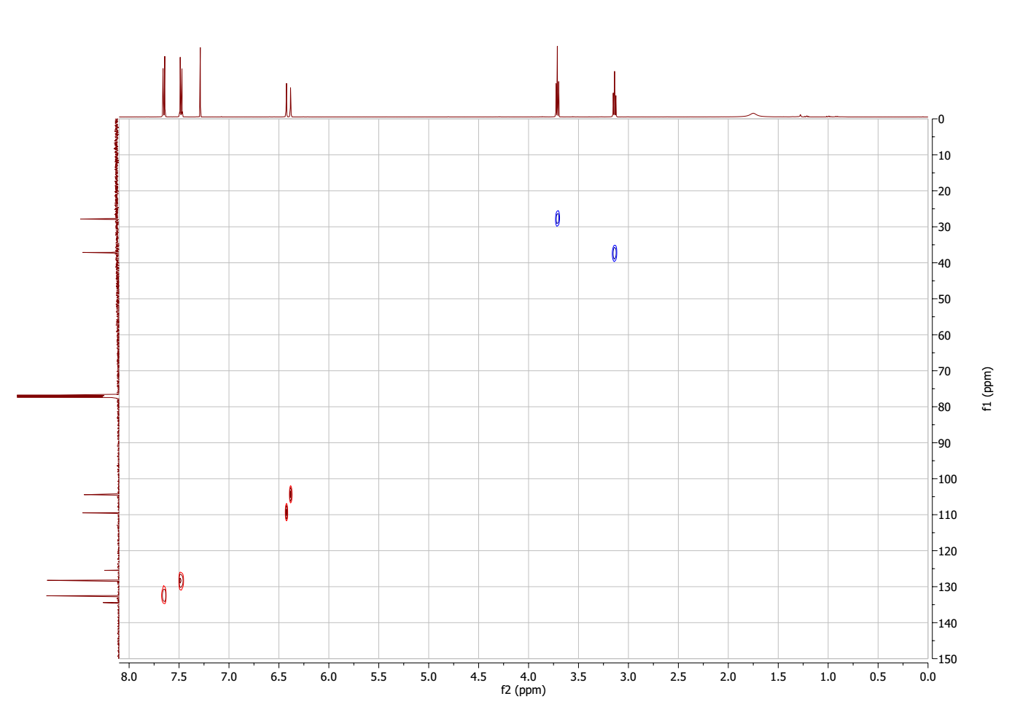
Figure 65. HSQC spectrum of 6-(2-bromoethyl)-4-(4-bromophenyl)-2H-pyran-2-one (16)
Figure 66. MS spectrum of 6-(2-bromoethyl)-4-(4-bromophenyl)-2H-pyran-2-one (16)
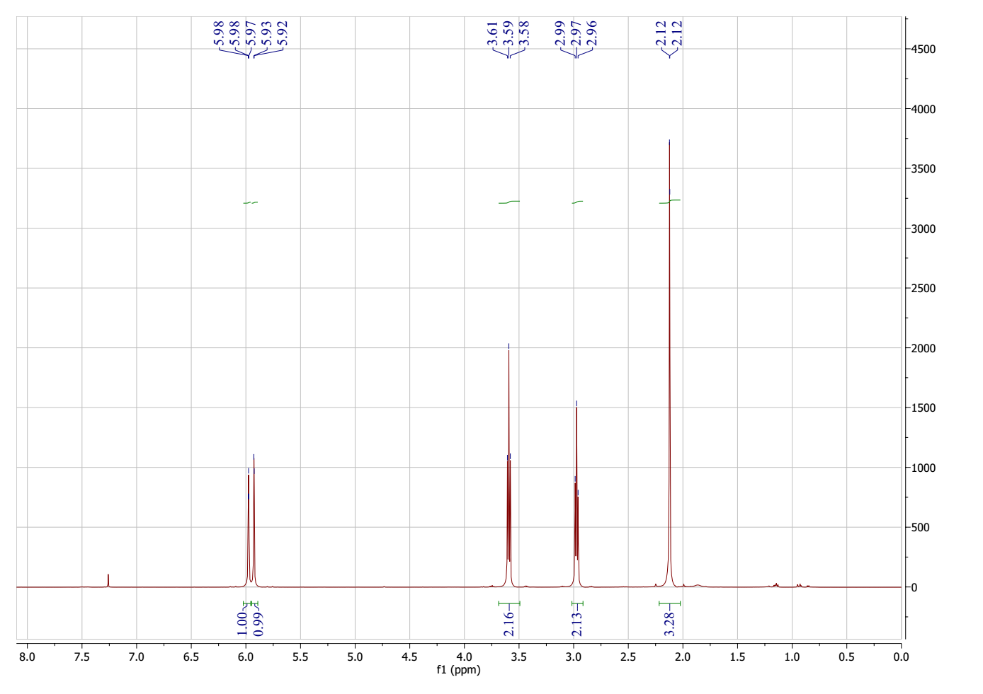
Figure 67. ¹H NMR spectrum of 6-(2-bromoethyl)-4-methyl-2H-pyran-2-one (17)
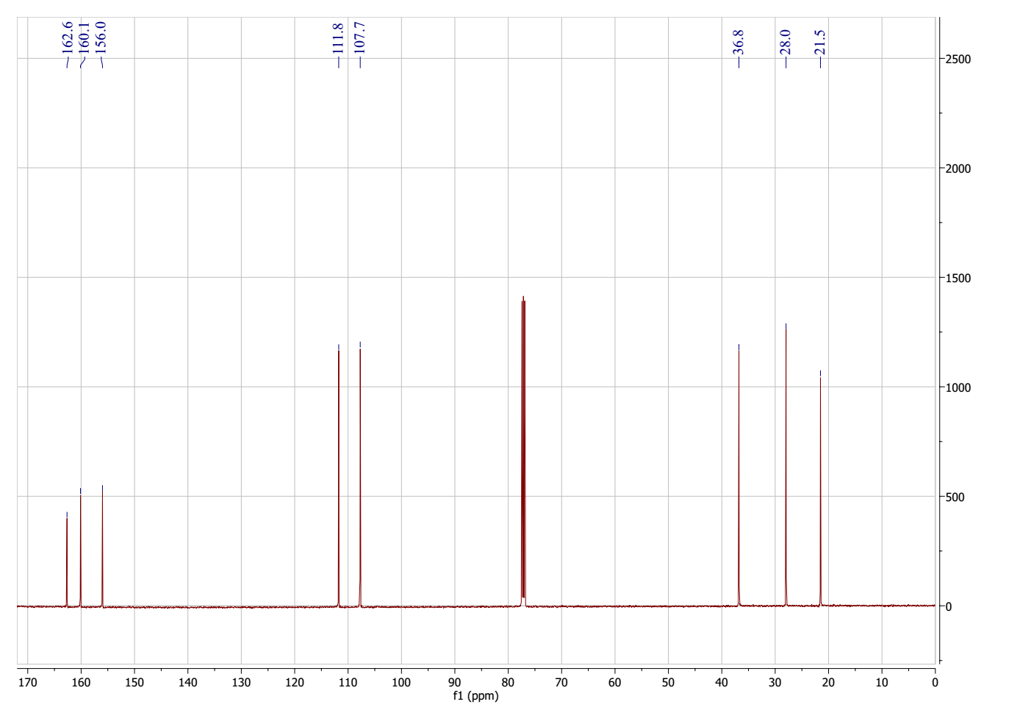
Figure 68. ¹³C NMR spectrum of 6-(2-bromoethyl)-4-methyl-2H-pyran-2-one (17)
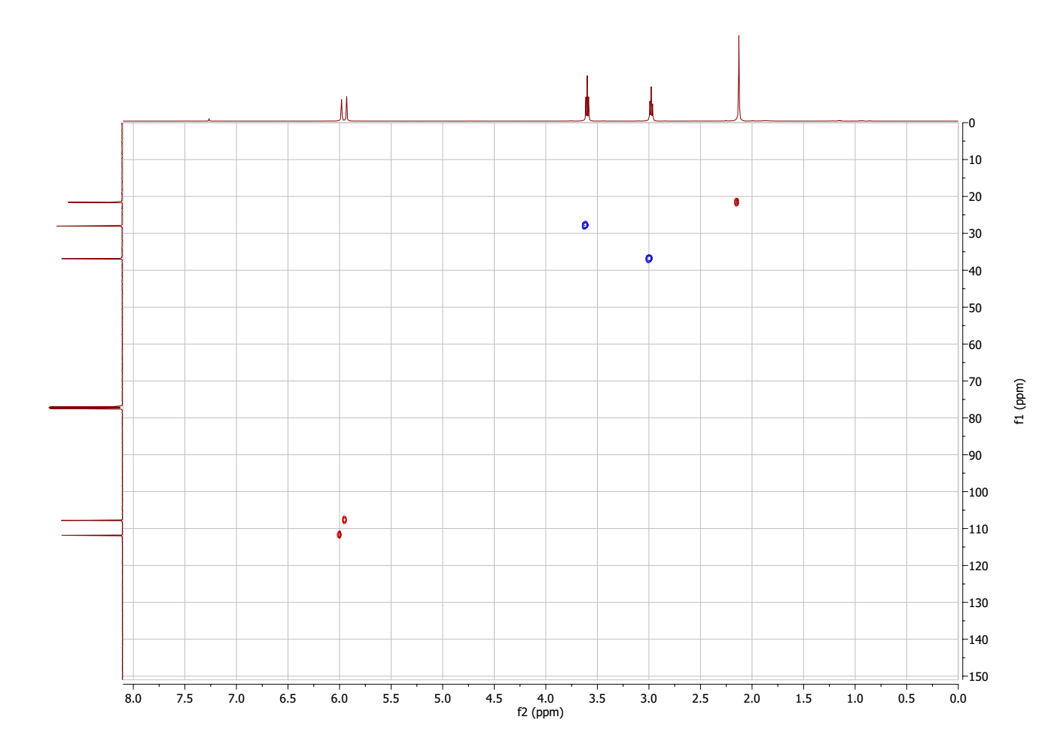
Figure 69. HSQC spectrum of 6-(2-bromoethyl)-4-methyl-2H-pyran-2-one (17)
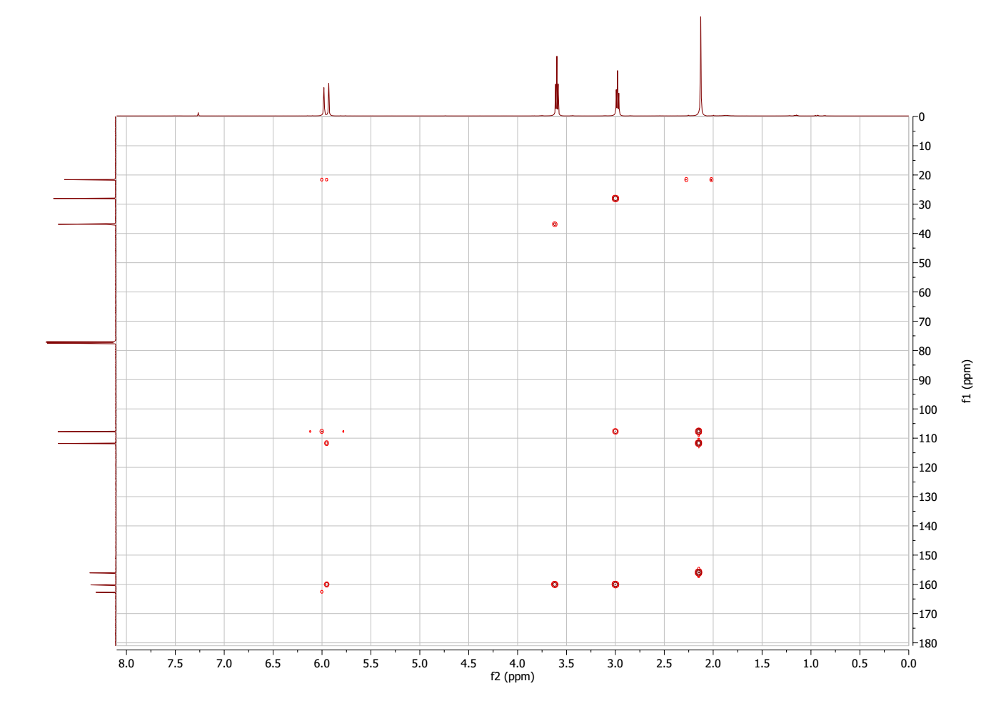
Figure 70. HMBC spectrum of 6-(2-bromoethyl)-4-methyl-2H-pyran-2-one (17)
Figure 71. HMBC NMR spectrum of 6-(2-bromoethyl)-4-methyl-2H-pyran-2-one (17)
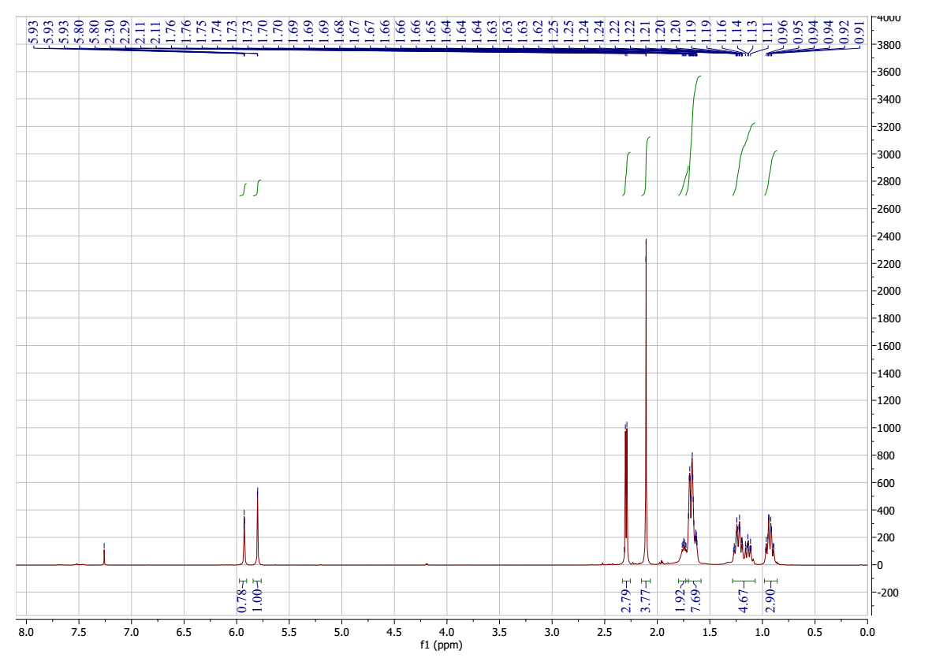
Figure 72. ¹H NMR spectrum of 6-(4-chlorobutyl)-2H-pyran-2-one (18)
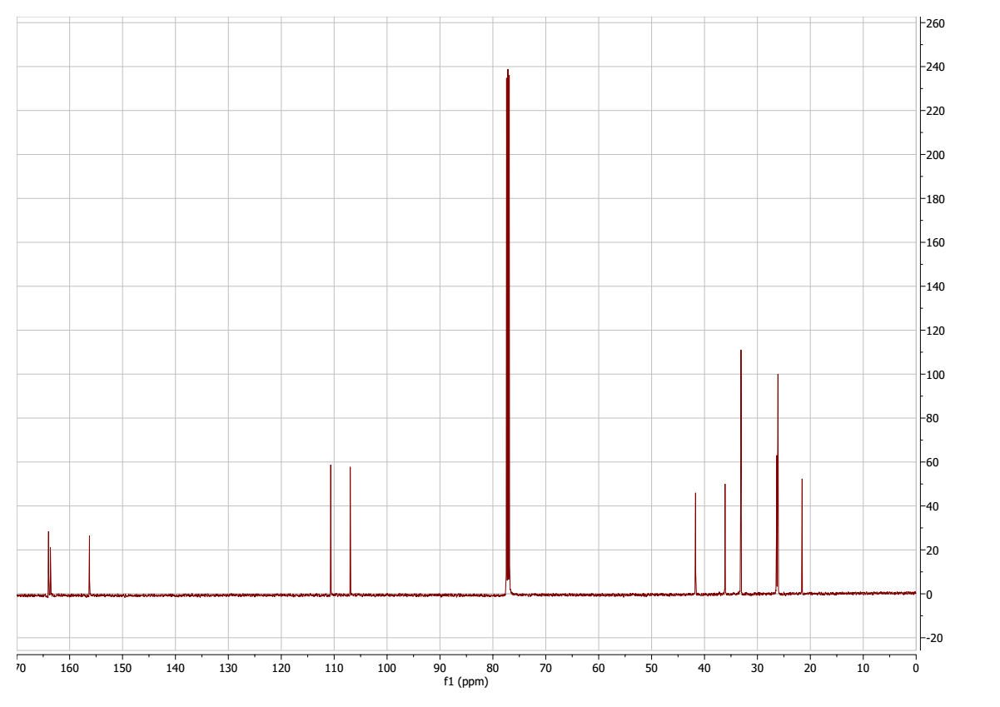
Figure 73. ¹³C NMR spectrum of 6-(4-chlorobutyl)-2H-pyran-2-one (18)
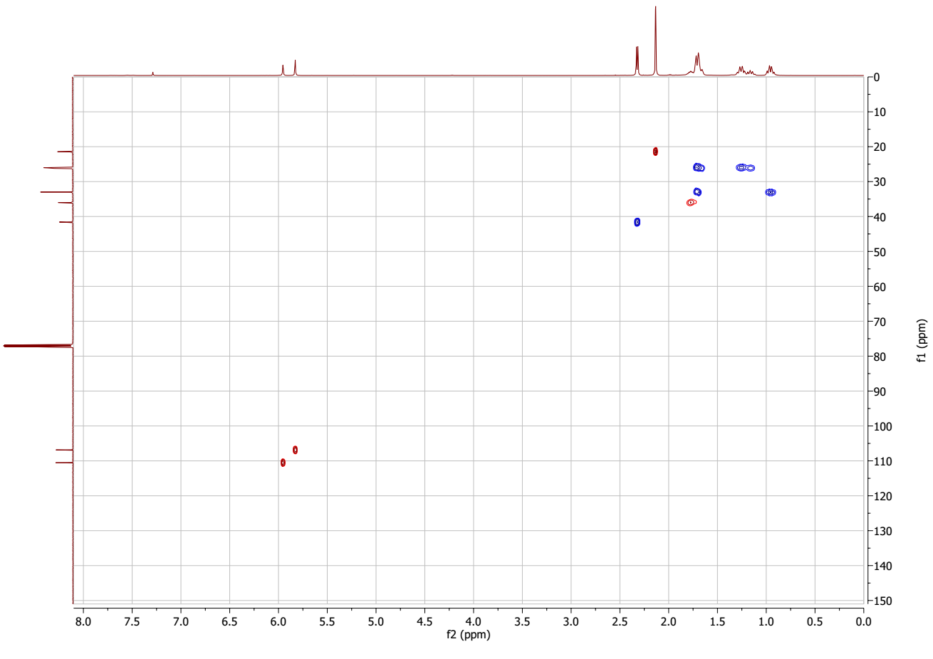
Figure 74. HSQC spectrum of 6-(4-chlorobutyl)-2H-pyran-2-one (18)
Figure 75. MS spectrum of 6-(4-chlorobutyl)-2H-pyran-2-one (18)
Figure 76. ¹H NMR spectrum of 6-(cyclohexylmethyl)-4-phenyl-2H-pyran-2-one (19)
Figure 77. ¹³C NMR spectrum of 6-(cyclohexylmethyl)-4-phenyl-2H-pyran-2-one (19)
Figure 78. HSQC spectrum of 6-(cyclohexylmethyl)-4-phenyl-2H-pyran-2-one (19)
Figure 79. MS spectrum of 6-(cyclohexylmethyl)-4-phenyl-2H-pyran-2-one (19)
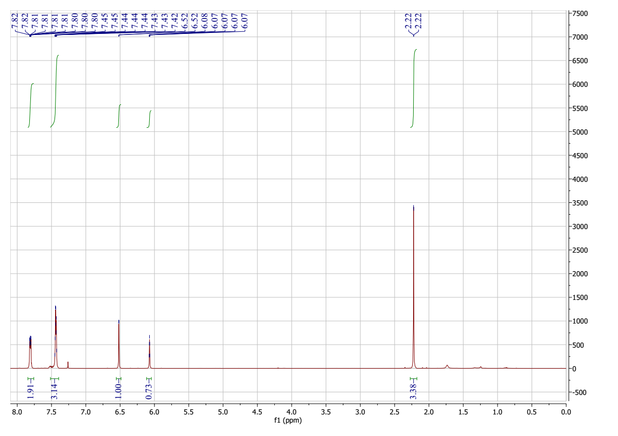
Figure 80. ¹H NMR spectrum of 4-methyl-6-phenyl-2H-pyran-2-one (20)
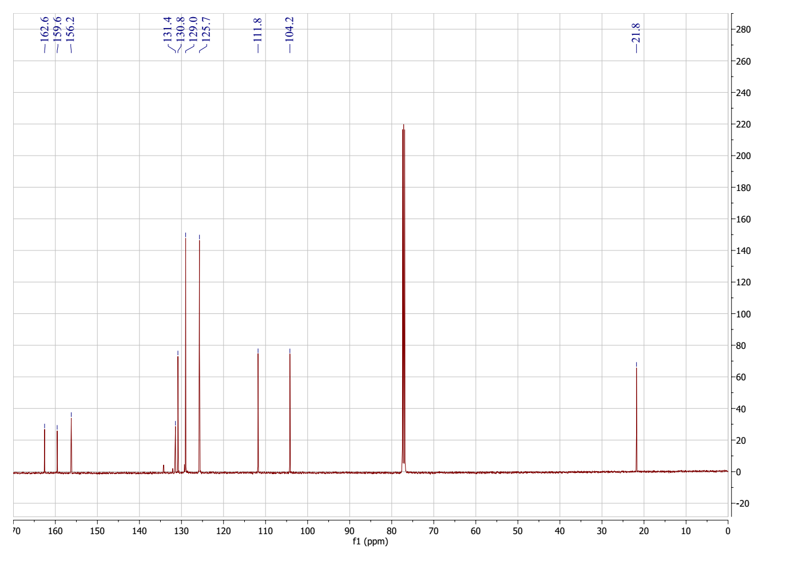
Figure 81. ¹³C NMR spectrum of 4-methyl-6-phenyl-2H-pyran-2-one (20)
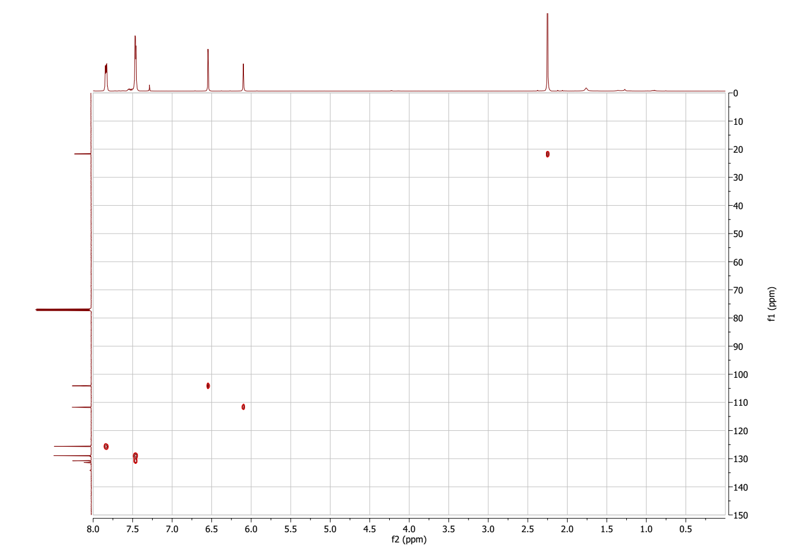
Figure 82. HSQC spectrum of 4-methyl-6-phenyl-2H-pyran-2-one (20)
Figure 83. MS spectrum of 4-methyl-6-phenyl-2H-pyran-2-one (20)

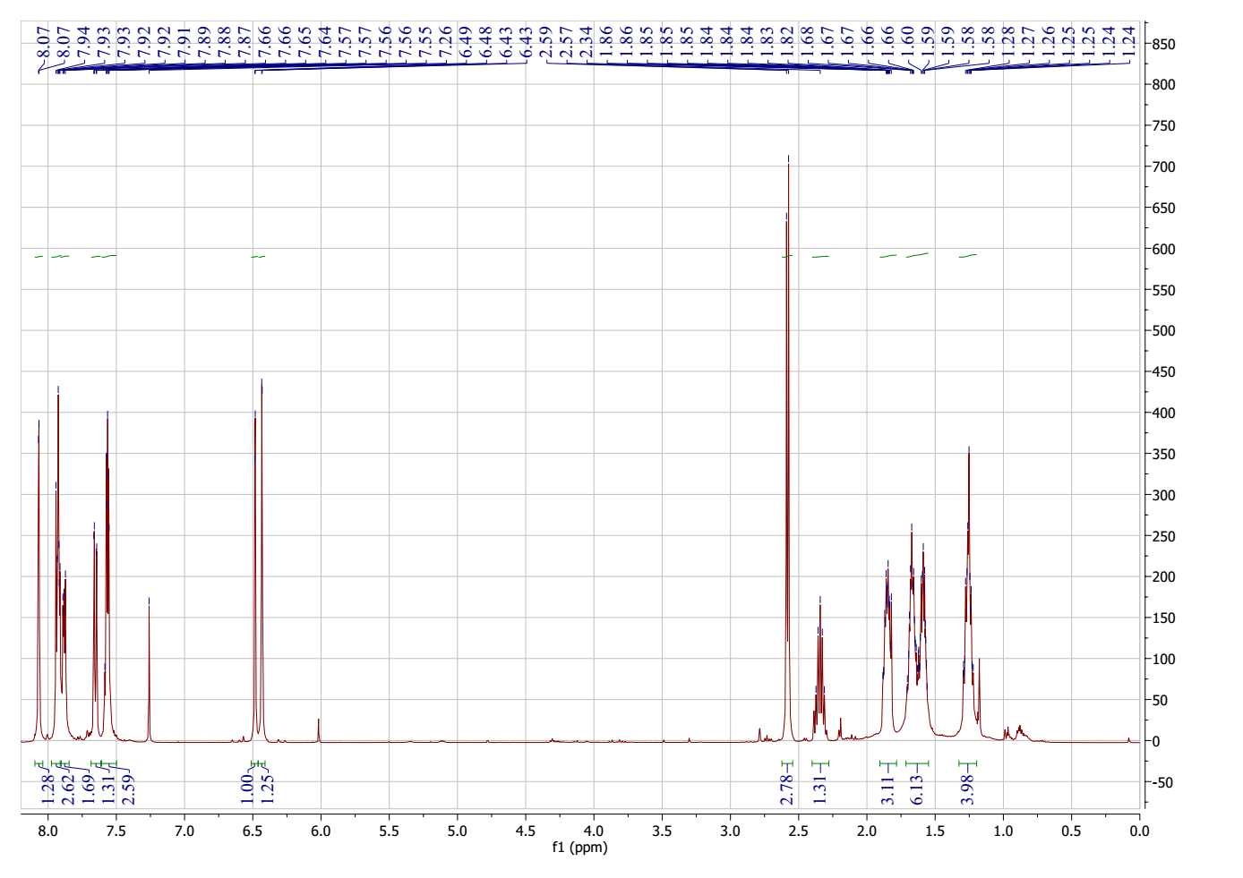
Figure 84. ¹H NMR spectrum of 6-(cyclopentylmethyl)-4-(naphthalen-2-yl)-2H-pyran-2-one (21)
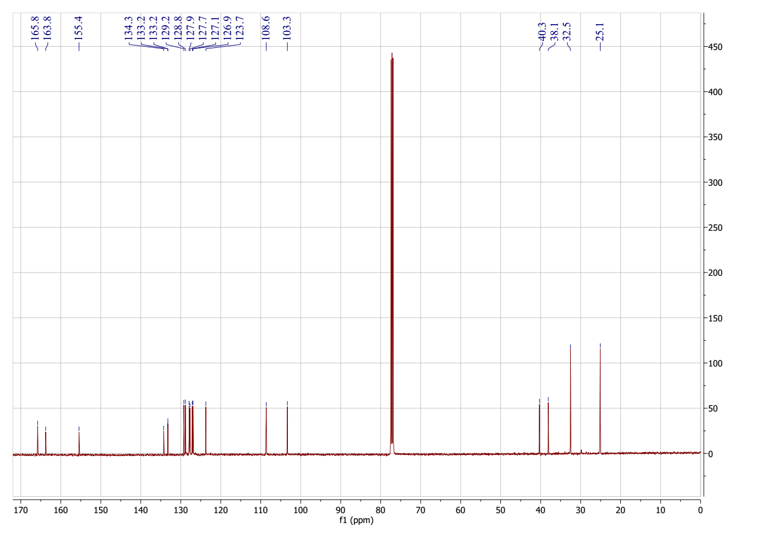
Figure 85. ¹³C NMR spectrum of 6-(cyclopentylmethyl)-4-(naphthalen-2-yl)-2H-pyran-2-one (21)
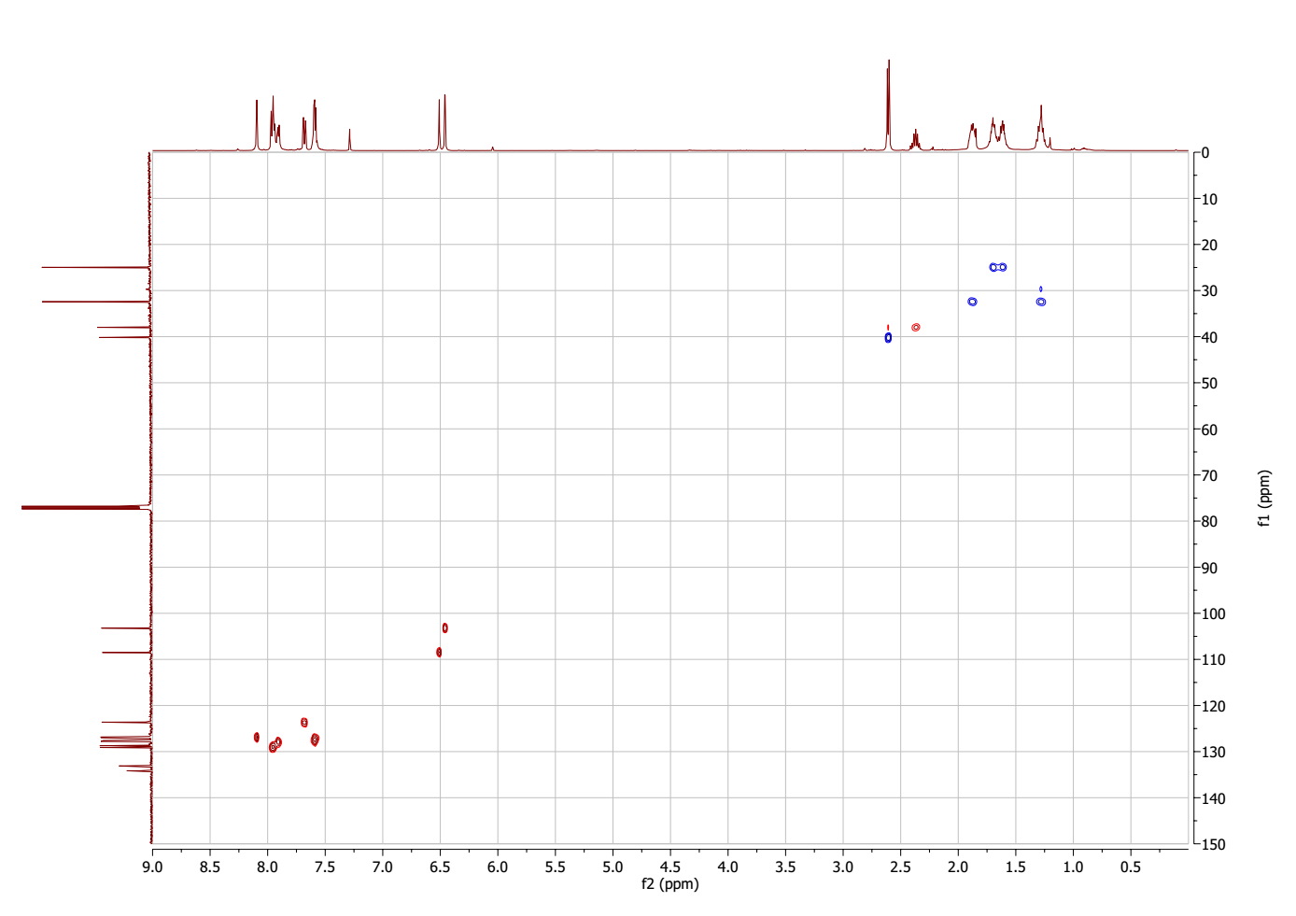
Figure 86. HSQC spectrum of 6-(cyclopentylmethyl)-4-(naphthalen-2-yl)-2H-pyran-2-one (21)
Figure 87. MS spectrum of 6-(cyclopentylmethyl)-4-(naphthalen-2-yl)-2H-pyran-2-one (21)
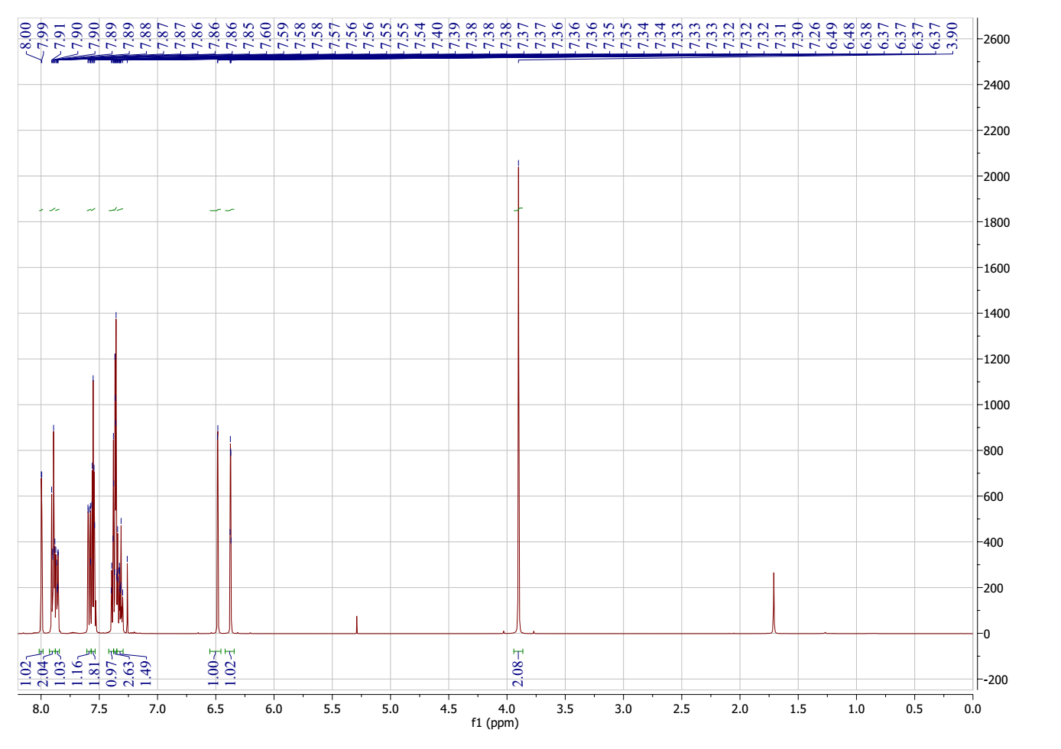
Figure 88. ¹H NMR spectrum of 6-benzyl-4-(prop-1-en-2-yl)-2H-pyran-2-one (22)

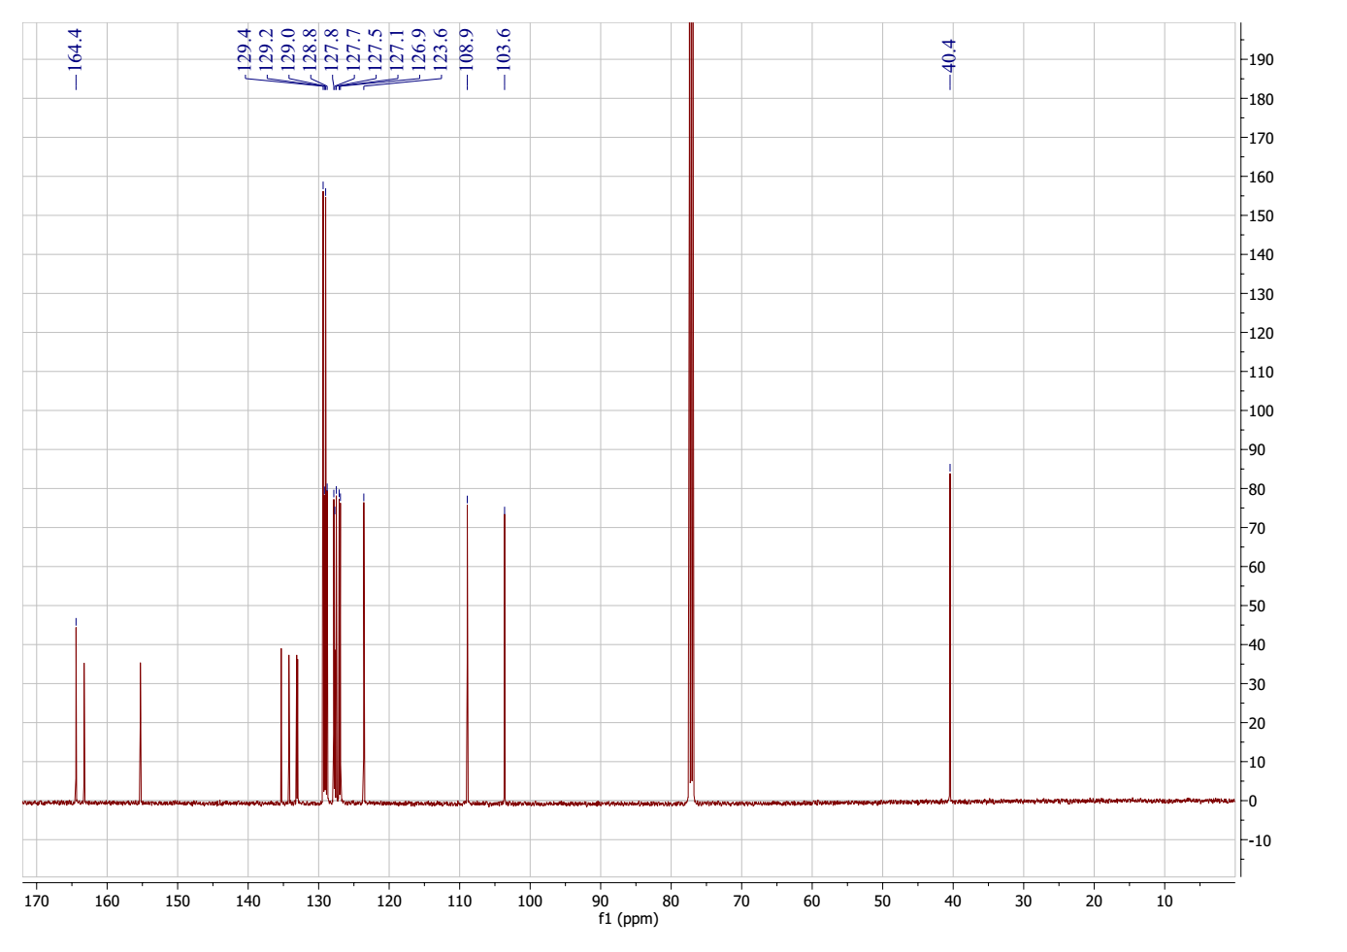
Figure 89. ¹³C NMR spectrum of 6-benzyl-4-(prop-1-en-2-yl)-2H-pyran-2-one (22)
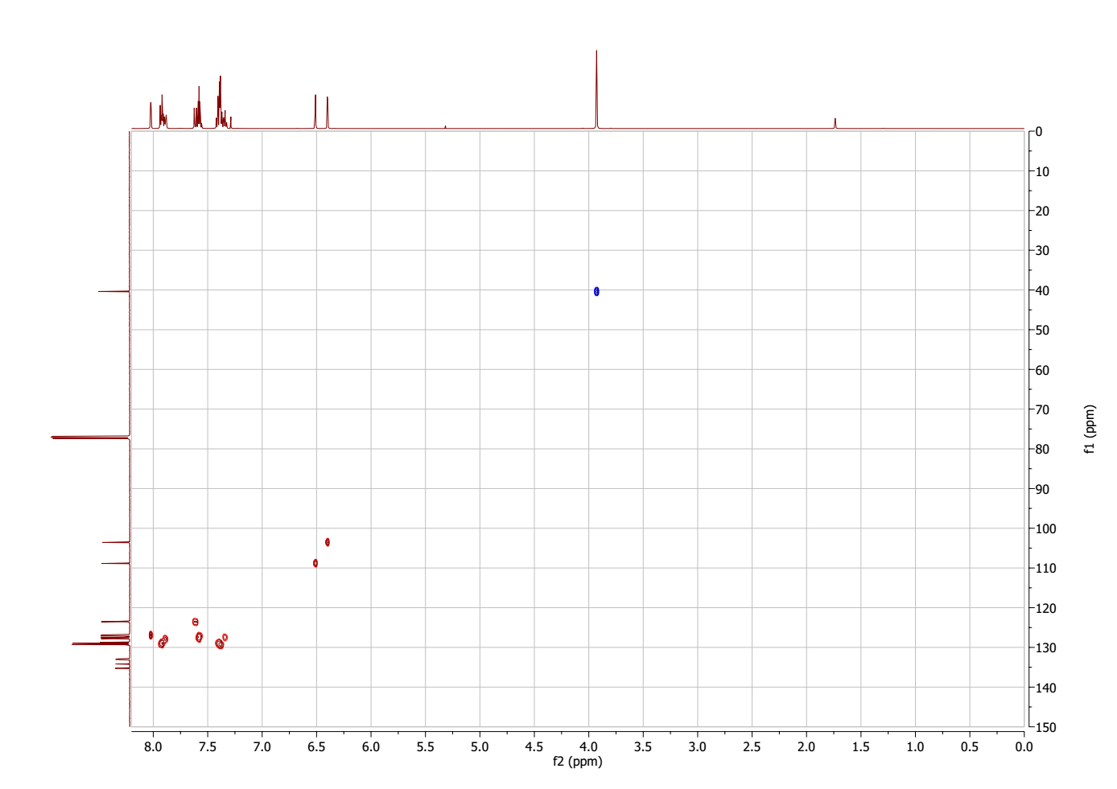
Figure 90. HSQC NMR spectrum of 6-benzyl-4-(prop-1-en-2-yl)-2H-pyran-2-one (22)
Figure 91. MS spectrum of 6-benzyl-4-(prop-1-en-2-yl)-2H-pyran-2-one (22)
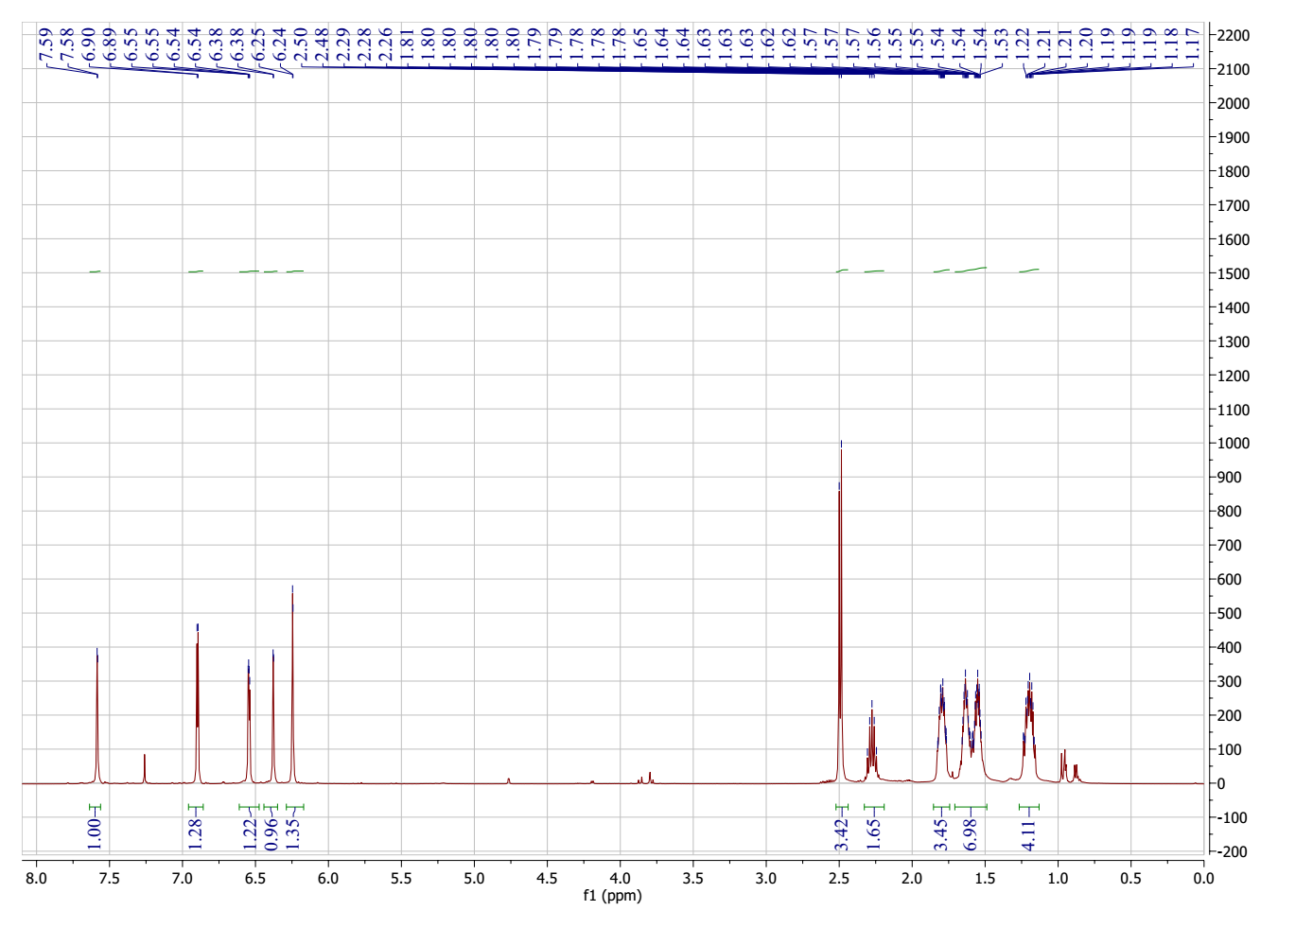
Figure 92. ¹H NMR spectrum of 6-(cyclopentylmethyl)-4-(furan-2-yl)-2H-pyran-2-one (23)
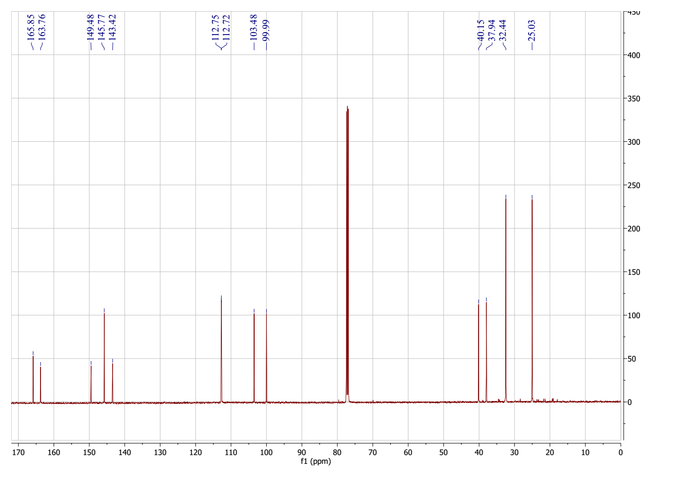
Figure 93. ¹³C NMR spectrum of 6-(cyclopentylmethyl)-4-(furan-2-yl)-2H-pyran-2-one (23)
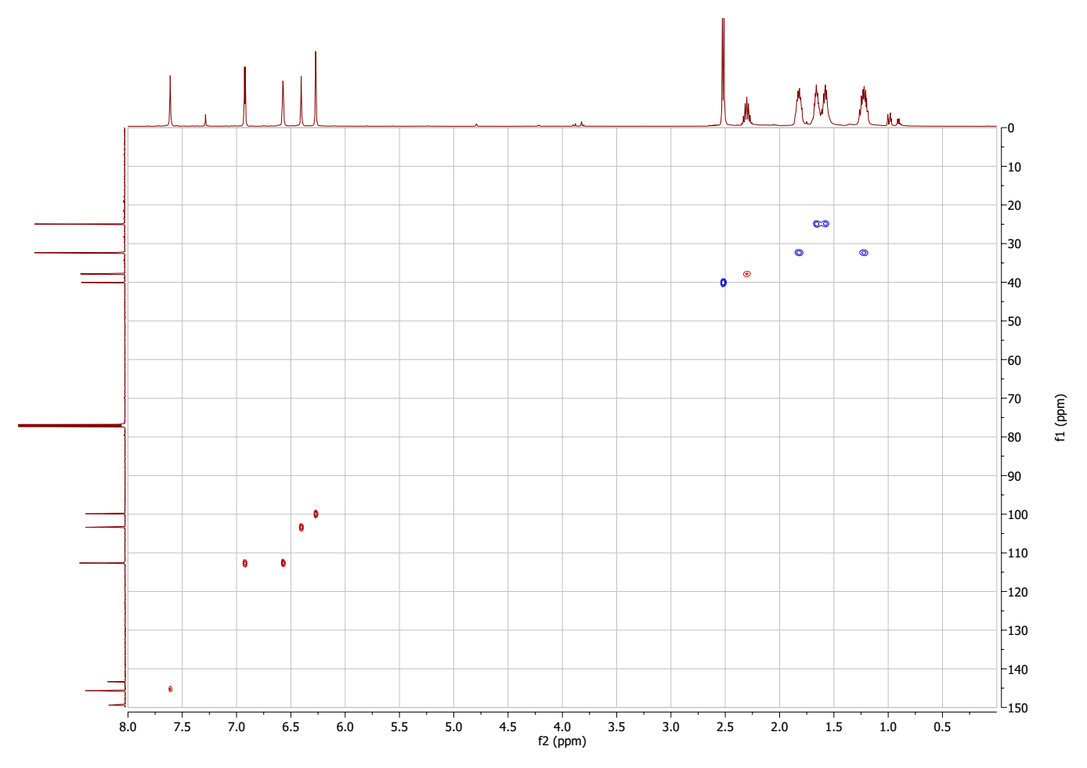
Figure 94. HSQC spectrum of 6-(cyclopentylmethyl)-4-(furan-2-yl)-2H-pyran-2-one (23)
Figure 95. MS spectrum of 6-(cyclopentylmethyl)-4-(furan-2-yl)-2H-pyran-2-one (23)
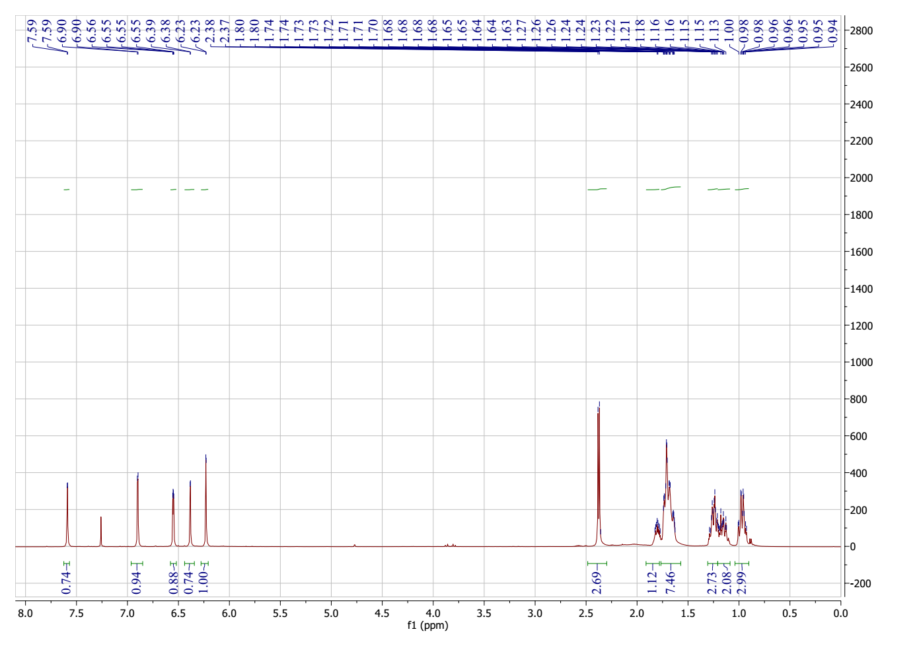
Figure 96. ¹H NMR spectrum of 6-(cyclohexylmethyl)-4-(furan-2-yl)-2H-pyran-2-one (24)
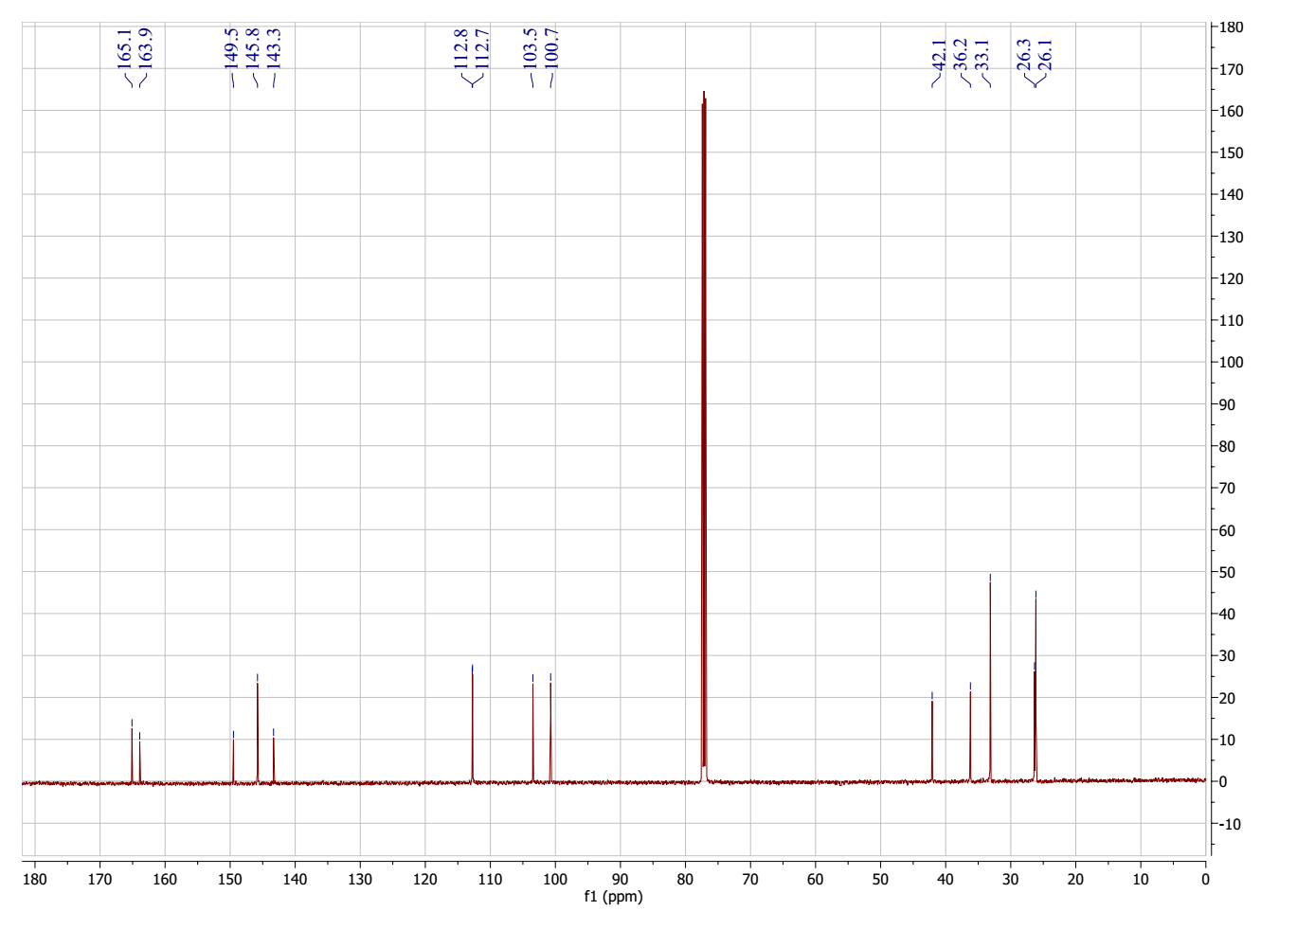
Figure 97. ¹³C NMR spectrum of 6-(cyclohexylmethyl)-4-(furan-2-yl)-2H-pyran-2-one (24)
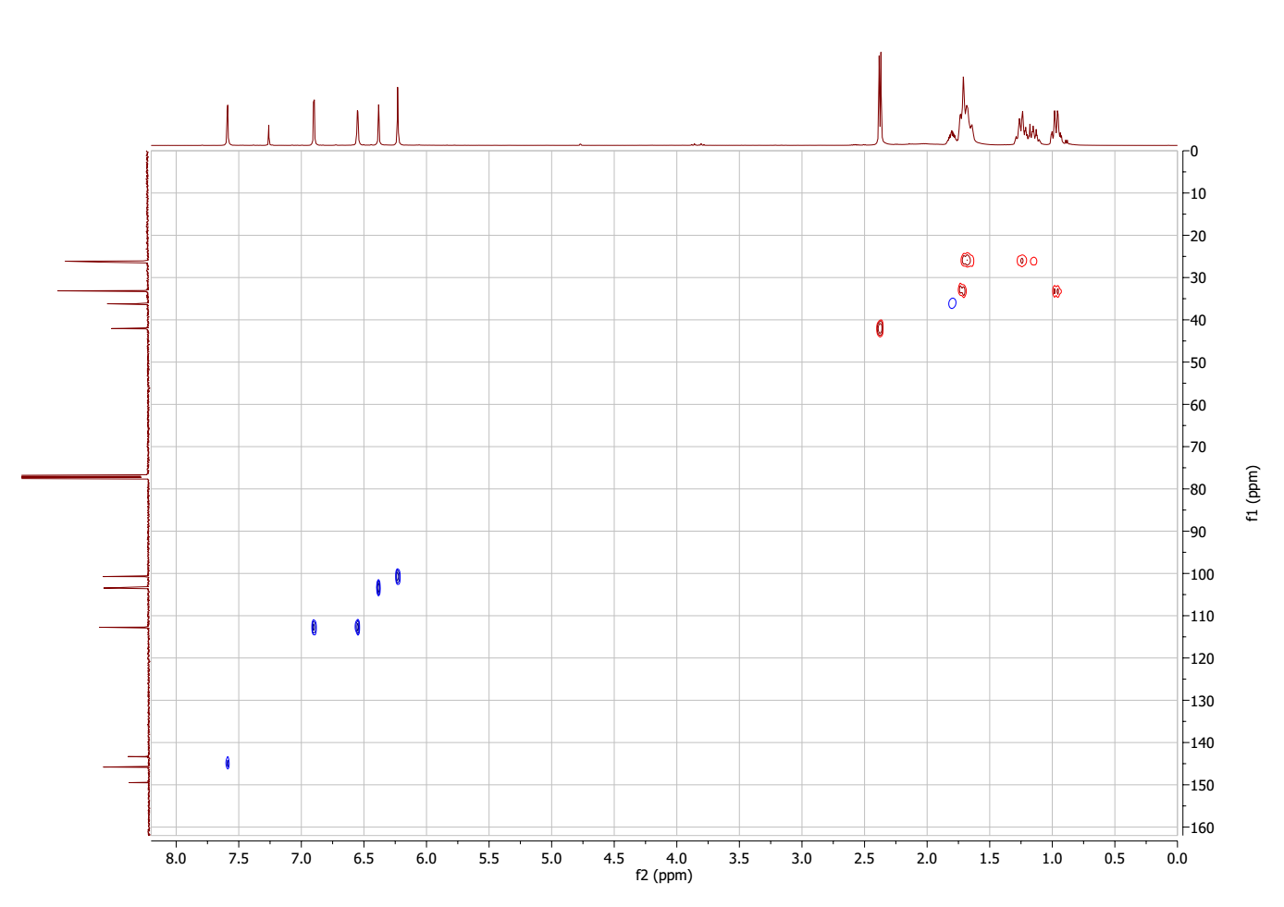
Figure 98. HSQC spectrum of 6-(cyclohexylmethyl)-4-(furan-2-yl)-2H-pyran-2-one (24)
Figure 99. MS spectrum of 6-(cyclohexylmethyl)-4-(furan-2-yl)-2H-pyran-2-one (24)

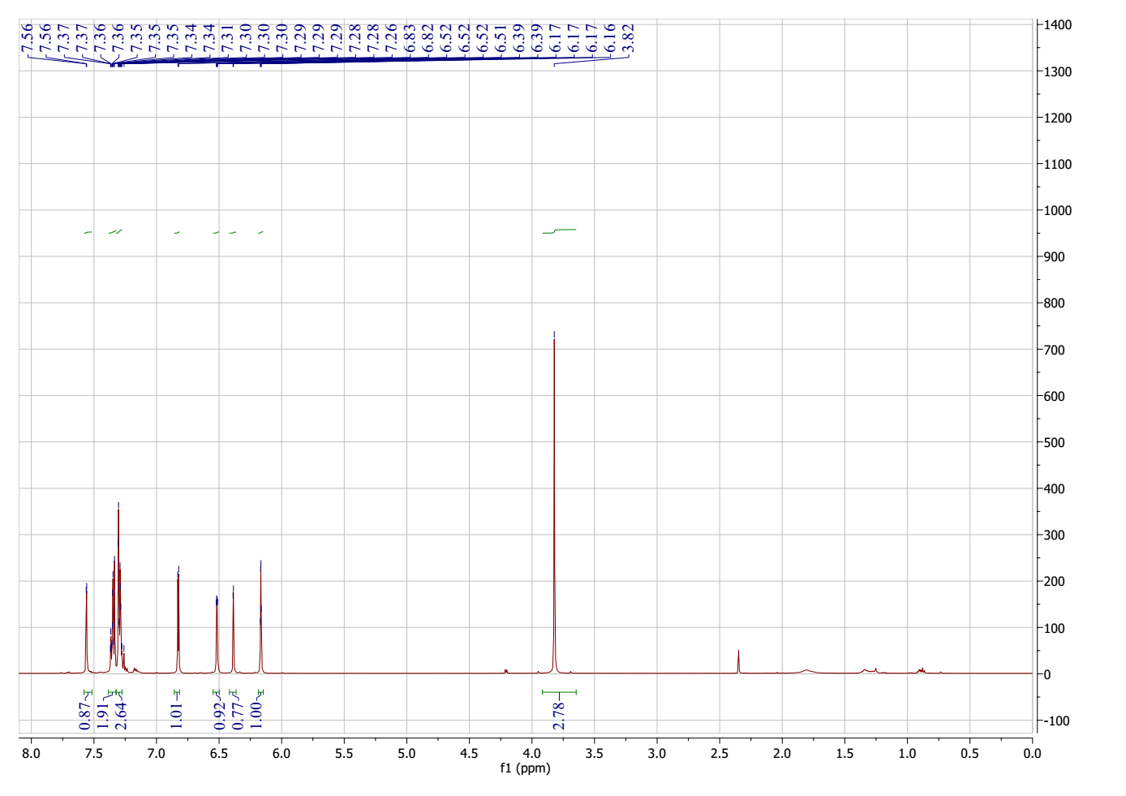
Figure 100. ¹H NMR spectrum of 6-benzyl-4-(furan-2-yl)-2H-pyran-2-one (25)
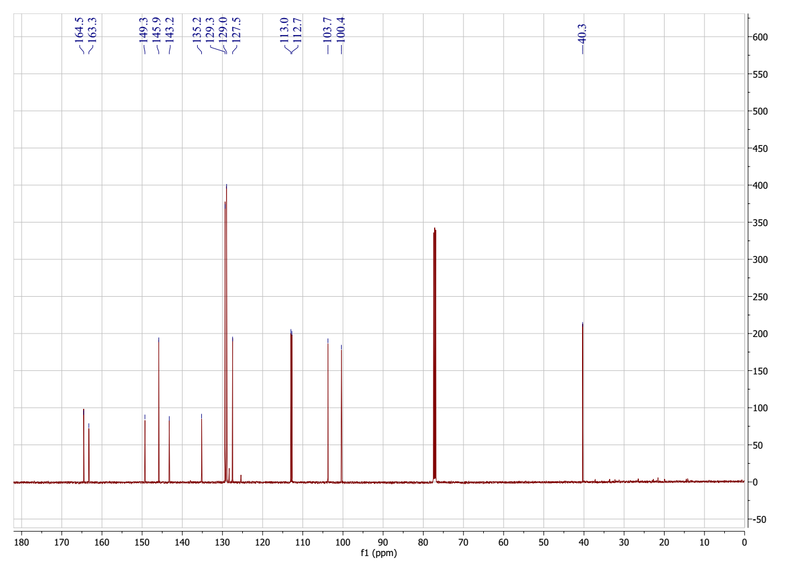
Figure 101. ¹³C NMR spectrum of 6-benzyl-4-(furan-2-yl)-2H-pyran-2-one (25)
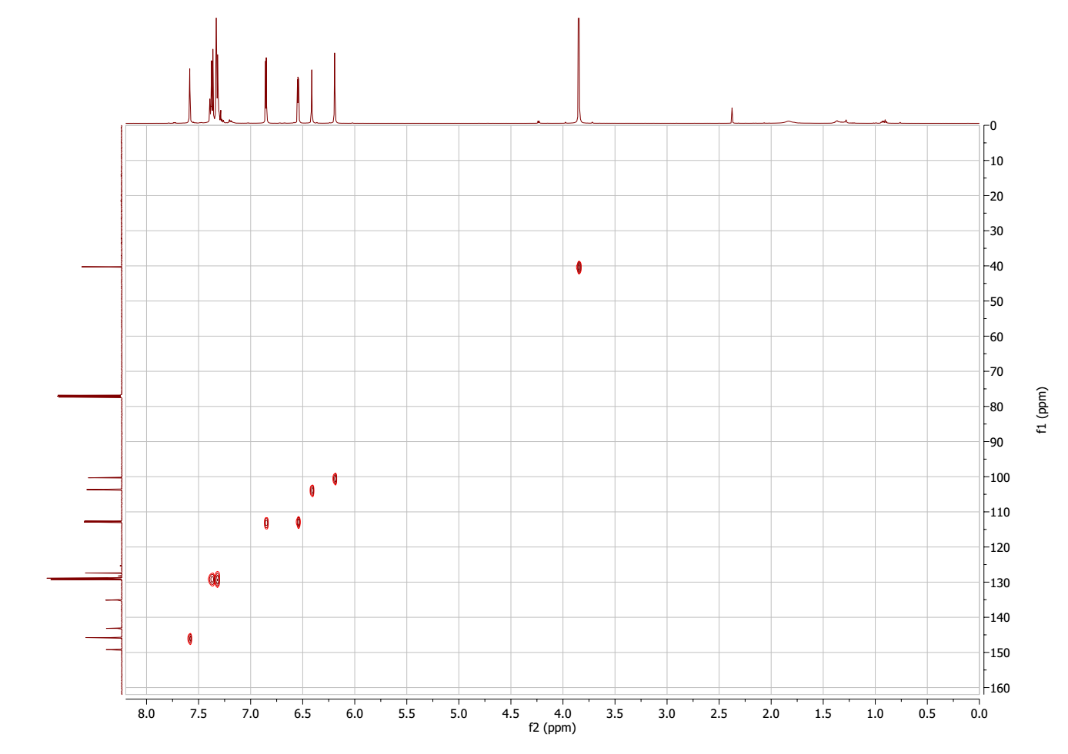
Figure 102. HSQC spectrum of 6-benzyl-4-(furan-2-yl)-2H-pyran-2-one (25)
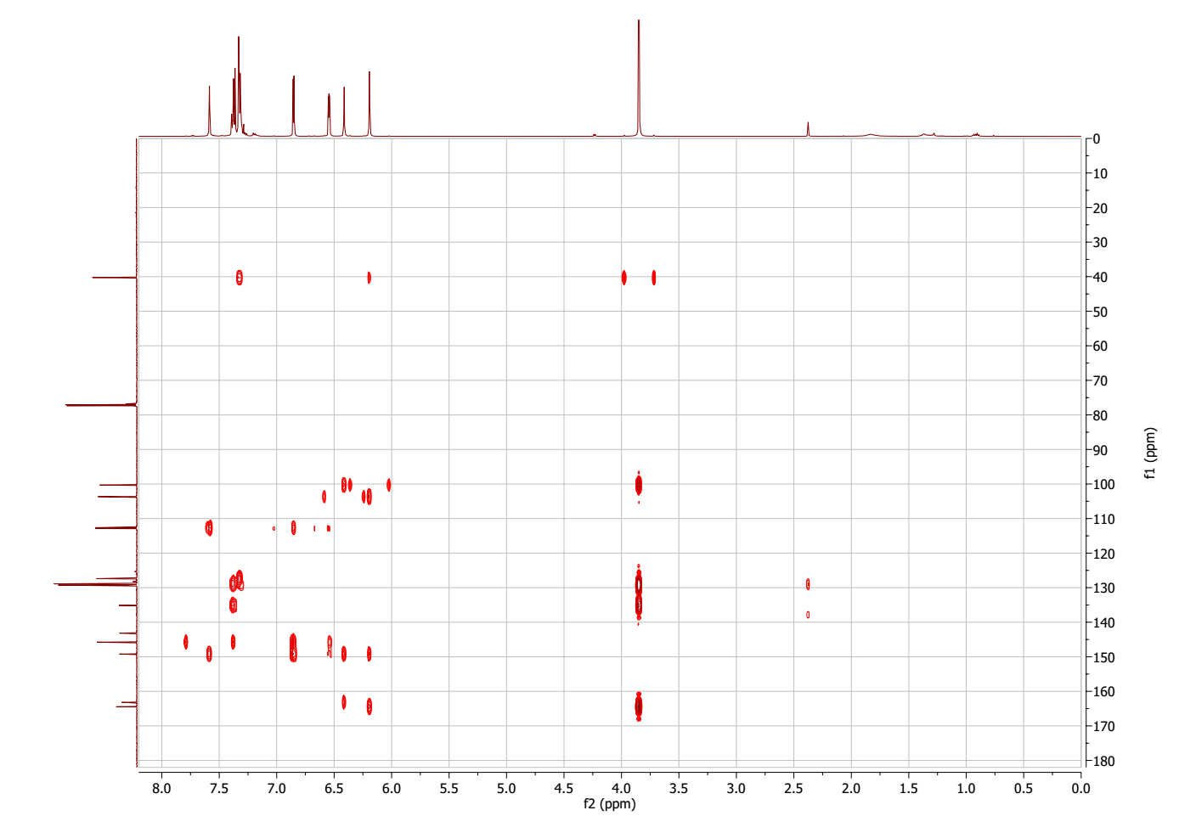
Figure 103. HMBC spectrum of 6-benzyl-4-(furan-2-yl)-2H-pyran-2-one (25)
Figure 104. MS spectrum of 6-benzyl-4-(furan-2-yl)-2H-pyran-2-one (25)

