Multimodal Deep Learning for Classifying Diabetes: Analyzing Carotid Ultrasound Images from UK and Taiwan Biobanks and Their Cardiovascular Disease Associations
Djeane Debora Onthoni¹, Hong-Ming Lin¹, Guo-Hung Li¹, Yu-Ping, Hsiao¹, Yong-Sheng, Zhuang¹, Ade Indra Onthoni¹, Yi-Hsuan Lai¹, Hung-Yi Chiou^{1,2}, Ren-Hua Chung^{1*}

¹Institute of Population Health Sciences, National Health Research Institutes, Miaoli County, Taiwan; Djeane@nhri.edu.tw (DDO); 120209@nhri.edu.tw (HML); leekh@nhri.edu.tw (GHL); yuping11@nhri.edu.tw (YPH); sam9624@nhri.edu.tw (YSZ); ade94@nhri.edu.tw (AIO); sashalai007@nhri.edu.tw (YHL); hychiou@nhri.edu.tw (HYC); rchung@nhri.edu.tw (RHC).
²School of Public Health, College of Public Health, Taipei Medical University, Taipei, Taiwan.

Corresponding author: Ren-Hua Chung, Ph.D.
Investigator, Institute of Population Health Sciences, National Health Research Institutes.
Email address: rchung@nhri.edu.tw
Address: No 35, Keyan Road, Zhunan, Miaoli County 350, Taiwan.
Tel.: +886-37-206-166 ext. 36105

SUPPLEMENTARY MATERIAL
Section S1. Taiwan Biobank image processing techniques
In the Taiwan Biobank (TWB), we preprocessed data from 25,616 out of 25,729 patients, considering information such as Age, Sex, and Image capture date available in DICOM files. The preprocessing involved two steps: 1) Removing unwanted and invalid DICOM files, and 2) Detecting Left Common Carotid Artery (LCCA) and Right Common Carotid Artery (RCCA) using template matching.
In the first step, invalid DICOM files with procedure report descriptions were removed. Measurement annotation images were excluded based on the channel homogeneity, and Region of Interest (ROI) bounding box coordinates [top: bottom, left: right] were determined for upper and lower annotated regions. The selected images were based on mean saturation thresholds.
In the second step, template matching was performed on cropped LCCA and RCCA ROIs to detect annotations. Normalized cross-correlation template matching algorithms in OpenCV were employed with a 0.75 threshold. The matched DICOM files were cropped based on pre-defined coordinates that correspond to pixel aspect ratio value extracted from DICOM, and stored in JPEG format for 25,600 patients. Further, considering pair-wise images, a total of 51,174 images were processed. The detailed TWB preprocessing steps are illustrated in Figure S1.
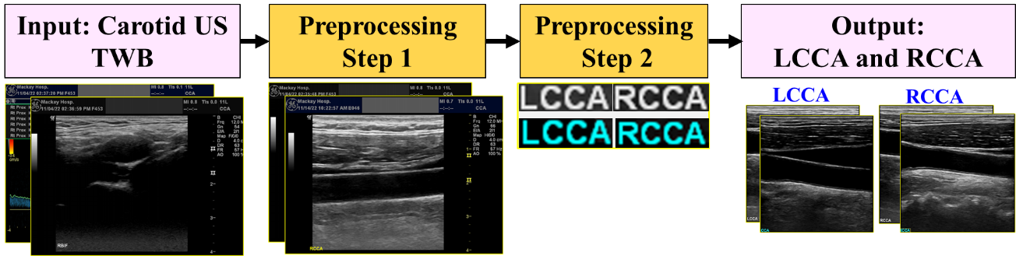
Figure S1. TWB preprocessing steps.

Section S2. UKB and TWB data details
In the UK Biobank (UKB), from the initially acquired data of 19,911 patients, we matched patient IDs between image and scalar data, leading to the final selection of 17,402 patients, each having both left and right images, totaling 34,804 images. Regarding Diabetes Mellitus (DM) outcomes, out of these 17,402 patients, 923 are DM, and 16,479 are non-DM patients. For training and testing purposes, we performed under-sampling on the non-DM group, resulting in two subsets: 923 patients for control matched with age group and sex, and 923 patients for control random with non-overlapping IDs between control matched and control random. To investigate cardiovascular disease (CVD) outcomes, data filtering was conducted by considering the 5-year period prior to instance 2, resulting in a total of 2,520 CVD cases. After matching the patient IDs of CVD cases with 923 DM cases, there were total 80 DM-CVD and 843 DM-non-CVD for the 5-year period prior. Additionally, we filtered data for the 3-year period after instance 2, resulting in a total of 1,664 CVD cases. After matching these cases with the 843 DM-non-CVD cases, there were 27 DM-CVD and 816 DM-non-CVD cases.
In the TWB, after matching with preprocessed image data, a total of 25,587 patients with both right and left images were identified. Following the TWB definition of DM for the 5 years prior to the image taken date and matching with scalar data, there were 22,309 total patients, including 2,612 DM cases and 19,697 non-DM cases. Similar to the approach in the UKB, we applied under-sampling for both control matched and control random, maintaining the same training-to-testing ratio. For our CVD analysis, out of 2,612 DM cases, there were only 2,468 total patients. Among these patients, 397 had DM-CVD, and 2,071 had DM-non-CVD for the retrospective study. We followed up with the 2,071 DM-non-CVD patients for the next 3 years in a prospective study, during which there were 342 cases of DM-CVD and 1,729 cases in the DM-non-CVD group. The details of UKB and TWB dataset can be summarized in Table S1.
Table S1. UKB and TWB data details.
Parameters | Values
UK Biobank
Total patients for image and scalar data | 17,402
Total patients | DM case: 923
Total patients | Non-DM: 16,479  - Control matched = 923  - Control random = 923
Training and testing (ratio 80:20) | Training: 1,478
Training and testing (ratio 80:20) | Testing: 368
Taiwan Biobank
Total patients for image and scalar data | 22,309
Total patients | DM case: 2,612
Total patients | Non-DM: 19,697  - Control matched = 2,612  - Control random = 2,612
Training and testing (ratio 80:20) | Training: 4,178
Training and testing (ratio 80:20) | Testing: 1,046

Section S3. Hardware and software details
The experiments were conducted on the CentOS-7 operating system with CUDA version 10.2. We primarily utilized Python v3.7.7 for coding, focusing on three essential functions: data preprocessing, multimodal DM classification model Deep Learning (DL), and Machine Learning (ML) algorithms. For DL framework, we employed PyTorch v1.11.0, and for ML algorithms, we utilized Scikit-learn v1.0.2. Additionally, crucial Python libraries including Pandas v1.1.3, NumPy v1.21.5, Matplotlib v3.3.3, Scipy v1.7.3, among others, were used. All software installations were executed on hardware with the following specifications: Tesla V100-PCIE-32GB.

Section S4. Multimodal diabetes mellitus classification model results on UK Biobank
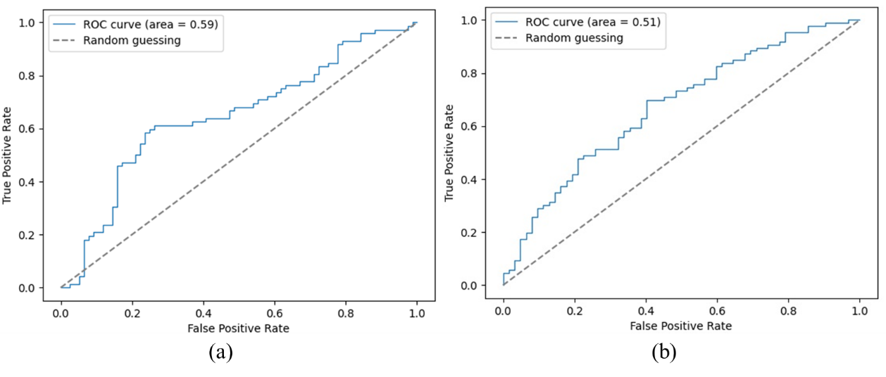
Figure S2. ROC curves comparison on UKB: (a) VGG-16; (b) ResNet-18

Section S5. Multimodal diabetes mellitus classification model results on Taiwan Biobank
- ROC on the existing CNN architectures.
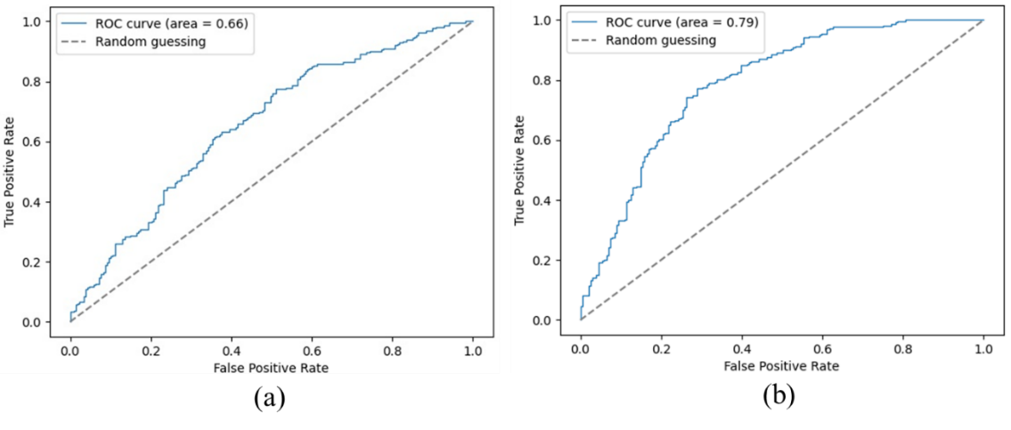
Figure S3. ROC curves comparison on TWB: (a) VGG-16; (b) ResNet-18
- Feature maps analysis results
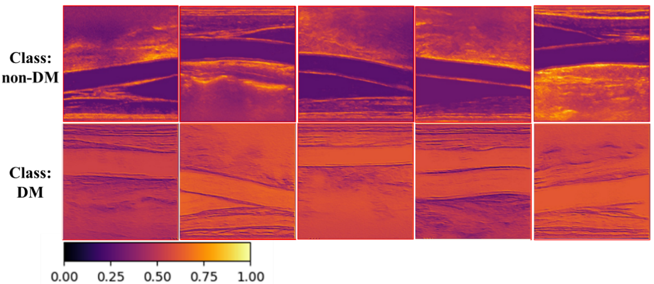
Figure S4. Feature maps in DM and non-DM classes on TWB.
- Statistical analysis results
Table S2. Combined cohort groups result on TWB.
Cohorts | Combine groups | Total patients | Total images | Left (P-value) | Right (P-value)
Retrospective  5 years before | - DM-CVD (397)  - DM-non-CVD (2,071) | 2,468 | 4.936 | 0.315 | 0.313
Prospective  3 years after | - DM-CVD (342)  - DM-non-CVD (1,729) | 2,071 | 4,142 | 0.154 | 0.414

