Supplementary 1

Risk of bias assessment
Low risk

Some concerns

High risk
+
?
-
 | Randomization process | Deviations from intended interventions | Missing outcome data | Measurement of the outcome | Selection of the reported result | Overall
Eisen et al. | + | + | + | ? | + | ?
Kim et al. | + | + | + | + | + | +
Kouba et al. | + | + | + | + | + | +
Pourang et al. | + | + | + | + | + | +
Tierney et al. | + | + | + | ? | + | ?
Zhuang et al.  ? | +  ? | +  ? | +  ? | ?  ? | +  ? | ?  ?

Supplementary 2

Fast gut suture vs Polyproline suture: Overall physician opinion

Continuous Random-Effects Model
Metric: Standardized Mean Difference

Estimate Lower bound Upper bound Std. error p-Value

0.438 0.082 0.794 0.182 0.016

Heterogeneity

tau^2 Q(df=1) Het. p-Value I^2

0.000 0.216 0.642 0

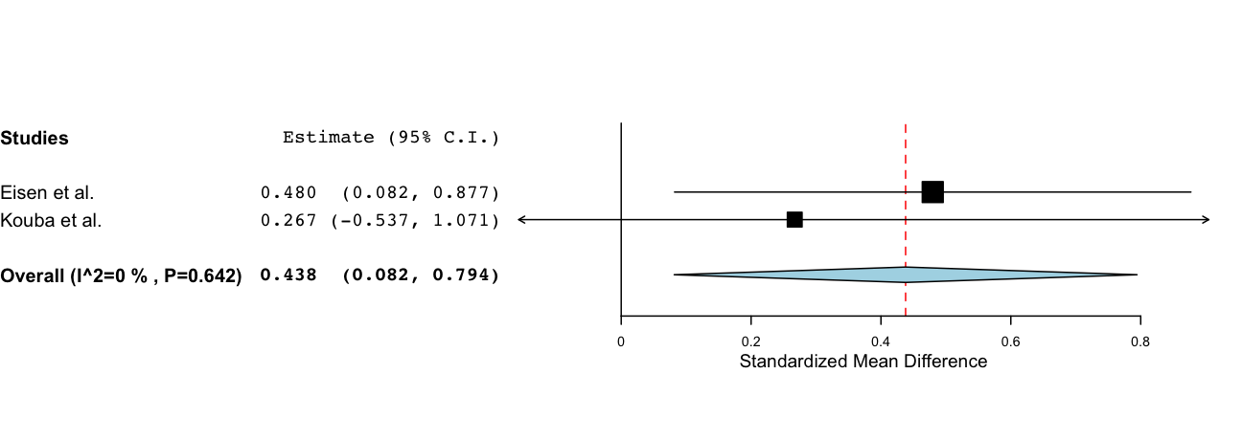

Supplementary 3

Fast gut suture vs Cyanoacrylate tissue adhesive: Overall physician opinion

Continuous Random-Effects Model
Metric: Standardized Mean Difference

Estimate Lower bound Upper bound Std. error p-Value

-0.024 -0.605 0.556 0.296 0.935

Heterogeneity

tau^2 Q(df=2) Het. p-Value I^2

0.153 4.772 0.092 58.09

