Supplementary Information for
New Benchmark Metal-Organic Framework for Ambient Hydrogen Storage: MOF-2087

This supplementary file includes:
Supplementary Methods 1-3
Supplementary Notes 1-2
Supplementary Figs. 1-14
Supplementary Tables 1-5
Supplementary References 1-36

Supplementary Methodology

Supplementary Methodology 1: Bootstrapping Aggregate (Bagged)-Random Forest Trees (B-RFT) Framework and Performance Evaluation
Random Forest Trees are the ensemble learning framework that couples the concepts of randomization and decision trees to synthesize a novel predictive framework for large sets of data points. These are the non-parameterized predictive models which can be used for regression and multiclass classification problems¹. The Random Forest algorithm utilizes the independent decision trees to make the predictions, thus it implements the multiple trees as parallel in different zones to attain the training convergence faster. At the same time, the parallel-grown trees increase the complexity of the framework, especially for large-sized data sets. Additionally, the intensive resampling can be aided with parallelization as an adaptive bootstrapping strategy to enhance the efficacy and scalable implementations of the framework in onboard applications.
Let's assume a Random Forest framework having an ensemble of A trees {T₁(x),....,T_{A}(x)}, where x={x₁,....,x_{n}}is a n-dimensional vector of properties associated with the variables. The framework produces A outputs {Ŷ₁=T₁(x),.....,Ŷ_{A}=T_{A}(x)}where Ŷ_{a}, a =1,...,A, will be the prediction for the input variable by the a^{th} tree. The final predictive output, Ŷ for the regression will be the average of the predictions of individual trees. For classification problems, the output will be the class predicted by the class of the majority of the trees. Let by assume the dataset LD={(x₁,y₁,z₁),......,(x_{n},y_{n},z_{n})}, where (x_{i} , y_{i}) , i = 1, ……., n, will be the descriptive vectors and z_{i} is the corresponding output vector. The framework training will proceed as follows,
(i) The bootstrap data sample will be drawn by using the training dataset LD (i.e., randomly sampled)
(ii) For every bootstrap data sample, the framework will grow a tree by choosing the feasible split among the randomly chosen subset of the m_{ini} from the LD at each node. The trees will be grown until they reach their maximum size and will not be trimmed back.
(iii) Repeating the above steps until reaching a sufficient number of trees (A). when m_{ini} = n i.e,. The feasible split at every node is selected among all the input variables, known as Bagging in the Random Forest algorithm². The trees grown in the framework are known as CART (Classification and Regression Trees)³.
The prediction efficacy of the bootstrap aggregate-random forest algorithm can be enhanced by using the large set of descriptors used for learning. The efficacy of the trained framework can be tested by using the performance of the grown single tree, firstly most of the usual tree-growing frameworks will test the splitting performance of every node for all input vectors. At the same time, the random forest framework tests only the m_{ini} of the input variables. Since m_{ini} is typically small, it accelerates the search faster (i.e., the framework effectively considers the m_{ini} rather than n). As discussed above the prediction performance of the framework can be improvised by using ensemble learning techniques such as Bagging and Boosting. Bagging of a Random Forest can be related as m_{ini} = n. While boosting is the sequence of trees individually trained for all the datasets, at the same time the datasets will be reweighted in every tree according to the mispredictions in the previous tree. While in regression, every tree will be grown according to the residuals of the previously grown trees.
Ideally, the performance assessment of the trained framework needs to be tested with the large number of datasets that have not been utilized for training. In practice, for a limited dataset, cross-validation will be usually used⁴. The parallel training in the random forest will identify the presence of Out-Of-Bag (OOB) variable samples which are used for cross-validation of the prediction performance of the trained framework. Usually, in a Random Forest, each tree will be grown by using a particular subset of samples. Since in bootstrapping, the samples will be replaced from the training dataset. In such cases, some of the sample data points will be left out of the sample, and the remaining will be repeated within the sample. The left-out variable, C^{OOB} a part of Out-Of-Bag samples. As an average for the growth of each tree, ⅔ of samples were used which leaves ⅓ of samples as Out-Of-Bag samples. These samples were not utilized for the growth of the tree. Hence these data samples can be used for the performance evaluation of the trained ensemble. Let by consider $C_{a}^{OOB}$ be the out-of-bag samples from the part of a^{th} tree. Hence the $C_{a}^{OOB}$ can be used for prediction using a^{th} trees. For each training variable, x_{i} is in an out-of-bag sample, as an average of ⅓ of the dataset. Hence Ŷ^{OOB} (x_{i}) will be the prediction of out of bag sample. The error rate (ER) and mean square error (MSE) for regression can be calculated as,
ER≈ER^{OOB} = n⁻¹$\sum_{i=1}^{n}{I (Ŷ^{OOB}(x_{i})≠ y_{i})}$……………………………………(Eq. 1)
MSE≈MSE^{OOB} = n⁻¹$\sum_{i=1}^{n}{{\{(x_{i})≠ y_{i}\}}^{2} }$………………………………...……(Eq. 2)
Where ‘i’ will be the indicator function. The vital target of the bootstrap aggregate random forest model (B-RFT) is to predict the usable volumetric and gravimetric hydrogen storage capacities of MOFs under a pressure swing operating environment. To enhance the accuracy of the present framework, a separate B-RFT model has been developed for each output. Additionally, the hydrogen adsorption prediction performance of the trained model was assessed by using the metrics like R², RMSE, AUE and MAE utilizing the following equations 3-6.
The accuracy of the trained Random Forest Trees framework was accessed by using the following metrics,
Coefficient of Determination (R² (y_{actual} , y_{predict})) = $\sqrt{\frac{\sum_{i=1}^{n samples}{{(y_{i,actual} - y_{i,predict})}^{2}}}{\sum_{i=1}^{n samples}{{(y_{i,actual} -\underline{y_{actual}})}^{2}}}}$, …………..(Eq.3)
Average Unsigned Error (AUE(y_{actual} , y_{predict})) = $\frac{\sum_{i=1}^{n samples-1}{\left|y_{i,actual} - y_{i,predict}\right|} }{n_{samples}}$, …………..(Eq.4)
Root Mean Square Error (RMSE(y_{actual} , y_{predict})) = $\sqrt{\frac{\sum_{i=1}^{n samples}{{(y_{i,actual} - y_{i,predict})}^{2}}}{n_{samples}}}$, ………..…..(Eq.5)
Median Absolute Error (MAE(y_{actual} , y_{predict})) = median $\left(\left|y_{1,actual} - y_{1,predict}\right|,......, \left|y_{n,actual} - y_{n,predict}\right|\right)$, …………………………………………….…..(Eq.6)
Whereas, $\underline{y_{actual}}$ = $\frac{\left(\sum_{i=1}^{n samples}{y_{i,actual}}\right)}{n_{samples}}$
Furthermore, the performance and reliability of the B-RFT will be significantly affected by the quantity and quality of the dataset provided for the learning phase^{4,5}. Recent investigations on the prediction performance of gas adsorption capacities in MOFs such as, Fanourgaskis et al. attained best prediction performance for methane uptake in MOFs with least dataset of 1k approx having six crystallographic properties⁶, Fernandez et al. obtained good prediction accuracy by using 10k MOFs dataset associated with three crystallographic features for methane uptake in MOFs⁷. Recently, Ahmed et al. reached a higher prediction accuracy on hydrogen uptake in MOFs by using a nearly 70k dataset having seven crystallographic features of MOFs⁸. To access the best performing B-RFT model for objective function formulation, the dataset size used for the B-RFT framework training has been varied up to 78,956 MOFs and the performance of the framework has been tested with 98695 MOFs.

Supplementary Methodology 2: Multi-Objective Particle Swarm Optimization (MOPSO)
The present work utilizes one of the heuristics and computationally inexpensive multi-objective particle swarm optimization^{9–11} to identify the set of feasible MOFs having better trade-off between usable gravimetric and volumetric capacity. Generally, the particle swarm optimization technique uses the set of populations consisting of N number of solution candidates (known as “particles”) to optimize the problem having a defined search space¹². Firstly, the candidate solutions are randomly distributed and the associated position of the solutions will be considered as p-${best}_{i}^{0}$. The algorithm computes the performance of every solution candidate by introducing the fitness function at each iteration. Let's consider a particle present in the ‘i^{th}’ location having the best-fit value p-${best}_{i}^{k}$ compared with the initial value p-${best}_{i}^{k-1}$then the present best fit value will be replaced in the global repository and the best location of the particle will be renewed as $p_{i}^{k}$. The particle which exhibits the best solution fit will be labeled as g-best^{k} at k^{th} iteration and its associated position will be recognized as $p_{g}^{k}$ . The movement of the particle in the k^{th} iteration will be based on the current location (x^{i}) and velocity of the particle (v^{i}) in the search space compared with the best solution obtained previously.
$v_{i}^{k+1}=⍵v_{i}^{k}$ + c₁ rand₁ ($p_{i}^{k}$ - $x_{i}^{k}$) + c₂ rand₂ ($p_{g}^{k}$ - $x_{g}^{k}$) ………………….....(Eq. 7)
$x_{i}^{k+1}$ =$x_{i}^{k}$ + $v_{i}^{k+1}$ ……………………………………………………………(Eq. 8)
|f($p_{g}^{(k)}$) - f($p_{g}^{(k-q)}$)| ⩽ ε for q=1,2,......,s₁ ……………………………...........(Eq. 9)
Where $⍵$ represents the inertial weight which influences the global and local abilities of the PSO and, ε and s₁ have been determined initially. The iterations will be finished once all the particles attain the inequality (Eq.9) or after reaching the fixed number m.
Multi-Objective optimization problems deal with various conflicting objectives and the optimality of these objectives obtained by the traditional unit objective optimization procedures may not be feasible¹³. Therefore, among the different objectives, it is necessary to choose a better trade-off or proper balance between the objectives. For solving multiple objectives, it is essential to create an external/local repository to store the feasible solutions that are not dominated by any available solutions (non-dominated). These non-dominated solutions can be found in the local archive which has the global better solutions p_{g} obtained from each particle (the best solutions identified so far). Moreover, the total number of identified non-dominated solutions becomes larger hence it is necessary to apply an archive method to shrink the repository which leads to keeping the defined number of feasible solutions by discarding the weaker solutions obtained. Therefore, the velocity of the solution candidates presented in a d dimensional space can be expressed with the aid of Eq.7 as,
$v_{d}^{k+1}=⍵v_{d}^{k}$ + c₁ rand₁ ($p_{d}$ -$x_{d}$) + c₂ rand₂ (rep(h)_{d} - $x_{d}$) ……………….(Eq. 10)
Where rep(h) is the solution obtained from the local repository (non-dominated) as the best candidate. Let's assume that n will be the number of available solution candidates presented in the hyper-cube (the two-dimensional squared region formed in the search domain). Hence identifying a hyper-cube with the least number of solution candidates will increase the diversity of the solution candidates which forms the pareto-front. Hence the probability of the roulette wheel has been employed to identify a hyper-cube having h index as expressed below,
P_{i} = $\frac{e^{-βn_{i}}}{e^{-βn_{1}} + e^{-βn_{2}} + .....+ e^{-βn_{j}}}$ ……………………………………………....(Eq. 11)
Where n_{i} represents the number of solution candidates available in the i^{th} hyper-cube, the number of differentiations in the probability will be controlled by using the constant $β$ and k represents the number of presented hyper-cubes in the search space. One of the solutions available in the identified hyper-cube h will be randomly chosen as a leader for the next iteration and new location of the solution candidate. The iteration will continue until reaching the feasible criteria. Usually, the criteria represent the specific number of iterations that can be taken to obtain the global non-dominated solution sets. The target of the adopted algorithm is to maximize the usable gravimetric capacity as well as the usable volumetric capacity of the MOFs employed for hydrogen storage. A wide range of investigations on the multi-objective particle swarm optimization has determined that the higher population size leads to enhanced benefits for the considered real-world objective functions^{14–16}. Hence the maximum population size has been constrained up to 200. The global and individual learning coefficients of the computational framework have been set to 1 and 2 respectively¹⁵. It has been widely reported that an inertia weight damping ratio of 0.5 will be most beneficial. The size of the local repository for obtaining the non-dominated solution is set to 200¹⁴. The simulation steps were applied until 500 generations to attain the global best solution.

Supplementary Methodology 3: Performance Assessment of Multi-Objective Optimization
Compared with Single Objective optimization, Multi Objective Optimization identifies a set of non-dominant solutions known as Pareto Optimal Points (Pareto Optimal Sets). Hence, the performance of multi-objective optimization will certainly depend upon the properties of the Pareto optimal set of solutions obtained¹⁷. As multi-objective optimization captures the proper tradeoff between the conflicting objectives, it is essential to evaluate the captured Pareto optimal set in the objective region rather than the decision region. To eliminate the inequalities between the units of conflicting objectives, the minimum-maximum normalization technique was adopted for each decision vector (Eq. 12). In the case of evaluating the tradeoff between usable gravimetric and volumetric capacities of MOFs, the decision vectors were normalized between 0 and 1. If the solution of an objective reaches the value ‘0’ it determines that the particular objective has been located in the reference or true Pareto optimal set.
$X_{i}^{j}=\frac{f_{i}^{j} -f_{min}^{j}}{f_{max}^{j} -f_{min}^{j}}$ …………………………………….……………………(Eq. 12)
Where $f_{i}^{j}$is the actual solution obtained for the jth objective. $f_{max}^{j} { and f}_{min}^{j}$are the maximum and minimum values recorded for the jth objective.
Supplementary Method 3.1: Size assessment of Pareto-optimal solutions set
In the real scenario, the number of solutions sets available or obtained will be an infinite set. However, estimating the entire solution sets available in the true Pareto-optimal set will be computationally expensive and highly unfeasible. Hence each multi-objective optimization methodology adopts a subset of Pareto points in the whole design space. The number of other possible solutions presented in the set will be significantly affected by the size of the Pareto-optimal set. At the same time, these size ranges will also influence the efficacy of the incorporated methodology on identifying the non-dominated solutions. Thus generally, a larger size of Pareto-optimal sets was helpful to get the feasible solutions.
Supplementary Method 3.2: Solution diversity assessment of a Pareto-optimal set
As mentioned earlier, the numbers of pareto-points obtained will not be infinite for the onboard cases. Since all of the multi-objective optimization techniques were restricted to have a defined number of representative approximate solutions. Therefore, the reliability of the diverged approximated Pareto points was crucial and needed to be evaluated (to avoid the missing potential solution sets). Generally, these Pareto-points having good diversity will be uniformly distributed throughout the front obtained. In Order to estimate the diversity of the obtained pareto-points from the multi-objective optimization algorithm, the standardized spacing metric indicator (SSM) was used¹⁸.
The SSM calculates the average deviation available between the Euclidean distances of two adjacent pareto-points and the average of presented Euclidean distances in the front.
SSM = $\frac{AD}{(n-1) \overline{d_{1}}}$ …………………………………………………..………..(Eq. 13)
AD = $\frac{\sum_{i}^{n-1}{|d_{i} - \overline{d_{1}}} |}{n-1}$………………………………………….……..……….(Eq. 14)
$\overline{d}$= $\frac{\sum_{i}^{n-1}{d_{i}} }{n-1}$ …………………………………………………..……………...(Eq. 15)
d_{i} = $\sqrt{\sum_{j=1}^{m}{{(F_{i}^{j} - F_{i+1}^{j})}^{2}}}$ ……………...…………………..…………...…..(Eq. 16)
Where, d_{i} indicates the standardized Euclidean distance available between the nearest solutions. $d$ represents the average of the available distances. Whereas the average deviation between the Euclidean distance of the solution sets and average distances possessed by the solutions. The smaller the SSM value determines the better diversity in the approximated pareto-points.
Supplementary Method 3.3: Solution convergence assessment of a Pareto-optimal set
The goal of multi-objective optimization technique is to converge the solution sets to the pareto-optimality as closer to the true pareto-optimal solutions. Hence, by accessing the proximity of the approximated pareto-points with the true pareto-points will indicate the performance of the multi-objective optimization techniques. For onboard problems, the true pareto-points were unknown. In such cases, the true pareto-points can be identified by several independent runs of the multi-objective optimization algorithm as many times.
The closeness of the approximated pareto-points to the obtained true pareto-points can be assessed by using standardized generational distance indicator (SGD)¹⁹. The standardized generational distance metric (SGD) measures the RMSE of Euclidean distance between the approximated Pareto-points with the nearest true pareto-points.
SGD= $\sqrt{\frac{\sum_{i=1}^{n}{ l_{i}^{2}}}{n}}$ …………………………………………………………………....(Eq. 17)
l_{i} = $\min_{k∈\{1,...,p\}}$ $\sqrt{\sum_{j=1}^{m}{{(F_{i}^{j} - F_{k}^{*j})}^{2}} }$………………. ………… ……….(Eq. 18)
Where l_{i} indicates the Euclidean distance between the i^{th} approximated Pareto-point and the neighbor reference Pareto-points. $F_{i}^{j}$ and $F_{k}^{*j}$ represents the standardized solution values of approximated and true Pareto-points respectively for the j^{th} fitness function. p represents the number of available solutions on true Pareto points. Considering the performance criteria, the least values of SGD are highly preferred which indicates that the approximated Pareto-front is much closer to the true Pareto-front
Supplementary Method 3.4: Ideal solution assessment in a Pareto-optimal set
Technically, each solution candidate presented in the Pareto-front can be considered for acceptance. Therefore, in practical cases, it is essential to find a feasible solution for solution implementations in onboard cases. The feasible solution is available among the entire Pareto points can be distinguished by comparing the quality of tradeoff between the objectives presented in the solutions. Generally, for multi-objective optimization problems numerous multi-criteria decision-making methods were available such as Multi-Attribute Utility Theory (MAUT)²⁰, Weighted Sum Method (WSM)²¹, Elimination And Choice Translation Reality (ELECTRE)²², Analytic Hierarchy Process (AHP)²³ and Technique for Order of Preference by Similarity to Ideal Solution method (TOPSIS)²⁴. The TOPSIS is one of the efficient multi-criteria decision-making methods that identifies the solution much closer to the ideal solution and far away from the negative ideal solution. The normalized and weighted decision matrix can be obtained by using the feature importance and its associated weights (w_{j}) by the following expression,
V_{ij} = $X_{ij} wj$, i=1,2,....m; j=1,2….n; ……..………………………………...(Eq. 19)
The nadir ideal and ideal solutions can be determined by using the following equations,
$\{V_{1}^{-},V_{2}^{-},.......V_{n}^{-}\}= \{(\min_{i} V_{ij}|j∈K), (\max_{i} V_{ij}|j∈K^{'}) | i=1,2,.....,m\}$……......(Eq. 20)
$\{V_{1}^{+},V_{2}^{+},.......V_{n}^{+}\}= \{(\max_{i} V_{ij}|j∈K), (\min_{i} V_{ij}|j∈K^{'}) | i=1,2,.....,m\}$……......(Eq. 21)
Where, K indicates the index for criteria of benefit and K’ indicates the index for criteria of cost. The Euclidean distance available between the nadir and ideal solution sets are measured by,
$S_{i}^{-}$ = $\sqrt{{ \{\sum_{j=1}^{n}{(V_{ij}-V_{j}^{-})} \}}^{2}}$ i=1, 2,...,m; j=1,2,.....m …………………..………....(Eq. 22)
$S_{i}^{+}$ = $\sqrt{{ \{\sum_{j=1}^{n}{(V_{ij}-V_{j}^{+})} \}}^{2}}$ i=1,2,...,m; j=1,2,.....m ……………………………...(Eq. 23)
The closeness of the solution candidate to the ideal solution is estimated by using the following expression,
C_{i} = $\frac{S_{i}^{-}}{S_{i}^{+} + S_{i}^{-}}$ i=1,2,......,m; 0 ≤ C_{i} ≤ 1 ………………….………………..(Eq. 24)
The solution which possesses the higher value of C_{i} will be considered as the single best solution available in the pareto-points²⁵. By reaching the termination criteria, the B-RFT-MOPSO identifies the feasible set of solutions which exhibits the better trade-off between the usable hydrogen storage capacities. Competitively, the feasible MOFs presented in the global database have been identified by using the 7-dimensional nearest neighbor search algorithm based on the Qhull which is utilized to compute the convex hulls²⁶.

Supplementary Table 1. Summary of machine learning models used to predict the hydrogen adsorption in MOFs in recent studies.
Machine Learning Algorithm | R² |  | RMSE
Machine Learning Algorithm | Usable gravimetric capacity | Usable volumetric capacity | Usable gravimetric capacity (wt%) | Usable volumetric capacity (g H₂ L⁻¹)
Random Forest⁸ | 0.997 | 0.982 | 0.037 | 2.156
Random Forest²⁷ | 0.931 | - | 0.333 | -
Random Forest²⁸ | 0.997 | 0.981 | 0.208 | 1.511
Linear Regression⁸ | 0.987 | 0.917 | 0.170 | 10.045
K-Nearest Neighbors⁸ | 0.983 | 0.913 | 0.226 | 10.517
Gradient Boosting⁸ | 0.997 | 0.980 | 0.045 | 2.454
XGBoost²⁷ | 0.939 | - | 0.296 | -
XGBoost²⁸ | 0.996 | 0.979 | 0.219 | 1.583
Decision Trees⁸ | 0.995 | 0.971 | 0.065 | 3.568
Support Vector Machine²⁷ | 0.962 | - | 1.006 | -
Decision Trees²⁸ | 0.994 | 0.965 | 0.285 | 2.07
Extremely Randomized Trees⁸ | 0.997 | 0.984 | 0.034 | 1.960
CatBoost²⁷ | 0.993 | - | 0.260 | -
Extremely Randomized Trees²⁸ | 0.997 | 0.981 | 0.210 | 1.541
Boosted Decision Trees⁸ | 0.997 | 0.983 | 0.037 | 2.104
Ada Boost⁸ | 0.975 | 0.936 | 0.332 | 7.732
Bagging with Decision Tree⁸ | 0.997 | 0.982 | 0.037 | 2.133
Bagging with Random Forest⁸ | 0.997 | 0.983 | 0.037 | 2.048
Ridge Regression⁸ | 0.987 | 0.917 | 0.170 | 10.046
Multilinear regression with LASSO²⁹ | - | 0.96 | - | 3.1-4.4
Neural Network³⁰ | - | 0.88 | - | 3.6
Present Study* | 0.997 | 0.985 | 0.163 | 1.37

Supplementary Note 1: The summary of the machine learning algorithms studied earlier indicates that Bagging with Random Forest and Extremely Randomized Trees as a best-performing algorithm for predicting the gravimetric and volumetric hydrogen storage in MOFs. Considering the advantage of choosing best node to split and bagging the subsets, we utilized bagging with random forest tree algorithm for our optimization-based screening route.
Supplementary Table 2. Summary of optimization techniques used for optimizing the performance of MOFs in recent studies.

Study | Optimization  Algorithm | Optimization performed on
Yulia et al.³¹ | Multi-objective genetic algorithm | High CO₂ adsorption and selectivity of CO₂/CH₄ with low heat of adsorption
Qu et al.³² | Genetic algorithm | Weights and bias for back propagation neural network to predict the CO₂ adsorption capacity on Ni/DOBDC-based MOFs
Ghude S and Chowdhury C³³ | Bayesian Optimization and  Evolutionary-Particle Swarm Optimization | Maximizing Hydrogen uptake among 98000 MOFs
Alizamir et al.³⁴ | Extreme Learning Machine with BAT | To accurately predict the CO₂ permeability and removal in MOF-based membranes
Singh et al.³⁵ | Particle Swarm Optimization assisted Genetic algorithm | Identifying appropriate functional groups to IRMOF-10 to improve its H₂ adsorption capacity
Dashti et al.³⁶ | Particle Swarm Optimization Adaptive Neuro-Fuzzy Inference System | CO₂ adsorption estimation in high-capacity MOFs

Supplementary Note 2: As far as observed form the earlier studies and to the best of our knowledge, crystallographic feature optimization of MOFs regarding the enhancement of its gas uptake using the heuristic methods was not reported yet. Many of studies reported attempted to optimize either the hyperparameters of machine learning algorithms to enhance the prediction performance or the manufacturing process to enhance its gas separation characteristics. Therefore, considering the model simplicity and ability of identifying the global optimum solution than the local optimum, the particle swarm optimization algorithm was chosen for our approach. Since the present problem deals with the multiple objectives, we utilized multi-objective particle swam optimization technique.

Supplementary Table 3. Maximum and Minimum bounds designed for the chosen design variables.

Design Variables | Minimum Bound | Maximum Bound
Single crystal density of MOF  (gcm⁻³) | 0.1 | 0.3
Gravimetric surface area of MOF  (m²g⁻¹) | 5300 | 7200
Volumetric surface area of MOF  (m²cm⁻³) | 530 | 2160
Void fraction of MOF | 0.89 | 0.91
Pore Volume  (cm³g⁻¹) | 3.0 | 8.9
Large Cavity Diameter (Å) | 10 | 30
Pore Limiting Diameter (Å) | 10 | 30

Supplementary Table 4. List of feasible solutions identified by using TOPSIS. Top 5 performing solution benchmarks from 152 feasible solution sets.

TOPSIS  Rank | Density  (gcm⁻³) | GSA  (m²g⁻¹) | VSA  (m²cm⁻³) | VF | PV  (cm³g⁻¹) | LCD  (Å) | PLD  (Å) | Predicted Usable Gravimetric Capacity  (wt%) | Predicted Usable Volumetric Capacity  (gH₂L⁻¹)
1 | 0.133 | 7200 | 958.552 | 0.908 | 6.827 | 17.759 | 14.545 | 17.959 | 35.699
2 | 0.133 | 7200 | 961.160 | 0.907 | 6.796 | 16.767 | 14.173 | 17.936 | 35.710
3 | 0.130 | 7196.881 | 936.656 | 0.90 | 6.961 | 15.840 | 14.322 | 18.047 | 35.683
4 | 0.125 | 7195.253 | 899.591 | 0.909 | 7.271 | 16.532 | 13.729 | 18.168 | 35.638
5 | 0.126 | 7197.339 | 911.964 | 0.908 | 7.171 | 16.37 | 14.02 | 18.11 | 35.66

Gravimetric surface area (GSA), Volumetric surface area (VSA), Void Fraction (VF), Accessible pore volume (PV), Large cavity diameter (LCD) and Pore limiting diameter (PLD)
Supplementary Table 5. List of MOF’s considered for B-RFT framework training and validation available MOFs in the databases.

Number of MOFs | Database | Type of MOF
5047 | CORE | eMOF
7139 | CSD-17 | eMOF
59 | H74A | hMOF
466 | IS | hMOF
897 | ISS | hMOF
90 | M-O | hMOF
20156 | NW | hMOF
2812 | ToBaCCo | hMOF
578 | UM | eMOF
61250 | UO | hMOF
200 | ZR | hMOF

Supplementary Fig.1. Sensitivity analysis of the B-RFT model, figures (A) and (B) represent the sensitivity analysis for usable gravimetric capacity prediction, and, figures (C) and (D) illustrate the sensitivity analysis for usable volumetric capacity prediction.

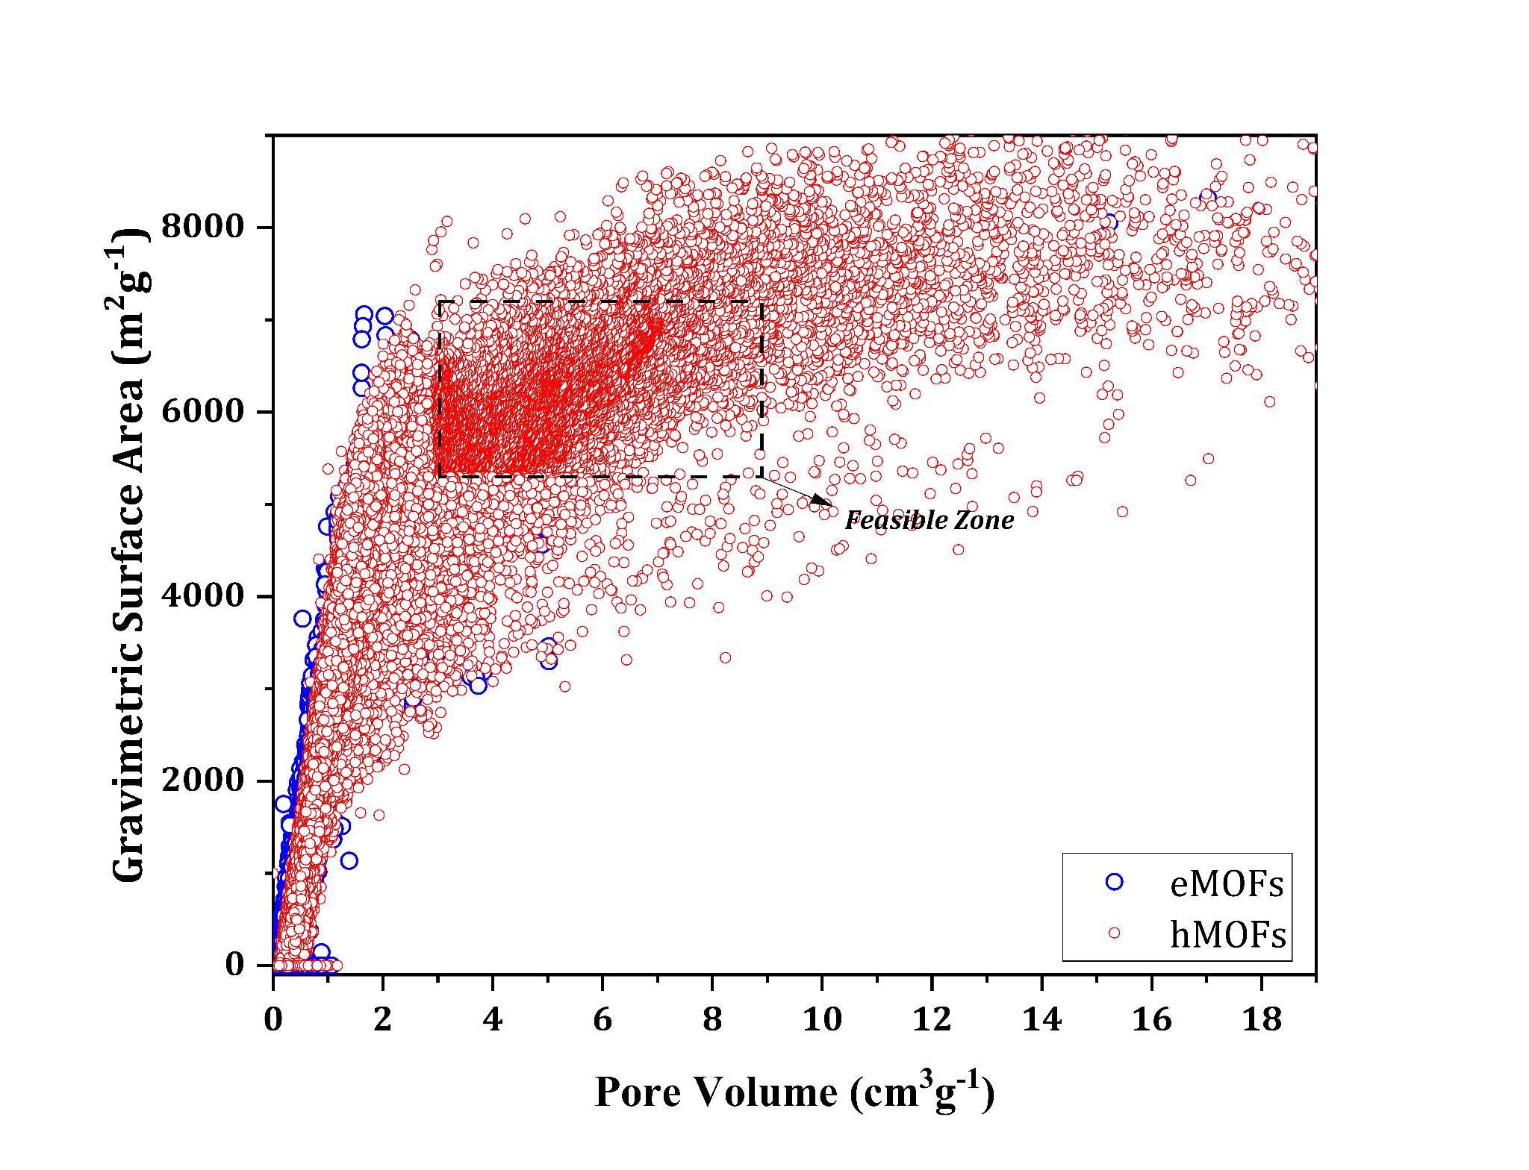
Supplementary Fig.2. Constructed feasible zone (search space) for B-RFT-MOPSO. A representative two-dimensional search space available between the pore volume and gravimetric surface area of MOFs.

Supplementary Fig.3. Comparison of Pareto-points obtained with local and global best MOFs shortlisted by using nearest neighbor search. Since 10 MOFs features were located far away from the feasible solution set. Therefore, the localized zone (represented using doted boundary lines) was applied to local best MOFs.

Supplementary Fig.4. Comparison of an obtained set of Pareto-optimal points concerning each run. (A) compares the size of Pareto points obtained for each independent run, (B) variation of SSM indicator concerning the independent model runs, and (C) computed SGD metric for each independent model run.

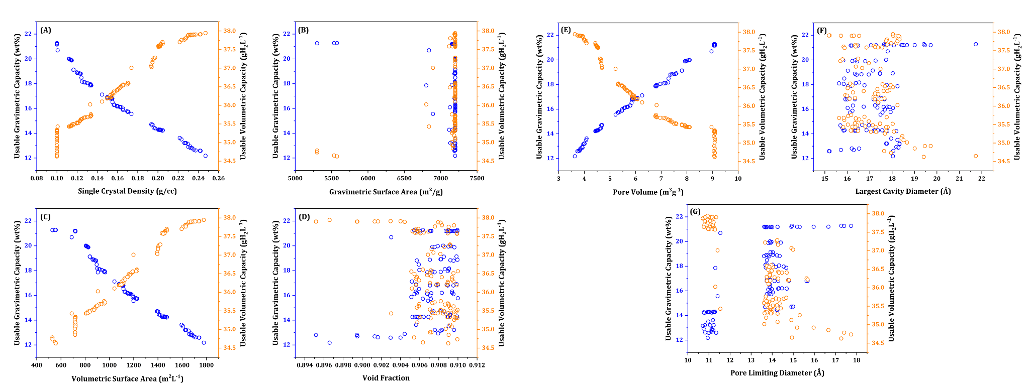

Supplementary Fig.5. Variation of B-RFT-MOPSO optimized crystallographic features of MOFs with respect to the usable gravimetric (navy blue) and volumetric hydrogen storage capacities (orange) of MOFs. (A) optimized single crystal density of MOFs, (B) feasible gravimetric surface area of MOFs, (C) variation of volumetric surface area of MOFs, (D) void fraction of MOFs, (E) desired pore volume of MOFs and, (F) and (G) represents the variation of large cavity and pore limiting diameter of MOFs respectively.

Supplementary Fig. 6. Parity plot of actual usable hydrogen storage capacities for pressure swing conditions (100-5 bar at 77K) concerning the calculated hydrogen storage capacities of tested MOFs (A, B). On average the calculation errors were less than -5% and -7.5% for UG and UV respectively, indicating that the present model was not overpredicting the hydrogen adsorption in MOFs.

Supplementary Fig. 7. The pore size distribution of MOF-2087. The two nearby peaks at 23.5 Å and 23.9 Å indicates the mesoporous nature of MOF-2087.
Supplementary Fig. 8. Isosteric heat of hydrogen adsorption for MOF 2087 evaluated at 298 K with varying pressure from 0 bar to 100 bar.
Supplementary Fig.9. Hydrogen density distribution of MOF 2087 under 5 bar (D, E, and F), 50 bar (G, H, and I), and (J, K, and L) respectively towards the crystallographic planes for the pore visualization. The (A, B, and C) represent the empty MOF 2087 2x2x2 supercell.
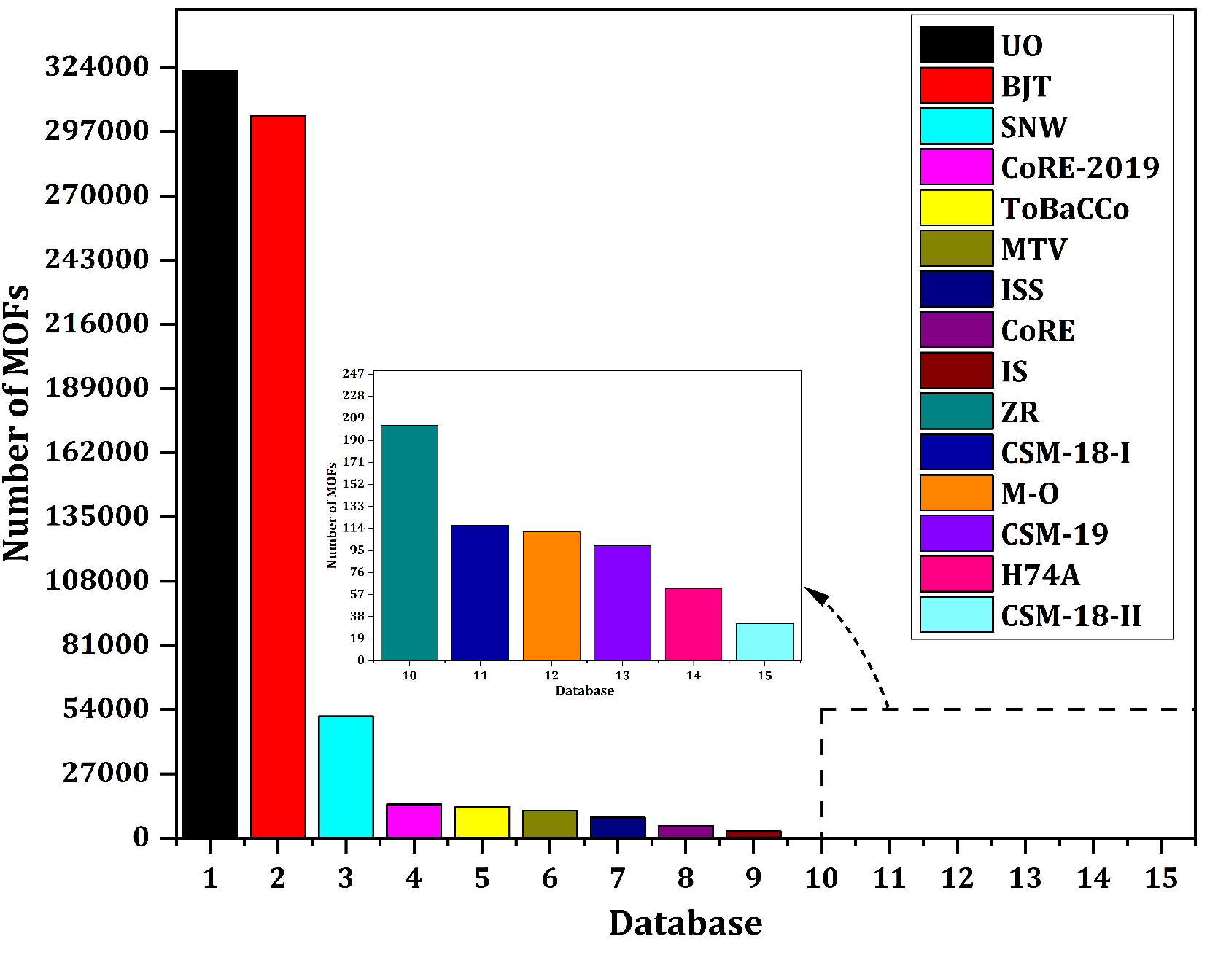
Supplementary Fig.10. Graphical illustration of the number of collected MOFs from the different databases.

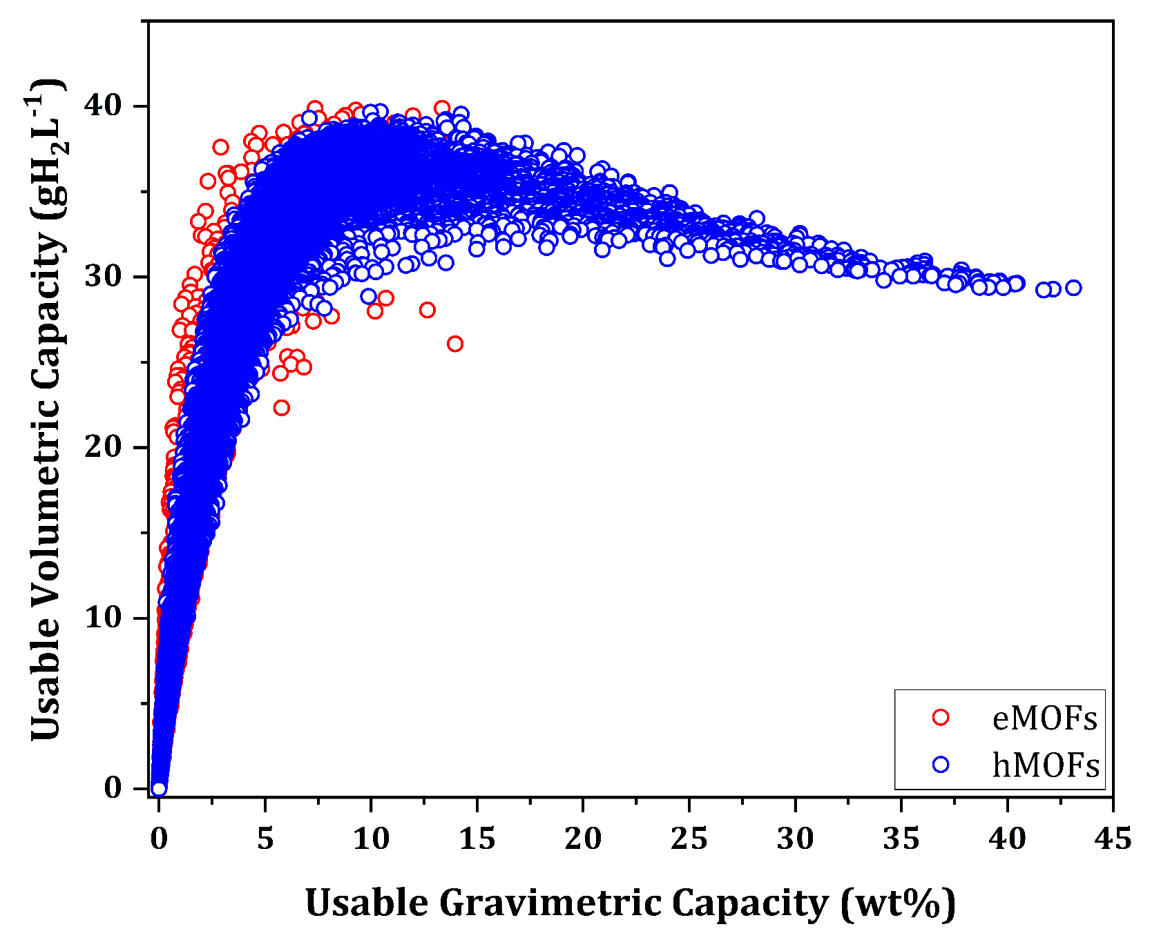
Supplementary Fig.11. Usable gravimetric capacity (UG) concerning the usable volumetric capacity (UV) of the subset used for bootstrap aggregation-random forest trees for the pressure swing 5bar-100 bar at 77K.

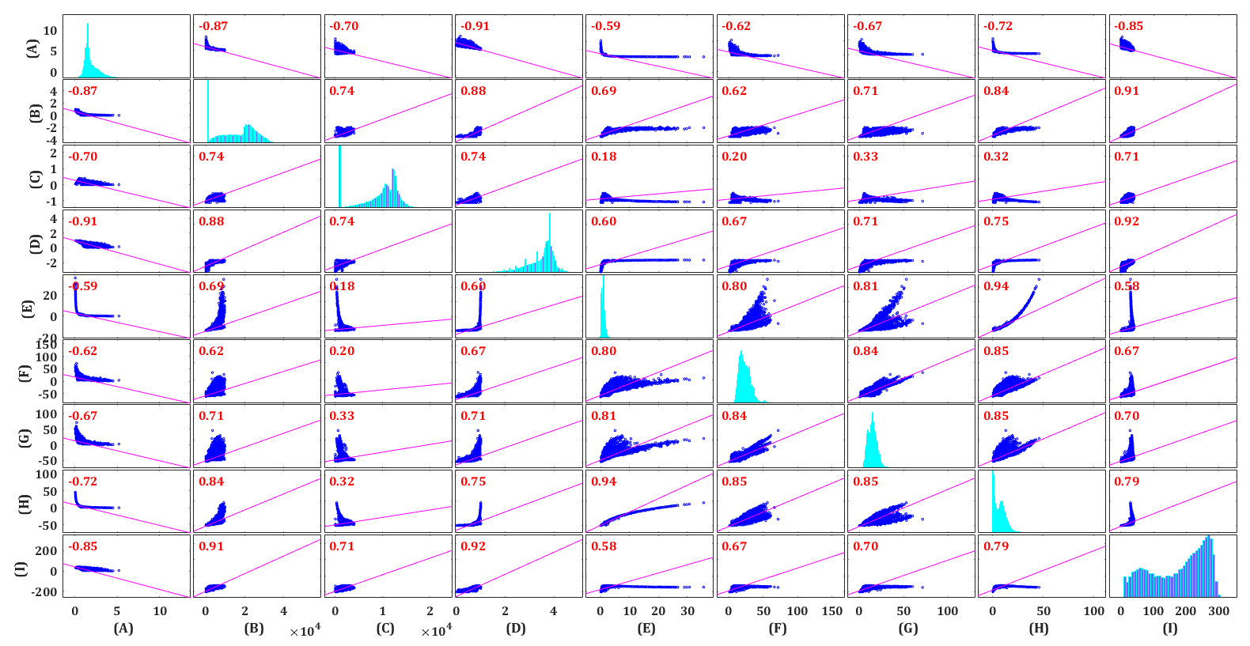

Supplementary Fig.12. Correlation between the crystallographic features with respect to the usable gravimetric capacity (UG) and usable volumetric capacity (UV) for the pressure swing of 5 bar to 100 bar at 77K. Where the descriptors indicates that (A)-single crystal density (gcm³), (B)-gravimetric surface area of MOFs (m²g⁻¹), (C) -volumetric surface area of MOFs (m²L⁻¹), (D)-void fraction of MOFs, (E)- accessible pore volume of MOFs (m³g⁻¹), (F)-largest cavity diameter available in MOFs (Å), (G)-pore limiting diameter of MOFs (Å), (H)-usable gravimetric hydrogen uptake (wt%) and (I)-usable volumetric hydrogen capacity of MOFs (gH₂L⁻¹). The correlation between the crystallographic features and hydrogen uptake capacities was analyzed by using Pearson correlation coefficient, which can be measured as r = $\frac{\sum_{i=1}^{n}{(a_{i}-\overline{a}) (b_{i}-\overline{b})} }{\sqrt{{\sum_{i=1}^{n}{ (a_{i}-\overline{a}) }}^{2} } \sqrt{{\sum_{i=1}^{n}{ (b_{i}-\overline{b}) }}^{2} }}$ where a and b represents the features and, the mean of features were represented as $\overline{a}$ and $\overline{b }$respectively.
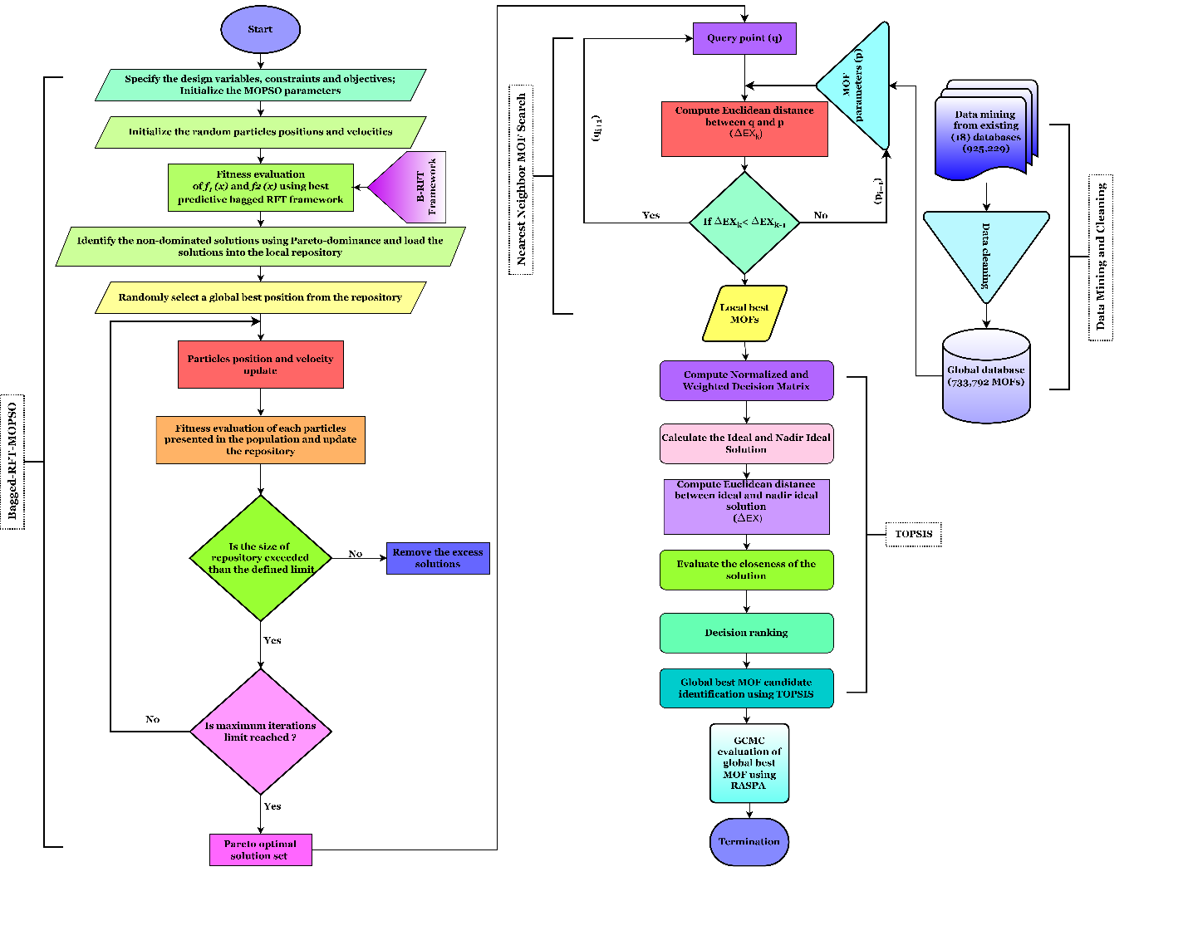

Supplementary Fig.13. Steps involved in the B-RFT-MOPSO-based deliverable gravimetric and volumetric hydrogen storage optimization of MOFs.
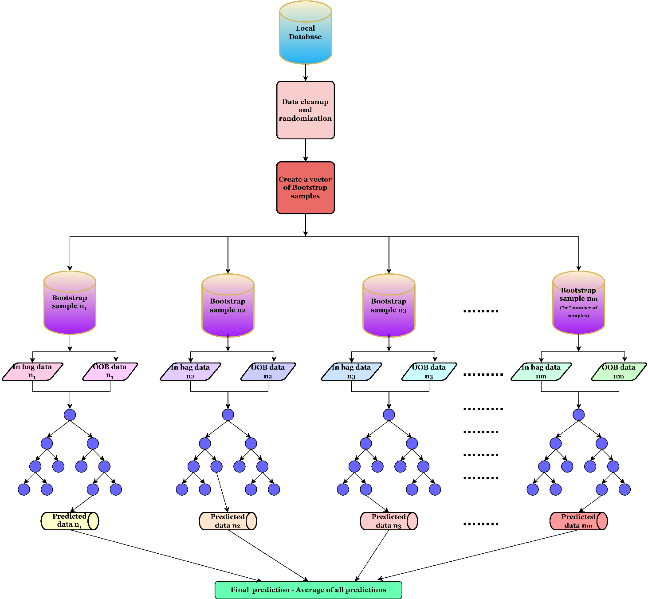
Supplementary Fig.14. Steps involved in random forest trees framework for hydrogen adsorption estimation in MOFs

References:

1. L Breiman. Random Forests. Mach. Learn. 45, 5–32 (2001).
2. Breiman, L. Bagging predictors. Mach. Learn. 24, 123–140 (1996).
3. Krzywinski, M. & Altman, N. Classification and regression trees. Nature Methods vol. 14 (Routledge, 2017).
4. Hawkins, D. M., Basak, S. C. & Mills, D. Assessing model fit by cross-validation. J. Chem. Inf. Comput. Sci. 43, 579–586 (2003).
5. Wei, J. et al. Machine learning in materials science. InfoMat 1, 338–358 (2019).
6. Fanourgakis, G. S., Gkagkas, K., Tylianakis, E. & Froudakis, G. A Generic Machine Learning Algorithm for the Prediction of Gas Adsorption in Nanoporous Materials. J. Phys. Chem. C 124, 7117–7126 (2020).
7. Fernandez, M., Woo, T. K., Wilmer, C. E. & Snurr, R. Q. Large-scale quantitative structure-property relationship (QSPR) analysis of methane storage in metal-organic frameworks. J. Phys. Chem. C 117, 7681–7689 (2013).
8. Ahmed, A. & Siegel, D. J. Predicting hydrogen storage in MOFs via machine learning. Patterns 2, 2 (2021).
9. Reyes-Sierra, M., Coello, C. A. C. & others. Multi-objective particle swarm optimizers: A survey of the state-of-the-art. Int. J. Comput. Intell. Res. 2, 287–308 (2006).
10. Lin, Q., Li, J., Du, Z., Chen, J. & Ming, Z. A novel multi-objective particle swarm optimization with multiple search strategies. Eur. J. Oper. Res. 247, 732–744 (2015).
11. Zhang, X., Zheng, X., Cheng, R., Qiu, J. & Jin, Y. A competitive mechanism based multi-objective particle swarm optimizer with fast convergence. Inf. Sci. (Ny). 427, 63–76 (2018).
12. Yang, J., Zhou, J., Liu, L. & Li, Y. A novel strategy of pareto-optimal solution searching in multi-objective particle swarm optimization (MOPSO). Comput. Math. with Appl. 57, 1995–2000 (2009).
13. Cui, Y., Geng, Z., Zhu, Q. & Han, Y. Review: Multi-objective optimization methods and application in energy saving. Energy 125, 681–704 (2017).
14. Reddy, M. J. & Kumar, D. N. Performance evaluation of elitist-mutated multi-objective particle swarm optimization for integrated water resources management. J. Hydroinformatics 11, 79–88 (2009).
15. Hojjati, A., Monadi, M., Faridhosseini, A. & Mohammadi, M. Application and comparison of NSGA-II and MOPSO in multi-objective optimization of water resources systems. J. Hydrol. Hydromechanics 66, 323–329 (2018).
16. Zhao, S. Z., Iruthayarajan, M. W., Baskar, S. & Suganthan, P. N. Multi-objective robust PID controller tuning using two lbests multi-objective particle swarm optimization. Inf. Sci. (Ny). 181, 3323–3335 (2011).
17. Deb, K. & Deb, K. Multi-objective optimization. in Search methodologies: Introductory tutorials in optimization and decision support techniques 403–449 (Springer, 2013).
18. Ribeiro, N. S., Folgado, J. & Rodrigues, H. C. Surrogate-based multi-objective design optimization of a coronary stent: Altering geometry toward improved biomechanical performance. Int. j. numer. method. biomed. eng. 37, 6 (2021).
19. Zhang, Z. et al. Multi-objective optimization of milk powder spray drying system considering environmental impact, economy and product quality. J. Clean. Prod. 369, 369 (2022).
20. Mateo, J. R. S. C. Multi-Criteria Analysis in the Renewable Energy Industry. Green Energy and Technology vol. 83 (Springer Science & Business Media, 2012).
21. Samanta, S., Chakraborty, J. & Dutta, S. B. Village Level Landslide Probability Analysis Based on Weighted Sum Method of Multi-Criteria Decision-Making Process of Darjeeling Himalaya, West Bengal, India. Adv. Geogr. Inf. Sci. 391–414 (2022) doi:10.1007/978-3-030-75197-5_17.
22. Peng, H. gang, Xiao, Z., Wang, J. qiang & Li, J. Stock selection multicriteria decision-making method based on elimination and choice translating reality I with Z-numbers. Int. J. Intell. Syst. 36, 6440–6470 (2021).
23. Lee, G. K. L. & Chan, E. H. W. The analytic hierarchy process (AHP) approach for assessment of urban renewal proposals. Soc. Indic. Res. 89, 155–168 (2008).
24. Kim, Y., Chung, E. S., Jun, S. M. & Kim, S. U. Prioritizing the best sites for treated wastewater instream use in an urban watershed using fuzzy TOPSIS. Resour. Conserv. Recycl. 73, 23–32 (2013).
25. Shanian, A. & Savadogo, O. TOPSIS multiple-criteria decision support analysis for material selection of metallic bipolar plates for polymer electrolyte fuel cell. J. Power Sources 159, 1095–1104 (2006).
26. Barber, C. B., Dobkin, D. P. & Huhdanpaa, H. The Quickhull Algorithm for Convex Hulls. ACM Trans. Math. Softw. 22, 469–483 (1996).
27. Salehi, K., Rahmani, M. & Atashrouz, S. Machine learning assisted predictions for hydrogen storage in metal-organic frameworks. Int. J. Hydrogen Energy (2023).
28. Sarikas, A. P., Fanourgakis, G. S., Gkagkas, K. & Froudakis, G. E. Comparison of machine learning approaches for the identification of top-performing materials for hydrogen storage. Sustain. Chem. Environ. 5, 100056 (2024).
29. Borboudakis, G. et al. Chemically intuited, large-scale screening of MOFs by machine learning techniques. npj Comput. Mater. 3, 40 (2017).
30. Thornton, A. W. et al. Materials Genome in Action: Identifying the Performance Limits of Physical Hydrogen Storage. Chem. Mater. 29, 2844–2854 (2017).
31. Yulia, F., Chairina, I., Zulys, A. & others. Multi-objective genetic algorithm optimization with an artificial neural network for CO2/CH4 adsorption prediction in metal--organic framework. Therm. Sci. Eng. Prog. 25, 100967 (2021).
32. Qu, Z. G., Wang, H., Zhang, W., Zhou, L. & Chang, Y. X. Prediction and experimental verification of CO2 adsorption on Ni/DOBDC using a genetic algorithm--back-propagation neural network model. Ind. \& Eng. Chem. Res. 53, 12044–12053 (2014).
33. Ghude, S. & Chowdhury, C. Exploring Hydrogen Storage Capacity in Metal-Organic Frameworks: A Bayesian Optimization Approach. Chem. Eur. J. e202301840 (2023).
34. Alizamir, M., Keshavarz, A., Abdollahi, F., Khosravi, A. & Karagöz, S. Accurately predicting the performance of MOF-based mixed matrix membranes for CO2 removal using a novel optimized extreme learning machine by BAT algorithm. Sep. Purif. Technol. 325, 124689 (2023).
35. Singh, S. K., Sose, A. T., Wang, F., Bejagam, K. K. & Deshmukh, S. A. Data Driven Discovery of MOFs for Hydrogen Gas Adsorption. J. Chem. Theory Comput. 19, 6686–6703 (2023).
36. Dashti, A., Bahrololoomi, A., Amirkhani, F. & Mohammadi, A. H. Estimation of CO2 adsorption in high capacity metal- organic frameworks: Applications to greenhouse gas control. J. CO2 Util. 41, 101256 (2020).

