Supplemental Methods & Results
Milwaukee sample
The Milwaukee sample was included as a robustness check of the generalizability of our findings to a largely racial minority sample. The measures of interest were assessed in both samples with only two waves. The sample at wave 2 (2004-2006) in Milwaukee was 592 participants and follow-up wave 3 (2016-2017) retained 389 participants (78% retention rate adjusted for mortality and other criteria). For correlational analysis, the Milwaukee sample totals 592 participants (62.5% female and 37.5% male) with a diverse sample largely represented by Black and/or African American-identifying participants. Multiple items asked: “What are your main racial origins – that is, what race or races are your parents, grandparents, and other ancestor?” Combining the first two responses to racial origins, the resulting sample was Black and/or African American = 450, Black and Native American or Alaska Native Aleutian Islander = 78, Black and White = 33, Black and Asian = 2, Black and Native Hawaiian or Pacific Islander = 2, Black and other = 10, White and Native American or Alaska Native Aleutian Islander = 5, Native American or Alaska Native Aleutian Islander = 2, other = 5, and 5 participants were missing responses to racial origins. The mean age for the participants were 51.64 years (range from 34 to 85, SD = 11.90 years) at wave 2 and mean age 61.05 years (range from 44 to 94, SD = 10.59 years) at wave 3.
Robustness Check
The Milwaukee sample with only two time-points serves as a conceptual generalizability check of the cross-time correlations. The within-time correlations with Agency were 0.02 < |r| < 0.67 and between-time were 0.06 < |r| < 0.45. Overall, the patterns of strongest correlates were similar in the Milwaukee sample as the non-twins and twins (see Table S21).
Non-twins
Measurement Invariance Methods
We sought to investigate measurement invariance of Agency across gender (comparing men and women). Measurement invariance allows for greater confidence in interpreting observed mean differences. We tested for measurement invariance using multi-group confirmatory factor analysis procedures outlined by Wu and Estabrook (2016) and further summarized by Svetina, Rutkowski, and Rutkowski (2020). Pairwise missingness was used for these procedures. The procedures from Wu and Estabrook (2016) are an appropriate categorical data approach comparable to Meredith’s (1993) continuous data approach. We used a categorical estimation strategy because only four response categories were presented to the participants, and simulation work indicates at least five categories are needed to obtain consistent estimates using continuous estimation strategies (Rhemtulla et al., 2012). To evaluate measurement invariance, five models were evaluated: (1) The baseline (configural) model imposed no constraints across groups. This baseline model was then compared to increasingly constrained models, holding equal across men and women (2) thresholds, (3) thresholds and loadings, (4) thresholds and intercepts, and (5) thresholds, loadings, and intercepts. Threshold invariance for ordered, categorical data equates scales of latent responses; therefore, the current data comparisons of factor means and variances can be made with invariant threshold, loadings, and intercepts. The model was first identified using delta parameterization (Wu & Estabrook, 2016). We used the change in CFI (i.e., ∆CFI between nested models), which needed to be ≤ 0.01 in order to establish measurement invariance (Cheung & Rensvold, 2002).
Measurement Invariance Results
For measurement invariance testing, the baseline model was fit to men and women simultaneously without equivalence constraints (configural invariance). We checked configural invariance using the theoretical single-factor structure of Agency proposed by the measurement scale (Lachman & Weaver, 1997; Rossi, 2001) across groups—men (N = 2,210) and women (N = 2,311). The fit of the baseline model was good according to the CFI (0.981), and TLI (0.962). RMSEA index was reported as 0.130. CFI and TLI > 0.95 and SRMR < 0.08 support an acceptable model fit; RMSEA did not meet suggested cut-offs: RMSEA < 0.06 (Hu & Bentler, 1999). All the items showed strong positive factor loadings onto the factor in men and women (λ > 0.55). The strictest model holding thresholds, loadings, and intercepts equal showed women have larger unstandardized variance (estimate = 1.339, se = 0.057) and lower factor means (-0.260; se = 0.036). The results were as expected following the descriptive statistics from item-average scores discussed earlier. Model fit compared to the thresholds only equal model did not significantly depreciate when these constraints were added (∆CFI = 0.006; Table S3). Therefore, the results suggest Agency was invariantly measured across men and women. The factor loadings ranked from strongest to weakest were: assertive, forceful, dominant, outspoken, and self-confident.
Twins
Measurement Invariance Methods
Measurement invariance of Agency between men and women was again tested as outlined in methods. Due to the configural model not being able to support a clustered variable to account for data dependencies among twins, we fit the model to twin 1 and twin 2 separately testing for gender invariance. Based on both twin 1 and twin 2 group results performing well, we combined the samples back and report those results.
Measurement Invariance Results
Measurement invariance testing was replicated in the twin sample. Again, the theoretical structure of Agency was fit across groups—men (N = 767) and women (N = 985). The fit of the baseline model was good according to the CFI (0.971), and TLI (0.975; see Table S3). Strong positive factor loadings were seen for all items in both groups > 0.55. Subsequent restrictions were added: thresholds held equivalent; thresholds and loadings; thresholds and intercepts; finally, all three held equal across groups. Model fit results and comparison are reported in Table S3. Based on the strictest invariance test model, women had greater unstandardized variance (estimate = 1.130; se = 0.105) and lower factor mean (0.247). Model fit does not significantly depreciate from the only threshold equal to the strictest model (ΔCFI =.004). Therefore, the results suggest Agency was invariantly measured in men and women in the twin sample as well as the non-twin sample.
Longitudinal non-twins
Measurement Invariance Results
Measurement invariance across time specifies the same baseline modeling and the groups are the waves. So, we examined whether thresholds and loadings were equivalent for the measure of our study variables assessed at time 1, time 2, and time 3. Measurement equivalence was supported each time. See Supplemental Table S6.
Longitudinal twins
Measurement Invariance Results
Measurement equivalence across waves was replicated in twins. See Table S7.

Supplemental Tables & Figures
Table S1. Heritability studies of agentic-like traits.
Trait Sample (pairs) Results
Positive Emotionality—Agentic N = 411 MZ; 215 DZ age = 24yrs h² = 0.50
(Hopwood et al., 2011)
Masculine instrumentality N = 509 MZ; 330 DZ h² = 0.36
(Lippa et al., 1999)
Masculinity—ASPI N = 38 MZ; 32 DZ ages = 8-15yrs h² = 0.46
(Mitchell et al., 1989)
Masculinity—CPAQ N = 38 MZ; 32 DZ ages = 8-15yrs h² = 0.48
(Mitchell et al., 1989)
Masculinity-femininity (single dimension) N = 312 MZ; 182 DZ male median age = 29yrs h² = 0.31
(Bailey et al., 2000) N = 669 MZ; 376 DZ female h² = 0.24
Masculinity-femininity (single dimension) k = 9 h² = 0.32
(McCartney et al., 1990)
Dominance N = 34 MZ; 32 DZ male ages = 14-25yrs h² = 0.51
(Gottesman, 1966) N = 45 MZ; 36 DZ female h² = 0.42
Dominance k = 7 h² = 0.60
(McCartney et al., 1990)
Note. In the chapter entitled “Developmental Roots of Adult Social Responsibility”, Rossi (2001) appeared to roughly estimate Agency from the National Survey of Midlife Development in the US using Falconer’s equation (2(rMZ – rDZ) to find Agency to be 42% heritable. The results cannot be found published in an empirical journal nor was it included in a meta-analysis on the heritability of all human traits due to not being published in a peer-reviewed scientific journal (i.e., Polderman et al., 2015).

Table S2. Descriptive statistics for non-twin (N = 5,194) on left and twin sample (N = 1,914) right.
Trait |  | Observed variables | α |  | Non-twin  M SD |  |  |  | α | Twin  M SD
Agency | Assertive  Forceful  Self-confident  Dominant  Outspoken |  |  | 0.797 |  | 2.83  2.53  3.14  2.34  2.73 | 0.84  0.90  0.78  0.93  0.97 | 0.801 |  |  | 2.75  2.43  3.13  2.25  2.63 | 0.85  0.90  0.80  0.95  0.98
Extraversion | Outgoing |  |  | 0.773 |  | 3.06 | 0.84 | 0.776 |  |  | 3.07 | 0.85
 | Friendly |  |  |  |  | 3.59 | 0.57 |  |  |  | 3.64 | 0.56
 | Lively  Active  Talkative |  |  |  |  | 3.10  3.26  2.94 | 0.77  0.73  0.90 |  |  |  | 3.16  3.31  2.94 | 0.76  0.72  0.90
Agreeableness  Conscientiousness | Helpful  Warm  Caring  Softhearted  Sympathetic  Organized  Hardworking  Responsible  Careless-R |  |  | 0.809  0.561 |  | 3.51  3.42  3.62  3.38  3.45  3.05  3.67  3.69  3.24 | 0.60  0.68  0.58  0.73  0.68  0.84  0.56  0.53  0.73 | 0.806  0.550 |  |  | 3.59  3.49  3.66  3.42  3.47  3.06  3.72  3.70  3.28 | 0.57  0.64  0.54  0.72  0.66  0.83  0.53  0.53  0.71
Neuroticism | Nervous  Worrying |  |  | 0.743 |  | 2.21  2.53 | 0.92  0.92 | 0.757 |  |  | 2.24  2.55 | 0.93  0.92
 | Moody |  |  |  |  | 2.18 | 0.87 |  |  |  | 2.19 | 0.86
 | Calm-R |  |  |  |  | 2.02 | 0.79 |  |  |  | 2.01 | 0.78
Openness  Generativity | Imaginative  Creative  Intelligent  Sophisticated  Adventurous  Broad-minded  Curious  “unique contributions”  “important skills”  “come to you for advice”  “other people need you”  “good influence”  “teach things” |  |  | 0.774  0.843 |  | 3.14  2.94  3.32  2.47  2.88  3.14  3.35  2.38  2.90  2.82  2.84  2.89  3.14 | 0.81  0.88  0.65  0.89  0.86  0.79  0.70  0.92  0.83  0.84  0.83  0.82  0.83 | 0.776  0.843 |  |  | 3.05  2.87  3.25  2.40  2.86  3.05  3.29  2.38  2.86  2.79  2.87  2.89  3.11 | 0.82  0.89  0.66  0.87  0.86  0.81  0.74  0.91  0.82  0.82  0.82  0.82  0.81
Note: The means and standard deviations are calculated from the MIDUS wave 1 raw scores. Items were rated 1-4 “describes me well”. Four was coded to correspond to higher trait agreement. Careless and calm are reversed so 4 corresponds to “not at all” for higher trait endorsement.

Figure S1. Histogram of Agency showing men and women separately for non-twin (A-top) and twin (B-bottom) sample.
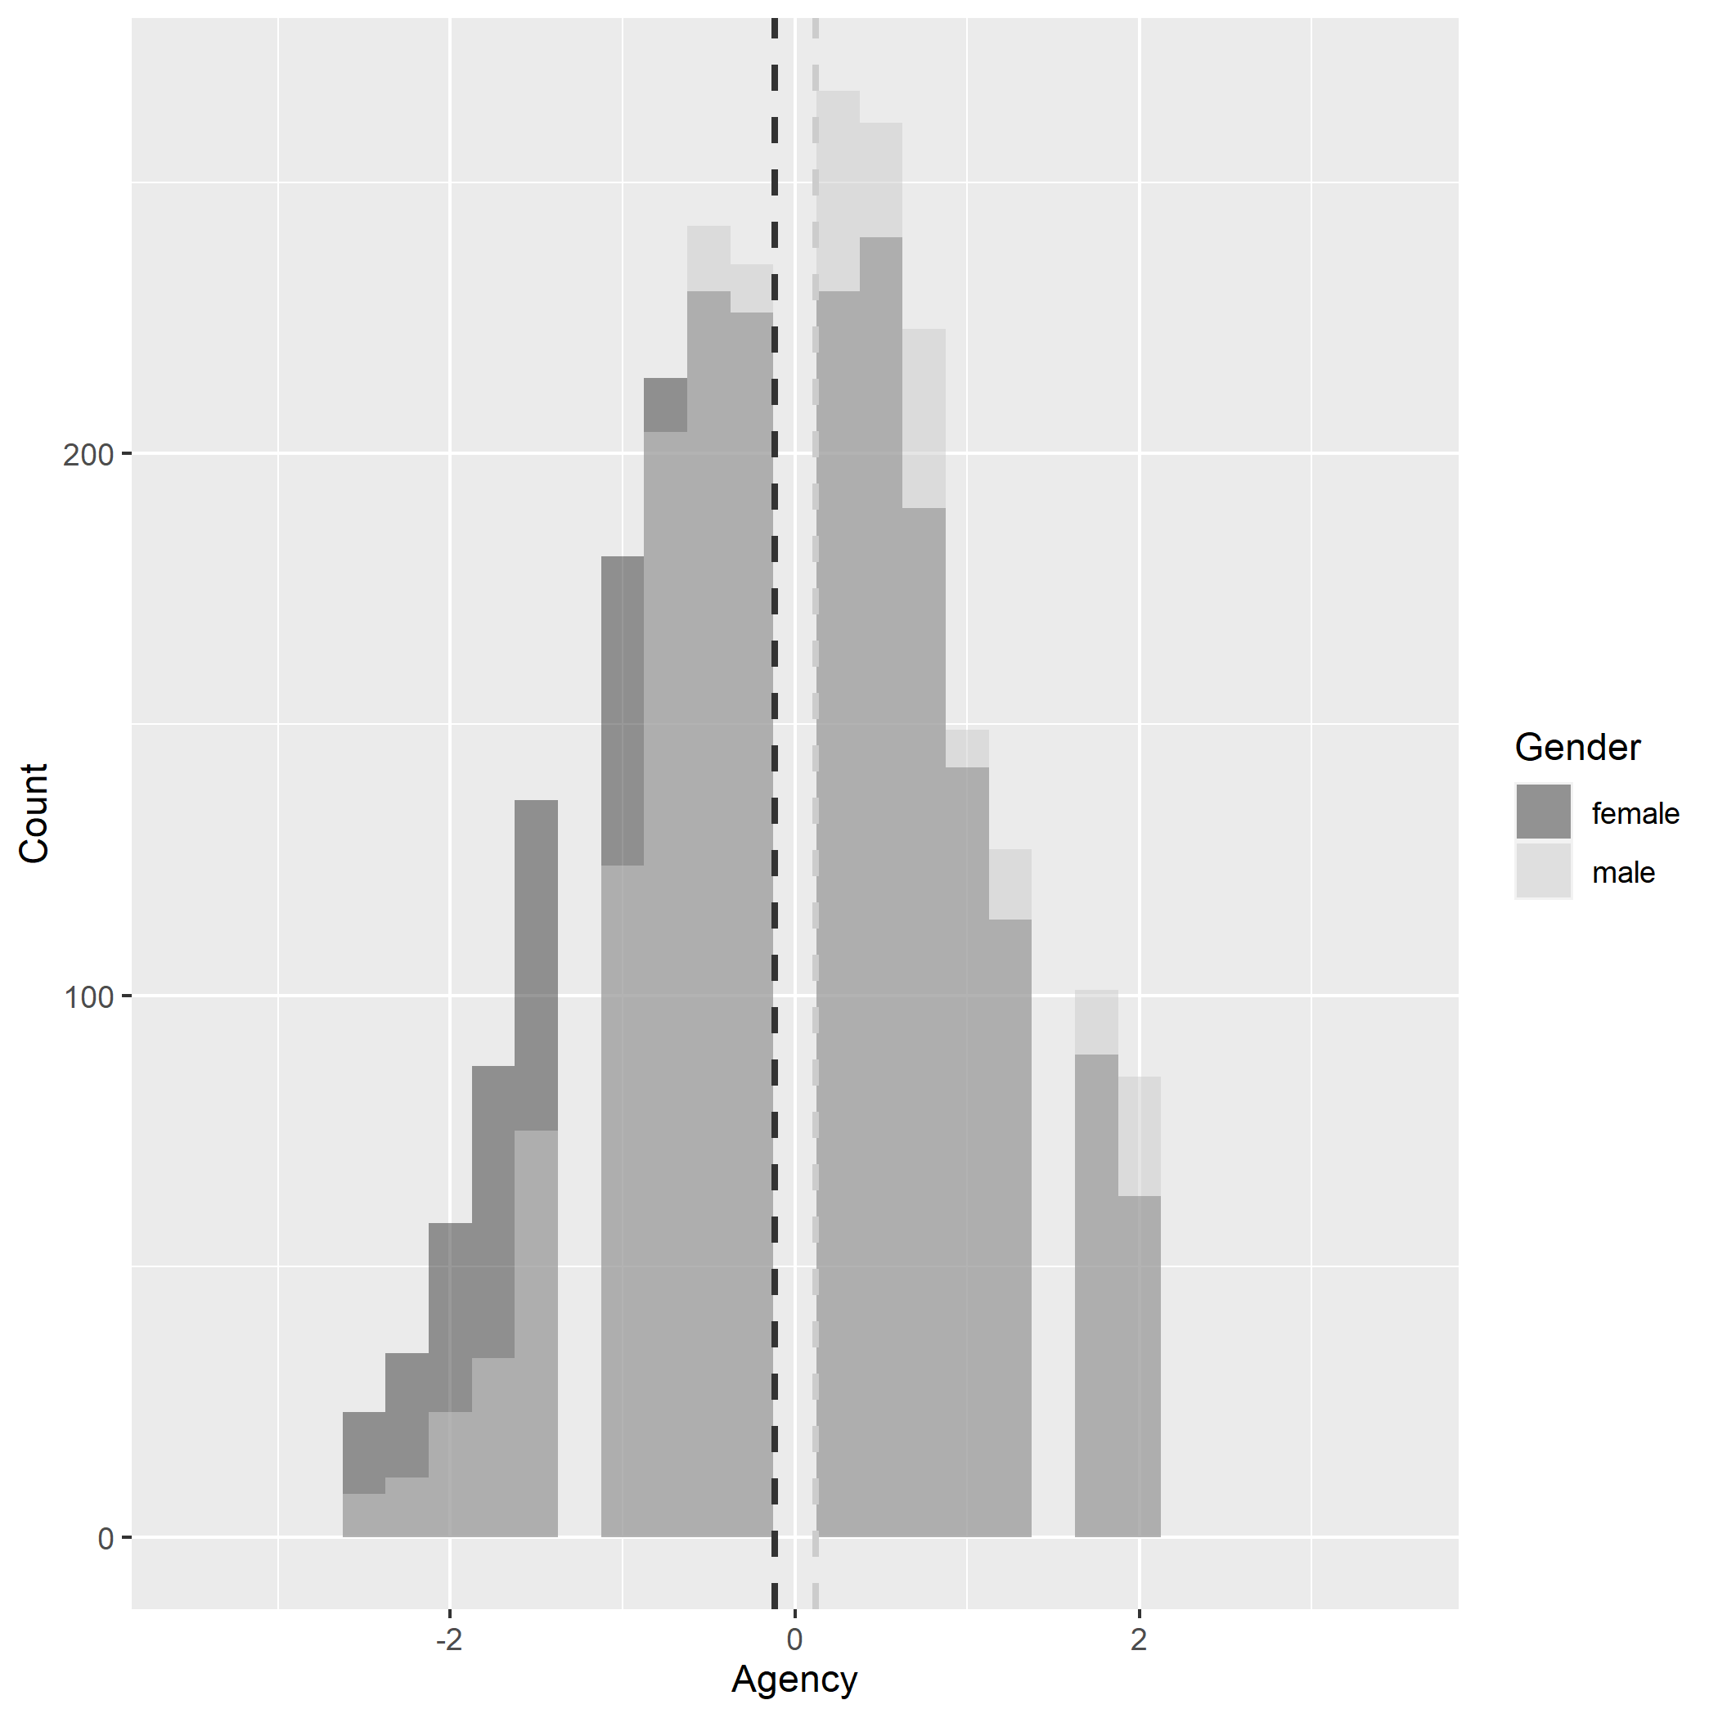
A

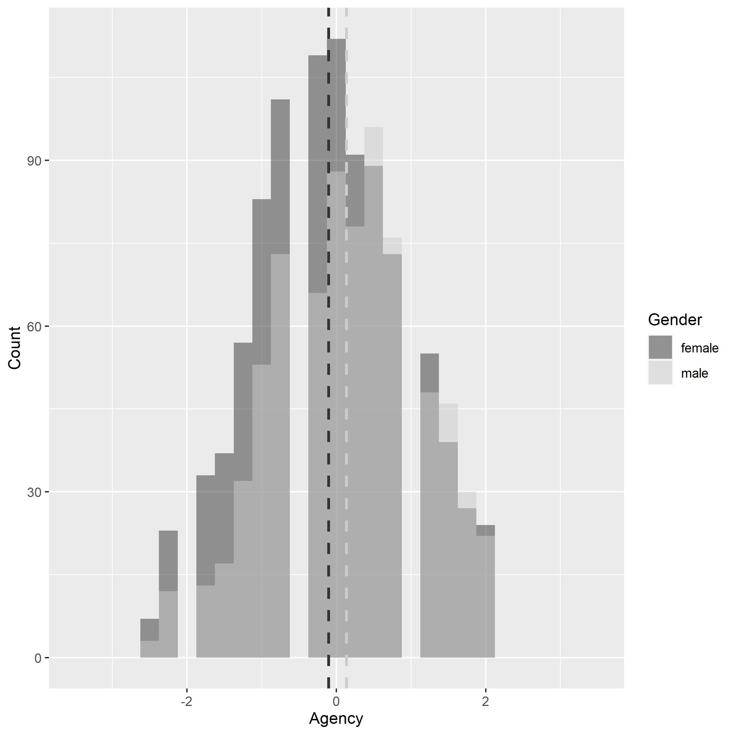

B

Table S3. Model Comparison Indices for agency (measurement invariance testing) in MIDUS1 samples.
Model: gender | χ2 | df | CFI | TLI | RMSEA | 90% CI  RMSEA | ∆CFI | Comparison Model
Non-twin Sample
1. Baseline | 392.02 | 10 | 0.981 | 0.962 | 0.130 | .119, .141
2. Thresholds | 432.53 | 15 | 0.979 | 0.973 | 0.111 | .102, .120 | -.002 | 1
3. Thresholds & Loadings | 495.92 | 19 | 0.976 | 0.975 | 0.105 | .097, .114 | -.003 | 2
4. Thresholds & Intercepts | 545.42 | 19 | 0.974 | 0.973 | 0.111 | .103, .119 | -.005 | 2
5. Thresholds, Loadings, & Intercepts | 560.85 | 23 | 0.973 | 0.977 | 0.102 | .095, .109 | -.006 | 2
Twin Sample
1. Baseline | 177.70 | 10 | 0.966 | 0.932 | 0.138 | .121, .157
2. Thresholds | 193.56 | 15 | 0.970 | 0.960 | 0.117 | .102, .132 | .004 | 1
3. Thresholds & Loadings | 177.12 | 19 | 0.974 | 0.972 | 0.098 | .085, .111 | .004 | 2
4. Thresholds & Intercepts | 208.85 | 19 | 0.968 | 0.967 | 0.107 | .094, .120 | -.002 | 2
5. Thresholds, Loadings, & Intercepts | 197.04 | 23 | 0.971 | 0.975 | 0.093 | .081, .105 | .001 | 2
Note. Samples are large enough that p-values will remain significant, so we did not report them.

Figure S2. IRT curves of Agency items from non-twin sample. Full (top), men (middle), and women (bottom) IIC (left) and TIC (right).
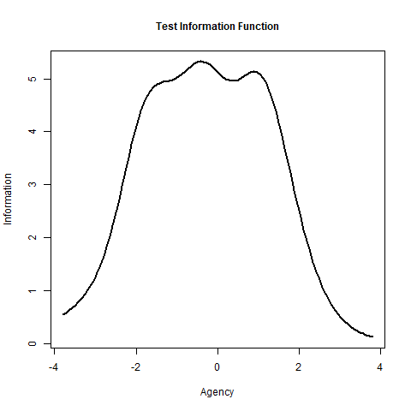
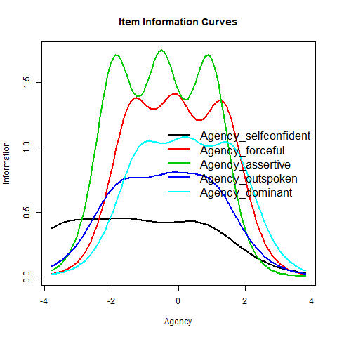

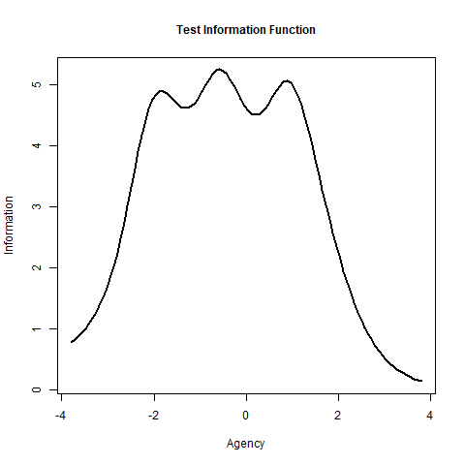
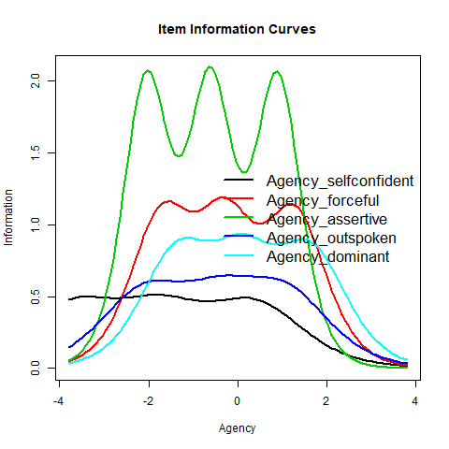

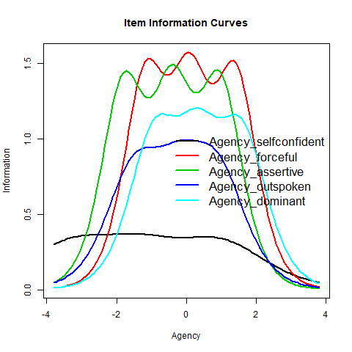

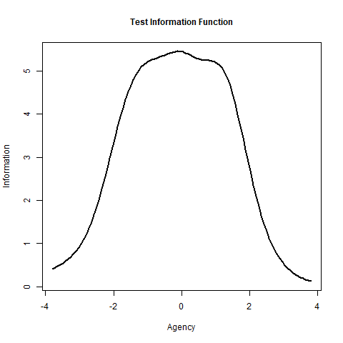
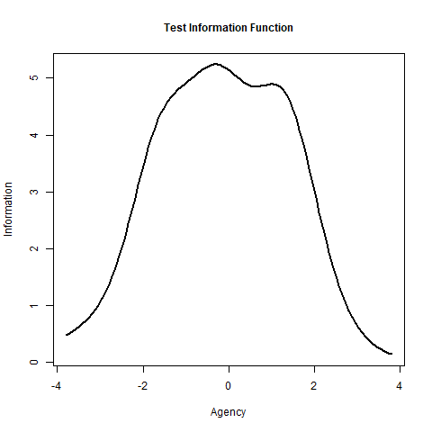
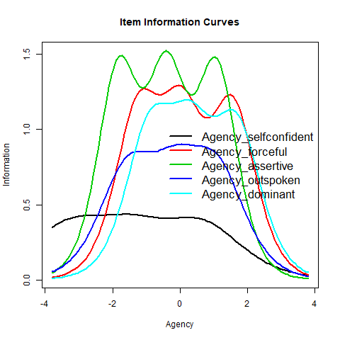
Figure S3. IRT curves of Agency items from twin sample. Full (top), men (middle), and women (bottom). IIC (left) and TIC (right).

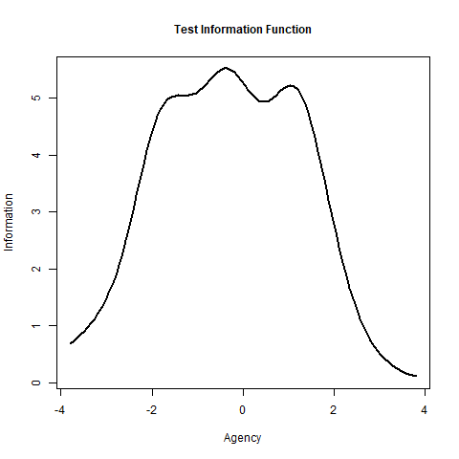
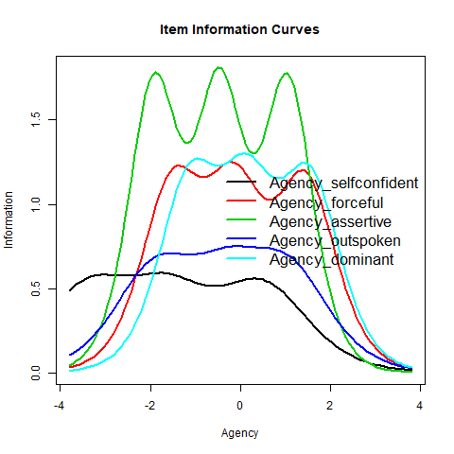

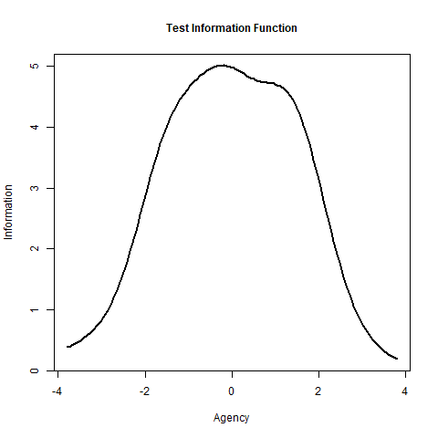

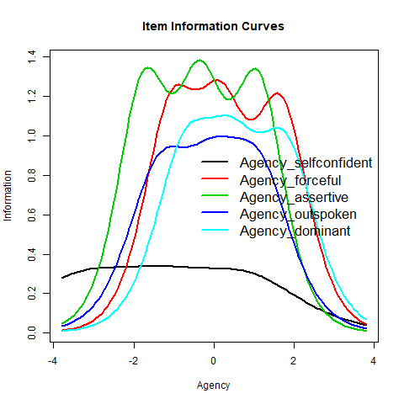
Figure S4. Regression plots from the non-twin sample (A-top) and twin sample (B-bottom) for each predictor in the multivariate regression models.
A
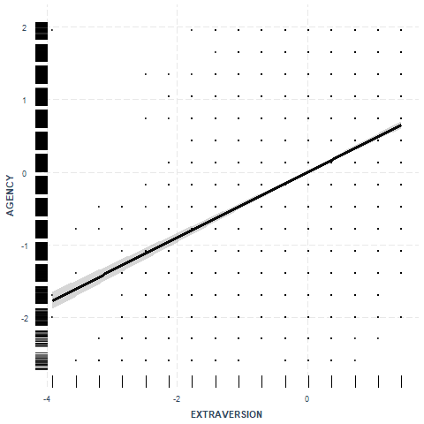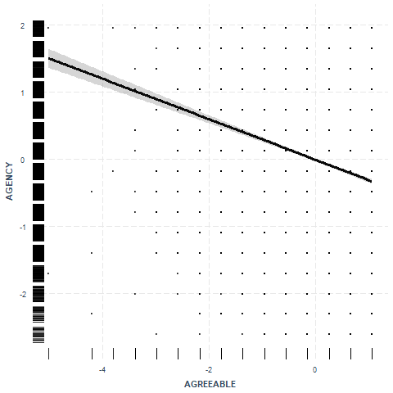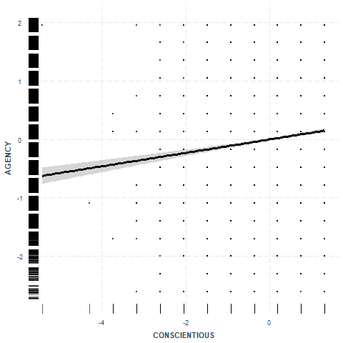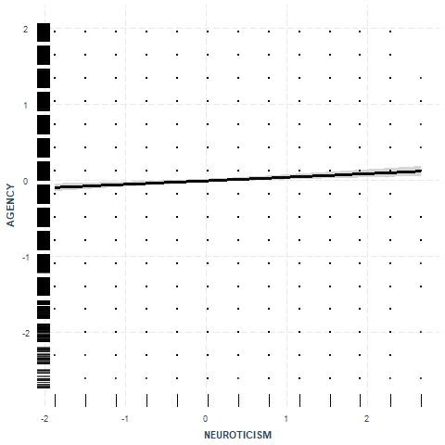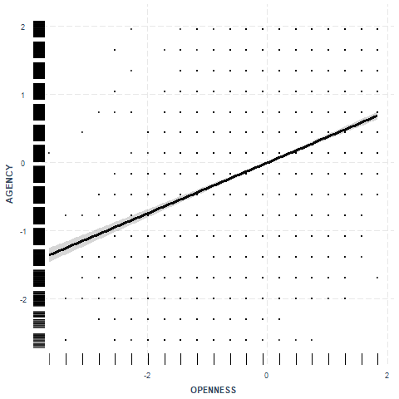

B
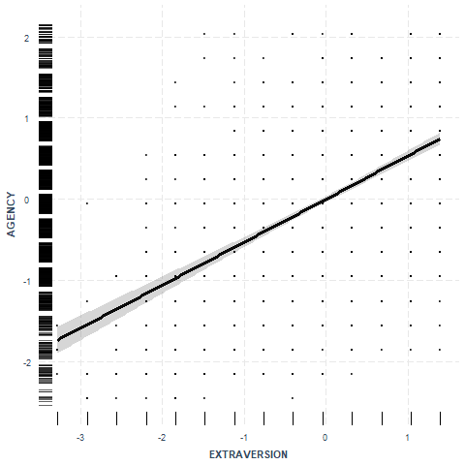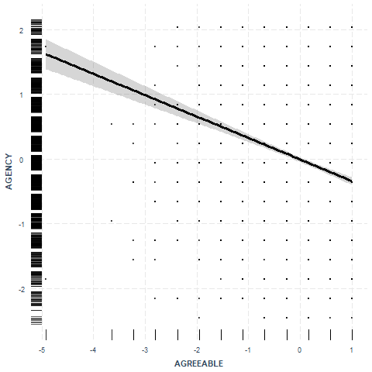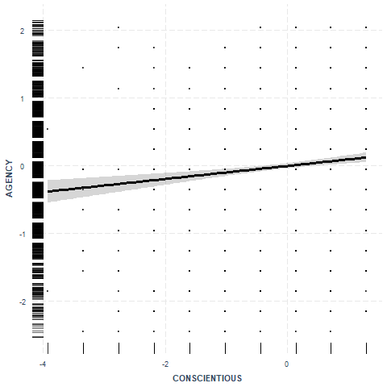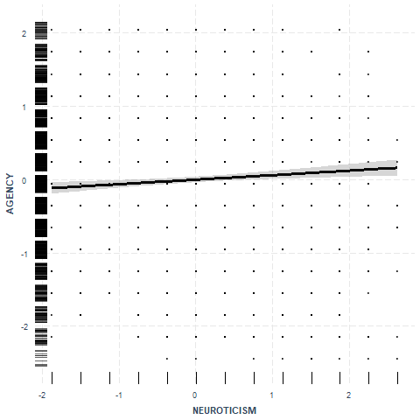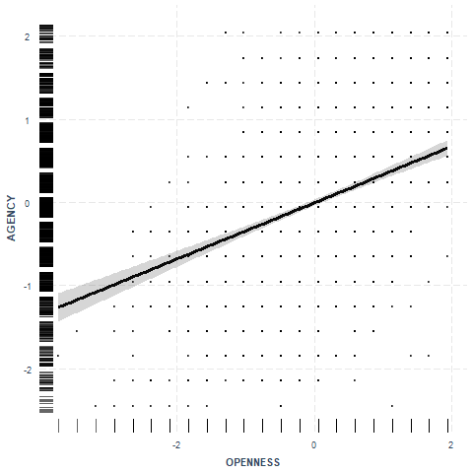

Table S4. Descriptive statistics for non-twin on left, twin sample middle, and Milwaukee sample right.
 |  | Non-twin sample |  |  |  |  |  |  |  |  | Twin sample |  |  |  |  |  |  |  | Milwaukee sample
Variable | Time1  M(SD) |  | Time1 α | Time2  M(SD) | Time2  α | Time3  M(SD) | Time3  α | Test-retest  ICC |  | Time1  M(SD) |  | Time1 α | Time2  M(SD) | Time2  α | Time3  M(SD) | Time3  α |  | Test-retest  ICC |  | Time2  M(SD) | Time2 α | Time3  M(SD) | Time3  α |  | Test-retest  ICC
N | 5,194 |  |  | 3,294 |  | 2,276 |  |  |  | 1,914 |  |  | 1,484 |  | 1,018 |  |  |  |  | 592 |  | 389
Agency | 2.71 (.66) |  | .797 | 2.64 (.67) | .814 | 2.62 (.66) | .803 | .882 |  | 2.64 (.67) |  | .801 | 2.55 (.64) | .785 | 2.53 (.67) | .809 |  | .871 |  | 2.81 (.61) | .707 | 2.78 (.67) | .727 |  | .671
Extraversion | 3.19 (.56) |  | .773 | 3.10 (.57) | .758 | 3.09 (.59) | .759 | .872 |  | 3.22 (.56) |  | .776 | 3.12 (.57) | .761 | 3.08 (.56) | .731 |  | .877 |  | 3.22 (.57) | .736 | 3.15 (.63) | .763 |  | .756
Agreeable  ness | 3.48 (.50) |  | .809 | 3.43 (.51) | .804 | 3.42 (.51) | .786 | .841 |  | 3.52 (.47) |  | .806 | 3.49 (.49) | .795 | 3.45 (.49) | .739 |  | .844 |  | 3.44 (.52) | .712 | 3.39 (.57) | .737 |  | .588
Conscien tiousness | 3.41 (.45) |  | .561 | 3.45 (.46) | .689 | 3.44 (.47) | .676 | .821 |  | 3.44 (.44) |  | .550 | 3.49 (.43) | .643 | 3.48 (.45) | .647 |  | .808 |  | 3.32 (.54) | .608 | 3.32 (.55) | .654 |  | .611
Neuroticism | 2.24 (.66) |  | .743 | 2.07 (.63) | .738 | 2.07 (.63) | .713 | .838 |  | 2.25 (.67) |  | .757 | 2.06 (.63) | .748 | 2.05 (.63) | .725 |  | .839 |  | 2.17 (.66) | .694 | 2.11 (.66) | .675 |  | .671
Openness | 3.04 (.53) |  | .774 | 2.92 (.54) | .776 | 2.93 (.54) | .772 | .865 |  | 2.97 (.53) |  | .776 | 2.86 (.54) | .765 | 2.84 (.53) | .762 |  | .858 |  | 2.97 (.59) | .791 | 2.92 (.62) | .814 |  | .716
Generativity | 2.83 (.63) |  | .843 | 2.83 (.65) | .850 | 2.81 (.66) | .855 | .835 |  | 2.82 (.62) |  | .843 | 2.84 (.63) | .852 | 2.81 (.62) | .847 |  | .801 |  | 3.15 (.62) | .815 | 3.10 (.60) | .806 |  | .745
BMI | 26.76 (5.34) |  |  | 27.95 (5.74) |  | 28.24 (6.12) |  | .929 |  | 26.48 (5.14) |  |  | 27.82 (5.89) |  | 28.29 (6.17) |  |  | .926 |  | 32.44 (15.19) |  | 31.97 (8.01) |  |  | .664
 | Time 1-2 Cohen’s d |  | 95% CI | Time 1-3 Cohen’s d | 95% CI | Time 2-3 Cohen’s d | 95% CI |  |  |  |  | Time 1-2 Cohen’s d |  | Time 1-3 Cohen’s d |  | Time 2-3 Cohen’s d |  |  |  |  | Time 2-3 Cohen’s d
Agency | .039 |  | [-.05, .12] | -.030 | [-.10, .04] | -.068 | [-.14, .005] |  |  |  |  | .033 | [-.11, .18] | .017 | [-.11, .14] | -.016 |  | [-.14, .10] |  |  | .118 | [-.09, .34]
Extraversion | .037 |  | [-.04, .12] | -.050 | [-.12, .02] | -.088 | [-.16, -.01] |  |  |  |  | -.043 | [-.18, .09] | .007 | [-.12, .12] | .050 |  | [-.06, .17] |  |  | .203 | [.005, .44]
Agreeable-  ness | .083 |  | [-.001, .16] | .062 | [-.007, .13] | -.022 | [-.09, .05] |  |  |  |  | .007 | [-.13, .16] | .048 | [-.07, .17] | .041 |  | [-.07, .14] |  |  | .079 | [-.14, .31]
Conscien  tiousness | -.008 |  | [-.09, .08] | -.147 | [-.22, -.07] | -.140 | [-.21, -.06] |  |  |  |  | -.124 | [-.26, .03] | -.210 | [-.33, -.09] | -.090 |  | [-.20, .03] |  |  | -.089 | [-.30, .14]
Neuroticism | .031 |  | [-.05, .11] | .080 | [.01, .15] | .050 | [-.02, .12] |  |  |  |  | .045 | [-.10, .19] | .113 | [-.01, .24] | .069 |  | [-.05, .19] |  |  | .003 | [-.21, .22]
Openness | -.008 |  | [-.09, .08] | -.064 | [-.13, .007] | -.056 | [-.14, .02] |  |  |  |  | .039 | [-.09, .18] | .007 | [-.12, .14] | -.033 |  | [-.14, .08] |  |  | .061 | [-.15, .28]
Generativity | .004 |  | [-.08, .08] | -.139 | [-.21, -.07] | -.143 | [-.21, -.06] |  |  |  |  | .005 | [-.13, .17] | -.123 | [-.24, -.005] | -.131 |  | [-.25, -.03]
BMI | -.006 |  | [-.09, .07] | .034 | [-.04, .10] | .040 | [-.03, .12] |  |  |  |  | -.073 | [-.22, .07] | -.0004 | [-.13, .12] | .076 |  | [-.04, .19] |  |  | -.062 | [-.28, .11]
Note: Item responses are coded so higher values indicate greater agreement. Personality items are 1 to 4; careless and calm are reversed so 4 corresponds to ‘not at all’. Generativity items are 1 to 4. The intraclass correlation was calculated within person across waves (2 or 3 depending on dataset), so the test-retest statistic represents consistency within individuals over time based on an average unit.

Table S5. Gender differences in wave 2 and wave 3 for nontwins, twins, and Milwaukee samples.
Wave 2 | d | CI lower | CI upper | Wave 3 | d | CI lower | CI upper
Non-twin
Agency | -0.262 | -0.34 | -0.18 |  | -0.236 | -0.33 | -0.15
Extraversion | 0.190 | 0.11 | 0.27 |  | 0.169 | 0.08 | 0.26
Agreeable | 0.615 | 0.54 | 0.69 |  | 0.577 | 0.48 | 0.67
Conscientious | 0.178 | 0.10 | 0.25 |  | 0.134 | 0.04 | 0.22
Neuroticism | 0.259 | 0.18 | 0.33 |  | 0.221 | 0.14 | 0.31
Openness | -0.132 | -0.20 | -0.06 |  | -0.089 | -0.17 | -0.001
Generativity | 0.055 | -0.02 | 0.13 |  | 0.075 | -0.01 | 0.16
BMI | -0.124 | -0.20 | -0.05 |  | -0.073 | -0.16 | 0.01
Twin
Agency | -0.238 | -0.36 | -0.13 |  | -0.200 | -0.33 | -0.05
Extraversion | 0.083 | -0.03 | 0.19 |  | 0.169 | 0.02 | 0.31
Agreeable | 0.520 | 0.41 | 0.64 |  | 0.679 | 0.55 | 0.82
Conscientious | 0.174 | 0.06 | 0.29 |  | 0.191 | 0.05 | 0.33
Neuroticism | 0.168 | 0.06 | 0.29 |  | 0.192 | 0.05 | 0.33
Openness | -0.032 | -0.14 | 0.08 |  | 0.069 | -0.07 | 0.21
Generativity | 0.010 | -0.10 | 0.12 |  | 0.159 | -0.27 | -0.03
BMI | -0.146 | -0.27 | -0.03 |  | -0.012 | -0.15 | 0.11
Milwaukee
Agency | -0.063 | -0.25 | 0.13 |  | -0.030 | -0.26 | 0.21
Extraversion | -0.187 | -0.39 | 0.03 |  | -0.046 | -0.27 | 0.18
Agreeable | -0.452 | -0.68 | -0.25 |  | -0.304 | -0.53 | -0.07
Conscientious | -0.215 | -0.44 | -0.02 |  | -0.186 | -0.42 | 0.04
Neuroticism | -0.024 | -0.24 | 0.20 |  | -0.005 | -0.23 | 0.23
Openness | -0.141 | -0.35 | 0.05 |  | -0.008 | -0.25 | 0.24
Generativity | -0.185 | -0.35 | -0.01 |  | -0.049 | -0.24 | 0.14
BMI | -0.344 | -0.44 | -0.24 |  | -0.281 | -0.61 | -0.17

Table S6. Measurement invariance across time in non-twins.
Models: waves | Chi-square | df | CFI | TLI | RMSEA | RMSEA 90% CI | SRMR | ΔCFI | ΔRMSEA | ΔSRMR
Agency | 435.657 | 15 | 0.97 | 0.94 | 0.095 | 0.087,0.103 | 0.027
Thresholds | 435.657 | 15 | 0.97 | 0.94 | 0.095 | 0.087,0.103 | 0.027 | 0 | 0 | 0
Thresholds & loadings | 442.149 | 23 | 0.97 | 0.961 | 0.076 | 0.070,0.083 | 0.028 | 0 | -0.019 | 0.001
Thresholds, loadings, & intercepts | 556.926 | 31 | 0.962 | 0.963 | 0.074 | 0.069,0.079 | 0.034 | -0.008 | -0.002 | 0.006
Extraversion | 831.843 | 15 | 0.933 | 0.867 | 0.132 | 0.125,0.140 | 0.041
Thresholds | 831.843 | 15 | 0.933 | 0.867 | 0.132 | 0.125,0.140 | 0.041 | 0 | 0 | 0
Thresholds & loadings | 847.658 | 23 | 0.933 | 0.912 | 0.107 | 0.101,0.113 | 0.042 | 0 | -0.025 | 0.001
Thresholds, loadings, & intercepts | 1004.889 | 31 | 0.921 | 0.923 | 0.1 | 0.095,0.106 | 0.048 | -0.012 | -0.007 | 0.006
Agreeableness | 240.506 | 6 | 0.978 | 0.935 | 0.112 | 0.100,0.124 | 0.023
Thresholds | 240.506 | 6 | 0.978 | 0.935 | 0.112 | 0.100,0.124 | 0.023 | 0 | 0 | 0
Thresholds & loadings | 256.499 | 12 | 0.977 | 0.966 | 0.081 | 0.072,0.090 | 0.026 | -0.001 | -0.031 | 0.003
Thresholds, loadings, & intercepts | 302.699 | 18 | 0.974 | 0.974 | 0.071 | 0.064,0.078 | 0.029 | -0.003 | -0.01 | 0.003
Conscientiousness | 106.945 | 6 | 0.974 | 0.922 | 0.073 | 0.062,0.086 | 0.022
Thresholds | 106.945 | 6 | 0.974 | 0.922 | 0.073 | 0.062,0.086 | 0.022 | 0 | 0 | 0
Thresholds & loadings | 144.917 | 12 | 0.966 | 0.949 | 0.06 | 0.051,0.068 | 0.029 | -0.008 | -0.013 | 0.007
Thresholds, loadings, & intercepts | 364.382 | 18 | 0.911 | 0.911 | 0.079 | 0.072,0.086 | 0.046 | -0.055 | 0.019 | 0.017
Neuroticism | 87.898 | 6 | 0.99 | 0.971 | 0.066 | 0.054,0.079 | 0.017
Thresholds | 87.898 | 6 | 0.99 | 0.971 | 0.066 | 0.054,0.079 | 0.017 | 0 | 0 | 0
Thresholds & loadings | 97.198 | 12 | 0.99 | 0.985 | 0.048 | 0.039,0.057 | 0.019 | 0 | -0.018 | 0.002
Thresholds, loadings, & intercepts | 269.557 | 18 | 0.971 | 0.971 | 0.067 | 0.060,0.074 | 0.038 | -0.019 | 0.019 | 0.019
Openness to experience | 353.53 | 15 | 0.956 | 0.911 | 0.085 | 0.078,0.093 | 0.027
Thresholds | 353.53 | 15 | 0.956 | 0.911 | 0.085 | 0.078,0.093 | 0.027 | 0 | 0 | 0
Thresholds & loadings | 366.364 | 23 | 0.955 | 0.941 | 0.069 | 0.063,0.076 | 0.029 | -0.001 | -0.016 | 0.002
Thresholds, loadings, & intercepts | 379.025 | 31 | 0.954 | 0.956 | 0.06 | 0.055,0.066 | 0.029 | -0.001 | -0.009 | 0
Generativity | 909.562 | 27 | 0.957 | 0.929 | 0.103 | 0.097,0.109 | 0.031
Thresholds | 909.562 | 27 | 0.957 | 0.929 | 0.103 | 0.097,0.109 | 0.031 | 0 | 0 | 0
Thresholds & loadings | 935.525 | 37 | 0.957 | 0.947 | 0.089 | 0.084,0.094 | 0.034 | 0 | -0.014 | 0.003
Thresholds, loadings, & intercepts | 1133.811 | 47 | 0.948 | 0.95 | 0.087 | 0.082,0.091 | 0.039 | -0.009 | -0.002 | 0.005

Table S7. Measurement invariance across time in twins.
Models: waves | Chi-square | df | CFI | TLI | RMSEA | RMSEA 90% CI | SRMR | ΔCFI | ΔRMSEA | ΔSRMR
Agency | 210.087 | 15 | 0.964 | 0.929 | 0.101 | 0.089,0.113 | 0.03
Thresholds | 210.087 | 15 | 0.964 | 0.929 | 0.101 | 0.089,0.113 | 0.03 | 0 | 0 | 0
Thresholds & loadings | 218.266 | 23 | 0.964 | 0.953 | 0.081 | 0.072,0.091 | 0.033 | 0 | -0.02 | 0.003
Thresholds, loadings, & intercepts | 254.591 | 31 | 0.959 | 0.96 | 0.075 | 0.067,0.084 | 0.037 | -0.005 | -0.006 | 0.004
Extraversion | 229.565 | 15 | 0.956 | 0.911 | 0.105 | 0.094,0.118 | 0.034
Thresholds | 229.565 | 15 | 0.956 | 0.911 | 0.105 | 0.094,0.118 | 0.034 | 0 | 0 | 0
Thresholds & loadings | 237.166 | 23 | 0.956 | 0.942 | 0.085 | 0.075,0.095 | 0.036 | 0 | -0.02 | 0.002
Thresholds, loadings, & intercepts | 322.076 | 31 | 0.94 | 0.942 | 0.085 | 0.077,0.094 | 0.044 | -0.016 | 0 | 0.008
Agreeableness | 107.492 | 6 | 0.976 | 0.927 | 0.115 | 0.096,0.134 | 0.024
Thresholds | 107.492 | 6 | 0.976 | 0.927 | 0.115 | 0.096,0.134 | 0.024 | 0 | 0 | 0
Thresholds & loadings | 111.782 | 12 | 0.976 | 0.964 | 0.08 | 0.067,0.094 | 0.026 | 0 | -0.035 | 0.002
Thresholds, loadings, & intercepts | 122.821 | 18 | 0.975 | 0.975 | 0.067 | 0.056,0.079 | 0.028 | -0.001 | -0.013 | 0.002
Conscientiousness | 29.914 | 6 | 0.982 | 0.947 | 0.056 | 0.037,0.076 | 0.018
Thresholds | 29.914 | 6 | 0.982 | 0.947 | 0.056 | 0.037,0.076 | 0.018 | 0 | 0 | 0
Thresholds & loadings | 35.221 | 12 | 0.983 | 0.974 | 0.039 | 0.024,0.054 | 0.021 | 0.001 | -0.017 | 0.003
Thresholds, loadings, & intercepts | 123.701 | 18 | 0.921 | 0.921 | 0.068 | 0.057,0.079 | 0.042 | -0.062 | 0.029 | 0.021
Neuroticism | 33.31 | 6 | 0.993 | 0.978 | 0.06 | 0.041,0.080 | 0.016
Thresholds | 33.31 | 6 | 0.993 | 0.978 | 0.06 | 0.041,0.080 | 0.016 | 0 | 0 | 0
Thresholds & loadings | 40.33 | 12 | 0.992 | 0.988 | 0.043 | 0.029,0.058 | 0.021 | -0.001 | -0.017 | 0.005
Thresholds, loadings, & intercepts | 102.793 | 18 | 0.977 | 0.977 | 0.061 | 0.049,0.072 | 0.037 | -0.015 | 0.018 | 0.016
Openness to experience | 202.546 | 15 | 0.935 | 0.871 | 0.099 | 0.087,0.111 | 0.032
Thresholds | 202.546 | 15 | 0.935 | 0.871 | 0.099 | 0.087,0.111 | 0.032 | 0 | 0 | 0
Thresholds & loadings | 211.506 | 23 | 0.935 | 0.915 | 0.08 | 0.070,0.090 | 0.035 | 0 | -0.019 | 0.003
Thresholds, loadings, & intercepts | 231.953 | 31 | 0.931 | 0.933 | 0.071 | 0.063,0.080 | 0.038 | -0.004 | -0.009 | 0.003
Generativity | 357.798 | 27 | 0.961 | 0.935 | 0.098 | 0.089,0.107 | 0.03
Thresholds | 357.798 | 27 | 0.961 | 0.935 | 0.098 | 0.089,0.107 | 0.03 | 0 | 0 | 0
Thresholds & loadings | 364.025 | 37 | 0.961 | 0.953 | 0.083 | 0.076,0.091 | 0.032 | 0 | -0.015 | 0.002
Thresholds, loadings, & intercepts | 464.95 | 47 | 0.951 | 0.953 | 0.084 | 0.077,0.091 | 0.039 | -0.01 | 0.001 | 0.007

Table S8. Model fit from the univariate growth models.
Models:  Growth | Intercept  Mean | Slope Mean | Correlation I~S | Chi-square | df | CFI | TLI | RMSEA | SRMR
 |  |  |  | Non-twins
Agency | 4.642 | -0.326 | -0.286 | 2.472 | 1 | 1 | 0.999 | 0.018 | 0.006
Extraversion | 6.658 | -0.571 | -0.04 | 16.488 | 1 | 0.995 | 0.986 | 0.058 | 0.015
Agreeable | 8.466 | -0.267 | -0.158 | 2.666 | 1 | 0.999 | 0.998 | 0.019 | 0.006
Conscientious | 8.999 | 0.024 | -0.251 | 7.019 | 1 | 0.997 | 0.992 | 0.036 | 0.011
Neuroticism | 4.07 | -0.529 | -0.336 | 81.835 | 1 | 0.97 | 0.91 | 0.132 | 0.035
Openness | 6.56 | -0.491 | -0.19 | 39.379 | 1 | 0.988 | 0.964 | 0.091 | 0.023
Generativity | 5.42 | -0.156 | -0.167 | 6.333 | 1 | 0.998 | 0.994 | 0.034 | 0.01
 |  |  |  | Twins
Agency | 4.763 | -0.346 | -0.16 | 7.014 | 1 | 0.994 | 0.983 | 0.058 | 0.014
Extraversion | 6.471 | -0.508 | -0.273 | 6.863 | 1 | 0.995 | 0.986 | 0.057 | 0.014
Agreeable | 8.834 | -0.245 | -0.259 | 0 | 1 | 1 | 1.003 | 0 | 0
Conscientious | 10.438 | 0.289 | 0.152 | 6.834 | 1 | 0.991 | 0.972 | 0.057 | 0.019
Neuroticism | 4.119 | -0.819 | -0.384 | 35.964 | 1 | 0.959 | 0.877 | 0.14 | 0.039
Openness | 6.42 | -0.5 | -0.263 | 12.36 | 1 | 0.986 | 0.959 | 0.08 | 0.02
Generativity | 5.32 | -0.073 | -0.405 | 3.648 | 1 | 0.996 | 0.988 | 0.038 | 0.013

Table S9. Model fit from the pairwise correlated growth models between each big five trait and agency.
Models:  Correlated Growth | Intercept  Mean | Slope Mean | Chi-square | df | CFI | TLI | SRMR | RMSEA
 |  |  | Non-twins
Agency ~~  Extraversion | 4.626  6.427 | -0.332  -0.395 | 362.99 | 7 | .961 | .917 | .105 | .024
Agency ~~  Agreeableness | 4.627  8.441 | -0.321  -0.252 | 67.05 | 7 | .991 | .980 | .043 | .012
Agency ~~  Conscientious | 4.613  8.968 | -0.323  0.024 | 96.71 | 7 | .986 | .970 | .053 | .014
Agency ~~  Neuroticism | 4.659  4.066 | -0.335  -0.526 | 94.52 | 7 | .986 | .970 | .052 | .023
Agency ~~  Openness | 4.625  6.464 | -0.344  -0.430 | 500.02 | 7 | .947 | .886 | .123 | .029
Agency ~~  Generativity | 4.630  5.453 | -0.330  -0.159 | 74.03 | 7 | .990 | .978 | .013 | .045
 |  |  | Twins
Agency ~~  Extraversion | 4.684  6.394 | -0.322  -0.464 | 96.80 | 7 | .974 | .943 | .085 | .021
Agency ~~  Agreeableness | 4.755  8.814 | -0.343  -0.242 | 31.64 | 7 | .989 | .977 | .044 | .013
Agency ~~  Conscientious | 4.738  10.358 | -0.342  0.214 | 40.79 | 7 | .984 | .965 | .052 | .019
Agency ~~  Neuroticism | 4.773  4.101 | -0.354  -0.783 | 48.60 | 7 | .981 | .966 | .058 | .025
Agency ~~  Openness | 4.680  6.264 | -0.322  -0.414 | 111.96 | 7 | .964 | .924 | .091 | .026
Agency ~~  Generativity | 4.706  5.285 | -0.323  -0.061 | 22.17 | 7 | .993 | .985 | .016 | .053

Table S10. Twin correlations matrices (Pearson) shaded on lower diagonal with standard errors on upper diagonal for Twin 1 (T1) and Twin 2 (T2). Top matrix is MZ correlations; middle matrix is DZ same-sex correlations; bottom matrix is DZ opposite-sex twins.

Note. Solid bold lines surround the rMZ and rDZ Agency correlations. The solid dotted lines highlight the within-twin cross-trait correlations of Agency and second variable. The alternate diagonal contains cross-twin cross-trait correlations.

Table S11. Univariate heritability standardized path loadings.
Model | Parameters  a² c² / d² e²
Agency  ADE  ACE  CE  AE  Generativity  ADE  DE  AE  Extraversion  ADE  DE  AE  Agreeableness  ADE  DE  AE  Conscientiousness  ADE  DE  AE  Neuroticism  ADE  DE  AE  Openness  ACE  CE  AE | 0.444  0.417  0.444  0.257  --  0.324  0.000  --  0.420  0.012  --  0.284  0.331  --  0.458  0.454  --  0.510  0.359  --  0.424 | 0.000  0.025  0.358  --  0.073  0.339  --  0.448  0.448  --  0.293  0.305  --  0.135  0.475  --  0.059  0.520  --  0.058  0.333  -- | 0.556  0.558  0.642  0.556  0.670  0.661  0.676  0.552  0.552  0.580  0.695  0.695  0.716  0.534  0.525  0.542  0.487  0.480  0.490  0.583  0.667  0.576

Table S12. Univariate heritability model fit indices.
Model | Fit  -2LL AIC p
Agency  ACE  ADE  CE  AE  Generativity  ACE  ADE  DE  AE  Extraversion  ACE  ADE  DE  AE  Agreeableness  ACE  ADE  DE  AE  Conscientiousness  ACE  ADE  DE  AE  Neuroticism  ACE  ADE  DE  AE  Openness  ACE  ADE  CE  AE | 3350.84  3350.88  3359.12  3350.88  3439.76  3542.39  3440.76  3439.76  3385.54  3381.29  3381.29  3385.54  3303.62  3302.48  3302.49  3303.62  3391.55  3391.24  3391.14  3391.55  3308.83  3308.77  3312.01  3308.83  3314.84  3315.06  3320.99  3315.06 | 920.841  920.876  927.122  918.876  999.762  999.618  998.757  997.762  931.541  927.289  925.289  929.541  849.622  848.484  846.486  847.622  935.552  935.238  935.144  933.552  866.827  866.771  868.012  864.827  880.843  881.058  884.991  879.058 | .004  .853  0.319  1.000  1.000  1.000  1.000  1.000  0.207  1.000  0.074  1.000  0.013  0.642
Note. Comparison fit (p) is in comparison to the ACE model.
Figure S5.
Multivariate biometric decomposition model displaying the additive genetic and nonshared environmental contributions to the covariance between Big Five traits (E, A, C, N, and O) and Agency. A, additive genetic factors; E, nonshared environmental factors. Latent factor subscripts denote the phenotype its shared with or “u” the unique/residual, influences of Agency. Cross-paths from Big Five trait A and E latent constructs are dropped for simplicity.

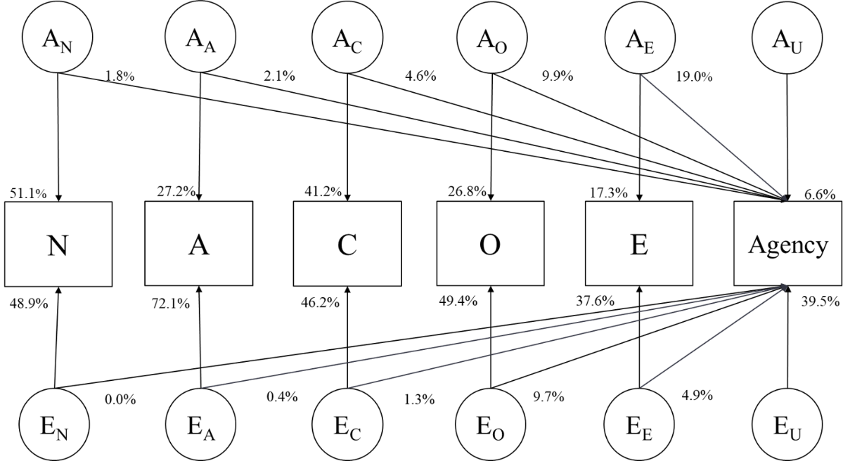

Table S13. Parameter estimates from the best-fitting models for bivariate and multivariate associations with Agency; residual estimates refer to unique influences on Agency. Also portrayed in the main paper.
Model |  | Shared Parameter Estimates  a² e² |  | Residual Parameter Estimates  a² e²
Generativity  Extraversion  Agreeableness  Conscientiousness  Neuroticism  Openness  Multivariate (total) | .143  .253  .026  .072  .019  .174  .374 |  | .038  .115  .005  .016  .001  .109  .163 |  | .303  .186  .417  .372  .426  .272  .066 | .516  .446  .552  .540  .554  .445  .395

Table S14. Full bivariate genetic model results (standardized path loadings).
Model | Shared Parameters |  |  | Residual parameters
 | a² | c²/ d² | e² | a² | c²/ d² | e²
Generativity  ACE  ADE  AE | 0.114  0.179  0.143 | 0  0.004  -- | 0.040  0.039  0.038 | 0.285  0.263  0.303 | 0.043  0  -- | 0.518  0.515  0.516
Extraversion  ACE  ADE  AE | 0.242  0.421  0.253 | 0.017  0.018  -- | 0.116  0.120  0.115 | 0.179  0  0.186 | 0  0  -- | 0.446  0.441  0.446
Agreeableness  ACE  ADE  AE | 0.017  0.433  0.026 | 0.042  0.011  -- | 0.005  0.005  0.005 | 0.381  0  0.417 | 0  0  -- | 0.555  0.551  0.552
Conscientiousness  ACE  ADE  AE | 0.077  0.054  0.072 | 0.035  0.019  -- | 0.016  0.016  0.016 | 0.329  0.371  0.372 | 0  0  -- | 0.543  0.540  0.540
Neuroticism  ACE  ADE  AE | 0.0166  0.033  0.019 | 0.018  0.006  -- | 0.0004  0.001  0.001 | 0.410  0.406  0.426 | 0  0  -- | 0.555  0.554  0.554
Openness  ACE  ADE  AE | 0.135  0.178  0.174 | 0.037  0.006  -- | 0.112  0.110  0.109 | 0.271  0.262  0.272 | 0  0  -- | 0.445  0.444  0.445
Note. The AE model was the best-fitting for all the bivariate decompositions. The standardized c or d estimates depend on whether the model was ACE or ADE.

Table S15. Full multivariate genetic model results (standardized path loadings) including overlap among the Big Five traits.

Table S16. Standard errors from full multivariate genetic model results.

Table S17. Bivariate and Multivariate model fit indices for overlap with Agency.
Model | Overall fit  -2LL AIC |  | Comparison Fit  p
Generativity  ACE  ADE  AE  Extraversion  ACE  ADE  AE  Agreeableness  ACE  ADE  AE  Conscientiousness  ACE  ADE  AE  Neuroticism  ACE  ADE  AE  Openness  ACE  ADE  AE  Multivariate  ACE  ADE  AE | 6623.25  6623.32  6623.38  6269.48  6265.15  6269.49  6631.28  6630.10  6631.39  6655.47  6655.23  6655.56  6646.24  6646.12  6646.26  6304.85  6305.11  6305.11  18251.92  18247.83  18254.08 | 6653.25  6653.32  6647.38  6299.48  6295.15  6293.49  6661.28  6660.10  6655.39  6685.47  6685.23  6679.56  6676.24  6676.12  6670.26  6334.85  6335.11  6329.11  3671.923  3667.823  3632.079 |  |  | .989  .999  .991  .993  .999  .966  1.00
Note. Comparison fit is in comparison to the ACE model.

Table S18. The results from the univariate ACE longitudinal growth models.
Models | a² | c² | e² | Cor(Ais) | Cor(Cis) | Cor(Eis)
Agency |  |  |  | 0.486 | -0.592 | 0.026
intercept | 0.637 | 0.000 | 0.364
slope | 0.658 | 0.000 | 0.343
Extraversion |  |  |  | -0.003 | NA | -0.431
intercept | 0.533 | 0.000 | 0.466
slope | 0.240 | 0.000 | 0.760
Agreeable |  |  |  | -0.335 | -0.969 | -0.403
intercept | 0.444 | 0.103 | 0.453
slope | 0.629 | 0.000 | 0.372
Conscientious |  |  |  | NA | -0.347 | -0.234
intercept | 0.676 | 0.000 | 0.325
slope | 0.000 | 0.000 | 1.000
Neuroticism |  |  |  | -0.972 | NA | -0.027
intercept | 0.709 | 0.000 | 0.291
slope | 0.254 | 0.000 | 0.746
Openness |  |  |  | 0.332 | NA | NA
intercept | 0.591 | 0.000 | 0.410
slope | 1.000 | 0.000 | 0.000
Generativity |  |  |  | NA | NA | -0.736
intercept | 0.396 | 0.000 | 0.604
slope | 0.000 | 0.456 | 0.545
Note. Cor(Ais) refers to the genetic correlation between the a parameter of the intercept and the slope. Similar for the notation Cor(Cis) and Cor(Eis).
Table S19. The fit from the univariate ACE longitudinal growth models.
Models | χ² | df | CFI | TLI | RMSEA | RMSEA 90% CI | SRMR
Agency | 41.903 | 34 | 0.993 | 0.994 | 0.027 | 0,0.050 | 0.053
Extraversion | 50.851 | 37 | 0.988 | 0.99 | 0.034 | 0,0.055 | 0.083
Agreeable | 44.276 | 34 | 0.989 | 0.99 | 0.03 | 0,0.053 | 0.057
Conscientious | 54.912 | 36 | 0.978 | 0.981 | 0.04 | 0.015,0.060 | 0.075
Neuroticism | 64.781 | 37 | 0.973 | 0.978 | 0.048 | 0.028,0.067 | 0.061
Openness | 40.984 | 39 | 0.998 | 0.999 | 0.012 | 0,0.041 | 0.065
Generativity | 46.275 | 38 | 0.989 | 0.992 | 0.026 | 0,0.049 | 0.07

Table S20. The fit from the bivariate ACE longitudinal growth models.
Models | χ² | df | CFI | TLI | RMSEA | SRMR
Extraversion | 119.92 | 61 | .976 | .978 | .054 | .087
Agreeable | 122.58 | 54 | .971 | .970 | .062 | .090
Conscientious i-s | 56.04 | 19 | .899 | .937 | .077 | .079
Conscientious s-i | 26.68 | 17 | .991 | .994 | .042 | .102
Conscientious s-s | 57.55 | 19 | .947 | .967 | .078 | .118
Conscientious i-i | 12.22 | 19 | 1 | 1 | 0 | .039
Neuroticism i-s | 29.26 | 19 | .976 | .985 | .041 | .065
Neuroticism s-i | 33.84 | 19 | .987 | .992 | .049 | .110
Neuroticism s-s | 56.12 | 19 | .955 | .971 | .077 | .118
Neuroticism i-i | 17.04 | 19 | 1 | 1 | 0 | .057
Openness i-s
Openness s-i | 45.21 | 19 | .973 | .983 | .065 | .109
Openness s-s
Openness i-i | 28.54 | 19 | .990 | .994 | .039 | .058
Generativity | 230.37 | 64 | .947 | .954 | .089 | .095
Note. For the models listed trait i-i, for example, separate models had to be estimated due to complexity.

Table S21. Cross-time correlations in MIDUS Milwaukee sample. The sample collection matches with time 2 and time 3 of the MIDUS main dataset.
 | BMI 2 | BMI 3 | Agency 2 | Agency 3 | E 2 | E 3 | A 2 | A 3 | C 2 | C 3 | N 2 | N 3 | O 2 | O 3 | Gener-ative 2
BMI 3 | .560 | 1.00
Agency 2 | .105 | .104 | 1.00
Agency 3 | .078 | .103 | .508 | 1.00
E 2 | .006 | .001 | .590 | .446 | 1.00
E 3 | .079 | .027 | .409 | .623 | .609 | 1.00
A 2 | -.065 | -.011 | .269 | .137 | .531 | .280 | 1.00
A 3 | .035 | .086 | .171 | .391 | .303 | .596 | .424 | 1.00
C 2 | -.040 | -.076 | .298 | .099 | .350 | .208 | .368 | .242 | 1.00
C 3 | -.008 | -.003 | .239 | .321 | .320 | .458 | .250 | .530 | .440 | 1.00
N 2 | -.025 | .048 | -.129 | -.056 | -.290 | -.154 | -.157 | -.107 | -.290 | -.188 | 1.00
N 3 | -.069 | -.062 | -.120 | -.017 | -.246 | -.233 | -.072 | -.257 | -.196 | -.373 | .507 | 1.00
O 2 | .068 | .050 | .607 | .359 | .598 | .352 | .489 | .203 | .287 | .146 | -.160 | -.124 | 1.00
O 3 | .103 | .159 | .374 | .670 | .473 | .617 | .345 | .560 | .190 | .475 | -.192 | -.224 | .558 | 1.00
Gener-ative 2 | .025 | .074 | .259 | .304 | .303 | .343 | .249 | .277 | .184 | .256 | -.082 | -.176 | .276 | .359 | 1.00
Gener-ative 3 | -.006 | .001 | .217 | .384 | .288 | .405 | .235 | .357 | .211 | .319 | -.187 | -.207 | .230 | .411 | .594

Information was obtained from Midlife in the United States (MIDUS 3): Milwaukee African American Sample, 2016-2017 Description file.
When using first and second ordering the racial origins were as follows: Black and/or African American = 296, Black and/or African American and Native American or Alaska Native Aleutian Islander = 73, the reverse where Native American is first and Black is second origin = 5, Black and/or African American and White = 18, the reverse where White was first origin and Black was second = 15, Black and/or African American and Asian = 2, Black and/or African American and Native Hawaiian or Pacific Islander = 2, Black and/or African American and other = 8, the reverse other and Black and/or African American = 2, White and Native American or Alaska Native Aleutian Islander = 4, the reverse where Native American was first and White second origin = 1, Native American or Alaska Native Aleutian Islander = 2, other = 5, and 5 participants were missing responses to racial origins.
This model was specified dropping the C parameter on the intercept of Agency in order to have a model that converged with no problematic results (e.g., correlations greater than 1).

