SUPPLEMENTARY FIGURES AND TABLES

average cell marking of the eightplicates

Table S1 – Cell proliferation evaluation of MCF7 and MCF10a lines exposed to different concentrations of Levonorgestrel and Estradiol

Cell Line | MCF7 |  |  | MCF10A
Hormonal Concentration | No. Cells | BdrU |  | No. Cells | BrdU
Hormonal Concentration | No. Cells | Absolut No. | % | No. Cells | Absolut No. | %
Levonorgestrel
0 µM | 10922 | 298,0 | 2,657 | 11369 | 3106,0 | 27,56
0,01 µM | 11912 | 390,5 | 3,232 | 11495 | 2475,0 | 18,65
0,1 µM | 12426 | 1093,0 | 9,053 | 10709 | 2570,0 | 20,43
1 µM | 13468 | 523,8 | 3,929 | 11670 | 2536,0 | 18,86
Estradiol
0 µM | 4840 | 860,0 | 13,25 | 17704 | 3451,0 | 19,98
0,01 µM | 8578 | 958,8 | 12,34 | 17635 | 3968,0 | 22,90
0,1 µM | 10217 | 1561,0 | 24,09 | 17437 | 6307,0 | 46,77
1 µM | 10616 | 1583,0 | 24,00 | 18250 | 6742,0 | 46,20

EXAMPLES OF BREAST PROLIFERATION AND ITS MARKING

Figure S1 – Example of prolifered breast line without BrdU marking with 100x increase

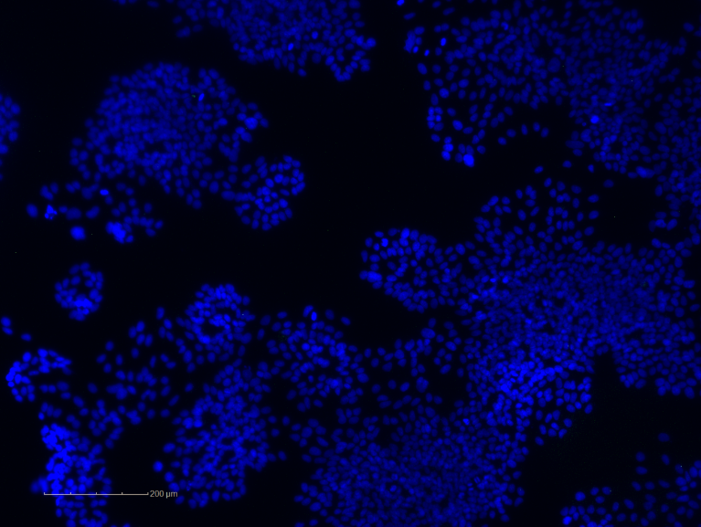

Figure S2 – Example of prolifered breast line with BrdU marking with 100x increase

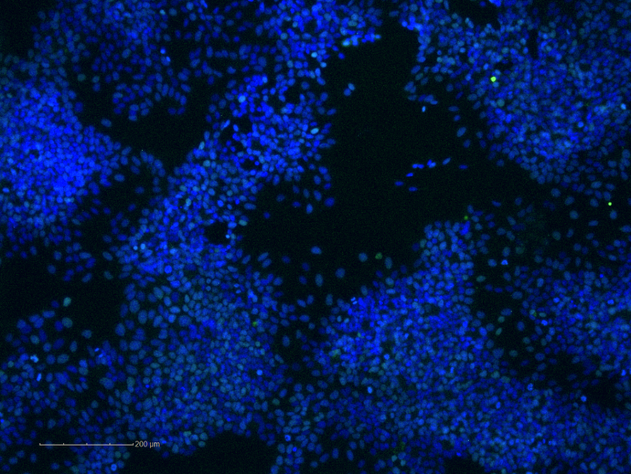

EXPERIMENT MAP

Figure S3 – Example of the 96 well plate

