Supplementary Figures

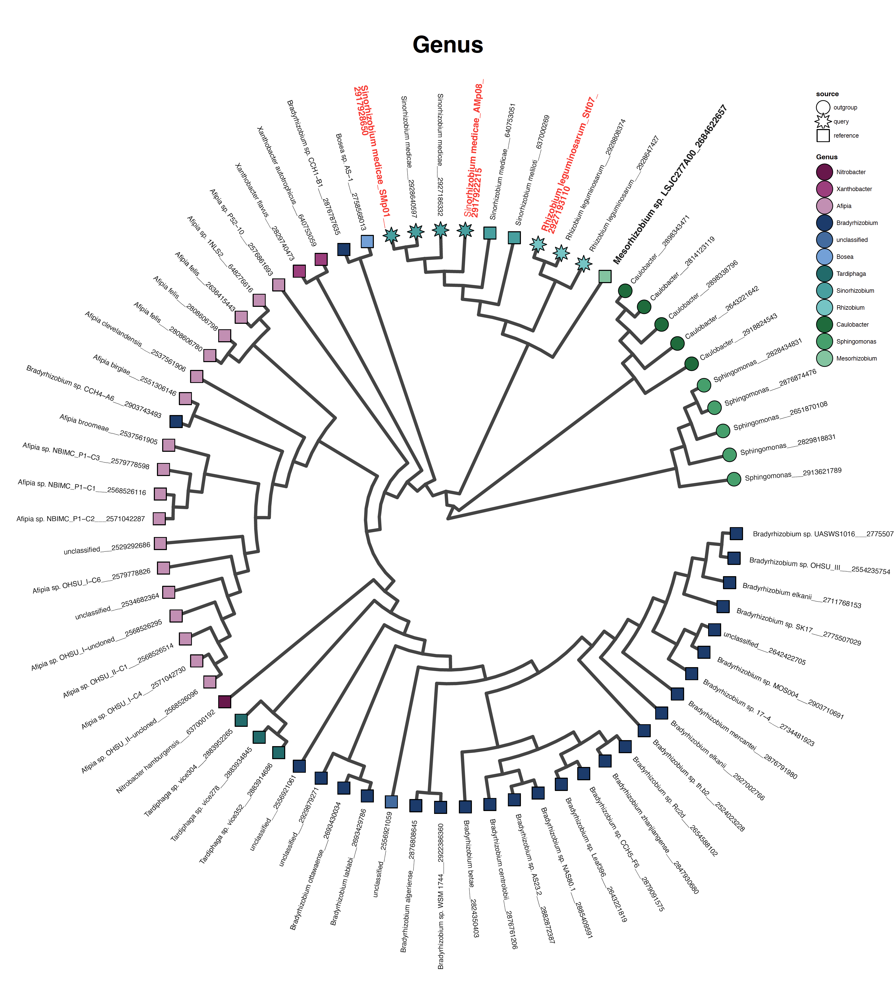
Fig. S1. Phylogenomic analysis of α-proteobacteria genera and species that were used to identify syntenic genomic regions and to verify the expected phylogenetic relationships of focal strains from Almadén. The three Almadén strains, Sinorhizobium medicae AMp08, SMp01 and Rhizobium leguminosarum Stf07 which are the most Hg-tolerant strains are labeled in red. Mesorhizobium sp. LSJC277A00 (bold) has a Mer operon.
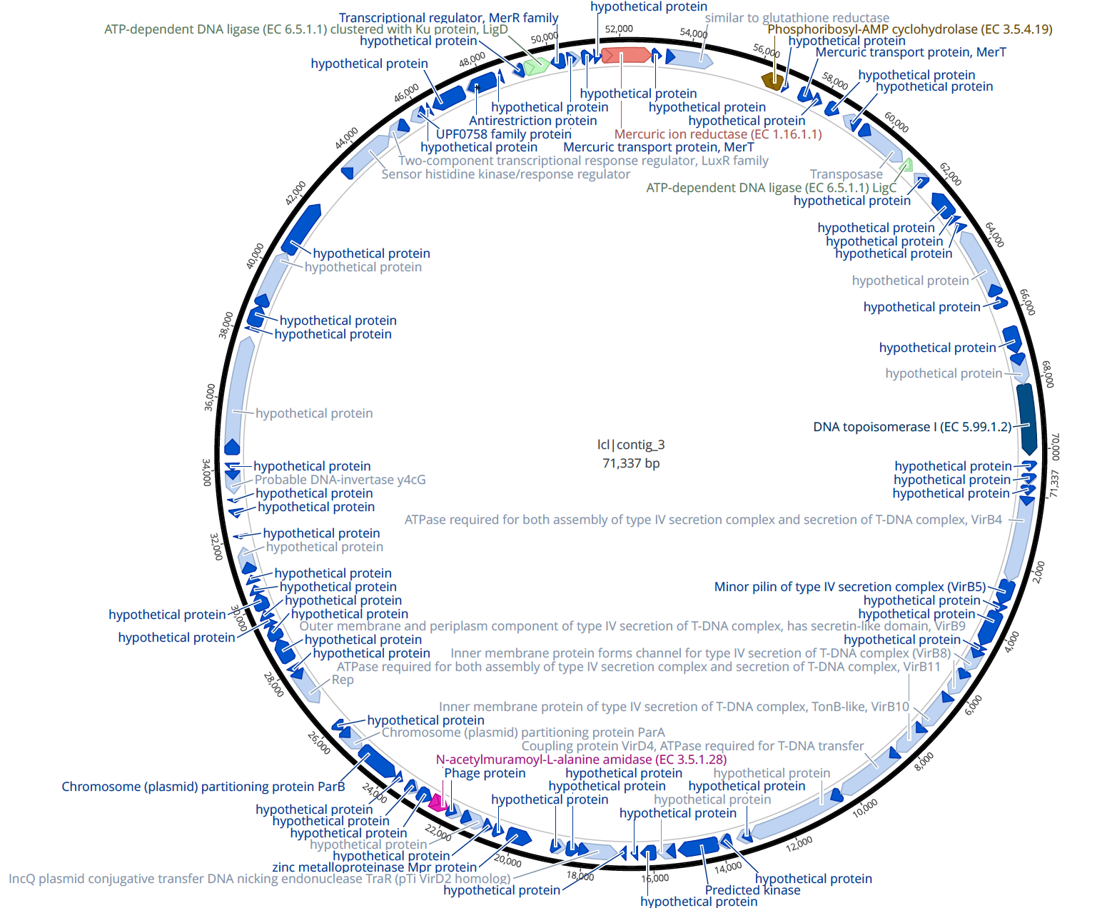
Fig. S2. The accessory plasmid containing the Mer operon in strain AMp08 is 71 kb and contains many uncharacterized genes (hypothetical proteins) and shows no homology or synteny with WSM419 (see Fig. 1a).

Fig. S3. Whole genome synteny of Rhizobium leguminosarum strain STf07 with R. leguminosarum WSM1325. The chromosome of WSM1325 is NC_012850.1 Others are plasmids: pR132501=NC_012848.1, pR132502=NC_012858.1, pR132503 = NC_012853.1
pR132504 =NC_012852.1 pR132505 = NC_012854.1. Genome alignment and circos Fig. was done using Sibelia v2.1.1.
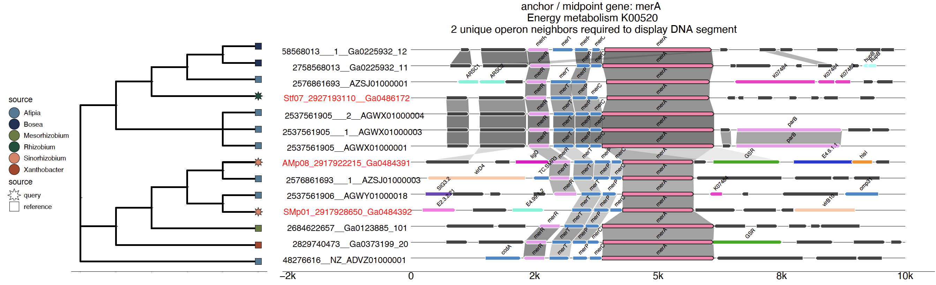
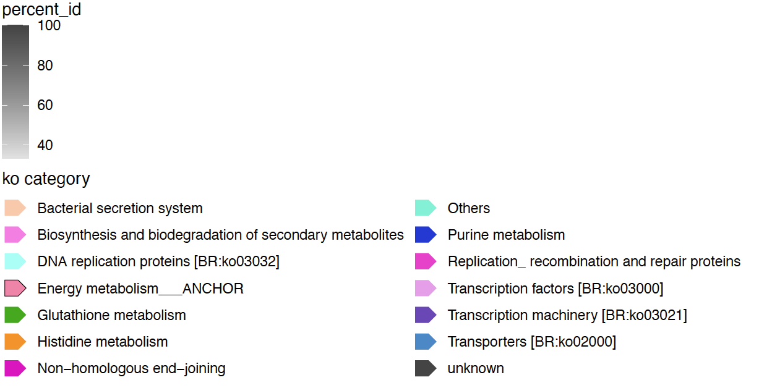

Fig. S4. Synteny of three Almaden mine strains anchored at the merA gene as a query, with other α-proteobacteria in the IMG database (https://img.jgi.doe.gov). The phylogeny shows the three Almadén strains names with high tolerance to Hg are colored using red text, and were used as query sequences indicated by the star character at the tips of the phylogeny.

merA2 -MWT---TLPPGASISSGVVMNKHFDAIIIGAGQAGPSLAGRLTDAGKTVALIE-RKLFG 55
merA1 -------------------MKQLTPDICVIGGGAAGLTVAAGAAAFGVPVVLVE-KGPMG 40
D2OD ----------------------MAYDLIVIGSGPGGYVCAIKAAQLGMKVAVVEKRSTYG 38
MS_MerA_4YWO -----------------------MHKLAIIGYGAAGFAAMIKANELGVKPVLIG-KGEIG 36
PA_MerA_1ZX9 --------------------MEPPVQVAVIGSGGAAMAAALKAVEQGAQVTLIE-RGTIG 39
MerA ---------MSDCCAPSAKNGNGRYDLIVVGAGSAGFSAAITAAEQGAQVALIG-HGTIG 50
LS_MerA_5X1Y ANYQAGEIEEVSSLENVALINEDNYDLLIIGSGAAAFSSAIKAIEYGAKVGMIE-RGTVG 119
. ::* * .. * :: : *

merA2 GTCVNTGCMPTKAMVASAYAIHTARRG-AEYGMTTGPVSVDFGRVMARKEKVRLDARSGL 114
merA1 GDCLNHGCVPSKALIAASRHAHSIRVA-AEFGIAAAGPVIDQERLTARIQSVIVGIAPHD 99
D2OD GTCLNVGCIPSKALLHASEMFHVAEHGLDALGVEVATPKLNLQKMMAHKDATVKSNVDG- 97
MS_MerA_4YWO GTCVNVGCVPSKRMLYIAEIYKKAREVTG-------SEVYPPFSSFQEKDGLVQEMRKTK 89
PA_MerA_1ZX9 GTCVNVGCVPSKIMIRAAHIAHLRRESPFDGGIAATVPTIDRSKLLAQQQARVDELRHAK 99
MerA GTCVNVGCVPSKALIRAAEAVHHANAAPRFAGIAAEARVADWGAQVAQKDALVAGLRQAK 110
LS_MerA_5X1Y GTCVNIGCVPSKTLLRAGEIIHLSKDN-PFIGLQTSAGEVDLASLITQKDKLVSELRNQK 178
* *:* **:*:* :: . : . . :

merA2 Q-KWLRGMTNCTLFEGHARFGGPREI-----RIGEELISGEQIFINVGGRAAVPALPGV- 167
merA1 SVERFTSLGVE-VIKDEACFVDNRTI-----AAGDRLIRARRFVIATGSSPAIPPIPGL- 152
D2OD -VAFLFKKNKIDGFQGLGKVLGQGKVAVANEKGEEQVLEAKNVVIATGSDV--AGIPGVE 154
MS_MerA_4YWO YEDLLSYYDVE-LIQGEARFISPHAV-----KVNGQVIEAEKFVIATGSSPLIPRIPGL- 142
PA_MerA_1ZX9 YEGILGGNPAITVVHGEARFKDDQSLTVRLNEGGERVVMFDRCLVATGASPAVPPIPGL- 158
MerA YADLLPSYNSV-AYHEGRARLVDGGV-----EAGGKRFAAERIIIATGTRPALPAIPGI- 163
LS_MerA_5X1Y YMDLIDEYNFD-LIKGEAKFVDASTV-----EVNGAKLSAKRFLIATGASPSLPQISGL- 231
: . : . . .: .* : *:

merA2 ---NGIPYLTNSSIMDLAELPEHLVIVGGSYIGLEFAQMFRRFGSDVTVIEKGPRLIGRE 224
merA1 ---AETPFLTNETLFSLKRLPRHLVVIGGGPVGLEMAGAHRRLGVEVTVVDKT-EALSGQ 208
D2OD VPFDEKIIVSSTGALALEKVPASMIVVGGGVIGLELGSVWARLGAKVTVVEYLDTILGGM 214
MS_MerA_4YWO ---DKVGFWTNREALSPDRRIDSLAVIGGRALALEFAQMYSRMKVEVAILQRSPVLIPDW 199
PA_MerA_1ZX9 ---KESPYWTSTEALASDTIPERLAVIGSSVVALELAQAFARLGSKVTVLARN-TLFFRE 214
MerA ---TDISILDSTTALELTALPRSMIVLGGGYIGVELAQTFARVGVEVTLVFRS-RLLPEA 219
LS_MerA_5X1Y ---EKMDYLTSTTLLELKKIPKRLTVIGSGYIGMELGQLFHHLGSEITLMQRSERLLKEY 288
. : : ::*. :.:*:. :. .:::: :

merA2 DPEVSDAIREILENEGIRIRTNAECIRFSQTAAGIAVGVD--CTSGEPEVTGSHVLLATG 282
merA1 DPELAAIVLDGLRAEGVHLHERTAIHAVERTERGIRLRCE--NGNGPFGIEGSDLLVAAG 266
D2OD DGEVAKQLQRMLTKQGLDFKLGAKVTGVVKSDEGAKVTFEPVKGGEATTLDAEVVLIATG 274
MS_MerA_4YWO EPEASVEARRIMENDGVAVVTGVNVKEVRKGAGKI-------VITDKGEVEADEILLATG 252
PA_MerA_1ZX9 DPAIGEAVTAAFRAEGIEVLEHTQASQVAHMDGE---FV---LTTTHGELRADKLLVATG 268
MerA EPEIGAALAGYLADEGIKVVGGLTYESIRRTEEGVALTV--VREGHTETLAAERVLVATG 277
LS_MerA_5X1Y DPEISESVEKALIEQGINLVKGATFERVEQSGEIKRVYV--TVNGSREVIESDQLLVATG 346
: . : :*: . . : : .. :*:*:*

merA2 RHPNTDDLGLEKAGVKTDARGYIEVDDSLRTNIPHIFAMGDCNGRGAFTHTSYNDFEIVA 342
merA1 RAPVHASLGLDAAGIRHDPK-RIEVGPNLRTSNRRVYAIGDAAGG-LFTHQASYHARLVL 324
D2OD RKPSTEGLGLAKAGVVLDQRGRVEIDQHFQTSITGVYAIGDVVRGPMLAHKAEDEG-IAV 333
MS_MerA_4YWO RKPNVD-LGLENAGVRLNERGGIKVDDELRTDNPHIYAAGDVLGGKMLEALAGRQGSIAT 311
PA_MerA_1ZX9 RTPNTRSLALDAAGVTVNAQGAIVIDQGMRTSNPNIYAAGDCTDQPQFVYVAAAAGTRAA 328
MerA RAPNTESLGLPEAGIALTPVGAIVVDDRMRTSKAGVYAAGDVTGKDQFVYMAAYGAKLAA 337
LS_MerA_5X1Y RKPNTDSLNLSAAGVETGKNNEILINDFGQTSNEKIYAAGDVTLGPQFVYVAAYEGGIIT 406
* * * * **: : :. :*. ::* ** : :

merA2 ANLLDDDPRRVSDRIQTYALYIDPPLGRAGMTETEARKKGCKLLIGTRPMTRVGRAVEKG 402
merA1 QQILFRLPAREKPFIVPRVIFTEPELAHVGLTEERAREAAPGATILRLDYSANDRSRTDG 384
D2OD AEIIAGQAGHVNYDVIPGVVYTQPEVASVGRTEEELKAAGVAYKVGKFPFTANGRARAML 393
MS_MerA_4YWO ENALTGSHKRVDENAVPQVIFTQPNLARVGLTEAEARAKEGEVEARVLPMSSVAKAEIIN 371
PA_MerA_1ZX9 INMTGG-DAALDLTAMPAVVFTDPQVATVGYSEAEAHHDGIETDSRTLTLDNVPRALANF 387
MerA KNALNGDSLRYDNSAMPAVVFTDPQVGSVGLTEAQARAAGYNVRTSVLSLDNVPRALAAR 397
LS_MerA_5X1Y DNAIGGLNKKIDLSVVPAVTFTNPTVATVGLTEEQAKEKGYDVKTSVLPLDAVPRAIVNR 466
: . . : :* :. .* :* . : ::

merA2 ETQGFMKVIVDADTKDILGASILGTGGDEAIQSILDVMYAKRPYTTISRAVHIHPTVSEL 462
merA1 LGRGLIKVVVG-RRGRVLGAAIAGSGAGEMINLWAFAVANRLTLKHFQTYVAPYPTLSEI 443
D2OD QTDGFAKILADKETDRVLGGHIIGFGAGEMIHEIAVLMEFGGSSEDLGRTCHAHPTMSEA 453
MS_MerA_4YWO SRLGFVKMVTMN--GRIVGVHAVGENVAEMIGEAALAIRFGATVHDLIDTVHMFPTIAES 429
PA_MerA_1ZX9 DTRGFIKLVIEEGSHRLIGVQAVAPEAGELIQTAALAIRNRMTVQELADQLFPYLTMVEG 447
MerA DTRGLIKLVADGDTRKLLGAHILAPEGADSIQTATMAIRGGLTIDDLAETIFPYLTTVEG 457
LS_MerA_5X1Y ETTGVFKLVADAETLKVLGVHIVSENAGDVIYAASLAVKFGLTVEDLTETLAPYLTMAEG 526
*. *:: ::* . : * : : . * *

Fig. S5. Multiple sequence alignment of MerA homologs. The motifs containing the active site residues are highlighted. merA1, merA2, MerA and D2OD are from S. medicae. PA = P. aeruginosa, MS = M. sedula, and LS = L. sphaericus.
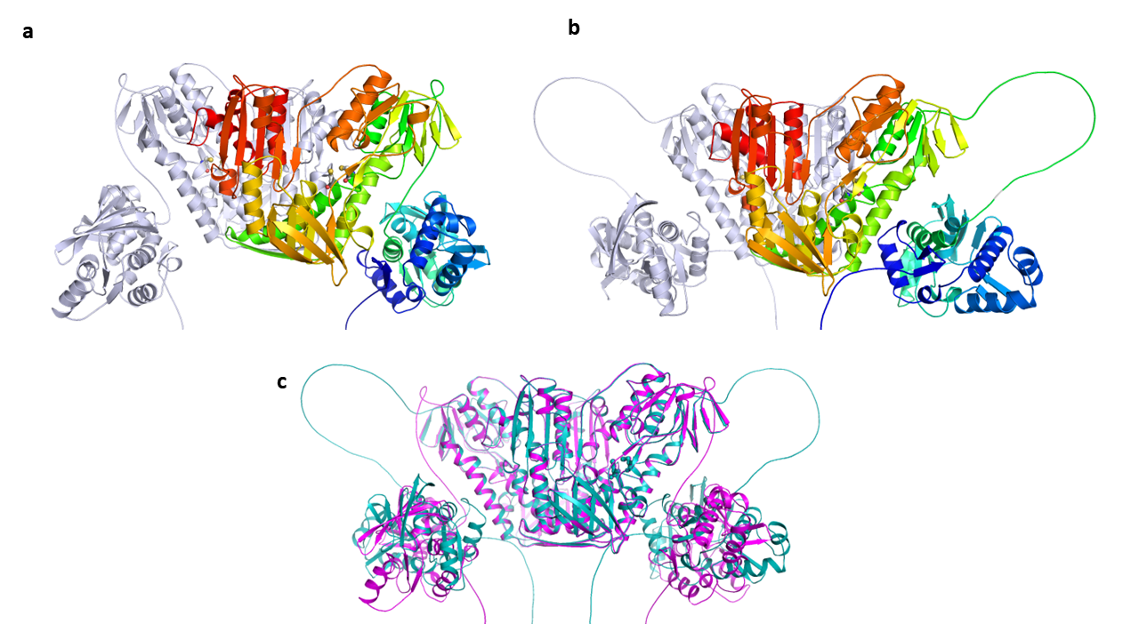

Fig. S6. AlphaFold structures of dimeric MerBA fusion proteins from R. leguminosarum strain STf07 (a) and Mesorhizobium sp. LSJC277A00 (b). The two subunits of MerBA dimer are shown in grey and spectrum (Blue = N-terminus, Red = C-terminus) colors. (c). Overlay of the structures of R. leguminosarum strain STf07 (magenta) and Mesorhizobium sp. LSJC277A00 (cyan). Cysteine residues are shown in the stick representation.

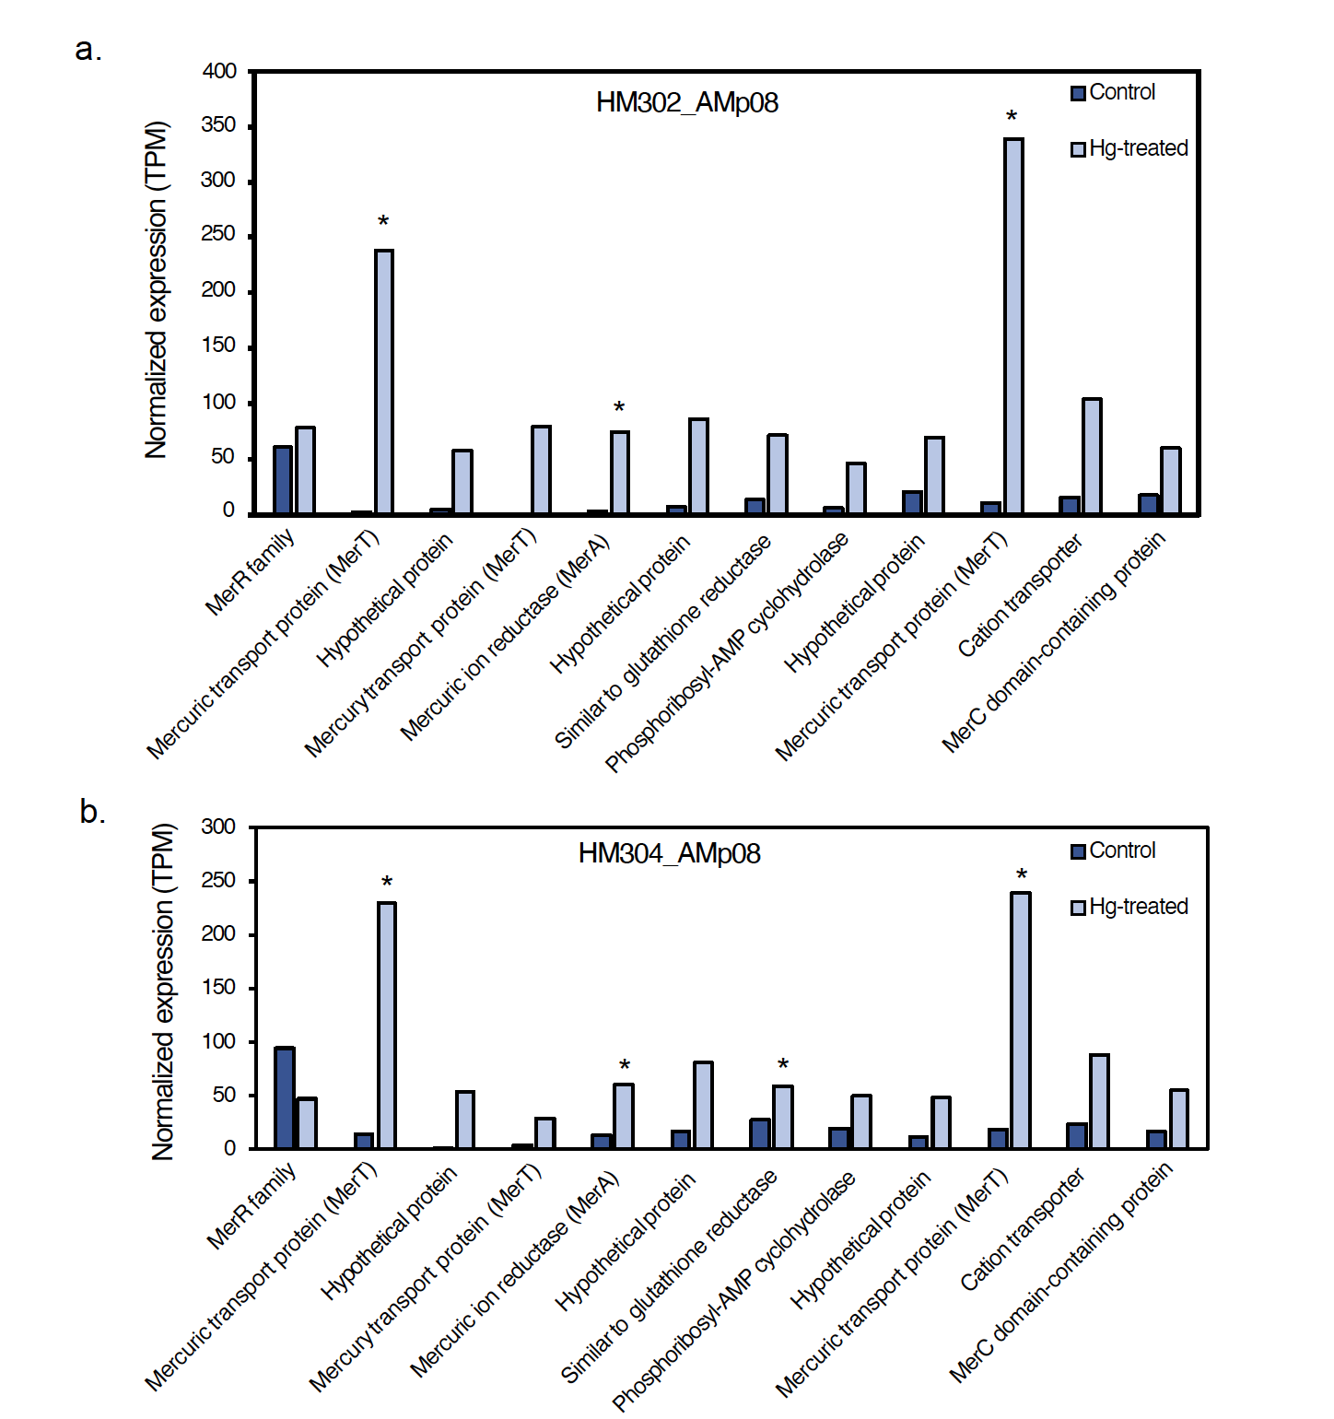
Fig. S7. Expression of Mer operon genes in nodules in two different M. truncatula host plant genotypes, formed by the S. medicae strain AMp08 in control conditions and following Hg treatments. (a) The Mer operon gene expression in nodules of the HM302 host plant, which is a low Hg accumulating plant genotype. (b) The Mer operon gene expression in nodules of the HM304 host plant, which is a high Hg accumulating plant genotype. The host-plants inoculated with rhizobia were treated with either 0 μM HgCl₂ (Control) or 100 μM HgCl₂ (Hg-treated). Normalized expression levels are the mean TPM values of three biological replicates.

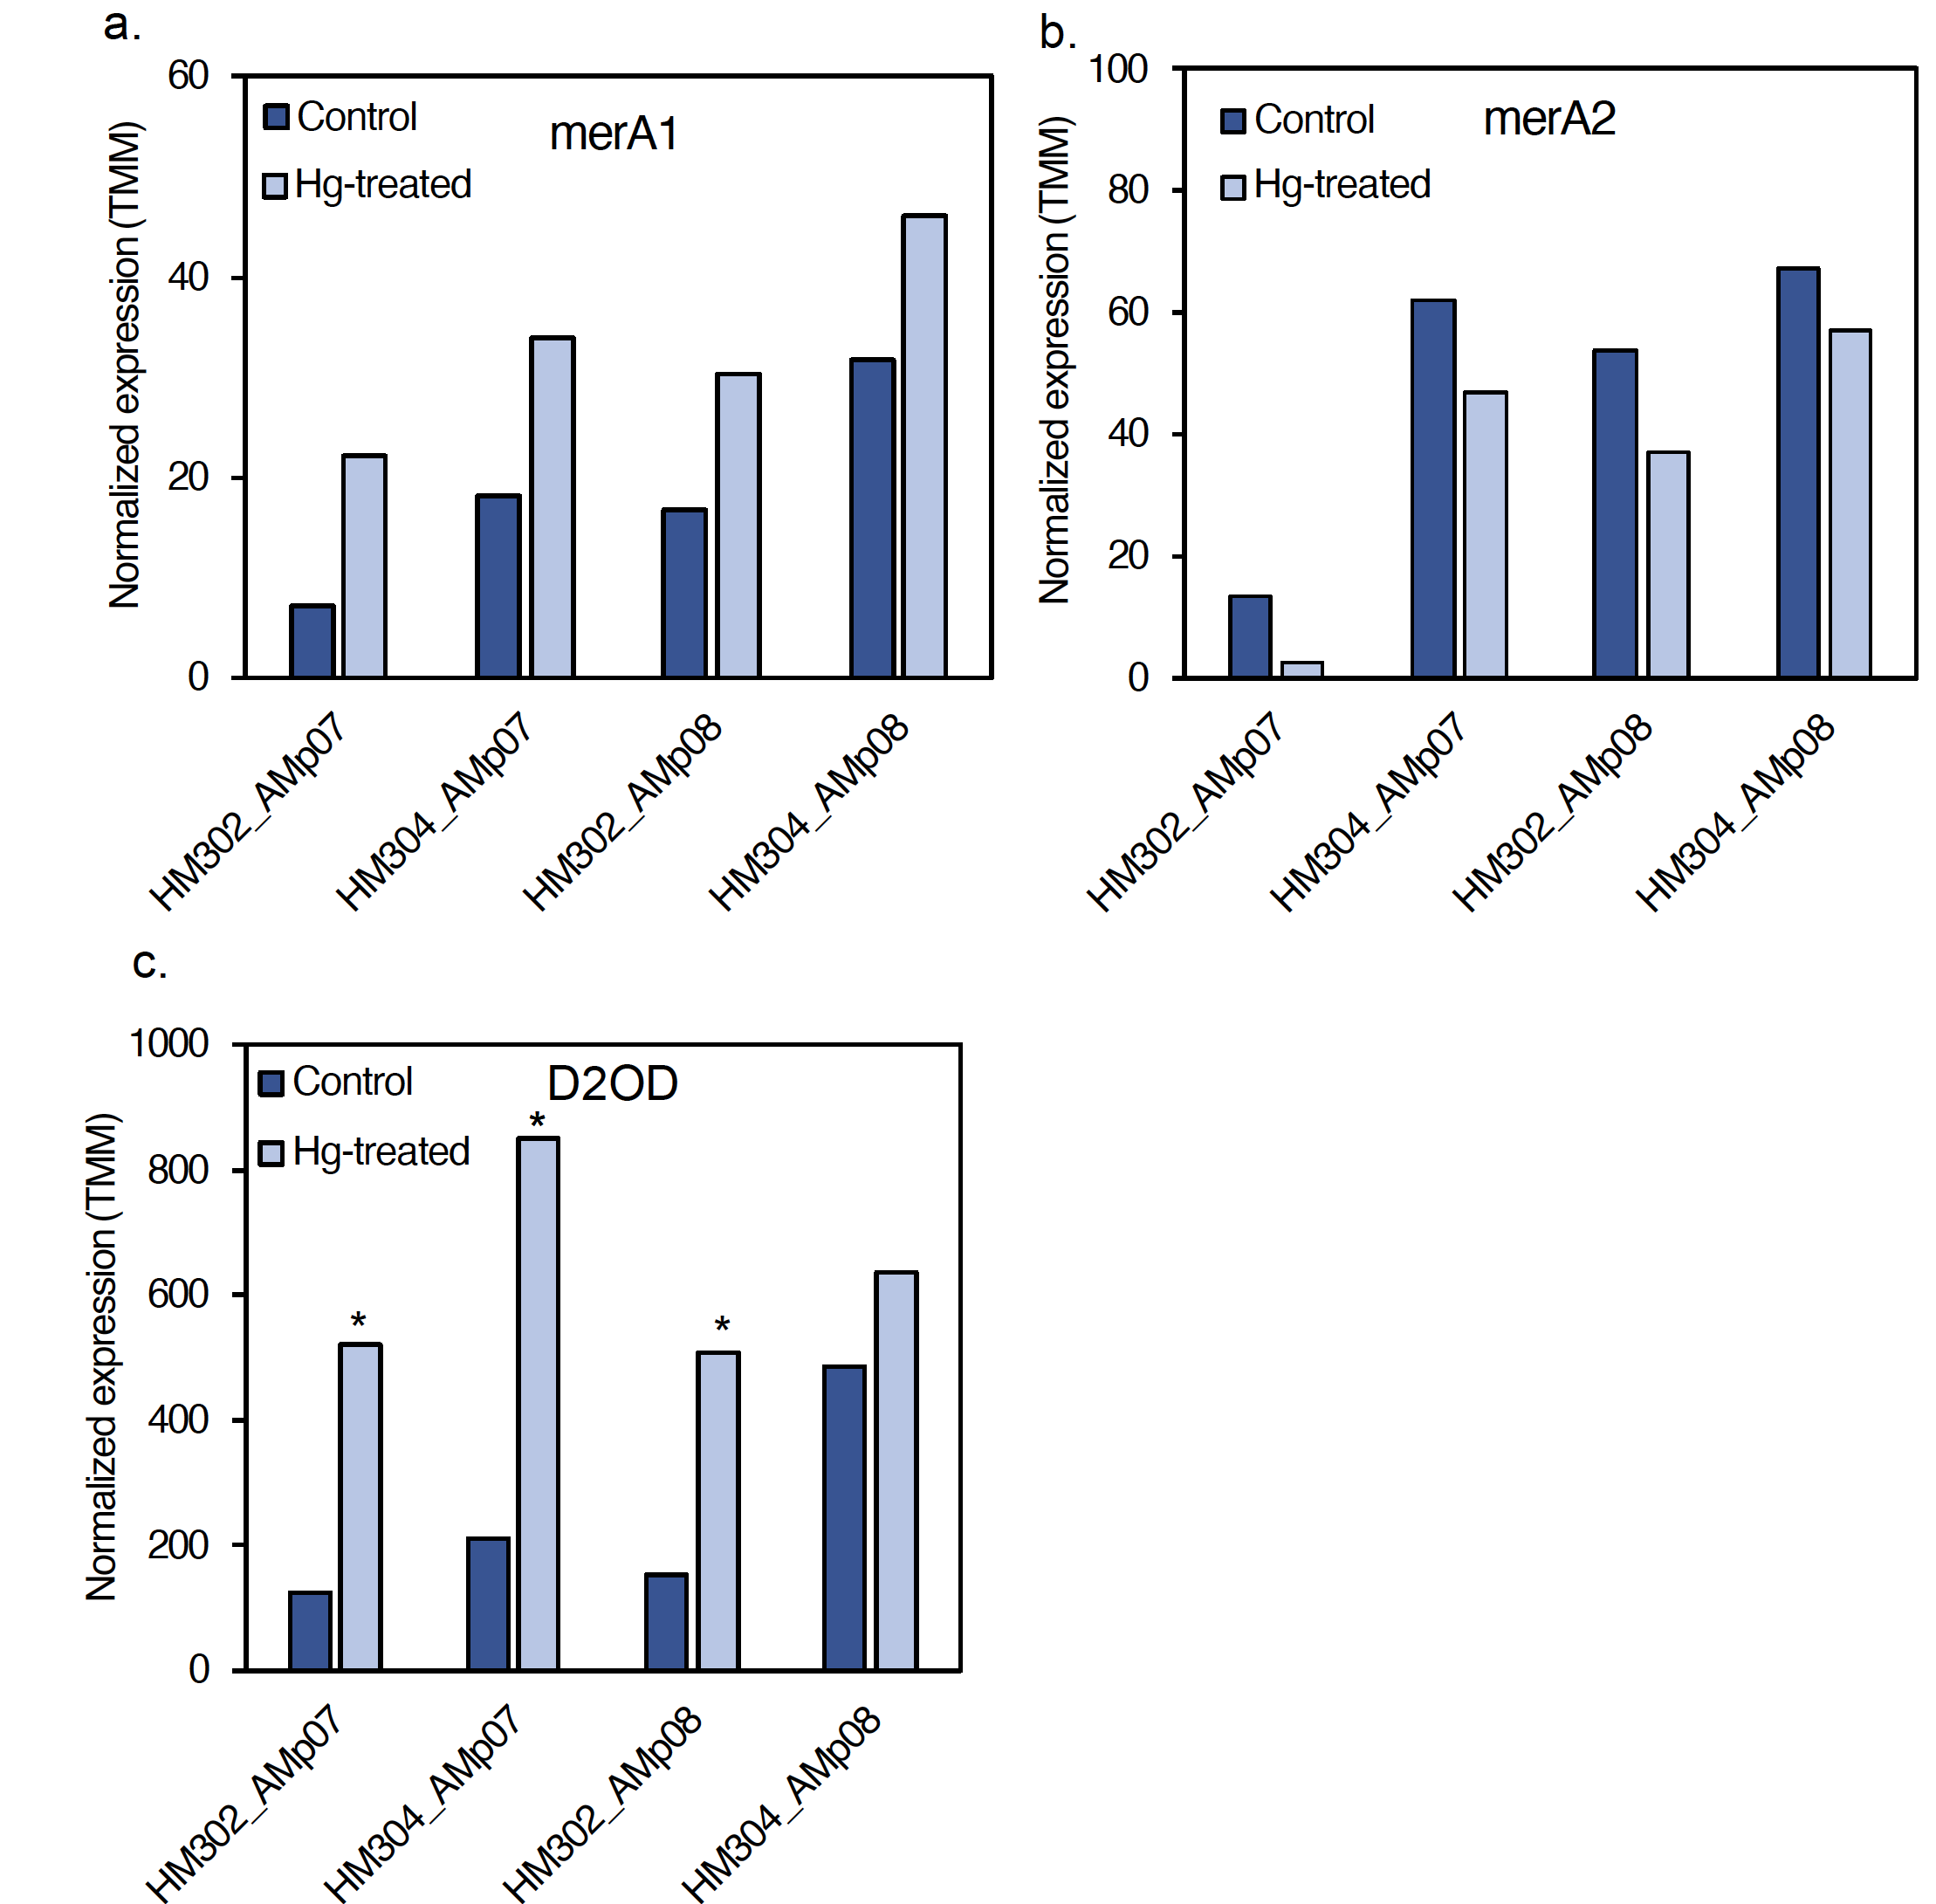
Fig. S8. Expression of mercuric ion reductase gene homologs in rhizobia present in nodules in control and following Hg treatments. (a) Mercury ion reductase (merA1) shows no significant change in response to Hg treatment in any of strains (AMp08 and AMp07). (b) Mercury ion reductase (merA2) shows no significant change in response to Hg stress in any of the strains tested (AMp08 and AMp07). (c) Dihydrolipoamide 2-oxoglutarate dehydrogenase (D2OD) showed significant upregulation in all the strains tested (AMp08 and AMp07). The normalized expression levels are shown as the mean TMM values of three biological replicates.

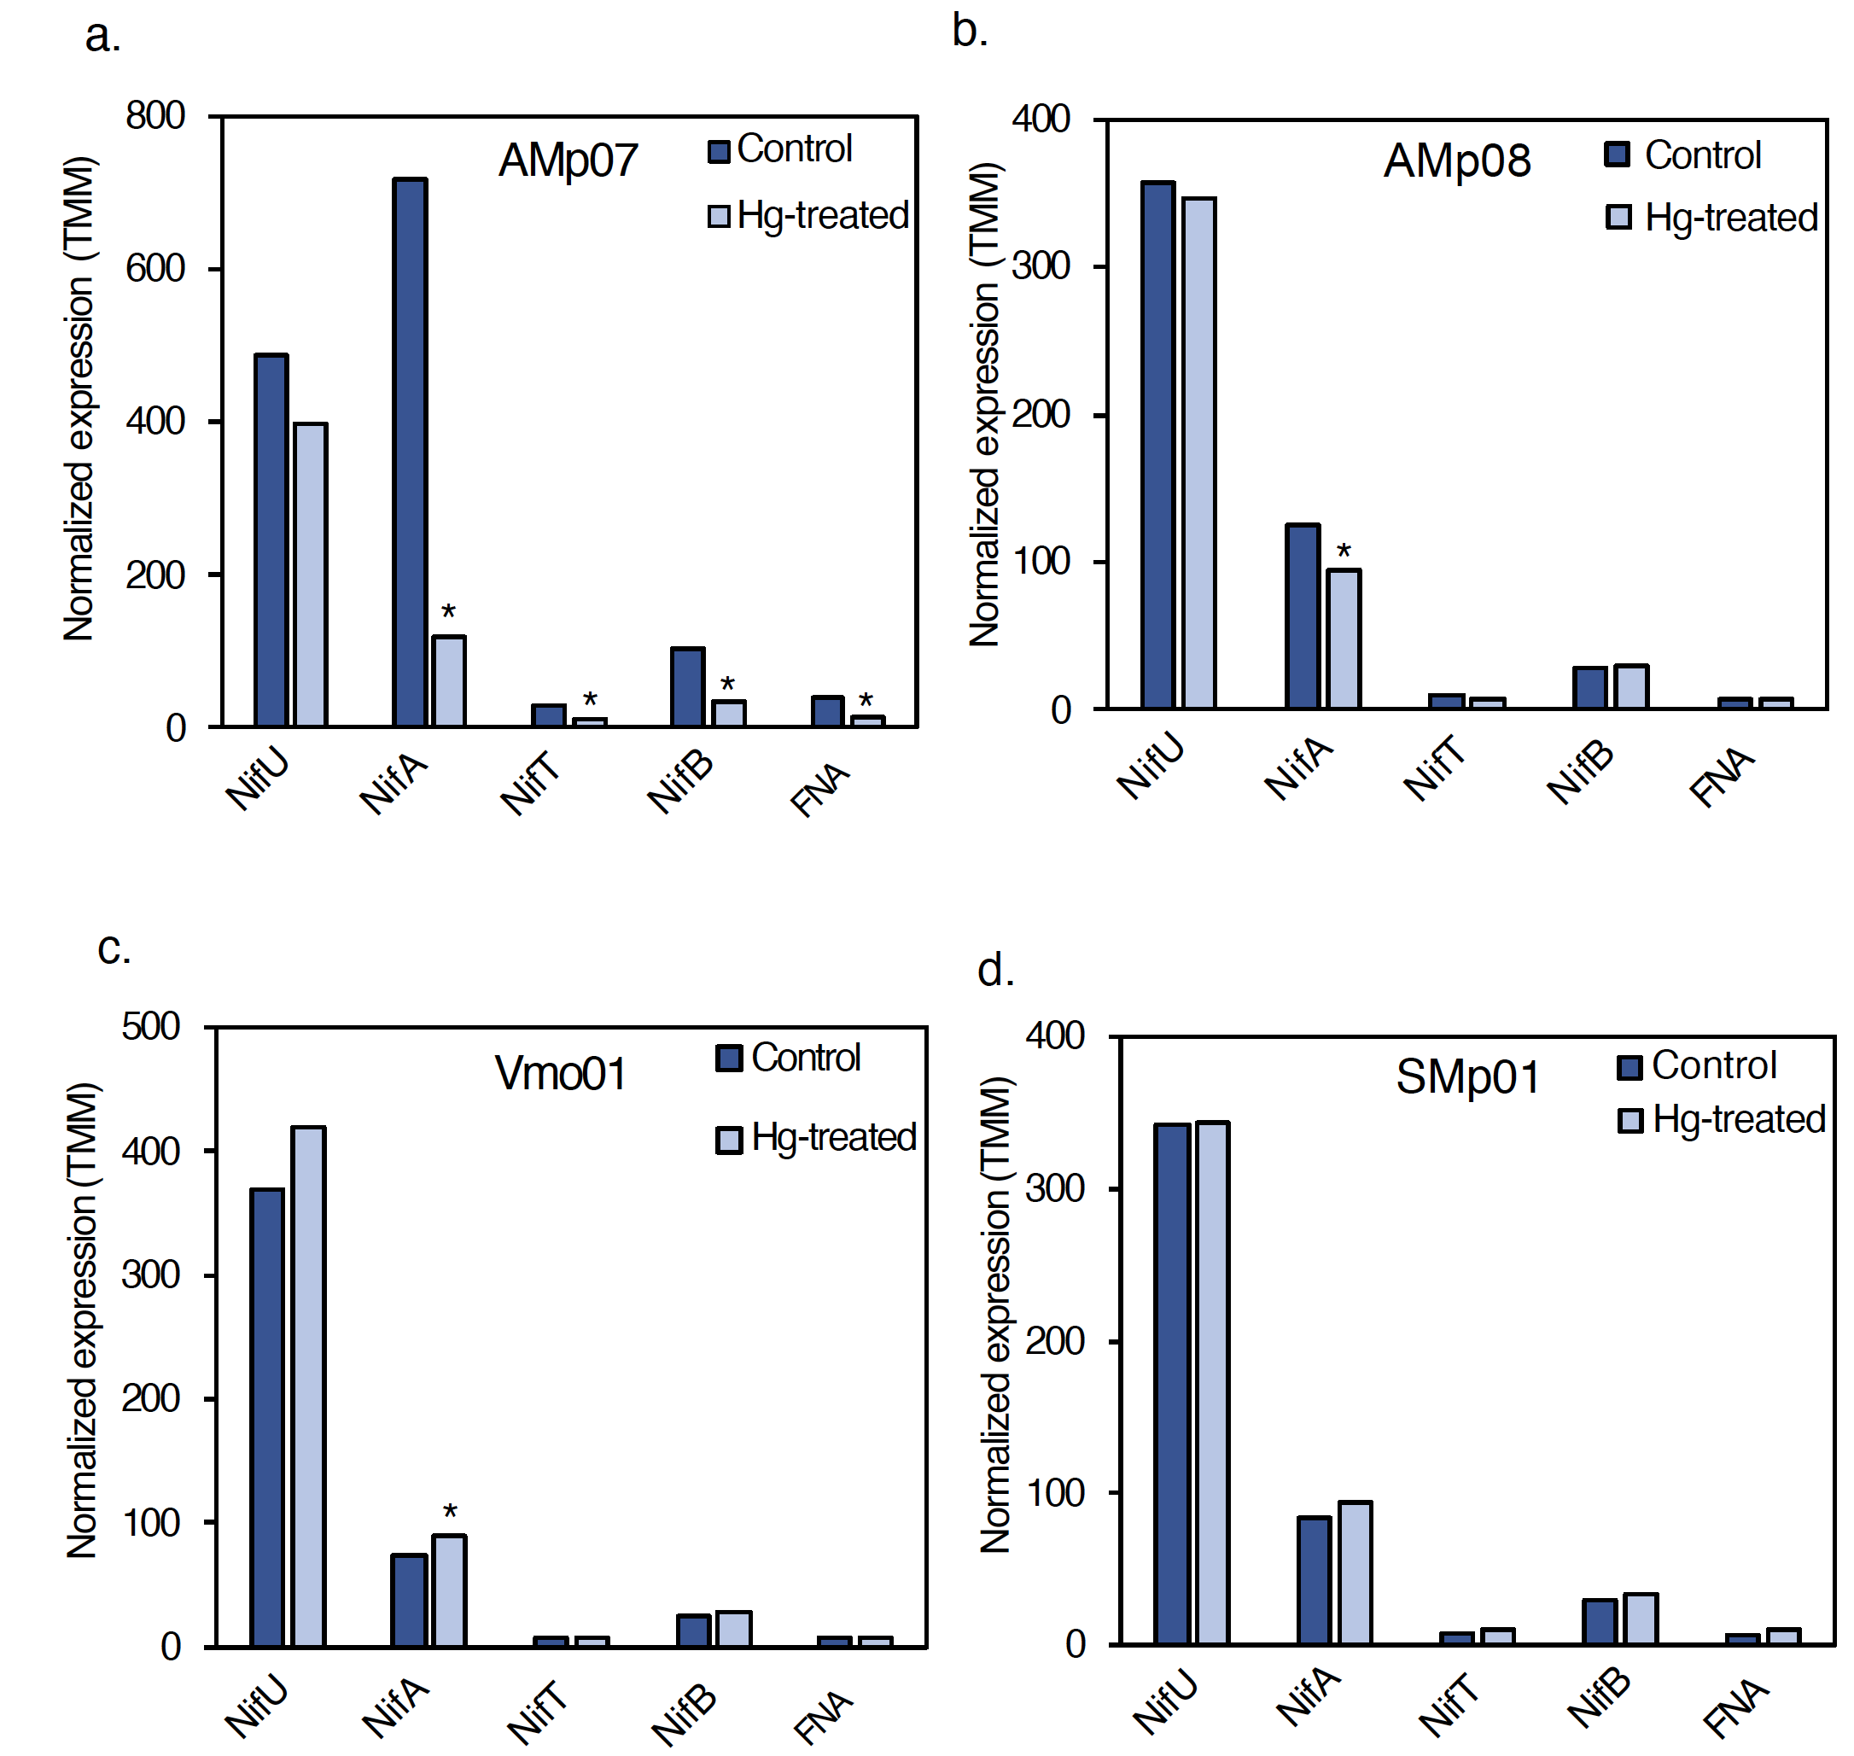
Fig. S9. Expression of nif genes in free-living rhizobia in control and Hg treatment conditions. (a) In the LT strain AMp07, the expression levels of nifU, nifA, nifT and 4Fe-4S ferredoxin nitrogenase-associated gene (FNA) were significantly downregulated. A small but significant change in nifA expression was observed in AMp08 (b), and small but significant change in nifA expression was observed in VMo01 (c), and no significant changes in SMp01 (d). Normalized expression levels are reported as mean TMM values of three biological replicates.

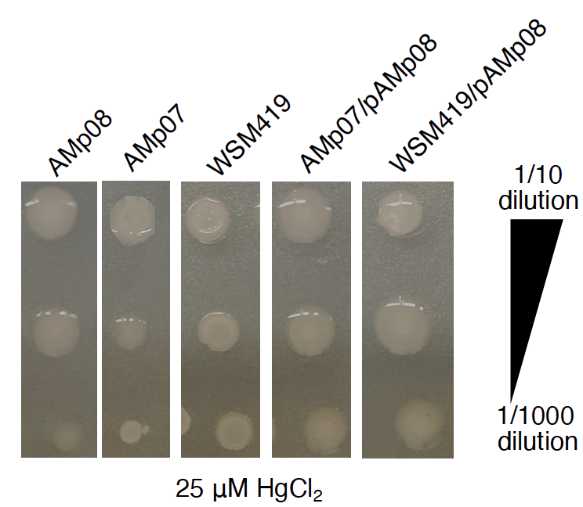

Fig. S10. Minimum inhibition concentration (MIC) assay shows the basic Hg-tolerance in LT strains, the HT strain AMp08 and the two strains transformed with the accessory plasmid from AMp08 (AMp07/pAMp08; WSM419/pAMp08). Each MIC image represents strains (from left to right: AMp08, AMp07, WSM419, AMp07/pAMp08, WSM419/pAMp08) grown on plates containing 25 μM HgCl₂. Each strain was grown at three dilution factors (from top to bottom): 1/10, 1/100 and 1/1000.

