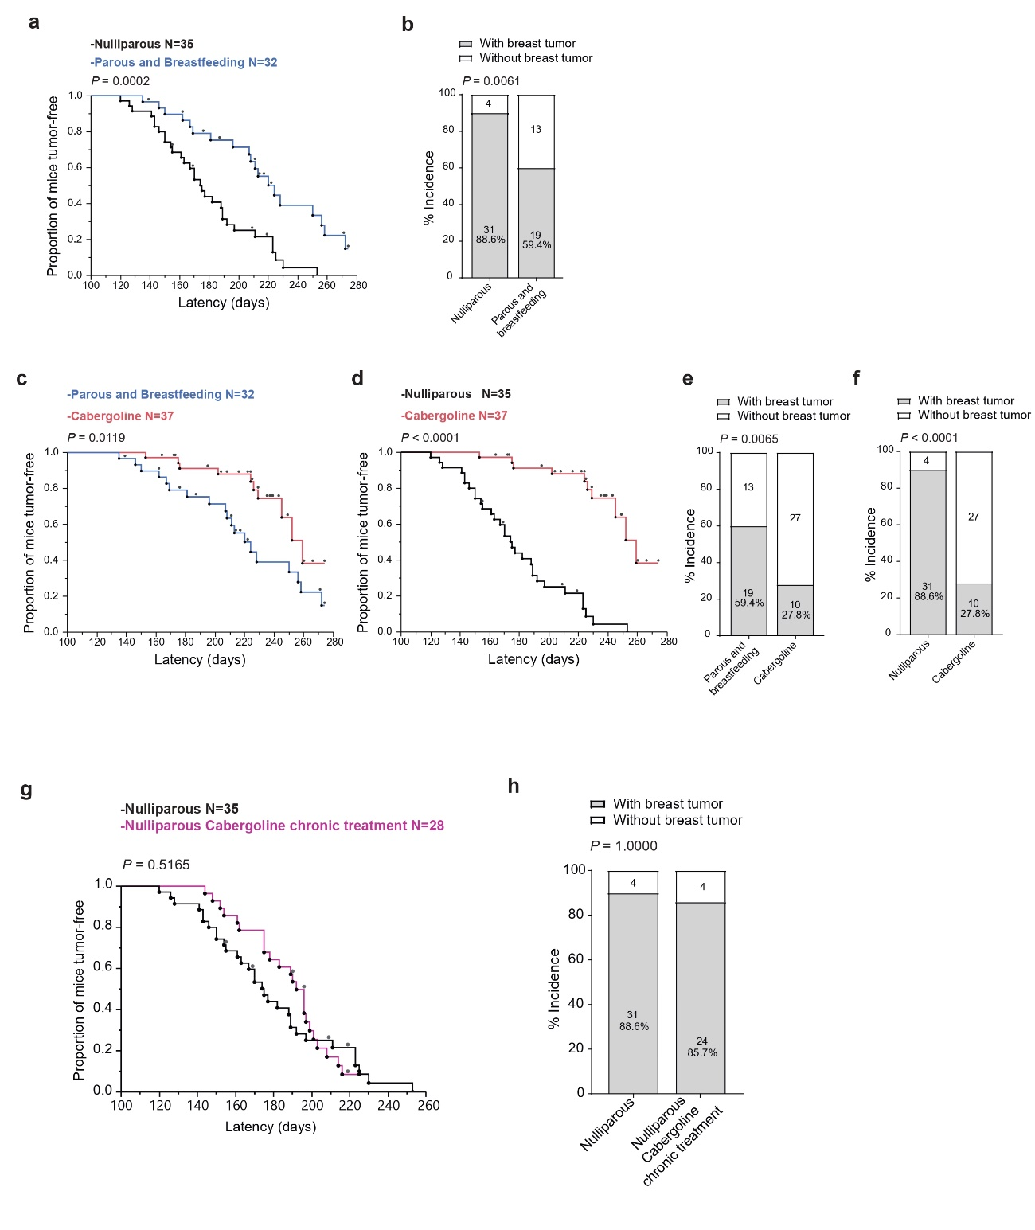
Extended Data Fig. 1. Analysis of tumor susceptibility in Brca1/P53-deficient mice: evaluating the role of parity and cabergoline. a, b) Tumor latency (a) and incidence (b) comparison in nulliparous versus multiparous mice. c-f) Enhanced tumor suppression in cabergoline-treated multiparous mice: Increased latency compared to untreated multiparous (c) and nulliparous mice (d), and reduced tumor incidence versus untreated multiparous (e) and nulliparous mice (f). g, h) Analysis of tumor latency (g) and multiplicity (h) in biweekly cabergoline-treated nulliparous mice. The number of mice analyzed is indicated in the respective figure panels. Kaplan-Meier survival curves and Log-Rank tests used for Panels a, b, d, g; Chi-square tests for Panels b, e, f, h.

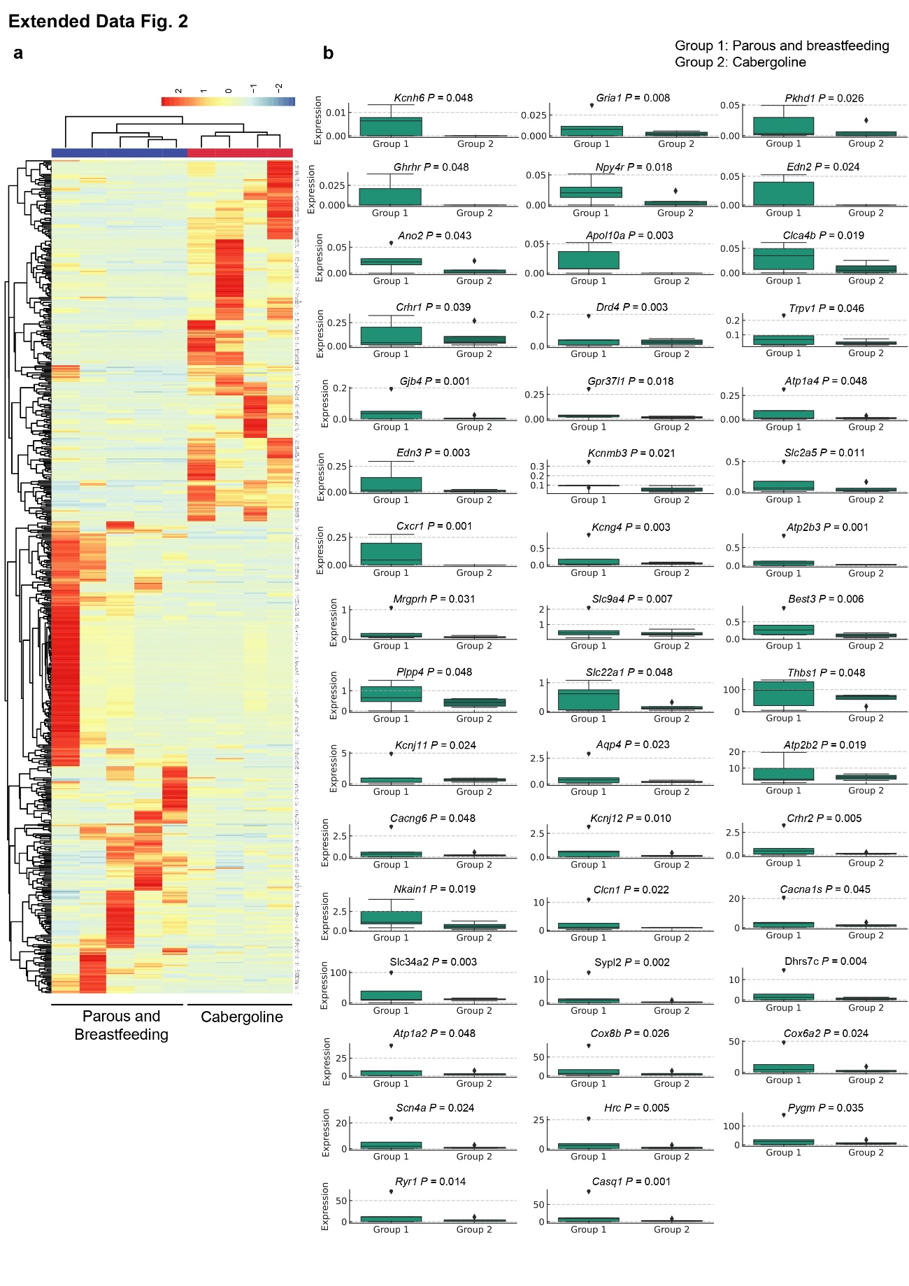
Extended Data Fig. 2. Impact of cabergoline on postlactational involution in mice: molecular insights from RNA-seq a) Heatmap from RNA-Seq analysis depicting gene expression variations one day post-lactation in cabergoline-treated and untreated Brca1/P53-deficient mice, highlighting unsupervised clustering based on differential gene transcripts (P < 0.05). b) Box plots comparing gene expression levels in mammary glands at 1-day post-lactation between untreated (N = 5) and cabergoline-treated Brca1/P53-deficient mice (N = 4). P-values derived from a negative binomial test for differential expression assessment.

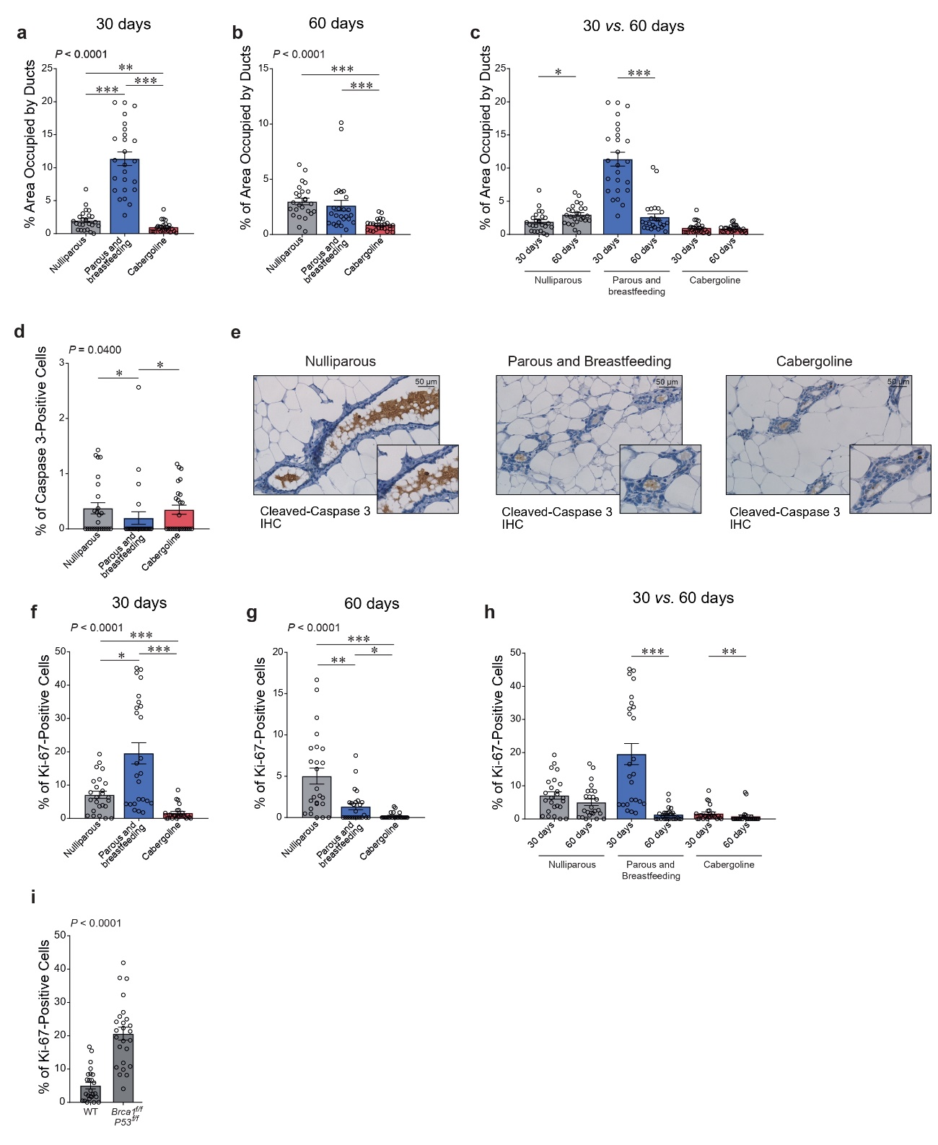
Extended Data Fig. 3. Comparative analysis of ductal changes and proliferation in wild-type and Brca1/P53-deficient mice during postlactational involution. a, b) Ductal area assessment at 30 and 60 days post-lactation in nulliparous and multiparous wild-type mice, untreated and treated with cabergoline. c) Comparison of ductal area changes over time in wild-type mice. d, e) Apoptosis evaluation in mammary glands of Brca1/P53-deficient mice at 60 days post-lactation using cleaved-caspase 3 immunohistochemistry, including representative images at 40x magnification. f, g) Proliferation analysis in wild-type mice at 30 and 60 days post-lactation, across different groups. h) Comparison of proliferation changes over time in wild-type mice. i) Proliferation contrast between nulliparous wild-type and Brca1/P53-deficient mice at corresponding ages. In each study, five mice per group were analyzed. Statistical significance denoted as *** P < 0.0005; ** P < 0.005; * P < 0.05.
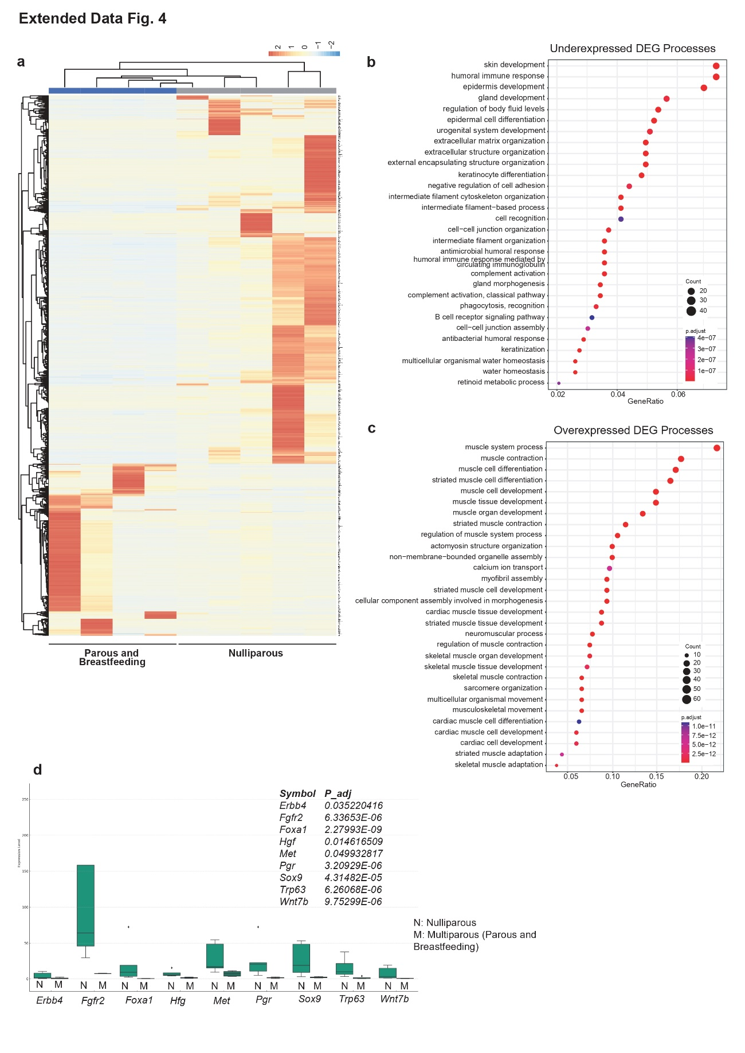
Extended Data Fig. 4. Comprehensive RNA-Seq analysis of mammary gland transcriptomics in Brca1/P53-deficient mice. a) Differential gene expression Analysis: evaluates gene expression in mammary glands at 60 days post-lactational involution, contrasting Brca1/P53-deficient nulliparous (N=5) and multiparous (N=4) mice. The heatmap displays 394 overexpressed and 845 underexpressed transcripts (q < 0.05). b, c) Biological process assessment: top 30 biological processes identified through enrichment analyses (Gene Ontology, ORA) using dot plots, categorizing underexpressed (b) and overexpressed genes (c). d) Expression level comparison: box plots comparing expression in nulliparous and multiparous mice at 60 days post-lactation. Differential expression assessed via a negative binomial test, with adjusted p-values computed using Benjamini-Hochberg for FDR control. The Y-axis shows TPMs (Transcripts Per Million).

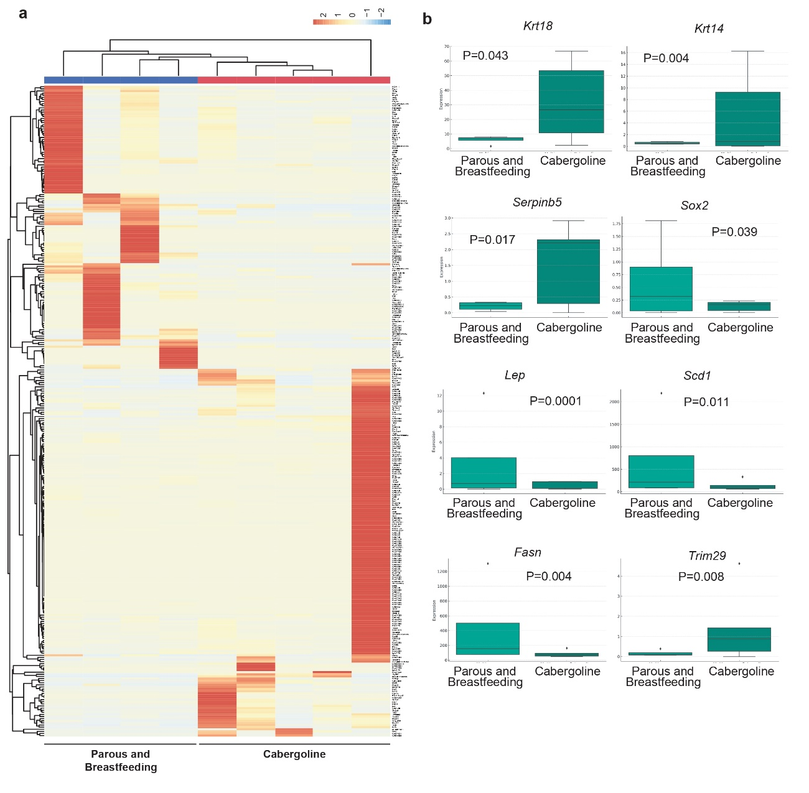 Extended Data Fig. 5a, b. Detailed RNA-Seq analysis of cabergoline's impact on mammary gland gene expression in Brca1/P53-deficient mice. a) Differential gene expression heatmap: evaluates gene expression changes in non-tumorous mammary glands of cabergoline-treated (N = 5) and untreated (N = 4) Brca1/P53-deficient mice, 60 days post-lactational involution. It identifies significant gene expression differences post-multitesting correction. b) Gene expression level comparison: box plots contrasting gene expression between cabergoline-treated and untreated multiparous Brca1/P53-deficient mice at 60 days post-lactation. Differential expression analysis was conducted using a negative binomial test, with P-values adjusted using the Benjamini-Hochberg method for FDR control. TPMs (transcripts per million) are displayed on the Y-axis.

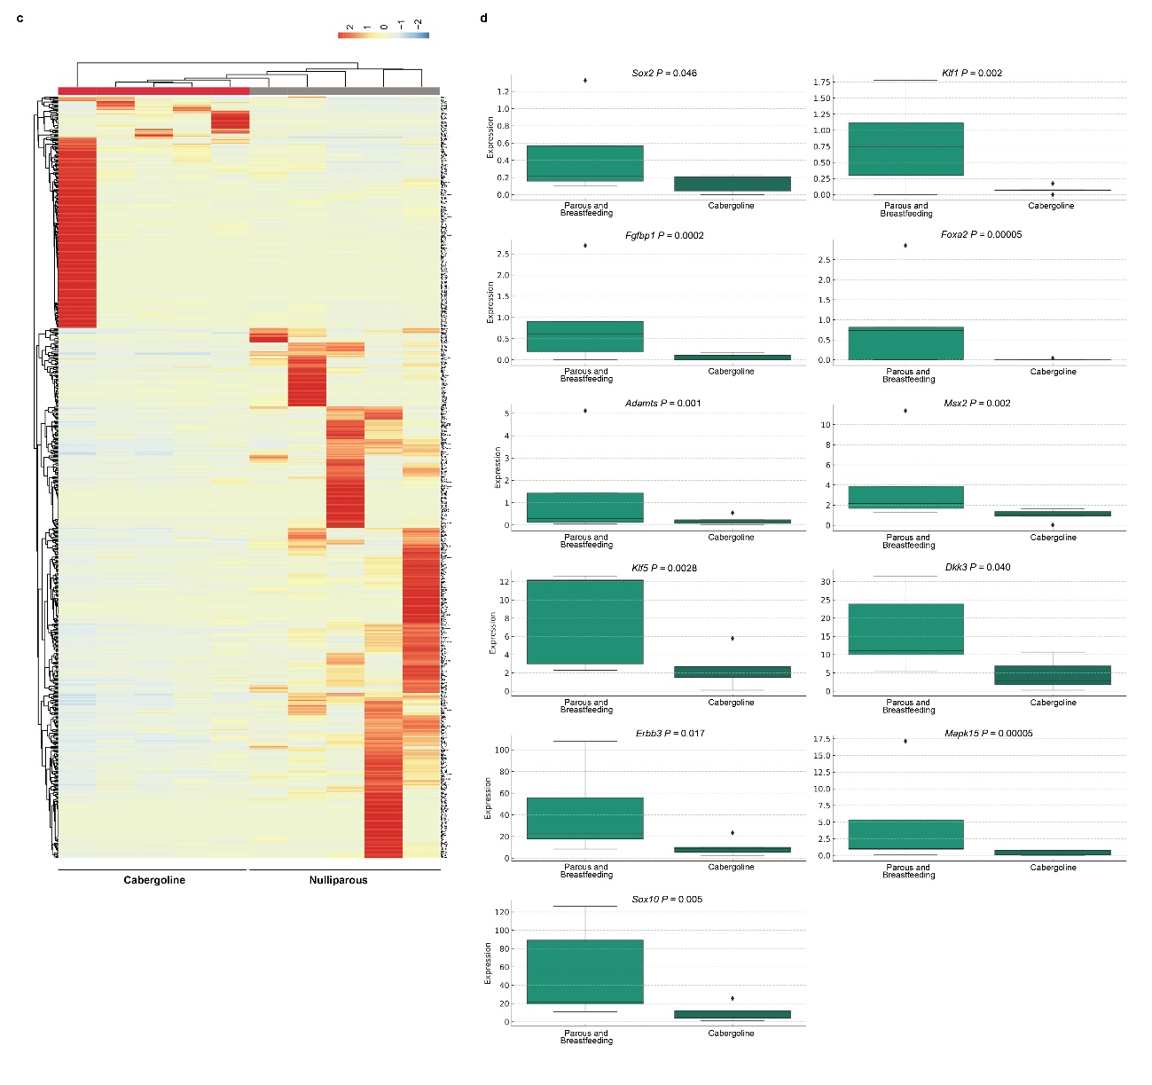 Extended Data Fig. 5c, d. c) Heatmap of post-intersection differential expression: analyzes gene expression in non-tumorous mammary glands of cabergoline-treated (N = 5) versus nulliparous (N = 5) Brca1/P53-deficient mice at 60 days post-lactational involution. The heatmap highlights specific DEGs identified after multitesting correction, focusing on genes uniquely altered in cabergoline-treated mice. d) Comparative gene expression analysis: box plots contrasting specific gene expressions between nulliparous and cabergoline-treated multiparous Brca1/P53-deficient mice. This analysis, conducted with a negative binomial test and adjusted for FDR using the Benjamini-Hochberg procedure, emphasizes the impact of cabergoline treatment on mammary gland gene expression, excluding overlapping DEGs and focusing on those unique to the treated group.

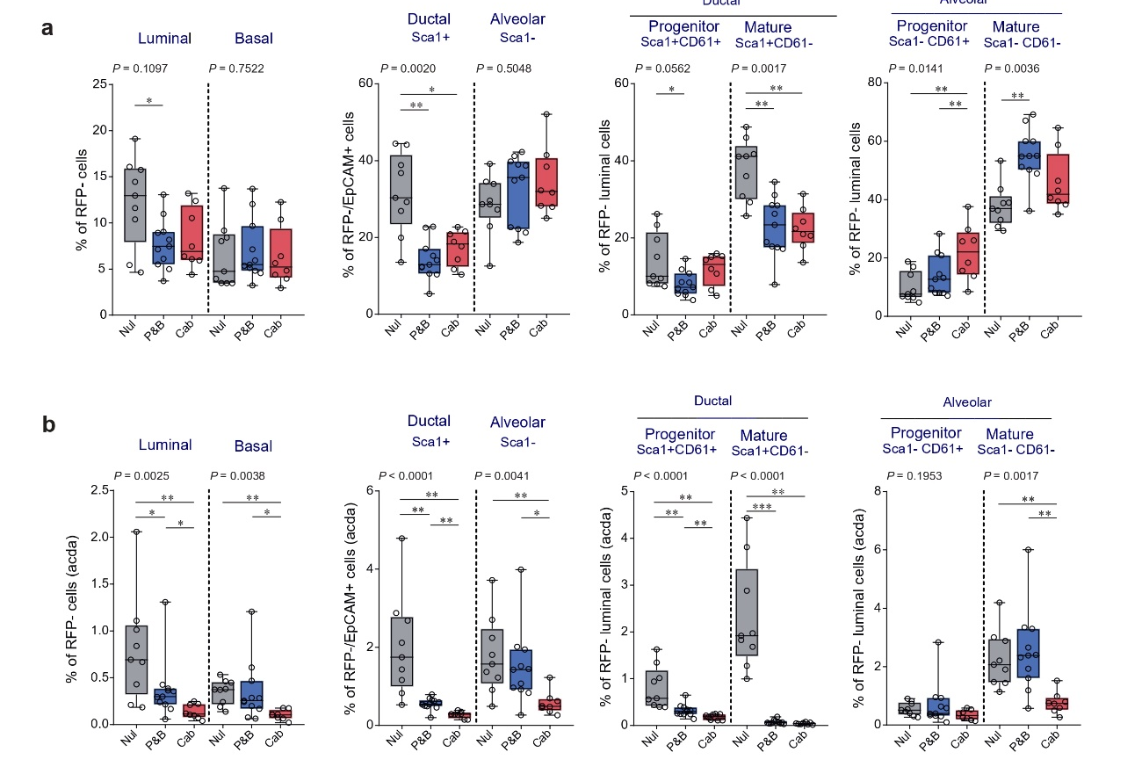 Extended Data Fig. 6. Evaluation of non-recombinant (RFP-) epithelial subpopulations in Brca1/P53-deficient mice. This analysis examines the impact of cabergoline on non-recombinant breast epithelial subpopulations in Brca1/P53-deficient mice, 60 days post-lactational involution. Groups include nulliparous, untreated multiparous, and cabergoline-treated multiparous mice. a) Subpopulation analysis: identifies luminal (EpCAM high, CD49f low) and basal (EpCAM low, CD49f high) cells, along with ductal (Sca1+) and alveolar (Sca1-) luminal cells, based on EpCAM and CD49f expression. Progenitor (CD61+) and mature cells (CD61-) are differentiated within these subpopulations. b) Adjusted subpopulation analysis: mirrors comparisons in panel a, adjusting subpopulation percentages for ductal area (d.a.). Statistical analysis uses Kruskal-Wallis test and Wilcoxon post-test. Significance levels indicated as *** P<0.0005; ** P<0.005; *P<0.05.

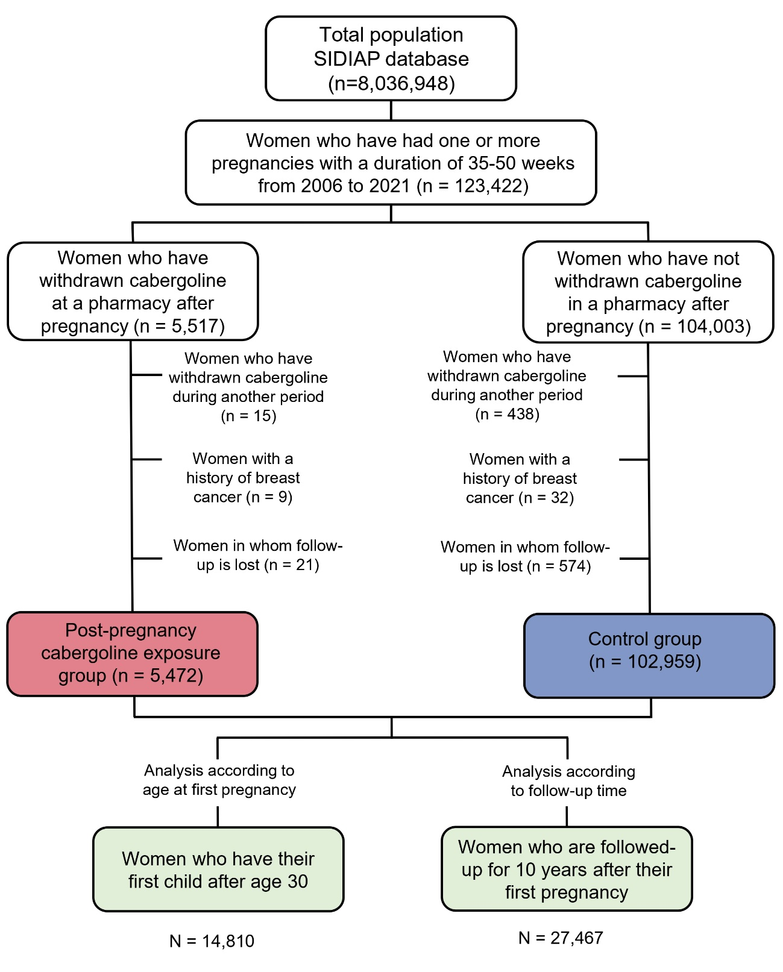Supplementary Figure 7. Flowchart of the SIDIAP Database Study on Post-Pregnancy Cabergoline's Impact on Breast Cancer Risk. This figure presents the methodology of a retrospective dynamic cohort study utilizing the SIDIAP database (2006-2021) to assess cabergoline's role in breast cancer prevention post-pregnancy. The study categorizes women based on cabergoline intake within one month post-pregnancy: (i) Exposed Group (n = 5,472) - Women who took cabergoline. (ii) Control Group (n = 102,959) - Women who did not. The study's focus includes a) Evaluating breast cancer incidence post-first pregnancy in women over 30, and b) Monitoring disease incidence up to 10 years following the first pregnancy, acknowledging the heightened risk for late first-time mothers.

