Table 1 Statistics of dataset images
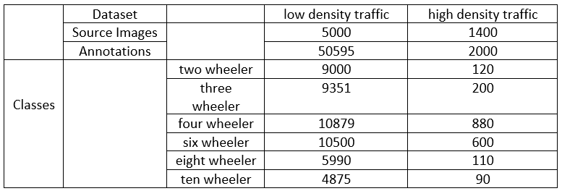
Table 2 Certain dataset specific statistics (HDD: High density dataset from high density traffic;
LDD: Low density dataset from low density traffic)
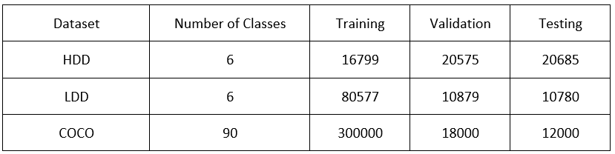
Table 3 COCO dataset accuracy comparison
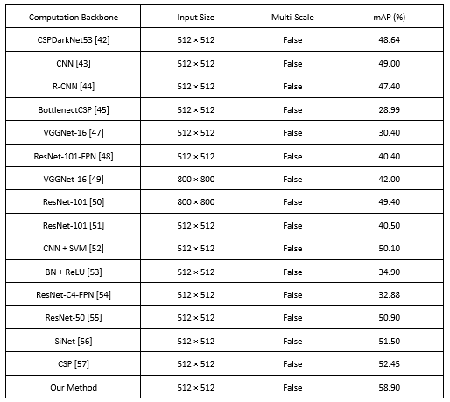

Table 4 Comparison of methods on DAWN datasets
