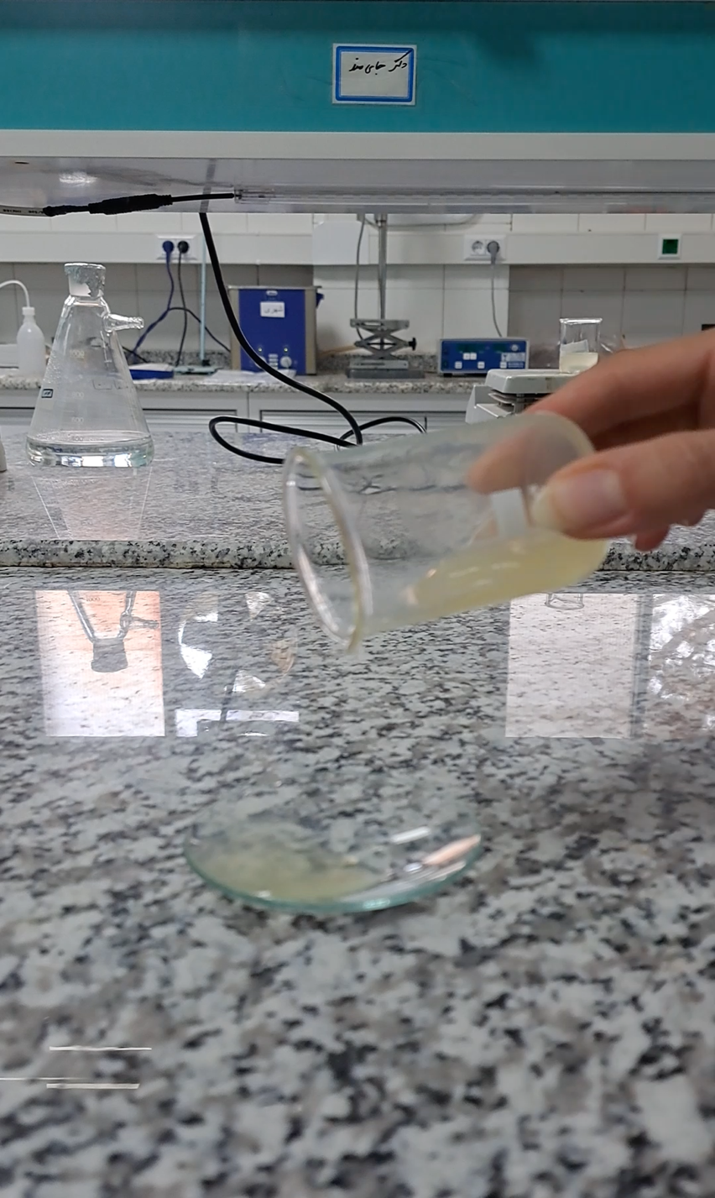

Video S1: Prepared CMC-sliming gel contains Chi/G-NLPs

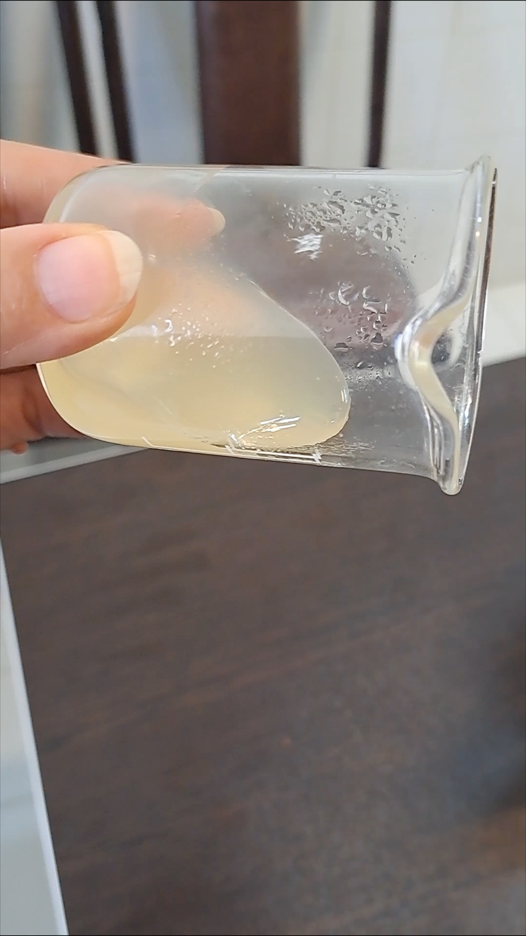

Video S2: The appearance and viscosity of CMC-sliming gel contains Chi/G-NLPs

