SI Appendix for: Towards the Elimination of Dog-Mediated Rabies: Development and Application of an Evidence-Based Management Tool
Rysava et al.

Supplementary material
Figure S1. Confirmed rabies cases between January 2011 and December 2015 for Mexico. Best fitting Poisson regression model shown by dashed blue line and logistic regression models shown by red solid line (insets). Model details are reported in Table S1.
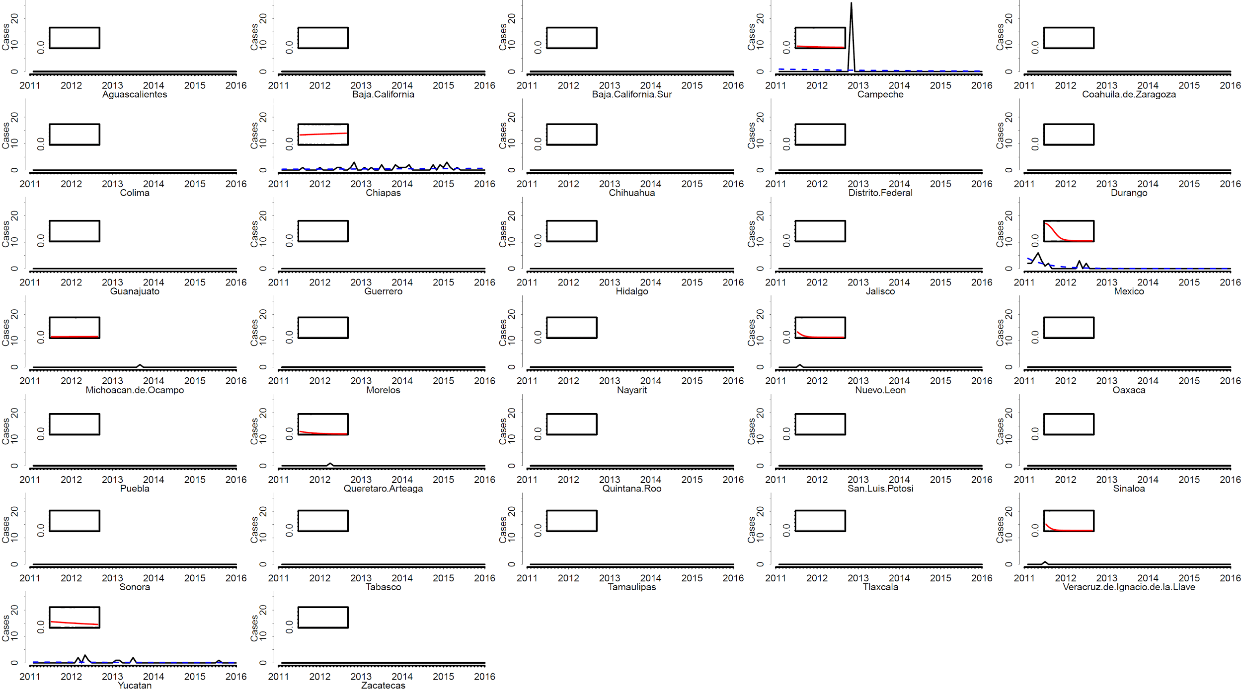

Figure S2. Confirmed rabies cases between January 2011 and December 2015 for Brazil. Best fitting Poisson regression model shown by dashed blue line and logistic regression models shown by red solid line (insets). Model details are reported in Table S1.
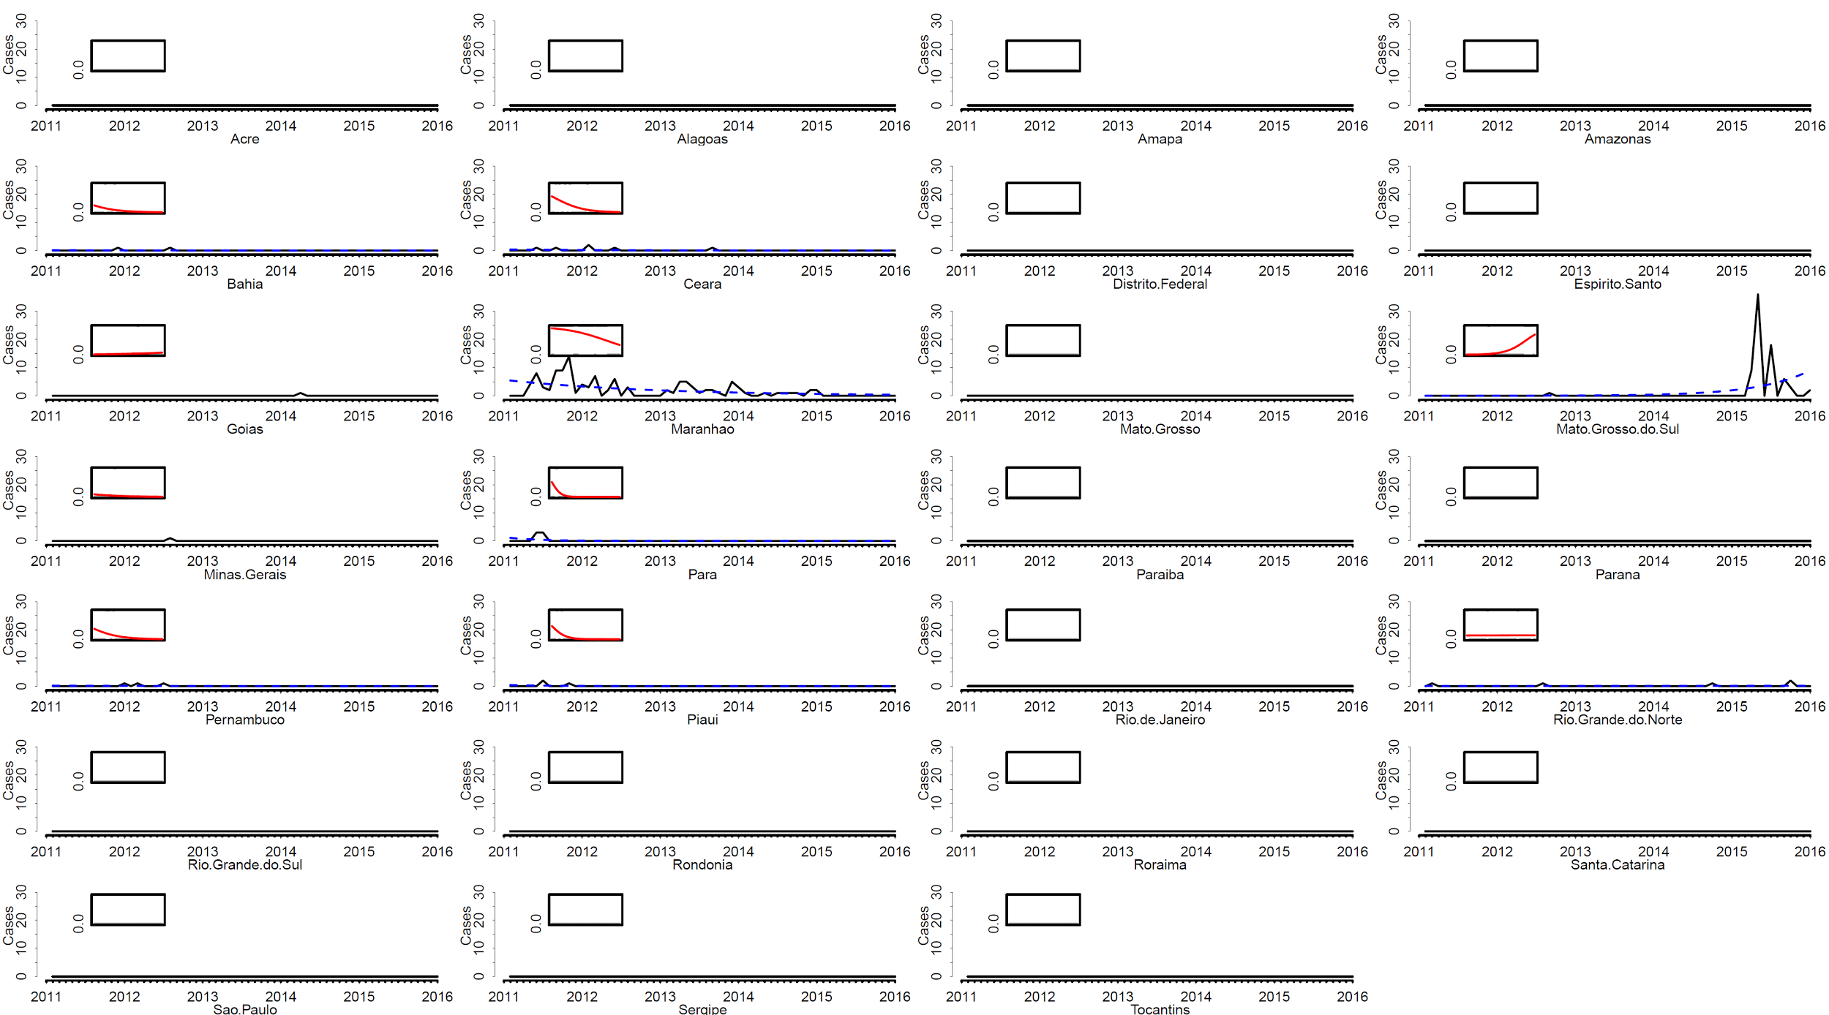

Figure S3: Confirmed rabies cases between January 2005 and December 2015 for Mexico. Background is shaded by epidemiological classifications (as per Figure 2) in each state classified every year.
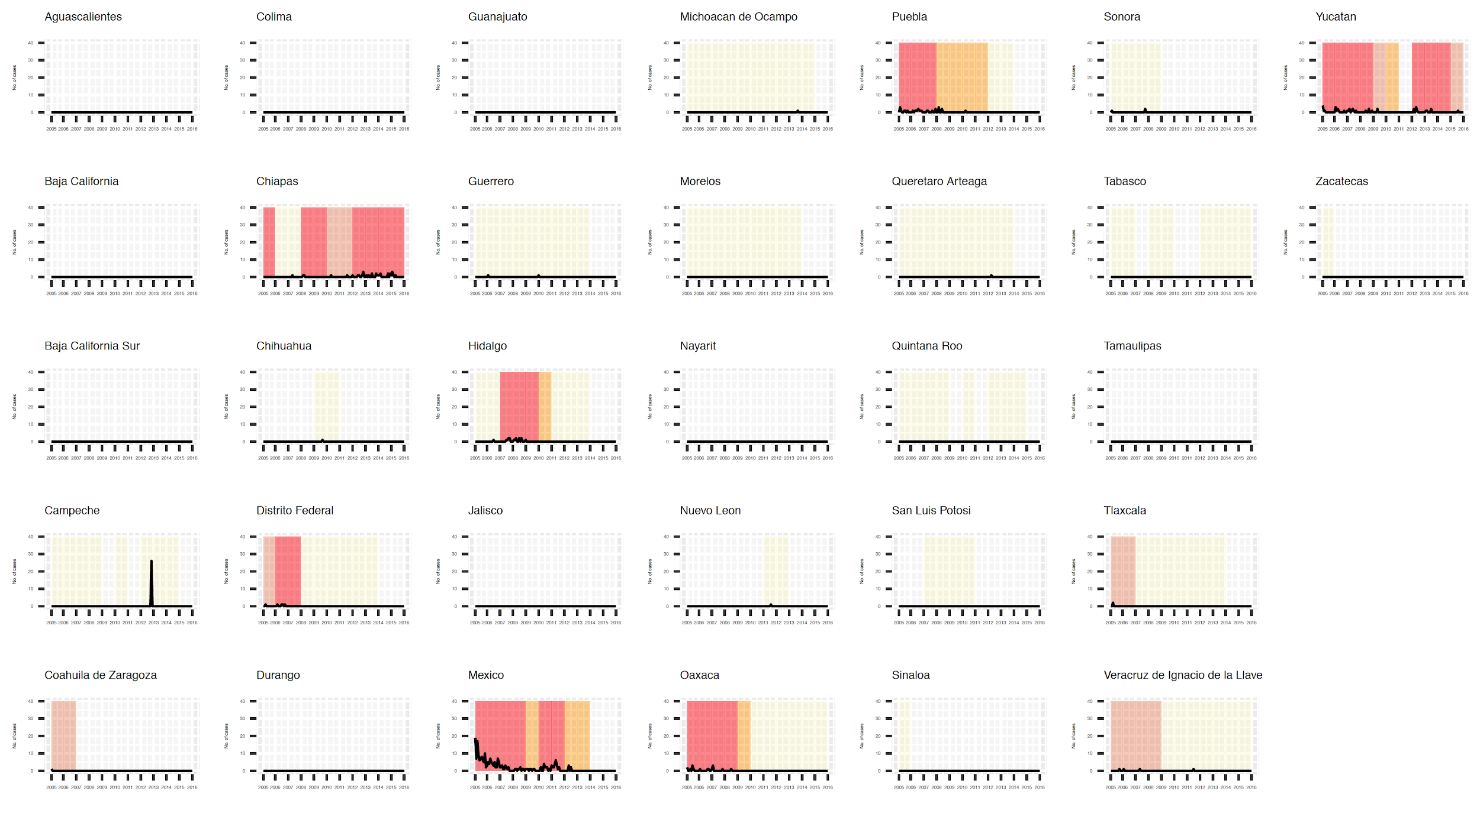

Figure S4: Confirmed rabies cases between January 2005 and December 2015 for Brazil. Background is shaded by epidemiological classifications (as per Figure 2) in each state classified every year.
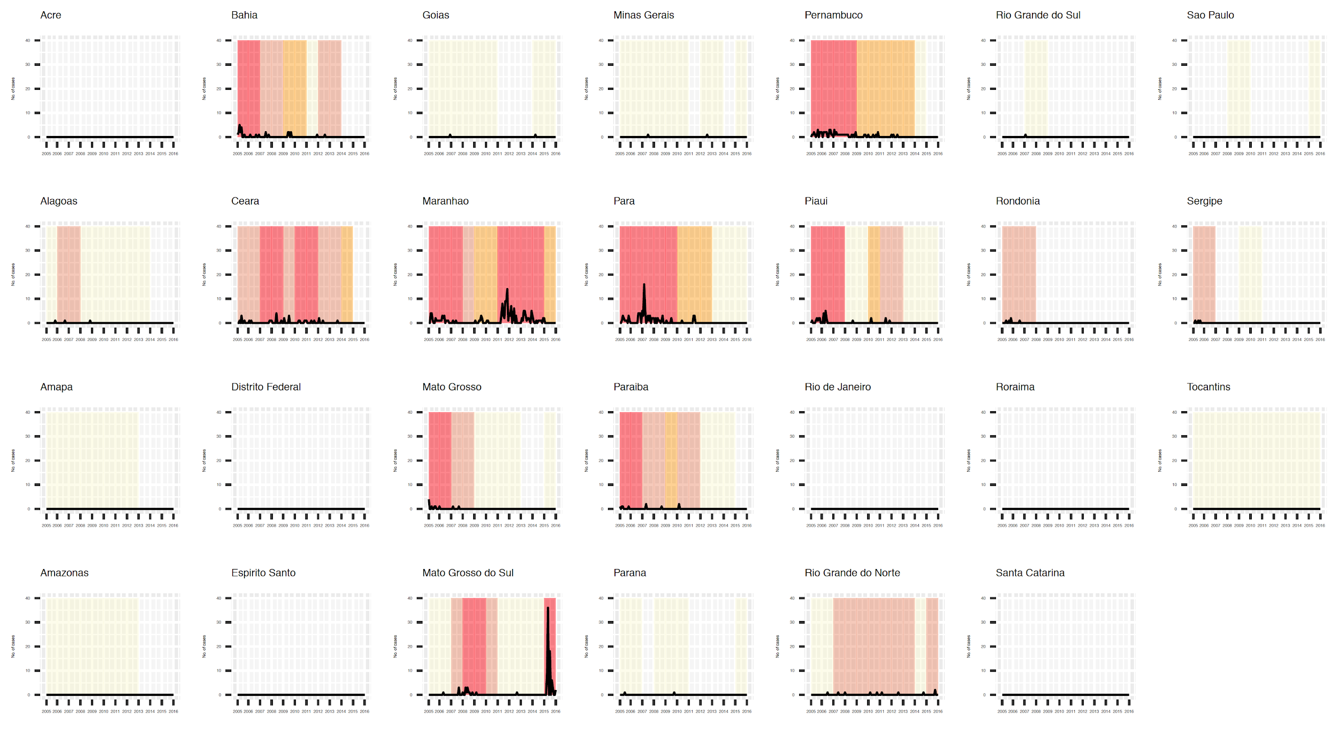

Figure S5. Completeness of location data for major and minor administrative units (states and municipalities respectively) in Mexico.
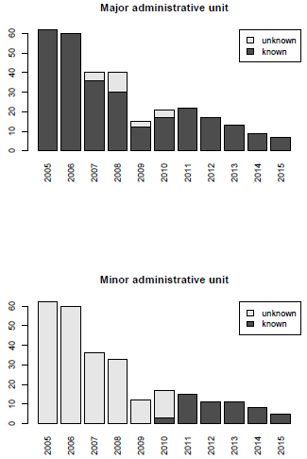

Figure S6. Completeness of location data for major and minor administrative units (states and municipalities respectively) in Brazil.
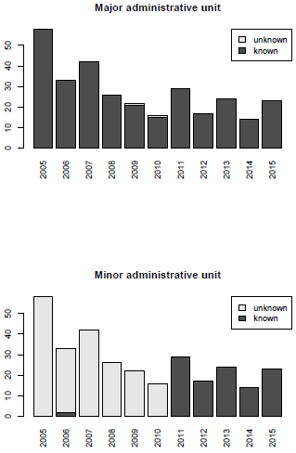

Table S1. Trends in case detection in Mexico and Brazil for 2005-2010 and 2010-2015. Coefficients, p-values and chi-square probability statistics (aka likelihood ratio p-value; <0.05 indicates the model performs better than chance at predicting the outcome, reject the null hypothesis) from Poisson regression (PR) and logistic regression (LR) models fitted to time series of detected cases and presence-absence data respectively. Coefficients represent the multiplicative change in the odds of case occurrence (for LR models) or case numbers (for PR models) associated with the passing of one month. States absent from the table had no cases detected.
 |  | P-value |  | Chi-square |  | Coefficient
Mexico 2015 |  | LR | PR | LR | PR | LR | PR
 | Campeche | 0.485 | 0.015 | 0.467 | 0.011 | 0.968 | 0.971
 | Chiapas | 0.691 | 0.278 | 0.690 | 0.275 | 1.006 | 1.012
 | Mexico | 0.002 | 0.000 | 0.000 | 0.000 | 0.805 | 0.845
 | Michoacan de Ocampo | 0.899 | NA | 0.899 | NA | 1.005 | NA
 | Nuevo Leon | 0.159 | NA | 0.020 | NA | 0.833 | NA
 | Queretaro Arteaga | 0.240 | NA | 0.168 | NA | 0.934 | NA
 | Veracruz de Ignacio de la Llave | 0.159 | NA | 0.012 | NA | 0.799 | NA
 | Yucatan | 0.428 | 0.190 | 0.424 | 0.179 | 0.985 | 0.976
Mexico 2010
 | Chiapas | 0.972 | 0.977 | 0.972 | 0.977 | 0.999 | 0.999
 | Chihuahua | 0.313 | NA | 0.265 | NA | 1.053 | NA
 | Distrito Federal | 0.015 | 0.046 | 0.000 | 0.001 | 0.690 | 0.833
 | Guerrero | 0.878 | 0.628 | 0.878 | 0.622 | 1.005 | 0.980
 | Hidalgo | 0.058 | 0.163 | 0.049 | 0.155 | 0.967 | 0.979
 | Mexico | 0.280 | 0.000 | 0.270 | 0.000 | 0.977 | 0.963
 | Oaxaca | 0.004 | 0.009 | 0.000 | 0.002 | 0.919 | 0.930
 | Puebla | 0.000 | 0.001 | 0.000 | 0.000 | 0.903 | 0.950
 | Sonora | 0.424 | 0.453 | 0.398 | 0.431 | 0.964 | 0.967
 | Veracruz de Ignacio de la Llave | 0.097 | 0.164 | 0.026 | 0.044 | 0.900 | 0.883
 | Yucatan | 0.000 | 0.000 | 0.000 | 0.000 | 0.919 | 0.946

 |  | P-value |  | Chi-square |  | Coefficient
Brazil 2015 |  | LR | PR | LR | PR | LR | PR
 | Bahia | 0.092 | 0.252 | 0.047 | 0.185 | 0.931 | 0.939
 | Ceara | 0.006 | 0.044 | 0.001 | 0.019 | 0.919 | 0.937
 | Goias | 0.485 | NA | 0.467 | NA | 1.033 | NA
 | Maranhao | 0.005 | 0.000 | 0.002 | 0.000 | 0.945 | 0.956
 | Mato Grosso do Sul | 0.002 | 0.000 | 0.000 | 0.000 | 1.122 | 1.136
 | Minas Gerais | 0.357 | NA | 0.319 | NA | 0.955 | NA
 | Para | 0.086 | 0.015 | 0.001 | 0.000 | 0.761 | 0.818
 | Pernambuco | 0.034 | 0.154 | 0.011 | 0.096 | 0.925 | 0.937
 | Piaui | 0.048 | 0.085 | 0.002 | 0.008 | 0.845 | 0.864
 | Rio Grande do Norte | 0.964 | 0.482 | 0.964 | 0.475 | 1.001 | 1.019
Brazil 2010
 | Alagoas | 0.250 | 0.453 | 0.223 | 0.431 | 0.962 | 0.967
 | Bahia | 0.029 | 0.572 | 0.020 | 0.570 | 0.958 | 0.991
 | Ceara | 0.147 | 0.224 | 0.139 | 0.218 | 1.024 | 1.016
 | Goias | 0.176 | NA | 0.069 | NA | 0.901 | NA
 | Maranhao | 0.014 | 0.008 | 0.009 | 0.006 | 0.959 | 0.967
 | Mato Grosso | 0.124 | 0.305 | 0.082 | 0.254 | 0.943 | 0.950
 | Mato Grosso do Sul | 0.173 | 0.309 | 0.164 | 0.304 | 0.976 | 0.985
 | Minas Gerais | 0.313 | NA | 0.265 | NA | 0.950 | NA
 | Para | 0.004 | 0.000 | 0.002 | 0.000 | 0.950 | 0.956
 | Paraiba | 0.804 | 0.767 | 0.804 | 0.766 | 1.006 | 1.008
 | Parana | 0.284 | NA | 0.227 | NA | 1.058 | NA
 | Pernambuco | 0.004 | 0.000 | 0.001 | 0.000 | 0.943 | 0.966
 | Piaui | 0.058 | 0.001 | 0.041 | 0.000 | 0.955 | 0.921
 | Rio Grande do Norte | 0.968 | 0.969 | 0.968 | 0.969 | 0.999 | 1.001
 | Rio Grande do Sul | 0.199 | NA | 0.109 | NA | 0.919 | NA
 | Rondonia | 0.159 | NA | 0.019 | NA | 0.833 | NA

