Supplementary information
Supplementary tables
Table S1: Sampled skin sites and sampling dates for all participants
ID_participant | condition | skin_site
ADH001 | Healthy | skin folds
ADH002 | Healthy | skin folds
ADH003 | Healthy | skin folds
ADH004 | Healthy | skin folds
ADH005 | Healthy | skin folds
ADH006 | Healthy | skin folds
ADH007 | Healthy | skin folds
ADH009 | Healthy | skin folds
ADH010 | Healthy | skin folds
ADH011 | Healthy | skin folds
ADH012 | Healthy | skin folds
ADH013 | Healthy | skin folds
ADH014 | Healthy | skin folds
ADH015 | Healthy | skin folds
ADH016 | Healthy | skin folds
ADH017 | Healthy | skin folds
ADH018 | Healthy | skin folds
ADH019 | Healthy | skin folds
ADH020 | Healthy | skin folds
ADH023 | Healthy | skin folds
ADH024 | Healthy | skin folds
ADH025 | Healthy | skin folds
ADH026 | Healthy | skin folds
ADH027 | Healthy | skin folds
ADH028 | Healthy | skin folds
ADH030 | Healthy | skin folds
ADH031 | Healthy | skin folds
ADH032 | Healthy | skin folds
ADH033 | Healthy | skin folds
ADH034 | Healthy | skin folds
ADH035 | Healthy | skin folds
ADH036 | Healthy | skin folds
ADH037 | Healthy | skin folds
ADH038 | Healthy | skin folds
ADH039 | Healthy | skin folds
ADH040 | Healthy | skin folds
ADH041 | Healthy | skin folds
ADH042 | Healthy | skin folds
ADH044 | Healthy | skin folds
ADH045 | Healthy | skin folds
ADH046 | Healthy | skin folds
ADH047 | Healthy | skin folds
ADH048 | Healthy | skin folds
ADH049 | Healthy | skin folds
ADH050 | Healthy | skin folds
ADH051 | Healthy | skin folds
ADH052 | Healthy | skin folds
ADH053 | Healthy | skin folds
ADH054 | Healthy | skin folds
AD001 | mild AD | face
AD002 | mild AD | face
AD003 | mild AD | skin folds
AD004 | moderate-to-severe AD | skin folds
AD005 | mild AD | skin folds
AD006 | mild AD | skin folds
AD007 | mild AD | face
AD008 | moderate-to-severe AD | face
AD009 | mild AD | skin folds
AD010 | mild AD | foot
AD011 | mild AD | abdomen
AD012 | mild AD | skin folds
AD013 | mild AD | arms
AD014 | moderate-to-severe AD | abdomen
AD015 | mild AD | hands
AD018 | mild AD | back
AD019 | moderate-to-severe AD | arms
AD020 | mild AD | skin folds
AD021 | mild AD | legs
AD022 | mild AD | arms
AD023 | moderate-to-severe AD | skin folds
AD024 | mild AD | neck
AD034 | moderate-to-severe AD | skin folds
AD036 | mild AD | skin folds
AD047 | mild AD | skin folds
AD049 | mild AD | legs
AD052 | mild AD | skin folds
ADA001_A | mild AD | arms
ADA001_B | mild AD | arms
ADA002_A | mild AD | arms
ADA002_B | mild AD | arms
ADA004_A | mild AD | neck
ADA004_B | mild AD | neck
ADC002_A | mild AD | abdomen
ADC002_B | mild AD | abdomen
ADC003_A | mild AD | skin folds
ADC003_B | mild AD | skin folds
ADC004_A | mild AD | skin folds
ADC004_B | mild AD | skin folds
ADC005_A | mild AD | back
ADC005_B | mild AD | legs

Table S2: participants’ demographics and information
Total (n = 83)
 | [n] | [%]
Healthy participants | 49 | 59.04
- Gender female | 29 | 59.18
- Antihistaminicum | 0 | 0
- Topical corticosteroids | 0 | 0
- Topical antibiotics | 0 | 0
- Oral antibiotics | 3 | 6.12
- Allergy | 3 | 6.12
- Age range | 0 – 53 | /
- Mean age, stdv | 11.87 +/- 11.83 * | /
- 0-3 years | 11 | 22.45
- 3-6 years | 10 | 20.41
- 6-12 years | 9 | 18.37
- 12-18 years | 10 | 20.41
- >18 years | 9 | 18.37
AD patients | 34 | 40.96
- Gender female | 21 | 61.76
- Antihistaminicum | 14 | 41.18
- Topical corticosteroids | 14 | 41.18
- Topical antibiotics | 3 | 8.82
- Oral antibiotics | 3 | 8.82
- Allergy | 8 | 23.53
- Age range | 1-70 | /
- Mean age, stdv | 20.41 +/- 16.96 | /
Mild AD patients | 28 | 33.73
- Gender female | 19 | 67.86
- Antihistaminicum | 11 | 39.29
- Topical corticosteroids | 10 | 35.71
- Topical antibiotics | 2 | 7.14
- Oral antibiotics | 2 | 7.14
- Allergy | 6 | 21.43
- Age range | 1-70 | /
- Mean age, stdv | 21.59 +/- 16.79 | /
- 0-3 years | 2 | 7.14
- 3-6 years | 6 | 21.43
- 6-12 years | 3 | 10.71
- 12-18 years | 1 | 3.57
- >18 years | 16 | 57.14
Moderate-to-severe AD patients | 6 | 7.23
- Gender female | 2 | 33.33
- Antihistaminicum | 3 | 50.00
- Topical corticosteroids | 4 | 66.67
- Topical antibiotics | 1 | 16.67
- Oral antibiotics | 1 | 16.67
- Allergy | 2 | 33.33
- Age range | 1-44 | /
- Mean age, stdv | 17.67 +/- 17.53 | /
- 0-3 years | 1 | 16.67
- 3-6 years | 1 | 16.67
- 6-12 years | 2 | 33.33
- 12-18 years | 0 | 0
- >18 years | 2 | 33.33

Supplementary figures
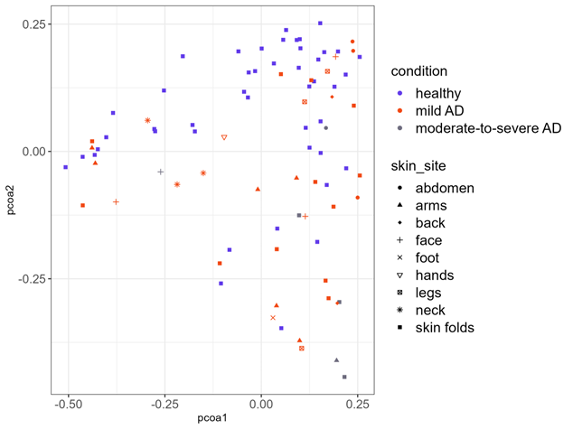
Figure S1: Principal Coordinates Analysis (PCoA) plot visualizing the beta diversity of AD skin samples, colored by skin condition and different shapes show the skin sites.
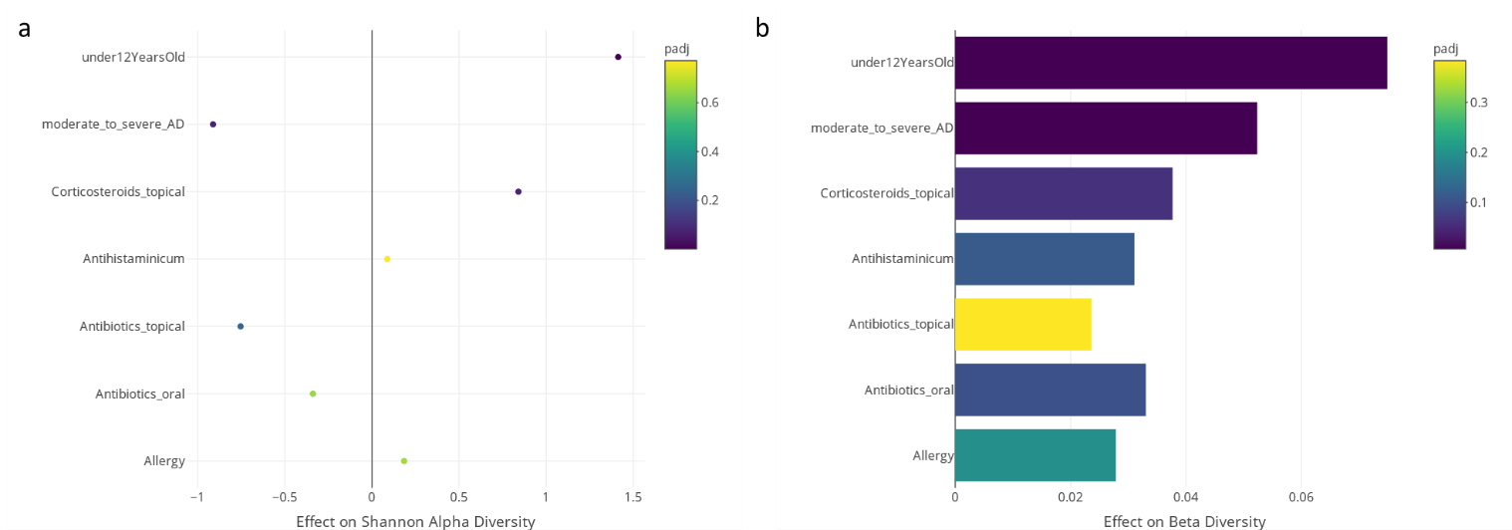
Figure S2: Effect of age and other host and environmental variables on the skin microbiome diversity in mild AD patients. (a) Alpha diversity calculated by Shannon index. (b) Beta diversity calculated by Bray-Curtis dissimilarity.
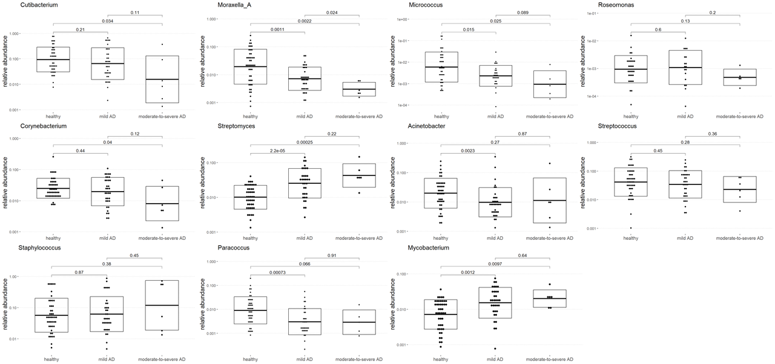
Figure S3: Boxplots showing the relative abundance of different skin genera in all three conditions, p-values are printed on the figures.
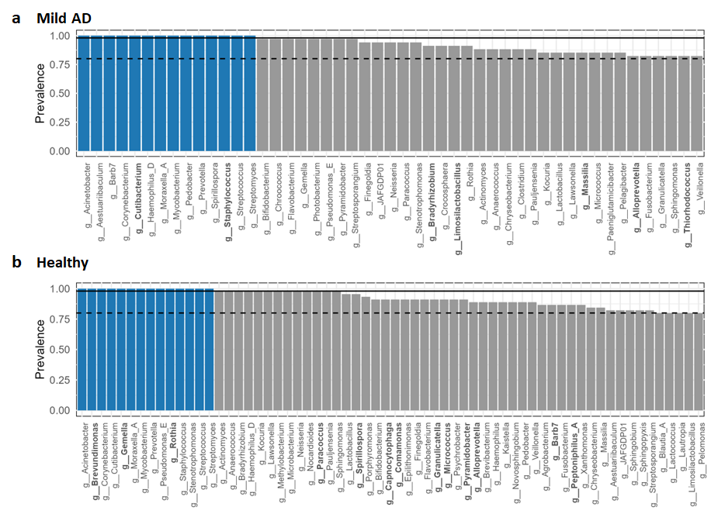
Figure S4: (a) Barplot showing the preservation of genera in the mild AD samples: all genera with a prevalence of at least 80% are shown as core prevalent genera. (b) Barplot showing the preservation of genera in the healthy samples: all genera with a prevalence of at least 80% are shown. The full and dotted line indicate a prevalence of 98% and 80% respectively. Blue represents omnipresent genera. Genera that were present for more than 98% in only one group, healthy or AD, are marked bold.

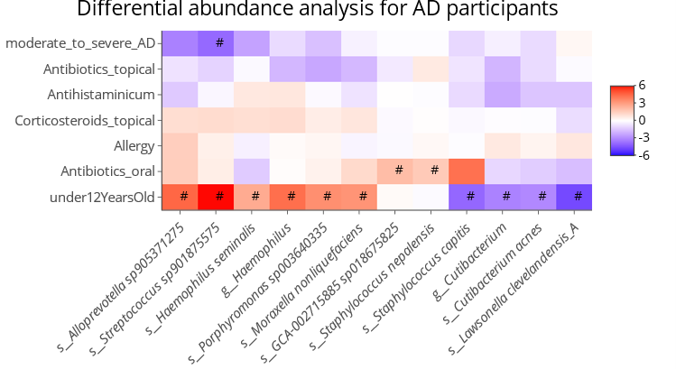
Figure S5: Differential abundance analysis of species for AD patients. The effect sizes show the differences in skin taxa relative abundance based on different factors such as AD severity, antibiotics, antihistaminicum, corticosteroids, allergies, and age.

