Supplementary Material

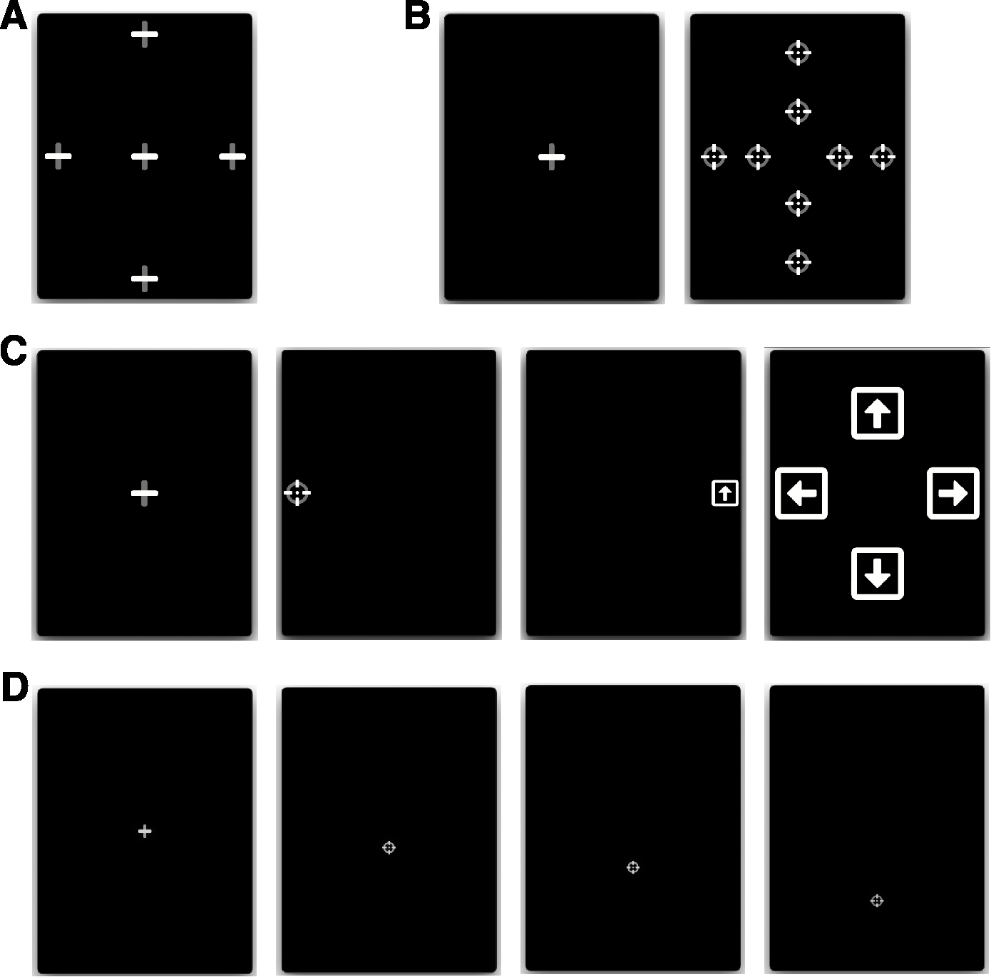

Supplementary Figure 1. Eye-tracking tasks. (A) Fixation: participants fixated a stationary target for 7 seconds, at one of 5 locations. (B) Pro-saccades: participants initially fixated a central fixation point, which disappeared after 1.0 – 3.5 s, after which a different target appeared at one of 8 eccentric locations for 1.5 seconds. (C) Anti-saccades: participants initially fixated a central fixation point, which disappeared after 1.0 – 3.5 s, after which a round target appeared at 10° to the left or right from the center. Participants were instructed to move their gaze in the opposite direction to the round target, where after 1200ms they were shown a square with an arrow inside that pointed in one of 4 random directions (left, right, up, or down; shown during 400ms). The users then had to direct their gaze toward the arrow orientation corresponding to the arrow they saw in the preceding step. (D) Smooth pursuit: after initially fixating on a central cross, participants followed a moving target with a constant velocity of 8°/s (in this example, a downward-moving target).

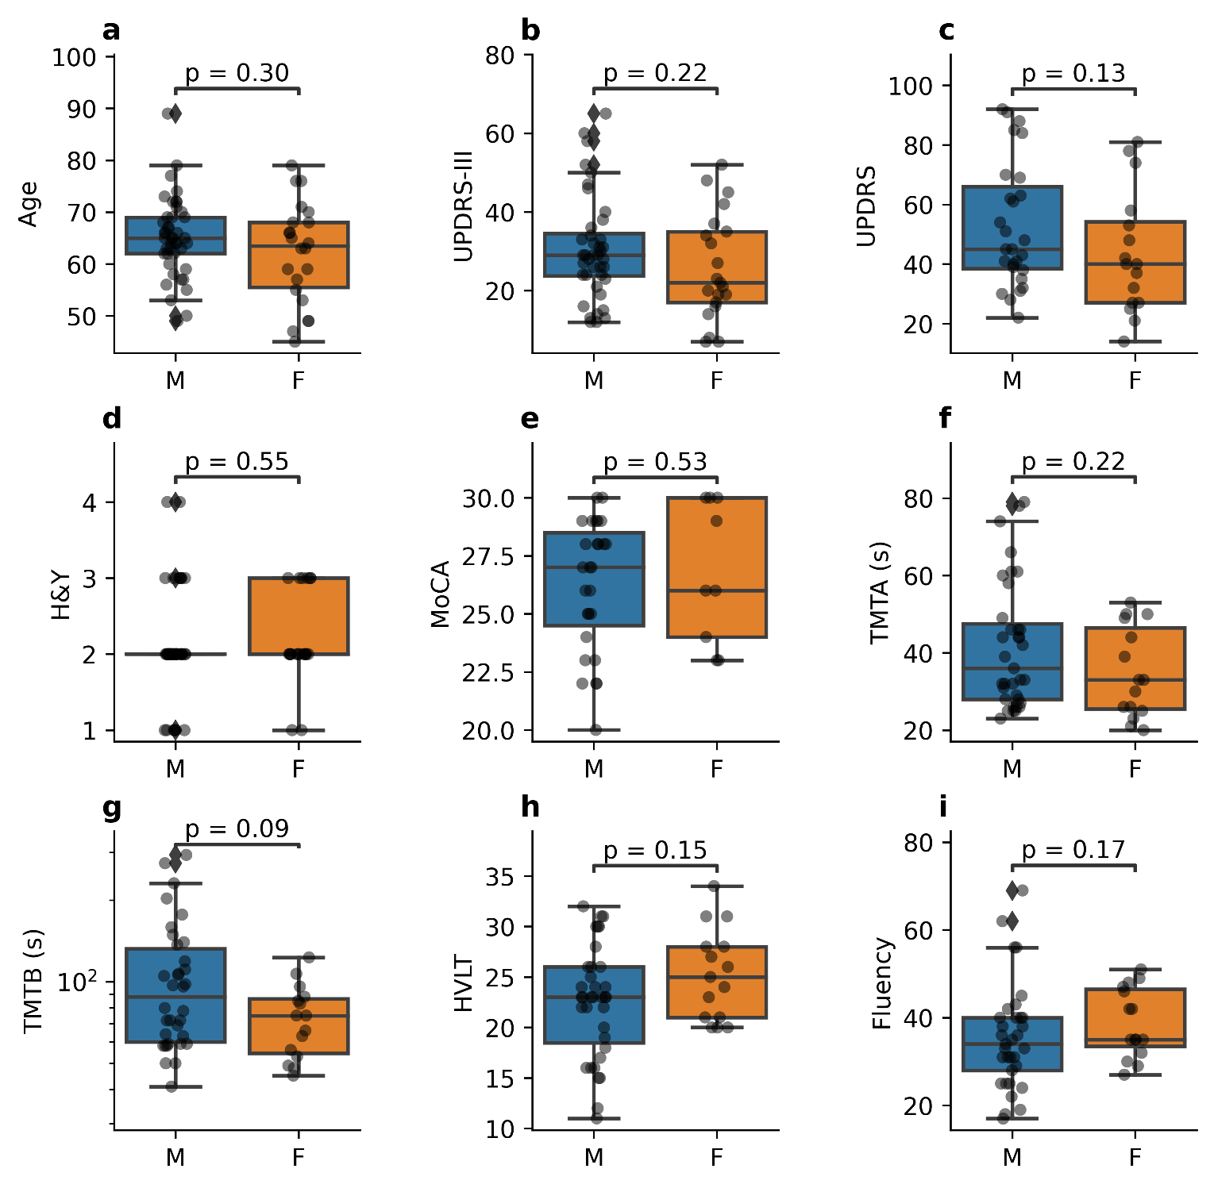
Supplementary Figure 2. Lack of differences between male (M) and female (F) participant
age (a; Mann–Whitney U = 547.5, n₁ = 43, n₂ = 22, p =0.3043 two-tailed) and participants’ clinical scores: UPDRS-III (b; Mann–Whitney U = 501.0, n₁ = 40, n₂ = 21, p = 0.2215 two-tailed), UPDRS (c; Mann–Whitney U = 277.0, n₁ = 27, n₂ = 16, p = 0.1284 two-tailed, H&Y (d; Mann–Whitney U = 357.0, n₁ = 39, n₂ = 20, p = 0.5505 two-tailed, MoCA (e; Mann–Whitney U = 104.0, n₁ =27, n₂ = 9, p = 0.5317 two-tailed), TMTA (f; Mann–Whitney U = 320.5, n₁ = 35, n₂ = 15, p = 0.2228 two-tailed), TMTB (g; Mann–Whitney U = 334.5, n₁ = 34, n₂ = 15, p = 0.0864 two-tailed), HVLT (h; Mann–Whitney U = 194.5, n₁ = 35, n₂ = 15, p = 0.1516 two-tailed), and COWAT-CFL (i; Mann–Whitney U = 185.5, n₁ = 33, n₂ = 15, p = 0.1707 two-tailed).
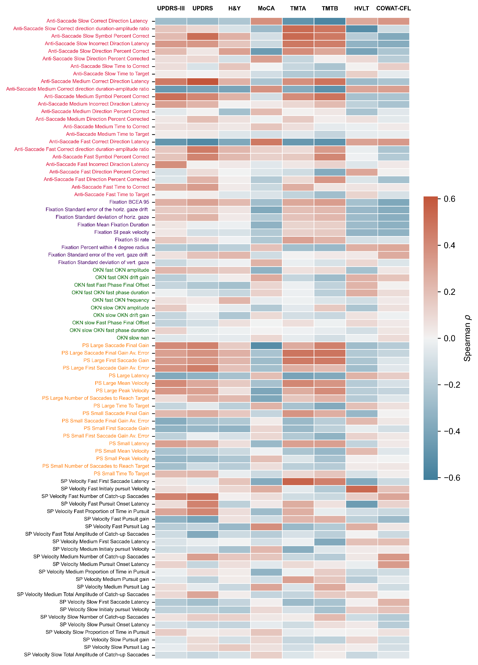Supplementary Figure 3. Correlations between eye-tracking parameters and clinical scores.

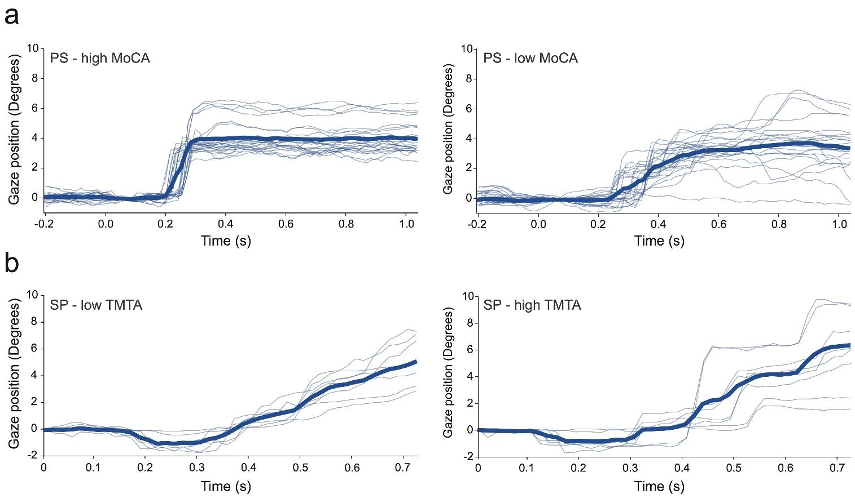
Supplementary Figure 4. Illustrated here are the gaze traces for 4 participants (light lines indicate individual trial traces, bold lines indicate the average trace). The top row (a) illustrates the gaze traces of two participants as measured during the small pro-saccade task: the left graph shows traces from a patient with a high MoCA score (30), whereas the right graph shows traces from a patient with a lower MoCA score (22); notice how the average saccade trace on the right has a much longer latency and takes longer to stabilize near the target. The bottom row (b) illustrates the gaze traces of two participants as measured during the medium velocity smooth pursuit task: the left graph shows traces from a patient with a low (good) TMTA time (29), whereas the right graph shows traces from a patient with a high TMTA time (71); notice how the average smooth pursuit trace on the right has larger amplitude catch-up saccades.

 | UPDRS-III | H&Y | UPDRS | MoCA | HVLT | TMTA (s) | TMTB (s) | COWAT-CFL
UPDRS-III | 1 | -- | -- | -- | -- | -- | -- | --
H&Y | 0.40  p=3.56e-03 | 1 | -- | -- | -- | -- | -- | --
UPDRS | 0.73  p=2.44e-07 | 0.42  p=1.08e-02 | 1 | -- | -- | -- | -- | --
MoCA | -0.31  p=8.69e-02 | -0.34  p=6.24e-02 | -0.36  p=0.159 | 1 | -- | -- | -- | --
HVLT | -0.28  p=6.78e-02 | -0.03  p=0.831 | -0.20  p=0.284 | 0.56  p=1.54e-03 | 1 | -- | -- | --
TMTA (s) | 0.52  p=5.32e-04 | 0.36  p=2.11e-02 | 0.54  p=2.22e-03 | -0.48  p=7.25e-03 | -0.37  p=1.27e-02 | 1 | -- | --
TMTB (s) | 0.48  p=1.52e-03 | 0.28  p=7.33e-02 | 0.58  p=1.52e-03 | -0.55  p=2.22e-03 | -0.56  p=1.35e-04 | 0.74  p=5.35e-09 | 1 | --
COWAT-CFL | -0.21  p=0.18 | -0.15  p=0.34 | -0.25  p=0.18 | 0.48  p=8.89e-03 | 0.30  p=5.88e-02 | -0.48  p=1.52e-03 | -0.56  p=1.35e-04 | 1

Supplementary Table 1. For each PD-related clinical and cognitive test scores., clinical score-clinical score correlations depicted in Figure 1j are shown. ρ, Spearman’s rho. p-values for two-sided t-tests are presented after FDR correction (Benjamini-Hochberg procedure, α = 0.05). UPDRS (Unified Parkinson’s Disease Rating Scale); H&Y (Hoehn and Yahr Scale); MoCA (Montreal Cognitive Assessment); TMT-A/B (Trail Making Test - A/B); HVLT (Hopkins Verbal Learning test); COWAT (Controlled Oral Word Association Tes
 |  | UPDRS-III |  |  |  |  | UPDRS |  |  |  |  | H&Y |  |  |  |  | MoCA
 |  | B | Std. Error | β | t | P value | B | Std. Error | β | t | P value | B | Std. Error | β | t | P value | B | Std. Error | β | t | P value
 | Const | 30.38 | 90.99 | 0.00 | 0.33 | 0.74 | 50.89 | 11.51 | 0.00 | 4.42 | 0.00 | 2.12 | 1.24 | 0.00 | 1.71 | 0.10 | 26.24 | 4.11 | 0.00 | 6.39 | 0.00
Anti-Saccade Slow | Correct Direction Latency |  |  |  |  |  | 4.05 | 17.81 | 0.04 | 0.23 | 0.82 | -0.14 | 0.72 | -0.03 | -0.19 | 0.85
Anti-Saccade Slow | Symbol Percent Correct |  |  |  |  |  |  |  |  |  |  | -0.38 | 0.00 | -14.90 | -108.59 | 0.00
Anti-Saccade Medium | Correct Direction Latency | -3.79 | 18.13 | -0.04 | -0.21 | 0.84 | 4.27 | 28.39 | 0.03 | 0.15 | 0.88
Anti-Saccade Medium | Symbol Percent Correct | -3.61 | 0.05 | -10.35 | -80.79 | 0.00
Anti-Saccade Medium | Time to Correct |  |  |  |  |  |  |  |  |  |  | -0.13 | 1.28 | -0.01 | -0.10 | 0.92
Anti-Saccade Medium | Time to Target | 6.59 | 18.09 | 0.07 | 0.36 | 0.72 |  |  |  |  |  | 0.18 | 1.43 | 0.02 | 0.13 | 0.90
Fixation | SI rate |  |  |  |  |  |  |  |  |  |  | 0.32 | 0.45 | 0.09 | 0.72 | 0.48
Fixation | Standard deviation of vert. gaze |  |  |  |  |  |  |  |  |  |  |  |  |  |  |  | -0.85 | 0.98 | -0.12 | -0.86 | 0.40
OKN Fast | OKN drift gain |  |  |  |  |  |  |  |  |  |  | -0.09 | 0.17 | -0.07 | -0.57 | 0.57
OKN Fast | OKN fast phase duration |  |  |  |  |  |  |  |  |  |  |  |  |  |  |  | 1.11 | 25.56 | 0.01 | 0.04 | 0.97
OKN Fast | OKN frequency |  |  |  |  |  |  |  |  |  |  | -0.22 | 0.01 | -5.31 | -40.85 | 0.00
PS Large | Saccade Final Gain Av. Error | -4.21 | 32.31 | -0.03 | -0.13 | 0.90
PS Large | First Saccade Gain | -2.46 | 15.53 | -0.03 | -0.16 | 0.88
PS Large | First Saccade Gain Av. Error | 5.50 | 35.76 | 0.04 | 0.15 | 0.88
PS Large | Time To Target |  |  |  |  |  | 8.23 | 37.52 | 0.03 | 0.22 | 0.83
PS Small | Saccade Final Gain Av. Error |  |  |  |  |  | 8.85 | 18.42 | 0.05 | 0.48 | 0.63
PS Small | Latency | 2.64 | 38.18 | 0.01 | 0.07 | 0.95
PS Small | Mean Velocity |  |  |  |  |  |  |  |  |  |  | 0.25 | 0.01 | 7.55 | 50.25 | 0.00
PS Small | Peak Velocity | -2.81 | 0.02 | -15.04 | -128.50 | 0.00 |  |  |  |  |  | -0.29 | 0.00 | -26.13 | -224.55 | 0.00
PS Small | Number of Saccades to Reach Target |  |  |  |  |  |  |  |  |  |  |  |  |  |  |  | -0.93 | 4.55 | -0.04 | -0.21 | 0.84
PS Small | Time To Target |  |  |  |  |  |  |  |  |  |  |  |  |  |  |  | -1.01 | 7.70 | -0.02 | -0.13 | 0.90
SP Velocity Medium | Number of Catch-up Saccades | 4.09 | 9.34 | 0.09 | 0.44 | 0.67
SP Velocity Slow | Proportion of Time in Pursuit | 8.65 | 93.09 | 0.02 | 0.09 | 0.93
 |  | TMTA |  |  |  |  | TMTB |  |  |  |  | HVLT |  |  |  |  | COWAT-CFL
 |  | B | Std. Error | β | t | P value | B | Std. Error | β | t | P value | B | Std. Error | β | t | P value | B | Std. Error | β | t | P value
Const |  | 38.14 | 27.38 | 0.00 | 1.39 | 0.18 | 95.55 | 127.63 | 0.00 | 0.75 | 0.46 | 23.03 | 5.95 | 0.00 | 3.87 | 0.00 | 35.50 | 13.49 | 0.00 | 2.63 | 0.01
Anti-Saccade Slow | Correct Direction Latency | -2.88 | 14.18 | -0.03 | -0.20 | 0.84 |  |  |  |  |  |  |  |  |  |  | -4.37 | 9.93 | -0.07 | -0.44 | 0.66
Anti-Saccade Slow | Symbol Percent Correct |  |  |  |  |  | -95.11 | 0.50 | -51.49 | -191.27 | 0.00
Anti-Saccade Slow | Time to Target |  |  |  |  |  | -37.93 | 95.10 | -0.09 | -0.40 | 0.69
Anti-Saccade Medium | Correct Direction Latency | -0.99 | 31.10 | -0.01 | -0.03 | 0.98
Anti-Saccade Medium | Symbol Percent Correct |  |  |  |  |  | 24.45 | 0.32 | 13.63 | 75.58 | 0.00
Anti-Saccade Medium | Incorrect Direction Latency |  |  |  |  |  |  |  |  |  |  |  |  |  |  |  | -3.27 | 11.26 | -0.04 | -0.29 | 0.77
Anti-Saccade Medium | Time to Correct
Anti-Saccade Medium | Time to Target | 5.11 | 30.98 | 0.03 | 0.17 | 0.87 | 42.87 | 113.23 | 0.08 | 0.38 | 0.71 |  |  |  |  |  | -2.44 | 17.58 | -0.02 | -0.14 | 0.89
Anti-Saccade Fast | Symbol Percent Correct | -6.75 | 0.05 | -16.64 | -131.41 | 0.00 |  |  |  |  |  | 0.75 | 0.02 | 5.61 | 45.19 | 0.00 | 3.99 | 0.04 | 14.81 | 99.39 | 0.00
Fixation | BCEA 95 |  |  |  |  |  |  |  |  |  |  | 1.60 | 0.35 | 1.01 | 4.58 | 0.00
Fixation | Standard error of the horiz. gaze drift |  |  |  |  |  |  |  |  |  |  |  |  |  |  |  | -1.84 | 36.25 | -0.01 | -0.05 | 0.96
Fixation | Standard deviation of horiz. gaze |  |  |  |  |  |  |  |  |  |  | -2.58 | 5.68 | -0.10 | -0.45 | 0.65
Fixation | SI peak velocity | 0.61 | 0.03 | 2.52 | 23.11 | 0.00
Fixation | SI rate |  |  |  |  |  |  |  |  |  |  |  |  |  |  |  | 1.29 | 7.53 | 0.02 | 0.17 | 0.87
PS Large | First Saccade Gain | 1.78 | 18.17 | 0.01 | 0.10 | 0.92 | -14.38 | 100.29 | -0.03 | -0.14 | 0.89
PS Large | First Saccade Gain Av. Error |  |  |  |  |  | 1.14 | 118.66 | 0.00 | 0.01 | 0.99
PS Large | Number of Saccades to Reach Target | 7.88 | 13.04 | 0.08 | 0.60 | 0.55 |  |  |  |  |  | -2.01 | 3.94 | -0.06 | -0.51 | 0.61
PS Small | Saccade Final Gain Av. Error |  |  |  |  |  | -126.56 | 396.70 | -0.26 | -0.32 | 0.75
PS Small | First Saccade Gain |  |  |  |  |  | 9.03 | 78.73 | 0.03 | 0.12 | 0.91
PS Small | First Saccade Gain Av. Error |  |  |  |  |  | 104.98 | 362.05 | 0.23 | 0.29 | 0.78
PS Small | Latency |  |  |  |  |  | 56.76 | 256.23 | 0.04 | 0.22 | 0.83
PS Small | Peak Velocity | -3.15 | 0.03 | -12.36 | -113.63 | 0.00
PS Small | Time To Target |  |  |  |  |  | -67.85 | 238.43 | -0.06 | -0.29 | 0.78
SP Velocity Fast | Number of Catch-up Saccades |  |  |  |  |  | 5.30 | 17.60 | 0.03 | 0.30 | 0.77
SP Velocity Medium | Initial pursuit Velocity |  |  |  |  |  |  |  |  |  |  | 3.50 | 0.13 | 3.59 | 27.71 | 0.00
Supplementary Table 2. Multiple regression tables for UPDRS-III, UPDRS, H&Y, MoCA, TMTA, TMTB, HVLT, and COWAT-CFL. Regression coefficients (B), standard error, standardized regression coefficients (ß), t-statistic and associated p-value (two-sided test) for each oculomotor parameter.

 | MAE | R2 | Adj. R2 |  | F | P value
UPDRS-III | 5.512 | 0.7068 | 0.6158 | F (10, 28) | 6.7495 | 2.97E-05
UPDRS | 10.323 | 0.6599 | 0.6269 | F (4, 30) | 14.5500 | 1.03E-06
H&Y | 0.296 | 0.7437 | 0.6617 | F (9,24) | 7.7398 | 2.91E-05
MoCA | 1.655 | 0.4885 | 0.4355 | F (4,28) | 6.6840 | 6.59E-04
TMTA | 6.243 | 0.7144 | 0.6454 | F (8, 28) | 8.7531 | 6.47E-06
TMTB | 20.720 | 0.8129 | 0.7149 | F(12, 20) | 7.2420 | 6.23E-05
HVLT | 2.514 | 0.6314 | 0.5806 | F (5, 28) | 9.5927 | 2.03E-05
COWAT-CFL | 5.563 | 0.5879 | 0.5144 | F (6, 27) | 6.4209 | 2.71E-04

Supplementary Table 3. Mean absolute error (MAE), non-adjusted and adjusted coefficient of determination (R2 and Adj. R2) as well as the F-statistic and associated p-value for the UPDRS-III, UPDRS, H&Y, MoCA, TMTA, TMTB, HVLT, and COWAT-CFL partial least squares regression models in Figure

