Association between mixed exposure of phthalates and migraine:
Evidence from NHANES 2003-2004
Yize Sun ª; Shencun Yu ª; Zheyi Wang ^{b,*}
a. Qilu Hospital (Qingdao), Shandong University, Qingdao 266035, Shandong, China
b. Qilu Hospital, Cheeloo College of Medicine, Shandong University, Jinan 250012, Shandong, China
*Corresponding author: Zheyi Wang
Email: zheyi91@126.com

Table S1. Association between single urinary metabolite of phthalic acid and migraine with all the chemicals included (N = 1310), NHANES, USA, 2003–2004.
Characteristics | Unadjusted |  | Adjust Model 1 |  | Adjust Model 2
Characteristics | OR(95%Cl) | P-value | OR(95%Cl) | P-value | OR(95%Cl) | P-value
lnMBP quartile
Q1 | 1 |  | 1 |  | 1
Q2 | 1.16 (0.78, 1.72) | 0.4697 | 1.16 (0.78, 1.72) | 0.474 | 0.92 (0.58, 1.49) | 0.7464
Q3 | 1.57 (1.07, 2.29) | 0.0209 | 1.56 (1.07, 2.29) | 0.0212 | 1.12 (0.68, 1.86) | 0.6564
Q4 | 1.41 (0.96, 2.07) | 0.0804 | 1.41 (0.96, 2.07) | 0.0804 | 0.89 (0.52, 1.54) | 0.6864
lnMEP quartile
Q1 | 1 |  | 1 |  | 1
Q2 | 1.78 (1.22, 2.59) | 0.0027 | 1.78 (1.22, 2.59) | 0.0026 | 1.78 (1.17, 2.70) | 0.0067
Q3 | 1.32 (0.89, 1.94) | 0.1626 | 1.32 (0.90, 1.95) | 0.1612 | 1.28 (0.83, 1.97) | 0.2645
Q4 | 1.06 (0.71, 1.59) | 0.7596 | 1.07 (0.71, 1.59) | 0.754 | 1.03 (0.66, 1.61) | 0.8799
lnMZP quartile
Q1 | 1 |  | 1 |  | 1
Q2 | 1.29 (0.86, 1.92) | 0.2163 | 1.29 (0.86, 1.93) | 0.2128 | 1.24 (0.78, 1.97) | 0.3526
Q3 | 1.36 (0.92, 2.03) | 0.1271 | 1.37 (0.92, 2.04) | 0.1242 | 1.19 (0.74, 1.91) | 0.4782
Q4 | 1.99 (1.36, 2.92) | 0.0004 | 2.00 (1.36, 2.93) | 0.0004 | 1.48 (0.91, 2.42) | 0.1176
lnMC1 quartile
Q1 | 1 |  | 1 |  | 1
Q2 | 0.78 (0.53, 1.15) | 0.2118 | 0.78 (0.53, 1.15) | 0.2104 | 0.85 (0.55, 1.31) | 0.4576
Q3 | 1.02 (0.71, 1.48) | 0.9085 | 1.02 (0.71, 1.48) | 0.9137 | 1.02 (0.65, 1.60) | 0.9453
Q4 | 1.02 (0.70, 1.47) | 0.925 | 1.02 (0.70, 1.47) | 0.9226 | 1.04 (0.65, 1.67) | 0.882
lnMHH quartile
Q1 | 1 |  | 1 |  | 1
Q2 | 0.72 (0.49, 1.07) | 0.1016 | 0.72 (0.49, 1.07) | 0.1015 | 0.58 (0.30, 1.12) | 0.1027
Q3 | 0.92 (0.63, 1.33) | 0.6511 | 0.92 (0.63, 1.33) | 0.6508 | 0.85 (0.36, 2.00) | 0.7035
Q4 | 1.05 (0.73, 1.51) | 0.7808 | 1.05 (0.73, 1.52) | 0.7824 | 1.36 (0.45, 4.06) | 0.5835
lnMOH quartile
Q1 | 1 |  | 1 |  | 1
Q2 | 0.95 (0.65, 1.39) | 0.7859 | 0.95 (0.65, 1.39) | 0.7854 | 1.16 (0.60, 2.25) | 0.6632
Q3 | 1.02 (0.70, 1.49) | 0.9075 | 1.02 (0.70, 1.49) | 0.9085 | 0.97 (0.40, 2.36) | 0.9514
Q4 | 1.13 (0.78, 1.64) | 0.5081 | 1.13 (0.78, 1.64) | 0.5103 | 0.88 (0.29, 2.71) | 0.8258
lnMIB quartile
Q1 | 1 |  | 1 |  | 1
Q2 | 1.02 (0.69, 1.51) | 0.9057 | 1.02 (0.69, 1.51) | 0.9054 | 0.85 (0.54, 1.33) | 0.4717
Q3 | 1.37 (0.94, 1.99) | 0.1024 | 1.37 (0.94, 1.99) | 0.103 | 0.99 (0.62, 1.57) | 0.9497
Q4 | 1.23 (0.84, 1.80) | 0.2885 | 1.23 (0.84, 1.80) | 0.2887 | 0.88 (0.54, 1.45) | 0.6289
lnECP quartile
Q1 | 1 |  | 1 |  | 1
Q2 | 0.95 (0.65, 1.38) | 0.7899 | 0.95 (0.65, 1.38) | 0.7926 | 1.13 (0.68, 1.89) | 0.6395
Q3 | 1.00 (0.69, 1.46) | 0.9836 | 1.00 (0.69, 1.46) | 0.981 | 1.02 (0.54, 1.94) | 0.9443
Q4 | 0.93 (0.64, 1.35) | 0.7016 | 0.93 (0.64, 1.35) | 0.7035 | 0.68 (0.30, 1.57) | 0.3666
OR: odds ratio; CI: confidence interval. Model 1 was adjusted for ln-transformed creatinine. Model 2 was adjusted for age, gender, ethnicity, educational levels, marriage, family income-to-poverty ratio, smoking status, drink, BMI, physical activity, ln-transformed creatinine, and ln-transformed concentration of all the other chemicals.

Table S2. Weights of metabolites in WQS model.
Phthalates | Postive model | Negtive model
lnMHH | 0.26162936 | 0.01219311
lnECP | 0.22646916 | 0.02729899
lnMZP | 0.19331854 | 0.05632779
lnMIB | 0.11451922 | 0.09268004
lnMBP | 0.07510762 | 0.09242387
lnMOH | 0.06824533 | 0.03514561
lnMEP | 0.04871800 | 0.31321461
lnMC1 | 0.01199278 | 0.37071598
Table S3. Weights of metabolites in WQS model.
Model | Outcomes |  | Male |  |  | Female
Model | Outcomes | OR | (95%CI) | P-value | OR | (95%CI) | P-value
Postive | No adjust | 1.45 | (0.94,2.23) | 0.089 | 0.88 | (0.66,1.16) | 0.358
 | Model1 | 1.4 | (0.91,2.16) | 0.124 | 0.84 | (0.63,1.12) | 0.239
 | Model2 | 1.09 | (0.68,1.75) | 0.716 | 0.81 | (0.59,1.12) | 0.201
Negative | No adjust | 0.84 | (0.55,1.3) | 0.443 | 0.89 | (0.68,1.18) | 0.434
 | Model1 | 0.85 | (0.55,1.32) | 0.473 | 0.9 | (0.68,1.2) | 0.479
 | Model2 | 1.05 | (0.61,1.79) | 0.87 | 0.88 | (0.66,1.17) | 0.368

Figure S1. Flowchart of population included in our study (N = 1310), NHANES, 2003–2004.

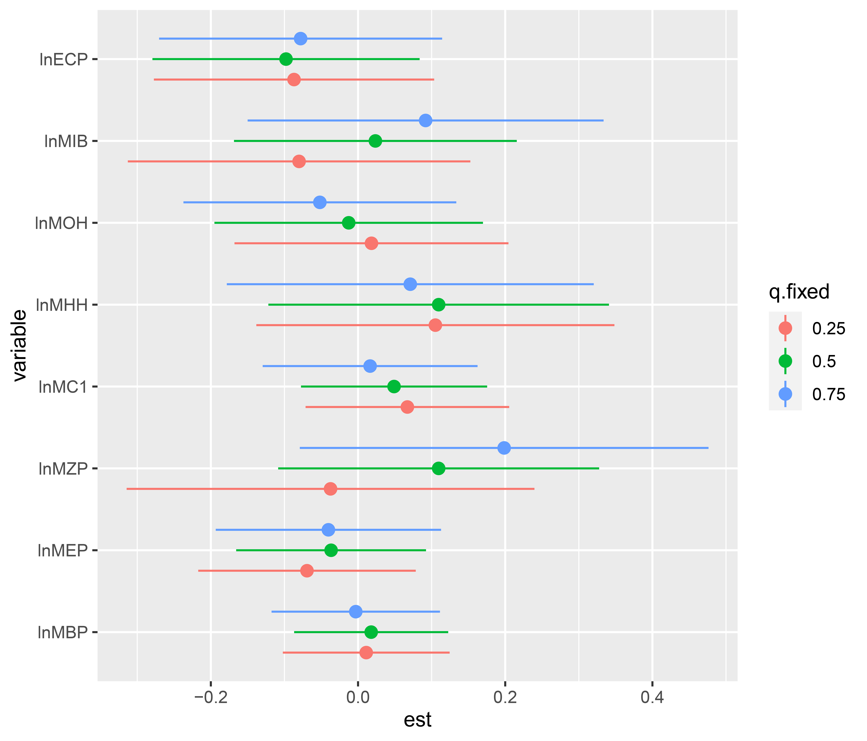
Figure S2. Associations between single-biomarker effect and migraine among the participants in BKMR model (estimates and 95% confidence intervals). The model was adjusted for gender, ethnicity, educational levels, age, family income-to-poverty ratio, smoking status, energy intake levels, physical activity, and ln-transformed creatinine.
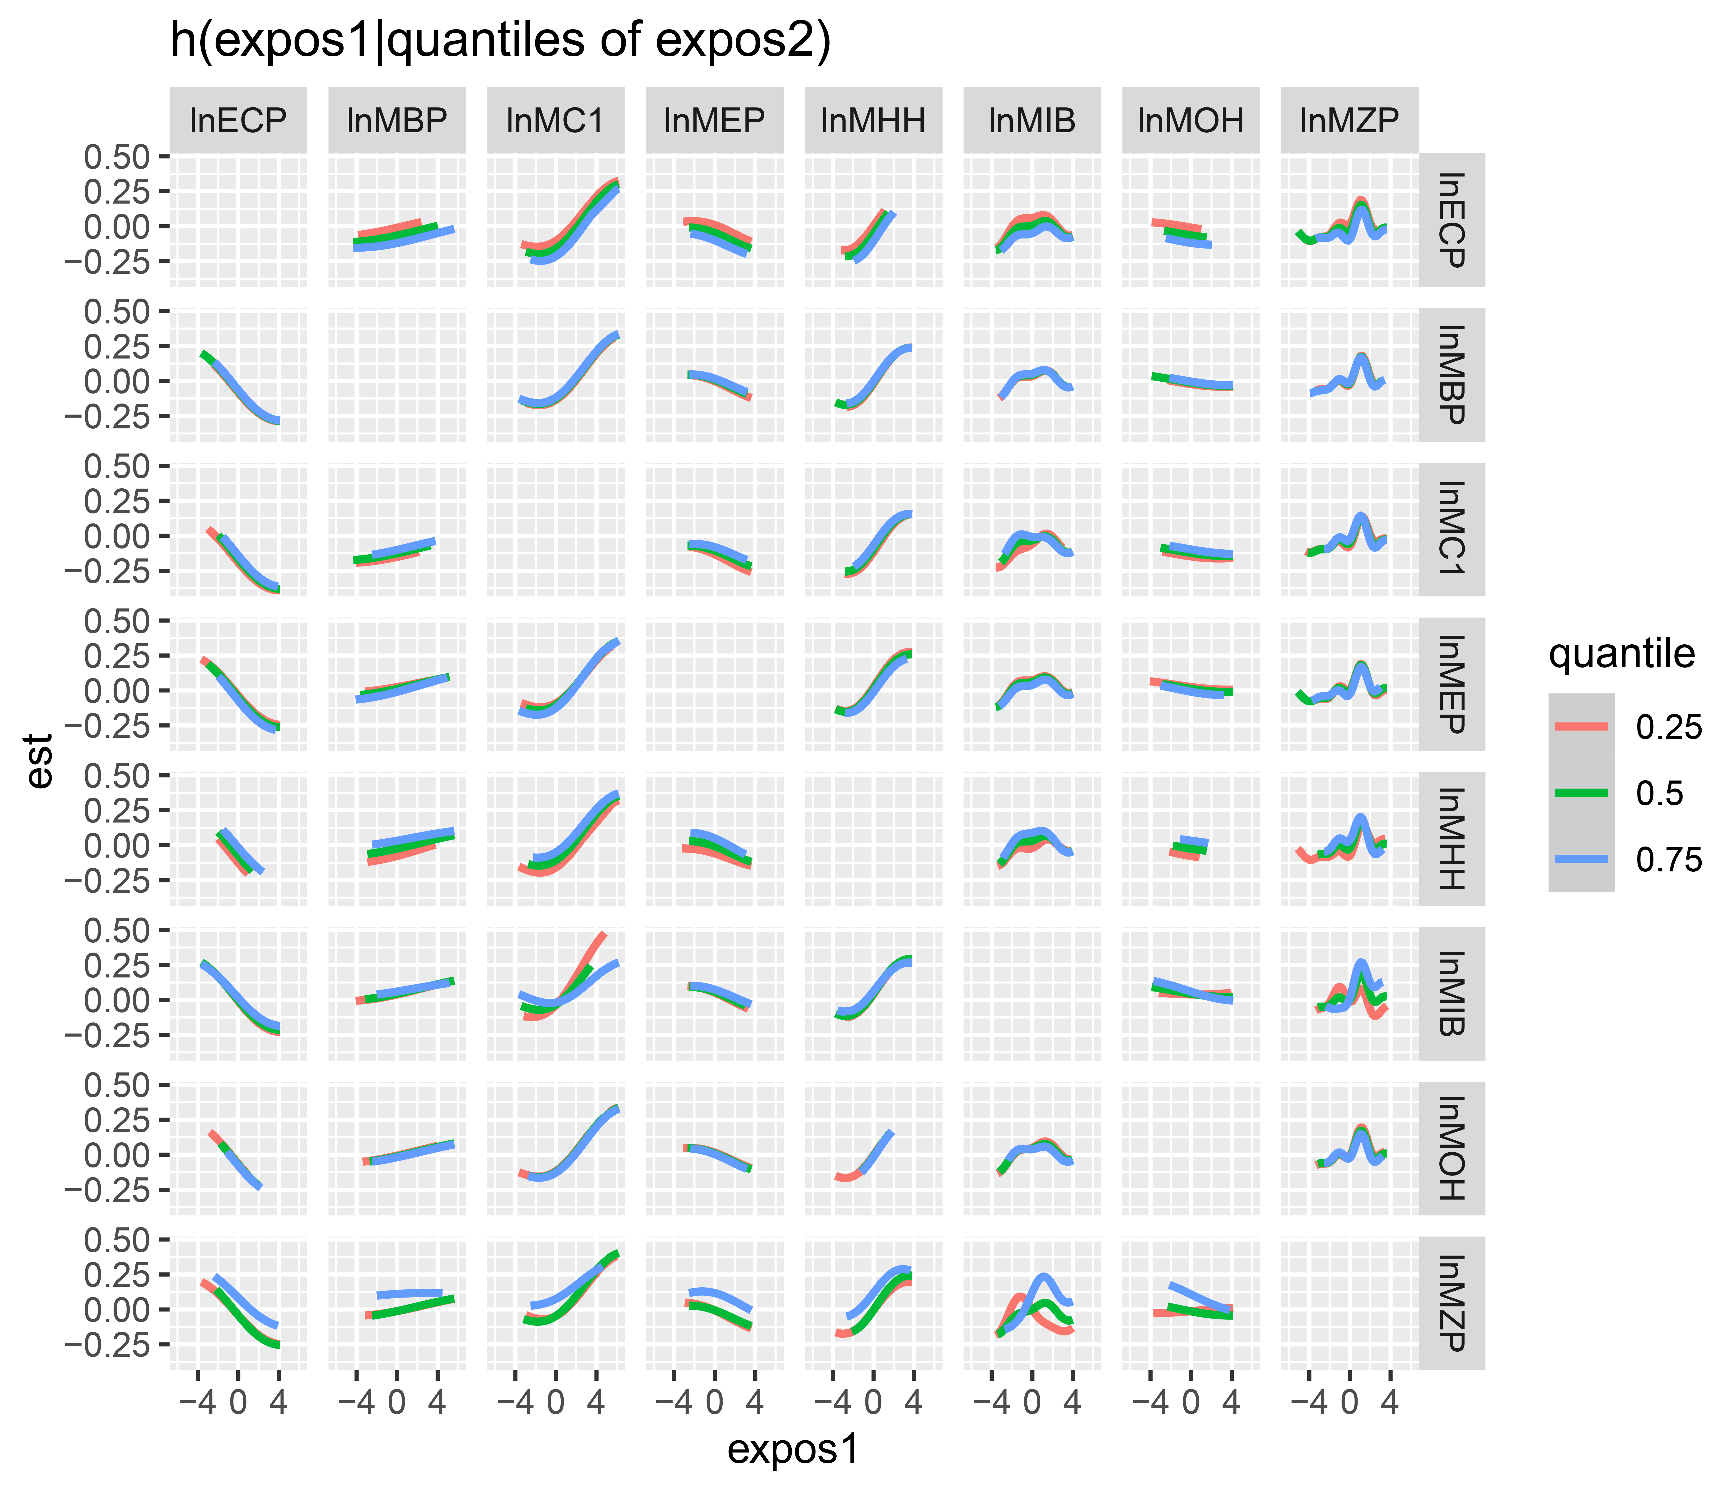
Figure S3. Mean difference in latent continuous variable of migraine as bivariate exposure–response functions for each of the exposure1 chemicals when exposure2 chemicals were at 25%, 50%, and 75% levels, and other chemicals were fixed at the median levels. The model was adjusted for gender, ethnicity, educational levels, age, family income-to-poverty ratio, smoking status, energy intake levels, physical activity, and ln-transformed creatinine.
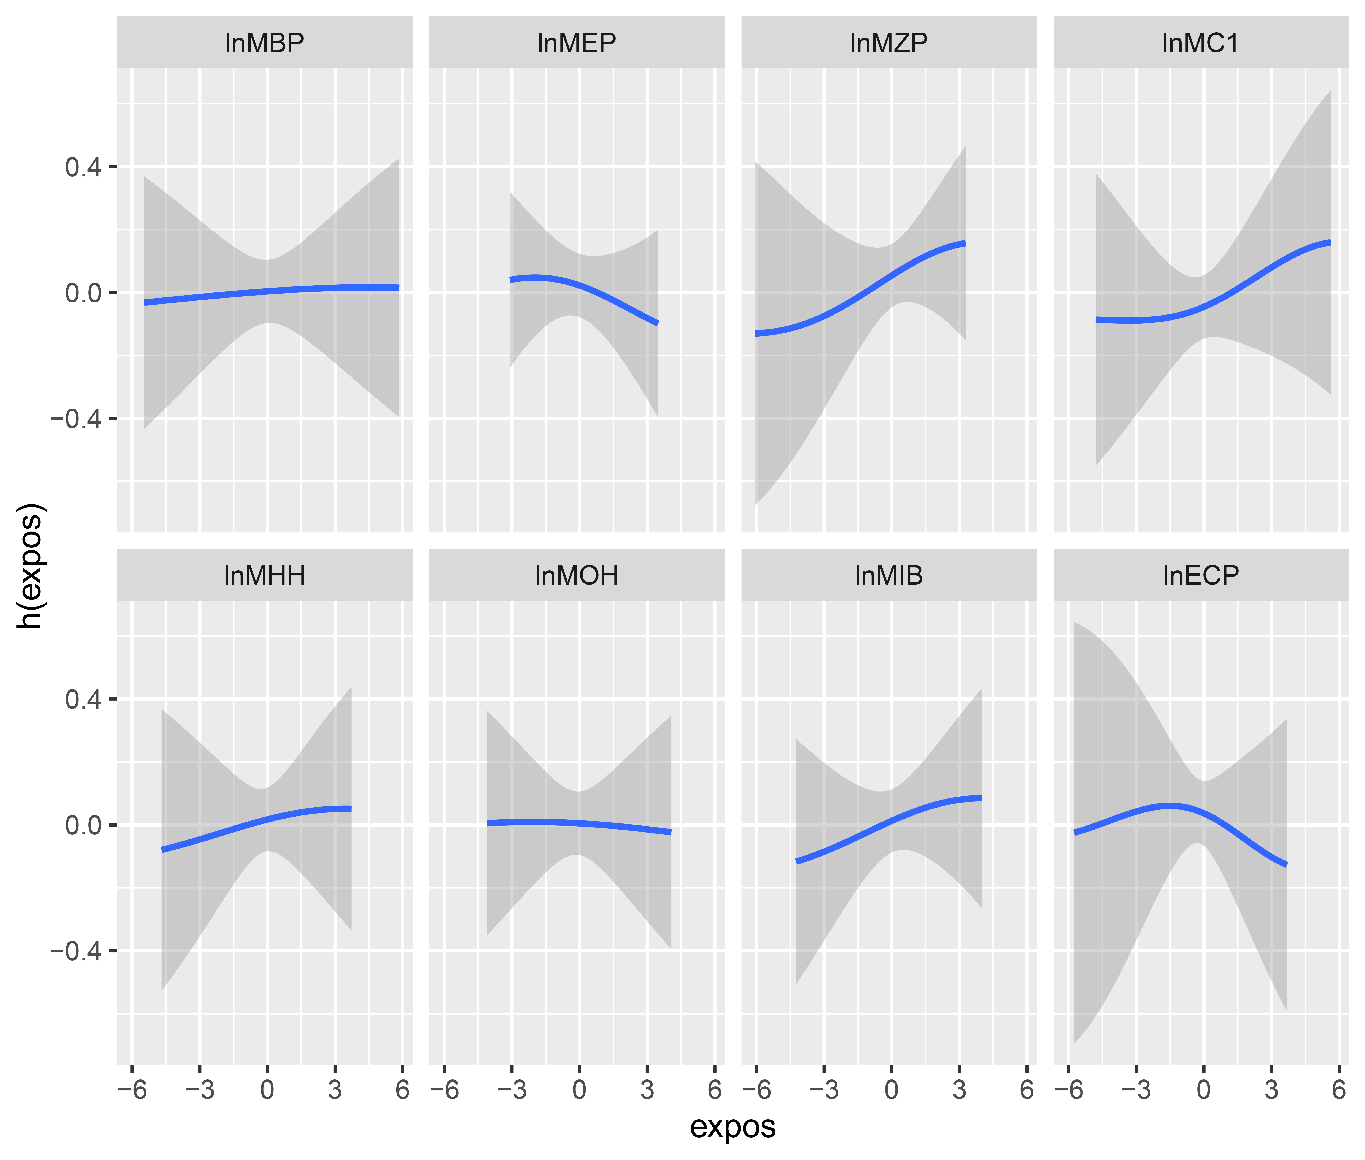
Figure 4S. Exposure-response curves for phthalate metabolite with the risk of male migraine in BKMR model. h(expos) can be interpreted as the relationship between chemicals and binary outcomes for migraine). Estimates were adjusted for age, ethnicity, educational levels, family income-to-poverty ratio, smoking status, energy intake levels, physical activity, and ln-transformed creatinine.
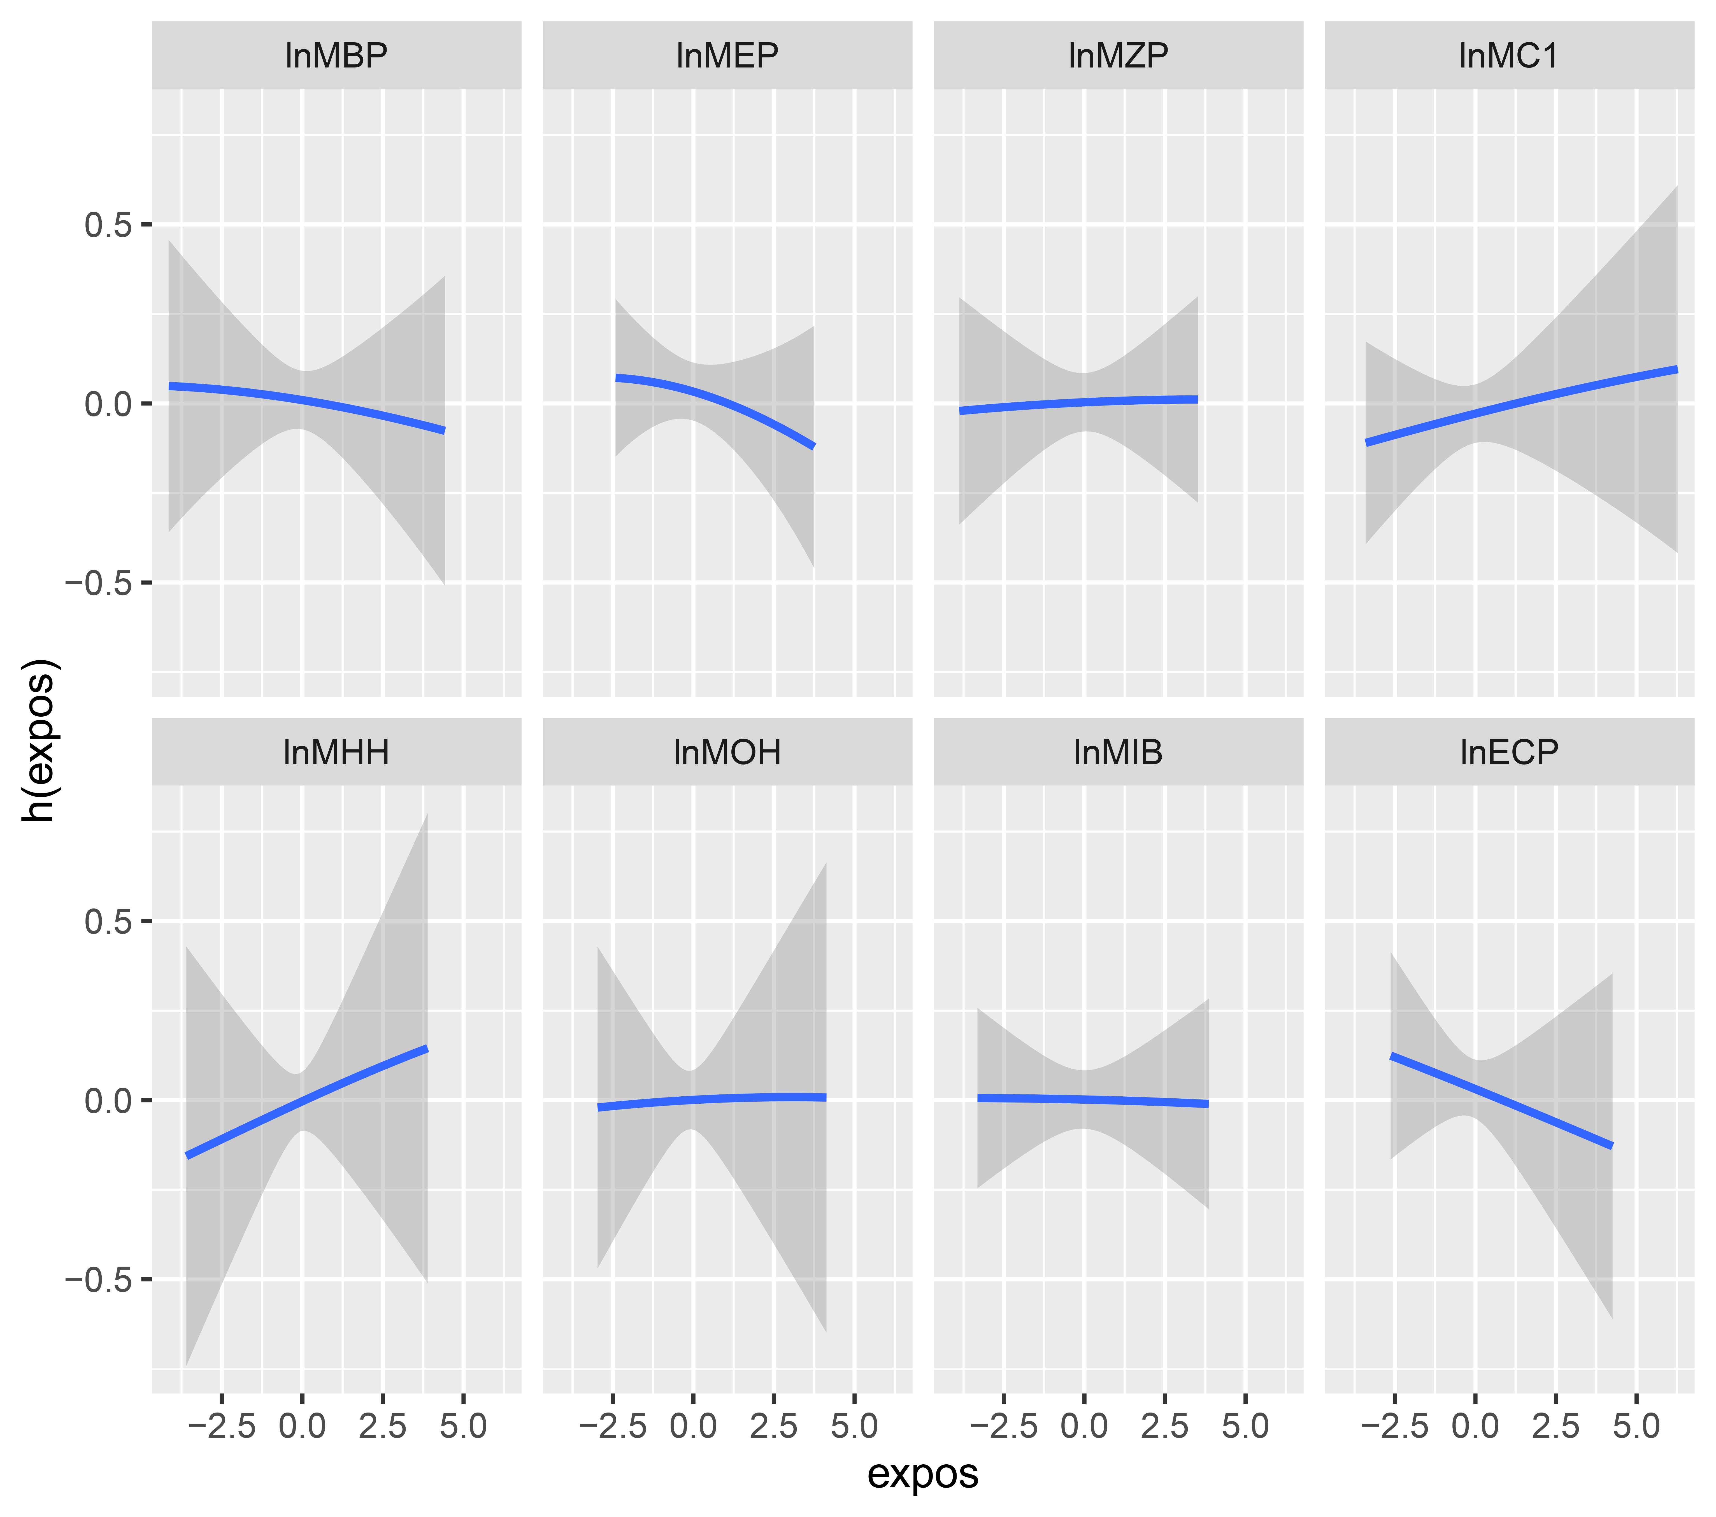
Figure 5S. Exposure-response curves for phthalate metabolite with the risk of female migraine in BKMR model. h(expos) can be interpreted as the relationship between chemicals and binary outcomes for migraine). Estimates were adjusted for age, ethnicity, educational levels, family income-to-poverty ratio, smoking status, energy intake levels, physical activity, and ln-transformed creatinine.

