Enhanced Recovery After Surgery (ERAS) versus standard recovery after radical cystectomy – a matched-pair analysis

Fischer Nikita Dhruva^{1*}, Brandt Maximilian Peter^{1*}, Epple Stefan¹, Horn Felix¹, Haack Maximilian¹, Duwe Gregor¹, Sparwasser Peter¹, Dotzauer Robert¹, Thomas Anita¹, Tsaur Igor¹, Haferkamp Axel¹, Jäger Wolfgang¹

- University Medical Center, Johannes Gutenberg University Mainz, Department of Urology, Germany
* contributed equally as first authors

Corresponding Author Nikita Dhruva Fischer, MD
Department of Urology
University Medical Center
Johannes Gutenberg University Mainz
Langenbeckstrasse 1
55131 Mainz, Germany
Tel + 49 6131-17-0
Fax: + 49 6131-17 5539
Email: nikita.fischer@unimedizin-mainz.de
ORCID: 0000-0003-4382-3106

Keywords: Cystoprostatectomy; ERAS; Hospital Stay; Complications; matched-pair analysis

Supplementary Material

Supplementary Table 1. Distribution of UICC tumor stages in ERAS and non-ERAS group

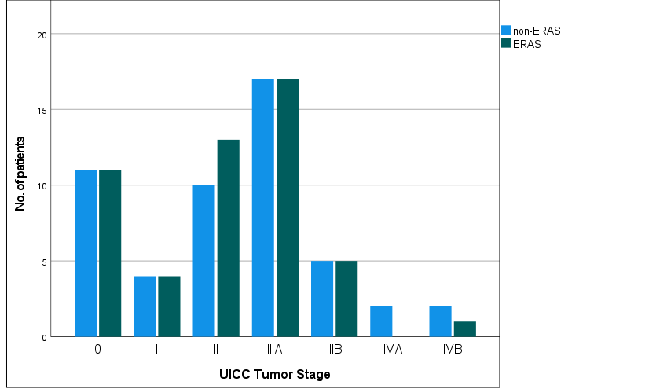

Supplementary Table 2. Duration of hospital stay in the ERAS and non-ERAS cohort.
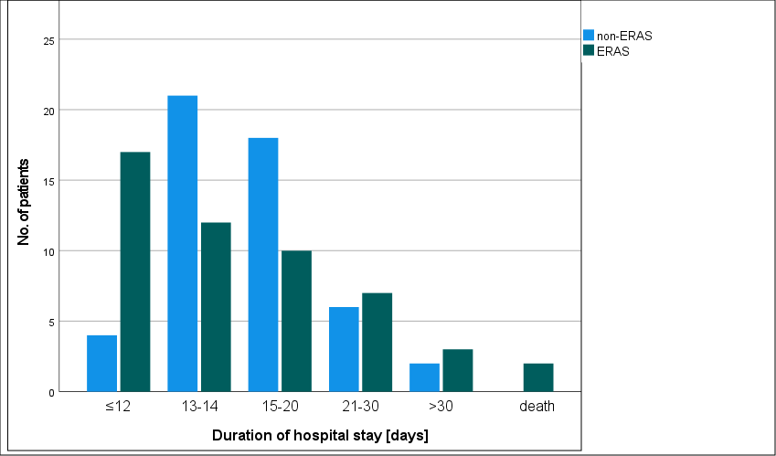

Supplementary Table 3. In-house ERAS protocol



University Medical Center Mainz
– Department of Urology –
ERAS Protocol

Preoperative | Perioperative | Postoperative
Surgical education | Venous compression (Kendall SCDTM, CardinalHealth) | Immediate removal of NG and rectal tubes
Stoma therapy consultation (stoma site education) | Depth monitoring during general anesthesia (bispectral Index) | Intravenous heparin therapy (PTT: 40-60 seconds)
Psycho-oncological consultation (“distress thermometer” form) | Prevention of hypovolemia, hypothermia, hypotension, hypoglycemia | Patient blood management (restrictive transfusion with attention to individual risk factors)
Physiotherapy consultation (pelvic floor training) | Prevention of acute blood loss | Reduced use of opioids
Nutrition counseling | Careful use of retractors | Naloxegol 25 mg 0-0-1 until first bowel movement
Anemia diagnostics | Prevention of lengthy surgeries | Early mobilization
Stool regulation (Macrogol) | Local wound infiltration | Liquid food intake 2 days post-surgery
Cessation of nicotine/alcohol consumption | Negative pressure wound therapy system (PICO®, Smith & Nephew) | Removal of single-J stents on days 8 and 9 post-surgery (prior contrast imaging)
Increase of physical activity | Sleep hygiene (single or double rooms only) | Discharge with resting single-J stents in continent urinary diversion if possible

