Evidence of northward dipping crustal layers underneath the eastern part of the Indo-Gangetic foreland basin, India: Implication for geodynamic evolution and seismogenesis

Avinash Kumar Chouhan^{1*}, Prakash Kumar², Meyarul Islam¹, S. P. Maurya³, Sumer Chopra⁴
¹Bihar Mausam Sewa Kendra, Government of Bihar, India
²Indian Institute of Technology, Kharagpur, West Bengal, India
³Banaras Hindu University, Varanasi, India
⁴Institute of Seismological Research, Government of Gujarat, India
Supplementary material
S1: Basement Depth calculation
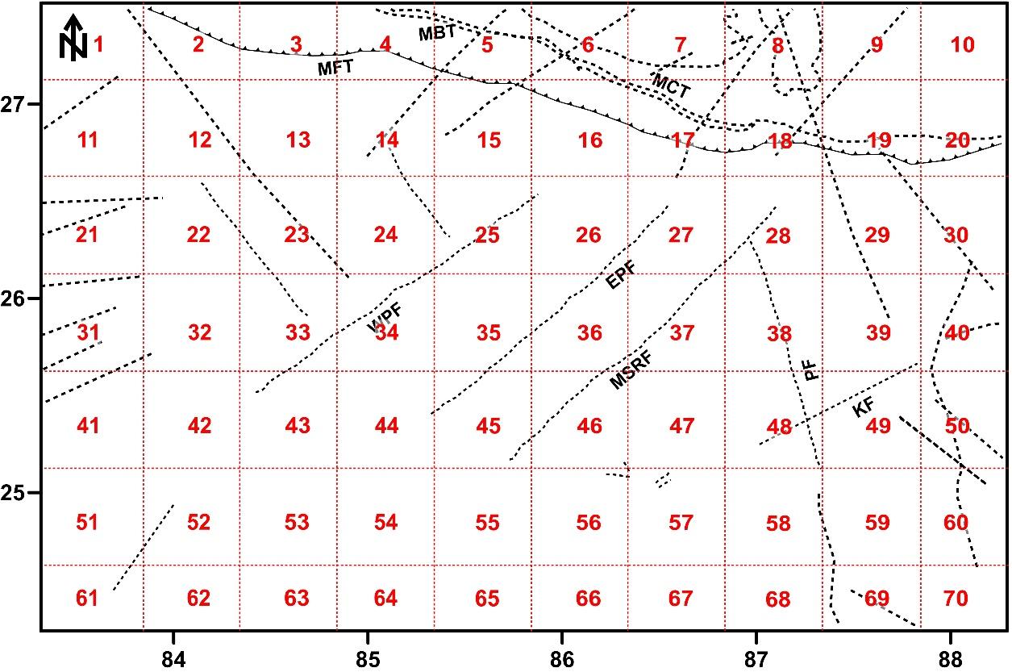
Figure 1: Grid division of 55 km x 55 km for the radially averaged power spectrum analysis of the Bouguer anomaly.

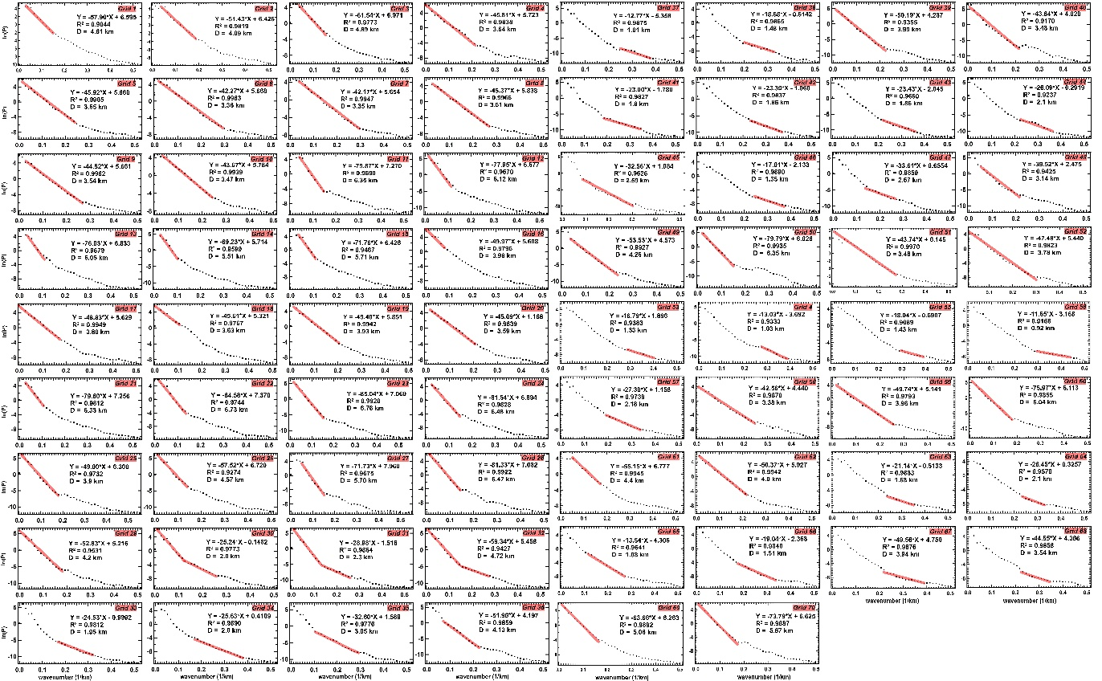
Figure 2: Radially averaged power spectrum analysis of different grids. Wavenumber and corresponding power spectra is plotted on X and Y axis. Red lines show the best fitted regression lines using least square method and is related to basement depth. Fitness of the best fit line (R²) is also provided for each grid.

Block No. | Latitude | Longitude | Basement Depth (km) | Block No. | Latitude | Longitude | Basement Depth (km)
1 | 27.5 | 83.75 | 4.61 | 37 | 25.75 | 86.75 | 1.01
2 | 27.5 | 84.25 | 4.09 | 38 | 25.75 | 87.25 | 1.48
3 | 27.5 | 84.75 | 4.89 | 39 | 25.75 | 87.75 | 3.99
4 | 27.5 | 85.25 | 3.64 | 40 | 25.75 | 88.25 | 3.48
5 | 27.5 | 85.75 | 3.65 | 41 | 25.25 | 83.75 | 1.8
6 | 27.5 | 86.25 | 3.36 | 42 | 25.25 | 84.25 | 1.86
7 | 27.5 | 86.75 | 3.35 | 43 | 25.25 | 84.75 | 1.86
8 | 27.5 | 87.25 | 3.61 | 44 | 25.25 | 85.25 | 2.1
9 | 27.5 | 87.75 | 3.54 | 45 | 25.25 | 85.75 | 2.59
10 | 27.5 | 88.25 | 3.47 | 46 | 25.25 | 86.25 | 1.35
11 | 26.75 | 83.75 | 6.35 | 47 | 25.25 | 86.75 | 2.67
12 | 26.75 | 84.25 | 6.12 | 48 | 25.25 | 87.25 | 3.17
13 | 26.75 | 84.75 | 6.05 | 49 | 25.25 | 87.75 | 4.26
14 | 26.75 | 85.25 | 5.51 | 50 | 25.25 | 88.25 | 6.35
15 | 26.75 | 85.75 | 5.71 | 51 | 24.75 | 83.75 | 3.48
16 | 26.75 | 86.25 | 3.97 | 52 | 24.75 | 84.25 | 3.78
17 | 26.75 | 86.75 | 3.88 | 53 | 24.75 | 84.75 | 1.33
18 | 26.75 | 87.25 | 3.63 | 54 | 24.75 | 85.25 | 1.03
19 | 26.75 | 87.75 | 3.93 | 55 | 24.75 | 85.75 | 1.43
20 | 26.75 | 88.25 | 3.59 | 56 | 24.75 | 86.25 | 0.92
21 | 26.25 | 83.75 | 6.33 | 57 | 24.75 | 86.75 | 2.18
22 | 26.25 | 84.25 | 6.73 | 58 | 24.75 | 87.25 | 3.38
23 | 26.25 | 84.75 | 6.76 | 59 | 24.75 | 87.75 | 3.96
24 | 26.25 | 85.25 | 6.48 | 60 | 24.75 | 88.25 | 6.04
25 | 26.25 | 85.75 | 3.9 | 61 | 24.25 | 83.75 | 4.4
26 | 26.25 | 86.25 | 4.57 | 62 | 24.25 | 84.25 | 4
27 | 26.25 | 86.75 | 5.7 | 63 | 24.25 | 84.75 | 1.68
28 | 26.25 | 87.25 | 6.47 | 64 | 24.25 | 85.25 | 2.1
29 | 26.25 | 87.75 | 4.2 | 65 | 24.25 | 85.75 | 1.08
30 | 26.25 | 88.25 | 2 | 66 | 24.25 | 86.25 | 1.51
31 | 25.75 | 83.75 | 2.3 | 67 | 24.25 | 86.75 | 3.94
32 | 25.75 | 84.25 | 4.72 | 68 | 24.25 | 87.25 | 3.54
33 | 25.75 | 84.75 | 1.95 | 69 | 24.25 | 87.75 | 5.06
34 | 25.75 | 85.25 | 2 | 70 | 24.25 | 88.25 | 5.87
35 | 25.75 | 85.75 | 3.05
36 | 25.75 | 86.25 | 4.13

Table 1: Basement depth (km) calculated for 70 grids.

