Table S1. NOP58 expression in cancerous versus normal tissue in Oncomine
Cancer Site | Cancer Type | P Value | Sample Size | Fold Change | Up/Down Regulated  Gene Rank | Reference  (PMID)
Brain and CNS Cancer | Anaplastic Oligodendroglioma | 1.17E-4 | 23 | 1.628 | 1730 (9%) | 16357140
Breast | Ductal Breast Carcinoma | 1.16E-8 | 40 | 1.831 | 239 (2%) | 16473279
 | Medullary Breast Carcinoma | 9.66E-8 | 32 | 1.678 | 1688 (9%) | 22522925
 | Invasive Breast Carcinoma Stroma | 2.01E-20 | 53 | -6.076 | 1163 (7%) | 18438415
Colorectal Cancer | Colorectal Carcinoma | 9.19E-9 | 18 | 1.730 | 41 (1%) | 16542501
 | Colorectal Carcinoma | 5.70E-13 | 36 | 1.740 | 131 (1%) | 20957034
 | Colorectal Adenocarcinoma | 1.02E-10 | 45 | 1.510 | 552 (3%) | 20957034
 | Colorectal Carcinoma | 1.08E-15 | 70 | 2.580 | 146 (1%) | 20143136
 | Colon Adenoma | 7.14E-13 | 25 | 2.123 | 644 (4%) | 18171984
 | Rectal Adenoma | 6.72E-5 | 7 | 2.317 | 1889 (10%) | 18171984
 | Rectal Adenocarcinoma | 6.67E-16 | 60 | 1.946 | 865 (5%) | TCGA
 | Colon Mucinous Adenocarcinoma | 1.63E-9 | 22 | 1.537 | 944 (5%) | TCGA
 | Cecum Adenocarcinoma | 2.46E-9 | 22 | 1.897 | 1208 (6%) | TCGA
 | Colon Adenocarcinoma | 1.77E-14 | 101 | 1.824 | 1227 (7%) | TCFA
 | Rectal Mucinous Adenocarcinoma | 3.46E-4 | 6 | 2.029 | 1708 (9%) | TCGA
 | Colon Carcinoma | 2.94E-7 | 5 | 2.397 | 882 (5%) | 20957034
 | Colon Adenoma | 1.97E-5 | 5 | 2.594 | 1270 (7%) | 20957034
 | Colon Adenoma | 1.65E-4 | 5 | 1.879 | 1738 (9%) | 20957034
 | Rectal Adenocarcinoma | 3.52E-15 | 65 | 1.520 | 1796 (10%) | 20725992
 | Rectosigmoid Adenocarcinoma | 2.47E-4 | 10 | 1.891 | 1805 (10%) | 17615082
Esophageal Cancer | Esophageal Squamous Cell Carcinoma | 1.63E-12 | 51 | 1.602 | 800 (5%) | 21385931
Gastric Cancer | Gastric Intestinal Type Adenocarcinoma | 1.14E-14 | 26 | 2.100 | 34 (1%) | 19081245
 | Gastric Mixed Adenocarcinoma | 4.50E-5 | 4 | 1.678 | 669 (4%) | 19081245
Head and Neck Cancer | Nasopharyngeal Carcinoma | 1.91E-5 | 31 | 1.890 | 795 (5%) | 16912175
Leukemia | Chronic Lymphocytic Leukemia | 1.76E-30 | 448 | 1.627 | 1749 (9%) | 20406941
Liver Cancer | Hepatocellular Carcinoma | 9.84E-5 | 35 | 1.617 | 1441 (8%) | 17393520
Lymphoma | Activated B-Cell-Like Diffuse Large B-Cell Lymphoma | 6.33E-8 | 17 | 1.603 | 1319 (7%) | 19412164
Other cancers | Vulvar Intraepithelial Neoplasia | 2.34E-5 | 9 | 1.934 | 420 (3%) | 17471573
 | Seminoma | 6.64E-8 | 12 | 2.772 | 632 (4%) | 16424014
 | Embryonal Carcinoma, NOS | 2.67E-7 | 15 | 2.390 | 985 (6%) | 16424014
 | Skin Squamous Cell Carcinoma | 1.50E-4 | 11 | 2.028 | 796 (5%) | 18442402
 | Skin Basal Cell Carcinoma | 3.44E-4 | 15 | 1.813 | 1036 (6%) | 18442402
Ovarian | Ovarian Endometrioid Adenocarcinoma | 1.12E-4 | 9 | 2.040 | 142 (1%) | 15161682
 | Ovarian Serous Adenocarcinoma | 1.84E-5 | 20 | 2.110 | 299 (2%) | 15161682
Table S2. Mutation spectrum of NOP58 across tumor samples
Table S3. The GO and KEGG enrichment analysis of NOP58-related differentially genes
ONTOLOGY | ID | Description | Gene Ratio | BgRatio | p-value | p-adjust | q-value
KEGG | hsa03008 | Ribosome biogenesis in eukaryotes | 23/64 | 111/8076 | 1.2726E-27 | 4.9632E-26 | 4.4207E-26
KEGG | hsa03040 | Spliceosome | 11/64 | 151/8076 | 2.1514E-08 | 4.1953E-07 | 3.7367E-07
KEGG | hsa04110 | Cell cycle | 10/64 | 124/8076 | 3.8013E-08 | 4.9417E-07 | 4.4015E-07
KEGG | hsa03030 | DNA replication | 3/64 | 36/8076 | 0.00281261 | 0.02742295 | 0.0244253
BP | GO:0016072 | rRNA metabolic process | 47/124 | 253/18670 | 3.0579E-56 | 3.5013E-53 | 2.7682E-53
BP | GO:0006364 | rRNA processing | 43/124 | 214/18670 | 8.2776E-53 | 4.7389E-50 | 3.7467E-50
BP | GO:0042254 | Ribosome biogenesis | 46/124 | 297/18670 | 4.3019E-51 | 1.6419E-48 | 1.2981E-48
BP | GO:0034470 | ncRNA processing | 46/124 | 384/18670 | 9.6846E-46 | 2.7722E-43 | 2.1918E-43
BP | GO:0042274 | Ribosomal small subunit biogenesis | 17/124 | 67/18670 | 7.8099E-23 | 1.7885E-20 | 1.414E-20
CC | GO:0030684 | Preribosome | 32/125 | 76/19717 | 1.3501E-51 | 2.1737E-49 | 1.7339E-49
CC | GO:0032040 | Small-subunit processome | 24/125 | 38/19717 | 1.5337E-44 | 1.2346E-42 | 9.848E-43
CC | GO:0030686 | 90S preribosome | 17/125 | 31/19717 | 3.4305E-30 | 1.841E-28 | 1.4685E-28
CC | GO:0044452 | Nucleolar part | 21/125 | 178/19717 | 5.5797E-21 | 2.2458E-19 | 1.7914E-19
CC | GO:0098687 | Chromosomal region | 22/125 | 349/19717 | 4.7723E-16 | 1.5367E-14 | 1.2257E-14
MF | GO:0030515 | snoRNA binding | 11/124 | 26/17697 | 8.9842E-18 | 1.8687E-15 | 1.5037E-15
MF | GO:0003688 | DNA replication origin binding | 6/124 | 24/17697 | 1.2718E-08 | 1.3226E-06 | 1.0643E-06
MF | GO:0004386 | Helicase activity | 10/124 | 163/17697 | 2.2073E-07 | 1.5304E-05 | 1.2314E-05
MF | GO:0140098 | Catalytic activity, acting on RNA | 13/124 | 386/17697 | 3.1851E-06 | 0.00016562 | 0.00013327
MF | GO:0008094 | DNA-dependent ATPase activity | 6/124 | 69/17697 | 8.7577E-06 | 0.00036432 | 0.00029315
Table S4. Clinical characteristics of LUAD patient
Characteristic | Low expression of NOP58 | High expression of NOP58 | P
n | 267 | 268
T stage, n (%) |  |  | < 0.001
T1 | 104 (19.5%) | 71 (13.3%)
T2 | 131 (24.6%) | 158 (29.7%)
T3 | 27 (5.1%) | 22 (4.1%)
T4 | 3 (0.6%) | 16 (3%)
Pathologic stage, n (%) |  |  | 0.018
Stage I | 161 (30.6%) | 133 (25.2%)
Stage II | 59 (11.2%) | 64 (12.1%)
Stage III | 32 (6.1%) | 52 (9.9%)
Stage IV | 9 (1.7%) | 17 (3.2%)
Gender, n (%) |  |  | 0.514
Female | 147 (27.5%) | 139 (26%)
Male | 120 (22.4%) | 129 (24.1%)
Race, n (%) |  |  | 0.603
Asian | 2 (0.4%) | 5 (1.1%)
Black or African American | 28 (6%) | 27 (5.8%)
White | 199 (42.5%) | 207 (44.2%)
Age, n (%) |  |  | 0.481
<=65 | 123 (23.8%) | 132 (25.6%)
>65 | 135 (26.2%) | 126 (24.4%)
Smoker, n (%) |  |  | 0.276
No | 42 (8.1%) | 33 (6.3%)
Yes | 216 (41.5%) | 230 (44.1%)
Table S5. Univariate and multivariate Cox regression analyses of the clinical characteristics associated with OS in LUAD
Characteristics | Total (N) | Univariate analysis |  | Multivariate analysis
Characteristics | Total (N) | Hazard ratio (95% CI) | P value | Hazard ratio (95% CI) | P value
T stage (T1&T2 vs. T3&T4) | 523 | 2.317 (1.591-3.375) | <0.001 | 1.849 (0.897-3.810) | 0.096
N stage  (N0&N1 vs. N2&N3) | 510 | 2.321 (1.631-3.303) | <0.001 | 2.273 (0.803-6.436) | 0.122
M stage  (M0 vs. M1) | 377 | 2.136 (1.248-3.653) | 0.006 | 1.962 (0.661-5.823) | 0.224
Pathologic stage (Stage I&Stage II vs. Stage III&Stage IV) | 518 | 2.664 (1.960-3.621) | <0.001 | 0.993 (0.333-2.964) | 0.990
Primary therapy outcome (CR&PR vs. PD&SD) | 439 | 2.653 (1.888-3.726) | <0.001 | 3.120 (1.874-5.193) | <0.001
Residual tumor (R0 vs. R1&R2) | 363 | 3.879 (2.169-6.936) | <0.001 | 2.792 (1.027-7.589) | 0.044
NOP58 | 526 | 1.459 (1.106-1.925) | 0.008 | 1.238 (0.801-1.914) | 0.336
Table S6. Univariate and multivariate Cox regression analyses of the clinical characteristics associated with DSS in LUAD
Characteristics | Total  (N) | Univariate analysis |  | Multivariate analysis
Characteristics | Total  (N) | Hazard ratio  (95% CI) | P value | Hazard ratio  (95% CI) | P value
T stage (T1&T2 vs. T3&T4) | 488 | 1.974 (1.190-3.275) | 0.008 | 1.829 (0.705-4.747) | 0.215
N stage (N0&N1 vs. N2&N3) | 475 | 1.971 (1.247-3.115) | 0.004 | 2.262 (0.582-8.788) | 0.239
M stage (M0 vs. M1) | 344 | 2.455 (1.269-4.749) | 0.008 | 2.199 (0.510-9.487) | 0.291
Pathologic stage (Pathologic stage vs. Stage III&Stage IV) | 483 | 2.436 (1.645-3.605) | <0.001 | 1.069 (0.253-4.519) | 0.928
Primary therapy outcome (CR&PR vs. PD&SD) | 428 | 4.028 (2.731-5.942) | <0.001 | 4.754 (2.671-8.461) | <0.001
Residual tumor (R0 vs. R1&R2) | 331 | 4.743 (2.352-9.566) | <0.001 | 3.171 (0.922-10.908) | 0.067
NOP58 | 491 | 1.600 (1.131-2.263) | 0.008 | 1.256 (0.736-2.144) | 0.403
Table S7. Univariate and multivariate Cox regression analyses of the clinical characteristics associated with PFI in LUAD
Characteristics | Total(N) | Univariate analysis |  | Multivariate analysis
Characteristics | Total(N) | Hazard ratio (95% CI) | P value | Hazard ratio (95% CI) | P value
T stage (T1&T2 vs. T3&T4) | 523 | 1.811 (1.249-2.628) | 0.002 | 3.453 (2.034-5.862) | <0.001
N stage (N0&T1 vs. T2&T3) | 510 | 1.325 (0.914-1.919) | 0.137
M stage (M0 vs. M1) | 377 | 1.513 (0.855-2.676) | 0.155
Pathologic stage (Stage I&Stage II vs. Stage III&Stage IV) | 518 | 1.513 (1.105-2.071) | 0.010 | 0.678 (0.416-1.105) | 0.119
Primary therapy outcome (CR&PR vs. PD&SD) | 439 | 3.756 (2.821-5.003) | <0.001 | 4.295 (2.894-6.375) | <0.001
Residual tumor (R0 vs. R1&R2) | 363 | 3.091 (1.662-5.750) | <0.001 | 2.493 (1.235-5.036) | 0.011
NOP58 | 526 | 1.227 (0.955-1.577) | 0.109
Table S8. Sequences of siRNAs
siRNAs | Sequence (5'->3')
si-NOP58-1 | CGAUAUAGAUUGAAGUUUATT
si-NOP58-2 | GGCAGUAGCUGAUGCUAAATT
si-NC | UUCUCCGAACGUGUCACGU
Table S9. Primer sequences for qRT-PCR
Primers | Sequence (5'->3')
NOP58 | Forward TTGAAACGTCTGTGGGTTACG
 | Reverse CCCTCCATCAGAGCTGTGA
GAPDH | Forward
 | Reverse

Figure S1. The expression of NOP58 gene in different cancers and pathological stages
(A) Based on the Oncomine database, NOP58 expression was explored in pan-cancers. A comparison of NOP58 mRNA expression levels in cancer tissues with normal tissues of GTEx combined with TCGA (B), as well as the comparison between tumor tissues and their matched paracancer tissues of TCGA project (C) were conducted (* P < 0.05; ** P < 0.01; *** P < 0.001). (D) The expression level of NOP58 total protein between normal tissue and primary tissue of breast cancer, ovarian cancer, colon cancer, clear cell RCC, UCEC and LUAD was analyzed based on the CPTAC dataset (*** P < 0.001, **** P < 0.0001). (E) Based on the TCGA data, the expression levels of the NOP58 gene were analyzed by the main pathological stages of several cancers. Log2 (TPM+1) was applied for log-scale. GTEx, Genotype-Tissue Expression; TCGA, The Cancer Genome Atlas; clear cell RCC, clear cell renal cell carcinoma; UCEC, uterine corpus endometrial carcinoma; LUAD, lung adenocarcinoma; CPTAC, Clinical proteomic tumor analysis consortium.
Figure S2. Phosphorylation analysis of NOP58 protein in different tumors
With UALCAN, we compared the expression of NOP58 phosphoprotein (NP_057018.1, S483, S502, S508, S509, S510, S514, T508 and T510 sites) between normal tissue and primary tumor tissue based on the CPTAC dataset. Box plots were provided for various cancers, including breast cancer (A), colon cancer (B), clear cell RCC (C), UCEC (D), and LUAD (E) (** P < 0.01; **** P < 0.0001). CPTAC, Clinical proteomic tumor analysis consortium; clear cell RCC, clear cell renal cell carcinoma; UCEC, uterine corpus endometrial carcinoma; LUAD, lung adenocarcinoma.

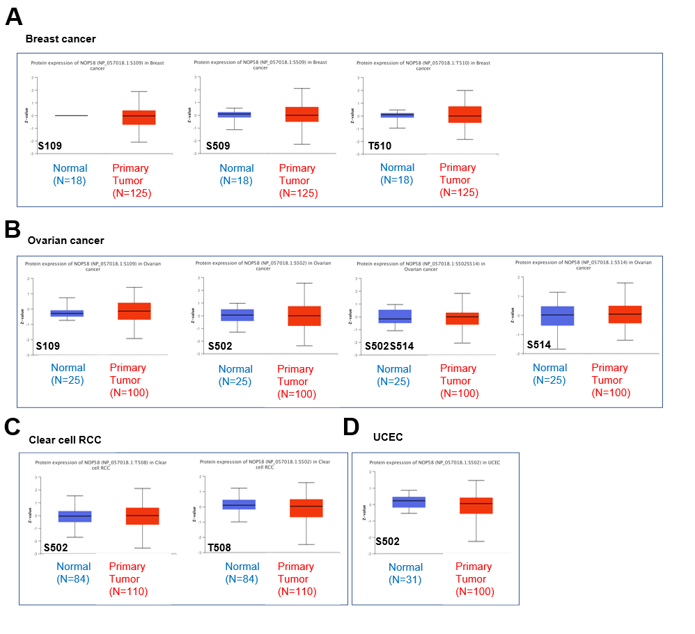Figure S3. Phosphorylation analysis of NOP58 protein in different tumors
Based on the CPTAC dataset, we analyzed the expression level of NOP58 phosphoprotein between normal tissue and primary tissue of breast cancer (A), ovarian cancer (B), clear cell RCC (C), and UCEC (D), via the UALCAN (P >0.05). CPTAC, Clinical proteomic tumor analysis consortium; clear cell RCC, clear cell renal cell carcinoma; UCEC, uterine corpus endometrial carcinoma.
Figure S4. Alterations summary of NOP58 in TCGA pan-cancer datasets (A) and mixed pan-cancer datasets (B). TCGA, The Cancer Genome Atlas.
Figure S5. The alteration frequency with mutation type and mutation site of NOP58 in TCGA pan-cancer datasets (A) and mixed pan-cancer datasets (B) are displayed. (C) The alteration types of NOP58 in pan-cancer. (D) The related genes alteration frequency in NOP58 altered group and unaltered group. TCGA, The Cancer Genome Atlas.
Figure S6. (A) The ROC curve plot of the association between NOP58 expression and responses to chemotherapy in breast and ovarian cancer cohorts. (B) Kaplan-Meier curves (left panel) of survival ratios as a measure of the immunotherapeutic response (immune checkpoint blockade) between cancer cohorts with high and those with low expression levels of NOP58. The right panel shows the correlation between the NOP58 expression and cytotoxic T-cell level in these cohorts. Only TCGA cancers with statistically significant differences between the cohorts are presented. ROC, receiver operating characteristic; TCGA, The Cancer Genome Atlas.
Figure S7. Correlation analysis of NOP58 expression and immune infiltration in LUAD
(A, B) Immune cell distribution in patients whose NOP58 expression is high and low. (C–J) Immune infiltration in LUAD and NOP58 expression levels: (C) cytotoxic cells, (D) CD8 T cells, (E) NK cells, (F) pDC cells, (G) Th2 cells, (H) Th1 cells, (I) TFH cells, (J) Tem cells (* P < 0.05; ** P < 0.01; *** P < 0.001). LUAD, lung adenocarcinoma; NK cells, Natural killer cells; pDC, plasmacytoid dendritic cells; Tem, effector memory T cell; TFH, follicular helper T cell.

