Supplementary material for “Bound in the continuum modes in indirectly-patterned hyperbolic media”
Authors: Hanan Herzig Sheinfux¹, Lorenzo Orsini¹, Minwoo Jung², Iacopo Torre¹, Matteo Ceccanti¹, Rinu Maniyara¹, David Barcons Ruiz¹, Sebastian Castilla¹, Niels C.H. Hesp¹, Eli Janzen³, Valerio Pruneri¹, James H. Edgar³, Gennady Shvets⁴, Frank H.L. Koppens^{1,5}
¹ ICFO-Institut de Ciencies Fotoniques, 08860 Castelldefels (Barcelona), Spain
² Department of Physics, Cornell University, Ithaca, New York, 14853, USA
³ Department of Chemical Engineering, Kansas State University, Durland Hall, Manhattan, KS 66506-5102, USA
⁴ School of Applied and Engineering Physics, Cornell University, Ithaca, New York 14853, USA
⁵ ICREA-Institució Catalana de Recerca i Estudis Avançats, 08010 Barcelona, Spain

Table of Contents
S1. Polaritonic nanocavity state of the art 2
S2. Cavity performance in the single mode limit 3
S2.1 PhP modes of a HyM slab 4
S2.2 A single mode in a trench cavity 5
S1.1 Single mode in a square cavity 6
S2.3 Estimated dependence of quality factor on absorption 9
S3. Hyperbolic bound in continuum modes 10
S3.1 hBIC modes in a trench cavity 10
S3.2 3d compact hBIC cavities 11
S3.3 hBICs without perfectly conducting metallic reflectors 12
S3.4 Alleviating the quasi-static limit in hBIC mode formation 13
S4. Cavity fabrication 14
S4.1 Substrate preparation and general note 14
S4.2 Focused ion milling 14
S4.3 PDMS based transfer of hBN 15
S4.4 Polycarbonate based transfer of hBN 16
S5. Near field measurement and analysis 17
S5.1 Nearfield measurement principles 17
S5.2 Verifying dispersion using edge reflected PhPs 18
S5.3 Frequency sweep measurements 19
S5.4 Spatial single frequency measurements 21
Single frequency heterodyne 21
Single frequency homodyne 22
S5.5 Additional measurements 23
Measurements with Device C2 23
Measurements with the large trench cavity 24
S5.6 Strain induced by milling 24

Polaritonic nanocavity state of the art

The common benchmark for cavity performance is the quality factor$Q=ω/Δω$, with $ω$ the resonance frequency and $Δω$ the full width half maximum (FWHM) of the cavity response. Another widely used definition of the quality factor relates to the amount of time light stays in the cavity relative to $1/f$, with $f$ the frequency. The two definitions are closely related, but only agree in value precisely for very large quality factors (note that for $Q=10$, this is already a reasonable estimate, for example in the case of a Fabry-Perot cavity). The quality factor contains both slow light and resonance effects, in contrast with the finesse $F=k/Δk$ (with $k$ the resonant momentum and $Δk$ the full width half maximum of the cavity momentum response). The finesse is equivalently $F=\frac{ω}{k}\frac{Δk}{Δω} Q$ or $F≈\frac{v_{g}}{v_{p}}Q$, with $v_{g},v_{p}$ the group and phase velocity.
The importance of characterizing the finesse is twofold: first, when considering the Purcell factor $Q/V$, the effective mode volume of a lossy (low finesse) cavity can be significantly larger than the physical volume of the cavity¹. Second, the finesse is a direct indication of the strength of interference effects in the cavity, unlike the quality factor which incorporates both interference and slow light effects. However, characterizing the finesse is considerably more difficult, requiring very fine control of the cavity size or, more realistically, a detailed comparison to theory. Surveying the finesse (or the strength of resonant interference effects) in the literature is thus beyond the scope of this text. However, we can point out that in general, the quality factor of nanocavities is a few times larger than the finesse and that the typical nanocavity finesse is on the order of 2-3.
In Fig. 1a, we refer to several cavity types, but some clarifications can be made regarding the state of the art:
- Nanogap cavities are a wide category characterized by having a plasmon polaritonic excitation whose energy is contained primarily in the dielectric gap between two metallic surfaces. This includes layered metal-insulator-metal structures, particles on a mirror and cavities composed of a metallic probe in adjacency to a metallic surface. Nanogap cavities achieve the smallest absolute volumes with excitation in the visible or NIR. Some works, e.g. ², report quality factors as high as 15, but generally much lower values are obtained.
- Metallic particles refer to plasmonic excitations in a single metallic structure (in contrast with nanogap). This is again a wide category where extensive research has been made. It also exemplifies the problem of the group velocity in nanophotonics. The plasmonic resonance in an ideal (loss free) plasmonic particle occurs at a singular frequency, independent of the plasmon polariton momentum³. Hence, an ideal plasmonic particle’s resonance can be understood as being a pure slow light effect. Realistically, there is some size dependence, even for spherical particles, but the principle remains.
- With phonon polariton nanocavities, a distinction is made between hyperbolic polaritons and non-hyperbolic polaritons. In both cases, the typical cavity size, while subwavelength, is on the order of 5 to 30 times smaller than the mid-IR wavelength of excitation. For hyperbolic phonon polaritons, the cavity can be defined directly by etching the cavity structure out of a pristine crystal. However, PhP cavities made this way are typically 300nm or larger (in the longest dimension). Though this is not mentioned explicitly in any paper we are aware of, it is commonly assumed (e.g. ⁴) that this is due to surface roughness and chemical damage incurred to the structure during the etching process. Such damage becomes increasingly more detrimental when the designated cavity size shrinks.
- Graphene cavities are also presented in Fig. 1a of the main text and are worth further discussion. The combination of small cavity volumes and long excitation wavelength means that graphene plasmon cavities, and especially acoustic plasmons, have reached volumes below ${10}^{9}λ^{-3}$. Moreover, the optical losses of graphene plasmon polaritons are greatly reduced at low temperatures, making it possible to envision low-loss cavities which are indirectly defined by local electrical gating and/or screening. Such cavities have not, to the best of our knowledge, been realized at low temperatures, but present the only alternative possibility we are aware of to achieve high-Q confinement on the extreme nanoscale. In contrast with hyperbolic polaritons, graphene plasmons cannot achieve wavelength contraction above $λ/300$, but at the current state of the art, that is not a major limitation.
- The term picocavity is used in the literature to describe a range of cavities with volumes ranging from $\sim 50$nm³ to the remarkable sub-nm³ scale. The low signal level from these cavities makes it hard to measure the quality factor directly, though it is seemingly clear that strong losses take place. In fact, the enhancement in these cavities has been attributed to lightning-rod-like effects⁵, rather than multiple constructively interfering reflections, as happens in macro cavities.

Cavity performance in the single mode limit
At a passing glance, it might be tempting to consider the mechanism enabling confinement in indirectly defined PhP cavities to be reflection due to impedance mismatch. Indeed, there is a very considerable momentum mismatch with the longest wavelength PhP inside the cavity being roughly 5-10 times larger outside (dependent on frequency). However, impedance mismatch is a generally inefficient confinement mechanism and in the particular case at hand, insufficient to explain the experimental results we obtain, specifically, the wavelength dependence and the strength of confinement. Let us substantiate this claim, by considering the grossly simplified scenario where only a single PhP mode is present in the hBN.
We start by deriving the PhP modes of a HyM slab. Following this, we consider and quantify the strength of confinement in a 1D trench-like cavity, infinitely extended in the y-direction. We then demonstrate an upper bound on confinement in a square cavity.

PhP modes of a HyM slab
Taking the curl of Faraday’s law of induction acting on an electric field at a fixed frequency $ω$,
$\vec{∇}×\left(\vec{∇}×\vec{E}\right)=\vec{∇}\left(\vec{∇}⋅\vec{E}\right)-∇^{2}\vec{E}=\frac{ω^{2}}{c^{2}}\overset{̿}{ϵ}⋅\vec{E}$. [1]
Here, $\vec{E}\left(\vec{r}\right)$ is the vector amplitude of the $ω$ frequency component of the electric field and $\overset{̿}{ϵ}$ is the permittivity matrix.
Substituting Ampère–Maxwell law, we obtain
$∇^{2}\vec{E}+\frac{ω^{2}}{c^{2}}\overset{̿}{ϵ}⋅\vec{E}=\vec{∇}\left(\vec{∇}⋅\vec{E}\right)$. [2]
We limit the discussion to waves in transverse magnetic (TM) polarization which propagate in the $x$-direction (so that the electric field probes the out of plane anisotropy). Hence, $B_{x}=B_{z}=0, ∂_{y}=0$. The $x$ component reads
$∂_{z}^{2}E_{x}-∂_{x}∂_{z}E_{z}+\frac{ω^{2}}{c^{2}}ϵ_{xx}E_{x}=0$. [3]
and
$\frac{ϵ_{xx}}{ϵ_{zz}}∂_{x}^{2}E_{x}+∂_{z}^{2}E_{x}+k_{0}^{2}ϵ_{xx}E_{x}=0$. [4]
Where $k_{0}=ω/c$.
Finally, owing to the deep subwavelength sizes of our cavities, we take the quasi-static limit of eq. [5], where the right-hand side tends to zero since $k_{0}$ is much smaller than the typical momentum of $E_{x}(x,z)$. This results in the following anisotropic-medium Helmhotlz equation, which is the starting point for all subsequent derivation:
$\frac{1}{ϵ_{zz}\left(ω;z\right)}∂_{x}^{2}E_{x}(x,z)+\frac{1}{ϵ_{xx}\left(ω;z\right)}∂_{z}^{2}E_{x}(x,z)=0$. [5]
We consider solutions of the form
$\begin{matrix}{\vec{E}}_{n}\left(\vec{r}\right)⋅\hat{x}=N_{n}e^{iq_{n}x}ψ_{n}\left(z\right) \\ ψ_{n}\left(z\right)=\left\{\begin{matrix}t_{2}e^{-q_{n}\left(z-t\right)} & z>t \\ e^{ik_{n}z}+re^{-ik_{n}z} & 0<z<t \\ t_{1}e^{q_{n}z} & z<0\end{matrix}\right.\end{matrix}$ , [6]
with $q_{n}$ being the x-component of the nth mode’s momentum, $k_{n}$ the (complex) z-component of the wavevector and $N_{n}$ a normalization coefficient. $r$ and $t_{1,2}$ are, as of yet undetermined, complex variables.
To simplify the notation, we use $ϵ_{x},ϵ_{z}$ to signify hBN’s anisotropic permittivity and $ϵ_{s}$ for the (isotropic) substrate,
$\begin{matrix}ϵ_{xx}\left(ω;z\right)=\left\{\begin{matrix}1 & z>t \\ ϵ_{x} & 0<z<t \\ ϵ_{s} & z<0\end{matrix}\right. \\ ϵ_{zz}\left(ω;z\right)=\left\{\begin{matrix}1 & z>t \\ ϵ_{z} & 0<z<t \\ ϵ_{s} & z<0\end{matrix}\right.\end{matrix}$. [7]

Neglecting retardation effects, we have
$q_{n}=θk_{n}$, [8]
with $θ=\sqrt{-\frac{ϵ_{z}}{ϵ_{x}}}$.
Using the boundary conditions for the tangential electric and magnetic field and the relation $∂_{z}B_{y}=ϵ_{x}ωE_{x}$ (Maxwell’s equations), we get $ψ_{n}$ and $ϵ_{xx}ω\int{ψ_{n}dz}$ should be continuous at the interface, so that
$\begin{matrix}t_{2}e^{ik_{n}t}=e^{ik_{n}t}+re^{-ik_{n}t} \\ \frac{1}{{iα}_{n}}e^{ik_{n}t}=\frac{ϵ_{z}}{k_{n}}\left(e^{ik_{n}t}-re^{-ik_{n}t}\right) \\ 1+r=t_{1} \\ \frac{ϵ_{z}}{k_{n}}(1-r)=\frac{1}{iα_{n}}\end{matrix}$. [9]
From these equations we obtain Fresnel’s reflection and transmission coefficients,
$\begin{matrix}r=\frac{iq_{n}ϵ_{x}-k_{n}}{q_{n}ϵ_{x}+k_{n}}=\frac{iθϵ_{x}-1}{iθϵ_{x}+1} \\ t_{1}=\frac{2k_{n}}{iq_{n}ϵ_{x}+k_{n}}=\frac{2}{iθϵ_{x}+1}\end{matrix}$, [10]
and
$t_{2}=e^{ik_{n}t}+re^{-ik_{n}t}$, [11]
as well as an additional relation, known as the resonance condition
$1=r^{2}⋅exp⁡(2ik_{n}t)$. [12]
Using the notation $ρ=ρ_{r}+{iρ}_{i}=-i⋅log(r)$, this gives
$\begin{matrix}Re\left\{k_{n}\right\}=\left(πn-ρ_{r}\right)/t \\ Im\left\{k_{n}\right\}=-ρ_{i}/t\end{matrix}$. [13]
Most notably, these $k_{n}$‘s (and correspondingly the $q_{n}$’s also) are not proportional to $n$, since generally $ρ_{r}≠0$. In fact, the $n=0$ mode tends to have a wavelength a few times larger than the wavelength of the $n=1$ mode (at some frequencies, even an order of magnitude larger). Though higher order modes approach harmonics of each other rather fast (see also Fig. 1 of the main paper).

A single mode in a trench cavity
Inside the cavity, the n^{th} mode propagates with momentum $±q_{n}$. Outside the cavity, the m^{th} mode propagates outwards, with momentum $q_{m}^{'}$, where $m$ is the mode for which $q_{m}^{'}=\left(π\left(2n+1\right)-ρ\right)/2ϕt$ is closest in value to $q_{n}=\left(πn-ρ\right)/ϕt$. The reflection at $x=w/2$ is determined from the boundary conditions, which are now for the z-component of the electric field (denoted $E_{z,n}$) and the y-component of the magnetic field. The electric field is obtained from Gauss’ law,
$∂_{z}E_{z,n}=∓q_{n}θ^{-1}ψ_{n}$, [14]
with the sign corresponding to the propagation direction (forward or reflected) of the incident beam. Taking the $z$-derivative of the $E_{z}$ boundary condition, we get
$q_{n}ψ_{n}\left(\frac{w}{2},z\right)-q_{n}ψ_{n}\left(\frac{w}{2},z\right)=tq_{m}^{'}ψ_{m}^{'}\left(\frac{w}{2},z\right)$. [15]
Taking the $z$-derivative of the $B_{y}$ boundary condition, and using Ampere’s law at the interface, $∂_{z}B_{y}=ϵ_{z}ωE_{x}$, so that
$ψ_{n}\left(\frac{w}{2},z\right)+rψ_{n}\left(\frac{w}{2},z\right)=tψ_{m}^{'}\left(\frac{w}{2},z\right)$. [16]
Multiplying eq. [15] and [16] by $Ξ_{n}^{}$, integrating on $z$, we have
$\begin{matrix}q_{n}\left(1-r\right)=tq_{m}^{'}\int{ψ_{m}\left(\frac{w}{2},z\right)Ξ_{n}^{}\left(\frac{w}{2},z\right)dz} \\ 1+r=t\int{ψ_{m}\left(\frac{w}{2},z\right)Ξ_{n}^{}\left(\frac{w}{2},z\right)dz}\end{matrix}$, [17]
and if $\int{ψ_{m}\left(\frac{w}{2},z\right)Ξ_{n}^{}\left(\frac{w}{2},z\right)dz}≠0$, we have
$r_{1D}=\frac{q_{n}-q_{m}^{'}}{q_{n}+q_{m}^{'}}$. [18]
We can now compare the strength of confinement induced by the reflections in the naïve single-mode behavior to the experimental results. To this end, we calculate the properties of a Fabry-Perot-like cavity with the same reflection coefficient in eq. [18]. Specifically, we calculate the trench cavity’s finesse, $F_{1D}$, quality factor, $Q_{1D}$, and $R_{1D}$, the ratio of the maximum to minimum signal inside the cavity. These are well known expressions (for example, see ⁶):
$F_{1D}=\frac{k_{r}}{Δk}=\frac{π}{2\operatorname{asin}\left(\frac{2r_{1D}}{1-r_{1D}}\right)}$, [19]
with $k_{r}$ being the cavity resonance and $Δk$ being the full width half maximum of the cavity’s response.
We note that,
$Q_{1D}=\frac{ω}{Δω}=\frac{ω/k}{\left(∂_{k}ω\right)Δk}=\frac{v_{p}}{v_{g}}F$. [20]
with $v_{p},v_{g}$ the phase and group velocity. We can also obtain,
$R_{1D}={\left|\frac{E_{max} }{E_{min} }\right|}^{2}={\left|\frac{1+r_{1D}^{2}}{1-r_{1D}^{2} }\right|}^{2}$, [21]
the ratio of the minimum and maximum intensity obtained in the cavity.

Single mode in a square cavity
We next turn to the fully 3D problem of a HyM slab over a square cavity. Generally, this problem does not have an analytical solution, we are aware of. However, we can consider a closely related problem which is easily solved and provides an upper bound on the cavity quality factor.
Consider the case where there is only one mode in every area, characterized by a singular spatially dependent z-component of the wavevector, $k_{z}(\overline{r})$, so that the Helmholtz equation takes the form
$\left(∂_{x}^{2}+∂_{y}^{2}-k_{z}^{2}\left(\overline{r}\right)\right)ψ\left(x,y\right)=0$. [22]
$ψ$ is defined as in other sections, though for generality an additional polarization component must also be considered for the 2D problem.
$k_{z}(\overline{r})=\left\{\begin{matrix}k_{0} & \left|x\right|<\frac{w}{2},\left|y\right|<\frac{w}{2} \\ k_{1}^{'} & \left|x\right|<\frac{w}{2},\left|y\right|>\frac{w}{2} or \left|x\right|>\frac{w}{2},\left|y\right|<\frac{w}{2} \\ κ_{1}^{'} & \left|x\right|>\frac{w}{2},\left|y\right|>\frac{w}{2}\end{matrix}\right.$, [23]
As illustrated in the figure below, with $κ_{1}^{'}=\sqrt{2{k^{'}}_{1}^{2}-k_{0}^{2}}$ and all other notations as in previous sections.
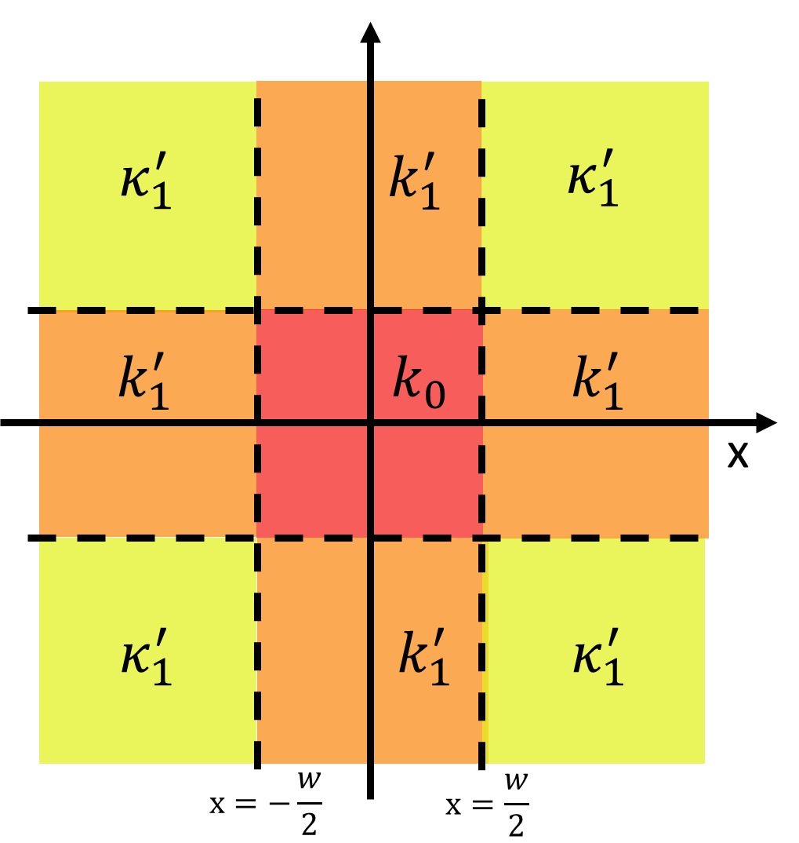
Figure S1 - illustration of the local impedance distribution
Substituting $ψ\left(x,y\right)=ψ_{x}\left(x\right)⋅ψ_{y}\left(y\right)$ we get,
$\frac{∂_{x}^{2}ψ_{x}}{ψ_{x}}+\frac{∂_{y}^{2}ψ_{y}}{ψ_{y}}=k_{0}^{2}+\left(k_{1}^{'2}-k_{0}^{2}\right)\left(T_{w}\left(x\right)+T_{w}\left(y\right)\right)$, [24]
with $T_{w}\left(x\right)=\frac{1}{2}\left(θ\left(\frac{w}{2}-x\right)-θ\left(x-\frac{w}{2}\right)\right)$ the top-hat function ($θ$ is the Heaviside function).
This problem can be solved in a much more general manner, but in the interest of brevity we will only consider here the zero-order mode of the cavity, which is the main experimental object of study. In this case, from symmetry, we expect two identical equations for $x$ and $y$ separately,
$\begin{matrix}\frac{∂_{x}^{2}ψ_{x}}{ψ_{x}}=\frac{1}{2}k_{0}^{2}+\left(k_{1}^{'2}-k_{0}^{2}\right)T_{w}\left(x\right) \\ \frac{∂_{y}^{2}ψ_{y}}{ψ_{y}}=\frac{1}{2}k_{0}^{2}+\left(k_{1}^{'2}-k_{0}^{2}\right)T_{w}\left(y\right)\end{matrix}$. [25]
These are easily solved separately. Inside the cavity, we get a similar solution but with the momentum normal to the boundary being $\frac{1}{\sqrt{2}}q_{1}=\frac{1}{\sqrt{2}}θk_{1}$. Outside of the cavity, in the $\left|x\right|<\frac{w}{2},\left|y\right|>\frac{w}{2}$and $\left|x\right|>\frac{w}{2},\left|y\right|<\frac{w}{2}$ regions, we get from conservation of momentum that
$q_{1}^{'}=\sqrt{k_{1}^{2}-\frac{1}{\sqrt{2}}q_{n}}$ [26]
and hence
$r_{2D}=\frac{\frac{1}{\sqrt{2}}θk_{1}-\sqrt{k_{1}^{2}-\frac{1}{\sqrt{2}}q_{n}^{2}}}{\frac{1}{\sqrt{2}}θk_{1}+\sqrt{k_{1}^{2}-\frac{1}{\sqrt{2}}q_{n}^{2}}}$. [27]
To obtain the total leakage outside of the cavity, we note that since $ψ\left(x,y\right)=ψ_{x}\left(x\right)⋅ψ_{y}\left(y\right)$ the total leakage is twice that prescribed for a single mode cavity with a $r_{2D}$ reflection.
Importantly, for the 2D cavity discussed in the main text $κ_{1}^{'}=k_{1}^{'}$ everywhere outside of the cavity core, whereas the cavity defined here (by eq. [23]) has $κ_{1}^{'}>k_{1}^{'}$. This implies that in the cavity defined by eq. [23] light should leak less into the corner $κ_{1}^{'}$regions than it would have for the more realistic case with $κ_{1}^{'}=k_{1}^{'}$. We therefore consider the quality factors obtained for the cavity defined by eq. [23] to be an upper bound on the real quality factor. The actual cavity should have slightly stronger decay, but less then the upperbound quality factor
$Q_{bound}=\frac{v_{p}}{v_{g}}\frac{π}{2\operatorname{asin}\left(\frac{2r_{2D}}{1-r_{2D}}\right)}$. [28]
Moreover, the calculation above is explicitly neglecting the presence of additional modes (inside and outside of the cavity), which is unphysical and unjustified. Intuitively, adding additional modes can only be expected to damage the cavity performance, because additional modes typically provide additional channels for power to leak, and because all of the high order modes incur larger absorption than the A0 and M1 modes. Finally, we note that the disagreement between the single mode and experimental measurements in Fig. 4a of the main paper is even more striking given the fact that the model above is quite simplistic and certainly neglects surface roughness and fabrication imperfections, which are present in the experimental setting and are detrimental to the cavity performance.
In the figure below, we show the expected quality factor for several different magnitudes of the impedance mismatch $q_{1}^{'}/q_{0}$. First, for the realistic value of the momentum $q_{1}^{'}/q_{0}$, with $q_{1}^{'},q_{0}$ the expected values for a flake of this thickness (in excellent agreement with measured value of the PhP wavelength). Second, for cavities with an artificially increased $q_{1}^{'}$. Roughly speaking, a 2-3 times larger $q_{1}^{'}$ is required to explain the peak quality factors we obtain experimentally (and in the finite element simulation). This is a huge deviation in momentum compared to the measured wavelengths and the basic theory of PhPs in hBN and confirms that single mode theory is insufficient to produce the large quality factors we find (as shown in Fig. 5e).
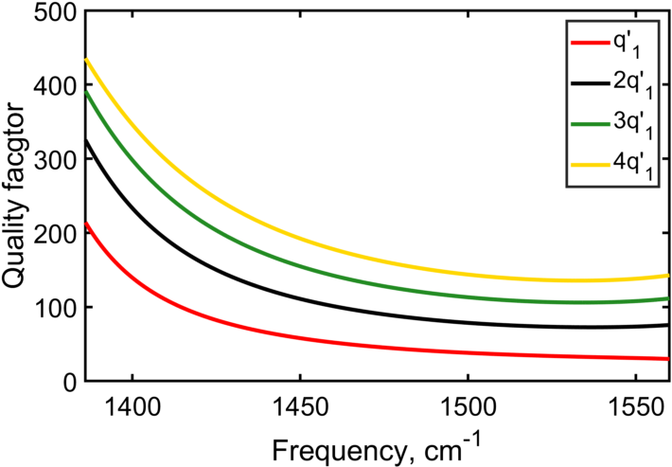
Figure S2 – single mode theory quality factor. The red line shows the quality factor vs frequency expected for a single mode cavity with a realistic impedance mismatch (based on the measured momentum $q_{1}^{'}$). The black, green and yellow lines correspond to cavities with an artificially heightened $q_{1}^{'}$, which is 2,3 or 4 times larger than its prescribed value.

Estimated dependence of quality factor on absorption
It is important to understand the behavior of the system when the absorption is tuned down and the cavities approach the theoretically loss-free limit. Naturally, if any degree of absorption is present, proper modes with $Q→∞$ are not expected. However, this can be complicated to demonstrate with some numerical methods, including the finite element and the semi analytical approach taken in this manuscript. The general reasoning is that in the presence of absorption the momentum of the wavevector is a complex valued vector, with the imaginary part proportional to the magnitude of the real part. This presents a practical cutoff on the largest momentum that needs to be included in a simulation. But when the losses are reduced, the computational resolution should, generally speaking, be increased making the computation time prohibitively long.
On the other hand, we will show that making an analytical estimate of the quality factor as a function of the amount of absorption is relatively simple. This will be a strictly rough estimate, but the scaling of this estimate with the quality factor should be physically meaningful. To this end, we consider an excitation which originates with unity magnitude at $x=0,z=t$ and model the depletion of energy in the cavity, in a partial wave expansion. As shown in⁷, if the ray propagates to the right it should reach the right boundary of the trench cavity with a width $Γ_{0}=\frac{w}{2}⋅imag\left(\sqrt{-\frac{ϵ_{x}}{ϵ_{z}}}\right)$. At every subsequent incidence on the interface, the beam will have a width
$Γ_{n}=w\left(n+\frac{1}{2}\right)imag\left(\sqrt{-\frac{ϵ_{x}}{ϵ_{z}}}\right)$ [29]
Here, even (odd) values of $n$ correspond to the beam incident on the right (left) side of the cavity (at $x=±w/2$). Because of this increase in width the reflection becomes increasingly imperfect⁷ – the reflection coefficient goes as $1-δ_{n}$ , with $δ_{n}$ linearly proportional to $Γ_{n}$. In addition to this, the ray is also attenuated at every reflection from the top and bottom interface since the reflection coefficient $r$ in a lossy HyM is a complex number of non-unity magnitude. The total amplitude of the ray after the $n$^{th} reflection event is therefore calculated as
$U_{n+1}=U_{n}\left(1-δ_{n}\right)e^{{-ρ}_{i}}$ [30]
As the reflection strength weakens gradually, the ray broadens and leaks more. This implies the decay of optical field in the cavity is not exponential and the frequency dependence is not a simple Lorentzian. Moreover, as the beam width expands, the above approximation of the reflection coefficient becomes less accurate. However, as the purpose of this section is to evaluate the divergence of the quality factor, and in particular only at the low-loss limit, we find it sufficient to use the above model and extract the quality factor from the number of cycles needed for the energy, ${\left|U_{n}\right|}^{2}$, to drop to $1/e$ . To further simplify, we normalize the reflection coefficient at the first reflection event so that the quality factor of the cavity is 100 and assume the cavity is a 25nm thick flake on top of a 100nm cavity, which is resonant at $\sim$1534.5cm⁻¹. Using this rough approximation, we can evaluate the quality factor as a function of the degree of loss in the hBN, where we multiply the imaginary part of the permittivity by a loss coefficient (see Fig. 2a). This shows that the quality factor indeed diverges as the loss coefficient goes to zero, as expected for a mode.

Hyperbolic bound in continuum modes
Given an ideal dipole source and neglecting any effect from absorption, we can expect very strong confinement of light inside a cavity due to the reflection mechanism. Such a source emits a pencil-like beam with $Γ→0$ width which will be perfectly reflected⁷, when incident at the cavity resonance frequency. In this section, we will show that, based on the same ideas, a proper mode will form inside the cavity, despite the presence of leakage channels outside of the cavity. The absence of leakage is a consequence of destructive interference between the modes forming the ray-like excitation, similar to what occurs in a BIC, with a clear spatial origin.

hBIC modes in a trench cavity
We begin this section by considering a trench-like cavity in the quasi-static limit, giving 2D confinement of light. Following this, we will consider a square cavity similar to the one in the main text where 3D confinement can be achieved. We will then consider alternative cavity designs in which no perfect metallic reflectors are needed. Finally, we will alleviate the assumption of the quasi-static limit made elsewhere in the text and demonstrate that hBICs can still exist in this case also, although the material on the cavity exterior needs to be tailored.
In all of the following discussion we will assume no optical absorption occurs in the hBN flake (otherwise proper modes are not expected to occur). To simplify, we assume the permittivity has the same real part as it does with regular isotopically pure hBN, but imaginary part is taken to zero. This can represent the case where the crystal is intercalated with gain medium, which is tuned to perfectly compensating for the losses. Accordingly, the beam broadening effect described earlier in the text does not occur and a narrow beam inside the hBN flake does not have to widen as it propagates (some widening is expected outside of the quasistatic limit, see discussion on this later).
Consider now a ray like excitation induced with a $Γ→0$ width.Such as the nearfield component excited by a dipole at $x=0,z→0^{+}$. As explained in the main text, in the quasistatic limit and neglecting the effect of absorption, this beam propagates through the cavity without expanding. Suppose now the frequency and dimensions of the cavity be such that the ray is incident on the corner of the cavity ($x=\frac{w}{2}, z=0$). In this case, on the left of the boundary, we have the infinitesimally narrow ray $E_{x}\left(x→{\left(\frac{w}{2}\right)}^{-},0\right)∝δ\left(z\right)$, and on the right, due to screening above the metal, all modes (nearfield and far field) should show $E_{x}\left(x→{\left(\frac{w}{2}\right)}^{+},0\right)=0$. Hence, perfect reflection is trivially expected.
In order for a resonance to form, the ray therefore needs to reach from one side of the cavity to the other at an integer number of jumps, meaning that $n_{s}=\frac{w}{2t}θ\left(ω\right)$. In addition, the beam should accumulate a $2πm$ phase in every roundtrip (with $m∈N$). Since the ray accumulates phase by reflecting off the top and bottom surfaces of the HyM slab, this implies $4n_{s}ρ_{r}\left(ω\right)=2πm$, with $ρ_{r}$ the phase upon reflection,
$ρ=angle\left(\frac{iθϵ_{x}-ϵ_{d}}{iθϵ_{x}+ϵ_{d}}\right)=2\operatorname{atan}{\frac{ϵ_{d}}{θ\left|ϵ_{x}\right|}}$. [31]
$ϵ_{d}∈R^{+}$ is the dielectric permittivity of the isotropic material surrounding the cavity (which was otherwise implicitly assumed to be unity).
Combining, we reach the following resonance condition
$\frac{m}{n_{s}}=\frac{4}{π}\operatorname{atan}{\frac{ϵ_{d}}{θ\left|ϵ_{x}\right|}}=\frac{4}{π}\operatorname{atan}{\frac{wn_{s}ϵ_{d}}{2t\left|ϵ_{x}\right|}}$. [32]
This condition for hBIC formation, which changes with frequency through $ϵ_{x}\left(ω\right)$, is equivalent to the graphical representation given in Fig. 2b of the main text.
Intuitively we note that if a cavity of width $w$ has the $m$^{th} resonance with $n_{s}$ skips at a certain $ω$, then a twice as wide cavity has the $2m$^{th} resonance at the same $ω$ with $2n_{s}$ skips.

3d compact hBIC cavities
So far, we have formally discussed only 2D hBICs. The extension to 3D hBICs (e.g. cavities formed by a square hole) is important but quite simple. To this end, we consider a cavity structure the same as in our experiments, a HIM layer on top of a metallic substrate with a square hole. As before, the metal is assumed to be a perfect conductor, the HIM is lossless hBN and the hole is infinitely deep. The dielectric above the flake is again tailored to correct for spatial dispersion, as we’ll discuss below.
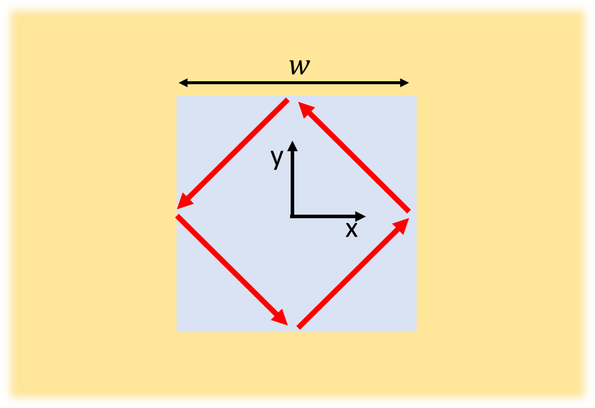
Figure S3 – 3D hBIC cavity illustration (topview)
For this section, we consider directional PhP modes, with
$\begin{matrix}\vec{E}\left(\vec{r}\right)⋅\left(\hat{k}×\hat{z}\right)=N_{n}e^{-iq_{n}\vec{r}⋅\hat{k}}ψ_{n}^{\hat{k}} \\ ψ_{n}^{\hat{k}}\left(x,z\right)=\left\{\begin{matrix}t_{1}e^{-θk_{n}\left(z-t\right)} & z>t \\ e^{ik_{n}z}+re^{-ik_{n}z} & 0<z<t \\ t_{1}e^{θk_{n}z} & z<0\end{matrix}\right.\end{matrix}$. [33]
Here, $r,t_{1},q_{n}$ are the Fresnel transmission and reflection coefficients
Under these circumstances, consider a point excitation at ${\vec{r}}_{0}=\left(-\frac{w}{2},0,0\right)$, which is produced by the sum of two infinitesimally narrow rays,
$\overline{E}\left({\vec{r}}_{0}\right)⋅\hat{x}=\lim_{s→0}\left[e^{-sn}\sum_{n=0}^{∞}{\left(\frac{\hat{x}+\hat{y}}{\sqrt{2}}ψ_{n}^{\hat{x}+\hat{y}}\left(x+\frac{w}{2},z\right)+\frac{\hat{x}-\hat{y}}{\sqrt{2}}ψ_{n}^{\hat{x}-\hat{y}}\left(x+\frac{w}{2},z\right)\right)}\right].$ [34]
By the same arguments as used in the 2D case, the beam propagating in the $\hat{x}+\hat{y}$ reaches $x=0,y=w/2$ and undergoes reflection to propagate in the $\hat{x}-\hat{y}$ direction and continues to propagate until it returns to $x=-\frac{w}{2},y=0$ (though not necessarily at the same $z$). Note that in contrast with the 1D case, the excitation we have here is point-like, rather than extended in the y-axis, and accordingly, it is the source for a ray that is fully compact.
For the resonant frequency, the ray completes $n_{s}$ bounces from one edge to the other, meaning $θ(ω)=\frac{tn_{s}}{\sqrt{2}w}$. In consequence, it hits $x=0,y=w/2$ at $z=0$, has zero overlap with any of the PhP modes outside the cavity and undergoes perfect reflection. Since the reflections from the hBN-dielectric interface are also unity magnitude (in the lossless approximation), the beam completes a circuit of the cavity. As before, the combination of the condition on the phase and reflection dictates the attainable $n_{s}$ and $ω$, though now there are additional modes possible, corresponding to different length closed loops in the cavity.

hBICs without perfectly conducting metallic reflectors
It is worth discussing the importance of the assumption of a perfect metal reflector we have made throughout the discussion. In non-hyperbolic BICs it has been shown that 3D compact BICs can only exist if the structure incorporates a perfect metal (or dielectric) with $\left|ϵ\right|→∞$ permittivity or an $ϵ=0$ material. It is therefore worth realizing whether the quality of the metallic substrate is instrumental to the existence of hBICs. Indeed, degrading the metallic substrate in the aforementioned cavity scheme degrades the quality of optical trapping and prevents the formation of an hBIC.
However, alternative metal-free hBIC cavity designs can be considered. Specifically, consider a hyperbolic 3D cavity whose cross-section is shown below. The cavity is made of a suspended hBN of thickness $t$ superimposed with cube protrusion of edge length $w≫t$. The bottom face of the cube is at the $z=0$ plane and overlaps with the hBN flake of thickness $t$ outside.
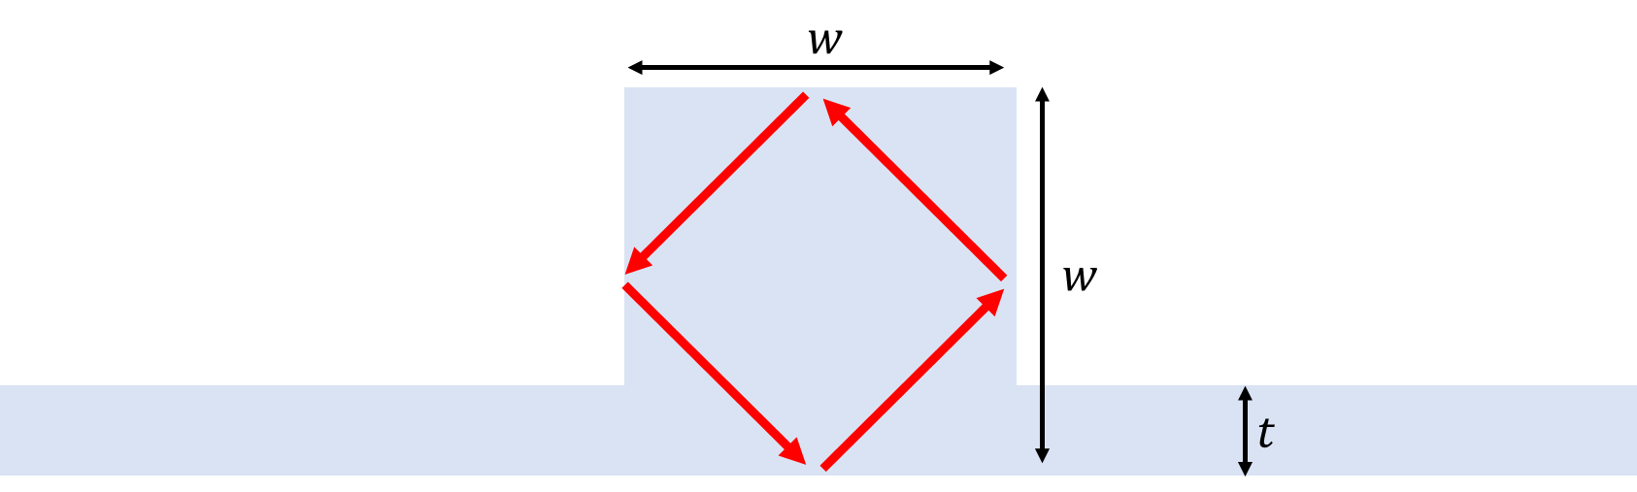
Figure S4 – alternative, non-metalic, hBIC cavity design
We can analyze this cavity similarly to the 3D cavity with metallic substrate, discussed earlier in this section. In this case, it should be immediately clear that there is no overlap (in $\overline{E}$ or $\overline{B}$) between the ray-like excitations inside the cube and any of the modes in the surrounding flake. Some care is required in discussing the coupling of the modes in the sidewalls to far field modes (with momentum comparable to $k_{0}$), since we cannot rely on transverse symmetry to automatically have momentum conservation from the side walls. Rather than delving into an analysis of that case, we will assume here that the upper half of the plane is surrounded by an imperfect metal with $ϵ=-1$. This simplifies the analysis considerably, since now light cannot escape from the top of the cavity, and due to momentum conservation it cannot escape from the bottom as well.

Alleviating the quasi-static limit in hBIC mode formation
In most of the analysis above, taking the quasistatic limit is completely justified due to the small size of the cavities relative to the mid-IR wavelength in which PhPs appear in hBN. However, when discussing the formation of hBICs there is some sense in going beyond this approximation, as a proper mode has an infinite lifetime and might be sensitive to otherwise negligible effects. The discussion ahead will seek to circumvent the problem by considering a more elaborate cavity design.
We note in advance that this design requires a very specific, somewhat artificial, choice for the dispersion of surrounding materials. This is made to clarify the theoretical applicability of our results, whereas realistically the effect of nonlocality is relatively weak and for sure secondary to the role of absorption.
Consider a 2D cavity, similar to the cavity discussed elsewhere in the text, but with the dielectric material surrounding the cavity having an isotropic momentum dependent dispersion $ϵ_{d}\left(k\right)$. This dispersion is tailored to adjust the phase on reflection from the top interface. For a trench cavity case (confined in 2D) we will adjust it so that it is $\frac{w}{2}$ periodic. The scenario of a 3D compact cavity will be addressed later. The reflection phase is
$ρ_{n}=ang(r)=ang\left(\frac{iα_{n}ϵ_{x}-k_{n}ϵ_{d}}{iα_{n}ϵ_{x}+k_{n}ϵ_{d}}\right)$ [35]
We require $q_{n}=\frac{2π\left(n+1\right)}{w}$ and find which $k_{n}$ fulfill the phase condition,
$\sqrt{ϵ_{x}k_{0}^{2}+{\left(\frac{2ϕπ\left(n+1\right)}{w}\right)}^{2}}=\left(πn-ρ_{n}\right)t^{-1}$ [36]
Since $ρ_{n}$ is a function of $k_{n}$ in itself, this is an implicit equation for $ϵ_{d}$. However, it is easy to get an approximate solution, using the fact that $\frac{π}{w}≫\frac{ϵ_{x}}{ϕ}k_{0},ϵ_{d}k_{0}$ for all small cavities, and that, in the lossless limit, $ϕ∈R^{+}$.
$ρ_{n}≈ang\left(\frac{iq_{n}ϵ_{x}-θ^{-1}q_{n}ϵ_{d}+O\left(q_{n}^{2}\right)}{iq_{n}ϵ_{x}+θ^{-1}q_{n}ϵ_{d}+O\left(q_{n}^{2}\right)}\right)=-\frac{2ϵ_{x}θ}{ϵ_{d}}+O\left(n^{-2}\right)$. [37]
$πn\left(\frac{2t}{wθ}-1\right)+π+O\left(n^{-2}\right)=-\frac{2ϵ_{x}θ}{ϵ_{d}}+O\left(n^{-2}\right)$. [38]
At resonant frequencies, $θ=\frac{2t}{w}$ and therefore
$ϵ_{d}\left(q_{n}\right)=ϵ_{x}θ{\left(π+O\left(n\right)\right)}^{-1}$. [39]
This assures us that the exact solution of eq. [33] is a finite $ϵ_{d}$ and though it is nonlocal, it is finite for all $k$.

Cavity fabrication

Substrate preparation and general note
The general idea of indirect patterning of cavities, as opposed, for instance, to etching and shaping a cavity, is that the substrate’s composition or geometry is modified (patterned) in order to somewhat indirectly induce confinement inside the designated cavity area. It should be noted that similar ideas have been explored in the past. In particular, to define cavities for (non-hyperbolic) phonon polaritons⁸, although those cavities were of considerably larger size. It is also worth mentioning the ability to indirect pattern and control the polaritons behavior suggested^{11,10,9,12}[hBN on gold/VO₂] and demonstrated^{14,13} previously with hBN, though not in order to confine light to small volume. In some similarity to hBN phonon polaritons, indirect patterning has been explored in the context of graphene plasmon polaritons, for example for making polaritonic crystals^{15,16}.
In our specific case, device fabrication starts with a Si/SiO₂ (285nm) substrate on which we evaporate (Kurt J. Lesker Company – LAB 18 Thin Film Deposition System) an ultrathin layer of gold: 2nm Ti adhesion layer and 10nm Au. Through optimization of the evaporation process, the roughness of the ultra-flat gold is reduced to under 500pm RMS, as qualified by atomic force microscopy (AFM).
As a general note, we should clarify that the following recipe is always successful in producing high Q cavities and in all cases showed significant quality factors. However, the quality of the cavities produced does vary significantly from sample to sample, due to various factors. Presumably this is related with hBN crystal quality, pattern quality, sample cleanliness, unintended strain\cracks interred during the transfer process. This is particularly notable in thinner hBN and smaller cavity sizes in samples such as device C2. The devices shown in the main text represent the higher quality devices made in our experiments, in comparison with a few other similarly designed devices made using similar methods that performed less well and hence were not studied as deeply.

Focused ion milling
For the fabrication of the cavities, very sharply defined holes need to be made in the gold. To this end, we found focused ion beam (FIB) milling to be the superior method, which generates higher quality cavities and achieves smaller minimal sizes, where we associate the higher quality factors with the superior sharpness of the edges produced by ion milling. However, an extensive comparison of cavity fabrication techniques lies well beyond the scope of this work. We observed that e-beam lithography produces lower quality cavities than the Ne FIB method described below, but with further study and optimization this could have been improved, which is interesting to consider for any application which requires a large area to be covered with cavities.
With FIB milling, we considered three ion species: He, Ne and Ga. Milling with Ga FIB (Zeiss Auriga) produced well defined cavities, potentially on sizable areas, but with the minimum feature size being $\sim 20nm$ at best. Moreover, the resulting devices showed lower quality factors than those made with Ne, more similar to those made with defocused Ne beams (Fig. 4a). At the other extreme, working with He ions provides superior resolution, but pockets of implanted He ions beneath the patterned area severely diminishing the van der Waals force and adherence of the hBN flake to the substrate. This made it impossible to transfer flakes with the methods described below.
Ne ions provide an excellent compromise – the lower collision cross-section and the smaller beam spot size relative to Ga ions allows features as small as $\sim 6nm$ to be milled. At the same time, the milling yield is significantly higher than He ions, meaning that far less ions are implanted in the sample.The total milling dose was reduced by using an ultrathin layer of gold, further reducing ion implantation and backscattered ion damage. We find that the combination of thin gold and Ne milling produces holes which are both exceptionally sharp and almost perfectly flat. Specifically, for small cavities, on the order of $120nm$ or less, an AFM measurement did not detect any topographical change due to Ne ion pockets, whereas larger area cavities showed a very slight elevation on the order of 1-3 nanometers. This is a possible cause for a minor amount of strain in the structure. Mild amounts of strain have been shown¹⁷ to shift the location of the Restrahlen band ($ω_{TO}$), but not broaden it.
Ne milling was performed in a Zeiss Orion microscope at low current ($\sim 0.4pA$), with a $10μm$ aperture and spot control of 4 or better. Ne pressure was set at $5μT$ and BIV voltage was increased above nominal value for Ne extraction to about 88% of the He value (or more), which stabilizes current and increases sourc lifetime. Extensive alignment to determine ideal beam conditions was performed in vicinity to the final patterned location. Demo structures were patterned and imaged in vicinity to the sample to confirm patterning quality and determine exact dimensions. In the case of the smallest cavities reported in the device with a 3nm thin hBN flake, patterning was performed by milling a single dot with increasing dwell time. In order to control the beam width (as in for Fig. 5d), the microscope focusing lens 2 was intentionally defocused to a few $μm$ away from the correct working distance. Milled demo structures are imaged in-situ using the Ne FIB or, in some cases with the superior resultion of He ion microscopy, but the actual structure is not.

PDMS based transfer of hBN
Following this, we transfer an isotopically pure hBN flake over the pattern. For thick hBN flakes (device C1), we followed a variation of the PDMS based dry transfer technique. Exfoliation is done directly with low retention PDMS (X0, either DGL or PF types). The original crystal is exfoliated until the PDMS is visibly covered in hBN all around, at which point a fresh PDMS sheet is used to pick up a portion of the hBN on the original PDMS and further exfoliation can be performed. After 2-5 such rounds, we do a last round of exfoliation directly on the stamp. Flake thickness can be estimated by calibrating the optical contrast with AFM measurements of dropped flakes.
To drop the flakes, the chip is heated to ${60}^{∘}C$ and the PDMS is slowly brought into contact with the chip. After the hBN flake is fully brought into contact with the chip, we heat further to ${85}^{∘}C$. The PDMS stamp is then lifted extremely slowly and the hBN remains attached to the substrate by van der Waals forces. In case of need, the flake can be later removed, e.g. by sonication or pickup with a PC stamp (see below), however, recycling chips in this way tends to reduce the quality of the produced devices, presumably due to surface contamination.
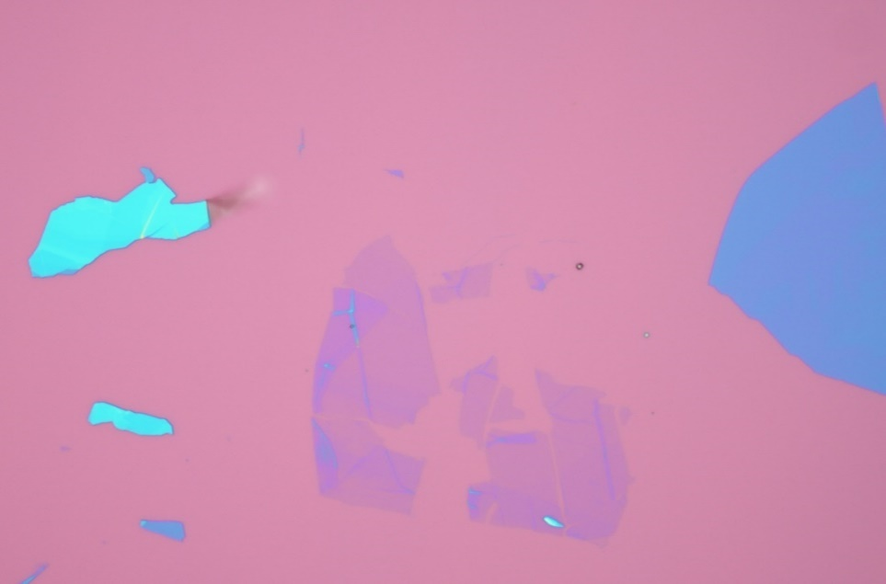
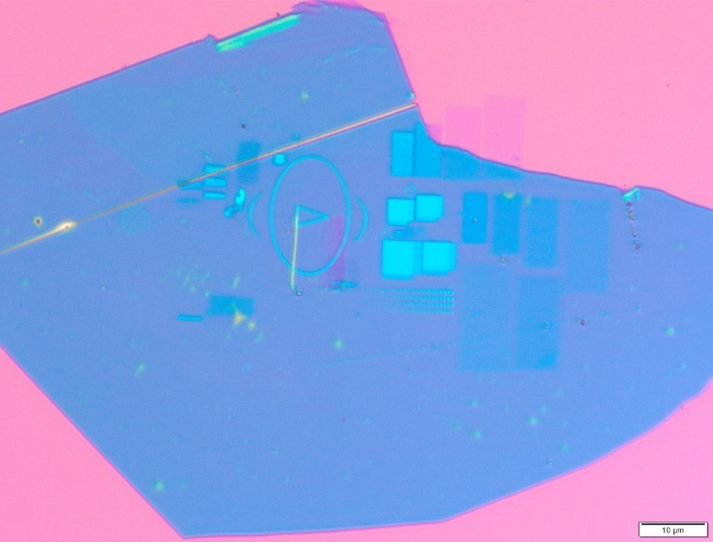
The flake is further cleaned from any transfer process residues by soaking in Acetone and isopropanol and, if needed, by contact mode AFM brooming.
10μm
10μm
A
B
Figure S5, cavity devices in optical microscope: A. Optical microscope image of the device C1. The isotopically pure h¹¹BN. The highlighted area contains four rows of square cavities ranging from 260nm to 20nm size. Other patterns shown are optical markers or various test structures. The circular light blue spots on the flakes are trapped air bubbles. B. Optical microscope image of the device C2. The isotopically pure h¹⁰BN and the flake thickness is estimated to be 3nm. Due to their size, the patterns are hard to observe optically (with the exception of a larger marker feature to assist location of the sample in the transfer setup, not seen in the picture).

Polycarbonate based transfer of hBN
For thin hBN flakes (device C2), the exfoliation procedure is the same of the one described previously, but in the final step the flakes are transferred to a silicon wafer (University Wafer). We press the PDMS against the substrate and we peel oﬀ to make the flakes detach from the PDMS film and stick over the silica substrate. After inspecting the chip using the optical microscope, we pick up the flake with a stamp made of a diamond-shaped piece of PDMS placed over a glass slide and covered by a thin ﬁlm of polycarbonate (PC). The flakes are picked up at ${60}^{∘}C$ and then transferred onto a different substrate under the microscope, at which point the PC is melted at${ 180}^{∘}C$. To remove PC residues, we soak the chip for 1h in chloroform. Afterwards, we transfer the chip to another beaker with fresh chloroform for 8h followed by a 1 minute IPA washing and blow dry.

Finite element simulations of near field response
This section describes the settings and procedures used in producing the simulated near field response shown in Fig. 4b and 4d of the main text. For emulating the experimental conditions as precisely as possible, the simulation considered a cylindrical metal tip with a spherical tip-end in proximity of the top surface of hBN as shown in Fig. S1a below. A p-polarized impinging wave is introduced with the incidence angle of ${45}^{∘}$, excited sufficiently far away from the hBN surface. At a given in-plane displacement $\left(x,y\right)$ of the tip with respect to the center of the cavity, we record the reflection coefficient $r\left(x,y;h\right)$ of the far-field (i.e. scattering matrix element $S_{11}$, where the index $1$ stands for the far-field port that excites the impinging wave) while varying the tip height from the surface $h=5, 50,$ and $100nm$. All simulations are done with COMSOL Multiphysics Electromagnetic Waves module.
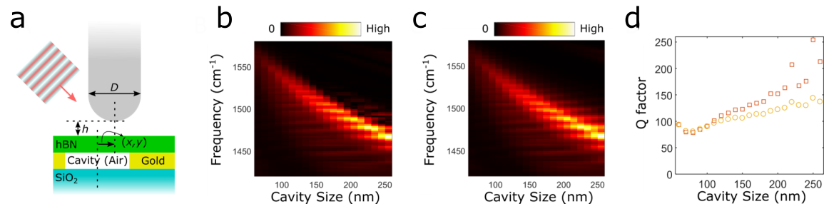
Figure S6, near field signal emulation: a. Schematic of simulation settings for emulating near-field response. b. Near-field response (in arbitrary unit) simulation; the tip position is assumed to be at the center of cavity (0,0). c. Absorption simulation under the same condition. d. Resonance quality factor extracted from Lorentzian fitting to the near-field response simulation results (red squares) and to the absorption simulation results (orange circles).
We emulate the mechanism of the near-field response measurement as closely as possible, by taking the amplitude of the fourth order Fourier harmonics of the reflectance under a time modulation of the tip height,
$NF\left(x,y\right)=\int_{-π}^{π}{dt e^{4it} {\left|r\left(x,y;h=\overline{h}+Δh\cos{t}\right)\right|}^{2}}$, [40]
where we assumed $\overline{h}-Δh=5nm$ and $\overline{h}+Δh=100nm$. We took the cubic interpolation of three data points—$r\left(x,y;h=5, 50, 100nm\right)$—so that $r\left(x,y;h\right)$ becomes a continuous function of $h$ to be used for the integration above. Fig. S1b shows the simulation results for the near-field response at the center of cavity $\left(x=0,y=0\right)$ with varying cavity sizes.
For comparison, we also extracted the amount of power absorption into the hBN slab, as shown in Fig. S6c. At a first glance, two simulation results resemble each other as expected. To assess the validity of our experimental Q factor estimation based on the near-field response, we provided in Fig. S6d the comparison between the values of Q factor evaluated with the near-field response simulation and those with the absorption simulation. Except for a few datapoints, the comparison shows that the quality factor estimation based on the near-field response is well within roughly 30% (underestimated) of the physical quality factor based on the absorption.
It interesting to study the dependence of the cavity response on the sharpness of the metallic corners, in both experiment and simulation. This is studied in Fig. S7, which clearly shows that rounding the corners and edges degrades $Q$ dramatically and slightly red-shifts the resonant frequencies, in good agreement with the experimental findings. Increasing the size of the milling ion beam to as little as 4-5nm reduces the quality factor by a sizable 30-40%. In this sense, it is reasonable to compare the experimental $Q$ estimated based on the near-field response to the theoretical $Q$ estimated based on the absorption simulation with perfectly sharp edges, since the former overestimates the physical $Q$ based on absorption roughly by 30% and the latter also overestimates the quality factor roughly by 30% compared to the realistic cases with smoothed edges and corners.
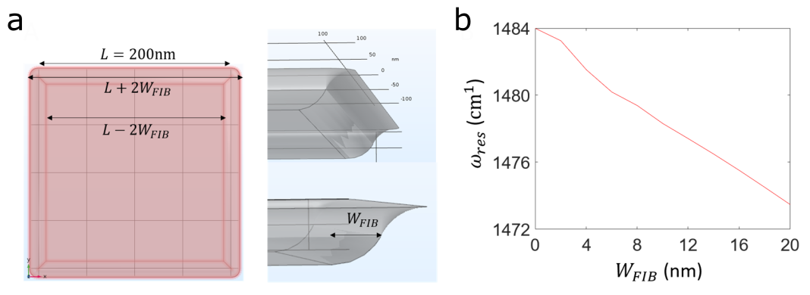
Figure S7, simulated response from smoothened cavities, a. Edge and corner smoothing in simulation; the following results are for 200nm-sized cavity. b. Red-shifts of resonance frequency and c. Q factor decrease as a function of radius of curvature of the smoothed edge and corners.

Near field measurement and analysis

Nearfield measurement principles
The SNOM is a widely used and commercially available technique that combines the accuracy of atomic force microscopy with optical excitation and measurement of deep subwavelength polaritons. Below, we summarize some of the essential details relevant to the current work. We follow the notation used in the pivotal SNOM paper¹⁸. For a more in depth presentation of SNOM techniques, see also⁶.
In a scattering SNOM measurement, an Atomic Force Microscope tip is illuminated with a focused laser beam. Underneath the tip apex, the electric field is locally enhanced and the material underneath is polarized. The mutual interaction between the polarized region and the tip apex leads to the formation of an effective dipole that radiates energy into the far-field. The scattered radiation contains information related to the local optical properties of the region underneath the tip apex. In addition to that, the tip can provide the missing momentum to transform far field radiation into near field modes, such as PhPs.
The average tip oscillation-amplitude is adjusted in order to optimize the signal strength, without reducing the background subtraction performance of the SNOM, which practically is about $\sim 120nm$ oscillation amplitude.
Notably, the size of the SNOM tip is comparable to and larger than some of the cavities measured in our experiments, which warrants consideration. The nominal diameter of the tips we used is$40-50nm$, but during the measurements the tip can be blunted considerably. It is important to remember that the signal is derived from the convolution between the tip apex and the spatial size of the measured feature and that the size of the observable features could be smaller than the resolution of the AFM tip. Moreover, when the PhPwavelength is comparable to the tip size, the coupling strength is diminished and depends on the exact structure of the tip. That is, the tip shape cannot be simply approximated as a sphere.
The scattered electric field can be expressed in a Fourier series¹⁸,
$E_{S}=\sum_{n=0}{O_{n}e^{inΩt}}$. [37]
Here E_{s} is the scattered electric field, Ω is the cantilever oscillation frequency and the complex coefficient O_{n} is the quantity extracted in the SNOM measurement. Generally speaking, the higher the $n$ of the term is, the stronger the relative contribution of the near field interaction is (i.e. the interaction which depends exponentially on the tip-sample distance). Hence, using higher order harmonics improves the measurement quality. All measurements were taken using the 4th harmonic of the SNOM signal.
We use two different kinds of detection schemes: pseudoheterodyne and homodyne. In the Pseudo-heterodyne measurement, the phase of the signal is extracted from the interference of the signal with an oscillating-phase reference. The Pseudo-heterodyne scheme gives good SNR and good background signal rejection. However, the presence of the reference arm introduces an inevitable amount of backscattering which destabilizes the QCL operation and needs to be manually compensated if the QCL wavelength is tuned. Therefore, for frequency sweep type of measurements, we resorted to blocking the reference arm and using a homodyne measurement technique. In the homodyne scheme, only the real part of the complex $O_{4}$ is extracted, up to a background phase which is weakly spatially dependent.

Verifying dispersion using edge reflected PhPs
Prior to the measurements, the thickness of the hBN flake is extracted from the AFM signal and the PhP dispersion (on gold) is obtained from the frequency dependent reflection signal on the edge of the flake. To this end, we scan along a single line, normal to the flake edge, while adjusting the QCL frequency in small increments (down to $\sim 0.5cm^{-1}$, below the nominal frequency stability of the QCL line).
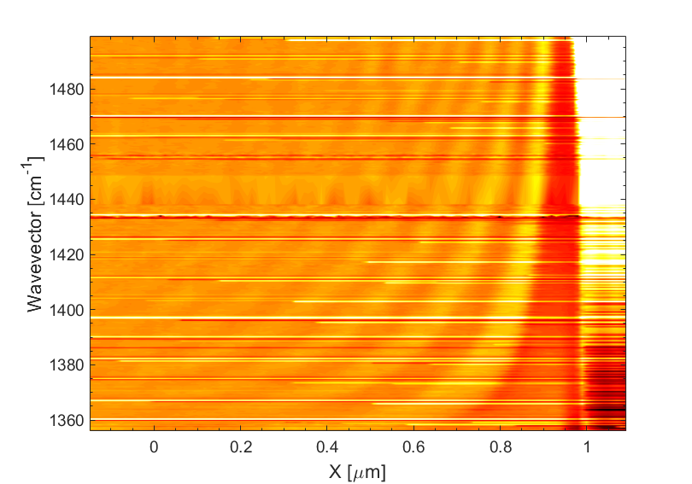
Figure S8, edge reflection measurement and dispersion extraction: A. Device C1 SNOM O₄ frequency scan measured at the edge of the flake. The black band covers the stop-band of the QCL. B. Horizontal line cuts of panel A at different frequencies which show the PhP standing waves between the edge of the flake and the SNOM tip. C. Measured and calculated dispersion relation of the hyperbolic phonon-polaritons considering 25nm h¹¹BN flake thickness.
QCL
A
B
C

Frequency sweep measurements
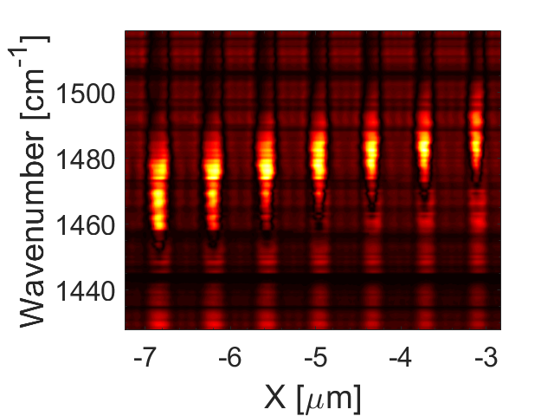
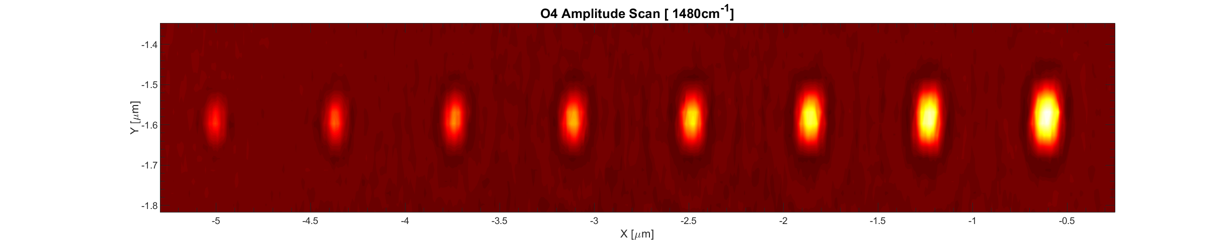
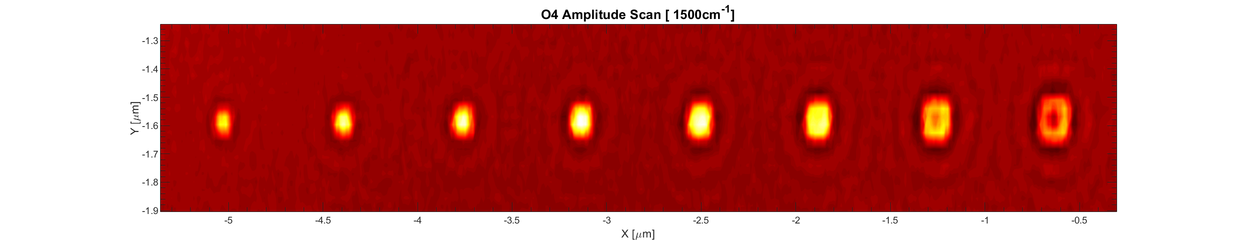
The frequency response of individual PhP cavities is measured, similarly, by scanning along the cross section of the cavity, while changing the QCL emission frequency. The cavities are arranged in a straight row (as shown in Fig. S3a), meaning that the several cavities can be measured simultanously at a single frequency sweep. This is helpful in ensuring the state of the SNOM tip is the same for all cavities. This results in Fig. S3b, from which the spectral dependence shown in Fig. 4b of the main text was obtained.
500nm
1480cm⁻¹
1500cm⁻¹
150nm 200nm
a
b
c
Figure S9, frequency sweep measurement, a. Near-field signal of an array of cavities at two different illumination frequencies. By decreasing the wavelength of the incident light, the resonant cavity is shifting towards a smaller size. To obtain the frequency response of the cavities, the SNOM tip scans the array along the white dashed line while changing the illumination wavelength. b. Plot of the Frequency scan of seven cavities. From left to right the size is decreasing and the maximum intensity of the signal shifts from longer wavelengths to a shorter one. c. Plot of the spectrum of the cavity cut by the dash-line in panel B. The shape of the signal is most likely due to the distortion that characterizes the homodyne measurements (see Fig. S4c). The two vertical dashed lines mark the width of the resonance.
As mentioned in the main text, smaller cavities are hard if not impossible to capture in such scans due to physical drift. The presence of such drift is clear from the variation in the topography (AFM) signal during the frequency sweep, combined with 2D scans regularly taken in the end of the scan. From these we can deduce the sample drifts away from the original position. The origin of this drift is presumably piezo relaxation, but the magnitude of the drift changed from day to day, and depended on the SNOM tip, the size and orientation of the scan or the sample chip, the amount of humidity in the air and some unknown factors. The measurements reported here are those which showed the least drift (and are consistent with other measurements taken). However, even $10-20nm$ of drift of the SNOM away from the center of a sub-$100nm$ cavity are enough to degrade the signal and for these smaller cavities, we use alternative methods to measure the spectral response which will be detailed later.
A disadvantage of this type of frequency sweep is that it can only be performed in the homodyne mode and not in the phase sensitive pseudo-heterodyne configuration. Measuring in pseudo-heterodyne requires additional alignment of the SNOM, which we could not do at every frequency step. In particular, the QCL laser we use is sensitive to back-reflected signal and uses an optical isolator which needs to be adjusted sensitively for different QCL frequencies.
As explained earlier, this homodyne signal is the real part of the SNOM signal, where the SNOM signal is the sum of the cavity response with a background signal. This typically results in a Fano-like line-shape, even if the resonance itself is perfectly Lorentzian as shown in Fig. S4, which warrants some care in extracting the resonance properties from the spectrum.
To clarify the methods, we evaluate the SNOM response from a substrate that has a generic Lorentzian resonance in the dielectric permittivity with f_{res} = $1500cm^{-1}$ and Q = 75 (Fig. S4a). Using a simple model¹⁹, we calculate the $O_{4}$ response for both pseudoheterodyne and homodyne detection schemes. Notably, the homodyne scheme shows a distorted response due to the presence of the background phase (φ_{R}).
a
b
c
Figure S10, SNOM response to Lorentzian resonance: a. Plot of the complex dielectric permittivity for a material that has a Lorentzian-like resonance. b. Plot of the calculated complex quantity O₄ amplitude and phase measured with pseudo-heterodyne detection scheme c. Plot of the calculated real-valued quantity O₄ measured with homodyne detection scheme${ φ}_{R} = π$.
Based on this reasoning, we estimate the quality factor of the cavity spectrum (e.g. from Fig. S4c) by dividing the frequency at which the signal is vanishing (estimate of the resonance frequency), with the distance between the maximum and the minimum peak of the spectrum. On the face of it, this is only a rough estimate, since the background phase is unknown and the shape of the spectrum is not necessarily Lorentzian. However, in practice we find that it compares favorably with other (more precise) methods of estimation, possibly underestimating the attainable quality factor.

Spatial single frequency measurements

Single frequency heterodyne
An alternative method to obtain the quality factor uses 2D single frequency scans, such as the scan shown in Fig. S5a, which suffer much less from tip drift. This is both because these scans are faster and because the voltage on the scanning piezos is adjusted actively throughout the scan. Moreover, any drift can be directly determined in the 2D scan.
1500cm⁻¹
a
b
d
c

Figure S11, spatial homodyne scan: a. Real space homodyne scan (4th harmonic signal, 1500cm-1)
b. Cross-section through the cavity middle c. Extracted signal as a function of cavity width d. Extracted signal as a function of frequency.
In order to associate the spatial variation along the scan (the change in the cavity size) with the spectral response of the cavity, we can associate the signal coming from the center of each cavity with the the corresponding resonance frequency. That is, we extract from the frequency sweep data the peak signal frequency as a function of the cavity width.
Figure S12, measured resonance frequencies for the set of square cavities, taken from set C1.
Using this dependence, we can obtain the quality factor as before – using the ratio between resonance frequency and distance between the maximum and the minimum peak of the plot. Notably, the dependence (Fig. S6) is practically linear, indicating that any shift in the resonance frequency (for example due to the peak of the Fano-like line-shape being shifted away from the resonant frequency) will not change the quality factor considerably.

Single frequency homodyne
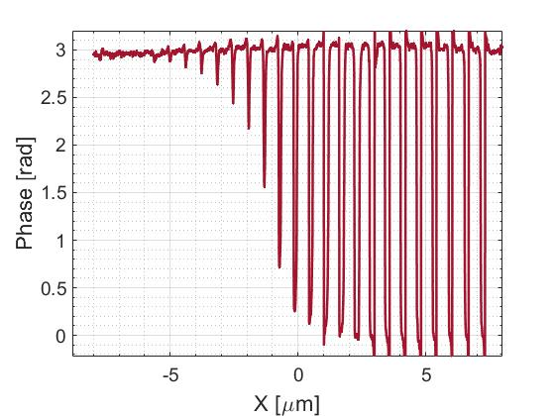
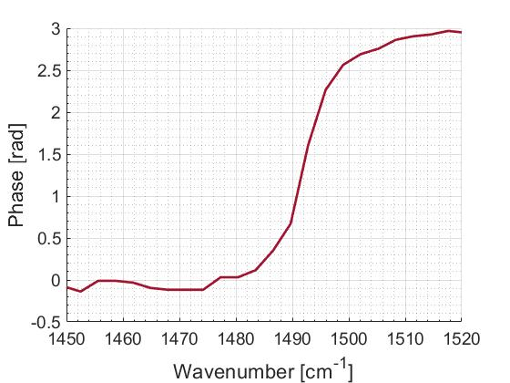
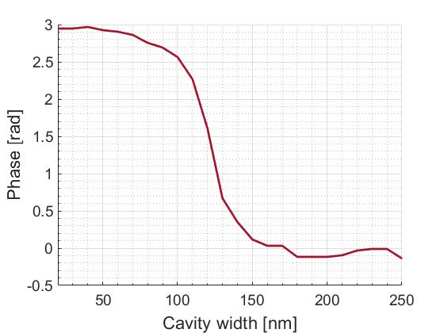
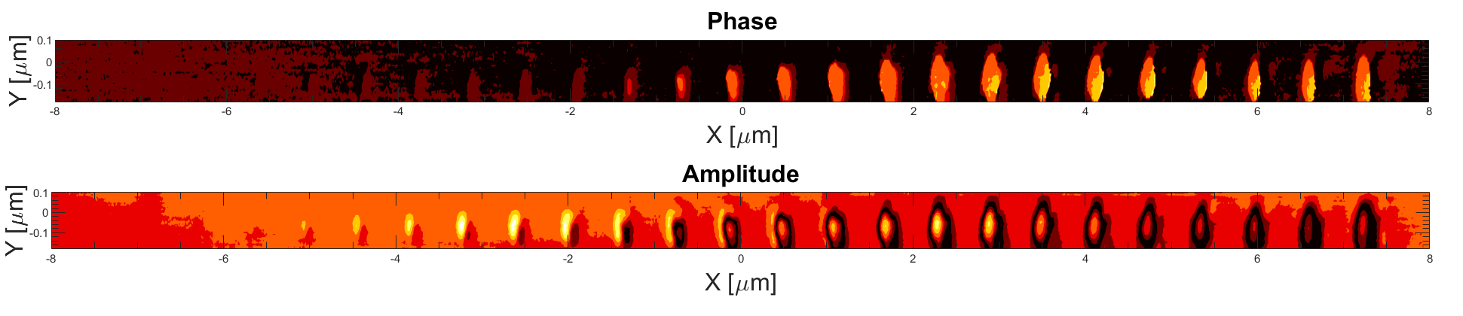
The third method we used to extract information about the cavity response spectrum involves a 2D scan with the SNOM in pseudo-heterodyne configuration. As discussed in the main text, a $π$ phase shift is expected when a critical parameter is changed across the resonance. This parameter can be the frequency, or in our case, and similarly to an etalon, can be the cavity size. This jump is a distinct and pronounced feature and the width of the phase jump is directly associated with the quality factor of a Lorentzian resonance, which is the easiest to evaluate and, in our assessment, the most accurate way to extract the cavity quality factor. As before, this measurement requires the prior extraction of the resonance location as a function of cavity width. In addition, this scheme suffers from additional back reflection which limits the maximum power the QCL can be operated at (which reflects on the signal to noise ratio). This is in contrast with the homodyne measurement, where there is no such limitation.
a
b
c
d
Figure S13, spatial pseudo-heterodyne scan, a. phase and amplitude Pseudo-heterodyne scan (4th harmonic signal, 1469cm⁻¹) b. Horizontal line-cut along the cavities’ center of a Pseudo-heterodyne O₄ phase c. Plot of the SNOM signal phase against the cavity width d. Plot of the SNOM signal phase against the calculated resonance frequency associated to each cavity.

Additional measurements

Measurements with Device C2
In the SI text above, the sample analysis was demonstrated with device C1 which showed a clear and easy to analyze signal. In the effort to reduce the size of the cavities further, we also studied device C2 with a thinner hBN (3nm thick h¹⁰BN) and smaller cavity sizes. In this subsection we report similar measurements and analyses made with device C2.
Fig. S14 shows two set of measurements taken at different illumination frequencies of an array of dots. By comparing the phase spatial scans S14b and S14e, it is clear that the dots array undergoes a resonance transition: the left part of the array experiences a phase change relative to the background when the illumination wavenumber is changed from $1460cm^{-1}$ to $1476cm^{-1}$ while the right part does not.
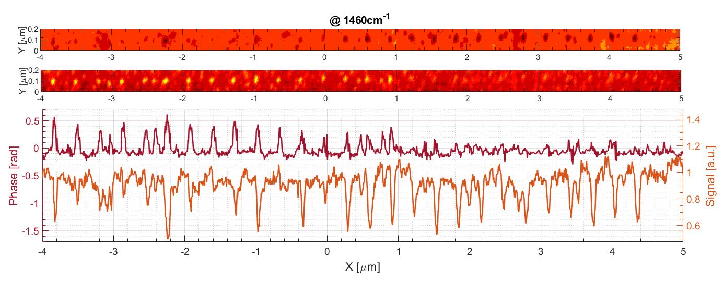
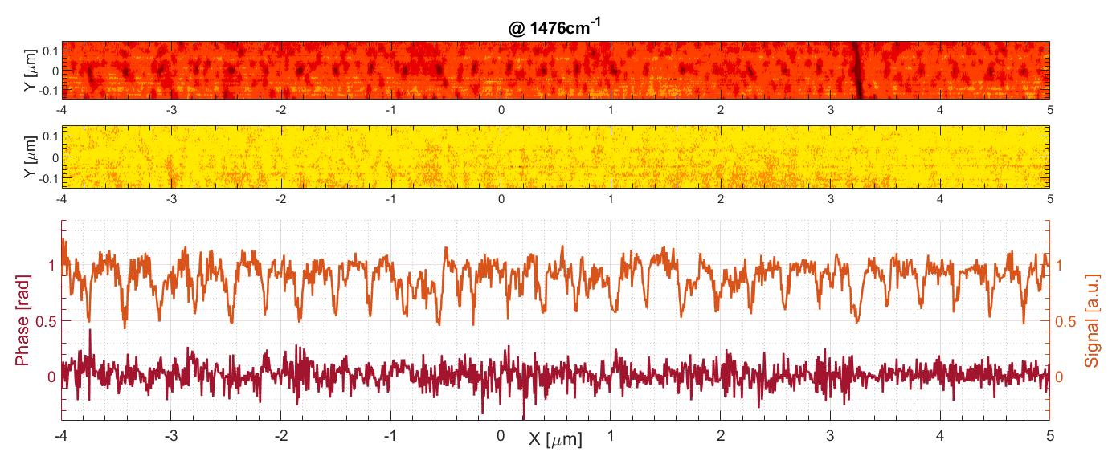
The phase changes from $\sim 0.5rad$ to the background level and does not reach$π$ because the cavity size is smaller/comparable to the radius of the tip apex. The signal is convoluted with the background that surrounds the dot cavity and consequently the intensity of both the phase and amplitude signal is reduced/averaged with the background.
a
b
c

d

e

f
Amplitude
Phase
Amplitude
Phase
Figure S14, Spatial pseudo-heterodyne scan of the dots array at 1460cm⁻¹ and 1476cm⁻¹ a-b. Pseudo-heterodyne O₄ at 1460cm⁻¹, amplitude spatial scan and phase spatial scan c. Horizontal line-cut along the array of the amplitude and phase spatial scan (A-B). d-e. Pseudo-heterodyne O₄ at 1476cm⁻¹, amplitude spatial scan and phase spatial scan f. Horizontal line-cut along the array of the amplitude and phase spatial scan (D-E).

Measurements with the large trench cavity
For completeness, we also report here on the device which contains the single$800nm$wide trench cavity shown in the main text in the context of the single reflection measurement. This device is made using a $\sim 20nm$ thick h¹⁰BN flake. Here we report the full frequency scan of the big trench cavity.
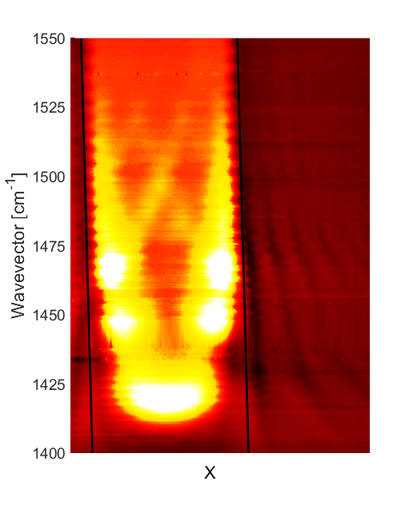
QCL gap
Figure S15, Near-field signal of a frequency scan of the trench cavity. The black solid lines are delimiting the trench cavity: the area in between the lines is milled and the HPPs defined as A_{N} can propagate. For instance, at around 1500cm⁻¹, we can see the 1st and the 2nd fringes of A0 being launched from both edges. We can also see a strong signal coming from the center of the cavity at 1420cm⁻¹, which corresponds to the expected resonance frequency of cavities of this size. The black square represents a gap in the QCL frequencies where signal to noise ratio is extremely poor.

Strain induced by milling
The process of patterning the cavities using the FIB introduces gas packets below the substrate. More precisely, a fraction of the ions used to mill the gold film is deposited below the cavity, creating nanobubbles and local swelling of the patterned area of about 1.5nm, possibly corresponding to a few percent of strain. It has been previously reported that strain in hBN can significantly shift the PhP resonance frequency¹⁷, but otherwise does not impact PhP performance. In any case it should be noted that the amount of swelling and strain relates to the dose needed to make it and hence scales with the size of the cavity squared. Thus, only the larger cavities show significant strain and for $w≲120nm$ no swelling is indicated from the AFM signal.

References
1. Lalanne, P., Yan, W., Vynck, K., Sauvan, C. & Hugonin, J.-P. Light Interaction with Photonic and Plasmonic Resonances. Laser Photon. Rev. 12, 1700113 (2018).
2. Chikkaraddy, R. et al. Single-molecule strong coupling at room temperature in plasmonic nanocavities. Nature 535, 127–130 (2016).
3. Maier, S. A. & Atwater, H. A. Plasmonics : Localization and guiding of electromagnetic energy in metal / dielectric structures APPLIED PHYSICS REVIEWS – FOCUSED REVIEW Plasmonics : Localization and guiding of electromagnetic energy in metal / dielectric structures. 011101, (2005).
4. Lee, I.-H. H. et al. Image polaritons in boron nitride for extreme polariton confinement with low losses. Nat. Commun. 11, (2020).
5. Urbieta, M. et al. Atomic-Scale Lightning Rod Effect in Plasmonic Picocavities: A Classical View to a Quantum Effect. ACS Nano 12, 585–595 (2018).
6. Ocelic, N., Huber, A. & Hillenbrand, R. Pseudoheterodyne detection for background-free near-field spectroscopy. Appl. Phys. Lett. 89, 101124 (2006).
7. Sheinfux, H. H. et al. Evolution and reflection of ray-like excitations in hyperbolic dispersion media. arXiv (2021).
8. Wang, T., Li, P., Hauer, B., Chigrin, D. N. & Taubner, T. Optical Properties of Single Infrared Resonant Circular Microcavities for Surface Phonon Polaritons. Nano Lett. 13, 5051–5055 (2013).
9. Dai, S. et al. Phase‐Change Hyperbolic Heterostructures for Nanopolaritonics: A Case Study of hBN/VO ₂. Adv. Mater. 31, 1900251 (2019).
10. Ambrosio, A. et al. Selective excitation and imaging of ultraslow phonon polaritons in thin hexagonal boron nitride crystals. Light Sci. Appl. 7, 27 (2018).
11. Folland, T. G. et al. Reconfigurable infrared hyperbolic metasurfaces using phase change materials. Nat. Commun. 9, 4371 (2018).
12. Fali, A. et al. Refractive Index-Based Control of Hyperbolic Phonon-Polariton Propagation. Nano Lett. 19, 7725–7734 (2019).
13. He, M. et al. Guided Mid-IR and Near-IR Light within a Hybrid Hyperbolic-Material/Silicon Waveguide Heterostructure. (2020).
14. Chaudhary, K. et al. Polariton nanophotonics using phase-change materials. Nat. Commun. 10, 4487 (2019).
15. Jung, M., Fan, Z. & Shvets, G. Active valley-topological plasmonic crystal in metagate-tuned graphene. arXiv vol. 121 086807 (2017).
16. Xiong, L. et al. Photonic crystal for graphene plasmons. Nat. Commun. 10, 1–6 (2019).
17. Lyu, B. et al. Phonon Polariton-assisted Infrared Nanoimaging of Local Strain in Hexagonal Boron Nitride. Nano Lett. 19, 1982–1989 (2019).
18. Ocelic, N., Huber, A. & Hillenbrand, R. Pseudoheterodyne detection for background-free near-field spectroscopy. Appl. Phys. Lett. 89, 101124 (2006).
19. Hillenbrand, R., Keilmann, F., Hanarp, P., Sutherland, D. S. & Aizpurua, J. Coherent imaging of nanoscale plasmon patterns with a carbon nanotube optical probe. Appl. Phys. Lett. 83, 368–370 (2003).

