Supplementary material
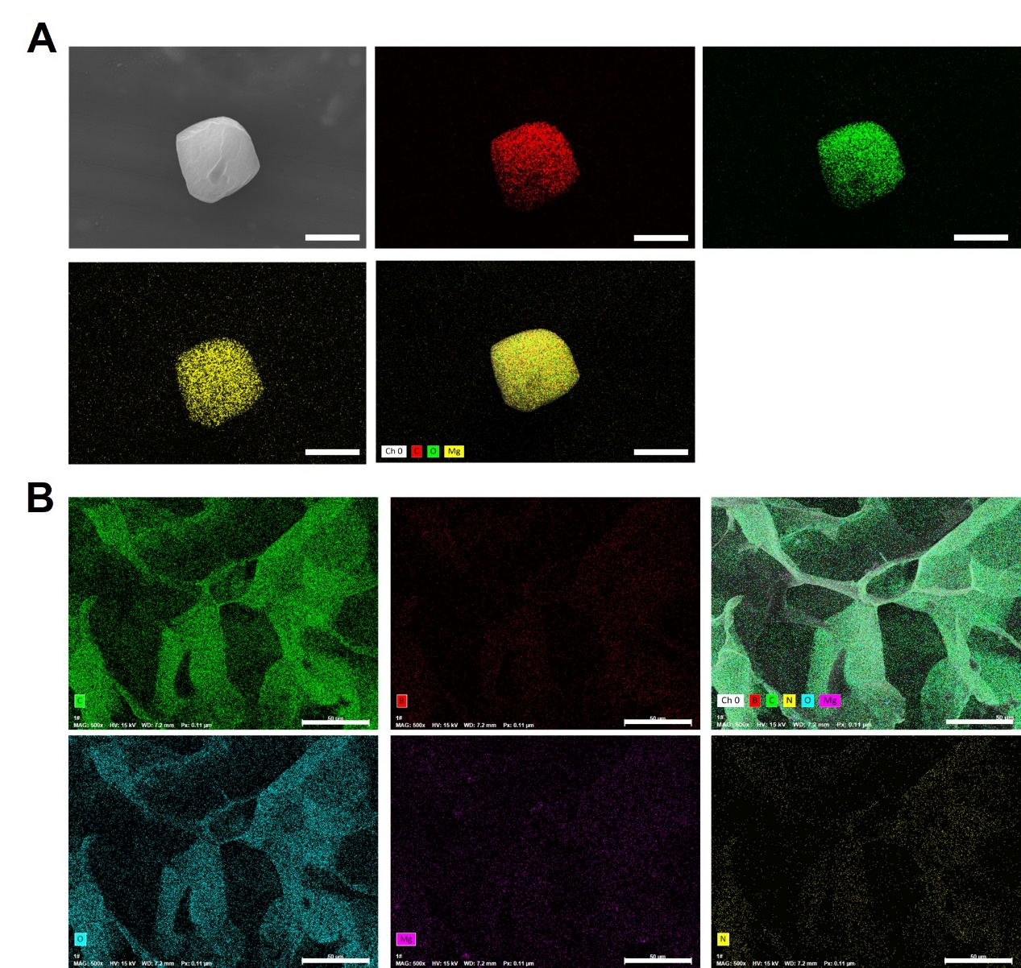
Fig. S1. The characterization of Mg-Ga and CSBDX@MOF. (A) The morphology and EDS mapping images of C, O and Mg element of Mg-GA (bar = 2 μm). (B) morphology and EDS mapping images of C, O, B, N and Mg element of CSBDX@MOF (bar = 50 μm).

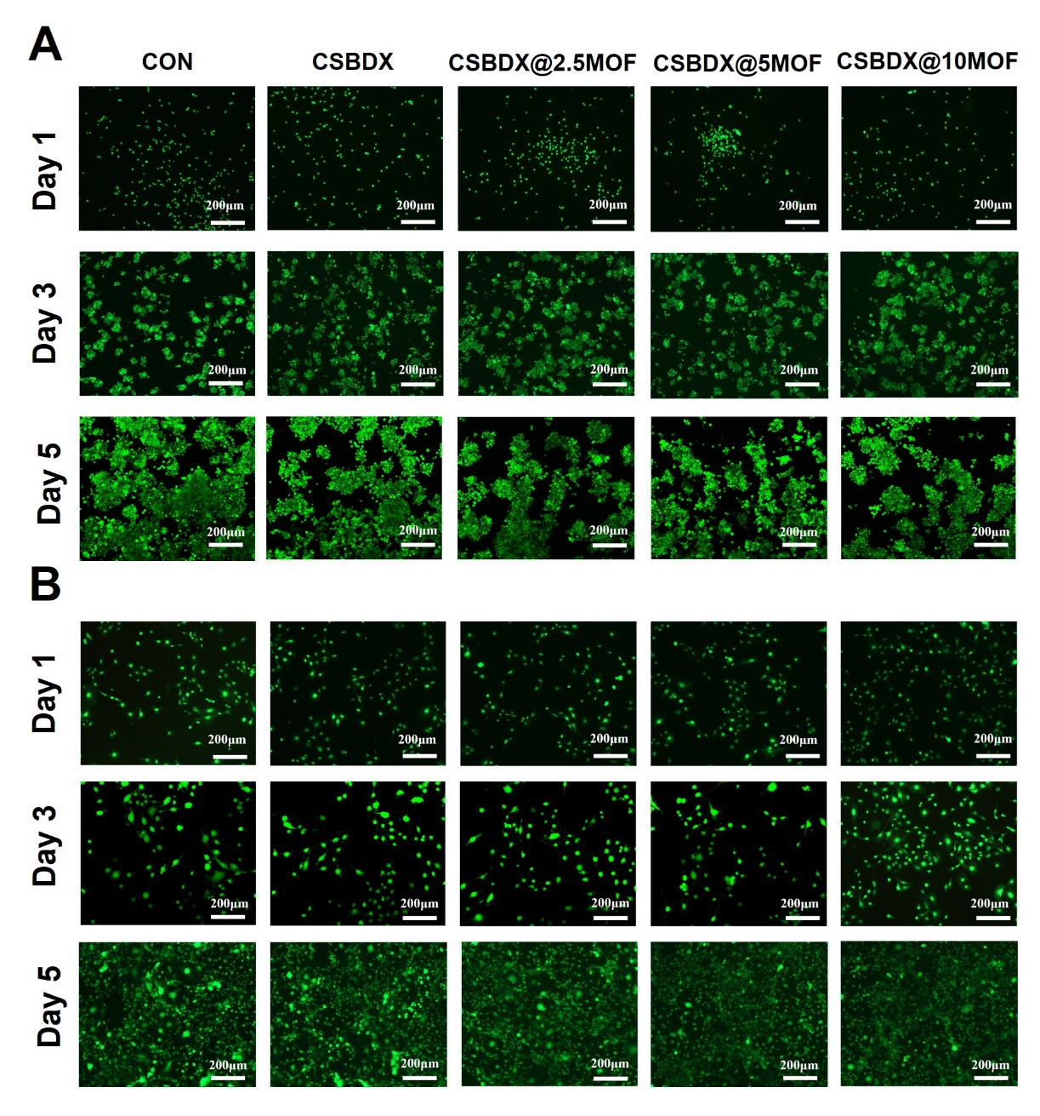
Fig. S2. The biocompatibility of CSBDX@MOF. The live/dead staining of RAW264.7s (A) and MC3T3 cells (B) cultured with hydrogel extracts for 1, 3 and 5 days (bar = 200 μm).

Supplementary Table 1. Primers used for QRT-PCR
Gene | Direction | Sequences
iNOS | Forward | 5’ CAG AAG TGC AAA GTC TCA GAC AT 3’
iNOS | Reverse | 5’ GTC ATC TTG TAT TGT TGG GCT 3’
COX-2 | Forward | 5’ AGA AGG AAA TGG CTG CAG AA 3’
COX-2 | Reverse | 5’ GCT CGG CTT CCA GTA TTG AG 3’
IL-6 | Forward | 5’ AGT TGT GCA ATG GCA ATT CTG A 3’
IL-6 | Reverse | 5’ AGG ACT CTG GCT TTG TCT TTC T 3’
TGF-β3 | Forward | 5’ CAA CAC CCT GAA CCC AGA G 3’
TGF-β3 | Reverse | 5’ CTT CAC CAC CAT GTT GGA CAG 3’
IL-10 | Forward | 5’ TCC CTG GGT GAG AAG CTG AAG AC 3’
IL-10 | Reverse | 5’ CAC CTG CTC CAC TGC CTT GC 3’
CD206 | Forward | 5’ AGA CGA AAT CCC TGC TAC TG 3’
CD206 | Reverse | 5’ CAC CCA TTC GAA GGC ATT C 3’
RUNX2 | Forward | 5’ AAG TGT TCT GTG GTC TCT GAG TTG A 3’
RUNX2 | Reverse | 5’ GCT GTA TGG TGA GGC TGG TAG G 3’
ALP | Forward | 5’ TTG TAC GTC TTG GAG AGG GC 3’
ALP | Reverse | 5’ TCA GAA GCT CAA CAC CAA CG3’
COL 1 | Forward | 5’ GGG TCT AGA CAT GTT CAG CTT TGT G 3’
COL 1 | Reverse | 5’ ACC CTT AGG CCA TTG TGT ATG C 3’
OCN | Forward | 5’ CAC TCC TCG CCC TAT TGG C 3’
OCN | Reverse | 5’ CCC TCC TGC TTG GAC ACA AAG 3’
OPN | Forward | 5’ CTC CAT TGA CTC GAA CGA CTC 3’
OPN | Reverse | 5’ CAG GTC TGC GAA ACT TCT TAG AT 3’
OPG | Forward | 5’ CAA AGG CAG GGC ATA CTT C 3’
OPG | Reverse | 5’ TTC AAT GAT GTC CAA GAA CAC C3’

