Terrihabitans elymus sp. nov., isolated from sandy arid soil

Supplementary materials

Fig. S1. Neighbor-joining tree showing the phylogenetic positions of strain Terrihabitans elymus PJ23^{T} and representatives of some other related taxa, based on 16S rRNA gene sequences. Bootstrap values (expressed as percentages of 1000 replications) ≥70 % are shown at branch points. Bar, 0.02 nt substitution rate (Knuc) units
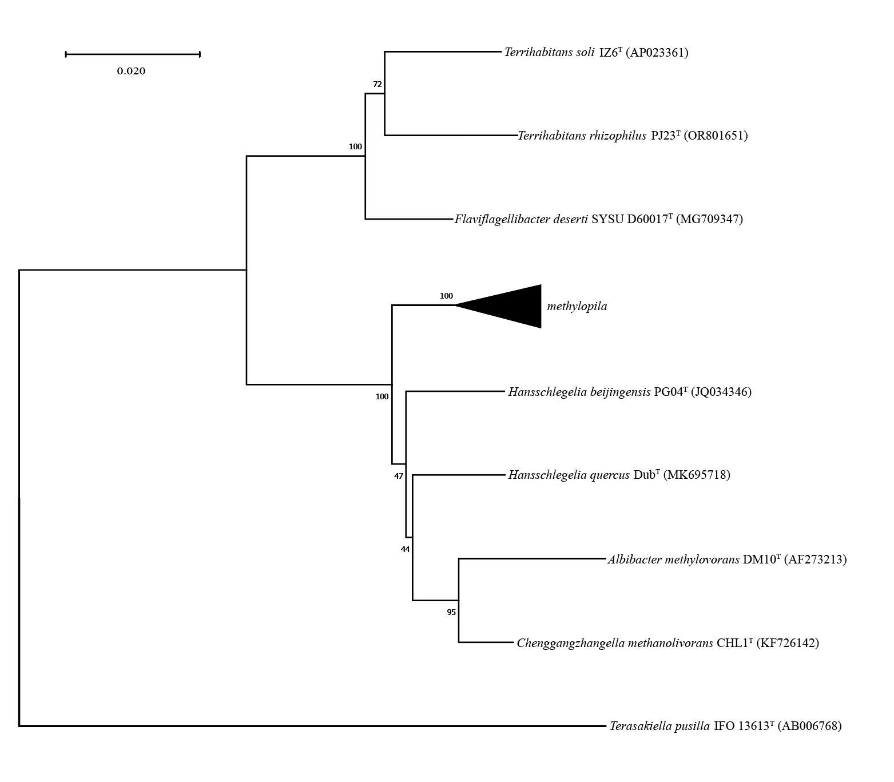

Fig. S2. Transmission electron micrograph of strain Terrihabitans elymus PJ23^{T} from cultures grown on 1/2 R2A agar for 10 days at 24ºC. Single bacteria morphology (a) and overall morphology (b).

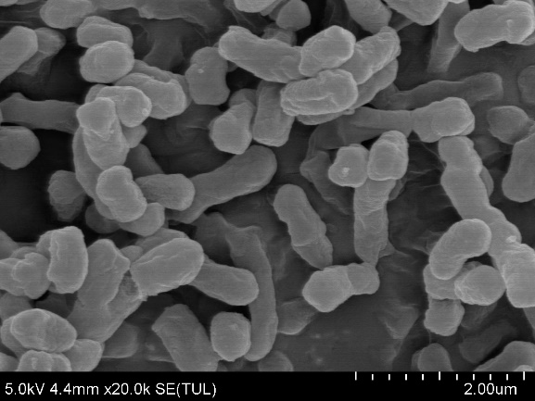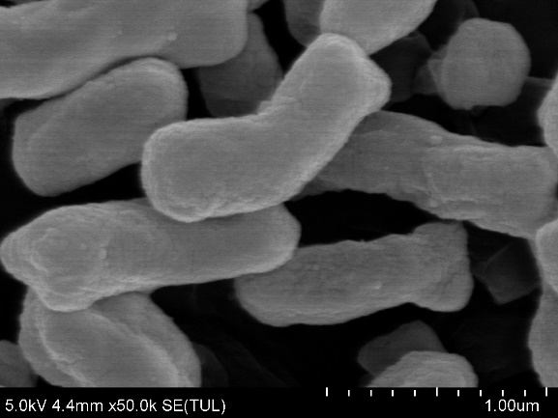
a
b

Fig. S3. Two-dimensional thin-layer chromatogram of polar lipids of strain Terrihabitans elymus PJ23^{T}. The lipids were visualized under UV light (366nm) after spraying a solution of aceton/water (60:40) containing 0.01% primuline (w, v) (a). Solvents were as follows: first direction, chloroform/methanol/water (65:29:4, by vol.); second direction, chloroform/methanol/acetic acid/water (80:12:15:4, by vol.). To differentiate and identify lipid types, different stains were applied, ninhydrin for aminolipids (b), molybdenum blue for phospholipids (c) and a-naphthol for glycolipids (d). The size of the plate is 10 cm×10 cm; APL, unidentified amino phospholipid; GL, unidentified glycolipid; PC, phosphatidylcholine; L, unidentified polar lipid.
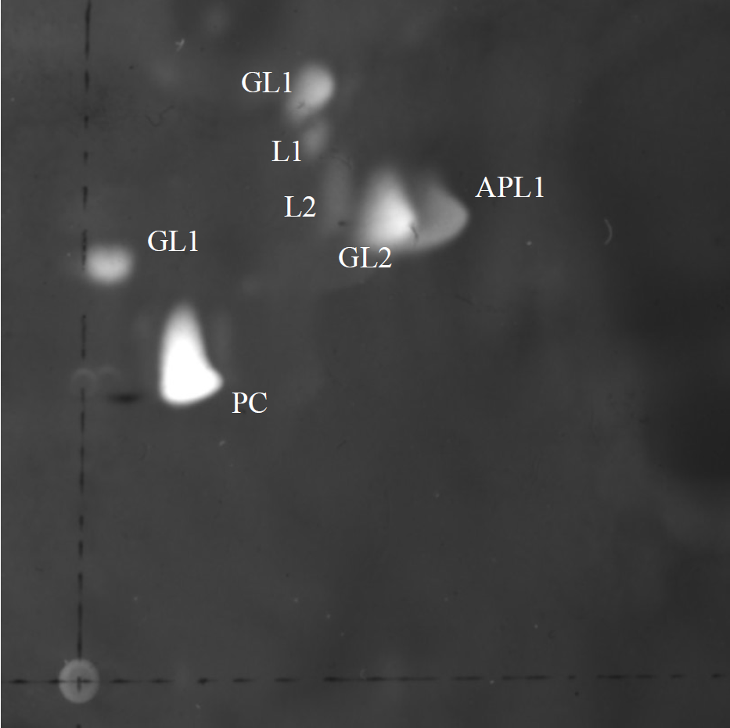
2nd direction
1st direction

Table S1. General features of the draft genome of strain PJ23T.
Attribute | Characteristics
Genome size (bp) | 3,415,191
Number of contigs | 25
Mean length (bp) | 136,607
N50 length (bp) | 364,001
G + C content (%) | 65.23
Number of coding genes | 3084
rRNA | 3
tRNA | 49
Total gene | 3271

Table S2. Phenotypic characteristics of strain Terrihabitans elymus PJ23^{T} determined by Biolog GEN III, API 20NE and API ZYM test kits.
BIOLOG GEN III
Sl. No. | Characteristic | Result | Sl. No. | Characteristic | Result
 | Carbon source utilization assay |  | 36. | _{L}-Pyroglutamic acid | –
1. | Acetic acid | + | 37. | α-Keto-glutaric acid | +
2. | Acetoacetic acid | – | 38. | Glycerol | –
3. | p-Hydroxyphenylacetic acid | – | 39. | Glycyl-_{L}-proline | –
4. | _{L}-Alanine | – | 40. | _{L}-Histidine | –
5. | _{D}-Arabitol | – | 41. | Inosine | –
6. | _{L}-Arginine | – | 42. | Myo-inositol | –
7. | _{D}-Aspartic acid | – | 43. | _{L}-Lactic acid | +
8. | _{L}-Aspartic acid | – | 44. | _{D}-Lactic acid methyl ester | –
9. | γ-Amino butyric acid | – | 45. | α-_{D}-Lactose | –
10. | α-Hydroxy-butyric acid | – | 46. | _{D}-Malic acid | –
11. | β-Hydroxy-_{D,L}-butyric acid | – | 47. | _{L}-Malic acid | –
12. | α-Keto-butyric acid | – | 48. | _{D}-Maltose | –
13. | _{D}-Cellobiose | – | 49. | _{D}-Mannitol | –
14. | Citric acid |  | 50. | _{D}-Mannose | +
15. | Dextrin | – | 51. | N-Acetyl-β-_{D}-mannosamine | –
16. | Formic acid | – | 52. | _{D}-Melibiose | +
17. | _{D}-Fructose | + | 53. | Mucic acid | –
18. | _{D}-Fructose-6-PO₄ | + | 54. | N-Acetyl neuraminic acid | –
19. | _{D}-Fucose | + | 55. | Pectin | –
20. | _{L}-Fucose | + | 56. | Methyl pyruvate | –
21. | _{L}-Galactonic acid lactone | + | 57. | Propionic acid | +
22. | _{D}-Galactose | + | 58. | Quinic acid | –
23. | N-Acetyl-_{D}-galactosamine | – | 59. | _{D}-Raffinose | –
24. | _{D}-Galacturonic acid | + | 60. | _{L}-Rhamnose | +
25. | Gelatin | – | 61. | _{D}-Saccharic acid | –
26. | Gentiobiose | + | 62. | _{D}-Salicin | –
27. | _{D}-Gluconic acid | + | 63. | _{D}-Serine | –
28. | α-_{D}-Glucose | + | 64. | _{L}-Serine | –
29. | 3-Methyl glucose | + | 65. | _{D}-Sorbitol | –
30. | N-Acetyl-_{D}-glucosamine | – | 66. | Stachyose | –
31. | _{D}-Glucose-6-PO₄ | + | 67. | Bromosuccinic acid | –
32. | β-Methyl-_{D}-glucoside | – | 68. | Sucrose | –
33. | Glucuronamide | + | 69. | _{D}-Trehalose | –
34. | _{D}-Glucuronic acid | + | 70. | _{D}-Turanose | +
35. | _{L}-Glutamic acid | – | 71. | Tween 40 | –
BIOLOG GEN III (contd.)
Sl. No. | Characteristic | Result | Sl. No. | Characteristic | Result
 | Chemical sensitivity assay |  | 83. | Niaproof 4 | –
72. | pH 5 | – | 84. | _{D}-Serine | +
73. | pH 6 | + | 85. | Potassium tellurite | +
74. | 1% NaCl | + | 86. | Tetrazolium blue | +
75. | 4% NaCl | + | 87. | Tetrazolium violet | +
76. | 8% NaCl | – | 88. | Aztreonam | +
77. | Sodium bromate | + | 89. | Lincomycin | +
78. | Sodium butyrate | + | 90. | Minocycline | +
79. | Lithium chloride | + | 91. | Nalidixic acid | –
80. | Guanidine HCl | – | 92. | Rifamycin SV | +
81. | Fusidic acid | + | 93. | Troleandomycin | –
82. | 1% Sodium lactate | – | 94. | Vancomycin | +

API 20NE
Sl. No. | Characteristic | Result | Sl. No. | Characteristic | Result
1. | Fermentation of _{D}-glucose | - | Assimilation of
2. | Indole production | - | 11. | _{L}-Arabinose | -
3. | Reduction of nitrates to nitrites | - | 12. | Capric acid | -
3. | Reduction of nitrates to N₂ | - | 13. | Trisodium citrate | -
4. | Arginine dihydrolase | - | 14. | Potassium gluconate | -
5. | β-Galactosidase | - | 15. | N-Acetyl glucosamine | -
6. | β-Glucosidase (esculin hydrolysis) | + | 16. | _{D}-Glucose | -
7. | Protease (gelatin hydrolysis) | - | 17. | Malic acid | -
8. | Urease | - | 18. | _{D}-Maltose | -
Assimilation of |  |  | 19. | _{D}-Mannose | -
9. | Phenylacetic acid | - | 20. | _{D}-Mannitol | -
10. | Adipic acid | -

API ZYM
Sl. No. | Characteristic | Result | Sl. No. | Characteristic | Result
1. | Cystine arylamidase | + | 11. | α-Glucosidase | -
2. | Leucine arylamidase | + | 12. | β-Glucosidase | -
3. | Valine arylamidase | + | 13. | β-Glucuronidase | -
4. | α-Chymotrypsin | - | 14. | Lipase (C14) | -
5. | Esterase (C4) | + | 15. | α-Mannosidase | -
6. | Esterase lipase (C8) | + | 16. | Acid phosphatase | +
7. | α-Fucosidase | - | 17. | Alkaline phosphatase | +
8. | α-Galactosidase | - | 18. | Naphthol-AS-BI-phosphohydrolase | +
9. | β-Galactosidase | - | 19. | Trypsin | -
10. | N-Acetyl-β-glucosaminidase | -

