Supplementary Material
Atomistic Molecular Dynamics Simulation and COSMO-SAC Approach for Enhanced 1,3-Propanediol Extraction with Imidazolium-Based Ionic Liquids.
Raj Akshatª, Anand Bharti^{b*} and Padmini Padmanabhan^{c*}
ªDepartment of Bioengineering and Biotechnology, Birla Institute of Technology, Ranchi, India; ^{b}Department of Chemical Engineering, Birla Institute of Technology, Ranchi, India; ^{c}Department of Bioengineering and Biotechnology, Birla Institute of Technology, Ranchi, India

* Corresponding author: E-mail: abharti@bitmesra.ac.in, padmini@bitmesra.ac.in

Tel: +91-8011097281, +91 7550008592

Sl. No. | Title of the table/figure | Page no.
Figure S1 | Molecular Structures of System Compounds: Optimized Configurations. | S5
Figure S2 | Validation of COSMO-Generated Sigma Profile against Reference Data. | S6
Figure S3 | Atom types for the 1-alkyl-3-methylimidazolium. | S7
Table S1 | Charges unscaled and scaled by 0.8. | S7
Table S2 | Non-Bonded Parameters σ(Å) and є (Kcal/mol), Bond force constants r₀ (Å) K_{r} (Kcal mol⁻¹Å⁻²) and Angle force constants θ₀ (degrees) K_{θ} (Kcal mol⁻¹rad⁻²), for cation 1-Butyl-3-methylimidazolium (Bmim). | S8
Table S3 | Torsional Fourier Coefficients (Kcal/mol) for 1-Butyl-3-methylimidazolium [Bmim]. | S9
Figure S4 | Atom Type Representation of Anions. (a) Bis(pentafluoroethanesulfonyl)amide [NPF2] (b) Bis[(trifluoromethyl)sulfonyl]imide [NTF2] (c) Thiocyanate [SCN] and (d) Trifluoromethanesulfonate [TFO]. | S10
Table S4 | Non-Bonded parameters σ(Å) and є (Kcal/mol), for selected anions. | S11
Table S5 | Bond force constants r₀ (Å) and K_{r} (Kcal mol⁻¹Å⁻²) , for anions. | S12
Table S6 | Angle force constants θ₀ (degrees) and K_{θ} (Kcal mol⁻¹rad⁻²), for selected Anions. | S13
Table S7 | Torsional Fourier Coefficients (Kcal/mol) for selected Anions. | S14
Figure S5 | Atom Type Representation of 1,3-Propanediol (1,3-PDO). | S15
Table S8 | Charges of 1,3-Propanediol: Unscaled and Scaled by 0.8. | S15
Table S9 | Non-Bonded Parameters σ(Å) and є (Kcal/mol), Bond force constants r₀ (Å) K_{r} (Kcal mol⁻¹Å⁻²) of 1,3-PDO. | S16
Table S10 | Angle force constants θ₀ (degrees) K_{θ} (Kcal mol⁻¹rad⁻²), for 1,3-PDO. | S17
Table S11 | Torsional Fourier Coefficients (Kcal/mol) for 1,3-PDO. | S18
Table S12 | Distribution of components in extract and raffinate phases from MD simulation at 298 K and 1 atm. | S19
Figure S6 | Density Profile Validation Using OPLS-AA Force Fields over 12ns Simulation at 298.15 K. | S20
Figure S7 | Validation of RDF Plot for [Bmim][NPF2] | S21
Figure S8 | Validation of RDF Plot for [Bmim][NTF2] | S22
Figure S9 | Validation of RDF Plot for [Bmim][SCN] | S23
Figure S10 | Validation of RDF Plot for [Bmim][TFO] | S24
Figure S11 | Spatial Distribution Function (SDF) Analysis of [Bmim][NPF2]: Molecular Density Distribution. (a) and (b) show the vertical and horizontal views of [NPF2] around [Bmim] cation. Similarly, (c) and (d) display [Bmim] cation around [Bmim] cation. Cyan color represents cation [Bmim] density, while purple depicts [NPF2] anion density. | S25
Figure S12 | Spatial Distribution Function (SDF) Analysis of [Bmim][SCN]: Molecular Density Distribution. (a) and (b) display vertical and horizontal views of [SCN] around [Bmim] cation, while (c) and (d) depict [Bmim] cation around [Bmim] cation. Cyan color indicates [Bmim] cation density, and red signifies [SCN] anion density. | S26
Figure S13 | Spatial Distribution Function (SDF) Analysis of [Bmim][TFO]: Molecular Density Distribution. (a) and (b) show vertical and horizontal views of [TFO] around [Bmim] cation, while (c) and (d) depict [Bmim] cation around [Bmim] cation. Cyan color represents [Bmim] cation density, and lime signifies [TFO] anion density. | S27
Figure S14 | Spatial Distribution Function (SDF) visualisations of ILs around 1,3-PDO, Color code: Cyan for [Bmim]⁺ cation, Purple for [NPF2]⁻, Blue for [NTF2]⁻, Red for [SCN]⁻, and Lime for [TFO]⁻. (a) SDF of [NPF2]⁻ and [Bmim]⁺ around 1,3-PDO in [Bmim][NPF2], (b) SDF of [NTF2]⁻ and [Bmim]⁺ around 1,3-PDO in [Bmim][NTF2], (c) SDF of [SCN]⁻ and [Bmim]⁺ around 1,3-PDO in [Bmim][SCN] and (d) SDF of [TFO]⁻ and [Bmim]⁺ around 1,3-PDO in [Bmim][TFO]. | S28
Figure S15 | Molecular Distribution Analysis and Interatomic RDF of [Bmim][NTF2] with 1,3-PDO. (a) SDF of 1,3-PDO around [NTF2]⁻, (b) SDF of 1,3-PDO around [Bmim]⁺, (c) SDF of [NTF2]⁻ around 1,3-PDO, (d) SDF of [Bmim]⁺ around 1,3-PDO, and (e) Interatomic RDF Plot of ILs and 1,3-PDO at 298 K. | S29
Figure S14 | This figure displays the average number of hydrogen bonds observed after equilibration at 298 K. (a) H-Bonding between ILs and 1,3-PDO and (b) H-Bonding involving ILs anions and 1,3-PDO. | S30
Figure S15 | Comparative Analysis of Water Entry in Various Ionic Liquids (ILs) at 298 K. Distinguished by colors (a) [Bmim][NPF2] in purple, (b) [Bmim][NTF2] in blue, (c) [Bmim][SCN] in red, and (d) [Bmim][TFO] in lime—the figure unveils the unique behavior of each IL in accommodating water molecules under specified conditions. | S31

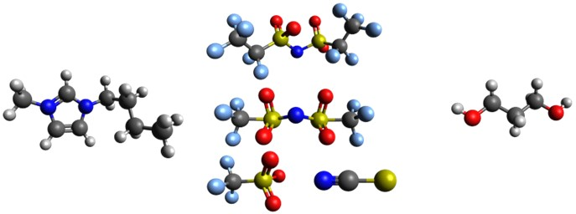
Figure S1. Molecular Structures of System Compounds: Optimized Configurations.

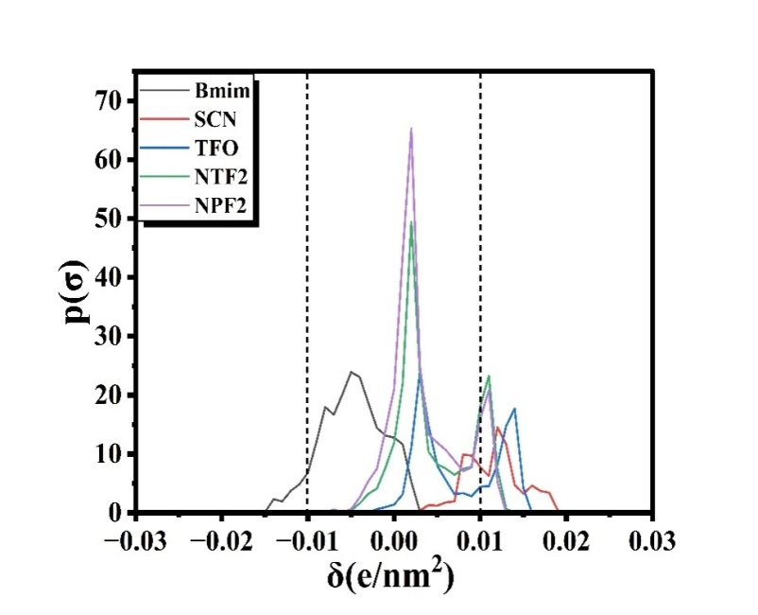
Figure S2. Validation of COSMO-Generated Sigma Profile against Reference Data (1).
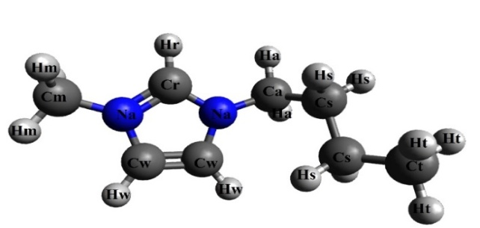
OPLS-AA Force field of 1-butyl-3-methylimidazolium cation (2,3)

TABLE S1. Charges unscaled and scaled by 0.8.
Atom type | q (e) 0.8* q (e)
Cm | -0.35 | -0.280
Na | 0.22 | 0.176
Cr | -0.09 | -0.072
Cw | -0.24 | -0.192
Ca | -0.17 | -0.136  Figure S3. Atom types for the 1-alkyl-3-methylimidazolium.
Cs | -0.12 | -0.096
Ct | -0.24 | -0.192
Hm | 0.18 | 0.144
Hr | 0.21 | 0.168
Hw | 0.27 | 0.216
Ha | 0.18 | 0.144
Hs | 0.06 | 0.048
Ht | 0.08 | 0.064

TABLE S2. Non-Bonded Parameters σ(Å) and є (Kcal/mol), Bond force constants r₀ (Å) K_{r} (Kcal mol⁻¹Å⁻²) and Angle force constants θ₀ (degrees) K_{θ} (Kcal mol⁻¹rad⁻²), for cation 1-Butyl-3-methylimidazolium [Bmim]⁺.
  Atom type | σ(Å) є (Kcal/mol)
  Cm | 3.55 | 0.066
  Na | 3.25 | 0.170
  Cr | 3.55 | 0.070
  Cw | 3.55 | 0.070
  Ca | 3.50 | 0.066
  Cs | 3.50 | 0.066
  Ct | 3.50 | 0.066
  Hm | 2.50 | 0.030
  Hr | 2.42 | 0.030
  Hw | 2.42 | 0.030
  Ha | 2.50 | 0.030
  Hs | 2.50 | 0.030
  Ht | 2.50 | 0.030
  Bonds | r₀ (Å) K_{r}  (Kcal mol⁻¹Å⁻²)
  Cr-Na | 1.315 | 477
  Hm-Cm | 1.080 | 340
  Na-Cm | 1.465 | 337
  Cr-Hr | 1.069 | 367
  Cw-Na | 1.378 | 427
  Cw-Cw | 1.336 | 520
  Cw-Hw | 1.068 | 367
  Na-Ca | 1.476 | 427
  Ca-Ha | 1.080 | 520
  Ca-Cs | 1.526 | 367
  Cs-Hs | 1.087 | 337
  Cs-Cs | 1.531 | 340
  Cs-Ct | 1.528 | 268
  Ct-Ht | 1.084 | 340
  Ca-Ct | 1.521 | 268

  Angles | θ₀  (degrees) | K_{θ} (Kcal mol⁻¹rad⁻²)
  Na-Ca-Ct | 112.6 | 58.35
  Ca-Cs-Ct | 113.1 | 58.35
  Ca-Ct-Ht | 110.7 | 37.50
  Ht-Ct-Ht | 107.9 | 33.00
  Cs-Ct-Ht | 111.1 | 37.50
  Cs-Cs-Cs | 112.3 | 58.35
  Cs-Cs-Ct | 112.3 | 58.35
  Hs-Cs-Hs | 106.7 | 33.00
  Hs-Cs-Cs | 109.6 | 37.50
  Hs-Cs-Ct | 109.7 | 37.50
  Ca-Cs-Cs | 113.3 | 58.35
  Cs-Cs-Hs | 108.6 | 37.50
  Ha-Ca-Ha | 108.9 | 58.35
  Ha-Ca-Cs | 111.1 | 37.50
  Angles | θ₀  (degrees) | K_{θ} (Kcal mol⁻¹rad⁻²)
  Na-Ca-Cs | 113.0 | 70.00
  Na-Ca-Ha | 107.5 | 70.00
  Cr-Na-Ca | 126.8 | 35.00
  Cw-Na-Ca | 125.3 | 35.00
  Hw-Cw-Cw | 130.9 | 70.00
  Na-Cw-Hw | 122.0 | 70.00
  Na-Cw-Cw | 107.1 | 70.00
  Cr-Na-Cw | 107.9 | 35.00
  Na-Cr-Na | 109.8 | 70.00
  Na-Cr-Hr | 125.1 | 35.00
  Cm-Na-Cw | 125.6 | 70.00
  Cm-Na-Cr | 126.4 | 70.00
  Hm-Cm-Na | 109.2 | 37.50
  Hm-Cm-Hm | 109.8 | 33.00

TABLE S3. Torsional Fourier Coefficients (Kcal/mol) for 1-Butyl-3-methylimidazolium [Bmim].
  Torsion | V1 | V2 | V3
  Hm-Cm-Na-Cr | 0.000 | 0.000 | 0.000
  Hm-Cm-Na-Cw | 0.000 | 0.000 | 0.124
  Cm-Na-Cr-Hr | 0.000 | 4.651 | 0.000
  Cm-Na-Cr-Na | 0.000 | 4.651 | 0.000
  Cm-Na-Cw-Cw | 0.000 | 3.000 | 0.000
  Cm-Na-Cw-Hw | 0.000 | 3.000 | 0.000
  Na-Cr-Na-Ca | 0.000 | 4.651 | 0.000
  Na-Cw-Cw-Hw | 0.000 | 10.750 | 0.000
  Na-Cw-Cw-Na | 0.000 | 10.750 | 0.000
  Hr-Cr-Na-Cw | 0.000 | 4.651 | 0.000
  Cr-Na-Cw-Hw | 0.000 | 3.000 | 0.000
  Hr-Cr-Na-Ca | 0.000 | 4.651 | 0.000
  Hw-Cw-Na-Ca | 0.000 | 3.000 | 0.000
  Cw-Cw-Na-Ca | 0.000 | 3.000 | 0.000
  Cr-Na-Ca-Ha | 0.000 | 0.000 | 0.000
  Ca-Cs-Cs-Hs | 0.000 | 0.000 | 0.366
  Ca-Cs-Cs-Ct | 1.300 | -0.050 | 0.200
  Cw-Na-Ca-Ct | -4.355 | -4.575 | -1.375
  Cw-Na-Ca-Ha | -2.700 | -5.650 | 0.355
  Cr-Na-Ca-Cs | -0.159 | 0.095 | -0.010
  Ha-Ca-Cs-Hs | 0.000 | -0.150 | 0.518
  Na-Ca-Cs-Cs | -0.788 | -0.800 | 0.400
  Cr-Na-Cw-Cw | 0.000 | 3.000 | 0.000
  Torsion | V1 | V2 | V3
  Hs-Cs-Cs-Hs | 0.000 | 0.000 | 0.318
  Hs-Cs-Ct-Ht | 0.000 | 0.000 | 0.318
  Hs-Cs-Cs-Ct | 0.000 | 0.000 | 0.366
  Ca-Cs-Cs-Cs | 1.300 | -0.050 | 0.200
  Cs-Cs-Cs-Cs | 1.300 | -0.050 | 0.200
  Cs-Cs-Cs-Ct | 1.300 | -0.050 | 0.200
  Cs-Cs-Cs-Hs | 0.000 | 0.000 | 0.366
  Cs-Cs-Ct-Ht | 0.000 | 0.000 | 0.366
  Hw-Cw-Cw-Hw | 0.000 | 10.750 | 0.000
  Na-Ca-Cs-Hs | 0.000 | 0.000 | 0.000
  Ha-Ca-Cs-Cs | 0.000 | 0.000 | 0.366
  Cw-Na-Cr-Na | 0.000 | 4.651 | 0.000
  Ha-Ca-Ct-Ht | 0.000 | 0.000 | 0.318
  Ca-Cs-Ct-Ht | 0.000 | 0.000 | 0.366
  Na-Ca-Cs-Ct | -0.688 | 0.650 | 0.900
  Ha-Ca-Cs-Ct | 0.000 | 0.000 | 0.366
  Na-Cs-Ct-Ht | 0.000 | 0.000 | 0.000
  Cr-Na-Ca-Ct | -2.000 | -0.275 | -1.650
  Cr-Na-Ca-Cs | -2.110 | -5.000 | 0.345
  X-Cw-X-Xª | 0.000 | 2.200 | 0.000
  X-Cr-X-Xª | 0.000 | 2.200 | 0.000
  X-Na-X-Xª | 0.000 | 2.200 | 0.000

OPLS-AA Force field of anions (3).
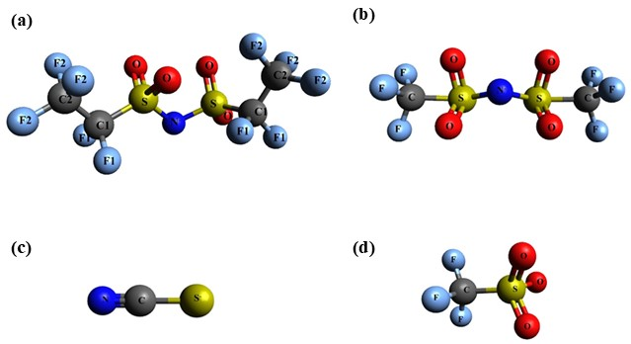
Figure S4. Atom Type Representation of Anions. (a) Bis(pentafluoroethanesulfonyl)amide [NPF2]⁻ (b) Bis[(trifluoromethyl)sulfonyl]imide [NTF2]⁻ (c) Thiocyanate [SCN]⁻ and (d) Trifluoromethanesulfonate [TFO]⁻.

TABLE S4. Non-Bonded parameters σ(Å) and є (Kcal/mol), for selected anions.
Anion | Atom type | q (e) | 0.8 * q (e) | σ (Å) | є (Kcal/mol)
[TFO]⁻ | S | 1.1887 | 0.95096 | 3.550 | 0.250
[TFO]⁻ | O | -0.6556 | -0.52448 | 2.960 | 0.210
[TFO]⁻ | C | 0.2692 | 0.21536 | 3.500 | 0.066
[TFO]⁻ | F | -0.1637 | -0.13096 | 2.950 | 0.053
[SCN]⁻ | N | -0.6452 | -0.51616 | 3.2 | 0.170
[SCN]⁻ | C | 0.3263 | 0.26104 | 3.3 | 0.066
[SCN]⁻ | S | -0.6811 | -0.54488 | 3.55 | 0.250
[NTF2]⁻ | F | -0.16 | -0.128 | 2.95 | 0.053
[NTF2]⁻ | C | 0.35 | 0.280 | 3.5 | 0.066
[NTF2]⁻ | S | 1.02 | 0.816 | 3.55 | 0.250
[NTF2]⁻ | O | -0.53 | -0.424 | 2.96 | 0.210
[NTF2]⁻ | N | -0.66 | -0.528 | 3.25 | 0.170
[NPF2]⁻ | N | -0.66 | -0.528 | 3.25 | 0.170
[NPF2]⁻ | S | 1.09 | 0.872 | 3.55 | 0.250
[NPF2]⁻ | O | -0.56 | -0.448 | 2.96 | 0.21
[NPF2]⁻ | C1 | 0.12 | 0.096 | 3.5 | 0.066
[NPF2]⁻ | C2 | 0.51 | 0.408 | 3.5 | 0.066
[NPF2]⁻ | F1 | -0.13 | -0.104 | 2.95 | 0.053
[NPF2]⁻ | F2 | -0.17 | -0.136 | 2.95 | 0.053

Table S5. Bond force constants r₀ (Å) and K_{r} (Kcal mol⁻¹Å⁻²) , for anions.
Anion | Bonds | r₀ (Å) | K_{r} (Kcal mol⁻¹Å⁻²) | Anion | Bonds | r₀ (Å) | K_{r} (Kcal mol⁻¹Å⁻²)
[TFO]⁻ | F-C | 1.323 | 441.92 | [NTF2] | N-S | 1.570 | 374.88
[TFO]⁻ | C-S | 1.818 | 233.03 | [NTF2] | S-O | 1.437 | 637.07
[TFO]⁻ | S-O | 1.437 | 637.07 | [NTF2] | S-C | 1.818 | 233.03
[SCN]⁻ | C-N | 1.157 | 650.0 | [NTF2] | C-F | 1.323 | 441.92
[SCN]⁻ | S-C | 1.655 | 236.29 | ### | ### | ### | ###
[NPF2]⁻ | N-S | 1.570 | 374.88 |  | C1-F1  C2-F2  C1-C2 | 1.323 | 441.92
[NPF2]⁻ | S-O | 1.437 | 637.07 |  | C1-F1  C2-F2  C1-C2 | 1.323 | 441.92
[NPF2]⁻ | S-C1 | 1.818 | 233.03 |  | C1-F1  C2-F2  C1-C2 | 1.529 | 268.00

Table S6. Angle force constants θ₀ (degrees) and K_{θ} (Kcal mol⁻¹rad⁻²), for selected Anions.
Anion | Angles | θ₀  (degrees) | K_{θ}  (Kcal mol⁻¹ rad⁻²) | Anion | Angles | θ₀  (degrees) | K_{θ}  (Kcal mol⁻¹ rad⁻²)
[TFO] | F-C-F | 107.1 | 93.33 | [NTF2] | N-S-O | 113.6 | 94.29
[TFO] | F-C-S | 111.7 | 82.93 | [NTF2] | N-C-S | 103.5 | 91.30
[TFO] | O-S-O | 118.5 | 115.80 | [NTF2] | S-C-F | 111.7 | 82.93
[TFO] | C-S-O | 102.6 | 103.97 | [NTF2] | S-N-S | 125.6 | 80.19
[SCN] | S-C-N | 180.0 | 150.0 | [NTF2] | F-C-F | 107.1 | 93.33
[NPF2] | N-S-O | 113.6 | 94.29 |  | ### | ### | ###
[NPF2] | N-S-C1 | 103.5 | 91.30 |  | C1-S-O | 102.6 | 103.97
[NPF2] | S-N-S | 125.6 | 80.19 |  | C1-C2-F2 | 109.5 | 50.00
 | S-C1-F1 | 111.7 | 82.93 |  | C2-C1-F1 | 109.5 | 50.00
 | S-C1-C2 | 115.9 | 50.00 |  | F1-C1-F1 | 107.1 | 93.33
 | O-S-O | 118.5 | 115.80 |  | F2-C2-F2 | 107.1 | 93.33

TABLE S7. Torsional Fourier Coefficients (Kcal/mol) for selected Anions.
Anion | Torsion | V1 | V2 | V3
[NTF2] | N-S-C-F | 0.000 | 0.000 | 0.316
[NTF2] | S-N-C-O | 0.000 | 0.000 | -0.004
[NTF2] | S-N-C-S | 7.833 | -2.490 | -0.764
[NTF2] | O-S-C-F | 0.000 | 0.000 | 0.347
[TFO] | O-S-C-F | 0.000 | 0.000 | 1.451
[NPF2] | N-S-C1-F1 | 0.000 | 0.000 | 0.316
[NPF2] | N-S-C1-C2 | -0.739 | 0.000 | 0.000
[NPF2] | S-N-S-O | 0.000 | 0.000 | -0.004
[NPF2] | S-N-S-C1 | 7.833 | -2.490 | -0.764
[NPF2] | S-C1-C2-F2 | 0.000 | 0.000 | 0.347
[NPF2] | F1-C1-C2-F2 | -2.500 | 0.000 | 0.250
[NPF2] | O2-S-C1-F1 | 0.000 | 0.000 | 0.347
[NPF2] | C2-C1-S-O | 0.000 | 0.000 | -0.177
[NPF2] | N-S-C1-F1 | 0.000 | 0.000 | 0.316

OPLS-AA Force field of 1,3-Propanediol (1,3-PDO) (4).
Table S8. Charges of 1,3-Propanediol: Unscaled and Scaled by 0.8.

Atom Type | q (e) | 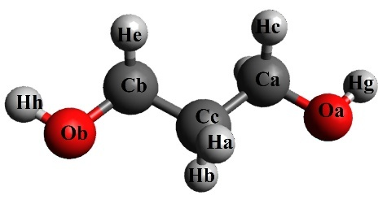  0.8*q(e)
Ca | 0.0083 | 0.00664
Cb | 0.0085 | 0.0068
Cc | -0.1981 | -0.15848
Ha | 0.1216 | 0.09728
Hb | 0.1216 | 0.09728  Figure S5. Atom Type Representation of 1,3-Propanediol (1,3-PDO).
Hc | 0.0668 | 0.05344
Hd | 0.0668 | 0.05344
He | 0.0669 | 0.05352
Hf | 0.0669 | 0.05352
Hg | 0.4122 | 0.32976
Hh | 0.412 | 0.3296
Oa | -0.5766 | -0.46128
Ob | -0.5769 | -0.46152

TABLE S9. Non-Bonded Parameters σ(Å) and є (Kcal/mol), Bond force constants r₀ (Å) K_{r} (Kcal mol⁻¹Å⁻²) of 1,3-PDO.
  Atom Type | σ (Å) | є (Kcal/mol)
  Ca | 0.066 | 3.50
  Cb | 0.066 | 3.50
  Cc | 0.066 | 3.50
  Ha | 0.030 | 2.50
  Hb | 0.030 | 2.50
  Hc | 0.030 | 2.50
  Hd | 0.030 | 2.50
  He | 0.030 | 2.50
  Hf | 0.030 | 2.50
  Hg | 0.003 | 2.50
  Hh | 0.00 | 0.00
  Oa | 0.170 | 3.120
  Ob | 0.170 | 3.120
  Bonds | r₀ (Å) | K_{r} (Kcal mol⁻¹Å⁻²)
  Ca-Cc | 268.00 | 1.5290
  Ca-Hc | 340.00 | 1.0900
  Ca-Hd | 340.00 | 1.0900
  Ca-Oa | 320.00 | 1.4100
  Cc-Cb | 268.00 | 1.5290
  Cc-Hb | 340.00 | 1.0900
  Cc-Hg | 340.00 | 1.0900
  Cb-He | 340.00 | 1.0900
  Cb-Hf | 340.00 | 1.0900
  Cb-Ob | 320.00 | 1.4100
  Cb-Oa | 553.00 | 0.9450
  Hh-Ob | 553.00 | 0.9450

TABLE S10. Angle force constants θ₀ (degrees) K_{θ} (Kcal mol⁻¹rad⁻²), for 1,3-PDO.
  Angles | θ₀ | K_{θ}
  Ca-Cc-Cb | 112.70 | 58.35
  Ca-Cc-Hb | 110.70 | 37.50
  Ca-Cc-Ha | 110.70 | 37.50
  Ca-Oe-Hg | 108.50 | 55.00
  Cc-Ca-Hc | 110.70 | 37.50
  Cc-Ca-Hd | 110.70 | 37.50
  Cc-Ca-Oa | 109.50 | 50.00
  Ca-Cb-He | 110.70 | 37.50
  Cc-Cb-Hf | 110.70 | 37.50
  Cc-Cb-Ob | 109.50 | 50.00
  Angles | θ₀ | K_{θ}
  Cb-Cc-Hb | 110.70 | 37.50
  Cb-Cc-Ha | 110.70 | 37.50
  Cb-Cc-Hd | 108.50 | 55.00
  Hf-Ca-Hd | 107.80 | 33.00
  Hf-Ca-Oa | 109.50 | 35.00
  Hd-Ca-Oa | 109.50 | 35.00
  Hb-Cc-Ha | 107.80 | 33.00
  He-Cb-Hf | 107.80 | 33.00
  He-Cb-Ob | 109.50 | 35.00
  Hf-Cb-Ob | 109.50 | 35.00

TABLE S11. Torsional Fourier Coefficients (Kcal/mol) for 1,3-PDO.
  Torsion | V1 | V2 | V3
  Ca-Cc-Cb-He | 0.000 | 0.000 | 0.300
  Ca-Cc-Cb-Hf | 0.000 | 0.000 | 0.300
  Ca-Cc-Cb-Ob | -1.552 | 0.000 | 0.000
  Cc-Ca-Ob-Hg | -0.356 | -0.174 | 0.492
  Cc-Cb-Ob-Hh | -0.356 | -0.174 | 0.492
  Hf-Ca-Cc-Cb | 0.000 | 0.000 | 0.300
  Hf-Ca-Cc-Hb | 0.000 | 0.000 | 0.300
  Hf-Ca-Cc-Ha | 0.000 | 0.000 | 0.300
  Hf-Ca-Oa-Hg | 0.000 | 0.000 | 0.352
  Hd-Ca-Cc-Cb | 0.000 | 0.000 | 0.300
  Hd-Ca-Cc-Hb | 0.000 | 0.000 | 0.300
  Hd-Ca-Cc-Ha | 0.000 | 0.000 | 0.300
  Torsion | V1 | V2 | V3
  Hd-Ca-Oa-Hn | 0.000 | 0.000 | 0.352
  Hb-Cc-Cb-He | 0.000 | 0.000 | 0.300
  Hb-Cc-Cb-Hf | 0.000 | 0.000 | 0.300
  Hb-Cc-Cb-Ob | 0.000 | 0.000 | 0.468
  Ha-Cc-Cb-He | 0.000 | 0.000 | 0.300
  Ha-Cc-Cb-Hf | 0.000 | 0.000 | 0.300
  Ha-Cc-Cb-Ob | 0.000 | 0.000 | 0.468
  He-Cb-Ob-Hh | 0.000 | 0.000 | 0.352
  Hf-Cb-Ob-Hh | 0.000 | 0.000 | 0.352
  Oe-Ca-Cc-Cb | -1.552 | 0.000 | 0.000
  Oe-Ca-Cc-Hb | 0.000 | 0.000 | 0.468
  Oe-Ca-Cc-Ha | 0.000 | 0.000 | 0.468

Table S12. Distribution of components in extract and raffinate phases from MD simulation at 298 K and 1 atm.
Systems | Extract Phase (IL phase) |  |  | Raffinate Phase (Aqueous phase)
 | $$N_{1,3-PDO}^{E}$$ | $$N_{Water}^{E}$$ | $$N_{IL}^{E}$$ | $$N_{1,3-PDO}^{R}$$ | $$N_{Water}^{R}$$ | $$N_{IL}^{R}$$
[Bmim][NPF2] | 82 | 1252 | 198 | 192 | 3348 | 2
[Bmim][NTF2] | 101 | 979 | 196 | 114 | 2521 | 4
[Bmim][SCN] | 145 | 375 | 237 | 35 | 2625 | 108
[Bmim][TFO] | 122 | 205 | 163 | 58 | 2795 | 72
Where, E represents Extract phase and R represents Raffinate phase.

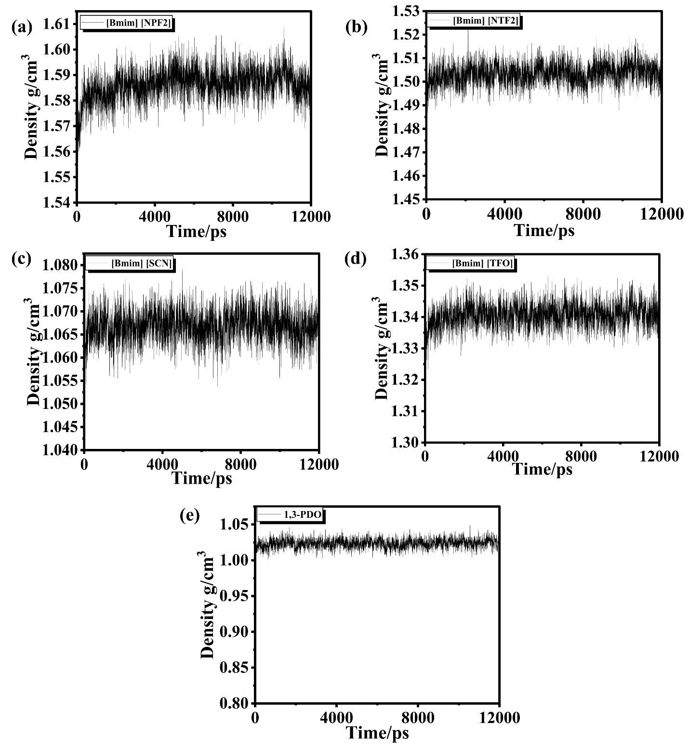
Figure S6. Density Profile Validation Using OPLS-AA Force Fields over 12ns Simulation at 298 K (5,6).
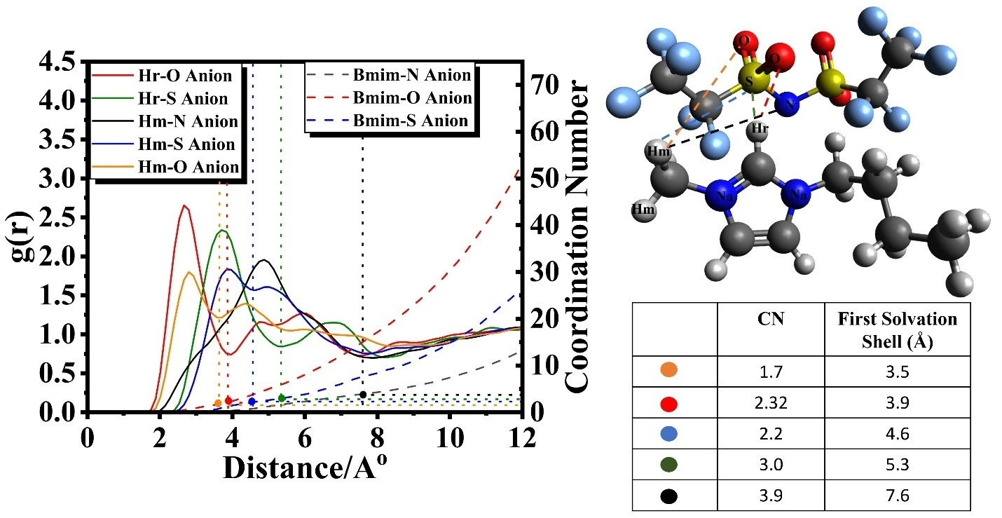
Figure S7. RDF Plot for [Bmim][NPF2].

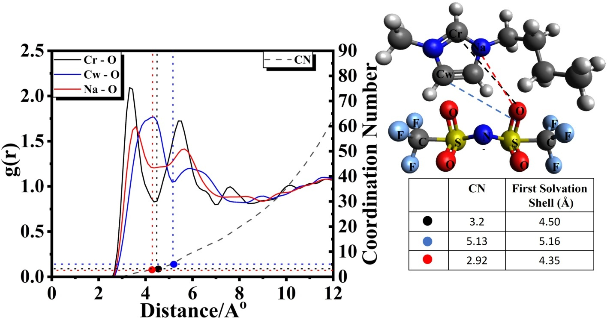
Figure S8. RDF Plot for [Bmim][NTF2] (7).

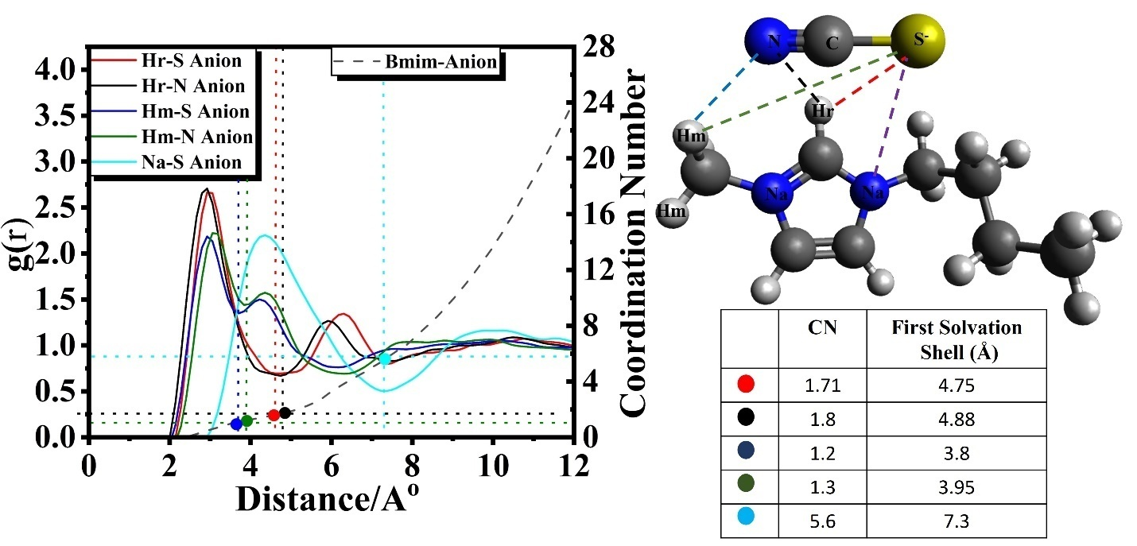
Figure S9. RDF Plot for [Bmim][SCN] (8).

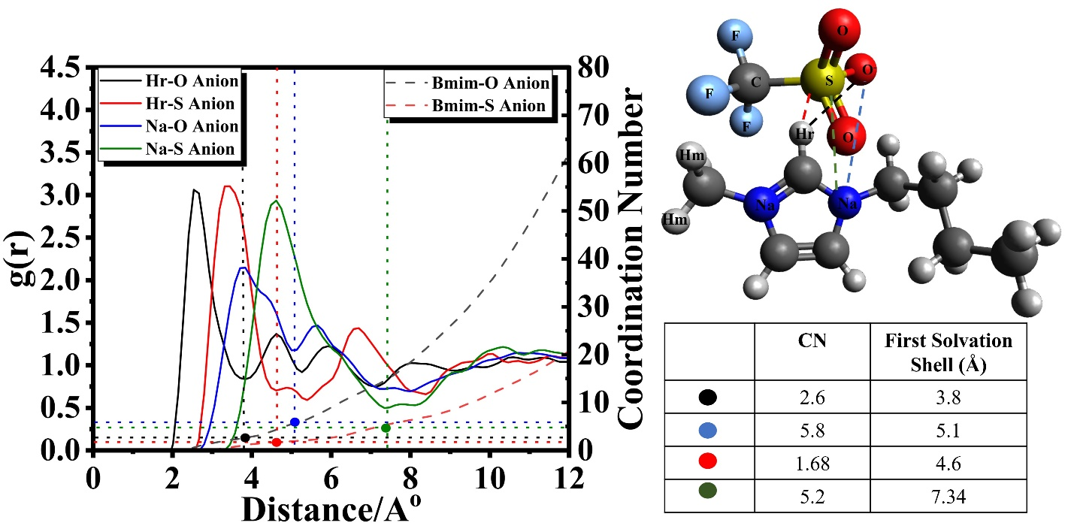
Figure S10. RDF Plot for [Bmim][TFO] (9).

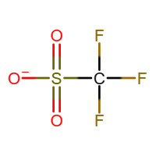

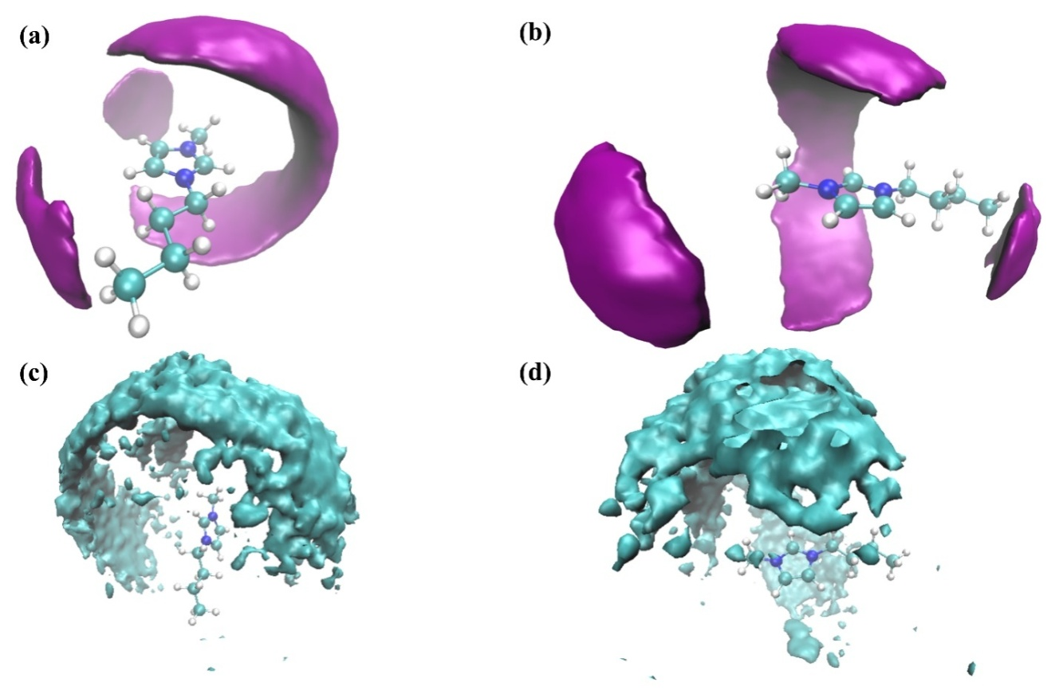
Figure S11. Spatial Distribution Function (SDF) Analysis of [Bmim][NTF2]: Molecular Density Distribution. (a) and (b) show the vertical and horizontal views of [NTF2] around [Bmim] cation. Similarly, (c) and (d) display [Bmim] cation around [Bmim] cation. Cyan color represents cation [Bmim] density, while purple depicts [NTF2] anion density (10).
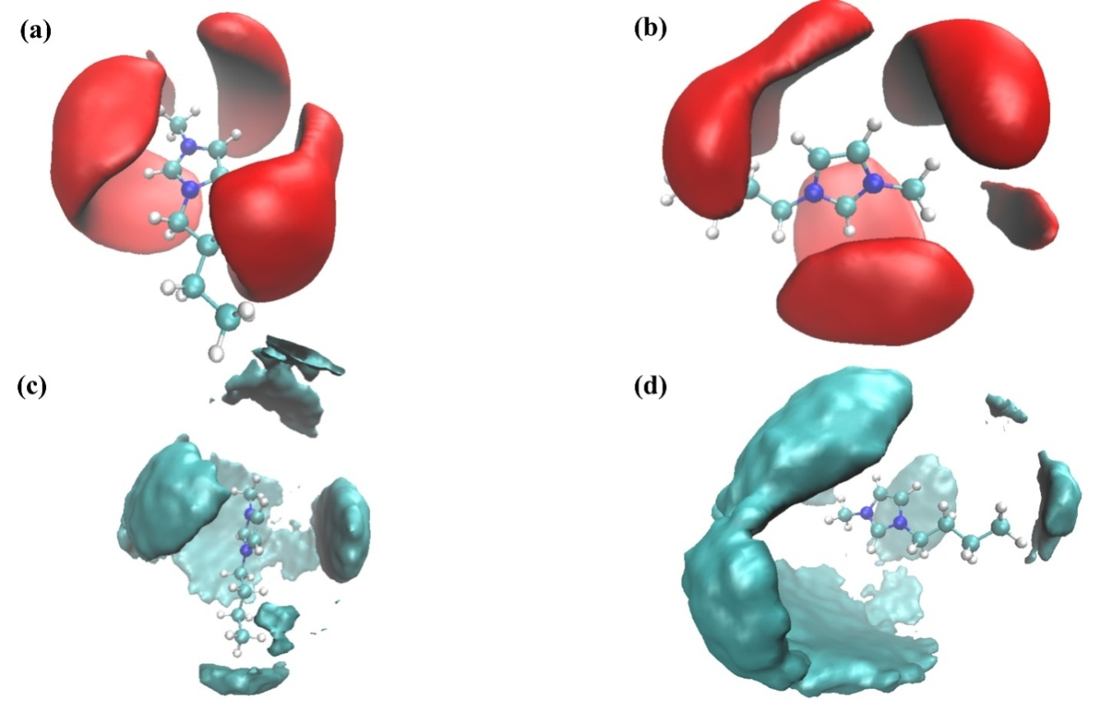
Figure S12. Spatial Distribution Function (SDF) Analysis of [Bmim][SCN]: Molecular Density Distribution. (a) and (b) display vertical and horizontal views of [SCN] around [Bmim] cation, while (c) and (d) depict [Bmim] cation around [Bmim] cation. Cyan color indicates [Bmim] cation density, and red signifies [SCN] anion density (11).
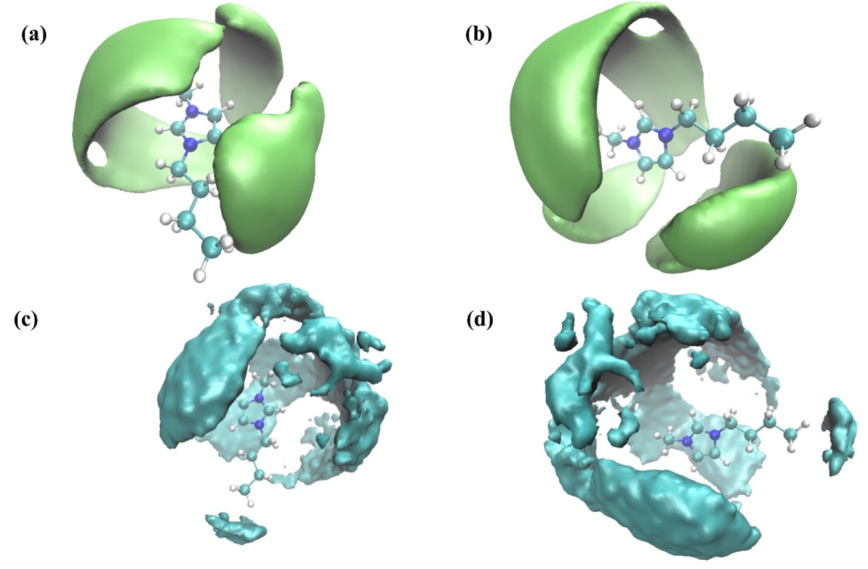
Figure S13. Spatial Distribution Function (SDF) Analysis of [Bmim][TFO]: Molecular Density Distribution. (a) and (b) show vertical and horizontal views of [TFO] around [Bmim] cation, while (c) and (d) depict [Bmim] cation around [Bmim] cation. Cyan color represents [Bmim] cation density, and lime signifies [TFO] anion density (12).

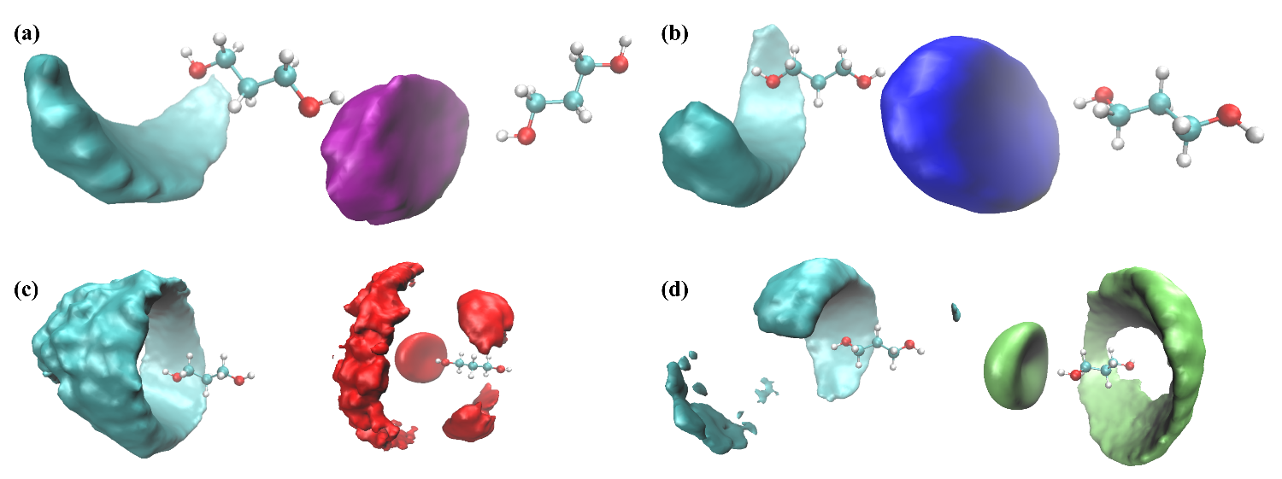
Figure S14. Spatial Distribution Function (SDF) visualisations of ILs around 1,3-PDO, Color code: Cyan for [Bmim]⁺ cation, Purple for [NPF2]⁻, Blue for [NTF2]⁻, Red for [SCN]⁻, and Lime for [TFO]⁻. (a) SDF of [NPF2]⁻ and [Bmim]⁺ around 1,3-PDO in [Bmim][NPF2], (b) SDF of [NTF2]⁻ and [Bmim]⁺ around 1,3-PDO in [Bmim][NTF2], (c) SDF of [SCN]⁻ and [Bmim]⁺ around 1,3-PDO in [Bmim][SCN] and (d) SDF of [TFO]⁻ and [Bmim]⁺ around 1,3-PDO in [Bmim][TFO].

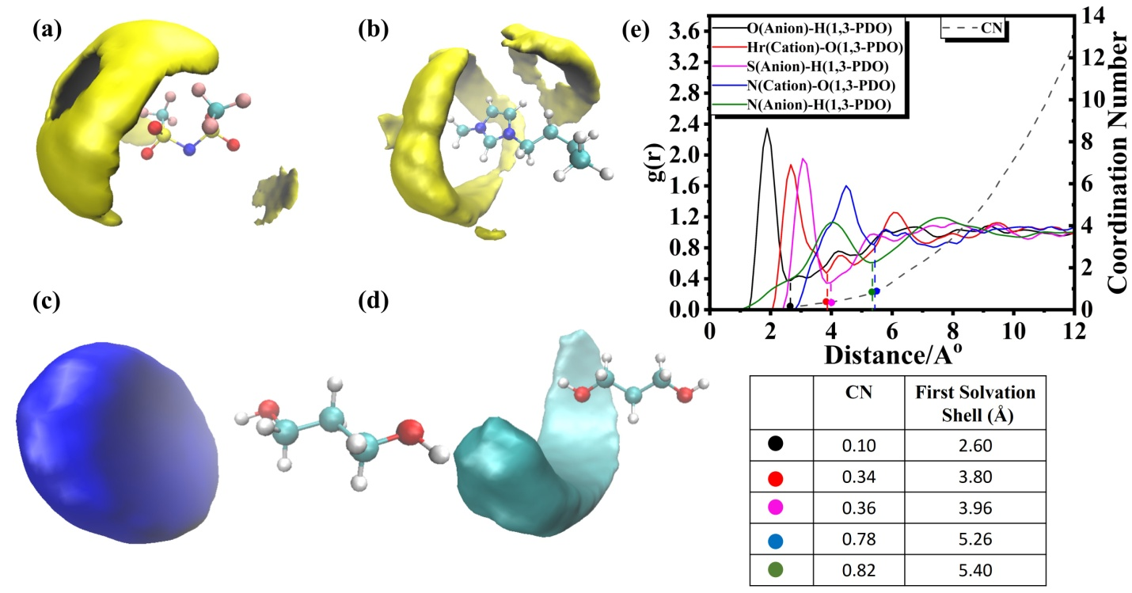
Figure S15. Molecular Distribution Analysis and Interatomic RDF of [Bmim][NTF2] with 1,3-PDO. (a) SDF of 1,3-PDO around [NTF2]⁻, (b) SDF of 1,3-PDO around [Bmim]⁺, (c) SDF of [NTF2]⁻ around 1,3-PDO, (d) SDF of [Bmim]⁺ around 1,3-PDO, and (e) Interatomic RDF Plot of ILs and 1,3-PDO at 298 K.

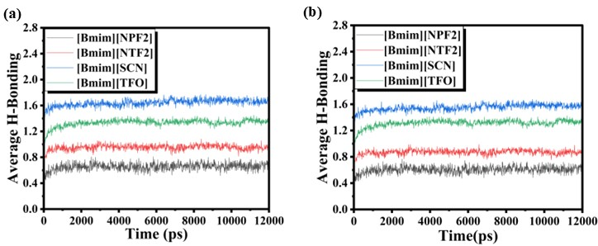 Figure S16. This figure displays the average number of hydrogen bonds observed after equilibration at 298 K. (a) H-Bonding between ILs and 1,3-PDO and (b) H-Bonding involving ILs anions and 1,3-PDO.

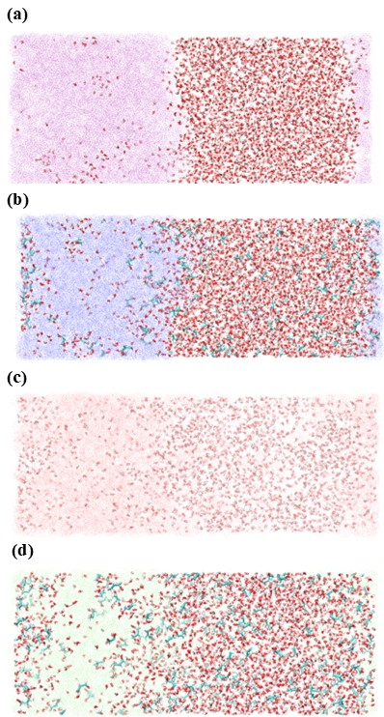
Figure S17. Comparative Analysis of Water Entry in Various Ionic Liquids (ILs) at 298 K. Distinguished by colors (a) [Bmim][NPF2] in purple, (b) [Bmim][NTF2] in blue, (c) [Bmim][SCN] in red, and (d) [Bmim][TFO] in lime—the figure unveils the unique behavior of each IL in accommodating water molecules under specified conditions.

Reference:
1. Banerjee T, Singh MK, Khanna A. Prediction of binary VLE for imidazolium based ionic liquid systems using COSMO-RS. Ind Eng Chem Res. 2006 Apr 26;45(9):3207–19. Available from: https://pubs.acs.org/doi/full/10.1021/ie051116c
2. Doherty B, Zhong X, Gathiaka S, Li B, Acevedo O. Revisiting OPLS Force Field Parameters for Ionic Liquid Simulations. J Chem Theory Comput. 2017 Dec 12;13(12):6131–5.
3. Sambasivarao S V., Acevedo O. Development of OPLS-AA force field parameters for 68 unique ionic liquids. J Chem Theory Comput. 2009 Apr 14;5(4):1038–50.
4. Dodda LS, De Vaca IC, Tirado-Rives J, Jorgensen WL. LigParGen web server: An automatic OPLS-AA parameter generator for organic ligands. Nucleic Acids Res. 2017 Jul 3;45(W1):W331–6.
5. Zhang R, Yue X, Li B, Yang J, Wu Z, Zhang J. Dynamic viscosity, density and surface tension of 1,3-propanediol (1) + 1,2-propanediamine (2) binary system at T = (293.15 to 318.15) K and atmosphere pressure. J Mol Liq. 2020 Feb 1;299.
6. Thomas M, Sanz IS, Kirchner B, Holloczki O. Ab Initio Molecular Dynamics Simulations of Ionic Liquids. NIC Symposium 2016. Forschungszentrum Jülich GmbH, Zentralbibliothek; 2016.
7. Jiang K, Liu L, Liu X, Zhang X, Zhang S. Insight into the Relationship between Viscosity and Hydrogen Bond of a Series of Imidazolium Ionic Liquids: A Molecular Dynamics and Density Functional Theory Study. Ind Eng Chem Res. 2019 Oct 9;58(40):18848–54.
8. Thar J, Brehmy M, Seitsonen AP, Kirchner B. Unexpected hydrogen bond dynamics in imidazolium-based ionic liquids. Journal of Physical Chemistry B. 2009 Nov 19;113(46):15129–32.
9. Fatima U, Riyazuddeen, Montes-Campos H, Varela LM. Experimental and MD simulation investigation on thermophysical properties of binary/ternary mixtures of 1-butyl-3-methylimidazolium trifluoromethanesulfonate with molecular solvents. J Mol Liq. 2020 Mar 15;302.
10. Dhakal P, Shah JK. Recent advances in molecular simulations of ionic liquid–ionic liquid mixtures. Vol. 18, Current Opinion in Green and Sustainable Chemistry. Elsevier B.V.; 2019. p. 90–7.
11. Wang N, Zhang Y, Al-Barghouti KS, Kore R, Scurto AM, Maginn EJ. Structure and Dynamics of Hydrofluorocarbon/Ionic Liquid Mixtures: An Experimental and Molecular Dynamics Study. Journal of Physical Chemistry B. 2022 Oct 20;126(41):8309–21. Available from: https://pubs.acs.org/doi/full/10.1021/acs.jpcb.2c05787
12. Marekha BA, Koverga VA, Chesneau E, Kalugin ON, Takamuku T, Jedlovszky P, et al. Local Structure in Terms of Nearest-Neighbor Approach in 1-Butyl-3-methylimidazolium-Based Ionic Liquids: MD Simulations. Journal of Physical Chemistry B. 2016 Jun 9;120(22):5029–41. Available from: https://pubs.acs.org/doi/full/10.1021/acs.jpcb.6b04066

