Supplementary Materials for

An additively manufactured flexible millimeter-wave Doppler radar: Towards fully printed high-frequency multilayer flexible hybrid electronics

Hong Tang¹, Yingjie Zhang², Shiqi Li³, Bowen Zheng¹, Sensong An¹, Mohammad Haerinia¹, Yunxi Dong¹, Yi Huang¹, Huan Zhao¹, Wei Guo², and Hualiang Zhang^{1*}

¹Department of Electrical and Computer Engineering, University of Massachusetts Lowell, Lowell, MA, 01854, USA
²Department of Physics and Applied Physics, University of Massachusetts Lowell, Lowell, MA, 01854, USA
³Yunnan Precious Metal Laboratory Co., Ltd, Kunming 650106, PR China
*Corresponding author. Email: Hualiang_Zhang@uml.edu

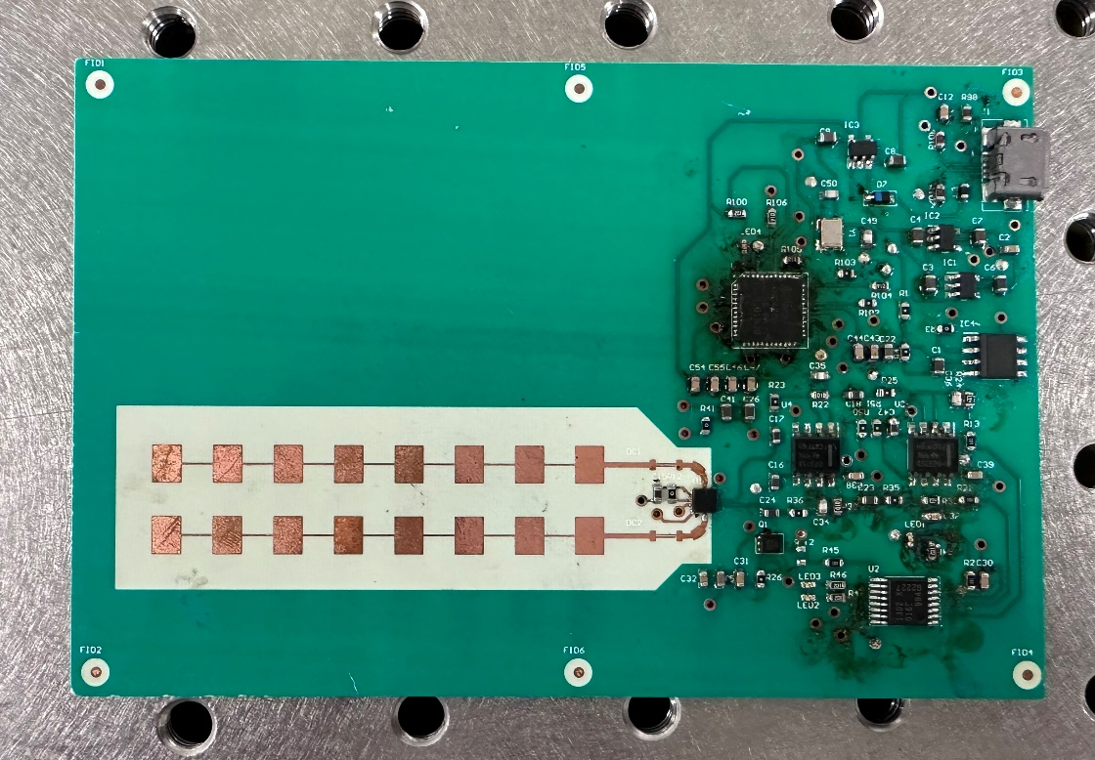

Supplementary Figure 1.
A photo of the rigid Doppler radar manufactured by conventional PCB technologies

Supplementary Figure 2.
Performance of the rigid Doppler radar. a) Measured output spectrum of the rigid radar. b) Simulated realized gain with different conductivities. c) Field tests results of the rigid radar.

The experimental setups are identical to the tests for printed radar detailed in section Results of the main manuscript. The output spectrum of the RF module is shown in Supplementary Figure 2a. It can be seen that the output frequency of the rigid radar is 24.05 GHz, and the detected output power at that frequency is -23.6737 dBm. It is worth mentioning that the measured amplitude is 3.31dBm larger than that of the printed radar. We surmise that the primary reason for this is the conductivity of the commercial silver ink, which is approximately 2M S/m, is less than that of copper, which stands at 58M S/m. Compared with copper, the lower conductivity of commercial silver ink leads to lower efficiency, lower realized gain, and lower output spectrum magnitude. Simulated realized gains with different values of conductivities are presented in Supplementary Figure 2b. It can be observed that a lower conductivity will lead to a lower gain. Indoor field tests were conducted to characterize performance of the rigid radar. The processed 2D velocity mapping is shown in Supplementary Figure 2c.

Supplementary Figure 3.
Geometries of the mmWave patch antenna array.

Supplementary Figure 4.
a) Simulation model of the un-bent antenna array. b) Simulation model of the bent antenna array. c, d) Simulated reflection coefficients and realized gains of the bent and un-bent antenna arrays.

Supplementary Figure 5.
Photos of the printed flexible radar which is conformally integrated with a vehicle rear bumper.

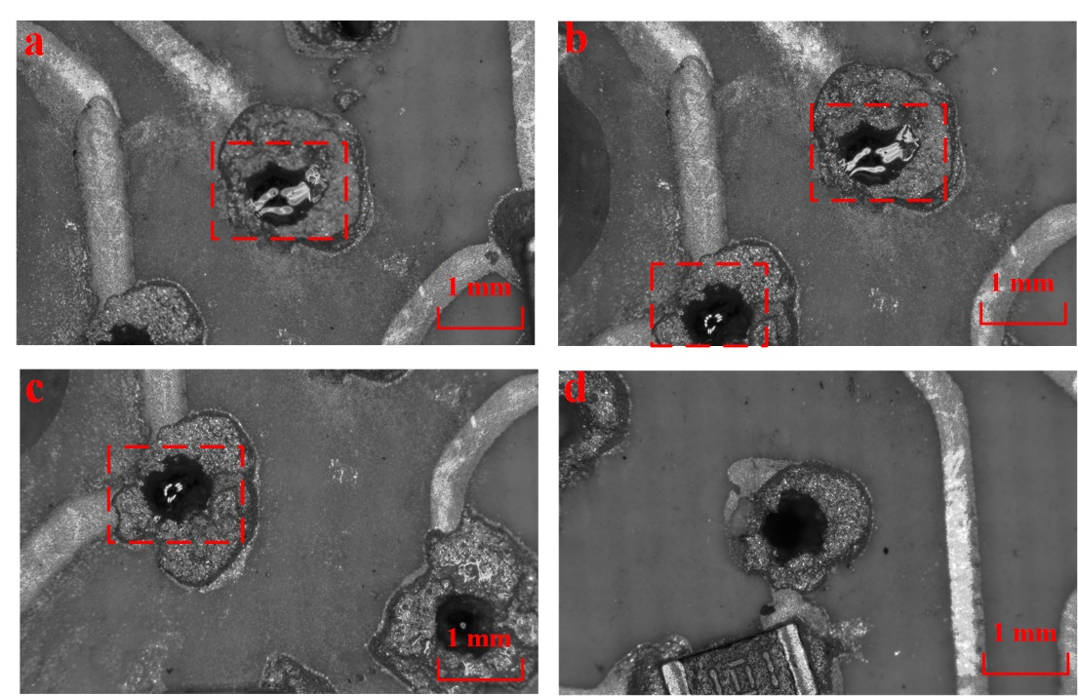

Supplementary Figure 6.
Comparisons between microphotographs of the vias. a-c) Vias filled with high-heat epoxy. d) Vias without high-heat epoxy.
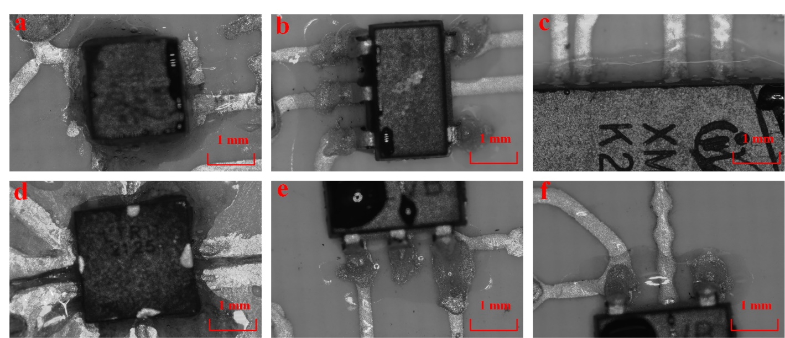

Supplementary Figure 7.
The microphotographs of the SMD chips/components with high-heat epoxy to increase the reliability of the radar system. a) CMOS switch. b) LDO. c) MCU. d) mmWave transceiver. e) LDO. f) LDO.

Supplementary Figure 8.
An example of the raw IF data before and after processing. a) The received raw IF data. b) The spectrum of the IF data. c) The processed velocity spectrum.

Supplementary Table 1.
Comparisons between the designed and fabricated parameters (labeled in SF. 3) of the mmWave patch antenna array.

Item Name | Designed Value (mm) | Manufactured  Value (mm) | Error Rate | Item  Name | Designed Value (mm) | Manufactured  Value (mm) | Error Rate
w1 | 0.51 | 0.50 | 2.00% | l1 | 3.12 | 3.10 | 0.64%
w2 | 4.1 | 4.13 | 0.73% | l2 | 3.44 | 3.32 | 3.49%
w3 | 0.2 | 0.18 | 10.00% | l3 | 3.12 | 3.14 | 0.64%
w4 | 4.1 | 4.11 | 0.24% | l4 | 3.44 | 3.26 | 5.23%
w5 | 0.2 | 0.19 | 5.00% | l5 | 3.12 | 3.11 | 0.32%
w6 | 4.1 | 4.08 | 0.49% | l6 | 3.44 | 3.26 | 5.23%
w7 | 0.2 | 0.19 | 5.00% | l7 | 3.12 | 3.14 | 0.64%
w8 | 4.1 | 4.08 | 0.49% | l8 | 3.44 | 3.29 | 4.36%
w9 | 0.2 | 0.21 | 5.00% | l9 | 3.12 | 3.11 | 0.32%
w10 | 4.1 | 4.11 | 0.24% | l10 | 3.44 | 3.32 | 3.49%
w11 | 0.2 | 0.18 | 10.00% | l11 | 3.12 | 3.12 | 0.00%
w12 | 4.1 | 4.09 | 0.24% | l12 | 3.44 | 3.29 | 4.36%
w13 | 0.2 | 0.21 | 5.00% | l13 | 3.12 | 3.09 | 0.96%
w14 | 4.1 | 4.13 | 0.73% | l14 | 3.44 | 3.31 | 3.78%
w15 | 0.2 | 0.18 | 10.00% | l15 | 3.12 | 3.11 | 0.32%
w16 | 4.1 | 4.10 | 0.00%

