Fig. S1. Prediction of subcellular localization of OsDUF6 protein
Fig. S2. Secondary domain analysis of OsDUF6 protein.
Fig. S3. Prediction of tertiary structure of OsDUF6 encoded protein.
Table. S1. Gene expression analysis primers for validation data.

Fig. S1. Prediction of subcellular localization of OsDUF6 protein
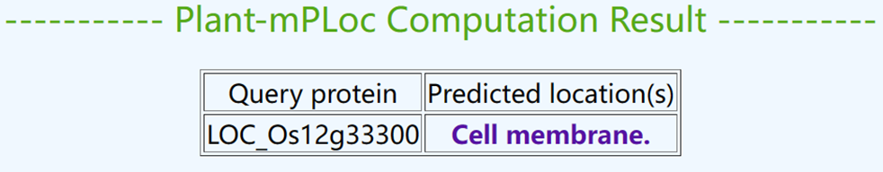

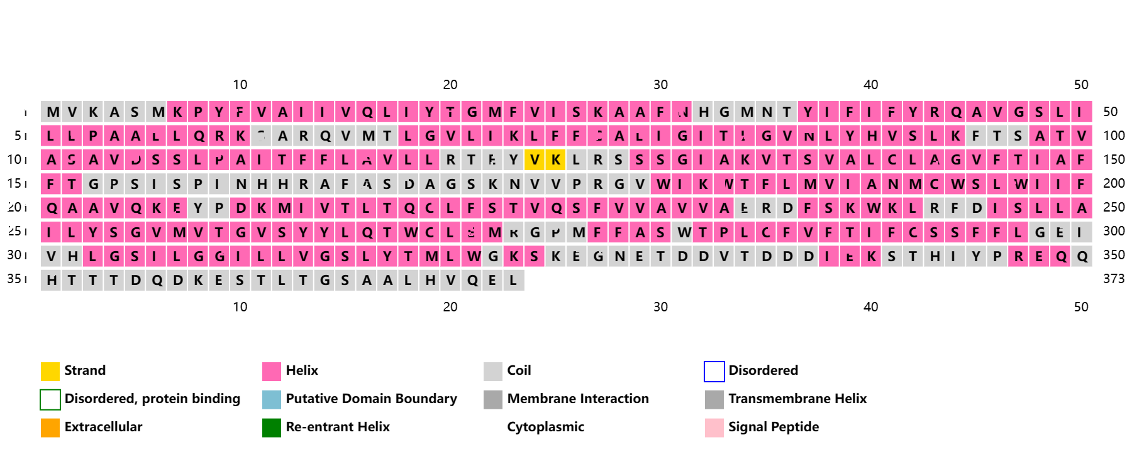
Fig. S2. Secondary domain analysis of OsDUF6 protein.
Fig. S3. Prediction of tertiary structure of OsDUF6 encoded protein. AlphaFold produces a per-residue confidence score (pLDDT) between 0 and 100. Some regions with low pLDDT may be unstructured in isolation
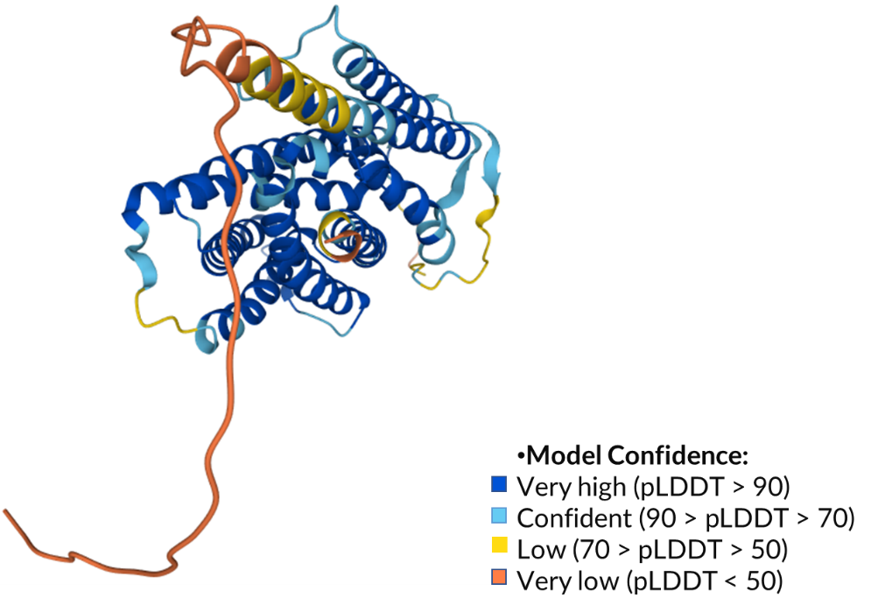

Table. S1. Gene expression analysis primers for validation data.
Gene name | Primer sequence | Description | Product size (bp)
LOC_Os11g26790 | F: CTCGTCTGAGGATGATGGAATG | dehydrin | 224
LOC_Os11g26790 | R: TGTCCATGATGCCCTTCTTC | dehydrin | 224
LOC_Os01g08320 | F: GGTGAACGGGACGGAGTA | OsIAA1 - Auxin-responsive Aux/IAA gene family member | 151
LOC_Os01g08320 | R: GGCTCTTGGTGCTAAGTTGA | OsIAA1 - Auxin-responsive Aux/IAA gene family member | 151
LOC_Os02g56120 | F: TTGATTTGGCCCTCCATTCC | OsIAA9 - Auxin-responsive Aux/IAA gene family member | 190
LOC_Os02g56120 | R: AAATCATCCCATGGCACGTC | OsIAA9 - Auxin-responsive Aux/IAA gene family member | 190
LOC_Os08g10290 | F: CAAGGTTACTACGGACCAATGA | SHR5-receptor-like kinase | 197
LOC_Os08g10290 | R: CCACCTTCTCCCACCATATTT | SHR5-receptor-like kinase | 197
LOC_Os02g42150 | F: GCCTACTCTTGGAGCAACTAAT | OsWAK14 - OsWAK receptor-like protein kinase | 166
LOC_Os02g42150 | R: ACACGCTGGTCAGATAGAATG | OsWAK14 - OsWAK receptor-like protein kinase | 166
LOC_Os04g51040 | F: CAAGGCTAGTCCCTTCCAATC | OsWAK50 - OsWAK receptor-like protein kinase | 189
LOC_Os04g51040 | R: TCCCTTCCTCTTGCCTATGA | OsWAK50 - OsWAK receptor-like protein kinase | 189
LOC_Os04g30240 | F: GCGCCTATGCTTGTCTATGAA | OsWAK60 - OsWAK receptor-like protein kinase | 194
LOC_Os04g30240 | R: AGGATGTTGGCTGGCTTTAC | OsWAK60 - OsWAK receptor-like protein kinase | 194
LOC_Os04g32480 | F: CTCCGATGACGCTCTTCTAC | zinc-finger protein | 163
LOC_Os04g32480 | R: GTTCTTGTGAGTGGCTCTTTG | zinc-finger protein | 163
LOC_Os01g19800 | F: CACGTTCACGGCTGTTCT | zinc finger, C3HC4 type | 178
LOC_Os01g19800 | R: GTATTGCCTCTGACCCTTCTG | zinc finger, C3HC4 type | 178
LOC_Os04g51830 | F: GCTCTTCGTCCTCATGATGTAT | OsHKT1;4 - Na+ transporter | 186
LOC_Os04g51830 | R: AGCTTTCTTCTCTCGGTGATG | OsHKT1;4 - Na+ transporter | 186

