Supplementary Information (SI)

Compounded Wind Gusts and Maximum Temperature via Semiparametric copula joint density modelling in the risk assessments of power blackouts and air-conditioning demands for major cities in Canada

Shahid Latif^{1*} and Taha B.M.J. Ouarda¹

¹Canada Research Chair in Statistical Hydro-Climatology, Institut national de la recherche scientifique, Centre Eau Terre Environnement, INRS-ETE, 490 De la Couronne, Québec City, QC, Canada

*Corresponding author Email address: Md_Shahid.LATIF@inrs.ca

This Supplementary material contains the following information:
- Supplementary Appendix (SA) (SA1-SA6)
- Supplementary Table (ST) (ST 1- ST6)
- Supplementary Figure (SF) (SF 1-SF 11)

Supplementary Appendix (SA)

SA1: Positively dependence parametric class 2-D copulas in the joint density modelling of bivariate extreme pairs

This present study selected positively dependence parametric copulas includes Archimedean class copulas and their mixed version (i.e., Frank, Clayton, Gumbel, AMH (Ali–Mikhail–Haq copula), Joe, BB1, BB6, BB7 and BB8), rotated mixed Archimedean by 180 degrees (also called Survival copulas) (i.e., Survival BB1, Survival BB6, Survival BB7 and Survival BB8), rotated monoparametric Archimedean by 180 degrees (i.e., Survival Clayton, Survival Gumbel and Survival Joe), extreme value (EV) class Tawn (Tawn type-1 and Tawn type-2) copula, rotated Tawn by 180 degrees (Survival Tawn type-1 and Survival Tawn type-2 copula) (Li 2016; Tang et al., 2015; Nikoloulopoulos et al., 2012; Reddy and Ganguli 2012; Manner 2010; Constantino 2008; Zhang and Singh 2007, 2006; Joe 1997; Joe et al., 1996; Tawn 1988). Rotation by 180 degrees is applicable to capture positive dependencies. The adequacy of Elliptical class-based Normal copula was also tested, which exhibit symmetrical tail dependence with zero upper and lower tail dependence structure (AghaKouchak et al., 2012; McNeil et al., 2005). Mixture Archimedean copulas usually possess higher flexibility than monoparametric Archimedean class (Latif and Simonovic 2022). For instance, BB1, BB7 and BB6 copula can easily capture upper tail dependence behaviour for WGS and MT events. Besides, Survival BB1 and Survival BB7 copulas can also effectively capture the upper tail portion for WGS and MT events. Besides, Gumbel and Joe copula can accommodate the upper tail extreme portion for given bivariate pairs. The Joe copula can effectively capture joint structure in case of higher positive dependency. Clayton and Frank copula have no upper tail dependency, whereas Frank copula can accommodate the entire dependence range, ${Frank}_{τ_{θ}}∈\left[-1, 1\right]$, while Clayton copula only accommodates a positive dependence range ${Clayton}_{τ_{θ}}∈\left[0, 1\right]$ and can capture lower tail dependence (Lee et al., 2013).

Mathematically, if $z_{1}$ and $z_{2}$ are the marginal vector, the rotation by 180 degrees is given by

${ C}^{180}=C(1-z_{1}, 1-z_{2})$ (1)

SA2: Estimating unknown dependence parameter fitted 2-D copulas for bivariate pairs AMWGS-MT (for EVSG-1) and AHMT-WGS (for EVSG-2) at selected time lag for all selected cities.

The selected candidate copulas' vector of unknown dependence parameters was estimated via rank-based distribution by maximizing the pseudo-log-likelihood functions, called maximum pseudo-likelihood (MPL) estimation (Latif et al., 2023; Latif and Simonovic 2022; Reddy and Ganguli 2012; Klein et al., 2010).

$Pseudo log-likelihood function= l\left(θ\right)=\sum_{v=1}^{n}{log⁡[C_{θ}\left\{F_{1}\left(Z_{v,1}\right), F_{2}\left(Z_{v,2}\right)\right\}}$ (1)

Where, $F_{1}\left(Z_{v,1}\right) and F_{2}\left(Z_{v,2}\right)$ are the empirical CDFs. The copula dependence parameters can be estimated by maximizing this rank-based pseudo-log-likelihood function, which is calculated by.

$\hat{θ}=argmax[lnL_{v}\left(θ\right)]$ (2)

SA3: Performance evaluation of fitted 2D copula density functions via Cramer von Mises (CvM) functional test statistics $S_{n}$ with parametric bootstrapping procedure.

The performance evaluation of fitted candidate copulas was examined using the Cramer von Mises (CvM) function test statistics S_{n} with a parametric bootstrapping procedure (Latif and Simonovic 2022; Ganguli and Reddy 2012)

$S_{n}=n∫_{{[0,1]}^{2}}{\left\{c_{n}\left(u,v\right)-c_{θ}\left(u,v\right)\right\}}^{2}dC_{n}\left(u,v\right)=\sum_{i=1}^{n}{{\left\{C_{n}\left(U_{i,n},V_{i, n}\right)-C_{θ}\left(U_{i,n},V_{i, n}\right)\right\}}^{2}}$ (1)

$C_{θ}$ is the parametric 2-D copula derived under the null hypothesis, $H_{o}$, where u and v are the univariate marginal distribuiton. $c_{n}\left(u,v\right)$, are the bivariate empirical copulas estimated using n observational random pairs. Similarly, $U_{i,n},{ and V}_{i, n}$ are the pseudo-observations of C transformed from $\left(X_{1}, Y_{1}\right), \left(X_{2}, Y_{2}\right),….., \left(X_{n}, Y_{n}\right)$ where the numerical value of $U_{i,n},V_{i, n}$ are estimated by

$U_{i,n}=\frac{1}{n+1}\sum_{j=1}^{n}{1(X_{j}≤X_{i})}; V_{i,n}=\frac{1}{n+1}\sum_{j=1}^{n}{1(Y_{j}≤Y_{i})} , i∈\left\{1, 2,…, n\right\}$ (2)

N represents the number of simulations. To incorporate CvM statistics, p-values must be estimated for each selected copula density, which is mathematically calculated by.

$P=\frac{1}{N}\sum_{i=1}^{n}{1(S_{n,t}≥S_{n})}$ (3)

The acceptance or rejection of candidate copulas is contingent on estimated S_{n} values (and p-value). To ensure a satisfactory selection and suitability of 2-D copula density, the minimum value of S_{n} statistics with p-values greater than 0.05 - based on a 5% significance level - must be attained, with any value below this threshold warranting rejection.

SA4: Bandwidth estimation procedure of fitted GKDE models in the univariate marginal distribution of AMWGS and corresponding MT events (for EVSG-1), and AHMT and corresponding WGS (for EVSG-2).

The mean integrated square error (MISE) statistics are used to outline the performance of fitted density, $\hat{f}$ is estimated by (Han et al., 2019; Chen 2015; Qin et al., 2011; Karmakar and Simonovic 2008).

$MISE=E\left(∫{(\hat{f}\left(z\right)-f\left(z\right))}^{2}dz\right)≈\frac{R\left(K\right)}{nh}+\frac{h^{4}μ_{2}^{2}\left(K\right)R(f^{'})}{4}$ (1)

The kernel bandwidth is usually estimated to minimize the MISE of Equation (1). The SiROT bandwidth is estimated by.

$h_{Silverman ROT}=0.9*min\left(σ,\frac{interquartile range \left(IQR\right)}{1.35}\right)*n^{-1/5}$ (2)

Where $σ$ is the standard deviation (SD). While the Scott's ROT bandwidth is estimated by

$h_{Scott ROT}=1.06*σ*n^{-1/5}$ (3)

Both SiROT and ScROT methods are straightforward to calculate. Furthermore, the optimal bandwidth for the NS bandwidth selector is estimated by (Chen 2015; Zamborn and Dias 2013)

$h_{Normal scale}={\left(\frac{4}{3n}\right)}^{0.2}*IQR$ (4)

Similarly, using Equation (9), the LSCV bandwidth selector is constructed, followed by Bowman (1984)

$LSCV=\int{{\hat{f}}^{2}\left(z\right)d\left(z\right)-\frac{2}{n}\sum_{i}{{\hat{f}}_{-i}(Z_{i})}}$ (5)

For the LSCV selector, it is required to examine the estimate of LSCV(h) from the given historical datasets and maximize it over h. the optimal bandwidth is estimated by
$h_{Least Square cross validation= }\begin{matrix}argmin \\ h\end{matrix}LSCV(h)$ (6)

SA5: Model compatibility test among the fitted 1-D marginal probability distribution.

The AIC, BIC and HQC statistics are estimated mathematically by

$AIC=Nlog\left(MSE\right)+[2*\log\left(N\right)]$ (1)

$BIC=Nlog\left(MSE\right)+[k*\log\left(N\right)]$ (2)

$HQC=Nlog\left(MSE\right)+[2*k*\log\left(\log\left(N\right)\right)]$ (3)

N is the sample size, and k is the number of fitted parameters. The minimum AIC, BIC, HQC, and MSE test values must indicate better performance.

SA6: Estimating primary joint return periods for bivariate OR- and AND-hazard scenarios and conditional joint distribution, for bivariate distribution pairs AMWGS-MT (in case of EVSG-1) and AHMT-WGS (in case of EVSG-2) defined at different time lags.

Situation 1: When both AMWGS (or AHMT) and the corresponding MT (or WGS) events simultaneously exceed a specific threshold value (say, wgs or mt), i.e., $AMWGS≥wgs AND MT≥mt$, in case of EVSG-1 datasets group (or $AHMT≥mt AND WGS≥wgs, in case of EVSG-2 group)$, and called the AND-joint distribution case (or concurrence probability) and their associated RP are estimated for both extreme group EVSG-1 and EVSG-2.

$T_{EVSG-1 \left(AMWGS, MT\right)}^{AND} (or T_{EVSG-2 \left(AHMT, WGS\right)}^{AND}) =\frac{μ=1 (for annual maxima-based analysis)}{1-F\left(AMWGS\right)-F\left(MT\right)+C(AMWGS, MT)}\left(or \frac{μ=1 (for annual maxima-based analysis)}{1-F\left(WGS\right)-F\left(AHMT\right)+C(AHMT, WGS)} \right)$ (1)

Where, $F\left(AMWGS\right)$and F(MT) are the marginal cdf of AMWGS, and corresponding MT events belong to EVSG-1. $F\left(AHMT\right)$and F(WGS) are the marginal cdf of AHMT, and corresponding WGS events belong to the EVSG-2 group. In Equation 1, the denominator term ($F\left(AMWGS\right)+F\left(MT\right)-C\left(AMWGS, MT\right) (or(F\left(AHMT\right)+F\left(WGS\right)-C\left(AHMT, WGS\right))$, define joint non-exceedance probability (NEP) in the simultaneous occurrence of bivariate events.

Situation 2: When either WGS or MT exceeds a specific threshold value, $AMWGS≥wgs OR MT≥mt$ (or AHMT$≥mt OR WGS≥wgs)$ called the OR-joint distribution case, and their associated OR-joint RP are estimated by

$T_{EVSG-1 \left(AMWGS, MT\right)}^{OR}(or T_{EVSG-2 \left(AHMT, WGS\right)}^{OR})=\frac{μ=1 (for annual maxima-based analysis)}{1-C(AMWGS, MT)}\left(or\frac{μ=1 (for annual maxima-based analysis)}{1-C(AHMT, WGS)}\right)$ (2)

Situation 3: Understanding conditional joint distribution is crucial in bivariate hazard risk modelling. The joint probability distribution of AMWGS (or AHMT) conditional on the corresponding MT (or WGS) events were defined at different percentile values (50th, 75th, 100th). This study used a semiparametric copula density model to estimate the conditional joint RPs for two different situations.

- When conditional on MT events (in the case of the EVSG-1 group)

$T_{AMWGS|MT≥mt}^{EVSG-1}=\frac{1}{(1-F\left(MT\right)*(1-F\left(MT\right)-F\left(AMWGS\right)+C\left(F\left(AMWGS\right), F\left(MT\right)\right))}$ (3)

- When conditional on WGS events (in the case of the EVSG-2 group)

$T_{AHMT|WGS≥wgs}^{EVSG-2}=\frac{1}{(1-F\left(WGS\right)*(1-F\left(AHMT\right)-F\left(WGS\right)+C\left(F\left(AHMT\right), F\left(WGS\right)\right))}$ (4)

References:

AghaKouchak, A., Sellars, S., Sorooshian, S., (2012). Methods of Tail Dependence Estimation. Water Science and Technology Library, pp. 163–179. https://doi.org/ 10.1007/978-94-007-4479-0_6.

Chen, S. (2015). Optimal bandwidth selection for kernel density functional estimation. Journal of Probability and Statistics, 2015.

Constantino M, Larran M, Brebbia CA (2008) Computational fnance and its applications III, Volume 41 of WIT transactions on information and communication technologies, WIT Press, 2008.
Genest C, Rémillard B, Beaudoin D (2009) Goodness-of-ft tests for copulas: a review and a power study. Insur Math Econ 44:199–214.

Genest C, Rémillard B (2008) Validity of the parametric bootstrap for goodness-of-ft testing in semiparametric models. Ann L’inst Henri Poincare Prob Stat 44:1096–1127.

Han, Q., Ma, S., Wang, T., & Chu, F. (2019). Kernel density estimation model for wind speed probability distribution with applicability to wind energy assessment in China. Renewable and Sustainable Energy Reviews, 115, 109387.

Joe, H., (1997). Multivariate Models and Multivariate Dependence Concepts. CRC press.
Joe, H., Hu, T., (1996). Multivariate distributions from mixtures of max-infinitely divisible distributions. J. Multivariate Anal. 57 (2), 240–265. https://doi.org/10.1006/jmva.1996.0032.
Karmakar, S., & Simonovic, S. P. (2008). Bivariate flood frequency analysis: Part 1. Determination of marginals by parametric and nonparametric techniques. Journal of Flood Risk Management, 1(4), 190-200.

Klein, B., Pahlow, M., Hundecha, Y., Schumann, A., 2010. Probability Analysis of Hydrological Loads for the Design of Flood Control Systems Using Copulas. J. of Hydrol. Eng. 15 (5), 360–369. https://doi.org/10.1061/(asce)he.1943- 5584.0000204.

Latif, S., & Simonovic, S. P. (2022). Parametric Vine copula framework in the trivariate probability analysis of compound flooding events. Water, 14(14), 2214.
Latif, S., Souaissi, Z., & Ouarda, T. B. (2023). Copula-based joint modelling of extreme river temperature and low flow characteristics in the risk assessment of aquatic life. Weather and Climate Extremes, 100586.

Latif, S., & Simonovic, S. (2022). Trivariate probabilistic assessments of the compound flooding events using Semiparametric Fully Nested Archimedean (FNA) copula approach.

Lee, T., Modarres, R. and Ouarda, T.B.M.J. (2013). Data-based analysis of bivariate copula tail dependence for drought duration and severity. Hydrol. Process., 27(10), 1454-1463, DOI:10.1002/hyp.9233

Li F (2016) Modeling covariate-contingent correlation and taildependence with copulas. https://arxiv.org/pdf/1401.0100.pdf.
Manner H (2010) Modelling assymetric and time-varying dependence. https://cris.maastrichtuniversity.nl/portal/fles/667227/ guid-ae8195ad-cf0b%20–4744–8bb1–6a44fbe10fe7-ASSET1.0.
McNeil, J., Frey, R., Embrechts, P., (2005). Quantitative Risk Management: Concepts, Techniques and Tools. Princeton University Press, Princeton, NJ, U.S.A., 2005.Bowman, A. W. (1984). An alternative method of cross-validation for the smoothing of density estimates. Biometrika, 71(2), 353-360.
Nikoloulopoulos, A.K., Joe, H., Li, H., (2012). Vine copulas with asymmetric tail dependence and applications to financial return data. Comput. Stat. Data Anal. 56 (11), 3659–3673. https://doi.org/10.1016/j.csda.2010.07.016.
Qin, Z., Li, W., & Xiong, X. (2011). Estimating wind speed probability distribution using kernel density method. Electric Power Systems Research, 81(12), 2139-2146.

Reddy MJ, Ganguli P (2012) Bivariate flood frequency analysis of Upper Godavari River flows using Archimedean copulas. Water Resour Manage. https://doi.org/10.1007/s11269-012-0124-z.

Tang Y, Huynh VN, Lawry J (2015) Integrated uncertainty in knowledge modelling and decision making. In: 4th International Symposium, Proceedings, LNAI 9376, Springer-Verlag.
Tawn, J.A., 1988. Bivariate extreme value theory: models and estimation. Biometrika 75 (3), 397–415. https://doi.org/10.1093/biomet/75.3.397.
Zamborn A, Dias R. A review of kernel density estimation with applications to econometrics. International Econometric Review 2013; 5:20–42.
Zhang L, Singh VP (2006) Bivariate flood frequency analysis using copula method. J Hydrol Eng 11(2):150. https://doi.org/10.1061/(ASCE)1084-0699(2006)11:2(150)
Zhang L, Singh VP (2007) Trivariate flood frequency analysis using the Gumbel-Hougaard copula. J Hydrol Eng 12(4):431–439. https://doi.org/10.1061/(ASCE)1084-0699(2007)12:4(431)

Supplementary Table (ST)

ST 1: Geographical location (with characteristics) of the selected major cities in Canada used in this study

Selected Geographical region of Canada | Case study cities (location of weather gauge station) | Geographical Coordinates |  | Elevations (meters) | Climate ID (WMO ID) | Data availability Time interval
Selected Geographical region of Canada | Case study cities (location of weather gauge station) | Latitude (Decimal Degrees) | Longitude (Decimal Degrees) | Elevations (meters) | Climate ID (WMO ID) | Data availability Time interval
Central Canada | Montreal (MONTREAL/PIERRE ELLIOTT TRUDEAU INTL A) | 45.47 | -73.75 | 36.00 | 7025250 (71627) | 1955-1995
Central Canada | Quebec City (QUEBEC/JEAN LESAGE INTL A) | 46.8 | -71.38 | 60.00 | 701S001(71714) | 1959-1991
Central Canada | Ottawa (OTTAWA MACDONALD-CARTIER INT’L A) | 45.32 | -75.67 | 114.00 | 6106000(71628) | 1955-2011
Central Canada | Toronto (TORONTO ISLAND A) | 43.63 | -79.4 | 76.50 | 6158665 (71265) | 1970-2004
Atlantic Canada | Halifax (HALIFAX STANFIELD INT’L A) | 44.88 | -63.5 | 145.40 | 8202250 (NA) | 1961-2012
West coast (Pacific) | Vancouver (VANCOUVER INT’L A) | -123.18 | 49.2 | 4.30 | 1108447 (NA) | 1955-2013
Canadian Prairies | Calgary (CALGARY INT’L A) | -114.02 | 51.11 | 1084.10 | 3031093 (NA) | 1955-2011
Canadian Prairies | Edmonton (EDMONTON CITY CENTRE A) | -113.52 | 53.57 | 670.60 | 3012208 (NA) | 1955-1991
Canadian Prairies | Regina (Regina INT’T Airport) | -104.67 | 50.43 | 577.60 | 4016560 (NA) | 1955-1995

ST2: Stationwise correlation measures for bivariate extreme sample of EVSG-1 and EVSG-2 (a) Montreal (b)Quebec City(c) Ottawa(d) Toronto(e) Halifax (f) Regina(g) Edmonton(h) Calgary (i) Vancouver

- EVSG-1 (Montreal)
PEARSON $r$ correlation measure  (Annual maximum WGS (km/hr)) | Corresponding highest MT (Time lag = 0days) | Corresponding highest MT (Time lag = $±$1days) | Corresponding highest MT (Time lag = $±2days$) | Corresponding highest MT (Time lag = $±3days$)
 | 0.1722423 | 0.1281539 | 0.2155188 | 0.07504514
KENDALL’S $τ$  Correlation measure  (Annual maximum WGS (km/hr)) | Corresponding highest MT (Time lag = 0day) | Corresponding highest MT (Time lag = $±$1days) | Corresponding highest MT (Time lag = $±2days$) | Corresponding highest MT (Time lag = $±3$days)
 | 0.1626238 | 0.09803922 | 0.1334206 | 0.09305405
SPEARMAN’S $ρ$  Correlation measure  (Annual maximum WGS (km/hr)) | Corresponding highest MT (Time lag = 0day) | Corresponding highest MT (Time lag = $±$1days) | Corresponding highest MT (Time lag = $±2$days) | Corresponding highest MT (Time lag = $±3days$)
 | 0.2065059 | 0.1451598 | 0.1960711 | 0.1392911
EVSG-2 (Montreal region)
PEARSON $r$ correlation measure  (Annual Highest MT (°C)) | Corresponding Maximum WGS (Time lag = 0day) | Corresponding Maximum WGS (Time lag = $±$1days) | Corresponding Maximum WGS (Time lag = $±2days$) | Corresponding Maximum WGS (Time lag = $±3days$)
PEARSON $r$ correlation measure  (Annual Highest MT (°C)) | 0.2628014 | 0.1037331 | 0.142345 | 0.1174951
KENDALL’S $τ$  Correlation measure  (Annual Highest MT (°C)) | Corresponding Maximum WGS (Time lag = 0day) | Corresponding Maximum WGS (Time lag = $±$1days) | Corresponding Maximum WGS (Time lag = $±2days$) | Corresponding Maximum WGS (Time lag = $±3days$)
KENDALL’S $τ$  Correlation measure  (Annual Highest MT (°C)) | 0.1583508 | 0.03446082 | 0.02251727 | 0.002642155
SPEARMAN’S $ρ$  Correlation measure  (Annual Highest MT (°C)) | Corresponding Maximum WGS (Time lag = 0day) | Corresponding Maximum WGS (Time lag = $±$1days) | Corresponding Maximum WGS (Time lag = $±2days$) | Corresponding Maximum WGS (Time lag = $±3$days)
 | 0.2303887 | 0.04524699 | 0.02584626 | 0.006071168

- EVSG-1 (Quebec City)
PEARSON $r$ correlation measure  (Annual maximum WGS (km/hr)) | Corresponding highest MT (Time lag = 0 day) | Corresponding highest MT (Time lag = $±$1 days) | Corresponding highest MT (Time lag = $±2 days$) | Corresponding highest MT (Time lag = $±3$ days)
 | 0.2994686 | 0.3031576 | 0.2958471 | 0.3120666
KENDALL’S $τ$  Correlation measure  (Annual maximum WGS (km/hr)) | Corresponding highest MT (Time lag = 0 day) | Corresponding highest MT (Time lag = $±$1 days) | Corresponding highest MT (Time lag = $±2 days$) | Corresponding highest MT (Time lag = $±3 days$)
 | 0.2363122 | 0.1990347 | 0.1884619 | 0.19865
SPEARMAN’S $ρ$  Correlation measure  (Annual maximum  WGS (km/hr)) | Corresponding highest MT (Time lag = 0 day) | Corresponding highest MT (Time lag = $±$1 days) | Corresponding highest MT (Time lag = $±2 days$) | Corresponding highest MT (Time lag = $±3$ days)
 | 0.3493976 | 0.2716691 | 0.2542259 | 0.2874006
EVSG-2 (Quebec City region)
PEARSON $r$ correlation measure  (Annual Highest MT (°C)) | Corresponding Maximum WGS (Time lag = 0 day) | Corresponding Maximum WGS (Time lag = $±$1 days) | Corresponding Maximum WGS (Time lag = $±2 days$) | Corresponding Maximum WGS (Time lag = $±3 days$)
PEARSON $r$ correlation measure  (Annual Highest MT (°C)) | 0.002052602 | -0.05249976 | 0.0520765 | 0.1057078
KENDALL’S $τ$  Correlation measure  (Annual Highest MT (°C)) | Corresponding Maximum WGS (Time lag = 0 day) | Corresponding Maximum WGS (Time lag = $±$1 days) | Corresponding Maximum WGS (Time lag = $±2 days$) | Corresponding Maximum WGS (Time lag = $±3 days$)
KENDALL’S $τ$  Correlation measure  (Annual Highest MT (°C)) | 0.01002006 | -0.05726039 | 0.04130371 | 0.0492187
SPEARMAN’S $ρ$  Correlation measure  (Annual Highest MT (°C)) | Corresponding Maximum WGS (Time lag = 0 day) | Corresponding Maximum WGS (Time lag = $±$1 days) | Corresponding Maximum WGS (Time lag = $±2 days$) | Corresponding Maximum WGS (Time lag = $±3 days$)
 | 0.003628695 | -0.07725314 | 0.0688848 | 0.0830957

- EVSG-1 (Ottawa)
PEARSON $r$ correlation measure  (Annual maximum WGS (km/hr)) | Corresponding highest MT (Time lag = 0 day) | Corresponding highest MT (Time lag = $±$1 days) | Corresponding highest MT (Time lag = $±2 days$) | Corresponding highest MT (Time lag = $±3 days$)
 | 0.1152766 | 0.1858249 | 0.1678671 | 0.1276688
KENDALL’S $τ$  Correlation measure  (Annual maximum WGS (km/hr)) | Corresponding highest MT (Time lag = 0 day) | Corresponding highest MT (Time lag = $±$1 days) | Corresponding highest MT (Time lag = $±2 days$) | Corresponding highest MT (Time lag = $±3 days$)
 | 0.07795756 | 0.1313278 | 0.1070865 | 0.08712478
SPEARMAN’S $ρ$  Correlation measure  (Annual maximum WGS (km/hr)) | Corresponding highest MT (Time lag = 0 day) | Corresponding highest MT (Time lag = $±$1 days) | Corresponding highest MT (Time lag = $±2 days$) | Corresponding highest MT (Time lag = $±3 days$)
 | 0.1190963 | 0.197487 | 0.1669102 | 0.1302859
EVSG-2 (OTTAWA)
PEARSON $r$ correlation measure  (Annual Highest MT (°C)) | Corresponding Maximum WGS (Time lag = 0 day) | Corresponding Maximum WGS (Time lag = $±$1 days) | Corresponding Maximum WGS (Time lag = $±2 days$) | Corresponding Maximum WGS (Time lag = $±3 days$)
PEARSON $r$ correlation measure  (Annual Highest MT (°C)) | -0.09687986 | 0.0140991 | -0.02571278 | 0.02073118
KENDALL’S $τ$  Correlation measure  (Annual Highest MT (°C)) | Corresponding Maximum WGS (Time lag = 0 day) | Corresponding Maximum WGS (Time lag = $±$1 days) | Corresponding Maximum WGS (Time lag = $±2 days$) | Corresponding Maximum WGS (Time lag = $±3 days$)
KENDALL’S $τ$  Correlation measure  (Annual Highest MT (°C)) | -0.05147489 | 0.01294577 | -0.02398895 | 0.0155604
SPEARMAN’S $ρ$  Correlation measure  (Annual Highest MT (°C)) | Corresponding Maximum WGS (Time lag = 0 day) | Corresponding Maximum WGS (Time lag = $±$1 days) | Corresponding Maximum WGS (Time lag = $±2$ days) | Corresponding Maximum WGS (Time lag = $±3 days$)
 | -0.06450599 | 0.02940224 | -0.02602875 | 0.02271956

- EVSG-1 (Toronto region)
PEARSON $r$ correlation measure  (Annual maximum WGS (km/hr)) | Corresponding highest MT (Time lag = 0 day) | Corresponding highest MT (Time lag = $±$1 days) | Corresponding highest MT (Time lag = $±2 days$) | Corresponding highest MT (Time lag = $±3 days$)
 | 0.07596 | 0.004108448 | -0.01565466 | 0.03832858
KENDALL’S $τ$  Correlation measure  (Annual maximum WGS (km/hr)) | Corresponding highest MT (Time lag = 0 day) | Corresponding highest MT (Time lag = $±$1 days) | Corresponding highest MT (Time lag = $±2 days$) | Corresponding highest MT (Time lag = $±3 days$)
 | 0.05495427 | -0.001838434 | 0.01648628 | 0.04758426
SPEARMAN’S $ρ$  Correlation measure  (Annual maximum WGS (km/hr)) | Corresponding highest MT (Time lag = 0 day) | Corresponding highest MT (Time lag = $±$1 days) | Corresponding highest MT (Time lag = $±2 days$) | Corresponding highest MT (Time lag = $±3 days$)
 | 0.07505969 | 0.01533982 | 0.02598906 | 0.07466492
EVSG-2 (Toronto region)
PEARSON $r$ correlation measure  (Annual Highest MT (°C)) | Corresponding Maximum WGS (Time lag = 0 day) | Corresponding Maximum WGS (Time lag = $±$1 days) | Corresponding Maximum WGS (Time lag = $±2 days$) | Corresponding Maximum WGS (Time lag = $±3 days$)
PEARSON $r$ correlation measure  (Annual Highest MT (°C)) | 0.1389063 | 0.07610823 | 0.2679714 | 0.2917215
KENDALL’S $τ$  Correlation measure  (Annual Highest MT (°C)) | Corresponding Maximum WGS (Time lag = 0 day) | Corresponding Maximum WGS (Time lag = $±$1 days) | Corresponding Maximum WGS (Time lag = $±2 days$) | Corresponding Maximum WGS (Time lag = $±3 days$)
KENDALL’S $τ$  Correlation measure  (Annual Highest MT (°C)) | 0.1054066 | 0.09957474 | 0.1883313 | 0.187026
SPEARMAN’S $ρ$  Correlation measure  (Annual Highest MT (°C)) | Corresponding Maximum WGS (Time lag = 0 day) | Corresponding Maximum WGS (Time lag = $±$1 days) | Corresponding Maximum WGS (Time lag = $±2 days$) | Corresponding Maximum WGS (Time lag = $±3 days$)
 | 0.1533575 | 0.1295283 | 0.2684093 | 0.2662181

- EVSG-1 (Halifax region)
PEARSON $r$ correlation measure  (Annual maximum WGS (km/hr)) | Corresponding highest MT (Time lag = 0) day | Corresponding highest MT (Time lag = $±$1 days) | Corresponding highest MT (Time lag = $±2 days$) | Corresponding highest MT (Time lag = $±3$ days)
 | 0.07874638 | 0.1565295 | 0.173619 | 0.1496117
KENDALL’S $τ$  Correlation measure  (Annual maximum WGS (km/hr)) | Corresponding highest MT (Time lag = 0 day) | Corresponding highest MT (Time lag = $±$1 days) | Corresponding highest MT (Time lag = $±2 days$) | Corresponding highest MT (Time lag = $±3$ days)
 | 0.08770344 | 0.0361174 | 0.02257338 | 0.02707586
SPEARMAN’S $ρ$  Correlation measure  (Annual maximum WGS (km/hr)) | Corresponding highest MT (Time lag = 0 day) | Corresponding highest MT (Time lag = $±$1 days) | Corresponding highest MT (Time lag = $±2 days$) | Corresponding highest MT (Time lag = $±3$ days)
 | 0.09423756 | 0.05199076 | 0.03204327 | .03785635
EVSG-2 (Halifax region)
PEARSON $r$ correlation measure  (Annual Highest MT (°C)) | Corresponding Maximum WGS (Time lag = 0 day) | Corresponding Maximum WGS (Time lag = $±$1 days) | Corresponding Maximum WGS (Time lag = $±2$ days) | Corresponding Maximum WGS (Time lag = $±3 days$)
PEARSON $r$ correlation measure  (Annual Highest MT (°C)) | -0.26255 | -0.4038373 | -0.3652568 | 0.09372683
KENDALL’S $τ$  Correlation measure  (Annual Highest MT (°C)) | Corresponding Maximum WGS (Time lag = 0 day) | Corresponding Maximum WGS (Time lag = $±$1 days) | Corresponding Maximum WGS (Time lag = $±2 days$) | Corresponding Maximum WGS (Time lag = $±3$ days)
KENDALL’S $τ$  Correlation measure  (Annual Highest MT (°C)) | -0.21597 | -0.2725985 | -0.1858746 | -0.1304172
SPEARMAN’S $ρ$  Correlation measure  (Annual Highest MT (°C)) | Corresponding Maximum WGS (Time lag = 0 day) | Corresponding Maximum WGS (Time lag = $±$1 days) | Corresponding Maximum WGS (Time lag = $±2 days$) | Corresponding Maximum WGS (Time lag = $±3$ days)
 | 0.2922987 | -0.3647874 | -0.2480239 | -0.1013898

- EVSG-1 (Regina region)
PEARSON $r$ correlation measure  (Annual maximum WGS (km/hr)) | Corresponding highest MT (Time lag = 0 day) | Corresponding highest MT (Time lag = $±$1 days) | Corresponding highest MT (Time lag = $±2 days$) | Corresponding highest MT (Time lag = $±3 days$)
 | 0.2517858 | 0.1791049 | 0.1835075 | 0.1819222
KENDALL’S $τ$  Correlation measure  (Annual maximum WGS (km/hr)) | Corresponding highest MT (Time lag = 0 day) | Corresponding highest MT (Time lag = $±$1 days) | Corresponding highest MT (Time lag = $±2 days$) | Corresponding highest MT (Time lag = $±3 days$)
 | 0.2340558 | 0.1608912 | 0.1353199 | 0.1194038
SPEARMAN’S $ρ$  Correlation measure  (Annual maximum WGS (km/hr)) | Corresponding highest MT (Time lag = 0 day) | Corresponding highest MT (Time lag = $±$1 days) | Corresponding highest MT (Time lag = $±2 days$) | Corresponding highest MT (Time lag = $±3 days$)
 | 0.3295246 | 0.2071341 | 0.179514 | 0.1671685
EVSG-2 (Regina region)
PEARSON $r$ correlation measure  (Annual Highest MT (°C)) | Corresponding Maximum WGS (Time lag = 0 day) | Corresponding Maximum WGS (Time lag = $±$1 days) | Corresponding Maximum WGS (Time lag = $±2 days$) | Corresponding Maximum WGS (Time lag = $±3 days$)
PEARSON $r$ correlation measure  (Annual Highest MT (°C)) | 0.267124 | 0.196414 | 0.1732792 | 0.1262524
KENDALL’S $τ$  Correlation measure  (Annual Highest MT (°C)) | Corresponding Maximum WGS (Time lag = 0 day) | Corresponding Maximum WGS (Time lag = $±$1 days) | Corresponding Maximum WGS (Time lag = $±2 days$) | Corresponding Maximum WGS (Time lag = $±3 days$)
KENDALL’S $τ$  Correlation measure  (Annual Highest MT (°C)) | 0.1846399 | 0.1457086 | 0.1343742 | 0.07121916
SPEARMAN’S $ρ$  Correlation measure  (Annual Highest MT (°C)) | Corresponding Maximum WGS (Time lag = 0 day) | Corresponding Maximum WGS (Time lag = $±$1 days) | Corresponding Maximum WGS (Time lag = $±2 days$) | Corresponding Maximum WGS (Time lag = $±3 days$)
 | 0.2448313 | 0.2034867 | 0.1982547 | 0.1180822

- EVSG-1 (Edmonton region)
PEARSON $r$ correlation measure  (Annual maximum WGS (km/hr)) | Corresponding highest MT (Time lag = 0 day) | Corresponding highest MT (Time lag = $±$1 days) | Corresponding highest MT (Time lag = $±2 days$) | Corresponding highest MT (Time lag = $±3 days$)
 | 0.09779512 | 0.06421658 | -0.03298008 | -0.08054646
KENDALL’S $τ$  Correlation measure  (Annual maximum WGS (km/hr)) | Corresponding highest MT (Time lag = 0 day) | Corresponding highest MT (Time lag = $±$1 days) | Corresponding highest MT (Time lag = $±2 days$) | Corresponding highest MT (Time lag = $±3 days$)
 | 0.1071977 | 0.07662855 | 0.06785132 | -0.001540878
SPEARMAN’S $ρ$  Correlation measure  (Annual maximum WGS (km/hr)) | Corresponding highest MT (Time lag = 0 day) | Corresponding highest MT (Time lag = $±$1 days) | Corresponding highest MT (Time lag = $±2 days$) | Corresponding highest MT (Time lag = $±3 days$)
 | 0.1291051 | 0.1033029 | 0.07249924 | -0.0127847
EVSG-2 (Edmonton region)
PEARSON $r$ correlation measure  (Annual Highest MT (°C)) | Corresponding Maximum WGS (Time lag = 0 day) | Corresponding Maximum WGS (Time lag = $±$1 days) | Corresponding Maximum WGS (Time lag = $±2$ days) | Corresponding Maximum WGS (Time lag = $±3 days$)
PEARSON $r$ correlation measure  (Annual Highest MT (°C)) | 0.006509779 | 0.008771324 | 0.112144 | 0.1137703
KENDALL’S $τ$  Correlation measure  (Annual Highest MT (°C)) | Corresponding Maximum WGS (Time lag = 0 day) | Corresponding Maximum WGS (Time lag = $±$1 days) | Corresponding Maximum WGS (Time lag = $±2 days$) | Corresponding Maximum WGS (Time lag = $±3 days$)
KENDALL’S $τ$  Correlation measure  (Annual Highest MT (°C)) | 0.02545809 | -0.03577416 | 0.0357195 | 0.05128888
SPEARMAN’S $ρ$  Correlation measure  (Annual Highest MT (°C)) | Corresponding Maximum WGS (Time lag = 0 day) | Corresponding Maximum WGS (Time lag = $±$1 days) | Corresponding Maximum WGS (Time lag = $±2 days$) | Corresponding Maximum WGS (Time lag = $±3 days$)
 | 0.02204802 | -0.03207769 | 0.06027628 | 0.09439377

- EVSG-1 (Calgary region)
PEARSON $r$ correlation measure  (Annual maximum WGS (km/hr)) | Corresponding highest MT (Time lag = 0 day) | Corresponding highest MT (Time lag = $±$1 days) | Corresponding highest MT (Time lag = $±2 days$) | Corresponding highest MT (Time lag = $±3 days$)
 | -0.1160151 | 0.07283216 | 0.05233625 | 0.0203222
KENDALL’S $τ$  Correlation measure  (Annual maximum WGS (km/hr)) | Corresponding highest MT (Time lag = 0 day) | Corresponding highest MT (Time lag = $±$1 days) | Corresponding highest MT (Time lag = $±2 days$) | Corresponding highest MT (Time lag = $±3 days$)
 | -0.1153259 | 0.03765205 | 0.02747624 | 0.005749012
SPEARMAN’S $ρ$  Correlation measure  (Annual maximum WGS (km/hr)) | Corresponding highest MT (Time lag = 0 day) | Corresponding highest MT (Time lag = $±$1 days) | Corresponding highest MT (Time lag = $±2 days$) | Corresponding highest MT (Time lag = $±3 days$)
 | -0.1616991 | 0.05347872 | 0.0168925 | -0.01092072
EVSG-2 (Calgary region)
PEARSON $r$ correlation measure  (Annual Highest MT (°C) ) | Corresponding Maximum WGS (Time lag = 0 day) | Corresponding Maximum WGS (Time lag = $±$1 days) | Corresponding Maximum WGS (Time lag = $±2 days$) | Corresponding Maximum WGS (Time lag = $±3 days$)
PEARSON $r$ correlation measure  (Annual Highest MT (°C) ) | 0.05991816 | 0.03534241 | -0.07960785 | -0.03550032
KENDALL’S $τ$  Correlation measure  (Annual Highest MT (°C)) | Corresponding Maximum WGS (Time lag = 0 day) | Corresponding Maximum WGS (Time lag = $±$1 days) | Corresponding Maximum WGS (Time lag = $±2 days$) | Corresponding Maximum WGS (Time lag = $±3 days$)
KENDALL’S $τ$  Correlation measure  (Annual Highest MT (°C)) | 0.03521258 | -0.03171657 | -0.09482492 | -0.04273771
SPEARMAN’S $ρ$  Correlation measure  (Annual Highest MT (°C)) | Corresponding Maximum WGS (Time lag = 0 day) | Corresponding Maximum WGS (Time lag = $±$1 days) | Corresponding Maximum WGS (Time lag = $±2 days$) | Corresponding Maximum WGS (Time lag = $±3$ days)
 | 0.04651006 | -0.03655115 | -0.1202459 | -0.06050195

- EVSG-1 (Vancouver region)
PEARSON $r$ correlation measure  (Annual maximum WGS (km/hr)) | Corresponding highest MT (Time lag = 0 day) | Corresponding highest MT (Time lag = $±$1 days) | Corresponding highest MT (Time lag = $±2 days$) | Corresponding highest MT (Time lag = $±3 days$)
 | -0.02034237 | 0.001599447 | -0.05506561 | -0.02555218
KENDALL’S $τ$  Correlation measure  (Annual maximum WGS (km/hr)) | Corresponding highest MT (Time lag = 0 day) | Corresponding highest MT (Time lag = $±$1 days) | Corresponding highest MT (Time lag = $±2 days$) | Corresponding highest MT (Time lag = $±3 days$)
 | 0.04542798 | 0.0539244 | -0.0006203905 | 0.01555273
SPEARMAN’S $ρ$  Correlation measure  (Annual maximum WGS (km/hr)) | Corresponding highest MT (Time lag = 0 day) | Corresponding highest MT (Time lag = $±$1 days) | Corresponding highest MT (Time lag = $±2 days$) | Corresponding highest MT (Time lag = $±3 days$)
 | 0.07823129 | 0.07627217 | 0.01032772 | 0.02992832
EVSG-2 (Vancouver region)
PEARSON $r$ correlation measure  (Annual Highest MT (°C)) | Corresponding Maximum WGS (Time lag = 0 day) | Corresponding Maximum WGS (Time lag = $±$1 days) | Corresponding Maximum WGS (Time lag = $±2 days$) | Corresponding Maximum WGS (Time lag = $±3 days$)
PEARSON $r$ correlation measure  (Annual Highest MT (°C)) | 0.1038279 | 0.3024717 | 0.2346232 | 0.1614975
KENDALL’S $τ$  Correlation measure  (Annual Highest MT (°C)) | Corresponding Maximum WGS (Time lag = 0 day) | Corresponding Maximum WGS (Time lag = $±$1 days) | Corresponding Maximum WGS (Time lag = $±2$ days) | Corresponding Maximum WGS (Time lag = $±3$ days)
KENDALL’S $τ$  Correlation measure  (Annual Highest MT (°C)) | 0.118292 | 0.2276333 | 0.1593892 | 0.07452412
SPEARMAN’S $ρ$  Correlation measure  (Annual Highest MT (°C)) | Corresponding Maximum WGS (Time lag = 0 day) | Corresponding Maximum WGS (Time lag = $±$1 days) | Corresponding Maximum WGS (Time lag = $±2$ days) | Corresponding Maximum WGS (Time lag = $±3$ days)
 | 0.1495825 | 0.2995688 | 0.2231366 | 0.1159082

Supplementary ST 3: Estimated 1-D parametric model distribution parameters via MLE and bandwidth of fitted GKDE model in the marginal distributions for station (a) Montreal (b) Quebec City (c) Ottawa (d) Toronto (e) Vancouver (f1 & f2) Regina (g) Edmonton

(a )Fitted 1-D probability distribution (Montreal) | Annual maximum WGS (km/hr) | Highest MT (Time lag = 0 day) ($℃)$ | Highest MT (Time lag = ±1 days) ($℃)$ | Highest MT (Time lag = ±2 days) ($℃)$ | Highest MT (Time lag = ±3 days) ($℃)$ | Annual highest MT ($℃)$ | Corresponding maximum WGS (Time lag = 0) (km/hr)
Gamma-2p/LMOM | alpha beta  32.665693 2.525585 | alpha beta  41.1923154 0.6482398 | alpha beta  56.6620922 0.4965842 | alpha beta  67.2065451 0.4234707 | alpha beta  97.8112796 0.2948791 | alpha beta  497.51861288 0.06566086 | alpha beta  3.73569 11.24960
GEV-3P/LMOM | xi alpha k  75.95258712 12.11118899 0.03830463 | xi alpha k  25.7061377 4.5261720 0.5143433 | xi alpha k  27.5260176 4.1999016 0.6672853 | xi alpha k  27.881065 3.898510 0.661041 | xi alpha k  28.0911553 3.1447967 0.4783176 | xi alpha k  32.0462754 1.3123590 0.1159485 | xi alpha k  35.002623 21.335030 0.320163
Normal/LMOM | mu sigma  82.5000 14.3796 | mu sigma  26.702500 4.147883 | mu sigma  28.137500 3.729766 | mu sigma  28.460000 3.465147 | mu sigma  28.842500 2.912619 | mu sigma  32.667500 1.464206 | mu sigma  42.02500 21.02971
NORMAL-2P/MLE | mean 82.50000 sd 14.32655 | mean 26.702500 sd 4.063095 | mean 28.137500 sd 3.749312 | estimate  mean 28.460000 sd 3.503484 | mean 28.842500  sd 2.854285 | estimate Std. Error  mean 32.667500 sd 1.488017 | estimate Std. Error  mean 42.02500 sd 21.28437
LOGISTIC-2P/MLE | location 81.421453 scale 8.023828 | location 26.950080 scale 2.353999 | location 28.503059 scale 2.088418 | location 28.799459  scale 1.933791 | location 28.998342  scale 1.641128 | estimate Std. Error  location 32.5908773 scale 0.8076737 | estimate Std. Error  location 42.64532 scale 11.67684
GEV/MLE | xi alpha kappa  76.16026317 11.86114312 0.04835383 | xi alpha kappa  25.8561500 4.4813684 0.5692258 | xi alpha kappa  27.7997405 4.3108674 0.8011786 | xi alpha kappa  28.0085833 3.9187407 0.7229846 | xi alpha kappa  28.2765202 3.1737028 0.5882701 | Estimated parameters:  location scale shape  32.0450049 1.3177168 -0.1062803 | Estimated parameters:  location scale shape  35.1630271 22.2104051 -0.3495419
Gaussian KDE-Silverman Rule-of-thumb (ROT) Model | 5.379483 | 1.770864 | 1.525525 | 1.340856 | 1.244015 | 0.6021809 | 6.503554
Gaussian KDE-Thumb Hand Rule by Scott (1992) Model | 6.335835 | 2.085684 | 1.796729 | 1.579231 | 1.465173 | 0.7092353 | 7.659741
Gaussian KDE-Methods of Sheather & Jones (1991) via Direct Plug-in (DPI) Model | 6.718046 | 2.006226 | 1.728608 | 1.585232 | 1.563681 | 0.7324773 | 5.309888
Gaussian KDE-Methods of Sheather & Jones (1991) via Solve-the-Equation (STE) Model | 6.758339 | 1.949948 | 1.716188 | 1.584848 | 1.581281 | 0.7374074 | 3.465909
Gaussian KDE-Biased-cross validation (BCV) by Scott and Terrell (1987) Model | 7.904995 | 2.239163 | 2.063842 | 1.932867 | 1.573505 | 0.8215668 | 11.72254
Gaussian KDE-Unbiased cross validation (UCV) by Scott and Terrell (1987) Model | 7.893545 | 2.241997 | 2.068853 | 1.933206 | 1.574981 | 0.8200262 | 1.77057
Gaussian KDE-Least Square Cross Validation (LSCV) Model | 7.875403 | 2.247618 | 2.070988 | 1.935222 | 1.577171 | 0.8184734 | 1.780695
Gaussian KDE-Normal Scale (NS) Model | 7.348776 | 2.084157 | 1.923203 | 1.797106 | 1.4641 | 0.7632754 | 10.91778
Gaussian KDE-Smoothed cross-validation (SCV) model | 7.344594 | 2.079209 | 1.813605 | 1.700362 | 1.620667 | 0.7737903 | 6.847382

(b) Fitted 1-D probability distribution (Quebec City) | Annual maximum WGS (km/hr) | Highest MT (Time lag = 0 day) ($℃)$ | Highest MT (Time lag = ±1 days) ($℃)$ | Highest MT (Time lag = ±2 days) ($℃)$ | Highest MT (Time lag = ±3 days) ($℃)$
Gamma-2p/LMOM | alpha beta  13.562875 6.483831 | alpha beta  25.179049 1.018163 | alpha beta  32.9457986 0.7965333 | alpha beta  32.1994069 0.8281726 | alpha beta  60.9565273 0.4540245
GEV-3P/LMOM | xi alpha k  74.9261691 14.2685598 -0.2559868 | 25.2381769 5.7911340 0.8389872 | xi alpha k  25.7909407 5.1850141 0.7970302 | xi alpha k  25.9188164 5.2772125 0.6756543 | xi alpha k  26.9024074 3.9033267 0.5578815
Normal/LMOM | mu sigma  87.93939 23.65957 | 25.63636 5.08372 | mu sigma  26.242424 4.554669 | mu sigma  26.666667 4.681225 | mu sigma  27.675758 3.537522
Normal-2P/MLE | mu sigma  87.93344 25.40533 | mean 25.636364 sd 5.248943 | mean 26.242424 sd 4.617689 | mean 26.66667  sd 4.66344 | mean 27.675758  sd 3.497188
Logistic-2P/MLE | location 84.09916  scale 13.07670 | location 26.335797 scale 2.805511 | location 26.84940  scale 2.57238 | location 27.179159  scale 2.641887 | location 27.93362  scale 1.97438
GEV/MLE | location scale shape  73.4717608 11.6247879 0.5356164 | location scale shape  25.1767067 5.7271578 -0.8060311 | location scale shape  25.7797964 5.0946503 -0.7824838 | location scale shape  25.9818139 5.2222988 -0.6881525 | location scale shape  26.9108891 3.8373497 -0.5482917
Gaussian KDE-Silverman Rule-of-thumb (ROT) Model | 9.679054 | 1.835683 | 1.335042 | 1.335042 | 1.26829
Gaussian KDE-Thumb Hand Rule by Scott (1992) Model | 11.39977 | 2.162026 | 1.572383 | 1.572383 | 1.493764
Gaussian KDE-Methods of Sheather & Jones (1991) via Direct Plug-in (DPI) Model | 8.021532 | 1.988374 | 1.492738 | 1.507741 | 1.366206
Gaussian KDE-Methods of Sheather & Jones (1991) via Solve-the-Equation (STE) Model | 6.412309 | 1.956727 | 1.458723 | 1.473639 | 1.08923
Gaussian KDE-Biased-cross validation (BCV) by Scott and Terrell (1987) Model | 14.5956 | 3.019641 | 2.655193 | 2.674743 | 2.008482
Gaussian KDE-Unbiased cross validation (UCV) by Scott and Terrell (1987) Model | 6.115967 | 2.499685 | 1.903539 | 1.985932 | 0.912341
Gaussian KDE-Least Square Cross Validation (LSCV) Model | 6.152816 | 2.499365 | 1.905935 | 1.986197 | 0.4869091
Gaussian KDE-Normal Scale (NS) Model | 13.57805 | 2.805684 | 2.468264 | 2.492719 | 1.86933
Gaussian KDE-Smoothed cross-validation (SCV) model | 9.158793 | 2.19504 | 1.775433 | 1.864718 | 1.740704

(c)Fitted 1-D probability distribution (Ottawa ) | Annual maximum WGS (km/hr) | Highest MT (Time lag = 0 day) ($℃)$ | Highest MT (Time lag = ±1 days) ($℃)$ | Highest MT (Time lag = ±2 days) ($℃)$ | Highest MT (Time lag = ±3 days) ($℃)$
Gamma-2p/LMOM | alpha beta  33.152903 2.374961 | alpha beta  37.0323669 0.7251599 | alpha beta  55.2275310 0.5138868 | alpha beta  61.3267339 0.4703595 | alpha beta  68.6422156 0.4271833
GEV-3P/LMOM | xi alpha k  72.08424428 10.55118819 -0.05132277 | xi alpha k  25.7662961 4.7793799 0.4997744 | xi alpha k  27.3668906 4.0923727 0.4617766 | xi alpha k  27.8824358 3.9586304 0.4700428 | xi alpha k  28.3256734 3.7510905 0.4285653
Normal/LMOM | mu sigma  78.73684 13.62324 | mu sigma  26.85439 4.39804 | mu sigma  28.380702 3.810332 | mu sigma  28.845614 3.675954 | mu sigma  29.322807 3.532803
Normal-2P/MLE | mean 78.73684  sd 14.73690 | mean 26.854386  sd 4.394337 | mean 28.380702  sd 3.768961 | mean 28.845614  sd 3.632991 | mean 29.322807  sd 3.500878
Logistic-2P/MLE | location 77.235282  scale 7.427497 | location 27.11580 scale 2.46708 | location 28.578651 scale 2.145963 | estimate  location 29.039576  scale 2.071918 | location 29.46780 scale 1.98688
GEV/MLE | location scale shape  72.18524649 10.67427132 0.03866296 | location scale shape  -287.323 2170.429 377.392 | location scale shape  23.32817 620.99938 162.21847 | location scale shape  -98.9492 818.2366 204.9452 | location scale shape  28.2728747 3.7061287 -0.3944096
Gaussian KDE-Silverman Rule-of-thumb (ROT) Model | 4.488012 | 1.615684 | 1.196803 | 1.376324 | 1.41608
Gaussian KDE-Thumb Hand Rule by Scott (1992) Model | 5.285881 | 1.902917 | 1.409568 | 1.621003 | 1.667828
Gaussian KDE-Methods of Sheather & Jones (1991) via Direct Plug-in (DPI) Model | 5.558803 | 1.975858 | 1.561859 | 1.736309 | 1.749818
Gaussian KDE-Methods of Sheather & Jones (1991) via Solve-the-Equation (STE) Model | 5.591767 | 1.982505 | 1.58675 | 1.748592 | 1.7582
Gaussian KDE-Biased-cross validation (BCV) by Scott and Terrell (1987) Model | 6.403871 | 2.251265 | 1.92752 | 1.85995 | 1.78975
Gaussian KDE-Unbiased cross validation (UCV) by Scott and Terrell (1987) Model | 6.987146 | 2.250035 | 1.9258 | 1.856734 | 1.791273
Gaussian KDE-Least Square Cross Validation (LSCV) Model | 6.996564 | 2.255172 | 1.933292 | 1.862834 | 1.796645
Gaussian KDE-Normal Scale (NS) Model | 7.015562 | 2.091942 | 1.794229 | 1.7295 | 1.666607
Gaussian KDE-Smoothed cross-validation (SCV) model | 6.022985 | 2.126066 | 1.739159 | 1.810402 | 1.798677

(d)Fitted 1-D probability distribution (Toronto) | Annual highest MT (km/hr) | Maximum WGS (Time lag = 0 day) ($℃)$ | Maximum WGS (Time lag = ±1 days) ($℃)$ | Maximum WGS (Time lag = ±2 days) ($℃)$ | Maximum WGS (Time lag = ±3 days) ($℃)$
Gamma-2p/LMOM | alpha beta  239.555126 0.137166 | alpha beta  3.51847 11.43545 | alpha beta  7.819270 6.104828 | alpha beta  15.088306 3.385949 | alpha beta  25.886486 2.064443
GEV-3P/LMOM | xi alpha k  32.0140600 1.9858920 0.1777739 | xi alpha k  36.5880624 23.2295233 0.6428916 | xi alpha k  45.2645980 18.9969758 0.7010037 | xi alpha k  47.7453030 14.0984874 0.4817316 | xi alpha k  49.6713768 10.2934064 0.2622138
Normal/LMOM | mu sigma  32.858824 2.121889 | mu sigma  40.23529 20.70390 | mu sigma  47.73529 16.80040 | mu sigma  51.08824 13.04381 | mu sigma  53.44118 10.45305
Normal-2P/MLE | mean 32.858824  sd 2.032112 | location 42.77719  scale 11.64862 | mean 47.73529 sd 18.05272 | mean 51.08824 sd 13.77416 | mean 53.44118 sd 10.25611
Logistic-2P/MLE | location 32.797690 scale 1.202378 | mean 40.23529  sd 21.23823 | location 49.813529  scale 9.079661 | location 51.827485 scale 7.098693 | location 53.399093  scale 5.857564
GEV/MLE | location scale shape  32.0738713 1.9004782 -0.2081928 | location scale shape  -2767.614 30217.972 1958.478 | location scale shape  -782.8801 12220.6096 613.8798 | location scale shape  -92.4421 2914.3724 106.1613 | location scale shape  49.4180158 9.7239792 -0.1938842
Gaussian KDE-Silverman Rule-of-thumb (ROT) Model* | 0.9170161 | 6.220756 | 6.635474 | 4.810718 | 4.147171
Gaussian KDE-Thumb Hand Rule by Scott (1992) Model | 1.080041 | 7.326669 | 7.815113 | 5.665957 | 4.884446
Gaussian KDE-Methods of Sheather & Jones (1991) via Direct Plug-in (DPI) Model | 1.253195 | 5.765939 | 6.308828 | 5.256197 | 4.49265
Gaussian KDE-Methods of Sheather & Jones (1991) via Solve-the-Equation (STE) Model | 1.273555 | 5.054933 | 5.631151 | 4.972076 | 4.252179
Gaussian KDE-Biased-cross validation (BCV) by Scott and Terrell (1987) Model | 1.160308 | 12.13381 | 8.671543 | 7.867321 | 5.856573
Gaussian KDE-Unbiased cross validation (UCV) by Scott and Terrell (1987) Model | 1.161131 | 1.266772 | 1.076769 | 6.954002 | 5.854882
Gaussian KDE-Least Square Cross Validation (LSCV) Model | 1.160006 | 1.056191 | 1.04273 | 6.975771 | 5.828503
Gaussian KDE-Normal Scale (NS) Model | 1.07925 | 11.27957 | 9.587756 | 7.315426 | 5.446995
Gaussian KDE-Smoothed cross-validation (SCV) model | 1.304081 | 7.037465 | 7.045567 | 6.388538 | 4.957346

(e)Fitted 1-D probability distribution (Vancouver) | Annual highest MT (km/hr) | Maximum WGS (Time lag = 0 day) ($℃)$ | Maximum WGS (Time lag = ±1 days) ($℃)$ | Maximum WGS (Time lag = ±2 days) ($℃)$ | Maximum WGS (Time lag = ±3 days) ($℃)$
Gamma-2p/LMOM | alpha beta  272.6170459 0.1055921 | alpha beta  0.1357427 44.0742413 | alpha beta  0.9970429 22.7915357 | alpha beta  2.334617 12.539902 | alpha beta  6.178894 5.798381
GEV-3P/LMOM | xi alpha k  28.03516524 1.54278830 0.09962139 | xi alpha k  0.5607632 2.0018735 -0.6869157 | xi alpha k  14.7008864 18.8745962 0.1781791 | xi alpha k  25.8014221 20.2795015 0.6127645 | xi alpha k  34.6337096 16.0895470 0.8264617
Normal/LMOM | mu sigma  28.786207 1.742645 | mu sigma  5.982759 9.010778 | mu sigma  22.72414 20.16180 | mu sigma  29.27586 18.16846 | mu sigma  35.82759 14.12495
Normal-2P/MLE | mean 28.786207  sd 1.771951 | mean 5.982759  sd 13.156212 | mean 22.72414  sd 20.70965 | mean 29.27586  sd 19.09847 | mean 35.82759  sd 15.79517
Logistic-2P/MLE | location 28.6855486  scale 0.9684532 | location 2.481685  scale 5.928125 | location 23.04497 scale 12.99537 | location 31.70852  scale 11.11768 | location 38.388757  scale 7.801551
GEV/MLE | location scale shape  28.0506814 1.5785030 -0.1178315 | location scale shape  2.424414e-12 7.570358e-12 3.078940e+00 | location scale shape  15.7410310 20.5993030 -0.3216528 | location scale shape  -414.6076 3620.0856 330.6826 | location scale shape  -757.1181 9019.8311 611.4624
Gaussian KDE-Silverman Rule-of-thumb (ROT) Model | 0.633594 | 5.3023 | 8.346534 | 7.697187 | 3.20524
Gaussian KDE-Thumb Hand Rule by Scott (1992) Model | 0.7462329 | 0 | 9.830362 | 9.065575 | 3.775061
Gaussian KDE-Methods of Sheather & Jones (1991) via Direct Plug-in (DPI) Model | 0.7417604 | NA | 4.018702 | 4.032095 | 2.956675
Gaussian KDE-Methods of Sheather & Jones (1991) via Solve-the-Equation (STE) Model | 0.7411758 | NA | 1.770976 | 2.612447 | 2.497189
Gaussian KDE-Biased-cross validation (BCV) by Scott and Terrell (1987) Model | 0.9038048 | 6.705774 | 10.55037 | 6.284847 | 4.788312
Gaussian KDE-Unbiased cross validation (UCV) by Scott and Terrell (1987) Model | 0.0943922 | 0.7008342 | 1.103207 | 1.017379 | 0.8414123
Gaussian KDE-Least Square Cross Validation (LSCV) Model | 0.1065675 | 1.042177 | 1.044797 | 1.038086 | 1.05766
Gaussian KDE-Normal Scale (NS) Model | 0.8404858 | 6.240359 | 9.823164 | 9.058937 | 7.492092
Gaussian KDE-Smoothed cross-validation (SCV) model | 0.800316 | 1.743063 | 3.793809 | 3.882871 | 4.015752

(f1) Fitted 1-D probability distribution (Regina) | Annual maximum WGS (km/hr) | Highest MT (Time lag = 0 day) ($℃)$ | Highest MT (Time lag = ±1 days) ($℃)$ | Highest MT (Time lag = ±2 days) ($℃)$ | Highest MT (Time lag = ±3 days) ($℃)$
Gamma-2p/LMOM | alpha beta  32.822059 3.214673 | alpha beta  17.355920 1.439588 | alpha beta  30.2140259 0.9083166 | alpha beta  53.8992019 0.5404849 | alpha beta  57.1533388 0.5169235
GEV-3P/LMOM | xi alpha k  97.11329875 15.36769786 0.03193009 | xi alpha k  24.2605168 6.7631027 0.7516547 | xi alpha k  26.5992273 5.5894428 0.6554358 | xi alpha k  28.2175547 4.3416149 0.5331169 | xi alpha k  28.489771 4.175908 0.453054
Normal/LMOM | mu sigma  105.51220 18.34706 | mu sigma  24.985366 5.954364 | mu sigma  27.443902 4.972165 | mu sigma  29.131707 3.958841 | mu sigma  29.543902 3.899398
Normal-2P/MLE | mean 105.51220  sd 18.06104 | mean 24.985366 sd 6.032819 | mean 27.443902  sd 4.984466 | mean 29.131707  sd 3.993253 | mean 29.543902  sd 3.946721
Logistic-2P/MLE | location 104.09842  scale 10.33459 | location 25.725820 scale 3.352686 | location 27.937532  scale 2.777825 | location 29.407499  scale 2.197279 | location 29.734372  scale 2.173777
GEV/MLE | location scale shape  97.32897925 14.74679057 -0.03071391 | location scale shape  17.73656 739.94158 83.52853 | location scale shape  -52.97727 829.31679 134.08539 | location scale shape  28.278930 4.370334 -0.558040 | location scale shape  28.5787973 4.2837901 -0.4990323
Gaussian KDE-Silverman Rule-of-thumb (ROT) Model | 7.669944 | 2.364899 | 2.077276 | 1.470073 | 1.597905
Gaussian KDE-Thumb Hand Rule by Scott (1992) Model | 9.033489 | 2.785326 | 2.44657 | 1.731419 | 1.881977
Gaussian KDE-Methods of Sheather & Jones (1991) via Direct Plug-in (DPI) Model | 9.009623 | 2.079131 | 2.221937 | 1.512147 | 1.509538
Gaussian KDE-Methods of Sheather & Jones (1991) via Solve-the-Equation (STE) Model | 9.009425 | 2.241751 | 2.177609 | 1.297293 | 1.190011
Gaussian KDE-Biased-cross validation (BCV) by Scott and Terrell (1987) Model | 9.905029 | 3.226377 | 2.737113 | 2.191918 | 2.166376
Gaussian KDE-Unbiased cross validation (UCV) by Scott and Terrell (1987) Model | 9.917172 | 1.922535 | 2.674007 | 1.481827 | 1.16293
Gaussian KDE-Least Square Cross Validation (LSCV) Model | 9.91672 | 1.924938 | 2.674933 | 1.454664 | 1.165478
Gaussian KDE-Normal Scale (NS) Model | 9.215854 | 3.078316 | 2.543382 | 2.037604 | 2.01386
Gaussian KDE-Smoothed cross-validation (SCV) model | 9.375529 | 2.370865 | 2.32482 | 1.783155 | 1.646875

(f2) Fitted 1-D probability distribution (Regina) | AHMT ($℃)$ | Maximum WGS (Time lag = 0 day) (km/hr) | Maximum WGS (Time lag = ±1 days) ) (km/hr) | Maximum WGS (Time lag = ±2 days) (km/hr) | Maximum WGS (Time lag = ±3 days) () (km/hr)
Gamma-2p/LMOM | alpha beta  427.7967314 0.0840894 | alpha beta  3.564254 12.967513 | alpha beta  13.568527 4.644896 | alpha beta  21.379719 3.150923 | alpha beta  21.260175 3.315486
GEV-3P/LMOM | xi alpha k  35.5505927 1.8942808 0.5086204 | xi alpha k  40.7670326 25.9301207 0.5336698 | xi alpha k  55.49194887 14.61963525 0.06645241 | xi alpha k  61.1664063 12.8943364 0.1068805 | xi alpha k  64.4367721 14.2228778 0.1776913
Normal/LMOM | mu sigma  35.973171 1.738734 | mu sigma  46.21951 23.64064 | mu sigma  63.02439 16.95287 | mu sigma  67.36585 14.48441 | mu sigma  70.48780 15.19771
Normal-2P/MLE | mean 35.973171  sd 1.749986 | mean 46.21951  sd 24.55607 | mean 63.02439  sd 16.59928 | mean 67.36585 sd 14.30121 | mean 70.48780  sd 14.97335
Logistic-2P/MLE | location 36.0726028  scale 0.9737473 | location 48.55108 scale 13.29913 | location 61.926497 scale 9.613457 | location 66.568656 scale 8.109956 | location 70.008335 scale 8.524193
GEV/MLE | location scale shape  -486.8266 2273.8213 1518.0633 | location scale shape  -1996.968 23961.777 1328.785 | location scale shape  55.72845090 14.06168030 -0.07203714 | location scale shape  61.477939 12.858052 -0.138001 | location scale shape  64.3462065 13.6892132 -0.1456373
Gaussian KDE-Silverman Rule-of-thumb (ROT) Model | 0.6711201 | 5.752458 | 7.196757 | 5.113296 | 6.491821
Gaussian KDE-Thumb Hand Rule by Scott (1992) Model | 0.7904303 | 6.775117 | 8.47618 | 6.022326 | 7.645922
Gaussian KDE-Methods of Sheather & Jones (1991) via Direct Plug-in (DPI) Model | 0.6457021 | 4.500569 | 8.485004 | 6.546729 | 8.313045
Gaussian KDE-Methods of Sheather & Jones (1991) via Solve-the-Equation (STE) Model | 0.5530278 | 3.568276 | 8.455039 | 6.671597 | 8.410249
Gaussian KDE-Biased-cross validation (BCV) by Scott and Terrell (1987) Model | 0.9611708 | 13.45714 | 9.099371 | 7.848402 | 8.213473
Gaussian KDE-Unbiased cross validation (UCV) by Scott and Terrell (1987) Model | 0.4227898 | 2.631589 | 9.102503 | 7.850011 | 8.218948
Gaussian KDE-Least Square Cross Validation (LSCV) Model | 0.4301787 | 2.629122 | 9.109154 | 7.825462 | 8.192864
Gaussian KDE-Normal Scale (NS) Model | 0.8929507 | 12.53002 | 8.469974 | 7.29736 | 7.640324
Gaussian KDE-Smoothed cross-validation (SCV) model | 0.7205828 | 6.516168 | 8.816884 | 7.554924 | 8.586653

(g)Fitted 1-D probability distribution (Edmonton) | Annual maximum WGS (km/hr) | Highest MT (Time lag = 0 day) ($℃)$ | Highest MT (Time lag = ±1 days) ($℃)$
Gamma-2p/LMOM | alpha beta  35.697517 2.521941 | alpha beta  20.000176 1.200935 | alpha beta  43.9176726 0.5974939
GEV-3P/LMOM | xi alpha k  84.3446363 14.4541052 0.2226339 | xi alpha k  23.0165004 5.9649096 0.6196073 | xi alpha k  25.3922648 4.3643054 0.5654587
Normal/LMOM | mu sigma  90.02703 15.01529 | mu sigma  24.018919 5.337322 | mu sigma  26.240541 3.948367
Normal-2P/MLE | mean 90.02703 sd 14.36679 | mean 24.018919  sd 5.251143 | mean 26.240541 sd 3.859874
Logistic-2P/MLE | location 89.733493  scale 8.589582 | location 24.509345  scale 3.025218 | location 26.530884 scale 2.229452
GEV/MLE | location scale shape  85.0012475 14.0681658 -0.2887086 | location scale shape  18.52232 398.19522 69.58633 | location scale shape  25.3427309 4.1840831 -0.5250693
Gaussian KDE-Silverman Rule-of-thumb (ROT) Model | 6.366658 | 2.120365 | 1.710507
Gaussian KDE-Thumb Hand Rule by Scott (1992) Model | 7.498509 | 2.497319 | 2.014597
Gaussian KDE-Methods of Sheather & Jones (1991) via Direct Plug-in (DPI) Model | 8.402273 | 2.208609 | 2.006177
Gaussian KDE-Methods of Sheather & Jones (1991) via Solve-the-Equation (STE) Model | 8.520569 | 2.137409 | 2.004119
Gaussian KDE-Biased-cross validation (BCV) by Scott and Terrell (1987) Model | 8.045186 | 2.945379 | 2.161359
Gaussian KDE-Unbiased cross validation (UCV) by Scott and Terrell (1987) Model | 8.045757 | 2.702473 | 2.165582
Gaussian KDE-Least Square Cross Validation (LSCV) Model | 8.035661 | 2.696633 | 2.167803
Gaussian KDE-Normal Scale (NS) Model | 7.493018 | 2.738741 | 2.013122
Gaussian KDE-Smoothed cross-validation (SCV) model | 8.817796 | 2.354508 | 2.078675

Supplementary ST 4: Summarizing most justifiable marginal probability density selected for station (a) Montreal (b) Quebec City (c) Ottawa (d) Toronto (e) Vancouver (f1 & f2) Regina (g) Edmonton

- Montreal | Best fitted univariate marginal pdf
Annual maximum WGS (km/hr) | Gaussian KDE-Silverman Rule-of-thumb (ROT)
Corresponding highest MT (Time lag = 0) ($℃$) | Gaussian KDE-Silverman Rule-of-thumb (ROT)
Corresponding highest MT (Time lag = ±1) ($℃$) | Gaussian KDE-Silverman Rule-of-thumb (ROT)
Corresponding highest MT (Time lag = ±2) ($℃$) | Gaussian KDE-Silverman Rule-of-thumb (ROT)
Corresponding highest MT (Time lag = ±3) ($℃$) | Gaussian KDE-Silverman Rule-of-thumb (ROT)
Annual highest MT ($℃$) | Gaussian KDE-Silverman Rule-of-thumb (ROT)
Corresponding maximum WGS (Time lag = 0) (km/hr) | Gaussian KDE-Least Square Cross Validation (LSCV)

- Quebec City | Best fitted univariate marginal pdf
Annual maximum WGS (km/hr) | Gaussian KDE-Least Square Cross Validation (LSCV) Model
Corresponding highest MT (Time lag = 0) ($℃$) | Gaussian KDE-Silverman Rule-of-thumb (ROT) Model
Corresponding highest MT (Time lag = ±1) ($℃$) | Gaussian KDE-Silverman Rule-of-thumb (ROT) Model
Corresponding highest MT (Time lag = ±2) ($℃$) | Gaussian KDE-Silverman Rule-of-thumb (ROT) Model
Corresponding highest MT (Time lag = ±3) ($℃$) | Gaussian KDE-Least Square Cross Validation (LSCV) Model

- Ottawa | Best fitted univariate marginal pdf
Annual maximum WGS (km/hr) | Gaussian KDE-Silverman Rule-of-thumb (ROT) Model
Corresponding highest MT (Time lag = 0) ($℃$) | Gaussian KDE-Silverman Rule-of-thumb (ROT) Model
Corresponding highest MT (Time lag = ±1) ($℃$) | Gaussian KDE-Silverman Rule-of-thumb (ROT) Model
Corresponding highest MT (Time lag = ±2) ($℃$) | Gaussian KDE-Silverman Rule-of-thumb (ROT) Model
Corresponding highest MT (Time lag = ±3) ($℃$) | Gaussian KDE-Silverman Rule-of-thumb (ROT) Model

- Toronto | Best fitted univariate marginal pdf
Annual highest MT ($℃$) | Gaussian KDE-Silverman Rule-of-thumb (ROT) Model
Corresponding maximum WGS (Time lag = 0day) (km/hr) | Gaussian KDE-Unbiased cross validation (UCV) by Scott and Terrell (1987) Model
Corresponding maximum WGS (Time lag = ±1 days) (km/hr) | Gaussian KDE-Unbiased cross validation (UCV) by Scott and Terrell (1987) Model
Corresponding maximum WGS (Time lag = ±2 days) (km/hr) | Gaussian KDE-Silverman Rule-of-thumb (ROT) Model
Corresponding maximum WGS (Time lag = ±3 days) (km/hr) | Gaussian KDE-Silverman Rule-of-thumb (ROT) Model

- Vancouver | Best fitted univariate marginal pdf
Annual highest MT($℃$) | Gaussian KDE-Unbiased cross validation (UCV) by Scott and Terrell (1987) Model
Corresponding maximum WGS (Time lag = 0day) (km/hr) | Gaussian KDE-Least Square Cross Validation (LSCV) Model
Corresponding maximum WGS (Time lag = ±1 days) (km/hr) | Gaussian KDE-Methods of Sheather & Jones (1991) via Solve-the-Equation (STE) Model
Corresponding maximum WGS (Time lag = ±2 days) (km/hr) | Gaussian KDE-Methods of Sheather & Jones (1991) via Solve-the-Equation (STE) Model
Corresponding maximum WGS (Time lag = ±3 days) (km/hr) | Gaussian KDE-Methods of Sheather & Jones (1991) via Solve-the-Equation (STE) Model

- Regina region) | Best fitted univariate marginal pdf |  | Best fitted univariate marginal pdf
AMWGS (km/hr) | Gaussian KDE-Silverman Rule-of-thumb (ROT) Model | AHMT ($℃$) | Gaussian KDE-Least Square Cross Validation (LSCV) Model
Corresponding highest MT (Time lag = 0day) ($℃)$ | Gaussian KDE-Unbiased cross validation (UCV) by Scott and Terrell (1987) Model | Corresponding maximum WGS (Time lag = 0day) (km/hr) | Gaussian KDE-Least Square Cross Validation (LSCV) Model
Corresponding highest MT (Time lag = ±1 days) ($℃)$ | Gaussian KDE-Silverman Rule-of-thumb (ROT) Model | Corresponding maximum WGS (Time lag = ±1 days) (km/hr) | Gaussian KDE-Silverman Rule-of-thumb (ROT) Model
Corresponding highest MT (Time lag = ±2 days) ($℃)$ | Gaussian KDE-Methods of Sheather & Jones (1991) via Solve-the-Equation (STE) Model | Corresponding maximum WGS (Time lag = ±2 days) (km/hr) | Gaussian KDE-Silverman Rule-of-thumb (ROT) Model
Corresponding highest MT (Time lag = ±3 days) ($℃)$ | Gaussian KDE-Unbiased cross validation (UCV) by Scott and Terrell (1987) Model | Corresponding maximum WGS (Time lag = ±3 days) (km/hr) | Gaussian KDE-Silverman Rule-of-thumb (ROT) Model

- Edmonton | Best fitted univariate marginal pdf
Annual maximum WGS (km/hr) | Gaussian KDE-Silverman Rule-of-thumb (ROT) Model
Highest MT (Time lag = 0 day) (℃) | Gaussian KDE-Silverman Rule-of-thumb (ROT) Model
Highest MT (Time lag = ±1 days) (℃) | Gaussian KDE-Silverman Rule-of-thumb (ROT) Model

Supplementary Table ST 5: Performance evaluation of fitted 1-D parametric and nonparametric models for station (a) Montreal (b) Quebec City (c) Ottawa (d) Toronto (e) Vancouver (f) Regina (g) Edmonton

(a-1) Annual maximum WGS ($℃)$  (Montreal) | Mean Square Error (MSE) | Akaike Information Criterion (AIC) | Bayesian Information Criterion (BIC) | Hannan-Quinn Information Criterion (HQC)
Gamma-2P/LMOM | 0.000996395 | -272.455 | -269.077 | -271.233
GEV-3P/LMOM | 0.0005000216 | -298.034 | -292.968 | -296.202
Normal-2P/LMOM | 0.001846977 | -247.768 | -244.39 | -246.547
NORMAL-2P/MLE | 0.001847752 | -247.751 | -244.374 | -246.53
LOGISTIC-2P/MLE | 0.001109072 | -268.169 | -264.792 | -266.948
GEV-3P/MLE | 0.0004923748 | -298.651 | -293.584 | -296.819
Gaussian KDE-Silverman Rule-of-thumb (ROT) Model | 0.0003410506 | -317.339 | -315.65 | -316.729
Gaussian KDE-Thumb Hand Rule by Scott (1992) Model | 0.000379994 | -313.014 | -311.325 | -312.404
Gaussian KDE-Methods of Sheather & Jones (1991) via Direct Plug-in (DPI) Model | 0.0003942508 | -311.541 | -309.852 | -310.93
Gaussian KDE-Methods of Sheather & Jones (1991) via Solve-the-Equation (STE) Model | 0.0003956625 | -311.398 | -309.709 | -310.787
Gaussian KDE-Biased-cross validation (BCV) by Scott and Terrell (1987) Model | 0.0004362031 | -307.496 | -305.807 | -306.885
Gaussian KDE-Unbiased cross validation (UCV) by Scott and Terrell (1987) Model | 0.000435779 | -307.535 | -305.846 | -306.924
Gaussian KDE-Least Square Cross Validation (LSCV) Model | 0.0004351233 | -307.595 | -305.906 | -306.985
Gaussian KDE-Normal Scale (NS) Model | 0.0004165213 | -309.343 | -307.654 | -308.732
Gaussian KDE-Smoothed cross-validation (SCV) model | 0.0004163736 | -309.357 | -307.668 | -308.746

(a-2)MT (Time lag = 0 day)  (Montreal) | Mean Square Error (MSE) | Akaike Information Criterion (AIC) | Bayesian Information Criterion (BIC) | Hannan-Quinn Information Criterion (HQC)
Gamma-2P/LMOM | 0.002600443 | -234.083 | -230.705 | -232.862
GEV-3P/LMOM | 0.0008970005 | -274.658 | -269.592 | -272.826
Normal-2P/LMOM | 0.001828529 | -248.17 | -244.792 | -246.948
NORMAL-2P/MLE | 0.001918078 | -246.257 | -242.88 | -245.036
LOGISTIC-2P/MLE | 0.001767874 | -249.519 | -246.141 | -248.298
GEV-3P/MLE | 0.0009957284 | -270.481 | -265.415 | -268.65
Gaussian KDE-Silverman Rule-of-thumb (ROT) Model | 0.0006631434 | -290.741 | -289.052 | -290.13
Gaussian KDE-Thumb Hand Rule by Scott (1992) Model | 0.000741637 | -286.266 | -284.577 | -285.655
Gaussian KDE-Methods of Sheather & Jones (1991) via Direct Plug-in (DPI) Model | 0.0007222528 | -287.325 | -285.637 | -286.715
Gaussian KDE-Methods of Sheather & Jones (1991) via Solve-the-Equation (STE) Model | 0.0007085073 | -288.094 | -286.405 | -287.483
Gaussian KDE-Biased-cross validation (BCV) by Scott and Terrell (1987) Model | 0.000780183 | -284.239 | -282.55 | -283.629
Gaussian KDE-Unbiased cross validation (UCV) by Scott and Terrell (1987) Model | 0.0007808849 | -284.203 | -282.514 | -283.593
Gaussian KDE-Least Square Cross Validation (LSCV) Model | 0.0007823012 | -284.131 | -282.442 | -283.52
Gaussian KDE-Normal Scale (NS) Model | 0.0007412567 | -286.287 | -284.598 | -285.676
Gaussian KDE-Smoothed cross-validation (SCV) model | 0.0007400227 | -286.353 | -284.664 | -285.743

(a-3) MT (Time lag = ±1 day)  (Montreal) | Mean Square Error (MSE) | Akaike Information Criterion (AIC) | Bayesian Information Criterion (BIC) | Hannan-Quinn Information Criterion (HQC)
Gamma-2P/LMOM | 0.003995145 | -216.907 | -213.529 | -215.686
GEV-3P/LMOM | 0.0006614525 | -286.843 | -281.776 | -285.011
Normal-2P/LMOM | 0.002890585 | -229.852 | -226.474 | -228.631
NORMAL-2P/MLE | 0.002883439 | -229.951 | -226.573 | -228.73
LOGISTIC-2P/MLE | 0.001679275 | -251.576 | -248.198 | -250.354
GEV-3P/MLE | 0.001327249 | -258.986 | -253.919 | -257.154
Gaussian KDE-Silverman Rule-of-thumb (ROT) Model* | 0.0007178865 | -287.568 | -285.879 | -286.957
Gaussian KDE-Thumb Hand Rule by Scott (1992) Model | 0.0007591431 | -285.333 | -283.644 | -284.722
Gaussian KDE-Methods of Sheather & Jones (1991) via Direct Plug-in (DPI) Model | 0.0007502021 | -285.807 | -284.118 | -285.196
Gaussian KDE-Methods of Sheather & Jones (1991) via Solve-the-Equation (STE) Model | 0.0007485573 | -285.895 | -284.206 | -285.284
Gaussian KDE-Biased-cross validation (BCV) by Scott and Terrell (1987) Model | 0.000797405 | -283.366 | -281.677 | -282.755
Gaussian KDE-Unbiased cross validation (UCV) by Scott and Terrell (1987) Model | 0.0007982222 | -283.325 | -281.636 | -282.714
Gaussian KDE-Least Square Cross Validation (LSCV) Model | 0.000798577 | -283.307 | -281.618 | -282.697
Gaussian KDE-Normal Scale (NS) Model | 0.0007759513 | -284.457 | -282.768 | -283.846
Gaussian KDE-Smoothed cross-validation (SCV) model | 0.0007612782 | -285.22 | -283.532 | -284.61

(a-4)MT (Time lag = ±2 day)  (Montreal) | Mean Square Error (MSE) | Akaike Information Criterion (AIC) | Bayesian Information Criterion (BIC) | Hannan-Quinn Information Criterion (HQC)
Gamma-2P/LMOM | 0.003989715 | -216.961 | -213.584 | -215.74
GEV-3P/LMOM | 0.0007556505 | -281.517 | -276.451 | -279.685
Normal-2P/LMOM | 0.002942504 | -229.14 | -225.762 | -227.918
NORMAL-2P/MLE | 0.002938636 | -229.192 | -225.815 | -227.971
LOGISTIC-2P/MLE | 0.001605639 | -253.369 | -249.992 | -252.148
GEV-3P/MLE | 0.0009632692 | -271.807 | -266.74 | -269.975
Gaussian KDE-Silverman Rule-of-thumb (ROT) Model* | 0.0007007627 | -288.534 | -286.845 | -287.923
Gaussian KDE-Thumb Hand Rule by Scott (1992) Model | 0.0007342238 | -286.668 | -284.979 | -286.057
Gaussian KDE-Methods of Sheather & Jones (1991) via Direct Plug-in (DPI) Model | 0.0007353328 | -286.607 | -284.919 | -285.997
Gaussian KDE-Methods of Sheather & Jones (1991) via Solve-the-Equation (STE) Model | 0.0007352669 | -286.611 | -284.922 | -286
Gaussian KDE-Biased-cross validation (BCV) by Scott and Terrell (1987) Model | 0.0007989293 | -283.29 | -281.601 | -282.679
Gaussian KDE-Unbiased cross validation (UCV) by Scott and Terrell (1987) Model | 0.000798996 | -283.286 | -281.597 | -282.676
Gaussian KDE-Least Square Cross Validation (LSCV) Model | 0.0007993639 | -283.268 | -281.579 | -282.657
Gaussian KDE-Normal Scale (NS) Model | 0.0007737935 | -284.568 | -282.879 | -283.958
Gaussian KDE-Smoothed cross-validation (SCV) model | 0.0007561069 | -285.493 | -283.804 | -284.882

(a-5) MT (Time lag = 3 day)  (Montreal) | Mean Square Error (MSE) | Akaike Information Criterion (AIC) | Bayesian Information Criterion (BIC) | Hannan-Quinn Information Criterion (HQC)
Gamma-2P/LMOM | 0.001843327 | -247.847 | -244.47 | -246.626
GEV-3P/LMOM | 0.0007623217 | -281.166 | -276.099 | -279.334
Normal-2P/LMOM | 0.001374921 | -259.574 | -256.197 | -258.353
NORMAL-2P/MLE | 0.00141137 | -258.528 | -255.15 | -257.306
LOGISTIC-2P/MLE | 0.001177514 | -265.774 | -262.396 | -264.553
GEV-3P/MLE | 0.001116661 | -265.896 | -260.83 | -264.065
Gaussian KDE-Silverman Rule-of-thumb (ROT) Model | 0.0007762683 | -284.44 | -282.752 | -283.83
Gaussian KDE-Thumb Hand Rule by Scott (1992) Model | 0.0008410335 | -281.235 | -279.546 | -280.625
Gaussian KDE-Methods of Sheather & Jones (1991) via Direct Plug-in (DPI) Model | 0.0008629512 | -280.206 | -278.517 | -279.595
Gaussian KDE-Methods of Sheather & Jones (1991) via Solve-the-Equation (STE) Model | 0.0008663874 | -280.047 | -278.358 | -279.436
Gaussian KDE-Biased-cross validation (BCV) by Scott and Terrell (1987) Model | 0.0008648516 | -280.118 | -278.429 | -279.507
Gaussian KDE-Unbiased cross validation (UCV) by Scott and Terrell (1987) Model | 0.00086514 | -280.105 | -278.416 | -279.494
Gaussian KDE-Least Square Cross Validation (LSCV) Model | 0.0008655703 | -280.085 | -278.396 | -279.474
Gaussian KDE-Normal Scale (NS) Model | 0.000840772 | -281.248 | -279.559 | -280.637
Gaussian KDE-Smoothed cross-validation (SCV) model | 0.0008738836 | -279.703 | -278.014 | -279.092

(a-6) AHMT Montreal | Mean Square Error (MSE) | Akaike Information Criterion (AIC) | Bayesian Information Criterion (BIC) | Hannan-Quinn Information Criterion (HQC)
Gamma-2p/LMOM | 0.001398627 | -258.891 | -255.513 | -257.669
GEV-3P/LMOM | 0.001132898 | -265.319 | -260.252 | -263.487
Normal-2P/LMOM | 0.00154412 | -254.932 | -251.554 | -253.711
Weinull-3P/LMOM | 0.001339067 | -258.631 | -253.565 | -256.799
NORMAL-2P/MLE | 0.00161337 | -253.177 | -249.799 | -251.956
LOGISTIC-2P/MLE | 0.001031432 | -271.072 | -267.695 | -269.851
GEV-3P/MLE | 0.002146739 | -239.752 | -234.686 | -237.92
Gaussian KDE-Silverman Rule-of-thumb (ROT) Model* | 0.0008232041 | -282.092 | -280.403 | -281.482
Gaussian KDE-Thumb Hand Rule by Scott (1992) Model | 0.0008528227 | -280.678 | -278.989 | -280.068
Gaussian KDE-Methods of Sheather & Jones (1991) via Direct Plug-in (DPI) Model | 0.0008604041 | -280.324 | -278.635 | -279.714
Gaussian KDE-Methods of Sheather & Jones (1991) via Solve-the-Equation (STE) Model | 0.0008619787 | -280.251 | -278.562 | -279.641
Gaussian KDE-Biased-cross validation (BCV) by Scott and Terrell (1987) Model | 0.0008859639 | -279.153 | -277.464 | -278.543
Gaussian KDE-Unbiased cross validation (UCV) by Scott and Terrell (1987) Model | 0.0008855779 | -279.171 | -277.482 | -278.56
Gaussian KDE-Least Square Cross Validation (LSCV) Model | 0.0008851864 | -279.188 | -277.5 | -278.578
Gaussian KDE-Normal Scale (NS) Model | 0.0008698294 | -279.889 | -278.2 | -279.278
Gaussian KDE-Smoothed cross-validation (SCV) model | 0.0008729894 | -279.743 | -278.055 | -279.133

(a-7) WGS (Time interval = 0) Montreal | Mean Square Error (MSE) | Akaike Information Criterion (AIC) | Bayesian Information Criterion (BIC) | Hannan-Quinn Information Criterion (HQC)
Gamma-2p/LMOM | 0.00761529 | -191.104 | -187.726 | -189.883
GEV-3P/LMOM | 0.003582991 | -219.262 | -214.196 | -217.43
Normal-2P/LMOM | 0.003390214 | -223.474 | -220.097 | -222.253
Weinull-3P/LMOM | 0.003475639 | -220.479 | -215.412 | -218.647
NORMAL-2P/MLE | 0.003480378 | -222.425 | -219.047 | -221.203
LOGISTIC-2P/MLE | 0.002430611 | -236.785 | -233.407 | -235.563
GEV-3P/MLE | 0.01031964 | -176.948 | -171.882 | -175.116
Gaussian KDE-Silverman Rule-of-thumb (ROT) Model* | 0.001014914 | -273.718 | -272.029 | -273.107
Gaussian KDE-Thumb Hand Rule by Scott (1992) Model | 0.001106862 | -270.249 | -268.56 | -269.638
Gaussian KDE-Methods of Sheather & Jones (1991) via Direct Plug-in (DPI) Model | 0.0008675104 | -279.995 | -278.306 | -279.385
Gaussian KDE-Methods of Sheather & Jones (1991) via Solve-the-Equation (STE) Model | 0.0005752172 | -296.431 | -294.742 | -295.82
Gaussian KDE-Biased-cross validation (BCV) by Scott and Terrell (1987) Model | 0.001655126 | -254.155 | -252.466 | -253.544
Gaussian KDE-Unbiased cross validation (UCV) by Scott and Terrell (1987) Model | 0.04886876 | -118.745 | -117.056 | -118.134
Gaussian KDE-Least Square Cross Validation (LSCV) Model | 0.0004072259 | -310.246 | -308.557 | -309.635
Gaussian KDE-Normal Scale (NS) Model | 0.001573384 | -256.181 | -254.492 | -255.57
Gaussian KDE-Smoothed cross-validation (SCV) model | 0.001096822 | -270.614 | -268.925 | -270.003

(b1) AMWGS ($℃)$  (QUEBEC CITY) | Mean Square Error (MSE) | Akaike Information Criterion (AIC) | Bayesian Information Criterion (BIC) | Hannan-Quinn Information Criterion (HQC)
Gamma-2P/LMOM | 0.004769243 | -172.404 | -169.411 | -171.397
GEV-3P/LMOM | 0.001370802 | -211.548 | -207.058 | -210.037
Normal-2P/LMOM | 0.007525321 | -157.353 | -154.36 | -156.346
NORMAL-2P/MLE | 0.00756722 | -157.17 | -154.177 | -156.163
LOGISTIC-2P/MLE | 0.003858349 | -179.398 | -176.405 | -178.391
GEV-3P/MLE | 0.02326228 | -118.11 | -113.621 | -116.6
Gaussian KDE-Silverman Rule-of-thumb (ROT) Model* | 0.001247997 | -218.645 | -217.149 | -218.142
Gaussian KDE-Thumb Hand Rule by Scott (1992) Model | 0.001674121 | -208.951 | -207.455 | -208.448
Gaussian KDE-Methods of Sheather & Jones (1991) via Direct Plug-in (DPI) Model | 0.0009334595 | -228.228 | -226.732 | -227.725
Gaussian KDE-Methods of Sheather & Jones (1991) via Solve-the-Equation (STE) Model | 0.0007857414 | -233.913 | -232.417 | -233.41
Gaussian KDE-Biased-cross validation (BCV) by Scott and Terrell (1987) Model | 0.002269326 | -198.913 | -197.416 | -198.409
Gaussian KDE-Unbiased cross validation (UCV) by Scott and Terrell (1987) Model | 0.0008150665 | -232.704 | -231.207 | -232.2
Gaussian KDE-Least Square Cross Validation (LSCV) Model | 0.0005418739 | -246.176 | -244.679 | -245.672
Gaussian KDE-Normal Scale (NS) Model | 0.00207271 | -201.904 | -200.407 | -201.4
Gaussian KDE-Smoothed cross-validation (SCV) model | 0.001069372 | -223.743 | -222.246 | -223.239

(b-2) MT (Time lag = 0 day) ($℃)$QUEBEC CITY | Mean Square Error (MSE) | Akaike Information Criterion (AIC) | Bayesian Information Criterion (BIC) | Hannan-Quinn Information Criterion (HQC)
Gamma-2P/LMOM | 0.008183708 | -154.585 | -151.592 | -153.578
GEV-3P/LMOM | 0.0009791226 | -222.652 | -218.163 | -221.142
Normal-2P/LMOM | 0.00561458 | -167.019 | -164.026 | -166.012
NORMAL-2P/MLE | 0.005613846 | -167.023 | -164.03 | -166.016
LOGISTIC-2P/MLE | 0.002516254 | -193.504 | -190.511 | -192.497
GEV-3P/MLE | 0.02294066 | -118.57 | -114.08 | -117.059
Gaussian KDE-Silverman Rule-of-thumb (ROT) Model* | 0.0005503003 | -245.667 | -244.17 | -245.163
Gaussian KDE-Thumb Hand Rule by Scott (1992) Model | 0.0005762067 | -244.148 | -242.652 | -243.645
Gaussian KDE-Methods of Sheather & Jones (1991) via Direct Plug-in (DPI) Model | 0.0005611518 | -245.022 | -243.526 | -244.519
Gaussian KDE-Methods of Sheather & Jones (1991) via Solve-the-Equation (STE) Model | 0.000558809 | -245.16 | -243.664 | -244.657
Gaussian KDE-Biased-cross validation (BCV) by Scott and Terrell (1987) Model | 0.0007009338 | -237.682 | -236.186 | -237.179
Gaussian KDE-Unbiased cross validation (UCV) by Scott and Terrell (1987) Model | 0.0006117333 | -242.174 | -240.678 | -241.671
Gaussian KDE-Least Square Cross Validation (LSCV) Model | 0.0006116937 | -242.176 | -240.68 | -241.673
Gaussian KDE-Normal Scale (NS) Model | 0.000657144 | -239.811 | -238.315 | -239.308
Gaussian KDE-Smoothed cross-validation (SCV) model | 0.0005792892 | -243.972 | -242.476 | -243.469

(b-3) MT (Time lag = ±1 days) ($℃)$  (QUEBEC CITY) | Mean Square Error (MSE) | Akaike Information Criterion (AIC) | Bayesian Information Criterion (BIC) | Hannan-Quinn Information Criterion (HQC)
Gamma-2P/LMOM | 0.009567129 | -149.431 | -146.438 | -148.424
GEV-3P/LMOM | 0.001520993 | -208.117 | -203.627 | -206.606
Normal-2P/LMOM | 0.007171831 | -158.941 | -155.948 | -157.934
NORMAL-2P/MLE | 0.007097939 | -159.282 | -156.289 | -158.275
LOGISTIC-2P/MLE | 0.004169242 | -176.841 | -173.848 | -175.834
GEV-3P/MLE | 0.02381549 | -117.335 | -112.845 | -115.824
Gaussian KDE-Silverman Rule-of-thumb (ROT) Model | 0.0009727474 | -226.868 | -225.371 | -226.364
Gaussian KDE-Thumb Hand Rule by Scott (1992) Model | 0.001031868 | -224.921 | -223.424 | -224.417
Gaussian KDE-Methods of Sheather & Jones (1991) via Direct Plug-in (DPI) Model | 0.001009743 | -225.636 | -224.139 | -225.132
Gaussian KDE-Methods of Sheather & Jones (1991) via Solve-the-Equation (STE) Model | 0.001000715 | -225.932 | -224.436 | -225.429
Gaussian KDE-Biased-cross validation (BCV) by Scott and Terrell (1987) Model | 0.001285339 | -217.672 | -216.176 | -217.169
Gaussian KDE-Unbiased cross validation (UCV) by Scott and Terrell (1987) Model | 0.001122787 | -222.134 | -220.638 | -221.631
Gaussian KDE-Least Square Cross Validation (LSCV) Model | 0.001123384 | -222.117 | -220.62 | -221.613
Gaussian KDE-Normal Scale (NS) Model | 0.001241494 | -218.818 | -217.321 | -218.314
Gaussian KDE-Smoothed cross-validation (SCV) model | 0.001089042 | -223.141 | -221.645 | -222.638

(b-4) MT (Time lag = ±2 days) ($℃)$  QUEBEC CITY | Mean Square Error (MSE) | Akaike Information Criterion (AIC) | Bayesian Information Criterion (BIC) | Hannan-Quinn Information Criterion (HQC)
Gamma-2P/LMOM | 0.007808847 | -156.132 | -153.139 | -155.125
GEV-3P/LMOM | 0.001889454 | -200.958 | -196.469 | -199.448
Normal-2P/LMOM | 0.005601384 | -167.096 | -164.103 | -166.089
NORMAL-2P/MLE | 0.005617978 | -166.999 | -164.006 | -165.992
LOGISTIC-2P/MLE | 0.003406652 | -183.507 | -180.514 | -182.5
GEV-3P/MLE | 0.02104785 | -121.412 | -116.922 | -119.901
Gaussian KDE-Silverman Rule-of-thumb (ROT) Model | 0.0006910209 | -238.152 | -236.656 | -237.649
Gaussian KDE-Thumb Hand Rule by Scott (1992) Model | 0.0007740957 | -234.406 | -232.909 | -233.902
Gaussian KDE-Methods of Sheather & Jones (1991) via Direct Plug-in (DPI) Model | 0.0007545656 | -235.249 | -233.753 | -234.746
Gaussian KDE-Methods of Sheather & Jones (1991) via Solve-the-Equation (STE) Model | 0.0007431602 | -235.752 | -234.255 | -235.248
Gaussian KDE-Biased-cross validation (BCV) by Scott and Terrell (1987) Model | 0.0009399795 | -227.999 | -226.502 | -227.495
Gaussian KDE-Unbiased cross validation (UCV) by Scott and Terrell (1987) Model | 0.0008507521 | -231.29 | -229.793 | -230.786
Gaussian KDE-Least Square Cross Validation (LSCV) Model | 0.0008507803 | -231.289 | -229.792 | -230.785
Gaussian KDE-Normal Scale (NS) Model | 0.0009074666 | -229.16 | -227.664 | -228.657
Gaussian KDE-Smoothed cross-validation (SCV) model | 0.0008353582 | -231.892 | -230.396 | -231.389

(b-5)MT (Time lag = ±3 days) ($℃)$  (QUEBEC CITY) | Mean Square Error (MSE) | Akaike Information Criterion (AIC) | Bayesian Information Criterion (BIC) | Hannan-Quinn Information Criterion (HQC)
Gamma-2P/LMOM | 0.003910242 | -178.957 | -175.964 | -177.95
GEV-3P/LMOM | 0.001888553 | -200.974 | -196.485 | -199.464
Normal-2P/LMOM | 0.002981587 | -187.905 | -184.912 | -186.898
NORMAL-2P/MLE | 0.002994353 | -187.764 | -184.771 | -186.757
LOGISTIC-2P/MLE | 0.00220708 | -197.831 | -194.838 | -196.824
GEV-3P/MLE | 0.01461905 | -133.439 | -128.95 | -131.929
Gaussian KDE-Silverman Rule-of-thumb (ROT) Model | 0.000898232 | -229.498 | -228.001 | -228.994
Gaussian KDE-Thumb Hand Rule by Scott (1992) Model | 0.001044517 | -224.519 | -223.022 | -224.015
Gaussian KDE-Methods of Sheather & Jones (1991) via Direct Plug-in (DPI) Model | 0.0009643885 | -227.153 | -225.656 | -226.649
Gaussian KDE-Methods of Sheather & Jones (1991) via Solve-the-Equation (STE) Model | 0.0007742625 | -234.399 | -232.902 | -233.895
Gaussian KDE-Biased-cross validation (BCV) by Scott and Terrell (1987) Model | 0.001284672 | -217.689 | -216.193 | -217.186
Gaussian KDE-Unbiased cross validation (UCV) by Scott and Terrell (1987) Model | 0.0006577978 | -239.778 | -238.282 | -239.275
Gaussian KDE-Least Square Cross Validation (LSCV) Model | 0.0003848849 | -257.465 | -255.968 | -256.961
Gaussian KDE-Normal Scale (NS) Model | 0.001230922 | -219.1 | -217.603 | -218.596
Gaussian KDE-Smoothed cross-validation (SCV) model | 0.001174914 | -220.636 | -219.14 | -220.133

(c-1)AMWGS (km/hr)  Ottawa | Mean Square Error (MSE) | Akaike Information Criterion (AIC) | Bayesian Information Criterion (BIC) | Hannan-Quinn Information Criterion (HQC)
Gamma-2P/LMOM | 0.001796821 | -356.339 | -352.253 | -354.751
GEV-3P/LMOM | 0.0008269454 | -398.573 | -392.444 | -396.191
Normal-2P/LMOM | 0.002921716 | -328.628 | -324.542 | -327.04
NORMAL-2P/MLE | 0.003577015 | -317.094 | -313.008 | -315.506
LOGISTIC-2P/MLE | 0.0007445574 | -406.555 | -402.469 | -404.967
GEV-3P/MLE | 0.0006834666 | -409.435 | -403.306 | -407.053
Gaussian KDE-Silverman Rule-of-thumb (ROT) Model | 0.0003290388 | -455.102 | -453.059 | -454.308
Gaussian KDE-Thumb Hand Rule by Scott (1992) Model | 0.0003561864 | -450.583 | -448.54 | -449.789
Gaussian KDE-Methods of Sheather & Jones (1991) via Direct Plug-in (DPI) Model | 0.0003688469 | -448.592 | -446.549 | -447.798
Gaussian KDE-Methods of Sheather & Jones (1991) via Solve-the-Equation (STE) Model | 0.0003705447 | -448.331 | -446.288 | -447.537
Gaussian KDE-Biased-cross validation (BCV) by Scott and Terrell (1987) Model | 0.0004211549 | -441.033 | -438.99 | -440.239
Gaussian KDE-Unbiased cross validation (UCV) by Scott and Terrell (1987) Model | 0.000463588 | -435.561 | -433.518 | -434.767
Gaussian KDE-Least Square Cross Validation (LSCV) Model | 0.0004642693 | -435.478 | -433.435 | -434.684
Gaussian KDE-Normal Scale (NS) Model | 0.0004656221 | -435.312 | -433.269 | -434.518
Gaussian KDE-Smoothed cross-validation (SCV) model | 0.0003953202 | -444.641 | -442.598 | -443.847

(c-2)MT (Time lag = 0 day) ($℃)$  Ottawa | Mean Square Error (MSE) | Akaike Information Criterion (AIC) | Bayesian Information Criterion (BIC) | Hannan-Quinn Information Criterion (HQC)
Gamma-2P/LMOM | 0.002116936 | -346.994 | -342.908 | -345.406
GEV-3P/LMOM | 0.0005265448 | -424.303 | -418.174 | -421.921
Normal-2P/LMOM | 0.001205818 | -379.074 | -374.988 | -377.486
NORMAL-2P/MLE | 0.001205156 | -379.105 | -375.019 | -377.517
LOGISTIC-2P/MLE | 0.0007939031 | -402.897 | -398.811 | -401.309
GEV-3P/MLE | 0.332958 | -56.6851 | -50.556 | -54.3031
Gaussian KDE-Silverman Rule-of-thumb (ROT) Model | 0.0002507622 | -470.587 | -468.544 | -469.793
Gaussian KDE-Thumb Hand Rule by Scott (1992) Model | 0.0002898806 | -462.324 | -460.281 | -461.53
Gaussian KDE-Methods of Sheather & Jones (1991) via Direct Plug-in (DPI) Model | 0.0002996858 | -460.428 | -458.385 | -459.634
Gaussian KDE-Methods of Sheather & Jones (1991) via Solve-the-Equation (STE) Model | 0.0003005626 | -460.262 | -458.219 | -459.468
Gaussian KDE-Biased-cross validation (BCV) by Scott and Terrell (1987) Model | 0.0003354334 | -454.005 | -451.962 | -453.211
Gaussian KDE-Unbiased cross validation (UCV) by Scott and Terrell (1987) Model | 0.0003352721 | -454.032 | -451.989 | -453.238
Gaussian KDE-Least Square Cross Validation (LSCV) Model | 0.0003359443 | -453.918 | -451.875 | -453.124
Gaussian KDE-Normal Scale (NS) Model | 0.0003150905 | -457.571 | -455.528 | -456.777
Gaussian KDE-Smoothed cross-validation (SCV) model | 0.0003195384 | -456.772 | -454.729 | -455.978

(c-3) MT (Time lag = ±1 day) ($℃)$  Ottawa | Mean Square Error (MSE) | Akaike Information Criterion (AIC) | Bayesian Information Criterion (BIC) | Hannan-Quinn Information Criterion (HQC)
Gamma-2P/LMOM | 0.002212254 | -344.483 | -340.397 | -342.895
GEV-3P/LMOM | 0.0007366733 | -405.162 | -399.033 | -402.78
Normal-2P/LMOM | 0.001410178 | -370.15 | -366.064 | -368.562
NORMAL-2P/MLE | 0.001407119 | -370.274 | -366.188 | -368.686
LOGISTIC-2P/MLE | 0.0009359899 | -393.513 | -389.427 | -391.925
GEV-3P/MLE | 0.10776 | -120.987 | -114.858 | -118.605
Gaussian KDE-Silverman Rule-of-thumb (ROT) Model | 0.0003034065 | -459.725 | -457.682 | -458.931
Gaussian KDE-Thumb Hand Rule by Scott (1992) Model | 0.0003224862 | -456.249 | -454.206 | -455.455
Gaussian KDE-Methods of Sheather & Jones (1991) via Direct Plug-in (DPI) Model | 0.0003370344 | -453.734 | -451.691 | -452.94
Gaussian KDE-Methods of Sheather & Jones (1991) via Solve-the-Equation (STE) Model | 0.00033945 | -453.326 | -451.283 | -452.532
Gaussian KDE-Biased-cross validation (BCV) by Scott and Terrell (1987) Model | 0.0003707281 | -448.302 | -446.259 | -447.508
Gaussian KDE-Unbiased cross validation (UCV) by Scott and Terrell (1987) Model | 0.0003705832 | -448.325 | -446.282 | -447.531
Gaussian KDE-Least Square Cross Validation (LSCV) Model | 0.0003712191 | -448.227 | -446.184 | -447.433
Gaussian KDE-Normal Scale (NS) Model | 0.0003589865 | -450.137 | -448.094 | -449.343
Gaussian KDE-Smoothed cross-validation (SCV) model | 0.0003539034 | -450.95 | -448.907 | -450.156

(c-4)Highest MT (Time lag = ±2 day) ($℃)$  AMWGS (  (EVSG-1) (Ottawa region) | Mean Square Error (MSE) | Akaike Information Criterion (AIC) | Bayesian Information Criterion (BIC) | Hannan-Quinn Information Criterion (HQC)
Gamma-2P/LMOM | 0.001818783 | -355.646 | -351.56 | -354.058
GEV-3P/LMOM | 0.0004561549 | -432.483 | -426.353 | -430.101
Normal-2P/LMOM | 0.00113181 | -382.684 | -378.598 | -381.096
NORMAL-2P/MLE | 0.001135898 | -382.479 | -378.393 | -380.891
LOGISTIC-2P/MLE | 0.0007935133 | -402.925 | -398.839 | -401.337
GEV-3P/MLE | 0.332958 | -56.6851 | -50.556 | -54.3031
Gaussian KDE-Silverman Rule-of-thumb (ROT) Model | 0.0002707735 | -466.211 | -464.168 | -465.417
Gaussian KDE-Thumb Hand Rule by Scott (1992) Model | 0.0002958723 | -461.158 | -459.115 | -460.364
Gaussian KDE-Methods of Sheather & Jones (1991) via Direct Plug-in (DPI) Model | 0.0003064801 | -459.15 | -457.107 | -458.356
Gaussian KDE-Methods of Sheather & Jones (1991) via Solve-the-Equation (STE) Model | 0.0003075652 | -458.949 | -456.906 | -458.155
Gaussian KDE-Biased-cross validation (BCV) by Scott and Terrell (1987) Model | 0.0003169825 | -457.23 | -455.187 | -456.436
Gaussian KDE-Unbiased cross validation (UCV) by Scott and Terrell (1987) Model | 0.0003167171 | -457.278 | -455.235 | -456.484
Gaussian KDE-Least Square Cross Validation (LSCV) Model | 0.0003172202 | -457.187 | -455.144 | -456.393
Gaussian KDE-Normal Scale (NS) Model | 0.0003058768 | -459.263 | -457.22 | -458.469
Gaussian KDE-Smoothed cross-validation (SCV) model | 0.0003129366 | -457.962 | -455.919 | -457.168

(c-5) MT (Time lag = ±3 day) ($℃)$  Ottawa | Mean Square Error (MSE) | Akaike Information Criterion (AIC) | Bayesian Information Criterion (BIC) | Hannan-Quinn Information Criterion (HQC)
Gamma-2P/LMOM | 0.001098335 | -384.396 | -380.31 | -382.808
GEV-3P/LMOM | 0.0003870459 | -441.847 | -435.718 | -439.465
Normal-2P/LMOM | 0.000661518 | -413.295 | -409.209 | -411.707
NORMAL-2P/MLE | 0.0006603231 | -413.399 | -409.312 | -411.811
LOGISTIC-2P/MLE | 0.0005986566 | -418.987 | -414.901 | -417.399
GEV-3P/MLE | 0.007841605 | -270.354 | -264.225 | -267.972
Gaussian KDE-Silverman Rule-of-thumb (ROT) Model* | 0.0002487905 | -471.037 | -468.994 | -470.243
Gaussian KDE-Thumb Hand Rule by Scott (1992) Model | 0.0002747522 | -465.38 | -463.336 | -464.586
Gaussian KDE-Methods of Sheather & Jones (1991) via Direct Plug-in (DPI) Model | 0.0002834522 | -463.603 | -461.56 | -462.809
Gaussian KDE-Methods of Sheather & Jones (1991) via Solve-the-Equation (STE) Model | 0.0002843341 | -463.426 | -461.383 | -462.632
Gaussian KDE-Biased-cross validation (BCV) by Scott and Terrell (1987) Model | 0.0002877406 | -462.747 | -460.704 | -461.953
Gaussian KDE-Unbiased cross validation (UCV) by Scott and Terrell (1987) Model | 0.0002879031 | -462.715 | -460.671 | -461.921
Gaussian KDE-Least Square Cross Validation (LSCV) Model | 0.0002884694 | -462.603 | -460.559 | -461.809
Gaussian KDE-Normal Scale (NS) Model | 0.0002746227 | -465.406 | -463.363 | -464.612
Gaussian KDE-Smoothed cross-validation (SCV) model | 0.0002886905 | -462.559 | -460.516 | -461.765

(d-0) AHMT ($℃)$ (TORONTO) | Mean Square Error (MSE) | Akaike Information Criterion (AIC) | Bayesian Information Criterion (BIC) | Hannan-Quinn Information Criterion (HQC)
Gamma-2P/LMOM | 0.0005526813 | -251.025 | -247.972 | -249.984
GEV-3P/LMOM | 0.0004826761 | -253.63 | -249.051 | -252.068
Normal-2P/LMOM | 0.0006867739 | -243.639 | -240.586 | -242.598
NORMAL-2P/MLE | 0.0008989338 | -234.486 | -231.434 | -233.445
LOGISTIC-2P/MLE | 0.0009513059 | -232.561 | -229.508 | -231.52
GEV-3P/MLE | 0.002595928 | -196.43 | -191.85 | -194.868
Gaussian KDE-Silverman Rule-of-thumb (ROT) Model | 0.000340521 | -269.491 | -267.965 | -268.971
Gaussian KDE-Thumb Hand Rule by Scott (1992) Model | 0.0003840402 | -265.402 | -263.876 | -264.881
Gaussian KDE-Methods of Sheather & Jones (1991) via Direct Plug-in (DPI) Model | 0.0004343234 | -261.219 | -259.692 | -260.698
Gaussian KDE-Methods of Sheather & Jones (1991) via Solve-the-Equation (STE) Model | 0.0004400796 | -260.771 | -259.245 | -260.25
Gaussian KDE-Biased-cross validation (BCV) by Scott and Terrell (1987) Model | 0.0004073951 | -263.395 | -261.868 | -262.874
Gaussian KDE-Unbiased cross validation (UCV) by Scott and Terrell (1987) Model | 0.0004076378 | -263.374 | -261.848 | -262.854
Gaussian KDE-Least Square Cross Validation (LSCV) Model | 0.0004073067 | -263.402 | -261.876 | -262.882
Gaussian KDE-Normal Scale (NS) Model | 0.0003838185 | -265.422 | -263.895 | -264.901
Gaussian KDE-Smoothed cross-validation (SCV) model | 0.0004486263 | -260.117 | -258.591 | -259.596

(d-2) WGS (Time lag = 0 day) km/hr  TORONTO | Mean Square Error (MSE) | Akaike Information Criterion (AIC) | Bayesian Information Criterion (BIC) | Hannan-Quinn Information Criterion (HQC)
Gamma-2P/LMOM | 0.01658137 | -135.382 | -132.329 | -134.341
GEV-3P/LMOM | 0.003145851 | -189.897 | -185.318 | -188.335
Normal-2P/LMOM | 0.007357095 | -163.011 | -159.958 | -161.97
NORMAL-2P/MLE | 0.007406435 | -162.784 | -159.731 | -161.743
LOGISTIC-2P/MLE | 0.003846026 | -185.064 | -182.012 | -184.023
GEV-3P/MLE | 0.3326766 | -31.4199 | -26.8408 | -29.8583
Gaussian KDE-Silverman Rule-of-thumb (ROT) Model* | 0.001286566 | -224.296 | -222.77 | -223.776
Gaussian KDE-Thumb Hand Rule by Scott (1992) Model | 0.001298717 | -223.977 | -222.451 | -223.456
Gaussian KDE-Methods of Sheather & Jones (1991) via Direct Plug-in (DPI) Model | 0.001495969 | -219.169 | -217.643 | -218.649
Gaussian KDE-Methods of Sheather & Jones (1991) via Solve-the-Equation (STE) Model | 0.001404549 | -221.313 | -219.787 | -220.793
Gaussian KDE-Biased-cross validation (BCV) by Scott and Terrell (1987) Model | 0.001602754 | -216.825 | -215.299 | -216.305
Gaussian KDE-Unbiased cross validation (UCV) by Scott and Terrell (1987) Model | 0.0008656413 | -237.769 | -236.243 | -237.249
Gaussian KDE-Least Square Cross Validation (LSCV) Model | 0.00133826 | -222.957 | -221.431 | -222.437
Gaussian KDE-Normal Scale (NS) Model | 0.001632852 | -216.193 | -214.666 | -215.672
Gaussian KDE-Smoothed cross-validation (SCV) model | 0.001291816 | -224.158 | -222.632 | -223.637

(d-3) WGS (Time lag = ±1 days ) km/hr  TORONTO | Mean Square Error (MSE) | Akaike Information Criterion (AIC) | Bayesian Information Criterion (BIC) | Hannan-Quinn Information Criterion (HQC)
Gamma-2P/LMOM | 0.01014015 | -152.103 | -149.05 | -151.062
GEV-3P/LMOM | 0.003409311 | -187.162 | -182.583 | -185.601
Normal-2P/LMOM | 0.005713445 | -171.608 | -168.555 | -170.567
NORMAL-2P/MLE | 0.006491799 | -167.265 | -164.213 | -166.224
LOGISTIC-2P/MLE | 0.002396364 | -201.149 | -198.097 | -200.108
GEV-3P/MLE | 0.3326766 | -31.4199 | -26.8408 | -29.8583
Gaussian KDE-Silverman Rule-of-thumb (ROT) Model* | 0.001394398 | -221.56 | -220.034 | -221.039
Gaussian KDE-Thumb Hand Rule by Scott (1992) Model | 0.001489241 | -219.323 | -217.796 | -218.802
Gaussian KDE-Methods of Sheather & Jones (1991) via Direct Plug-in (DPI) Model | 0.001392306 | -221.611 | -220.085 | -221.09
Gaussian KDE-Methods of Sheather & Jones (1991) via Solve-the-Equation (STE) Model | 0.001834923 | -212.226 | -210.699 | -211.705
Gaussian KDE-Biased-cross validation (BCV) by Scott and Terrell (1987) Model | 0.001452832 | -220.164 | -218.638 | -219.644
Gaussian KDE-Unbiased cross validation (UCV) by Scott and Terrell (1987) Model | 0.001248086 | -225.329 | -223.803 | -224.808
Gaussian KDE-Least Square Cross Validation (LSCV) Model | 0.001628102 | -216.292 | -214.765 | -215.771
Gaussian KDE-Normal Scale (NS) Model | 0.001497878 | -219.126 | -217.6 | -218.605
Gaussian KDE-Smoothed cross-validation (SCV) model | 0.001450677 | -220.215 | -218.688 | -219.694

(d-4) WGS (Time lag = ±2 days ) km/hr  TORONTO | Mean Square Error (MSE) | Akaike Information Criterion (AIC) | Bayesian Information Criterion (BIC) | Hannan-Quinn Information Criterion (HQC)
Gamma-2P/LMOM | 0.003305593 | -190.213 | -187.16 | -189.172
GEV-3P/LMOM | 0.001808492 | -208.719 | -204.14 | -207.157
Normal-2P/LMOM | 0.00194269 | -208.285 | -205.232 | -207.244
NORMAL-2P/MLE | 0.002368432 | -201.548 | -198.495 | -200.507
LOGISTIC-2P/MLE | 0.00123857 | -223.589 | -220.536 | -222.548
GEV-3P/MLE | 0.3326766 | -31.4199 | -26.8408 | -29.8583
Gaussian KDE-Silverman Rule-of-thumb (ROT) Model | 0.0007603964 | -242.177 | -240.65 | -241.656
Gaussian KDE-Thumb Hand Rule by Scott (1992) Model | 0.0009461958 | -234.744 | -233.218 | -234.224
Gaussian KDE-Methods of Sheather & Jones (1991) via Direct Plug-in (DPI) Model | 0.0007812041 | -241.259 | -239.733 | -240.738
Gaussian KDE-Methods of Sheather & Jones (1991) via Solve-the-Equation (STE) Model | 0.0008813096 | -237.159 | -235.633 | -236.639
Gaussian KDE-Biased-cross validation (BCV) by Scott and Terrell (1987) Model | 0.001048628 | -231.249 | -229.723 | -230.729
Gaussian KDE-Unbiased cross validation (UCV) by Scott and Terrell (1987) Model | 0.0008891221 | -236.859 | -235.333 | -236.339
Gaussian KDE-Least Square Cross Validation (LSCV) Model | 0.001017643 | -232.269 | -230.743 | -231.749
Gaussian KDE-Normal Scale (NS) Model | 0.001047469 | -231.287 | -229.761 | -230.766
Gaussian KDE-Smoothed cross-validation (SCV) model | 0.0008337261 | -239.047 | -237.52 | -238.526

(d-5) WGS (Time lag = ±3 days) km/hr  (TORONTO | Mean Square Error (MSE) | Akaike Information Criterion (AIC) | Bayesian Information Criterion (BIC) | Hannan-Quinn Information Criterion (HQC)
Gamma-2P/LMOM | 0.00201429 | -207.055 | -204.002 | -206.014
GEV-3P/LMOM | 0.001601156 | -212.859 | -208.28 | -211.297
Normal-2P/LMOM | 0.001458529 | -218.031 | -214.978 | -216.99
NORMAL-2P/MLE | 0.001458759 | -218.026 | -214.973 | -216.985
LOGISTIC-2P/MLE | 0.001597277 | -214.941 | -211.889 | -213.9
GEV-3P/MLE | 0.004391513 | -178.555 | -173.976 | -176.993
Gaussian KDE-Silverman Rule-of-thumb (ROT) Model | 0.0008669458 | -237.718 | -236.192 | -237.198
Gaussian KDE-Thumb Hand Rule by Scott (1992) Model | 0.0009594024 | -234.273 | -232.746 | -233.752
Gaussian KDE-Methods of Sheather & Jones (1991) via Direct Plug-in (DPI) Model | 0.000914725 | -235.894 | -234.368 | -235.374
Gaussian KDE-Methods of Sheather & Jones (1991) via Solve-the-Equation (STE) Model | 0.0008823954 | -237.118 | -235.591 | -236.597
Gaussian KDE-Biased-cross validation (BCV) by Scott and Terrell (1987) Model | 0.001051843 | -231.145 | -229.619 | -230.625
Gaussian KDE-Unbiased cross validation (UCV) by Scott and Terrell (1987) Model | 0.001051687 | -231.15 | -229.624 | -230.63
Gaussian KDE-Least Square Cross Validation (LSCV) Model | 0.001049286 | -231.228 | -229.702 | -230.707
Gaussian KDE-Normal Scale (NS) Model | 0.001014018 | -232.39 | -230.864 | -231.87
Gaussian KDE-Smoothed cross-validation (SCV) model | 0.0009668951 | -234.008 | -232.482 | -233.488

(e-!) AHMT $℃$(Vancouver) | Mean Square Error (MSE) | Akaike Information Criterion (AIC) | Bayesian Information Criterion (BIC) | Hannan-Quinn Information Criterion (HQC)
Gamma-2P/LMOM | 0.00145642 | -374.843 | -370.722 | -373.238
GEV-3P/LMOM | 0.001091198 | -389.588 | -383.406 | -387.18
Normal-2P/LMOM | 0.001683908 | -366.425 | -362.304 | -364.82
NORMAL-2P/MLE | 0.001756813 | -363.967 | -359.846 | -362.362
LOGISTIC-2P/MLE | 0.0009933256 | -397.038 | -392.917 | -395.433
GEV-3P/MLE | 0.002149317 | -350.271 | -344.09 | -347.863
Gaussian KDE-Silverman Rule-of-thumb (ROT) Model* | 0.0006859234 | -420.515 | -418.455 | -419.713
Gaussian KDE-Thumb Hand Rule by Scott (1992) Model | 0.0007601084 | -414.559 | -412.498 | -413.756
Gaussian KDE-Methods of Sheather & Jones (1991) via Direct Plug-in (DPI) Model | 0.0007576811 | -414.744 | -412.684 | -413.942
Gaussian KDE-Methods of Sheather & Jones (1991) via Solve-the-Equation (STE) Model | 0.0007573667 | -414.768 | -412.708 | -413.966
Gaussian KDE-Biased-cross validation (BCV) by Scott and Terrell (1987) Model | 0.0008283532 | -409.572 | -407.512 | -408.77
Gaussian KDE-Unbiased cross validation (UCV) by Scott and Terrell (1987) Model | 0.0002724777 | -474.061 | -472.001 | -473.259
Gaussian KDE-Least Square Cross Validation (LSCV) Model | 0.0003515623 | -459.281 | -457.221 | -458.479
Gaussian KDE-Normal Scale (NS) Model | 0.0008049125 | -411.237 | -409.177 | -410.434
Gaussian KDE-Smoothed cross-validation (SCV) model | 0.0007875843 | -412.499 | -410.439 | -411.697

(e-2) WGS (Time lag = 0 day) km/hr  (VANCOUVER | Mean Square Error (MSE) | Akaike Information Criterion (AIC) | Bayesian Information Criterion (BIC) | Hannan-Quinn Information Criterion (HQC)
Gamma-2P/LMOM | 0.1894491 | -92.4908 | -88.3699 | -90.8857
GEV-3P/LMOM | 0.0688825 | -149.17 | -142.989 | -146.763
Normal-2P/LMOM | 0.07004814 | -150.197 | -146.076 | -148.592
NORMAL-2P/MLE | 0.05479122 | -164.445 | -160.324 | -162.84
LOGISTIC-2P/MLE | 0.04881671 | -171.142 | -167.021 | -169.536
GEV-3P/MLE | 0.06217118 | -155.116 | -148.935 | -152.708
Gaussian KDE-Silverman Rule-of-thumb (ROT) Model* | 0.04767019 | -174.52 | -172.46 | -173.717
Gaussian KDE-Thumb Hand Rule by Scott (1992) Model | NA | NA | NA | NA
Gaussian KDE-Methods of Sheather & Jones (1991) via Direct Plug-in (DPI) Model | NA | NA | NA | NA
Gaussian KDE-Methods of Sheather & Jones (1991) via Solve-the-Equation (STE) Model | NA | NA | NA | NA
Gaussian KDE-Biased-cross validation (BCV) by Scott and Terrell (1987) Model | 0.04741746 | -174.828 | -172.768 | -174.026
Gaussian KDE-Unbiased cross validation (UCV) by Scott and Terrell (1987) Model | 0.04774938 | -174.424 | -172.363 | -173.621
Gaussian KDE-Least Square Cross Validation (LSCV) Model | 0.04703725 | -175.295 | -173.235 | -174.493
Gaussian KDE-Normal Scale (NS) Model | 0.05153728 | -169.996 | -167.936 | -169.194
Gaussian KDE-Smoothed cross-validation (SCV) model | 0.04977493 | -172.014 | -169.954 | -171.212

(e-3)WGS (Time lag = ±1 DAYS) km/hr  (VANCOUVER ) | Mean Square Error (MSE) | Akaike Information Criterion (AIC) | Bayesian Information Criterion (BIC) | Hannan-Quinn Information Criterion (HQC)
Gamma-2P/LMOM | 0.03997943 | -182.725 | -178.604 | -181.119
GEV-3P/LMOM | 0.01739226 | -229 | -222.819 | -226.593
Normal-2P/LMOM | 0.01596092 | -235.981 | -231.861 | -234.376
NORMAL-2P/MLE | 0.01513238 | -239.073 | -234.952 | -237.468
LOGISTIC-2P/MLE | 0.014115 | -243.11 | -238.989 | -241.505
GEV-3P/MLE | 0.02010915 | -220.582 | -214.4 | -218.174
Gaussian KDE-Silverman Rule-of-thumb (ROT) Model* | 0.007656587 | -280.587 | -278.527 | -279.784
Gaussian KDE-Thumb Hand Rule by Scott (1992) Model | 0.009401933 | -268.677 | -266.616 | -267.874
Gaussian KDE-Methods of Sheather & Jones (1991) via Direct Plug-in (DPI) Model | 0.008348579 | -275.569 | -273.508 | -274.766
Gaussian KDE-Methods of Sheather & Jones (1991) via Solve-the-Equation (STE) Model | 0.0067796 | -287.643 | -285.582 | -286.84
Gaussian KDE-Biased-cross validation (BCV) by Scott and Terrell (1987) Model | 0.009427123 | -268.522 | -266.461 | -267.719
Gaussian KDE-Unbiased cross validation (UCV) by Scott and Terrell (1987) Model | 0.02070297 | -222.894 | -220.833 | -222.091
Gaussian KDE-Least Square Cross Validation (LSCV) Model | 0.007489277 | -281.868 | -279.808 | -281.066
Gaussian KDE-Normal Scale (NS) Model | 0.009401586 | -268.679 | -266.618 | -267.876
Gaussian KDE-Smoothed cross-validation (SCV) model | 0.007251106 | -283.743 | -281.682 | -282.94

(e-4) WGS (Time lag = ±2 DAYS) km/hr  (VANCOUVER | Mean Square Error (MSE) | Akaike Information Criterion (AIC) | Bayesian Information Criterion (BIC) | Hannan-Quinn Information Criterion (HQC)
Gamma-2P/LMOM | 0.02965164 | -200.058 | -195.937 | -198.453
GEV-3P/LMOM | 0.008346949 | -271.58 | -265.399 | -269.172
Normal-2P/LMOM | 0.01578884 | -236.61 | -232.489 | -235.005
NORMAL-2P/MLE | 0.01495626 | -239.752 | -235.631 | -238.147
LOGISTIC-2P/MLE | 0.0113821 | -255.591 | -251.47 | -253.986
GEV-3P/MLE | 0.3329649 | -57.7837 | -51.6023 | -55.3759
Gaussian KDE-Silverman Rule-of-thumb (ROT) Model* | 0.002352338 | -349.036 | -346.976 | -348.233
Gaussian KDE-Thumb Hand Rule by Scott (1992) Model | 0.003192389 | -331.325 | -329.265 | -330.523
Gaussian KDE-Methods of Sheather & Jones (1991) via Direct Plug-in (DPI) Model | 0.002317276 | -349.907 | -347.847 | -349.104
Gaussian KDE-Methods of Sheather & Jones (1991) via Solve-the-Equation (STE) Model | 0.02147317 | -220.775 | -218.715 | -219.973
Gaussian KDE-Biased-cross validation (BCV) by Scott and Terrell (1987) Model | 0.01622802 | -237.019 | -234.958 | -236.216
Gaussian KDE-Unbiased cross validation (UCV) by Scott and Terrell (1987) Model | 0.001990144 | -358.734 | -356.673 | -357.931
Gaussian KDE-Least Square Cross Validation (LSCV) Model | 0.002112633 | -355.27 | -353.209 | -354.467
Gaussian KDE-Normal Scale (NS) Model | 0.003189435 | -331.379 | -329.318 | -330.576
Gaussian KDE-Smoothed cross-validation (SCV) model | 0.002291832 | -350.547 | -348.487 | -349.745

(e-5) WGS (Time lag = ±3 DAYS) km/hr  (VANCOUVER) | Mean Square Error (MSE) | Akaike Information Criterion (AIC) | Bayesian Information Criterion (BIC) | Hannan-Quinn Information Criterion (HQC)
Gamma-2P/LMOM | 0.02093688 | -220.242 | -216.121 | -218.637
GEV-3P/LMOM | 0.004767078 | -304.069 | -297.888 | -301.662
Normal-2P/LMOM | 0.0124927 | -250.191 | -246.071 | -248.586
NORMAL-2P/MLE | 0.01327865 | -246.653 | -242.532 | -245.048
LOGISTIC-2P/MLE | 0.005415512 | -298.672 | -294.551 | -297.067
GEV-3P/MLE | 0.3329649 | -57.7837 | -51.6023 | -55.3759
Gaussian KDE-Silverman Rule-of-thumb (ROT) Model* | 0.0006746263 | -421.478 | -419.418 | -420.676
Gaussian KDE-Thumb Hand Rule by Scott (1992) Model | 0.0007618307 | -414.428 | -412.367 | -413.625
Gaussian KDE-Methods of Sheather & Jones (1991) via Direct Plug-in (DPI) Model | 0.0006451797 | -424.067 | -422.006 | -423.264
Gaussian KDE-Methods of Sheather & Jones (1991) via Solve-the-Equation (STE) Model | 0.0005914494 | -429.11 | -427.05 | -428.308
Gaussian KDE-Biased-cross validation (BCV) by Scott and Terrell (1987) Model | 0.001883024 | -361.943 | -359.882 | -361.14
Gaussian KDE-Unbiased cross validation (UCV) by Scott and Terrell (1987) Model | 0.01258662 | -251.757 | -249.697 | -250.954
Gaussian KDE-Least Square Cross Validation (LSCV) Model | 0.000666861 | -422.15 | -420.089 | -421.347
Gaussian KDE-Normal Scale (NS) Model | 0.0009061392 | -404.366 | -402.306 | -403.564
Gaussian KDE-Smoothed cross-validation (SCV) model | 0.0007715968 | -413.689 | -411.628 | -412.886

(f-1) AMWGS km/hr (Regina) | Mean Square Error (MSE) | Akaike Information Criterion (AIC) | Bayesian Information Criterion (BIC) | Hannan-Quinn Information Criterion (HQC)
Gamma-2P/LMOM | 0.001014542 | -278.626 | -275.199 | -277.378
GEV-3P/LMOM | 0.0003796063 | -316.931 | -311.791 | -315.059
Normal-2P/LMOM | 0.001944813 | -251.946 | -248.519 | -250.698
NORMAL-2P/MLE | 0.001979593 | -251.219 | -247.792 | -249.971
LOGISTIC-2P/MLE | 0.001195647 | -271.892 | -268.465 | -270.644
GEV-3P/MLE | 0.0004473289 | -310.201 | -305.06 | -308.329
Gaussian KDE-Silverman Rule-of-thumb (ROT) Model | 0.000356584 | -323.497 | -321.783 | -322.873
Gaussian KDE-Thumb Hand Rule by Scott (1992) Model | 0.0003891355 | -319.915 | -318.201 | -319.291
Gaussian KDE-Methods of Sheather & Jones (1991) via Direct Plug-in (DPI) Model | 0.0003884773 | -319.984 | -318.271 | -319.36
Gaussian KDE-Methods of Sheather & Jones (1991) via Solve-the-Equation (STE) Model | 0.0003884719 | -319.985 | -318.271 | -319.361
Gaussian KDE-Biased-cross validation (BCV) by Scott and Terrell (1987) Model | 0.000415215 | -317.255 | -315.542 | -316.631
Gaussian KDE-Unbiased cross validation (UCV) by Scott and Terrell (1987) Model | 0.0004155986 | -317.217 | -315.504 | -316.593
Gaussian KDE-Least Square Cross Validation (LSCV) Model | 0.0004155843 | -317.219 | -315.505 | -316.595
Gaussian KDE-Normal Scale (NS) Model | 0.0003942067 | -319.384 | -317.67 | -318.76
Gaussian KDE-Smoothed cross-validation (SCV) model | 0.0003988791 | -318.901 | -317.187 | -318.277

(f-2) MT (Time lag = 0 day) ($℃)$  (Regina) | Mean Square Error (MSE) | Akaike Information Criterion (AIC) | Bayesian Information Criterion (BIC) | Hannan-Quinn Information Criterion (HQC)
Gamma-2P/LMOM | 0.008629513 | -190.855 | -187.428 | -189.607
GEV-3P/LMOM | 0.001159457 | -271.152 | -266.011 | -269.28
Normal-2P/LMOM | 0.005609947 | -208.512 | -205.085 | -207.264
NORMAL-2P/MLE | 0.005569593 | -208.808 | -205.381 | -207.56
LOGISTIC-2P/MLE | 0.003125498 | -232.495 | -229.067 | -231.247
GEV-3P/MLE | 0.07537391 | -99.9971 | -94.8563 | -98.1251
Gaussian KDE-Silverman Rule-of-thumb (ROT) Model | 0.0004676256 | -312.382 | -310.668 | -311.758
Gaussian KDE-Thumb Hand Rule by Scott (1992) Model | 0.0005430765 | -306.249 | -304.535 | -305.625
Gaussian KDE-Methods of Sheather & Jones (1991) via Direct Plug-in (DPI) Model | 0.0004338076 | -315.459 | -313.746 | -314.835
Gaussian KDE-Methods of Sheather & Jones (1991) via Solve-the-Equation (STE) Model | 0.0004501443 | -313.944 | -312.23 | -313.32
Gaussian KDE-Biased-cross validation (BCV) by Scott and Terrell (1987) Model | 0.0006368744 | -299.716 | -298.003 | -299.092
Gaussian KDE-Unbiased cross validation (UCV) by Scott and Terrell (1987) Model | 0.0004278711 | -316.03 | -314.32 | -315.4
Gaussian KDE-Least Square Cross Validation (LSCV) Model | 0.0004278782 | -316.02 | -314.31 | -315.3
Gaussian KDE-Normal Scale (NS) Model | 0.0006036986 | -301.91 | -300.196 | -301.286
Gaussian KDE-Smoothed cross-validation (SCV) model | 0.000468533 | -312.302 | -310.588 | -311.678

(f-3) MT (Time lag = ±1 days) ($℃)$  (Regina) | Mean Square Error (MSE) | Akaike Information Criterion (AIC) | Bayesian Information Criterion (BIC) | Hannan-Quinn Information Criterion (HQC)
Gamma-2P/LMOM | 0.01047056 | -182.9266985 | -179.5 | -181.679
GEV-3P/LMOM | 0.005037016 | -210.9285989 | -205.788 | -209.057
Normal-2P/LMOM | 0.008428258 | -191.822772 | -188.396 | -190.575
NORMAL-2P/MLE | 0.008420162 | -191.8621747 | -188.435 | -190.614
LOGISTIC-2P/MLE | 0.006718196 | -201.1203601 | -197.693 | -199.872
GEV-3P/MLE | 0.3327984 | -39.10895349 | -33.9682 | -37.237
Gaussian KDE-Silverman Rule-of-thumb (ROT) Model | 0.005003527 | -215.2021008 | -213.489 | -214.578
Gaussian KDE-Thumb Hand Rule by Scott (1992) Model | 0.005086768 | -214.5256174 | -212.812 | -213.902
Gaussian KDE-Methods of Sheather & Jones (1991) via Direct Plug-in (DPI) Model | 0.005037219 | -214.9269465 | -213.213 | -214.303
Gaussian KDE-Methods of Sheather & Jones (1991) via Solve-the-Equation (STE) Model | 0.005027002 | -215.0101914 | -213.297 | -214.386
Gaussian KDE-Biased-cross validation (BCV) by Scott and Terrell (1987) Model | 0.005149988 | -214.0191967 | -212.306 | -213.395
Gaussian KDE-Unbiased cross validation (UCV) by Scott and Terrell (1987) Model | 0.005136334 | -214.128043 | -212.414 | -213.504
Gaussian KDE-Least Square Cross Validation (LSCV) Model | 0.005136534 | -214.1264466 | -212.413 | -213.502
Gaussian KDE-Normal Scale (NS) Model | 0.005108116 | -214.3539099 | -212.64 | -213.73
Gaussian KDE-Smoothed cross-validation (SCV) model | 0.005060005 | -214.7419001 | -213.028 | -214.118

(f-4) MT (Time lag = ±2 days) ($℃)$  (Regina) | Mean Square Error (MSE) | Akaike Information Criterion (AIC) | Bayesian Information Criterion (BIC) | Hannan-Quinn Information Criterion (HQC)
Gamma-2P/LMOM | 0.005028854 | -212.9950893 | -209.568 | -211.747
GEV-3P/LMOM | 0.003187581 | -229.6882112 | -224.547 | -227.816
Normal-2P/LMOM | 0.004131819 | -221.0505389 | -217.623 | -219.803
NORMAL-2P/MLE | 0.004156989 | -220.8015349 | -217.374 | -219.554
LOGISTIC-2P/MLE | 0.003194136 | -231.6039847 | -228.177 | -230.356
GEV-3P/MLE | 0.015742 | -164.2083421 | -159.068 | -162.336
Gaussian KDE-Silverman Rule-of-thumb (ROT) Model | 0.002522272 | -243.2864031 | -241.573 | -242.662
Gaussian KDE-Thumb Hand Rule by Scott (1992) Model | 0.002610074 | -241.8834449 | -240.17 | -241.259
Gaussian KDE-Methods of Sheather & Jones (1991) via Direct Plug-in (DPI) Model | 0.002534877 | -243.0820167 | -241.368 | -242.458
Gaussian KDE-Methods of Sheather & Jones (1991) via Solve-the-Equation (STE) Model | 0.002474421 | -244.0717028 | -242.358 | -243.448
Gaussian KDE-Biased-cross validation (BCV) by Scott and Terrell (1987) Model | 0.00280644 | -238.9093786 | -237.196 | -238.285
Gaussian KDE-Unbiased cross validation (UCV) by Scott and Terrell (1987) Model | 0.002525704 | -243.2306532 | -241.517 | -242.607
Gaussian KDE-Least Square Cross Validation (LSCV) Model | 0.002517642 | -243.3617337 | -241.648 | -242.738
Gaussian KDE-Normal Scale (NS) Model | 0.002737624 | -239.9272604 | -238.214 | -239.303
Gaussian KDE-Smoothed cross-validation (SCV) model | 0.00263009 | -241.5702257 | -239.857 | -240.946

(f-5) MT (Time lag = ±3 days) ($℃)$  (Regina) | Mean Square Error (MSE) | Akaike Information Criterion (AIC) | Bayesian Information Criterion (BIC) | Hannan-Quinn Information Criterion (HQC)
Gamma-2P/LMOM | 0.003911503 | -223.2971768 | -219.87 | -222.049
GEV-3P/LMOM | 0.003157449 | -230.0776251 | -224.937 | -228.206
Normal-2P/LMOM | 0.003428174 | -228.7048284 | -225.278 | -227.457
NORMAL-2P/MLE | 0.003455424 | -228.3802145 | -224.953 | -227.132
LOGISTIC-2P/MLE | 0.003199014 | -231.5414183 | -228.114 | -230.293
GEV-3P/MLE | 0.01332775 | -171.034185 | -165.893 | -169.162
Gaussian KDE-Silverman Rule-of-thumb (ROT) Model | 0.002328797 | -246.5585416 | -244.845 | -245.935
Gaussian KDE-Thumb Hand Rule by Scott (1992) Model | 0.002444871 | -244.5642796 | -242.851 | -243.94
Gaussian KDE-Methods of Sheather & Jones (1991) via Direct Plug-in (DPI) Model | 0.002295431 | -247.1502208 | -245.437 | -246.526
Gaussian KDE-Methods of Sheather & Jones (1991) via Solve-the-Equation (STE) Model | 0.002174439 | -249.3703677 | -247.657 | -248.746
Gaussian KDE-Biased-cross validation (BCV) by Scott and Terrell (1987) Model | 0.002579949 | -242.3594116 | -240.646 | -241.735
Gaussian KDE-Unbiased cross validation (UCV) by Scott and Terrell (1987) Model | 0.002163851 | -249.5704967 | -247.857 | -248.947
Gaussian KDE-Least Square Cross Validation (LSCV) Model | 0.002164808 | -249.5523678 | -247.839 | -248.928
Gaussian KDE-Normal Scale (NS) Model | 0.002505583 | -243.5585873 | -241.845 | -242.935
Gaussian KDE-Smoothed cross-validation (SCV) model | 0.002347688 | -246.2272949 | -244.514 | -245.603

(f-6) AHMT ($℃)$  (Regina) | Mean Square Error (MSE) | Akaike Information Criterion (AIC) | Bayesian Information Criterion (BIC) | Hannan-Quinn Information Criterion (HQC)
Gamma-2P/LMOM | 0.003063527 | -233.316 | -229.889 | -232.068
GEV-3P/LMOM | 0.001909533 | -250.697 | -245.556 | -248.825
Normal-2P/LMOM | 0.002802769 | -236.963 | -233.536 | -235.715
NORMAL-2P/MLE | 0.002812107 | -236.827 | -233.4 | -235.579
LOGISTIC-2P/MLE | 0.00231834 | -244.743 | -241.316 | -243.495
GEV-3P/MLE | 0.3327984 | -39.109 | -33.9682 | -37.237
Gaussian KDE-Silverman Rule-of-thumb (ROT) Model | 0.00124556 | -272.215 | -270.501 | -271.591
Gaussian KDE-Thumb Hand Rule by Scott (1992) Model | 0.001331989 | -269.464 | -267.751 | -268.84
Gaussian KDE-Methods of Sheather & Jones (1991) via Direct Plug-in (DPI) Model | 0.001230054 | -272.729 | -271.015 | -272.105
Gaussian KDE-Methods of Sheather & Jones (1991) via Solve-the-Equation (STE) Model | 0.0011728 | -274.683 | -272.969 | -274.059
Gaussian KDE-Biased-cross validation (BCV) by Scott and Terrell (1987) Model | 0.001453343 | -265.889 | -264.176 | -265.265
Gaussian KDE-Unbiased cross validation (UCV) by Scott and Terrell (1987) Model | 0.001125506 | -276.37 | -274.657 | -275.746
Gaussian KDE-Least Square Cross Validation (LSCV) Model | 0.001120629 | -276.548 | -274.835 | -275.924
Gaussian KDE-Normal Scale (NS) Model | 0.001407465 | -267.205 | -265.491 | -266.581
Gaussian KDE-Smoothed cross-validation (SCV) model | 0.001279392 | -271.116 | -269.403 | -270.492

(f-7) WGS (Time lag = 0 day)  (Regina) | Mean Square Error (MSE) | Akaike Information Criterion (AIC) | Bayesian Information Criterion (BIC) | Hannan-Quinn Information Criterion (HQC)
Gamma-2P/LMOM | 0.01667497 | -163.848 | -160.421 | -162.6
GEV-3P/LMOM | 0.006096033 | -203.105 | -197.964 | -201.233
Normal-2P/LMOM | 0.008186442 | -193.016 | -189.589 | -191.768
NORMAL-2P/MLE | 0.008358819 | -192.162 | -188.735 | -190.914
LOGISTIC-2P/MLE | 0.005395902 | -210.107 | -206.68 | -208.859
GEV-3P/MLE | 0.05371412 | -113.887 | -108.747 | -112.015
Gaussian KDE-Silverman Rule-of-thumb (ROT) Model | 0.0008096159 | -289.877 | -288.163 | -289.253
Gaussian KDE-Thumb Hand Rule by Scott (1992) Model | 0.001013016 | -280.688 | -278.974 | -280.064
Gaussian KDE-Methods of Sheather & Jones (1991) via Direct Plug-in (DPI) Model | 0.0007361631 | -293.776 | -292.063 | -293.152
Gaussian KDE-Methods of Sheather & Jones (1991) via Solve-the-Equation (STE) Model | 0.0007032168 | -295.654 | -293.94 | -295.03
Gaussian KDE-Biased-cross validation (BCV) by Scott and Terrell (1987) Model | 0.001785098 | -257.46 | -255.746 | -256.836
Gaussian KDE-Unbiased cross validation (UCV) by Scott and Terrell (1987) Model | 0.0006829051 | -296.855 | -295.142 | -296.231
Gaussian KDE-Least Square Cross Validation (LSCV) Model | 0.0006798779 | -297.037 | -295.324 | -296.414
Gaussian KDE-Normal Scale (NS) Model | 0.001715101 | -259.1 | -257.386 | -258.476
Gaussian KDE-Smoothed cross-validation (SCV) model | 0.0008190699 | -289.401 | -287.687 | -288.777

(f-8) WGS (Time lag = ±1 days)  (Regina) | Mean Square Error (MSE) | Akaike Information Criterion (AIC) | Bayesian Information Criterion (BIC) | Hannan-Quinn Information Criterion (HQC)
Gamma-2P/LMOM | 0.0007936319 | -288.695 | -285.267 | -287.447
GEV-3P/LMOM | 0.000661109 | -294.185 | -289.045 | -292.313
Normal-2P/LMOM | 0.001805695 | -254.989 | -251.562 | -253.741
NORMAL-2P/MLE | 0.001892088 | -253.073 | -249.646 | -251.825
LOGISTIC-2P/MLE | 0.00153659 | -261.606 | -258.179 | -260.358
GEV-3P/MLE | 0.0008060734 | -286.057 | -280.916 | -284.185
Gaussian KDE-Silverman Rule-of-thumb (ROT) Model | 0.0004228357 | -316.51 | -314.796 | -315.886
Gaussian KDE-Thumb Hand Rule by Scott (1992) Model | 0.000475409 | -311.705 | -309.991 | -311.081
Gaussian KDE-Methods of Sheather & Jones (1991) via Direct Plug-in (DPI) Model | 0.0004758096 | -311.67 | -309.957 | -311.046
Gaussian KDE-Methods of Sheather & Jones (1991) via Solve-the-Equation (STE) Model | 0.0004744498 | -311.788 | -310.074 | -311.164
Gaussian KDE-Biased-cross validation (BCV) by Scott and Terrell (1987) Model | 0.0005058189 | -309.163 | -307.449 | -308.539
Gaussian KDE-Unbiased cross validation (UCV) by Scott and Terrell (1987) Model | 0.0005059773 | -309.15 | -307.436 | -308.526
Gaussian KDE-Least Square Cross Validation (LSCV) Model | 0.0005063181 | -309.122 | -307.409 | -308.498
Gaussian KDE-Normal Scale (NS) Model | 0.0004751275 | -311.729 | -310.015 | -311.105
Gaussian KDE-Smoothed cross-validation (SCV) model | 0.0004916149 | -310.33 | -308.617 | -309.706

(f-9) WGS (Time lag = ±2 days)  (Regina) | Mean Square Error (MSE) | Akaike Information Criterion (AIC) | Bayesian Information Criterion (BIC) | Hannan-Quinn Information Criterion (HQC)
Gamma-2P/LMOM | 0.0008350428 | -286.609 | -283.182 | -285.361
GEV-3P/LMOM | 0.0006983483 | -291.938 | -286.798 | -290.067
Normal-2P/LMOM | 0.001553613 | -261.154 | -257.727 | -259.906
NORMAL-2P/MLE | 0.001552976 | -261.171 | -257.744 | -259.923
LOGISTIC-2P/MLE | 0.001146552 | -273.611 | -270.184 | -272.363
GEV-3P/MLE | 0.001541094 | -259.486 | -254.345 | -257.614
Gaussian KDE-Silverman Rule-of-thumb (ROT) Model | 0.0004565586 | -313.364 | -311.65 | -312.74
Gaussian KDE-Thumb Hand Rule by Scott (1992) Model | 0.0005115146 | -308.704 | -306.99 | -308.08
Gaussian KDE-Methods of Sheather & Jones (1991) via Direct Plug-in (DPI) Model | 0.0005394557 | -306.523 | -304.809 | -305.899
Gaussian KDE-Methods of Sheather & Jones (1991) via Solve-the-Equation (STE) Model | 0.0005456173 | -306.057 | -304.344 | -305.433
Gaussian KDE-Biased-cross validation (BCV) by Scott and Terrell (1987) Model | 0.00059716 | -302.356 | -300.643 | -301.732
Gaussian KDE-Unbiased cross validation (UCV) by Scott and Terrell (1987) Model | 0.0005972232 | -302.352 | -300.638 | -301.728
Gaussian KDE-Least Square Cross Validation (LSCV) Model | 0.0005962418 | -302.419 | -300.706 | -301.795
Gaussian KDE-Normal Scale (NS) Model | 0.0005745812 | -303.937 | -302.223 | -303.313
Gaussian KDE-Smoothed cross-validation (SCV) model | 0.0005854346 | -303.169 | -301.456 | -302.545

(f-10) WGS (Time lag = ±3 days)  (Regina) | Mean Square Error (MSE) | Akaike Information Criterion (AIC) | Bayesian Information Criterion (BIC) | Hannan-Quinn Information Criterion (HQC)
Gamma-2P/LMOM | 0.0005302792 | -305.226 | -301.799 | -303.978
GEV-3P/LMOM | 0.0005171858 | -304.251 | -299.111 | -302.379
Normal-2P/LMOM | 0.0006241373 | -298.545 | -295.118 | -297.297
NORMAL-2P/MLE | 0.0006309214 | -298.101 | -294.674 | -296.854
LOGISTIC-2P/MLE | 0.0006706743 | -295.596 | -292.169 | -294.348
GEV-3P/MLE | 0.001865204 | -251.66 | -246.519 | -249.788
Gaussian KDE-Silverman Rule-of-thumb (ROT) Model | 0.0003521335 | -324.012 | -322.298 | -323.388
Gaussian KDE-Thumb Hand Rule by Scott (1992) Model | 0.0004001296 | -318.773 | -317.059 | -318.149
Gaussian KDE-Methods of Sheather & Jones (1991) via Direct Plug-in (DPI) Model | 0.000426021 | -316.202 | -314.488 | -315.578
Gaussian KDE-Methods of Sheather & Jones (1991) via Solve-the-Equation (STE) Model | 0.0004297271 | -315.847 | -314.133 | -315.223
Gaussian KDE-Biased-cross validation (BCV) by Scott and Terrell (1987) Model | 0.0004221407 | -316.577 | -314.863 | -315.953
Gaussian KDE-Unbiased cross validation (UCV) by Scott and Terrell (1987) Model | 0.0004223531 | -316.556 | -314.843 | -315.932
Gaussian KDE-Least Square Cross Validation (LSCV) Model | 0.0004213431 | -316.655 | -314.941 | -316.031
Gaussian KDE-Normal Scale (NS) Model | 0.0003999118 | -318.795 | -317.081 | -318.171
Gaussian KDE-Smoothed cross-validation (SCV) model | 0.0004365002 | -315.206 | -313.492 | -314.582

(g-1) AMWGS (km/hr) EDMONTON | Mean Square Error (MSE) | Akaike Information Criterion (AIC) | Bayesian Information Criterion (BIC) | Hannan-Quinn Information Criterion (HQC)
Gamma-2P/LMOM | 0.0007552551 | -261.973 | -258.751 | -260.837
GEV-3P/LMOM | 0.0006822619 | -263.734 | -258.901 | -262.03
Normal-2P/LMOM | 0.0009754521 | -252.507 | -249.285 | -251.371
NORMAL-2P/MLE | 0.001298589 | -241.92 | -238.698 | -240.784
LOGISTIC-2P/MLE | 0.001382541 | -239.602 | -236.38 | -238.466
GEV-3P/MLE | 0.004273085 | -195.851 | -191.018 | -194.147
Gaussian KDE-Silverman Rule-of-thumb (ROT) Model | 0.0003423414 | -293.249 | -291.638 | -292.681
Gaussian KDE-Thumb Hand Rule by Scott (1992) Model | 0.0003736586 | -290.01 | -288.399 | -289.442
Gaussian KDE-Methods of Sheather & Jones (1991) via Direct Plug-in (DPI) Model | 0.0004044834 | -287.077 | -285.466 | -286.509
Gaussian KDE-Methods of Sheather & Jones (1991) via Solve-the-Equation (STE) Model | 0.0004090136 | -286.665 | -285.054 | -286.097
Gaussian KDE-Biased-cross validation (BCV) by Scott and Terrell (1987) Model | 0.0003915315 | -288.281 | -286.671 | -287.714
Gaussian KDE-Unbiased cross validation (UCV) by Scott and Terrell (1987) Model | 0.0003915515 | -288.28 | -286.669 | -287.712
Gaussian KDE-Least Square Cross Validation (LSCV) Model | 0.0003911995 | -288.313 | -286.702 | -287.745
Gaussian KDE-Normal Scale (NS) Model | 0.0003734947 | -290.026 | -288.416 | -289.459
Gaussian KDE-Smoothed cross-validation (SCV) model | 0.0004206651 | -285.626 | -284.015 | -285.058

(g-2) MT (Time lag = 0 day) EDMONTON | Mean Square Error (MSE) | Akaike Information Criterion (AIC) | Bayesian Information Criterion (BIC) | Hannan-Quinn Information Criterion (HQC)
Gamma-2P/LMOM | 0.005726277 | -187.02 | -183.798 | -185.884
GEV-3P/LMOM | 0.0007735718 | -259.086 | -254.253 | -257.382
Normal-2P/LMOM | 0.003476472 | -205.484 | -202.262 | -204.348
NORMAL-2P/MLE | 0.003544466 | -204.768 | -201.546 | -203.632
LOGISTIC-2P/MLE | 0.002185937 | -222.651 | -219.429 | -221.515
GEV-3P/MLE | 0.06914207 | -92.8489 | -88.0161 | -91.1451
Gaussian KDE-Silverman Rule-of-thumb (ROT) Model* | 0.0003697261 | -290.402 | -288.791 | -289.834
Gaussian KDE-Thumb Hand Rule by Scott (1992) Model | 0.0004256534 | -285.19 | -283.579 | -284.622
Gaussian KDE-Methods of Sheather & Jones (1991) via Direct Plug-in (DPI) Model | 0.0003810555 | -289.285 | -287.674 | -288.717
Gaussian KDE-Methods of Sheather & Jones (1991) via Solve-the-Equation (STE) Model | 0.0003718141 | -290.193 | -288.582 | -289.625
Gaussian KDE-Biased-cross validation (BCV) by Scott and Terrell (1987) Model | 0.0005136688 | -278.235 | -276.625 | -277.668
Gaussian KDE-Unbiased cross validation (UCV) by Scott and Terrell (1987) Model | 0.0004636336 | -282.027 | -280.416 | -281.459
Gaussian KDE-Least Square Cross Validation (LSCV) Model | 0.0004624806 | -282.12 | -280.509 | -281.552
Gaussian KDE-Normal Scale (NS) Model | 0.0004708388 | -281.457 | -279.846 | -280.889
Gaussian KDE-Smoothed cross-validation (SCV) model | 0.0004022387 | -287.283 | -285.672 | -286.715

(g-3) MT (Time lag = ±1 days) $℃$ EDMONTON | Mean Square Error (MSE) | Akaike Information Criterion (AIC) | Bayesian Information Criterion (BIC) | Hannan-Quinn Information Criterion (HQC)
Gamma-2P/LMOM | 0.00327024 | -207.747 | -204.525 | -206.611
GEV-3P/LMOM | 0.0006848892 | -263.591 | -258.759 | -261.888
Normal-2P/LMOM | 0.002174788 | -222.84 | -219.619 | -221.705
NORMAL-2P/MLE | 0.002251937 | -221.551 | -218.329 | -220.415
LOGISTIC-2P/MLE | 0.0015245 | -235.985 | -232.763 | -234.849
GEV-3P/MLE | 0.0127149 | -155.504 | -150.672 | -153.801
Gaussian KDE-Silverman Rule-of-thumb (ROT) Model | 0.0006506702 | -269.488 | -267.877 | -268.92
Gaussian KDE-Thumb Hand Rule by Scott (1992) Model | 0.0007190854 | -265.789 | -264.178 | -265.221
Gaussian KDE-Methods of Sheather & Jones (1991) via Direct Plug-in (DPI) Model | 0.0007175198 | -265.869 | -264.258 | -265.301
Gaussian KDE-Methods of Sheather & Jones (1991) via Solve-the-Equation (STE) Model | 0.0007171375 | -265.889 | -264.278 | -265.321
Gaussian KDE-Biased-cross validation (BCV) by Scott and Terrell (1987) Model | 0.0007438476 | -264.536 | -262.925 | -263.968
Gaussian KDE-Unbiased cross validation (UCV) by Scott and Terrell (1987) Model | 0.0007445073 | -264.503 | -262.892 | -263.935
Gaussian KDE-Least Square Cross Validation (LSCV) Model | 0.0007448526 | -264.486 | -262.875 | -263.918
Gaussian KDE-Normal Scale (NS) Model | 0.0007188115 | -265.803 | -264.192 | -265.235
Gaussian KDE-Smoothed cross-validation (SCV) model | 0.0007303829 | -265.212 | -263.601 | -264.644

Supplementary Table ST 6: Model performance evaluation of the fitted 2-D copulas via CvM functional statistics S_{n} with parametric bootstrapping procedure together with estimating copula dependence parameter via MPL estimator (a) Montreal (b) Quebec City (c) Ottawa (d) Toronto (e) Vancouver (f) Regina (g) Edmonton

(a-1)
2-D Copula function (Montreal) | Estimated copula dependence parameter via Maximum pseudo likelihood (MPL) estimation (Annual maximum WGS-Corresponding highest MT (Time lag = 0 day) | Estimated copula dependence parameter via Maximum pseudo likelihood (MPL) estimation (Annual maximum WGS-Corresponding highest MT (Time lag =$±1$days) | Estimated copula dependence parameter via Maximum pseudo likelihood (MPL) estimation (Annual maximum WGS-Corresponding highest MT (Time lag =$±2$days) | Estimated copula dependence parameter via Maximum pseudo likelihood (MPL) estimation (Annual maximum WGS-Corresponding highest MT (Time lag =$±3$days) | Estimated copula dependence parameter via Maximum pseudo likelihood (MPL) estimation (Annual highest MT-Corresponding maximum WGS (Time lag = 0 day)
Normal copula | 0.2827 | rho.1  0.2256 | rho.1  0.2835 | rho.1  0.1592 | 0.2969
Frank copula | 1.341 | alpha  0.9547 | alpha  1.246 | alpha  0.8319 | 1.325
Clayton | 0.4155 | alpha  0.4657 | alpha  0.55 | alpha  0.1927 | 0.5527
Gumbel | 1.167 | alpha  1.088 | alpha  1.118 | alpha  1.054 | 1.1
Joe | 1.197 | alpha  1.014 | alpha  1.049 | alpha  1.028 | 2
Plackett copula | 1.936 | alpha  1.649 | alpha  1.835 | alpha  1.456 | alpha  1.736
AMH Copula | 0.5935 | alpha  0.6486 | alpha  0.999 | alpha  0.4009 | alpha  0.7793
BB1 copula | theta delta  0.4155 1.0000 | theta delta  0.4656 1.0000 | theta delta  0.55 1.00 | theta delta  0.1928 1.0000 | theta delta  0.5527 1.0000
BB6 copula | theta delta  1.000 1.167 | theta delta  1.0 1.1 | theta delta  1.000 1.118 | theta delta  1.000 1.054 | theta delta  1.0 1.1
BB7 copula | theta delta  1.0000 0.4155 | theta delta  1.0000 0.4657 | theta delta  1.00 0.55 | theta delta  1.0000 0.2001 | theta delta  1.0000 0.5528
BB8 copula | par = 6, par2 = 0.22 | par = 6, par2 = 0.15 | par = 6, par2 = 0.19 | par = 6, par2 = 0.14 | par = 6, par2 = 0.2
Survival Clayton (Rotated Clayton 180 degrees) | theta  0.2917 | theta  0.09977 | theta  0.1703 | theta  0.1335 | theta  0.1055
Survival Gumbel (Rotated Clayton 180 degrees) | theta  1.21 | theta  1.211 | theta  1.248 | theta  1.084 | theta  1.224
Survival Joe (Rotated Joe 180 degrees) | theta  1.317 | theta  1.383 | theta  1.443 | theta  1.112 | theta  1.411
Survival BB1 (Rotated BB1 180 degrees) | theta delta  3.145e-08 1.210e+00 | theta delta  4.419e-10 1.211e+00 | theta delta  8.763e-09 1.248e+00 | theta delta  0.006003 1.081442 | theta delta  1.025e-08 1.224e+00
Survival BB6 (Rotated BB6 180 degrees) | theta delta  1.192 1.077 | theta delta  1.383 1.000 | theta delta  1.443 1.000 | theta delta  1.000 1.084 | theta delta  1.411 1.000
Survival BB7 (Rotated BB7 180 degrees) | theta delta  1.2789 0.1165 | theta delta  1.383e+00 2.020e-09 | theta delta  1.443e+00 5.269e-08 | theta delta  1.06453 0.08614 | theta delta  1.411e+00 2.287e-08
Survival BB8 (Rotated BB8 180 degrees) | theta delta  1.317 1.000 | par = 1.38, par2 = 1 | par = 1.44, par2 = 1 | par = 2.33, par2 = 0.44 | theta delta  1.411 1.000
Tawn type-1 copula | par = 2.47, par2 = 0.3 | par = 1.84, par2 = 0.19, | par = 5.31, par2 = 0.1 | par = 5.3, par2 = 0.1 | param1 param2  1.9652 0.1
Tawn type-2 copula | par = 2.95, par2 = 0.06 | par = 20, par2 = 0.05 | par = 20, par2 = 0.05 | par = 12.43, par2 = 0.05 | param1 param2  1.82 0.18
Survival Tawn type 1 copula (180 degrees rotation) | par = 1.19, par2 = 0.36 | par = 1.28, par2 = 0.3 | par = 1.38, par2 = 0.33, | par = 2, par2 = 0.5 | param1 param2  2.7198 0.2155
Survival Tawn type 2 copula (180 degrees rotation) | par = 2.21, par2 = 0.35 | par = 1.54, par2 = 0.3 | par = 1.55, par2 = 0.33 | par = 11.93, par2 = 0.1 | param1 param2  4.13 0.19

(a-2)
2-D Copula function (Montreal) | Cramer von Mises (CvM) functional test statistics $S_{n}$ (estimated p-value≥0.05) with parametric bootstrap procedure, (No. of Bootstrapping samples, N=1000)  (Annual maximum WGS-Corresponding highest MT (Time lag = 0 day) | Cramer von Mises (CvM) functional test statistics $S_{n}$ (estimated p-value≥0.05) with parametric bootstrap procedure, (No. of Bootstrapping samples, N=1000)  (Annual maximum WGS-Corresponding highest MT (Time lag = ±1 days) | Cramer von Mises (CvM) functional test statistics $S_{n}$ (estimated p-value≥0.05) with parametric bootstrap procedure, (No. of Bootstrapping samples, N=1000)  (Annual maximum WGS-Corresponding highest MT (Time lag = ±2 days) | Cramer von Mises (CvM) functional test statistics $S_{n}$ (estimated p-value≥0.05) with parametric bootstrap procedure, (No. of Bootstrapping samples, N=1000)  (Annual maximum WGS-Corresponding highest MT (Time lag = ±3 days) | Cramer von Mises (CvM) functional test statistics $S_{n}$ (estimated p-value≥0.05) with parametric bootstrap procedure, (No. of Bootstrapping samples, N=1000)  (Annual highest MT-Corresponding maximum WGS (Time lag = 0 day)
Normal copula | statistic = 0.040041 | statistic = 0.023299 | statistic = 0.022393 | statistic = 0.027989 | statistic = 0.025314
Frank copula | statistic = 0.04801 | statistic = 0.029062 | statistic = 0.029028 | statistic = 0.029978 | statistic = 0.033124
Clayton | statistic = 0.048052 | statistic = 0.021769 | statistic = 0.01978 | statistic = 0.03153 | statistic = 0.01835
Gumbel | statistic = 0.047582 | statistic = 0.033758 | statistic = 0.035433 | statistic = 0.039724k | statistic = 0.04587
Joe | statistic = 0.060762 | statistic = 0.054523 | statistic = 0.05752 | statistic = 0.050453 | statistic = 0.049719
Plackett copula | statistic = 0.048038 | statistic = 0.028099 | statistic = 0.029333 | statistic = 0.031719 | statistic = 0.037267
AMH Copula | statistic = 0.046908 | statistic = 0.022252 | statistic = 0.021264 | statistic = 0.028423 | statistic = 0.020466
BB1 copula | statistic = 0.048052 | statistic = 0.021769 | statistic = 0.01973 | statistic = 0.031525 | statistic = 0.018346
BB6 copula | statistic = 0.047626 | statistic = 0.031664 | statistic = 0.0354 | statistic = 0.039647 | statistic = 0.045831
BB7 copula | statistic = 0.048052 | statistic = 0.021769 | statistic = 0.019726 | statistic = 0.030926 | statistic = 0.018344
BB8 copula | statistic = 0.048814 | statistic = 0.03771 | statistic = 0.031945 | statistic = 0.0312 | statistic = 0.036635
Survival Clayton (Rotated Clayton 180 degrees) | statistic = 0.051999 | statistic = 0.042265 | statistic = 0.042414 | statistic = 0.036751 | statistic = 0.057458
Survival Gumbel (Rotated Clayton 180 degrees) | statistic = 0.044871 | statistic = 0.020972 | statistic = 0.020049 | statistic = 0.033481 | statistic = 0.023248
Survival Joe (Rotated Joe 180 degrees) | statistic = 0.053429 | statistic = 0.022253 | statistic = 0.020438 | statistic = 0.038035 | statistic = 0.020736
Survival BB1 (Rotated BB1 180 degrees) | statistic = 0.044871 | statistic = 0.020972 | statistic = 0.020049 | statistic = 0.033302 | statistic = 0.023248
Survival BB6 (Rotated BB6 180 degrees) | statistic = 0.04936 | statistic = 0.022253 | statistic = 0.020438 | statistic = 0.033481 | statistic = 0.020736
Survival BB7 (Rotated BB7 180 degrees) | statistic = 0.044168 | statistic = 0.022253 | statistic = 0.020438 | statistic = 0.033948 | statistic = 0.020736
Survival BB8 (Rotated BB8 180 degrees) | statistic = 0.053429 | statistic = 0.022281 | statistic = 0.020489 | statistic = 0.029517 | statistic = 0.020736
Tawn type-1 copula | statistic = 0.01648 | statistic = 0.020733 | statistic = 0.034789 | statistic = 0.024966 | statistic = 0.051693
Tawn type-2 copula | statistic = 0.075113 | statistic = 0.039734 | statistic = 0.048461 | statistic = 0.037755 | statistic = 0.043257
Survival Tawn type 1 copula (180 degrees rotation) | statistic = 0.072639 | statistic = 0.031004 | statistic = 0.029149 | statistic = 0.032173 | statistic = 0.023098
Survival Tawn type 2 copula (180 degrees rotation) | statistic = 0.05023 | statistic = 0.026211 | statistic = 0.02539 | statistic = 0.037309 | statistic = 0.024056

(b-1)
2D -Copula function Quebec City) | Estimated dependence parameter via Maximum pseudo likelihood (MPL) estimation (annual maximum WGS- corresponding highest MT (Time lag = 0 day) | Estimated dependence parameter via Maximum pseudo likelihood (MPL) estimation (annual maximum WGS- corresponding highest MT (Time lag = ±1days) | Estimated dependence parameter via Maximum pseudo likelihood (MPL) estimation [annual maximum WGS- corresponding highest MT (Time lag = ±2days)] | Estimated dependence parameter via Maximum pseudo likelihood [(MPL) estimation (annual maximum WGS- corresponding highest MT (Time lag = ±3days)]
Normal copula | rho.1  0.3657 | rho.1  0.3035 | rho.1  0.2746 | rho.1  0.3087
Frank copula | alpha  2.173 | alpha  1.672 | alpha  1.531 | alpha  1.731
Clayton | alpha  0.3949 | alpha  0.2596 | alpha  0.2312 | alpha  0.3012
Gumbel | alpha  1.306 | alpha  1.241 | alpha  1.21 | alpha  1.233
Joe | alpha  1.483 | alpha  1.402 | alpha  1.348 | alpha  1.37
Plackett copula | alpha  2.614 | alpha  2.114 | alpha  1.966 | alpha  2.126
AMH Copula | alpha  0.6245 | alpha  0.5096 | alpha  0.4821 | alpha  0.5428
BB1 copula | theta delta  2.894e-09 1.306e+00 | theta delta  1.742e-09 1.241e+00 | theta delta  1.753e-09 1.210e+00 | theta delta  1.098e-09 1.233e+00
BB6 copula | theta delta  1.078 1.247 | theta delta  1.401 1.000 | theta delta  1.297 1.027 | theta delta  1.048 1.198
BB7 copula | theta delta  1.483e+00 6.879e-08 | theta delta  1.402e+00 5.772e-08 | theta delta  1.348e+00 8.899e-09 | theta delta  1.370e+00 1.103e-08
BB8 copula | theta delta  3.2811 0.5902 | par = 1.99, par2 = 0.8 | par = 2.15, par2 = 0.71 | par = 2.69, par2 = 0.61
Survival Clayton (Rotated Clayton 180 degrees) | theta  0.5709 | theta  0.4853 | theta  0.4264 | theta  0.4613
Survival Gumbel (Rotated Clayton 180 degrees) | theta  1.234 | theta  1.156 | theta  1.129 | theta  1.172
Survival Joe (Rotated Joe 180 degrees) | theta  1.251 | theta  1.114 | theta  1.081 | theta  1.166
Survival BB1 (Rotated BB1 180 degrees) | theta delta  0.5709 1.0000 | theta delta  0.4853 1.0000 | theta delta  0.4262 1.0000 | theta delta  0.4613 1.0000
Survival BB6 (Rotated BB6 180 degrees) | theta delta  1.000 1.234 | theta delta  1.000 1.156 | theta delta  1.000 1.129 | theta delta  1.000 1.172
Survival BB7 (Rotated BB7 180 degrees) | theta delta  1.0000 0.5709 | theta delta  1.0000 0.4853 | theta delta  1.0000 0.4262 | theta delta  1.0000 0.4613
Survival BB8 (Rotated BB8 180 degrees) | par = 6, par2 = 0.32 | par = 6, par2 = 0.25 | par = 6, par2 = 0.23 | par = 6, par2 = 0.26
Tawn type-1 copula | par = 1.44, par2 = 0.44 | par = 1.29, par2 = 0.4 | par = 1.22, par2 = 0.39 | par = 1.23, par2 = 0.4
Tawn type-2 copula | par = 1.49, par2 = 0.44 | par = 1.54, par2 = 0.4 | par = 1.65, par2 = 0.37 | par = 1.81, par2 = 0.35
Survival Tawn type 1 copula (180 degrees rotation) | par = 2.47, par2 = 0.14 | par = 7.87, par2 = 0.1 | par = 10.45, par2 = 0.11 | par = 2.57, par2 = 0.15
Survival Tawn type 2 copula (180 degrees rotation) | par = 1.28, par2 = 0.44 | par = 1.12, par2 = 0.4 | par = 1.15, par2 = 0.09 | par = 1.2, par2 = 0.1

(b-2)
2-D Copula function (QUEBEC CITY) | Cramer von Mises functional test statistics $S_{n}$ (estimated p-value≥0.05) with parametric bootstrap procedure, (No. of Bootstrapping samples, N=1000)  (Annual maximum WGS- Corresponding highest MT (Time lag = 0 day) | Cramer von Mises functional test statistics $S_{n}$ (estimated p-value≥0.05) with parametric bootstrap procedure, (No. of Bootstrapping samples, N=1000)  (Annual maximum WGS- Corresponding highest MT (Time lag = ±1days) | Cramer von Mises functional test statistics $S_{n}$ (estimated p-value≥0.05) with parametric bootstrap procedure, (No. of Bootstrapping samples, N=1000)  [Annual maximum WGS- Corresponding highest MT (Time lag = ±2days)] | Cramer von Mises functional test statistics $S_{n}$ (estimated p-value≥0.05) with parametric bootstrap procedure, (No. of Bootstrapping samples, N=1000)  (Annual maximum WGS- Corresponding highest MT (Time lag = ±3days)]
Normal copula | statistic = 0.033219 | statistic = 0.037969 | statistic = 0.042644 | statistic = 0.031193
Frank copula | statistic = 0.033199 | statistic = 0.040737 | statistic = 0.044246 | statistic = 0.0332
Clayton | statistic = 0.06237 | statistic = 0.06736 | statistic = 0.069594 | statistic = 0.054522
Gumbel | statistic = 0.029526 | statistic = 0.034543 | statistic = 0.040083 | statistic = 0.030108
Joe | statistic = 0.03221 | statistic = 0.0348 | statistic = 0.040593 | statistic = 0.032237
Plackett copula | statistic = 0.03804 | statistic = 0.044924 | statistic = 0.048945 | statistic = 0.037956
AMH Copula | statistic = 0.053709 | statistic = 0.056863 | statistic = 0.058488 | statistic = 0.046529
BB1 copula | statistic = 0.029489 | statistic = 0.034493 | statistic = 0.040023 | statistic = 0.030057
BB6 copula | statistic = 0.029356 | statistic = 0.034852 | statistic = 0.040147 | statistic = 0.030024
BB7 copula | statistic = 0.032202 | statistic = 0.034754 | statistic = 0.040558 | statistic = 0.032199
BB8 copula | statistic = 0.028416 | statistic = 0.033128 | statistic = 0.038587 | statistic = 0.029501
Survival Clayton (Rotated Clayton 180 degrees) | statistic = 0.030261 | statistic = 0.03244 | statistic = 0.037795 | statistic = 0.028980
Survival Gumbel (Rotated Clayton 180 degrees) | statistic = 0.051707 | statistic = 0.059145 | statistic = 0.064481 | statistic = 0.047958
Survival Joe (Rotated Joe 180 degrees) | statistic = 0.076126 | statistic = 0.086363 | statistic = 0.090343 | statistic = 0.068008
Survival BB1 (Rotated BB1 180 degrees) | statistic = 0.030261 | statistic = 0.032436 | statistic = 0.037813 | statistic = 0.028985
Survival BB6 (Rotated BB6 180 degrees) | statistic = 0.051707 | statistic = 0.059145 | statistic = 0.064481 | statistic = 0.047958
Survival BB7 (Rotated BB7 180 degrees) | statistic = 0.030261 | statistic = 0.032441 | statistic = 0.037813 | statistic = 0.028976
Survival BB8 (Rotated BB8 180 degrees) | statistic = 0.037819 | statistic = 0.046015 | statistic = 0.04964 | statistic = 0.037569
Tawn type-1 copula | statistic = 0.045311 | statistic = 0.055844 | statistic = 0.064332 | statistic = 0.05501
Tawn type-2 copula | statistic = 0.041863 | statistic = 0.038458 | statistic = 0.039554 | statistic = 0.031936
Survival Tawn type 1 copula (180 degrees rotation) | statistic = 0.073411 | statistic = 0.07095 | statistic = 0.064613 | statistic = 0.049559
Survival Tawn type 2 copula (180 degrees rotation) | statistic = 0.067152 | statistic = 0.082663 | statistic = 0.094791 | statistic = 0.082258

(c-1)
2D -Copula function  EVSG-1 (Ottawa) | Estimated dependence parameter via Maximum pseudo likelihood (MPL) estimation (annual maximum WGS- corresponding highest MT (Time lag = 0 day) | Estimated dependence parameter via Maximum pseudo likelihood (MPL) estimation (annual maximum WGS- corresponding highest MT (Time lag = ±1days) | Estimated dependence parameter via Maximum pseudo likelihood (MPL) estimation [annual maximum WGS- corresponding highest MT (Time lag = ±2days)] | Estimated dependence parameter via Maximum pseudo likelihood [(MPL) estimation (annual maximum WGS- corresponding highest MT (Time lag = ±3days)]
Normal copula | rho.1  0.128 | rho.1  0.2118 | rho.1  0.1926 | rho.1  0.1485
Frank copula | alpha  0.6848 | alpha  1.17 | alpha  0.9813 | alpha  0.7642
Clayton | alpha  0.1365 | alpha  9.002e-18 | alpha  2.386e-17 | alpha  3.15e-18
Gumbel | alpha  1.044 | alpha  1.178 | alpha  1.147 | alpha  1.099
Joe | alpha  1.028 | alpha  1.32 | alpha  1.253 | alpha  1.158
Plackett copula | alpha  1.353 | alpha  1.689 | alpha  1.552 | alpha  1.413
AMH Copula | alpha  0.3294 | alpha  0.3702 | alpha  0.3499 | alpha  0.3135
BB1 copula | theta delta  0.1375 1.0000 | theta delta  3.009e-10 1.178e+00 | theta delta  1.497e-09 1.147e+00 | theta delta  1.754e-08 1.099e+00
BB6 copula | theta delta  1.000 1.044 | theta delta  1.32 1.00 | theta delta  1.253 1.000 | theta delta  1.158 1.000
BB7 copula | theta delta  1.0000 0.1364 | theta delta  1.320e+00 1.099e-08 | theta delta  1.253e+00 2.631e-08 | theta delta  1.158e+00 1.514e-07
BB8 copula | par = 6, par2 = 0.12 | par = 1.32, par2 = 1 | par = 1.25, par2 = 1 | par = 1.16, par2 = 1
Survival Clayton (Rotated Clayton 180 degrees) | theta  0.1036 | theta  0.4019 | theta  0.3292 | theta  0.2134
Survival Gumbel (Rotated Clayton 180 degrees) | theta  1.062 | theta  1.065 | theta  1.059 | theta  1.05
Survival Joe (Rotated Joe 180 degrees) | theta  1.077 | theta  2 | theta  1 | theta  1.011
Survival BB1 (Rotated BB1 180 degrees) | theta delta  0.01815 1.05461 | theta delta  0.4019 1.0000 | theta delta  0.3293 1.0000 | theta delta  0.2134 1.0000
Survival BB6 (Rotated BB6 180 degrees) | theta delta  1.000 1.062 | theta delta  1.000 1.065 | theta delta  1.000 1.059 | theta delta  1.00 1.05
Survival BB7 (Rotated BB7 180 degrees) | theta delta  1.04192 0.07288 | theta delta  1.0000 0.4019 | theta delta  1.0000 0.3297 | theta delta  1.0000 0.2134
Survival BB8 (Rotated BB8 180 degrees) | par = 6, par2 = 0.12 | par = 6, par2 = 0.18 | par = 6, par2 = 0.16, | par = 6, par2 = 0.13
Tawn type-1 copula | par = 1.56, par2 = 0.07 | par = 1.4, par2 = 0.33 | par = 1.33, par2 = 0.31 | par = 1.18, par2 = 0.29
Tawn type-2 copula | par = 20, par2 = 0.02 | par = 1.29, par2 = 0.33 | par = 1.27, par2 = 0.31 | par = 1.24, par2 = 0.29
Survival Tawn type 1 copula (180 degrees rotation) | par = 4.69, par2 = 0.08 | par = 1.77, par2 = 0.03 | par = 1.94, par2 = 0.08 | par = 1.74, par2 = 0.05
Survival Tawn type 2 copula (180 degrees rotation) | par = 2, par2 = 0.5 | par = 1.48, par2 = 0.15 | par = 1.52, par2 = 0.12 | par = 1.45, par2 = 0.12

(c-2)
2-D Copula function (Ottawa) | Cramer von Mises functional test statistics $S_{n}$ (estimated p-value≥0.05) with parametric bootstrap procedure, (No. of Bootstrapping samples, N=1000)  (Annual maximum WGS- Corresponding highest MT (Time lag = 0 day) | Cramer von Mises functional test statistics $S_{n}$ (estimated p-value≥0.05) with parametric bootstrap procedure, (No. of Bootstrapping samples, N=1000)  (Annual maximum WGS- Corresponding highest MT (Time lag = ±1days) | Cramer von Mises functional test statistics $S_{n}$ (estimated p-value≥0.05) with parametric bootstrap procedure, (No. of Bootstrapping samples, N=1000)  [Annual maximum WGS- Corresponding highest MT (Time lag = ±2days)] | Cramer von Mises functional test statistics $S_{n}$ (estimated p-value≥0.05) with parametric bootstrap procedure, (No. of Bootstrapping samples, N=1000)  (Annual maximum WGS- Corresponding highest MT (Time lag = ±3days)]
Normal copula | statistic = 0.019072 | statistic = 0.032485 | statistic = 0.02272 | statistic = 0.022096
Frank copula | statistic = 0.020319 | statistic = 0.034157 | statistic = 0.025336 | statistic = 0.024003,
Clayton | statistic = 0.023774 | statistic = 31.471 | statistic = 31.576 | statistic = 31.646
Gumbel | statistic = 0.027365 | statistic = 0.023577 | statistic = 0.018066 | statistic = 0.021558
Joe | statistic = 0.034882 | statistic = 0.018246 | statistic = 0.015672 | statistic = 0.022348,
Plackett copula | statistic = 0.02193, | statistic = 0.036431 | statistic = 0.026993 | statistic = 0.025491
AMH Copula | statistic = 0.019717 | statistic = 0.043752 | statistic = 0.030155 | statistic = 0.025993
BB1 copula | statistic = 0.023691 | statistic = 0.023553 | statistic = 0.018071 | statistic = 0.021587
BB6 copula | statistic = 0.02731 | statistic = 0.018262 | statistic = 0.015654 | statistic = 0.022367
BB7 copula | statistic = 0.02378 | statistic = 0.018262 | statistic = 0.015654 | statistic = 0.022367
BB8 copula | statistic = 0.020834 | statistic = 0.018262 | statistic = 0.015846 | statistic = 0.022177
Survival Clayton (Rotated Clayton 180 degrees) | statistic = 0.025369 | statistic = 0.017652 | statistic = 0.014642 | statistic = 0.02016
Survival Gumbel (Rotated Clayton 180 degrees) | statistic = 0.024467 | statistic = 0.054799 | statistic = 0.038392 | statistic = 0.033483
Survival Joe (Rotated Joe 180 degrees) | statistic = 0.028685 | statistic = 0.083471 | statistic = 0.077515 | statistic = 0.04602
Survival BB1 (Rotated BB1 180 degrees) | statistic = 0.023764 | statistic = 0.017641 | statistic = 0.014638 | statistic = 0.02014
Survival BB6 (Rotated BB6 180 degrees) | statistic = 0.024467 | statistic = 0.054799 | statistic = 0.038392 | statistic = 0.033483
Survival BB7 (Rotated BB7 180 degrees) | statistic = 0.023972 | statistic = 0.017660 | statistic = 0.014622 | statistic = 0.02017
Survival BB8 (Rotated BB8 180 degrees) | statistic = 0.020923 | statistic = 0.037802 | statistic = 0.027111 | statistic = 0.025114
Tawn type-1 copula | statistic = 0.025909 | statistic = 0.025238 | statistic = 0.020637 | statistic = 0.026471
Tawn type-2 copula | statistic = 0.034213 | statistic = 0.031083 | statistic = 0.02222 | statistic = 0.023251
Survival Tawn type 1 copula (180 degrees rotation) | statistic = 0.020955 | statistic = 0.0678 | statistic = 0.037218 | statistic = 0.0358
Survival Tawn type 2 copula (180 degrees rotation) | statistic = 0.041124 | statistic = 0.051188 | statistic = 0.034788 | statistic = 0.028536

(d-1)
2D -Copula function  (Toronto) | Estimated dependence parameter via Maximum pseudo likelihood (MPL) estimation (Annual highest MT-corresponding maximum WGS (Time lag = 0 day) | Estimated dependence parameter via Maximum pseudo likelihood (MPL) estimation (Annual highest MT-corresponding maximum WGS (Time lag = ±1days) | Estimated dependence parameter via Maximum pseudo likelihood (MPL) estimation [Annual highest MT-corresponding maximum WGS (Time lag = ±2days)] | Estimated dependence parameter via Maximum pseudo likelihood [(MPL) estimation (Annual highest MT-corresponding maximum WGS (Time lag = ±3days)]
Normal copula | rho.1  0.1843 | rho.1  0.1263 | rho.1  0.3424 | rho.1  0.3705
Frank copula | alpha  1.042 | alpha  0.9081 | alpha  1.843 | alpha  1.751
Clayton | alpha  0.2948 | alpha  0.1481 | alpha  0.3533 | alpha  0.4133
Gumbel | alpha  1.16 | alpha  1.156 | alpha  1.303 | alpha  1.291
Joe | alpha  1.238 | alpha  1.267 | alpha  1.49 | alpha  1.45
Plackett copula | alpha  1.741 | alpha  1.667 | alpha  2.518 | alpha  2.301
AMH Copula | alpha  0.4591 | alpha  0.3336 | alpha  0.5868 | alpha  0.6312
BB1 copula | theta delta  0.06999 1.13390 | theta delta  3.865e-09 1.156e+00 | theta delta  9.531e-10 1.303e+00 | theta delta  0.00333 1.28943
BB6 copula | theta delta  1.065 1.114 | theta delta  1.267 1.000 | theta delta  1.49 1.00 | theta delta  1.259 1.110
BB7 copula | theta delta  1.1836 0.1648 | theta delta  1.283e+00 1.863e-09 | theta delta  1.489161 0.002697 | theta delta  1.3956 0.1703
BB8 copula | theta delta  1.238 1.000 | theta delta  1.267 1.000 | theta delta  1.49 1.00 | theta delta  1.45 1.00
Survival Clayton (Rotated Clayton 180 degrees) | theta  0.2471 | theta  0.2575 | theta  0.5818 | theta  0.5536
Survival Gumbel (Rotated Clayton 180 degrees) | theta  1.161 | theta  1.104 | theta  1.226 | theta  1.24
Survival Joe (Rotated Joe 180 degrees) | theta  1.255 | theta  1.127 | theta  1.252 | theta  1.297
Survival BB1 (Rotated BB1 180 degrees) | theta delta  0.0271 1.1484 | theta delta  0.236 1.013 | theta delta  0.5818 1.0000 | theta delta  0.4703 1.0505
Survival BB6 (Rotated BB6 180 degrees) | theta delta  1.054 1.124 | theta delta  1.0 1.1 | theta delta  1.000 1.226 | theta delta  1.000 1.225
Survival BB7 (Rotated BB7 180 degrees) | theta delta  1.210 0.106 | theta delta  1.0261 0.2415 | theta delta  1.0000 0.5817 | theta delta  1.1110 0.4983
Survival BB8 (Rotated BB8 180 degrees) | theta delta  1.7472 0.6995 | par = 6, par2 = 0.15 | par = 6, par2 = 0.28 | par = 6, par2 = 0.27,
Tawn type-1 copula | par = 1.46, par2 = 0.31 | par = 1.38, par2 = 0.3 | par = 1.4, par2 = 0.39 | par = 1.36, par2 = 0.39
Tawn type-2 copula | par = 1.14, par2 = 0.31 | par = 1.13, par2 = 0.3, | par = 1.58, par2 = 0.39 | par = 6.36, par2 = 0.17
Survival Tawn type 1 copula (180 degrees rotation) | par = 1.26, par2 = 0.31 | par = 1.16, par2 = 0.3 | par = 1.43, par2 = 0.39 | par = 3.25, par2 = 0.16
Survival Tawn type 2 copula (180 degrees rotation) | par = 1.27, par2 = 0.31 | par = 1.19, par2 = 0.3 | par = 1.3, par2 = 0.39 | par = 1.3, par2 = 0.39

(d-2)
2-D Copula function (Toronto) | Cramer von Mises functional test statistics $S_{n}$ (estimated p-value≥0.05) with parametric bootstrap procedure, (No. of Bootstrapping samples, N=1000)  (Annual maximum WGS- Corresponding highest MT (Time lag = 0 day) | Cramer von Mises functional test statistics $S_{n}$ (estimated p-value≥0.05) with parametric bootstrap procedure, (No. of Bootstrapping samples, N=1000)  (Annual maximum WGS- Corresponding highest MT (Time lag = ±1days) | Cramer von Mises functional test statistics $S_{n}$ (estimated p-value≥0.05) with parametric bootstrap procedure, (No. of Bootstrapping samples, N=1000)  [Annual maximum WGS- Corresponding highest MT (Time lag = ±2days)] | Cramer von Mises functional test statistics $S_{n}$ (estimated p-value≥0.05) with parametric bootstrap procedure, (No. of Bootstrapping samples, N=1000)  (Annual maximum WGS- Corresponding highest MT (Time lag = ±3days)]
Normal copula | statistic = 0.03014 | statistic = 0.039415 | statistic = 0.027586 | statistic = 0.027912
Frank copula | statistic = 0.03133d | statistic = 0.034606 | statistic = 0.032173 | statistic = 0.035903
Clayton | statistic = 0.030704 | statistic = 0.045854 | statistic = 0.049181 | statistic = 0.044804
Gumbel | statistic = 0.025258 | statistic = 0.023394 | statistic = 0.01953 | statistic = 0.024295
Joe | statistic = 0.027738 | statistic = 0.021117 | statistic = 0.017628 | statistic = 0.024087
Plackett copula | statistic = 0.029864 | statistic = 0.031732 | statistic = 0.031063 | statistic = 0.036479
AMH Copula | statistic = 0.031344 | statistic = 0.039789 | statistic = 0.043012 | statistic = 0.041462
BB1 copula | statistic = 0.024191 | statistic = 0.023394 | statistic = 0.019559 | statistic = 0.024309
BB6 copula | statistic = 0.025516 | statistic = 0.02116 | statistic = 0.01763 | statistic = 0.023482
BB7 copula | statistic = 0.022619 | statistic = 0.019789 | statistic = 0.017596 | statistic = 0.022375
BB8 copula | statistic = 0.027725 | statistic = 0.02116 | statistic = 0.01763 | statistic = 0.024067
Survival Clayton (Rotated Clayton 180 degrees) | statistic = 0.030164, | statistic = 0.026616 | statistic = 0.017779 | statistic = 0.023298
Survival Gumbel (Rotated Clayton 180 degrees) | statistic = 0.027965 | statistic = 0.03874 | statistic = 0.039021 | statistic = 0.038011
Survival Joe (Rotated Joe 180 degrees) | statistic = 0.031482 | statistic = 0.046901 | statistic = 0.055638 | statistic = 0.05036
Survival BB1 (Rotated BB1 180 degrees) | statistic = 0.027173 | statistic = 0.026587 | statistic = 0.017779 | statistic = 0.022994
Survival BB6 (Rotated BB6 180 degrees) | statistic = 0.028515 | statistic = 0.039431 | statistic = 0.039021 | statistic = 0.039354
Survival BB7 (Rotated BB7 180 degrees) | statistic = 0.026212 | statistic = 0.026349 | statistic = 0.017784 | statistic = 0.022633
Survival BB8 (Rotated BB8 180 degrees) | statistic = 0.031691 | statistic = 0.036603 | statistic = 0.0353 | statistic = 0.038274
Tawn type-1 copula | statistic = 0.021076 | statistic = 0.024621 | statistic = 0.034116 | statistic = 0.039461
Tawn type-2 copula | statistic = 0.040364 | statistic = 0.043488 | statistic = 0.026157 | statistic = 0.044621
Survival Tawn type 1 copula (180 degrees rotation) | statistic = 0.035987 | statistic = 0.045029 | statistic = 0.042649 | statistic = 0.045066
Survival Tawn type 2 copula (180 degrees rotation) | statistic = 0.035526 | statistic = 0.042684 | statistic = 0.050078 | statistic = 0.048146

(e-1)
2D -Copula function  (Vancouver) | Estimated dependence parameter via Maximum pseudo likelihood (MPL) estimation (Annual highest MT-corresponding maximum WGS (Time lag = 0 day) | Estimated dependence parameter via Maximum pseudo likelihood (MPL) estimation (Annual highest MT-corresponding maximum WGS (Time lag = ±1days) | Estimated dependence parameter via Maximum pseudo likelihood (MPL) estimation [Annual highest MT-corresponding maximum WGS (Time lag = ±2days)] | Estimated dependence parameter via Maximum pseudo likelihood [(MPL) estimation (Annual highest MT-corresponding maximum WGS (Time lag = ±3days)]
Normal copula | rho.1  0.2535 | rho.1  0.32 | rho.1  0.2435 | rho.1  0.1349
Frank copula | alpha  1.333 | alpha  2.105 | alpha  1.453 | alpha  0.7466
Clayton | alpha  0.3995 | alpha  0.6053 | alpha  0.3657 | alpha  0.2674
Gumbel | alpha  1.072 | alpha  1.255 | alpha  1.191 | alpha  1.078
Joe | alpha  1.051 | alpha  1.336 | alpha  1.273 | alpha  1.077
Plackett copula | alpha  1.775 | alpha  3.123 | alpha  2.104 | alpha  1.468
AMH Copula | alpha  0.6698 | alpha  0.7451 | alpha  0.5444 | alpha  0.4243
BB1 copula | theta delta  0.3994 1.0000 | theta delta  0.2966 1.1545 | theta delta  0.02884 1.18015 | theta delta  0.2674 1.0000
BB6 copula | theta delta  1.000 1.072 | theta delta  1.000 1.255 | theta delta  1.000 1.191 | theta delta  1.000 1.078
BB7 copula | theta delta  1.0000 0.3994 | theta delta  1.1668 0.4648 | theta delta  1.2032 0.1888 | theta delta  1.0000 0.2674
BB8 copula | par = 6, par2 = 0.21 | par = 6, par2 = 0.32 | par = 2.1, par2 = 0.68 | par = 6, par2 = 0.13
Survival Clayton (Rotated Clayton 180 degrees) | theta  0.1386 | theta  0.4089 | theta  0.3144 | theta  0.0623
Survival Gumbel (Rotated Clayton 180 degrees) | theta  1.176 | theta  1.337 | theta  1.205 | theta  1.123
Survival Joe (Rotated Joe 180 degrees) | theta  1.245 | theta  1.546 | theta  1.309 | theta  1.225
Survival BB1 (Rotated BB1 180 degrees) | theta delta  1.485e-08 1.176e+00 | theta delta  1.340e-08 1.337e+00 | theta delta  0.07906 1.16418 | theta delta  2.231e-08 1.123e+00
Survival BB6 (Rotated BB6 180 degrees) | theta delta  1.000 1.176 | theta delta  1.000 1.337 | theta delta  1.0 1.2 | theta delta  1.225 1.000
Survival BB7 (Rotated BB7 180 degrees) | theta delta  1.20602 0.07435 | theta delta  1.4362 0.1693 | theta delta  1.1940 0.1995 | theta delta  1.225e+00 1.699e-07
Survival BB8 (Rotated BB8 180 degrees) | theta delta  2.6539 0.5719 | theta delta  3.9002 0.5029 | par = 1.17, par2 = 0.36 | theta delta  1.225 1.000
Tawn type-1 copula | par = 2.84, par2 = 0.06 | par = 1.2, par2 = 0.43 | par = 1.18, par2 = 0.36 | par = 1, par2 = 0
Tawn type-2 copula | par = 20, par2 = 0.02 | par = 1.84, par2 = 0.43 | par = 1.57, par2 = 0.36 | par = 1.21, par2 = 0.27
Survival Tawn type 1 copula (180 degrees rotation) | par = 1.18, par2 = 0.32 | par = 2, par2 = 0.43 | par = 1.84, par2 = 0.36 | par = 1.35, par2 = 0.27
Survival Tawn type 2 copula (180 degrees rotation) | par = 2.53, par2 = 0.09 | par = 1.28, par2 = 0.43 | par = 1.17, par2 = 0.36 | par = 1.17, par2 = 0.27

(e-2)
2-D Copula function (Vancouver) | Cramer von Mises functional test statistics $S_{n}$ (estimated p-value≥0.05) with parametric bootstrap procedure, (No. of Bootstrapping samples, N=1000)  (Annual highest MT-corresponding maximum WGS(Time lag = 0 day) | Cramer von Mises functional test statistics $S_{n}$ (estimated p-value≥0.05) with parametric bootstrap procedure, (No. of Bootstrapping samples, N=1000)  (Annual highest MT-corresponding maximum WGS(Time lag = ±1days) | Cramer von Mises functional test statistics $S_{n}$ (estimated p-value≥0.05) with parametric bootstrap procedure, (No. of Bootstrapping samples, N=1000)  [Annual highest MT-corresponding maximum WGS(Time lag = ±2days)] | Cramer von Mises functional test statistics $S_{n}$ (estimated p-value≥0.05) with parametric bootstrap procedure, (No. of Bootstrapping samples, N=1000)  (Annual highest MT-corresponding maximum WGS(Time lag = ±3days)]
Normal copula | statistic = 0.012939 | statistic = 0.047429 | statistic = 0.027257 | statistic = 0.025295
Frank copula | statistic = 0.017529 | statistic = 0.035957 | statistic = 0.025854 | statistic = 0.025895
Clayton | statistic = 0.023747 | statistic = 0.047006 | statistic = 0.032603 | statistic = 0.018574
Gumbel | statistic = 0.031329 | statistic = 0.048564 | statistic = 0.025416 | statistic = 0.029354
Joe | statistic = 0.044894 | statistic = 0.072149 | statistic = 0.033634 | statistic = 0.036512
Plackett copula | statistic = 0.02127 | statistic = 0.029401 | statistic = 0.024459 | statistic = 0.025463
AMH Copula | statistic = 0.015673 | statistic = 0.044881 | statistic = 0.030545 | statistic = 0.021785
BB1 copula | statistic = 0.023749 | statistic = 0.036384 | statistic = 0.024401 | statistic = 0.018575
BB6 copula | statistic = 0.031267 | statistic = 0.048586 | statistic = 0.025361 | statistic = 0.029312
BB7 copula | statistic = 0.023749 | statistic = 0.038414 | statistic = 0.023224 | statistic = 0.018575
BB8 copula | statistic = 0.018655 | statistic = 0.037722 | statistic = 0.025902 | statistic = 0.026642
Survival Clayton (Rotated Clayton 180 degrees) | statistic = 0.029975 | statistic = 0.065104 | statistic = 0.032709 | statistic = 0.039284
Survival Gumbel (Rotated Clayton 180 degrees) | statistic = 0.021538 | statistic = 0.036602 | statistic = 0.026999 | statistic = 0.020281
Survival Joe (Rotated Joe 180 degrees) | statistic = 0.033889 | statistic = 0.048982 | statistic = 0.035475 | statistic = 0.018838
Survival BB1 (Rotated BB1 180 degrees) | statistic = 0.021538 | statistic = 0.036602 | statistic = 0.024617 | statistic = 0.020281
Survival BB6 (Rotated BB6 180 degrees) | statistic = 0.021538 | statistic = 0.036602 | statistic = 0.02763 | statistic = 0.018838
Survival BB7 (Rotated BB7 180 degrees) | statistic = 0.024821 | statistic = 0.039906 | statistic = 0.024564 | statistic = 0.018838
Survival BB8 (Rotated BB8 180 degrees) | statistic = 0.016702 | statistic = 0.034358 | statistic = 0.094095 | statistic = 0.018838
Tawn type-1 copula | statistic = 0.026472 | statistic = 0.11126 | statistic = 0.026904 | statistic = 0.059999
Tawn type-2 copula | statistic = 0.047507 | statistic = 0.042585 | statistic = 0.028069 | statistic = 0.02909
Survival Tawn type 1 copula (180 degrees rotation) | statistic = 0.041148 | statistic = 0.024086 | statistic = 0.016107 | statistic = 0.020035
Survival Tawn type 2 copula (180 degrees rotation) | statistic = 0.04699 | statistic = 0.090316 | statistic = 0.053655 | statistic = 0.027568

(f-1)
2D -Copula function  (Regina) | Estimated dependence parameter via Maximum pseudo likelihood (MPL) estimation (Annual maximum WGS-Corresponding highest MT Time lag = 0 day) | Estimated dependence parameter via Maximum pseudo likelihood (MPL) estimation (Annual maximum WGS-Corresponding highest MT Time lag ±1days) | Estimated dependence parameter via Maximum pseudo likelihood (MPL) estimation (Annual maximum WGS-Corresponding highest MT Time lag ±2 days) | Estimated dependence parameter via Maximum pseudo likelihood (MPL) estimation [Annual maximum WGS-Corresponding highest MT Time lag ±3 days)
Normal copula | rho.1  0.3494 | rho.1  0.1987 | rho.1  0.2024 | rho.1  0.1948
Frank copula | alpha  2.227 | alpha  1.471 | alpha  1.218 | alpha  1.063
Clayton | par = 0.3 | par = 0.18 | alpha  0.3312 | par = 0.27
Gumbel | alpha  1.324 | alpha  1.198 | alpha  1.115 | alpha  1.086
Joe | alpha  1.537 | alpha  1.323 | alpha  1.097 | alpha  1.058
Plackett copula | alpha  3.034 | alpha  2.288 | alpha  1.913 | alpha  1.674
AMH Copula | alpha  0.5777 | alpha  0.4639 | alpha  0.5614 | alpha  0.4756
BB1 copula | theta delta  2.242e-08 1.324e+00 | theta delta  5.676e-08 1.198e+00 | theta delta  0.3312 1.0000 | theta delta  0.2697 1.0000
BB6 copula | theta delta  1.537 1.000 | theta delta  1.323 1.000 | theta delta  1.000 1.115 | theta delta  1.000 1.086
BB7 copula | theta delta  1.537e+00 1.992e-08 | theta delta  1.3234923 0.0000001 | theta delta  1.0000 0.3317 | theta delta  1.0000 0.2693
BB8 copula | theta delta  1.9696 0.8956 | theta delta  1.7615 0.8372 | par = 6, par2 = 0.2 | par = 6, par2 = 0.18
Survival Clayton (Rotated Clayton 180 degrees) | theta  0.6356 | theta  0.3742 | theta  0.1728 | theta  0.1771
Survival Gumbel (Rotated Clayton 180 degrees) | theta  1.235 | theta  1.152 | theta  1.164 | theta  1.136
Survival Joe (Rotated Joe 180 degrees) | theta  1.204 | theta  1.158 | theta  1.259 | theta  1.206
Survival BB1 (Rotated BB1 180 degrees) | theta delta  0.6356 1.0000 | theta delta  0.3742 1.0000 | theta delta  4.950e-08 1.164e+00 | theta delta  8.319e-08 1.136e+00
Survival BB6 (Rotated BB6 180 degrees) | theta delta  1.000 1.235 | theta delta  1.000 1.152 | theta delta  1.218 1.024 | theta delta  1.023 1.120
Survival BB7 (Rotated BB7 180 degrees) | theta delta  1.0000 0.6356 | theta delta  1.000 0.374 | theta delta  1.259e+00 3.495e-07 | theta delta  1.19488 0.02683
Survival BB8 (Rotated BB8 180 degrees) | par = 6, par2 = 0.31 | par = 6, par2 = 0.23 | par = 1.55, par2 = 0.87 | par = 1.73, par2 = 0.72
Tawn type-1 copula | par = 1.53, par2 = 0.43 | par = 1.15, par2 = 0.36 | par = 1, par2 = 0.04 | par = 3.34, par2 = 0.05
Tawn type-2 copula | par = 1.43, par2 = 0.43 | par = 1.62, par2 = 0.33, | par = 6.92, par2 = 0.09 | par = 7.97, par2 = 0.07
Survival Tawn type 1 copula (180 degrees rotation) | par = 1.36, par2 = 0.43 | par = 1.34, par2 = 0.36, | par = 1.57, par2 = 0.26 | par = 1.96, par2 = 0.2
Survival Tawn type 2 copula (180 degrees rotation) | par = 1.32, par2 = 0.4 | par = 1.16, par2 = 0.36 | par = 1.19, par2 = 0.34 | par = 11.39, par2 = 0.04

(f-2)
2-D Copula function (Regina region ) | Cramer von Mises functional test statistics $S_{n}$ (estimated p-value≥0.05) with parametric bootstrap procedure, (No. of Bootstrapping samples, N=1000)  (Annual maximum WGS-Corresponding highest MT Time lag= 0 days) | Cramer von Mises functional test statistics $S_{n}$ (estimated p-value≥0.05) with parametric bootstrap procedure, (No. of Bootstrapping samples, N=1000)  (Annual maximum WGS-Corresponding highest MT Time lag ±1 days)) | Cramer von Mises functional test statistics $S_{n}$ (estimated p-value≥0.05) with parametric bootstrap procedure, (No. of Bootstrapping samples, N=1000)  (Annual maximum WGS-Corresponding highest MT Time lag ±2 days)) | Cramer von Mises functional test statistics $S_{n}$ (estimated p-value≥0.05) with parametric bootstrap procedure, (No. of Bootstrapping samples, N=1000)  [Annual maximum WGS-Corresponding highest MT Time lag ±3 days)
Normal copula | statistic = 0.039899 | statistic = 0.038989 | statistic = 0.030031 | statistic = 0.025633
Frank copula | statistic = 0.036172 | statistic = 0.028801 | statistic = 0.028126 | statistic = 0.02653
Clayton | statistic = 21.459 | statistic = 22.047 | statistic = 0.029933 | statistic = 0.029317
Gumbel | statistic = 0.028214 | statistic = 0.024828 | statistic = 0.036437 | statistic = 0.03616
Joe | statistic = 0.027171 | statistic = 0.025837 | statistic = 0.054191 | statistic = 0.051744
Plackett copula | statistic = 0.034365 | statistic = 0.023803 | statistic = 0.0257 | statistic = 0.027039,
AMH Copula | statistic = 0.064564 | statistic = 0.042159 | statistic = 0.025967 | statistic = 0.026237
BB1 copula | statistic = 0.028198 | statistic = 0.024853 | statistic = 0.029934 | statistic = 0.029314
BB6 copula | statistic = 0.027161 | statistic = 0.025891 | statistic = 0.036517 | statistic = 0.036236
BB7 copula | statistic = 0.027161 | statistic = 0.025837 | statistic = 0.029897 | statistic = 0.029343
BB8 copula | statistic = 0.023989 | statistic = 0.022162 | statistic = 0.029342 | statistic = 0.02712
Survival Clayton (Rotated Clayton 180 degrees) | statistic = 0.025664 | statistic = 0.025629 | statistic = 0.044219 | statistic = 0.035515
Survival Gumbel (Rotated Clayton 180 degrees) | statistic = 0.057235 | statistic = 0.041064 | statistic = 0.028613 | statistic = 0.027959
Survival Joe (Rotated Joe 180 degrees) | statistic = 0.092364 | statistic = 0.059669 | statistic = 0.033737 | statistic = 0.032815
Survival BB1 (Rotated BB1 180 degrees) | statistic = 0.025664 | statistic = 0.025629 | statistic = 0.028613 | statistic = 0.027959
Survival BB6 (Rotated BB6 180 degrees) | statistic = 0.057235 | statistic = 0.041064 | statistic = 0.032639 | statistic = 0.028318
Survival BB7 (Rotated BB7 180 degrees) | statistic = 0.025664 | statistic = 0.025649 | statistic = 0.033737 | statistic = 0.030976
Survival BB8 (Rotated BB8 180 degrees) | statistic = 0.044344 | statistic = 0.032146 | statistic = 0.028263 | statistic = 0.027206
Tawn type-1 copula | statistic = 0.039963 | statistic = 0.058129 | statistic = 0.078083 | statistic = 0.050239
Tawn type-2 copula | statistic = 0.047962 | statistic = 0.025394 | statistic = 0.053341 | statistic = 0.045596
Survival Tawn type 1 copula (180 degrees rotation) | statistic = 0.068419 | statistic = 0.040203 | statistic = 0.026317 | statistic = 0.022948
Survival Tawn type 2 copula (180 degrees rotation) | statistic = 0.075036 | statistic = 0.059336 | statistic = 0.04326 | statistic = 0.0508

(f-3)
2D -Copula function  (Regina) | Estimated dependence parameter via Maximum pseudo likelihood (MPL) estimation (Annual highest MT-Corresponding maximum WGS Time lag = 0 day) | Estimated dependence parameter via Maximum pseudo likelihood (MPL) estimation (Annual highest MT-Corresponding maximum WGS Time lag ±1days) | Estimated dependence parameter via Maximum pseudo likelihood (MPL) estimation (Annual highest MT-Corresponding maximum WGS Time lag ±2 days) | Estimated dependence parameter via Maximum pseudo likelihood (MPL) estimation [Annual highest MT-Corresponding maximum WGS Time lag = ±3 days)
Normal copula | rho.1  0.3104 | rho.1  0.2073 | rho.1  0.239 | rho.1  0.1679
Frank copula | alpha  1.548 | alpha  1.284 | alpha  1.156 | alpha  0.7022
Clayton | alpha  0.4549 | alpha  0.3858 | alpha  0.3671 | alpha  0.3138
Gumbel | alpha  1.192 | alpha  1.107 | alpha  1.092 | alpha  1.022
Joe | alpha  1.24 | alpha  1.044 | alpha  1.017 | alpha  1
Plackett copula | alpha  2.013 | alpha  1.833 | alpha  1.647 | alpha  1.371
AMH Copula | alpha  0.6411 | alpha  0.6405 | alpha  0.6066 | alpha  0.5085
BB1 copula | theta delta  0.4158 1.0230 | theta delta  0.386 1.000 | theta delta  0.3671 1.0000 | theta delta  0.3139 1.0000
BB6 copula | theta delta  1.0 1.2 | theta delta  1.000 1.107 | heta delta  1.0 1.1 | theta delta  1.000 1.022
BB7 copula | theta delta  1.0323 0.4365 | theta delta  1.0000 0.3858 | theta delta  1.0000 0.3671 | theta delta  1.0000 0.3138
BB8 copula | par = 6, par2 = 0.25 | par = 6, par2 = 0.2 | par = 6, par2 = 0.18 | par = 6, par2 = 0.11
Survival Clayton (Rotated Clayton 180 degrees) | theta  0.3418 | theta  0.1132 | theta  0.1106 | par = 0
Survival Gumbel (Rotated Clayton 180 degrees) | theta  1.228 | theta  1.178 | theta  1.154 | theta  1.117
Survival Joe (Rotated Joe 180 degrees) | theta  1.347 | theta  1.305 | theta  1.259 | theta  1.229
Survival BB1 (Rotated BB1 180 degrees) | theta delta  0.02476 1.21692 | theta delta  7.967e-09 1.178e+00 | theta delta  2.317e-08 1.154e+00 | theta delta  3.106e-08 1.117e+00
Survival BB6 (Rotated BB6 180 degrees) | theta delta  1.001 1.228 | theta delta  1.305 1.000 | theta delta  1.262 1.000 | theta delta  1.229 1.000
Survival BB7 (Rotated BB7 180 degrees) | theta delta  1.2793 0.1646 | theta delta  1.289e+00 4.352e-08 | theta delta  1.259e+00 4.235e-08 | theta delta  1.229e+00 3.249e-08
Survival BB8 (Rotated BB8 180 degrees) | par = 4.48, par2 = 0.34 | par = 1.6, par2 = 0.88 | par = 1.33, par2 = 0.94 | par = 1.33, par2 = 0.94
Tawn type-1 copula | par = 1.77, par2 = 0.25 | par = 5.07, par2 = 0.05 | (par = 20, par2 = 0.04 | par = 4.29, par2 = 0.05
Tawn type-2 copula | par = 1.25, par2 = 0.38 | par = 1, par2 = 0.05 | par = 1.24, par2 = 0.28 | par = 20, par2 = 0.03
Survival Tawn type 1 copula (180 degrees rotation) | par = 1.71, par2 = 0.32 | par = 1.17, par2 = 0.35 | par = 20, par2 = 0.11 | par = 6.85, par2 = 0.12
Survival Tawn type 2 copula (180 degrees rotation) | par = 1.35, par2 = 0.38 | par = 19.16, par2 = 0.11 | par = 1.89, par2 = 0.09 | par = 20, par2 = 0.05

(f-4)
2-D Copula function (Regina) | Cramer von Mises functional test statistics $S_{n}$ (estimated p-value≥0.05) with parametric bootstrap procedure, (No. of Bootstrapping samples, N=1000)  (Annual highest MT-Corresponding maximum WGS Time lag= 0 days) | Cramer von Mises functional test statistics $S_{n}$ (estimated p-value≥0.05) with parametric bootstrap procedure, (No. of Bootstrapping samples, N=1000)  (Annual highest MT-Corresponding maximum WGS Time lag ±1 days)) | Cramer von Mises functional test statistics $S_{n}$ (estimated p-value≥0.05) with parametric bootstrap procedure, (No. of Bootstrapping samples, N=1000)  (Annual highest MT-Corresponding maximum WGS Time lag ±2 days)) | Cramer von Mises functional test statistics $S_{n}$ (estimated p-value≥0.05) with parametric bootstrap procedure, (No. of Bootstrapping samples, N=1000)  [Annual highest MT-Corresponding maximum WGS Time lag ±3 days)
Normal copula | statistic = 0.022522 | statistic = 0.023125 | statistic = 0.01692 | statistic = 0.018718
Frank copula | statistic = 0.029829 | statistic = 0.022036 | statistic = 0.02201 | statistic = 0.022937
Clayton | statistic = 0.026087 | statistic = 0.01893 | statistic = 0.018562 | statistic = 0.015534
Gumbel | statistic = 0.030579 | statistic = 0.031557 | statistic = 0.030027 | statistic = 0.032674
Joe | statistic = 0.042332 | statistic = 0.053401 | statistic = 0.052052 | statistic = 0.037835
Plackett copula | statistic = 0.032605 | statistic = 0.023172 | statistic = 0.025006 | statistic = 0.02398
AMH Copula | statistic = 0.027977 | statistic = 0.016749 | statistic = 0.0171 | statistic = 0.017342
BB1 copula | statistic = 0.024514 | statistic = 0.018918 | statistic = 0.018563 | statistic = 0.015532
BB6 copula | statistic = 0.029349 | statistic = 0.03156 | statistic = 0.028487 | statistic = 0.032712
BB7 copula | statistic = 0.024368 | statistic = 0.018928 | statistic = 0.018563 | statistic = 0.015535
BB8 copula | statistic = 0.030815 | statistic = 0.024545 | statistic = 0.024414 | statistic = 0.02461
Survival Clayton (Rotated Clayton 180 degrees) | statistic = 0.035582 | statistic = 0.043945 | statistic = 0.038418 | statistic = 0.041097
Survival Gumbel (Rotated Clayton 180 degrees) | statistic = 0.025182 | statistic = 0.019997 | statistic = 0.020814 | statistic = 0.018252
Survival Joe (Rotated Joe 180 degrees) | statistic = 0.030448 | statistic = 0.021888 | statistic = 0.022869 | statistic = 0.016909
Survival BB1 (Rotated BB1 180 degrees) | statistic = 0.024509 | statistic = 0.019997 | statistic = 0.020814 | statistic = 0.018252
Survival BB6 (Rotated BB6 180 degrees) | statistic = 0.025098 | statistic = 0.021571 | statistic = 0.022672 | statistic = 0.016909
Survival BB7 (Rotated BB7 180 degrees) | statistic = 0.023057 | statistic = 0.022614 | statistic = 0.022869 | statistic = 0.016909
Survival BB8 (Rotated BB8 180 degrees) | statistic = 0.02959 | statistic = 0.018812 | statistic = 0.024656 | statistic = 0.017341
Tawn type-1 copula | statistic = 0.03136 | statistic = 0.043703 | statistic = 0.043094 | statistic = 0.028456
Tawn type-2 copula | statistic = 0.043603 | statistic = 0.06283 | statistic = 0.029807 | statistic = 0.031479
Survival Tawn type 1 copula (180 degrees rotation) | statistic = 0.0272 | statistic = 0.037523 | statistic = 0.024766 | statistic = 0.014593
Survival Tawn type 2 copula (180 degrees rotation) | statistic = 0.035481 | statistic = 0.038885 | statistic = 0.032125 | statistic = 0.025115

(g-1)
2D -Copula function  (Edmonton) | Estimated dependence parameter via Maximum pseudo likelihood (MPL) estimation (Annual maximum WGS-corresponding highest MT(Time lag = 0 day) | Estimated dependence parameter via Maximum pseudo likelihood (MPL) estimation (Annual maximum WGS-corresponding highest MT(Time lag = ±1 days)
Normal copula | rho.1  0.1225 | rho.1  0.09559
Frank copula | alpha  0.8923 | alpha  0.7434
Clayton | alpha  0.2704 | alpha  0.3832
Gumbel | alpha  1.107 | alpha  1.048
Joe | alpha  1.12 | alpha  1
Plackett copula | alpha  1.676 | alpha  1.591
AMH Copula | alpha  0.4003 | alpha  0.4505
BB1 copula | theta delta  0.2704 1.0000 | theta delta  0.3832 1.0000
BB6 copula | theta delta  1.000 1.107 | theta delta  1.000 1.048
BB7 copula | theta delta  1.0000 0.2704 | theta delta  1.0000 0.3833
BB8 copula | par = 6, par2 = 0.16 | par = 6, par2 = 0.12
Survival Clayton (Rotated Clayton 180 degrees) | theta  0.06209 | par = 1
Survival Gumbel (Rotated Clayton 180 degrees) | theta  1.136 | theta  1.176
Survival Joe (Rotated Joe 180 degrees) | theta  1.225 | theta  1.345
Survival BB1 (Rotated BB1 180 degrees) | theta delta  3.458e-09 1.136e+00 | par = 0, par2 = 1.18
Survival BB6 (Rotated BB6 180 degrees) | theta delta  1.225 1.000 | par = 1.34, par2 = 1
Survival BB7 (Rotated BB7 180 degrees) | theta delta  1.225e+00 4.086e-08 | par = 1.34, par2 = 0
Survival BB8 (Rotated BB8 180 degrees) | theta delta  1.225 1.000 | ar = 1.34, par2 = 1
Tawn type-1 copula | par = 1, par2 = 0.01 | par = 1.13, par2 = 0.28
Tawn type-2 copula | par = 1.14, par2 = 0.31 | par = 1, par2 = 0
Survival Tawn type 1 copula (180 degrees rotation) | par = 1.15, par2 = 0.31 | par = 1.16, par2 = 0.28
Survival Tawn type 2 copula (180 degrees rotation) | par = 1.36, par2 = 0.31, | par = 1.57, par2 = 0.28

(g-2))
2-D Copula function (Edmonton) | Cramer von Mises functional test statistics $S_{n}$ (estimated p-value≥0.05) with parametric bootstrap procedure, (No. of Bootstrapping samples, N=1000)  ((Annual maximum WGS-corresponding highest MT (Time lag = 0 day) | Cramer von Mises functional test statistics $S_{n}$ (estimated p-value≥0.05) with parametric bootstrap procedure, (No. of Bootstrapping samples, N=1000)  (Annual maximum WGS-corresponding highest MT (Time lag = ±1 days)
Normal copula | statistic = 0.041574 | statistic = 0.032085
Frank copula | statistic = 0.03605 | statistic = 0.027565
Clayton | statistic = 0.037351 | statistic = 0.017311
Gumbel |  | statistic = 0.035624
Joe | statistic = 0.041445
Plackett copula | statistic = 0.032241 | statistic = 0.02384
AMH Copula | statistic = 0.03693 | statistic = 0.022343
BB1 copula | statistic = 0.037353 | statistic = 0.017311
BB6 copula | statistic = 0.033427 | statistic = 0.035626
BB7 copula | statistic = 0.037353 | statistic = 0.017309
BB8 copula | statistic = 0.035391 | statistic = 0.029456
Survival Clayton (Rotated Clayton 180 degrees) | statistic = 0.055141 | statistic = 0.038629,
Survival Gumbel (Rotated Clayton 180 degrees) | statistic = 0.034495 | statistic = 0.017197
Survival Joe (Rotated Joe 180 degrees) | statistic = 0.039466 | statistic = 0.017094
Survival BB1 (Rotated BB1 180 degrees) | statistic = 0.034495 | statistic = 0.016951
Survival BB6 (Rotated BB6 180 degrees) | statistic = 0.039466 | statistic = 0.017199
Survival BB7 (Rotated BB7 180 degrees) | statistic = 0.039466 | statistic = 0.017199
Survival BB8 (Rotated BB8 180 degrees) | statistic = 0.039466 | statistic = 0.017199
Tawn type-1 copula | statistic = 0.067974 | statistic = 0.033173
Tawn type-2 copula | statistic = 0.044436 | statistic = 0.025546
Survival Tawn type 1 copula (180 degrees rotation) | statistic = 0.046948 | statistic = 0.032094
Survival Tawn type 2 copula (180 degrees rotation) | statistic = 0.033631 | statistic = 0.021428

Supplementary Figure (SF)

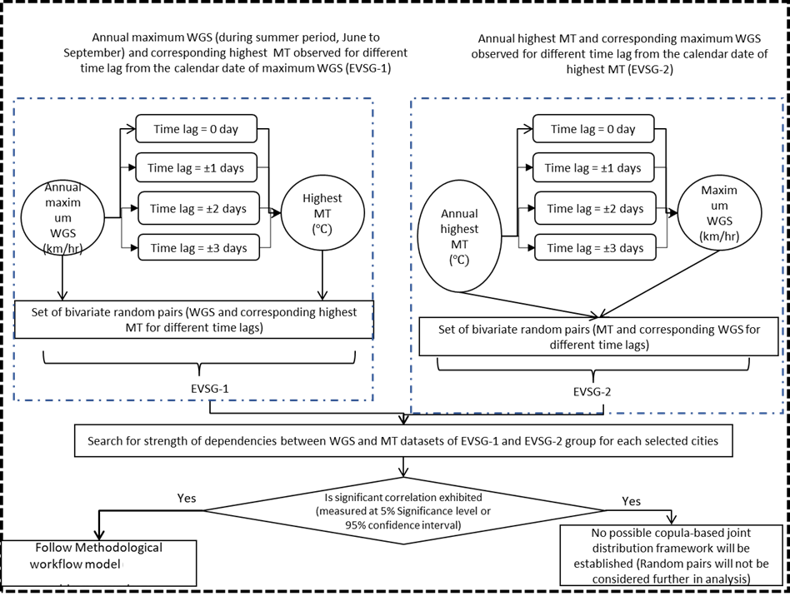

Supplementary SF1: Flowchart in the delineation of extreme value sample groups (EVSG) for defining bivariate extreme pairs in compounded WGS and MT events

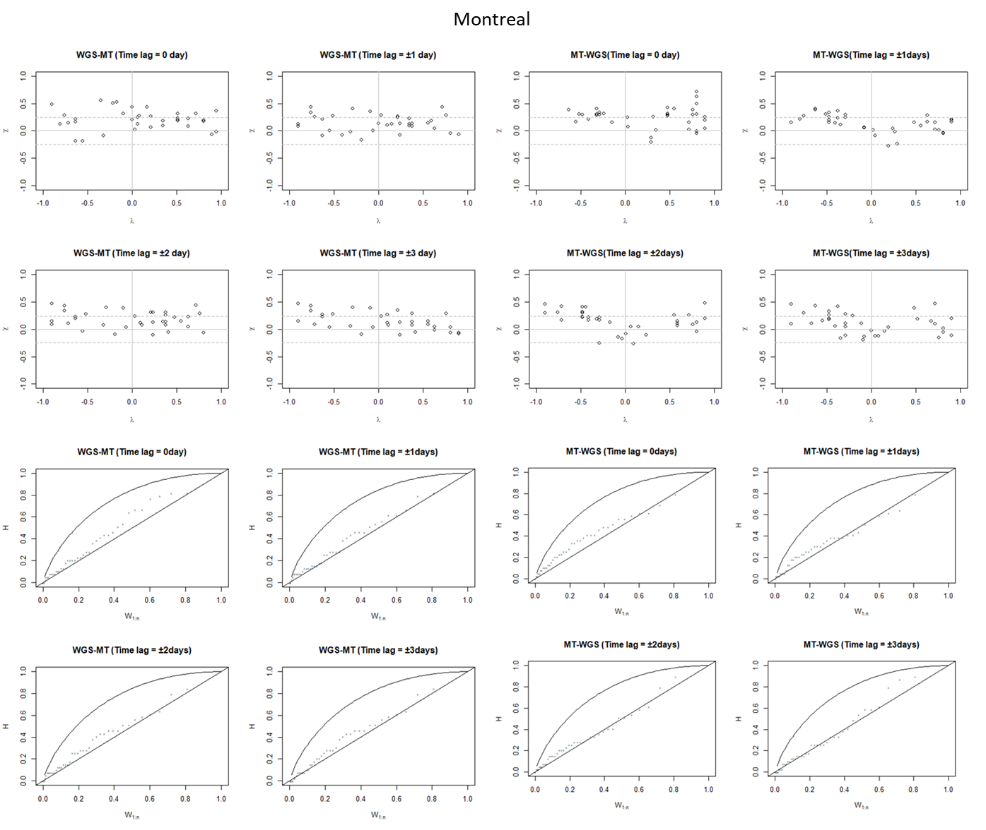 (a-1)
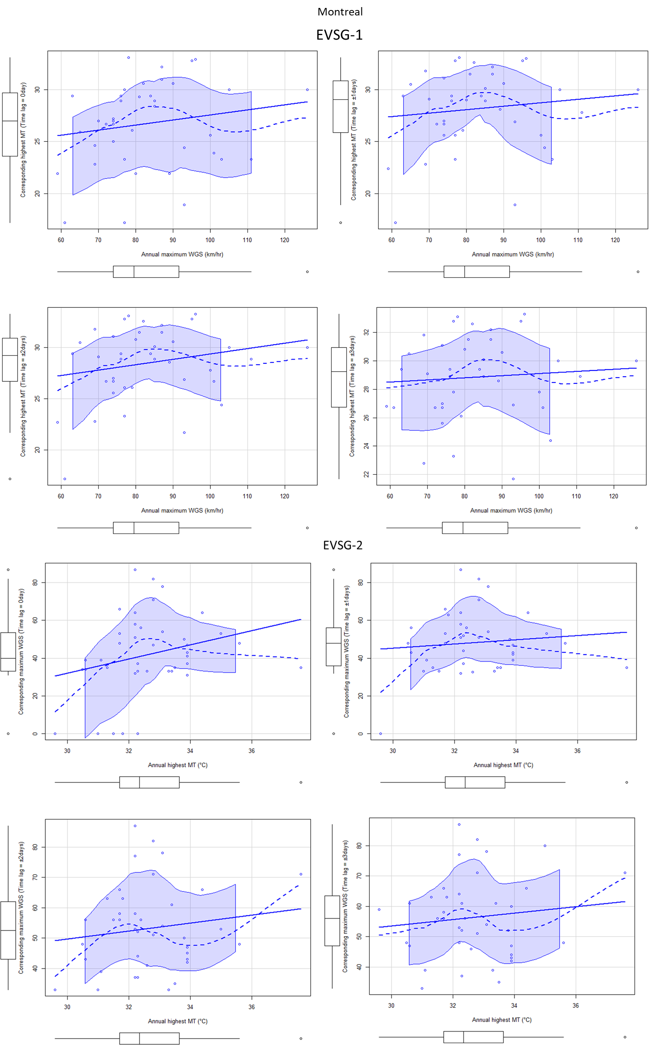 (a-2)

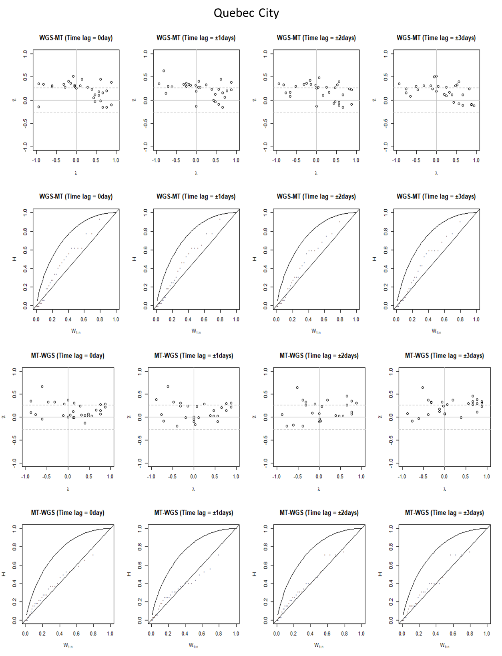(b-1)
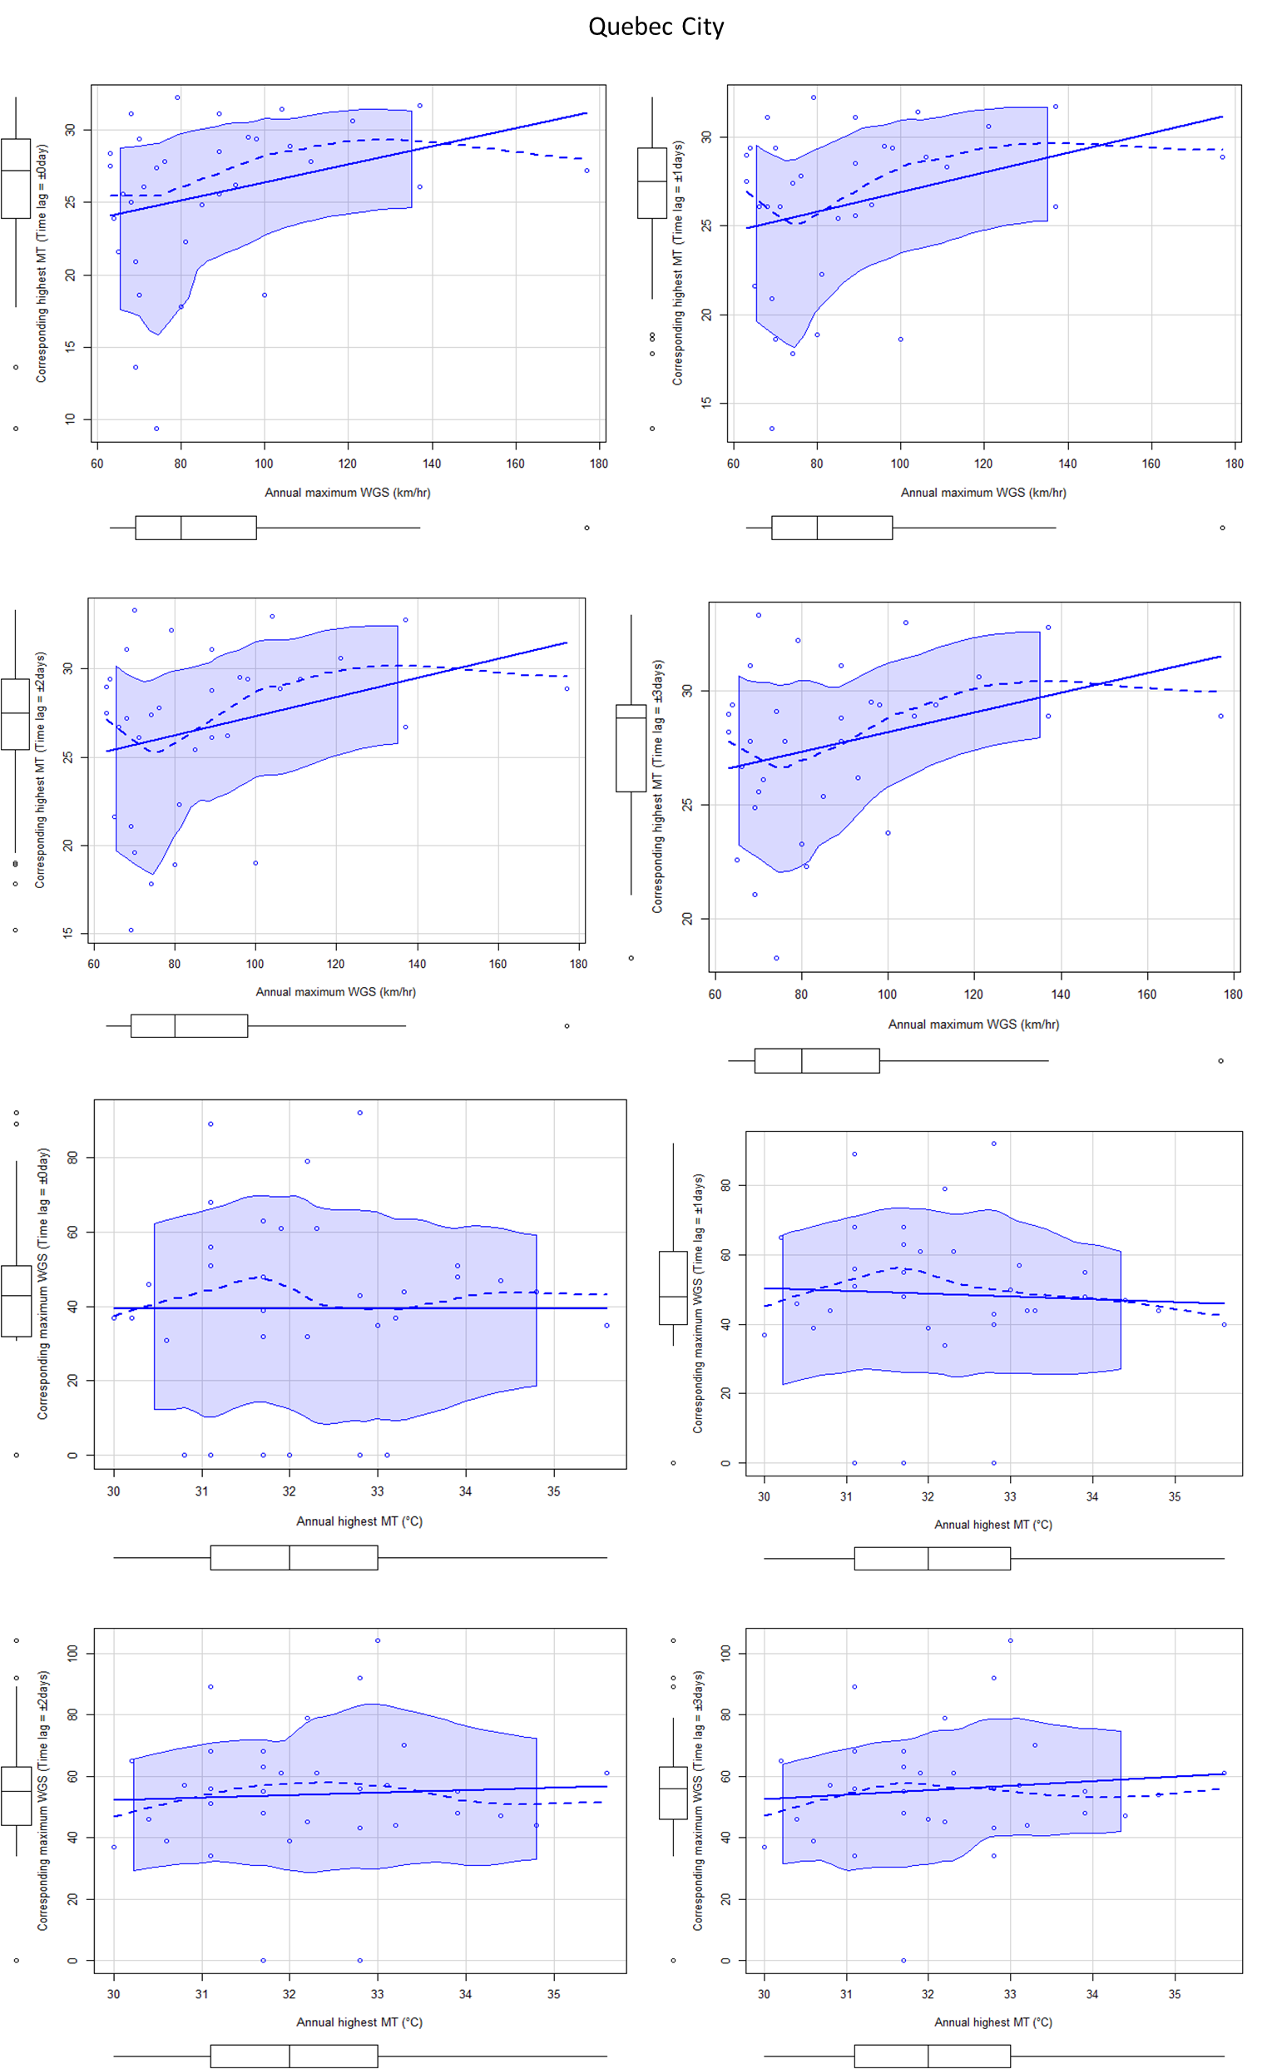(b-2)

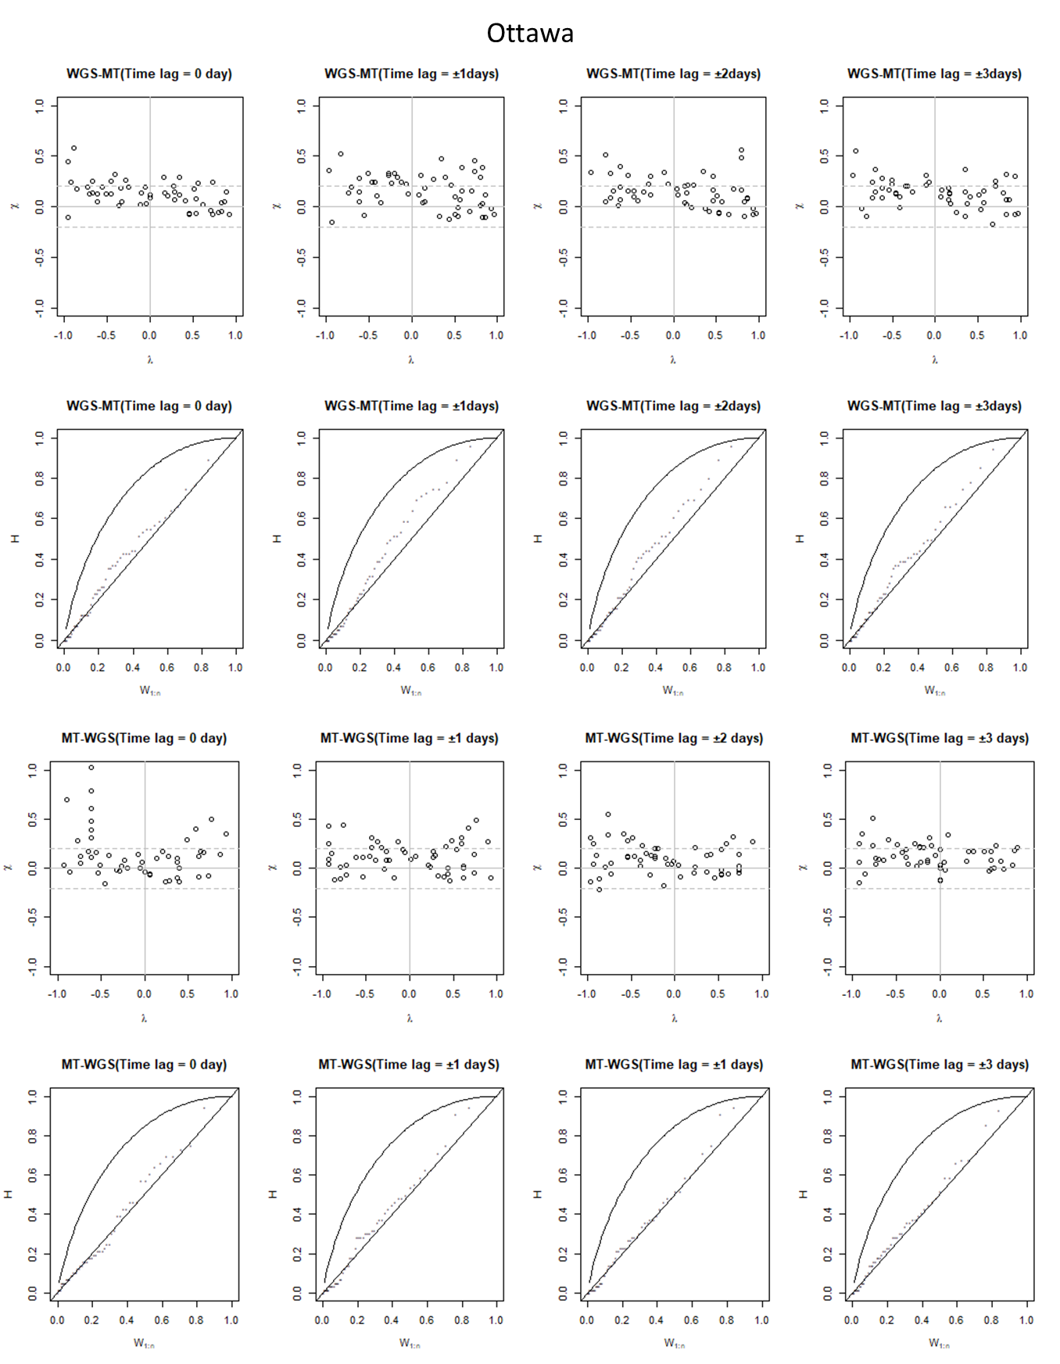(c-1)

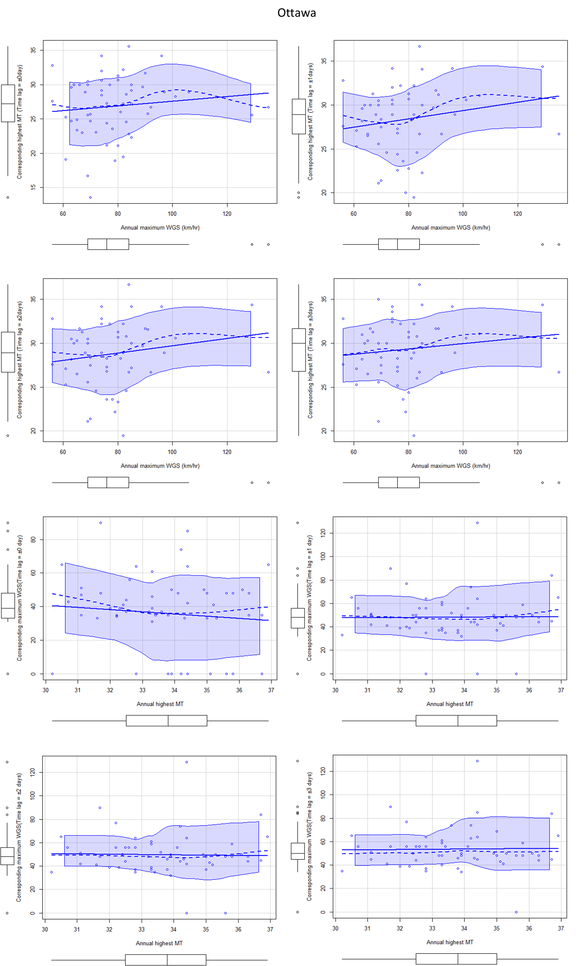(c-2)

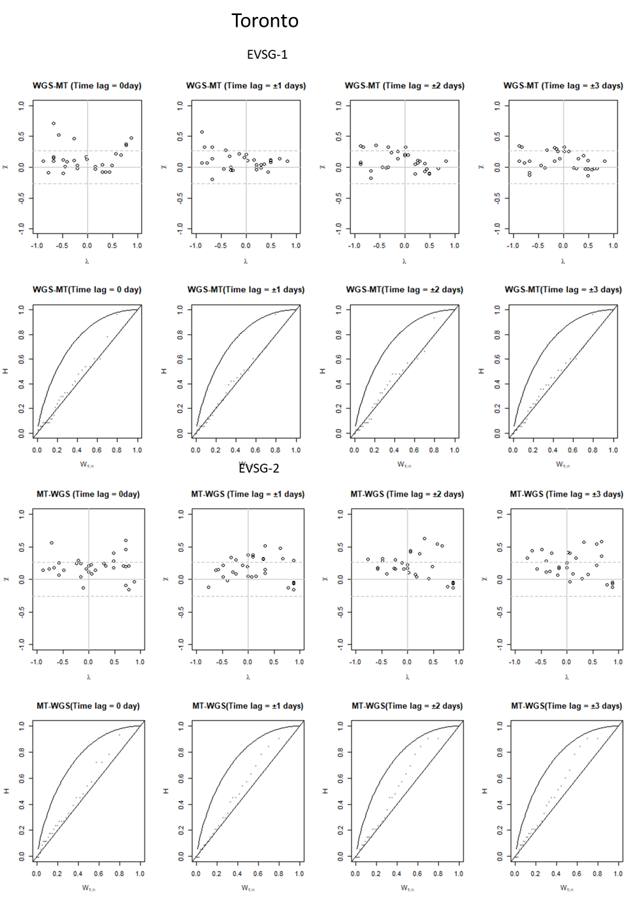(d-1)
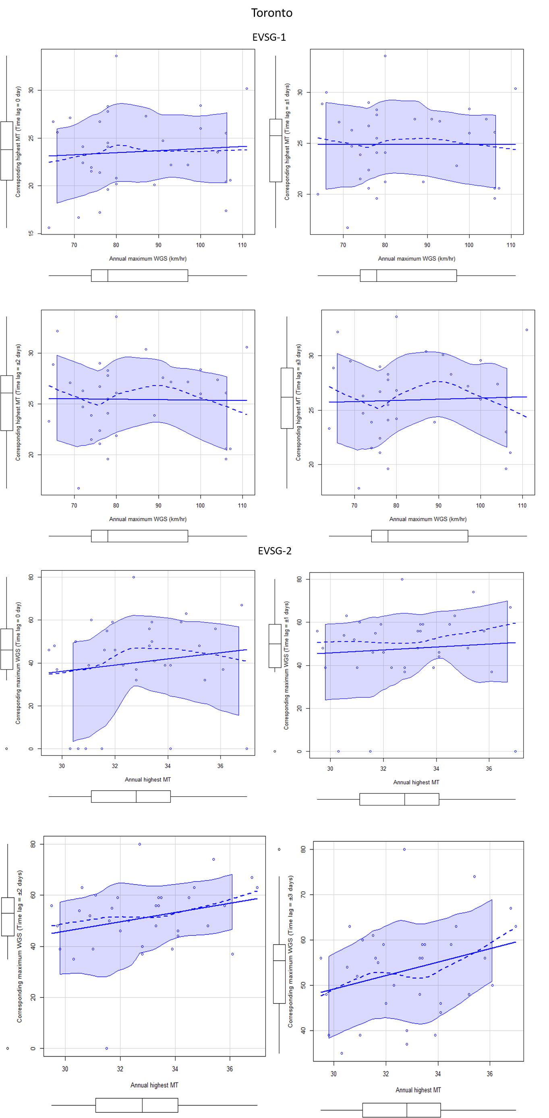(d-2)
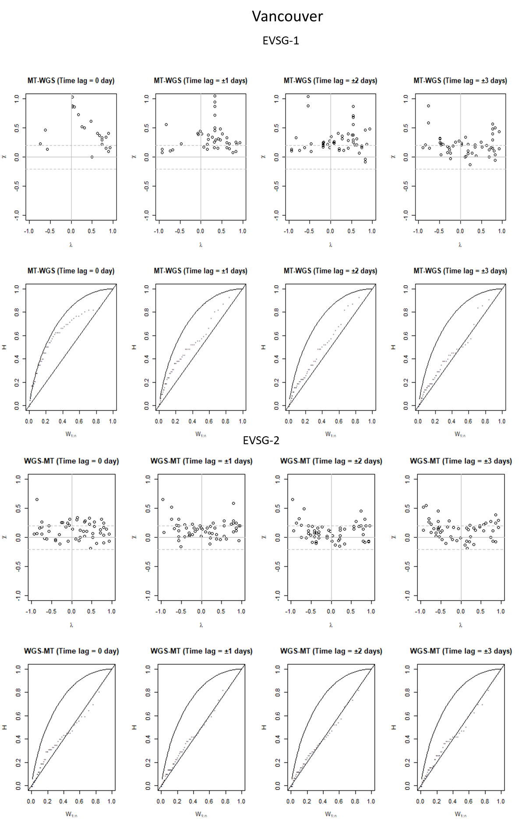(e-1)
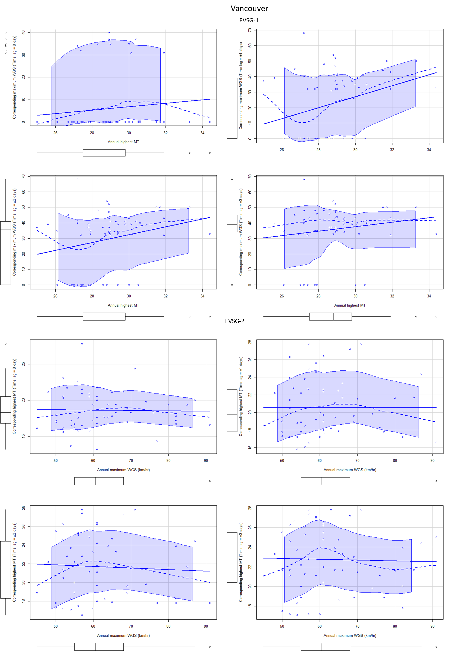(e-2)
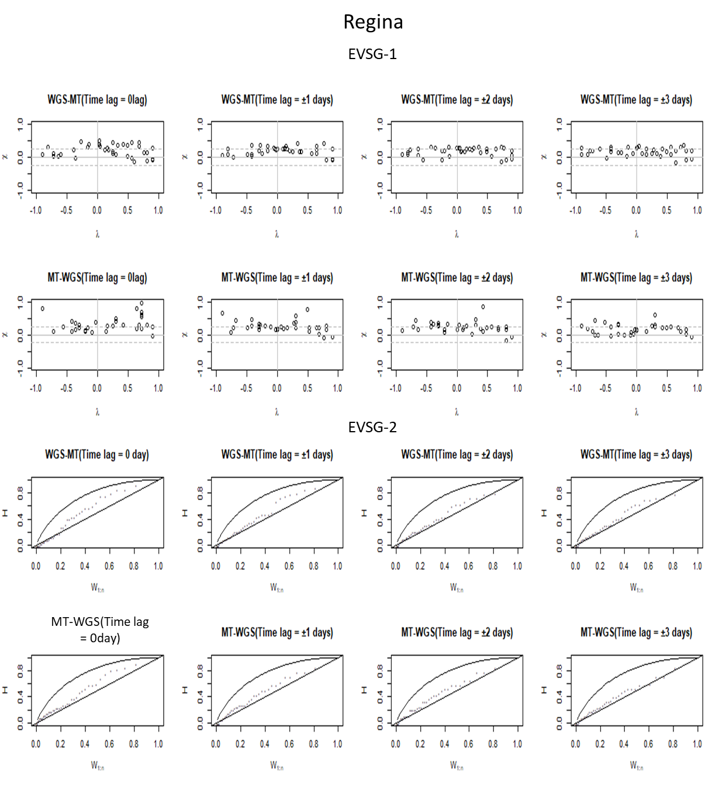(f-1)
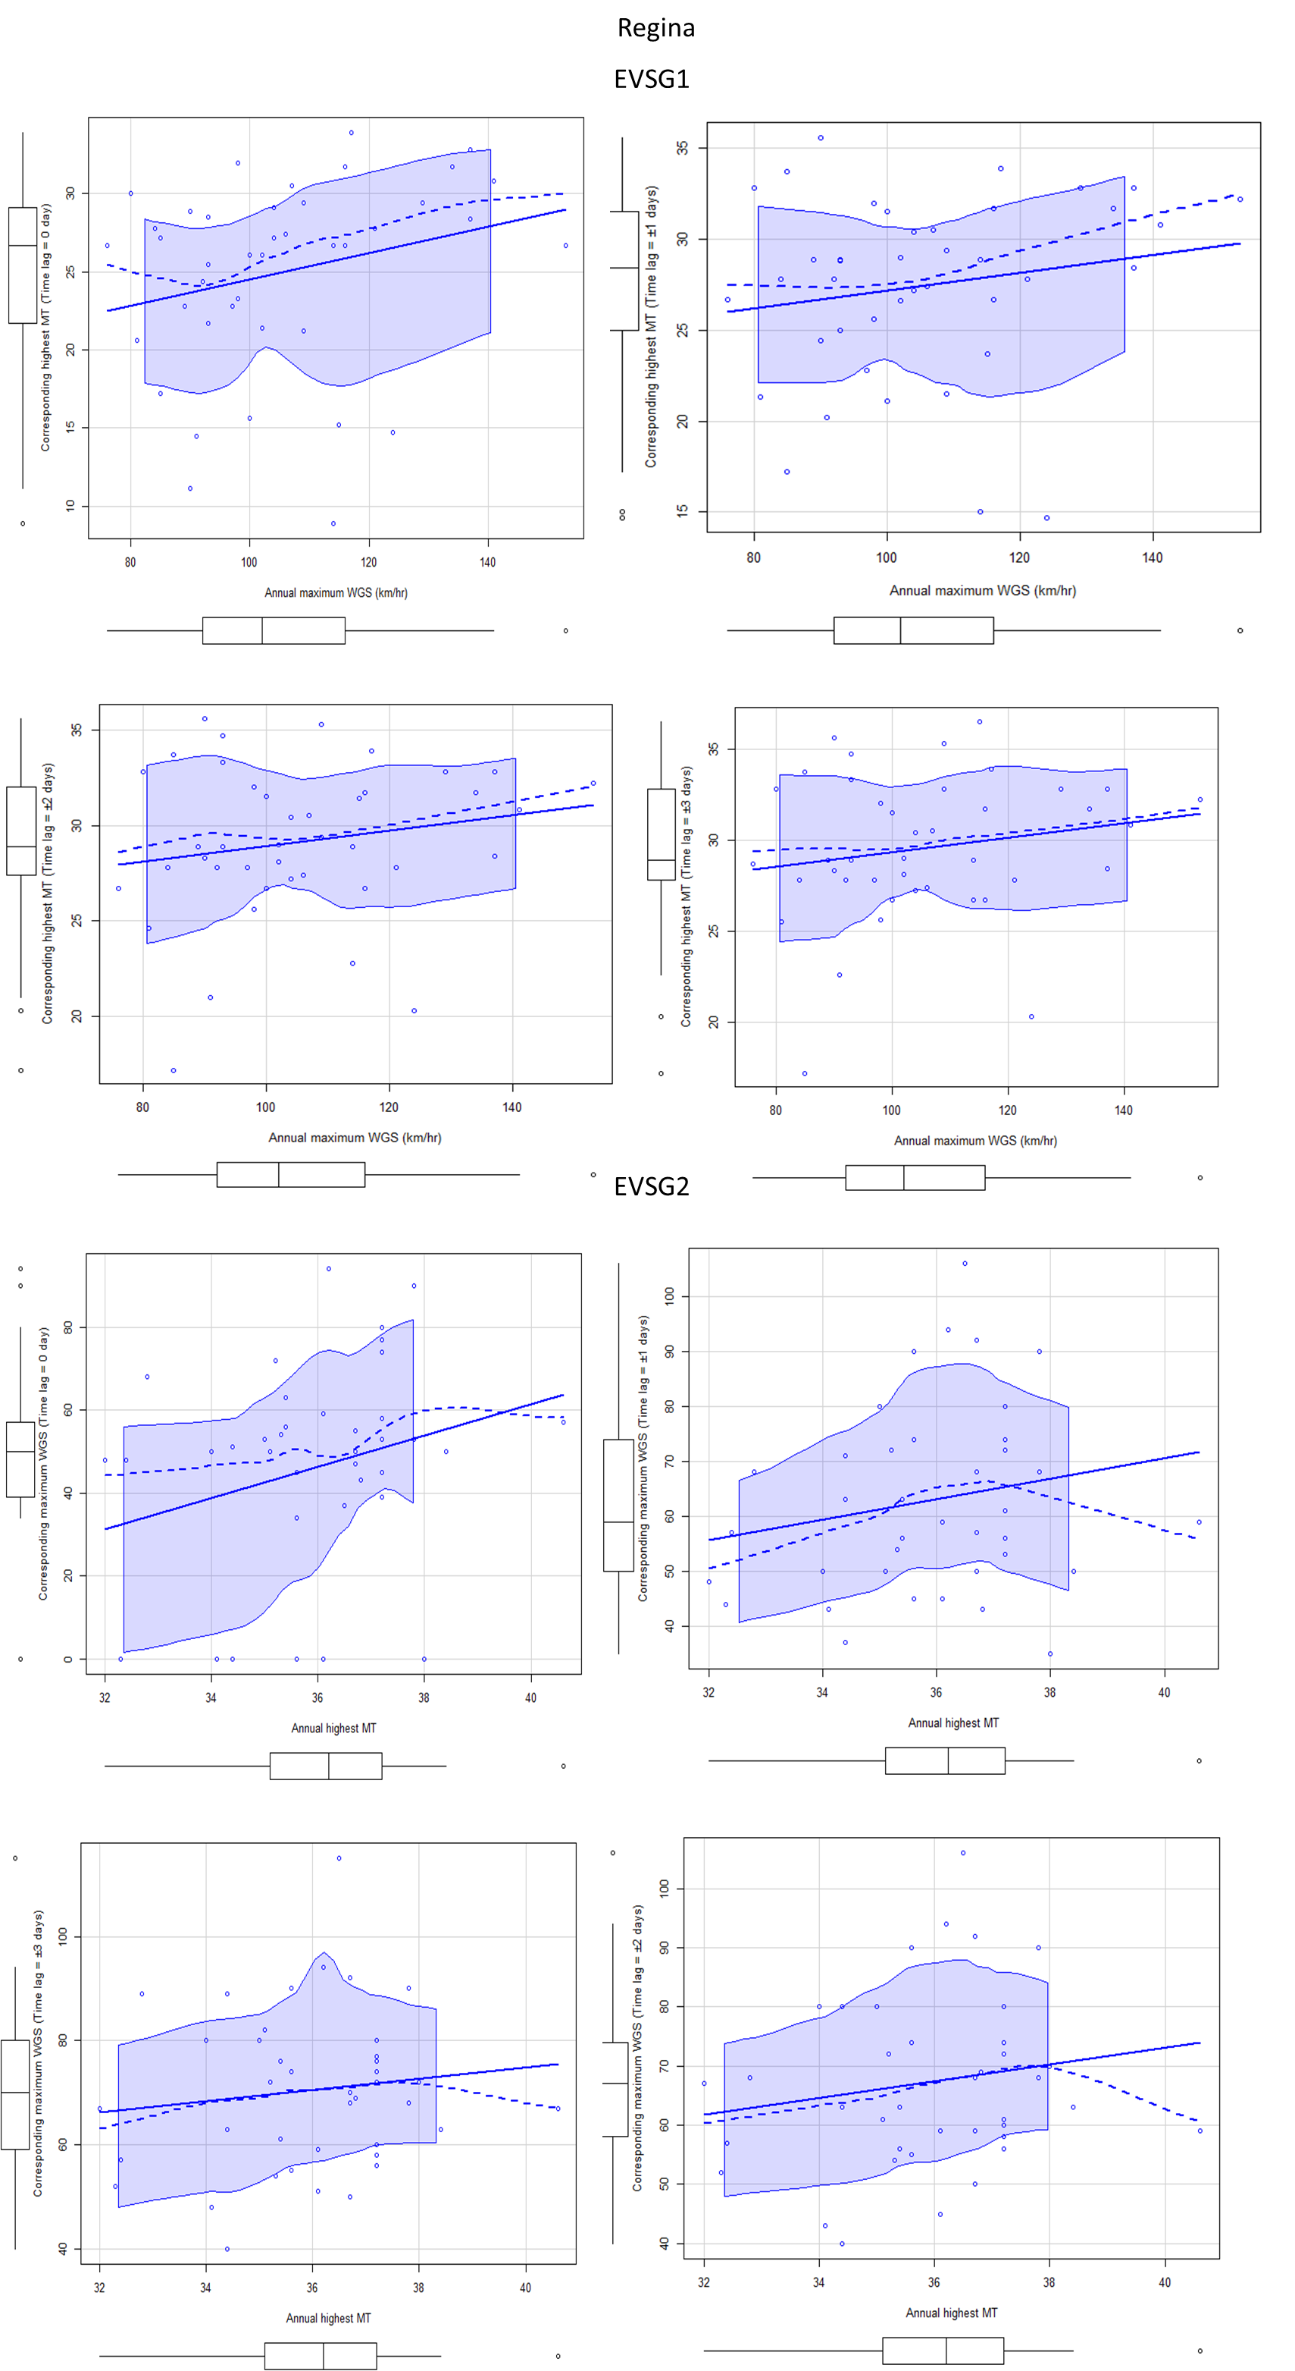(f-2)
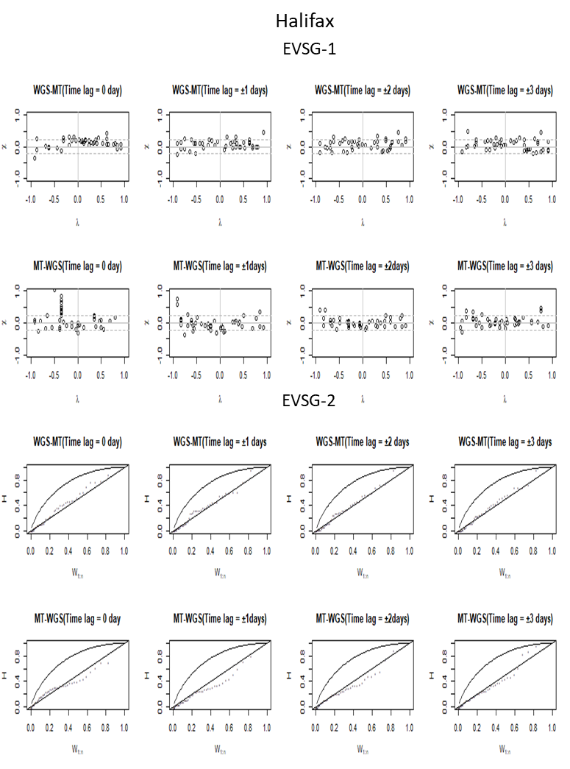(g-1)

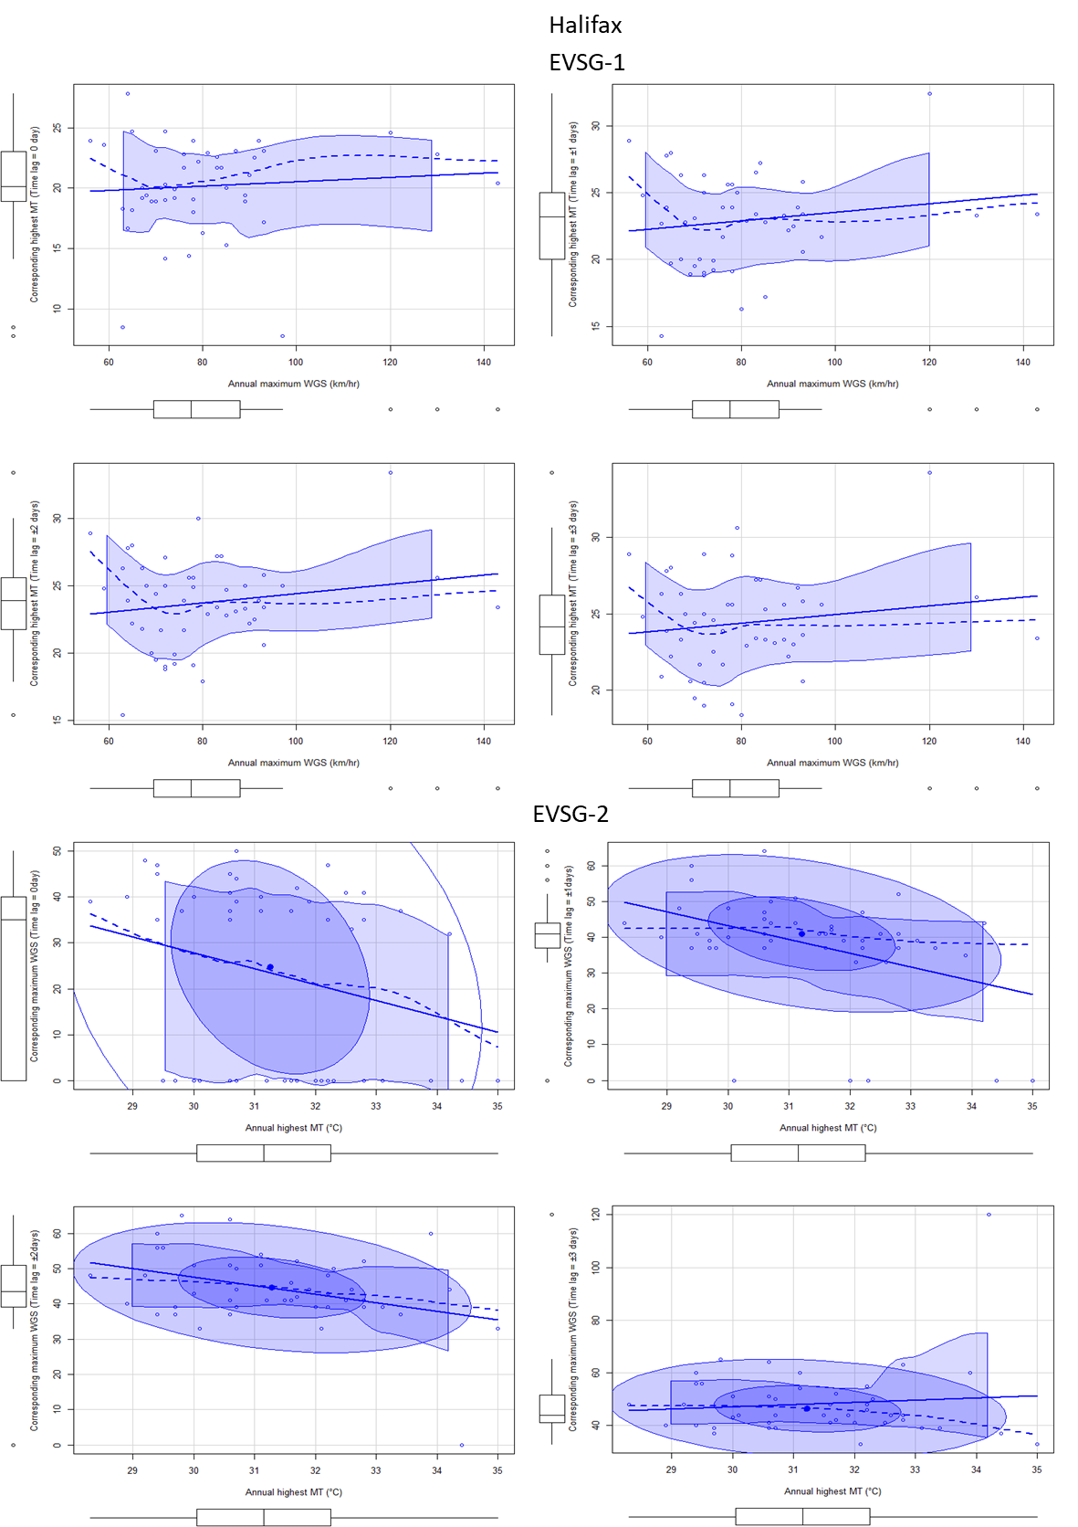(g-2)

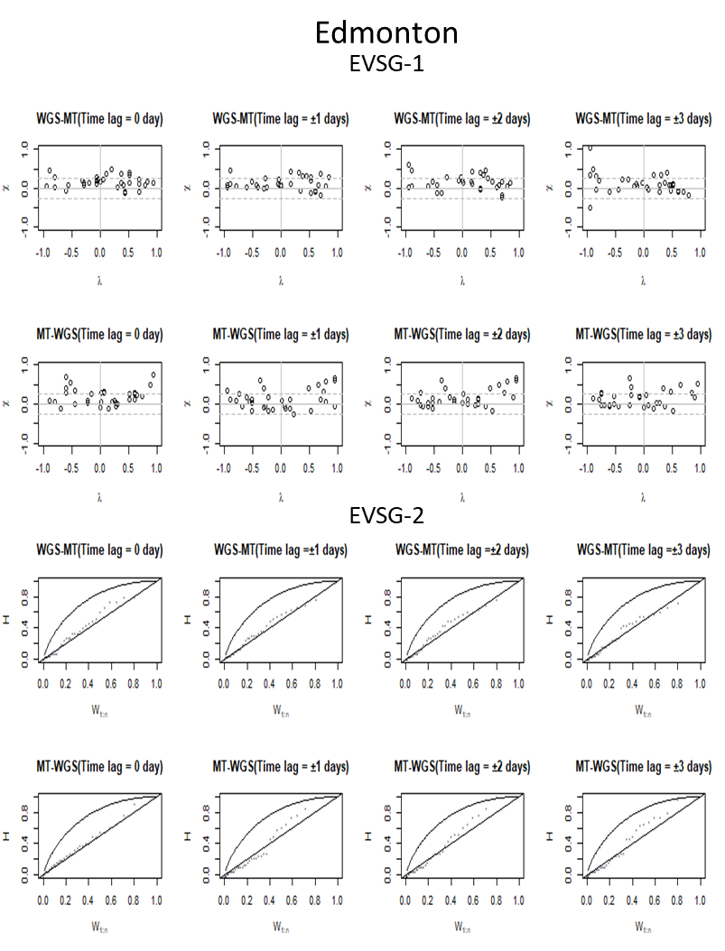(h-1)

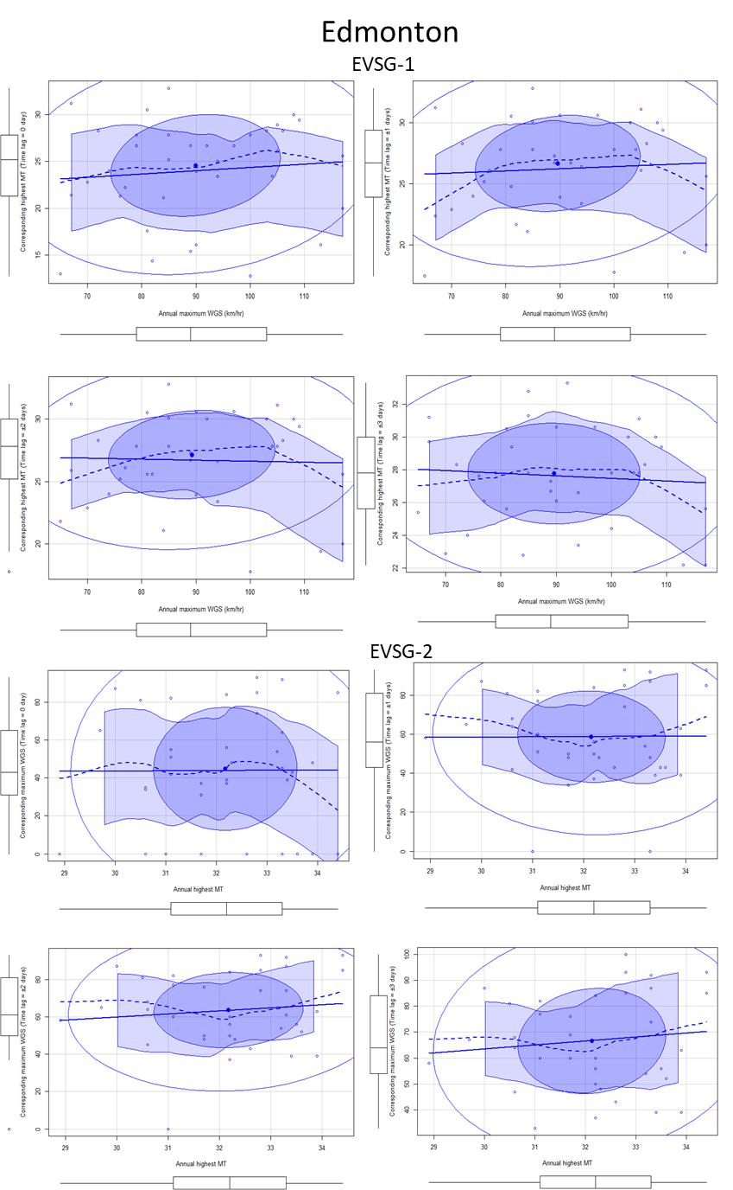(h-2)
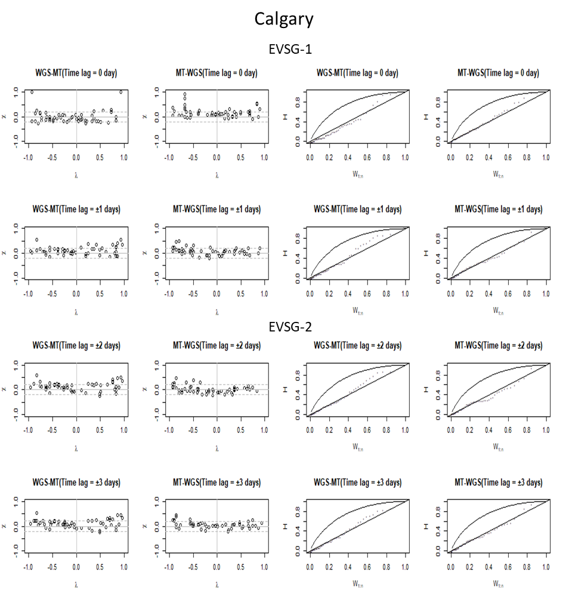(i-1)

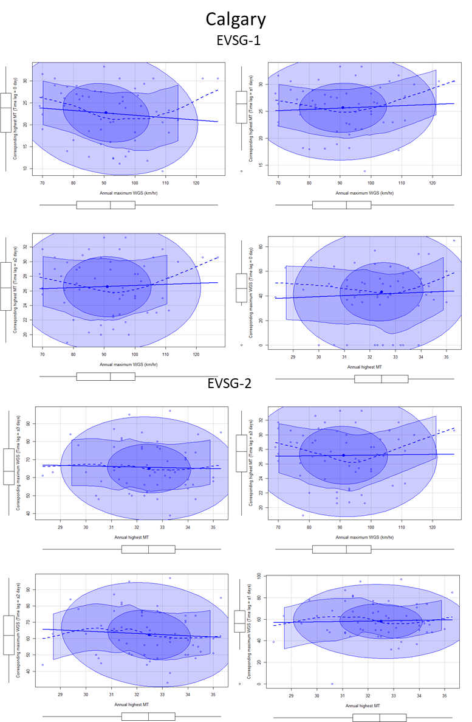(i-2)

Supplementary SF 2: Stationwise visualizing strength of dependencies via 2-D Chi-plots, 2-D Kendall’s (K) plots and 2-D scatter plots (a-1 and a-2) Montreal (b-1 and b-2) Quebec city (c-1 and c-2) Ottawa(d-1 and d-2) Toronto(e-1 and e-2) Vancouver (f-1 and f-2) Regina (g-1 and g-2) Halifax (h-1 and h-2) Edmonton (i-1 and i-2) Calgary

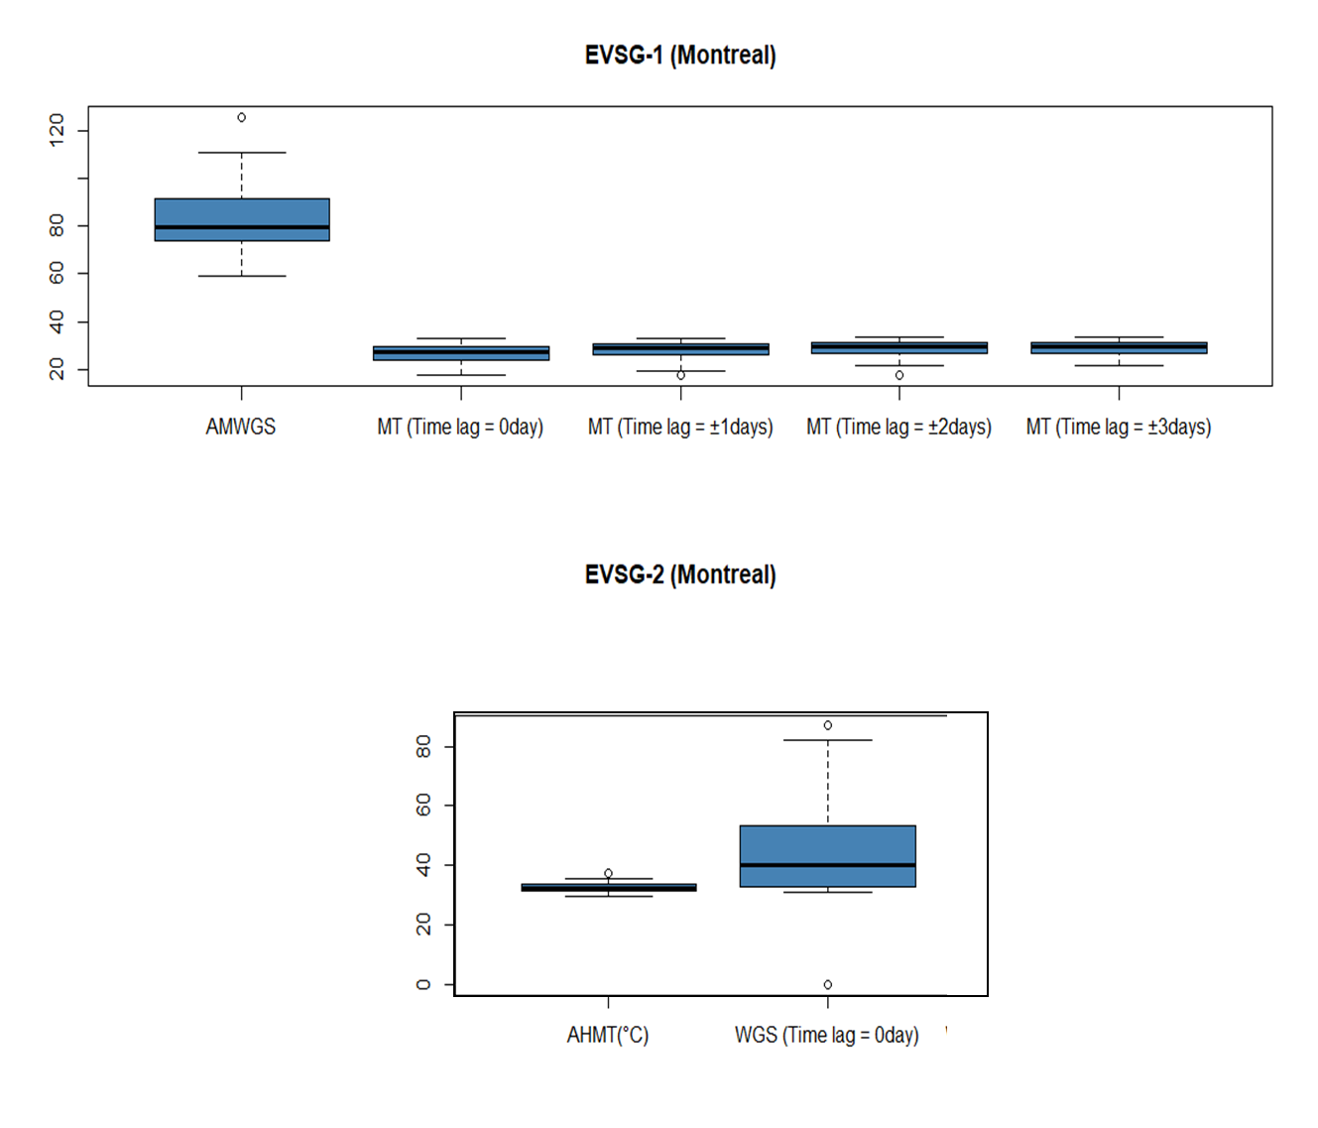(a)
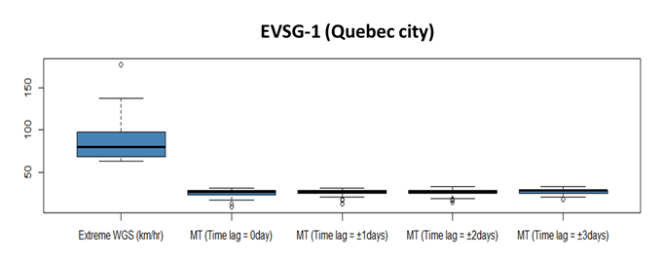(b)
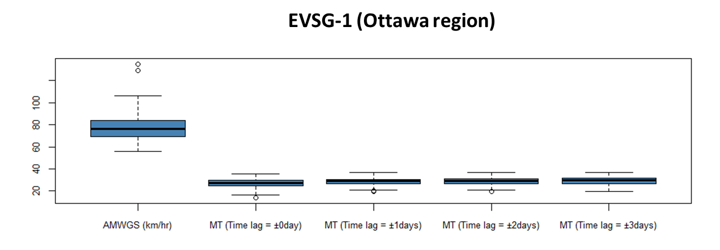(C)

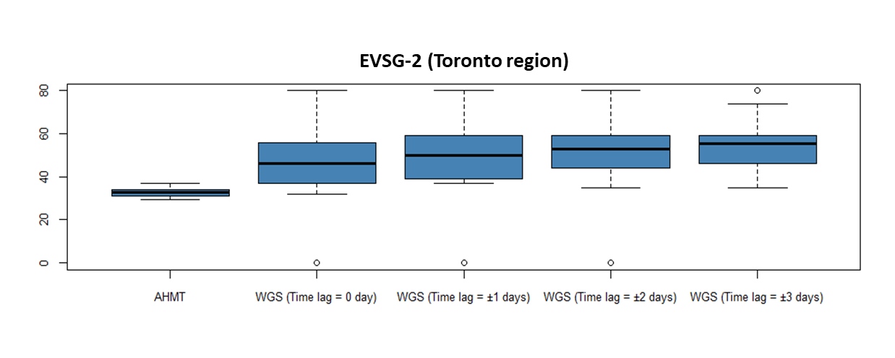(d)

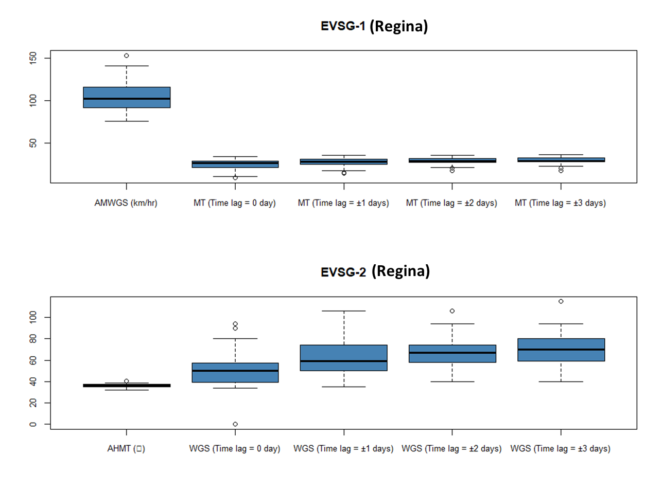(e)

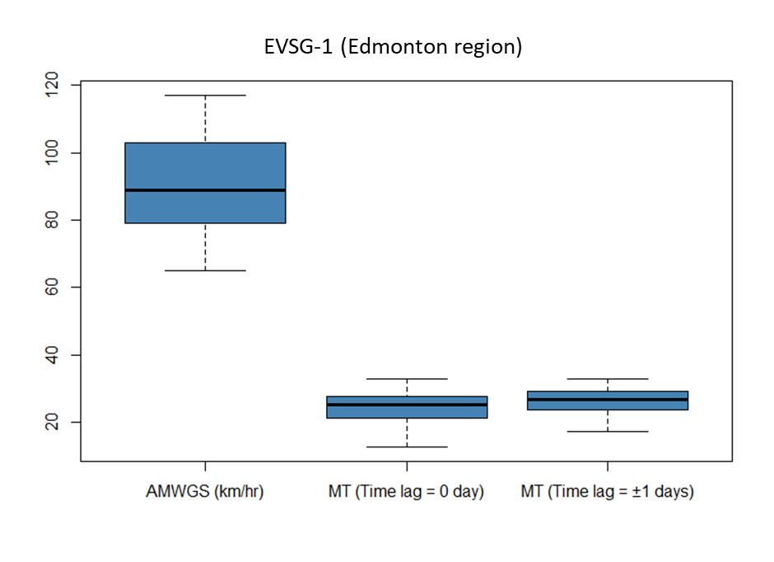 (f)
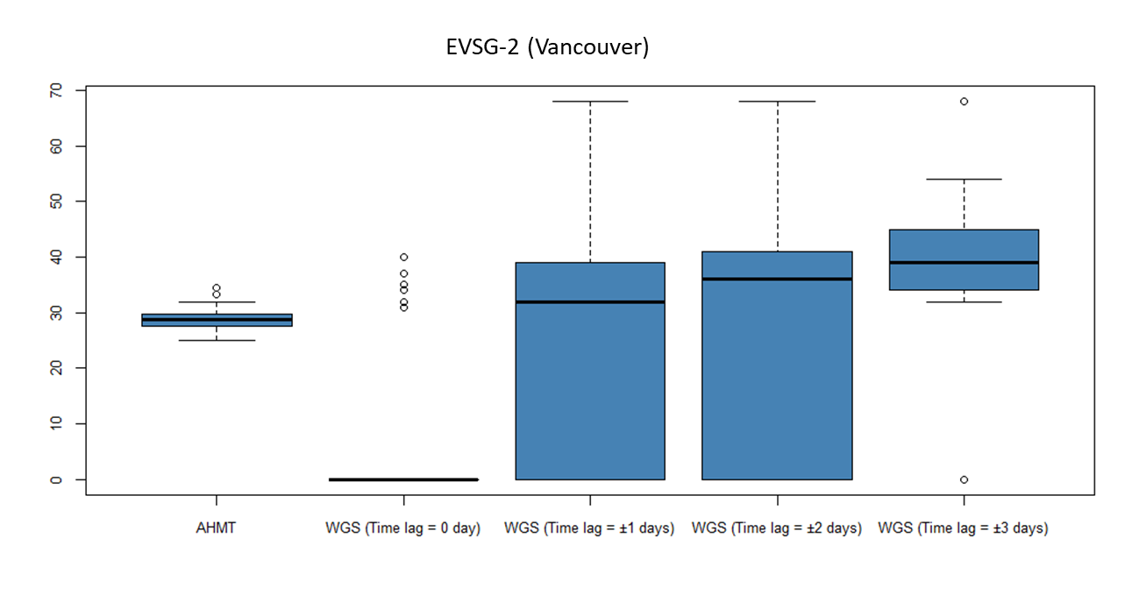(g)

Supplementary SF 3: Stationwise Box-whisker plots (a) Montreal (b) Quebec City (c) Ottawa (d) Toronto (e) Regina (f) Edmonton (g) Vancouver

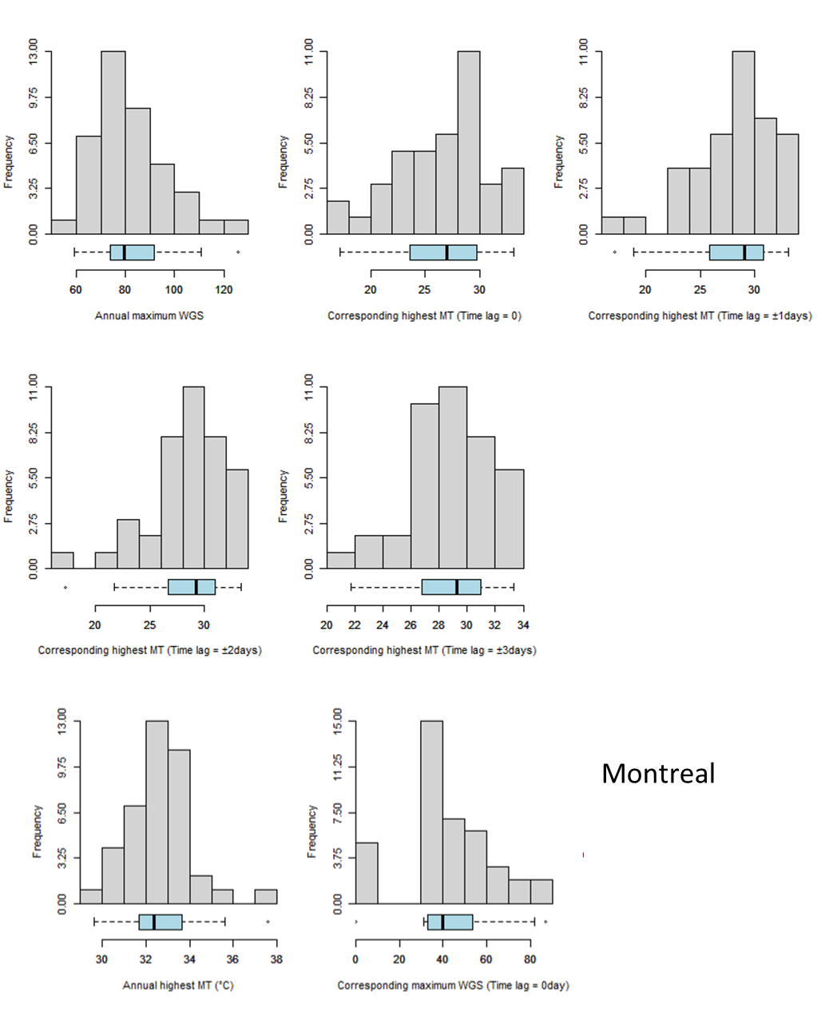(a)
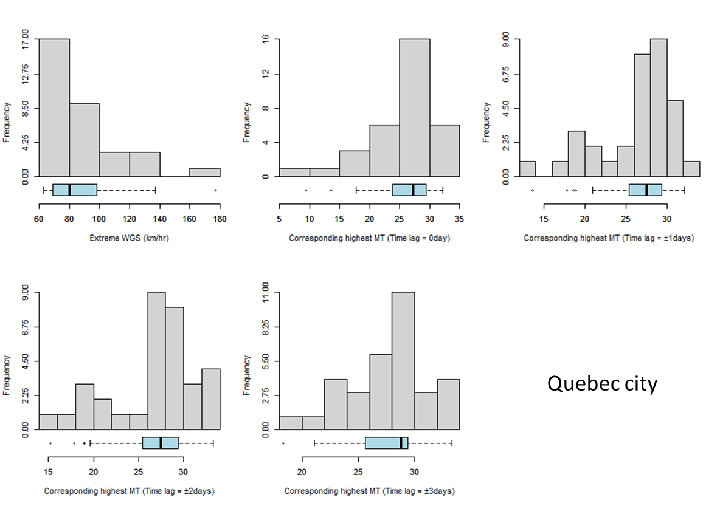(b)

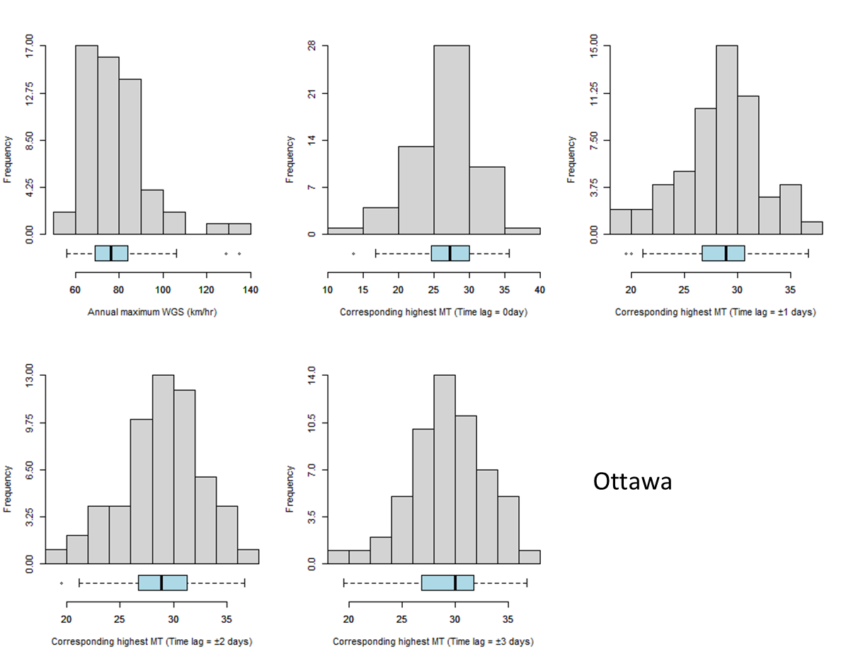(c)
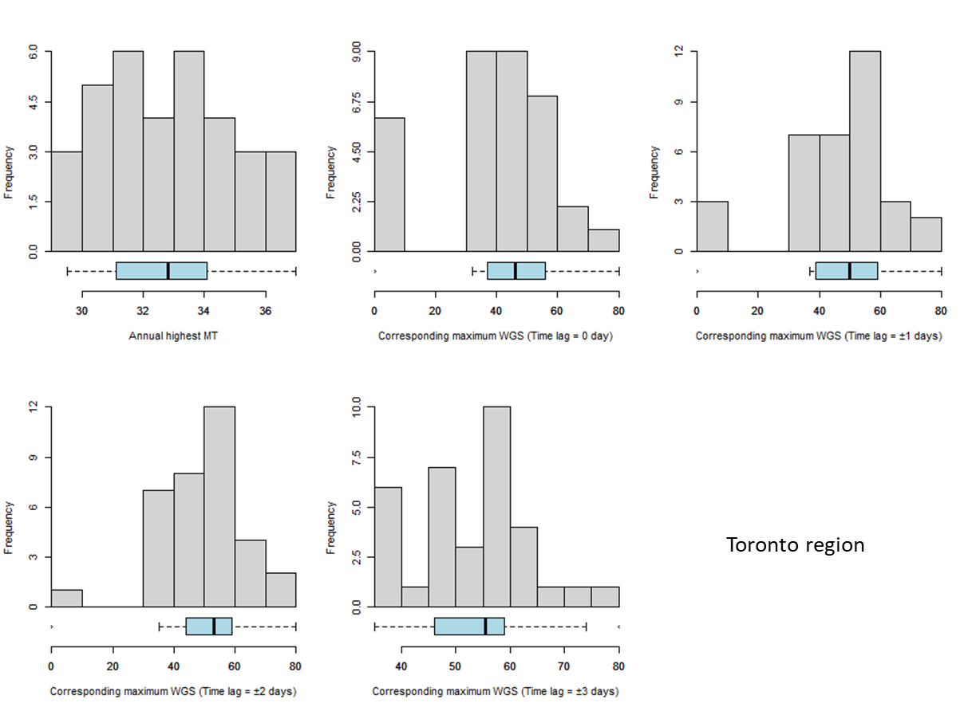 (d)

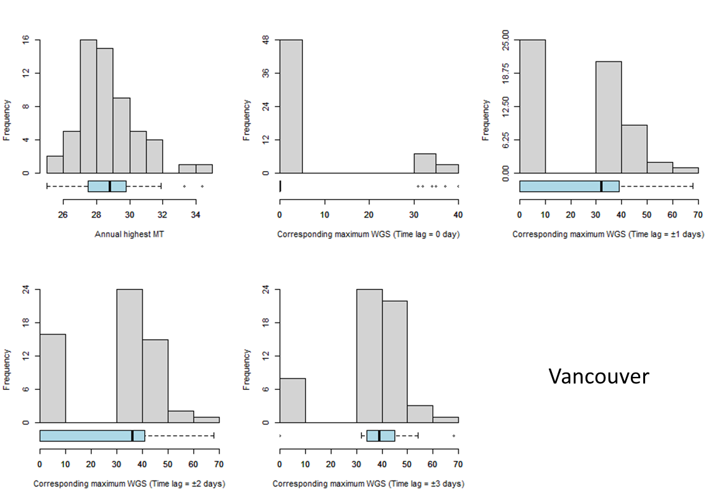 (e)

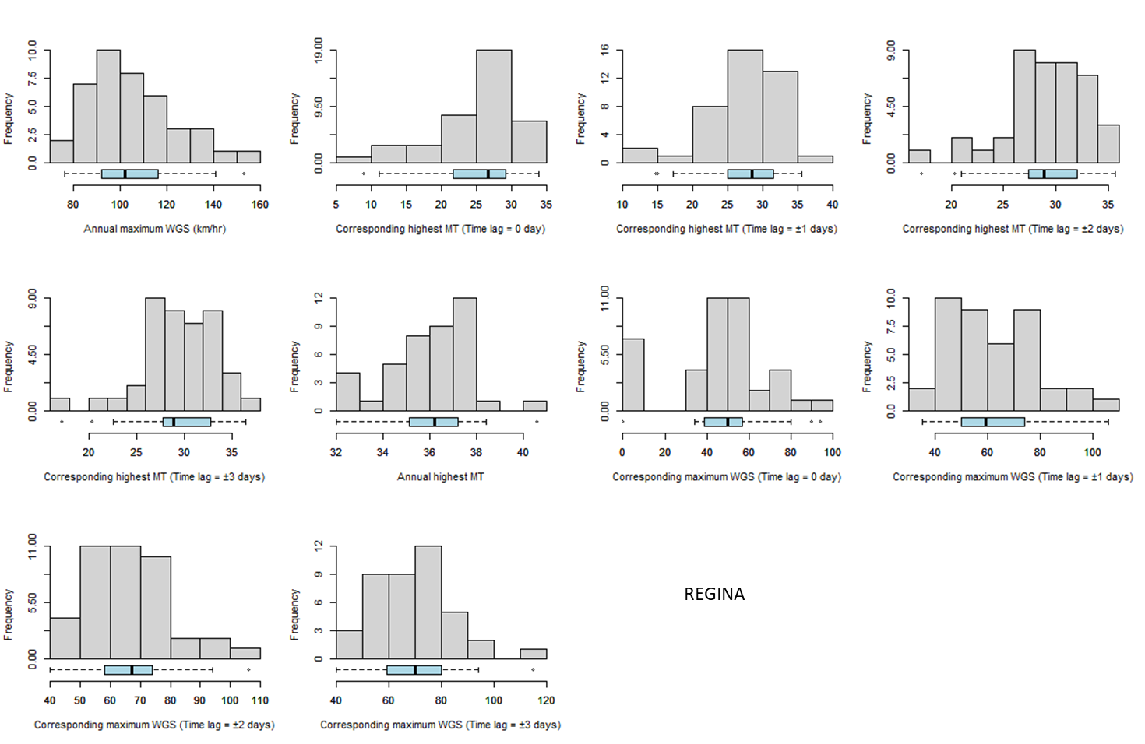(f)

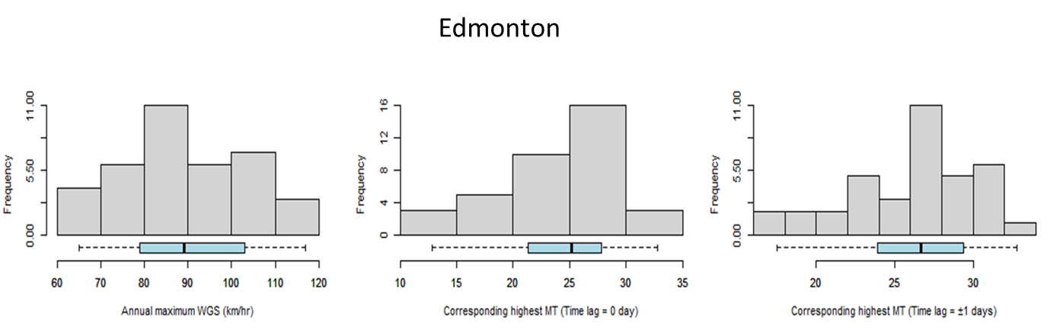(g)

Supplementary SF 4: Stationwise histogram distribution plots (a) Montreal (b) Quebec City (c) Ottawa (d) Toronto (e) Vancouver (f) Regina (g) Edmonton

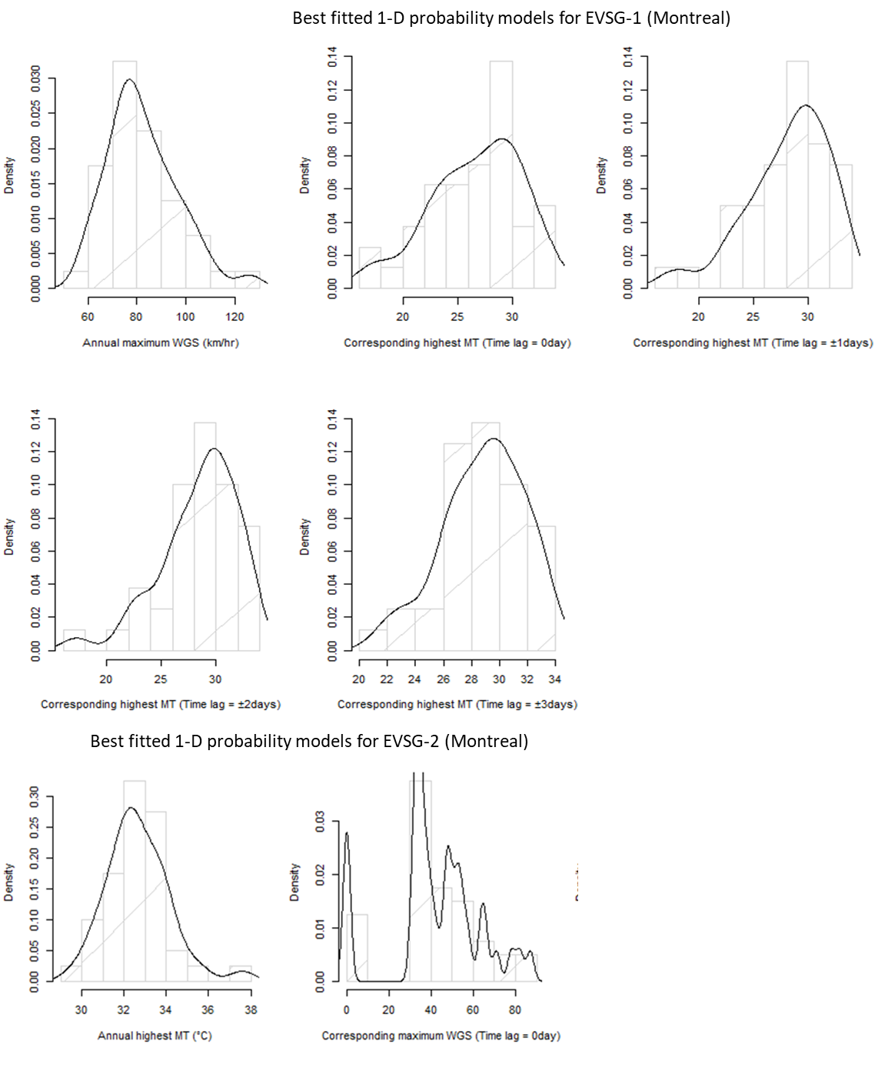 (a)

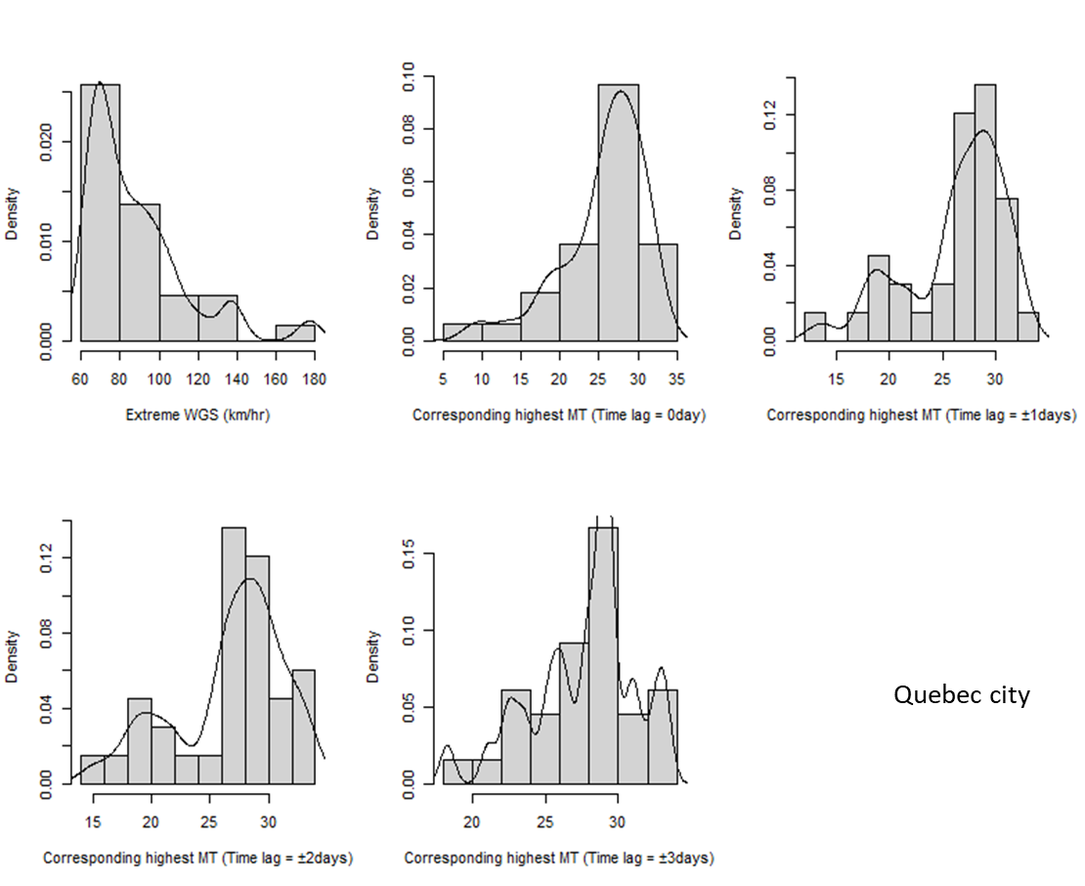(b)
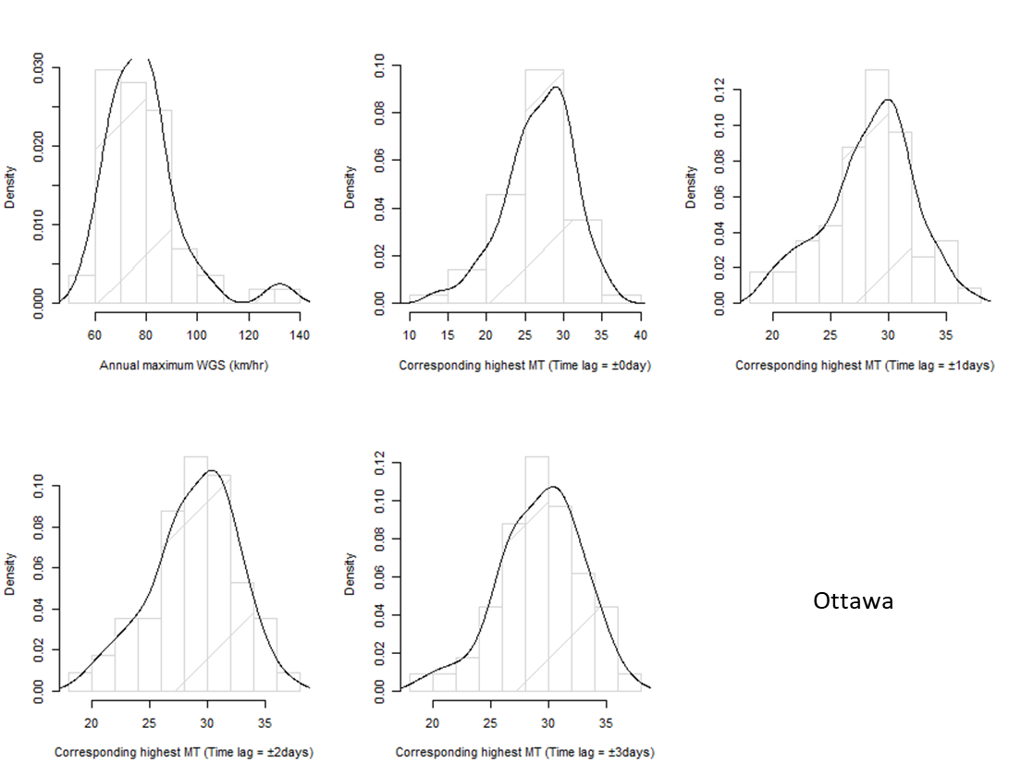(c)

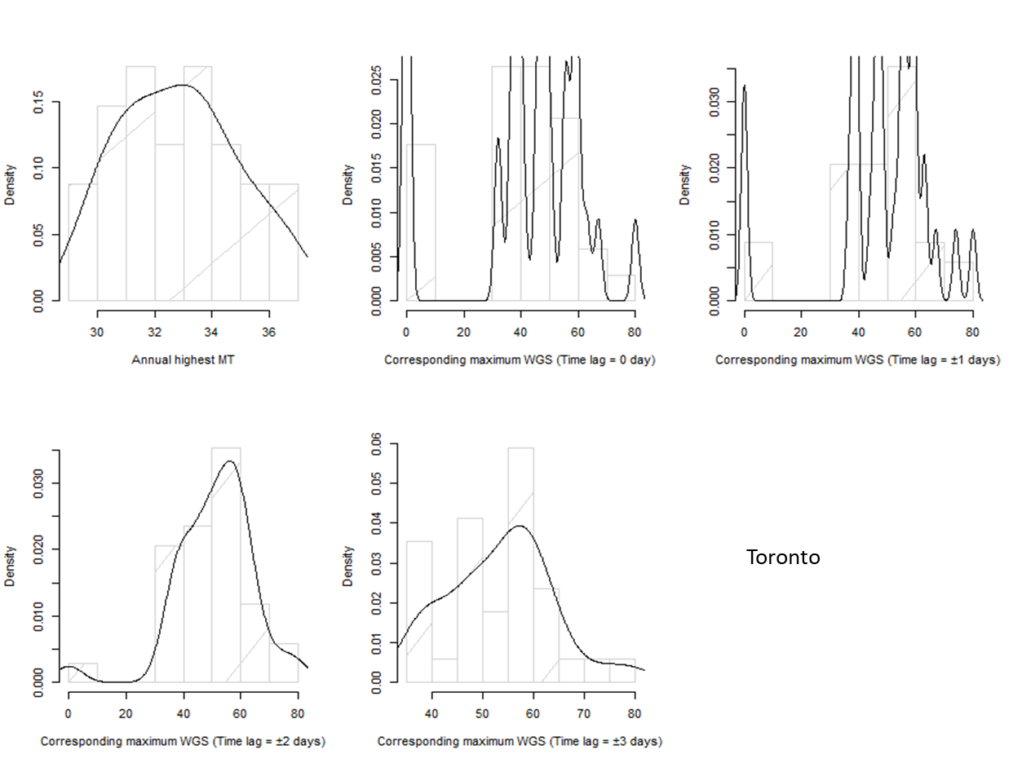(d)

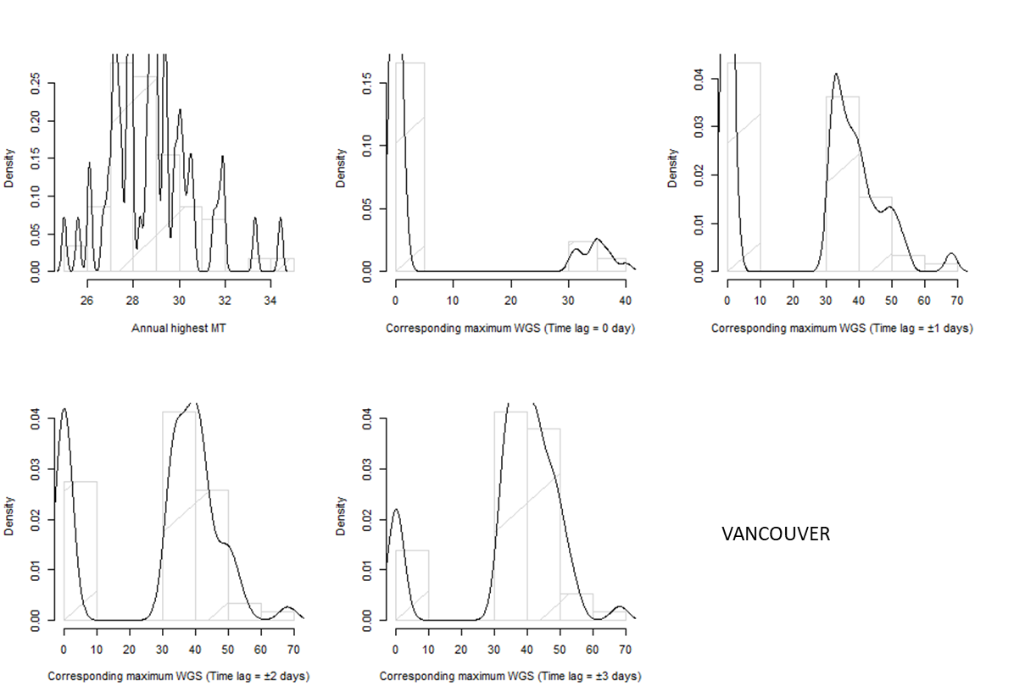(e)

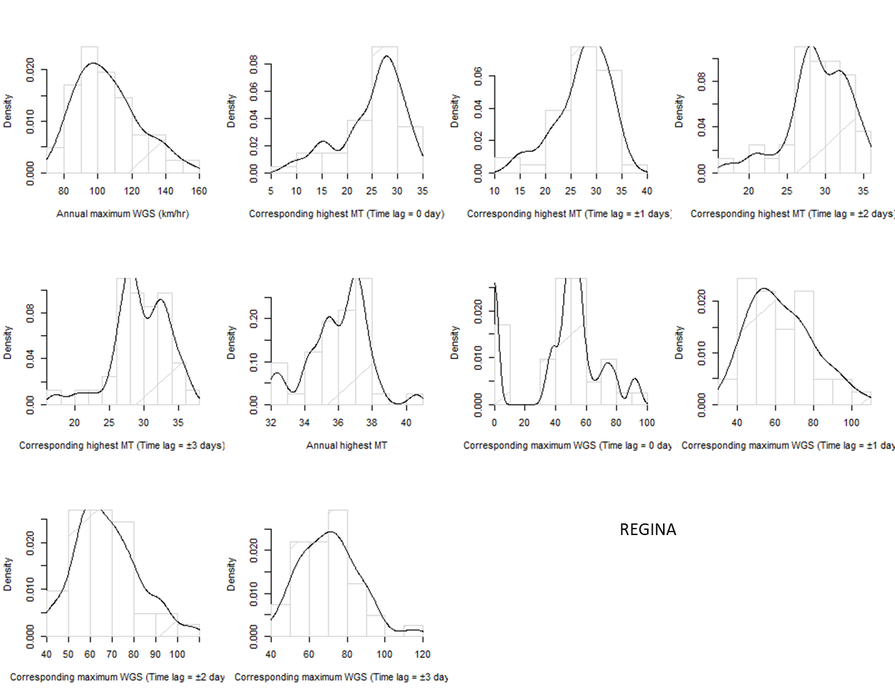(f)

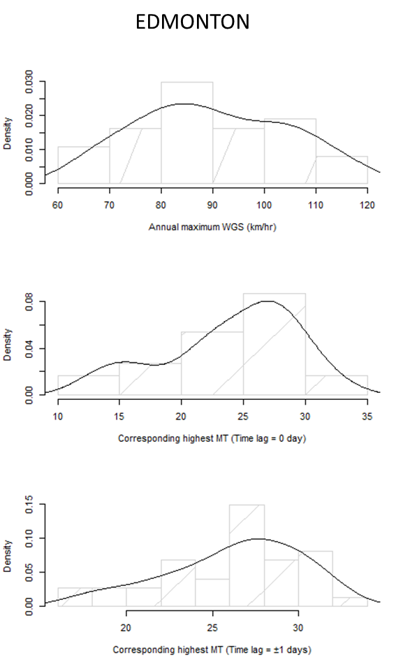(g)
Supplementary SF 5: Probability density functions (PDFs) of the most justifiable nonparametric GKDE models fitted to selected univariate series of EVSG-1/2 at (a) Montreal (b) Quebec City (c) Ottawa (d) Toronto (e) Vancouver (f) Regina (g) Edmonton

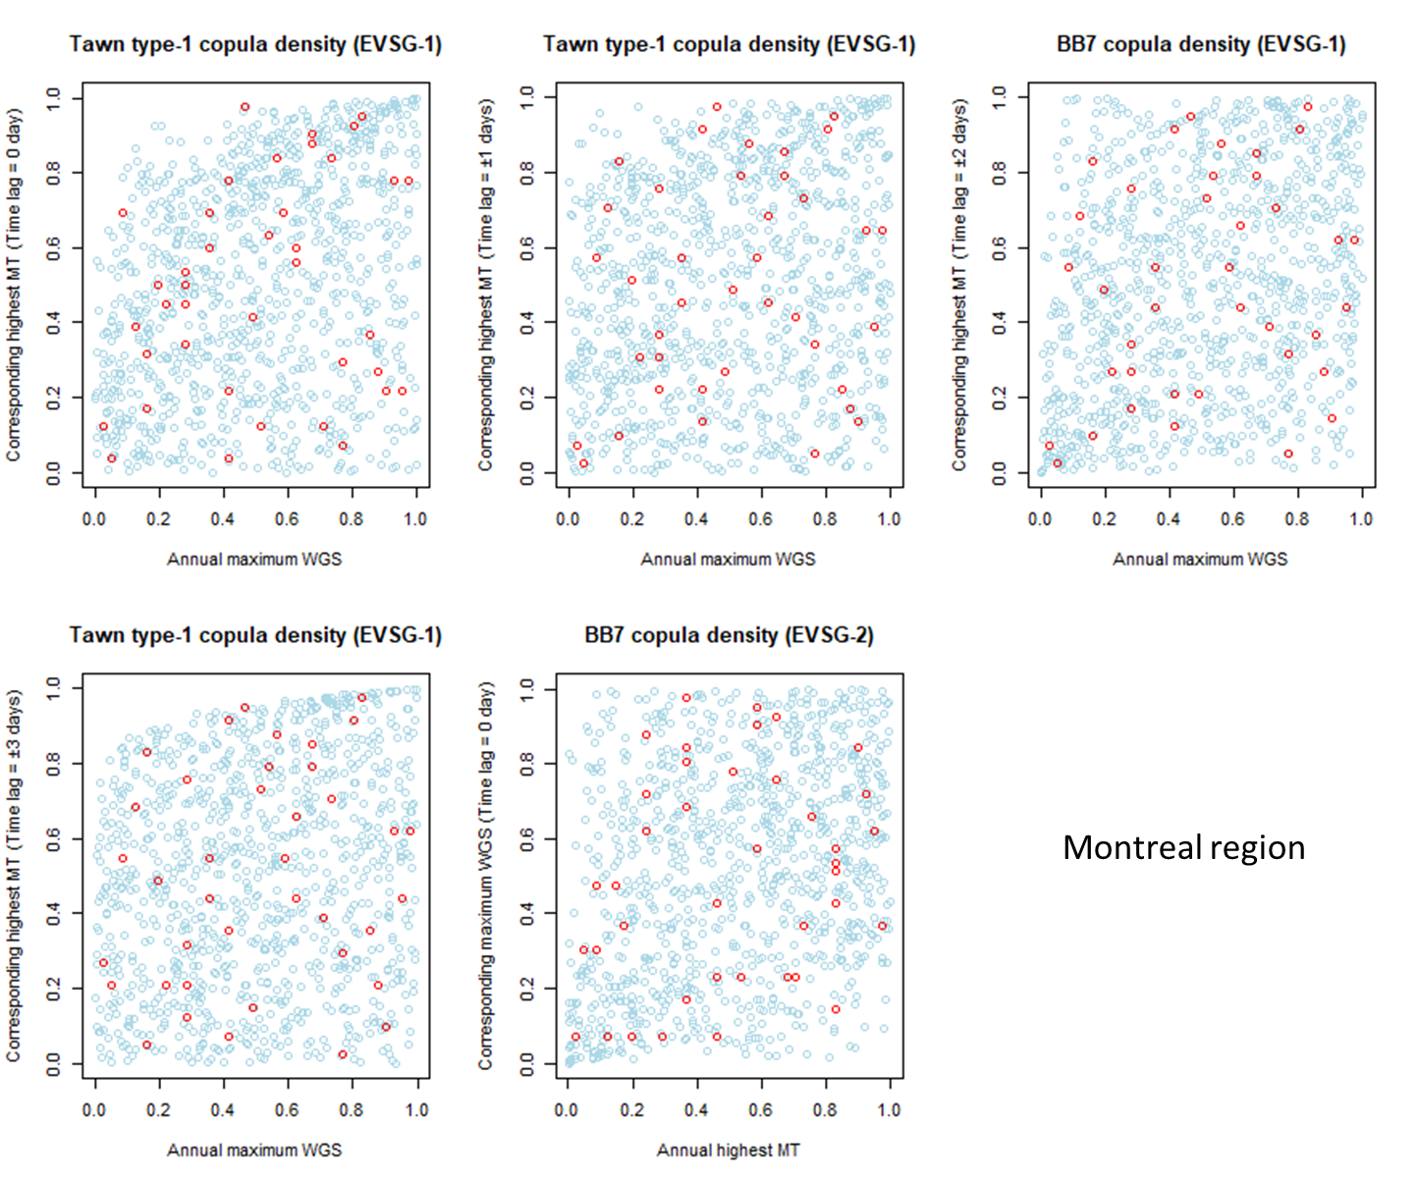(a)

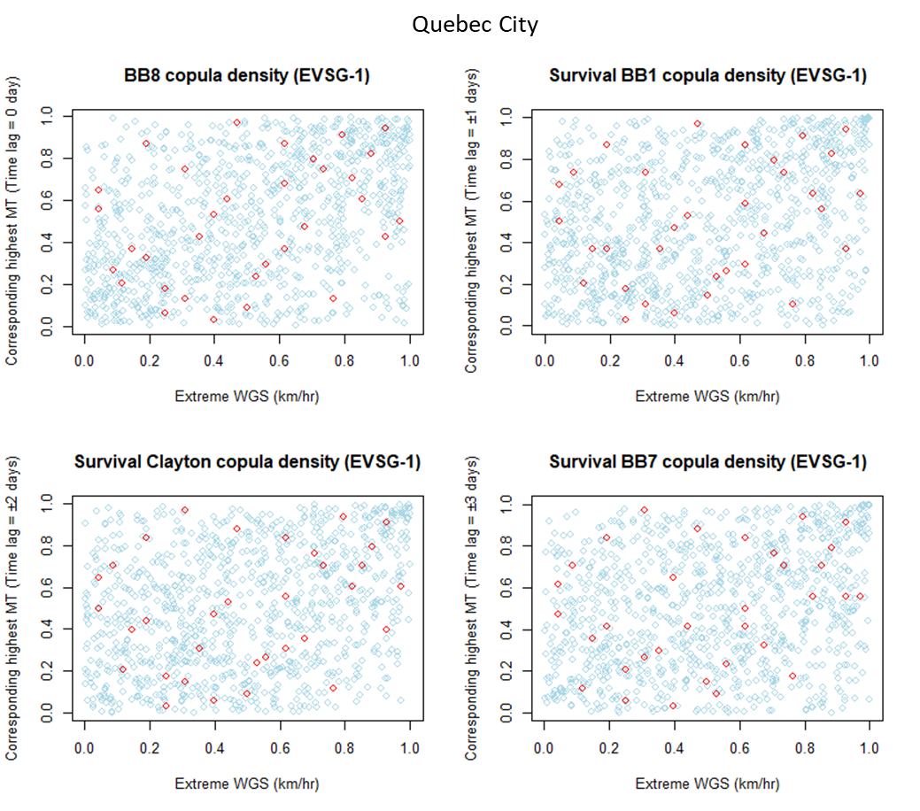 (b)
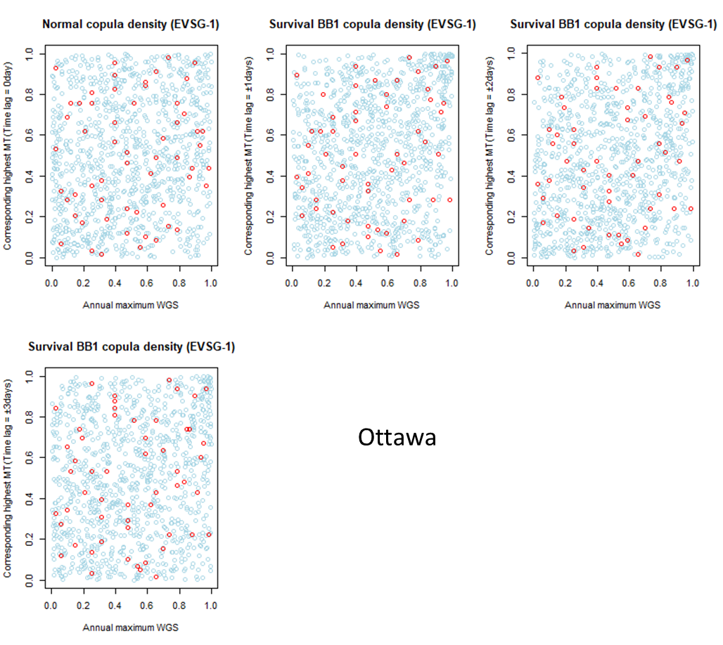(c)
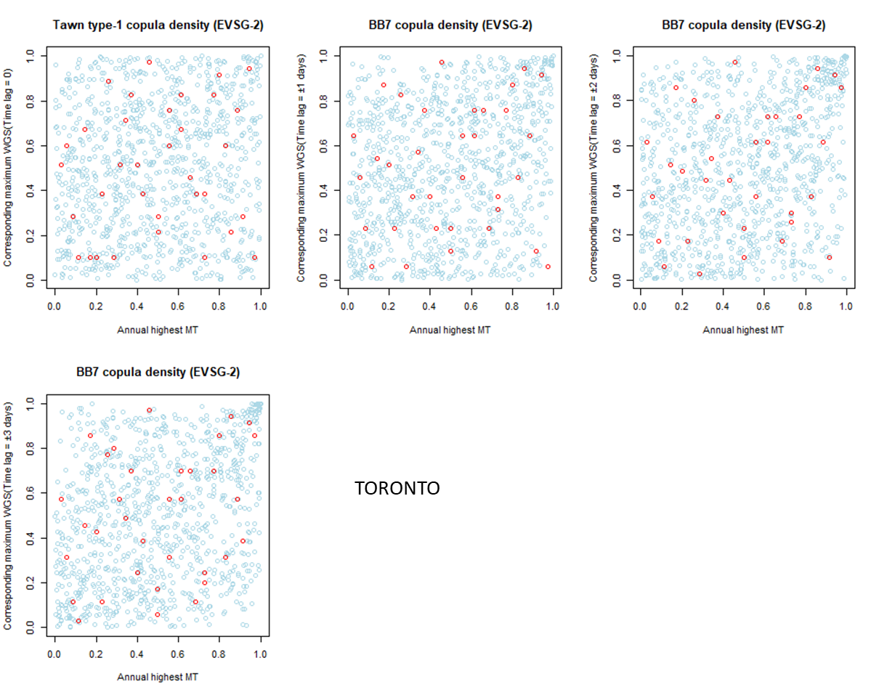(d)
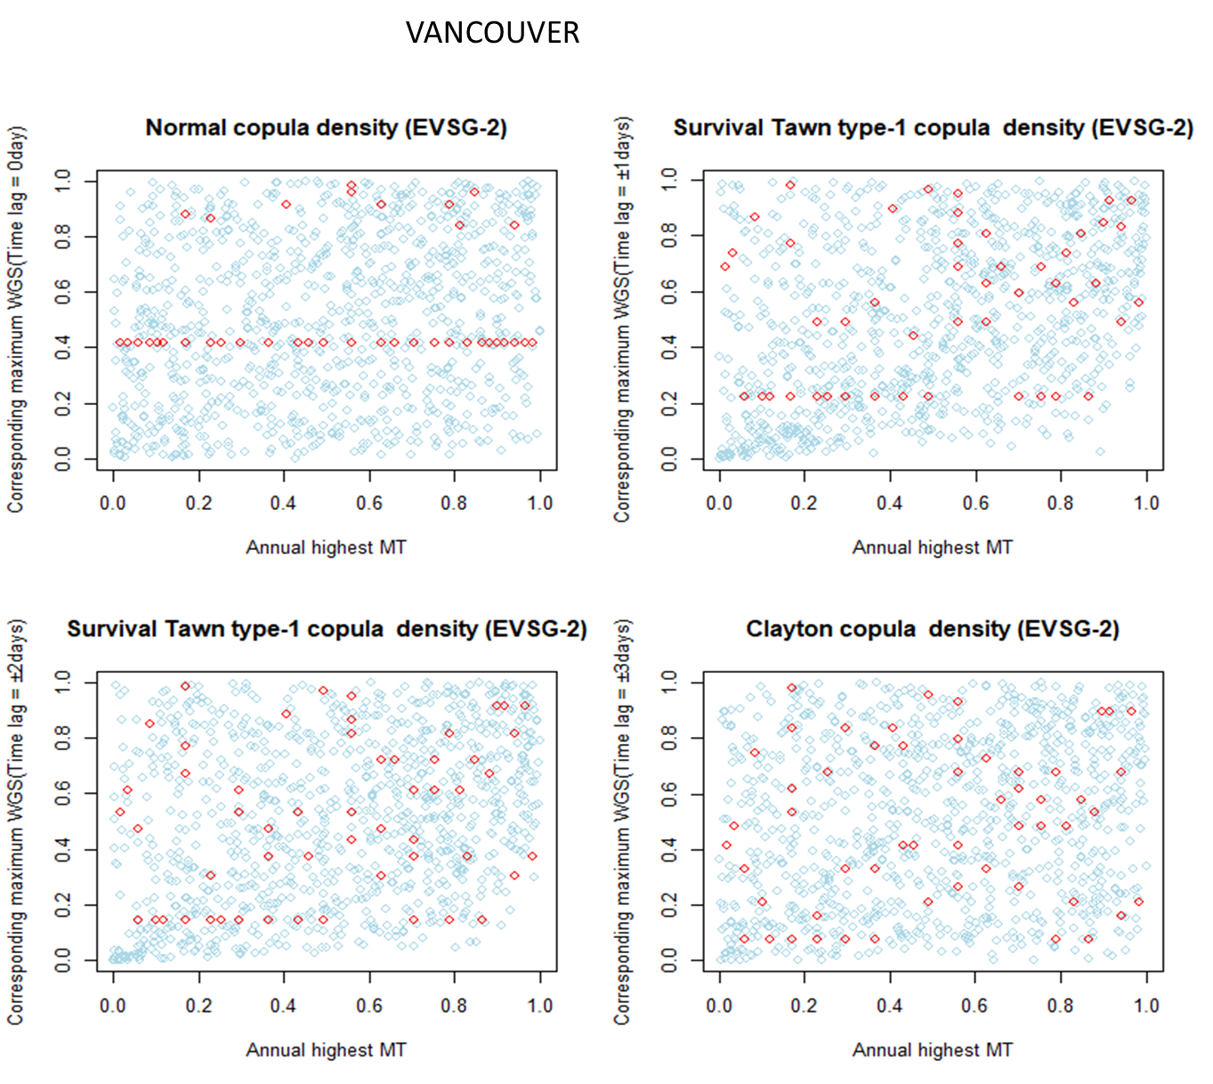(e)

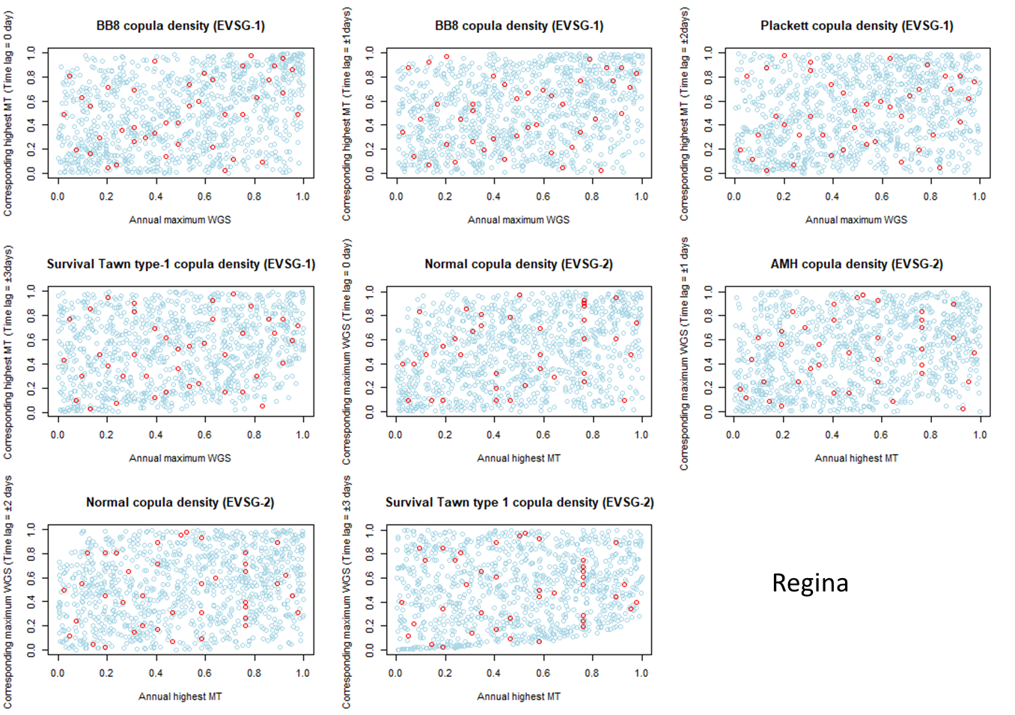

(f)

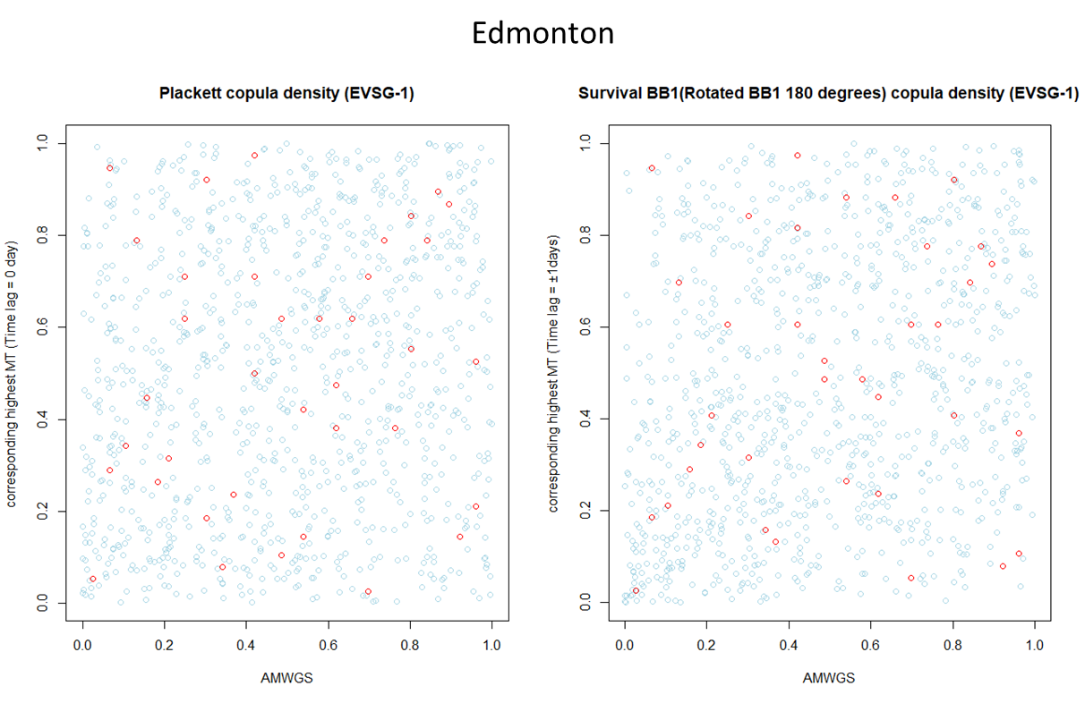(g)

Supplementary SF 6: Visual comparison based on the 2-D scatter plot between bivariate observed (red colour) extreme pairs with set of 1000 random observations simulated (light blue colour) from best-fitted bivariate 2-D copulas for each selected bivariate extreme pairs of selected cities using the MPL estimator. For station (a) Montreal (b) Quebec City (c) Ottawa (d) Toronto (e) Vancouver (f) Regina (g) Edmonton

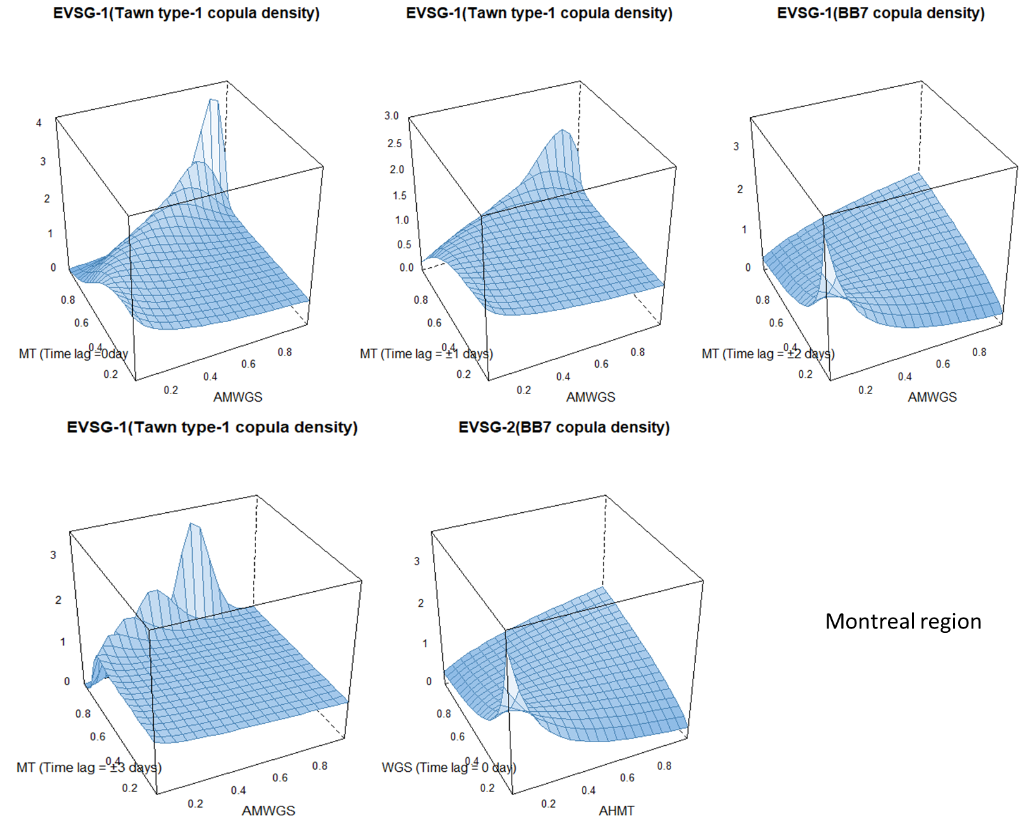(a)

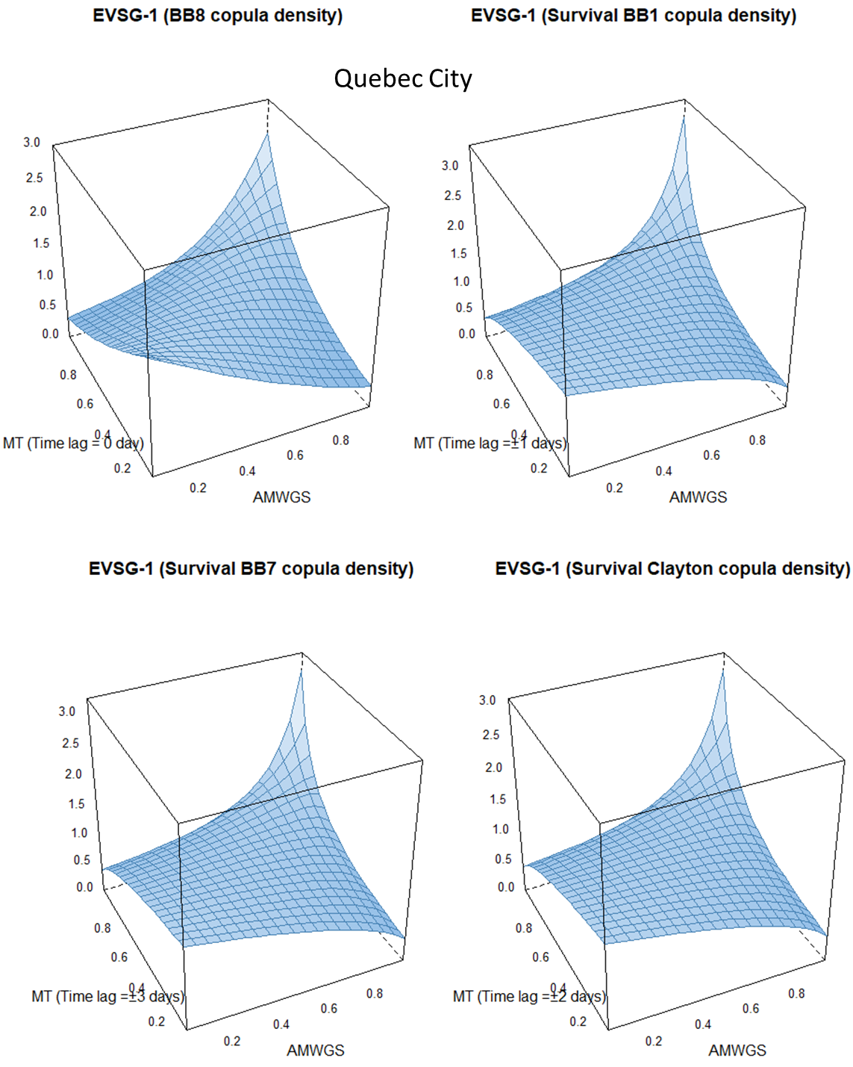 (b)
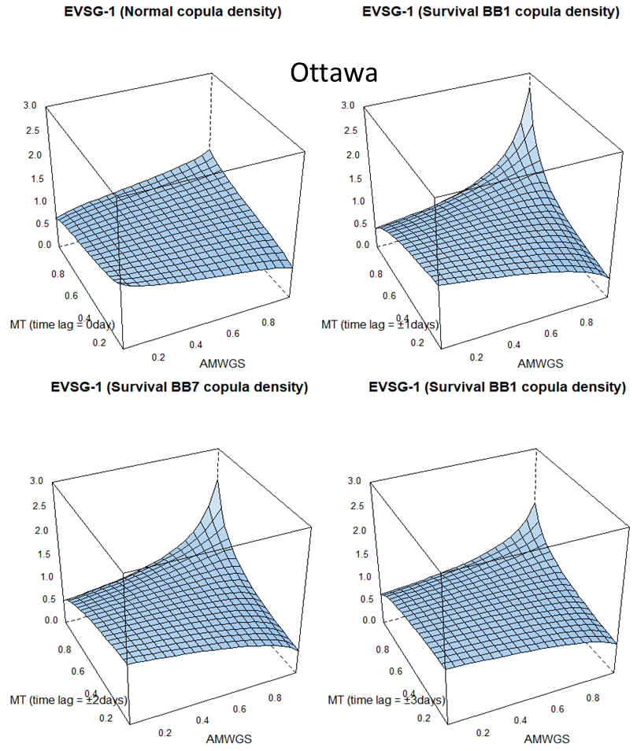(c)

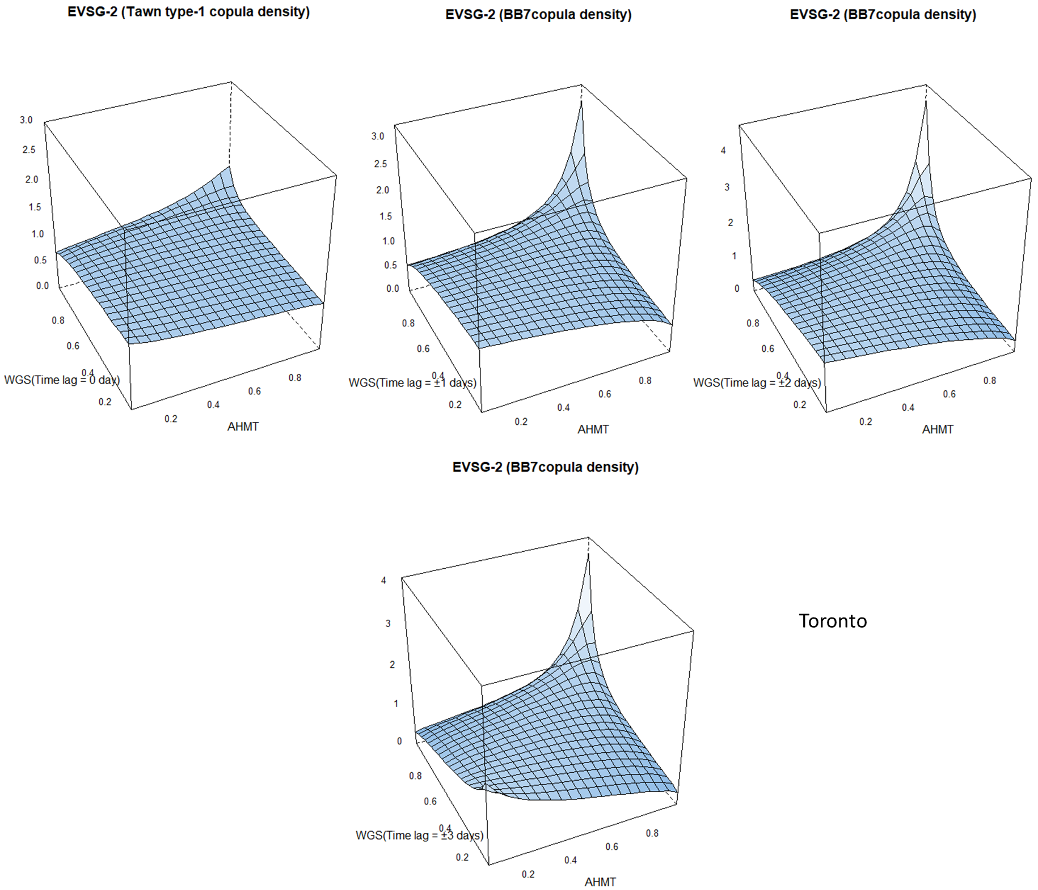 (d)

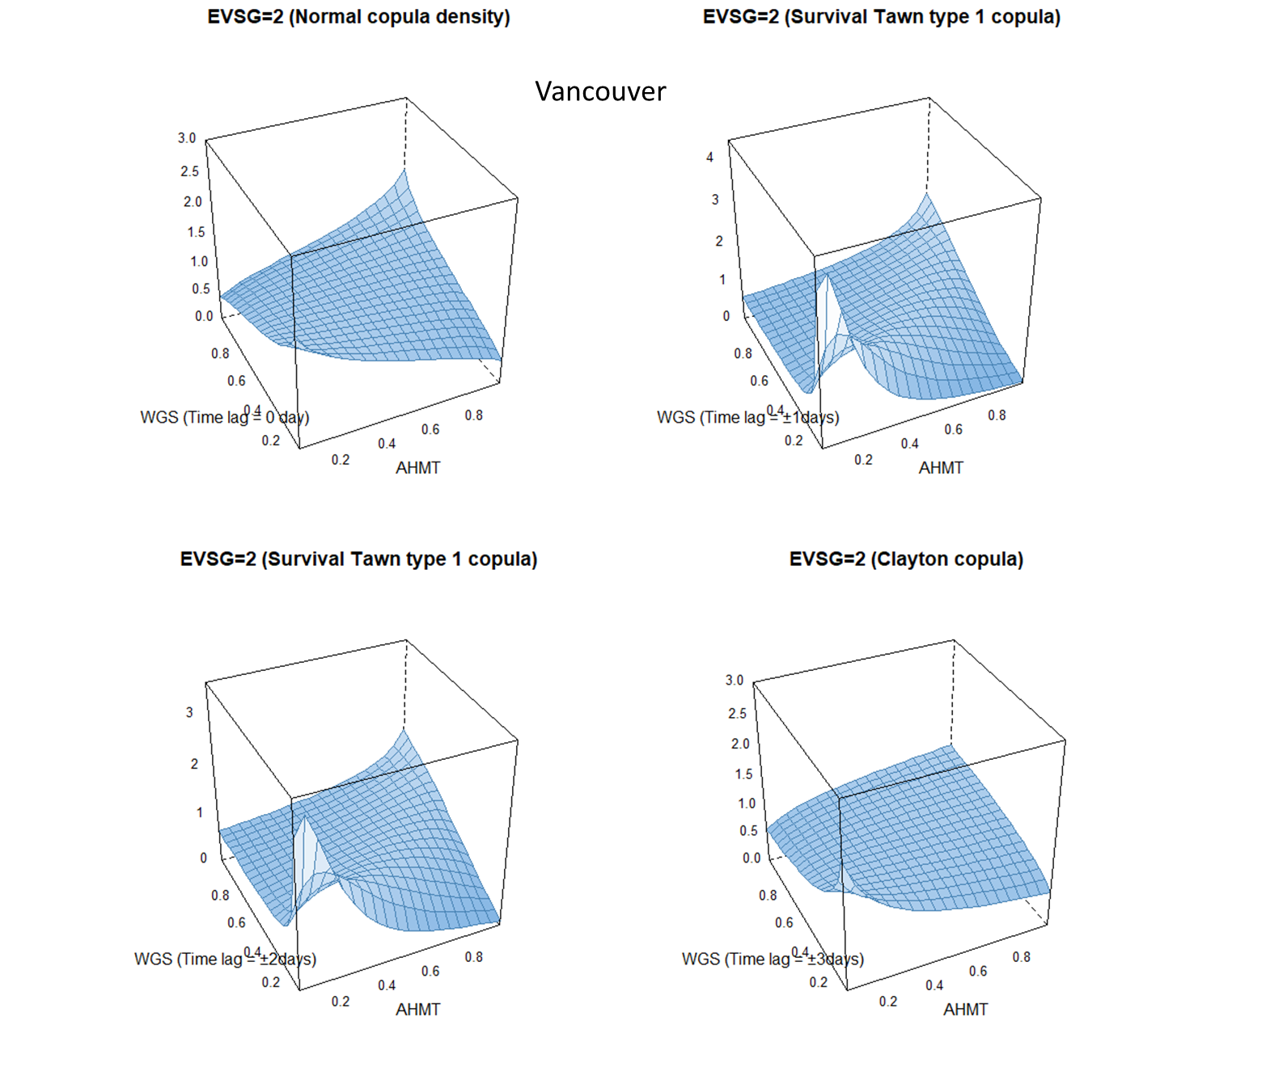(e)

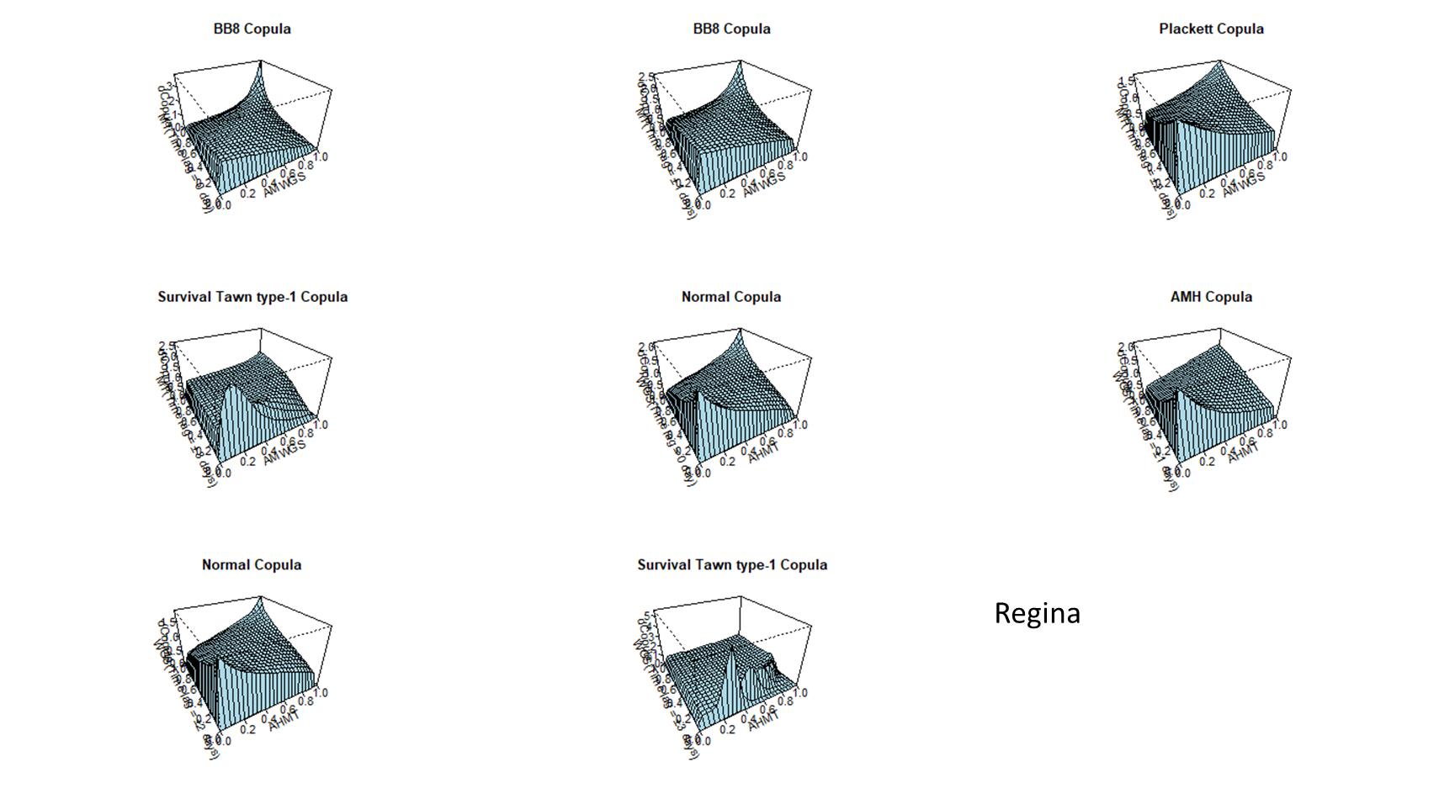(f)

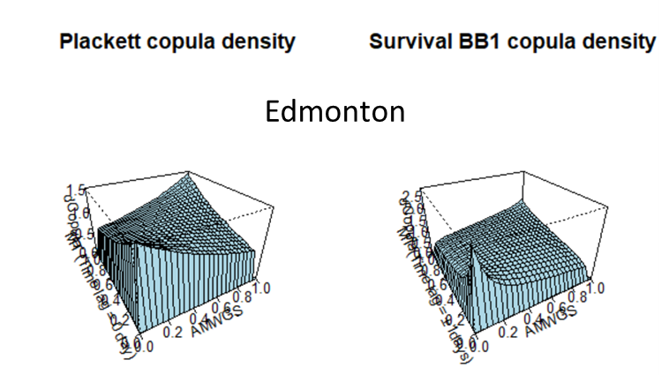 (g)

Supplementary SF7: Illustrating surface density of best-fitted copula density selected for station (a) Montreal (b) Quebec City (c) Ottawa (d) Toronto (e) Vancouver (f) Regina (g) Edmonton

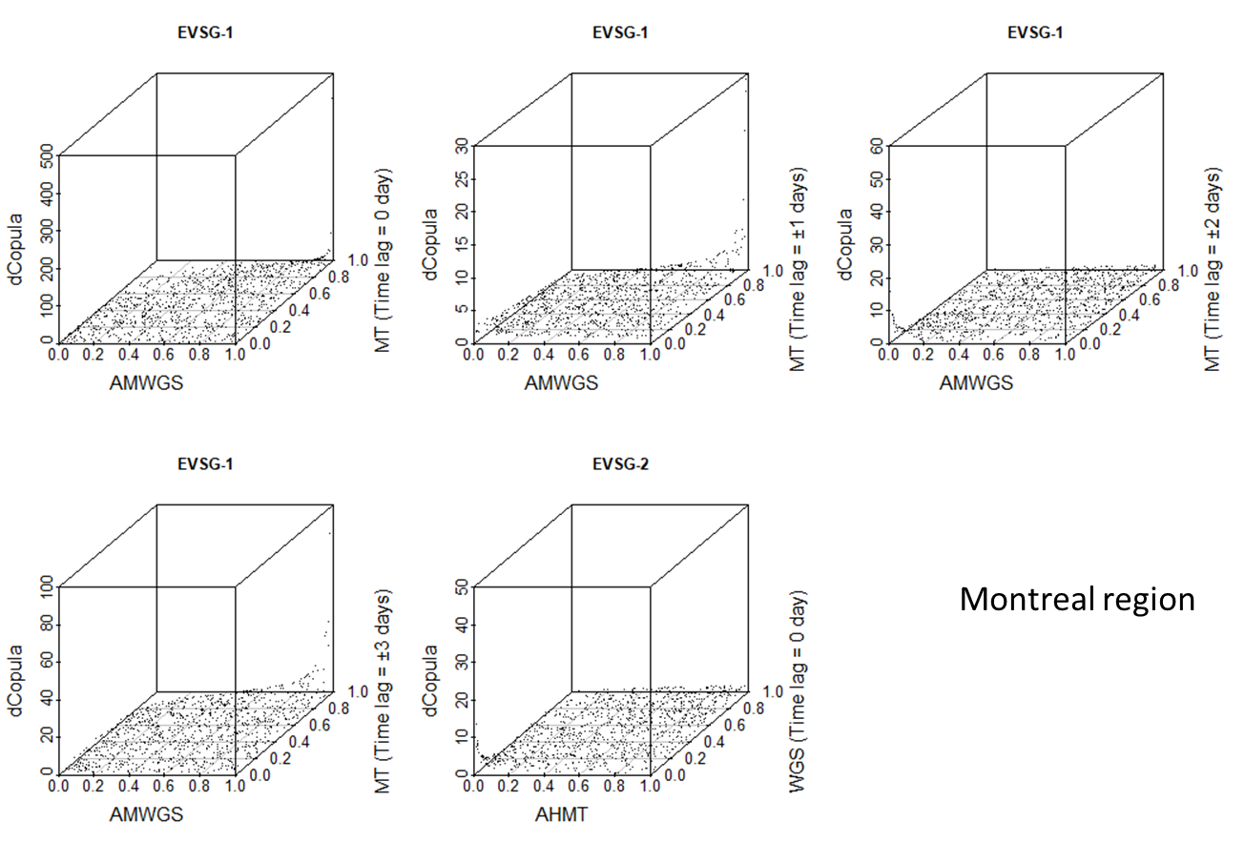(a)

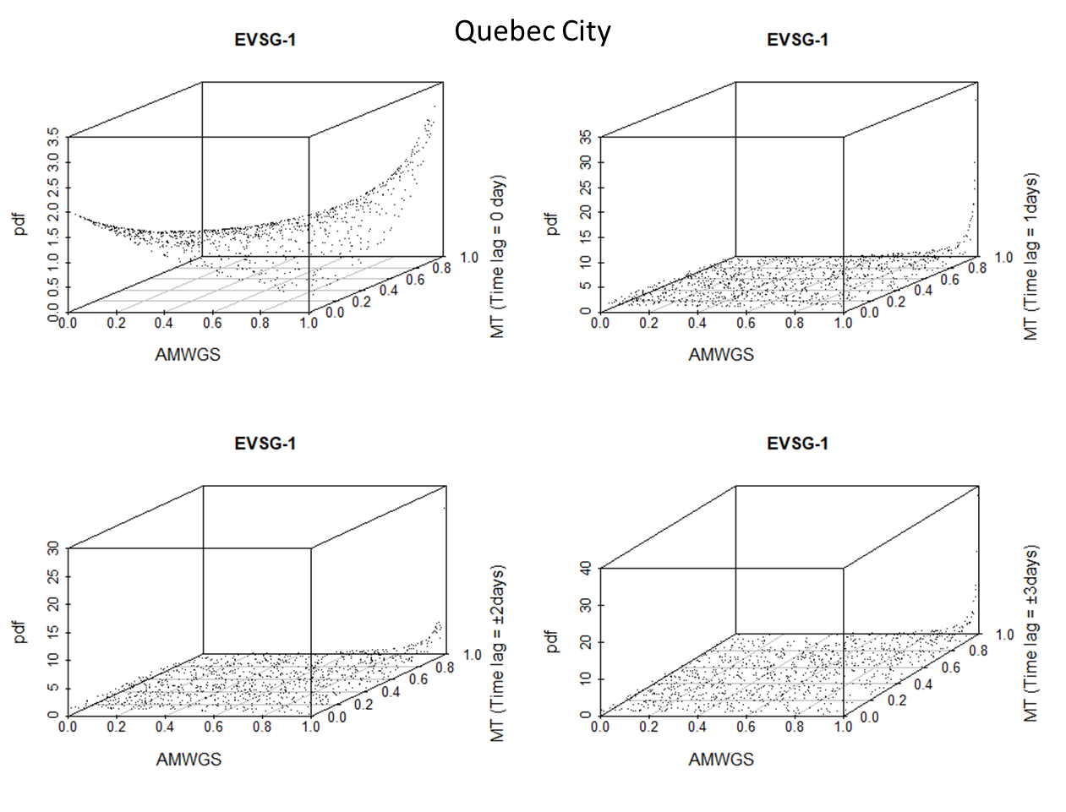 (b)

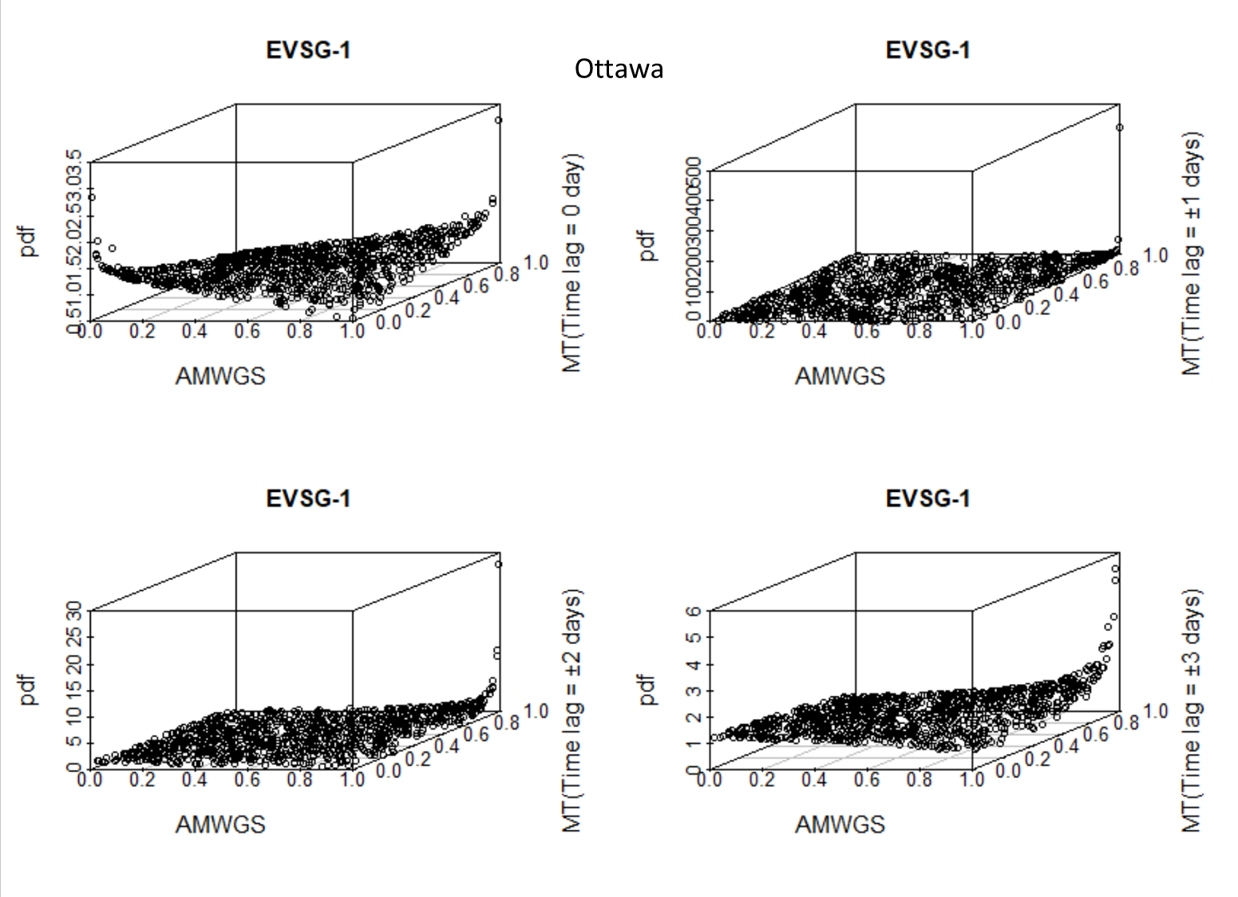 (c)

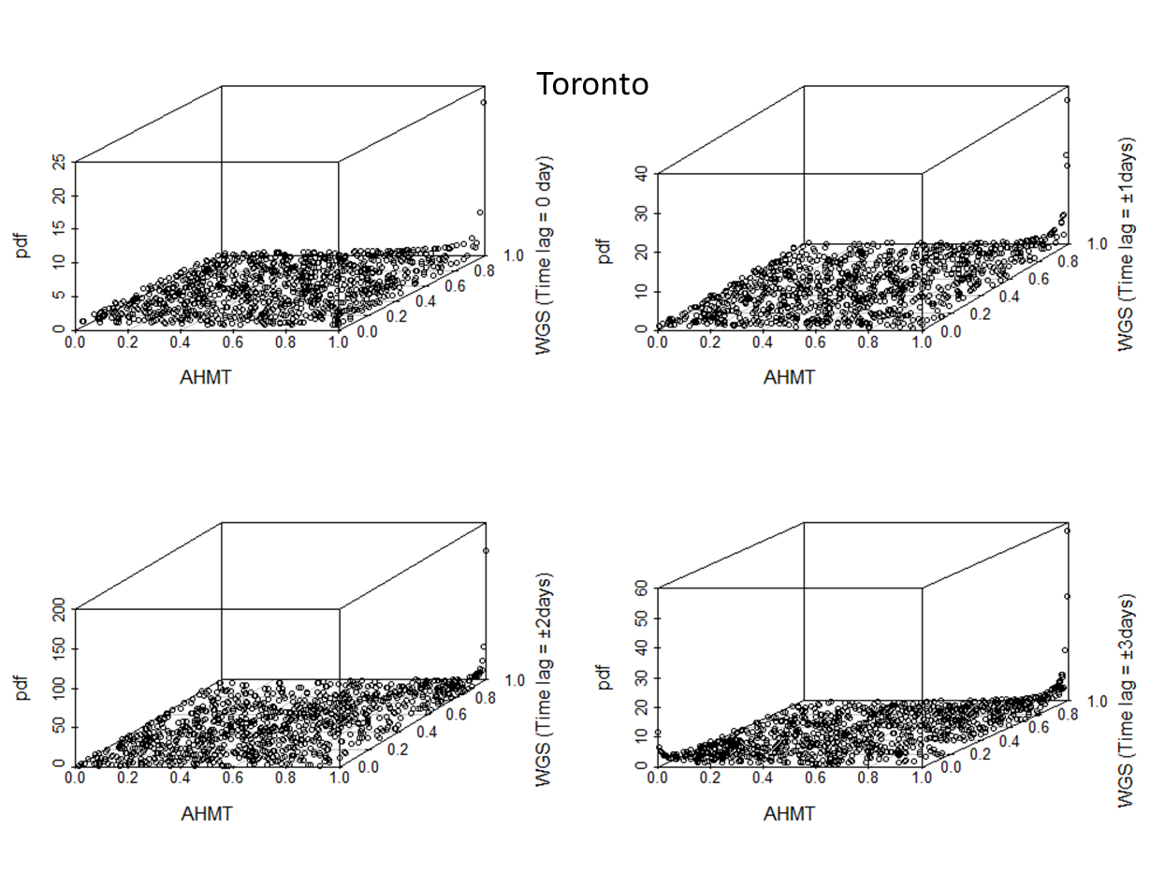(d)

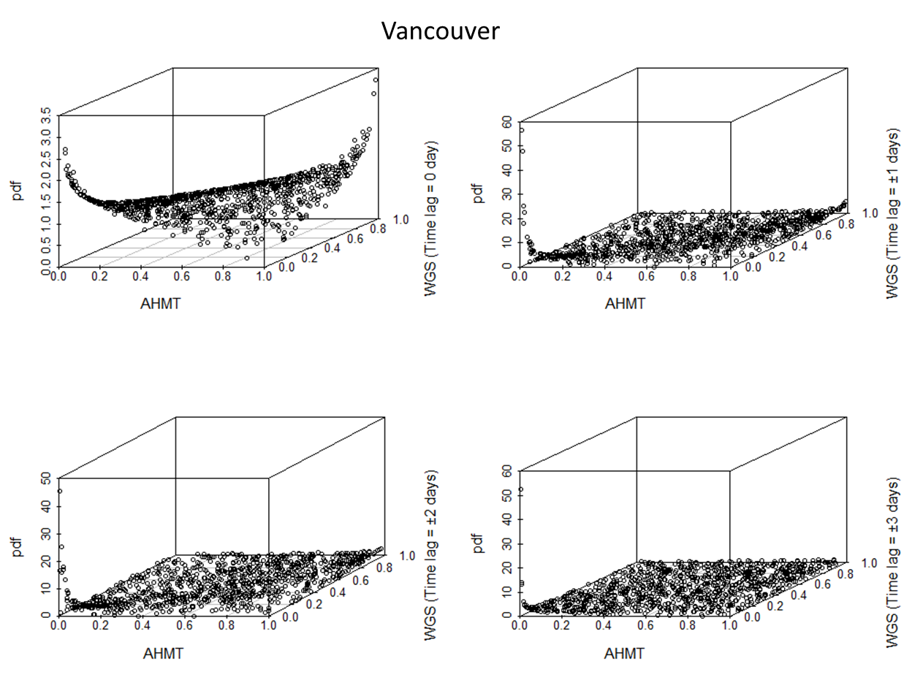 (e)
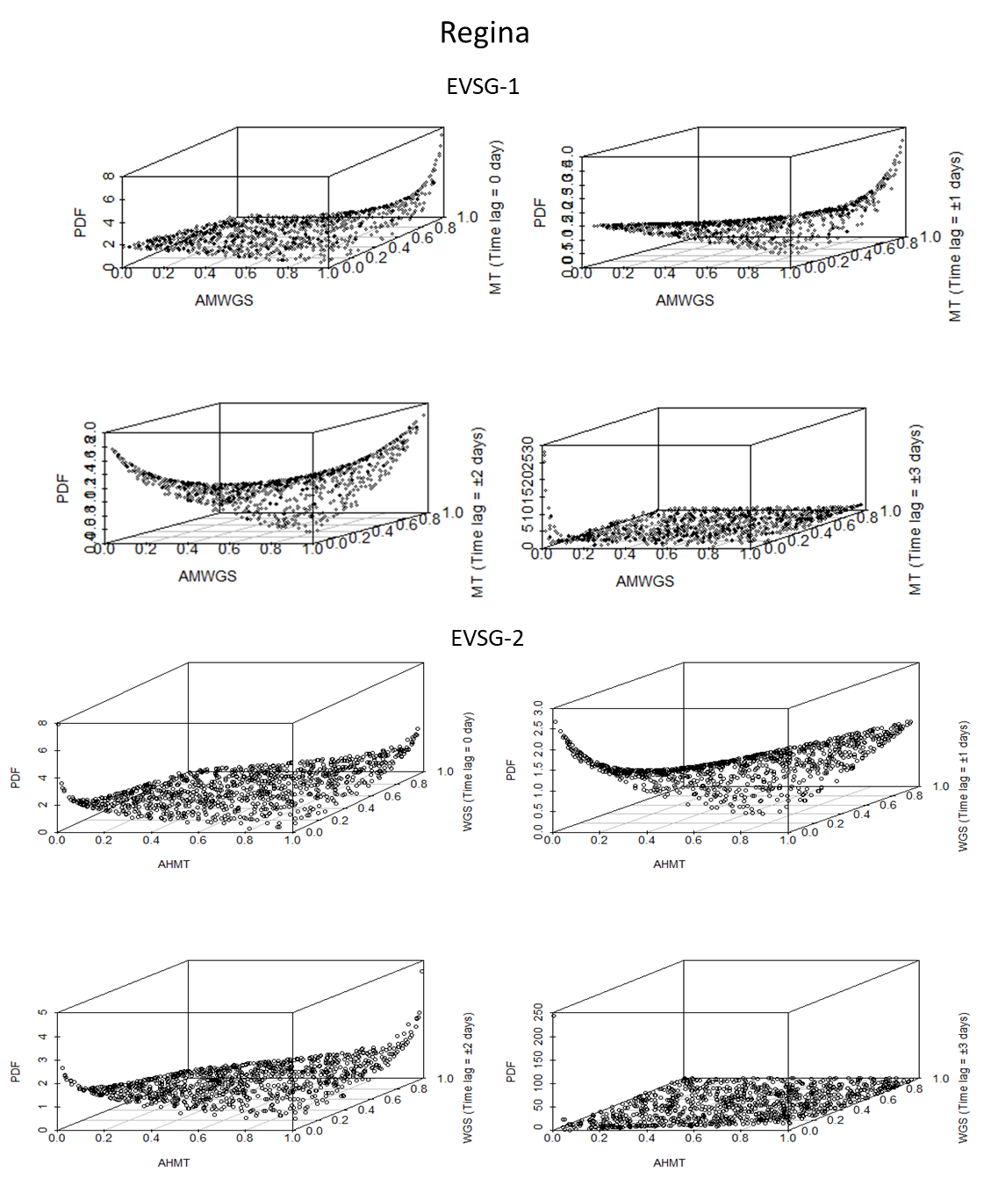(f)

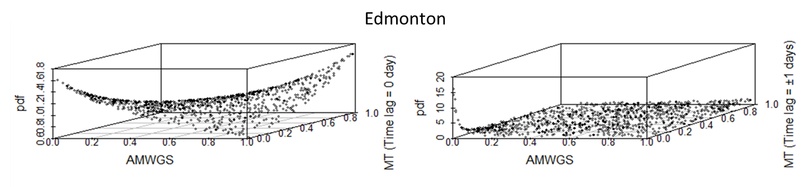 (g)

Supplementary SF 8: Illustrating 3-D scatterplot of joint PDF drawn using 1000 random samples extracted from best-fitted 2-D copula for station (a) Montreal (b) Quebec City (c) Ottawa (d) Toronto (e) Vancouver (f) Regina (g) Edmonton

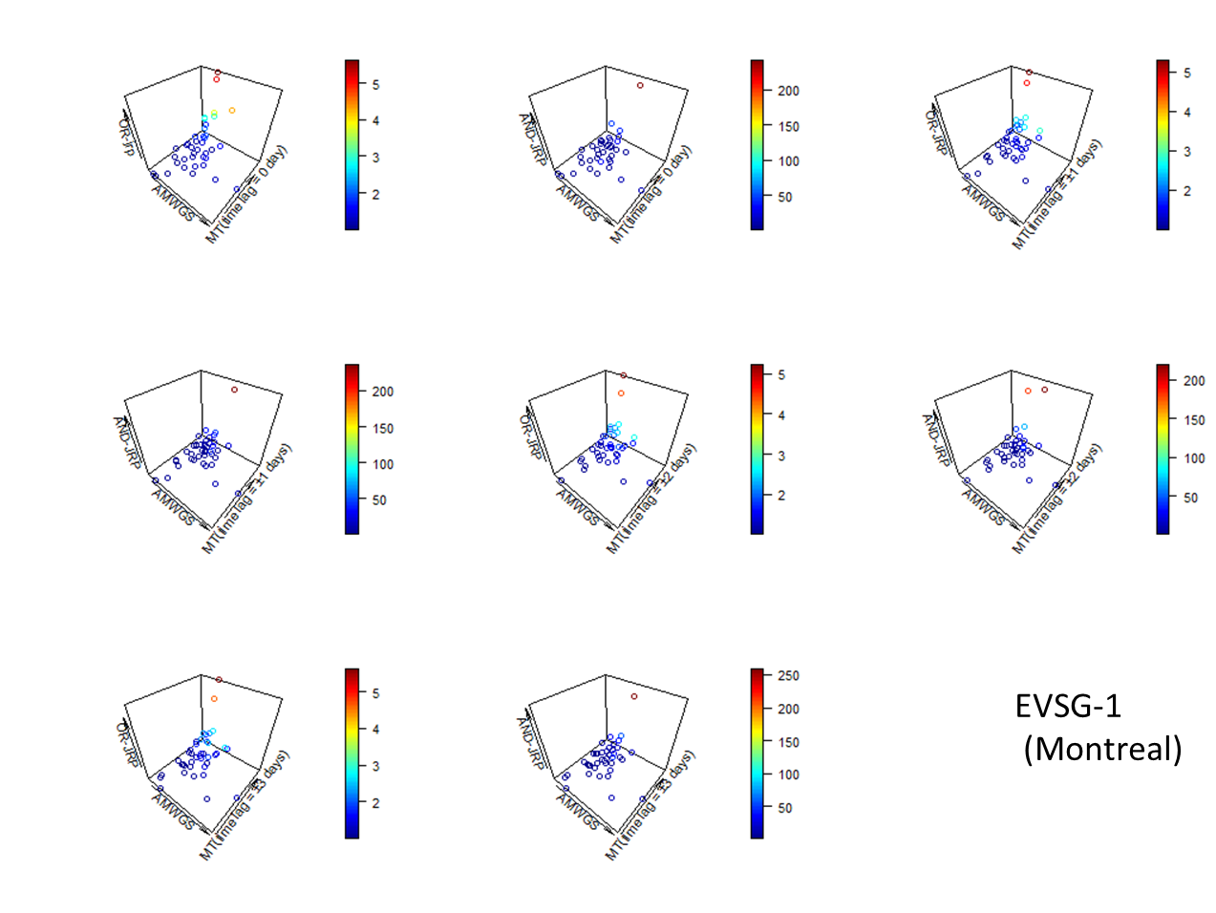(a-1)
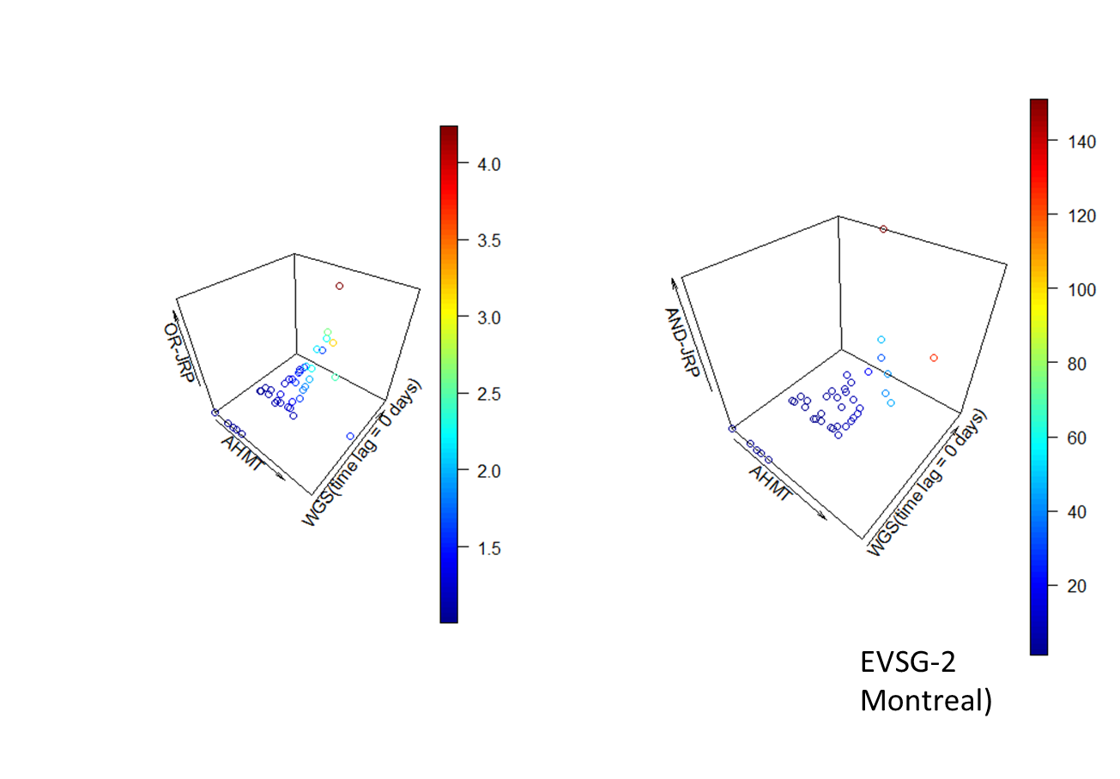(a-2)
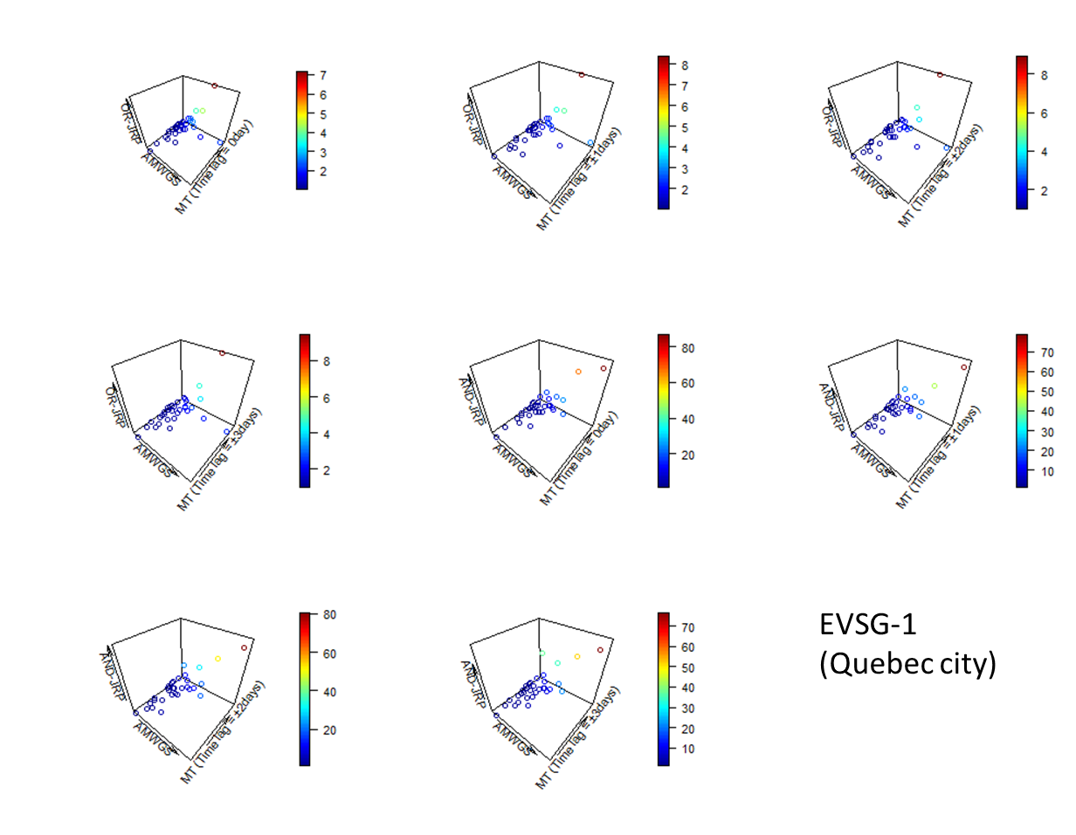(b)
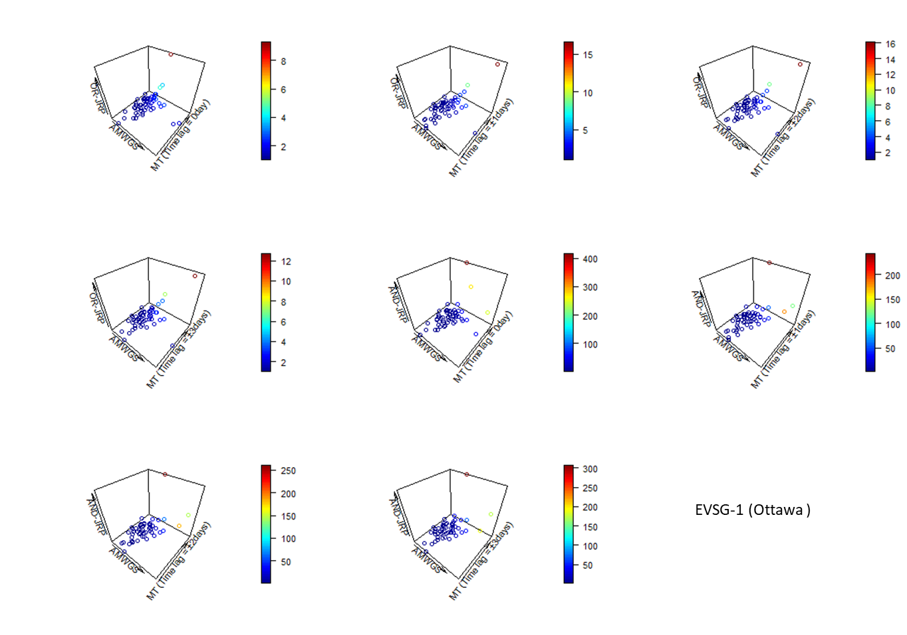(c)
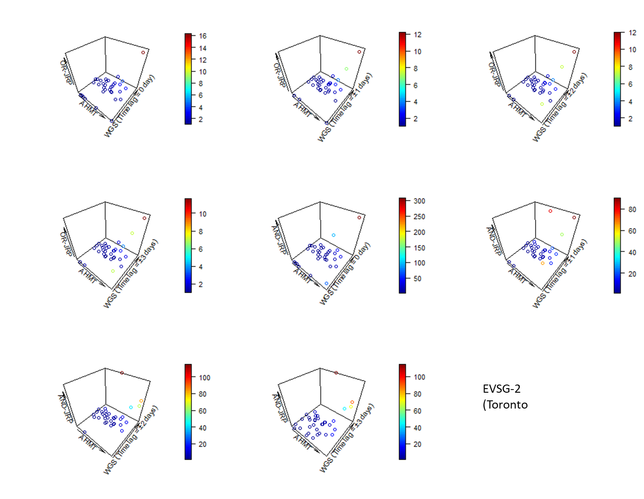(d)
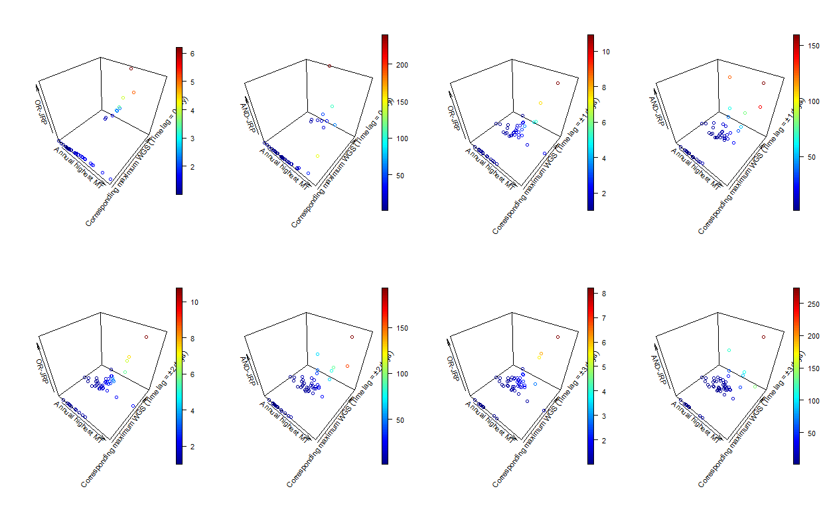(e)
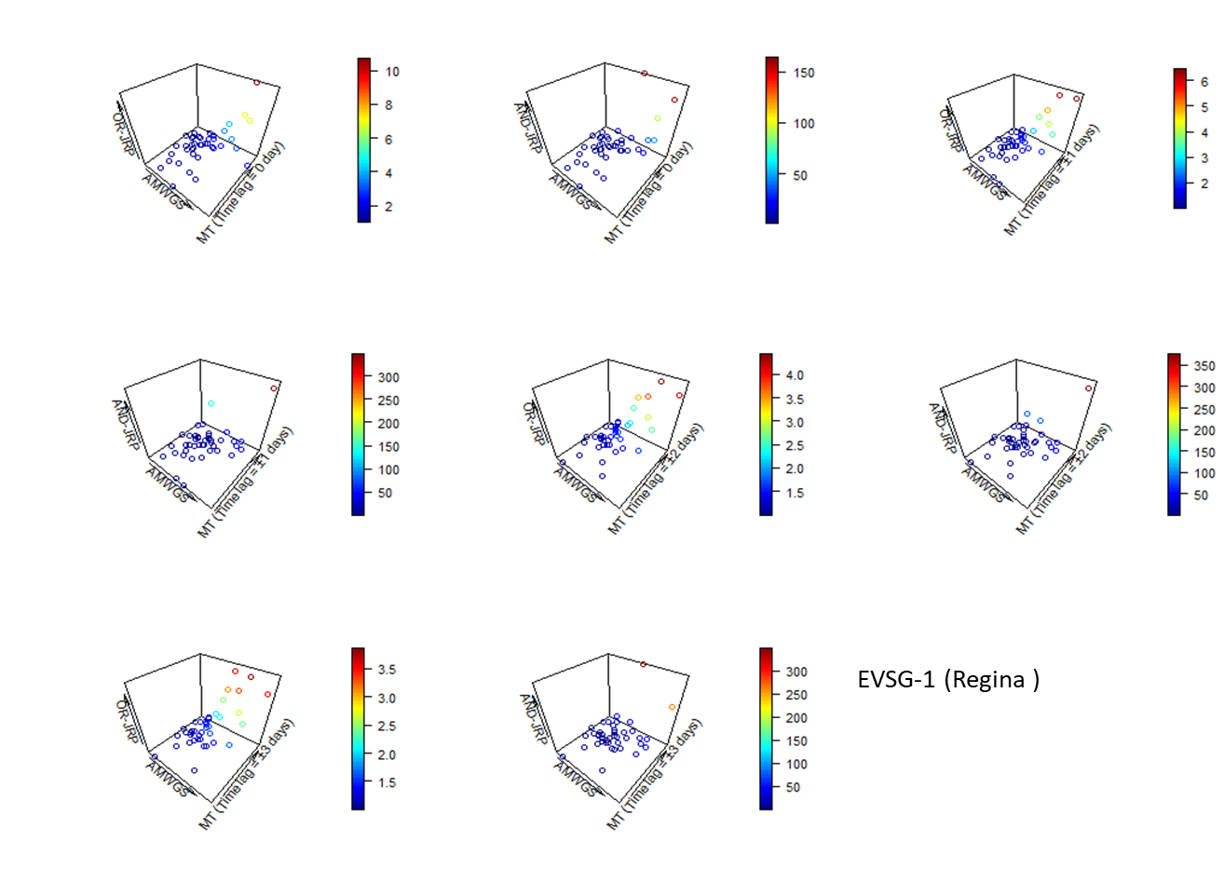(f-1)
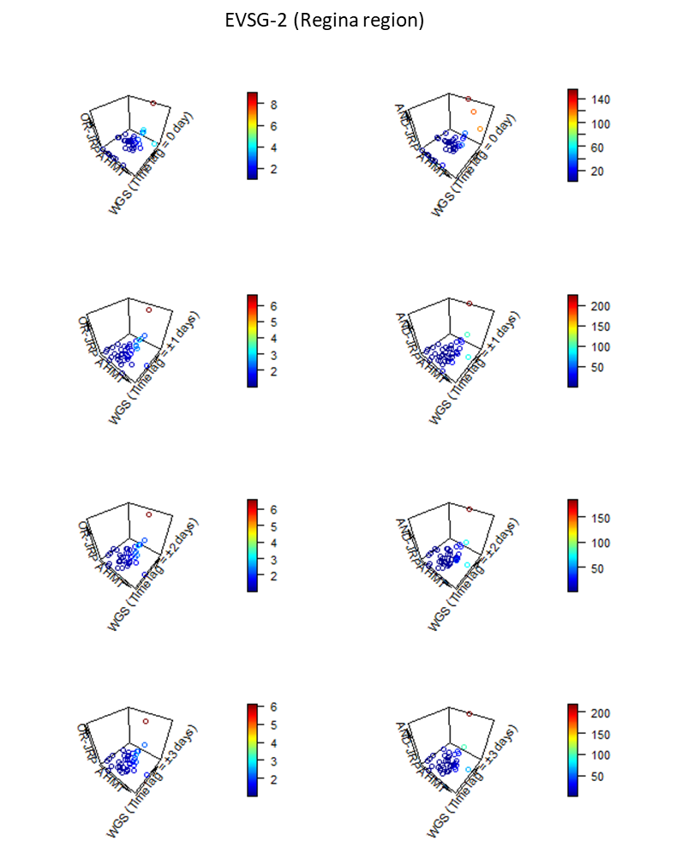 (f-2)
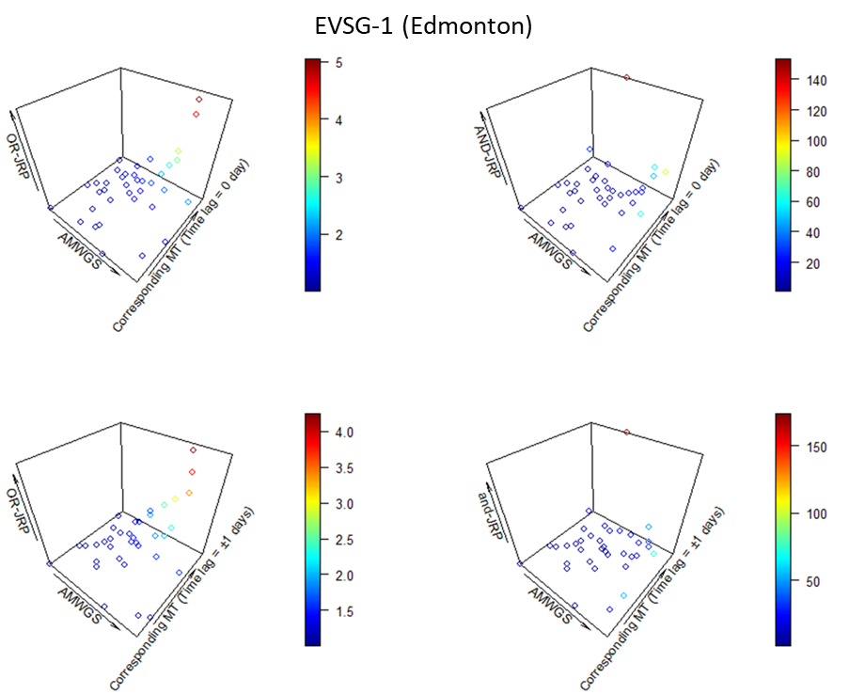(g)

Supplementary SF9: 3-D scatterplots illustrating the primary joint RPs for bivariate OR and AND hazard scenario for the different possible combination using the historical events (datasets) at the station (a-1, a-2) Montreal (b) Quebec City (c) Ottawa (d) Toronto (e) Vancouver (f-1, f-2) Regina (g) Edmonton

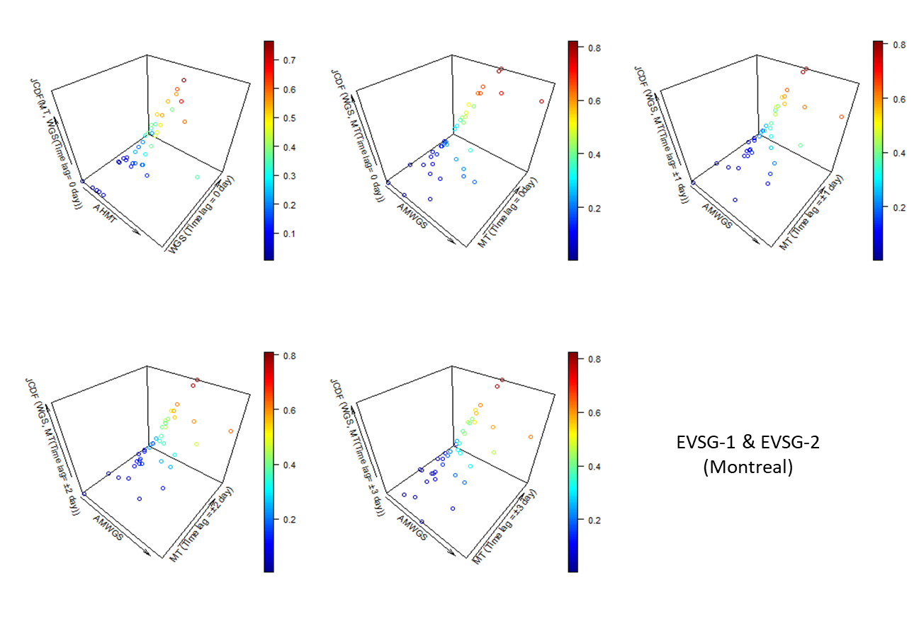(a)
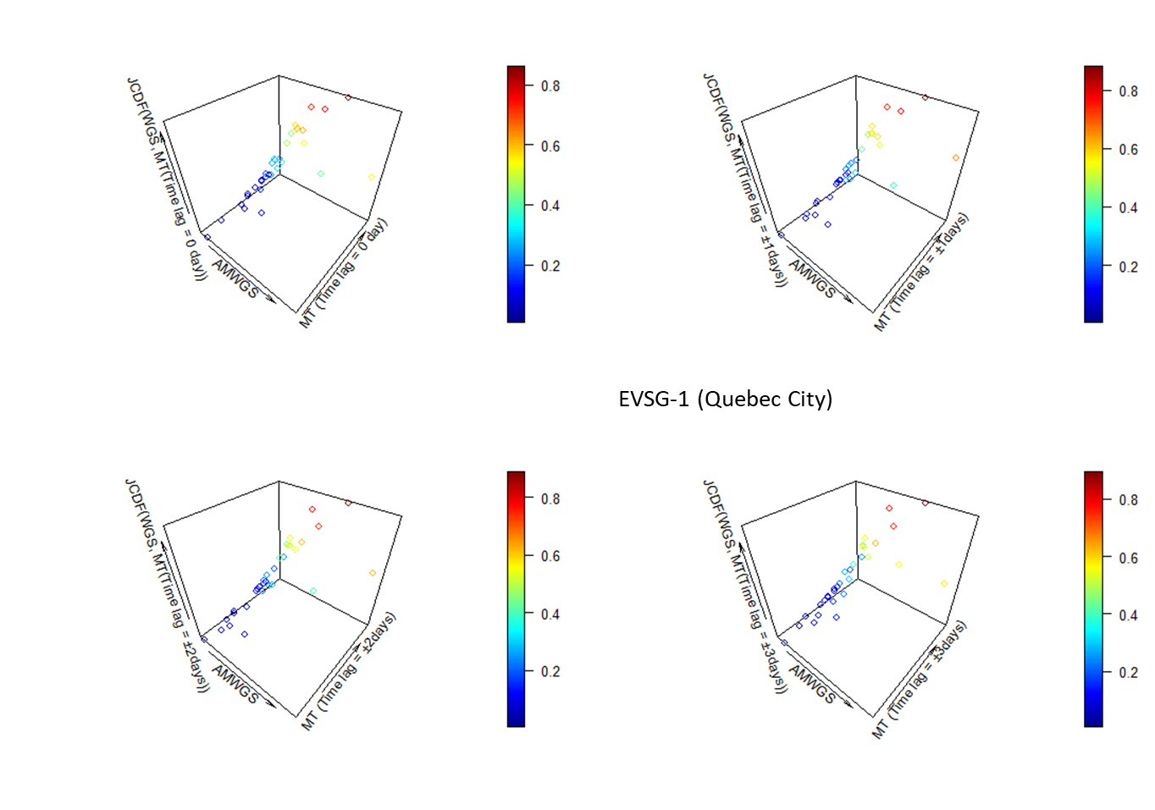(b)
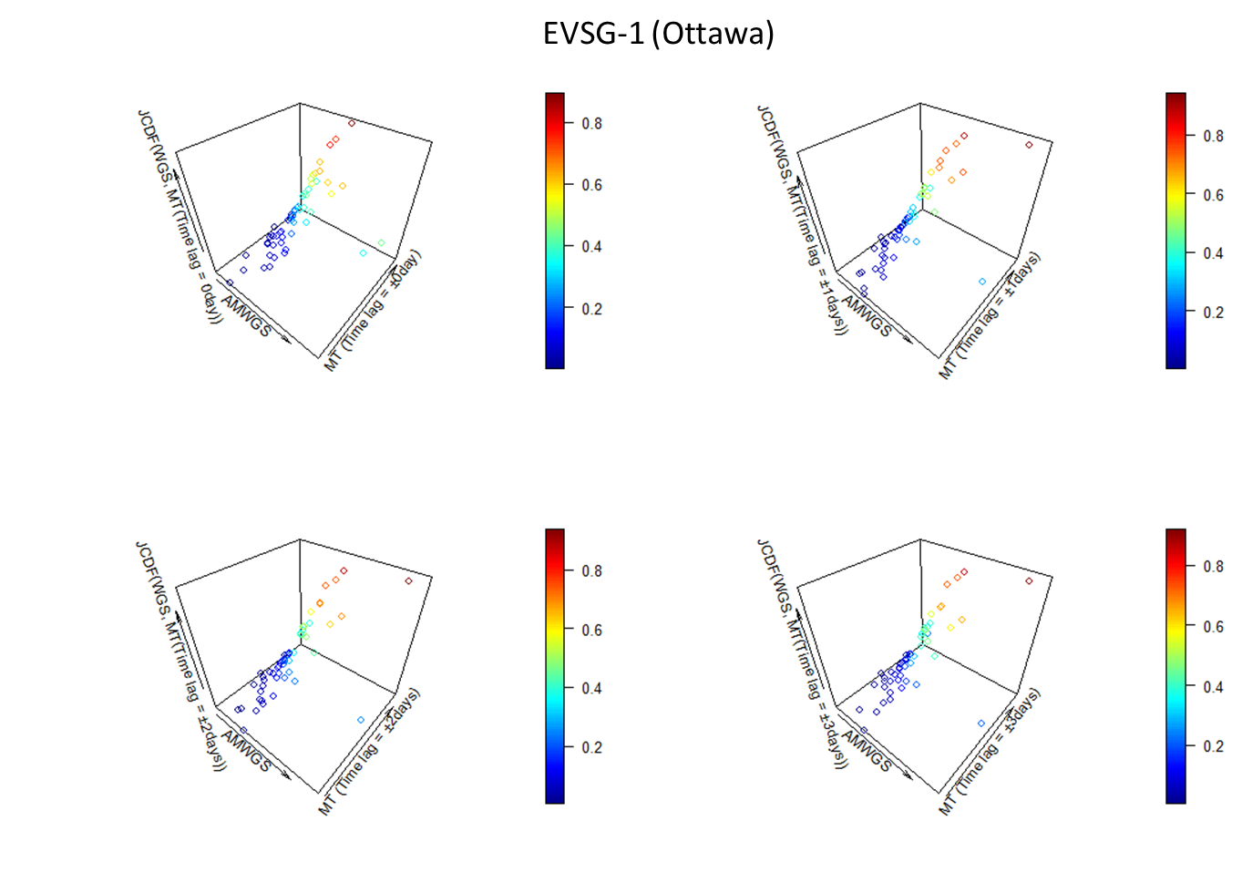(c)
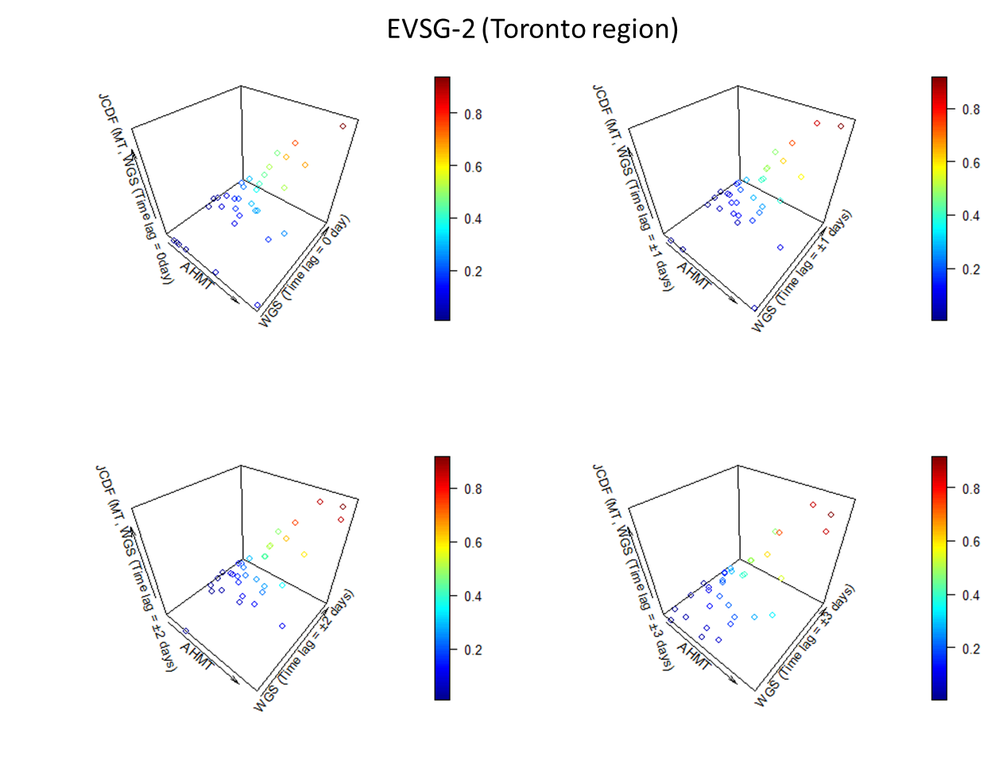(d)
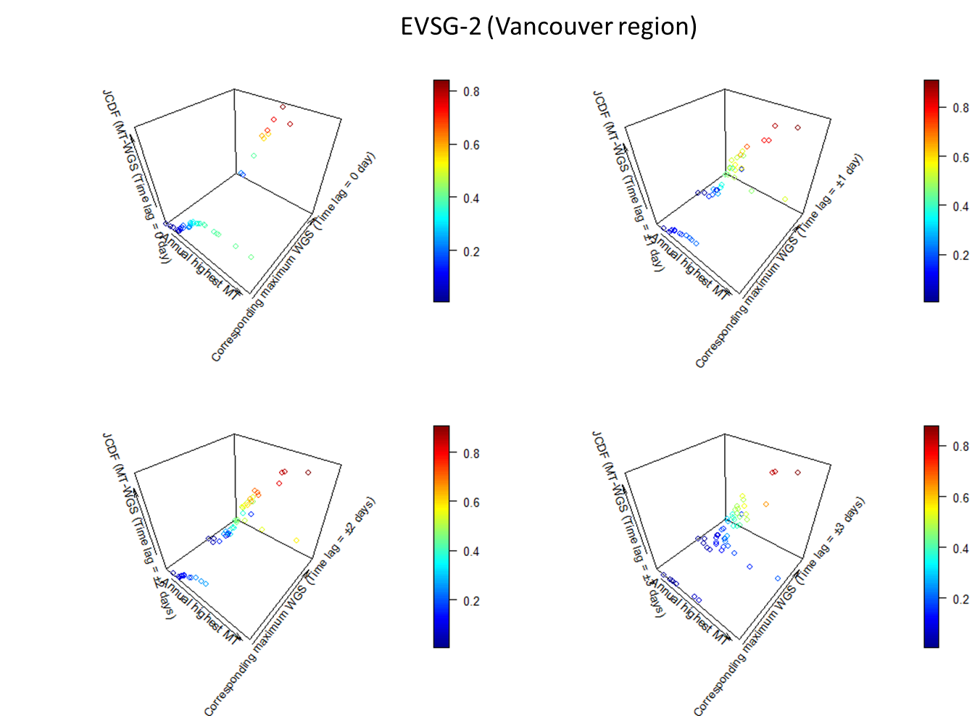

(e)

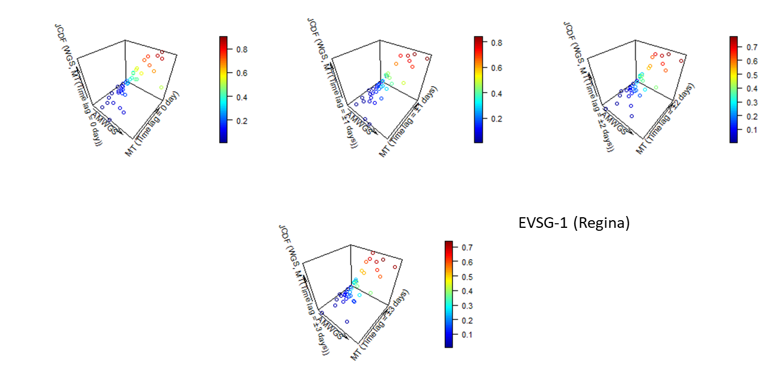 (f-1
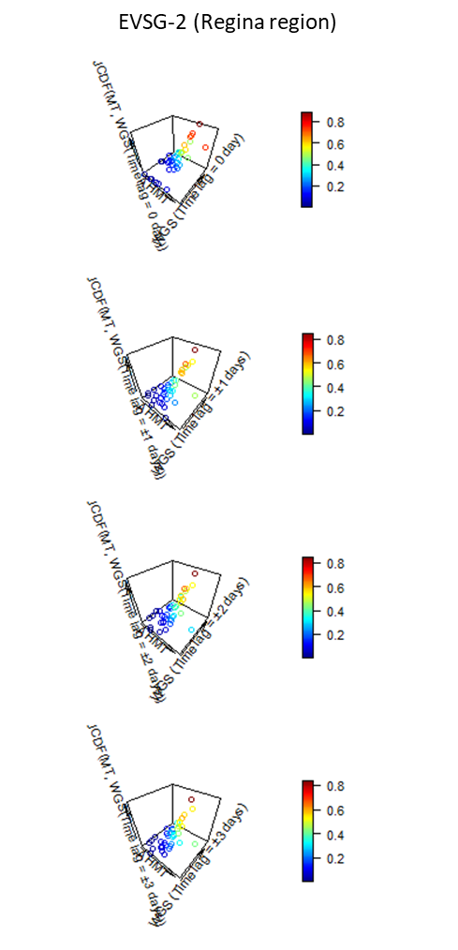(f-2)

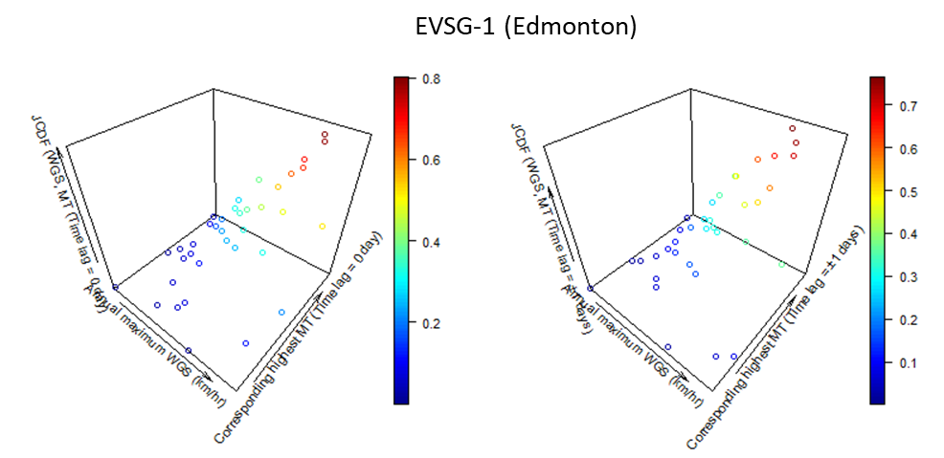

(g)

Supplementary SF 10 3-D scatterplots illustrating the Joint CDF (also, called joint nonexceedance probabilities) associated with bivariate extreme pairs of the historical events at the station (a-1, a-2) Montreal (b) Quebec City (c) Ottawa (d) Toronto (e) Vancouver (f-1, f-2) Regina (g) Edmonton

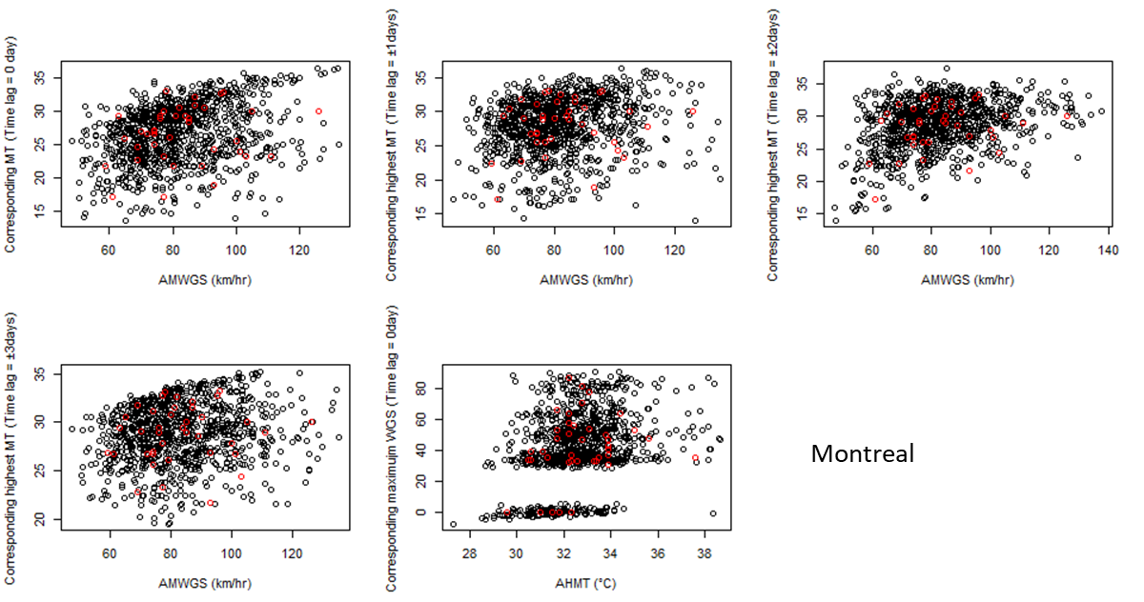(a)
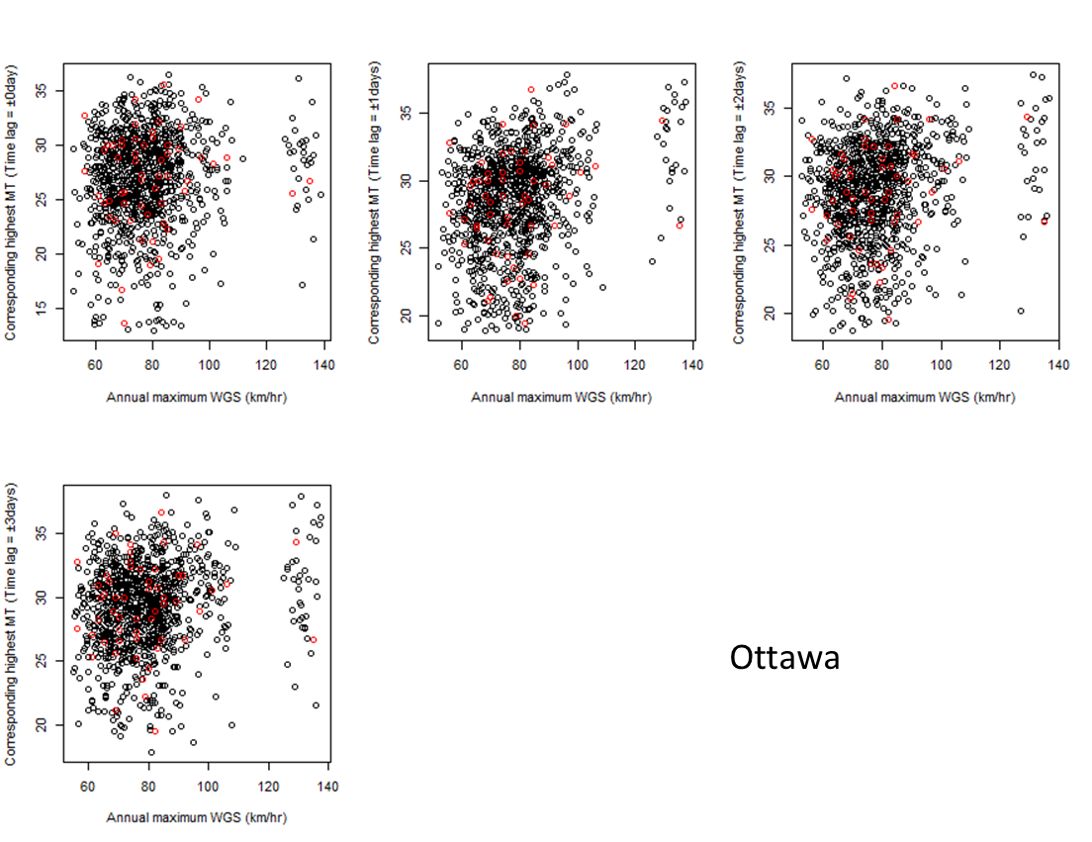
(c)

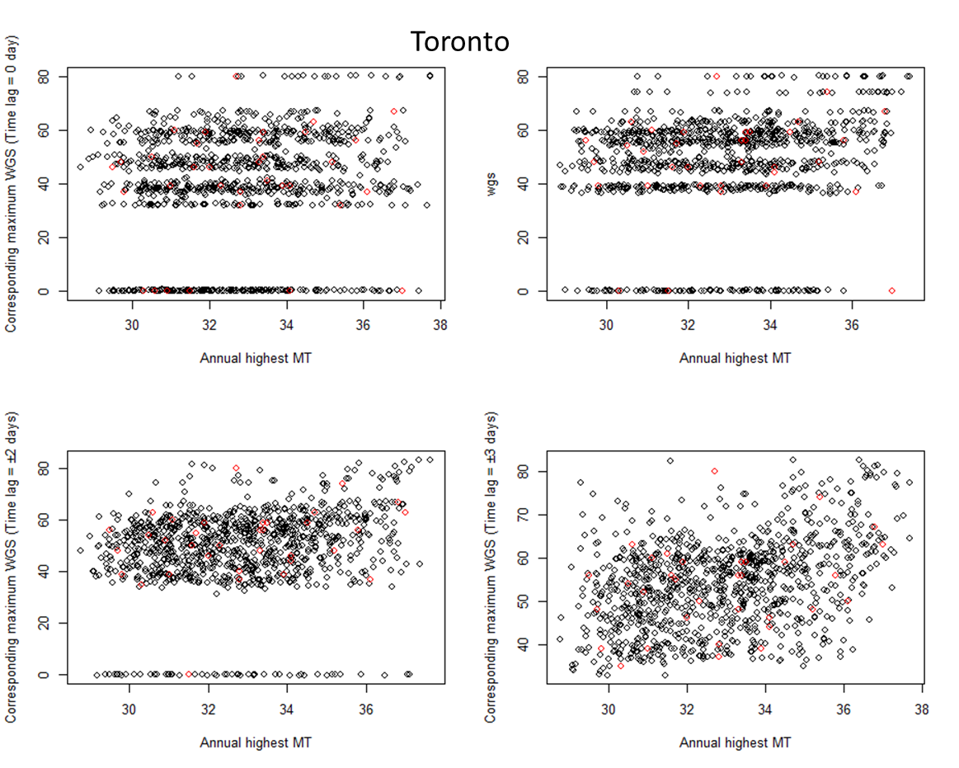
(d)

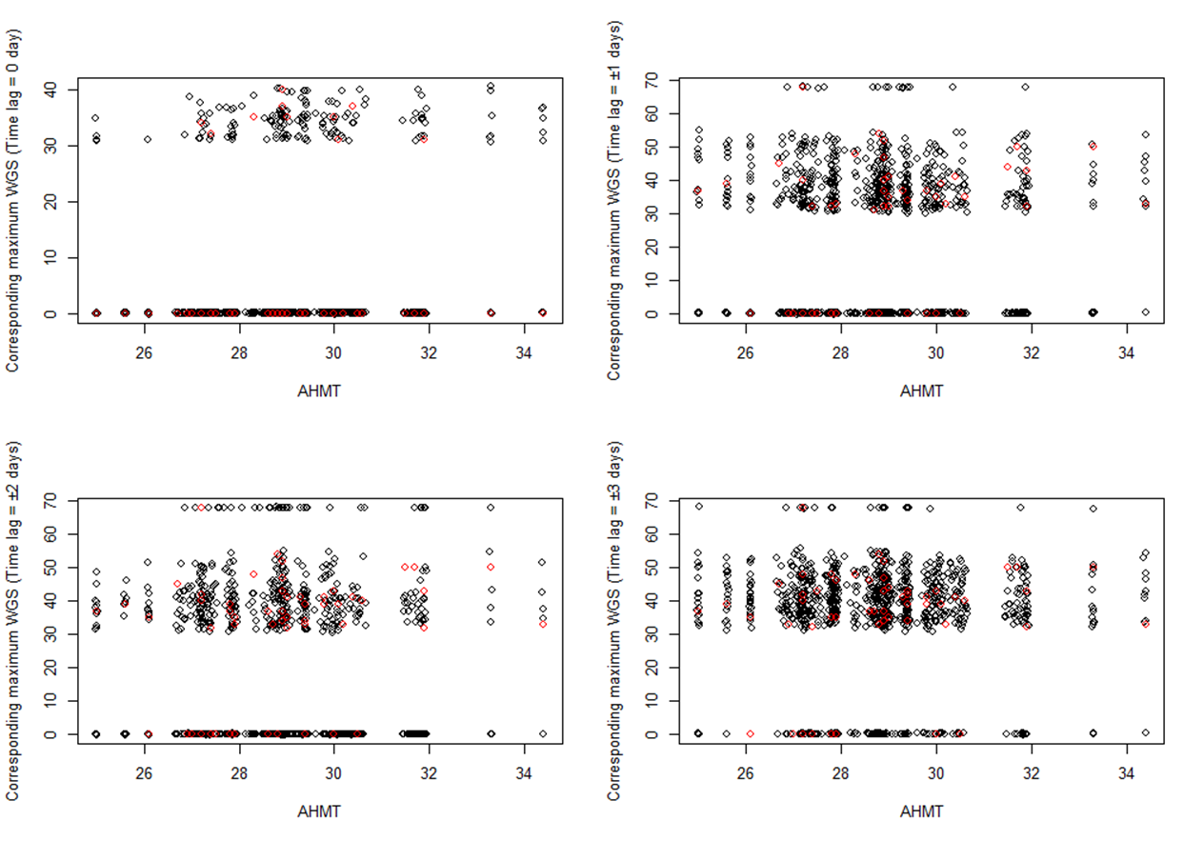(e)

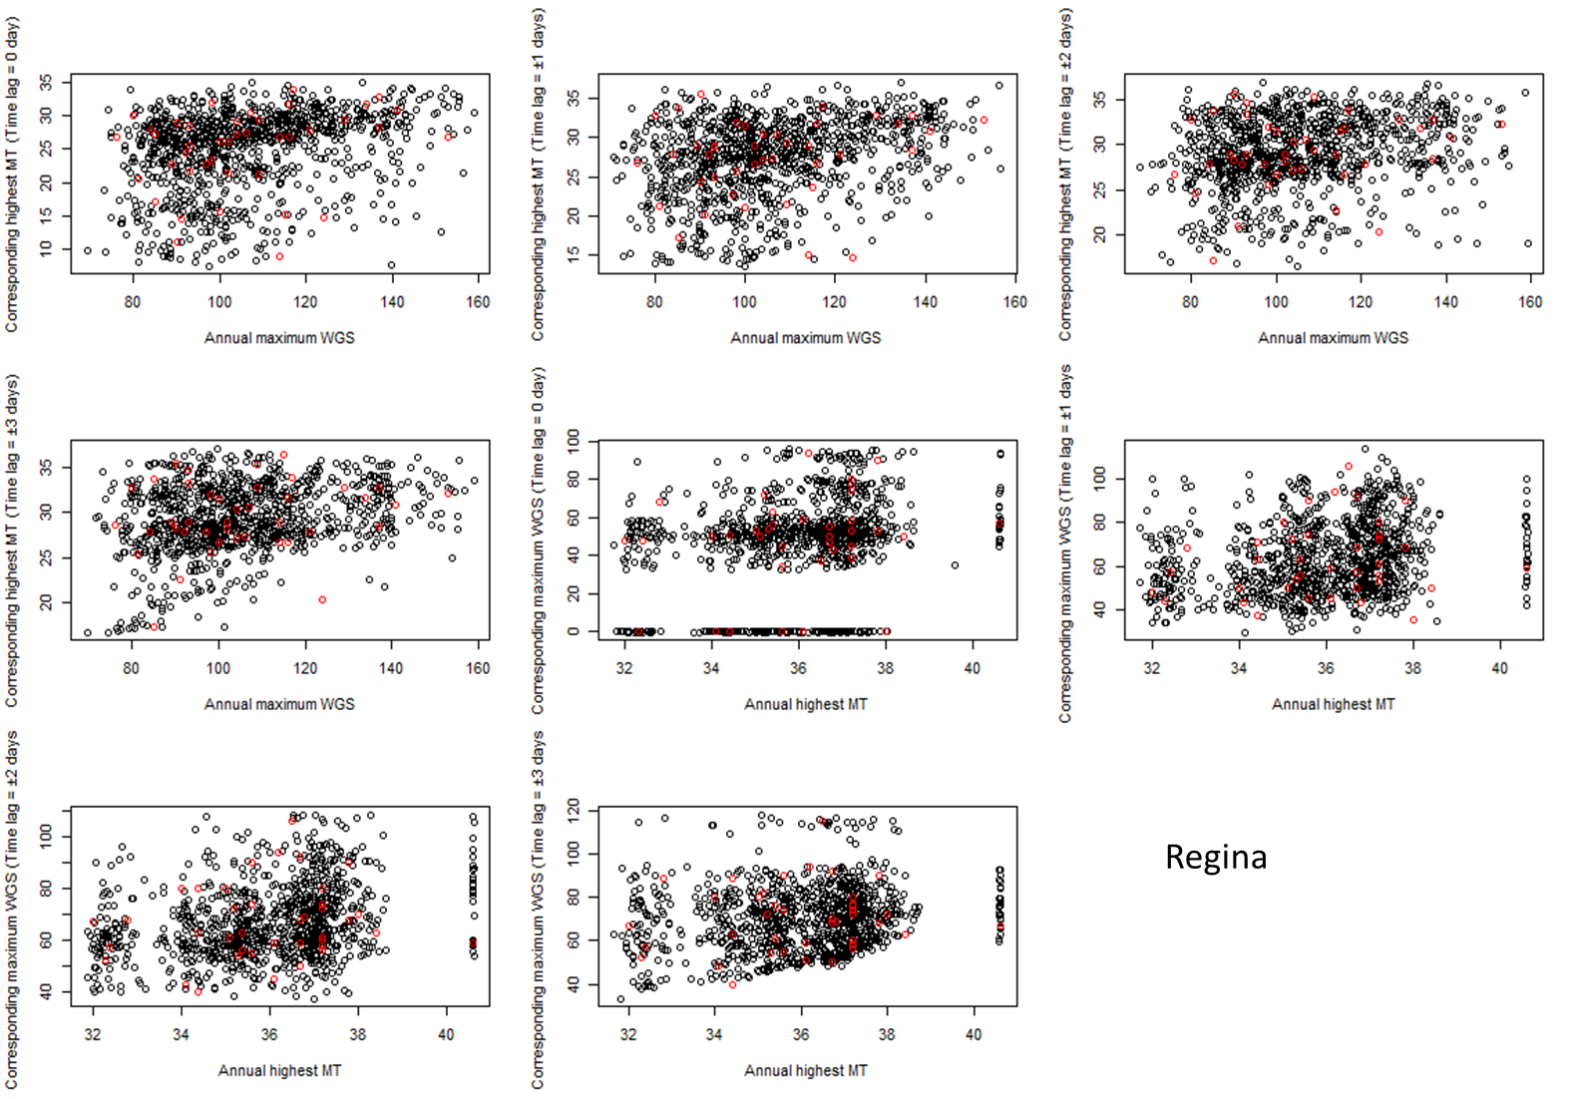(f)
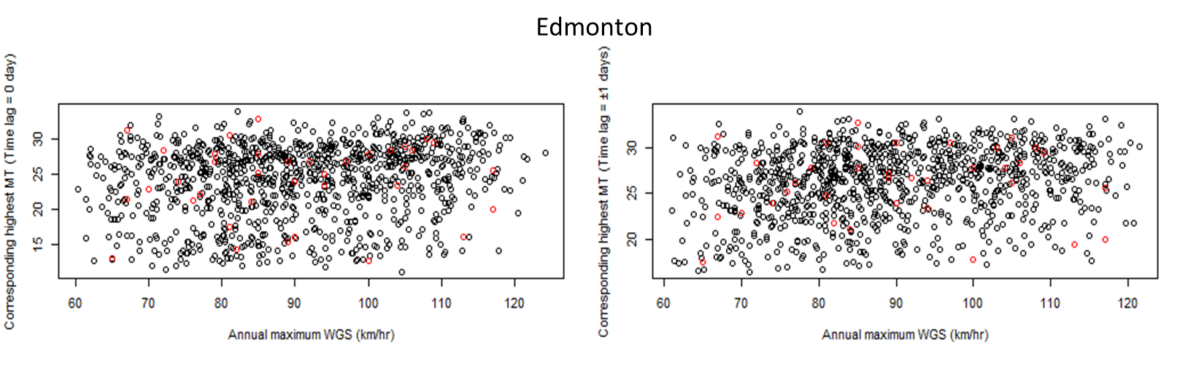(g)

Supplementary SF 11 Synthetically generated (sample size, N=1000) bivariate extreme events using the selected semiparametric copula joint density at the station (a-1) Montreal (b) Quebec City (c) Ottawa (d) Toronto (e) Vancouver (f-1, f-2) Regina (g) Edmonton

