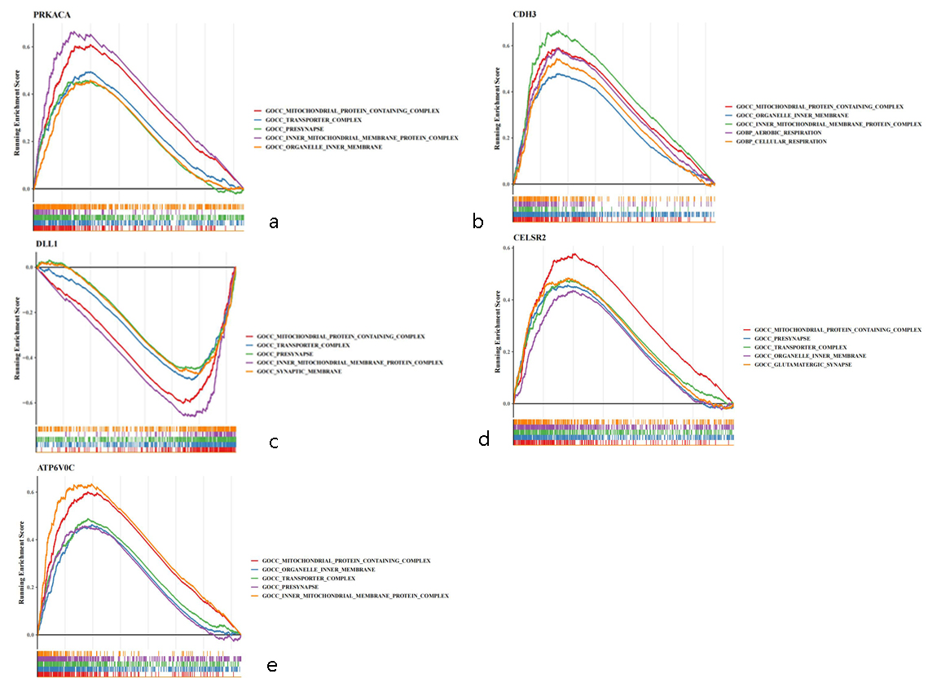
A. GSEA enrichment analysis of five key genes. (a) GO enrichment analysis of PRKACA; (b) GO enrichment analysis of CDH3; (c) GO enrichment analysis of DLL1 (d) GO enrichment analysis of CELSR2; (e) GO enrichment analysis of ATP6V0C. Under Enrichment Score, the horizontal axis is the sequenced genes and the vertical axis is the corresponding Running ES. There is a peak in the line figure, which is Enrichemnt score of this gene set, and genes before the peak are the core genes under this gene set. The lower part of the line marks the genes located under this gene set.
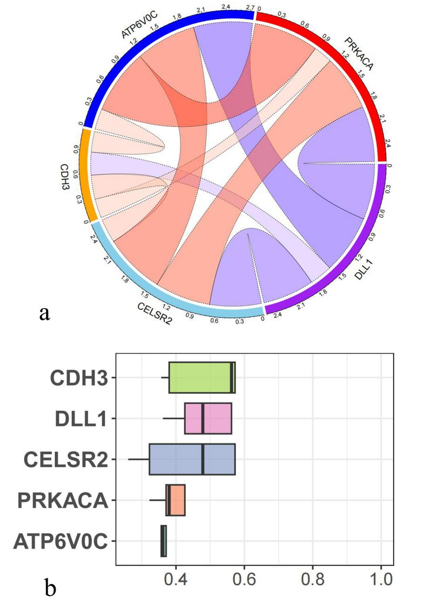
B. Correlation analysis and functional similarity analysis of key genes. (a) The blue line represents a negative correlation between genes, the red line represents a positive correlation between genes, the thicker the line and the darker the color, the stronger the correlation, and the outer number represents the correlation value. (b)When the value is closer to 1, key gene functions are more similar.
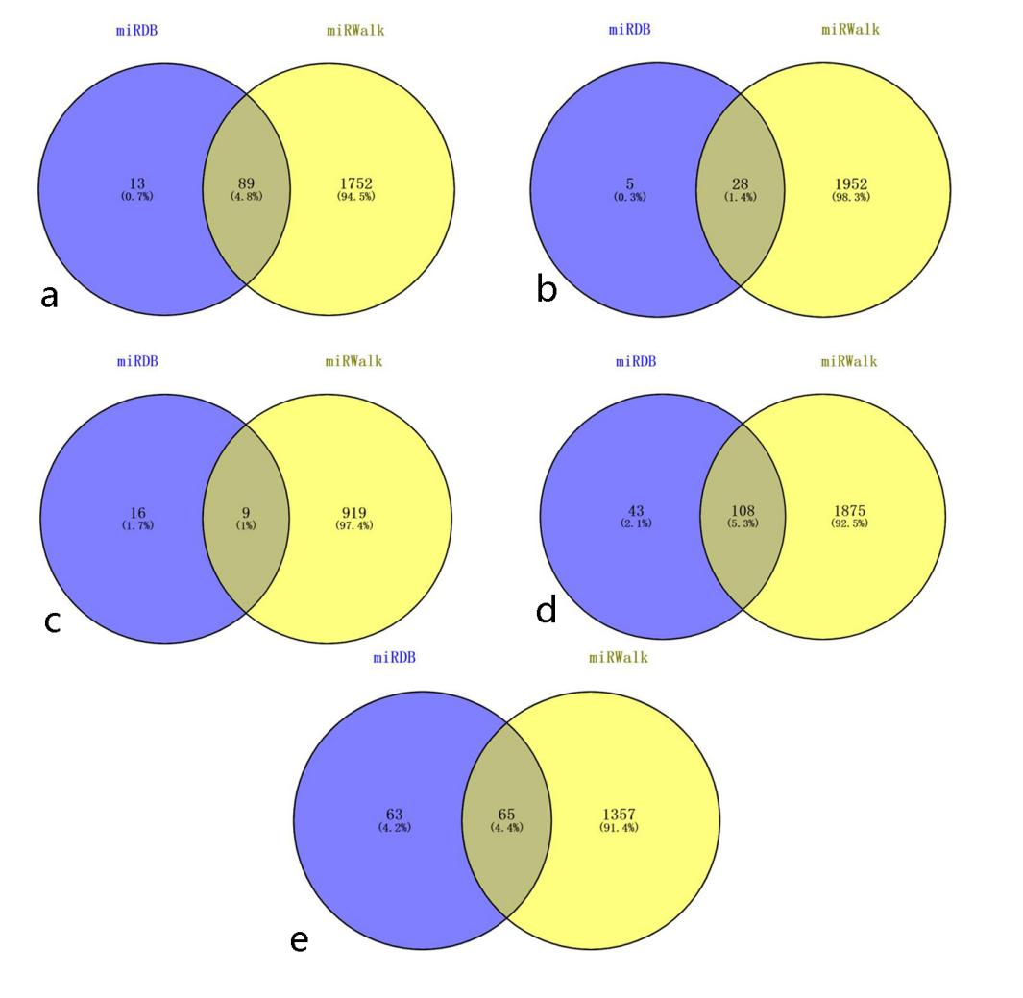
C. Five key genes predicted the intersection of miRNA with the Venn diagram. (a) PRKACA; (b) CDH3; (c) ATP6V0C; (d) CELSR2; (e) DLL1
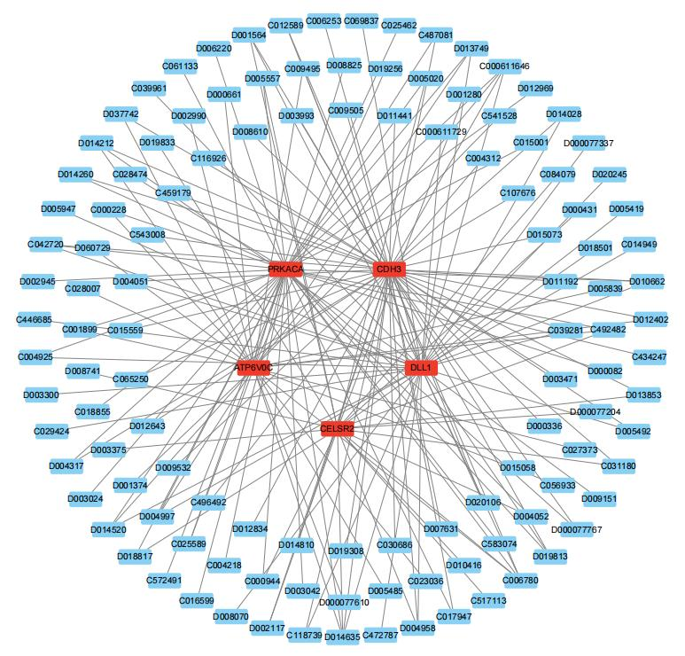
D. Key gene drug prediction network. Red is the key gene; blue is the predictive drug. This network has 83 nodes and 158 edges.

