Climate Dynamics
Supporting Information for
On the Mechanisms that Control the Rainy Season Transition Period in the Southern Congo Basin
Sarah Worden^{1*} and Rong Fu²
1*University of California, Los Angeles; ²University of California, Los Angeles

*Corresponding author(s). E-mail(s): sarahrw27@g.ucla.edu; Contributing authors: rfu@atmos.ucla.edu
Contents of this file
Figures S1-S2
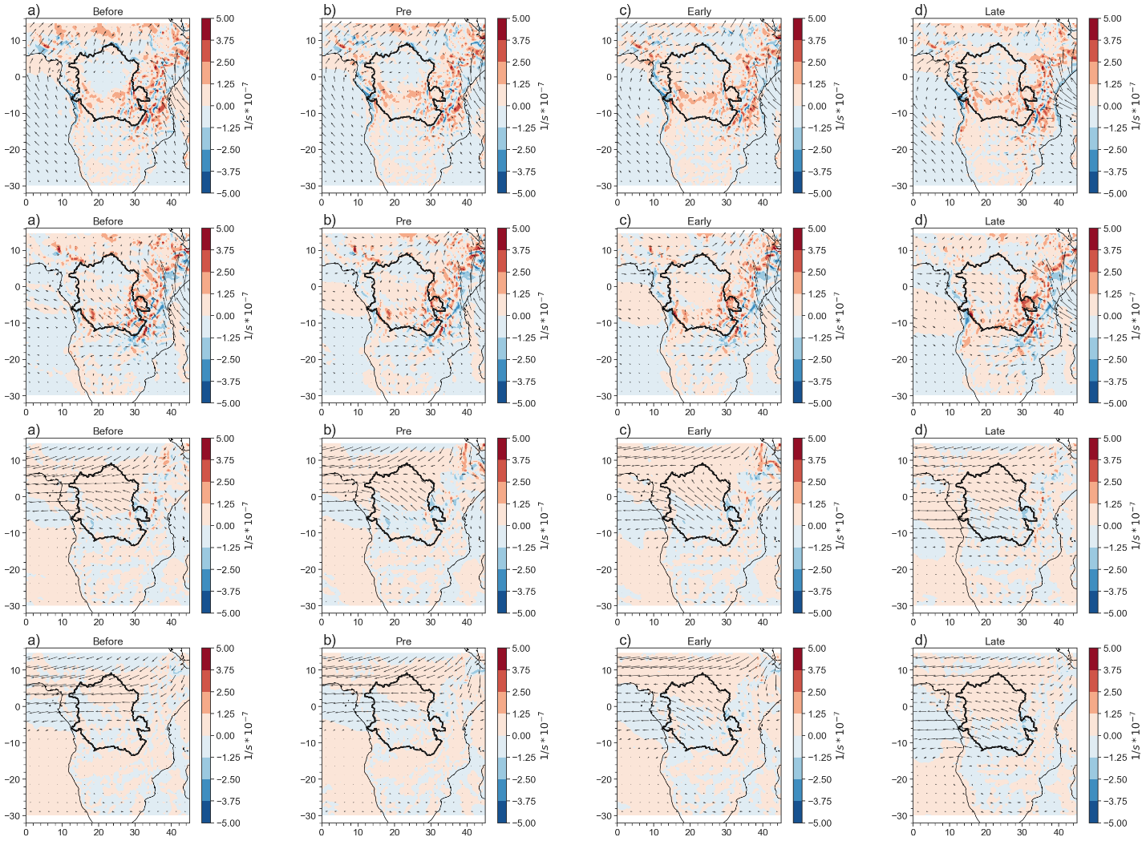
Figure S1
Figure S1: moisture transport and moisture convergence at 650 hPa for a) the “before” period; b) the pre-transition; c) the early-transition, and d) the late transition period.

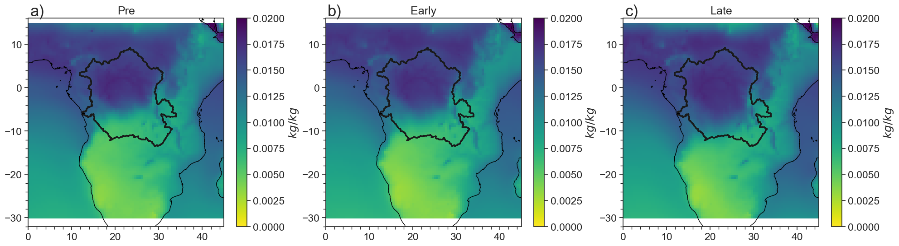
Figure S2
Figure S2: Surface specific humidity from ERA5 for a) the pre-transition period; b) the early-transition period; and c) the late-transition period. The sharp diagonal gradient in surface humidity denotes the rough position of the Congo Air Boundary (CAB).

