Targeted triterpenoids from Dysoxylum alliaceum stem barks as cytotoxic agents in human cancer and normal cells

Sandra Amalia Riyadi^{1,2}, Al Arofatus Naini², Tri Mayanti¹, Rony Lesmana^{2,3}, Mohamad Nurul Azmi⁴, Sofa Fajriah⁵, Kindi Farabi^{1,2}, Unang Supratman^{1,2}*

¹Department of Chemistry, Faculty of Mathematics and Natural Sciences,
Universitas Padjadjaran, Jatinangor 45363, Sumedang, Indonesia.
²Central Laboratory, Universitas Padjadjaran, Jatinangor 45363, Sumedang, Indonesia.
³Physiology Division, Department of Biomedical Sciences, Faculty of Medicine, Universitas Padjadjaran, Jatinangor 45363, Indonesia
⁴School of Chemical Sciences, Universiti Sains Malaysia, 11800 Minden, Penang, Malaysia
⁵Research Center for Pharmaceutical Ingredients and Traditional Medicine, National Research and Innovation Agency (BRIN), Cibinong Science Center Complex – BRIN, Cibinong 16911, Bogor, West Java, Indonesia.

*Corresponding author: E-mail: unang.supratman@unpad.ac.id
Supplementary material

Figure S 1. HR-ESI-QTOFMS Spectrum of 1 3
Figure S 2 ¹H-NMR Spectrum of 1 4
Figure S 3 ¹³C-NMR and DEPT Spectrum of 1 4
Figure S 4 HMQC Spectrum of 1 5
Figure S 5 HMBC spectrum of 1 6
Figure S 6 ¹H-¹H COSY spectrum of 1 6
Figure S 7 NOESY spectrum of 1 7
Figure S 8 HR-ESI-QTOFMS Spectrum of 2 7
Figure S 9 ¹H-NMR Spectrum of 2 8
Figure S 10 ¹³C-NMR and DEPT Spectrum of 2 8
Figure S 11 HR-ESI-QTOFMS Spectrum of 3 9
Figure S 12 ¹H-NMR Spectrum of 3 9
Figure S 13 ¹³C-NMR and DEPT Spectrum of 3 10
Figure S 14 HR-ESI-QTOFMS Spectrum of 4 11
Figure S 15 ¹H-NMR Spectrum of 4 12
Figure S 16 ¹³C-NMR and DEPT Spectrum of 4 12
Figure S 17 FTIR Spektrum of 4 13
Figure S 18 HR-ESI-QTOFMS Spectrum of 5 13
Figure S 19 ¹H-NMR Spectrum of 5 14
Figure S 20 ¹³C-NMR and DEPT Spectrum of 5 14
Figure S 21 HMQC Spectrum of 5 15
Figure S 22 HMBC Spectrum of 5 15
Figure S 23 ¹H-¹H COSY Spectrum of 5 16
Figure S 24 NOESY Spectrum of 5 16
Figure S 25 ¹H-NMR Spectrum of 6 17
Figure S 26 ¹³C-NMR and DEPT Spectrum of 6 17
Figure S 27 HMQC Spectrum of 6 18
Figure S 28 HMBC Spectrum of 6 18
Figure S 29 ¹H-¹H COSY Spectrum of 6 19
Figure S 30 NOESY Spectrum of 6 19
Figure S 31 HR-ESI-QTOFMS Spectrum of 7 20
Figure S 32 FTIR Spectrum of 7 20
Figure S 33 ¹H-NMR Spectrum of 7 21
Figure S 34 ¹³C-NMR and DEPT Spectrum of 7 21
Figure S 35 HMQC Spectrum of 7 22
Figure S 36 HMBC Spectrum of 7 22
Figure S 37 ¹H-¹H COSY Spectrum of 7 23
Figure S 38 NOESY spectrum of 7 23
Figure S 39 HR-ESI-QTOFMS Spectrum of 8 24
Figure S 40 ¹H-NMR Spectrum of 8 24
Figure S 41 ¹³C-NMR and DEPT Spectrum of 8 25

Figure S 1. HR-ESI-QTOFMS Spectrum of 1
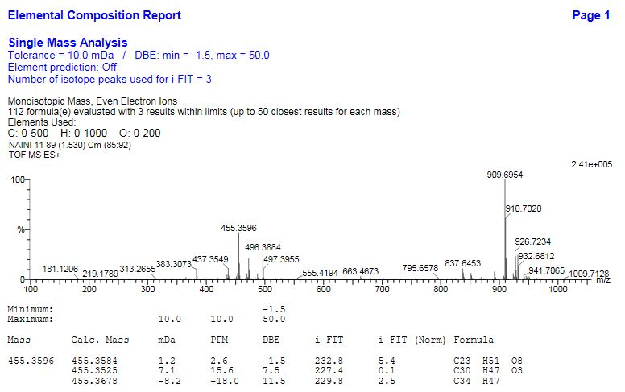

Figure S 2 ¹H-NMR Spectrum of 1
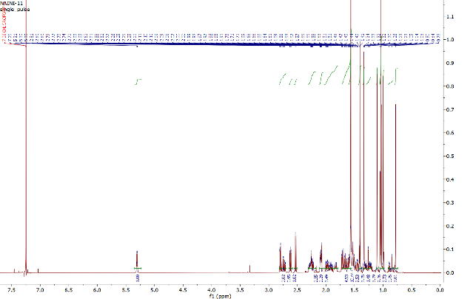

Figure S 3 ¹³C-NMR and DEPT Spectrum of 1
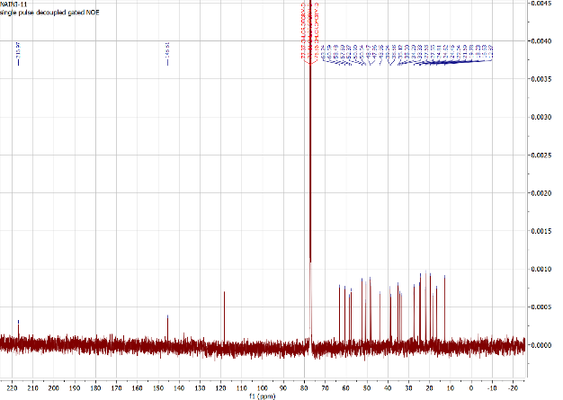
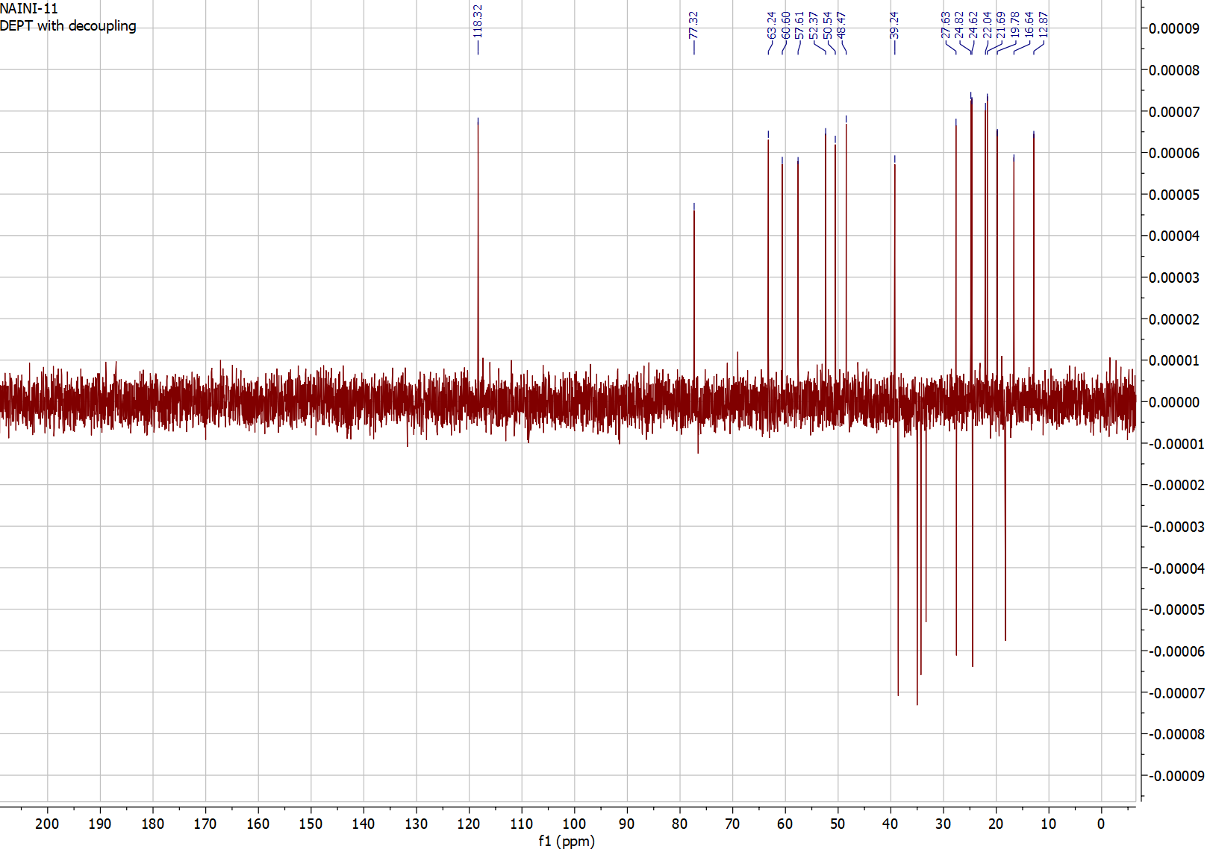

Figure S 4 HMQC Spectrum of 1
Figure S 5 HMBC spectrum of 1

Figure S 6 ¹H-¹H COSY spectrum of 1
Figure S 7 NOESY spectrum of 1

Figure S 8 HR-ESI-QTOFMS Spectrum of 2
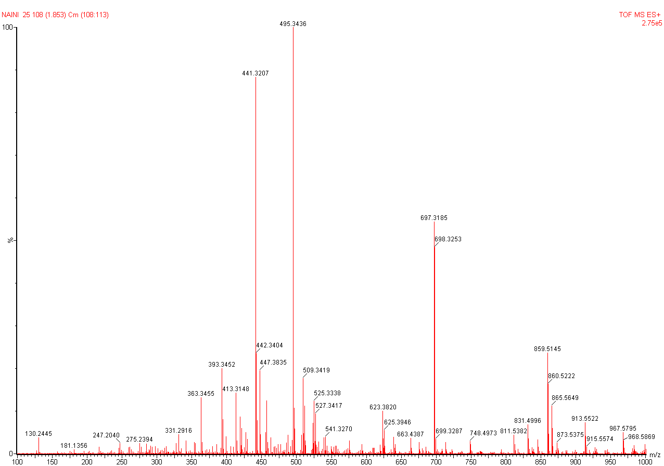

Figure S 9 ¹H-NMR Spectrum of 2
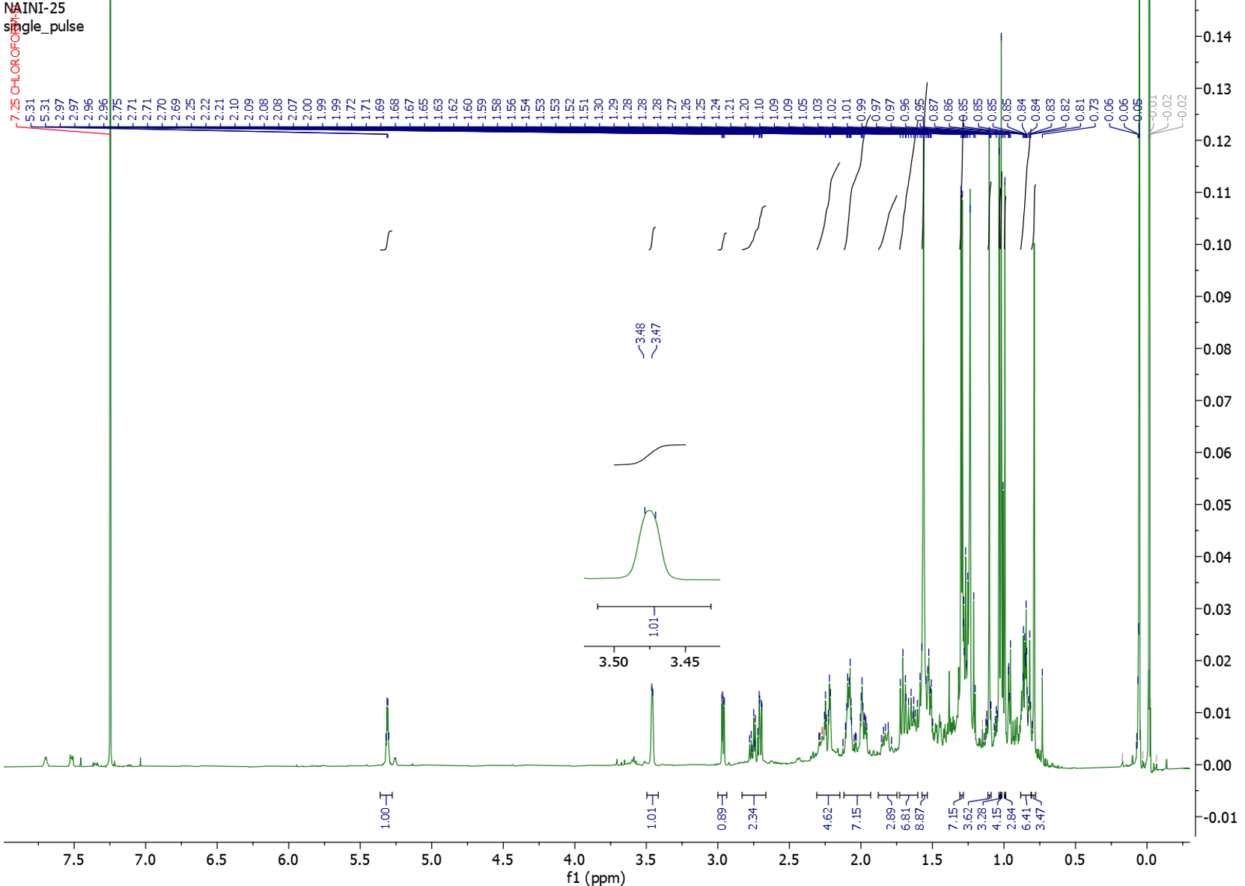

Figure S 10 ¹³C-NMR and DEPT Spectrum of 2
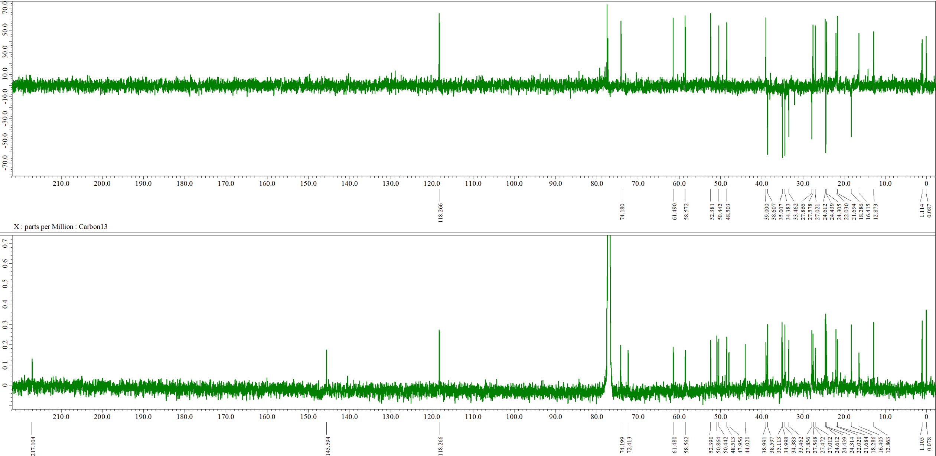

Figure S 11 HR-ESI-QTOFMS Spectrum of 3
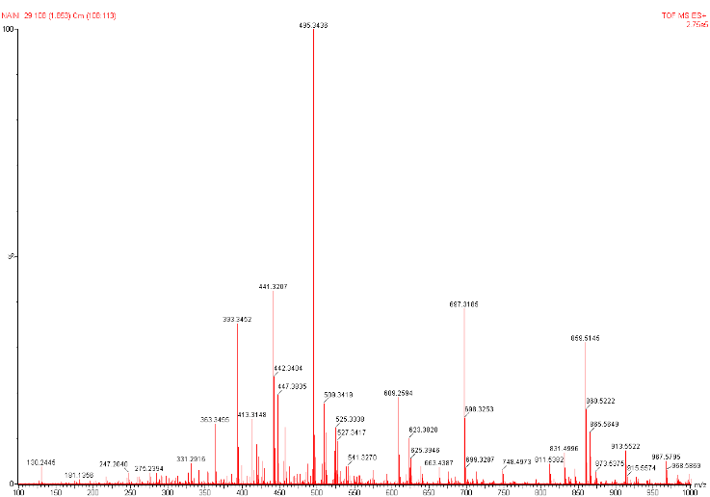

Figure S 12 ¹H-NMR Spectrum of 3
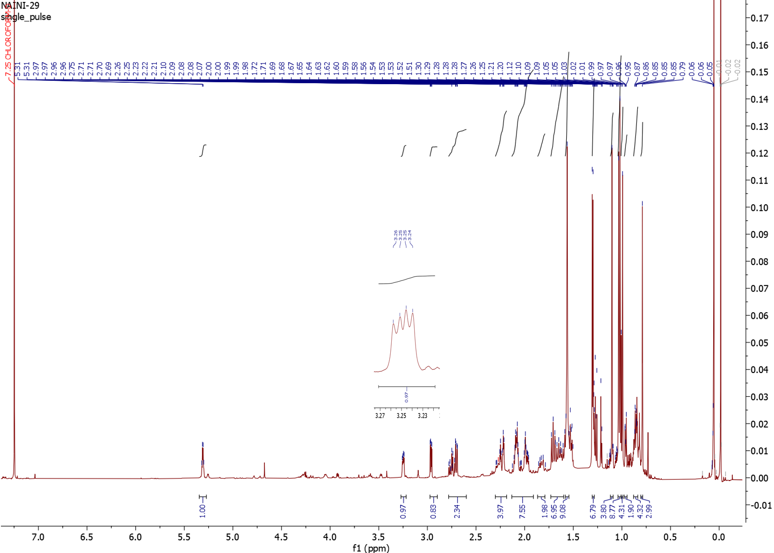

Figure S 13 ¹³C-NMR and DEPT Spectrum of 3
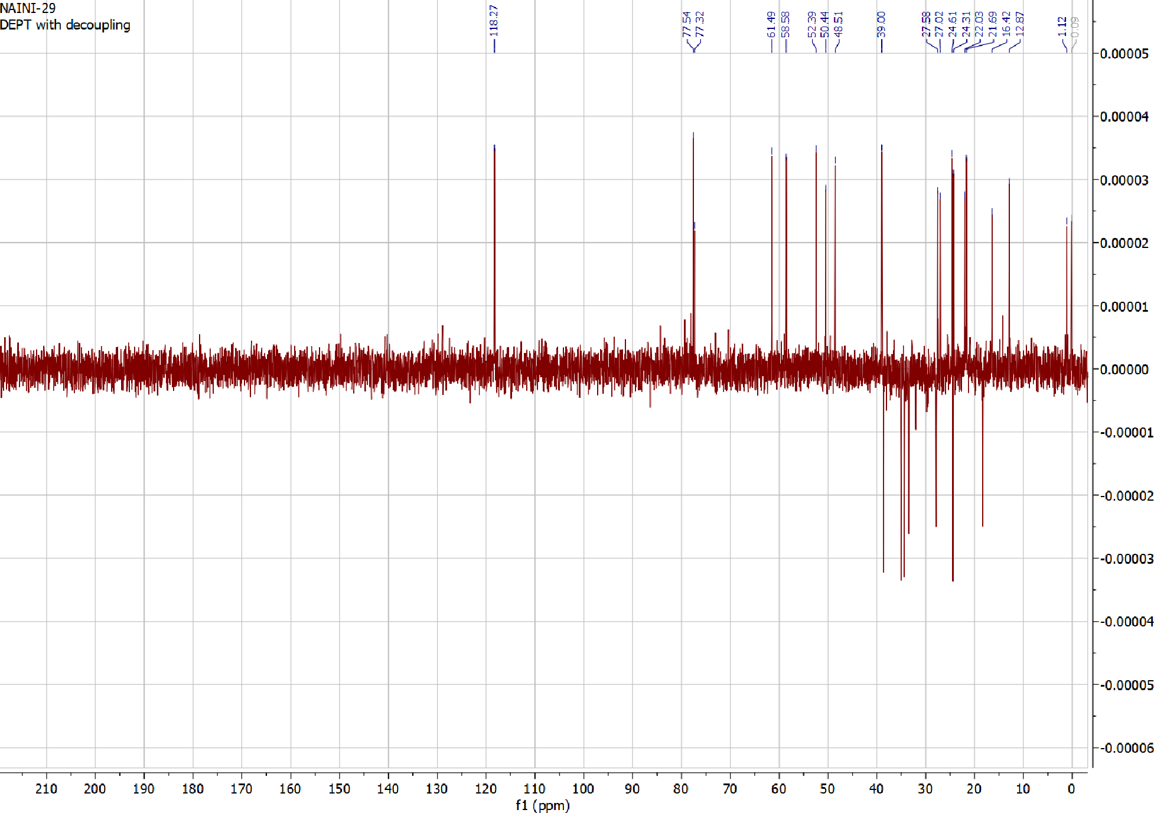
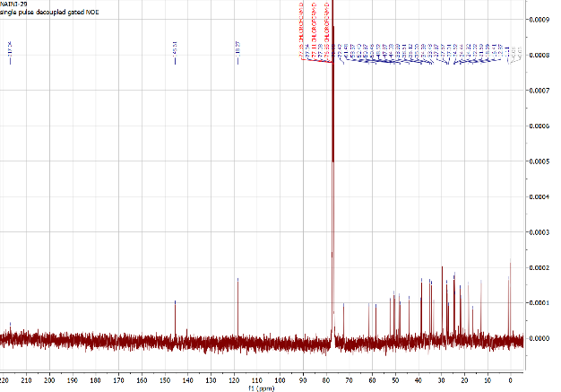

Figure S 14 HR-ESI-QTOFMS Spectrum of 4
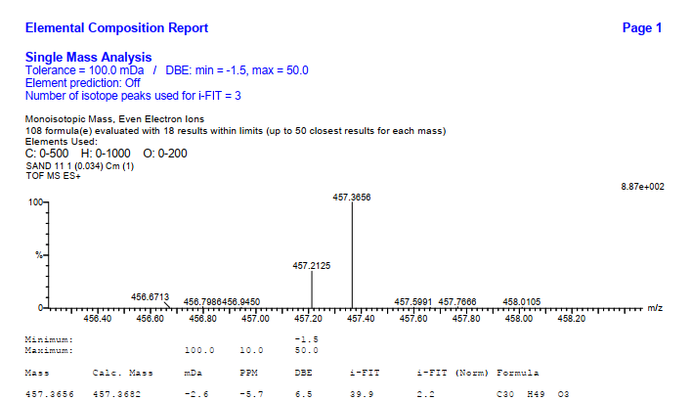

Figure S 15 ¹H-NMR Spectrum of 4

Figure S 16 ¹³C-NMR and DEPT Spectrum of 4
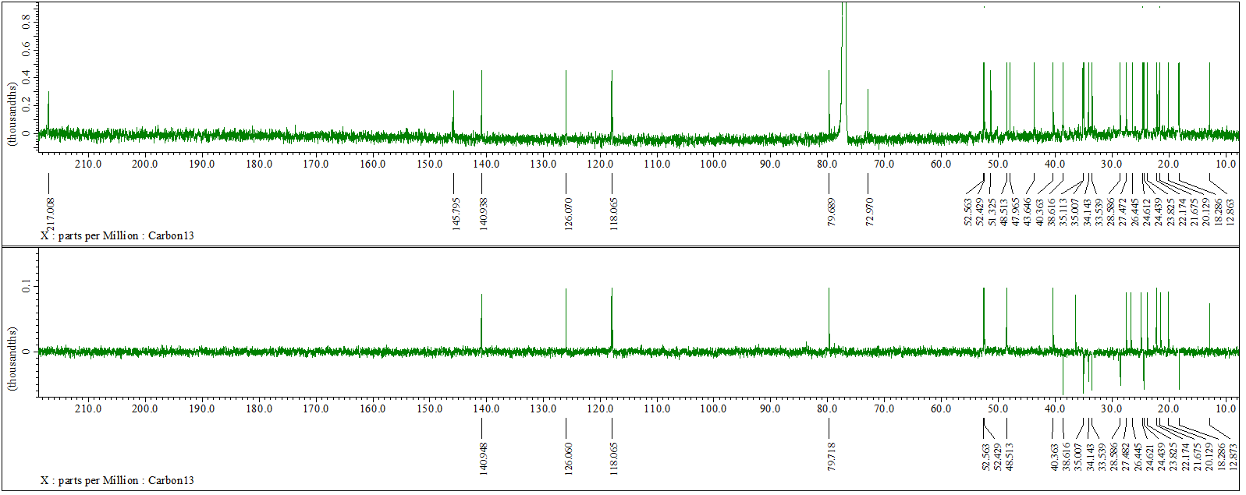

Figure S 17 FTIR Spektrum of 4
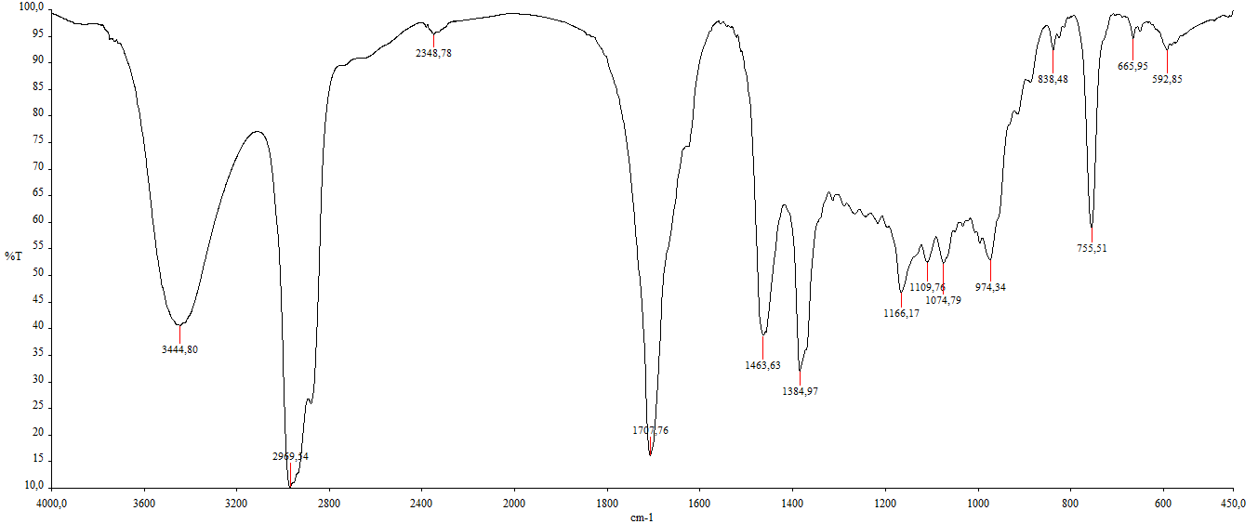

Figure S 18 HR-ESI-QTOFMS Spectrum of 5
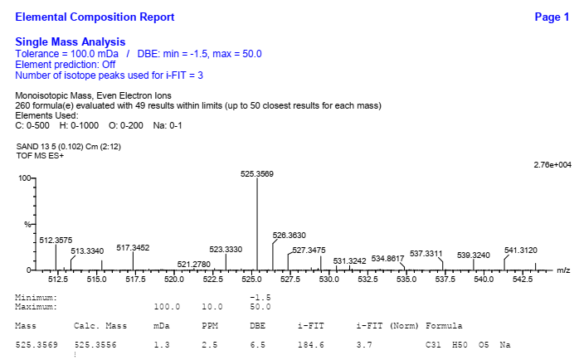

Figure S 19 ¹H-NMR Spectrum of 5
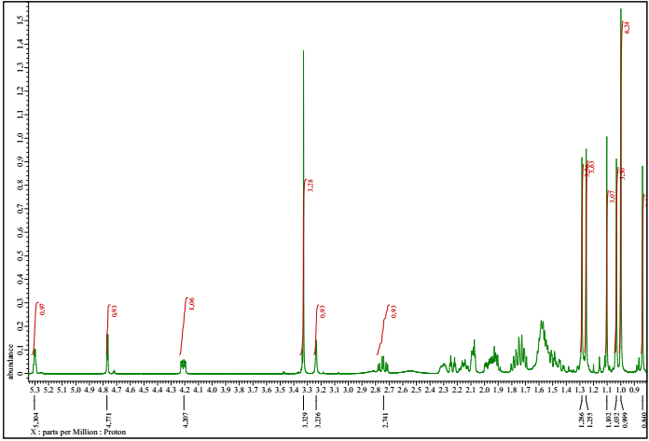

Figure S 20 ¹³C-NMR and DEPT Spectrum of 5
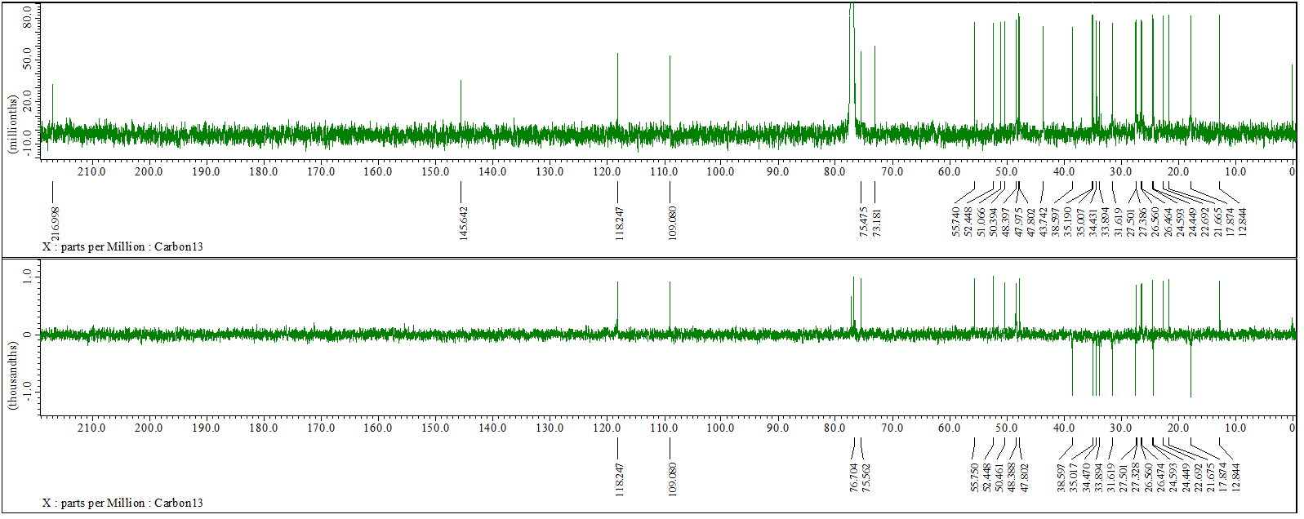

Figure S 21 HMQC Spectrum of 5
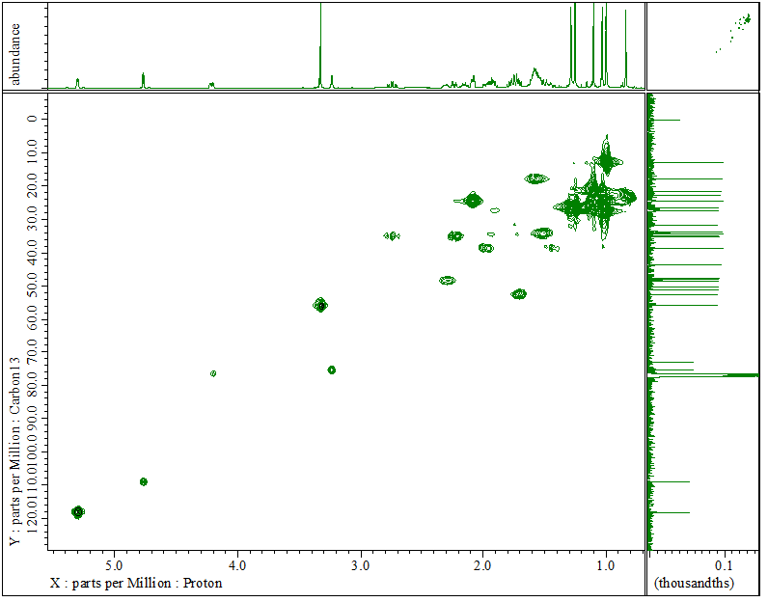

Figure S 22 HMBC Spectrum of 5

Figure S 23 ¹H-¹H COSY Spectrum of 5
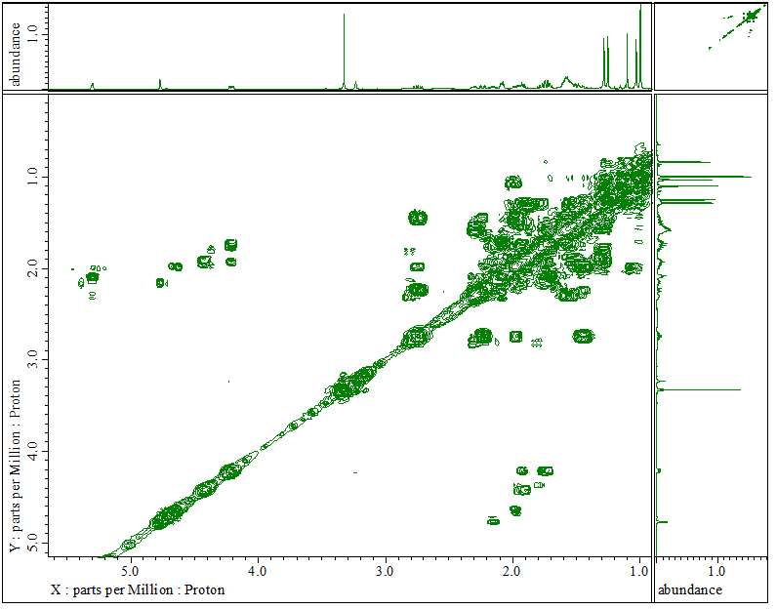

Figure S 24 NOESY Spectrum of 5
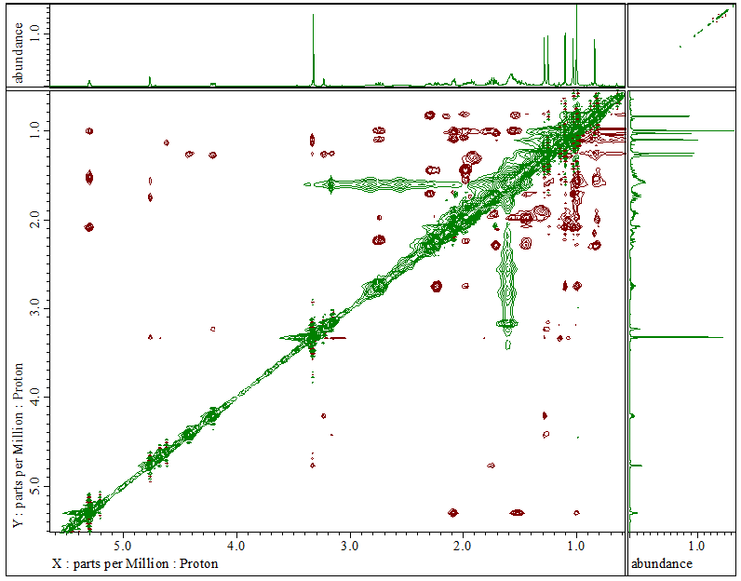

Figure S 25 ¹H-NMR Spectrum of 6
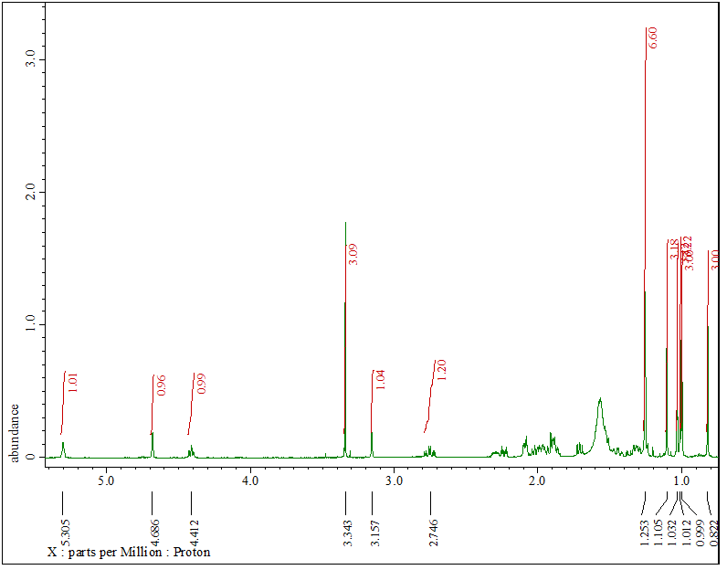

Figure S 26 ¹³C-NMR and DEPT Spectrum of 6
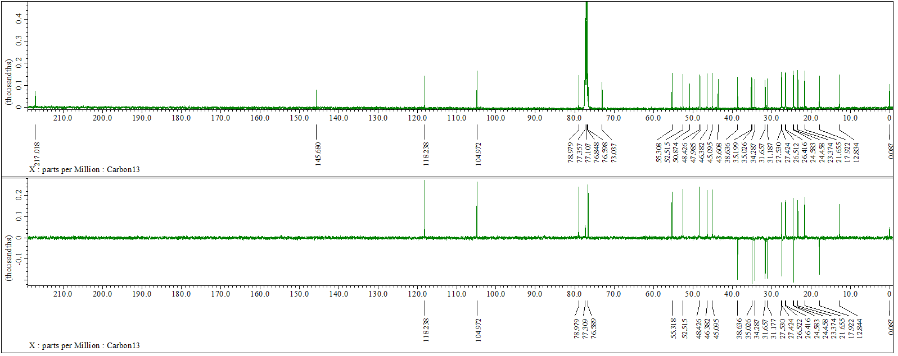

Figure S 27 HMQC Spectrum of 6
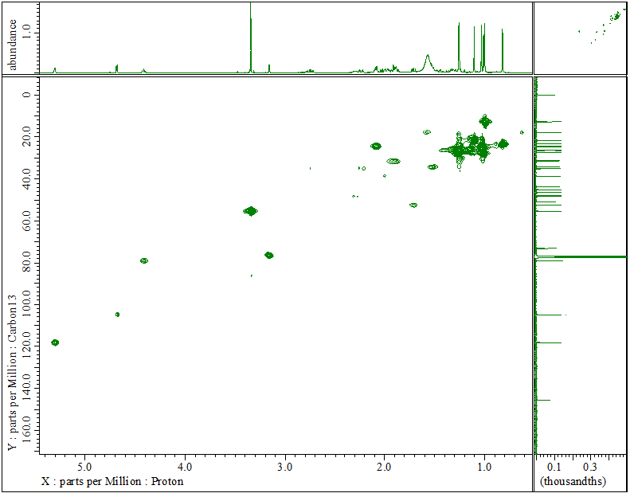

Figure S 28 HMBC Spectrum of 6
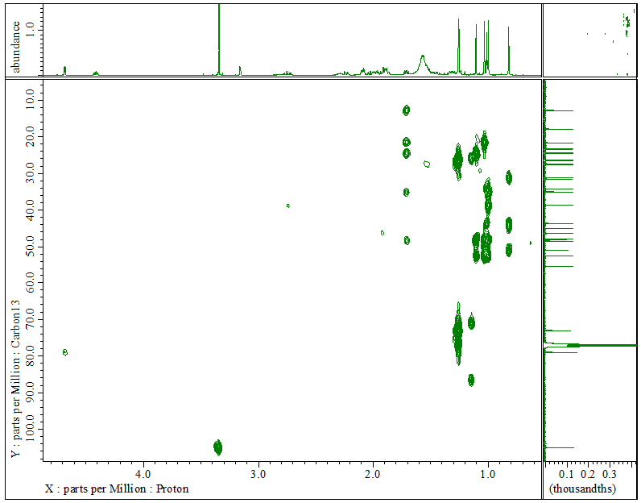

Figure S 29 ¹H-¹H COSY Spectrum of 6
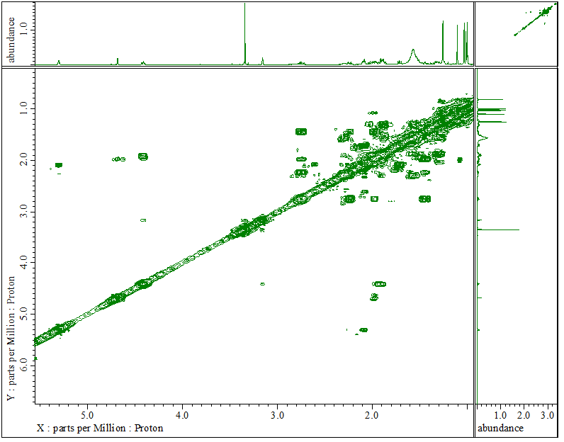

Figure S 30 NOESY Spectrum of 6
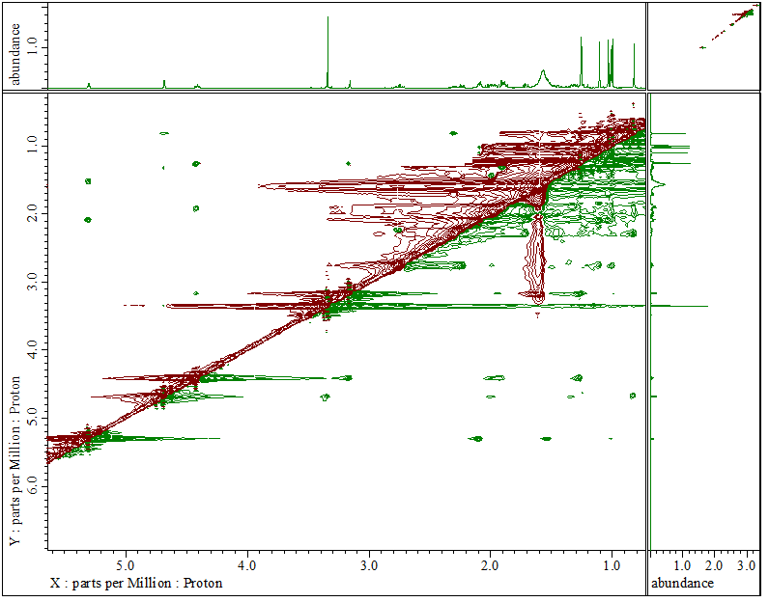

Figure S 31 HR-ESI-QTOFMS Spectrum of 7
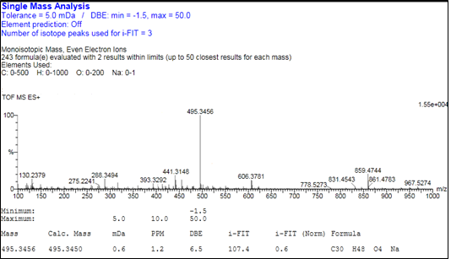

Figure S 32 FTIR Spectrum of 7
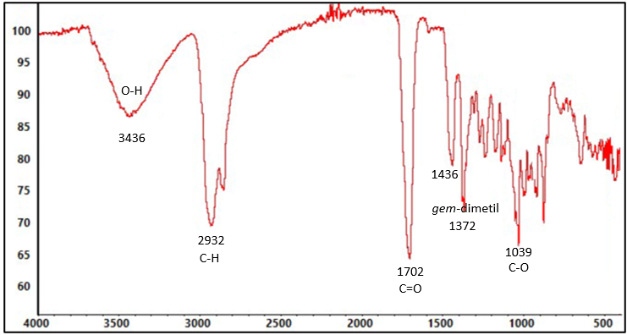

Figure S 33 ¹H-NMR Spectrum of 7
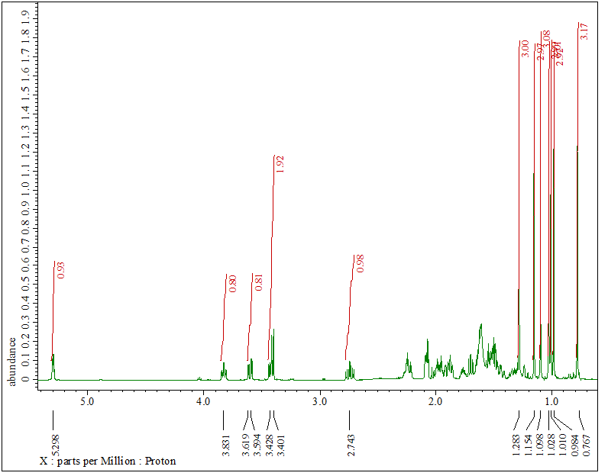

Figure S 34 ¹³C-NMR and DEPT Spectrum of 7
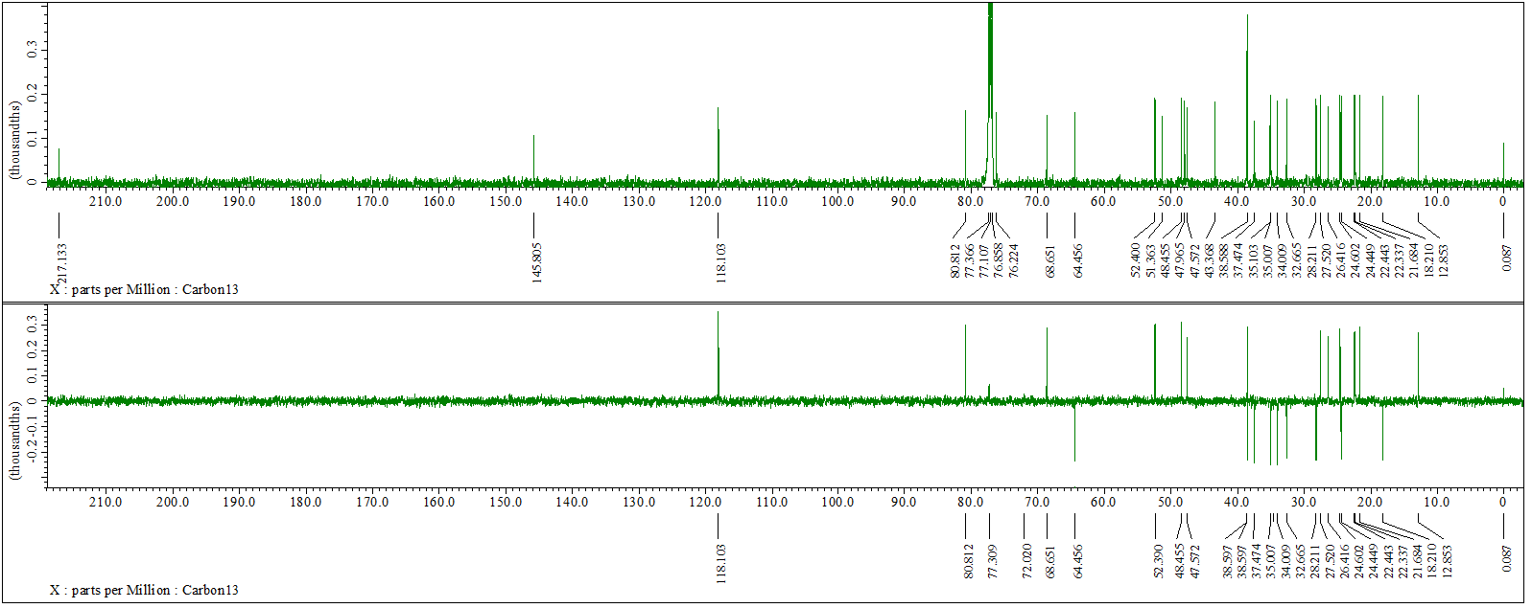

Figure S 35 HMQC Spectrum of 7

Figure S 36 HMBC Spectrum of 7

Figure S 37 ¹H-¹H COSY Spectrum of 7

Figure S 38 NOESY spectrum of 7

Figure S 39 HR-ESI-QTOFMS Spectrum of 8
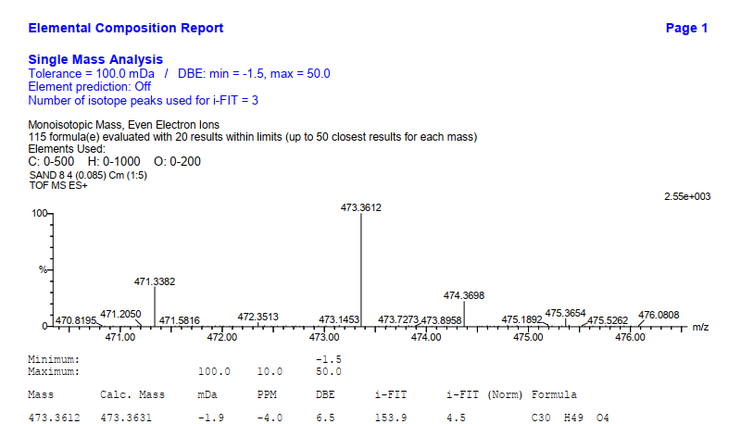

Figure S 40 ¹H-NMR Spectrum of 8

Figure S 41 ¹³C-NMR and DEPT Spectrum of 8
