Supplemental Material:

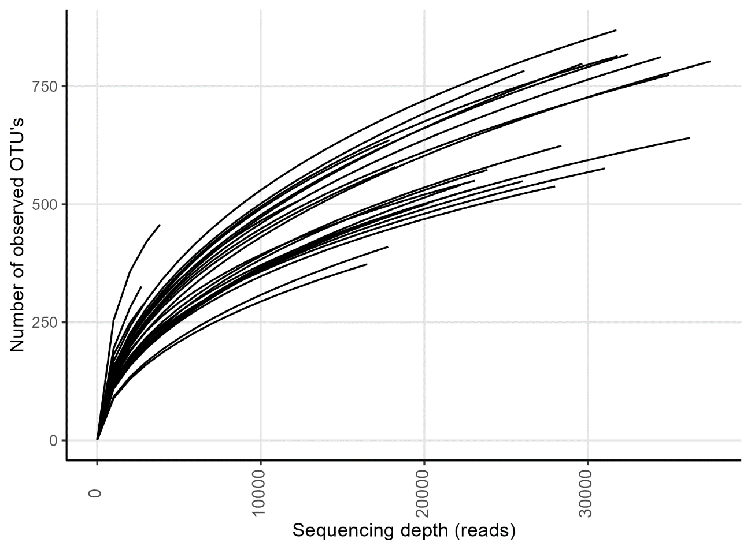
Figure S1: Rarefaction curve of the individual samples.
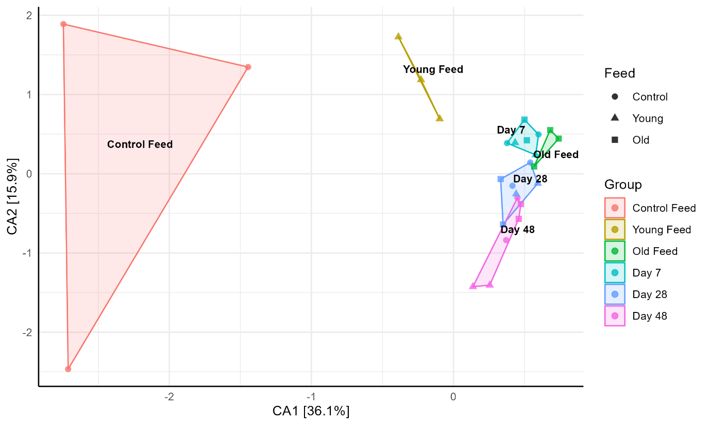
Figure S2: Correspondence analysis of microbiome samples and feed samples, based on Bray-Curtis distances. The age of the flies is differentiated by colour. This is also true for the different feed solutions. The type of feed is noted by differently shaped sample points.

