Supplemental Data
Supp Table 1. Onco’nect alerts according to patient answers to ePRO questionnaires.

 | Question | Answer | Orange alert | Red alert
1 | What is your temperature today or yesterday? | < 36°C |  | X
1 | What is your temperature today or yesterday? | > 39°C |  | X
2 | Over the last 7 days, how severe has your cough been at its worst? | No
2 |  | Slight
2 |  | Moderate
2 |  | Severe |  | X
2 |  | Very severe |  | x
3 | In the last 7 days, how severe were your problems with tasting food or drinks at their worst? | No
3 |  | Slight
3 |  | Moderate
3 |  | Severe | X
3 |  | Very severe |  | X
4 | In the last 7 days, how severe were your mouth ulcers (canker sores) or throat ulcers at their worst? | No
4 |  | Slight
4 |  | Moderate | X
4 |  | Severe |  | X
4 |  | Very severe |  | X
5 | In the last 7 days, how much have mouth ulcers (canker sores) or throat ulcers interfered with your usual or daily activities? | Not at all
5 |  | A little bit
5 |  | Quite a bit
5 |  | Very much | X
5 |  | A great deal |  | X
6 | In the last 7 days, how severe was the decrease in your appetite at its worst? | Aucune
6 |  | Légère
6 |  | Modérée
6 |  | Sévère |  | x
6 |  | Très sévère |  | x
7 | Over the past 7 days, how has your decreased appetite affected your usual or daily activities? | Aucune
7 |  | Légère
7 |  | Modérée
7 |  | Sévère | x
7 |  | Très sévère |  | x
8 | Over the past 7 days, how often have you experienced nausea? | Never
8 | Over the past 7 days, how often have you experienced nausea? | Rarely
8 | Over the past 7 days, how often have you experienced nausea? | Occasionally
8 | Over the past 7 days, how often have you experienced nausea? | Frequently |  | x
8 | Over the past 7 days, how often have you experienced nausea? | Almost constantly |  | x
9 | In the last 7 days, how severe was your nausea at its worst? | Aucune
9 | In the last 7 days, how severe was your nausea at its worst? | Légère
9 | In the last 7 days, how severe was your nausea at its worst? | Modérée
9 | In the last 7 days, how severe was your nausea at its worst? | Sévère |  | x
9 | In the last 7 days, how severe was your nausea at its worst? | Très sévère |  | x
10 | Over the past 7 days, how often have you experienced vomiting? | Never
10 |  | Rarely
10 |  | Occasionally
10 |  | Frequently |  | x
10 |  | Almost constantly |  | x
11 | In the last 7 days, how severe was your vomiting at its worst? | No
11 |  | Slight
11 |  | Moderate | x
11 |  | Severe |  | x
11 |  | Very severe |  | x
12 | Over the past 7 days, how often have you had loose or liquid stools (diarrhea)? | Never
12 |  | Rarely
12 |  | Occasionally
12 |  | Frequently | x
12 |  | Almost constantly |  | x
13 | In the last 7 days, how severe was your shortness of breath at its worst? | No
13 |  | Slight
13 |  | Moderate | x
13 |  | Severe |  | x
13 |  | Very severe |  | x
14 | In the last 7 days, how much has shortness of breath interfered with your usual or daily activities? | Not at all
14 |  | A little bit
14 |  | Quite a bit | x
14 |  | Very much |  | x
14 |  | A great deal |  | x
15 | Have you had a rash in the last 7 days? | yes | x
15 | Have you had a rash in the last 7 days? | no
16 | Over the last 7 days, how severe has your hand-foot syndrome (rash on hands or feet that can cause chapping, peeling, redness or pain at its worst) been? | No
16 |  | Slight
16 |  | Moderate
16 |  | Severe |  | x
16 |  | Very severe |  | x
17 | Over the past 7 days, how severe was the numbness or tingling in your hands or feet at its worst? | No
17 |  | Slight
17 |  | Moderate | x
17 |  | Severe | x
17 |  | Very severe | x
18 | Over the past 7 days, how much has numbness or tingling in your hands or feet interfered with your usual or daily activities? | Not at all
18 |  | A little bit
18 |  | Quite a bit | x
18 |  | Very much | x
18 |  | A great deal | x
19 | Over the past 7 days, how often have you felt pain? | Never
19 | Over the past 7 days, how often have you felt pain? | Rarely
19 | Over the past 7 days, how often have you felt pain? | Occasionally
19 | Over the past 7 days, how often have you felt pain? | Frequently | x
19 | Over the past 7 days, how often have you felt pain? | Almost constantly |  | x
20 | In the last 7 days, how severe was your pain at its worst? | 0
20 | In the last 7 days, how severe was your pain at its worst? | 1
20 | In the last 7 days, how severe was your pain at its worst? | 2
20 | In the last 7 days, how severe was your pain at its worst? | 3
20 | In the last 7 days, how severe was your pain at its worst? | 4
20 | In the last 7 days, how severe was your pain at its worst? | 5
20 | In the last 7 days, how severe was your pain at its worst? | 6
20 | In the last 7 days, how severe was your pain at its worst? | 7 |  | x
20 | In the last 7 days, how severe was your pain at its worst? | 8 |  | x
20 | In the last 7 days, how severe was your pain at its worst? | 9 |  | x
20 | In the last 7 days, how severe was your pain at its worst? | 10 |  | x
21 | Over the past 7 days, how much has your pain interfered with your usual or daily activities? | Not at all
21 |  | A little bit
21 |  | Quite a bit
21 |  | Very much | x
21 |  | A great deal |  | x
22 | Over the last 7 days, how severe has your fatigue, weariness or lack of energy been at its worst? | 0
22 |  | 1
22 |  | 2
22 |  | 3
22 |  | 4
22 |  | 5
22 |  | 6
22 |  | 7 | x
22 |  | 8 | x
22 |  | 9 | x
22 |  | 10 | x
23 | Over the past 7 days, how much has fatigue, lassitude or lack of energy interfered with your usual or daily activities? | Not at all
23 |  | A little bit
23 |  | Quite a bit
23 |  | Very much | x
23 |  | A great deal | x
24 | In the last 7 days, how often did you feel that nothing could cheer you up? | Never
24 |  | Rarely
24 |  | Occasionally
24 |  | Frequently | x
24 |  | Almost constantly | x
25 | Over the past 7 days, how severe has this feeling been at its worst? | No
25 |  | Slight
25 |  | Moderate
25 |  | Severe | x
25 |  | Very severe | x
26 | Over the past 7 days, how much has this feeling interfered with your usual or daily activities? | Not at all
26 |  | A little bit
26 |  | Quite a bit
26 |  | Very much | x
26 |  | A great deal | x
27 | Over the past 7 days, have you had a temperature above 38.3°C or below 36°C, or chills? | Oui | x
27 |  | Non
28 | Have you had any other symptoms you'd like to report? | Yes | x
28 | Have you had any other symptoms you'd like to report? | No
29 | What is/are this/these symptom(s)? | Free text
30 | In the last 7 days, how severe was this symptom at its worst? | No
30 |  | Slight
30 |  | Moderate | x
30 |  | Severe |  | x
30 |  | Very severe |  | x
31 | Have you had any new symptoms in the last 7 days for which you would like to be contacted? | Yes |  | x
31 |  | No
32 | Are you ready for your next chemo treatment? | 0 | x
32 | Are you ready for your next chemo treatment? | 1 | x
32 | Are you ready for your next chemo treatment? | 2 | x
32 | Are you ready for your next chemo treatment? | 3 | x
32 | Are you ready for your next chemo treatment? | 4 | x
32 | Are you ready for your next chemo treatment? | 5 | x
32 | Are you ready for your next chemo treatment? | 6 | x
32 | Are you ready for your next chemo treatment? | 7
32 | Are you ready for your next chemo treatment? | 8
32 | Are you ready for your next chemo treatment? | 9
32 | Are you ready for your next chemo treatment? | 10
33 | Have you been in contact within 3 days with a person suffering from Covid 19? | Yes |  | x
33 |  | No
33 |  | I don't know

Supplementary Table 2. Patient verbatim related to the overarching and subthemes summarizing patient issues when using Onco’nect.
Understanding of the clinical relevance of remote monitoring | Benefits for patient care | "It's to find out how I'm doing."
Understanding of the clinical relevance of remote monitoring | Benefits for patient care | "For good care... to better help us to better accompany us."
Understanding of the clinical relevance of remote monitoring | Sense of security | "Feeling how more secure."
Understanding of the clinical relevance of remote monitoring | Sense of security | "And then when I need them, they're there."
Understanding of the clinical relevance of remote monitoring | Misunderstanding | "Connecting with other patients too."
Understanding of the clinical relevance of remote monitoring | Misunderstanding | "It was offered to me, so I accepted it."
Poor level of health literacy | Understanding the questionnaire  Daily reading | "It may have a word or two that I can't understand."  "I used to buy newspapers, so I read."
Poor level of health literacy | Understanding the questionnaire  Daily reading | "Read (pff) not so much no."
Poor level of health literacy | Understanding the questionnaire  Daily reading | "To be honest, I don't read much."
Poor level of health literacy | Interest in pictograms | "It would be nice to have images like that."
Poor level of health literacy | Interest in pictograms | "Why not the image with it can still help."
Poor level of health literacy | Interest in pictograms | "It can still help sometimes that sometimes sentences we can't understand."
Emotional burden | Fear | "Were you afraid you'd misunderstood the question? Patient: Voilà!"
 |  | "Sometimes I make spelling mistakes.”
"I was making mistakes so, I was looking on the phone to see if it's the right one, how to see if it's well written."
"Fear of bad ticking."
 | Devaluation | "As little as I understand."
 |  | "I'm a little more evolved, though, huh."
 |  | «It's a block maybe like I don't master I don't know."
 | Annoyance | "That's what really gets me."
 |  | "The connection problems, did that get you into trouble? Patient: Yeah exactly."
 | Discrimination | "Oh I was born under the French flag, huh. Yes, I'm Algerian by birth, but..."
 | Guilt | "I tried to make it up to you."
 |  | "I confess."
 |  | "They're very, very nice people, aren't they? You have to be, in both senses."

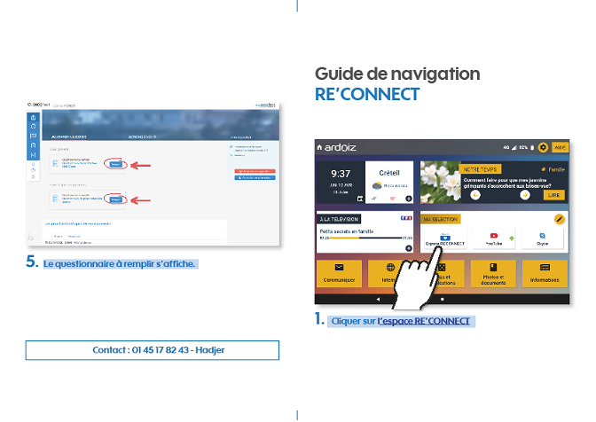
Supplementary Figure 1. Educational tools created by the patient partner

Cough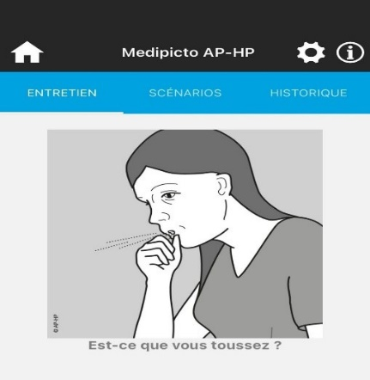 Dysgeusia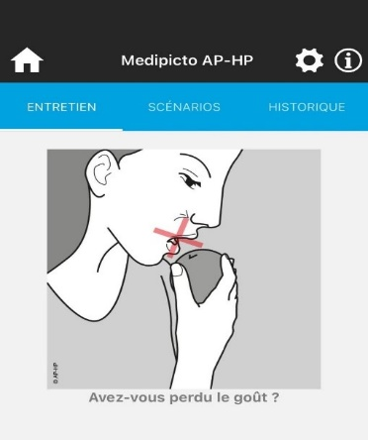

Anorexia 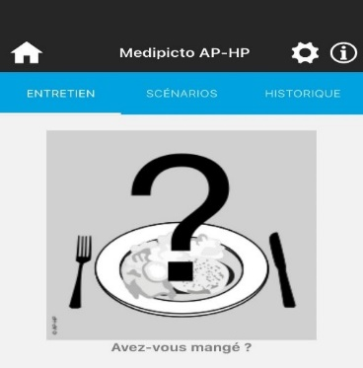 Nausea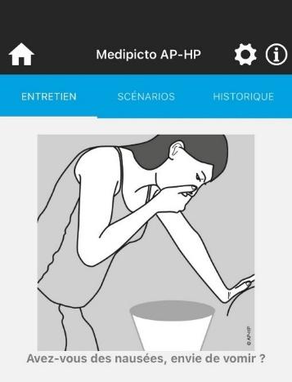

Vomiting 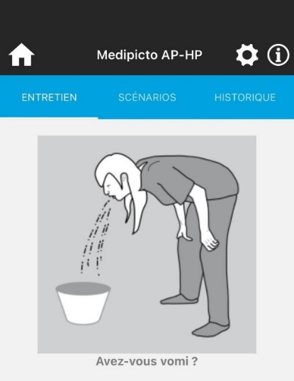 Diarrhea 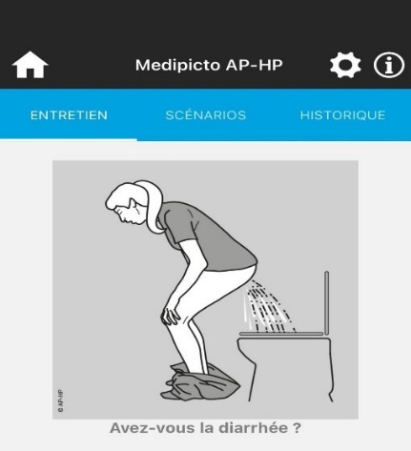

Dyspnea Skin rash

Pain Fatigue

Fever

Supplementary Figure 2. Médipicto AP-HP pictograms related to ePRO

