LIST OF SUPPORTING INFORMATION

An Imidazole-Copper(I) Metallacycle Complex Exhibiting Thermochromic Fluorescence
Zongsu Yu, Miao Li, Wei Huang, Dayu Wu*

Jiangsu Key Laboratory of Advanced Catalytic Materials and Technology, Advanced Catalysis & Green Manufacturing Collaborative Innovation Center, School of Petrochemical Engineering, Changzhou University, Changzhou 213164, China.
*e-mail: wudy@cczu.edu.cn

Contents
Experimental Section
Fig. SI-1. ¹H NMR spectra of the ligand used in this work.
Fig. SI-2. Infrared image of complex 1
Fig. SI-3. The TGA pattern of complex 1

Fig. SI-4. The powder XRD pattern of complex 1
Fig. SI-5.The fluorescence quantum yield at room temperature of complex 1
Fig. SI-6. Diagram of fluorescence intensity changing with temperature.
Fig. SI-7. Fluorescence variation with temperature in 330-80 K range.

Experimental Section
Materials Preparation All chemicals and reagents were purchased from Aldrich and used as received without further purification. The ligand bipy was prepared according to the literature method with slight modifications[1]. The synthetic details are described as following.
Synthesis of 2,6-bisimdazol pyridine (bipy)
In a 50 mL Schlenk flask charged with a stir bar, 2,6-dibromopyridine(2.37 g, 10.0 mmol), imidazole(1.70 g, 25.0 mmol), copper(I) iodide(0.10 g, 0.53 mmol), salicylaldoxime(0.274 g, 2.0 mmol), and cesium carbonate(9.78 g, 30.0 mmol) were dissolved in dry CH₃CN(15 mL). The reaction mixture was degassed through three cycles of freeze-pump-thaw procedure and was later heated at 85°C under a nitrogen atmosphere for 48 hours. The resulting suspension was filtered off and the residue was rinsed with CH₂Cl₂(2×150 mL). The filtrate was then washed with water(3×100 mL), and the resulting organic phase was dried over Na₂SO₄ and evaporated to dryness. The crude compound was purified by flash column chromatography on silica gel (50:1 CH₂Cl₂/CH₃OH) to yield 2,6-bisimdazol pyridine（yied: 61.9%) as a white solid. ¹H NMR (400 MHz, CDCl₃): δ 8.41(s,1H), 8.00(t, J = 8.0Hz, 1H), 7.70(d, J =1.2Hz, 1H), 7.3(dd, J = 22.8, 9.3Hz, 3H). Anal. Calcd for C₁₁H₉CuIN₅: C 32.89, H 2.25, N 17.43; found: C 32.85, H 2.29, N 17.41.

Fig. SI-1.¹H NMR spectra of the ligand used in this work.

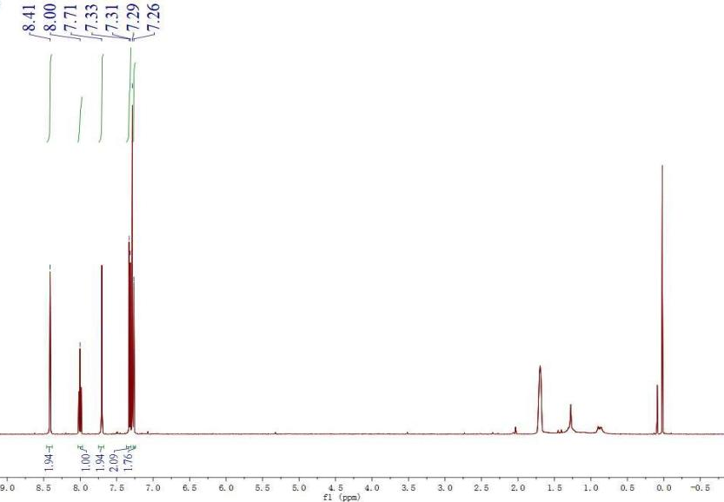
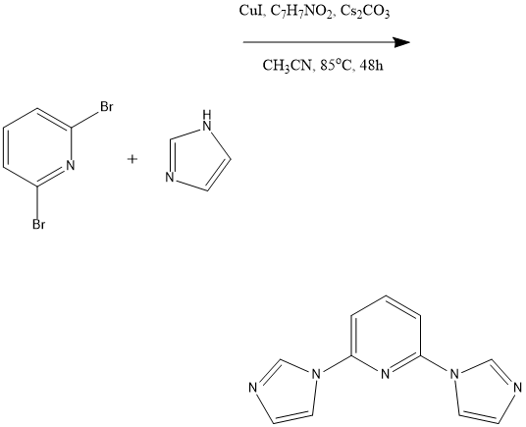

Fig. SI-2. Infrared spectra of complex 1 and bipy ligand.
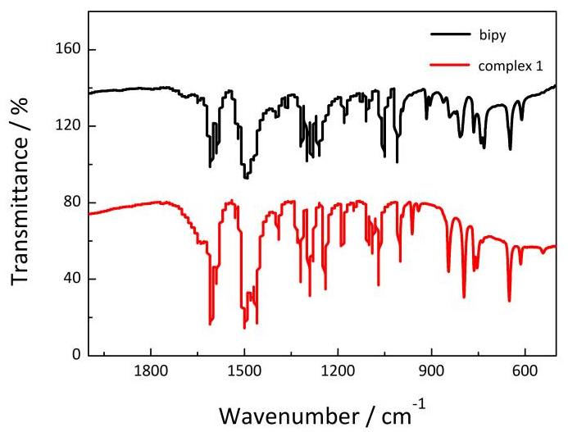
Fig. SI-3. The TGA pattern of complex 1

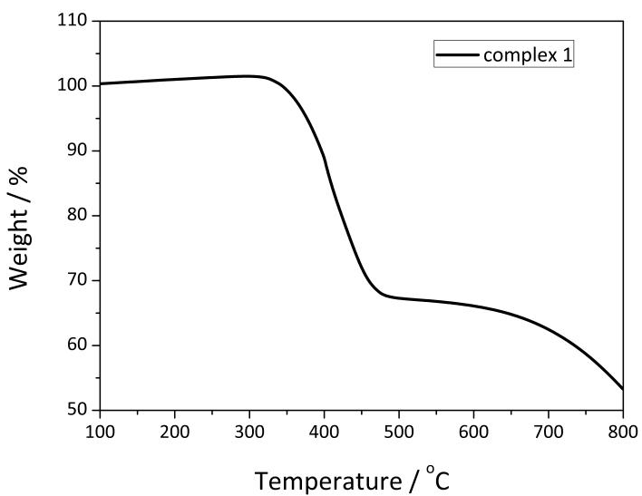

Fig. SI-4. The powder XRD pattern of complex 1
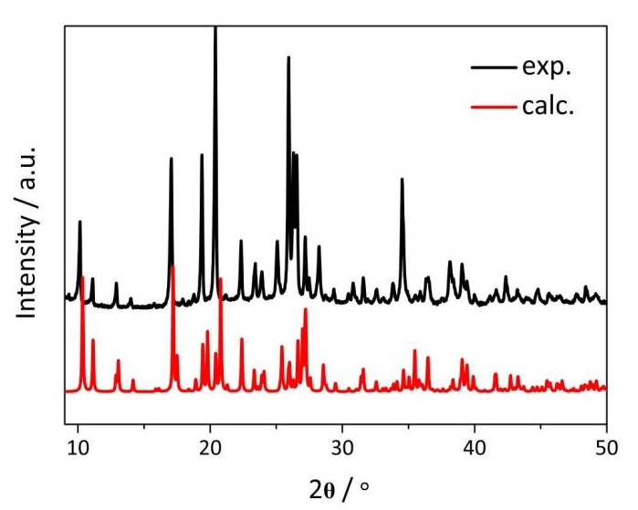

Fig. SI-5. The fluorescence quantum yield at room temperature of complex 1

Fig. SI-6. Diagram of fluorescence intensity change with temperature.
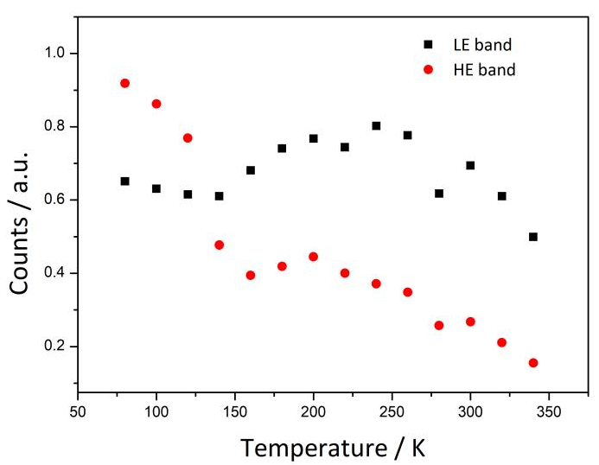

Fig. SI-7. The fluorescence color change with temperature in 330-80 K range under irradiation with UV light.
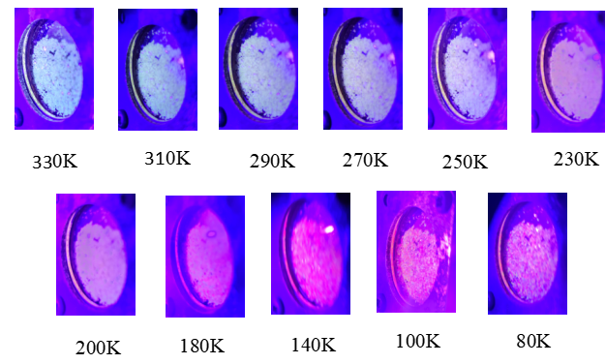

Reference:
- Wu, R. T., Chi, X. D., Sessler, J., et al. J. Am. Chem. Soc., 2018, vol. 140, no. 22, pp. 6823–6831.
https://doi.org/10.1021/jacs.7b12957

