SUPPLEMENTARY MATERIAL

The following appendix the Electronic Supplementary Material of the article entitled “Local-scale environmental filtering shapes plant taxonomic and phylogenetic diversity at an isolated Amazonian tepui (Tepequém table mountain)”

Table A1.
Soil chemical and physical variables gradient from different phytophysiognomies in the Tepequém table mountain, Roraima state, northwestern Brazil.The number represents the average per plot and standard deviation. H = Kruscal Wallis test. All variables were significantly different (p < 0.05).

 | Open Rupestrian Grassland | Shrubby Rupestrian Grassland | Forest
pH (H₂O) | 4.23 ± 0.24^{b} | 4.30 ± 0.23ª | 4.29 ± 0.16ª
P (mg/dm³) | 6.78 ± 5.22ª | 3.21 ± 2.87^{b} | 3.51 ± 1.53^{b}
K⁺ (mg/dm³) | 32.89 ± 15.72ª | 18.53 ± 15.58^{b} | 38.63 ± 22.30ª
Na⁺ (mg/dm³) | 0.18 ± 1.13^{b} | 0.78 ± 2.62ª | 0.72 ± 0.80ª
Ca²⁺ (cmol_{c}/dm³) | 0.70 ± 0.63^{b} | 0.87 ± 0.62ª | 0.13 ± 0.09^{c}
Mg²⁺ (cmol_{c}/dm³) | 0.19 ± 0.24^{b} | 0.32 ± 0.25ª | 0.14 ± 0.08^{c}
Al³⁺ (cmol_{c}/dm³) | 3.11 ± 1.67ª | 1.48 ± 0.73^{c} | 2.73 ± 1.13^{b}
H+Al (cmol_{c}/dm³) | 16.0 ± 5.28ª | 13.13 ± 6.64^{b} | 9.22 ± 3.70^{c}
BS (cmol_{c}/dm³) | 0.98 ± 0.87^{b} | 1.24 ± 0.89ª | 0.36 ± 0.20^{c}
ECEC (t) (cmol_{c}/dm³) | 4.10 ± 1.76ª | 2.72 ± 1.16^{c} | 3.09 ± 1.26^{b}
CEC (T) (cmol_{c}/dm³) | 16.98 ± 5.84ª | 14.38 ± 7.16ª | 9.59 ± 3.86^{b}
V (%) | 5.39 ± 2.90^{b} | 8.83 ± 4.91ª | 3.79 ± 1.32^{c}
m (%) | 75.36 ± 15.33^{b} | 56.34 ± 19.68^{c} | 88.00 ± 4.75ª
ISNa % | 0.01 ± 0.04^{b} | 0.03 ± 0.14ª | 0.03 ± 0.04ª
OM (dag/kg) | 12.35 ± 6.85ª | 7.95 ± 6.93^{b} | 5.75 ± 3.25^{c}
P-rem (mg/ L) | 43.51 ± 10.54^{b} | 55.16 ± 3.43ª | 32.44 ± 9.03^{c}
Zn (mg/dm³) | 1.56 ± 0.90^{b} | 2.65 ± 1.75ª | 0.89 ± 0.26^{c}
Fe (mg/dm³) | 50.01 ± 33.32^{b} | 17.94 ± 8.08^{c} | 271.41 ± 168.22ª
Mn (mg/dm³) | 4.87 ± 5.66^{b} | 17.60 ± 14.50ª | 4.51 ± 3.51^{b}
Cu (mg/dm³) | 0.89 ± 0.26^{b} | 1.34 ± 0.24ª | 1.35 ± 0.47ª
CoarseSand (dag/kg) | 0.41 ± 0.23^{b} | 0.70 ± 0.07ª | 0.22 ± 0.19^{c}
Fine Sand (dag/kg) | 0.14 ± 0.06^{b} | 0.13 ± 0.04^{b} | 0.30 ± 0.18ª
Silt (dag/kg) | 0.15 ± 0.15^{b} | 0.10 ± 0.04^{c} | 0.25 ± 0.08ª
Clay (dag/kg) | 0.20 ± 0.09^{b} | 0.08 ± 0.03^{c} | 0.33 ± 0.20ª
pH = Hydrogen Potential; P = Available phosphorus; K = Potassium; Na = Sodium; Ca = Calcium; Mg = Magnesium; Al = Aluminum; H + Al = Acidity potential; BS = Bases Sum; ECEC (t) = Effective Cation Exchange Capacity; CEC (T) = Cation Exchange Capacity at pH 7.0; V = Base Saturation Index; m = Aluminum Saturation Index; ISNa = Sodium Saturation Index; OM = organic matter; P-rem = remaining phosphorous; Zn = Zinc; Fe = Iron; Mn = Manganese; Cu = Copper; Different letters indicate significant differences at posteriori analyses (p < 0.05) between phytophysiognomies with Dunn test.

Pedological gradient pattern
The studied phytophysiognomies differed significantly in all soil characteristics. The soils were generally dystrophic and very acidic (pH 4.2 to 4.3), characteristics that resulted in high levels of exchangeable aluminum (Al⁺³). Open Rupestrian Grassland showed higher amounts of OM compared to the others. Shrubby Rupestrian Grassland presented highest values for Ca²⁺, Mg²⁺, BS, V%, and remaining phosphorus. This phytophysiognomy showed the highest amount of coarse sand, whereas forest showed the highest fine sand, silt and clay content.
Table A2. Linear regression of effects of altitude and soil properties on phylogenetic metrics in different phytophysiognomies in the Tepequém table mountain, Roraima state, northwestern Brazil.
PCA1f and PCA2f (variability of nutrients content related soil fertility); and PCA1t and PCA2t (variability of physical properties related soil texture).
Response variable |  | Model | R² | F | p-value
Species Richness | ~Altitude | y = 36.16 − 104.94x | 0.79 | 515.8 | ***
 | ~PCA1t | y = 8.37 + 0.917x | 0.04 | 5.95 | *
 | ~PCA1f | y = 8.37 − 1.10x | 0.20 | 34.93 | ***
 | ~PCA2t | y = 8.37 − 2.83x | 0.18 | 30.07 | ***
 | ~PCA2f | y = 8.37 − 0.22x | 0.005 | 0.72 | ns
PD | ~Altitude | y = 3062.4 − 8693.1x | 0.81 | 599 | ***
 | ~PCA1t | y = 760.51 − 64.07x | 0.03 | 4.30 | *
 | ~PCA1f | y = 760.51 − 224.42x | 0.16 | 28.01 | ***
 | ~PCA2t | y = 760.51 − 87.51x | 0.19 | 32.6 | ***
 | ~PCA2f | y = 760.51 − 23.33x | 0.008 | 1.12 | ns
MPD | ~Altitude | y = 272.77 − 170.64x | 0.07 | 10.22 | **
 | ~PCA1t | y = 227.58 - 5.00x | 0.04 | 5.86 | *
 | ~PCA1f | y = 227.58 + 0.91x | 0.004 | 0.63 | ns
 | ~PCA2t | y = 227.58 - 2.86x | 0.006 | 0.84 | ns
 | ~PCA2f | y = 227.58 - 0.79x | 0.002 | 0.28 | ns
MNTD | ~Altitude | y = 48.25 + 440.78x | 0.18 | 31.36 | ***
 | ~PCA1t | y = 164.96 - 9.63x | 0.06 | 8.95 | **
 | ~PCA1f | y = 164.96 + 6.70x | 0.10 | 15.29 | ***
 | ~PCA2t | y = 164.96 + 14.97x | 0.07 | 9.87 | **
 | ~PCA2f | y = 164.96 + 1.58x | 0.003 | 0.45 | ns
ses.PD | ~Altitude | y = 0.51 - 2.54x | 0.008 | 1.20 | ns
 | ~PCA1t | y = -1.18 - 0.19x | 0.03 | 4.97 | *
 | ~PCA1f | y = -1.18 - 0.02x | 0.002 | 0.29 | ns
 | ~PCA2t | y = -1.18 - 0.02x | 0.000 | 0.02 | ns
 | ~PCA2f | y = -1.18 - 0.01x | 0.000 | 0.06 | ns
ses.MPD | ~Altitude | y = 0.50 - 6.94x | 0.04 | 5.80 | *
 | ~PCA1t | y = -1.33 + 0.03x | 0.000 | 0.08 | ns
 | ~PCA1f | y = -1.33 - 0.09x | 0.01 | 2.62 | ns
 | ~PCA2t | y = -1.33 - 0.30x | 0.02 | 3.37 | ns
 | ~PCA2f | y = -1.33 - 0.09x | 0.01 | 1.51 | ns
ses.MNTD | ~Altitude | y = -1.05 + 0.09x | 0.000 | 0.002 | ns
 | ~PCA1t | y = -1.02 - 0.15x | 0.03 | 5.50 | *
 | ~PCA1f | y = -1.02 + 0.04x | 0.01 | 1.82 | ns
 | ~PCA2t | y = -1.02 - 0.002x | 0.000 | 0.002 | ns
 | ~PCA2f | y = -1.02 + 0.12x | 0.01 | 1.44 | ns
*** p < 0.0001; ** p < 0.001; * p < 0.01; ns = not significant

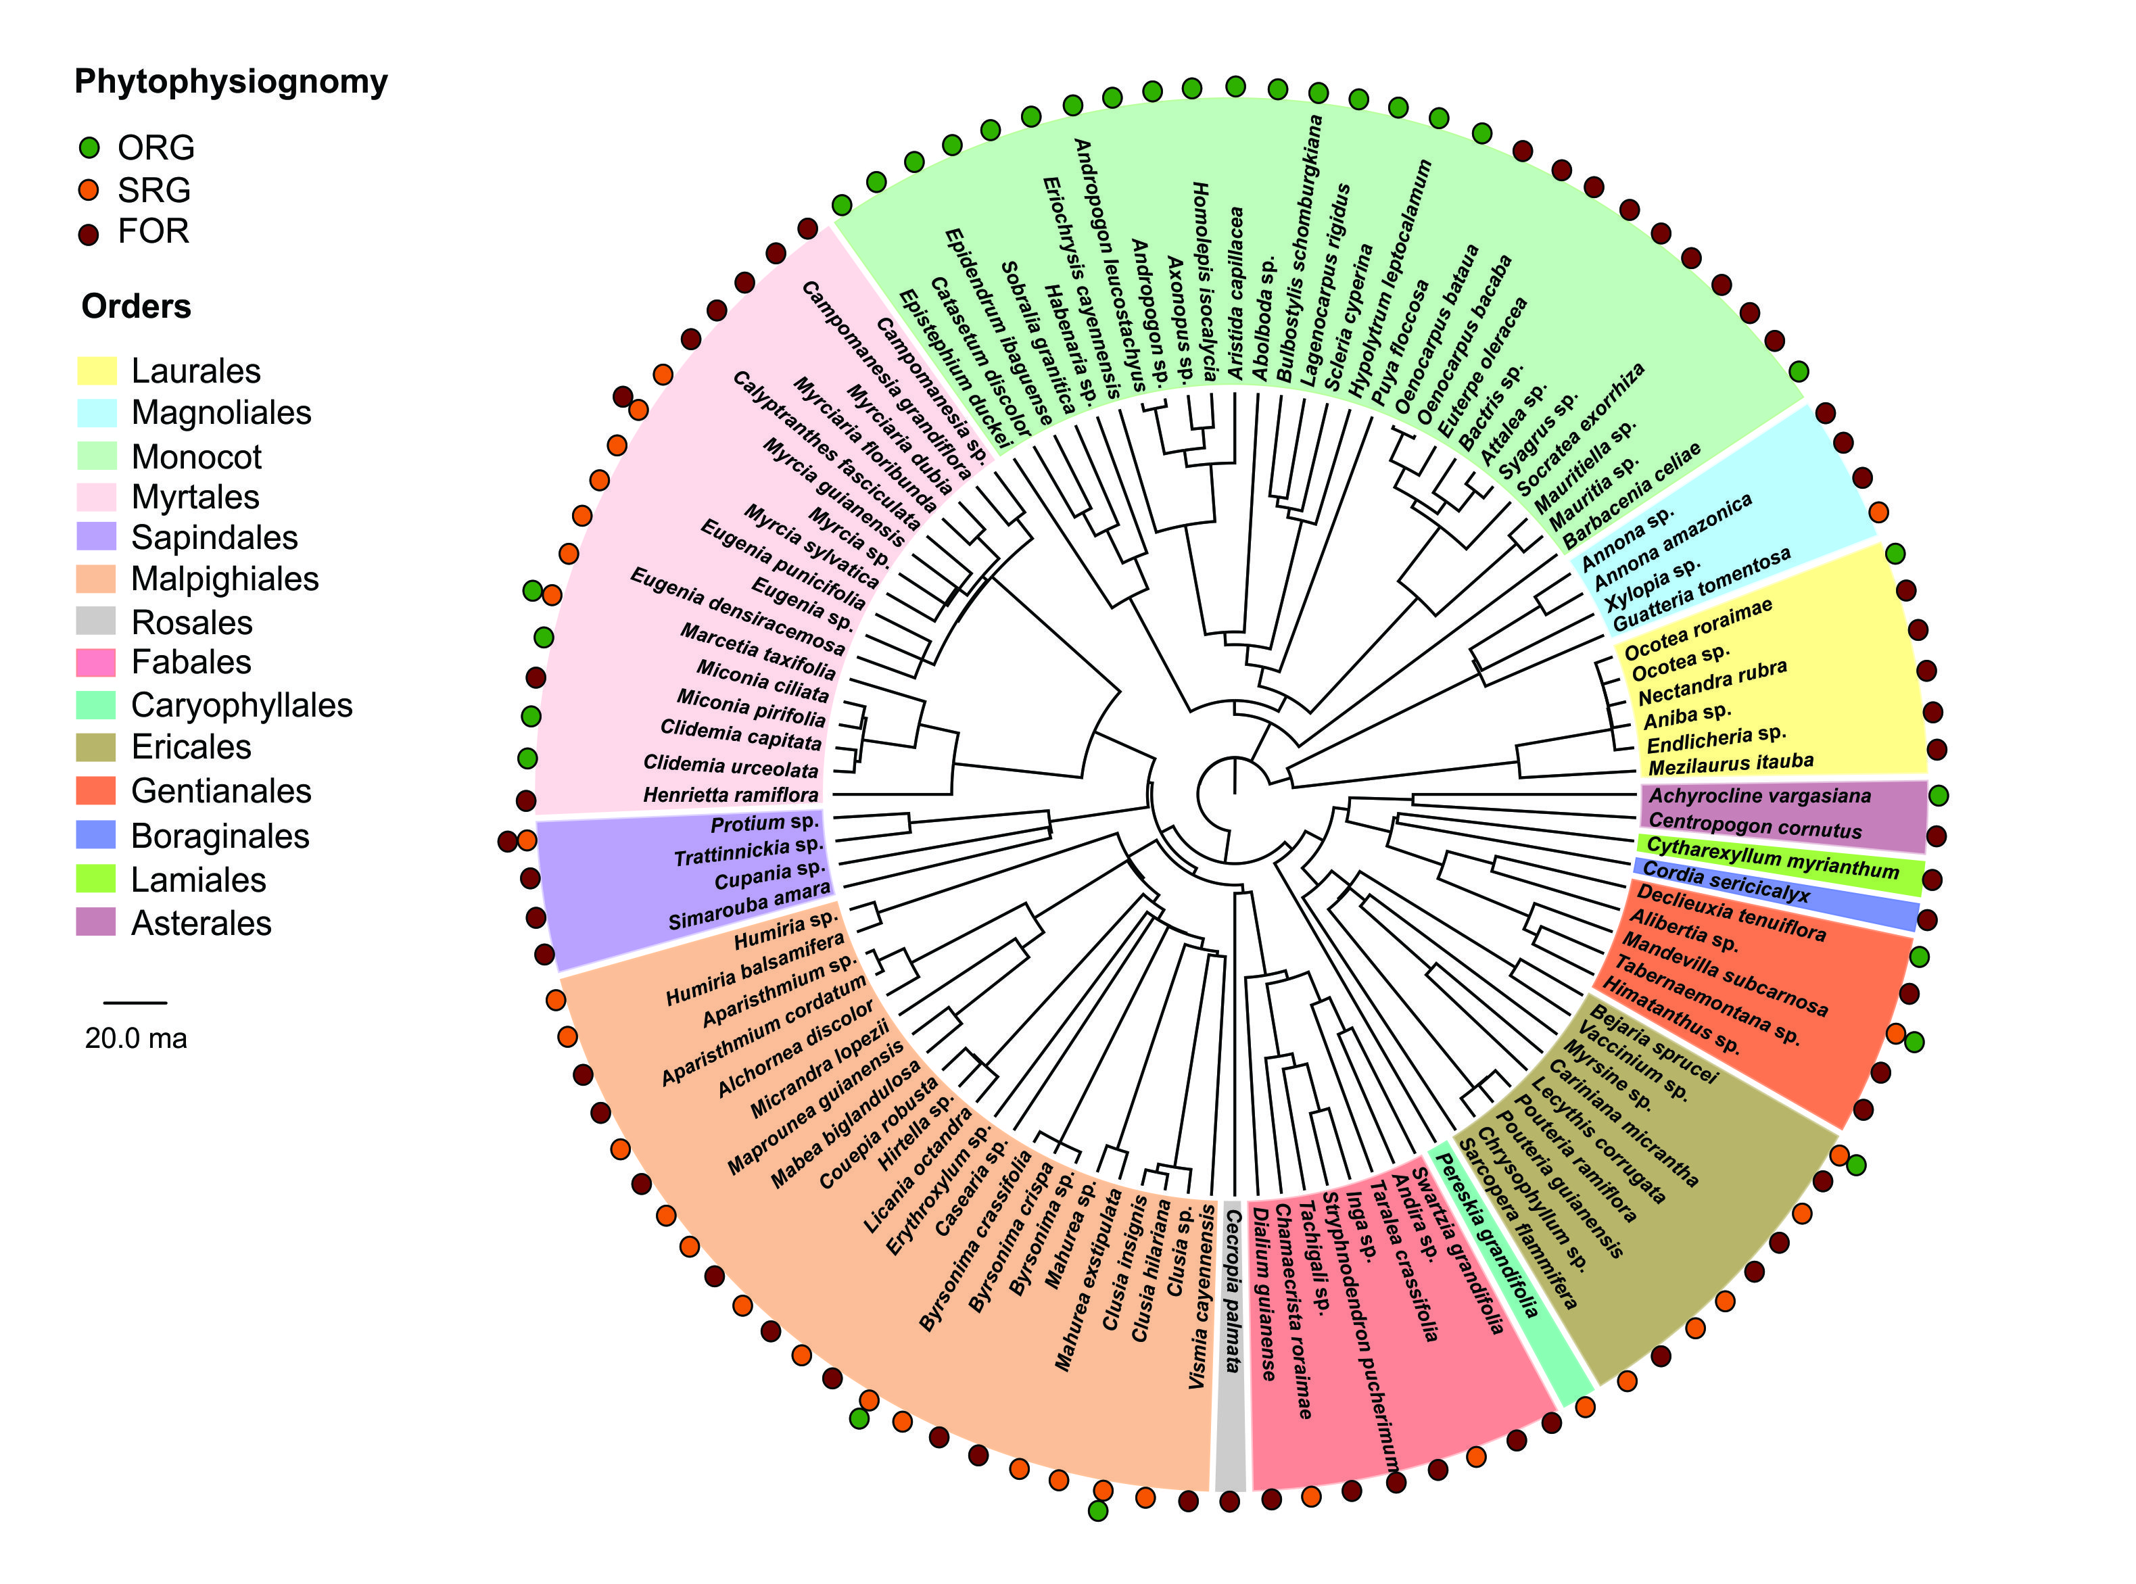

Fig. S1 Phylogenetic relationships among species sampled in the Tepequém table mountain, Roraima state, northwestern Brazil. Open Rupestrian Grassland (ORG; green); Shrubby Rupestrian Grassland (SRG; orange); Forest (FOR; red). Phylogenetic divergence scale is indicated in millions of years (ma).

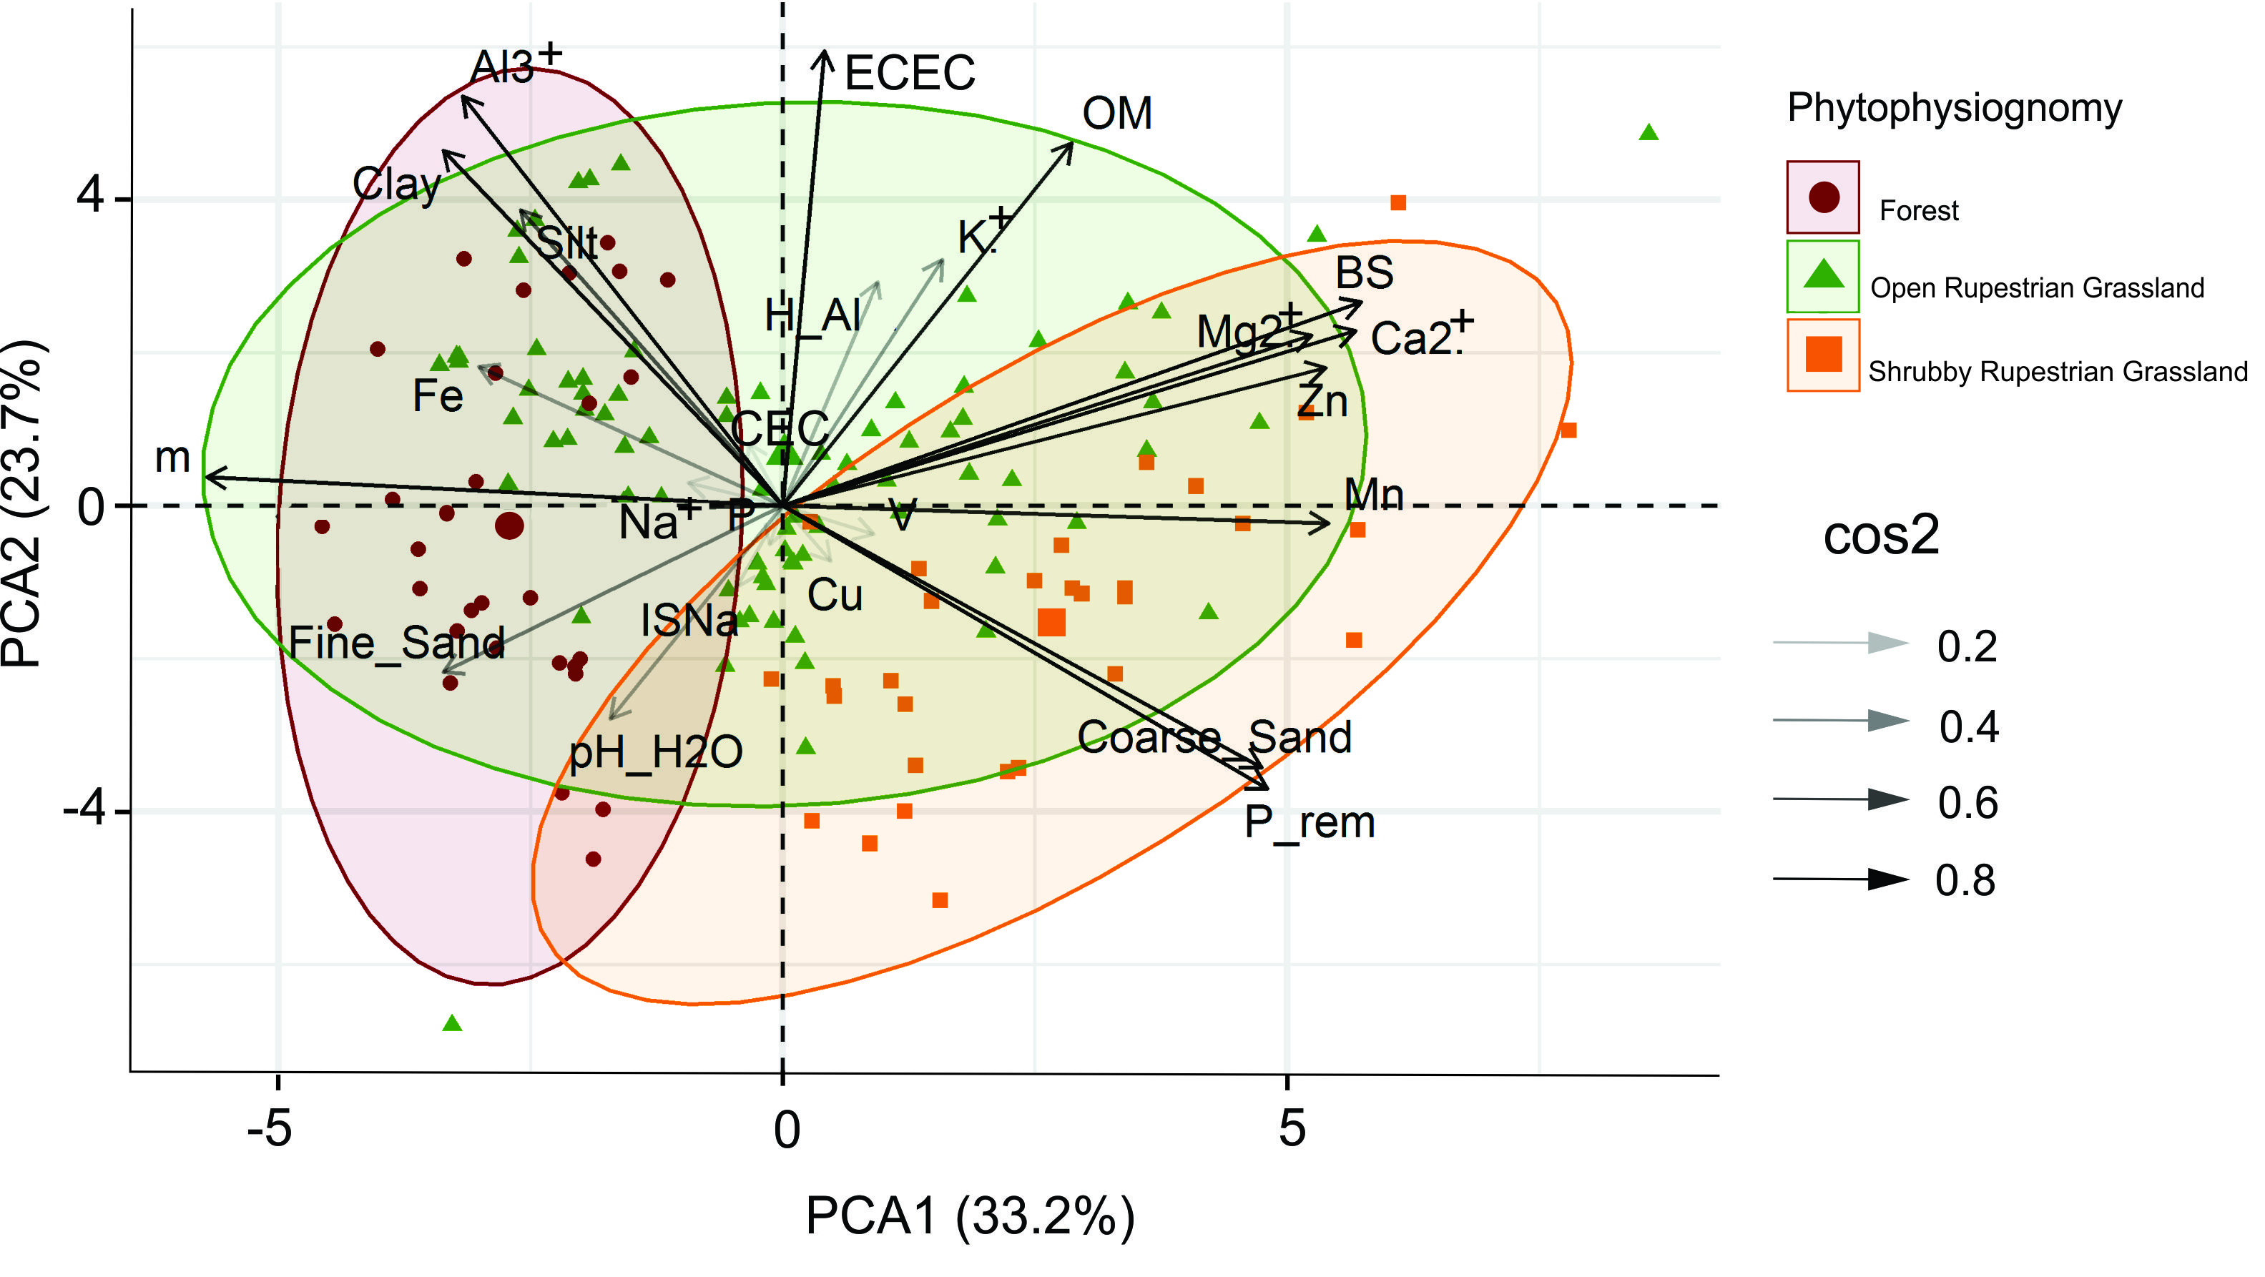
Fig. S2 Principal component analysis (PCA) for the soil properties distribution in different phytophysiognomies in the Tepequém table mountain, Roraima state, northwestern Brazil.The level of Pearson correlation of each vector is indicated (cos2).

Pedological gradient pattern

There was a soil fertility and texture gradient observed along phytophysiognomies. The first two PCA axes explained 56.9% of the variation in soil data. The first principal component (PCA1) explained 33.2% of the variance and was positively correlated with Mg²⁺, Ca²⁺, BS, remaining phosphorous, Zn, Mn, and coarse sand; and was negatively correlated with Fe, aluminum saturation index, and fine sand. The second principal component (PCA2) explained 23.7% of the variation in soil data and was positively correlated with the K⁺, Al⁺³, ECEC, clay, and silt. Organic matter was highly correlated with both PCA1 and PCA2.
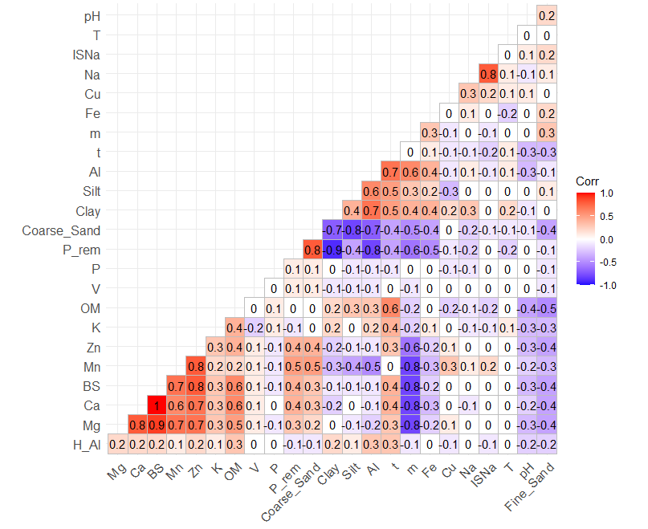
Fig. S3 Pearson correlation among all individual variables measured in different phytophysiognomies in the Tepequém table mountain, Roraima state, northwestern Brazil.pH = Hydrogen Potential; P = Available phosphorus; K = Potassium; Na = Sodium; Ca = Calcium; Mg = Magnesium; Al = Aluminum; H + Al = Acidity potential; BS = Basic Sum; ECEC (t) = Effective Cation Exchange Capacity; CEC (T) = Cation Exchange Capacity at pH 7.0; V = Base Saturation Index; m = Aluminum Saturation Index; ISNa = Sodium Saturation Index; OM = organic matter; P-rem = remaining phosphorous; Zn = Zinc; Fe = Iron; Mn = Manganese; Cu = Copper

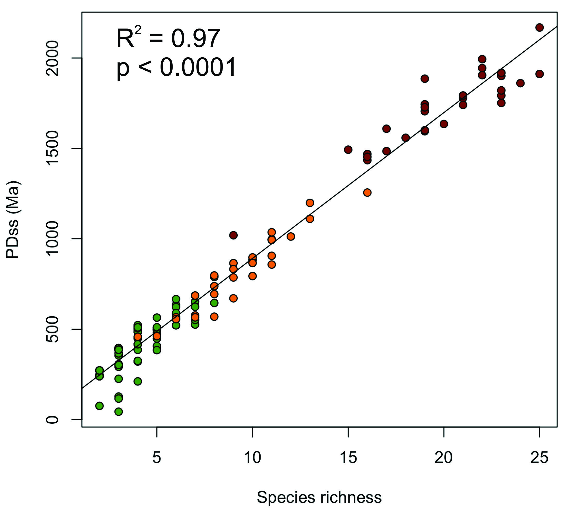
Fig. S4 Relationship between phylogenetic diversity (PD) and species richness in different phytophysiognomies in the Tepequém table mountain, Roraima state, northwestern Brazil. Open Rupestrian Grassland (ORG; green); Shrubby Rupestrian Grassland (SRG; orange); Forest (FOR; red).

