Supplementary data

HPLC-UV monitored photostability-test of LE404 and identification of the degradation products via NMR and LC‑HRMS

Stephanie Zergiebel*, Nico Ueberschaar⁺, Jonathan Plentz†, Andreas Seeling*#

*Institute of Pharmacy, Friedrich-Schiller University Jena, Philosophenweg 14, 07743 Jena, Germany
⁺Mass Spectrometry Platform, Friedrich Schiller University Jena, Humboldtstraße 8, 07743 Jena, Germany
†Leibniz-Institute of Photonic Technology (IPHT) Jena e.V., Department Functional Interfaces, Albert-Einstein-Straße 9, 07745 Jena, Germany.

*Corresponding Author
PD Dr. Andreas Seeling
Institute of Pharmacy,
Department of Pharmaceutical/Medicinal Chemistry,
Friedrich Schiller University Jena,
Philosophenweg 14, 07743 Jena, Germany
E-Mail: andreas.seeling@uni-jena.de
Phone: (+49)3641 9-49814
Fax: (+49)3641 9-49802
Table of contents
S1. Apparatus
S2. Experimental and synthetic procedures, analytical data for products
S3. NMR and IR spectra, MS-data
S4. Degradation studies

S1. Apparatus

HPLC analyses were performed using a LC-10 AS pump, an autoinjector SIL-10 A with an UV detector SPD-10A in combination with a communication bus module SCL-10AVP. Integration and calculation were done with Class LC10™ software (all parts Shimadzu Europe).
A WTW Multical™ pH-meter (Wissenschaftlich-Technische Werkstätten, Weilheim, Germany) with a Blueline 11 electrode (Schott Instruments, Mainz, Germany) was used. Melting points (mp) were measured by using MEL-TEMP® (Laboratory Devices Inc., USA) and were uncorrected.
Infrared spectroscopy (IR) was recorded by UV1900 UV-Vis-Spectrophotometer (Shimadzu Europe) with ATR measurement head.
Proton ¹H- and carbon ¹³C-NMR spectra were recorded on a Bruker Fourier 300 spectrometer (300 MHz), Bruker Avance 400 (400MHz) or Bruker Avance 600 spectrometer (600 MHz) using DMSO-d₆, acetonitrile-d₃, CDCl₃ or methanol-d₄ as solvent. Chemical shifts (δ) are given in ppm relative to residual solvent peak. References for DMSO-d₆ were 2.50 ppm (¹H) and 39.52 ppm (¹³C), for acetonitrile-d₃ 1.94 ppm (¹H) and 1.32 ppm (¹³C), for CDCl₃ 7.26 ppm (¹H) and 77.16 ppm (¹³C) and for methanol-d₄ 3.31 ppm (¹H) and 49.00 ppm (¹³C).
Ultra high performance liquid chromatography coupled with high resolution mass spectrometry was carried out using a THERMO (Bremen, Germany) UltiMate HPG-3400 RS binary pump, WPS-3000 autosampler which was set to 10 °C and was equipped with a 25 µL injection syringe and a 100 µL sample loop. The column was kept at 25 °C within the column compartment TCC-3200. Chromatography column was used THERMO Accucore® C-18 RP (100 × 2.1 mm; 2.6 µm) using the gradient from 0 to 100% Eluent B from 0.2 to 8.0 min, holding for 3 min at 100% B and restore to the initial conditions for one additional minute. A constant flow rate of 0.4 mL·min⁻¹ was set. Eluent A was deionized water, with 2% acetonitrile and 0.1% formic acid. Eluent B was pure acetonitrile. Mass spectra were recorded with THERMO QExactive plus orbitrap mass spectrometer coupled to a heated electrospray source (HESI). Column flow was switched at 0.5 min from waste to the MS and at 11.5 min again back to the waste, to prevent source contamination. For monitoring two full scan modes were selected with the following parameters. Polarity: positive; scan range: 100 to 1500 m/z; resolution: 70,000; AGC target: 3 × 10⁶; maximum IT: 200 ms. General settings: sheath gas flow rate: 60; auxiliary gas flow rate 20; sweep gas flow rate: 5; spray voltage: 3.0 kV; capillary temperature: 360 °C; S-lens RF level: 50; auxiliary gas heater temperature: 400 °C; acquisition time frame: 0.5-11.5 min. For negative mode, all values were kept instead of the spray voltage which was set to 3.3 kV.

S2. Experimental and synthetic procedures, analytical data for products

S2.1 DP1 (3-Hydroxy-7-methyl-5,6,7,8,9,14-hexahydrodibenz[d,g]azecin-7-oxide)
To a solution of LE404 (25 mg, 0.0935 mmol) in 4 ml acetonitrile HPLC-grade at 25 °C was added dropwise 50 eq. H₂O₂ (460 µl 30% H₂O₂-solution in deionized water = 4.68 mmol H₂O₂). The mixture was stirred for 20 h under exclusion of light at 25°C. The colorless precipitate formed was filtered through a membrane filter (0.2 µm RC membrane filter, Sartorius, Germany) and washed several times with acetonitrile. After drying under vacuum, DP1 was obtained as a colorless solid with a yield of 75%.

Mp 144 °C. ¹H-NMR (600.15 MHz, DMSO-d₆): δ 10.77-10.00 (s, 1H), 7.31-7.21 (d, 1H), 7.21-7.08 (m+d, 3H), 6.97-6.88 (d, 1H), 6.65-6.57 (s, 1H), 6.54-6.46 (d, 1H), 4.33-4.11 (d, 1H), 3.95-3.82 (d, 1H), 3.82-3.67 (m, 2H), 3.48-3.37 (m, 2H), 3.18-3.11 (s, 3H), 2.99-2.77 (m, 4H). ¹³C-NMR: (150.93 MHz, DMSO-d₆): δ 157.44, 139.74, 138.93, 136.96, 131.37, 130.86, 130.80, 127.13, 126.90, 126.67, 116.68, 114.72, 68.88, 66.18, 58.24, 35.89, 27.19, 27.02. IR (ATR, [cm-1]): υ = 3012, 2944, 2810, 1607, 1482, 1448, 1374, 1281, 1254, 1235, 751, 472. HRMS (ESI): m/z calculated for C₁₈H₂₂NO₂⁺ [M+H⁺]: 284.1645. Found: 284.1640.

S2.2 DP2 (3-Hydroxy-7-methyl-6,7,8,9-tetrahydrodibenzo[d,g]azecin-14(5H)-one (DP2-1), (14-Hydroxy-7-methyl-6,7,8,9-tetrahydrodibenzo[d,g]azecin-3(5H)-one) (DP2-2)
LE404 (38 mg, 0.1421 mmol) were dissolved in 1 ml acetonitrile HPLC-grade. The solution was stirred at 25°C for 105 days. The reaction mixture was thus exposed to an approximatively average exposure time of 892 hours (8.5 h x 105 d) to daylight. The extent and speed of decomposition depends on the intensity of the sun, which varies depending on the time of day and the season. The reaction was stopped when 70 area percent DP2 was detectable by HPLC-UV. The reaction mixture was separated by semipreparative HPLC and the fractions for peak DP2 were collected. The HPLC-method was carried out as described in [Zergiebel, S.; Seeling, A., Robust and Fast UV–HPLC Method for Biotransformation Analysis of Azecines. Chromatographia, 2021. 84: p. 275–283]. The pooled fractions of peak DP2 comprised approximately 50 ml. All of the following work steps and the fractionation were carried out with the exclusion of light. Extraction was carried out three times with DCM after addition of 20 ml of saturated sodium hydrogencarbonate solution. The combined DCM extracts were washed with saturated sodium chloride solution, dried over anhydrous sodium sulfate, filtered and the solvent removed under vacuum. After drying under high vacuum for 48 h, an aliquot of the samples was redissolved and analyzed using the same HPLC method to ensure that only the desired peak was isolated.

Mp 159 °C. ¹H-NMR (600.15 MHz, DMSO-d₆): δ = 7.41-7.33 (t, 1H), 7.29-7.24 (X, 1H), 7.24-7.19 (m, 1.5H), 7.13-7.06 (m, 2H), 5.34-5.29 (m, 0.5H), 2.93-2.91 (s, 0.37H), 2.10-1.90 (m, 4H). 1.82-1.76 (s, 2.65H), 1.59-1.38 (m, 4H). ¹³C-NMR: (150.93 MHz, DMSO-d₆): δ 190.75, 174.29, 159.41, 142.04, 140.01, 135.30, 132.90, 130.01, 129.80, 126.78, 125.75, 116.57, 112.54, 41.78, 35.12, 29.06, 26.62, 25.12. IR (ATR, [cm-1]): υ = 3350, 3177, 2920, 2849, 1734, 1631, 1570, 1490, 1285, 1248, 1090, 1049, 753. HRMS (ESI): m/z calculated for C₁₈H₂₀NO₂⁺ [M+H⁺]: 282.1489. Found: 282.1479.

S2.3 LE404 (7-Methyl-5,6,7,8,9,14-hexahydrodibenzo[d,g]azecin-3-ol)
The synthesis was carried out as described in [Zergiebel, S.; Arndt, H.-D.; Seeling, A., Optimized synthesis of new LE404-derived azecine-prodrugs. Tetrahedron Letters, 2017. 58: p. 3640–3642]

Mp 70 °C. ¹H-NMR (600.15 MHz, DMSO-d₆): δ = 9.07-8.99 (s, 1H), 7.32-7.27 (m, 1H), 7.12-7.05 (m, 4H), 6.53-6.45 (m, 2H), 4.16-4.10 (s, 2H), 2.74-2.61 (m, 8H), 2.10-2.06 (s, 3H). ¹³C-NMR (75.49 MHz, DMSO-d₆): δ =155.41, 141.42, 141.20, 140.27 ,130.88, 130.80, 130.17, 129.96, 125.86, 125.73, 116.48, 113.05, 35.95, 33.79, 33.54, 61.15, 61.15, 47.63. IR (ATR, [cm⁻¹]): υ = 2931, 2789, 1605, 1578, 1479, 1445, 1248, 747. HRMS (ESI): m/z calculated for C₁₈H₂₂NO⁺ [M+H⁺]: 268.1696. Found: 268.1691.

S3. NMR and IR spectra, MS-data

S3.1 DP1

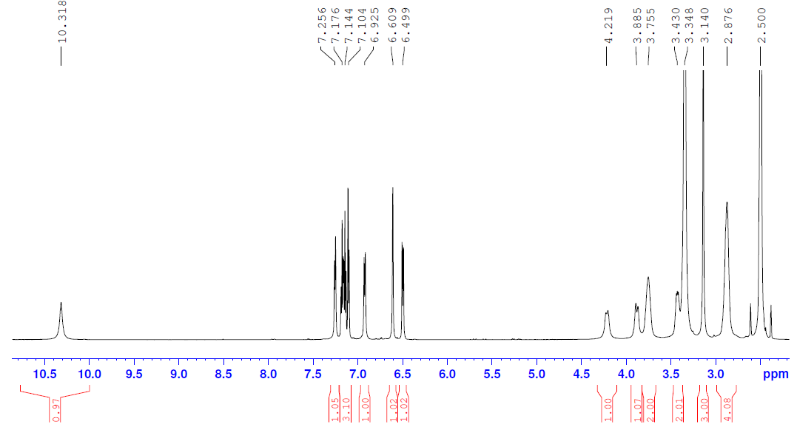
Fig. S1 ¹H-NMR of DP1 (600.15 MHz, DMSO-d₆)

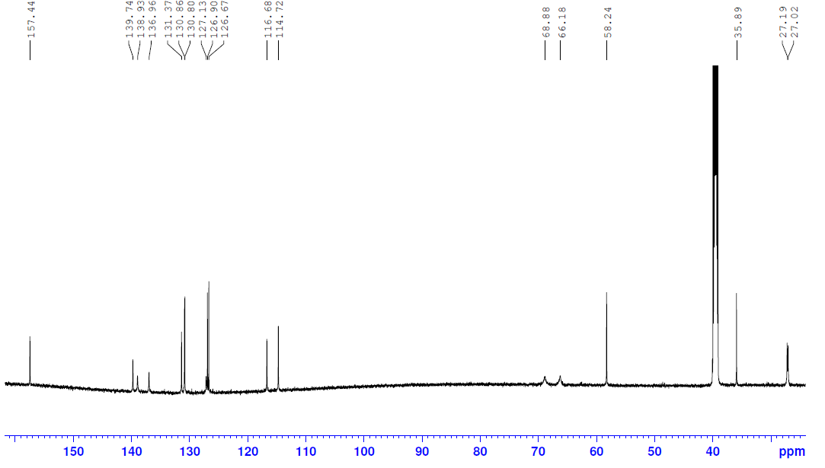
Fig. S2 ¹³C-NMR of DP1 (150.93 MHz, DMSO-d₆)

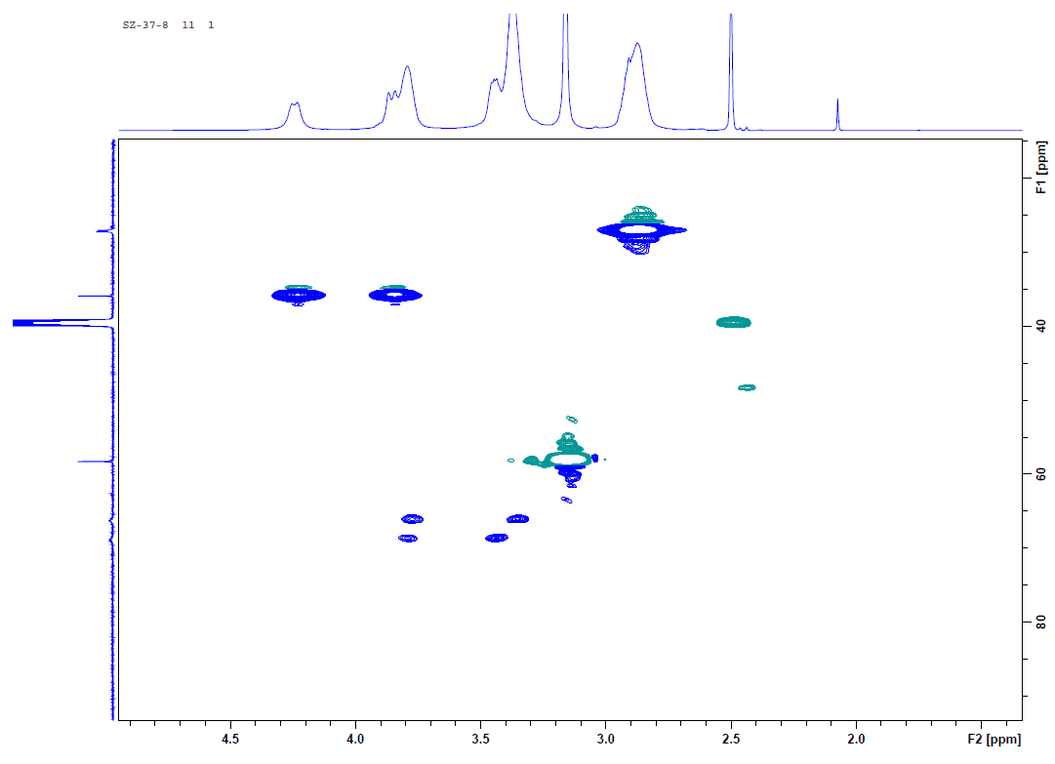
Fig. S3 ASAP-HSQC-DEPT of DP1 (600.15 MHz, DMSO-d₆)

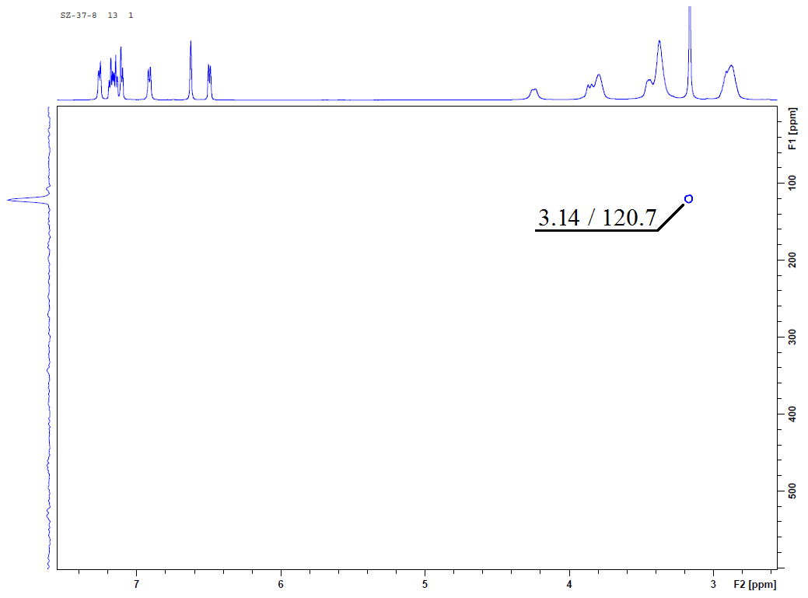
Fig. S4 ¹H/ ¹⁵N-HMBC of DP1 (600.15 MHz, DMSO-d₆)

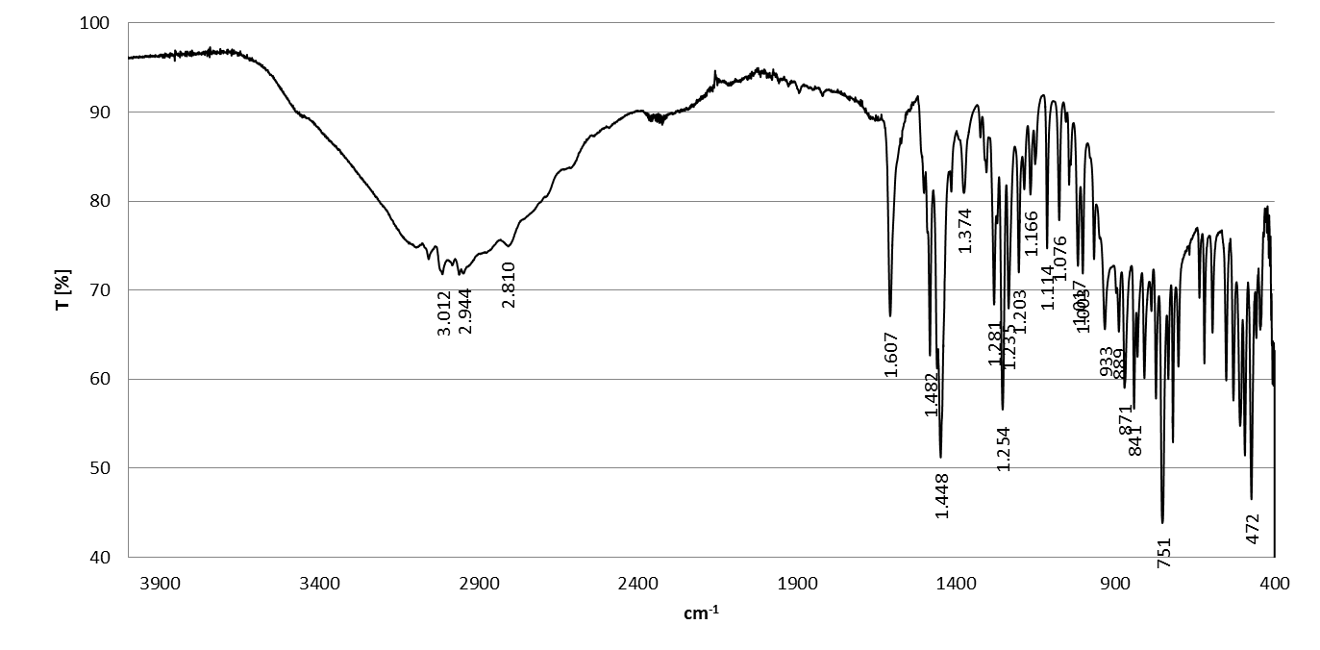
Fig. S5 IR-spectra of DP1

S3.2 DP2

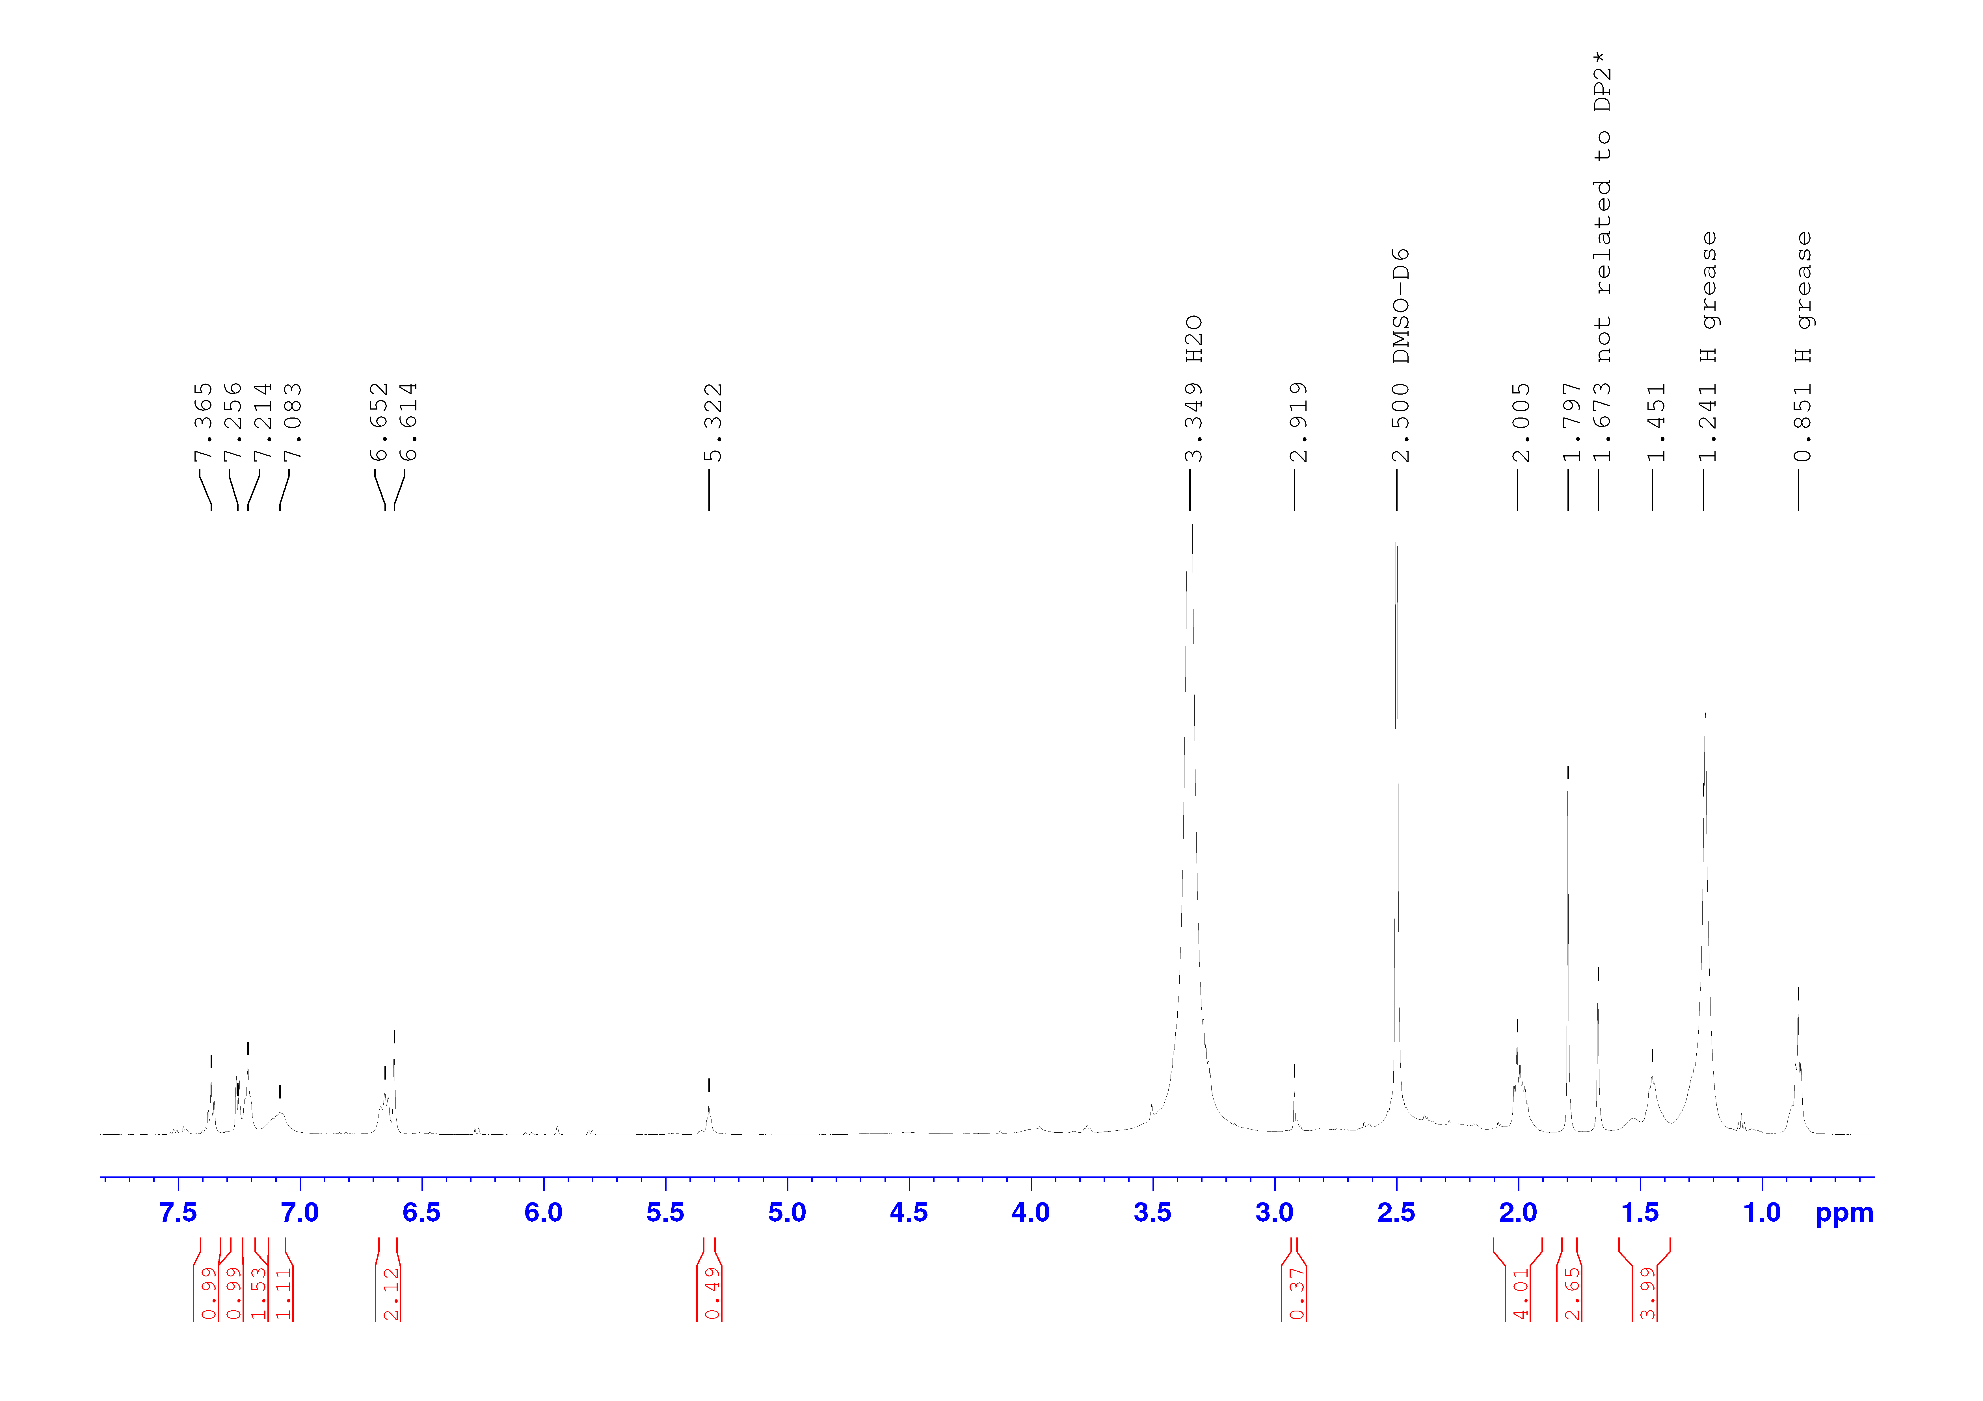
Fig. S6 ¹H-NMR of DP2 (600.15 MHz, DMSO-d₆), * signal 1.673 ppm not related to DP2 based on DOSY and ASAP-HSQC experiments

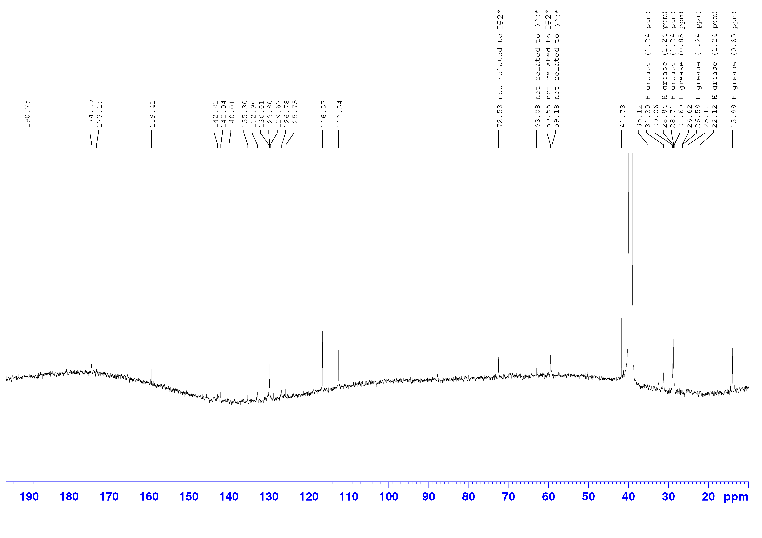
Fig. S7 ¹³C-NMR of DP2 (150.93 MHz, DMSO-d₆), * signals in range of 59-73 ppm not related to DP2 based on DOSY and ASAP-HSQC experiments

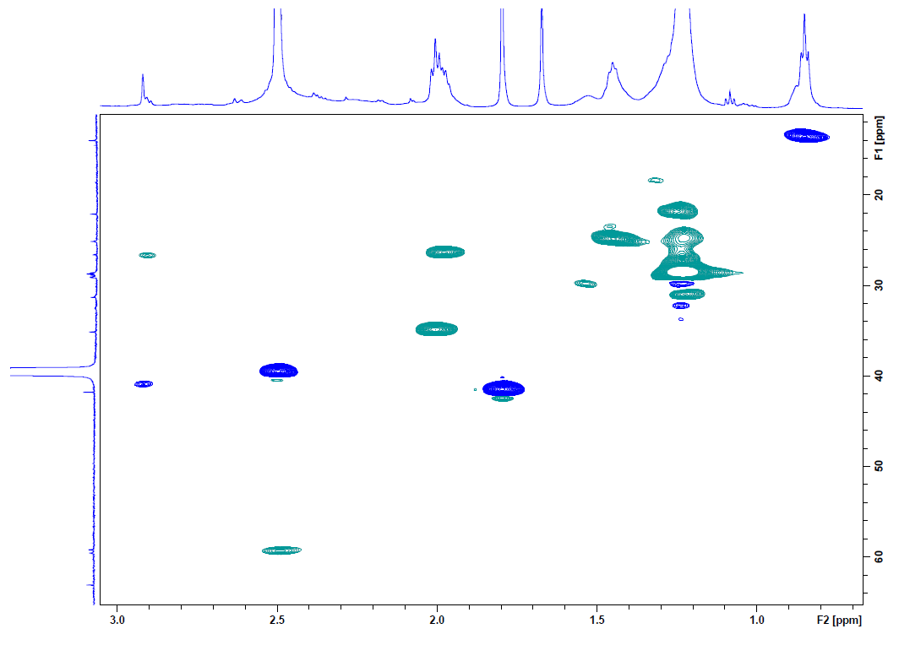
Fig. S8A ASAP-HSQC-DEPT (aliphatic range) of DP2 (600.15 MHz, DMSO-d₆)

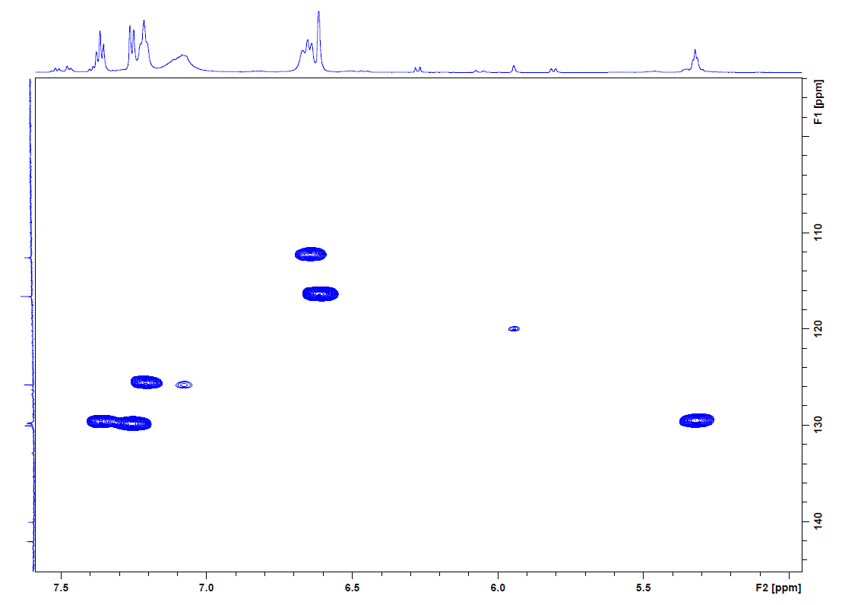
Fig. S8B ASAP-HSQC-DEPT (aromatic range) of DP2 (600.15 MHz, DMSO-d₆)

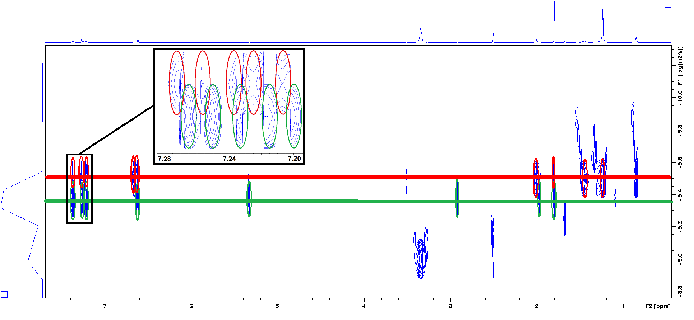
Fig. S9 DOSY experiment of DP2 (500.18 MHz, DMSO-d₆), signals associated with the individual tautomers are marked red or green respectively

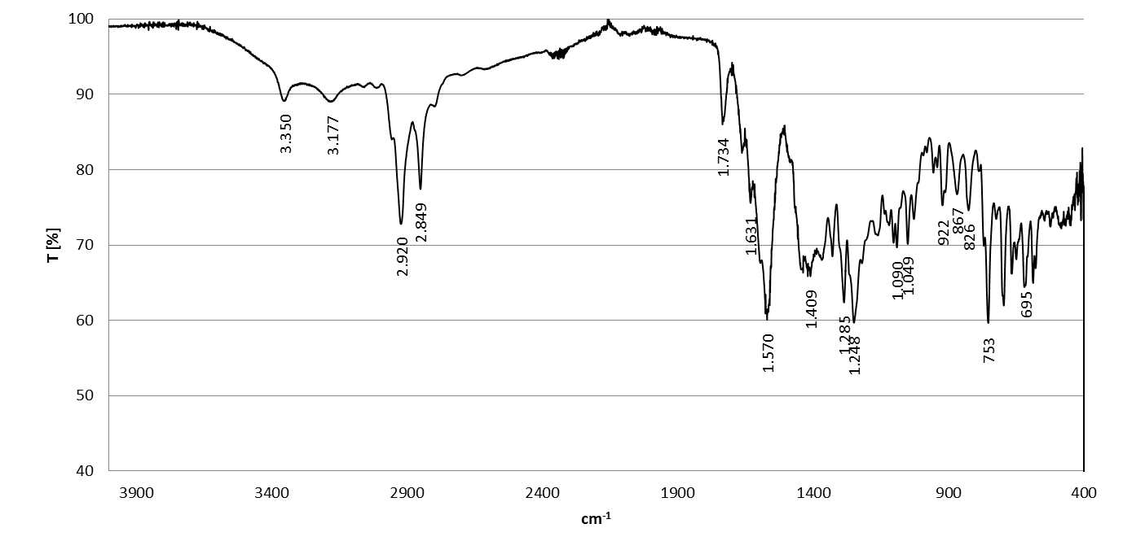
Fig. S10 IR-spectra of DP2

S3.3 LE404

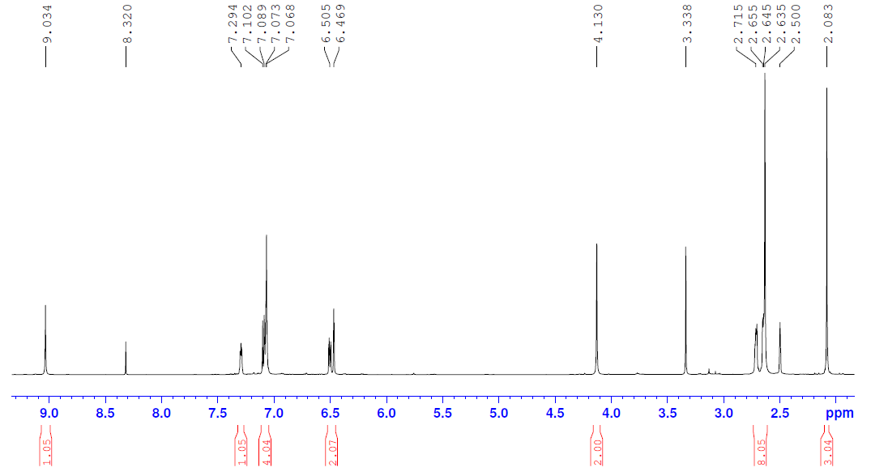
Fig. S11 ¹H-NMR of LE404 (600.15 MHz, DMSO-d₆)

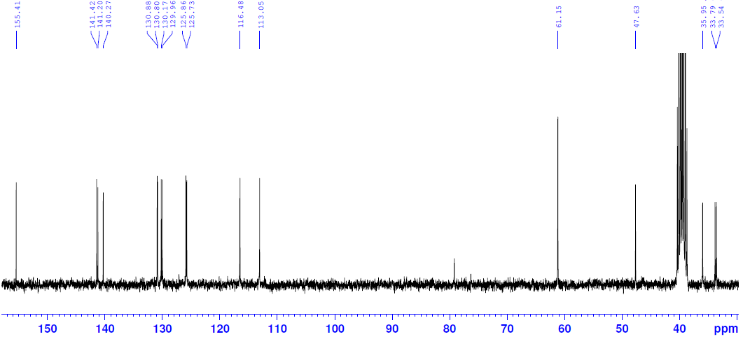
Fig. S12 ¹³C-NMR of LE404 (75.49 MHz, DMSO-d₆)

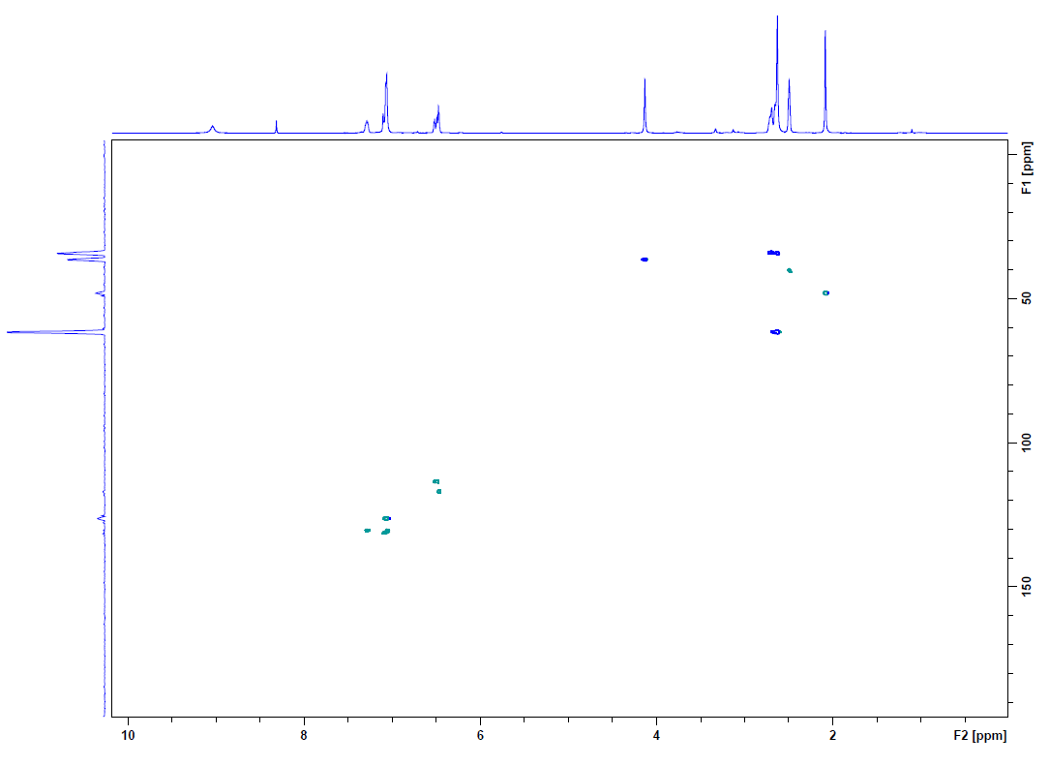
Fig. S13 HSQC-DEPT of LE404 (300.19 MHz, DMSO-d₆)
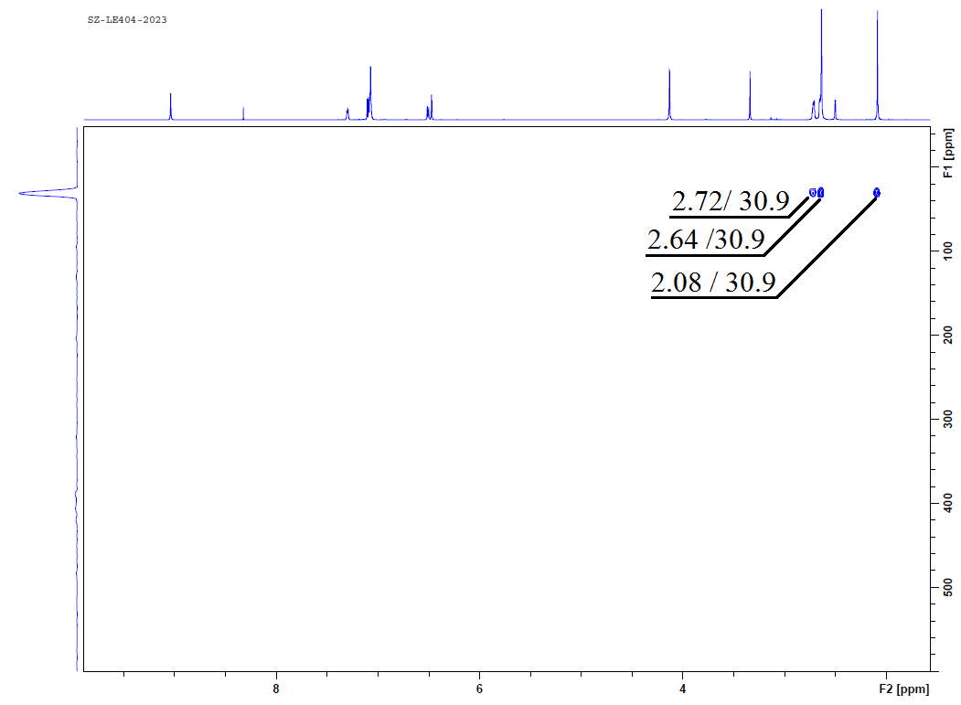
Fig. S14 ¹H/ ¹⁵N-HMBC of LE404 (600.15 MHz, DMSO-d₆)

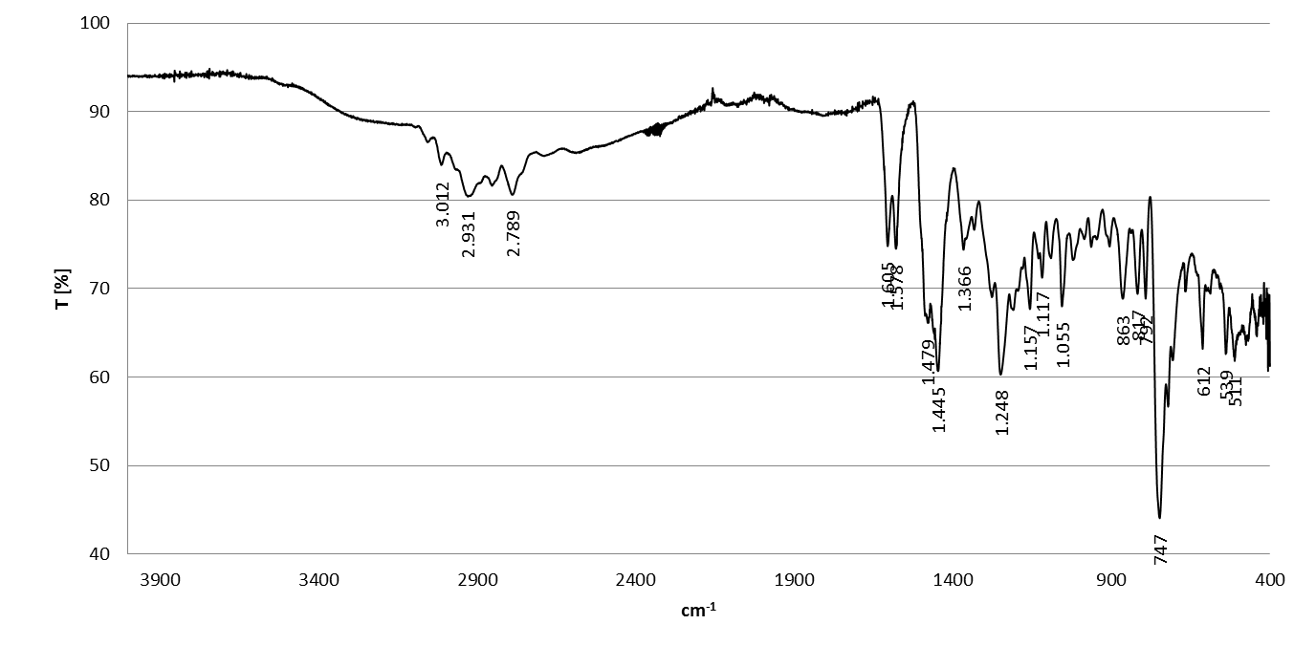
Fig. S15 IR-spectra of LE404

S4. Degradation studies

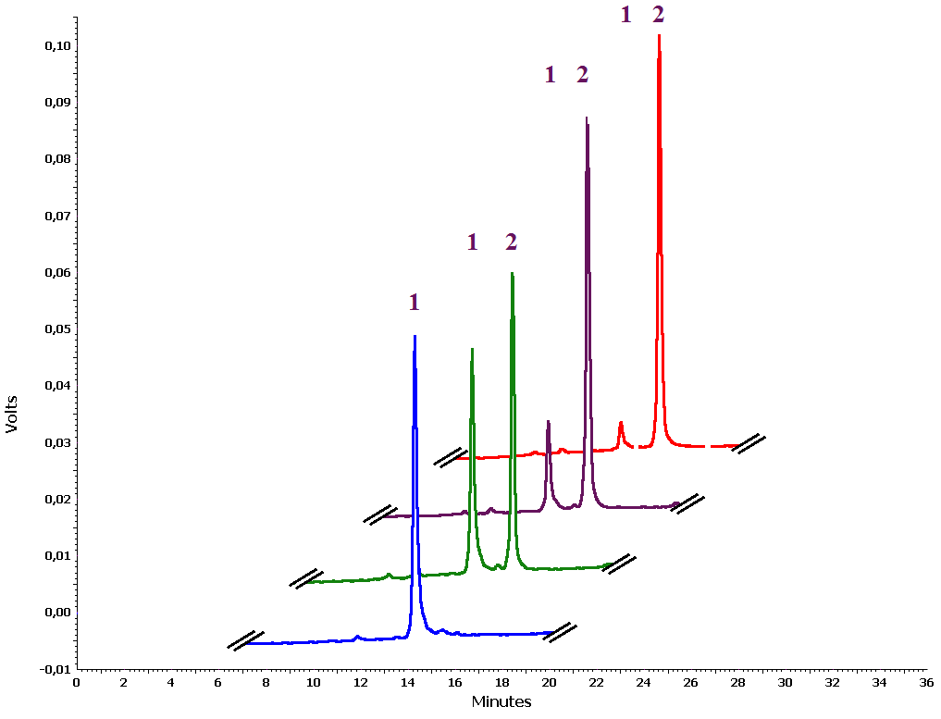
Fig. S16 HPLC-UV chromatogram showing separation of LE404 (peak 1), the degradation product DP1 (peak 2) formed by oxidation at the measurement times 0 min (blue), 15 min (green), 60 min (violet), 150 min (red)

Table S1 Retention times (t_{R}), peak area (PA), and the respective relative standard deviation (RSD) of LE404 and DP1 after oxidative degradation by H₂O₂ in MeCN/H₂O
duration  [min]  MeCN | LE404 (n=3, mean) |  |  |  | DP1 (n=3, mean)
duration  [min]  MeCN | t_{R}  [min] | RSD t_{R}  [%] | PA | RSD PA  [%] | t_{R}  [min] | RSD t_{R}  [%] | PA | RSD PA  [%]
0 | 14.247 | 0.28 | 2.083 | 1.51 | - | - | - | -
2 | 14.017 | 0.30 | 2.022 | 0.93 | 15.800 | 0.21 | 0.541 | 4.02
5 | 13.775 | 0.45 | 1.892 | 2.94 | 15.514 | 0.40 | 0.722 | 2.52
15 | 13.898 | 1.90 | 1.586 | 2.66 | 15.614 | 1.69 | 1.623 | 4.73
30 | 13.964 | 0.51 | 1.359 | 1.77 | 15.681 | 0.48 | 2.091 | 4.28
45 | 13.839 | 1.24 | 0.851 | 2.79 | 15.492 | 0.82 | 3.363 | 4.93
60 | 13.767 | 1.27 | 0.744 | 2.35 | 15.419 | 1.22 | 3.950 | 4.64
90 | 13.711 | 1.51 | 0.544 | 1.97 | 15.355 | 1.35 | 4.293 | 4.18
120 | 13.778 | 0.57 | 0.318 | 3.00 | 15.411 | 0.42 | 4.555 | 2.22
150 | 13.503 | 1.95 | 0.152 | 2.39 | 15.150 | 1.63 | 4.829 | 3.95

Table S2 Retention times (t_{R}), peak area (PA), and the respective relative standard deviation (RSD) of LE404 and DP1 after oxidative degradation by H₂O₂ in MeOH/H₂O
duration  [min]  MeOH | LE404 (n=3, mean) |  |  |  | DP1 (n=3, mean)
duration  [min]  MeOH | t_{R}  [min] | RSD t_{R}  [%] | PA | RSD PA  [%] | t_{R}  [min] | RSD t_{R}  [%] | PA | RSD PA  [%]
0 | 12.631 | 0.45 | 2.055 | 2.10 | - | - | - | -
2 | 12.731 | 0.52 | 1.717 | 1.32 | 14.136 | 0.44 | 0.388 | 4.38
5 | 12.547 | 0.11 | 1.470 | 1.25 | 14.147 | 0.34 | 0.501 | 2.12
15 | 12.617 | 0.51 | 1.355 | 1.84 | 14.253 | 0.94 | 0.685 | 2.72
30 | 12.708 | 0.14 | 1.201 | 1.60 | 14.172 | 0.50 | 0.947 | 4.55
45 | 12.519 | 1.56 | 1.014 | 1.62 | 14.091 | 0.34 | 1.207 | 4.91
60 | 12.750 | 0.70 | 0.848 | 0.86 | 14.269 | 0.70 | 1.576 | 3.20
90 | 12.705 | 0.35 | 0.713 | 1.83 | 14.203 | 0.36 | 1.825 | 3.19
120 | 12.786 | 0.43 | 0.525 | 2.48 | 14.250 | 0.19 | 2.126 | 1.66
150 | 12.950 | 0.21 | 0.365 | 0.40 | 14.444 | 0.21 | 2.269 | 1.92

Table S3 Determination of content using HPLC. Comparison of the oxidative degradation of LE404 using H₂O₂ in MeCN/H₂O and MeOH/H₂O
 | MeCN/H₂O (n=3, mean) | MeOH/H₂O (n=3, mean)
duration  [min] | amount LE404 [%] | amount LE404 [%]
0 | 100.00 ± 1.51 | 100.00 ± 2.10
2 | 97.05 ± 0.91 | 83.55 ± 1.10
5 | 90.83 ± 2.67 | 71.54 ± 0.90
15 | 76.13 ± 2.03 | 65.92 ± 1.22
30 | 65.26 ± 1.15 | 58.44 ± 0.93
45 | 40.84 ± 1.14 | 49.33 ± 0.80
60 | 35.74 ± 0.84 | 41.28 ± 0.35
90 | 26.12 ± 0.51 | 34.70 ± 0.64
120 | 15.26 ± 0.46 | 25.56 ± 0.63
150 | 7.27 ± 0.17 | 17.75 ± 0.07

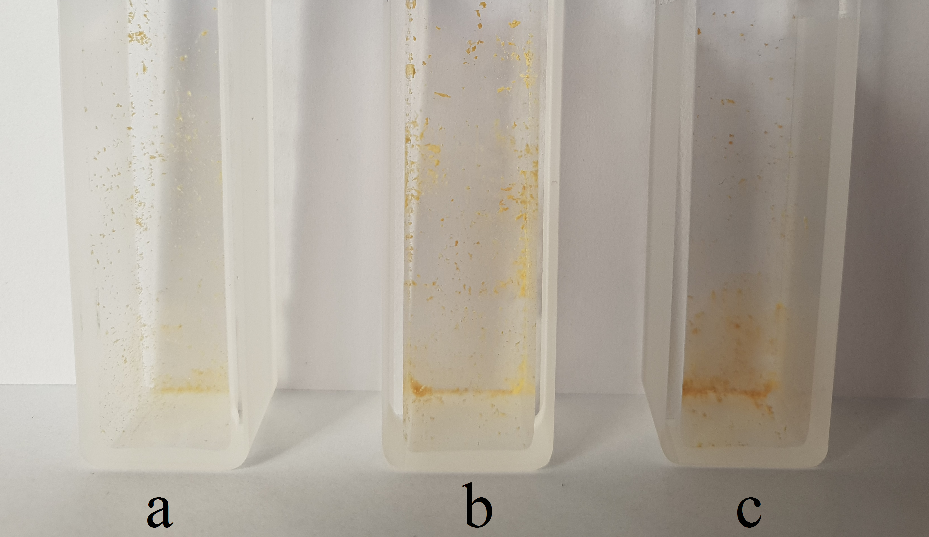
Fig. S17 Color change of LE404 during the photodegradation study according to ICH (a: t = 4 h, b: t = 8 h, c: t = 12 h). At starting conditions (t=0) LE404 is colorless crystalline.

Table S4 Retention times (t_{R}), peak area (PA), and the respective relative standard deviation (RSD) of LE404 and the degradation products DP1 and DP2 after exposure to light according to ICH guideline
illumination  time  [h] | LE404 (n=3, mean) |  |  |  | DP1 (n=3, mean) |  |  |  | DP2 (n=3, mean)
illumination  time  [h] | t_{R}  [min] | RSD t_{R}  [%] | PA | RSD PA  [%] | t_{R}  [min] | RSD t_{R}  [%] | PA | RSD PA  [%] | t_{R}  [min] | RSD t_{R}  [%] | PA | RSD PA  [%]
0 | 13.025 | 0.67 | 1.068 | 2.84 | - | - | - | - | - | - | - | -
4 | 12.717 | 0.38 | 1.062 | 0.47 | 14.503 | 0.64 | 0.019 | 2.93 | 9.275 | 0.86 | 0.007 | 1.01
8 | 12.772 | 0.64 | 1.043 | 1.25 | 14.556 | 0.52 | 0.023 | 0.77 | 9.380 | 1.77 | 0.010 | 2.17
12 | 12.922 | 0.18 | 0.998 | 1.13 | 14.647 | 1.00 | 0.024 | 1.28 | 9.594 | 0.32 | 0.078 | 2.53

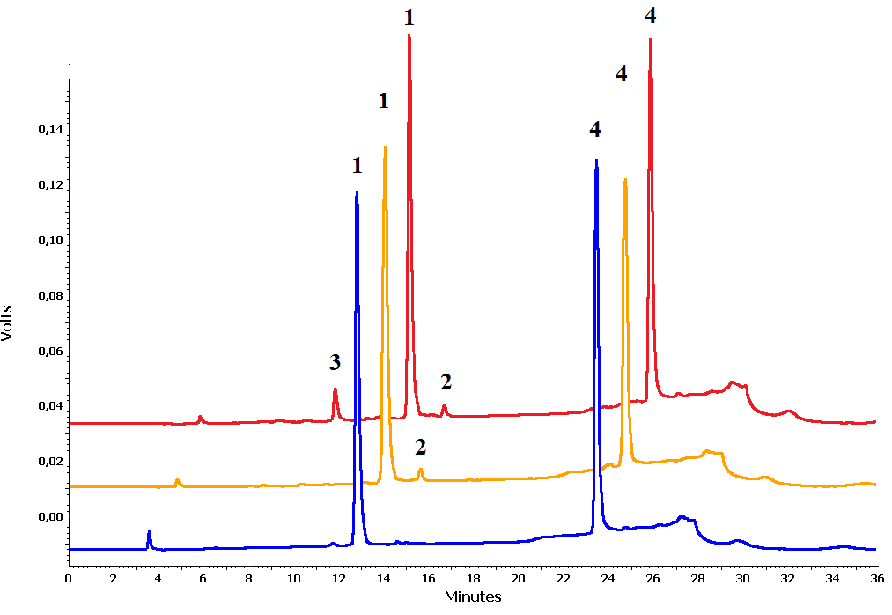
Fig. S18 HPLC-UV chromatogram of the photostability test according to ICH guideline showing separation of LE404 (peak1) and the degradation products DP1 (peak 2) and DP2 (peak 3) as well as the internal standard β-naphthol (peak 4) at different test times (0 h = blue, dark-control = orange, 12 h = red)

Table S5 Predicted chemical shifts according to ChemDraw© for the individual isomers DP2-1, DP2-2 and DP2-3 (*estimation quality is rough, #estimation quality is medium)
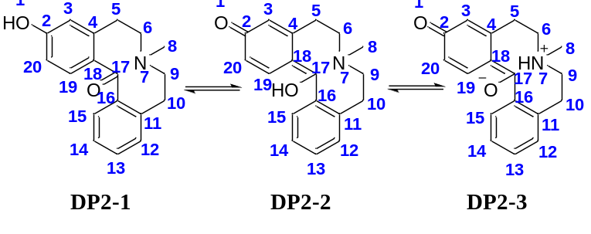
atom-  No. | DP2-1  ¹³C  [ppm] | DP2-2  ¹³C  [ppm] | DP2-3  ¹³C  [ppm] | DP2-1  ¹H  [ppm] | DP2-2  ¹H  [ppm] | DP2-3  ¹H  [ppm]
0 | - | - | - | - | 17.07 | -
1 | - | - | - | 9.29 | - | -
2 | 160.6 | 183.0 | 183.0 | - | - | -
4 | 143.6 | 145.2 | 145.2 | - | - | -
16 | 131.0 | 126.9 | 134.3 | - | - | -
11 | 142.2 | 138.3 | 138.3 | - | - | -
18 | 123.6 | 104.2 | 136.0 | - | - | -
19 | 131.6 | 147.9 | 147.9 | 7.57 | 7.34 | 6.46
15 | 127.3 | 127.6 | 126.3 | 8.37 | 6.46 | 7.34
14 | 125.6 | 122.7 | 125.8 | 7.46 | 7.27 | 7.27
13 | 132.3 | 127.8 | 127.8 | 7.96 | 7.65 | 7.65
12 | 127.4 | 127.6 | 127.6 | 7.59 | 7.44 | 7.44
3 | 114.9 | 112.9 | 112.9 | 6.84 | 6.41 | 6.41
20 | 112.8 | 115.3 | 115.3 | 6.70 | 6.25 | 6.25
17 | 187.0 | 174.5 | 122* | - | - | -
10 | 31.4 | 32.3 | 29# | 2.65 | 2.65 | 2.99
5 | 31.7 | 35.1 | 31# | 2.65 | 2.06 | 2.40
9 | 60.3 | 60.8 | 59.2 | 2.69 | 2.69 | 3.57
6 | 60.3 | 56.9 | 54.6 | 2.69 | 2.40 | 3.28
8 | 47.2 | 47.3 | 42.9 | 2.18 | 2.18 | 2.86
7 | - | - | - | - | - | 7.2*

