Carbon Quantum Dots of Ginsenoside Rb1 for Application in a Mouse Model of Intracerebral Hemorrhage
Xiaolong Tang^{1,2†}, Xinyu Yang^{1,2†}, Yamei Yu^{1,3†}, Miaojing Wu^{1,2†}, Yuanyuan Li¹, Guangyu Jia^{1,2}, Qi Wang^{1,2}, Xingen Zhu^{1,2*}, Shiyong Li^{1,2*}, Wei Tu^{1,2*}
^{1*}Institute of Neuroscience, Jiangxi Medical College,Nanchang University, Street, Nanchang,Jiangxi, 330036, China.
²Department of Neurosurgery, The Second Affiliated Hospital,Jiangxi Medical College,Nanchang University , Street, Nanchang,Jiangxi, 330008, China.
³Department of Neurology, The Second Affiliated Hospital,Jiangxi Medical College,Nanchang University, Street, Nanchang,Jiangxi, 330008, China.

*Corresponding author(s). E-mail(s): ndefy89006@ncu.edu.cn; sylicg@ncu.edu.cn; Ndefy06044@ncu.edu.cn;
Contributing authors: 413007210224@email.ncu.edu.cn; 353007210006@email.ncu.edu.cn; 403007220020@email.ncu.edu.cn; ndefy15119@ncu.edu.cn; ndefy21215@ncu.edu.cn; 403007220005@email.ncu.edu.cn; 403007230003@email.ncu.edu.cn;
†These authors contributed equally to this work.

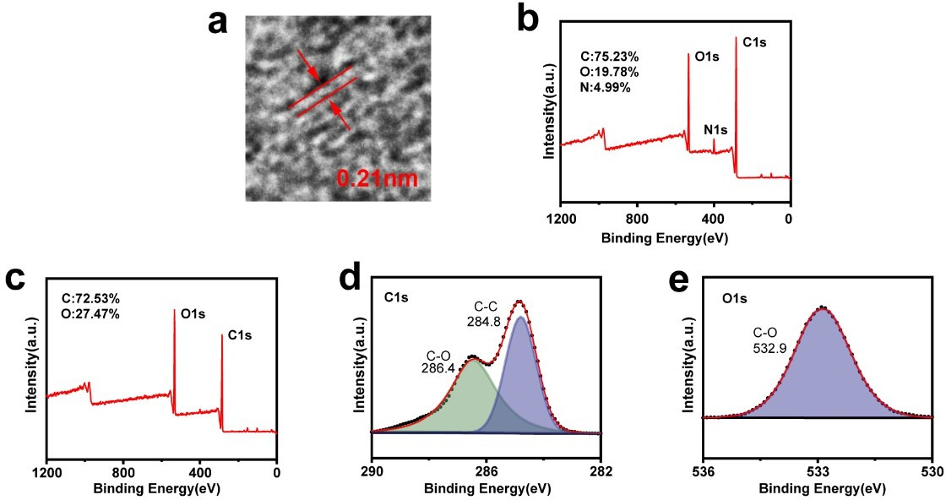

Fig. S1 haracterization of Ginsenoside Rb1 and RBCQDs.(a) HRTEM image of RBCQDs. (b) XPS survey spectrum of RBCQDs. (c-d) XPS survey spectrum (c), C1s peak (d), and O1s peak (e) of ginsenoside Rb1.
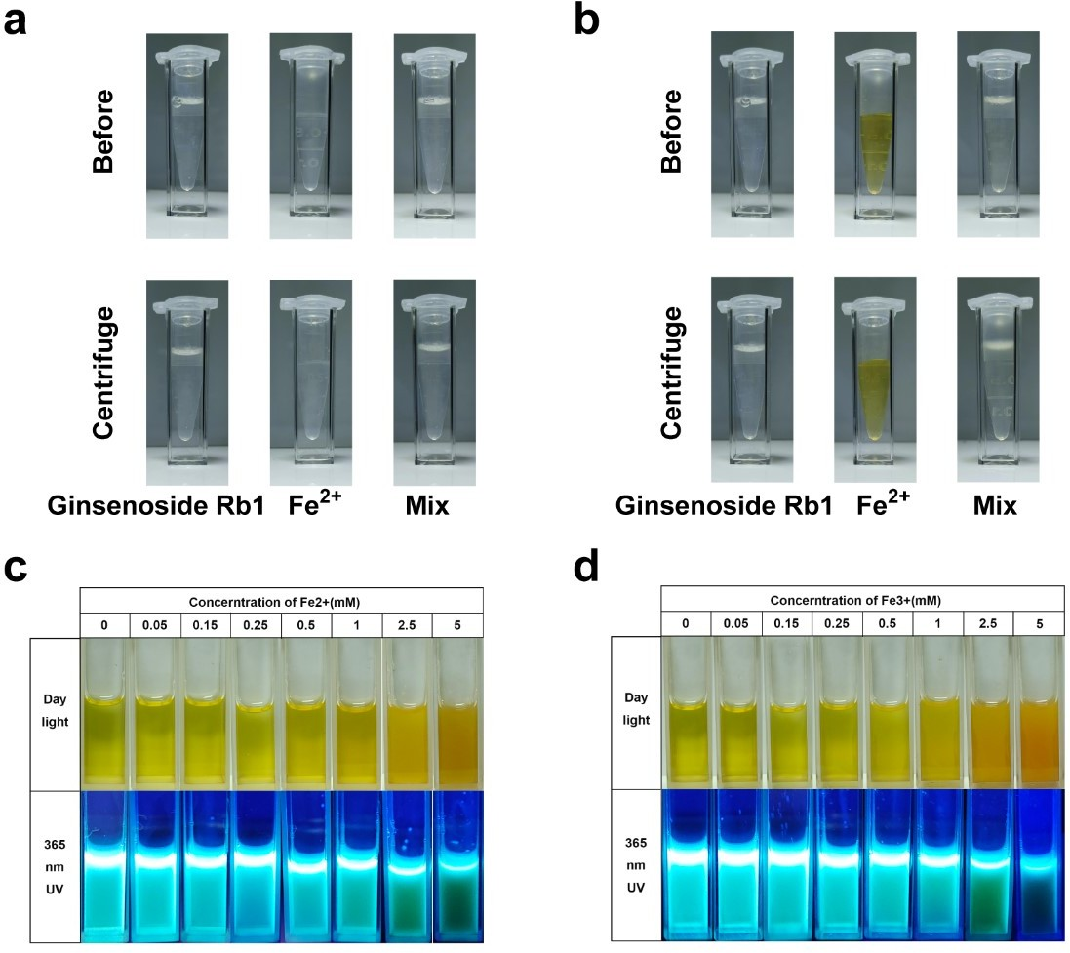

Fig. S2 Chelation of Iron Ions by Ginsenoside Rb1 and RBCQDs.a-b Images before and after mixing ginsenoside Rb1 with Fe2⁺ (a) and Fe3⁺ (b). c-d Bright-field and 365nm UV images after mixing CQDs with different concentrations of Fe2⁺ or Fe3⁺ (c), and images of RBCQDs after reacting with different concentrations of Fe2⁺ (d).

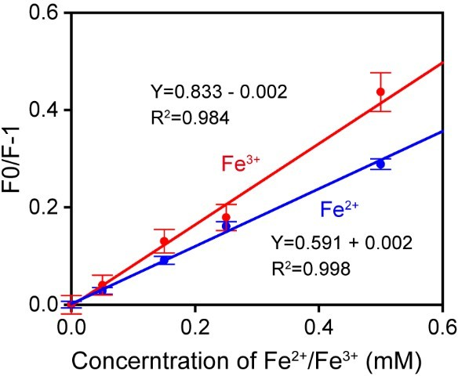

Fig. S3 Stern-Volmer plots of Fe2⁺ and Fe3⁺ on RBCQDs.
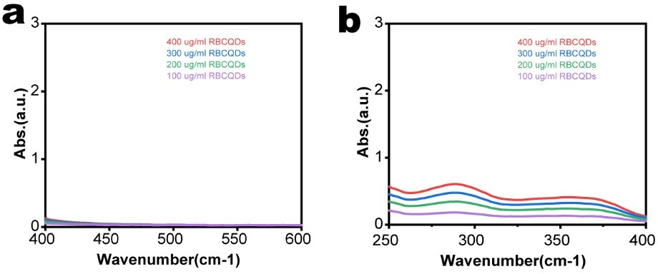

Fig. S4 UV Spectra of RBCQDs at Different Concentrations.

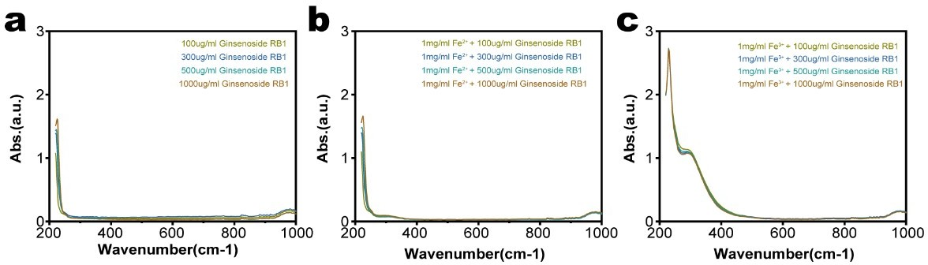

Fig. S5 UV Spectra of Ginsenoside Rb1 Binding to Fe2⁺ or Fe3⁺

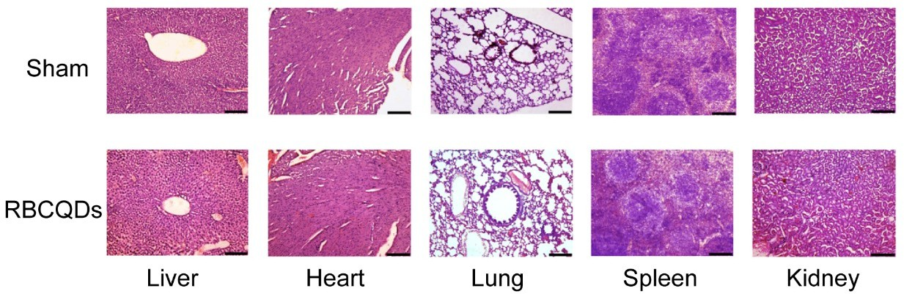

Fig. S6 HE Staining Images of Major Organs in Sham and RBCQDs Groups of Mice.

