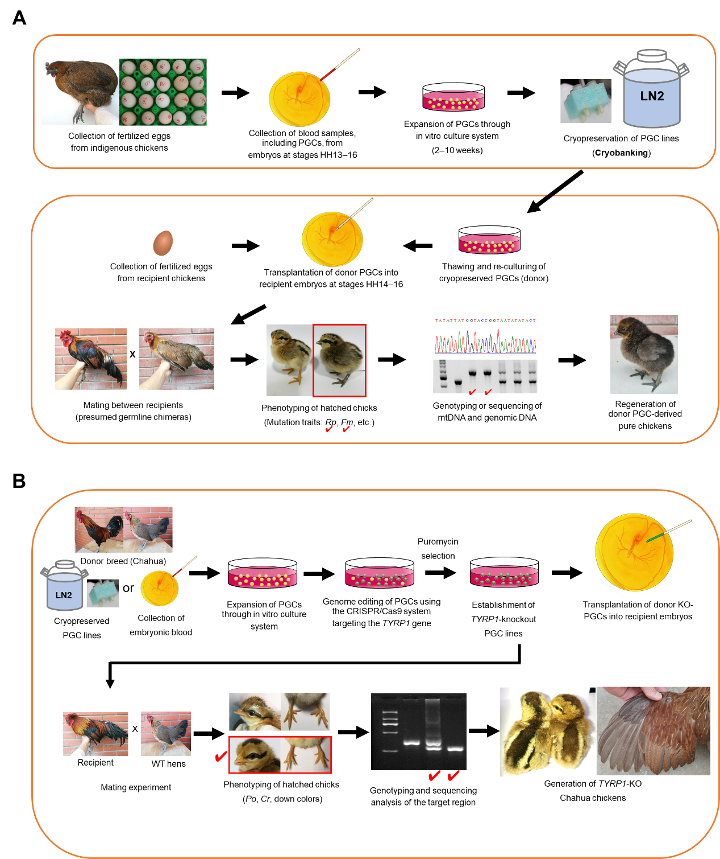

Fig. S1. Overview of primary culture, PGC cryobanking, native chicken regeneration and knockout (KO) chicken generation. (A) Primary culture and PGC cryobanking, donor PGC native chicken regeneration. Freshly fertilized eggs were collected from native chickens and PGC-containing single embryo blood samples were collected at embryonic stages HH13–16. These samples were cultured in vitro for 2–10 weeks and expanded to >100,000 cells. Expanded PGC lines can be cryopreserved in liquid nitrogen. Frozen-thawed PGCs were re-expanded and then transplanted as donor cells into recipient embryos, and recipient chicks were hatched by embryonic culture using surrogate eggshells. Mature male and female recipient chickens were mated to produce donor PGC-derived pure Piao chicks. The hatched chicks were classified by donor-derived mutations (rumplessness, Rp; fibromelanosis, Fm; etc.) and finally, pure Piao chicks derived from male and female donor PGCs were identified by sequencing the mtDNA haplotype and genotypes for the deletion mutation responsible for Rp. (B) Workflow for generation of TYRP1 KO Chahua chickens. CRISPR/Cas9 plasmid vectors containing sgRNAs targeting the TYRP1 gene on chromosome Z were transfected into expanded male Chahua PGCs. By puromycin selection and enrichment of several weeks of culture, TYRP1 KO PGC lines with CRISPR/Cas9-induced mutations were established. The KO PGCs were transplanted into recipient embryos, and KO Chahua chicks were produced by mating mature recipient males with wild-type Chahua females. Chicks without mutant traits (polydactyly, Po; crest, Cr) from recipient males were screened and finally confirmed as TYRP1 KO Chahua chickens by Sanger sequencing and genotyping for mutations within the target region.

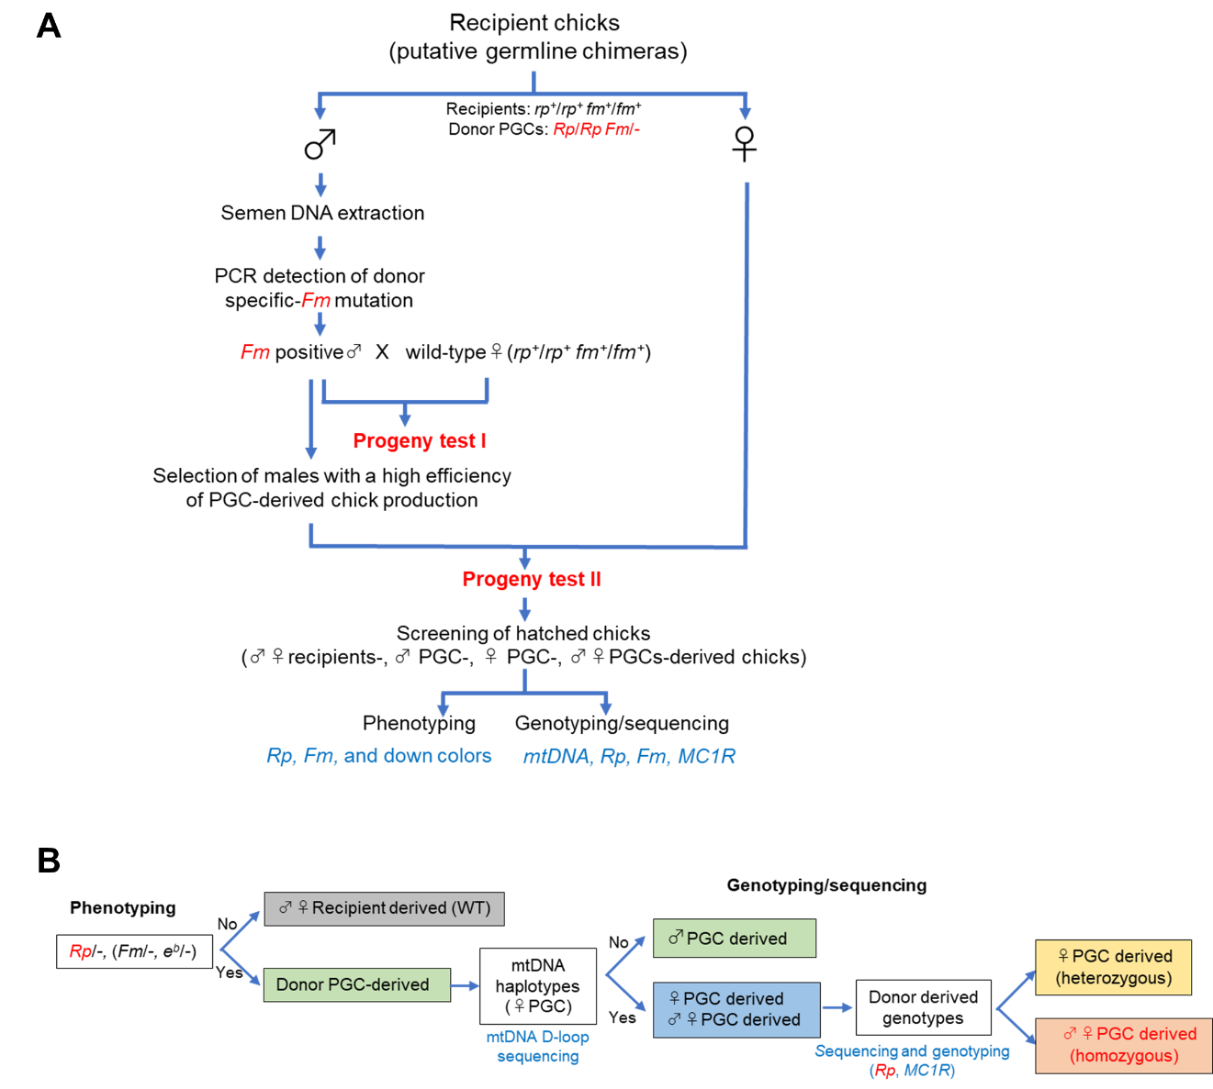
Fig. S2. Overview of regeneration and identification of donor PGC-derived Piao chickens. (A) Flowchart of recipient male selection and classification of donor PGC-derived chicks by progeny testing. First, recipient males (putative germline chimeras) were confirmed to produce donor PGC-derived sperm. A specific fragment of the fibromelanosis (Fm) mutation derived from the donor PGCs was amplified by PCR using semen and blood-derived DNA samples (see Fig. S3). To verify that recipient males can produce donor PGC-derived chicks, Fm-positive recipient males were mated to WT hens in Progeny Test I. Hatched chicks were classified as recipient (WT) or donor PGC-derived based on the presence/absence of donor PGC-derived mutant traits, such as rumplessness (Rp). The high-performing recipient males were selected in Progeny Test I and crossed with recipient females (putative germline chimera) in Progeny Test II to regenerate pure Piao chickens derived from donor PGCs. The hatched chicks were divided into four groups according to the combination of their parents: chicks derived from male and female recipients, chicks derived from male recipient and female PGC, chicks derived from female recipient and male PGC, and chicks derived from both male and female PGC. (B) Classification of chicks in Progeny Test II. Chicks produced from the mating of six recipient females and two recipient males selected in Progeny Test I can be divided into two groups by phenotyping for donor-derived mutations such as rumplessness (Rp): chicks derived from recipient males and females, and chicks derived from donor PGCs. Furthermore, donor PGC-derived chicks can be divided into two groups based on their mtDNA D-loop haplotypes (see Table S4). The first group contains chicks derived from male donor PGCs and female recipient chickens, while the second group contains chicks derived from male recipient chickens and female donor PGCs or chicks derived from both male and female donor PGCs. Finally, the chicks with the mtDNA haplotype from the donor female PGC were classified by molecular analysis for the genotypes of Rp and MC1R (see Fig. 5). The heterozygous chicks were derived from recipient male and donor female PGCs, and the homozygous chicks were pure Piao chicks derived from both male and female donor PGCs.

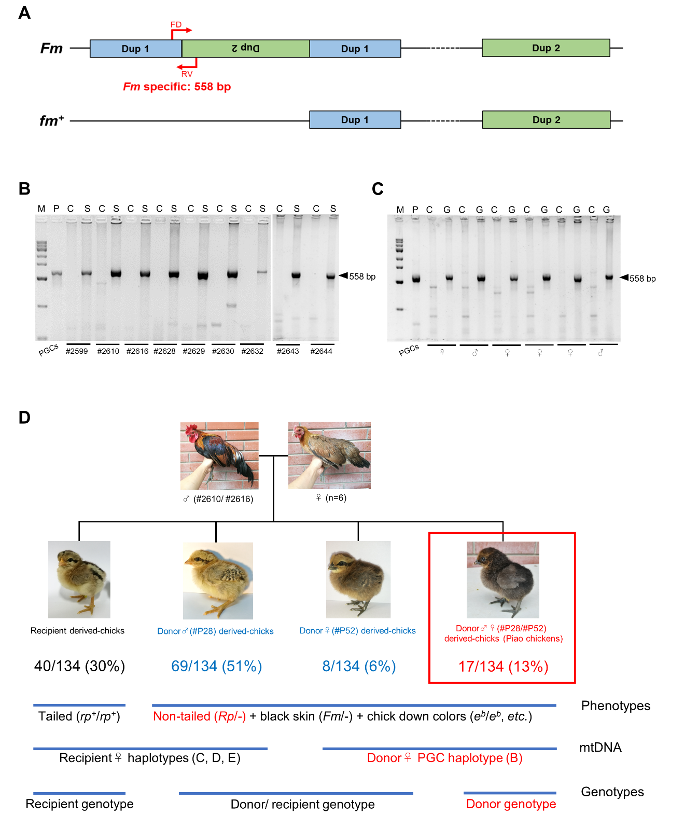
Fig. S3. PCR detection of the fibromelanosis (Fm) mutation from donor Piao PGCs in recipient semen or gonadal tissue. (A) Schematic representation of the Fm and wild-type (WT, fm⁺) alleles. The Fm allele results from an inversion and duplication of chromosome 20 within the EDN3 region [55]. The Fm allele duplicates two different segments of the WT allele. The Fm allele has an additional dup1 (Dup1), represented by the blue box from the WT allele, and an additional inverted dup2 (Dup2), represented by the green box from the WT allele. Primers specific for the Fm allele (FD and RV) were designed to target the Fm allele-specific duplication and the inverted duplication. A 558 bp PCR fragment is amplified only in the presence of the Fm allele. (B–C) PCR-based detection of a 558-bp Fm-specific fragment from donor Piao PGCs in recipient male semen and gonadal tissue or embryos. (B) A 558-bp fragment was detected in all semen-derived (S) DNA samples from 8 recipient males (#2599–#2644). No fragment was detected in the control blood sample (C) from the recipient males. (C) Detection of the Fm-specific 558-bp fragment in gonadal tissues from late-stage male and female embryos. The 558-bp fragment was detected in DNA from both male and female gonadal tissues (G). No fragment was detected in control samples (C) derived from blood or skin tissues. M represents a DNA size marker and P is the positive control DNA from two donor PGCs. (D) Regeneration of PGC-derived pure Piao chickens by recipient parent-only mating (Progeny Test II). Pooled semen from two recipient males (#2610 and #2616) was artificially inseminated into six recipient females, resulting in the production of 134 chicks. Of the 134 hatched individuals, 30% (40/134) were confirmed to be chicks derived from recipient parents, 51% (69/134) were chicks derived from donor male PGC and recipient female, 6% (8/134) were chicks derived from recipient male PGC and donor female PGC, and 13% (17/134) were pure Piao chicks derived from donor male and donor female PGC. These hatched chicks comprise four groups (see Fig. 3B), which are first classified by phenotyping the donor PGC-derived mutations (Rp, Fm, and e^{b}). In addition, three subgroups of donor PGC-derived chicks are classified by mtDNA (D-loop region) haplotypes and by genotypes of Rp and e^{b} mutations using genomic DNA (see Fig. 3, 4, S2).

Table S1. List of primers used for amplification, sequencing, and genotyping.
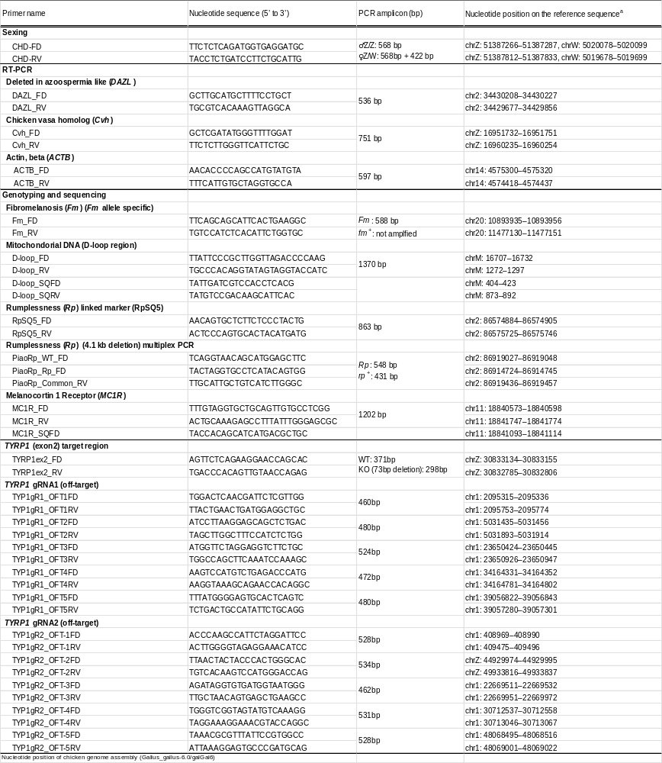

Table S2. Target sequences of four gRNAs in the chicken TYRP1 gene.

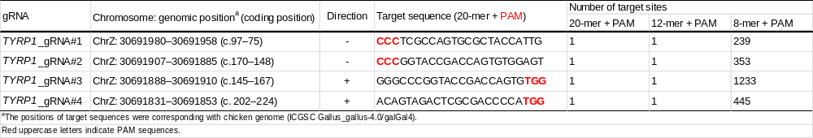

Table S3. Potential off-target analysis in the TYRP1 knockout chickens.
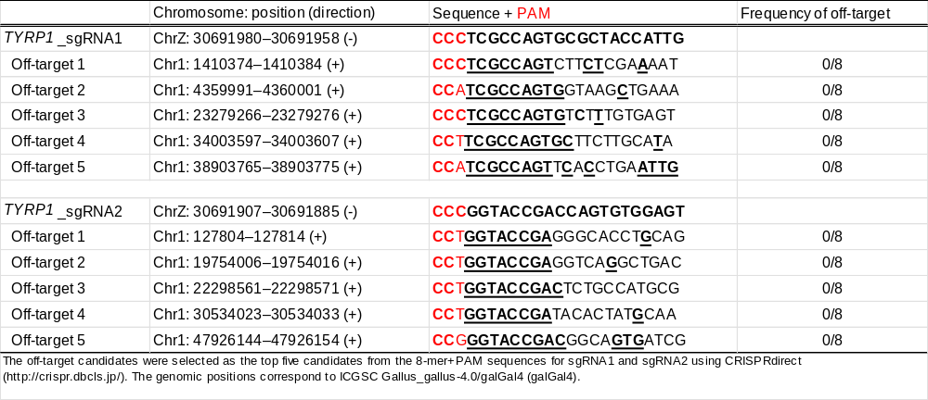

Table S4. Haplotypes of mitochondrial D-loop region of donor Piao PGCs and 8 recipient chickens.

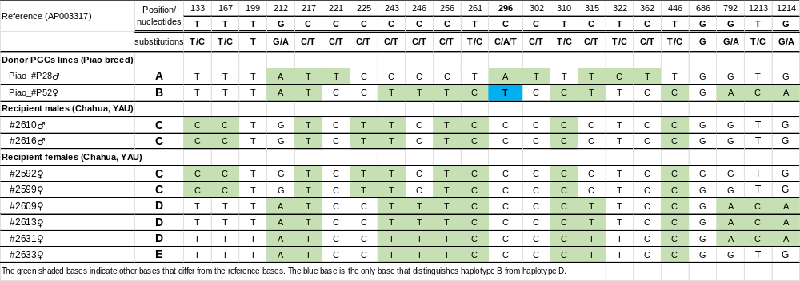

Table S5. Nucleotide polymorphism of MC1R at the E locus for donor PGCs and recipient chickens.

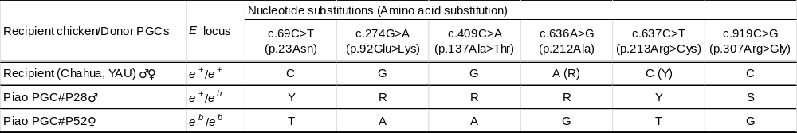

Table S6. Genotypes of phenotypic mutation traits of recipient chickens, donor PGCs, and hatched chicks.
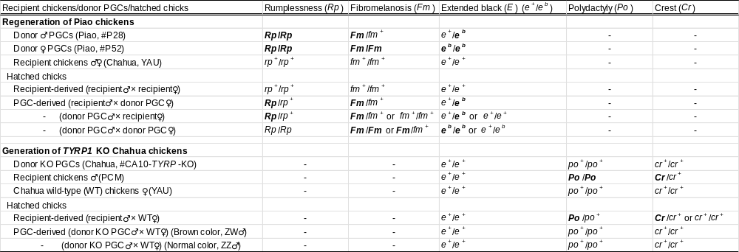

Materials and Methods
Fertilized eggs. Fertilized eggs were collected from four indigenous Chinese chicken breeds (Chahua, Piao, Wuding, and Xichou black bone) and one crossbreed chicken (PCM). These fertilized eggs from Chahua (YAU), Wuding, Xichou black bone and PCM were used in preliminary experiments to confirm the culture conditions. In addition, two native breeds (Chahua and Piao) were used for practical conservation of genetic resources of rare indigenous Chinese chicken breeds based on PGC. Fertilized eggs were collected in four batches from 2020 to 2021 from heritage populations (>1500 chickens/population) maintained at an indigenous chicken genetic stock farm in the Xishuangbanna Autonomous Region, Yunnan Province, China. PCM or Chahua (YAU) fertilized eggs were used as recipients for gonadal migration assays and germline chimera production. Animal care and all experimental procedures were approved by the Animal Care and Use Committee of Yunnan Agricultural University (approval code: YAUACUC01) and were performed in accordance with the Animal Experiment Regulations of Yunnan Agricultural University.
Sexing of samples. PCR-based sexing was performed using primers (CHD1-F and CHD1-R) for the CHD1 genes on chromosomes Z and W (Table S1). Genomic DNA was extracted using QuickExtract DNA Extraction Solution (Lucigen, Co., Middleton, WI, USA) or DNAZOL solution (Molecular Research Center, Cincinnati, USA), followed by PCR amplification in a 10 μL reaction mixture consisting of 1.0 μL template, 0.01 μM of each primer, and 5 μL ES-Taq Master Mix (Tiangen Biotech, Co., Ltd., Beijing, China). The amplicon sizes for CHD1-Z and CHD1-W were 568 bp and 422 bp, respectively.
Immunofluorescence staining. For immunofluorescence analysis, cultured PGCs (1 × 10⁵) were fixed with 4% paraformaldehyde (PFA) at RT for 10 min. After washing with PBS(-), the cells were permeabilized with 0.5% Triton-X100/PBS(-) solution for 5 min at RT. The fixed samples were washed with PBST (PBS(-) with 0.1% Tween 20) and incubated with 10% goat serum/PBST for 15 min at RT. The samples were then incubated overnight at 4 °C with a mouse monoclonal IgM antibody against stage-specific embryonic antigen-1 (SSEA-1) at a dilution of 1:150 (DSHB, IA, USA). The samples were then washed with PBST and incubated with a secondary antibody, Alexa Fluor 594 goat anti-mouse IgM (1:250; Invitrogen, Carlsbad, CA, USA), for 3 h at RT. The samples were then washed with PBS(-) and counterstained with DAPI (Prolong Diamond Antifade Mountant with DAPI, Invitrogen). Imaging was performed with a fluorescence microscope (Axio Vert. A1; Carl Zeiss Meditec AG, Jena, Germany).
RT-PCR. Germ cell-specific gene expression (cDAZL, CVH) was assessed by RT-PCR using cultured PGCs and control cells (CEFs, chicken embryonic fibroblasts). Total RNA was extracted from the cells using TRIzol reagent (Invitrogen), and 1.0 μg of total RNA was reverse transcribed using the PrimeScript RT-PCR Kit (Takara, Otsu, Japan) with oligo dT primers. RT-PCR was performed in a 25 μL reaction containing 25 ng cDNA, 1 × KOD FX buffer, 100 µM dNTPs, 0.75 μL of 10 μM forward and reverse primers (Table S1), and 1 unit of KOD FX DNA polymerase (TOYOBO, Osaka, Japan). PCR cycles included an initial denaturation at 94 °C for 2 min, followed by 35 cycles of 98 °C for 10 sec, 64 °C for 30 sec, and 68 °C for 2 min, with a final extension at 68 °C for 7 min. The PCR products were electrophoresed on a 2.5% agarose gel.
Gonadal migration assay. Chahua PGCs, expanded after cryopreservation in liquid nitrogen, were used as donor cells to assess the migration and colonization ability of cultured PGCs within recipient gonads. These PGCs were labeled with PKH26 GL dye (Sigma) and then microinjected into the dorsal aorta of HH14–16 recipient embryos (Chahua, YAU or PCM) in a volume of 1 µL containing 1,500–4,500 cells. The engineered embryos were cultured to the HH30–32 stage using the surrogate eggshell culture system (System III) [1]. Whole gonads were then collected from the embryos, and PKH26-positive cells were identified by fluorescence microscopy.
Transplantation of donor PGCs into recipient embryos and generation of germline chimeras. Two Piao PGC lines, one male (#P28) and one female (#P52), cryopreserved for three months, were used as donors for transplantation into recipient embryos. These donor PGC lines were expanded and subcultured over a period of weeks to months during their use in transplantation experiments. The two PGC lines were mixed in approximately equal proportions, and a 1 µL volume of medium containing 5,800 to 16,000 cells was microinjected into the dorsal aorta of HH13–16 stage recipient embryos (Chahua, YAU). Most recipient embryos were used after reduction of blood containing endogenous PGCs as described in a previously reported method [2]. These embryos were cultured until hatching using surrogate eggshells as described above. The hatched recipient chicks were reared to sexual maturity. To determine whether the male recipients could produce donor-derived sperm, genomic DNA samples were extracted from semen and blood for detection of the Piao PGC-derived black skin (fibromelanosis, Fm) mutation using PCR. The PCR was performed using a primer pair (Fm_FD and Fm_RV) listed in Table S1, which was specifically designed to target an inverted duplicated region near EDN3 on chromosome 20 that is unique to the Fm mutation, as described by Dorshorst et al. [3] (Fig. S3A). A 588 bp Fm-specific fragment was amplified in a 10 μL reaction volume containing 1.0 μL lysis sample, 0.01 μM of each primer, and 5 μL ES-Taq Master Mix (Tiangen Biotech).
Progeny testing. Two progeny tests, Progeny Test I using male recipients and Progeny Test II using recipients of both sexes, were performed (Fig. S1A and S2). In Progeny Test I, we performed mating between each male recipient and WT hens to assess whether male recipients that tested positive for Fm in sperm could actually produce offspring derived from donor PGCs (Fig. S1A). In Progeny Test II, we mated two recipient males with high efficiency in producing donor-derived offspring with six recipient females to regenerate the original PGC-derived Piao chickens (Fig. S1A and S2).
In both progeny tests, we distinguished donor PGC-derived chicks from recipient-derived chicks by phenotypic observations (Table S6). Because both donor Piao PGCs were homozygous for the autosomal dominant rumplessness (Rp) mutation, which is characterized by the absence of free caudal vertebrae and uropygial glands, the donor PGC-derived chicks lacked tails (Rp/rp⁺), whereas recipient-derived chicks had normal tails (rp⁺/rp⁺). In addition, Piao donor PGCs had black skin (Fm/-) and a brown chick-down color (e^{b} allele at the E locus, MC1R) mutations in at least one dose. Therefore, in some cases, we also used Fm and E mutations as phenotypic markers to identify donor PGC-derived chicks.
In Progeny Test II, because the donor PGC-derived chicks identified by phenotypic observation were expected to be a mixture of three groups (male PGC-derived, female PGC-derived, and both PGC-derived chicks), we further classified them using Sanger sequencing and PCR genotyping with mitochondrial DNA and genomic DNA. First, we categorized the three groups into two groups, male PGC-derived chicks and female or both PGC-derived chicks, based on the sequence haplotypes of the D-loop region (1370 bp) in mitochondrial DNA (mtDNA) (Table S1). Subsequently, chicks from the female or both donor PGCs were further classified by Sanger sequencing of markers strongly associated with the Rp mutation and genotyping of the Rp causative mutation. Initially, since the causative mutation of Rp had not been identified, we used a sequencing marker (RpSQ5: 863 bp) that could discriminate between donor and recipient genotypes from three linkage markers designed within the Rp candidate region located between the IRX1 and IRX2 genes on chromosome 2 reported by Freese et al. [4]. Since the causative mutation of Rp in Piao chickens was later identified as a 4.1 kb deletion located upstream of the IRX1 gene by Zhang et al. [5], we genotyped the donor-derived chicks with newly designed PCR-based genotyping markers based on this information. The primers used for PCR amplification/sequencing are listed in Table S1.
Transplantation of TYRP1-KO PGCs into recipients. A total of 3,500–5,000 TYRP1-KO PGC cells were microinjected into the dorsal aorta of HH13–16 Chahua (YAU) recipient embryos using the protocol described above. These recipient embryos were then transferred to the System III shell of surrogate eggshell culture systems and incubated at 37.8 °C until hatching.
Progeny testing and screening of TYRP1 KO chickens. Hatched recipient chicks that were transplanted with a donor TYRP1 KO Chahua PGC line (#CA10-TYRP1-KO) were reared to sexual maturity. The putative germline chimeric males were then mated with wild-type Chahua (YAU) hens. The differentiation between chicks derived from donor KO PGCs and those from recipients was based on their phenotypic characteristics. Specifically, the recipient PCM males were homozygous for the polydactyly (Po) mutation, resulting in the formation of an extra digit on the feet. In contrast, the donor Chahua PGCs and the mating Chahua females were normal, without polydactyly (po⁺/po⁺) (Fig. S1B and Table S6). Consequently, chicks with normal digits (po⁺/po⁺) were expected to be the offspring of donor KO PGCs, while those with an extra digit (Po/po⁺) were determined to be the offspring of recipient males. In addition, since TYRP1 is a sex-linked gene located on the Z chromosome, we expected that female chicks (Z^{TYRP1-}/W) with the TYRP1 mutation would have reduced eumelanin in their chick-down color compared to that in wild-type chicks. In contrast, male chicks (Z⁺/Z^{TYRP1-}) with the TYRP1 mutation were expected to have the typical Chahua (wild-type) chick-down color. These phenotypes were finally confirmed by PCR-based genotyping and sequence analysis of the target region. The PCR fragment containing the two target sites was amplified and sequenced using the primer pair listed in Table S1.
Off-target analysis. We selected four highly specific sgRNA sequences (sgRNA#1–#4) targeting TYRP1 exon 2 using CRISPRdirect (http://crispr.dbcls.jp/) based on the genome database (ICGSC Gallus_gallus-4.0/galGal4) (Table S2). These sequences did not have any off-target candidates in the 12-mer and 20-mer+PAM motif (NGG) regions. However, as a precaution, we also searched for potential off-target sequences for TYRP1-sgRNA#1 and -#2 using the updated genome databases Cas-OFFinder (http://www.rgenome.net/cas-offinder/) (Galgal5) and Ensembl Database (http://www.ensembl.org/index.html) (Galgal6). No off-target candidates were found in either database. Nevertheless, we selected five candidates from each of the 8-mer + PAM motif regions using CRISPRdirect (Table S3). PCR products were amplified from the genomic DNA of KO PGCs (#CA10-TYRP1-KO) using the primers listed in Table S1, and eight TA clones each were sequenced by the Sanger method.

References

1. Perry, M.M., A complete culture system for the chick embryo. Nature, 1988. 331(6151): p. 70-2.
2. Naito, M., et al., Production of germline chimeric chickens, with high transmission rate of donor-derived gametes, produced by transfer of primordial germ cells. Mol Reprod Dev, 1994. 39(2): p. 153-61.
3. Dorshorst, B., et al., A complex genomic rearrangement involving the endothelin 3 locus causes dermal hyperpigmentation in the chicken. PLoS Genet, 2011. 7(12): p. e1002412.
4. Freese, N.H., et al., A novel gain-of-function mutation of the proneural IRX1 and IRX2 genes disrupts axis elongation in the Araucana rumpless chicken. PLoS One, 2014. 9(11): p. e112364.
5. Zhang, J., et al., A ∼ 4.1 kb deletion in IRX1 gene upstream is completely associated with rumplessness in Piao chicken. Genomics, 2022. 114(6): p. 110515.

