Supporting Information

Ligand-functionalized Anderson-type Polyoxometalate for Efficient Selective Cationic Dye Adsorption

Hongji Kang,^{aǂ} Lili Yang,^{bǂ} Yuqi Liu,ª Ke Su,^{b} Hao Zhang,ª Xiaoxue Huang,ª Lu Yangª*

[a] Shandong University of Technology, School of Chemistry and Chemical Engineering, Zibo, 255000, P. R. China.
[b] Shangqiu Product Quality Inspection and Research Center, Shangqiu, 476000, P. R. China.

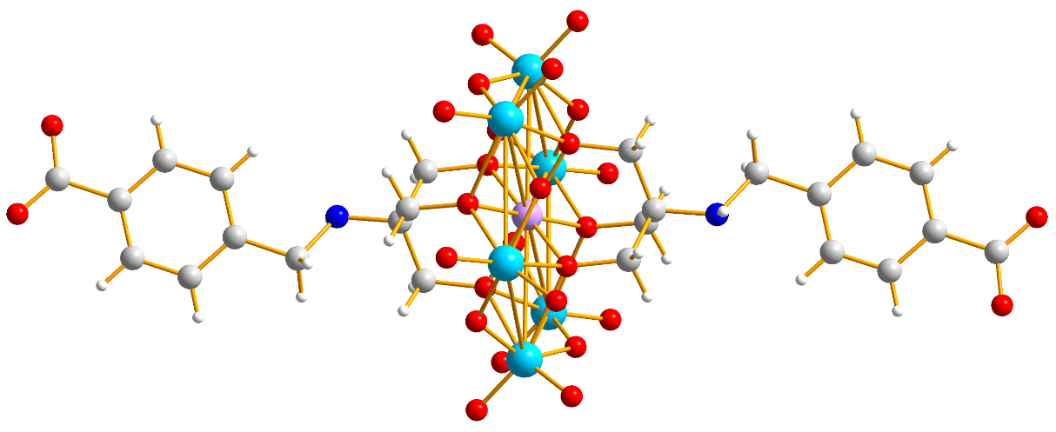
(a)

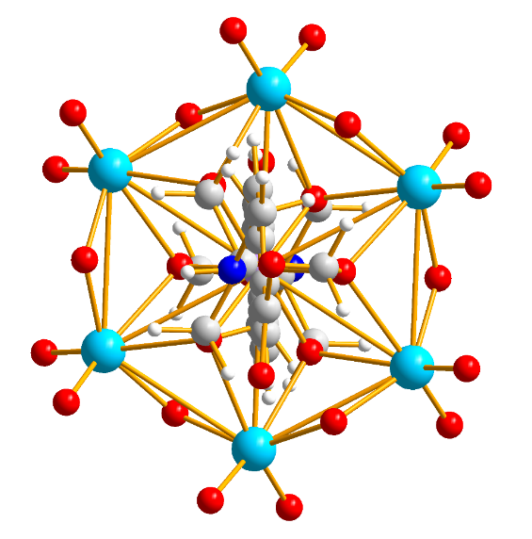
(b)

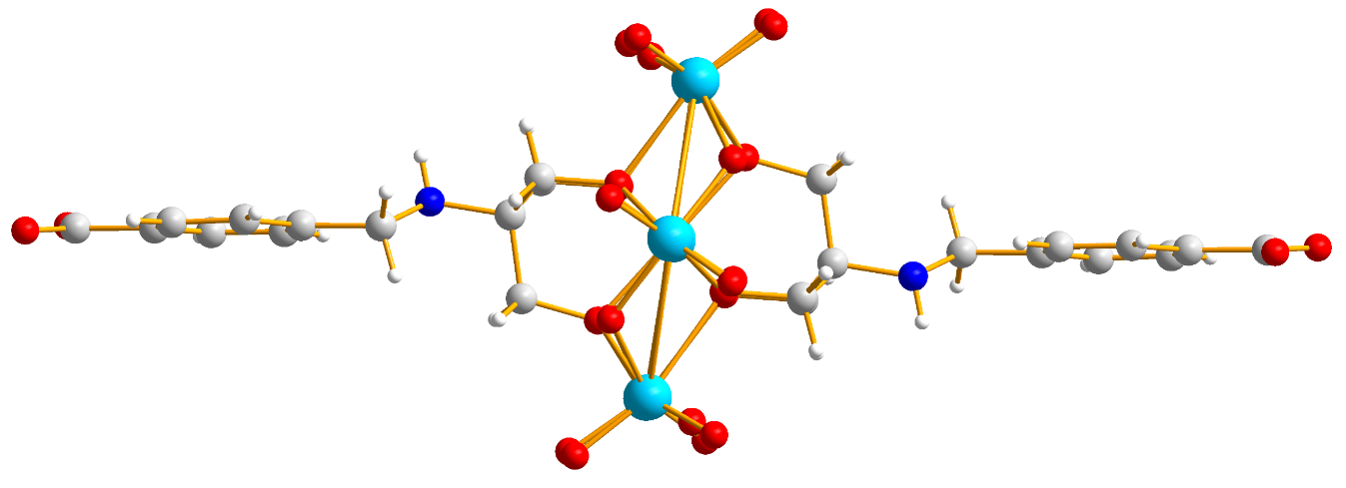
(c)

Figure S1. Front, side, and top views of the POM-1 structure.
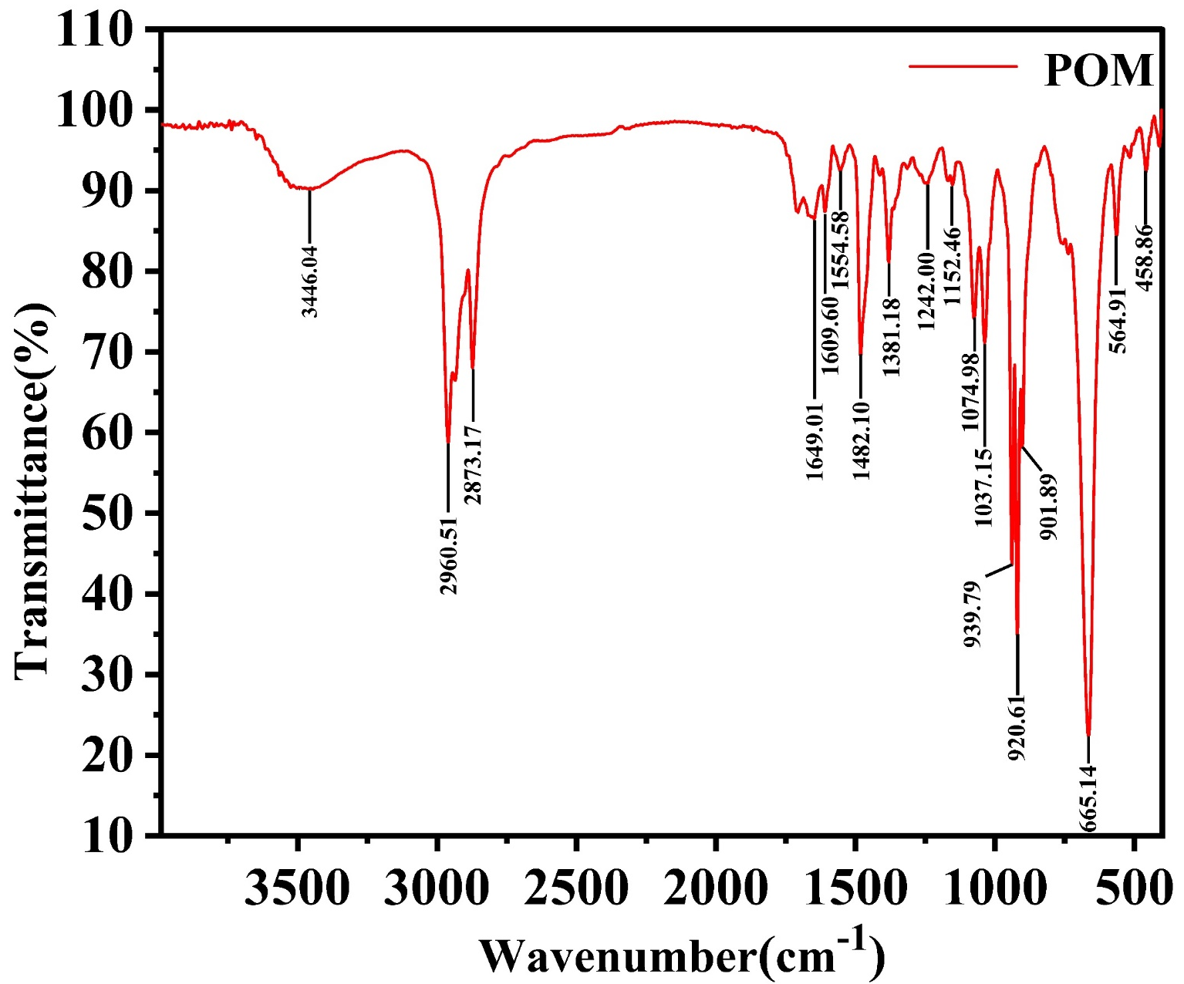
Figure S2. FT-IR spectrum of POM-1.

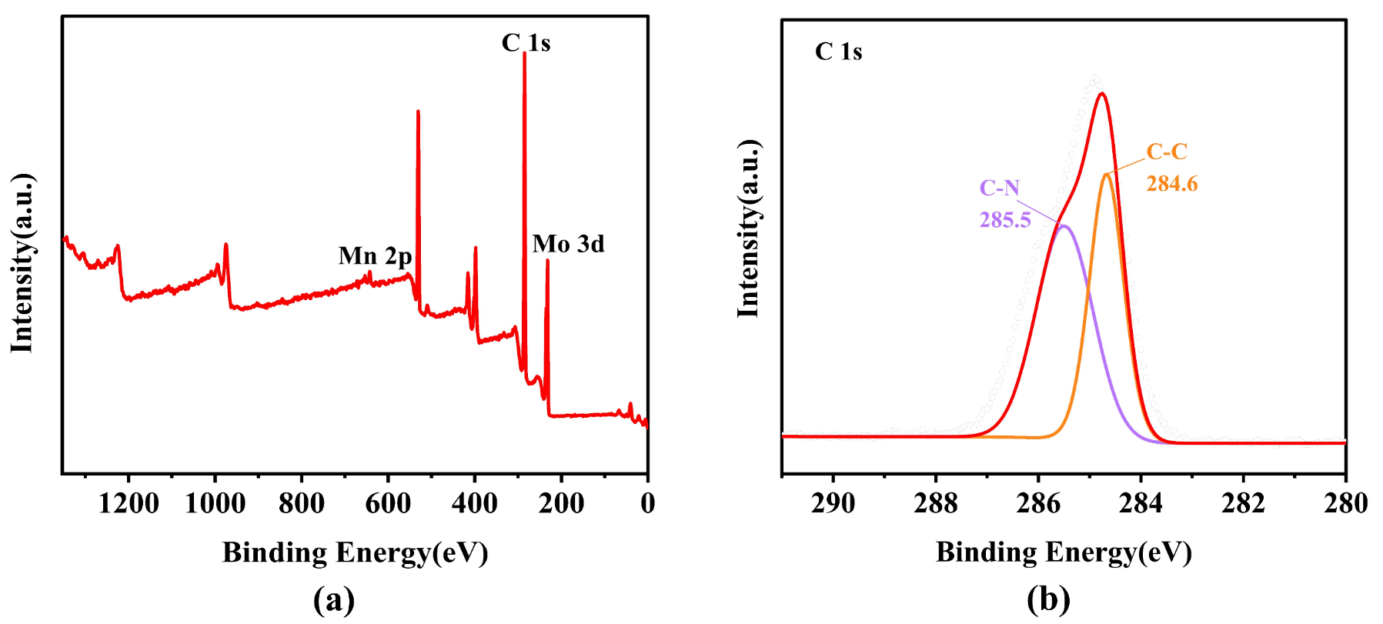
Figure S3. (a) XPS survey spectrum of POM-1; (b) C 1s XPS spectrum of POM-1.

Table S1. The structural formulas of used organic dyes.

 | Structure | Size | Charge
MB |  | 7.3339 Å | +1
Rh6G |  | 8.5652 Å | +1
MO |  | 8.6609 Å | -1

