Supplementary information

Table S1. Composition of stock solutions for media preparation
Stock solution | Substance | Concentration
MS macrosalts | NH₄NO₃ | 33 g/l
MS macrosalts | KNO₃ | 38 g/l
MS macrosalts | KH₂PO₄ | 3.4 g/l
MS macrosalts | MgSO₄×7H₂O | 7.4 g/l
L7 macrosalts | NH₄NO₃ | 33 g/l
L7 macrosalts | Ca(NO₃)₂ ×4H₂O | 8.8 g/l
L7 macrosalts | KH₂PO₄ | 3.4 g/l
L7 macrosalts | MgHPO₄×3H₂O | 7.4 g/l
L7 macrosalts | K₂SO₄ | 38 g/l
Calcium | CaCl₂ | 6.6 g/l
Iron chelate | FeSO₄×7H₂O | 5.58 g/l
Iron chelate | Na₂ЭДТА | 7.46 g/l
microsalts | H₃BO₃ | 6.2 g/l
microsalts | MnSO₄×4H₂O | 22 g/l
microsalts | ZnCl₂ | 8.6 g/l
microsalts | KI | 830 mg/l
microsalts | CuSO₄×2H₂O | 25 mg/l
microsalts | CoCl₂×6H₂O | 25 mg/l
microsalts | Na₂(MoO₄)₂×H₂O | 250 mg/l
microsalts | FeCl₃*6H₂O | 27.8 g/l
Vitamins | Thiamine hydrochloride | 0.1 mg/ml
Vitamins | Pyridoxine hydrochloride | 0.5 mg/ml
Vitamins | Niacin | 0.5 mg/ml
Inositol | Myo-inositol | 20 mg/ml
Amino acids | Glutamine | 18,75 g/l
Amino acids | Proline | 3,75 g/l
Amino acids | Asparagine | 2,5 g/l

Table S2. Nutrient medium for transformation.
Stock solution | Quantity for preparing 1 liter of medium
MS macrosalts | 50 ml
Саlcium | 40 ml
Iron chelate | 10 ml
Microsalts | 1 ml
Vitamins | 1 ml
Inositol | 1 ml
Glutamine | 20 ml
MES | 1,95 g
D-Glucose | 10 g
D-Maltose | 40 g
Acetoseringone | 100 mM

Table S3. Co-culture medium
Stock solution | Quantity for preparing 1 liter of medium
MS macrosalt | 50 ml
Саlcium | 40 ml
Iron chelate | 10 ml
Microsalts | 1 ml
Vitamins | 1 ml
Inositol | 1 ml
Glutamine | 20 ml
MES | 0.5 g
D-Glucose | 10 g
D-Maltose | 40 g
Agar | 5 g
Acetoseringone | 100 mM

Table S4. Callus induction medium
Stock solution | Quantity for preparing 1 liter of medium
MS macrosalt | 50 ml
Саlcium | 40 ml
Iron chelate | 10 ml
Microsalts | 1 ml
Vitamins | 1 ml
Inositol | 1 ml
3АА (Amino acids) | 20 ml
MES | 1,95 g
Sucrose | 30 g
Agar | 5 g
2.4 - D | 2 mg/ml
IAA | 0.5 mg/ml
BASTA | 5 mg/ml
Cefotaxime | 400 mg/ml

Table S5. Regeneration medium
Stock solution | Quantity for preparing 1 liter of medium
MS macrosalt | 50 ml
Саlcium | 50 ml
Iron chelate | 10 ml
Microsalts | 1 ml
Vitamins | 5 ml
Inositol | 5 ml
3АА (Amino acids) | 20 ml
MES | 0.5 g
D-Maltose | 60 g
Agar | 5 g
BASTA | 5 mg/l
Cefotaxime | 500 mg/l

Table S6. Rooting medium
Stock solution | Quantity for preparing 1 liter of medium
MS macrosalt | 50 ml
Саlcium | 50 ml
Iron chelate | 10 ml
Microsalts | 1 ml
Vitamins | 5 ml
Inositol | 5 ml
3АА (Amino acids) | 20 ml
MES | 0.5 g
D-Maltose | 60 g
Agar | 5 g
IAA | 0.5 mg/l
BASTA | 5 mg/l

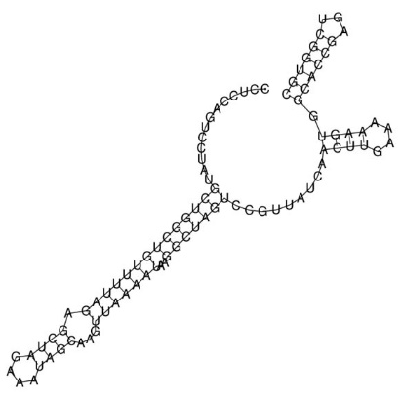
Fig. S1. Structure of gRNA with spacer sequence CER_1078 CCTCCAGTCCTATGCTGGCT, taken from the RNAfold website.

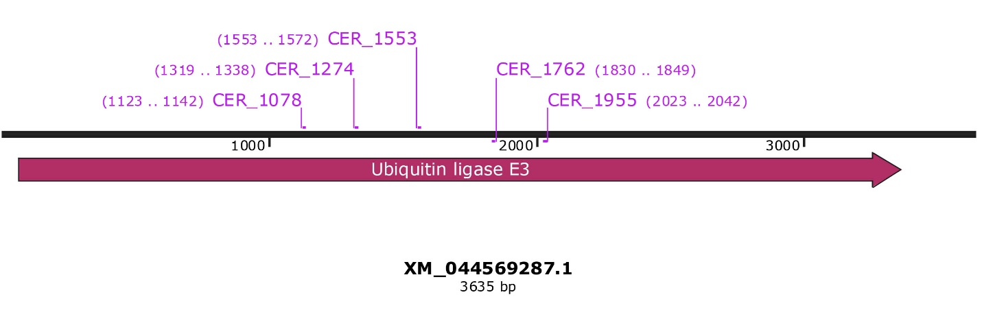
Fig. S2. Location of designed 5 gRNAs on the CER9/SUD1 gene.

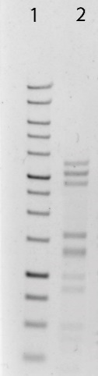
Fig. S3. Electropherogram of pMOD_B2103 plasmid digesting with BanI restriction enzyme. 1 – 1 kb DNA Ladder.

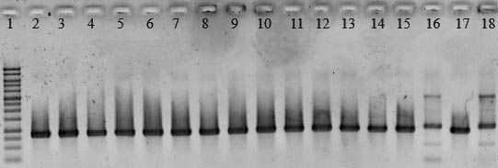
Fig. S4. Electropherogram of PCR pMOD_B2103 plasmid with primers TC089R and TC320. 1 – 1 kb DNA Ladder, 2-18 – bacterial samples. The estimated amplicon length (765 bp) coincides in samples 2-15, 17.

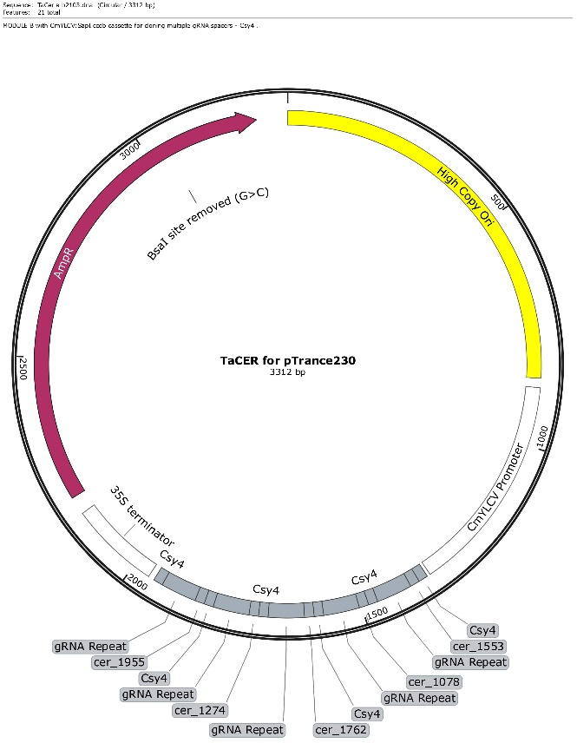
Fig. S5. Map of pMOD_B2103 plasmid with integrated gRNAs.

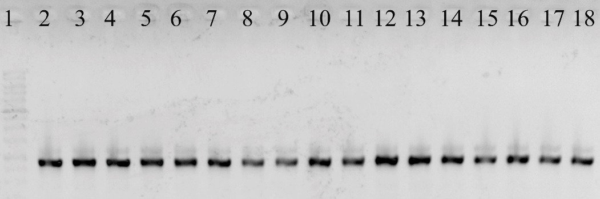
Fig. S6. Electropherogram of PCR of pTRANS_230 plasmid with primers NB463 and GFPF. 1 – 1 kb DNA Ladder, 2-18 – bacterial samples. Amplicon size 772 bp.

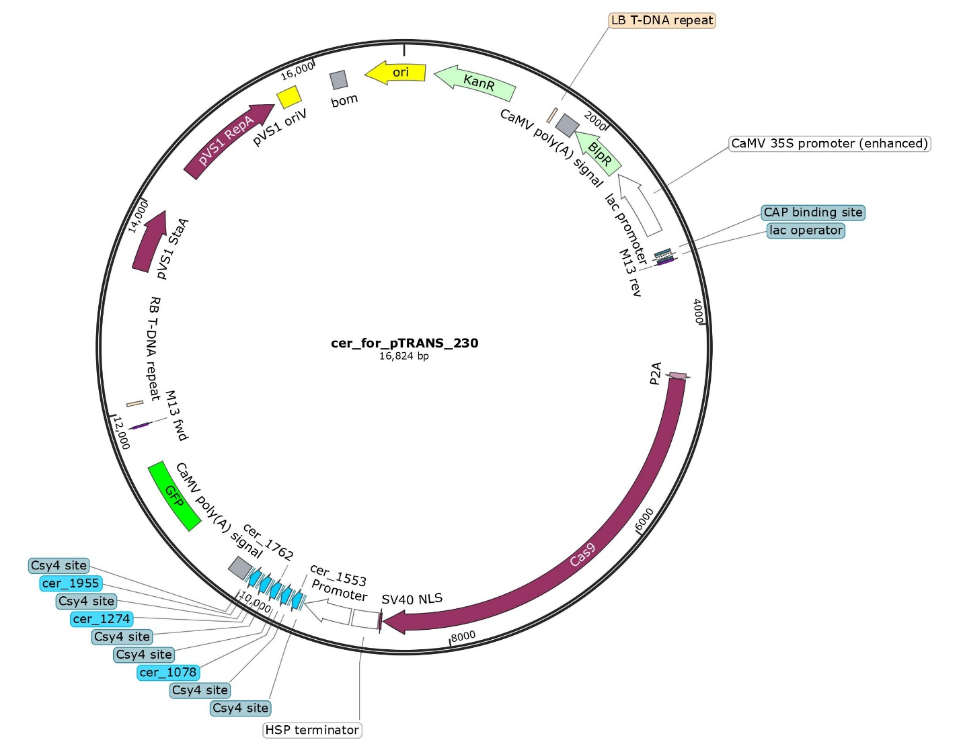
Fig. S7. Map of pTRANS_230 plasmid with built-in modules.

