Supplementary Materials for
Glutamine Deprivation Suppresses Lung Cancer Metastasis via Inducing the Activation of ZAKα and Translation Inhibition

Yinrui Lei^{1,}*,Huiyun Lin¹, Peiyan Liu¹, Fang Guo^{1,}*

*Corresponding authors
Correspondence to Fang Guo (fguo@sjtu.edu.cn) or Yinrui Lei (yrlei@sjtu.edu.cn).

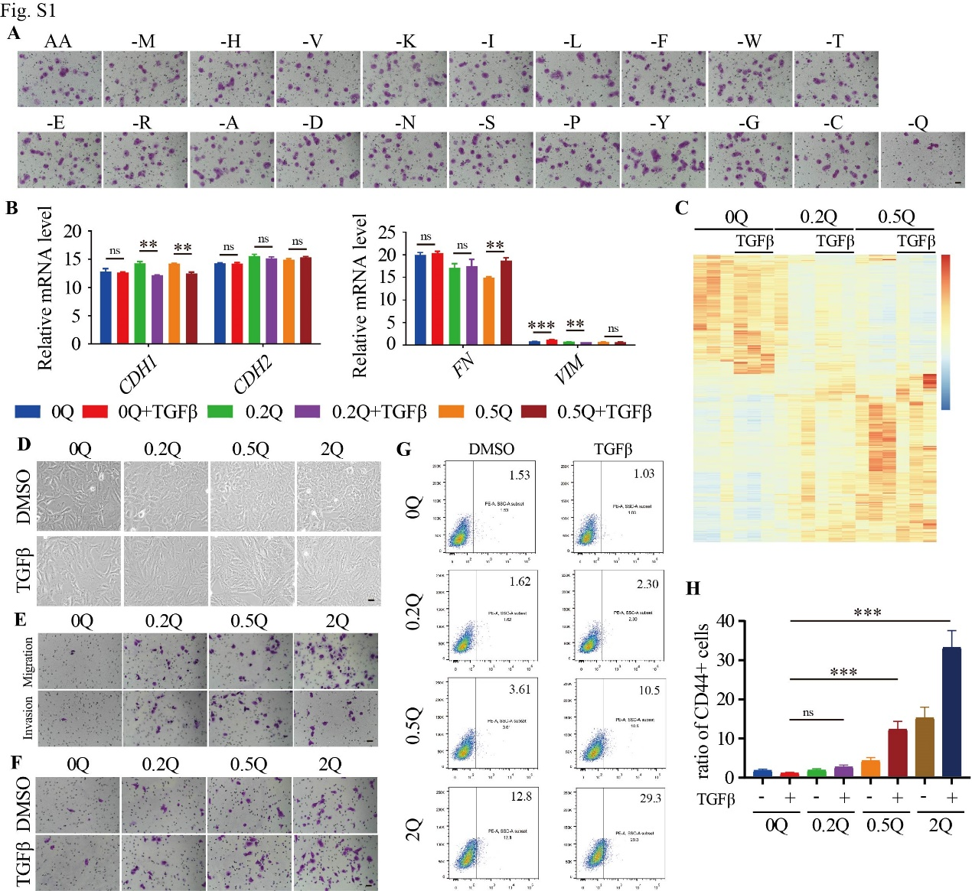

Fig. S1: Glutamine limitation suppresses lung cancer cell metastasis.
A Transwell of H1299 cells under normal or every basic amino acid deprivation conditions.
B Real-time PCR of the indicated genes in LU65 cells under 0, 0.2 or 0.5 mM glutamine, treated with or without 2 ng/μL TGFβ.
C Heatmap of RNA-seq data of A549 cells under different concentrations (0, 0.2 or 0.5 mM) of glutamine, with or without 2 ng/μL TGFβ.
D The morphology of A549 cells under 0, 0.2, 0.5 or 2 mM glutamine, treated with 2 ng/μL TGFβ or not.
E Migration and invasion of the glutamine free medium-cultured A549 cells (20,000 cells) under concentration gradients (0, 0.2 or 0.5 mM) of glutamine.
F Migration of A549 cells (20,000 cells) under 0, 0.2, 0.5 or 2 mM glutamine, treated with or without 2ng/μL TGFβ.
G FACS analysis of cell surface CD44 expression of A549 cells under 0, 0.2, 0.5 or 2 mM glutamine, treated with 2 ng/μL TGFβ or not.
H Quantification of the FACS of cell surface CD44 expression under the indicated treatment.

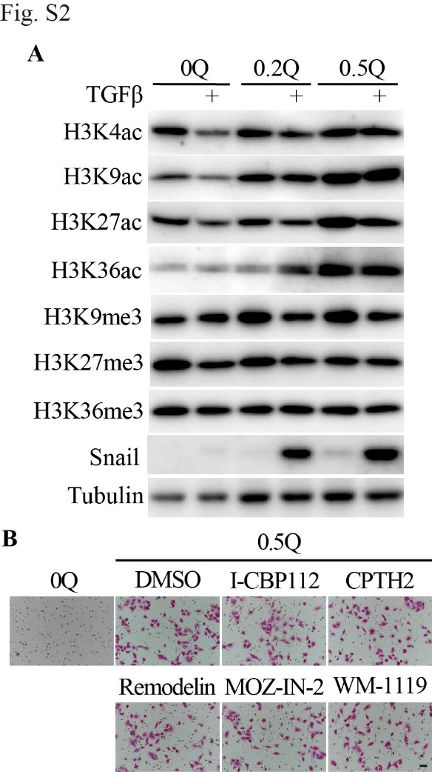

Fig. S2: Acetylation is dispensable for the migration of lung cancer cells.
A Immunoblots of the acetylation of H3K4/K9/K27/K36 and trimethylation of H3K9/K27/K36 in A549 cells under 0, 0.2 or 0.5 mM glutamine, treated with 2 ng/μL TGFβ or not.
B Migration of A549 cells under 0.5 mM glutamine, added 10 μM I-CBP112, 100 μM CPTH2, 50 μM Remodelin, 200 μM MOZ-IN-2 or 10 μM WM-1119.

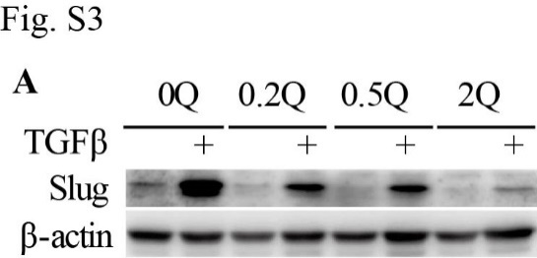

Fig. S3: Glutamine deprivation promotes the expression of Slug.
A Immunoblots of Slug in A549 cells under 0, 0.2, 0.5 or 2 mM glutamine, treated with or without 2 ng/μL TGFβ.

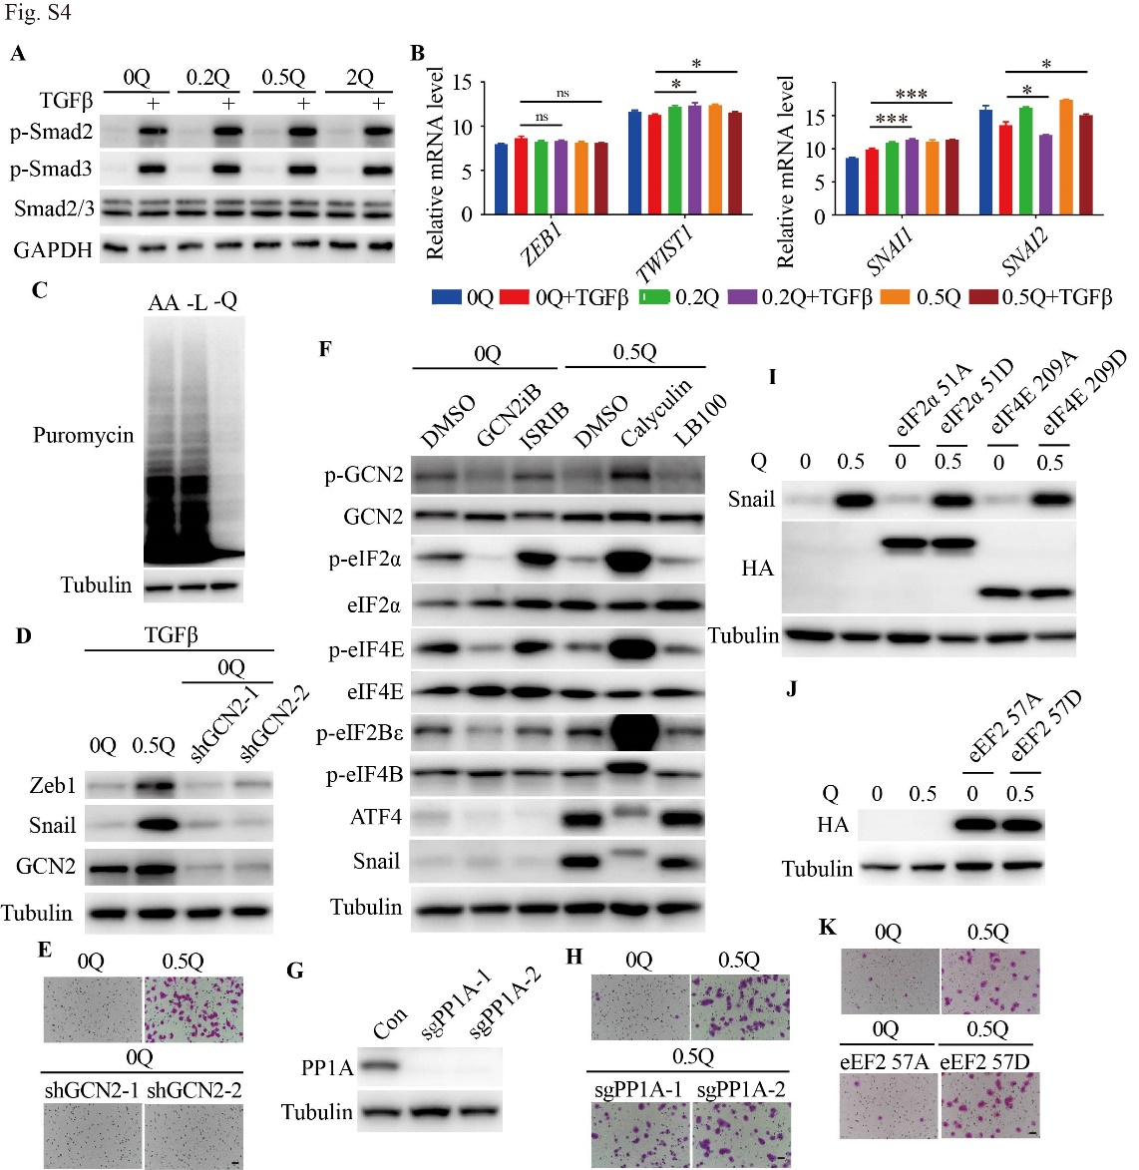

Fig. S4: Glutamine promotes metastasis of A549 cells via enhancing the translation of Zeb1 and Snail.
A Immunoblots for the phosphorylation of Smad2 and Smad3 in LU65 cells under 0, 0.2, 0.5 or 2 mM glutamine, treated with or without 2 ng/μL TGFβ.
B Real-time PCR of the indicated genes in LU65 cells under 0, 0.2 or 0.5 mM glutamine, treated with or without 2 ng/μL TGFβ.
C Western blots for puromycin of LU65 cells after 20 min 10 ng/μL puromycin treatment, following 2 hr Leu or Gln limitation.
D Representative immunoblots of Zeb1 and Snail in control shRNA or two GCN2 shRNA stably expressing A549 cells under glutamine limitation with 2 ng/μL TGFβ treatment.
E Transwell of A549 cells stably expressing control shRNA or two GCN2 shRNA during Gln limitation.
F Immunoblots for ATF4, Snail and the phosphorylation of GCN2, eIF2α, eIF4E, eIF2Bε and eIF4B in A549 cells under Gln limitation with 5 μM GCN2Bi or 2 μM ISRIB treatment or under 0.5 mM glutamine with 2 μM Calyculin or 2 μM LB100 treatment.
G Representative immunoblots for PP1A in two PP1A sgRNA KO A549 cells.
H Transwell of PP1A KO A549 cells under 0.5 mM Gln.
I Western blots for the HA and Snail in A549 cells stably expressing eIF2α 51A or eIF4E 209A during Gln limitation or eIF2α 51D or eIF4E 209D under 0.5 mM Gln.
J Immunoblots for the HA in LU65 cells stably expressing eEF2 57A or eEF2 57D.
K Transwell of LU65 cells stably expressing eEF2 57A during Gln limitation or eEF2 57D under 0.5 mM Gln.

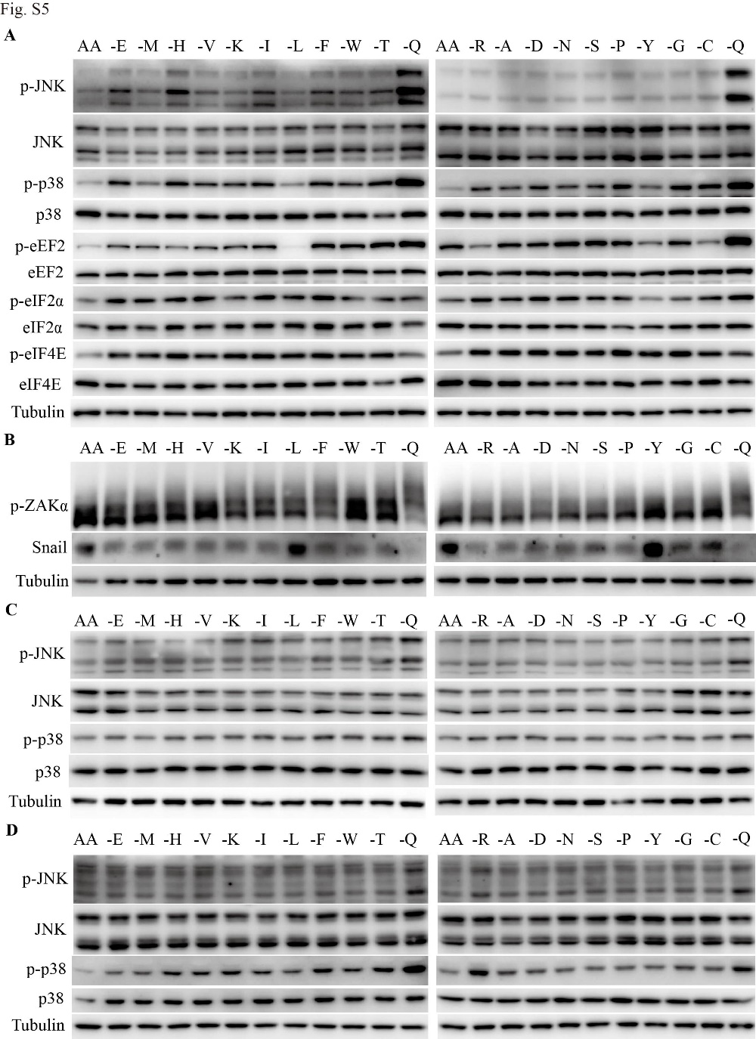

Fig. S5: Glutamine deprivation dramatically activates ZAKα.
A Representative immunoblots for the phosphorylation of JNK, p38, eEF2, eIF2α and eIF4E in LU65 cells under2 hr every basic amino acid limitation.
B Representative immunoblots for the phosphorylation of ZAKα by phosphor-tag gel and Snail in A549 cells under 2 hr every basic amino acid depletion conditions.
C and D Immunoblots for the phosphorylation of JNK and p38 in H1299 cells (C) and H460 cells (D) during 2 hr every basic amino acid withdrawn.

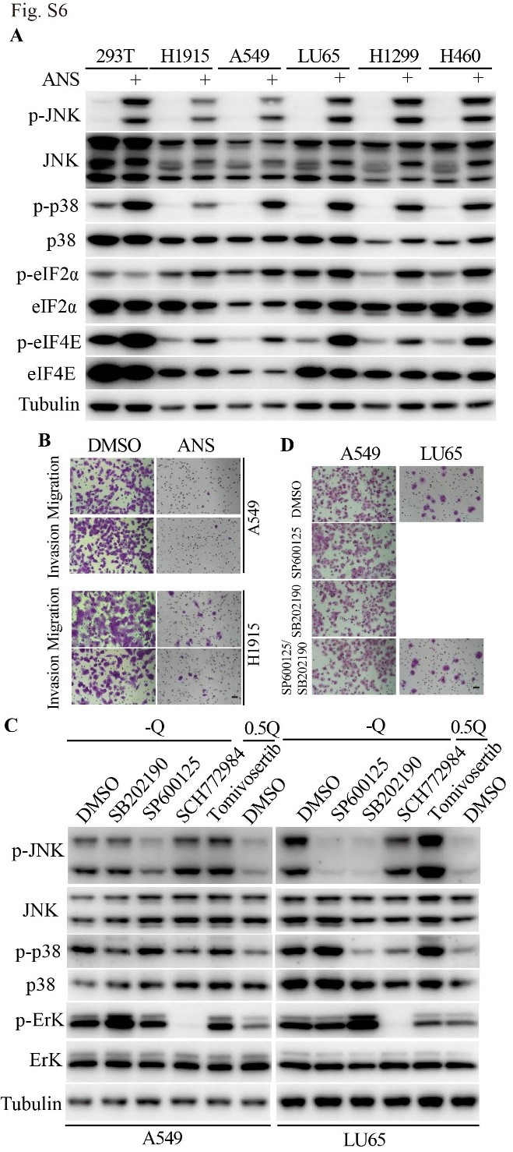

Fig. S6: Ribosome collision inhibits tumor cell migration independent of JNK or p38 activation.
A Immunoblots for the phosphorylation of JNK, p38, eIF2α and eIF4E in the indicated cells treated with 5 μM anisomycin.
B Transwell of A549 cells and H1915 cells treated with 5 μM anisomycin under 0.5 mM glutamine.
C Representative western blots for the phosphorylation of JNK, p38, and ErK in A549 cells and LU65 cells treated with 2 μM SB202190, SP600125, SCH772984 or Tomivosertib.
D Transwell of A549 cells and LU65 cells treated with the indicated drugs under 0.5 mM glutamine.

