Supplementary Information

Transcriptome and metabolome analysis reveals mechanism of light intensity modulating iridoid biosynthesis in Gentiana macrophylla Pall.

Huanhuan Fu ¹, Yaomin Wang ¹, Fakai Mi ², Li Wang ¹, Ye Yang ¹, Fang Wang ¹, Zhenggang Yue ^{1,2*}, Yihan He ^{1*}

¹ State Key Laboratory of Research & Development of Characteristic Qin Medicine Resources (Cultivation), Co-construction Collaborative Innovation Center for Chinese Medicinal Resources Industrialization by Shaanxi & Education Ministry, Shaanxi Innovative Drug Research Center, School of Pharmacy, Shaanxi University of Chinese Medicine, Xianyang 712046, P.R. China
² College of Life Science, Qinghai Normal University, Xining 810016, P.R. China

Huanhuan Fu and Yaomin Wang have contributed equally to this work.

* Correspondence: Zhenggang Yue, liuxingjian1981@163.com; Yihan He, annaaid@126.com

Supplementary Figure 1 KEGG pathway of carotenoid metabolic diagram
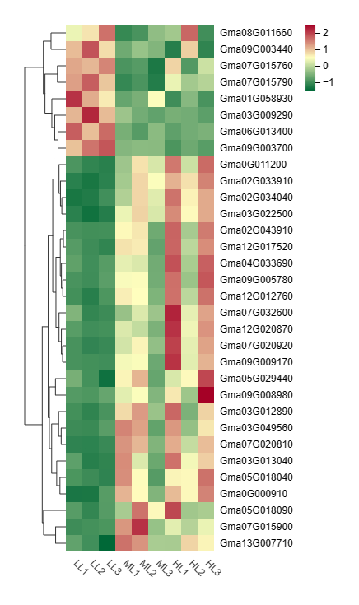
Supplementary Figure 2 Heatmap analysis of genes expression of carotenoid metabolic
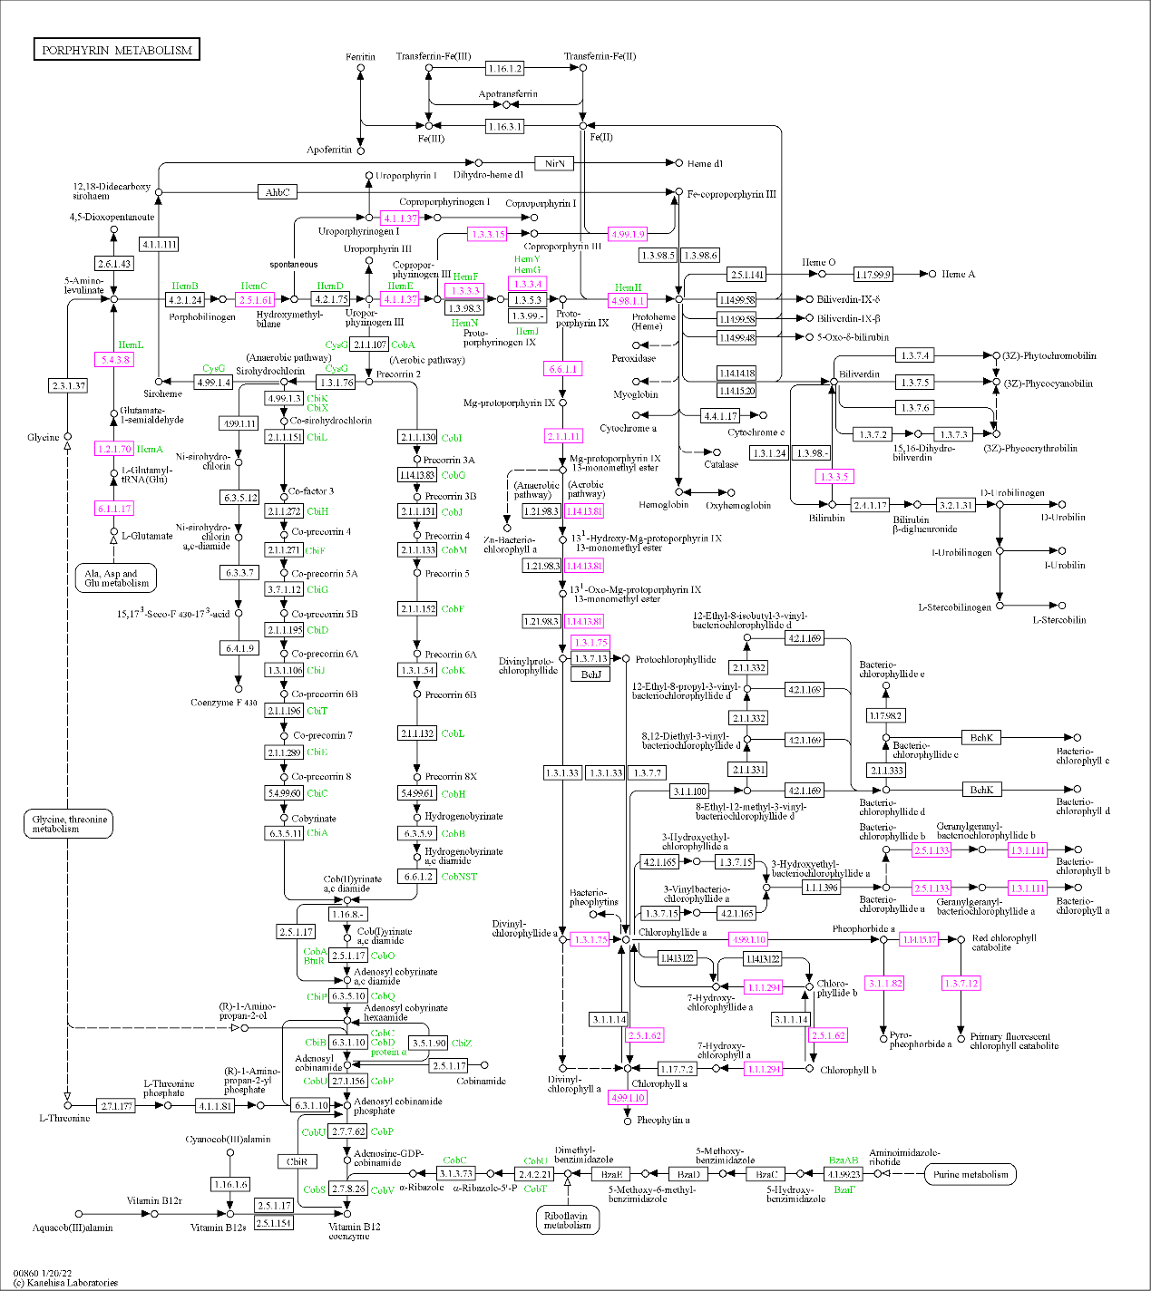
Supplementary Figure 3 KEGG pathway of Porphyrin metabolism

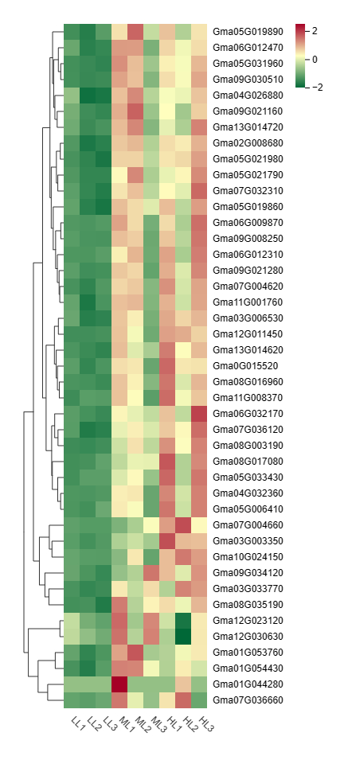
Supplementary Figure 4 Heatmap analysis of genes expression of porphyrin metabolic.
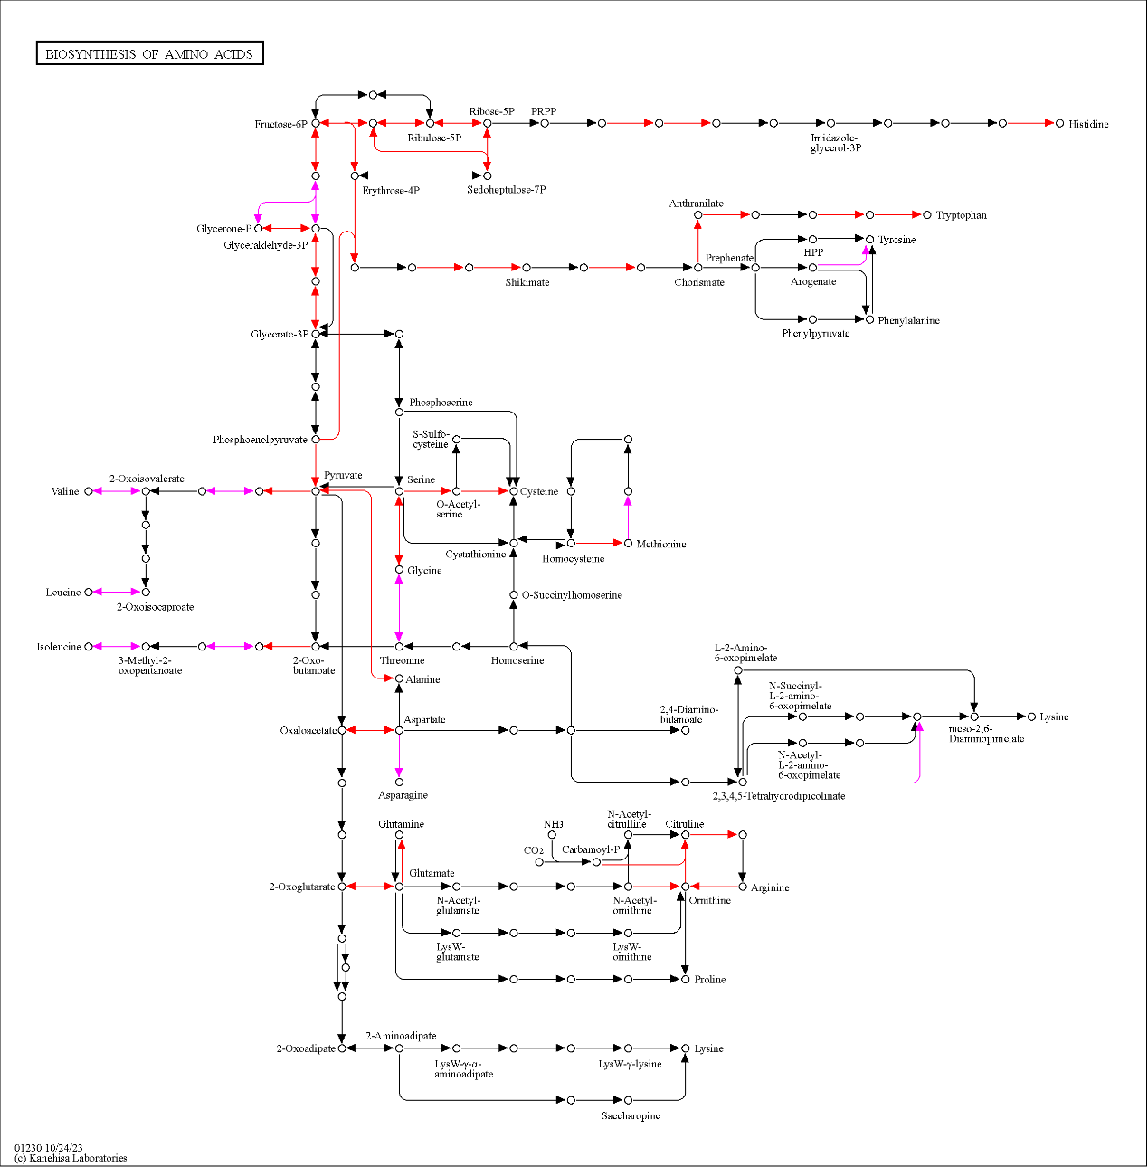
Supplementary Figure 5 KEGG pathway of amino acids and their derivatives metabolic diagram.

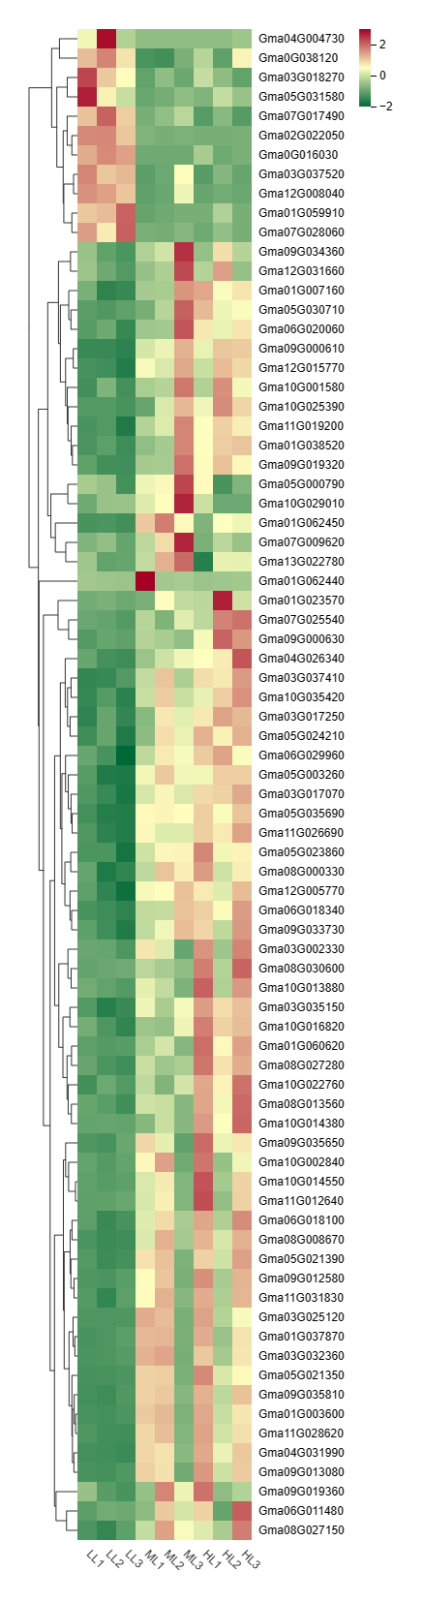
Supplementary Figure 6 Heatmap analysis of genes expression of amino acids and their derivatives metabolic
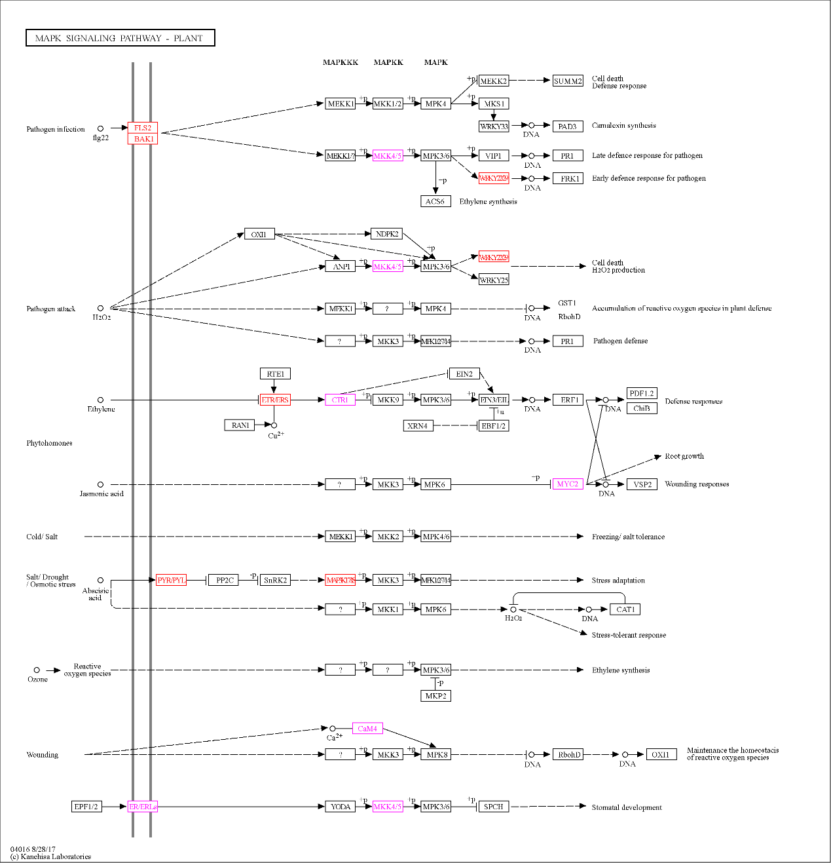
Supplementary Figure 7 KEGG pathway of MAPK signaling pathway
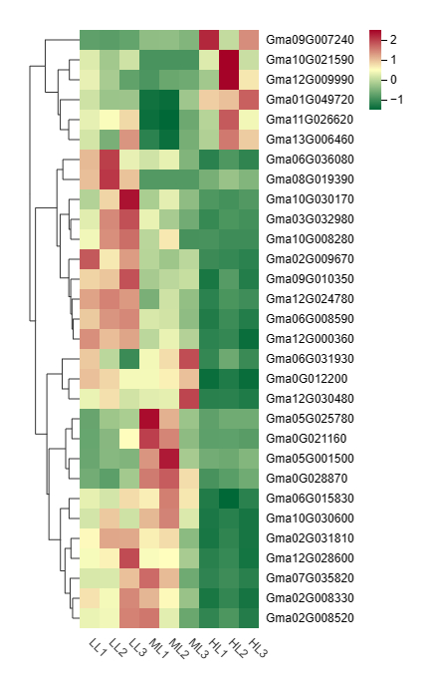
Supplementary Figure 8 Heatmap analysis of genes expression of MAPK signaling pathway

