Supplementary Figures S1–S10

Title The Cardinium wins on Wolbachia in double-infected mite cultures

Authors: E. Tresnakova, E. Glowska, J. Hubert

Journal: Microbiome

Fig S1 The genomes of Cardinium and Wolbachia visualized in Proksee [52].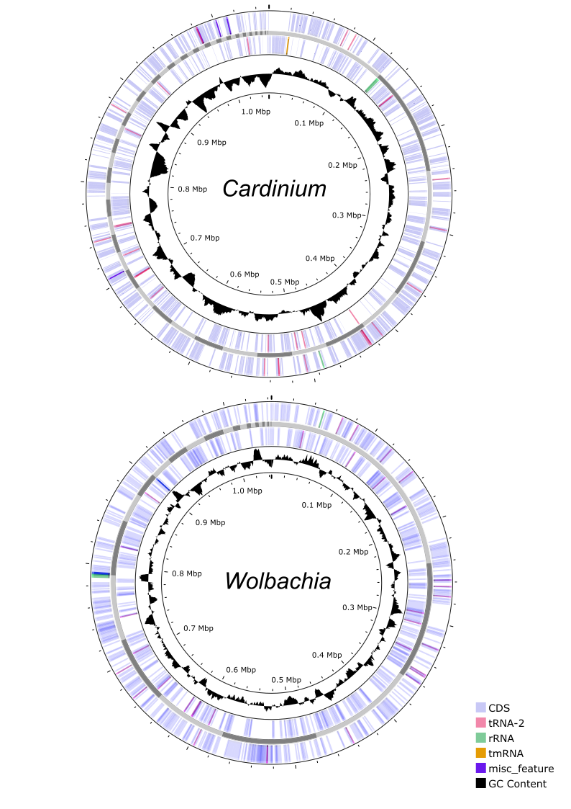
Fig S2 Phylogenetic analyses of Cardinium based on whole-genome similarity metrics using Cardinium genomes available in GenBank; A - FastANI analysis using average nucleotide identities (ANI); B - phylogram based on the M1CR0B1AL1Z3R pipeline. Cardinium from this study is labeled CZ, Chinese is JANAVR01 Cardinium from Tyrophagus putrescentiae described previously [80].
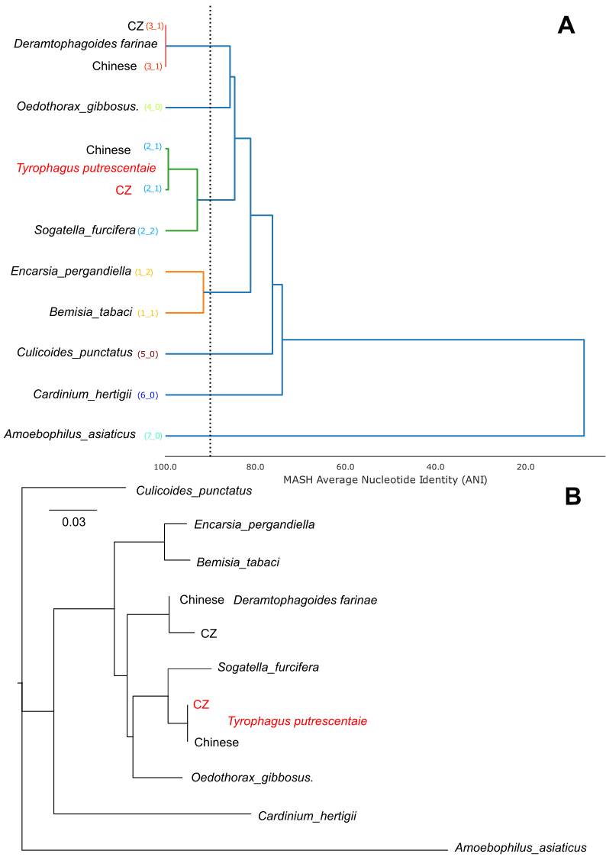

Fig S3 Comparison of the Cardinium genome (red point) to others Cardinium available in using the M1CR0B1AL1Z3R pipeline [65]. GC content and open reading frame (ORF) comparisons are shown as violin and scatter plots.
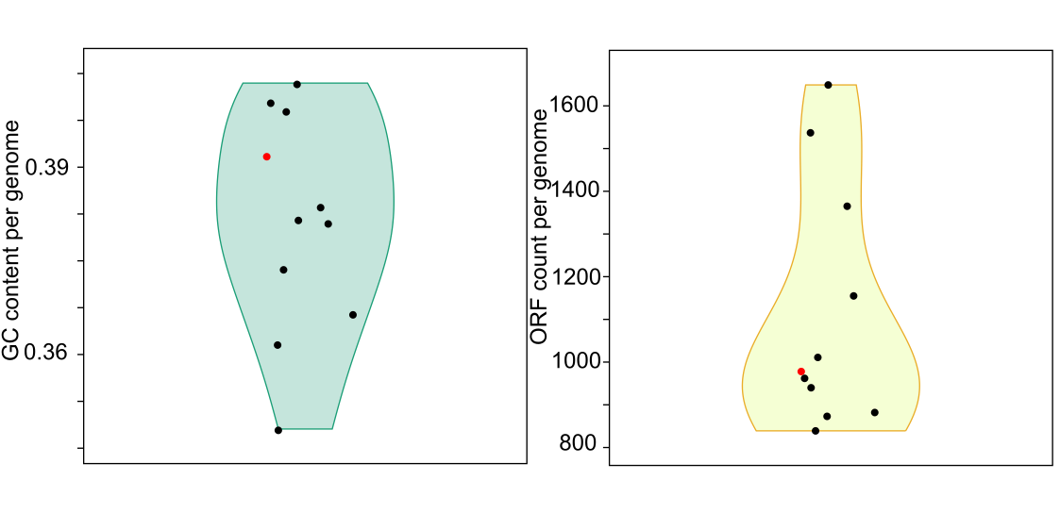

Fig S4 Venn diagram comparing the KEGG assigned proteins of Cardinium from Tyrophagus putrescentiae CZ and Chinese strain [80], Sogatella furcifera [79] and Oedothorax gibbosus [81].
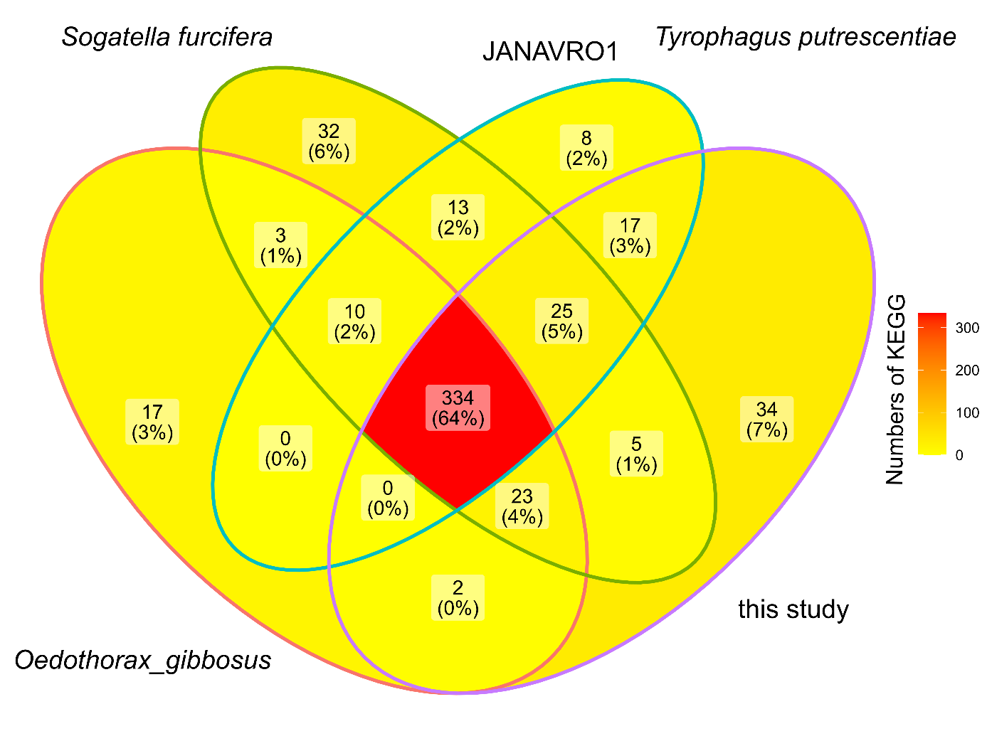

Fig S5 Phylogenetic analyses of Wolbachia based on whole-genome similarity metrics using Wolbachia genomes available in GenBank; A - phylogram based on the M1CR0B1AL1Z3R pipeline. The dendrogram is organized according to Wolbachia host. B - FastANI analysis using average nucleotide identities (ANI); Legend: * -Wolbachia of Tyrophagus putrescentiae, ** GIJY0000000 annotation of Wolbachia from T. putrescentiae; *** identified Wolbachia species.

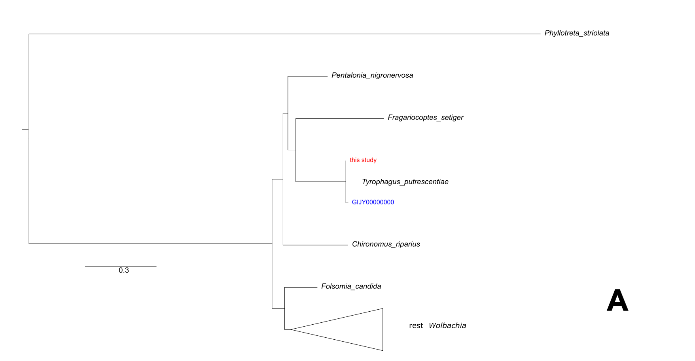
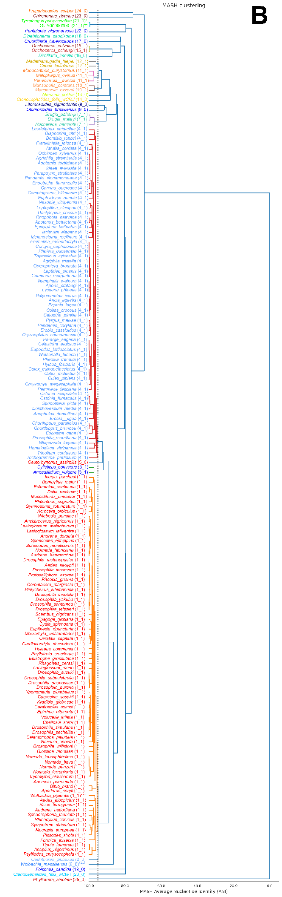
Fig S6 Comparison of the Wolbachia genome of Tyrophagus putrescentiae (red point) to others Wolbachia available in using the M1CR0B1AL1Z3R pipeline [65]. GC content and open reading frame (ORF) comparisons are shown as violin and scatter plots. The blue point indicates previous incomplete version of Wolbachia symbiont from T. putrescentiae.
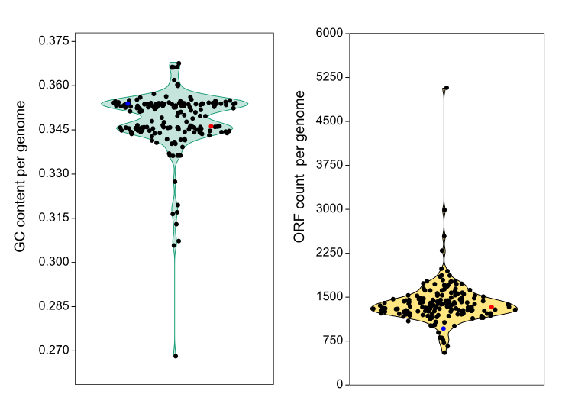

Fig S7 Venn diagram comparing the KEGG assigned proteins of Wolbachia from Tyrophagus putrescentiae and mite Fragariocoptes setiger [83] and Pentalonia nigronervosa [82]. GIJY0000000 is previously deposited incomplete Wolbachia from T. putrescentiae.

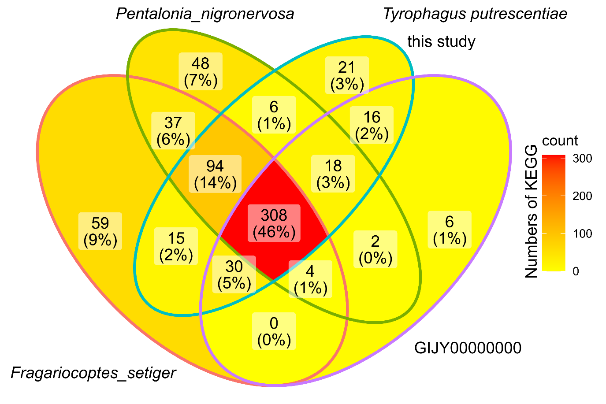

Fig S8 The correlations matrix describes the correlations between Cardinium and Wolbachia expressions. The correlation matrix was based on Spearman correlations, only those significant (Permutation test, P<0.05) are showed. The matrix was clustered by Ward methods.
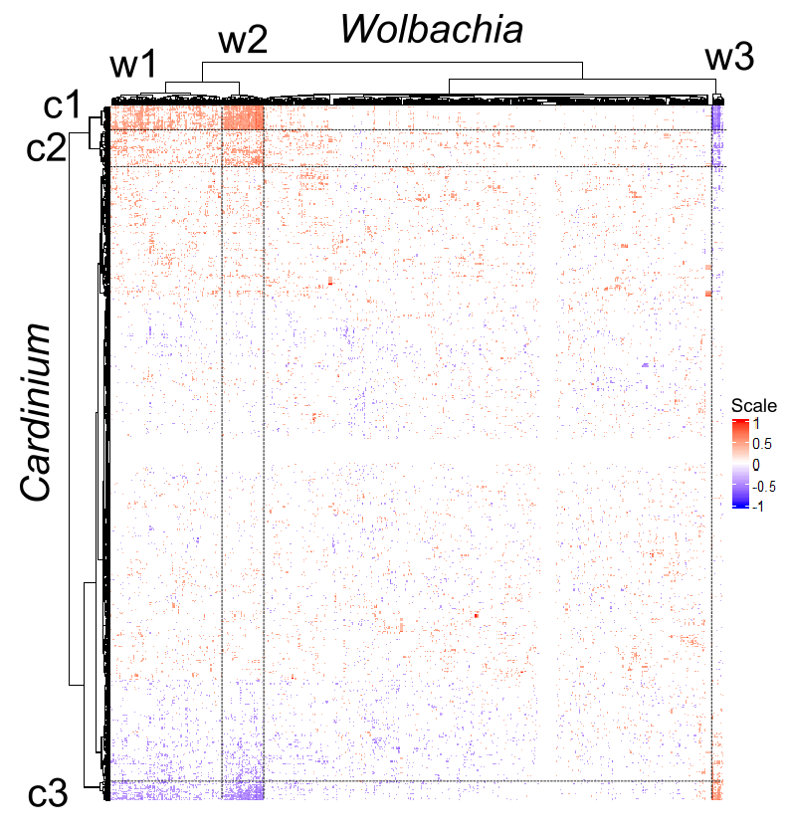

Fig S9 The correlation triplot of distance base redundancy analyses (dbRDA) model showed interaction among Tyrophagus putrescentiae KEGG gene expression and symbionts Cardinium and Wolbachia in the host cultures. The mite cultures were infested with the bacterium, i.e. Cardinium in 5L,5S; Wolbachia in 5P and 5N and double-infected by both Cardinium and Wolbachia (5LN, 5LP, 5SN, 5SP). The showed environmental variables included bacterial strain and the presence of other symbiont in multi-infested samples. The variable participation for every dbRDA model is shown in Venn diagram.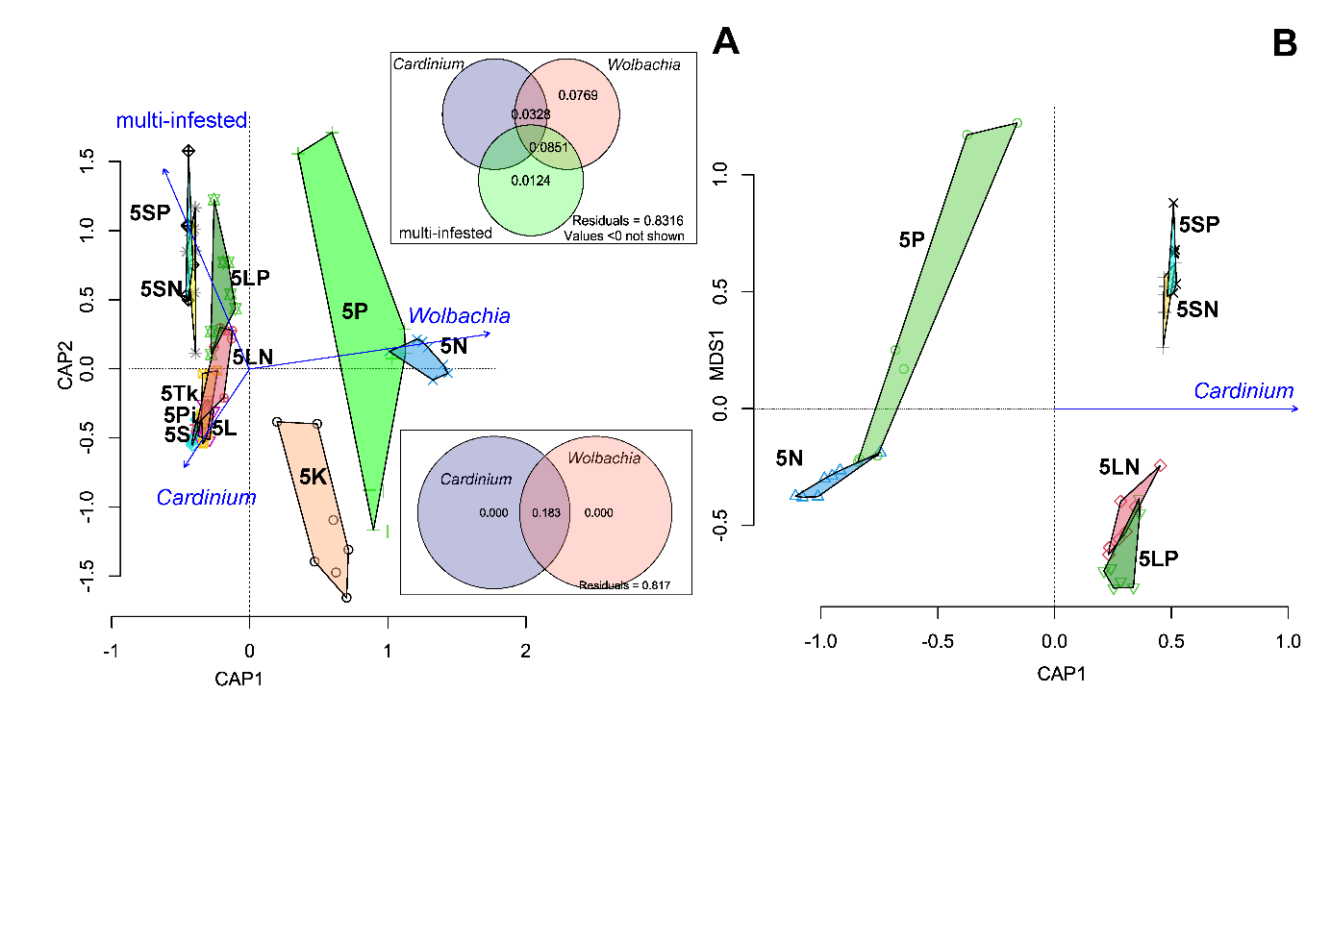

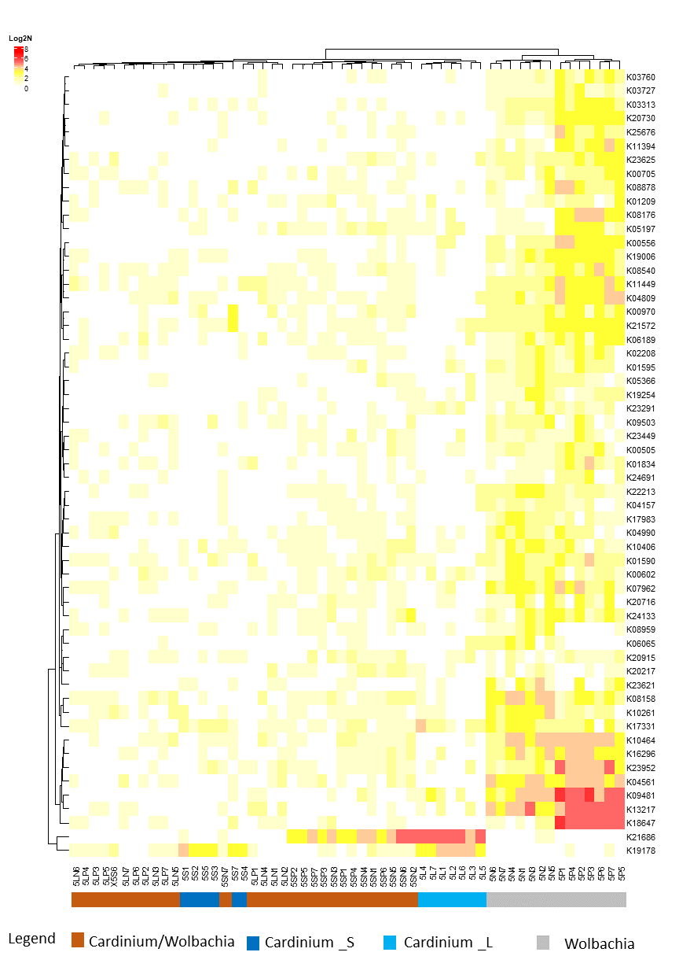
Fig S10 The heatmap showed the Tyrophagus putrescentiae KEGG proteins expression in the cultures with single infected symbiont (Cardinium or Wolbachia) and double-infected cultures (Cardinium/Wolbachia). There were differences between two cultures L and S infested by Cardinium. The mite protein with highest contribution to differences were selected (all significantly differed in METSTATS , P<0.05) are showed. The data were log2 transformed and clustered by Ward method.
Supplementary references
52. Grant JR, Enns E, Marinier E, Mandal A, Herman EK, Chen C-y, Graham M, Van Domselaar G, Stothard P. Proksee: in-depth characterization and visualization of bacterial genomes. Nucleic Acids Res. 2023;51(W1):W484–92. https://doi.org/10.1093/nar/gkad326.
65. Avram O, Rapoport D, Portugez S, Pupko T. M1CR0B1AL1Z3R—a user-friendly web server for the analysis of large-scale microbial genomics data. Nucleic Acids Res. 2019;47(W1):W88–92. https://doi.org/10.1093/nar/gkz423.
79. Zeng Z, Fu Y, Guo D, Wu Y, Ajayi OE, Wu Q. Bacterial endosymbiont Cardinium cSfur genome sequence provides insights for understanding the symbiotic relationship in Sogatella furcifera host. BMC Genomics. 2018;19(1):688. https://doi.org/10.1186/s12864-018-5078-y.
80. Xiong Q, Fung CS-H, Xiao X, Wan AT-Y, Wang M, Klimov P, Ren Y, Yang KY, Hubert J, Cui Y, Liu X, Tsui SK-W. Endogenous plasmids and chromosomal genome reduction in the Cardinium endosymbiont of Dermatophagoides farinae. mSphere. 2023;8(2):e0007423. https://doi.org/10.1128/msphere.00074-23.
81. Halter T, Hendrickx F, Horn M, Manzano-Marin A. A novel widespread MITE element in the repeat-rich genome of the Cardinium endosymbiont of the spider Oedothorax gibbosus. Microbiol Spectr. 2022;10(6):e0262722. https://doi.org/10.1128/spectrum.02627-22.
82. Mathers TC, Mugford ST, Hogenhout SA, Tripathi L. Genome sequence of the banana aphid, Pentalonia nigronervosa Coquerel (Hemiptera: Aphididae) and its symbionts. G3 (Bethesda). 2020;10(12):4315–21. https://doi.org/10.1534/g3.120.401358.
83. Klimov PB, Chetverikov PE, Dodueva IE, Vishnyakov AE, Bolton SJ, Paponova SS, Lutova LA, Tolstikov AV. Symbiotic bacteria of the gall-inducing mite Fragariocoptes setiger (Eriophyoidea) and phylogenomic resolution of the eriophyoid position among Acari. Sci Rep. 2022;12(1):3811. https://doi.org/10.1038/s41598-022-07535-3.

