Supplementary Information for

Non-Exchange Bias in Soft-Hard Nanoparticle Composites

Pierfrancesco Maltoni^{1*}, Raúl López-Martín^{2*}, Elena H. Sánchez², Peter S. Normile², Marianna Vasilakaki³, Su Seong Lee⁴, Benito Santos Burgos², Eloy A. López del Castillo², Davide Peddis⁵, Chris Binns², Kalliopi N. Trohidou³, Roland Mathieu¹, Josep Nogués^{6,7*}, José A. De Toro^{2*}

¹ Department of Materials Science and Engineering, Uppsala University, Box 35, SE-751 03 Uppsala, Sweden
² Instituto Regional de Investigación Científica Aplicada (IRICA) and Departamento de F´ısica Aplicada, Universidad de Castilla-La Mancha 13071 Ciudad Real, Spain
³ Institute of Nanoscience and Nanotechnology, NCSR “Demokritos”, 153 10 Agia Paraskevi, Attiki, Greece
⁴ Institute of Materials Research and Engineering (IMRE), Agency for Science, Technology and Research (A*STAR), 2 Fusionopolis Way, Innovis #08-03, Singapore 138634, Republic of Singapore
⁵ Dipartimento di Chimica e Chimica Industriale, Università degli Studi di Genova, Via Dodecaneso 31, 1-16146, Genova, Italy
⁶ Catalan Institute of Nanoscience and Nanotechnology (ICN2), CSIC and BIST, Campus UAB, Bellaterra, Barcelona, 08193 Spain
⁷ ICREA, Pg. Lluís Companys 23, Barcelona, 08010 Spain

1. Discarding minor loop effects

Fig 1 Dependence on the concentration of soft particles of the bias H_{B} measured using a maximum field either H_{Max} = 90 kOe (blue dots) or 50 kOe (black dots), respectively, for x ≤ 50%.; For comparison, the bias field extracted from the superposition loops for the case of M0 loops collected in a 90kOe or 50kOe field (black and blue circles, respectively) is also included.

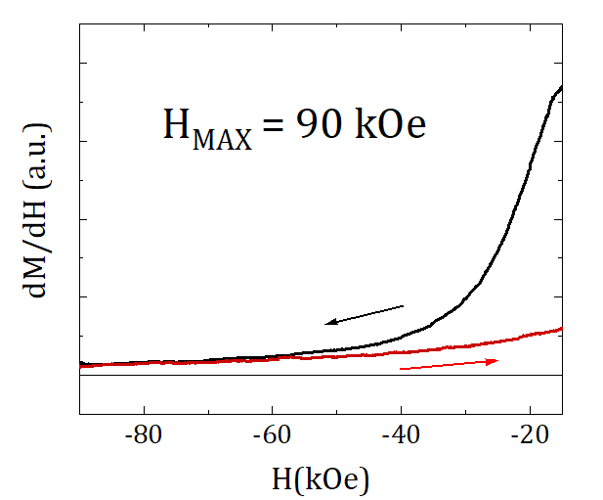
Fig 2 Criterium to determine the proper saturation of the hysteresis loops for M0 (which has the highest saturation field).

2. Estimation of Bias field (H_{B}) for the individual components in the mixtures from the fits

Several attempts were carried out to fit the data, considering various fixed parameters to evaluate the possible correlations between parameters that could affect the fitting results. An example is provided in the figure below.

Fig 3 low-field region of the experimental hysteresis for sample M50 (symbols) and the corresponding fit to equation (2) (dashed line curves - see main text for details).

Interestingly, the results for soft particle concentrations higher than 50% are rather consistent independent of the fitting conditions, while below this threshold the effect of loop asymmetry introduces fluctuations between $S_{hard,left/right}$,$H_{C,hard}$, $H_{B,hard}$and $H_{B,soft}$, as can be seen in Fig 4 for $H_{B,hard}$and $H_{B,soft}$. Different approaches were attempted to minimize the correlation effects. First, if we assume to have $H_{B,soft}=0$ (i.e. none induced-bias on the soft particles), the corresponding $H_{B,hard}$ (black circles) turn out to largely vary, indicating that a $H_{B,soft}≠0$ is necessary for the consistency of the variables. Then, by fixing $H_{C,hard}$ and $H_{B,hard}$ in different combinations to the values of M0 (hard loop), we have quantified the fluctuations on the corresponding hard and soft field values, revealing a strong correlation between these parameters and the asymmetry of the hard component (for soft fractions <50%). To overcome this issue, the squareness parameters were constrained in this region by assuming $S_{hard,left/rigt}$ to not largely depart from those of M0, giving the ‘optimized fit’ results. Despite this constraint, it is important to highlight that although depending on the fitting condition the results somewhat fluctuate the observed trends are the same for all the fitting conditions.
In Fig 5, the results for the coercivity of both the hard and soft components from the optimized fit are shown.

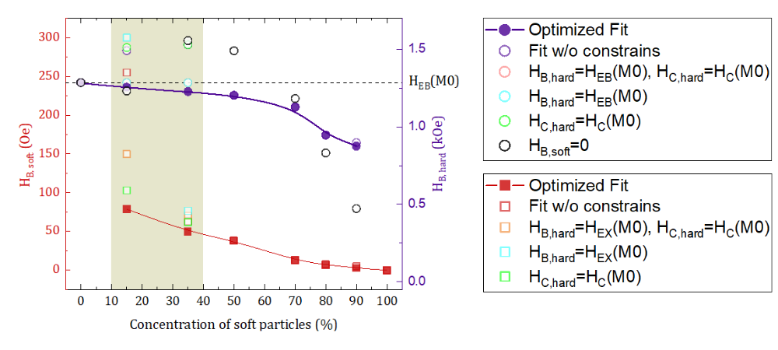
Fig 4 Estimated bias fields for hard (circles) and soft (squares) particle fractions ($H_{B,hard}$and $H_{B,soft}$, respectively) from fitting analysis.

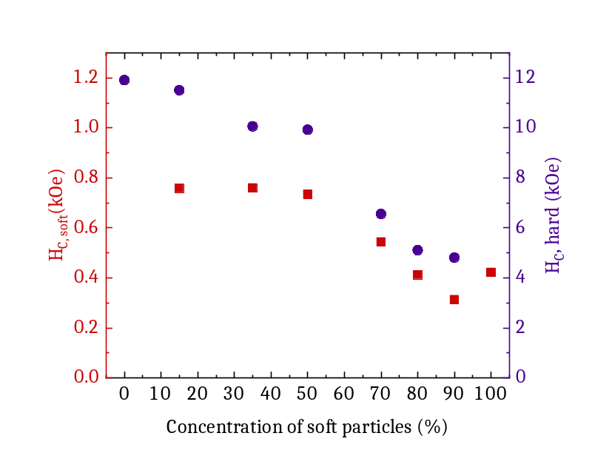
Fig 5 Coercive field values for hard ($H_{C,hard}$; circles) and soft ($H_{C,soft}$; squares) from the optimized fit. Note that y-axis scales are different.

3. Magnetic properties of soft and hard nanoparticles

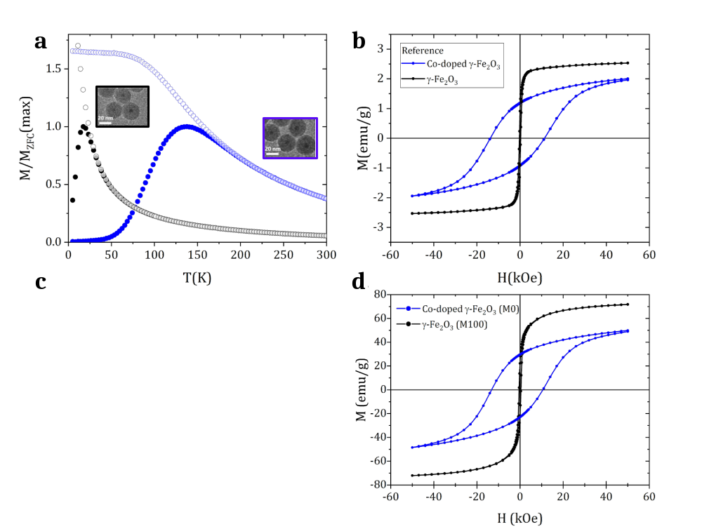
Fig 6 a, Zero field cooled-field cooled (ZFC-FC) magnetization curves for the reference compacts of magnetically isolated (silica-coated) nanoparticles (reference) and b, the corresponding hysteresis loops at 5 K after field cooling. The insets in (a) shows the transmission electron microscopy images of the silica-coated particles. (c) and (d) show the ZFC-FC magnetization curves and the hysteresis loops for the compacts of bare soft (M100) and hard (M0) particles.

Table 1 Coercive field (H_{C}), exchange-bias field (H_{EB}) and blocking temperature (T_{B}) values for the reference (silica coated) compacts and the corresponding M100 and M0 compacts made of bare nanoparticles.

 | γ-Fe₂O₃ (reference) | γ- Fe₂O₃ (M100) | Co-doped  γ-Fe₂O₃ (reference) | Co-doped  γ-Fe₂O₃  (M0)
H_{C} (kOe) | 0.3 | 0.4 | 12.6 | 11.9
H_{EB} (kOe) | - | - | 1.20 | 1.28
T_{B} (K) | 11.5 | 170 | 140 | 255

4. Origin of the exchange bias in the Co-doped particles

This large exchange-bias in the hard nanoparticles likely arises from magnetic disorder (either at the surface or in the core of the particle)^{1–5}, consistent with the reduced M_{S}. Note that disorder was concluded to be absent or too small to provide a detectable exchange bias effect in the pure γ-Fe₂O₃ particles⁶. To compare the presence of disorder in the pure and Co-doped particles, X-ray powder diffraction (XRPD; Fig 2) and transmission electron microscopy (TEM, Fig 1a,b in the main text) experiments were performed on the 2 sets of nanoparticles to evaluate their size and the results indicate that while both types of particles have an equally-sized diameter using TEM (d_{TEM}; Table 2). The size obtained from the Scherrer equation,

$d_{XRPD}=\frac{k·λ}{FWHM·cos⁡(θ)}$ (Eq.1)

With $λ_{CuK_{α}}=1.5406 Å$ and $k=0.9$for spherical particles is smaller in the Co-doped particles than in the γ-Fe₂O₃ ones (Table 2). In fact, the ratio d_{XRPD} /d_{TEM} evidences the plausible presence of disordered in the Co-doped particles.
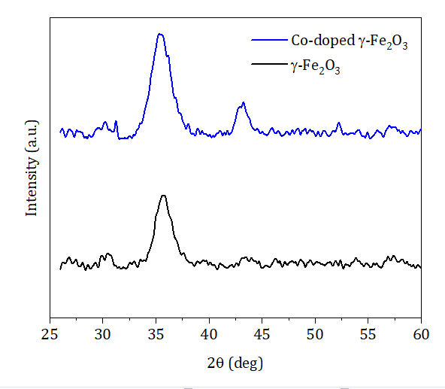

Fig 7 X-ray powder diffraction patterns for the γ-Fe₂O₃ and Co-doped γ-Fe₂O₃ nanoparticles.

Table 2 Average particle diameters obtained from XRPD, d_{XRPD}, and TEM, d_{TEM}.

Sample | d_{XRPD} (nm) | d_{TEM} (nm) | d_{XRPD}/d_{TEM}
γ-Fe₂O₃ | 6.8(3) | 6.8(6) | 1.00
Co-doped γ-Fe₂O₃ | 5.7(3) | 6.8(6) | 0.83

Moreover, note that X-ray diffraction only shows the presence of a single spinel phase, ruling at the presence of any antiferromagnetic phase like CoO.

5. Hysteresis loops for the M0 – M100 series
Fig 8 Low-field region of the hysteresis loops at 5 K after field cooling for the different Mx systems. The dashed lines near the origin mark the centre of the loops (bias field, H_{B}).
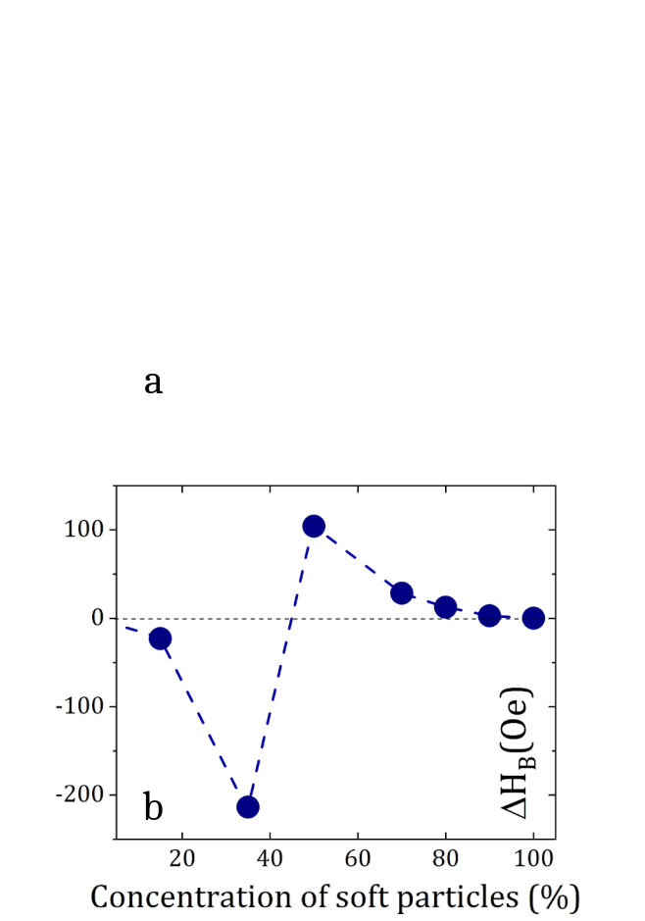

Fig 9 Differences between the experimental values and those extracted from the superposition loops for a, H_{C} [Δ(H_{c})] and b, H_{B} [Δ(H_{B})], respectively.

6. Asymmetric reversal of the hard nanoparticles
Asymmetric reversal is an intrinsic effect of exchange bias which arises from the symmetry breaking induced by the field cooling. Namely, there is a competition between the unidirectional and uniaxial anisotropies during the magnetization reversal⁷. The intensity of the effects (i.e., the difference between the two branches of the hysteresis loop) depends mainly on the ratio between these anisotropies. Note that although this effect is typically observed in ferromagnetic/antiferromagnetic thin film systems, it should emerge in any system where there are unidirectional and uniaxial anisotropy, like in the Co-doped nanoparticles. Thus, these competing anisotropies are the origin of the asymmetric reversal of the Co-doped nanoparticles. However, it is important to emphasize that in the hard-soft mixtures the anisotropic reversal is carried over by the Co-doped particles, it is not introduced by the nanoparticle mixing itself.

7. Bias induced in the binary mixtures by the asymmetric reversal of the hard particles

The role of the asymmetric reversal-induced bias of the hard loop in the enhanced global bias of the binary mixtures was investigated by superposing the experimental (unshifted and symmetric) loop for the soft particles and the simulated loops (with different degree of asymmetric reversal and coercivity) for the hard particles. This procedure was repeated for various soft particle fractions, and the resulting maximum attainable bias was plotted as a contour plot (see Fig 5c in the main text) for each set of coercivity and squareness parameter of the hard particles, $H_{B}^{max} \left(\frac{S_{hard, right}}{S_{hard, left}};H_{C,hard}\right)$, irrespective of the soft particle fraction at which this maximum is reached. Fig 10 shows the (a) horizontal and (b) vertical cuts from the contour plot: the maximum attainable bias is shown as a function of (a) the asymmetry for fixed $H_{C,hard}$ values and (b) as a function of $H_{C,hard}$ for determined $S_{hard,left/rigt}$ values.

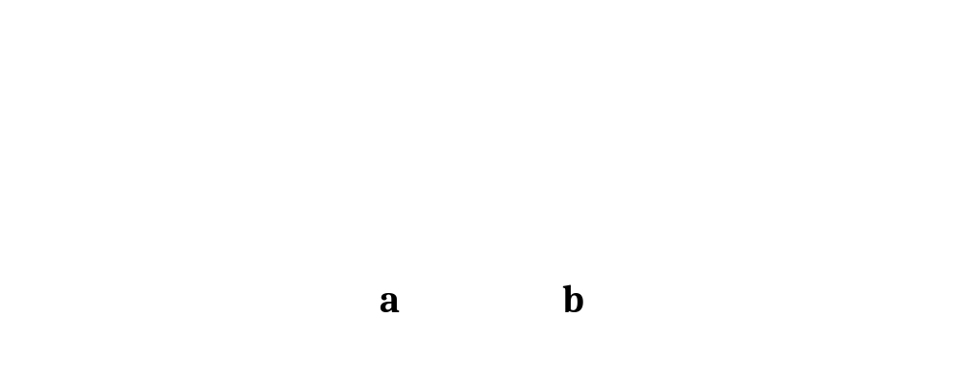
Fig 10 a, Horizontal and b, vertical cuts from the contour plot (Fig 5(c) in the main text). Note that in panel (b) the vertical axis is represented as $H_{B}^{max}/H_{C,hard}$ for a better view of the pseudo-linearity above 5 kOe.

8. Exchange vs dipolar energies in exchange biased nanoparticle
To evaluate the energies associated to the intraparticle exchange-coupling and interparticle dipolar interactions, the parameter $T_{ex}/T_{dd}$ was calculated by quantifying the exchange-coupling energy at the interface as $E_{ex}=k_{B} T_{ex}= H_{B}V_{FiM}M_{S}$ (where $H_{B}$ is the exchange-bias field, $V_{FM}$ is the volume of the ferromagnetic core and $M_{S}$ the saturation magnetization) and the dipolar interaction as $T_{dd}= \frac{µ_{0}}{4πk_{b}}M_{S}^{2}Vφ$ (where $φ$ is the packing fraction). Fig. 5 shows $T_{ex}/T_{dd}$ calculated for a number of systems with similar particle size, as a function of $T_{dd}$. We can deduce that, being $T_{ex}$ (exchange coupling energy) proportional to $H_{EB}$, a higher $H_{EB}$ will generate a higher $T_{ex}/T_{dd}$, independently from $T_{dd}$, as also shown in Table 3. Thus, y-scale informs of the dominance of exchange over dipolar energy for all systems but those with a very low exchange-bias field.

Fig 11 Estimated $T_{ex}/T_{dd}$ ratio (with $T_{ex}$defining the exchange-coupling energy at the interface and $T_{dd}$ the dipolar interaction energy) for several exchange biased nanoparticle systems from the literature, as a function of dipolar interaction strength, $T_{dd}$; coloured crosses represent the mixtures Mx investigated in this study, for which $T_{ex}$ is constant, and equal to that of M0 (i.e., $T_{dd}$ is the only varying parameter). The dashed line marks the $T_{ex}=T_{dd}$.

Table 3 Estimated $T_{ex}/T_{dd}$ ratio and corresponding dipolar interaction strength, $T_{dd}$, ferromagnetic core diameter, d_{FM}, and exchange-bias field, H_{EB}.
Ref. | $$T_{ex}/T_{dd}$$ |  | $T_{dd}$ (K) | d_{FM} (nm) | H_{EB} (kOe)
Co-doped γ-Fe₂O₃  (fCo:0.2) [This study] | 13.5 | 29 |  | 6.7 | 1.28
Co-doped γ-Fe₂O₃ (fCo:0.1)⁸ | 4.0 | 40 |  | 6.7 | 0.30
CoO@Co_{0.5}Ni_{0.5}Fe₂O₄⁹ | 5.1 | 10 |  | 4.7 | 0.80
CoO@Co_{0.5}Ni_{0.5}Fe₂O₄⁹ | 11.4 | 8 |  | 4.5 | 2.3
Fe_{3−δ}O₄@CoO¹⁰ | 17.6 | 60 |  | 9.6 | 1.68
Fe_{3−δ}O₄@CoO¹⁰ | 38 | 90 |  | 8.2 | 4.04
Fe_{3−δ}O₄@CoO¹⁰ | 11.8 | 110 |  | 9.6 | 1.36
Fe₃O₄@CoFe₂O₄¹¹ | 1.0 | 40 |  | 7.2 | 0.09
Fe₃O₄@CoFe₂O₄¹¹ | 0.7 | 85 |  | 10.3 | 0.05
Fe₃O₄@CoO¹¹ | 15.0 | 80 |  | 8.8 | 2.00

9. Monte Carlo results

Fig 12 Loop shift of the hard (H_{B,hard})(blue) and soft (H_{B,soft})(red) counterparts obtained from the Monte Carlo simulations for different conditions: a, Soft particle core anisotropy, K_{S_core} = 0.09(), 0.17(), 0.35(); b, Soft particle surface anisotropy, K_{S_surface} = 10(),15(), 30(); c, Hard particle core anisotropy, K_{H_core} = 25(), 50(), 80(); d, Hard particle surface anisotropy, K_{H_surface} = 100(), 150(), 160(); e, Soft particle dipolar interactions, g₁ = 12.33(), 13.70(), 15.07(); f, Hard particle dipolar interactions, g₂ = 7.56() ,8.40(), 9.24(). The dotted lines are guides to the eye. Note that filled symbols are the data shown in Fig 6b in the main text for the optimized parameters.

References

1. Vasilakaki, M. & Trohidou, K. N. Numerical study of the exchange-bias effect in nanoparticles with ferromagnetic core/ferrimagnetic disordered shell morphology. Phys. Rev. B 79, 144402 (2009).
2. Topkaya, R. et al. Surface spin disorder and spin-glass-like behaviour in manganese-substituted cobalt ferrite nanoparticles. J. Nanoparticle Res. 14, 1156 (2012).
3. Kodama, R. H., Berkowitz, A. E., McNiff, Jr., E. J. & Foner, S. Surface Spin Disorder in NiFe₂O₄ Nanoparticles. Phys. Rev. Lett. 77, 394–397 (1996).
4. De Toro, J. A. et al. Remanence Plots as a Probe of Spin Disorder in Magnetic Nanoparticles. Chem. Mater. 29, 8258–8268 (2017).
5. Muzzi, B. et al. Defect‐Engineering by Solvent Mediated Mild Oxidation as a Tool to Induce Exchange Bias in Metal Doped Ferrites. Small Methods (2023) in press doi:10.1002/smtd.202300647.
6. Sánchez, E. H. et al. Simultaneous Individual and Dipolar Collective Properties in Binary Assemblies of Magnetic Nanoparticles. Chem. Mater. 32, 969–981 (2020).
7. Camarero, J. et al. Origin of the Asymmetric Magnetization Reversal Behavior in Exchange-Biased Systems: Competing Anisotropies. Phys. Rev. Lett. 95, 057204 (2005).
8. Sánchez, E. H. et al. Crossover From Individual to Collective Magnetism in Dense Nanoparticle Systems: Local Anisotropy Versus Dipolar Interactions. Small 2106762 (2022) doi:10.1002/smll.202106762.
9. Lavorato, G. et al. Exchange bias and surface effects in bimagnetic CoO−core/Co_{0.5}Ni_{0.5}Fe₂O₄-shell nanoparticles. Phys. Rev. B 94, 054432 (2016).
10. Liu, Y. et al. Investigation of the Collective Properties in Monolayers of Exchange-Biased Fe_{3− δ}O₄@CoO Core–Shell Nanoparticles. J. Phys. Chem. C 122, 17456–17464 (2018).
11. Sartori, K. et al. Strong interfacial coupling through exchange interactions in soft/hard core–shell nanoparticles as a function of cationic distribution. Nanoscale 11, 12946–12958 (2019).

