Supplementary data

Supplementary Table 1.
Primer name | Primer forward sequence (5’ - 3’) | Primer reverse sequence (5’ - 3’)
HERVK-pol | TCACATGGAAACAGGCAAAA | AGGTACATGCGTGACATCCA
HERVK-gag | AGCAGGTCAGGTGCCCGTAACATT | TGGTGCCGTAGGATTAAGTCTCCT
HERVK-env₁ | CTGAGGCAATTGCAGGAGTT | GCTGTCTCTTCGGAGCTGTT
HERVK-env₃ | CACAACTAAAGAAGCTGACG | CATAGGCCCAGTTGGTATAG
HERVE-env | CTGGTCCACGCACGGCCGAAGCATG | TTTGCTGTCCTACCTCAGTGAC
HERVH-env | TTCACTCCATCCTTGGCTAT | CGTCGAGTATCTACGAGCAAT
HERVFC1-env  HERVP-env | GGTGGCTACTTCTGGTGTAACT  CAAGATTGGGTCCCCTCAC | GAGGCAACAAGTGAGGAGGT  CCTATGGGGTCTTTCCCTC
HERVR-env | CATGGGAAGCAAGGGAACT | CTTTCCCCAGCGAGCAATAC
HERVW-env | GTATGTCTGATGGGGGTGGAG | CTAGTCCTTTGTAGGGGCTAGAG
GAPDH | GTTCGACAGTCAGCCGCATC | TCCGTTGACTCCGACCTTCA
β-actin | GCTCACCATGGATGATGATATCGC | CACATAGGAATCCTTCTGACCCAT

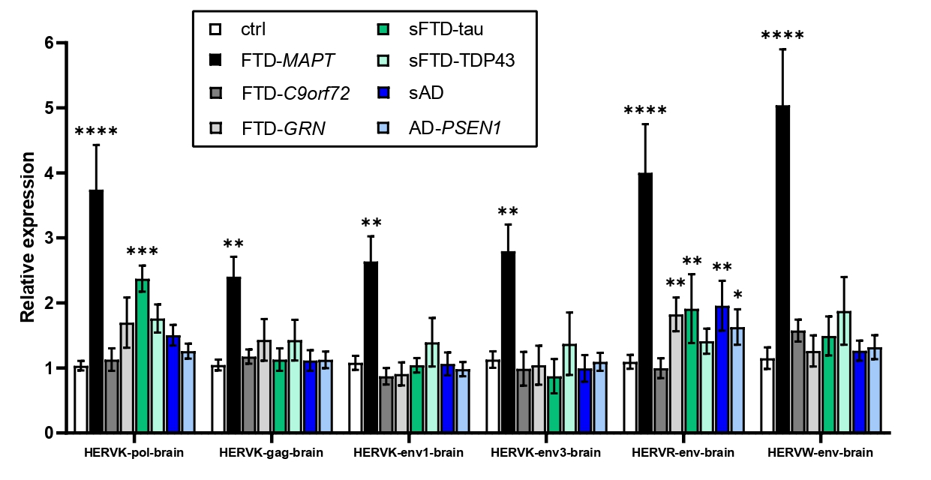
Supplementary Figure 1.
qRT-PCR analysis of HERVs expression in post-mortem cortex tissue from (left to right) healthy controls (white), FTD-MAPT (black), FTD-C9orf72 (dark grey), FTD-GRN (light grey), sFTD-tau (green), sFTD-TDP43 (light green), sAD (dark blue), and AD-PSEN1 (light blue) patients. GAPDH and β-actin were used as reference genes. All experiments were done in triplicate. Bar charts represent mean. Error bars indicate SEM. *p < 0.05, **p < 0.01, ***p < 0.001 (Mann Whitney test).

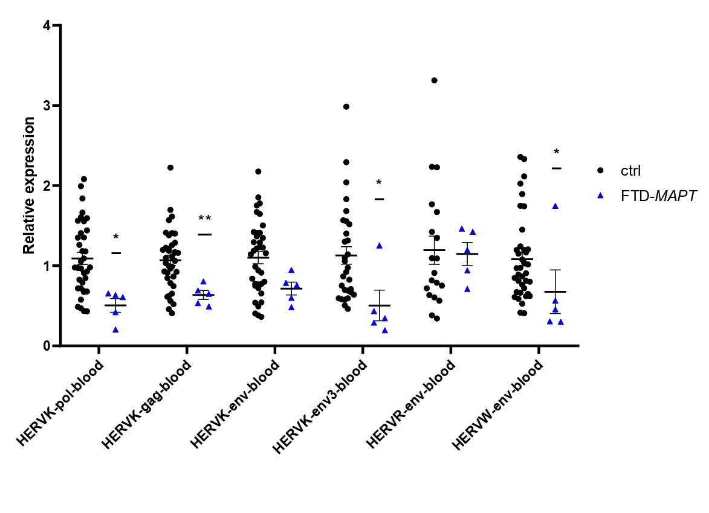
Supplementary Figure 2.
qRT-PCR analysis of HERVs expression in blood samples from FTD-MAPT patients compared to healthy patients. GAPDH and β-actin were used as reference genes. All experiments were done in duplicate. Error bars indicate SEM. Dots represent control subjects (n = 39) and triangles indicate FTD-MAPT patients (n = 5). *p < 0.05, **p < 0.01, ***p < 0.001 (Mann Whitney test).

Supplementary Table 2.
Gene name | CpG region | Effect | Group | p_val
ERVMER34-1 | cg23199416  TSS1500 | 0.07905  0.08511  0.07669  0.08200  0.05356 | FTD-MAPT  FTD-GRN  FTD-C9orf72  sFTD-TDP43  sFTD-tau | 0.04498  0.01030  0.02182  3.13E-05  0.04431
PIWIL3 | cg24436207  TSS200 | 0.1135  0.1200  0.1330  0.1235  0.1159 | FTD-MAPT  FTD-GRN  FTD- C9orf72  sFTD-TDP43  sFTD-tau | 0.01987  0.01715  0.00447  0.00017  0.01002
CHD4 | cg25624599  TSS1500 | 0.11157  0.13432  0.12197  0.11867 | FTD-MAPT  FTD-GRN  FTD-C9orf72  sFTD-TDP43 | 0.00878  0.00025  0.03359  0.00108
Ctrl n = 5; FTD-MAPT n = 5; FTD-C9orf72 n = 5; FTD-GRN n = 5; sFTD-tau n = 5; sFTD-TDP43 n = 5

