Supplementary Material for

Death Toll by Dementia Drug

Jong-Hoon Lee

Correspondence to: science@research.re.kr

Supplemental Section 1. Korea Drug Code Medicine
Korean Standard Classification of Diseases (KCD) code for "Alzheimer's disease."
(1) KCD code for Alzheimer's disease.
Supplementary Table1. Mental and Behavioural Disorders, F00-F09, G30
F00 code | Dementia in Alzheimer's disease (G30.-+)
F01 code | Vascular dementia
F02 code | Dementia in other diseases classified elsewhere
F03 code | Unspecified dementia
F04 code | Organic amnesic syndrome, not induced by alcohol and other psychoactive substances
F05 code | Delirium, not induced by alcohol and other psychoactive substances
F06 code | Other mental disorders due to brain damage and dysfunction and to physical disease
F07 code | Personality and behavioural disorders due to brain disease, damage and dysfunction
F09 code | Unspecified organic or symptomatic mental disorder
G30 code | Alzheimer's disease

(2) For symptomatic relief of Alzheimer's disease
Supplementary Table2. First Group: For Symptomatic Relief of Alzheimer’s Disease
donepezil hydrochloride | 148603ATB 148602ATD 148602ATB 148601ATD 148601ATB 643401ATD 643402ATD
rivastigmine | 224501ACH 224503ACH 224504ACH 224505ACH 224506CPC 224507CPC 224508CPC
galantamine | 385203ACR 385203ATR 385204ACR 385204ATR 385205ACR 385205ATR
N-methyl-D-aspartate (NMDA) receptor antagonist | 190031ALQ 190001ATB 190003ATD 190004ATB 190004ATD

Supplementary Table3. Second Group: For Psychologic Symptoms of Alzheimer’s Disease
haloperidol | 167903ATB 167904ATB 167905ATB 167906ATB 167908ATB 167908ATB 168030BIJ
Risperidone | 224201ATB 224201ATD 224202ATB 224202ATD 224203ATB 224204ATB 224205BIJ 224206BIJ
Quetiapine | 378601ATB 378602ATB 378603ATB 378604ATB 378605ATB 378605ATR 378606ATR 378607ATR 378608ATR 378608ATR 378610ATB
Olanzapine | 204001ATB 204001ATD 204002ATB 204002ATD 204004ATB 204005ATB
Aripiprazole | 451501ATB 451501ATD 451502ATB 451502ATD 451503ATB 451504ATB 451505ATB 451506BIJ 451507BIJ
Oxcarbazepine | 206330ASS 206301ATB 206302ATB 206303ATB
fluvoxamine | 162501ATB 162502ATB
Escitalopram | 474801ATB 474802ATB 474803ATB 474804ATB
Trazodone | 242901ACH 242901ATB 242902ATB 242903ATR
Sertraline | 227001ATB 227002ATB 227003ATB
Escitalopram | 474801ATB 474802ATB 474803ATB 474804ATB
Fluoxetine | 161501ACH 161501ATB 161502ACH 161502ATB 161502ATD

Supplemental Section 2. Data
The National Agency approved this study for Management of Life-sustaining Treatment, which certified that the life-sustaining treatments were managed properly (Korea National Institute for Bioethics Policy (KoNIBP) approval number P01-202007-22-006).
According to the Official Information Disclosure Act in Korea, the Seoul study analyzed AD and anti-Alzheimer's disease drug (AAD) use in Hansen subjects. We searched all medical records of the National Health Insurance Service (NHIS) in Korea and the Sorokdo National Hospital from the time when the International Classification of Diseases (ICD)-9 code and Electronic Data Interchange (EDI) were computerized.
The Sorokdo National Hospital was established in May 1916 to treat leprosy. We connected to the medical record database of the Sorokdo National Hospital and archived it from January 2005 to June 2020. With the ICD-9 and -10 codes, medical data on the correlation between DDS and AD were then analyzed. In the group of patients diagnosed with Alzheimer's disease, the average age of deaths while taking only drugs for dementia treatment (group 1) and the mean age of deaths with taking psychiatric drugs (group 1 & group 2) (Supplementary Table1).
Supplementary Table4. The Life expectancy of Hansen's disease patients in the Sorokdo National Hospital
year | AD First group | AD First & Second group | The life expectancy of Korean
2005 | 90.4 | 93.98 | 78.24
2006 | 82.5 | 93.49 | 78.78
2007 | 92.38 | 92.2 | 79.16
2008 | 96.25 | 92.87 | 79.6
2009 | 94.74 | 93.09 | 80.04
2010 | 92.14 | 90.24 | 80.24
2011 | 91.25 | 90.22 | 80.62
2012 | 90.16 | 89.28 | 80.87
2013 | 90.6 | 89.07 | 81.36
2014 | 92.27 | 90.94 | 81.8
2015 | 85.56 | 84.88 | 82.06
2016 | 87.22 | 87.88 | 82.4
2017 | 88.45 | 86.67 | 82.7
2018 | 88.2 | 72.1 | 82.7
2019 | 88.2 | 72.1 | 83.3

According to the Official Information Disclosure Act in Korea, we also requested and analyzed the entire ICD 9 and 10 code data (from 2010 to 2019) of AD and AAD from the Health Insurance Review & Assessment system. From 2010 to June 2020, the diagnosis of patients with MCI and AD in Korea increased dramatically (Supplementary Table2).
Supplementary Table5. Numbers of drug prescriptions for dementia patients in Korea from 2010 to 2019
Year | Total billed quantity of drugs | Line of amount billed for drugs | Total number of patients
2,010 | 56,258,246 | 109,447,005 | 257,385
2,011 | 72,339,833 | 134,113,061 | 319,327
2,012 | 88,533,271 | 140,102,940 | 376,126
2,013 | 106,422,008 | 160,202,046 | 435,538
2,014 | 127,120,294 | 187,253,891 | 497,676
2,015 | 154,734,543 | 215,276,824 | 562,844
2,016 | 181,226,560 | 240,267,891 | 627,823
2,017 | 207,303,641 | 265,949,724 | 692,531
2,018 | 234,480,000 | 296,443,092 | 767,282
2,019 | 261,621,750 | 328,425,771 | 839,413
(Currency data provided by Morningstar on February 7, 12:58 AM UTC)

Datalink & processing sheet – Supplementary Tables 4 and 5
https://docs.google.com/spreadsheets/d/1_L1Q59DNHpod2RdXnZMu_96utTpIpBugCPZKSZEXJ-E/edit?usp=sharing

NHIS refused to provide information according to the Official Information Disclosure Act in Korea. The reason was that there was an obligation to protect the business information of pharmaceutical companies. So, the Open Data Mediation Committee should do its best to provide a more efficient and prompt dispute mediation service, intervening in the dispute between NHIS and researchers. Eventually, it was agreed to provide the number of users and deaths for code like this. There were duplicate users and deaths for each code because there might have been a defect in the NHIS database relationships. We decided to accept it and draw a power series to analyze the correlation between the Dementia Management Act trends in 2018 through regression (R² ) analysis.
Supplementary Table6. NHIS Masked Code and ICD-9, -10 Code
Masked code | ICD 9, 10 code | Drug
1486 | 148603ATB 148602ATD 148602ATB 148601ATD 148601ATB 643401ATD 643402ATD | donepezil hydrochloride
1615 | 161501ACH 161501ATB 161502ACH 161502ATB 161502ATD | Fluoxetine
1900 | 190031ALQ 190001ATB 190003ATD 190004ATB 190004ATD | N-methyl-D-aspartate (NMDA) receptor antagonist
2040 | 204001ATB 204001ATD 204002ATB 204002ATD 204004ATB 204005ATB | Olanzapine
2242 | 224201ATB 224201ATD 224202ATB 224202ATD 224203ATB 224204ATB 224205BIJ 224206BIJ | Risperidone
2245 | 224501ACH 224503ACH 224504ACH 224505ACH 224506CPC 224507CPC 224508CPC | Rivastigmine
2270 | 227001ATB 227002ATB 227003ATB | Sertraline
3786 | 378601ATB 378602ATB 378603ATB 378604ATB 378605ATB 378605ATR 378606ATR 378607ATR 378608ATR 378608ATR 378610ATB | Quetiapine
4515 | 451501ATB 451501ATD 451502ATB 451502ATD 451503ATB 451504ATB 451505ATB 451506BIJ 451507BIJ | Aripiprazole
4748 | 474801ATB 474802ATB 474803ATB 474804ATB | Escitalopram
9999 | The others | The others

Supplementary Table7. Anti-Alzheimer's drug (AAD) and User and the Death Toll
Year | AAD | AAD Users | Death
2010 | all | 1496235 | 78528
2011 | all | 1624963 | 87053
2012 | all | 1793974 | 100711
2013 | all | 1879280 | 109772
2014 | all | 2028410 | 119542
2015 | all | 2191614 | 135524
2016 | all | 2373538 | 148351
2017 | all | 2598416 | 167853
2018 | all | 2880654 | 185099
2019 | all | 3234536 | 197232

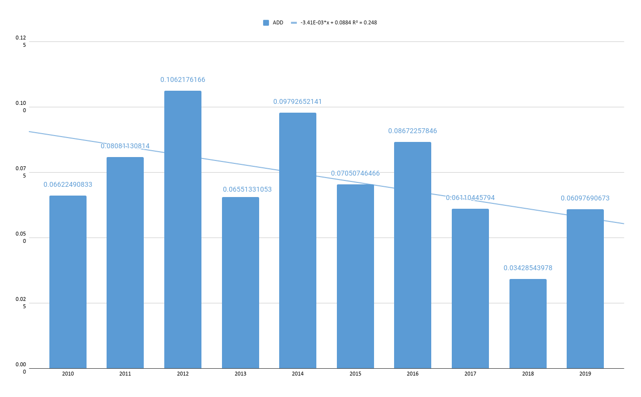Supplementary Fig.1. AAD Trend line. -3.41E-03*x + 0.0884 R² = 0.248
Supplementary Table8. Donepezil code and User and the Death Toll
Year | Donepezil | Donepezil Users | Death
2010 | 1486 | 96,820 | 12,575
2011 | 1486 | 123,101 | 15,797
2012 | 1486 | 150,128 | 19,604
2013 | 1486 | 176,440 | 22,941
2014 | 1486 | 204,724 | 26,636
2015 | 1486 | 236,834 | 32,084
2016 | 1486 | 267,241 | 36,375
2017 | 1486 | 294,203 | 42,187
2018 | 1486 | 319,751 | 47,487
2019 | 1486 | 336,683 | 48,830

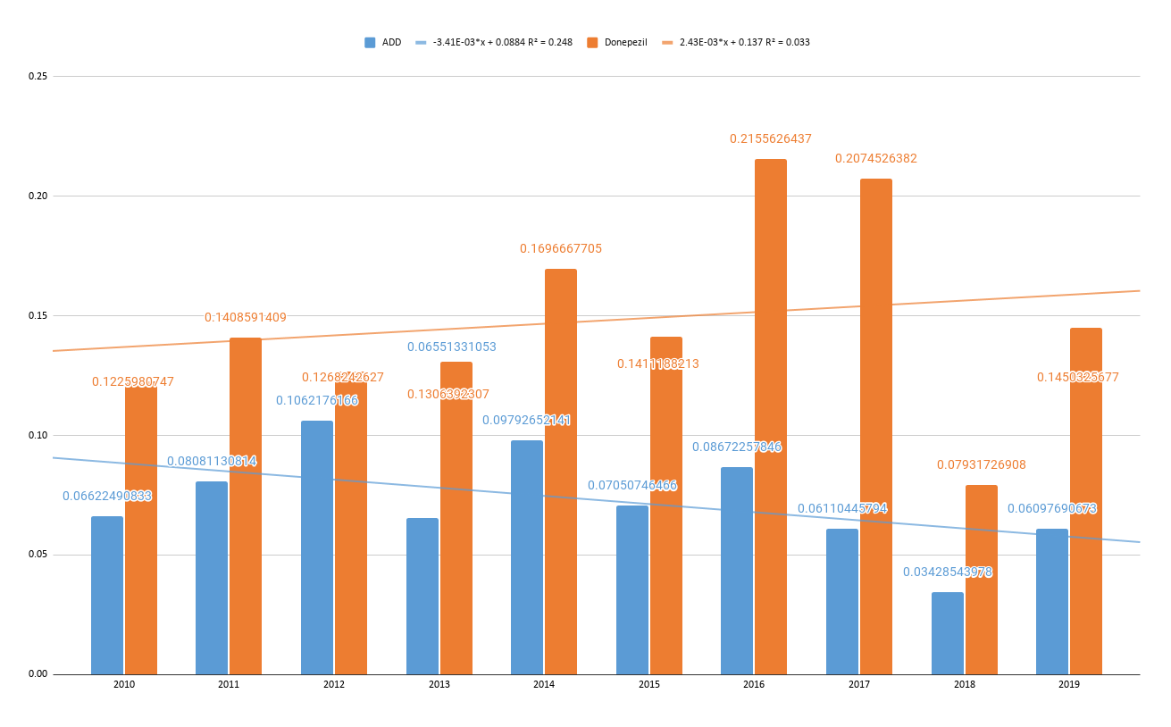Supplementary Fig.2. Donepezil Trend line. 2.43E-03*x + 0.137 R² = 0.033
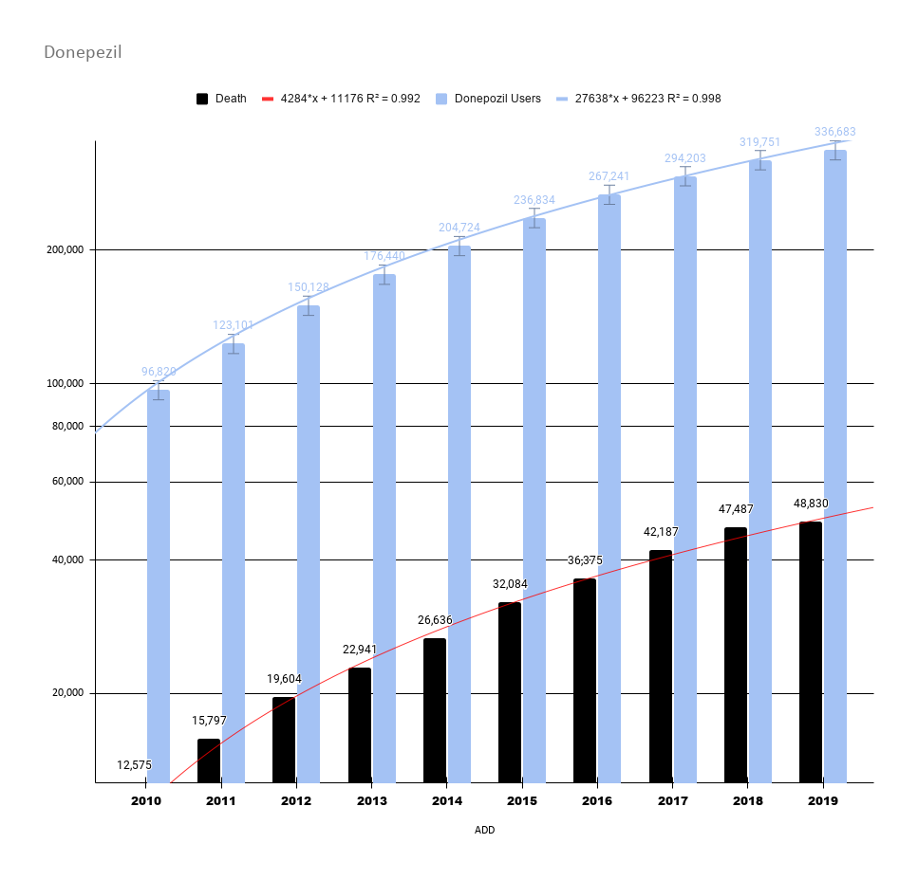
Supplementary Fig.2-1. Graph of donepezil users and deaths in Korea from 2010 to 2019
The number of users who took donepezil in Korea increased 3.48 times, and the number of deaths increased 3.88 times from 2010 to June 2019. Donepezil users' life expectancies were significantly observed between 2017 and 2019. The DMA was strengthened on June 12 2018.

Supplementary Table9. Rivastigmine and User and Death Toll
year | code | Rivastigmine user | death
2010 | 2245 | 8,070 | 780
2011 | 2245 | 9,788 | 850
2012 | 2245 | 11,218 | 1,103
2013 | 2245 | 11,935 | 1,170
2014 | 2245 | 13,705 | 1,291
2015 | 2245 | 15,542 | 1,847
2016 | 2245 | 15,103 | 1,682
2017 | 2245 | 14,443 | 1,716
2018 | 2245 | 14,777 | 1,839
2019 | 2245 | 14,964 | 1,840

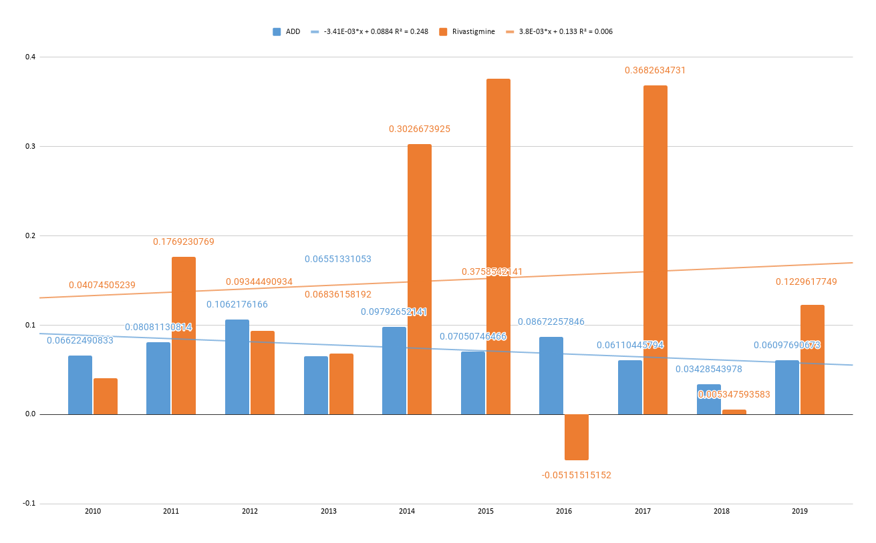
Supplementary Fig.3. Rivastigmine Trend line. 3.8E-03*x + 0.133 R² = 0.006
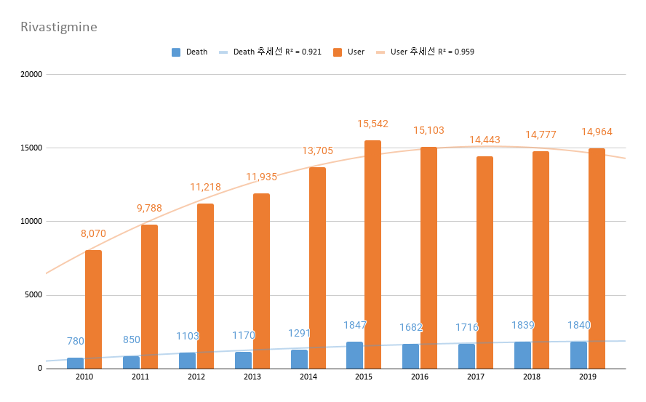
Supplementary Fig.3-1. Rivastigmine Trend line. The number of users who took rivastigmine in Korea increased 1.84 times, and the number of deaths increased by 2.36 times from 2010 to June 2019

Supplementary Table10. Memantine and User and the Death Toll
year | code | Memantine user | death
2010 | 1900 | 31,965 | 5,559
2011 | 1900 | 35,315 | 5,945
2012 | 1900 | 37,138 | 6,419
2013 | 1900 | 38,391 | 6,403
2014 | 1900 | 43,165 | 6,568
2015 | 1900 | 52,358 | 8,134
2016 | 1900 | 58,626 | 9,080
2017 | 1900 | 65,605 | 10,718
2018 | 1900 | 70,873 | 11,597
2019 | 1900 | 79,770 | 12,714

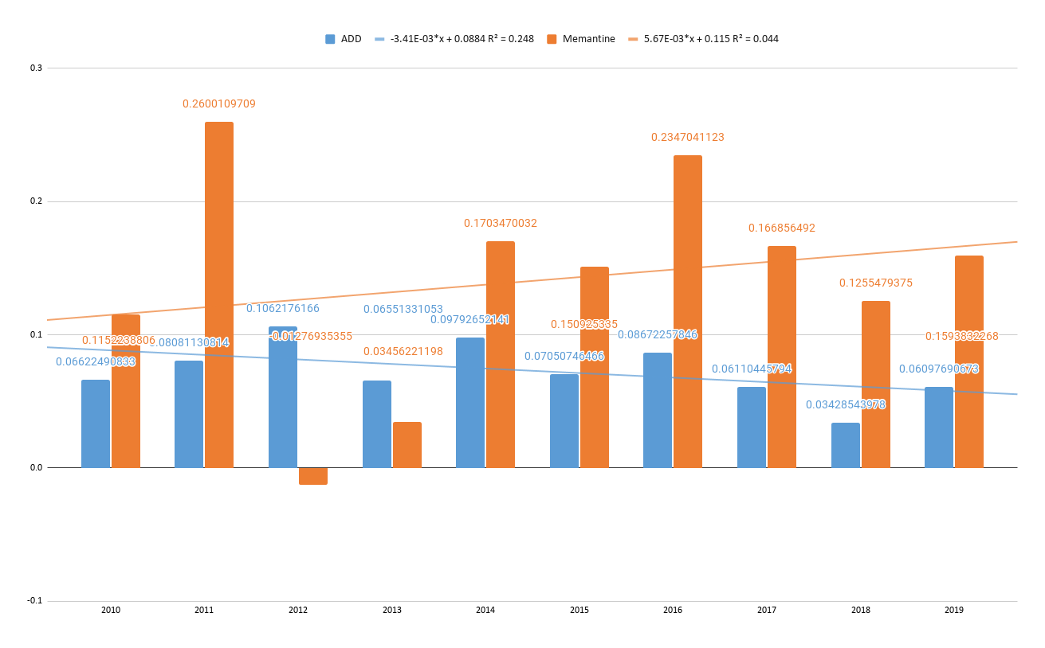
Supplementary Fig.4. Memantine Trend line. 5.67E-03*x + 0.115 R² = 0.044
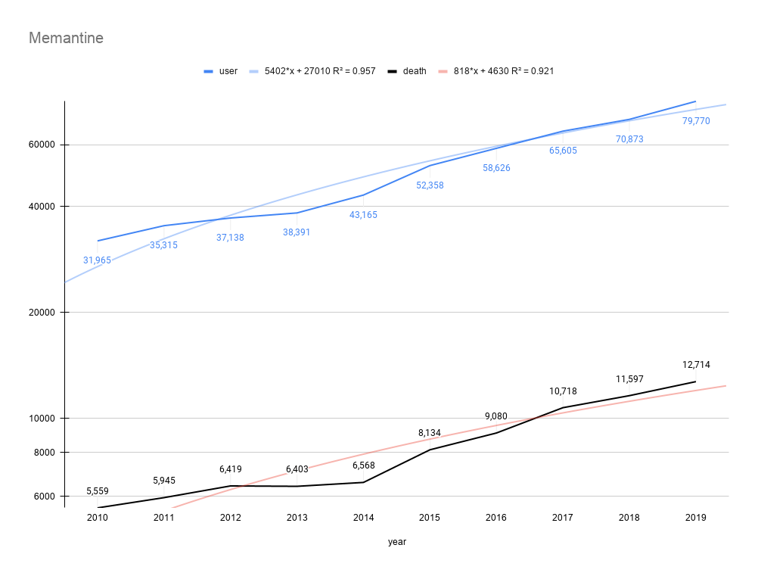
Supplementary Fig.4-1. Graph with memantine users and deaths in Korea from 2010 to 2019
The number of users who took memantine in Korea increased 2.50 times, and the number of deaths increased by 2.29 times from 2010 to June 2019. Memantine is an uncompetitive NMDA receptor modulator. It is prescribed to treat moderate-to-severe AD.

Supplementary Table11. Risperidone and User and Death Toll
year | code | Risperidone user | death
2010 | 2242 | 181,728 | 8,945
2011 | 2242 | 186,077 | 8,976
2012 | 2242 | 191,121 | 9,519
2013 | 2242 | 189,702 | 9,354
2014 | 2242 | 190,178 | 9,271
2015 | 2242 | 195,951 | 10,052
2016 | 2242 | 199,776 | 10,396
2017 | 2242 | 203,635 | 10,822
2018 | 2242 | 208,994 | 11,179
2019 | 2242 | 228,123 | 12,044

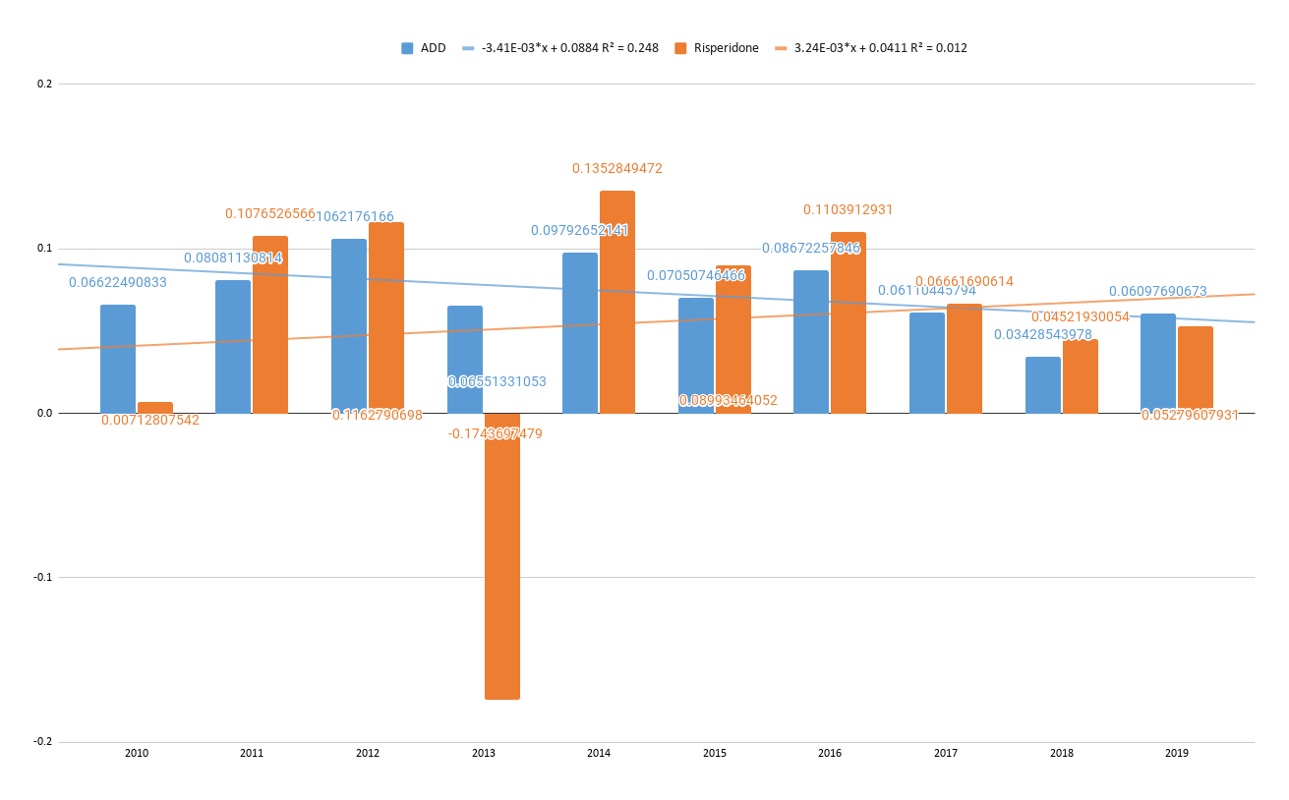
Supplementary Fig.5. Risperidone Trend line. 3.24E-03*x + 0.0411 R² = 0.012
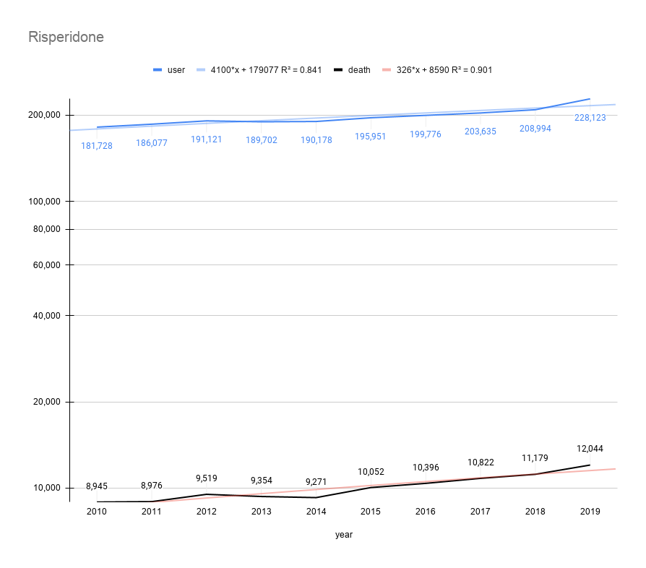
Supplementary Fig.5-1. Graph with risperidone users and deaths in Korea from 2010 to 2019
The number of users who took risperidone in Korea increased 1.26 times, and the number of deaths increased by 1.35 times from 2010 to June 2019. Risperidone is an antipsychotic medication prescribed to treat schizophrenia and bipolar disorder. It is known to increase the mortality of dementia patients.

Supplementary Table12. Fluoxetine and User and Death Toll
year | code | Fluoxetine user | death
2010 | 1802 | 156,899 | 1,802
2011 | 1802 | 151,252 | 1,580
2012 | 1802 | 150,654 | 1,582
2013 | 1802 | 140,194 | 1,439
2014 | 1802 | 134,013 | 1,395
2015 | 1802 | 133,262 | 1,373
2016 | 1802 | 137,846 | 1,329
2017 | 1802 | 144,496 | 1,268
2018 | 1802 | 157,170 | 1,369
2019 | 1802 | 173,284 | 1,405

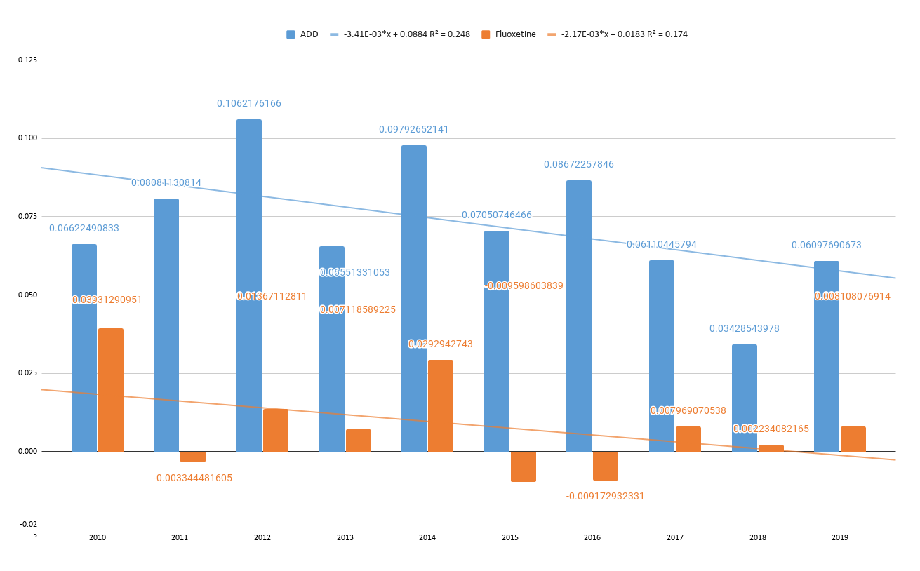
Supplementary Fig.6. Fluoxetine Trend line. -2.17E-03*x + 0.0183 R² = 0.174

Supplementary Table13. Olanzapine and User and Death Toll
year | code | Olanzapine user | death
2010 | 2040 | 37,810 | 1,654
2011 | 2040 | 45,177 | 2,001
2012 | 2040 | 54,344 | 2,681
2013 | 2040 | 59,184 | 3,112
2014 | 2040 | 63,444 | 3,276
2015 | 2040 | 64,123 | 3,036
2016 | 2040 | 66,902 | 3,368
2017 | 2040 | 75,153 | 3,700
2018 | 2040 | 81,868 | 4,042
2019 | 2040 | 87,565 | 4,359

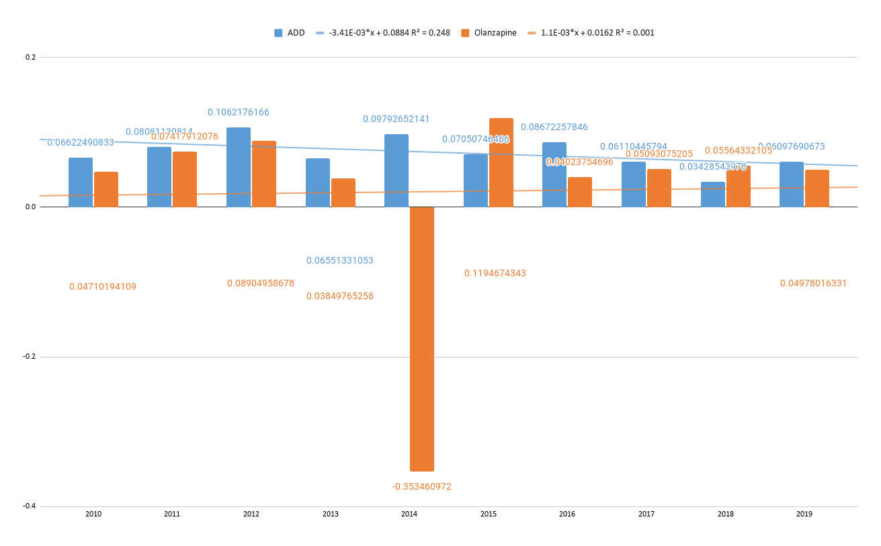
Supplementary Fig.7. Olanzapine Trend line. 1.1E-03*x + 0.0162 R2 = 0.001

Supplementary Table14. Sertaline and User and Death Toll
year | code | Sertaline user | death
2010 | 2270 | 71,494 | 1,341
2011 | 2270 | 76,809 | 1,319
2012 | 2270 | 85,193 | 1,377
2013 | 2270 | 86,931 | 1,427
2014 | 2270 | 89,114 | 1,565
2015 | 2270 | 92,676 | 1,522
2016 | 2270 | 103,099 | 1,684
2017 | 2270 | 115,370 | 1,853
2018 | 2270 | 129,710 | 1,982
2019 | 2270 | 142,660 | 2,005

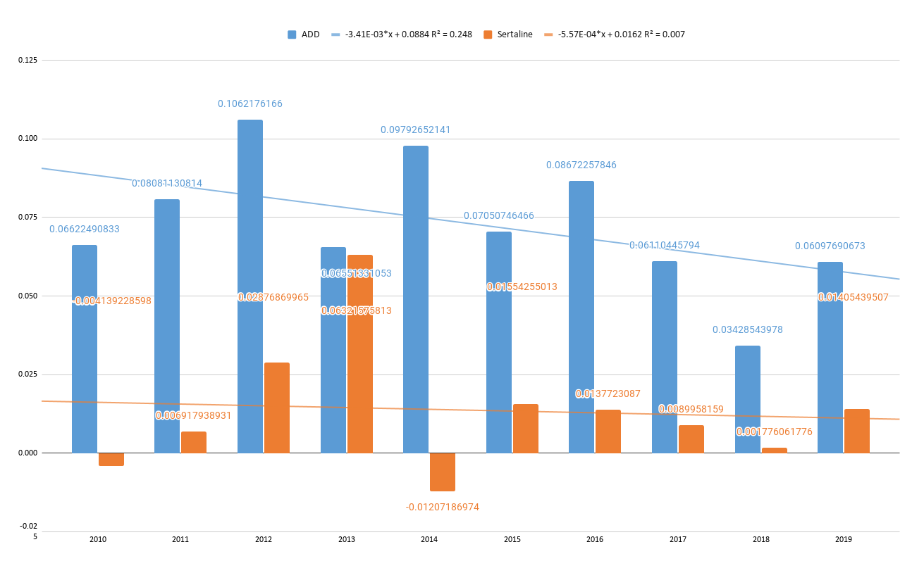
Supplementary Fig.8. Sertaline Trend line. -5.57E-04*x + 0.0162 R² = 0.007

Supplementary Table15. Quetiapine and User and Death Toll
year | code | Quetiapine user | death
2010 | 3786 | 140,218 | 10,654
2011 | 3786 | 172,218 | 13,466
2012 | 3786 | 202,486 | 17,654
2013 | 3786 | 228,140 | 21,117
2014 | 3786 | 259,635 | 24,520
2015 | 3786 | 290,105 | 27,972
2016 | 3786 | 331,811 | 32,972
2017 | 3786 | 384,209 | 39,984
2018 | 3786 | 439,704 | 46,257
2019 | 3786 | 540,397 | 51,767

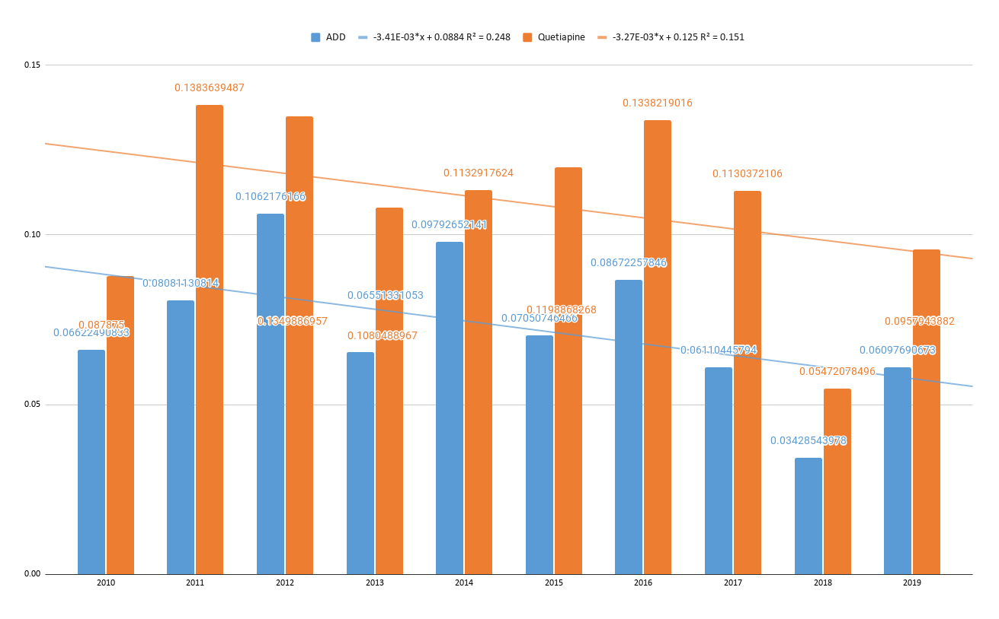
Supplementary Fig.9. Quetiapine Trend line. -3.27E-03*x + 0.125 R² = 0.151

Supplementary Table16. Aripiprazone and User and Death Toll
year | code | Ariprprazone | death
2010 | 4515 | 25,155 | 330
2011 | 4515 | 28,561 | 382
2012 | 4515 | 37,290 | 466
2013 | 4515 | 45,297 | 570
2014 | 4515 | 67,152 | 768
2015 | 4515 | 84,102 | 1,086
2016 | 4515 | 102,241 | 1,164
2017 | 4515 | 133,075 | 1,448
2018 | 4515 | 174,861 | 1,895
2019 | 4515 | 214,761 | 2,211

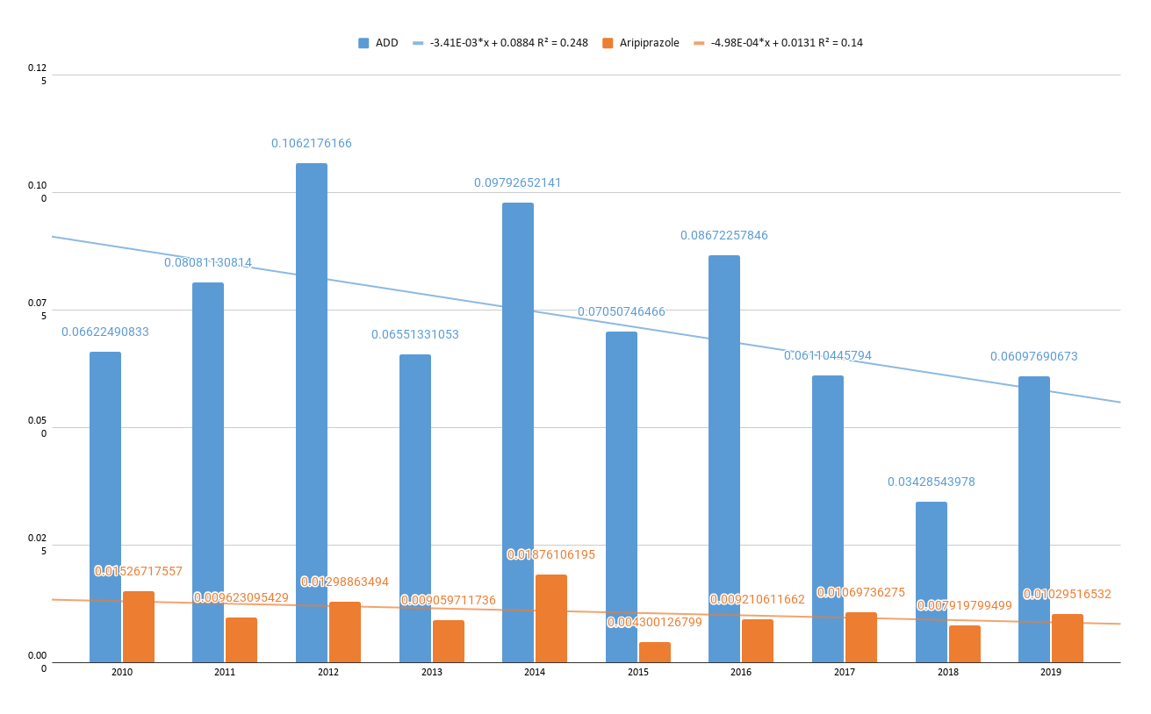
Supplementary Fig.10. Aripiprazone Trend line. -4.98E-04*x + 0.0131 R² = 0.14

Supplementary Table17. Escitalopram and User and the Death Toll
year | code | Escitalopram | death
2010 | 4748 | 227,186 | 5,093
2011 | 4748 | 258,981 | 5,949
2012 | 4748 | 303,698 | 7,060
2013 | 4748 | 326,645 | 7,585
2014 | 4748 | 359,582 | 8,118
2015 | 4748 | 391,772 | 8,726
2016 | 4748 | 431,465 | 9,298
2017 | 4748 | 478,751 | 10,365
2018 | 4748 | 549,235 | 11,480
2019 | 4748 | 612,579 | 12,472

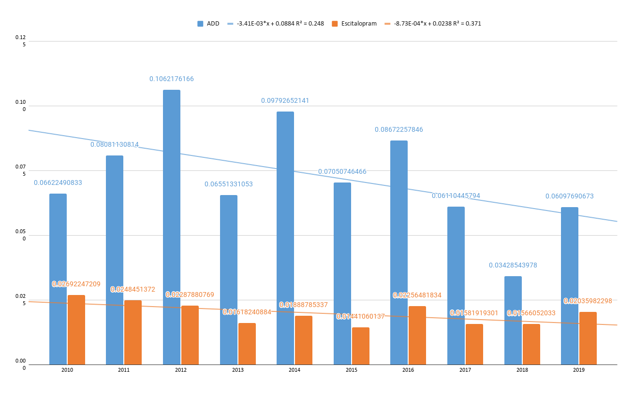
Supplementary Fig.11. Escitalopram Trend line. -8.73E-04*x + 0.0238 R² = 0.371

Supplementary Table18. The others and User and the Death Toll
year | code | The others user | death
2010 | 9999 | 518,890 | 29,795
2011 | 9999 | 537,684 | 30,788
2012 | 9999 | 570,704 | 33,246
2013 | 9999 | 576,421 | 34,654
2014 | 9999 | 603,698 | 36,134
2015 | 9999 | 634,889 | 39,692
2016 | 9999 | 659,428 | 41,003
2017 | 9999 | 689,476 | 43,792
2018 | 9999 | 733,711 | 45,972
2019 | 9999 | 803,750 | 47,585

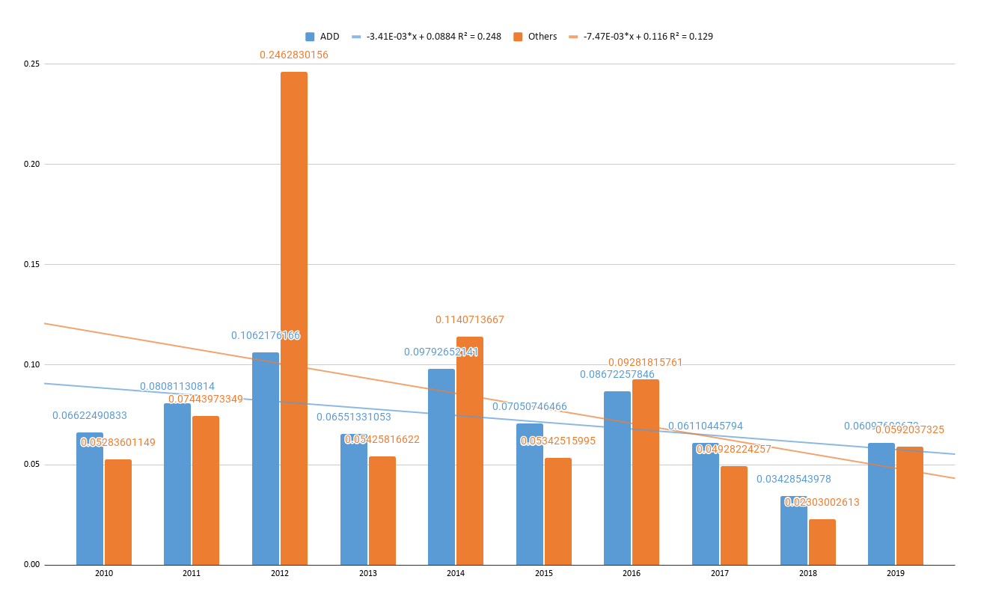
Supplementary Fig.12. AAD The others line. -7.47E-03*x + 0.116 R² = 0.129
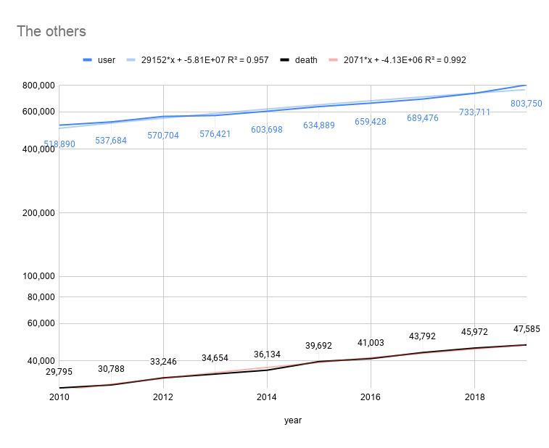
Supplementary Fig. 12-1. Graph with the other users (including galantamine) and deaths in Korea from 2010 to 2019
The number of users who took galantamine and other psychotropic medications in Korea increased 1.55 times, and the number of deaths increased by 1.60 times from 2010 to June 2019.

Datalink & processing sheet – Supplementary Table7 and S8
https://docs.google.com/spreadsheets/d/1I7WbRVIs4ZKZLCHbpytiOsQlZ8KIgRG55tzKKv1P8U8/edit?usp=sharing

Datalink & processing sheet – Supplementary Table9~S18
https://docs.google.com/spreadsheets/d/1gKivXeY7M_Jp7E_QP7YlDZSav2s6DCOcTY3i90-ubt0/edit?usp=sharing

Datalink & processing sheet – Figure 9
https://docs.google.com/spreadsheets/d/1cWk1adwRFXXynmRPkIMnj1rGghZRAPfK9OHKhcEi8kU/edit?usp=sharing

Supplemental Section 3. Statistics
The number of deaths is the independent variable, the group of independent variables is five, and the dependent variable is Lee's hidden data.

Supplementary Table 19. NHIS Dementia Medicines: Users and Deaths Toll
Year | AAD |  | Fluoxetine |  | Olanzapine |  | Sertraline |  | Quetiapine |  | Aripiprazole |  | Escitalopram |  | The others
 | User | Death | user | death | user | death | user | death | user | death | user | death | user | death | user | death
2010 | 1,496,235 | 78,528 | 156,899 | 1,802 | 37,810 | 1,654 | 71,494 | 1,341 | 140,218 | 10,654 | 25,155 | 330 | 227,186 | 5,093 | 518,890 | 29,795
2011 | 1,624,963 | 87,053 | 151,252 | 1,580 | 45,177 | 2,001 | 76,809 | 1,319 | 172,218 | 13,466 | 28,561 | 382 | 258,981 | 5,949 | 537,684 | 30,788
2012 | 1,793,974 | 100,711 | 150,654 | 1,582 | 54,344 | 2,681 | 85,193 | 1,377 | 202,486 | 17,654 | 37,290 | 466 | 303,698 | 7,060 | 570,704 | 33,246
2013 | 1,879,280 | 109,772 | 140,194 | 1,439 | 59,184 | 3,112 | 86,931 | 1,427 | 228,140 | 21,117 | 45,297 | 570 | 326,645 | 7,585 | 576,421 | 34,654
2014 | 2,028,410 | 119,542 | 134,013 | 1,395 | 63,444 | 3,276 | 89,114 | 1,565 | 259,635 | 24,520 | 67,152 | 768 | 359,582 | 8,118 | 603,698 | 36,134
2015 | 2,191,614 | 135,524 | 133,262 | 1,373 | 64,123 | 3,036 | 92,676 | 1,522 | 290,105 | 27,972 | 84,102 | 1,086 | 391,772 | 8,726 | 634,889 | 39,692
2016 | 2,373,538 | 148,351 | 137,846 | 1,329 | 66,902 | 3,368 | 103,099 | 1,684 | 331,811 | 32,972 | 102,241 | 1,164 | 431,465 | 9,298 | 659,428 | 41,003
2017 | 2,598,416 | 167,853 | 144,496 | 1,268 | 75,153 | 3,700 | 115,370 | 1,853 | 384,209 | 39,984 | 133,075 | 1,448 | 478,751 | 10,365 | 689,476 | 43,792
2018 | 2,880,654 | 185,099 | 157,170 | 1,369 | 81,868 | 4,042 | 129,710 | 1,982 | 439,704 | 46,257 | 174,861 | 1,895 | 549,235 | 11,480 | 733,711 | 45,972
2019 | 3,234,536 | 197,232 | 173,284 | 1,405 | 87,565 | 4,359 | 142,660 | 2,005 | 540,397 | 51,767 | 214,761 | 2,211 | 612,579 | 12,472 | 803,750 | 47,585

Supplementary Table 19-1. NHIS Dementia Medicines: Users and Deaths Toll
Year | AAD group 1 excluding galantamine |  | Donepezil |  | Rivastigmine |  | Memantine
 | User | Death | User | Death | User | Death | user | death
2010 | 136,855 | 18,914 | 96,820 | 12,575 | 8,070 | 780 | 31,965 | 5,559
2011 | 168,204 | 22,592 | 123,101 | 15,797 | 9,788 | 850 | 35,315 | 5,945
2012 | 198,484 | 27,126 | 150,128 | 19,604 | 11,218 | 1,103 | 37,138 | 6,419
2013 | 226,766 | 30,514 | 176,440 | 22,941 | 11,935 | 1,170 | 38,391 | 6,403
2014 | 261,594 | 34,495 | 204,724 | 26,636 | 13,705 | 1,291 | 43,165 | 6,568
2015 | 304,734 | 42,065 | 236,834 | 32,084 | 15,542 | 1,847 | 52,358 | 8,134
2016 | 340,970 | 47,137 | 267,241 | 36,375 | 15,103 | 1,682 | 58,626 | 9,080
2017 | 374,251 | 54,621 | 294,203 | 42,187 | 14,443 | 1,716 | 65,605 | 10,718
2018 | 405,401 | 60,923 | 319,751 | 47,487 | 14,777 | 1,839 | 70,873 | 11,597
2019 | 431,417 | 63,384 | 336,683 | 48,830 | 14,964 | 1,840 | 79,770 | 12,714
 | Results of mortality
Year | AAD group 1 excluding galantamine |  | Donepezil |  | Rivastigmine |  | Memantine
 | User | Death | User | Death | User | Death | user | death
2010 |  | 0.1382 |  | 0.1299 |  | 0.0967 |  | 0.1739
2011 |  | 0.1343 |  | 0.1283 |  | 0.0868 |  | 0.1683
2012 |  | 0.1367 |  | 0.1306 |  | 0.0983 |  | 0.1728
2013 |  | 0.1346 |  | 0.1300 |  | 0.0980 |  | 0.1668
2014 |  | 0.1319 |  | 0.1301 |  | 0.0942 |  | 0.1522
2015 |  | 0.1380 |  | 0.1355 |  | 0.1188 |  | 0.1554
2016 |  | 0.1382 |  | 0.1361 |  | 0.1114 |  | 0.1549
2017 |  | 0.1459 |  | 0.1434 |  | 0.1188 |  | 0.1634
2018 |  | 0.1503 |  | 0.1485 |  | 0.1245 |  | 0.1636
2019 |  | 0.1469 |  | 0.1450 |  | 0.1230 |  | 0.1594
One-Way ANOVA Calculator
Summary of Data
 | Treatments
 | 1 | 2 | 3 | 4 | 5 | Total
N | 10 | 10 | 10 | 10 |  | 40
∑X | 1.395 | 1.3574 | 1.0705 | 1.6307 |  | 5.4536
Mean | 0.1395 | 0.1357 | 0.1071 | 0.1631 |  | 0.136
∑X² | 0.1949 | 0.1847 | 0.1163 | 0.2664 |  | 0.7624
Std.Dev. | 0.0061 | 0.0074 | 0.0137 | 0.0075 |  | 0.022
Result Details
Source |  | SS | df | MS
Between-treatments |  | 0.0158 | 3 | 0.0053 | F = 62.7191
Within-treatments |  | 0.003 | 36 | 0.0001
Total |  | 0.0189 | 39
The f-ratio value is 62.7191. The p-value is < .00001. The result is significant at p < .05.
The values of the Friedman X²_{r} statistic and p appear
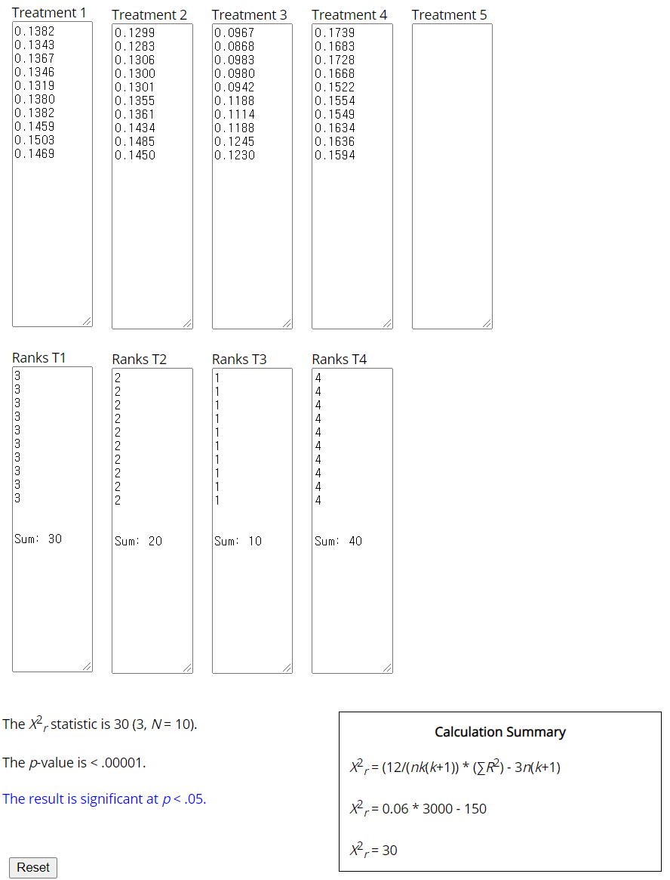

Supplementary Table 20. NHIS Dementia Medicines: Users and Deaths Toll
Year | AAD |  | Donepezil |  | Rivastigmine |  | Memantine |  | Risperidone
 | User | Death | User | Death | User | Death | user | death | user | death
2010 | 1,496,235 | 78,528 | 96,820 | 12,575 | 8,070 | 780 | 31,965 | 5,559 | 181728 | 8945
2011 | 1,624,963 | 87,053 | 123,101 | 15,797 | 9,788 | 850 | 35,315 | 5,945 | 186077 | 8976
2012 | 1,793,974 | 100,711 | 150,128 | 19,604 | 11,218 | 1,103 | 37,138 | 6,419 | 191121 | 9519
2013 | 1,879,280 | 109,772 | 176,440 | 22,941 | 11,935 | 1,170 | 38,391 | 6,403 | 189702 | 9354
2014 | 2,028,410 | 119,542 | 204,724 | 26,636 | 13,705 | 1,291 | 43,165 | 6,568 | 190178 | 9271
2015 | 2,191,614 | 135,524 | 236,834 | 32,084 | 15,542 | 1,847 | 52,358 | 8,134 | 195951 | 10052
2016 | 2,373,538 | 148,351 | 267,241 | 36,375 | 15,103 | 1,682 | 58,626 | 9,080 | 199776 | 10396
2017 | 2,598,416 | 167,853 | 294,203 | 42,187 | 14,443 | 1,716 | 65,605 | 10,718 | 203635 | 10822
2018 | 2,880,654 | 185,099 | 319,751 | 47,487 | 14,777 | 1,839 | 70,873 | 11,597 | 208994 | 11179
2019 | 3,234,536 | 197,232 | 336,683 | 48,830 | 14,964 | 1,840 | 79,770 | 12,714 | 228123 | 12044
Supplementary Table20-1. Lee's hidden equation for a comparison graph of five independent variables
Year | AAD | Donepezil | Rivastigmine | Memantine | Risperidone
2010 | 0.0662 | 0.1226 | 0.0407 | 0.1152 | 0.0071
2011 | 0.0808 | 0.1409 | 0.1769 | 0.2600 | 0.1077
2012 | 0.1062 | 0.1268 | 0.0934 | -0.0128 | 0.1163
2013 | 0.0655 | 0.1306 | 0.0684 | 0.0346 | -0.1744
2014 | 0.0979 | 0.1697 | 0.3027 | 0.1703 | 0.1353
2015 | 0.0705 | 0.1411 | 0.3759 | 0.1509 | 0.0899
2016 | 0.0867 | 0.2156 | -0.0515 | 0.2347 | 0.1104
2017 | 0.0611 | 0.2075 | 0.3683 | 0.1669 | 0.0666
2018 | 0.0343 | 0.0793 | 0.0053 | 0.1255 | 0.0452
2019 | 0.0610 | 0.1450 | 0.1230 | 0.1594 | 0.0528
One-Way Repeated Measures ANOVA Calculator
Summary of Data
 | Treatments
 | AAD | Donepezil |  | Rivastigmine |  | Memantine |  | Risperidone |  | Total
N | 10 | 10 |  | 10 |  | 10 |  | 10 |  | 50
∑X | 0.7302 | 1.4791 |  | 1.5031 |  | 1.4047 |  | 0.5569 |  | 5.674
Mean | 0.073 | 0.1479 |  | 0.1503 |  | 0.1405 |  | 0.0557 |  | 0.113
∑X² | 0.0572 | 0.2336 |  | 0.4327 |  | 0.2581 |  | 0.1034 |  | 1.085
Std.Dev. | 0.0207 | 0.0406 |  | 0.1516 |  | 0.0822 |  | 0.0897 |  | 0.0949
Result Details
Source |  |  | SS |  | df |  | MS
Between-treatments |  |  | 0.0825 |  | 4 |  | 0.0206 |  | F = 3.2028
Within-treatments |  |  | 0.3587 |  | 45 |  | 0.008
Error |  |  | 0.2317 |  | 36 |  | 0.0064
The F-ratio value is 3.2028. The p-value is .023868. The result is significant at p < .05.
(https://www.socscistatistics.com/tests/anovarepeated/default.aspx)
The values of F and p appear significant.

