HLA-DR4Pred2: An improved method for predicting HLA-DRB1*04:01 binders
Sumeet Patiyal, Anjali Dhall, Nishant Kumar, Gajendra P. S. Raghava*
Department of Computational Biology, Indraprastha Institute of Information Technology, Okhla Phase 3, New Delhi-110020, India.

Mailing Address of Authors
Sumeet Patiyal (SP): sumeetp@iiitd.ac.in ORCID ID: https://orcid.org/0000-0003-1358-292X
Anjali Dhall (AD): anjalid@iiitd.ac.in ORCID ID: https://orcid.org/0000-0002-0400-2084
Nishant Kumar (NK) nishantk@iiitd.ac.in ORCID ID: https://orcid.org/0000-0001-7781-9602
Gajendra P. S. Raghava (GPSR): raghava@iiitd.ac.in ORCID ID: https://orcid.org/0000-0002-8902-2876

*Corresponding Author
Prof. Gajendra P. S. Raghava
Head and Professor
Department of Computational Biology
Indraprastha Institute of Information Technology, Delhi
Okhla Industrial Estate, Phase III (Near Govind Puri Metro Station)
New Delhi, India – 110020 Office: A-302 (R&D Block)
Phone: 011-26907444
Email: raghava@iiitd.ac.in
Website: http://webs.iiitd.edu.in/raghava/

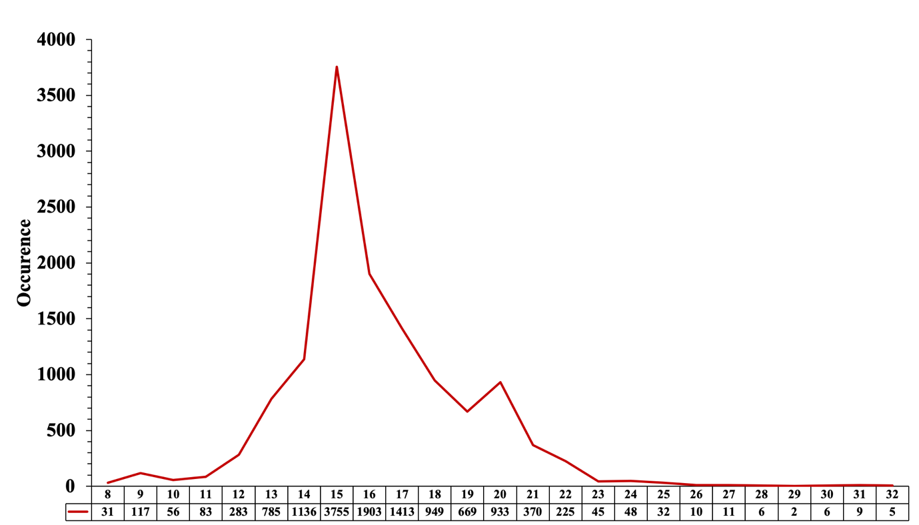

Supplementary Figure 1: Lengthwise distribution of HLA-DRB1*04:01 binding peptides

