Appendix I – Demographic Sheet
(A) Demographic information
Name: __________________________
Gender: |  |  | □ Male |  |  | □ Female
Age: | □ 6 |  |  | □ 7 |  |  | □ 8 |  | □ 9 |  | □ 10 |  | □ 11 | □ 12 |  |  | □ 13
 | □ 14 |  |  | □ 15 |  |  | □ 16 |  | □ 17 |  | □ 18 |  | □ 19 | □ 20 or above
Grade: |  | □ P1 |  |  | □ P2 |  |  | □ P3 |  | □ P4 |  | □ P5 |  |  | □ P6
 |  | □ S1 |  |  | □ S2 |  |  | □ S3 |  | □ S4 |  | □ S5 |  |  | □ S6

Appendix II – Mood Scale

(B) Mood Scale
 | Mood Scale
 | 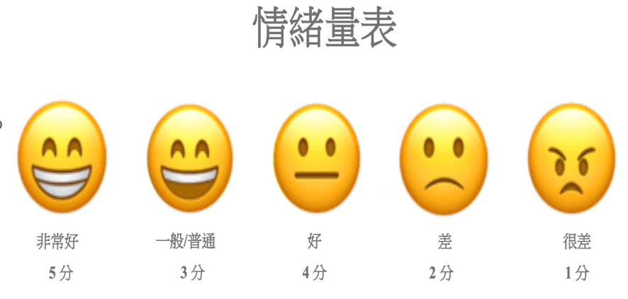
Very Good  5 |  | Good  4 | Neutral  3 | Bad  2 | Very Bad  1

Appendix III – Short Chinese version of Stat-Trait Anxiety Inventory (STAI)
(C) STAI-S and STAT-T-7)

Domains / Items | Not at all | Somewhat | Moderately so | Very much so
Here’s how you feel at the moment. (STAT-S-6)
1. I feel at ease. | 1 | 2 | 3 | 4
2. I feel comfortable. | 1 | 2 | 3 | 4
3. I am relaxed. | 1 | 2 | 3 | 4
4. I feel content. | 1 | 2 | 3 | 4
5. I feel steady. | 1 | 2 | 3 | 4
6. I feel pleasant. | 1 | 2 | 3 | 4
Here’s how you feel often. (STAI-T-7)
1. I feel pleasant. | 1 | 2 | 3 | 4
2. I feel satisfied with myself. | 1 | 2 | 3 | 4
3. I feel rested. | 1 | 2 | 3 | 4
4. I am calm, cool and collected. | 1 | 2 | 3 | 4
5. I am happy. | 1 | 2 | 3 | 4
6. I feel secure. | 1 | 2 | 3 | 4
7. I am content. | 1 | 2 | 3 | 4

Appendix IV – The Child Behavior Rating Scale (CBRS)
(d) Self-regulation and Social Skills

Items | Never | Seldom | Sometimes | Often | Always
Classroom Self-regulation Skills
1. Observes rules and follows direction without reminders. | 1 | 2 | 3 | 4 | 5
2. Completes learning tasks in an organized way. | 1 | 2 | 3 | 4 | 5
3. Complete tasks successfully. | 1 | 2 | 3 | 4 | 5
4. Attempts new and challenging tasks. | 1 | 2 | 3 | 4 | 5
5. Concentrate when working, not easily distracted. | 1 | 2 | 3 | 4 | 5
6. Responds to instructions and begins appropriate task. | 1 | 2 | 3 | 4 | 5
7. Takes time to do his/her best work. | 1 | 2 | 3 | 4 | 5
8. Finds and organizes materials. | 1 | 2 | 3 | 4 | 5
9. See own errors on tasks and correct them. | 1 | 2 | 3 | 4 | 5
10. Returns to unfinished tasks after interruption. | 1 | 2 | 3 | 4 | 5
Social Skills (Interpersonal Skills)
1. Willing to share. | 1 | 2 | 3 | 4 | 5
2. Expresses hostility – Verbally. | 1 | 2 | 3 | 4 | 5
3. Expresses hostility – Physically. | 1 | 2 | 3 | 4 | 5
4. Cooperate with playmates. | 1 | 2 | 3 | 4 | 5
5. Take turns without being told to do so. | 1 | 2 | 3 | 4 | 5
6. Complies with adult directives – With little or no resistance. | 1 | 2 | 3 | 4 | 5
7. Does not fuss when doesn’t get teacher’s attention. | 1 | 2 | 3 | 4 | 5

Appendix V – Children Playfulness Scale
(e) Children Playfulness Scale (CPS-23)
Items | Almost never true for me | Seldom true for me | Sometimes true for me | Often true for me | Almost always true for me
I. Social Spontaneity
1. The child assumes a leadership role when playing with others. | 1 | 2 | 3 | 4 | 5
2. The child initiates play with others. | 1 | 2 | 3 | 4 | 5
3. The child is willing to share playthings | 1 | 2 | 3 | 4 | 5
4. The child respond easily to others’ approaches during play. | 1 | 2 | 3 | 4 | 5
5. The child plays cooperatively with other children. | 1 | 2 | 3 | 4 | 5
II. Cognitive spontaneity
6. The child invent his/her own game to play. | 1 | 2 | 3 | 4 | 5
7. The Child stays with one activity rather than changes activity during play. | 1 | 2 | 3 | 4 | 5
8. The child assumes different character roles in play. | 1 | 2 | 3 | 4 | 5
9. The child uses unconventional objects in play | 1 | 2 | 3 | 4 | 5
III. Physical spontaneity
10. The child runs (skips, hops, jumps) a lot in play. | 1 | 2 | 3 | 4 | 5
11. The child prefers to be active rather than quiet in play. | 1 | 2 | 3 | 4 | 5
12. The child is physically active during play. | 1 | 2 | 3 | 4 | 5
13. The child’s movement are generally well-coordinated during play activities. | 1 | 2 | 3 | 4 | 5
IV. Sense of humor
14. The child enjoys joking with other children. | 1 | 2 | 3 | 4 | 5
15. The child tells funny stories | 1 | 2 | 3 | 4 | 5
16. The child gently teases others while at play. | 1 | 2 | 3 | 4 | 5
17. The child laughs at funny stories. | 1 | 2 | 3 | 4 | 5
18. The child likes to clown around in play. | 1 | 2 | 3 | 4 | 5
V. Manifest Joy
19. The child sings and talks while playing. | 1 | 2 | 3 | 4 | 5
20. The child shows enthusiasm during play. | 1 | 2 | 3 | 4 | 5
21. The child expresses enjoyment during play. | 1 | 2 | 3 | 4 | 5
22. The child demonstrates exuberance during play. | 1 | 2 | 3 | 4 | 5
23. The child is restrained in expressing emotion during play. | 1 | 2 | 3 | 4 | 5

The End

