Supplementary information
An integrated pilot scale UASB and aerotank system for the treatment of rice paper production wastewater: A case study from Phu Hoa Dong, Ho Chi Minh City, Vietnam
Nguyen Trong Hiep¹, Vu Thi Minh Chau¹, Le Thu Thuy², Le Minh Tuan³, Eldon R. Rene⁴, Tran Ngoc Binh⁵, Anina James⁶, and Van Tai Tang^{7,8,*}
¹⁾ Southern Branch of Joint Vietnam-Russia Tropical Science and Technology Research Center, Ho Chi Minh City, Vietnam
Email: hiepnguyen@vrtc.org.vn/chauvu.vrtc@gmail.com (N.T.H/V.T.M.C)
²⁾ Institute of Environmental Technology, Vietnam Academy of Science and Technology, Hanoi, Vietnam
Email: tuangb@gmail.com (L.T.T)
³⁾ Hanoi University of Natural Resources and Environment, Hanoi, Vietnam
Email: ltthuy.mt@hunre.edu.vn (L.M.T)
⁴⁾ IHE Delft Institute for Water Education, Department of Water Supply, Sanitation and Environmental Engineering, 2601 DA Delft, The Netherlands
Email: e.raj@un-ihe.org (E.R.R)
⁵⁾ Vinh Medical University-Faculty of Public Health, Vinh, Vietnam
Email: ngocbinhvmu@gmail.com (T.N.B)
⁶⁾ Department of Zoology, Deen Dayal Upadhyaya College (University of Delhi), Dwarka Sector 3, Delhi, 110078, India
Email: aninajames5408@ddu.du.ac.in (A.J)
⁷⁾ Advanced Applied Sciences Research Group, Dong Nai Technology University, Bien Hoa City, Vietnam.
⁸⁾ Faculty of Technology, Dong Nai Technology University, Bien Hoa City, Vietnam.
Email: tangvantai@dntu.edu.vn (V. T.T)

Corresponding author:
Email: tangvantai@dntu.edu.vn (V. T.T)
1. Bacillus. sp (TB31)

Information: Bacillus. sp (in:Bacteria) strain T21 16S ribosolmal RNA gene, partial sequence
Sequence ID: MT457467.1; Length: 902; Range1: 23 to 902
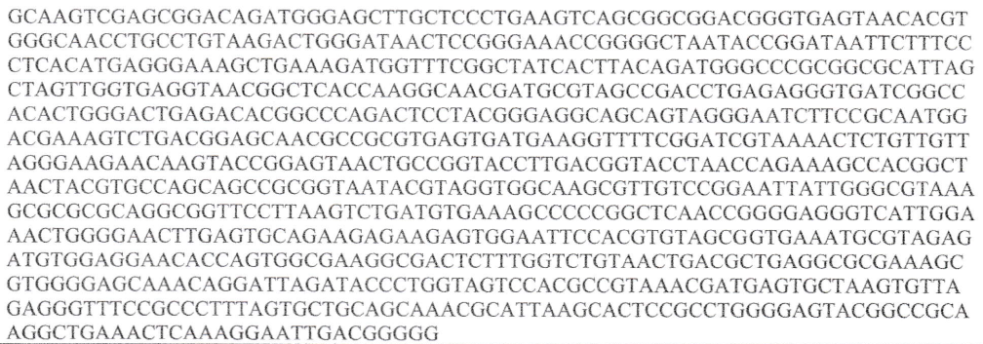

2. Bacillus. thuringiensis (TB17)

Information: Bacillus. thuringiensis (in:Bacteria) strain GS3 16S ribosolmal RNA gene, partial sequence
Sequence ID: M1985372.1; Length: 923; Range1: 8 to 567
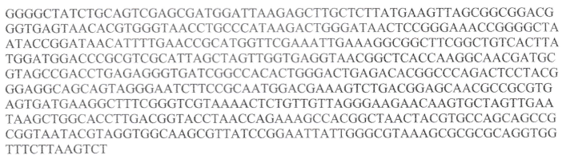

3. Bacillus cereus (TB19)

Information: Bacillus. cereus (in:Bacteria) strain GS3 16S ribosolmal RNA gene, partial sequence
Sequence ID: LC386021.1; Length: 863; Range1: 73 to 863
