Supplementary Materials

Discrepancy Results of Treponemal Tests: Exploring the Associated Risk Factors Using Machine Learning Technology Based on 18 Years of Electronic Medical Records and National Claims Data
Supplementary Table S1. Definitions of diseases might affect syphilis test results.
Supplementary Table S2. Patient characteristics
Supplementary Table S3. Treponemal test pattern for the cases with tests discrepancy
Supplementary Table S4. Association between comorbidities and discrepant syphilis test results. The comorbidities were defined by at least one diagnosis occurrences.
Supplementary Table S5. Association between comorbidities and discrepant syphilis test results. The comorbidities were defined by at least two diagnoses occurrences.
Supplementary Figure S1. Study flow diagram. CGRD: Chang Gung Research Database; NHIRD: National Health Insurance Research Database
Supplementary Figure S2. The online risk calculator based on the TTs discrepancy predictive model

Supplementary Table S1. Definitions of diseases might affect syphilis test results [1–10]
Diseases might affect syphilis test results | ICD-9 | ICD-10
Atrophic disorders of skin | 7010 | L900
Other localized connective tissue disorders | 7010 | L94[013]
Rheumatoid arthritis | 714 | M0[56]
Juvenile arthritis | 7143[02] | M08
Other and unspecified arthropathy | 7144, 7160[0123456789], 7192[0123456789], 7193[0123456789], 7161[123456789], 7164[0123456789], 7168[012345789], | M12
Systemic lupus erythematosus | 7100 | M32
Dermatopolymyositis | 7103 | M33
Scleroderma | 7101, 5172 | M34
Mixed connective tissue disease | 710[2589], 1361, 71120, 725, 7285 | M35
Systemic disorders of connective tissue in diseases classified elsewhere | 7132 | M36
Ankylosing spondylitis | 7200 | M45
Other inflammatory spondylopathies | 720[129], 72089 | M46[01589]
Other spondylopathies | 7240[01239], 7230, 721[5678] | M48
Spondylopathies in diseases classified elsewhere | 72081 | M49
Vasomotor and allergic rhinitis | 477 | J30
Urticaria | 708 | L50
Other and unspecified soft tissue disorders, not elsewhere classified | 729[056], 7293[01], 71944, 7299[029], 72981, 7297[1239] | M79
Psoriasis | 696[01], 6943 | L40
Polyosteoarthritis | 7150[049], 7158[09] | M15
Other and unspecified osteoarthritis | 7151[012347], 7152[0123478], 71530 | M19
Other disorders involving the immune mechanism, not elsewhere classified | 2795[0123], 27941, 2799, 273[02] | D89
Other disorders of arteries and arterioles | 447, 4432 | I77
Inflammatory bowel disease  (Noninfective enteritis and colitis) | 555, 556[2345689], 558, 5357[01] | K5[0-2]
Autoinflammatory syndromes | - | M04
Infectious mononucleosis | 075 | B27
Mycoplasma pneumonia | 4830 | J157
Enterovirus infections | 00867, 04[78], 074, 079[12] | A0839, A850, A870, A880, B08[45], B341, B971
Pregnancy | 63[0123456789], 64[0123456789], 65[0123456789], 66[0123456789], 67[0123456] | O0[01234789], O1[0123456], O2[012345689], O3[0123456], O4[012345678], O6[0123456789], O7[01234567], O8[0256789], O9[012489]
Opioid abuse | 3055 | F11
Tuberculosis | 01[012345678] | A1[5789]
Scarlet fever | 0341 | A38
Viral pneumonia | 4809 | J12
Pneumonia | 48[0123456] | J1[2-7]
Brucellosis | 023 | A23
Rat-bite fever | 026 | A25
Relapsing fever | 087 | A68
Leptospirosis | 100 | A27
Measles | 055 | B05
Mumps | 072 | B26
Lymphogranuloma venereum | 0991 | A55
Malaria | 084 | B5[0-4]
Trypanosomiasis | 086 | B57
Leprosy | 030 | A30
Hashimotos thyroiditis | 2452 | E063
Rheumatic heart disease | 391[89], 3989[09] | I01[89], I099, I0989
Hepatic cirrhosis | 571[023568] | K70[0237], K74, K760, K7689
Polyarteritis nodosa | 4460 | M300
Genital herpes simplex | 0541 | A60
Alcoholic cirrhosis | 5712 | K703

Supplementary Table S2. Patient characteristics
Patient Characteristics | Discrepancy group  (n = 133) | Non-Discrepancy  group (n = 5,647) | p Value
Sex (%)
Male | 60 (45.1) | 2,783 (49.3) | 0.388
Female | 73 (54.9) | 2,864 (50.7)
Age (median  [IQR, Q1–Q3]ª) | 67.8  [35.5, 41.4-76.9] | 44.8  [36.2, 30.1-66.2] | <0.001 *
* p < 0.05, ª IQR, interquartile range [first quartile, third quartile]

Supplementary Table S3. Treponemal test pattern for the cases with tests discrepancy
Treponemal Test Results | n (%)
TPPAª + followed by TPPA- | 94 (70.7)
TPPA+ followed by FTA-Abs^{b}- | 16 (12.0)
FTA-Abs+ followed by TPPA- | 10 (7.5)
TPPA+ followed by FTA-Abs+, and then TPPA- | 7 (5.3)
TPPA+ followed by TPPA- AND FTA-Abs- | 4 (3.0)
FTA-Abs+ followed by TPPA-, and then FTA-Abs- | 2 (1.5)
ª Treponema pallidum particle agglutination. ^{b} Fluorescent treponema antibody absorption.

Supplementary Table S4. Association between comorbidities and discrepant syphilis test results. The comorbidities were defined by at least one diagnosis occurrences.
Comorbidities | Odds Ratio
Comorbidities | Crude  (95%CI) | P value | Adjusted  (95%CI) | P value
HIV and AIDS (Acquired immune deficiency syndrome) | 1.53 (0.84-2.6) | 0.136 | 2.45 (1.3-4.34) | 0.007 *
Alcohol abuse | 2.03 (0.61-4.96) | 0.173 | 2.03 (0.66-4.8) | 0.194
Deficiency anemias | 1.04 (0.51-1.89) | 0.910 | 0.73 (0.36-1.33) | 0.320
Rheumatoid arthritiscollagen vascular diseases | 1.62 (0.82-2.9) | 0.133 | 1.37 (0.7-2.44) | 0.344
Congestive heart failure | 1.67 (0.78-3.15) | 0.144 | 0.99 (0.47-1.89) | 0.986
Chronic pulmonary disease | 1.77 (1.14-2.67) | 0.008 * | 1.27 (0.8-1.94) | 0.302
Coagulation deficiency | 0.92 (0.23-2.47) | 0.889 | 0.78 (0.22-2) | 0.645
Depression | 1.38 (0.61-2.67) | 0.389 | 1.11 (0.5-2.13) | 0.777
Diabetes without chronic complications | 1.89 (1.21-2.84) | 0.003 * | 1.15 (0.73-1.78) | 0.541
Diabetes with chronic complications | 1.62 (0.9-2.71) | 0.084 | 1.03 (0.57-1.74) | 0.918
Drug abuse | 1.96 (0.59-4.78) | 0.195 | 2.07 (0.67-4.9) | 0.183
Hypertension, uncomplicated | 2.05 (1.43-2.9) | 0.000 * | 1.08 (0.71-1.64) | 0.714
Hypertensive heart disease without heart failure | 1.22 (0.6-2.23) | 0.546 | 0.77 (0.38-1.41) | 0.408
Liver disease | 1.01 (0.57-1.66) | 0.978 | 0.89 (0.51-1.46) | 0.660
Fluid and electrolyte disorders | 2.28 (1.21-3.95) | 0.006 * | 1.44 (0.76-2.53) | 0.246
Other neurological disorders | 1.72 (1.02-2.75) | 0.032 * | 1.01 (0.59-1.66) | 0.966
Paralysis | 1.74 (0.67-3.69) | 0.192 | 1.25 (0.5-2.63) | 0.597
Peripheral vascular disease | 1.46 (0.61-2.94) | 0.338 | 1.04 (0.45-2.09) | 0.911
Psychoses | 0.82 (0.32-1.73) | 0.648 | 0.69 (0.28-1.42) | 0.338
Renal failure | 1.44 (0.5-3.23) | 0.430 | 1.03 (0.38-2.26) | 0.953
Solid tumor without metastasis | 0.52 (0.2-1.08) | 0.118 | 0.35 (0.14-0.73) | 0.003*
Chronic peptic ulcer disease | 1.03 (0.43-2.07) | 0.940 | 0.8 (0.35-1.59) | 0.556
Valvular disease | 1.8 (0.84-3.39) | 0.095 | 1.27 (0.6-2.39) | 0.504
Arthropathy (M08, M12) | 1.4 (0.59-2.81) | 0.397 | 1.02 (0.44-2.04) | 0.957
Connective tissue disease  (M33, M34, M35, M36) | 2.42 (0.93-5.17) | 0.039 * | 2.3 (0.92-4.85) | 0.073
Inflammatory spondylopathies  (M45, M46, M48, M49) | 1.33 (0.59-2.57) | 0.446 | 0.93 (0.42-1.8) | 0.841
Hepatic cirrhosis | 0.77 (0.19-2.07) | 0.660 | 0.74 (0.2-1.87) | 0.562
Inflammatory bowel disease | 0.96 (0.57-1.53) | 0.872 | 0.95 (0.57-1.51) | 0.841
Other and unspecified osteoarthritis | 3.91 (1.88-7.29) | 0.000 * | 2.55 (1.23-4.77) | 0.014*
Other and unspecified soft tissue disorders not elsewhere classified | 1.39 (0.82-2.25) | 0.197 | 0.99 (0.57-1.61) | 0.960
Pneumonia | 1.28 (0.71-2.14) | 0.374 | 0.83 (0.46-1.41) | 0.513
Polyosteoarthritis | 1.66 (0.64-3.52) | 0.232 | 1.09 (0.43-2.28) | 0.845
Pregnancy | 1.19 (0.46-2.5) | 0.684 | 1.73 (0.69-3.64) | 0.221
Rheumatoid arthritis | 1.79 (0.54-4.37) | 0.260 | 1.46 (0.47-3.45) | 0.468
Systemic lupus erythematosus | 2.58 (0.62-7.15) | 0.114 | 3.09 (0.83-8.24) | 0.085
Urticaria | 1.05 (0.55-1.83) | 0.877 | 1.03 (0.54-1.79) | 0.924
Vasomotor and allergic rhinitis | 0.81 (0.45-1.35) | 0.453 | 0.8 (0.45-1.33) | 0.412
Adjusted for covariates: Age and Sex. * P < 0.05

Supplementary Table S5. Association between comorbidities and discrepant syphilis test results. The comorbidities were defined by at least two diagnoses occurrences.
Medical histories | Odds Ratio
Medical histories | Crude  (95%CI) | P value | Adjusted  (95%CI) | P value
HIV and AIDS (Acquired immune deficiency syndrome) | 1.64 (0.89-2.78) | 0.085 | 2.59 (1.37-4.59) | 0.004 *
Deficiency anemias | 0.79 (0.24-1.91) | 0.654 | 0.6 (0.2-1.4) | 0.261
Rheumatoid arthritiscollagen vascular diseases | 1.73 (0.72-3.49) | 0.167 | 1.65 (0.71-3.29) | 0.227
Congestive heart failure | 1.88 (0.79-3.81) | 0.111 | 1.14 (0.49-2.32) | 0.737
Chronic pulmonary disease | 1.75 (1.04-2.8) | 0.026 * | 1.21 (0.71-1.97) | 0.465
Depression | 1.6 (0.67-3.24) | 0.232 | 1.28 (0.55-2.56) | 0.535
Diabetes without chronic complications | 1.83 (1.13-2.84) | 0.009 * | 1.13 (0.69-1.79) | 0.607
Diabetes with chronic complications | 1.61 (0.83-2.82) | 0.123 | 1.03 (0.53-1.81) | 0.934
Hypertension, uncomplicated | 2.03 (1.41-2.9) | 0.000 * | 1.1 (0.72-1.66) | 0.667
Hypertensive heart disease without heart failure | 1.36 (0.53-2.86) | 0.472 | 0.85 (0.34-1.77) | 0.685
Liver disease | 0.61 (0.27-1.18) | 0.183 | 0.57 (0.26-1.08) | 0.087
Fluid and electrolyte disorders | 3.7 (1.63-7.32) | 0.001 * | 2.16 (0.95-4.32) | 0.064
Other neurological disorders | 2.17 (1.21-3.65) | 0.006 * | 1.28 (0.7-2.2) | 0.411
Peripheral vascular disease | 2.92 (1.12-6.26) | 0.013 * | 1.91 (0.76-4.08) | 0.156
Solid tumor without metastasis | 0.44 (0.11-1.16) | 0.159 | 0.32 (0.09-0.81) | 0.013*
Chronic peptic ulcer disease | 1.17 (0.41-2.6) | 0.739 | 0.94 (0.35-2.05) | 0.885
Valvular disease | 2.83 (1.25-5.55) | 0.006 * | 1.97 (0.88-3.85) | 0.093
Arthropathy (M08, M12) | 2.5 (0.87-5.66) | 0.051 | 1.9 (0.69-4.22) | 0.192
Connective tissue disease  (M33, M34, M35, M36) | 2.66 (0.8-6.57) | 0.061 | 2.79 (0.9-6.72) | 0.072
Inflammatory bowel disease | 1.3 (0.58-2.52) | 0.479 | 1.34 (0.61-2.57) | 0.435
Inflammatory spondylopathies  (M45, M46, M48, M49) | 2.17 (0.9-4.4) | 0.051 | 1.6 (0.69-3.23) | 0.254
Other and unspecified osteoarthritis | 4.18 (1.72-8.66) | 0.000 * | 2.75 (1.16-5.67) | 0.024*
Other and unspecified soft tissue disorders not elsewhere classified | 2.22 (1.28-3.64) | 0.003 * | 1.51 (0.86-2.51) | 0.141
Pneumonia | 1.68 (0.82-3.08) | 0.122 | 1.09 (0.53-2.02) | 0.806
Polyosteoarthritis | 2.56 (0.89-5.8) | 0.045 * | 1.59 (0.58-3.58) | 0.335
Pregnancy | 1.73 (0.6-3.88) | 0.240 | 2.78 (1-6.31) | 0.050*
Rheumatoid arthritis | 2.48 (0.6-6.86) | 0.130 | 2.07 (0.56-5.47) | 0.241
Urticaria | 1.39 (0.58-2.8) | 0.404 | 1.31 (0.57-2.61) | 0.493
Vasomotor and allergic rhinitis | 1.19 (0.62-2.08) | 0.574 | 1.11 (0.59-1.94) | 0.723
Adjusted for covariates: Age and Sex. * P < 0.05

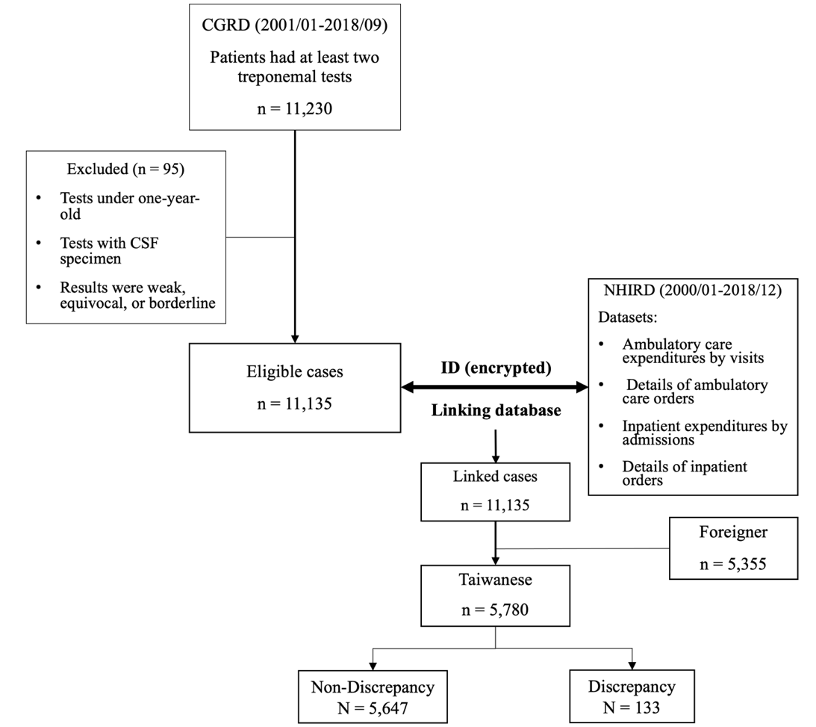
Supplementary Figure S1. Study flow diagram. CGRD: Chang Gung Research Database; NHIRD: National Health Insurance Research Database
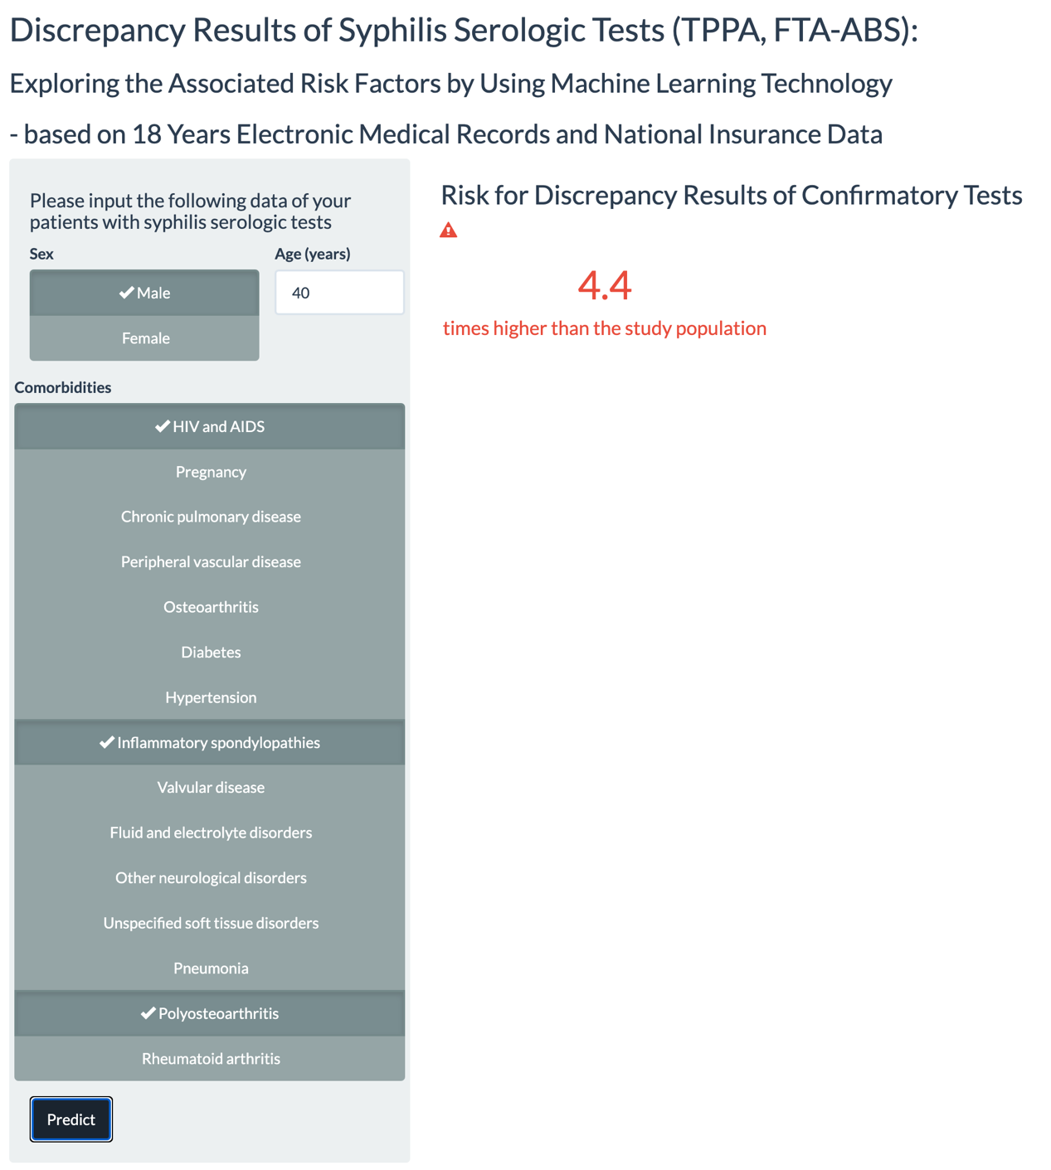
Supplementary Figure S2. The online risk calculator based on the TTs discrepancy predictive model https://yijutseng.shinyapps.io/SyphilisTTDiscrepancy/

References
1. Trepka MJ, Sheehan DM, Fennie KP, et al (2016) Completeness of HIV reporting on death certificates for Floridians reported with HIV infection, 2000-2011. AIDS Care 28:98–103. https://doi.org/10.1080/09540121.2015.1069786
2. Watkins DA, Johnson CO, Colquhoun SM, et al (2017) Global, Regional, and National Burden of Rheumatic Heart Disease, 1990–2015. New England Journal of Medicine 377:713–722. https://doi.org/10.1056/NEJMoa1603693
3. Deiss R, Bower RJ, Co E, et al (2016) The Association between Sexually Transmitted Infections, Length of Service and Other Demographic Factors in the U.S. Military. PLoS One 11:e0167892–e0167892. https://doi.org/10.1371/journal.pone.0167892
4. Lamagni T, Guy R, Chand M, et al (2018) Resurgence of scarlet fever in England, 2014–16: a population-based surveillance study. Lancet Infect Dis 18:180–187. https://doi.org/https://doi.org/10.1016/S1473-3099(17)30693-X
5. Rüütel K, Lemsalu L, Lätt S (2018) Monitoring HIV-indicator condition guided HIV testing in Estonia. HIV Med 19:47–51. https://doi.org/10.1111/hiv.12586
6. Jones RP (2010) Can time-related patterns in diagnosis for hospital admission help identify common root causes for disease expression? Med Hypotheses 75:148–154. https://doi.org/https://doi.org/10.1016/j.mehy.2010.02.009
7. Gil A, San-Martı́n M, Carrasco P, González A (2002) Epidemiology of Pneumonia Hospitalizations in Spain, 1995–1998. Journal of Infection 44:84–87. https://doi.org/https://doi.org/10.1053/jinf.2002.0966
8. Sickbert-Bennett EE, Weber DJ, Poole C, et al (2010) Utility of International Classification of Diseases, Ninth Revision, Clinical Modification Codes for Communicable Disease Surveillance. Am J Epidemiol 172:1299–1305. https://doi.org/10.1093/aje/kwq285
9. Zákoucká H, Polanecký V, Kaštánková V (2004) Syphilis and gonorrhoea in the Czech Republic. Eurosurveillance 9:13–14. https://doi.org/https://doi.org/10.2807/esm.09.12.00496-en
10. Lin J-N, Lin C-L, Lin M-C, et al (2015) Risk of leukaemia in children infected with enterovirus: a nationwide, retrospective, population-based, Taiwanese-registry, cohort study. Lancet Oncol 16:1335–1343. https://doi.org/https://doi.org/10.1016/S1470-2045(15)00060-1

