Supplementary information
Text S1: Bioenergy crop cultivation maps
The two cultivation maps from 2015 to 2100 in the study are based on the bioenergy with carbon capture and storage (BECCS) scenarios from the integrated assessment model, MAgPIE (Popp et al., 2014) under the SSP2-2.6 (Shared Socio-economic Pathway 2 and Representative Concentration Pathway 2.6, the low-warming scenario) and SSP5-3.4 (SSP5 and RCP3.4, the overshoot scenario) pathways (Hurtt et al., 2020). The maps were generated by harmonizing the historical patterns of cropland, pasture and grassland based on the Global Environmental History Database (HYDE 3.1) (Klein et al., 2011). The low-warming BECCS scenario of MAgPIE employs BECCS as the only negative emission technology (NET), and thus there are no other NETs such as afforestation and reforestation (Hurtt et al., 2020). These global cultivation maps show bioenergy crop cultivation in both CN and non-CN countries (Figure 1). The total cultivation area under the low-warming scenario expands to 408 Mha in 2100 (352 Mha in the CN countries and 56 Mha in the non-CN countries). In the overshoot scenarios, the air temperature will increase rapidly and exceed the 2 °C warming target of Pairs Agreement in the first half of the 21st century, and NETs (mainly BECCS) will be widely deployed after 2040 (Hurtt et al., 2020). Hence, in the overshoot BECCS scenario, the total bioenergy crop cultivation area will reach 803 Mha in 2100 (645 Mha in the CN countries and 158 Mha in the non-CN countries). In line with the principle of cost minimization in MAgPIE, the bioenergy crop expansion area mainly comes from low vegetation such as cropland, pasture and grassland (Popp et al., 2014), and more forests will be converted into bioenergy crop cultivation under overshoot scenario than under low-warming scenario (Figure S2).

Text S2: Estimating the biogeochemical effects
2.1 Response curves of carbon pools and calculation of net carbon-dioxide removal (CDR)
The offline simulation in this study used an improved version of the DGVM of ORCHIDEE-MICT (Guimberteau et al., 2018). This version incorporates processes related to the growth, ecology, and biomass harvest of bioenergy crops (Li et al., 2018). It includes four additional Plant Functional Types (PFTs) representing bioenergy crops: eucalypt, poplar-willow, miscanthus, and switchgrass. The parameterizations of the physiological processes, growth, and phenology of these bioenergy crop PFTs area based on extensive field observations (Li et al., 2018). This model version also includes a carbon pool for post-harvest biomass and a dynamic forest age-based harvest module specifically designed for woody bioenergy crops. The model has been validated and shown to perform well in simulating global bioenergy crop yields (Li et al., 2018; Li et al., 2018; Wang et al., 2021; Wang et al., 2023).
The response curves of carbon pools for 4 types of land use change (LUC) (from forest, grass, pasture and cropland to switchgrass) were obtained from the offline simulations, and then used to calculate the CDR under different bioenergy crop cultivation scenarios (see details in Wang et al. (2023)). Specifically, the spin-up simulations were run to reach a steady state of the terrestrial ecosystem, where the atmospheric CO₂ concentration and land cover remained at the level of 1900, and a 20-year meteorological data cycle from 1901 to 1920 was used as the climate forcing data. Further, to simulate the historical carbon dynamics from 1901 to 2014, the historical transient climate data (Viovy et al., 2018), varying atmospheric CO₂ concentration data (https://gml.noaa.gov/ccgg/trends/global.html) and annually updated PFT maps (Sitch et al., 2015; Peng et al., 2015) were used to force the model.
In the next stage for simulations of idealized bioenergy crop cultivation, the atmospheric CO₂ concentration and land use type were fixed at the level of 2014, and the climate forcing data were cycled from 2007 to 2016 (Viovy et al., 2018). In each idealized bioenergy crop cultivation simulation, one of the original vegetation types (such as cropland) would be converted to switchgrass cultivation in 2015 initially, and the model was then run to 2100 to obtain the response curves of different carbon pools. Therefore, each idealized bioenergy crop cultivation simulation could reflect the change of carbon pool caused by the conversion of one original land use type to switchgrass. We extracted the response curves at 0.5° × 0.5° grid level for different carbon pools including biomass, soil carbon, harvested bioenergy biomass, carbon capture and sequestration (CCS) processing loss. Their relationships follow:
$CDR= F_{CCS}+ F_{LUC}$ (S1)
$F_{CCS}= {Bioe}_{harvest}- {CCS}_{loss}= {Bioe}_{harvest}× {CCS}_{efficiency}$ (S2)
${CCS}_{loss}= {Bioe}_{harvest}×（1- {CCS}_{efficiency})$ (S3)
$F_{LUC}= ∆{SOC}_{dec}+ ∆{SOC}_{acc}+ ∆{Bm}_{ori}+ ∆{Bm}_{bioe}$ (S4)
In Eq. (S1), CDR refers to the amount of net CO₂ removal, and F_{CCS} and F_{LUC} are the CCS flux and the carbon emissions caused by LUC. In Eq. (S2), F_{CCS} is calculated by the product of harvested bioenergy crop biomass (Bioe_{harvest}) and CCS efficiency (CCS_{efficiency}). The CCS_{efficiency} reported in literature varies from 44% to 90% (Smith et al., 2013; Boysen et al., 2017; Read et al., 2008; Bui et al., 2018; Rhodes et al., 2015; Kuramochi et al., 2012; Koornneef et al., 2008; Hanssen et al., 2020), and here we took the median value (65%). In Eq. (S3), CCS_{loss} is the carbon loss in the process of CCS. In Eq. (S4), F_{LUC} consists of the biomass loss of original vegetation type caused by LUC (∆Bm_{ori}), the decay of original soil organic carbon after LUC (∆SOC_{dec}), the biomass of bioenergy crop (∆Bm_{bioe}, including the unharvested biomass part), and the accumulation of soil carbon after LUC (∆SOC_{acc}) (Li et al., 2018; Wang et al., 2023). The positive or negative values stand for the land carbon sink or emission. Thus, the response curves at the grid cell scale were multiplied by the gridded cultivation areas to derive the CDR using a bookkeeping method. Contributions of the CN and non-CN countries to different components of CDR at the regional scale are shown in Figure S10.

2.2 Fertilization and the corresponding emissions
The CDR of bioenergy crop cultivation depends on its frequent harvest, which may result in a continuous loss of soil fertility because the nutrients (e.g., nitrogen) stored in harvested biomass would be removed from the ecosystem. It would lead to a reduction in crop productivity if not replenishing fertilizer to soils. In this study, we assumed that nitrogen fertilizers were applied to replenish the nitrogen loss during harvest based on the harvested biomass and the nitrogen concentrations in biomass (Table S2, Li et al., 2021; Wang et al., 2023). A nitrogen use efficiency of 0.59 was used for the fertilizer application (Liu et al., 2010). The greenhouse gases (GHG) emissions (CO₂ equivalent, CO₂eq) during the production and transportation of nitrogen fertilizer were further calculated based on the GHG emission factors for nitrogen fertilizers in different regions of the world reported by FAO (Table S3, FAO, 2017). The N₂O emission during fertilizer application was also included using the emission factor (1.8% of nitrogen element) (Tian et al., 2020). As a result, the GHG changes in this study contain the reduction of atmospheric CO₂ caused by CDR, the GHG emissions from nitrogen fertilizer production and transportation, and the N₂O emissions during nitrogen fertilizer application. Combined with the biomass production of bioenergy crop in each scenario, soil nitrogen loss caused by periodic harvests and the application amount of nitrogen fertilizer were estimated (Table S2). The corresponding GHG emissions are shown in Table S4.

2.3 Biogeochemical temperature change
In this study, we utilized the compact Earth System Model (OSCAR v3.1.1) (Gasser et al., 2017; Arneth et al., 2017) to analyze how the changes in atmospheric GHG concentrations induced by BECCS subsequently affected air temperature, the result is shown in Figure S11. We employed OSCAR (v3.1) to simulate air temperature changes resulting from the CDR processes associated with BECCS (Text S2.1) and the GHG emissions associated with fertilization (Text S2.2). To account for uncertainties inherent in such complex modeling, OSCAR incorporated a sampling approach by randomly selecting parameters from a diverse range originated from various complex Earth system models. Our study used a sample size of 2000. By aggregating the biogeochemical cooling effects in the 10 regions according to the OSCAR outputs (see the region division in Figure S3), we further calculated the global mean biogeochemical cooling effect. We also computed the impact of switchgrass cultivation in both CN and non-CN countries on changes in atmospheric CO₂ levels in 2100 (Figure S9). More details for simulating the biogeochemical effects can be found in Wang et al. (2023).

Supplementary Text 3: Estimating the biophysical effects
3.1 Simulation based on the coupled model
We used the coupled land-atmosphere model IPSL-CM (v6.0.10, a modified version of IPSL-CM6A-LR) (Boucher et al., 2020) to simulate the biophysical effects caused by bioenergy crop cultivation. This version of IPSL-CM contains the detailed ecological processes of bioenergy crops in the land model ORCHIDEE-MICT-BIOENERGY (Li et al., 2018; Krinner et al., 2005) and the atmospheric dynamics and physical processes in the atmosphere model LMDz (v6) (Hourdin et al., 2006; Contoux et al., 2012). The ocean and sea-ice models in the IPSL-CM are not activated in this study. Instead, the sea surface temperature and sea ice were prescribed using the climatological data from the Atmospheric Model Intercomparison Project (AMIP, www.pcmdi.llnl.gov/projects/amip) in our simulations. All coupled simulations were run for 50 years with the atmospheric CO₂ concentration same as that of 2014 (Sitch et al., 2015; Peng et al., 2015). All the spatial resolutions of coupled simulation based on IPSL-CM in this study is 1.26° × 2.5° (latitude × longitude).
The dynamic and physical processes of the atmosphere simulated by the coupled model have been well validated in previous studies (Li et al., 2020, NSR; Zeng et al., 2017, NCC; Wang et al., 2021). The model outputs were generally consistent with stable-isotope-based transpiration observations, satellite-based surface radiation data, and surface energy fluxes derived from reanalysis data. The coupled IPSL-CM model was also able to reproduce the sensitivity of evapotranspiration to variations in leaf area index (LAI) and effectively capture the temporal fluctuations of surface energy fluxes (Zeng et al., 2017; Li et al., 2020). The model performance on simulating albedo and evapotranspiration for both food crops and bioenergy crops were also fully evaluated (Wang et al., 2021).
For the scenarios of bioenergy crops cultivation, a total of 5 coupled simulations were conducted, including 4 bioenergy crop cultivation simulations and a reference scenario without bioenergy crop (Table S1). The 4 bioenergy crop cultivation simulations are switchgrass cultivation in the CN countries only and in both the CN and non-CN countries under the low-warming and overshoot scenarios, respectively. The reference scenario was based on the land cover in 2015 with fixed original vegetation types at the grid level. To assess the biophysical effects of switchgrass cultivation, we compared the results of the 4 bioenergy crop cultivation simulations to the reference simulation (Table S1). Note that the contribution of non-CN countries is calculated as the difference between the simulation with switchgrass cultivated in both CN and non-CN countries and the simulation with switchgrass cultivated only in the CN countries. All the bioenergy crop cultivation maps used in the simulations have various cultivation fractions in each grid cell, that is, bioenergy crops only cover a portion of each grid cell.
The main variables of vegetation growth such as leaf area index (LAI) and gross primary productivity (GPP), as well as variables closely related to energy balance, such as evapotranspiration (ET) and albedo, reached the steady state between the fifth and tenth year of simulation onset for switchgrass in the coupled simulations (Wang et al., 2021). The results of the last ten years simulation were proved to be representative compared with that of the 36th to 50th year and 31st to 50th year (Wang et al., 2021). Therefore, the biophysical effects of the bioenergy crop cultivation scenarios in this study were analyzed using the average results of the last decade of the 50-year simulation (i.e., 41st to 50th years). More details for simulating the biophysical effects can be found in Wang et al. (2021). Contributions of the CN and non-CN countries to biophysical air temperature change in each region are shown in Figure S12.

Supplementary Text 4: Changes in atmospheric CO₂ concentrations and the biogeochemical temperature
In the low-warming scenario, cultivation of switchgrass results in a decrease of global atmospheric CO₂ concentration by 12 ppm (Figure S9). Specifically, cultivating switchgrass solely in the CN countries leads to a reduction of approximately 10 ppm in the global atmospheric CO₂ concentration (Figure S9). Further cultivation in the non-CN countries would lead to an additional 3 ppm reduction, accounting for 25% to the overall reduction (Figure S9). This proportion is higher than the proportion of their cultivation area (14%). In the overshoot scenario, the contributions to the CO₂ concentration reduction are 23 ppm (79%) and 6 ppm (21%) for the CN and non-CN countries, respectively. These proportions align with the proportions of cultivation areas (80% and 20%). Therefore, the contribution of the non-CN countries to the global total reduction in the atmospheric CO₂ concentration is relatively larger in the low-warming scenario than in the overshoot scenario. If switchgrass only cultivates in the CN countries, the global average biogeochemical cooling is -0.06℃ and -0.14℃ in the low-warming and overshoot scenarios (Figure S11). Further cultivation in the non-CN countries will lead to an extra biogeochemical cooling by 0.03 ℃ and 0.05 ℃ in the low-warming and overshoot scenarios (Figure S11).

Supplementary Text 5: Uncertainties
5.1 Uncertainties in CDR calculations
In this study, the amounts of CDR in different bioenergy crop cultivation scenarios were calculated using the response curves of various carbon pools derived from the offline simulations by ORCHIDEE-MICT-BIOENERGY. In the offline simulations, we used the cyclic meteorological data from 2007 to 2016 as the climate forcing data, and the atmospheric CO₂ concentration was also fixed at the level in the year of 2014, which ignores the impact of future climate change on the bioenergy crop biomass production.
In the low warming scenario, changes in future climate and the atmospheric CO₂ concentrations are moderate, and thus the influence on the growth of bioenergy crop and carbon pools is expected to be small (Li et al., 2021). But in the overshoot scenarios, the global temperature and atmospheric CO₂ concentrations are deemed to change dramatically due to massive emissions (Kriegler et al., 2017), resulting in a global warming of above 2℃ in 2040. After 2040, the increased temperature is expected to be reduced through high-intensity NETs. As a result, bioenergy crop cultivation under the overshoot scenarios starting in 2040 is likely to be affected by changes in climate and atmospheric CO₂ concentrations, which would alter the quantity of harvested biomass, land use change fluxes, and the corresponding biogeochemical temperature changes.
In addition, the value of CCS_{efficiency} used in calculating F_{CCS} was simply taken as the median (65%) from a range of values reported in literature (44% to 90%), and this fixed value was applied globally. However, in reality, CCS_{efficiency} may vary spatially due to different CCS technologies employed and the CCS costs among different regions.
In order to evaluate the uncertainties induced by the fixed CCS efficiency, we did a sensitivity test for the CDR estimates using varying CCS efficiencies (Figure S13). The response of CDR to the CCS efficiency is linear, as indicated by their relationships (Eq. S1 and Eq. S2). Based on the literature (Smith et al., 2013; Boysen et al., 2017; Read et al., 2008; Bui et al., 2018; Rhodes et al., 2015; Kuramochi et al., 2012; Koornneef et al., 2008; Hanssen et al., 2020), the CCS efficiency ranges from 44% to 90%. In the sensitivity test, we thus calculated the CDR in each country using varying CCS efficiencies within this range. Compared to the CN countries, variations in the CCS efficiency have a smaller impact on the change in CDR for non-CN countries, because the CDR amounts of the non-CN countries are relatively lower (Figure S13). In the low-warming scenarios, the CDR range for the CN countries is 24.05-66.59 PgC, compared to a CDR of 43.47 PgC using a CCS efficiency of 65% in the main results. For the non-CN countries, the CDR range is 5.08-13.77 PgC, and the value in the main results is 9.05 PgC. The changes in CDR are larger in the overshoot scenarios than the low-warming scenarios because of the larger biomass production. In the overshoot scenario, the CDR range is 38.61-123.95 PgC and 10.26-31.30 PgC for the CN and non-CN countries, respectively, compared to 77.57 PgC and 19.87 PgC in the main results. Similarly at the regional level, regions with larger biomass production (Figure S10) have large changes in CDR using different CCS efficiencies, such as Africa and south and central America (Figure S13). More spatially explicit estimates of CCS efficiency are thus needed to reduce the uncertainties in the biogeochemical effects.
For other GHG emissions, we included the emissions of N₂O and other GHG from fertilization effect. However, the model used in this study does not yet include a complete representation of nitrogen cycle, and it cannot account for the possible limitations of nitrogen, phosphorus, and other nutrient elements on the growth of bioenergy crops. As a result, it may result in some consistency issues in estimating N₂O and other GHG emissions from fertilization.

5.2 Possible delays in implementing bioenergy crop cultivation in different regions
In the main text, the contribution of the non-CN countries was quantified by assuming that both non-CN countries and CN countries implement bioenergy crop cultivation simultaneously. In reality there may be a delay in the BECCS implementation in the non-CN countries, which may lead to a decreased contribution from these countries towards the overall mitigation effort. To account for potential delays in bioenergy crop cultivation in the non-CN countries, we conducted a sensitivity test and assumed varying delayed years (Figure S14). For example, if the cultivation in the non-CN countries delays 20 years, the cumulative CDR would be reduced by 4 PgC in the low-warming scenario and 12 PgC in the overshoot scenario by 2100, and its proportion in the global total cumulative CDR would decrease by 7% and 11% respectively, which is about half of the contribution of non-CN countries in the synchronous cultivation scenarios. Furthermore, even if the bioenergy crop cultivation is initiated by the CN countries, the timing of deployment in the non-CN countries may not be synchronized. Some non-CN countries may take action before others, but not all may follow. Nevertheless, delaying the bioenergy crop cultivation would result in a decrease in CDR and ultimately reduce the effectiveness of BECCS as a climate mitigation strategy.
For the CN countries, the achievement of carbon neutrality also remains uncertain, given the varying levels of social and economic development across different nations. Among the 136 CN countries, 69 countries, mostly in Africa and South and Central America, have carbon neutrality targets that are "under discussion" (Figure S1). These countries play a critical role in achieving global CDR targets due to the large areas of potential bioenergy crop cultivation and corresponding CDR in each scenario (Figure 2b and c). However, the implementation of carbon-neutral policies in these regions faces potential conflicts between climate mitigation and local socio-economic development, such as the competition between bioenergy crops and food crops for land use. Moreover, social stability, external financial support, and technology transfer may also limit the ability of these countries to implement carbon neutrality policies (Dong et al., 2022, Wei et al., 2022). These uncertainties regarding the likelihood and driving forces behind the adoption and implementation of carbon neutrality targets in these countries can impact estimates of achievable CDR and temperature change in the corresponding bioenergy crop cultivation scenarios.

Table S1 Switchgrass cultivation simulations in this study.
Name | Scenario | Cultivation zone | Biogeochemical effect | Biophysical effect
Bioenergy crop cultivation simulations | Low-warming | CN countries | √ | √
Bioenergy crop cultivation simulations | Overshoot | CN countries | √ | √
Bioenergy crop cultivation simulations | Low-warming | CN countries + non-CN countries | √ | √
Bioenergy crop cultivation simulations | Overshoot | CN countries + non-CN countries | √ | √
Reference simulation | / | CN countries + non-CN countries |  | √

Table S2 Nitrogen concentrations in aboveground biomass of switchgrass from published field data (Li et al., 2021) and nitrogen fertilizer application amount from 2015 to 2100.
Bioenergy crop type | Nitrogen content of dry matters (g N kg⁻¹) | Standard deviation of nitrogen content of dry matter (g N kg⁻¹) | Nitrogen fertilizer applied in low-warming scenario (Pg N) | Nitrogen fertilizer applied in overshoot scenario (Pg N)
switchgrass | 7.65 | 5.1 | 3.12 | 6.65

Table S3 the GHG emission factors for the production and transportation of nitrogen fertilizer in different regions or continents in the world (FAO, 2017).
Region/Continent | Mean emission factor  (kg CO₂eq kg⁻¹ N)
Western Europe | 5.62
Eurasia | 6.87
South America | 3.53
North America | 4.00
Asia | 6.92
Oceania | 3.06

Table S4 N₂O emissions caused by nitrogen fertilizer application and GHG emissions in the fertilizer production and transportation from 2005 to 2100.
Bioenergy crop type | N₂O emission in the low-warming scenario (Pg N) | N₂O emission in the overshoot scenario (Pg N) | GHG emission in the low-warming scenario (Pg C CO₂eq) | GHG emission in the overshoot scenario (Pg C CO₂eq)
switchgrass | 0.06 | 0.12 | 3.83 | 8.61

Figure S1 Map of the CN countries and non-CN countries.
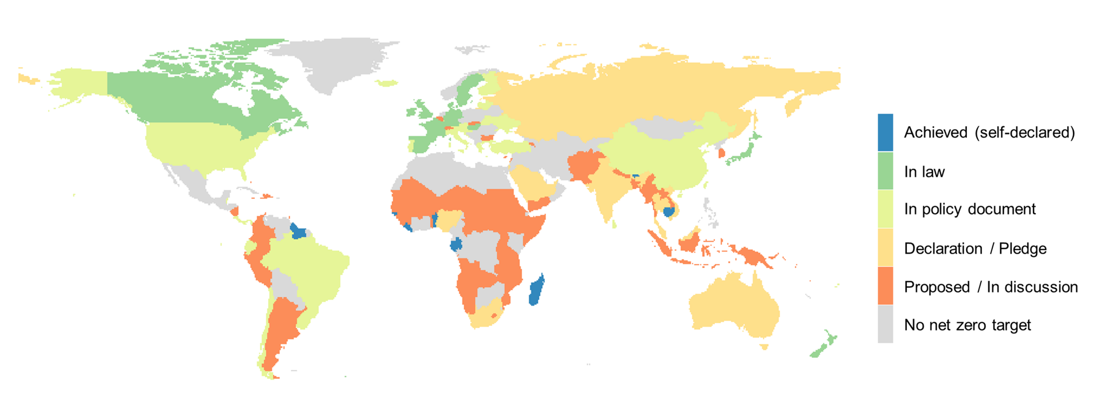

Figure S2 Spatial pattern and land source of bioenergy crop cultivation area under the low-warming (a) and overshoot (b) scenarios in this study. The pie charts show the proportion of the original vegetation types that are converted into bioenergy crop cultivation.
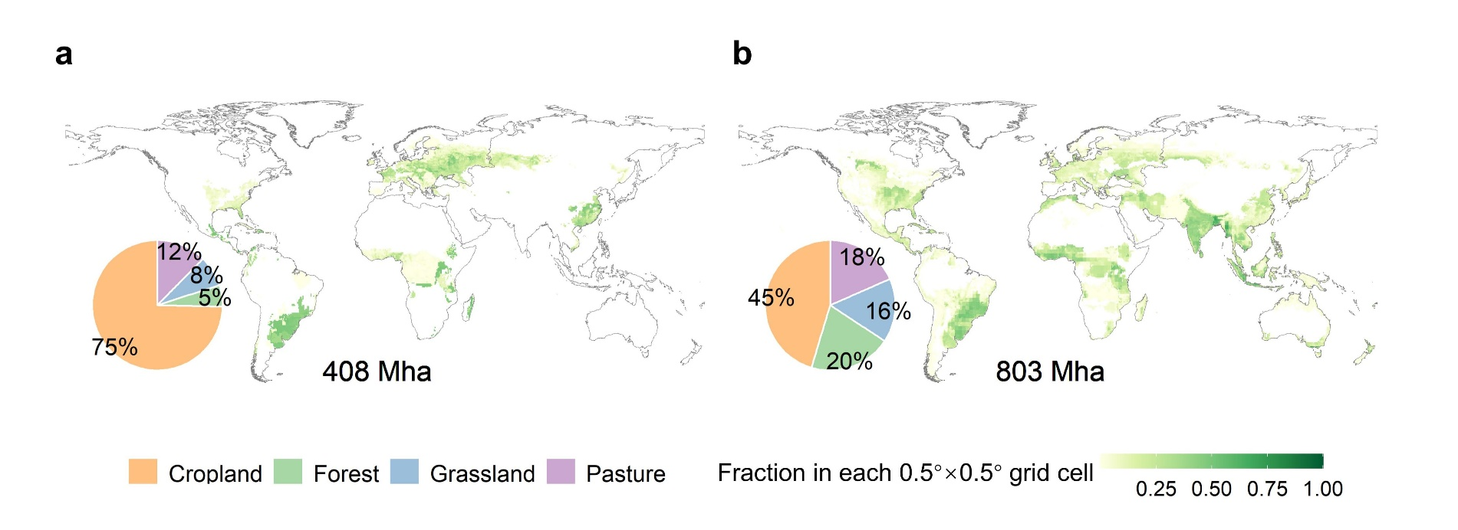

Figure S3 Region division used in this study.
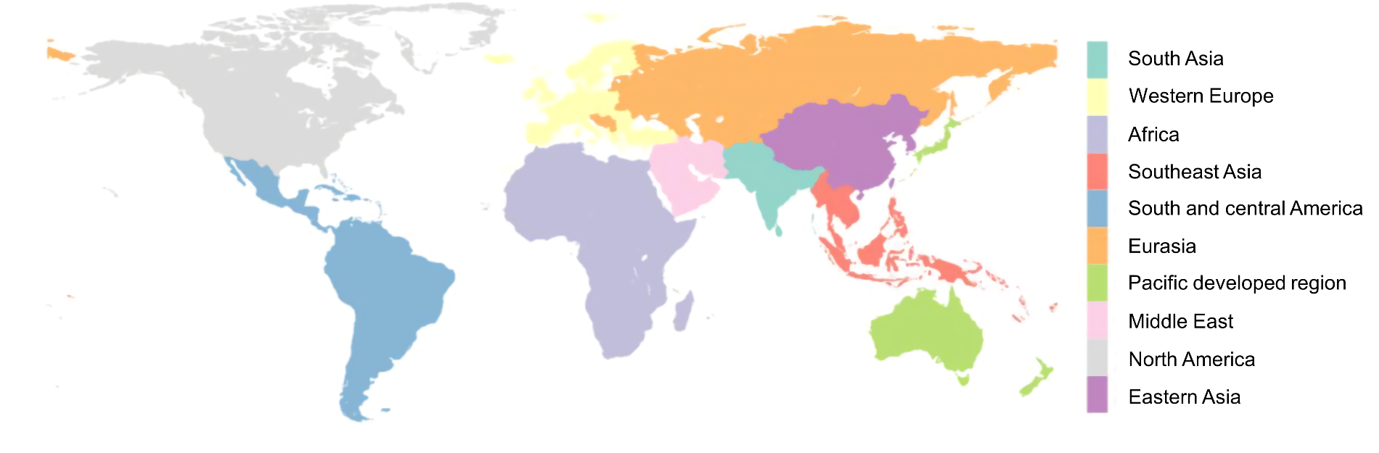

Figure S4 Annual bioenergy cultivation area and the areas of original vegetation types being converted in the low-warming (a) and overshoot (b) scenarios.
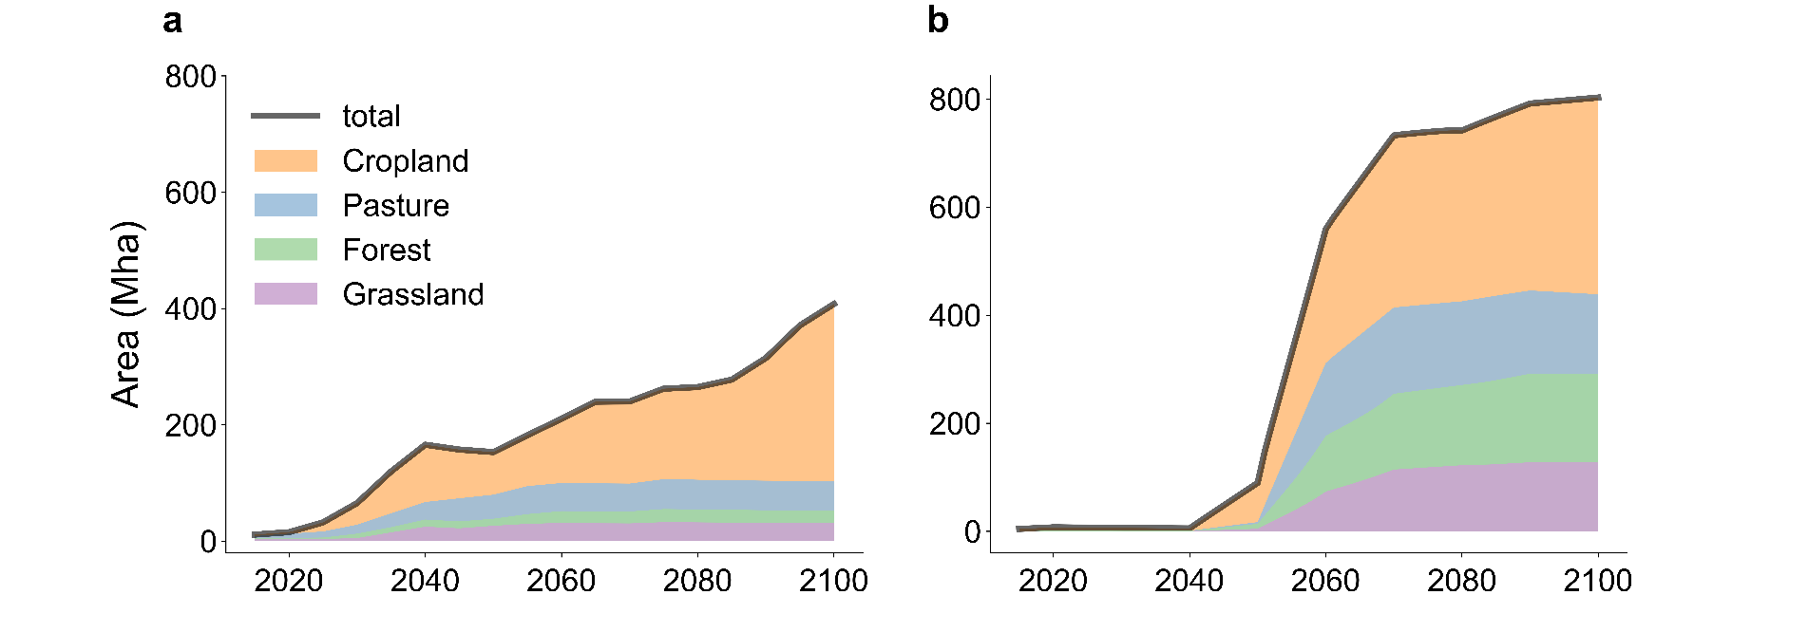
Figure S5 A schematic of methods for estimating biogeochemical and biophysical effects.
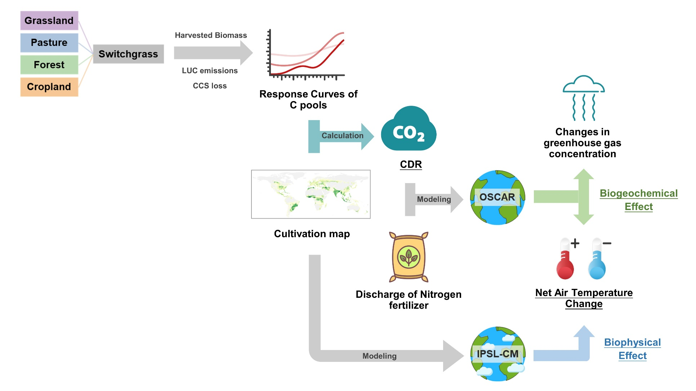
Figure S6 Contributions of the CN and non-CN countries to net carbon-dioxide removal (CDR) and biophysical air temperature change in the top ten non-CN countries with the largest cultivation area and the top ten CN countries with the maximum air temperature change under the low-warming (a and c) and overshoot (b and d) scenarios with switchgrass cultivation only in the CN countries and in all countries. Purple arrows refer to the biophysical air temperature change when cultivating switchgrass in the CN countries only, and green arrows indicate the biophysical air temperature changes after further cultivation in the non-CN countries. Pink dots indicate the amount of CDR in each country. DRC and CIV are the Democratic Republic of the Congo and the Republic of Côte d'Ivoire.
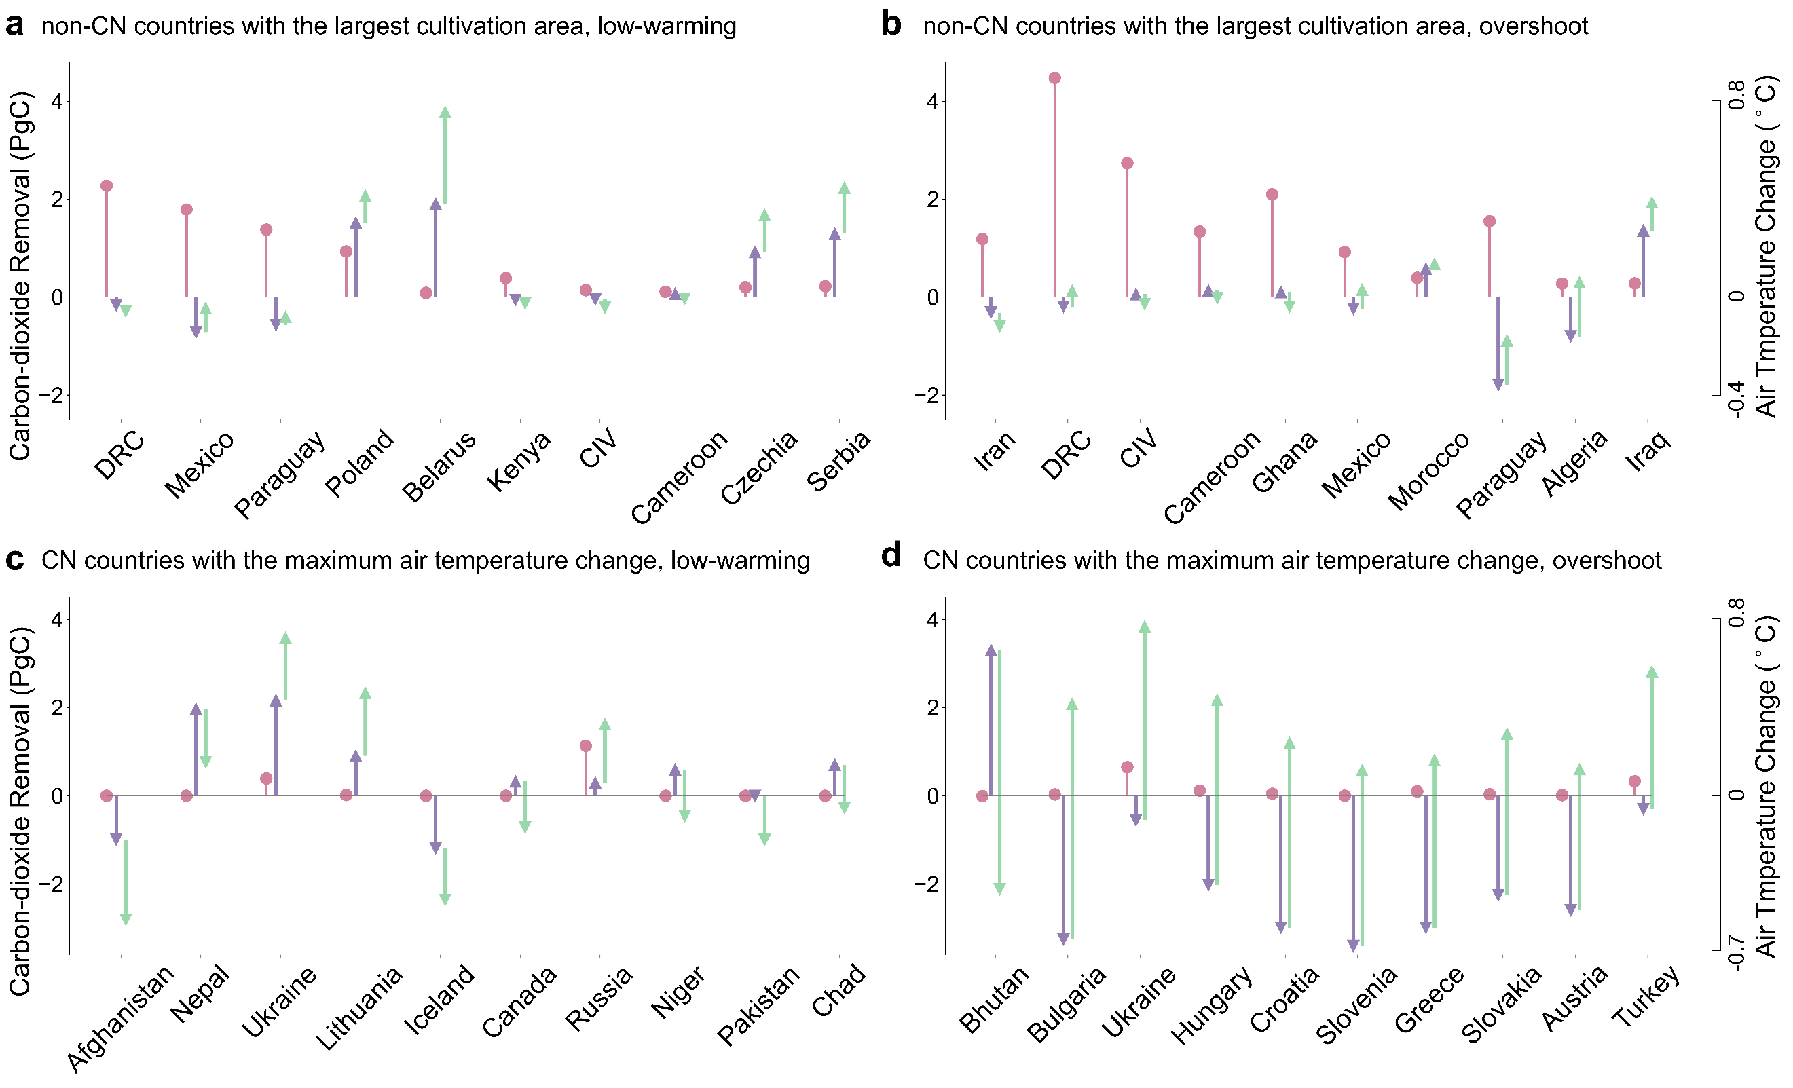

Figure S7 The cultivation area, net carbon-dioxide removal (CDR), biophysical air temperature change and net air temperature change in the top ten CN countries with the largest cultivation area under the low-warming (a) and overshoot (b) scenarios. Purple arrows refer to the biophysical air temperature change when cultivating switchgrass in the CN countries only, and green arrows indicate the biophysical air temperature changes after further cultivation in the non-CN countries. Blue arrows refer to the net air temperature change when cultivating switchgrass in the CN countries only, and green arrows indicate the net air temperature changes after further cultivation in the non-CN countries. Black and pink dots indicate the cultivation area and the amount of CDR in each country, respectively. USA is the United States of America.
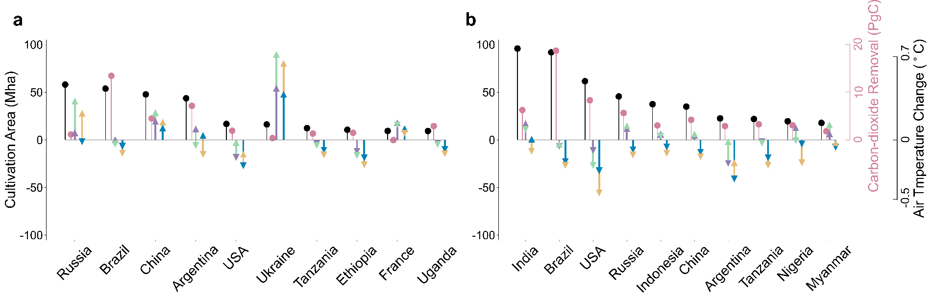
Figure S8 Biomass yields of switchgrass in the top ten non-CN countries with the largest cultivation area and the top ten CN countries with the maximum net air temperature change under the low-warming (a and c) and overshoot (b and d) scenarios. DRC and CIV are the Democratic Republic of the Congo and the Republic of Côte d'Ivoire.
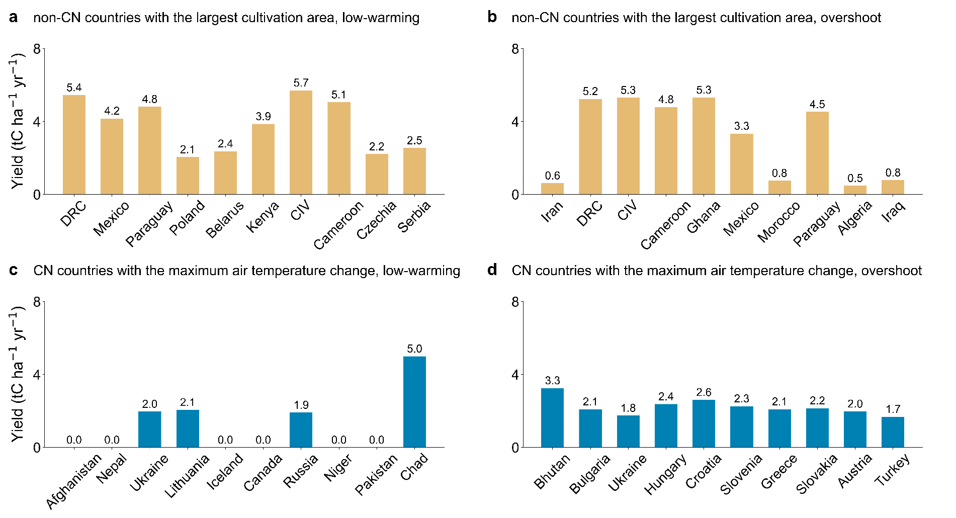
Figure S9 Contributions of the CN and non-CN countries to changes in the global CO₂ concentrations in the atmosphere from 2015 to 2100 under the low-warming and overshoot scenarios.
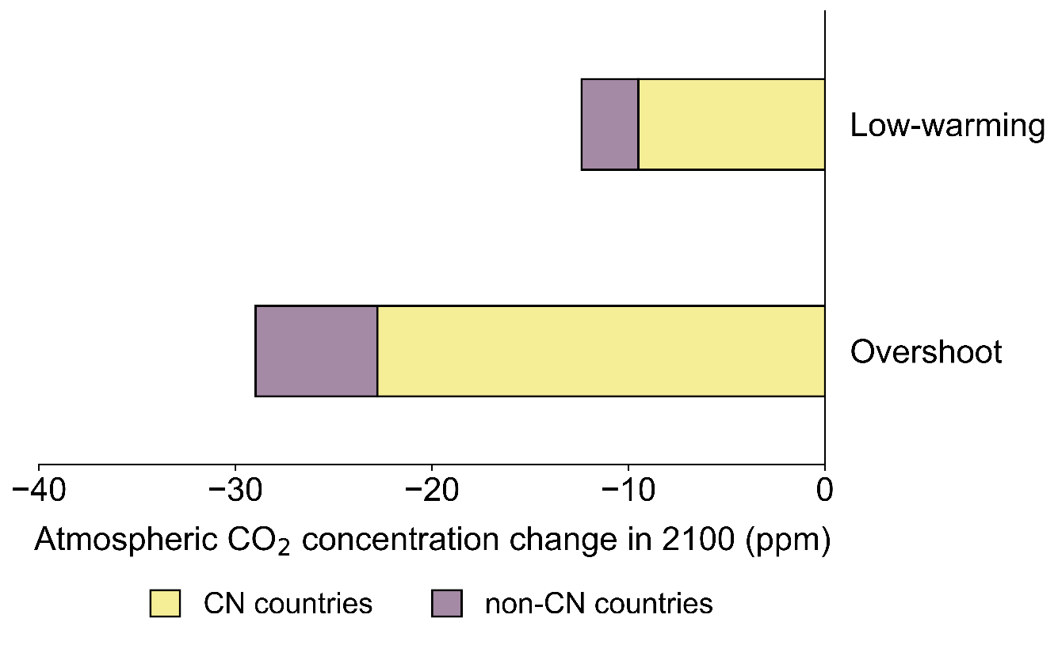

Figure S10 Contributions of the CN and non-CN countries to different components of net carbon-dioxide removal (CDR) in each region from 2015 to 2100 under the low-warming (a) and overshoot (b) scenarios. Darker and lighter bars are for the CN and non-CN countries, respectively. The red vertical lines stand for the total CDR in each region contributed by both the CN and non-CN countries (i.e., the sum of all bars).
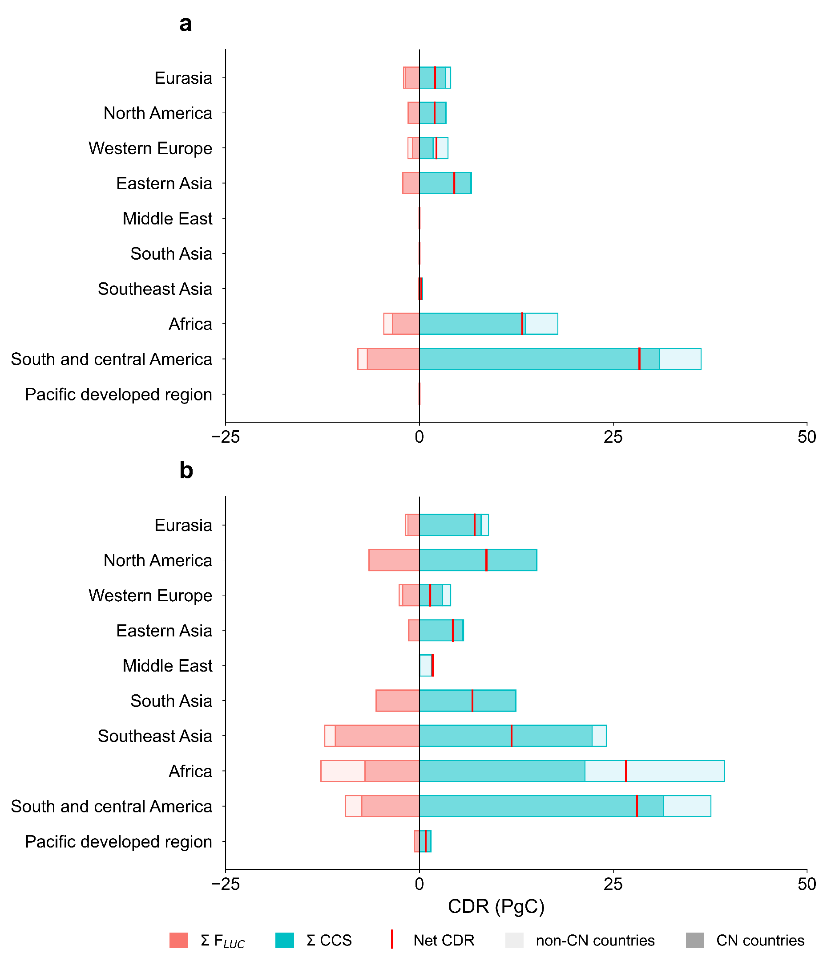

Figure S11 Contributions of the biogeochemical effects of CN and non-CN countries to the air temperature change under the low-warming (a) and overshoot (b) scenarios.
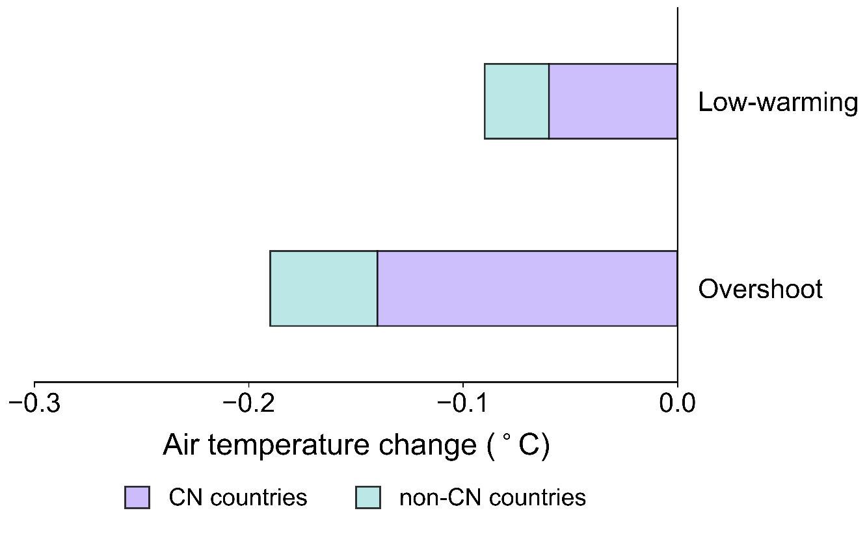

Figure S12 Contributions of the CN and non-CN countries to biophysical air temperature change in each region under the low-warming (a) and overshoot (b) scenarios. The black dots represent the biophysical air temperature change caused by the cultivation in both CN and non-CN countries.
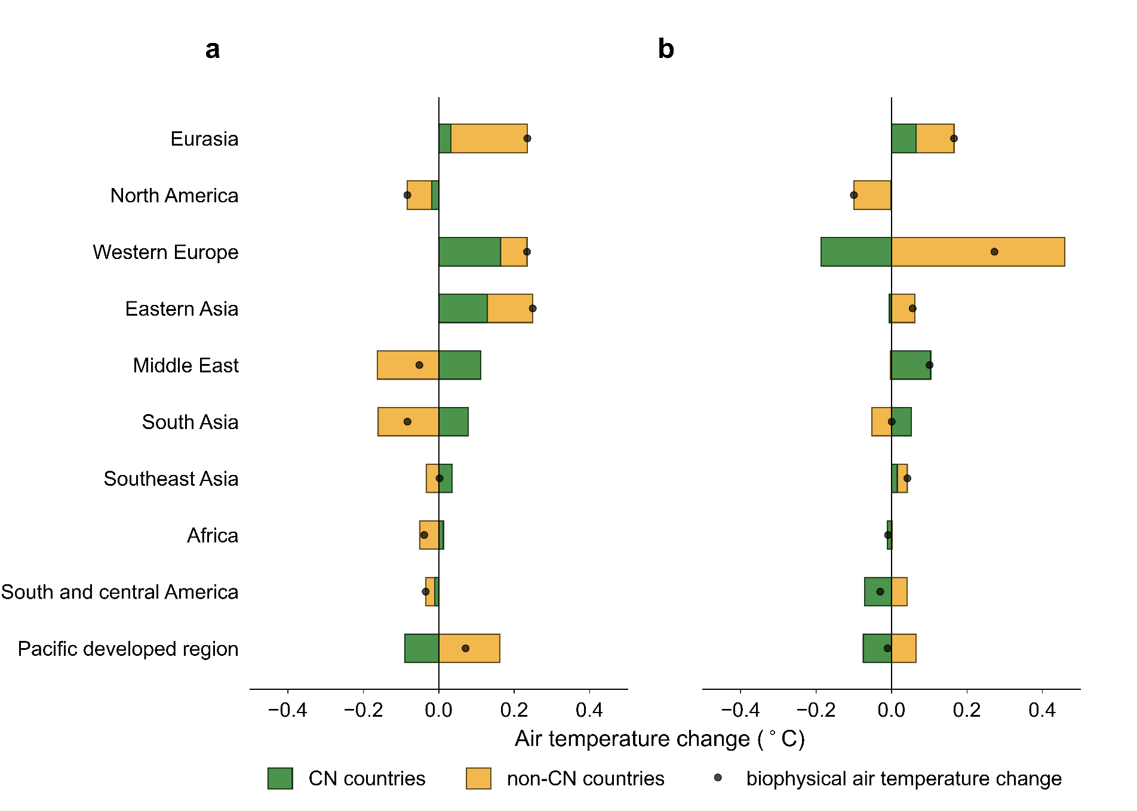

Figure S13 Responses of CDR of the CN and non-CN countries in each region to varying CCS efficiencies under the low-warming (a) and overshoot (b) scenarios. Lines on the left side represent the changes in the CDR under varying CCS efficiencies from 44% to 90%. Dots on the right side indicate the amount of CDR calculated when CCS efficiency is taken to be 65% in the study, and the error bars represent the range of CDR under different CCS efficiencies from 44% to 90%. Darker and lighter colors are for the CN and non-CN countries, respectively.
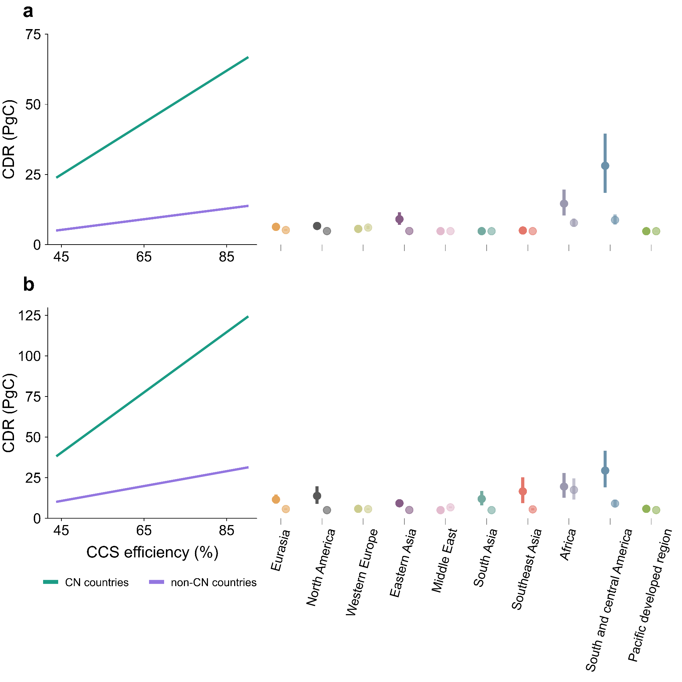
Figure S14 Impact of delayed implementation time of switchgrass cultivation in the non-CN countries on the CDR contribution of non-CN countries. The x-axis represents the delayed implementation years in the non-CN countries compared to the implementation year in the CN countries, and the y-axis refers to the CDR contribution of the non-CN countries to the global total CDR.
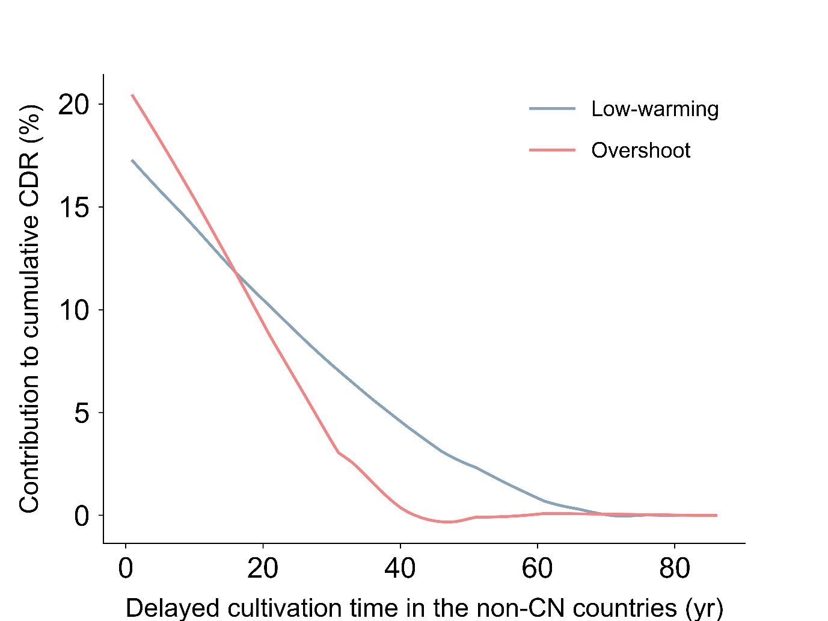

References
1. Popp, A., Rose, S.K., Calvin, K. et al. Land-use transition for bioenergy and climate stabilization: model comparison of drivers, impacts and interactions with other land use based mitigation options. Climatic Change 123, 495–509 (2014).
2. Hurtt, G. C., Chini, L., Sahajpal, R., et al. Harmonization of global land use change and management for the period 850–2100 (LUH2) for CMIP6, Geosci. Model Dev., 13, 5425–5464 (2020).
3. Klein Goldewijk, K., Beusen, A.,Van Drecht, G.& De Vos, M. The HYDE 3.1 spatially explicitdatabase of human-induced global land-use change over the past 12,000 years. Global Ecol.Biogeogr. 20,73-86 (2011).
4. Li, W., Yue, C., Ciais, P., et al. ORCHIDEE-MICT-BIOENERGY: an attempt to represent the production of lignocellulosic crops for bioenergy in a global vegetation model, Geosci. Model Dev., 11, 2249–2272 (2018).
5. Li, W., Ciais, P., Makowski, D. & Peng, S. A global yield dataset for major lignocellulosic bioenergy crops based on field measurements. Sci Data 5, 180169 (2018).
6. Wang, J., Li, W., Ciais, P. et al. Global cooling induced by biophysical effects of bioenergy crop cultivation. Nat Commun 12, 7255 (2021).
7. Wang, J. et al. Temperature Changes Induced by Biogeochemical and Biophysical Effects of Bioenergy Crop Cultivation. Environmental science & technology 57, (2023).
8. Guimberteau, M. et al. ORCHIDEE-MICT (v8.4.1), a land surface model for the high latitudes: model description and validation. Geosci. Model Dev. 11, 121–163 (2018).
9. N. Viovy. Research Data Archive at the National Center for Atmospheric Research, Computational and Information Systems Laboratory, Boulder CO, (2018).
10. S. Sitch, P. Friedlingstein, N. Gruber, et al. Recent trends and drivers of regional sources and sinks of carbon dioxide.Biogeosciences 12, 653 (2015).
11. Peng, S., P. Ciais, F. Maignan, et al. Sensitivity of land use change emission estimates to historical land use and land cover mapping, Global Biogeochem Cycles, 31, 626–643 (2015).
12. Smith, L.J., Torn, M.S. Ecological limits to terrestrial biological carbon dioxide removal. Climatic Change 118, 89-103 (2013).
13. Boysen, Lena R., et al. The limits to global‐warming mitigation by terrestrial carbon removal. Earth's Future 5.5, 463-474 (2017).
14. Read, P. Biosphere carbon stock management: addressing the threat of abrupt climate change in the next few decades: an editorial essay. Climatic Change 87, 305–320 (2008).
15. Bui, Mai, et al. Carbon capture and storage (CCS): the way forward. Energy & Environmental Science 11.5, 1062-1176 (2018).
16. Rhodes, James S. and David William Keith. Engineering economic analysis of biomass IGCC with carbon capture and storage. Biomass & Bioenergy 29, 440-450 (2005).
17. Kuramochi T, Ramírez A, Turkenburg W, et al. Comparative assessment of CO2 capture technologies for carbon-intensive industrial processes. Progress in Energy and Combustion Science, 38(1), 87-112 (2012).
18. Koornneef J, van Keulen T, Faaij A, et al. Life cycle assessment of a pulverized coal power plant with post-combustion capture, transport and storage of CO2. International Journal of Greenhouse Gas Control, 2(4), 448-467 (2008).
19. Hanssen S V, Daioglou V, Steinmann Z J N, et al. The climate change mitigation potential of bioenergy with carbon capture and storage. Nature Climate Change, 10(11), 1023-1029 (2020).
20. Liu J, You L, Amini M, et al. A high-resolution assessment on global nitrogen flows in cropland. Proceedings of the National Academy of Sciences, 107(17): 8035-8040 (2010).
21. FAO. Global database of GHG emissions related to feed crops: A life cycle inventory. Italy. (2017).
22. Tian H, Xu R, Canadell J G, et al. A comprehensive quantification of global nitrous oxide sources and sinks. Nature, 586(7828), 248-256 (2020).
23. Gasser, T., Ciais, P., Boucher, O., et al. The compact Earth system model OSCAR v2.2: description and first results, Geosci. Model Dev., 10, 271-319 (2017).
24. Arneth, A., Sitch, S., Pongratz, J. et al. Historical carbon dioxide emissions caused by land-use changes are possibly larger than assumed. Nature Geosci 10, 79–84 (2017).
25. Boucher, O., Servonnat, J., Albright, A. L., Aumont, O., Balkanski, Y., & Bastrikov, V., et al. Presentation and evaluation of the IPSL-CM6A-LR climate model. Journal of Advances in Modeling Earth Systems, 12, e2019MS002010 (2020).
26. Krinner, G. et al. A dynamic global vegetation model for studies of the coupled atmosphere-biosphere system. Global Biogeochem. Cy. 19, (2005)
27. Hourdin, F., Musat, I., Bony, S. et al. The LMDZ4 general circulation model: climate performance and sensitivity to parametrized physics with emphasis on tropical convection. Clim Dyn 27, 787–813 (2006).
28. Contoux, C., Ramstein, G., and Jost, A.: Modelling the mid-Pliocene Warm Period climate with the IPSL coupled model and its atmospheric component LMDZ5A, Geosci. Model Dev., 5, 903–917 (2012).
29. Li, Y., Piao, S., Chen, A., Ciais, P. & Li, L. Z. X. Local and teleconnected temperature effects of afforestation and vegetation greening in China. Natl Sci. Rev. 7, 897–912 (2020).
30. Zeng, Z. et al. Climate mitigation from vegetation biophysical feedbacks during the past three decades. Nat. Clim. Change 7, 432–436 (2017).
31. Li W, Ciais P, Han M, et al. Bioenergy crops for low warming targets require half of the present agricultural fertilizer use. Environmental Science & Technology, 55(15), 10654-1066(2021).
32. Dong, F., Zhu, J., Li, Y. et al. How green technology innovation affects carbon emission efficiency: evidence from developed countries proposing carbon neutrality targets. Environ Sci Pollut Res 29, 35780–35799 (2022).
33. Y.-M. Wei, K. Chen, J.-N. Kang et al., Policy and Management of Carbon Peaking and Carbon Neutrality: A Literature Review, Engineering. (2022).

