Supplement
Methods:
Tactile Sensitivity Questionnaire based on the tactile questions from the sensory perception quotient and sensory profile, ratings from 1 to 5.
Question from Sensory Perception Quotient, Tavassoli et al.:
- I wouldn’t be able to feel the label at the back of my shirt even if I thought about it.
- I would be able to tell the weight difference between two different coin sizes on the palm of my hand, if my eyes were closed.
- I wouldn’t notice the difference between even and uneven ground when driving over it sitting in the back seat of a car.
- I wouldn’t be able to feel the vibrations from loud music if I was sitting next to the loud speaker (for example, at a concert).
- I would be able to feel the elastic holding up my socks if I stop and thought about it.
- I notice the weight and pressure of a hat on my head.
- I would feel if a single hair touched the back of my hand.
- If my mobile phone was vibrating in my pocket I would be quick to sense it.
Questions adjusted from Sensory Profile, Dunn, et al.:
- Dental work and toothbrushing cause me discomfort.
- Shoes and Socks irritate me.
- I do not like standing in line or close to people.
- People sometimes become irritated with me because I touch them too much.
- I am a “touchy” person.
- I am a picky eater - Certain food textures disgust me (e.g. bananas, yoghurt, mushrooms).
- I avoid certain types of clothing.
- I avoid certain kinds of materials (rough textures).
- I cannot wear stiff clothes, clothes with rough textures, turtlenecks, etc.

Results:
Figure 1: ADHD and controls did not differ in baseline C4 amplitude (mean ADHD ±SD = 3.36 ± 1.12, mean NT ±SD = 2.81 ± 0.8, t = -1.97, p = 0.055), but differed in the level of radial nerve stimulation that was tolerable (mean ADHD ±SD =9.74 ± 1.46 , mean NT ±SD = 10.87 ± 1.85, t = 2.442, p = .018)
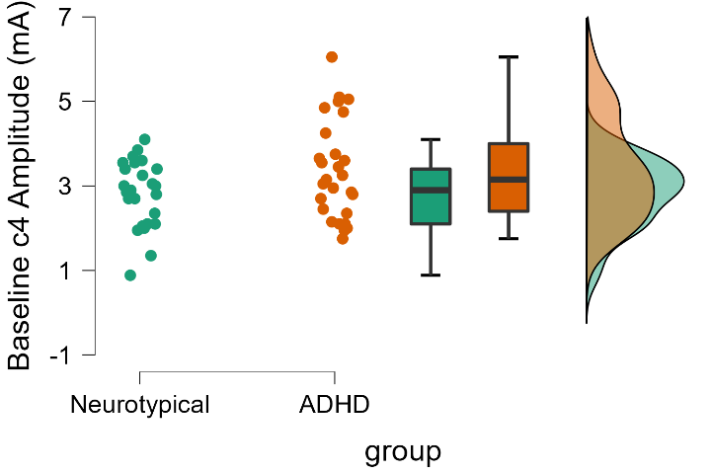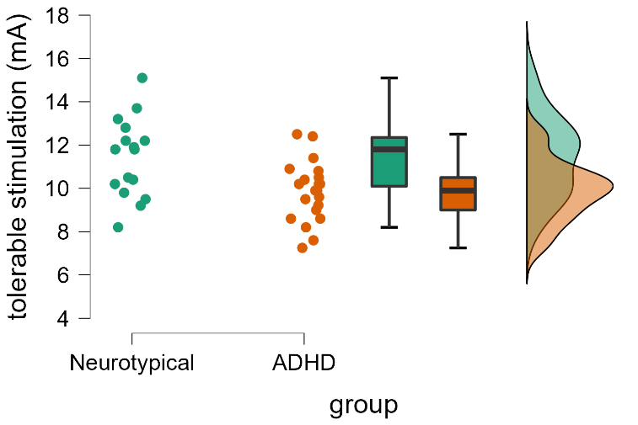
Figure 2: No differences were found at the cervical level between groups (F = 0.904, p=0.408) or conditions (F = 0.886, p=0.416).
