External validation of population pharmacokinetic models of tacrolimus in Thai adult liver transplant recipients.
Virunya Komenkul^{1*}, Waroonrat Sukarnjanaset², Piyawat Kolmolmit³, Thitima Wattanavijitkul¹
¹Department of Pharmacy Practice, Faculty of Pharmaceutical Sciences, Chulalongkorn University, Bangkok, Thailand.
²Department of Pharmaceutical care, College of Pharmacy, Rangsit University, Pathum Thani, Thailand.
³Department of Medicine, Faculty of Medicine, Chulalongkorn University, Bangkok, Thailand.
Correspondence Thitima Wattanavijitkul, PhD Department of Pharmacy Practice, Faculty of Pharmaceutical Sciences, Chulalongkorn University, Bangkok, Thailand.
Email: thitima.w@pharm.chula.ac.th
*Principal Investigator: Virunya Komenkul. Email: Komenkulv@gmail.com
ORCID
Virunya Komenkul https://orcid.org/0009-0002-8711-2752
Waroonrat Sukarnjanaset https://orcid.org/0000-0002-9331-1734
Piyawat Kolmolmit https://orcid.org/0000-0002-7890-8356
Thitima Wattanavijitkul https://orcid.org/0000-0003-1474-4249

Supplements
Table S1 Characteristics of the published population pharmacokinetics
Study (publication year) | Country of study (continent) | Single- or multicenter | Number of patients (male / female) | Tacrolimus formulation | Concomitant immunosuppressant drugs | Number of samples | Postoperative time mean  ± SD/ median (range)(days) | Bioassay | Biological fluid
Staatz et al. (2003) | Australia (Oceania) | Single | 68 (48/20) | Prograf® (po) | MMF or azathioprine + corticosteroids | 1846 | 323 ± 370  (6-2115 days) | LC–MS/MS | Whole blood
Dansirikul  et al. (2004) | Australia (Oceania) | Multiple | 31(23/8) | Prograf® (po) | MMF or azathioprine + corticosteroids | NA | 420 ± 530  (11-1886) days | LC-MS/MS | Whole blood
Zahir et al. (2005) | Australia (Oceania) | Single | 67 (45/22) | Prograf® (po) | Corticosteroids ± azathioprine ± sirolimus ± MMF ± muromonab | 694 | 40.2 ± 17.3  (14–94 days) | MEIA | Whole blood
Sam et al. (2006) | Singapore (Asia) | Single | 31 (23/8)  adult and pediatric | Prograf® (po) | Corticosteroids | 213 | NA | HPLC-MS/MS | Whole blood
Blanchet  et al. (2008) | France  (Europe) | Single | 14 (11/3) | Prograf® (po) | Corticosteroids ± MMF | NA | 6-97 | EMIT | Whole blood
Zhang et al. (2012) | China (Asia) | Single | 262 (226/36) | Prograf® (po) | MMF + corticosteroids | 3763 | 85.4 ± 211.5 / 37.5 (2–1941) | MEIA | Whole blood
Lu et al. (2015) | China (Asia) | Single | 112 (86/26) | Prograf® (po) | MMF + corticosteroids | 1100 | 19.38±17.75 (2–137) | MEIA | Whole blood
Tharanon  et al. (2021) | Thailand (Asia) | Single | 50 (34/16) | Prograf® (po) | MMF + corticosteroids | 1012 | 0-6 mo | CMIA | Whole blood
po; oral administration, MMF; mycophenolate mofetil, C0; trough concentration, N/A; not available.

Table S2 Covariate relationships of the published population pharmacokinetics
Study (publication year) | Covariate relationships | Weight (BMI) | Hemoglobin  (mg/dL) | Hematocrit (mg/dL) | ALT (U/L) | ALP (U/L) | Total bilirubin (mg/dL) | Albumin (g/dL) | Total protein (g/dL)
Staatz et al. (2003) | ALT, Weight | 72±16 | N/A | N/A | N/A | N/A | N/A | N/A | N/A
Dansirikul et al. (2004) | No | 75.4±15.6  (26.0±4.97) | N/A | N/A | 54±41 | 103±60 | N/A | N/A | N/A
Zahir et al. (2005) | HCT, Alb, Fluconazole, Diltiazem | 77.8±17.4 | N/A | 41.0  (25.0-46.0) | 149  (14-5450) | N/A | 2.28  (0.29-36.8) | 4.3  (2.3-5.2) | N/A
Sam et al. (2006) | Weight, ALP, HCT, HT, Scr | 55.0 (6.5-127) | N/A | 31.1  (22.8-46.0) | 152 (23-577) | 149 (37-718) | 1.23  (0.18-17.08) | 3.2  (2.4-4.4) | 6.2  (4.8-8.3)
Blanchet et al. (2008) | Whole graft | 73 (56-115) | N/A | 32.9±5.2 | 19 (15-25) | 79 (53-122) | 0.64  (0.58-0.70) | N/A | N/A
Zhang et al. (2012) | Daily dose, TP, HCT, Sulfonylureas | 64 (35-125) | 11.8  (5.0-16.3) | 35.4  (13.8-49.0) | 33  (0.24-834) | 81 (6-828) | 1.16  (0.29-16.9) | 4.2 (2.9-5.5) | 6.9  (0.01-9.82)
Lu et al. (2015) | ALT | 69.0 ± 11.8 | 9.75±1.6 | 29.1±4.77 | 146.4±290.0 | N/A | 0.58±3.11 | N/A | N/A
Tharanon et al. (2021) | Hb, TB | 66.04±11.47 (24.71±3.66) | 11.1  (10.2, 12.3) | 33.7  (30.0, 36.5) | 52  (33, 99) | 123  (78, 204) | 1.2  (0.7, 3.9) | 3.36  (3.07, 3.83) | N/A
Hb, hemoglobin; HCT, Hematocrit; HT, height; SCR; TP, total protein; ALB, albumin; DBIL, direct bilirubin; ALT, alanine transaminase; ALP, alkaline phosphatase, N/A; not available.

Table S3 Simulation-based NPDE diagnostics
Study  (publication year) | Mean (SE) | Variance (SE) | Skewness | Kurtosis | t-test | Fisher variance test | SW test of normality | Global test
Staatz et al. (2003) | 0.03553  (0.05) | 0.3798  (0.067) | 0.3798 | 1.627 | 1 | 0.437 | 9.89e-06  *** | 9.89e-06  ***
Dansirikul et al. (2004) | 0.08033  (0.049) | 0.8745  (0.066) | -0.03181 | 0.478 | 0.312 | 0.25 | 0.914 | 0.25
Zahir et al. (2005) | 0.3219  (0.047) | 0.7856  (0.059) | 0.6323 | 1.565 | 7.52e-11 *** | 0.00616  ** | 3.58e-07  *** | 7.52e-11  ***
Sam et al. (2006) | 0.06946  (0.05) | 0.9151  (0.068) | -0.17 | 0.425 | 0.507 | 0.755 | 0.447 | 0.447
Blanchet et al. (2008) | -0.006379 (0.049) | 0.8622  (0.064) | -0.07699 | 0.6412 | 1 | 0.167 | 0.19 | 0.167
Zhang et al. (2012) | 0.0288  (0.051) | 0.9477  (0.071) | -0.3528 | 0.5201 | 1 | 1 | 0.00787  ** | 0.00787 **
Lu et al. (2015) | 0.1458  (0.055) | 1.085  (0.082) | 0.0654 | 0.4663 | 0.0284 * | 0.775 | 0.407 | 0.0248 *
Tharanon et al. (2021) | -0.004671 (0.05) | 0.9123  (0.068) | 0.4983 | 2.036 | 1 | 0.707 | 1.04e-07 *** | 1.04e-07  ***
Significance: '***' 0.001 '**' 0.01 '*' 0.05 '.' 0.1

Table S4 Predictive error in the Bayesian forecasting.
 | MDIPE |  |  |  | MAIPE |  |  |  | F20 |  |  |  | F30
 | 0 | 1 | 2 | 3 | 0 | 1 | 2 | 3 | 0 | 1 | 2 | 3 | 0 | 1 | 2 | 3
Staatz et al. (2003) | -2.17 | 2.76 | 2.98 | -0.04 | 35.75 | 9.39 | 7.93 | 11.92 | 5.13 | 37.70 | 24.59 | 19.26 | 10.26 | 43.44 | 27.87 | 20.90
Dansirikul  et al. (2004) | -2.74 | -3.54 | -3.26 | -5.36 | 35.59 | 10.27 | 9.48 | 11.00 | 5.13 | 39.34 | 27.32 | 19.26 | 9.89 | 47.54 | 30.05 | 21.72
Zahir et al. (2005) | -5.10 | 0.70 | 3.18 | -1.40 | 34.34 | 9.38 | 11.24 | 10.15 | 6.59 | 39.34 | 25.68 | 18.85 | 9.52 | 42.62 | 28.96 | 21.72
Sam et al. (2006) | -0.22 | -5.11 | -3.72 | -5.42 | 37.95 | 9.08 | 10.06 | 11.14 | 5.49 | 42.62 | 28.42 | 20.08 | 9.16 | 47.54 | 30.60 | 22.54
Blanchet et al. (2008) | 1.81 | -2.71 | -2.56 | -4.93 | 36.66 | 10.21 | 9.52 | 11.11 | 5.49 | 40.16 | 27.32 | 18.85 | 9.52 | 54.90 | 30.05 | 21.72
Zhang et al. (2012) | -2.87 | -5.29 | -4.60 | -4.04 | 32.86 | 10.10 | 11.74 | 14.07 | 5.13 | 39.34 | 24.59 | 17.62 | 10.26 | 46.72 | 28.42 | 19.67
Lu et al. (2015) | -20.08 | -5.47 | -3.66 | -6.22 | 38.40 | 10.41 | 8.84 | 10.63 | 6.59 | 42.80 | 26.78 | 19.26 | 9.16 | 45.08 | 30.05 | 21.72
Tharanon  et al. (2021) | 0.15 | 1.91 | 4.58 | 2.90 | 32.85 | 10.02 | 9.05 | 10.16 | 6.96 | 37.70 | 25.14 | 18.44 | 10.62 | 43.44 | 28.96 | 20.49
MDPE, median prediction error; MAPE, median absolute prediction error; F20, percentage of prediction error that falls within ±20%; F30, percentage of prediction error that falls within ±30%.

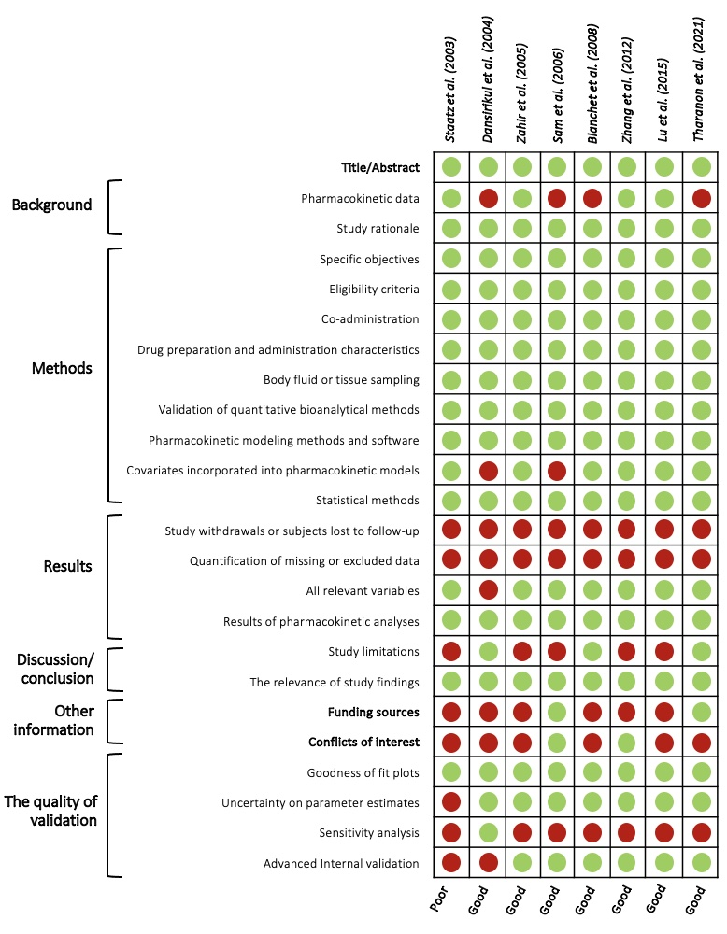
Fig. S1 Evaluation of selected PPK models.

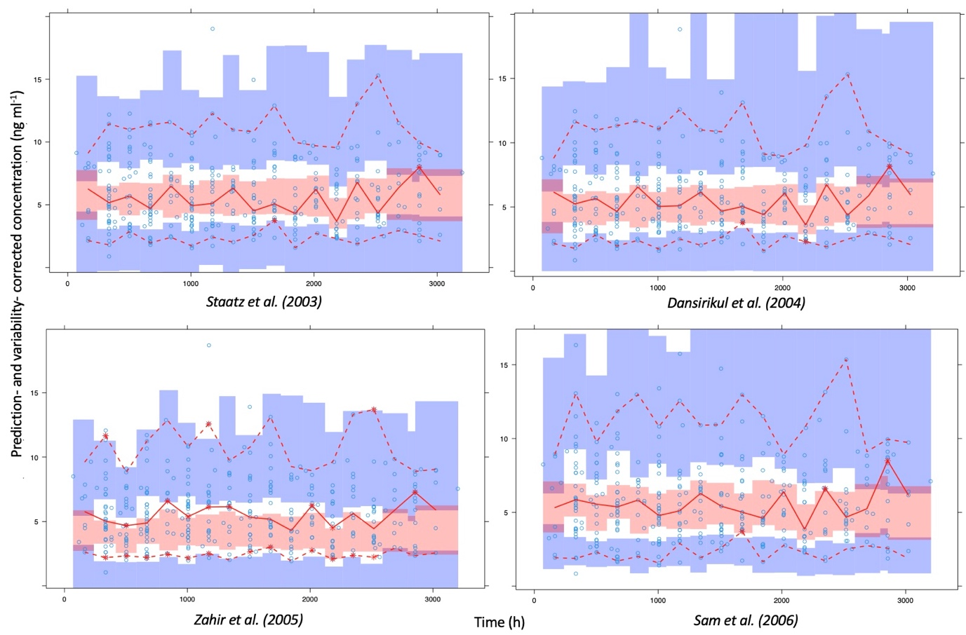
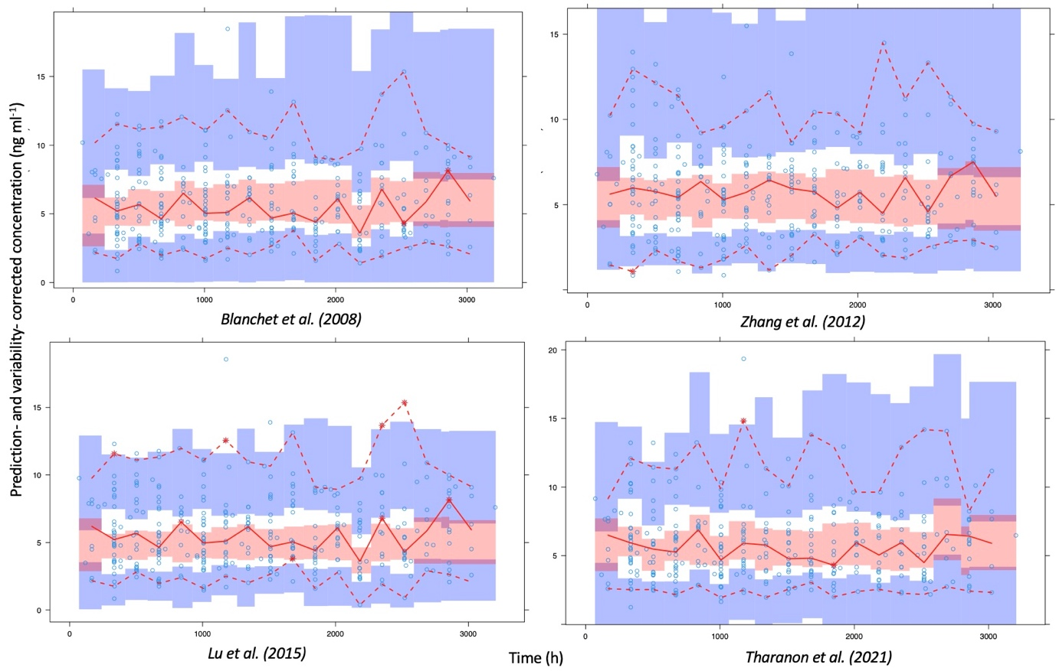 Fig. S2 Prediction-corrected visual predictive check (pcVPC)
Prediction-corrected visual predictive check (pcVPC) of each model displays the prediction- and variability-corrected observed concentration values as transparent blue dots, while the median prediction- and variability-corrected observations and 95% confidence intervals (CI) from the simulations are represented by solid red lines and semitransparent red shades, respectively. Additionally, the 5th and 95th percentiles of the corrected observations and 95% CI from the simulations of corrected observed percentiles are shown using dashed red lines and semitransparent blue shades, respectively.

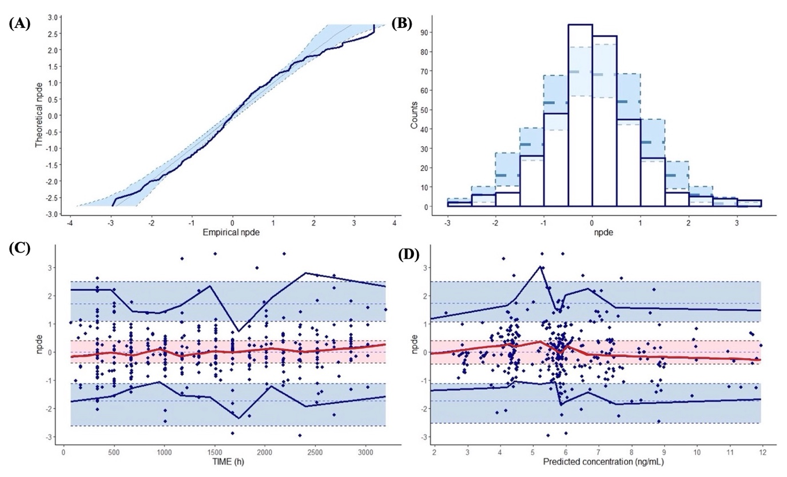Staatz et al. (2003)
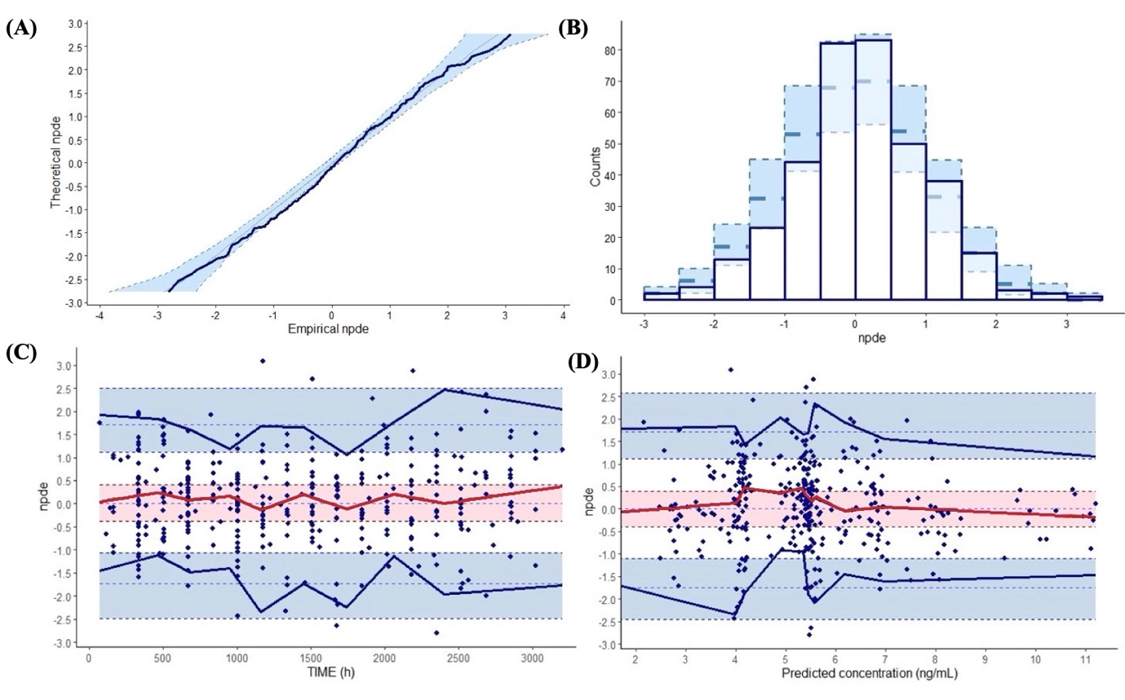
Dansirikul et al. (2004)
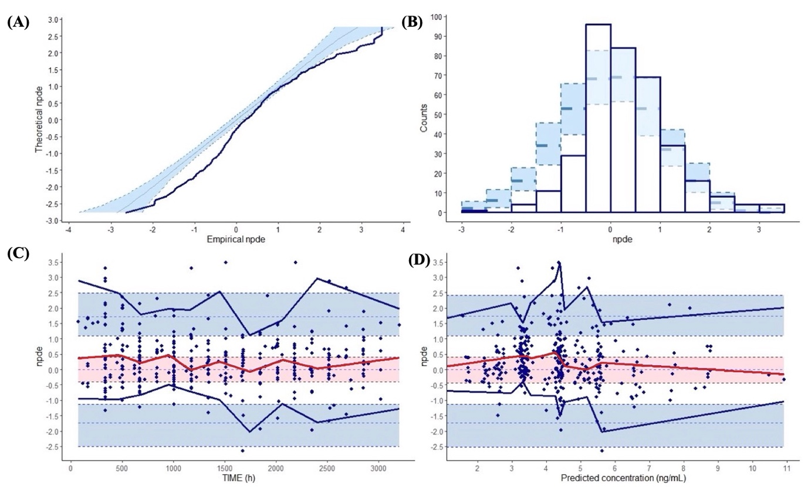
Zahir et al. (2005)
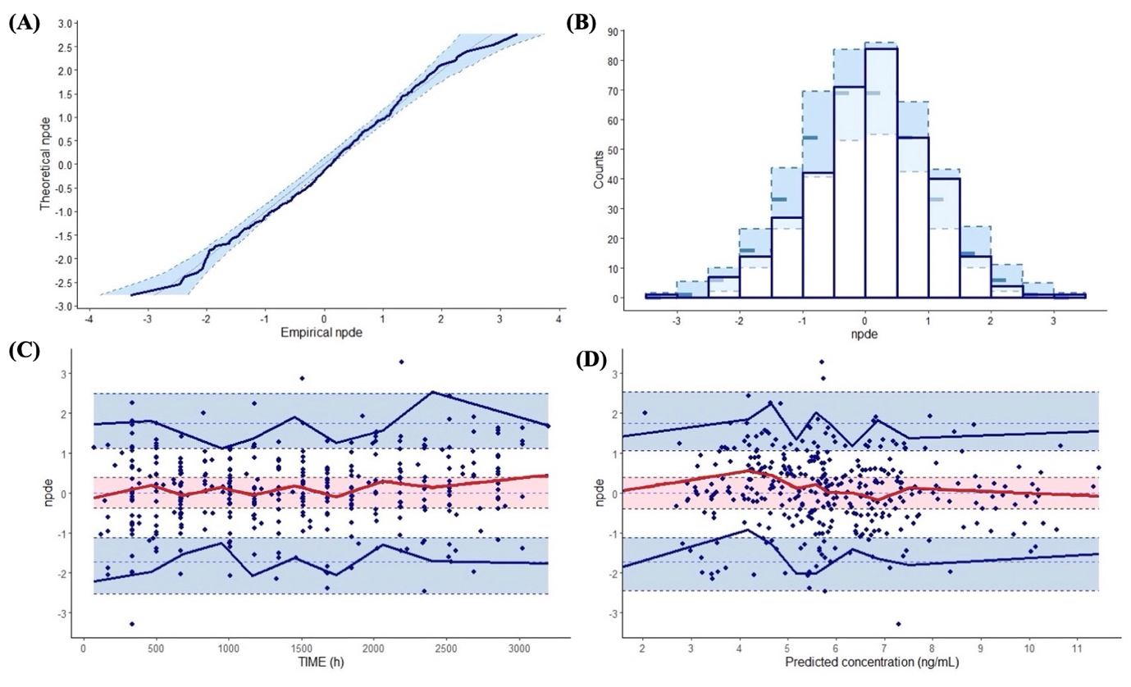Sam et al. (2006)
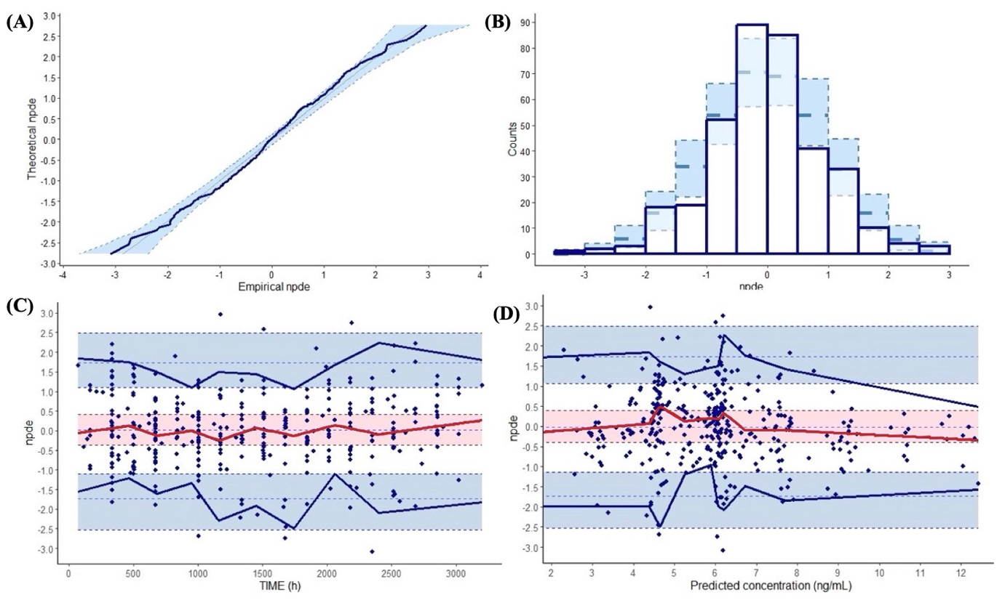Blanchet et al. (2008)
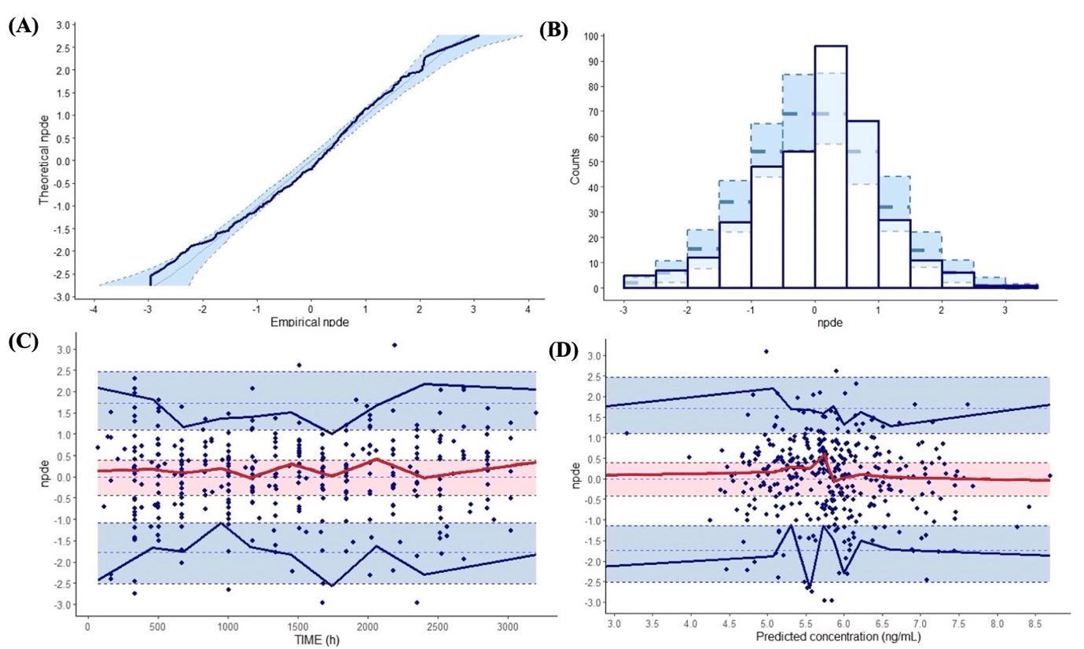
Zhang et al, (2012)

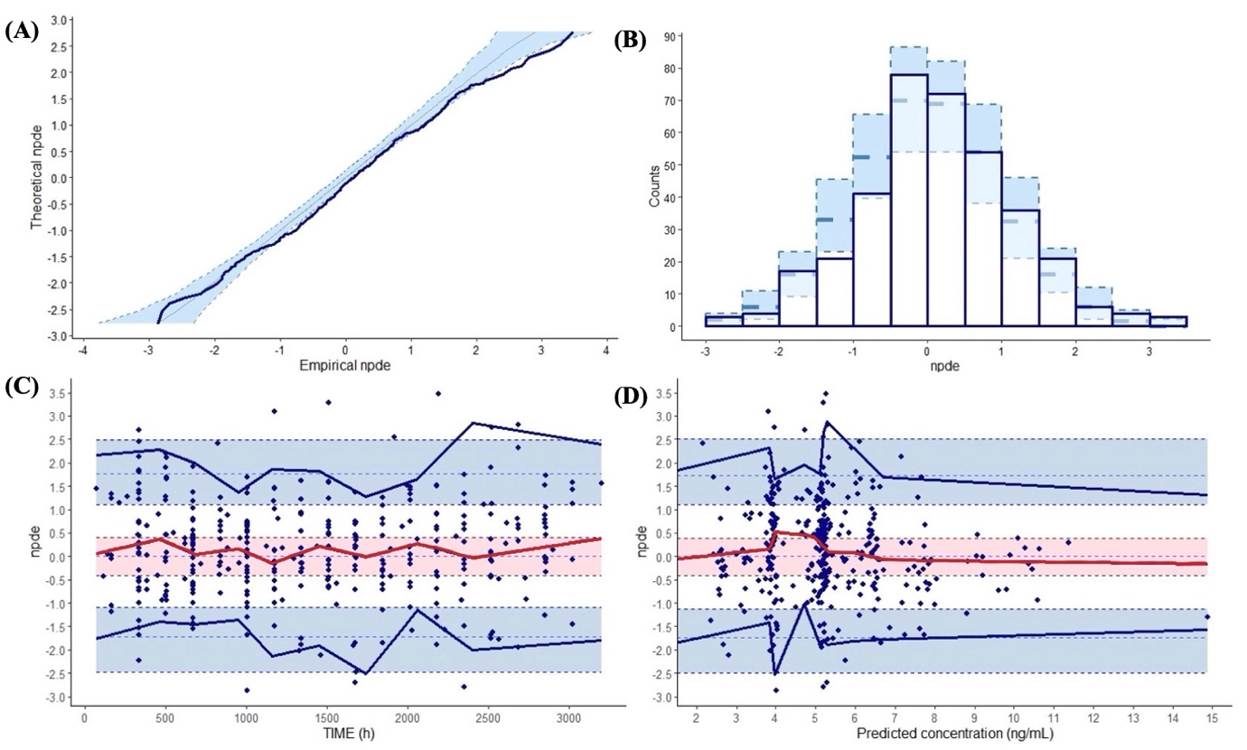Lu et al. (2015)
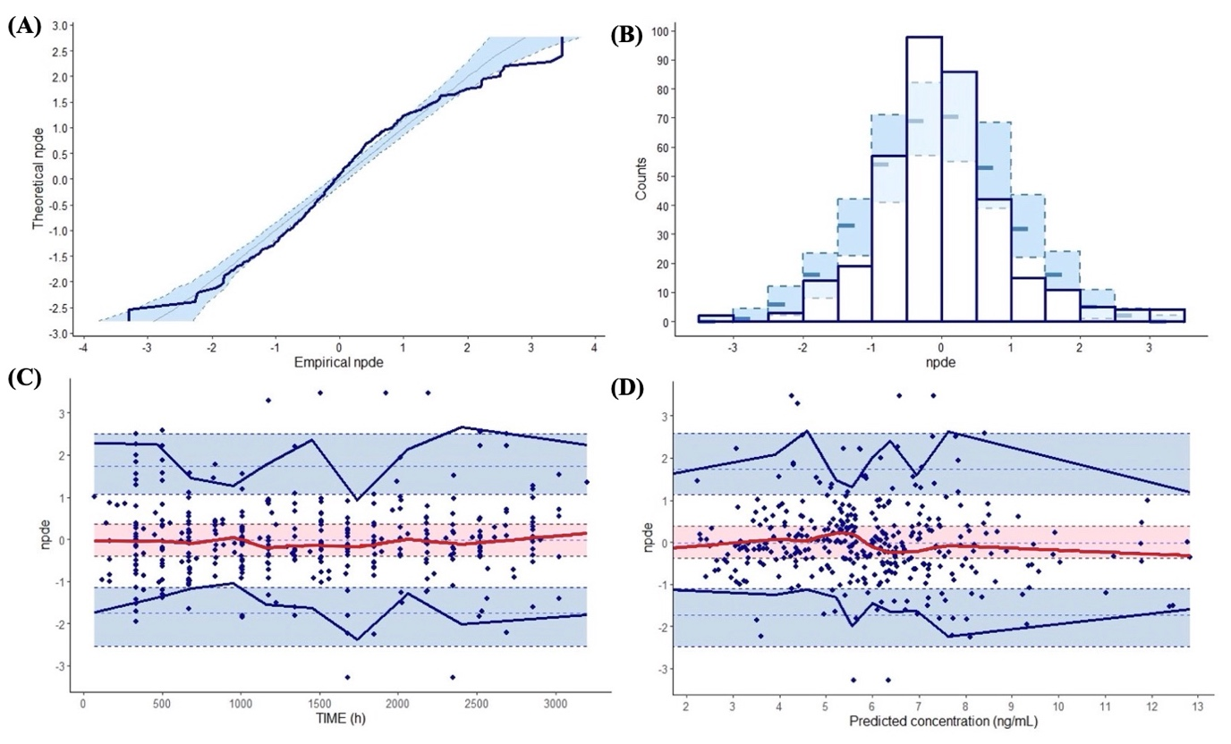Tharanon et al. (2021)
Fig. S3 Simulation-based diagnostics
Normalized prediction distribution error (NPDE) plots: (A) Histogram of NPDE. (B) Q-Q plots showing the distribution of NPDE compared to the theoretical distribution, represented by semitransparent blue fields. (C) NPDE plotted against postoperative time (h). In plots C and D, the solid red lines represent the median value of NPDE obtained from observations, while the semitransparent red fields display the 95% confidence interval (CI) of the median derived from simulations. (D) NPDE plotted against predicted concentrations. Additionally, solid blue lines in the plots represent the NPDE of the observed 5th and 95th percentiles, and semitransparent blue fields indicate a simulation-based 95% CI for the corresponding model-predicted percentiles.

